*भारतीय मानक*

**साइकिलें — पैडल समुच्चय — विशिष्टि**

*(****तीसरा पुनरीक्षण****)*

*Indian Standard*

**BICYCLES – PEDAL ASSEMBLY – SPECIFICATION**

(*Third Revision*)

ICS 43.150

© BIS 2024



भारतीय मानक ब्यूरो

BUREAU OF INDIAN STANDARDS

मानक भवन, 9 बहादुर शाह ज़फर मार्ग, नई दिल्ली - 110002

MANAK BHAVAN, 9 BAHADUR SHAH ZAFAR MARG

NEW DELHI - 110002

[www.bis.gov.in](http://www.bis.org.in) [www.standardsbis.in](http://www.standardsbis.in)

**May 2024 Price Group**

Bicycles Sectional Committee, Ted 16

**FOREWORD**

This Indian (*Third Revision*) Standard was adopted by the Bureau of Indian Standards, after the draft finalized by the Bicycles Sectional Committee had been approved by Transport Engineering Division Council.

This standard was initially published in 1955 and revised in 1963 and 1993. In this revision, following significant changes have been made:

1. More choices of materials have been allowed;
2. More number of shapes have been included; and
3. New tests such as durability test, Impact test and Toxicity test have been specified.

The composition of the Committee responsible for the formulation of this standard is given in Annex A.

For the purpose of deciding whether a particular requirement of this Standard has complied with the final value, observed or calculated, expressing the result of a test or analysis shall be rounded off as per IS 2: 2022 Rules for rounding off numerical values (*Second revision*). The number of significant places retained in the rounded-off value should be the same as that of the specified value in this Standard.

*Indian Standard*

**BICYCLES – PEDAL ASSEMBLY – SPECIFICATION**

*(Third Revision)*

**1 SCOPE**

This standard prescribes the requirements for pedal assembly suitable for fitting in bicycles for general use.

**2 REFERENCES**

The following standards contain provisions, which through reference in this text, constitute provisions of this standard. At the time of publication, the editions indicated were valid. All standards are subject to revision and parties to agreements based on this standard are encouraged to investigate the possibility of applying the most recent editions of the standards indicated below.

|  |  |
| --- | --- |
| *IS No.* | *Title* |
| 1068: 1993 | Electroplated coatings of nickel plus chromium and copper plus nickel plus chromium on iron and steel (third revision) |
| 1570-4: 1988 | Schedules for wrought steels: Part 4 alloy steels (Alloy Constructional and Spring Steels) with specified chemical composition and mechanical properties (*first* *revision*) |
| 1572: 1986 | Electroplated coatings of cadmium on iron and steel (*second revision*) |
| 1573: 1986 | Electroplated coating of zinc on iron and steel (*second revision*) |
| 2898 (Part 1): 2019/ ISO 3290-1: 2014 | Rolling bearings -- Balls: Part 1 Steel balls (*second revision*) |
| 4398: 1994 | Carbon - Chromium steel for the manufacture of balls, rollers and bearing races - Specification (*second revision*) |
| ISO 6742-2: 2023 | Cycles Lighting and retro-reflective device. Part 2: Retro-reflective device |
| 10613: 2023 | Cycles - Safety and performance requirements for bicycles (*third revision*) |
| DOC: TED 16 (18837) | BMX bicycles – Safety requirements and test methods |
| DOC: TED 16 (23113) | Cycles - Safety requirements for bicycles for young children (*second revision* of IS 15533:2018/ISO 8098: 2014) |

**3 MATERIALS**

**3.1** The components of the pedal assembly may be made from any suitable material subject to its conformity with tests specified in this standard. The commonly used materials for spindle or axle are Steel, Cr-Mo Steel. Stainless Steel and Titanium alloy are the commonly used materials for body. For platform the commonly used materials are Stainless Steel, Aluminium alloy, Forged alloy, Composites or Synthetic Plastic, and Rubber.

**3.2** Components of the pedal assembly which are subjected to friction such as ball races and spindle shall have a minimum hardness of 600 HV (with 5 kgf load) on the wearing surfaces.

**3.3** Balls, if made of steel, shall conform to grade105Cr5 of IS 1570 (Part 4) or Grade 103Cr4of IS 4398. The finished balls shall conform to grade 200 of IS 2898 part 1. These shall be heat treated to achieve hardness between 708 HV to 890 HV (with 5 kgf load). These shall be spherical and uniform in size.

The manufacturers may use any other suitable material for balls subject to their conformity with tests specified in this standard.

**3.4** If ceramic balls are used, they shall conform to the gradeSi3N4 (Silicon Nitride) or its equivalent. The finished balls shall conform to grade 5 of IS 2898 part 2. These shall be heat treated (hot isostatic pressed) to achieve hardness between 78 HRC to 83 HRC (with 150 kgf load). These shall be spherical and uniform in size.

**4 SHAPES AND DIMENSIONS**

**4.1** The pedal spindle shall conform to the dimensions given in Fig. 1, Fig. 2 and Table 1. Other components shall be made to suit the spindle size (*see* Fig. 3, Fig. 4, Fig. 5).

**4.2** Some common shapes of pedal are given in Fig. 3, Fig. 4 and Fig. 5.

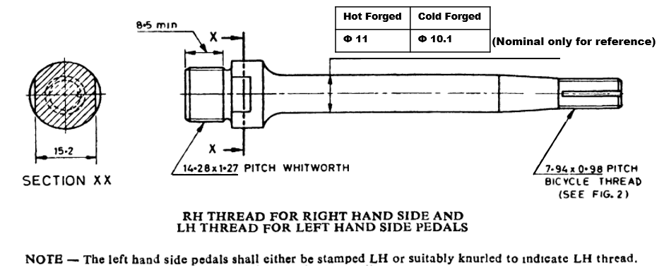

All dimensions in millimetres.

Fig. 1 Pedal Spindle

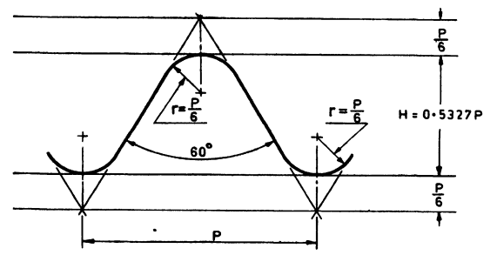

Fig. 2 Form of Thread

**Table 1 Dimensions of Form Thread**

(Clause 4.1)

All dimensions in millimetres

|  |  |  |  |  |  |  |  |  |  |  |  |  |  |  |
| --- | --- | --- | --- | --- | --- | --- | --- | --- | --- | --- | --- | --- | --- | --- |
| **Sl No.** | **Size** | **Pitch**  *P* | **External Thread** | | | | | | **Internal Thread** | | | | | |
| **Major Dia.** | | **Effective Dia.** | | **Minor Dia.** | | **Major Dia.** | **Effective Dia.** | | **Minor Dia.** | | |
| *Max* | *Min* | *Max* | *Min* | *Max* | *Min* | *Min* | *Max* | *Min* | | *Max* | *Min* | |
|  |  |  |  |  |  |  |  |  |  |  |  | |  |  | |
|  | 7.94 × 0.98 | 0.977 | 7.938 | 7.798 | 7.417 | 7.325 | 6.896 | 6.706 | 7.938 | 7.508 | 7.417 | | 7.093 | 6.896 | |

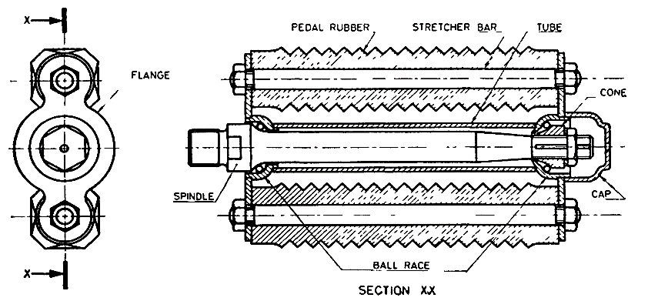

Fig. 3 Block Type Pedal Assembly (Schematic)

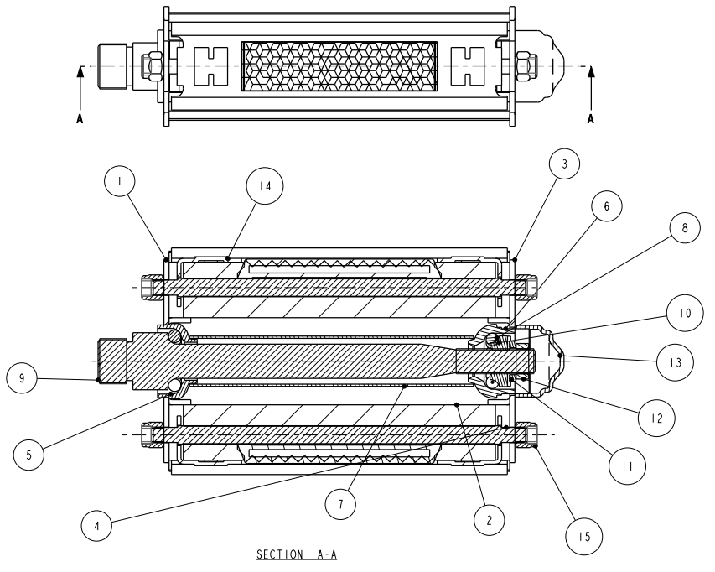

|  |  |  |  |
| --- | --- | --- | --- |
| **No.** | **Name of Parts** | **No.** | **Name of Parts** |
| 1 | Pedal Plate Crank End | 9 | Pedal Axle |
| 2 | Pedal Block | 10 | Pedal Axle Cone |
| 3 | Pedal Plate Cone End | 11 | Lock Washer |
| 4 | Stretcher Bar | 12 | Pedal Axle Nut |
| 5 | Crank End Cup | 13 | Dust Cover |
| 6 | Cone End Cup | 14 | Block Plate |
| 7 | Pedal Pipe | 15 | HEX NYLOC Nut M5 X 0.8P |
| 8 | Steel Ball |  |  |

Fig. 4 Rat-Trap/Heavy Duty Type Pedal Assembly (Schematic)

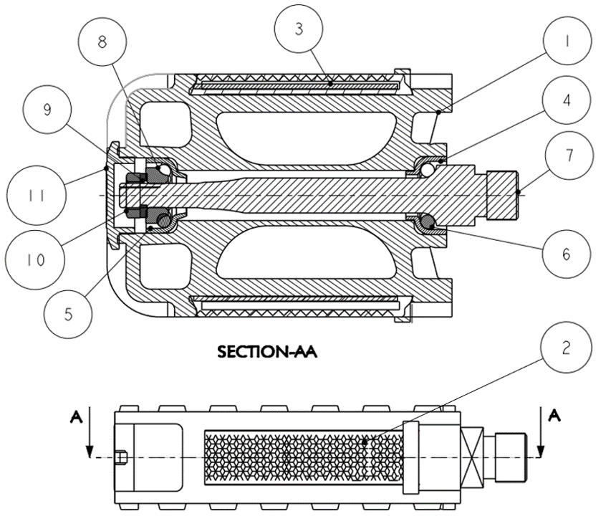

|  |  |  |  |
| --- | --- | --- | --- |
| **No.** | **Name of Parts** | **No.** | **Name of Parts** |
| 1 | Pedal Body | 7 | Pedal Axle |
| 2 | Pedal Reflector | 8 | Pedal Axle Cone |
| 3 | Reflector Strip | 9 | Lock Washer |
| 4 | Crank End Cup | 10 | Pedal Axle Nut |
| 5 | Cone End Cup | 11 | Pedal Cap |
| 6 | Steel Ball |  |  |

Fig. 5 Integral Type Pedal Assembly (Schematic)

**5 MANUFACTURE**

**5.1** Pedal shall be fitted to the spindle for free rotations. The pedal spindle assembly shall be then connected to the crank arm through threads for transferring the motion or power to the chain wheel. The threads shall be so formed as to facilitate easy fitting and replacement. The pedal spindle shall have a right-handed crank fitting thread if it is a right pedal spindle and a left-handed crank fitting thread if it is a left pedal spindle.The pedal shall bear a marking of “Right” or “Left” accordingly. The reflector attached to the pedal body shall conform to IS/ISO 6742-2.

**6 FINISH**

**6.1** The spindles may preferably be chemically coloured or plated.

**6.2** The tubes, flanges, stretcher bars and caps, if made of steel shall be finished smooth and shall be enamelled or nickel-chrome plated to Service Grade No. 1 [Classification Code Fe/(s Ni) 10b (Cr r)] of IS 1068 or cadmium plated to Service Condition No. 2 (Classification No. Fe/Cd 8) of IS 1572 or zinc plated to Service condition No. 2 (Classification No. Fe/Zn 7.5) of IS 1573 and if made of aluminium alloys shall be finished smooth and shall be enamelled or nickel-chrome plated to Service Grade No. 1 [Classification Code Al/(s Ni) 10b (Cr r)] of IS 1068.

**NOTE**

In view of the shape of some of the components a uniform thickness of plating is not to be expected. Therefore, in order to ensure that the thickness of nickel plating at any point is not less than that specified, an appropriately higher plating thickness should be aimed at.

**6.3** Finished surfaces without plating shall be given a suitable rustproof treatment unless the substrate material is corrosion resistant.

**6.4** Exposed edges that could come into contact with the rider’s hands, legs, etc, during normal riding or normal handling and normal maintenance shall not be sharp, for example, deburred, broken, rolled, or processed with comparable techniques.

**7 TESTS**

All strength tests involving any synthetic resin/plastic materials shall be pre-conditioned for two hours and tested at an ambient temperature of 23 °C ± 5 °C.

**7.1 Static Load Test (Not applicable to Young Children’s bicycles)**

**7.1.1** For ‘Young adult bicycles’; ‘City andTrekking’; ‘Roadster’; ‘SLR bicycles’; ‘Mountain bicycles’; and ‘Racing bicycles’, the pedal shall pass the test as specified in **4.10.3** of IS 10613.,

**7.1.2** For BMX bicycles, the pedal shall pass the test as specified in **4.14.3** of DOC: TED 16 (18837)

**7.1.3** For EPAC bicycles, the pedal shall pass the test as specified in **4.3.12.3**.

**7.2 Dynamic Durability Test**

**7.2.1** For bicycles for young children, the pedal shall pass the test as specified in **4.12.4** of Doc TED 16(23113)

**7.2.2** For ‘Young adult bicycles’; ‘City andTrekking’; ‘Roadster’; ‘SLR bicycles’; ‘Mountain bicycles’; and ‘Racing bicycles’, the pedal shall pass the test as specified in **4.10.5** of IS 10613.,

**7.2.3** For BMX bicycles, the pedal shall pass the test as specified in **4.14.4** of DOC: TED 16 (18837)

**7.2.4** For EPAC bicycles, the pedal shall pass the test as specified in **4.3.12.5**.

**7.3 Impact Test**

**7.3.1** *Impact Test on pedal*

**7.3.1.1** For bicycles for young children, the pedal shall pass the test as specified in **4.12.3** of Doc TED 16(23113)

**7.3.1.2** For ‘Young adult bicycles’; ‘City andTrekking’; ‘Roadster’; ‘SLR bicycles’; ‘Mountain bicycles’; and ‘Racing bicycles’, the pedal shall pass the test as specified in **4.10.4** of IS 10613.,

**7.3.1.3** For BMX bicycles, the crank/pedal assembly shall pass the test as specified in **4.14.5.1** of DOC: TED 16 (18837)

**7.3.1.4** For EPAC bicycles, the pedal shall pass the test as specified in **4.3.12.4.**

**7.3.2** *Impact Test on Plastic (Synthetic Resin) Pedal (Only applicable to BMX bicycles)*

For BMX bicycles, the plastic pedal shall pass the test as specified in **4.14.5.2** of DOC: TED 16 (18837).

**7.3.3** *Toxicity Test*

**7.3.3.1** For bicycles for young children, the pedal shall pass the test as specified in **National Annex A** of Doc TED 16(23113).

**7.3.3.2** For ‘Young adult bicycles’; ‘City andTrekking’; ‘Roadster’; ‘SLR bicycles’; ‘Mountain bicycles’; and ‘Racing bicycles’, the pedal shall pass the test as specified in **4.1.2** of IS 10613.

**7.3.3.3** For BMX bicycles, the crank/pedal assembly shall pass the test as specified in **4.20** of DOC: TED 16 (18837)

**7.3.3.4** For EPAC bicycles, the pedal shall pass the test as specified in **4.3.1.9**.

**8 MARKING**

**8.1** The pedal assembly shall be marked indicating the source of manufacture and/or trademark. The pedal assembly shall carry suitable identification mark for left hand threads as indicated in Fig 1.

**8.2** **BIS Certification Marking**

**8.2.1** The pedal assembly may also be marked with the Standard Mark.

**8.2.2** The product(s) conforming to the requirements of this standard may be certified as per the conformity assessment schemes under the provisions of the *Bureau of Indian Standards Act*, 2016 and the Rules and Regulations framed thereunder, and the products may be marked with the standard mark.

**ANNEX A**

(*Foreword*)

**COMMITTEE COMPOSITION**

BICYCLES SECTIONAL COMMITTEE, TED 16

| ***Organization*** | ***Representative(s)*** |
| --- | --- |
| Research and Development Centre for Bicycle and Sewing Machine, Ludhiana | Mr. Rakesh Pathak (***Chairman***) |
| All India cycle Manufacturers Association, New Delhi | Dr. K B Thakur  Shri Shri Zoheb Khan (*Alternate)* |
| Amar Wheels Private Limited, Ludhiana | Shri Karan Aggarwal |
| Avon Cycles Limited, New Delhi | Shri Onkar Singh Pahwa  Shri Rajwinder Singh (*Alternate )* |
| Central Tool Room, Ludhiana | Shri Onkar Singh Pahwa (*Alternate* ) |
| Citizen Press Components, Ludhiana | Mr. Manjinder Singh  Amit Prakash Sharma (*Alternate* ) |
| Controllerate of Quality Assurance, New Delhi | Shri Subir Roychowdhuri  Shri Asoka Kumar MN (*Alternate* ) |
| Department of Industries of Commerce, Haryana | Shri Shashi Kant  Shri Ajay Kumar (*Alternate* ) |
| G-13 Bicycle Forum | UMESH KUMAR NARANG  Shri Rajinder Jindal (*Alternate* ) |
| Hero Cycles, Ludhiana | Shri S K Rai  Shri K C Sharva (*Alternate* ) |
| Hero Ecotech Limited, Ludhiana | Gurdeep Singh  Shri Surinder Pal (*Alternate* ) |
| Institute for Auto Parts and Hand tools Technology, Ludhiana | Dr. Sanjeev Katoch |
| Lucky Exports, Ludhiana | Shri Sohrab Chhabra  Shri Harsimer Jit Singh (*Alternate* ) |
| Metro Tyres Limited, Ludhiana | shri Jagdeep Kumar Sablok  shri. Samir Mayra (*Alternate* ) |
| National Institute of Technology, Jalandhar | Dr. Raman Bedi |
| Research & Development Centre For Bicycle and Sewing Machines, Ludhiana | Shri Vishwas Mehta |
| Research and Development Centre for Bicycle and Sewing Machine, Ludhiana | Mr. Rajeev Sharma |
| S.K. Bikes Private Limited, Ludhiana | Shri Mukesh Kumar  hri Sachin Lakra (*Alternate*) |
| Sebco Enterprises, Ludhiana | Shri Rajeev jain  Shri Lalit Sharma (*Alternate* ) |
| Spark Engineering Private Limited, Ghaziabad | Shri Anoop Aggarwal  Shri Pradeep Kumar Aggarwal (*Alternate* ) |
| Tube Investments of India Limited, Chennai | Shri Prakash V.  Shri Venkateswaran B (*Alternate* ) |
| United Cycle and Parts Manufacturers Association, Punjab | President  General Secretary (*Alternate* ) |
| Vishal Cycles Private Limited, Ludhiana | Shri Sanjeev Mahindru  Shri. Bhim Sain (*Alternate )* |
| BIS Directorate General | Shri Deepak Aggarwal, Scientist ‘F’ & Head (TED)  [Representing Director General (Ex-officio)] |

Member Secretary

Shri Ravindra Beniwal

Scientist C / Deputy Director

(Transport Engineering Department)