***भारतीय मानक***

***Indian Standard***

**TED 14 (20706) F**

**IS 7879 (Part 1): XXXX**

**वैमानिक और खगोलीय शब्दों की शब्दावली**

**भाग 1 सामान्य**

*(****पहला*** *पुनरीक्षण)*

**GLOSSARY OF AERONAUTICAL AND ASTRONAUTICAL TERMS**

**PART 1 GENERAL**

*(First Revision)*

ICS: 49.020

© BIS 2024

भारतीय मानक ब्यूरो

BUREAU OF INDIAN STANDARDS

मानक भवन, 9 बहादुर शाह ज़फर मार्ग, नई दिल्ली 110002

MANAK BHAVAN, 9 BAHADUR SHAH ZAFAR MARG

NEW DELHI 110002

[www.bis.gov.in](http://www.bis.org.in) [www.standardsbis.in](http://www.standardsbis.in)

**November 2024 Price Group**

Air and Space Vehicles Sectional Committee, TED 14

**FOREWORD**

This Indian Standard (Part 1) (First Revision) was adopted by the Bureau of Indian Standards, after the draft finalized by the Air and Space Vehicles Sectional Committee had been approved by the Transport Engineering Division Council.

This standard was first published in 1975. The present revision has been taken up with a view to incorporating the modifications found necessary as a result of experience gained on the use of this standard. Also, in this revision, the standard has been brought into the latest style and format of Indian Standard, and references to Indian Standards, wherever applicable have been updated.

This standard is one of the series of Indian Standards on ‘Glossary of Aeronautical and Astronautical terms’. Other standards in this series are:

|  |  |
| --- | --- |
| IS 7879 (Part 2) : 1975 | Glossary Of Aeronautical and Astronautical Terms — Part 2: Motion of Aircraft |
| IS 7879 (Part 3) : 1975 | Glossary of Aeronautical and Astronautical Terms — Part 3: Structure |
| IS 7879 (Part 4) : 1980 | Glossary of Aeronautical and Astronautical Terms — Part 4: Aerodynamics |
| IS 7879 (Part 5) : 1982 | Glossary of Aeronautical and Astronautical Terms — Part 5: Aerodynes (Heavier - Than - Air - Aircraft) |
| IS 7879 (Part 6) : 1978 | Glossary of Aeronautical and Astronautical Terms — Part 6: Space Terms |
| IS 7879 (Part 7) : 1984 | Glossary of Aeronautical and Astronautical Terms — Part 7: Air Traffic and Ground Services |
| IS 7879 (Part 8) : 1987 | Glossary of Aeronautical and Astronautical Terms — Part 8: Power Plant |

The present standard provides standard definitions of technical terms peculiar to aeronautics, astronautics and related subjects. Terms in general use in other branches of engineering are also included where they have some special relevance to aeronautics or astronautics.

This standard consists of a series of parts, each part covering terms specific to a particular feature, type of aircraft, equipment, service, etc.

Each term has been assigned a 4-digit or 5-digit number. The first one (or two) digit, in the thousandth place, represents the part number. This part number with the following digit in the hundredth place represents the section. The last two digits represent the position of the definition within a section. Thus, the term 3405 is the 6th definition of Section 34, which is in Part 3.

Where two or more synonymous terms are in use, the term, which is favored, is given first, with the intention that it should gradually displace the others. The alternative terms are given below the preferred terms in less prominent type.

Assistance has been derived from BSI 185 ‘Aeronautical and Astronautical Terms’ issued by the British Standards Institution, in the preparation of this Indian Standard.

The composition of the Committee responsible for the formulation of this standard will be added later.

*Indian Standard*

**GLOSSARY OF AERONAUTICAL AND ASTRONAUTICAL TERMS**

**PART 1 GENERAL**

*(First Revision)*

**1 SCOPE**

This part covers the standard definitions for general aeronautical terms.

**2 REFERENCES**

This standard does not contain any cross reference.

**3 TERMINOLOGY**

**SECTION 11 — GENERAL**

| **No.** | **Term** | **Definition** |
| --- | --- | --- |
| **1101** | Aeronautics | All activities relating to aerial locomotion (*see* **1109**). |
| **1102** | Aerostation | The operation of lighter-than-air aircraft (*see* **1109**). |
| **1103** | Aircraft Dinghy | An inflatable boat carried in an aircraft for use after alighting on water. |
| **1104** | Airworthy | Complying with the regulations prescribed by the competent authority certifying the fitness for flight of an aircraft. |
| **1105** | Altitude | The vertical distance above mean sea-level (*see* **1118**). |
| **1106** | Density Altitude  (Density Height) | An atmospheric density expressed as the altitude which corresponds to that density in the international standard atmosphere. |
| **1107** | Pressure Altitude | An atmospheric pressure expressed as the altitude which corresponds to that pressure in the international standard atmosphere. |
| **1108** | Altitude Chamber | A chamber in which conditions of pressure, and sometimes temperature, at altitude can be simulated for test purposes. |
| **1109** | Aviation | 1. The operation of heavier-than-air aircraft (*see* **1102**); and 2. Synonym for ' aeronautics '. |
| **1110** | Avionics | The application of electronics to aeronautics and astronautics. |
| **1111** | Buoyancy | The vertical force on an aircraft, or other body, wholly or partly immersed in a fluid, equal to the weight of the fluid displaced. |
| **1112** | Centre of Buoyancy | The centre of gravity of the fluid displaced by an aircraft, or other body, wholly or partially immersed in a fluid. |
| **1113** | Reserve | Excess of the buoyancy of a seaplane, with its hull or floats completely immersed, over its weight. |
| **1114** | Elevation | 1. The altitude of a point on the Earth's surface; and 2. The angle between the observer's horizontal plane and the oblique line from the observer to a given point above him. (Abbreviation for ‘angle of elevation’). |
| **1115** | Flight Simulator | Equipment, in which certain flight conditions are simulated as far as possible, used for training aircrew to operate a given type of aircraft, or for investigating the flying characteristics of an aircraft. |
| **1116** | Gas Dynamics | The science of the flow of gases, especially when compressibility and ‘eal gas’ effects such as dissociation or noncontinuum behavior are present. |
| **1117** | Ground, To | To prohibit an aircraft from flying. |
| **1118** | Height | The vertical distance above a specified datum (*see* **1105**). |
| **1119** | Jettison | To throw overboard. |
| **1120** | Magnet Of Fluid Dynamics  [Magneto Hydrodynamics (MHD) Magneto Gas Dynamics] | The study of the flow of electrically conducting fluids (for example, ionized gases) in magnetic fields. |
| **1121** | Mechanics of Fluids | The science of the behavior of fluids under the action of forces. Fluids include liquids and gases, and simple fluids may be characterized by continuing deformation under the action of shear stresses. Fluid Statics is a branch of this science dealing with fluids in equilibrium. The term Fluid Dynamics is used for the branch dealing with the flow of fluids under the action of forces.  Classically, Hydrostatics and Hydrodynamics are referred to water. However, they are now used for incompressible fluids, generally liquids. Aerodynamics classically is referred to air, usually relative motion of air with a solid body. It is sometimes used to refer to compressible fluids, usually gases. |
| **1122** | Plasma | An electrically conductive state of a gas in which it is comprised of neutral particles, ionized particles and free electrons but, taken as a whole, is electrically neutral. |
| **1123** | Sortie | A flight by an aircraft for a specific purpose. |
| **1124** | Airborne Time | The period beginning at the time when the aircraft leaves the Earth's surface and ending when it again makes contact with the Earth's surface. |
| **1125** | Flight Time  (Block Time Chock-To-Chock Time Buoy-To-Buoy Time) | The period beginning at the time when the aircraft starts to move under the control of the pilot end ending when it returns to rest at the end of the flight. |
| **1126** | Flying Time | The summation of the flight times. |
| **1127** | Ground Running Time | The period of engine-running time while an aircraft is at rest and/or taxing |
| **SECTION 12 — AIRCRAFT**  The classification of the main types of aircraft defined in this standard is diagrammatically (*see* Annex A). | | |
| **1201** | Aeroplane | A power-driven heavier-than-air aircraft with supporting surfaces, which remain, fixed under given conditions of flight. |
| **1202** | Amphibian | An aircraft capable of operating from either a land or a water surface. |
| **1203** | Boat Amphibian | An amphibian of which the main body or hull is also the means of support on water. |
| **1204** | Landplane | An aeroplane capable of operating from a land surface. |
| **1205** | Seaplane | An aeroplane capable of operating from a water surface. |
| **1206** | Float Seaplane | A seaplane provided with floats as its means of support on water. |
| **1207** | Flying Boat (Boat Seaplane) | A seaplane of which the main body or hull is also the means of support on water. |
| **1208** | Aircraft | A vehicle designed to travel through the air outside the ground effect region. |
| **1209** | Heavier-Than-Air Aircraft (Aerodyne) | An aircraft, which derives its lift chiefly from aerodynamic forces. |
| **1210** | Lighter-Than-Air Aircraft (Aerostat) | An aircraft, which is supported chiefly by its buoyancy in air. |
| **1211** | Airship | A power-driven lighter-than-air aircraft. |
| **1212** | Non-rigid | An airship in which the internal pressure alone maintains the designed shape of the envelope. |
| **1213** | Rigid Airship | An airship having a rigid framework to maintain the designed shape of the envelope. |
| **1214** | Semi-rigid Airship | An airship having a rigid longitudinal member to distribute the load and to assist in maintaining the designed shape of the envelope. |
| **1215** | Balloon | A non-power-driven lighter-than-air aircraft. |
| **1216** | Captive Balloon | A balloon anchored or towed by a line. |
| **1217** | Free Balloon | A balloon floating freely in the air. |
| **1218** | Glider | A non-power-driven heavier-than-air aircraft. |
| **1219** | Kite | A non-power-driven heavier-than-air aircraft without controls anchored or towed by a line. |
| **1220** | Ornithopter | A heavier-than-air aircraft supported in flight chiefly by the reaction of the air on wings to which a flapping motion is imparted. |
| **1221** | Rotorcraft | A heavier-than-air aircraft, which derives lift from a rotor or rotors. |
| **1222** | Cyclogyro (PADDLE-PLANE) | A rotorcraft on which the rotor is similar in form to a paddle wheel, power-driven about a horizontal axis. |
| **1223** | Gyroplane | A rotorcraft with non-power-driven rotor(s) rotating about axes which are vertical, or nearly so, when the aircraft is in horizontal flight. |
| **1224** | Helicopter | A rotorcraft deriving lift from power-driven rotor(s) rotating about axes, which are vertical, or nearly so, when the aircraft is in horizontal flight. |

**Annex A**(Section — 12) **CLASSIFICATION OF MAIN TYPES OF AIRCRAFT**

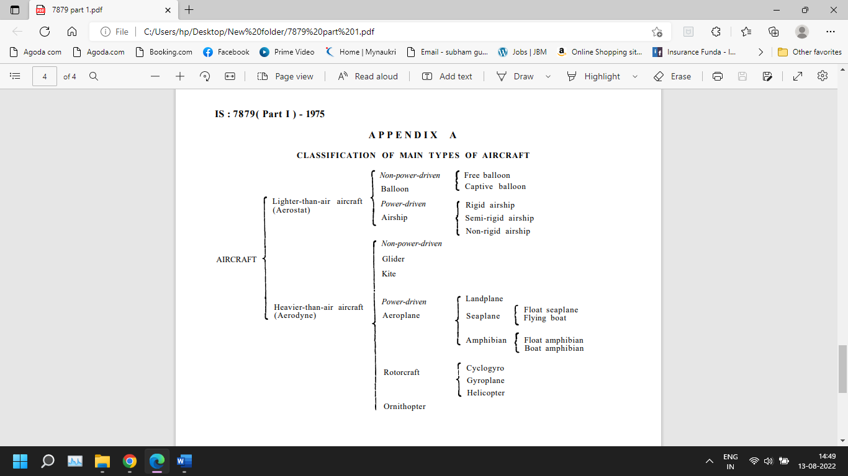

**ANNEX B**

(*Foreword*)

**COMMITTEE COMPOSITION**

AIR AND SPACE VEHICLES SECTIONAL COMMITTEE SECTIONAL COMMITTEE, TED 14

| *Organization* | *Representative(s)* |
| --- | --- |
| Indian National Space Promotion and Authorisation Centre (IN-SPACe), Ahmedabad | Shri. Rajeev jyoti(*Chairman*) |
| Aeronautical Development Agency, Bengaluru | Shri D K P Sinha  Shri Rammohan V Kaki (*Alternate*) |
| Airbus Group India Private limited, Bengaluru | Shri George Suraj DSA |
| Airports Authority of India, New Delhi | Shri D Dilip Kumar |
| CSIR - National Aerospace Laboratories, Bengaluru | Shri Shri Thennavarajan S |
| Department of Defence Production, Ministry of Defence, New Delhi | Shri Arindam Chaudhary |
| Directorate General of Aeronautical Quality Assurance, Ministry of Defence, New Delhi | Shri Sanjay Kumar Sharma  Shri Mukesh Chand Meena (*Alternate*) |
| Directorate of Naval Air Material, Ministry of Defence | Shri Abhijat Phand |
| Gas Turbine Research Establishment, Bengaluru | Shri D Nagaraju |
| Hindustan Aeronautics Limited, Bengaluru | Shri Pratap Panda  Shri Sushil Kumar (*Alternate*) |
| Indian Institute of Technology Ropar, Punjab | Shri Dhiraj Kumar Mahajan |
| Indian National Space Promotion and Authorisation Centre (IN-SPACe), Ahmedabad | Shri Paragjyoti Garg |
| Indian Space Research Organization - U R Rao Satellite Centre, Bengaluru | Shri Raghavendra Kulkarni  Shri Rayan Kutty P P (*Alternate*) |
| Indian Space Research Organization - Vikram Sarabhai Space Centre, Thiruvananthapuram | Shri P. Ramkumar  Shri Jayakumar M  Shri Govind (*Alternate*) |
| Indian Space Research Organization, Bengaluru | Dr. A K Anil Kumar  Shri Manish Saxena (*Alternate*) |
| In personal capacity | Shri A V Joshi |
| In personal capacity | Shri S C Shrimali |
| BIS Directorate General | Shri A.P.D Dwivedi, Scientist ‘F’ & Head (TED)  [Representing Director General (Ex-officio)] |

Member Secretary

Mr. Ravindra Beniwal

Scientist D / Joint Director

(Transport Engineering Department)