**DRAFT** **AMENDMENT NO. 2**

**TO**

**IS 16192 (PART 3): 2018 AUTOMOTIVE VEHICLES — WHEEL RIMS FOR TWO AND THREE WHEELED VEHICLES**

PART 3 SPOKE WHEEL RIMS — METHODS OF TESTS AND REQUIREMENTS

[*First cover page*, *Title,* (*see* also Amendment no. 1)] — Substitute the following for the existing:

‘*भारतीय मानक*

**स्वचल वाहन — दो और तीन पहिए वाले वाहनों के लिए व्हील रिम**

**भाग 3 तार तीली व्हील रिम — परीक्षण पद्धतियाँ और अपेक्षाए**

*Indian standard*

# Automotive Vehicles — Wheel Rims for Two and Three Wheeled Vehicles

## Part 3 Wired Spoke Wheel Rims — Method of Tests and Requirements’

(*Foreword, Para* **1**) — Insert the following after Para 1:

Load and deflection value for various sizes is specified under clause **4.2** of this standard. Due to unavailability of data, for other sizes, load and deflection values are not defined. To provide a provision for manufacturing and certification of other sizes, a clause has been added for declaration by manufacturer. These load and deflection value should be declared by manufacturer in agreement with vehicle manufacturer, and it shall be the responsibility of manufacturer to declare values which provide adequate safety to the wheel.

(*Foreword, Para***3**) — Substitute the following for Para 3:

In the preparation of this standard, considerable assistance has been derived from the following standards:

|  |  |
| --- | --- |
| AIS – 073 (Part 3) | Automotive Vehicles — Wheel rims for two and three wheeled vehicles — Spoke wheel rims — Method of tests and requirements |
| JIS D4215 : 1995 | Rims for motorcycles issued by the Japanese Industrial Standards (JIS) |
| ISO 4249 Part 3: 2010 | Motorcycle tyres and rims (code-designated series) — Part 3: Rims |

(*Page* 1, *Title*) — Substitute the following for the existing title:

*‘Indian standard*

**Automotive Vehicles — Wheel Rims for Two and Three Wheeled Vehicles**

Part 3 Wired Spoke Wheel Rims — Methods of Tests and Requirements’

(*Page* 1, *clause* 1) — Substitute the following for the existing:

**‘1 SCOPE**

This Standard prescribes the general and performance requirements of wired spoke wheel rims intended for use on Two wheelers (L1 and L2 category of vehicles as defined in IS 14272), three wheelers (L5 category of vehicles as defined in IS 14272), E-rickshaws and E-carts.’

(*Page* 1, *clause* **4.2**) — Substitute the following for the existing:

**‘4.2 Strength Requirements**

**4.2.1** *Load Applying Method*

Place the rim vertically on the base having a plane of not smaller than a horizontal rim width and add the load gradually, as per Fig. 1 to the rim, toward the direction of vertical centre of rim from the most outside circumference part of rim.

**4.2.2** *Requirements*

**4.2.2.1** When the deflection of wheel rims (without wired spokes) has attained a value given in Table 1 by applying a load by the method given in Fig. 1 to the rim, the load shall not be smaller than the value given in Table 2 and in addition, the rim shall be free from cracks.

**4.2.2.2** For the sizes not available in Table 1 and Table 2,when the deflection of wheel rims (without wired spokes) has attained a value as declared by wheel rim manufacturer, applying a load by the method given **4.2.1** to the rim, the load shall not be smaller than the value declared by wheel rim manufacturer and in addition, the rim shall be free from cracks.

NOTE— For wheel rims sizes (width and diameter) not mentioned in IS standards, ISO standards, Manuals of *European Tyre and Rim Technical Organization* (ETRTO), *Indian Tyre Technical Advisory Committee* (ITTAC), *Japan Automobile Tyre Manufacturers Association* (JATMA), and *The Tire & Rim Association* (T & RA) Book, wheel manufacturer shall submit a declaration from vehicle manufacturer (OEM) certifying application of such wheel rims in their vehicle. However, such declaration shall not be required, if for any such sizes, certificate (for regulatory requirement) has been granted to any manufacturer based on OEM declaration.’

**Table 1 Amount of Deflection**

(*Clauses* 4.2.2.1 and 4.2.2.2)

|  |  |  |  |
| --- | --- | --- | --- |
| **Nominal Rim Width Code** | **Nominal Rim Diameter Code** | | |
| 15 *Max*. | 16,17,18 | 19 *Min*. |
| 1. 10 to 2.75 and MT 1.85 to MT 6.0 | 10 mm | 15 mm | 20 mm |

**Table 2 Load**

(*Clause* 4.2)

|  |  |  |  |
| --- | --- | --- | --- |
| **SI. No**. | **Nominal Rim Width** | | **Load**  **kN (kgf)** |
| (1) | (2) | (3) | (4) |
| i | 1.10 | — | 0.98(100) |
| ii) | 1.20 | — | 1.47 (150) |
| iii) | 1.40 | — | 1.96 (200) |
| iv) | 1.50 | — | 2.45 (250) |
| v) | 1.60 | — | 3.43 (350) |
| vi) | 1.85 | MT 1.85 | 4.41(450) |
| vii) | 2.15 | MT 2.15 | 4.90 (500) |
| viii) | 2.50 | MT 2.50 | 6.37 (650) |
| ix) | 2.75 | MT 2.75 | 6.37 (650) |
| x) | — | MT 3.00 | 6.37 (650) |
| xi) | — | MT 3.50 | 6.37 (650) |
| xii) | — | MT 4.00 | 6.37 (650) |
| xiii) | — | MT 4.50 | 6.37 (650) |
| xiv) | — | MT 5.00 | 6.37 (650) |
| xv) | — | MT 5.50 | 6.37 (650) |
| xvi) | — | MT 6.00 | 6.37 (650) |

NOTE— Rim width under column 2 is for cylindrical bead seat rim contour, and under column 3 is for tapered bead seat rim contour.

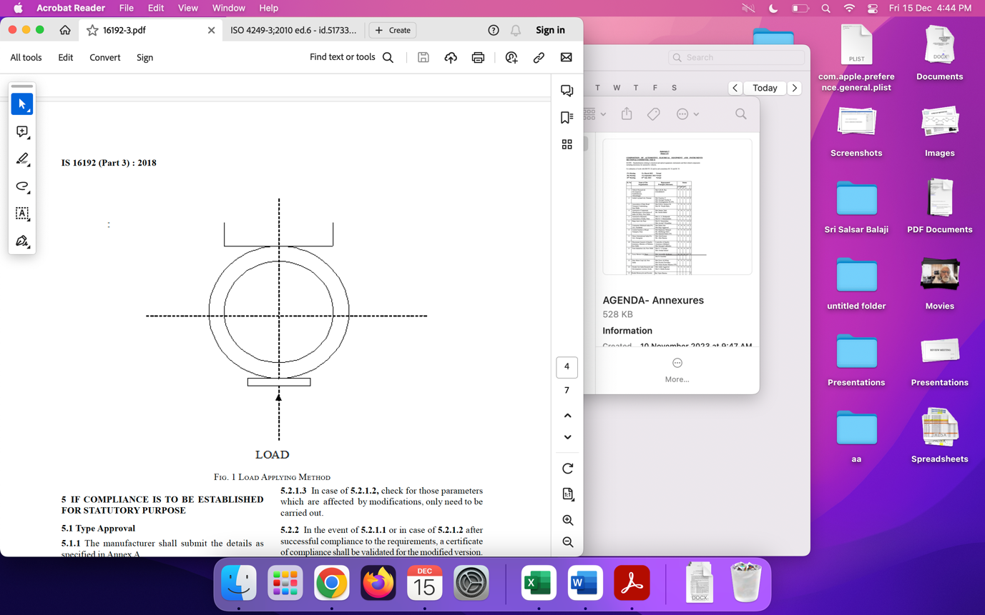

FIG. 1 LOAD APPLYING METHOD

(*Page* 2, *clause* **4**) — Insert the following after *clause* **4** and renumber the subsequent clauses:

**5 RIM CONTOUR**

**5.1 Cylindrical Bead Seat**

A rim contour for cylindrical bead seat rim is given at Fig. 2.

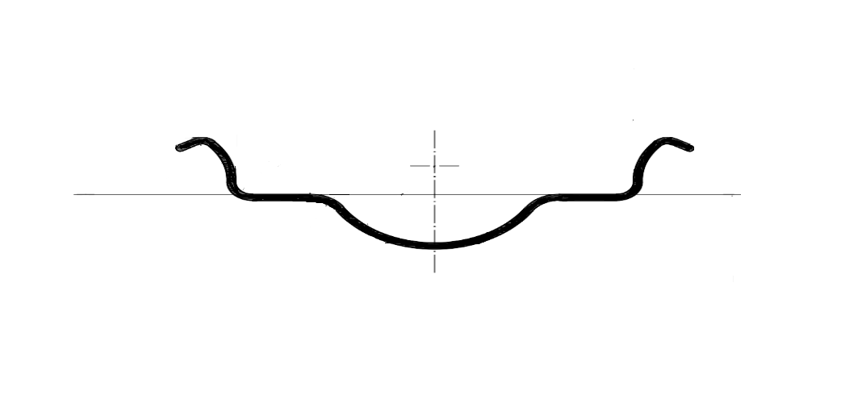

FIG. 2 — CYLINDRICAL BEAD SEAT RIM CONTOURS

**5.2 Tapered Bead Seat Rims (MT Type)**

**5.2.1** Rim contour for Tapered bead seat rim with hump is given in Fig. 3, rim contour for Tapered bead seat rim with hump and well contour is given in Fig. 4, and rim contour for Tapered bead seat rim without hump is given at Fig. 5.

**5.2.2** Rims without hump shall only be used with tyres for tube type application.

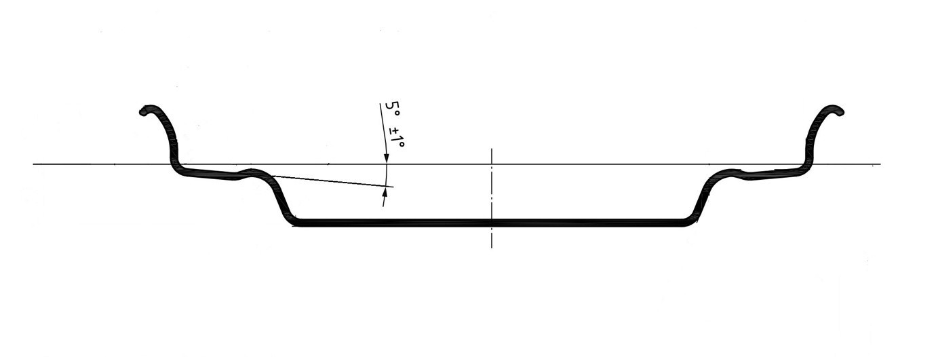

FIG. 3 — 5° TAPERED BEAD SEAT RIM CONTOURS (MT TYPE)

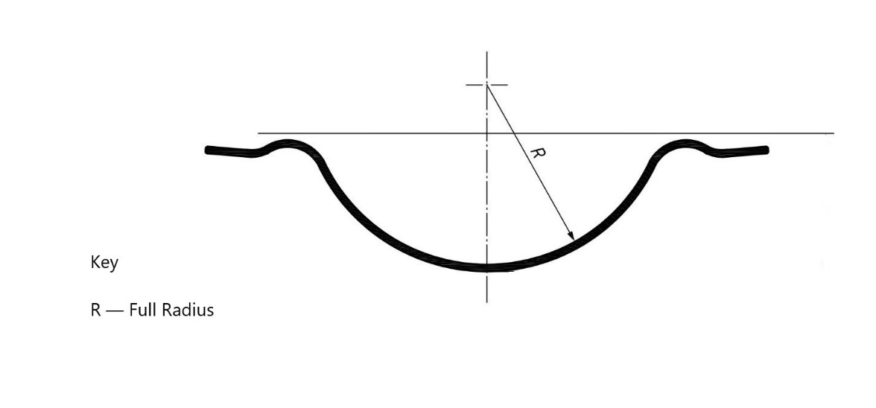

FIG. 4 — WELL CONTOUR — OPTION 1

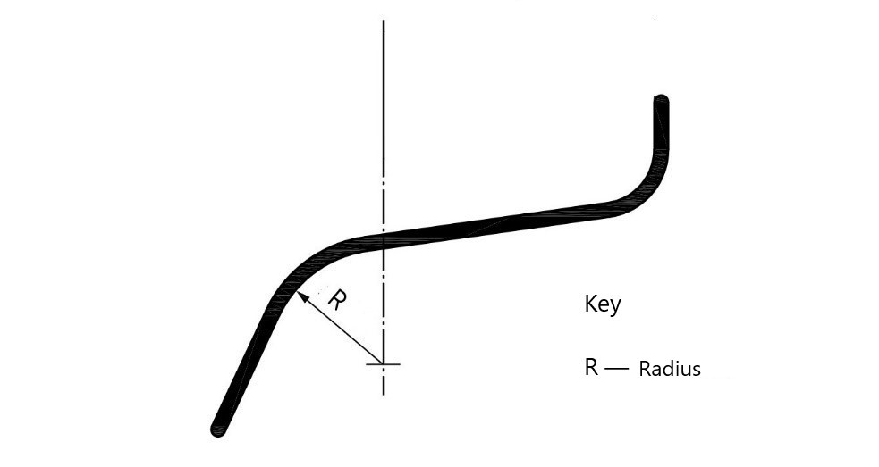

FIG. 5 — TAPERED BEAD SEAT CONTOURS FOR RIMS WITHOUT HUMP

*(Page* 3, *Annex* A) — Substitute ‘(*clause* **6.1.1**)’ for ‘(*clause* **5.1.1**)’.

*(Page* 3, *Annex* A) — Insert the following after Sl. No. 14

15. Declaration by Vehicle Manufacturer (OEM), if applicable (*clause* **4.2.2.2**).

16. Vehicle Models, in which wheel rims shall be used.

(TED 07)

_________________________________

Publication Unit, BIS, New Delhi, India