**TED 26 (18377) F**

***भारतीय मानक***

***Indian Standard***

**IS 15719: 2024**

**सड़क वाहन ─ संपीड़ित प्राकृतिक गैस (सीएनजी)/जैव-संपीड़ित प्राकृतिक गैस (जैव-सीएनजी)/ द्रवित पेट्रोलियम गैस (एलपीजी) ─ ईंधन प्रणाली के घटक ─ इलेक्ट्रिकल वायरिंग किट**

(*पहला पुनरीक्षण*)

**ROAD VEHICLES — COMPRESSED NATURAL GAS (CNG) / BIO- COMPRESSED NATURAL GAS (BIO- CNG) / LIQUEFIED PETROLEUM GAS (LPG) — FUEL SYSTEM COMPONENTS — ELECTRICAL WIRING KIT**

**(***First Revision***)**

W

ICS 43.060.40

© BIS 2024

भारतीय मानक ब्यूरो

BUREAU OF INDIAN STANDARDS

मानक भवन, 9 बहादुर शाह ज़फर मार्ग, नई दिल्ली 110002

MANAK BHAVAN, 9 BAHADUR SHAH ZAFAR MARG

NEW DELHI 110002

[www.bis.gov.in](http://www.bis.org.in) [www.standardsbis.in](http://www.standardsbis.in)

**JUNE 2024 Price Group**

Automotive Vehicles Running on Non-Conventional Energy Sources Sectional Committee, TED 26

FOREWORD

This Indian Standard (*First Revision*) was adopted by the Bureau of Indian Standards, after the draft finalized by the Automotive Vehicles Running on Non-conventional Energy Sources Sectional Committee had been approved by the Transport Engineering Division Council.

This standard was first published in 2006 to specify definitions, test methods and requirements of electrical wiring kit of CNG onboard fuel system components, intended for use on motor vehicles defined in IS 14272. In this Revision, Bio- CNG is added to the scope of this standard keeping in view the technological advancements that have taken place since its last Publication. The revised version also incorporates the Amendments issued to the standard.

In the formulation of this standard considerable assistance has been derived from the following AIS Standards issued by the Automotive Research Association of India:

AIS 024(Rev.1) (Part A):- Safety and Procedural Requirements for Type Approval of Gaseous Fuelled Vehicles - Part A (Automotive Application).

AIS 024(Rev.1) (Part B):- Safety and Procedural Requirements for Type Approval of Gaseous Fuel Agricultural Tractors - Part B (Agricultural Tractors Application).

AIS 024(Rev.1) (Part C):- Safety and Procedural Requirements for Type Approval of Gaseous Fuel Vehicles - Part C (CEV’s Application).

AIS-025 (Version 3): Safety and Procedural requirements for Type Approval of LPG Operated Vehicles

AIS 026 (Version 3): Code of Practice for use of LPG Fuel in Internal Combustion Engine to Power 4 Wheeled Vehicles and heavy motor vehicles

AIS 027 (Version 3): Code of Practice for use of LPG Fuel in Internal Combustion Engine to Power 2 and 3 Wheeled Vehicles.

AIS 028(Rev.1) (Part A):-Code of Practice for Use of Gaseous Fuels in Internal Combustion Engine Vehicles - Part A (Automotive Application)

AIS 028(Rev.1) (Part B):-Code of Practice for Use of Gaseous Fuels in Internal Combustion Engine Agricultural Tractors - Part B (Agricultural Tractors Application)

AIS 028(Rev.1) (Part C):-Code of Practice for Use of Gaseous Fuels in Internal Combustion Engine Construction Equipment Vehicles (CEV’s) - Part C (CEV’s Application).

JIS C 3406: 1993 — Low voltage cables for automobiles

This standard is one of the series of Indian Standards published on CNG/Bio-CNG/LPG onboard fuel system components. Other standards in the series are:

*IS No. Title*

15710: 2024 Road vehicles - Compressed natural gas (CNG) /Bio-Compressed   
 natural gas (Bio-CNG) fuel system components – General   
 requirements & definition.

15711: 2024 Road vehicles - Compressed natural gas (CNG) /Bio-Compressed   
 natural gas (Bio-CNG) fuel system components –Performance and   
 general test methods

15712: 2024 Road vehicles - Compressed natural gas (CNG) /Bio-Compressed   
 natural gas (Bio-CNG) fuel system components – Automatic valve

15713: 2024 Road vehicles - Compressed natural gas (CNG) /Bio-Compressed   
 natural gas (Bio-CNG) fuel system components–Pressure regulator

15714: 2024 Road vehicles - Compressed natural gas (CNG) /Bio-Compressed   
 natural gas (Bio-CNG) fuel system components – Gas Air mixer

15715: 2024 Road vehicles - Compressed natural gas (CNG) /Bio-Compressed   
 natural gas (Bio-CNG) / Liquefied Petroleum Gas (LPG) Fuel   
 system components – CNG/Bio-CNG/LPG Conduit (Ventilation   
 Hose/Pipe)

15716: 2024 Road vehicles - Compressed natural gas (CNG) /Bio-Compressed   
 natural gas (Bio-CNG) fuel system components –CNG / Bio-CNG   
 high pressure fuel line (rigid) with end connections (having   
 pressure exceeding 2.15 MPa)

15717: 2024 Road vehicles - Compressed natural gas (CNG) /Bio-Compressed   
 natural gas (Bio-CNG) / Liquefied Petroleum Gas (LPG) Fuel   
 system components – Petrol valve (Automatic/Manual)

15718: 2024 Road vehicles - Compressed natural gas (CNG) /Bio-Compressed   
 natural gas (Bio-CNG) fuel system components – CNG/Bio-CNG   
 high Pressure fuel line(flexible hose)with end connections (having   
 pressure exceeding 2.15 MPa)

15720: 2024 Road vehicles - Compressed natural gas (CNG) /Bio-Compressed   
 natural gas (Bio-CNG) /Liquefied Petroleum Gas (LPG) fuel   
 system component – Compartments sub- Compartments

15721: 2024 Road vehicles - Compressed natural gas (CNG) / Bio-Compressed   
 natural gas (Bio-CNG)/ Liquefied Petroleum Gas (LPG) fuel   
 system components – Fire retardant material for seat, upholstery,   
 roof and side lining

15722: 2024 Road vehicles - Compressed natural gas (CNG) / Bio-Compressed   
 natural gas (Bio-CNG) fuel system components - CNG /Bio-CNG   
 flexible fuel line with or without end connections(having pressure   
 not exceeding 2.15 MPa)

15723: 2024 Road vehicles - Compressed natural gas (CNG) /Bio-Compressed   
 natural gas (Bio-CNG) /Liquefied Petroleum Gas (LPG) fuel   
 system components – Current Limiting devices

The composition of the Committee responsible for the formulation of this standard is given at Annex A.

For the purpose of deciding whether a particular requirement of this standard is complied with, the final value, observed or calculated, expressing the result of test or analysis, shall be rounded off in accordance with IS 2: 2022 ‘Rules for rounding off numerical values (*Second Revision*)’. The number of significant places retained in the rounded off value should be the same as that of the specified value in this standard.

*Indian Standard*

**ROAD VEHICLES — COMPRESSED NATURAL GAS (CNG) / BIO- COMPRESSED NATURAL GAS (BIO- CNG) / LIQUEFIED PETROLEUM GAS (LPG) — FUEL SYSTEM COMPONENTS — ELECTRICAL WIRING KIT**

(*First Revision*)

# SCOPE

## This standard specifies definitions, test methods and requirements of electrical wiring kit of CNG / Bio- CNG/ LPG onboard fuel system components, intended for use on motor vehicles defined in IS 14272.

### This standard is applicable to CNG / Bio- CNG/LPG fuel system components intended to be used on vehicles using compressed natural gas / Bio- compressed natural gas/Liquefied petroleum gas in accordance with IS 15320 Part 1 (mono-fuel or bi-fuel applications or dual fuel applications).

### This standard is not applicable to the following:

1. Liquefied natural gas (LNG) fuel system components located upstream of, and including, the vaporizer;
2. Fuel containers;
3. Stationary gas engines;
4. CNG / Bio- CNG/LPG fuel systems components for the propulsion of marine craft; and
5. Hydrogen Natural Gas Blend (HCNG) Fuel system components

# REFERENCES

The following standards contain provisions which, through reference in this text, constitute provisions of this standard. At the time of publication the editions indicated were valid. All standards are subject to revision and parties to agreements based on this standard are encouraged to investigate the possibility of applying the most recent editions of the standards indicated below:

|  |  |
| --- | --- |
| *IS No.* | *Title* |
| 2465: 1984 | Specification for cables for motor vehicles (Second Revision) |
| 10810 (Part 5): 1984 | Methods of test for cables: Conductor resistance test |
| 10810 (Part 44): 1984 | Methods of test for cables: Spark test |
| IS 14272: 2011 | Automotive Vehicles – Types – Terminology |
| 15710: 2024 | Road vehicles - Compressed Natural Gas (CNG) / Bio- Compressed Natural Gas (Bio-CNG) fuel system components – General requirements and definitions |

# DEFINITIONS

For the purpose of this standard definitions given in IS 15710 shall apply.

# REQUIREMENTS OF ELECTRICAL WIRING KIT:

## General

All wiring shall be properly installed, taped, clipped or contained in a loom along its length.

## Conductor Resistance Test

The wiring cables for motor vehicles when tested as per **13** of IS 10810 (Part 5) for conductor resistance test shall comply with the requirements specified in Table 1.

**Table 1 Conductor Resistance of Cables**

(*Clause* 4.2)

|  |  |  |
| --- | --- | --- |
| **Sl. No.** | **Nominal Sectional Area (mm2)** | **Conductor Resistance (20°C) Ω/m, Max** |
| i) | 0.5 f1) | 0.0369 |
| ii) | 0.5 | 0.0327 |
| iii) | 0.75 f1) | 0.0244 |
| iv) | 0.85 | 0.0208 |
| v) | 1.25 f1) | 0.0147 |
| vi) | 1.25 | 0.0143 |
| vii) | 2 | 0.00881 |
| viii) | 3 | 0.00559 |
| ix) | 5 | 0.00352 |
| x) | 8 | 0.00232 |
| xi) | 15 | 0.00138 |
| xii) | 20 | 0.000887 |
| xiii) | 30 | 0.000520 |
| xiv) | 40 | 0.000428 |
| xv) | 50 | 0.000337 |
| xvi) | 60 | 0.000287 |
| xvii) | 85 | 0.000215 |
| xviii) | 100 | 0.000168 |

NOTE — Superscript ‘1)’ indicates ‘f in nominal sectional area indicates flexible’.

## Spark Test

### The cable when tested for spark test as per IS 10810 (Part 44) shall withstand 5000 V for 0.15s or more.

### Immersion Test

For the immersion test the following procedure shall be followed:

A test specimen about 600 mm in length shall be taken for the immersion test from a lot of cable which has passed the spark test. The insulator at both the ends for a length of about 25 mm of the specimen shall be torn off and the bare conductor twisted and as shown in Fig. 1, the central part of the specimen for a length of 300 mm shall be immersed in 5 percent salt solution.

After immersion for 5 min, an ac voltage of 50 to 60 Hz cycles/sec and nearly sinusoidal wave shall be applied between the conductor and earth. The voltage shall be gradually increased up to 1000 V and cable shall withstand this voltage for 1 min.

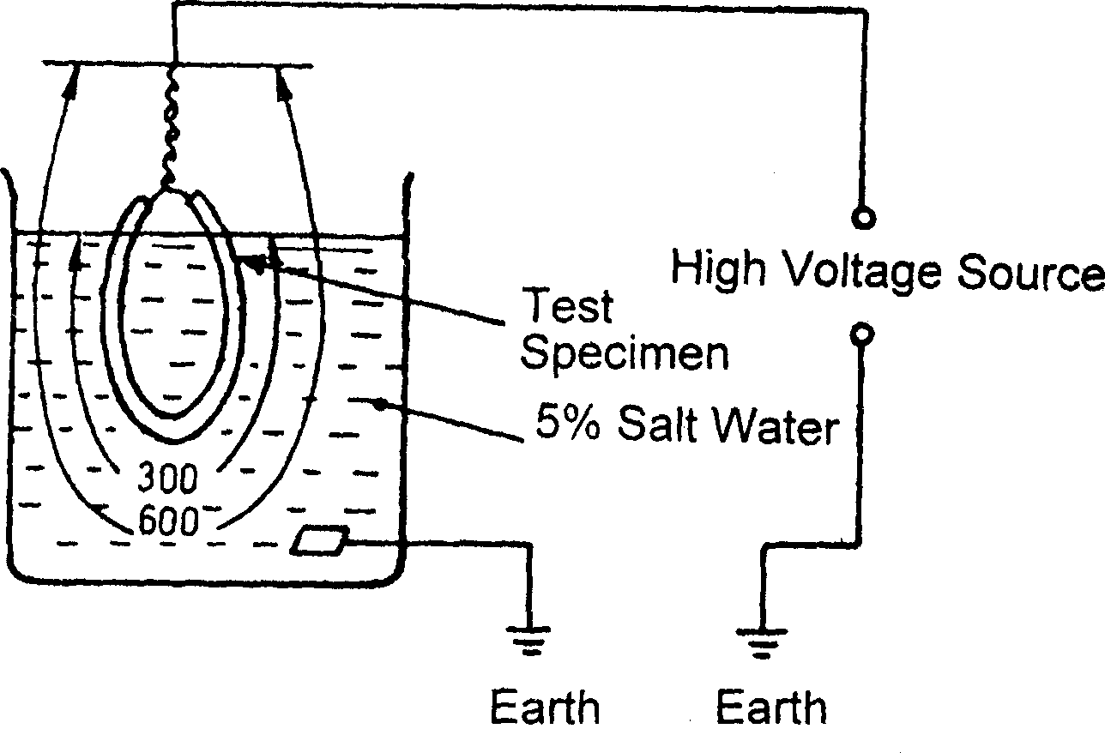

# All Dimension In Millimetres.

# Fig.1 Immersion Test Plan

## Flammability Test

The fire-retardant material of the electrical wiring when tested as per **13** of IS 2465 shall conform to **22** of IS 2465.

# MARKING

## Each Electrical wiring kit shall be legibly and indelibly marked with the following:

1. Manufacturer’s name or trade-mark or symbol;
2. Part No. or unique identification mark; and
3. Date of manufacturer or Batch No.

## BIS Certification Marking

Each wiring kit for CNG / Bio-CNG/LPG vehicles may also be marked with the Standard Mark.

### The use of the Standard Mark is governed by the provisions of the *Bureau of Indian Standard is Act*, 2016 and the Rules and Regulations made thereunder. The details of conditions under which the licence for the use of the Standard Mark may be granted to manufacturers or producers may be obtained from the Bureau of Indian Standards,

# TECHNICAL INFORMATION TO BE SUBMITTED BY THE COMPONENT MANUFACTURER:

Technical information to be submitted by the component manufacturer for component type approval/ type test shall contain at least following information:

1. Name of the manufacturer of the wiring kit;
2. Wiring kit manufacturing plant address;
3. Part number of wiring kit (as allotted by the manufacturer]
4. Batch number;
5. Identification code number (allotted by the supplier/trader, if any);
6. Details of the vehicles for which the wiring kit is intended for use such as 2W, 3W, 4W goods/passenger, HCV/LCV/CEV/ AT, etc.;
7. Make and model of the vehicle for which the wiring kit is intended for use;
8. Name of the manufacturer of the wires used in the wiring kit;
9. Wire manufacturing plant address;
10. Name of the material of the conductor and wire insulation;
11. Manufacturing date and batch number of the wires; and
12. Drawings with relevant dimensions.

# NUMBER OF SAMPLES FOR TESTING

Minimum one electrical wiring kit sample shall be submitted to the test agency for testing. In case any wire in the kit is less than 2 m long then manufacturer shall submit additional sample of the same wire 2 m in length, declaring it as a representative sample.

# TYPE TEST (TYPE APPROVAL)

Electrical wiring kit shall meet the requirements of this standard for type approval.

# ACCEPTANCE TEST (CONFORMITY OF PRODUCTION)

Electrical wiring kit approved under this standard shall be so manufactured as to conform test requirements as specified in **4**.

# CHANGES IN TECHNICAL SPECIFICATIONS OF A TYPE APPROVED COMPONENT AND EXTENSION OF APPROVAL

Any modification in technical specification of already type approved component shall require re-type test/extension of approval at the discretion of certification authority, based on the justification provided by the component manufacturer and reviewed by the certification authority which has granted type approval.

1. (Foreword)

**COMMITTEE COMPOSITION**

|  |  |
| --- | --- |
| ***Organization*** | ***Representative(s)*** |
| Automotive Research Association of India (ARAI) | Dr S. S. Thipse (***Chairperson***)  Shri A D Dekate |
| Ashok Leyland Ltd. | Ms. Suchismita C.  Shri Muthukumar N (*Alternate*) |
| Automotive Component Manufactures Association of India (ACMA) | Shri Sanjay Tank  Ms. Seema Babal (*Alternate*) |
| A B Process Technologies | Shri Kunal Chopde |
| Bajaj Auto Ltd., Pune | Shri Milind J. Pagare  Shri Arvind V. Kumbhar (*Alternate*) Shri Abhay Kumar (*Young Professional*) |
| Bosch Limited, Bengaluru | Shri Bharadwaj M. Krishnamurthy  Shri Vikram K (*Alternate*) |
| Central Institute of Road Transport, Pune | Shri Samir Sattigeri   Shri V. V. Joshi (*Alternate*) |
| Central Pollution Control Board | Shri A Sudhakar  Shri Suneel Dave (*Alternate*)  Shri Kedarnath Dash (*Alternate-II*) |
| CLH Gaseous Fuel Applications Ltd, Gurgaon | Shri Shishir Agrawal  Shri Gagan Agrawal (*Alternate*) |
| Delhi Transport Corporation | Shri Vikas Batra |
| GAIL (India) Limited, New Delhi | Shri Ashish Kumar Mittal  Shri Lokesh Mehta (*Alternate*) |
| Indian Auto LPG Coalition, Faridabad | Shri Shishir Agrawal  Shri Suyash Gupta (*Alternate*) |
| Indian Institute of Petroleum, Dehradun | Shri Wittison Kamei  Shri Robindro Lairenlakpam (*Alternate*) |
| Indian Institute of Science, Bengaluru | Prof. R.V. Ravikrishna |
| Indian Institute of Technology Ropar, Punjab | Shri Dhiraj Kumar Mahajan  Dr. Debaprasad Mandal (*Alternate*) |
| Indian Oil Corporation Ltd., (R & D Centre), Faridabad | Dr. M Sithananthan (*Alternate*) |
| Indian Rubber Mfrs. Research Association, Thane, Mumbai | Dr. K Raj Kumar  Dr. Bharat Kapgate (*Alternate*) |
| International Centre for Automotive Technology (ICAT) | Shri Vaibhav Prashant Yadav  Shri Vijayanta Ahuja (*Alternate*) |
| Mahindra & Mahindra Ltd., Mumbai | Shri Rajamani Parthiban  Shri Shailesh Kulkarni (*Alternate*) |
| Mahindra & Mahindra Ltd. (Truck and Bus Division) | Shri V G Kulkarni (*Alternate*) |
| Maruti Suzuki India Limited, Gurgaon | Shri Gururaj Ravi  Shri Arun Kumar (*Alternate*)  Shri Rajesh Kumar (*Young Professional*) |
| Minda Emer TechnologiesLimited, Gurgaon | Shri Vivek Jain  Shri Bibhuti Kumar (*Alternate*) |
| Ministry of New and Renewable Energy, NewDelhi | Shri Dipesh Pherwani |
| Petroleum and Explosive Safety Organization,  Nagpur | Shri D K Gupta  Shri Vivek Kumar (*Alternate*) |
| Petronet LNG Ltd. New Delhi | Shri Pankaj Wadhwa (*Alternate*) |
| Prodair Air Products India Private Ltd., Pune | Shri Ravi Subramanian  Shri Arun Kuruvangattil (*Alternate*) |
| Renault India Private Limited,Mumbai | Shri Rajendra Khile  Shri Vijay Dinakaran (*Alternate*)  Shri Jebin Jowhar (*Young Professional*) |
| Rohan BRC Gas Equipment Pvt. Ltd, Ahmedabad | Shri Stefano De Carolis  Shri Parthiv Shukla (*Alternate*) |
| Society of Indian Automobile Manufacturers, New Delhi | Shri P K Banerjee  Dr. Sandeep Garg (*Alternate*) |
| Swagelok – Bombay Fluid System components Pvt. Ltd. | Shri Sachin Koulgi  Shri Harish Takke (*Alternate*) |
| Tata Motors Ltd. | Shri P. S. Gowrishankar  Shri Shailendra Dewangan (*Alternate*) |
| TVS Motor Company Ltd, Hosur | Shri V Pattabiraman  Shri K M Srikanth (*Alternate*) |
| Vanaz Engineers Ltd. Pune | Shri S J Vispute  Shri J S Dhumal (*Alternate*) |
| Volkswagen India Pvt. Ltd. | Shri Joreg Bouzek  Shri Pankaj Gupta (*Alternate*) |
| BIS Directorate General | Shri Deepak Agarwal, Scientist ‘F’/ senior director and head (transport engineering) [representing director general (ex-officio)] |

Member Secretary

Shri Gaurav Jayaswal

Scientist ‘C’ / Deputy Director

(transport engineering), BIS