**IS 417 : XXXX**

***भारतीय मानक***

***Indian Standard***

**(Superseding**

**IS 417 (Part 1),**

**IS 417 (Part 2),**

**IS 417 (Part 3),**

**IS 417 (Part 4),**

**IS 417 (Part 5),**

**IS 417 (Part 6),**

**IS 11729)**

***हवा वाली गेंदे — विशिष्टि***

**Inflatable Balls — Specification**

ICS 97.220.40; 97.220.30

© BIS 2024



भारतीय मानक ब्यूरो

BUREAU OF INDIAN STANDARDS

मानक भवन, 9 बहादुर शाह ज़फर मार्ग, नई दिल्ली - 110002

MANAK BHAVAN, 9 BAHADUR SHAH ZAFAR MARG

NEW DELHI - 110002

[www.bis.gov.in](http://www.bis.org.in) [www.standardsbis.in](http://www.standardsbis.in)

**December 2024 Price Group**

Sports Goods Sectional Committee, PGD 41

FOREWORD

This Indian Standard was adopted by the Bureau of Indian Standards, after the draft finalized by the Sports Goods Sectional Committee had been approved by the Production and General Engineering Division Council.

Football, volleyball, basketball, netball, throwball, water polo balls, and handball are specialized spherical objects designed for their respective sports. Each ball is manufactured to meet the unique demands of its sport, enabling players to perform at their best. Inflatable balls were earlier covered under following different Indian Standards which have been now amalgamated into single standard:

1. IS 417 (Part 1) : 2003 Footballs, volleyballs, basketballs, netballs, throwballs and water - Polo balls - Specification: Part 1 footballs (*fourth revision*)
2. IS 417 (Part 2) : 1986 Specification for footballs, volleyballs, basketballs, netballs, throwballs and water - Polo balls: Part 2 volleyballs (*fourth revision*)
3. IS 417 (Part 3) : 1986 Specification for footballs, volleyballs, basketballs, netballs, throwballs and water - Polo balls: Part 3 basketballs (*fourth revision*)
4. IS 417 (Part 4) : 1976 Specification for footballs, volleyballs, basketballs, netballs, throwballs and water - Polo balls - Part 4 : netballs (*third revision*)
5. IS 417 (Part 5) : 1976 Specification for footballs, volleyballs, basketballs, netballs, throwballs, and water - Polo balls - Part 5 : throwballs (*third revision*)
6. IS 417 (Part 6) : 1976 Specification for footballs, volleyballs, basketballs, netballs, throwballs and water - Polo balls - Part 6 : water - Polo balls (*third revision*)
7. IS 11729 : 1986 Specification for handballs

The composition of the Committee, responsible for the formulation of this standard is given in Annex D.

For the purpose of deciding whether a particular requirement of this standard is complied with, the final value, observed or calculated, expressing the result of a test or analysis, shall be rounded off in accordance with IS 2 : 2022 ‘Rules for rounding off numerical values (*second revision*). The number of significant places retained in the rounded off value should be the same as that of the specified value in this standard.

*Indian Standard*

**INFLATABLE BALLS — SPECIFICATION**

**1 SCOPE**

This standard specifies the requirements for indoor and outdoor footballs, volleyballs, basketballs, netball, throwballs, water-polo ball and handball.

**2 TERMINOLOGY**

**2.1 Linear Variable Differential Transfer (LVDT)** - It is an electromechanical sensor used to convert mechanical motion like rectilinear motion, into a variable electrical current, voltage or electric signals, and the reverse.

**2.2 Stem** -The bottom portion of LVDT, which rest on the ball while taking measurement.

**2.3 Setting Block** - Gauge used for setting the initial position of LVDT.

**2.4 Indoor Balls** - These balls are meant for playing indoor games.

**2.5 Outdoor Balls** -These balls are meant for playing outdoor games.

**3 CLASSIFICATION**

**3.1** Inflatable balls are classified into following four different levels based on the level of playing as given below:

1. Level 1 — Recommended for match level games.
2. Level 2 — Recommended for training level games.
3. Level 3 — Recommended for beginner level games.
4. Level 4 — Recommended for recreation level games.

**3.2** Handballs are classified into following categories based on the sizes of ball:

a) Size 3 — Recommended for men.

b) Size 2 — Recommended for women.

c) Size 1 — Recommended for juniors.

**3.3** Different types of inflatable balls are further classified into different sizes based on their uses. Different levels and different sizes of balls shall conform to the requirements listed in Table 1 to Table 8.

**4 REQUIREMENTS**

**4.1 Materials**

**4.1.1** *Top Layer*

Top layer of ball shall be made of rubber, synthetic materials, polyurethane (PU), synthetic leather, natural leather, thermoplastic polyurethane (TPU), polyvinyl chloride (PVC) or any other suitable material.

**4.1.2** *Bladder*

Bladder shall be made of natural latex, synthetic latex, natural rubber, synthetic rubber or a combination of any of these.

**4.1.3** *Prints and Cosmetics*

Non-toxic inks, pigments or solvents shall be used.

**4.1.4** *Stitching/Winding Thread*

Thread shall be made of polyester, cotton, nylon, or mix thread. Thread shall consist of 1 to 8 ply.

**4.1.5** *Glue*

Any form of bonded latex, water based or solvent based adhesives shall be used.

**4.2 Surface Texture**

The surface of the inflatable ball shall have smooth, grained, dimpled, or shiny texture.

**4.3 Weight**

Weight of different levels and different sizes of inflatable balls shall conform to the values specified in Table 1 to Table 8.

**5 MANUFACTURING AND WORKMANSHIP**

**5.1** Inflatable ballscan be manufactured from any of the following construction methods:

a) Moulded,

b) Hand-stitched,

c) Machine-stitched, and

d) Laminated.

**5.1.1** The ball shall be made from suitable number of panels of shapes capable of giving roundness. It is recommended to have minimum 6 number of panels and maximum 32 number of panels except for basketball. It is recommended to have minimum 8 number of panels and maximum 18 number of panels for basketball.

**5.2 Mouth**

The mouth shall be adequate and permit the nozzle of the inflating pump or needle to be accommodated and suitable means shall be provided to deflate the ball.

**6 PERFORMANCE TEST**

**6.1 Rebound Test**

This test is only applicable for indoor football, outdoor football, volleyball, and basketball. The ball shall be tested according to the method prescribed in Annex A. The value of rebound for different types of inflatable balls shall conform to the values as given in from Table 1 to Table 4.

**6.2 Circumference and Roundness Test**

The ball shall be tested according to the method prescribed in Annex B. The value of the circumference and roundness for different types of inflatable balls shall conform to the values given in from Table 1 to Table 8.

**6.3 Water Absorption Test**

This test is only applicable for outdoor football. The ball shall be tested according to the method prescribed in Annex C. The value of water absorption for outdoor footballs shall conform to the values as given in Table 1.

**6.4 Loss of Pressure**

This test ensures that the ball does not deflate too quickly. The ball shall be inflated to a defined pressure using a compressed air. A pressure gauge of 1.5 bar with an accuracy of ± 0.01 bar shall be used for measuring the pressure.

**6.4.1** Different level of outdoor footballs, basketball, and water-polo ball shall be inflated to the following pressure:

1. Level 1 - 0.8 ± 0.1 bar
2. Level 2 - 0.8 ± 0.1 bar
3. Level 3 - 0.5 ± 0.1 bar
4. Level 4 - 0.5 ± 0.1 bar

**6.4.2** The indoor footballs of all levels shall be inflated to 0.6 ± 0.1 bar.

**6.4.3** Volleyball and handball of all level shall be inflated to 0.3 ± 0.1 bar.

**6.4.4** Different level of throwball shall be inflated to the following pressure:

1. Level 1 - 0.8 ± 0.1 bar
2. Level 2 - 0.6 ± 0.1 bar
3. Level 3 - 0.5 ± 0.1 bar

Note — 1 bar = 105 Pa

All level and sizes of balls are then stored at temperature of 27 ± 2ºC and a humidity of 65 ± 5 percent for 72 hours, after which the pressure is measured again. The percentage change in loss of pressure for inflatable balls shall not be more than as given in Table 1 to Table 8, wherever applicable.

**Table 1 Requirements for Outdoor Footballs**

( *Clauses* 4.3 *and* 6)

|  |  |  |  |  |  |  |  |
| --- | --- | --- | --- | --- | --- | --- | --- |
| **Sl No.** | **Size** |  | **Requirements** | **Level 1** | **Level 2** | **Level 3** | **Level 4** |
| (1) | (2) |  | (3) | (4) | (5) | (6) | (7) |
| i) | Size 5 |  | Weight, g | 410-450 | 400-450 | 400-450 | 300-450 |
| ii) | Circumference, cm | 68-70 | 68-70 | 68-70 | 67-71 |
| iii) | Rebound/ Bounce, cm | 115-155 | 110-150 | 100-150 | 70-150 |
| iv) | Water absorption, percent, *Max* | 15 | 20 | 35 | 40 |
| v) | Roundness, percent, *Max* | 2 | 2.5 | 4.0 | 4.0 |
| vi) | Loss of pressure, percent, *Max* | 25 | 30 | 35 | 40 |
|  |  |  |  |  |  |  |  |
| vii) | Size 4 |  | Weight, g | 350-390 | 340-400 | 340-400 | 280-400 |
| viii) | Circumference, cm | 63.50-66 | 63-66 | 63-66 | 62-66 |
| ix) | Rebound/ Bounce, cm | 110-160 | 100-160 | 90-160 | 70-150 |
| x) | Water absorption, percent, *Max* | 20 | 25 | 35 | 40 |
| xi) | Roundness, percent, *Max* | 2.5 | 3.0 | 4.0 | 4.0 |
| xii) | Loss of pressure, percent, *Max* | 25 | 30 | 35 | 40 |
|  |  |  |  |  |  |  |  |
| xiii) | Size 3 |  | Weight, g | - | 300-350 | 280-350 | 250-350 |
| xiv) | Circumference, cm | - | 58-60 | 57-60 | 57-60 |
| xv) | Rebound/ Bounce, cm | - | 70-150 | 70-150 | 70-150 |
| xvi) | Water absorption, percent, *Max* | - | 35 | 35 | 40 |
| xvii) | Roundness, percent, *Max* | - | 4 | 4 | 4 |
| xviii) |  |  |  |  |  |  |  |
| xix) | Size 2 |  | Weight, g | - | - | 190-250 | 140-200 |
| xx) | Circumference, cm | - | - | 51-55 | 50-56 |
| xxi) | Rebound/ Bounce, cm | - | - | 60-150 | 60-150 |
| xxii) | Roundness, percent, *Max* | - | - | 5 | 5 |
|  |  |  |  |  |  |  |  |
| xxiii) | Size 1 |  | Weight, g | - | - | - | 110-150 |
| xxiv) | Circumference, cm | - | - | - | 43-49 |
| xxv) | Rebound/ Bounce, cm | - | - | - | 50-150 |
| xxvi) | Roundness, percent, *Max* | - | - | - | 5 |
| xxvii) |  |  |  |  |  |  |  |
| xxix) | Size 0 |  | Weight, g | - | - | - | 40-110 |
| xxx) | Circumference, cm | - | - | - | 34-40 |

**Table 2 Requirements for Indoor Footballs**

(*Clauses* 4.3 *and* 6)

|  |  |  |  |  |
| --- | --- | --- | --- | --- |
| **Sl. No.** | **Requirements** | **Level 1** | **Level 2** | **Level 3** |
| (1) | (2) | (3) | (4) | (5) |
| i) | Weight, g | 410-440 | 400-440 | 400-450 |
| ii) | Circumference, cm | 62-64 | 62-64 | 61-64 |
| iii) | Rebound/ Bounce, cm | 55-70 | 55-80 | 55-80 |
| iv) | Roundness, percent, *Max* | 2.0 | 2.5 | 4.0 |
| v) | Loss of pressure, percent, *Max* | 25 | 30 | 40 |

**Table 3 Requirements for Volleyballs**

( *Clauses* 4.3 *and* 6)

|  |  |  |  |  |
| --- | --- | --- | --- | --- |
| **Sl No.** | **Requirements** | **Level 1** | **Level 2** | **Level 3** |
| (1) | (2) | (3) | (4) | (5) |
| i) | Weight, g | 260-280 | 260-280 | 240-300 |
| ii) | Circumference, cm | 65-67 | 65-67 | 64-67 |
| iii) | Rebound, cm | 60-70 | 50-70 | 40 or above |
| iv) | Roundness, Percent, *Max* | 2 | 3 | 4 |
| v) | Loss of pressure, Percent, *Max* | 25 | 30 | 35 |

**Table 4 Requirements for Basketballs**

(*Clauses* 4.3 *and* 6)

|  |  |  |  |  |  |  |  |
| --- | --- | --- | --- | --- | --- | --- | --- |
| **Sl No.** | **Size** |  | **Requirements** | **Level 1** | **Level 2** | **Level 3** | **Level 4** |
| (1) | (2) |  | (3) | (4) | (5) | (6) | (7) |
| i) | Size 7 |  | Weight, g | 580-620 | 580-620 | 570-650 | 470-650 |
| ii) | Rebound/ Bounce, cm | 100-130 | 90-130 | 90-140 | 60 or above |
| iii) | Circumference, cm | 75-77 | 75-77 | 75-77 | 74-78 |
| v) | Roundness, percent, *Max* | 2.5 | 3.0 | 4.0 | 5.0 |
| vi) | Loss of pressure, percent, *Max* | 15 | 20 | 35 | 40 |
|  |  |  |  |  |  |  |  |
| vii) | Size 6 |  | Weight, g | 510-550 | 510-550 | 510-550 | 450-550 |
| viii) | Rebound/ Bounce, cm | 100-130 | 90-130 | 90-140 | 60 or above |
| ix) | Circumference, cm | 71-75 | 71-75 | 70-75 | 70-75 |
| xi) | Roundness, percent, *Max* | 2.5 | 3.0 | 4.0 | 5.0 |
| xii) | Loss of pressure, percent, *Max* | 15 | 20 | 35 | 40 |
|  |  |  |  |  |  |  |  |
| xiii) | Size 5 |  | Weight, g | 460-500 | 460-500 | 450-500 | 400-500 |
| xiv) | Rebound/ Bounce, cm | 100-140 | 90-130 | 90-140 | 60 or above |
| xv) | Circumference, cm | 68-70 | 68-70 | 68-70 | 68-70 |
| xvii) | Roundness, percent, *Max* | 2.5 | 3.0 | 4.0 | 5.0 |
| xviii) | Loss of pressure, percent, *Max* | 15 | 20 | 35 | 40 |
|  |  |  |  |  |  |  |  |
| xix) | Size 4 |  | Weight, g | - | - | 350-400 | 300-400 |
| xx) | Rebound/ Bounce, cm | - | - | 80-130 | 60 or above |
| xxi) | Circumference, cm | - | - | 63-67 | 63-67 |
| xxii) | Roundness, percent, *Max* | - | - | 4 | 5 |
|  | Loss of pressure, percent, *Max* | - | - | 35 | 40 |
| xxiii) |  |  |  |  |  |  |  |
| xxiv) | Size 3 |  | Weight, g | - | - | 300-350 | 260-350 |
| xxv) | Rebound/ Bounce, cm | - | - | 80-130 | 60 or above |
| xxvi) | Circumference, cm | - | - | 54-57 | 54-57 |
| xxvii) | Roundness, percent, *Max* | - | - | 4 | 5 |
| xxix) | Loss of pressure, percent, *Max* | - | - | 35 | 40 |
| xxx) |  |  |  |  |  |  |  |
| xix) | Size 1 |  | Weight, g | - | - | - | 130-180 |
| xx) | Rebound/ Bounce, cm | - | - | - | 50 or above |
| xxxi) | Circumference, cm | - | - | - | 40-45 |
| xxxii) | Roundness, percent, *Max* | - | - | - | 5 |
| xxxiii) | Loss of pressure, percent, *Max* | - | - | - | 40 |

**Table 5 Requirements for Netball**

*( Clauses* 4.3 *and* 6 *)*

|  |  |  |  |  |
| --- | --- | --- | --- | --- |
| **Sl No.** | **Requirements** | **Level 1** | **Level 2** | **Level 3** |
| (1) | (2) | (3) | (4) | (5) |
| i) | Weight, gm | 410 - 450 | 410 - 450 | 400 – 450 |
| ii) | Circumference, cm | 69 - 71 | 68 - 71 | 68 – 71 |
| iii) | Roundness, percent, *Max* | 2 | 3 | 4 |

**Table 6 Requirements for Throwballs**

*( Clauses* 4.3 *and* 6 *)*

|  |  |  |  |  |
| --- | --- | --- | --- | --- |
| **Sl No.** | **Requirements** | **Level 1** | **Level 2** | **Level 3** |
| (1) | (2) | (3) | (4) | (5) |
| i) | Weight, g | 420 - 450 | 410 - 450 | 400 - 450 |
| ii) | Circumference, cm | 68 - 70 | 68 -70 | 68 - 70 |
| iii) | Roundness, percent, *Max* | 1.5 | 2.0 | 3.0 |
| iv) | Loss of pressure, percent, *Max* | 25 | 25 | 40 |

**Table 7 Requirements for Water Polo Balls**

*( Clauses* 4.3 *and* 6 *)*

|  |  |  |  |  |
| --- | --- | --- | --- | --- |
| **Sl No.** | **Requirements** | **Level 1** | **Level 2** | **Level 3** |
| (1) | (2) | (3) | (4) | (5) |
| i) | Weight, g | 400-450 | 400-450 | 400-450 |
| ii) | Circumference, cm | 68-71 | 68-71 | 68-71 |
| iii) | Roundness, percent, *Max* | 2.0 | 2.5 | 4.0 |
| iv) | Loss of pressure, percent, *Max* | 15 | 20 | 30 |

**Table 8 Requirements for Handballs**

*( Clauses* 4.3*and* 6 *)*

|  |  |  |  |  |  |  |
| --- | --- | --- | --- | --- | --- | --- |
| **Sl. No.** | **Size** |  | **Requirements** | **Level 1** | **Level 2** | **Level 3** |
| (1) | (2) |  | (3) | (4) | (5) | (6) |
| i) | Size 3 |  | Weight, g | 390-490 | 390-490 | 390-490 |
| ii) | Circumference, cm | 53-62 | 53-62 | 53-62 |
| iii) | Roundness, percent, *Max* | 3.0 | 3.5 | 4.0 |
| iv) | Loss of pressure, percent, *Max* | 20 | 25 | 30 |
|  |  |  |  |  |  |  |
| v) | Size 2 |  | Weight, g | 290-390 | 290-390 | 290-390 |
| vi) | Circumference, cm | 49-58 | 49-58 | 49-58 |
| vii) | Roundness, percent, *Max* | 3.0 | 3.5 | 4.0 |
| viii) | Loss of pressure, percent, *Max* | 20 | 25 | 30 |
|  |  |  |  |  |  |  |
| ix) | Size 1 |  | Weight, gm | 275-350 | 250-350 | 250-350 |
| x) | Circumference, cm | 46-55 | 46-55 | 46-55 |
| xi) | Roundness, percent, *Max* | 3.0 | 3.5 | 4.0 |
| xii) | Loss of pressure, percent, *Max* | 20 | 25 | 30 |

**7 PACKING AND MARKING**

**7.1 Packing**

Each ball shall first be wrapped in a polyethylene, paper, or similar cover and then packed together with other balls similarly wrapped according to the instructions of the purchaser.

**7.2 Marking**

**7.2.1** Each ball or its packaging shall be marked with the following information:

1. Manufacturer’s name, initials or trade-mark;
2. Ball size and level of ball;
3. Month and year of manufacturing; and
4. Batch number/lot number.

**7.2.2** *BIS Certification Marking*

The product(s) conforming to the requirements of this standard may be certified as per the conformity assessment schemes under the provisions of the *Bureau of Indian Standards Act*, 2016 and the Rules and Regulations framed thereunder, and the product(s) may be marked with the standard mark.

**ANNEX A**

( *Clause* 6.1 )

**REBOUND TEST**

**A-1 PRINCIPLE**

The ball shall satisfy certain requirements of rebound after impact on the ground. The height of the rebound is determined after the impact of a freely falling ball from a specific height onto a suitable horizontal surface and observing the height to which it bounces after the impact.

**A-2 TEST CONDITION**

The ambient temperature during testing shall be 27 ± 2°C and humidity of 65 ± 5 percent.

**A-3 INFLATING OF BALL**

**A-3.1** A pressure gauge of 1.5 bar with an accuracy of ± 0.01 bar shall be used for measuring the pressure.

**A-3.2** Different level of outdoor football shall be inflated to the following pressure:

1. Level 1 - 0.8 ± 0.1 bar
2. Level 2 - 0.8 ± 0.1 bar
3. Level 3 - 0.5 ± 0.1 bar
4. Level 4 - 0.5 ± 0.1 bar

**A-3.3** The indoor footballs of all levels shall be inflated to 0.6 ± 0.1 bar.

**A-3.4** Inflating pressure of basketball varies from ball to ball. The basketball shall be inflatedto the pressure where the rebound of ball meets the value given in Table 4. Furthermore, the same pressure shall be maintained during the circumference and roundness test (*see* **6.2**).

**A-3.5** Volleyball of all level shall be inflated to 0.3 ± 0.1 bar.

Note — 1 bar = 105 Pa

**A-4 APPARATUS**

The apparatus shall consist of a sturdy metallic framework having a rigid and flat impact surface of steel plate of at least 20 mm thickness, rigidly connected to a solid underground of at least 500 kg. A vertical scale graduated in centimetres to indicate the height of rebound, and an adjustable guide plate from which the ball can be dropped. The typical diagram used for measuring the rebound of balls is given in Fig. 1.

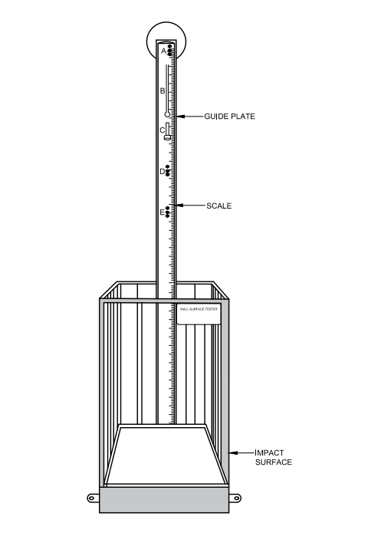

Fig. 1 Typical Diagram Used for Measuring Rebound of the Ball

**A-5 PROCEDURE**

**A-5.1** Inflate the ball with the compressed air to a specified pressure as given in **A-3**. The height of the rebound for different type of inflatable ball is determined after the impact of a freely falling ball from a specific drop height as given below:

|  |  |
| --- | --- |
| *Ball Type* | *Drop Height, h* |
| Indoor and Outdoor Football | 200 ± 1 cm |
| Volleyball | 100 ± 1cm |
| Basketball | 180 ± 1 cm |

**A-5.2** Set the guide plate in such a way that the lowest point of the ball is at a distance of as mention in above table from the top of the steel plate. Height of the guide plate can be calculated as given below:

*Height of the guide plate =*( *h + Dm*) cm

Where,

*h*= Distance between the lowest point of the ball and top of the steel plate; and

*Dm* = Average diameter of the ball.

**B-5.3** Bring the ball in contact with the guide plate and release it.

**B-5.4** Check the rebound height visually. The measurement shall be taken from top of the steel plate and bottom most point of the ball. The rebound height can also be found out by photographic methods.

**B-5.5** Repeat the test 5 time and find the mean value.

**ANNEX B**

( *Clause* 6.2 )

**CIRCUMFERENCE AND ROUNDNESS TEST**

**B-1 PRINCIPLE**

Circumference test indicates the dimensions of the ball as an average value, based on different axes of measurement. This test is critical to ensure the ball is of correct size. Roundness test analyses the departure of sphericity of balls by measuring their diameters at various randomly selected points on their surface and finding their variation from the average value.

**B-2 TEST CONDITION**

The ambient temperature during testing shall be (27 ± 2)°C, and humidity shall be (65 ± 5) percent.

**B-3 INFLATING THE BALL**

**B-3.1** A pressure gauge of 1.5 bar with an accuracy of ± 0.01 bar shall be used for measuring the pressure.

**B-3.2** Different level of outdoor football, and water-polo ball shall be inflated to the following pressure:

1. Level 1 - 0.8 ± 0.1 bar
2. Level 2 - 0.8 ± 0.1 bar
3. Level 3 - 0.5 ± 0.1 bar
4. Level 4 - 0.5 ± 0.1 bar

**B-3.3** The indoor footballs of all levels shall be inflated to 0.6 ± 0.1 bar.

**B-3.4** Different level ofbasketball shall be inflated as per **A-3.4**.

**B-3.5** Volleyball and handball of all level shall be inflated to 0.3 ± 0.1 bar.

**B-3.6** Different level of netball, and throwball shall be inflated to the following pressure:

1. Level 1 - 0.8 ± 0.1 bar
2. Level 2 - 0.6 ± 0.1 bar
3. Level 3 - 0.5 ± 0.1 bar

Note — 1 bar = 105 Pa

**B-4 APPARATUS**

**B-4.1** The diameter and roundness of the ball shall be measured by placing the ball between a horizontal metallic surface (base) and the stem of linear variable differential transfer (LVDT). The distance between the base and bottom of stem gives the diameter of the ball.

**B-4.2** The apparatus shall consist of a metallic frame made up of three rigid flat plates joined together to form a right-angled corner. An arrangement shall be made in such a way that a linear variable differential transfer (LVDT) is attached to the system and shall be able to measure a diameter between 170 mm and 270 mm. The lower face of the stem of LVDT shall have a flat surface of diameter of at least 30 millimetre (*see* Fig. 2). The least count of the measurement shall be 0.01 mm. The LVDT may be combined with ordinary PC and related software package for calculation of circumference.

**B-4.3** The above apparatus can also be used to determine the roundness of the ball by measuring its diameters at various randomly selected points on its surface and finding their mean percentage variations from the average value of ball diameter.

**B-4.4** Alternatively, this measurement can also be carried out with the help of LVDT of 100 mm range using a setting block of 160 ± 0.1 mm height.

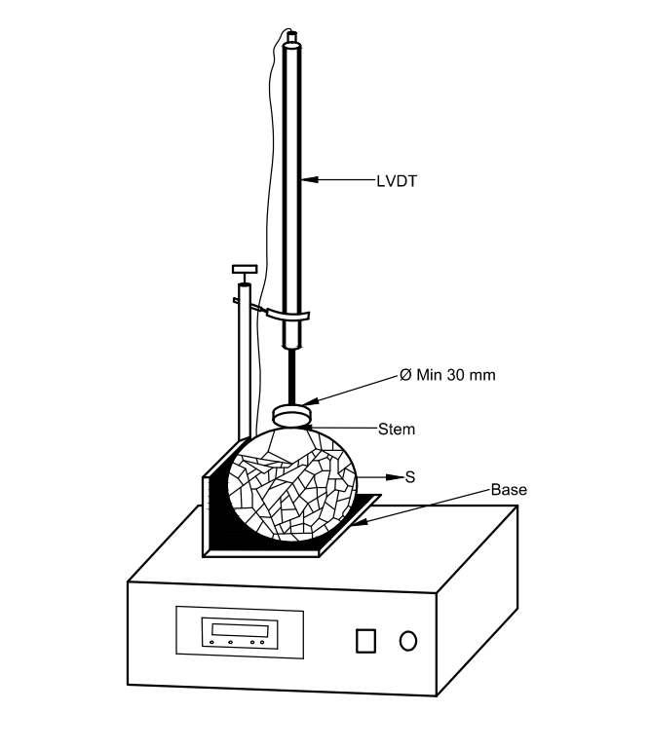

Fig. 2 Typical Diagram of Circumference and Roundness Testing Machine

**B-5 PROCEDURE**

**B-5.1** Bring the stem in contact with the base of the setup and set zero point on LVDT. In case a setting block is used, the top surface of setting block will act as a base. The height of setting block shall be added later for calculation of circumference and roundness.

**B-5.2** Inflate the ball to a pressure as specified in **B-3**. Place the ball manually against the metallic walls so it touches both the vertical walls properly. Adjust the position of LVDT in such a way that the stem rests on top of the football. The distance between the base and stem of LVDT gives the diameter of the ball. In case setting block is used, the height of setting block shall be added to LVDT reading to obtain the diameter of the ball.

**B-5.3** Repeat the test 16 times at randomly selected points on the surface of the ball.

**B-6 CALCULATION**

**B-6.1** The arithmetic mean of all 16 readings calculated as per **B-5** shall give the diameter of the ball (Dm).

The circumference of the ball can be calculated using following formula.

*Circumference, Pm = π × Dm*

Calculate absolute deviations of each absorb reading from the average value of diameter, then find the mean absolute deviations using the formula given below:

$Absolute mean deviation, ΔD =\frac{\sum_{i=1}^{i=16}{\left|D_{i}-D_{m}\right|}}{16}$

Calculation of roundness can be done using formula given below:

$Roundness, Percentage= \frac{ΔD}{D_{m}}$ × 100

**B-6.2** Circumference and roundness calculation is illustrated in example for 5 readings.

*Example:*

If the readings from calculated as per **B-5** are as follows:

221.03, 219.15, 220.68, 218.95, 218.68

$D_{m}=\frac{221.03+219.15+220.68+218.95+218.68}{5}$

= 219.70

*Circumference, Pm = π × Dm*

= 3.14 *×* 219.7

= 68.98 cm

|  |  |  |
| --- | --- | --- |
| Di | Dm |  |
| 221.03 | 219.70 | 1.33 |
| 219.15 | 219.70 | 0.55 |
| 220.68 | 219.70 | 0.98 |
| 218.95 | 219.70 | 0.75 |
| 218.68 | 219.70 | 1.02 |

$ΔD=\frac{1.33+0.55+0.98+0.75+1.02}{5}$

= 0.926

$Roundness, Percentage= \frac{ΔD}{D_{m}}$ × 100

$=\frac{0.926}{219.70}×100$

= 0.42

**ANNEX C**

( *Clause* 6.3 )

**WATER ABSORPTION TEST**

**C-1 PRINCIPLE**

This test is only conducted for outdoor football. When game is played on a wet field or under rain, the surface of the football used in the game absorbs water and its weight increases. Water absorption test used to determine the changes in weight of ball by pressing the ball into water by means of a pneumatic system and left to soak the water. The ball is then weighed again and its final weight is compared to its original weight.

**C-2 TEST CONDITION**

Reproduce to **A-2**.

**C-3 INFLATING OF BALL**

**C-3.1** Different level of outdoor football shall be inflated to the following pressure:

1. Level 1 - 0.8 ± 0.1 bar
2. Level 2 - 0.8 ± 0.1 bar
3. Level 3 - 0.5 ± 0.1 bar
4. Level 4 - 0.5 ± 0.1 bar

**C-3.2** A pressure gauge of 1.5 bar with an accuracy of ± 0.01 bar shall be used for measuring the pressure

Note — 1 bar = 105 Pa

**C-4 APPARATUS**

**C-4.1** The apparatus shall consist of a trough with water in which the football is kept for wetting. A pneumatically operated arrangement shall be made to press down the ball repeatedly at pre-set time interval, to compress the ball to desired depth. An arrangement shall also be provided to support and rotate the ball, when the ball is not being pressed, in order to bring the complete football surface in contact with water during the test.

**C-4.2** The apparatus shall be capable of achieving a compression of 25 percent of football diameter at a frequency of at least 40 compressions per minutes.

**C-4.3** Water trough shall be cylindrical vessel having a diameter of (30 ± 2) cm. It shall be filled with (2 ± 0.2) cm height of water. The diameter of compression plate shall be (16 ± 1) cm. The typical diagram of apparatus used for measuring water absorption of ball is given in Fig. 3.

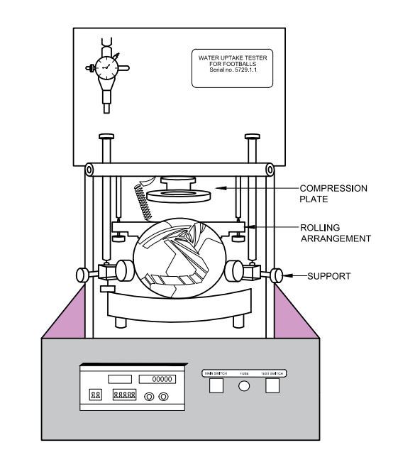

Fig. 3 Typical Diagram used for Measuring Water Absorption

**C-5 PROCEDURE**

**C-5.1** Inflate the ball to a specified pressure as given in **C-3**. The ball is weighed using electronic balance having an accuracy of 0.1 g. The depth of compression shall be calculated from the mean diameter obtained from the circumference test (25 percent of football diameter).

**C-5.2** Fill the water trough with (2 ± 0.2) cm height of water and placed the football at its centre.Adjust the compression plate, support plates and ball rotating arrangements as required.

**C-5.4** A compression equal to 25 percent of the diameter of the ball is applied at 40 compressions per minute. The compression can be measured by finding the difference between the trough base and the compression plate in the end position.

**C-5.5** After 250 compressions the ball shall be remove quickly and wipe dry on the surface using a standard towel. Each ball shall be weighed again using electronic balance after the test.

**C-6 CALCULATION**

Calculate the water uptake of the ball using the following formula:

$$Water Absorption \left(percentage\right)= \frac{(w_{f}-w_{i})}{w_{i}} ×100$$

Where,

*wi* = Weight of the ball before the test; and

*wf* = Weight of the ball after the test.

### **ANNEX D**

(*Foreword*)

### **COMMITTEE COMPOSITION**

Sports Goods Sectional Committee, PGD 41

|  |  |
| --- | --- |
| *Organization* | *Representative(s)* |
| Sports Goods Export Promotion Council | Shri Tarun Dewan **(*Chairperson*)** |
| All India Lawn Tennis Association, New Delhi | Shri Zeeshan Ali  Shri Vivek Sharma (*Alternate* I)  Shri Vinit Pundir (*Alternate* II) |
| Anand & Anand, Jalandhar | Shri Ashish Anand |
| Athletic Federation of India, New Delhi | Shri Sandeep Mehta  Shri Gopala Krishnan (*Alternate*) |
| Bhalla International Vinex, Meerut | Shri Sanjay Bhalla |
| Central Institute of Plastics Engineering & Technology (CIPET), Murthal | Shri K. A. Rajesh  Shri Vivek Kumar (*Alternate*) |
| COSCO India Pvt Ltd, Gurugram | Shri Pankaj Jain  Shri Amit Jain (*Alternate*) |
| Freewill Sports Pvt Ltd, Jalandhar | Shri Mohit Prabhakar |
| Government e Market Place, New Delhi | Ms Deepika Shokeen  Shri Abhishek Kakkar (*Alternate*) |
| Gymnastic Federation of India, Mumbai | Shri Riaz Bhati |
| Micro, Small and Medium Enterprises, Technology Development Centre, New Delhi | Shri Aditya Prakash Sharma  Shri V. K. Singh (*Alternate*) |
| Nelco (India) Pvt Ltd, Meerut | Shri Amber Anand |
| Premier Leg Guard Works, Meerut | Shri Sumesh Agarwal  Shri Kshitij Agarwal (*Alternate*) |
| Ranson Sports Industry, Jalandhar | Shri Arvind Singh Rana |
| Sanspareils Greenlands Pvt Ltd, Meerut | Shri Puneet Anand  Shri Puneet Arora (*Alternate*) |
| SGS India Private Limited, Mumbai | Shri Amit Saluja  Shri Sailesh Sharma (*Alternate*) |
| Shri Ram Institute For Industrial Research, Delhi | Ms M. Archana Bisht  Dr Manmohan Kumar |
| Soccer International Pvt Ltd, Jalandhar | Ms Shaalini Gupta |
| Softball Association of India, New Delhi | Ms Shibani Tagore |
| Sports and Toys Exporters Association, Jalandhar | Shri Nitin Mahajan |
| Sports Authority of India, New Delhi | Shri K. C. Meena  Shri Vishnubhtla Sharma (*Alternate*) |
| Sports Goods Manufacturers and Exporters Association (SGMEA), Jalandhar | Shri Vipin Mahajan |
| Stag International Sports, Meerut | Shri Rakesh Kohli  Shri Vivek Kohli (*Alternate*) |
| Universal Sports, Jalandhar | Shri Mahesh Chadha |
| Voluntary Organisation In Interest Of Consumer Education (Voice), New Delhi | Shri M. A. U. Khan |
| Yonker Skates Private Limited, Delhi | Shri Ojasvi Nagpal |
| BIS Directorate General | Shri R. R. Singh, Scientist ‘F’/Senior Director and Head (Production and General Engineering) [Representing Director General (*Ex-officio*)] |

*Member Secretary*

Shri Ajay Kumar

Scientist ‘C’/Deputy Director

(Production and General Engineering), BIS