***भारतीय मानक***

***Indian Standard***

**IS 8856 (Part 1) : 2024**

**(*Superseding IS 8856 : 1991)***

***वेल्ड ढिबरियाँ — विशिष्टि***

***भाग* 1** ***षट्कोणीय ढिबरियाँ***

**Weld Nuts — Specification**

**Part 1 Hexagon Nuts**

ICS 21.060.20

© BIS 2024

भारतीय मानक ब्यूरो

BUREAU OF INDIAN STANDARDS

मानक भवन, 9 बहादुर शाह ज़फर मार्ग, नई दिल्ली - 110002

MANAK BHAVAN, 9 BAHADUR SHAH ZAFAR MARG

NEW DELHI - 110002

[www.bis.gov.in](http://www.bis.org.in) [www.standardsbis.in](http://www.standardsbis.in)

**November 2024 Price Group X**

General Engineering and Fasteners Standards Sectional Committee, PGD 37

FORWORD

This Indian Standard was adopted by the Bureau of Indian Standards after the draft finalized by the General Engineering and Fasteners Standards Sectional Committee had been approved by the Production and General Engineering Division Council.

Weld nuts are specialized fasteners designed to be welded on to metal surfaces, creating strong and secure attachment points. They are typically projection welded, a process where the protrusions of the nuts focus the welding current and pressure, ensuring a strong bond with minimal distortion. To use a weld nut, it is positioned over a pre-drilled hole in the metal surface. The protrusions melt when current and pressure are applied, there by fusing the nut to the metal substrate. Once the weld is cooled and solidified, the nut provides a robust threaded anchor point for bolts or screws, facilitating the assembly of various components. This method is widely used in automotive, construction, and manufacturing industries to ensure durable and reliable joints.

IS 8856 was first published in 1973 and subsequently revised in 1991. The committee responsible for the formulation of this standard has decided to revise this standard by publishing it into 3 parts covering the requirements of hexagon weld nuts, square weld nuts and flange weld nuts respectively.

In comparison to IS 8856 : 1991, the following modifications have been made in this standard:

a) The scope of the standard has been revised;

b) Various designs of hexagonal weld nuts have been added;  
c) Mechanical requirements have been revised; and   
d) References have been updated.

The standard also specifies informative Annex A, Annex B and Annex C for the assembly of hexagon weld nuts, peel strength to pressing, and peel strength to torque, respectively.

In preparation of this standard assistance has been derived from the following standards:

|  |  |
| --- | --- |
| DIN 929 : 2013 | Hexagon weld nuts |
| JIS B 1196 : 2010 | Weld nuts |

The composition of the Committee responsible for the formulation of this standard is given in Annex D.

For the purpose of deciding whether a particular requirement of this standard is complied with, the final value, observed or calculated, expressing the result of a test or analysis, shall be rounded off in accordance with IS 2: 2022 ‘Rules for rounding off numerical values (*second revision*)’. ’The number of significant places retained in the rounded off value should be the same as that of the specified value in this standard.

*Indian Standard*

**HEXAGON WELD NUTS — SPECIFICATION**

**1 SCOPE**

This standard specifies the requirements for hexagonal weld nuts with metric coarse pitch threads from sizes M3 to M16 and with metric fine pitch threads from sizes M8 to M16.

**2 REFERENCES**

The standards listed below contain provisions which, through reference in this text, constitute provisions of this standard. At the time of publication, the editions indicated were valid. All standards are subject to revision, and parties to agreements based on this standard are encouraged to investigate the possibility of applying the most recent editions of the standards listed below:

|  |  |
| --- | --- |
| *IS No* | *Title* |
| IS 513 (Part 1) : 2016 | Cold reduced carbon steel sheet and strip: Part 1 Cold forming and drawing purpose (*sixth revision*) |
| [IS 1367 (Part 1) : 2014](https://www.services.bis.gov.in/php/BIS_2.0/bisconnect/standard_review/Standard_review/Isdetails?ID=MTgzMTk%3D)/ ISO 8992 : 2005 | Technical supply conditions for threaded steel fasteners: Part 1 General requirements for bolts, screws, studs and nuts (*fourth revision*) |
| [IS 1367 (Part 2) : 2002](https://www.services.bis.gov.in/php/BIS_2.0/bisconnect/standard_review/Standard_review/Isdetails?ID=MTgzMjI%3D)/ ISO 4759-1 | Technical supply conditions for threaded steel fasteners: Part 2 Tolerances for fasteners **—** Bolts, screws, studs and nuts **—** Product grades A, B and C (*third revision*) |
| IS 1367 (Part 3) : 2017/ ISO 898-1 : 2013 | Technical supply conditions for threaded steel fasteners: Part 3 Mechanical properties of fasteners made of carbon steel and bolts, screws and studs (*fifth revision*) |
| IS 1367 (Part 6) : 2018/ ISO 898-2 : 2012 | Technical supply conditions for threaded steel fasteners: Part 6 Mechanical properties of fasteners made of carbon steel and alloy steel **—** Nuts with specified property classes **—** Coarse thread and fine pitch thread (*fourth revision*) |
| [IS 1367 (Part 11) : 2020](https://www.services.bis.gov.in/php/BIS_2.0/bisconnect/standard_review/Standard_review/Isdetails?ID=NTM1Mg%3D%3D) | Technical supply conditions for threaded steel fasteners: Part 11 Electroplated coating systems (*fourth revision*) |
| [IS 1367 (Part 17) : 2023](https://www.services.bis.gov.in/php/BIS_2.0/bisconnect/standard_review/Standard_review/Isdetails?ID=Mjg0MzA%3D)/ ISO 3269 : 2019 | Technical supply conditions for threaded steel fasteners: Part 17 Inspections sampling and acceptance procedure. |
| IS 4218 (Part 3) : 1999/ ISO 724 : 1993 | ISO general purpose metric screw threads: Part 3 Basic dimensions (*second revision*) |
| [IS 14962 (Part 1) : 2018](https://www.services.bis.gov.in/php/BIS_2.0/bisconnect/standard_review/Standard_review/Isdetails?ID=MzU%3D)/ ISO 965-1 : 2013 | ISO general purpose metric screw threads **—** Tolerances: Part 1 Principles and basic data (*first revision*) |

**3 TYPES**

**3.1** Weld nuts shall be of the types as specified in Table 1.

**Table 1 Types of Weld Nuts**(*Clause* 3.1)

|  |  |  |
| --- | --- | --- |
| **Sl No.** | **Type** | **Existence of pilot** |
| (1) | (2) | (3) |
| i) | Type A11), 2) | Yes |
| ii) | Type A22) | Yes |
| ii) | Type B1) | No |
| iii) | Type F3) |
| 1)The classification A and B gives the division of existence of pilot.  2)The classification A1 and A2 gives the division of 2 designs of weld nuts with the existence of pilot.  3)F refers to type B without undercut on upper and lower surfaces. | | |

**3.2** Hexagonal weld of type A2, B and F shall be of 2 strength classes 5T and 8T based on the dimensional and proof load requirements.

**4 DIMENSIONS**

**4.1** The dimensions of hexagonal weld nuts of type A1 shall be as given in Fig. 1 and Table 2.

**4.2** The dimensions of hexagonal weld nuts of type A2 and B shall be as given in Fig. 2 and Table 3.

**4.3** The dimensions of hexagonal weld nuts of type F shall be as given in Fig. 3 and Table 4.

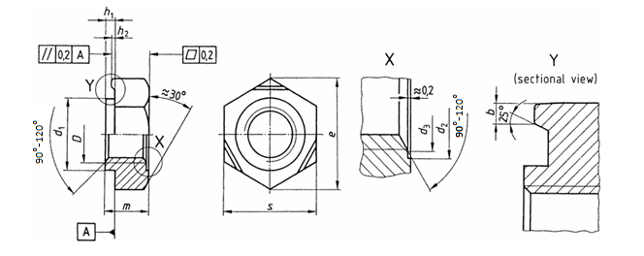

FIG. 1 DIMENSIONS Of Hexagonal Weld Nuts (Type A1)

**Table 2 Dimensions of Hexagonal Weld Nuts (Type A1)**

(*Clause* 4.1)

All dimensions are in millimetres.

|  |  |  |  |  |  |  |  |  |  |  |  |  |  |
| --- | --- | --- | --- | --- | --- | --- | --- | --- | --- | --- | --- | --- | --- |
| **Sl No.** | **Thread Size**  ***d*** | | **M3** | **M4** | **M5** | **M6** | **M8** | **M10** | **7/10-20 UNF-2B**1) | **7/10-20 UNF-2B1)** | **M12** | **M14** | **M16** |
| (1) | (2) | | (3) | (4) | (5) | (6) | (7) | (8) | (9) | (10) | (11) | (12) | (13) |
| i) | *P*2) | Coarse | 0.5 | 0.7 | 0.8 | 1 | 1.25 | 1.5 | - | - | 1.75 | 2 | 2 |
| Fine | - | - | - | - | M8 × 1 | M10 × 1.25,  M10 × 1 | - | - | M12 × 1.5,  M12 × 1.25 | M14 × 1.5 | M16 × 1.5 |
| ii) | *b*3) | Nominal | 0.8 | 0.8 | 0.8 | 0.9 | 1.0 | 1.25 | 1.25 | 1.25 | 1.25 | 1.5 | 1.5 |
| Tolerance | ±0.2 | ±0.2 | ±0.2 | ±0.22 | ±0.25 | ±0.3 | ±0.3 | ±0.3 | ±0.3 | ±0.4 | ±0.4 |
| iii) | *d1* (d11) | | 4.50 | 6.00 | 7.00 | 8.00 | 10.50 | 12.50 | 12.50 | 13.50 | 14.80 | 16.80 | 18.80 |
| iv) | *d2* (H*13)* | | 4.50 | 6.00 | 7.00 | 8.00 | 10.50 | 12.50 | 13.50 | 13.50 | 14.80 | 16.80 | 18.80 |
| v) | *d3,* *Max* | | 3.45 | 4.60 | 5.75 | 6.75 | 8.75 | 10.80 | 11.70 | 11.70 | 12.96 | 15.12 | 17.28 |
| vi) | *e*4)*, Min* | | 8.15 | 9.83 | 10.95 | 12.02 | 15.38 | 18.74 | 18.74 | 20.91 | 20.91 | 24.27 | 26.51 |
| vii) | *h*1 | Nominal | 0.55 | 0.65 | 0.70 | 0.75 | 0.90 | 1.15 | 1.15 | 1.40 | 1.40 | 1.80 | 1.80 |
| Tolerance | 0 -0.1 | 0 -0.1 | 0 -0.1 | 0 -0.15 | 0 -0.15 | 0 -0.2 | 0 -0.2 | 0 -0.2 | 0 -0.2 | 0 -0.2 | 0 -0.2 |
| viii) | *h*2 | Nominal | 0.25 | 0.35 | 0.40 | 0.40 | 0.50 | 0.65 | 0.65 | 0.80 | 0.80 | 1.00 | 1.00 |
| Tolerance | 0 -0.1 | 0 -0.1 | 0 -0.1 | 0 -0.1 | 0 -0.15 | 0 -0.15 | 0 -0.2 | 0 -0.2 | 0 -0.2 | 0 -0.2 | 0 -0.2 |
| ix) | *m* (h14) | | 3.0 | 3.5 | 4.0 | 5.0 | 6.5 | 8.0 | 10.0 | 10.0 | 10.0 | 11.0 | 13.0 |
| x) | *s* (h13) | | 7.5 | 9.0 | 10.0 | 11.0 | 14.0 | 17.0 | 17.0 | 19.0 | 19.0 | 22.0 | 24.0 |
| 1)The tolerance class for these threads shall be 2B in accordance with ISO 5864 : 1993.  2)P is the pitch of the thread. 3)Unless otherwise agreed between the user/purchaser and the manufacturer, the dimensions of leg width *b* shall be as given in the Table. However, the tolerance values shall be as specified in the Table.  4)*e*min = 1.12*s*min | | | | | | | | | | | | | |

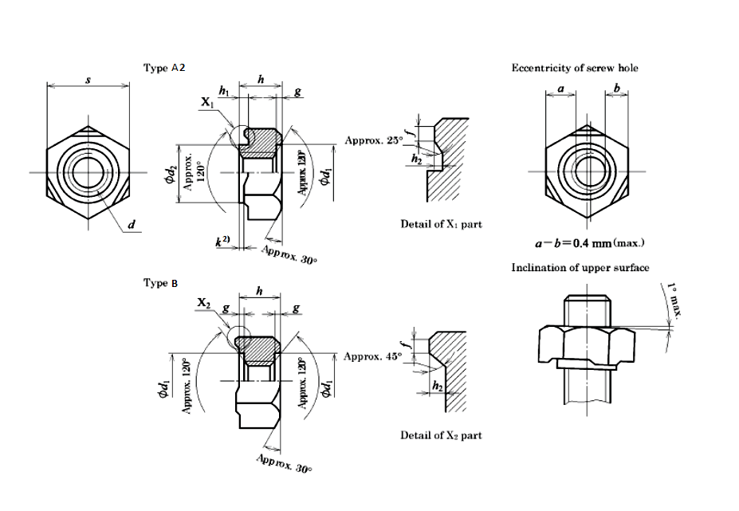

FIG. 2 DIMENSIONS Of Hexagonal Weld Nuts (Type A2 and B)

**Table 3 Dimension of Hexagon Weld Nut (Type A2 and Type B)**(*Clause* 4.2)

All dimensions are in millimetres.

|  |  |  |  |  |  |  |  |  |  |
| --- | --- | --- | --- | --- | --- | --- | --- | --- | --- |
| **Sl No.** | **Thread Size**  ***d*** | | | **M4** | **M5** | **M6** | **M8** | **M10** | **M12** |
| (1) | (2) | | | (3) | (4) | (5) | (6) | (7) | (8) |
| i) | Pitch | | Coarse | 0.7 | 0.8 | 0.1 | 1.25 | 1.5 | 1.75 |
| Fine | - | - | - | M8 × 1 | M10 × 1.25,  M10 × 1 | M12 × 1.5, M12 × 1.25 |
| ii) | Outline | *S* | Nominal | 11 | 11 | 13 | 15 | 17 | 19 |
| Tolerance | 0  -0.43 | 0 | 0 | 0 | 0 | 0 |
| -0.43 | -0.43 | -0.43 | -0.43 | -0.52 |
| *h* | Nominal value for  strength class 5T | 5 | 5 | 6 | 7.5 | 9 | 11 |
| Nominal value for  strength class 8T | 5 | 5 | 6 | 7.5 | 10 | 12 |
| Tolerance | 0  -0.30 | 0  -0.30 | 0  -0.30 | 0  -0.36 | 0  -0.36 | 0  -0.43 |
| iii) | Undercut | *d1* | ≈ | 7 | 7 | 9 | 11 | 13 | 15 |
| *g* | Type A2 | 0.5 | 0.5 | 0.5 | 0.8 | 0.8 | 0.8 |
| Type B | 0.5 | 0.5 | 0.5 | 0.5 | 0.5 | 0.5 |
| iv) | Pilot | *d2* | Nominal | 7 | 7 | 9 | 11 | 13 | 15 |
| Tolerance | -0.1  -0.3 | -0.1  -0.3 | -0.1  -0.3 | -0.1  -0.3 | -0.1  -0.3 | -0.1  -0.3 |
| *h1* | Nominal | 0.8 | 0.8 | 0.8 | 0.8 | 1.2 | 1.2 |
| Tolerance | 0  -0.2 | 0  -0.2 | 0  -0.2 | 0  -0.2 | 0  -0.2 | 0  -0.2 |
| v) | Weld Protection1) | *f* | | 0.2 to 1 | 0.2 to 1 | 0.2 to 1 | 0.2 to 1.2 | 0.2 to 1.2 | 0.2 to 1.2 |
| *h2* | Nominal value for type A2 | 0.5 | 0.5 | 0.5 | 0.5 | 0.7 | 0.7 |
| Nominal value for type B | 0.8 | 0.8 | 0.8 | 0.8 | 1 | 1 |
| Tolerance | 0  -0.2 | 0  -0.2 | 0  -0.2 | 0  -0.2 | 0  -0.2 | 0  -0.2 |
| **1)**The difference between the maximum value and the minimum value of height (*h – h1 + h2* for type A2, and *h + h2* for type B) including the weld projection shall be 0.15 mm or less, and the difference between the maximum value and the minimum value of width (*f*) of the weld projection shall be 0.7 mm or less per a nut.  2) The difference (*k)* between levels of the pilot and the end point of weld projection shall be 0.15 mm or more (*see* Fig.2).  NOTE — The threaded portion of lower surface of type A2 nut should be chamfered to the extent that its diameter becomes (nominal diameter of screw thread + 0.5 mm) or more and surely leave a flat surface at a lower surface of pilot. The threaded portions of upper surface of type A2 nut and upper surface/lower surface of type B nut should be chamfered to the extent that their diameters become slightly larger than the major diameter of the internal thread. | | | | | | | | | |



FIG. 3 DIMENSIONS Of Hexagonal Weld Nuts (Type f)

**Table 4 Dimension of Hexagon Weld Nuts (Type F)**(*Clause* 4.3)

All dimensions are in millimetres.

|  |  |  |  |  |  |  |  |  |  |
| --- | --- | --- | --- | --- | --- | --- | --- | --- | --- |
| **Sl No.** | **Thread Size**  *d* | | | **M4** | **M5** | **M6** | **M8** | **M10** | **M12** |
| (1) | (2) | | | (3) | (4) | (5) | (6) | (7) | (8) |
| i) | Pitch | | Coarse | 0.7 | 0.8 | 0.1 | 1.25 | 1.5 | 1.75 |
| Fine | - | - | - | M8 × 1 | M10 × 1.25,  M10 × 1 | M12 × 1.5,  M12 × 1.25 |
| ii) | Outline | *s* | Nominal | 11 | 11 | 13 | 15 | 17 | 19 |
| Tolerance | 0  -0.43 | 0  -0.43 | 0  -0.43 | 0  -0.43 | 0  -0.43 | 0  -0.52 |
| *m* | Standard dimension for strength division 5T | 4 | 4 | 5 | 6.5 | 8 | 10 |
| Standard dimension for strength division 8T | 5 | 5 | 6 | 7.5 | 10 | 12 |
| Tolerance (h14) | 0  -0.30 | 0  -0.30 | 0  -0.30 | 0  -0.36 | 0  -0.36 | 0  -0.43 |
| iii) | Weld Protection1) | *f* | | 0.2  to 1 | 0.2  to 1 | 0.2  to 1 | 0.2  to 1.2 | 0.2  to 1.2 | 0.2  to 1.2 |
| *h2* | Nominal | 0.8 | 0.8 | 0.8 | 0.8 | 1 | 1 |
| Tolerance | 0  -0.2 | 0  -0.2 | 0  -0.2 | 0  -0.2 | 0  -0.2 | 0  -0.2 |
| 1)The difference between the maximum value and the minimum value of height (*m* + *h*2) including the weld projection shall be 0.15 mm or less and the difference between the maximum value and the minimum value of width (*f*) of the weld projection shall be 0.7 mm or less per a nut.  NOTE — The threaded portion of lower surface of nut should be chamfered to the extent that its diameter becomes approximately (nominal diameter of screw thread + 1 mm), and the threaded portion of upper surface of nut should be chamfered to the extent that its diameter becomes slightly larger than the major diameter of the internal thread. | | | | | | | | | |

**5 REQUIREMENTS**

The various requirements of hexagon weld nuts shall be as given in Table 5, Table 6 and Table 7.

**Table 5 Requirements**(*Clause* 5)

|  |  |  |  |
| --- | --- | --- | --- |
| **Sl No.** | **Material** | | **Steel with a maximum carbon mass of 0.25 percent for type A1 and 0.20 percent for type A2, B and F** |
| (1) | (2) | (3) | (4) |
| i) | General requirements | As specified in | IS 1367 (Part 1) |
| ii) | Thread | Tolerance class | 6G for type A1; 6H for types A2, B and F |
| As specified in | IS 14962 (Part 1) |
| iii) | Mechanical properties | Proof loads | *see* Tables 6 and 7 |
| Proof load test | IS 1367 (Part 6) |
| iv) | Limit deviations, geometrical tolerances | Product grade | A |
| As specified in | IS 1367 (Part 2) |
| v) | Surface finish — Coating | | Plain (Clean and bright)  IS 1367 (Part 11) applies with regard to electroplating  The requirements of additional coating shall in agreement between the user and the manufacturer. |
| vi) | Acceptance inspection | | IS 1367 (Part 17) applies with regard to acceptance inspection. |
|  | | | |

**Table 6 Proof Load Values for Hexagon weld Nuts with Coarse Pitch Threads**(*Clause* 5)

|  |  |  |  |
| --- | --- | --- | --- |
| **Sl No.** | **Thread Size**  *D* | **Proof Load** N,*Min* | |
| A1 | A2, B and F  Strength class 5T Strength class 8T |
| (1) | (2) | (3) | (4) |
| i) | M3×0.5 | 3 800 | 2452 3 932 |
| ii) | M4×0.7 | 6 800 | 4 315 6 865 |
| iii) | M5×0.8 | 11 000 | 6 963 11 180 |
| iv) | M6×1 | 15 500 | 9 807 15 690 |
| v) | M8×1.25 | 28 300 | 17 950 28 440 |
| vi) | M10×1.5 | 44 800 | 28 440 45 110 |
| ix) | M12 ×1.75 | 65 300 | 41 290 65 710 |
| xi) | M14×2 | 89 700 | 56 390 90 220 |
| xii) | M16×2 | 123 000 | 76 980 123 600 |

**Table 7 Proof Load Values for Hexagon weld Nuts with Fine Pitch Threads**(*Clause* 5)

|  |  |  |  |
| --- | --- | --- | --- |
| **Sl No.** | **Thread Size**  *D* | **Proof Load** N,*Min* | |
| A1 | A2, B and F  Strength class 5T Strength class 8T |
| (1) | (2) | (3) | (4) |
| i) | M8×1 | 30 200 | 19 220 30 400 |
| ii) | M10×1.25 | 47 800 | 30 010 48 050 |
| iii) | M10×1 | 50 200 | 31 600 50 630 |
| iv) | 7/16-20 UNF-2B | 53 600 | - - |
| v) | M12×1.5 | 68 200 | 43 170 69 160 |
| vi) | M12×1.25 | 72 100 | 45 110 72 570 |
| vii) | M14×1.5 | 97 500 | 61 290 98 070 |
| viii) | M16×1.5 | 132 000 | 81 890 131 400 |

**6 DESIGNATION**

Hexagon weld nuts confirming to the requirements of this standard shall be designated by the IS number of this standard, the thread size, and the strength class (if applicable).

*Examples*:

a) A hexagon weld nut of size M8 × 1.25, of type A1 shall be designated as:   
 IS 8856 — M8 × 1.25 — A1

b) A hexagon weld nut of size M8 × 1, of type B, strength class 5T shall be designated as:  
 IS 8856 — M8 × 1 — B — 5T

**7 MARKING**

**7.1** Hexagon weld nuts shall be marked with the following items on the outside surface of the packaging:

a) Designation,  
b) Batch number/lot number/date of manufacturing, and

b) Manufacturer’s name/initials or trademark.

**7.2 BIS Certification Marking**

The product(s) conforming to the requirements of this standard may be certified as per the conformity assessment schemes under the provisions of the *Bureau of Indian Standards Act*, 2016 and the Rules and Regulations framed thereunder, and the product(s) may be marked with the standard mark.

**ANNEX A**   
(*National Foreword*)  
(*Informative*)

**DIMENSIONS OF ASSEMBLY**

**A-1 DIMENSIONS OF ASSEMBLY**

The dimensions of assembly of hexagon weld nuts (before welding) shall be as given in Fig. 4, Table 8 and Table 9.



Fig. 4 Connecting Dimensions (Nut not Welded on)

**Table 8** **Connecting Dimensions (Type A1)**(*Clause* A-1)

|  |  |  |  |  |
| --- | --- | --- | --- | --- |
| **Sl No.** | ***D*** | **Sheet Thickness** *a* | | **Hole Diameter *d*4** H11 |
| *Min* | *Max* |
| (1) | (2) | (3) | (4) | (5) |
| i) | M3 | 0.63 | 1.5 | 4.5 |
| ii) | M4 | 0.75 | 1.5 | 6.0 |
| iii) | M5 | 0.88 | 2.0 | 7.0 |
| iv) | M6 | 0.88 | 2.5 | 8.0 |
| v) | M8 | 1.00 | 3.0 | 10.5 |
| vi) | M10 | 1.25 | 4.0 | 12.5 |
| vii) | 7/16-20 UNF-2B | 1.25 | 4.0 | 13.5 |
| viii) | M12 | 1.50 | 5.0 | 14.8 |
| ix) | M14 | 2.00 | 6.0 | 16.8 |
| x) | M16 | 2.00 | 6.0 | 18.8 |

**Table 9 Connecting Dimensions (Type A2, B and F)**(*Clause* A-1)

|  |  |  |  |  |  |  |
| --- | --- | --- | --- | --- | --- | --- |
| **Sl No.** | ***D*** | **Sheet Thickness** *a* | | **Hole Diameter $${\text{d}\text{4}}_{ \text{0}}^{\text{+0.3}}$$** | | |
| *Min* | *Max* | A2 | B | F |
| (1) | (2) | (4) | (5) | (6) | (7) | (8) |
| ii) | M4 | 0.80 | 1 | 7 | 5 | 5 |
| iii) | M5 | 1.0 | 1.2 | 7 | 6 | 6 |
| iv) | M6 | 1.2 | 1.6 | 9 | 7 | 7 |
| v) | M8 | 1.6 | 2.0 | 11 | 9 | 9 |
| vi) | M10 | 2.0 | 2.3 | 13 | 11 | 11 |
| viii) | M12 | 2.3 | 3.2 | 15 | 13 | 13 |

**ANNEX B**   
(*National Foreword*)  
(*Informative*)

**PEEL STRENGTH TO PRESSING AND ITS TEST METHOD**

**B-1 PEEL STRENGTH TO PRESSING**

**B-1.1** The peel strength to pressing when a nut (Type A2, B or F) is tested in accordance with the method specified in **B-2** is given in Table 10 for reference.

**B-1.2** The welded assembly is deemed satisfactory even if the weld is deformed in the peel test by pressing when the load at the test is not less than the relevant value in Table 10.

**Table 10 Peel Strength to Pressing**(*Clauses* B-1.1, B-1.2 *and* B-2.2)

|  |  |  |  |  |  |  |  |
| --- | --- | --- | --- | --- | --- | --- | --- |
| **Sl No.** | **Nominal diameter of screw thread (mm)** | **4** | **5** | **6** | **8** | **10** | **12** |
| (1) | (2) | (3) | (4) | (5) | (6) | (7) | (8) |
| i) | Peel strength to pressing, kN | 3.24 | 3.24 | 3.24 | 3.73 | 6.03 | 6.03 |
| NOTE — The peel strength to pressing (*F*) is obtained by the following formula:  *F = S× n× σ*  where,   *S* = cross sectional area at root of one weld point, in mm2;  n = number of weld points per a nut;  *σ =* tensile strength of weld (*σ* = 294 N/mm2);  *S* and *n* are obtained by the calculation with the median of standard values for the hexagon weld nut type A2 in Table 2. | | | | | | | |

**B-2 METHOD FOR PEEL TEST BY PRESSING**

**B-2.1** Weld the nut to the steel sheet with the grade and thickness as mentioned in Table 11. Place the welded assembly on a spacer as shown in Fig. 5 and screw a bolt into the welded nut. Apply compressive load gradually to the bolt head so that the centre of load coincides with the centre of screw as much as possible, and the load when the bolt peels off is measured.

**B-2.2** When the test steel sheet bends noticeably at a load not more than that given in Table 10, retest is carried out by using a thicker steel sheet within the nominal thickness given in Table 11, by increasing the temper grade of sheet, or by decreasing the space between the inside diameter of spacer and the nut as much as possible.

**B-2.3 Test Conditions**

**B-2.3.1** The hole diameter on steel sheet (*d'*) (*see* Fig. 5) should be according to the hole diameter of corresponding plate specified in Table 9.

**B-2.3.2** The welding condition of nut shall be based upon the agreement between the parties concerned with delivery

**B-2.3.3** When the steel sheet with other thickness than the nominal thickness specified in Table 11 is used, it shall be based upon the agreement between the parties concerned with delivery.

NOTE — The bolt employed in the test should have tolerance class of 6g and should be of property class 8.8 or better.

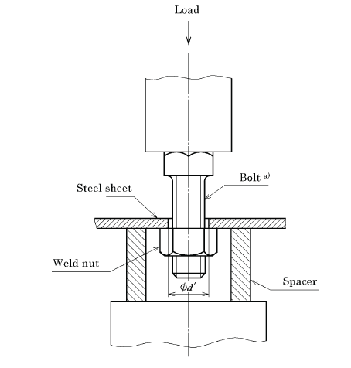

Fig. 5 Method for peel test by pressing

**Table 11 Steel Sheet to Which Nut is Welded**(*Clauses* B-2.1, B-2.2, B-2.3.3*,* C-2.1, C-2.2 *and* C-2.3.4)

|  |  |  |  |
| --- | --- | --- | --- |
| **Sl No.** | **Nominal Diameter**  **of Screw Thread (mm)** | **Steel Sheet to which Nut is Welded** | |
| Applicable standard | Nominal thickness, mm |
| (1) | (2) | (3) | (4) |
| i) | 4 | Cold rolled carbon steel sheet of grade CR1 as specified in IS 513 (Part 1). |  |
| ii) | 5 |  |
| iii) | 6 | *see* Table 8 |
| iv) | 8 |  |
| v) | 10 |  |
| vi) | 12 |  |

**ANNEX C**(*National Foreword*)  
(*Informative*)

**PEEL STRENGTH TO TORQUE AND ITS TEST METHOD**

**C-1 PEEL STRENGTH TO TORQUE**

**C-1.1** The peel strength to torque when a nut is tested in accordance with the method specified in **C-2** is given in Table 12 for reference.

**C-1.2** The welded assembly is deemed satisfactory even if the weld is deformed in the pee test by torque when the torque at the test is not less than the relevant value in Table 12.

**Table 12 Peel Strength to Torque**

(*Clause* C-1.1, C-1.2 *and* C-2.2)

|  |  |  |  |  |  |  |  |
| --- | --- | --- | --- | --- | --- | --- | --- |
| **Sl No.** | **Nominal Diameter**  **of Screw Thread (mm)** | **4** | **5** | **6** | **8** | **10** | **12** |
| (1) | (2) | (3) | (4) | (5) | (6) | (7) | (8) |
| i) | Peel strength to torque, N-m | 12.7 | 12.7 | 15.5 | 20.5 | 37.3 | 42.2 |
| NOTE — The peel strength to torque (*T*) is obtained by the following formula:  *T=S × n × τ × L*  where,   *S* = cross sectional area at root of one weld point, in mm2;  n = number of weld points per a nut;  L = distance from screw centre to weld point; and  *τ =* tensile strength of weld (*τ* = *σ* ×0.7= 206 N/mm2)  *S, n,* and *L* are obtained by the calculation with the median of standard values for the hexagon weld nut type A2 in Table 2. | | | | | | | |

**C-2 METHOD FOR PEEL TEST BY TORQUE**

**C-2.1** The nut is welded to the steel sheet given in Table 11, the steel sheet is fixed firmly as shown in Fig. 6, the torque is applied along a plane perpendicular to the centre of screw as much as possible, and the torque when the weld of nut peels off is measured.

**C-2.2** When the test sheet at the weld is torn off by the torque not more than that given in Table 12, retest is carried out by using a thicker sheet within the nominal thickness given in Table 11 or by increasing the temper grade of the sheet.

**C-2.3 B-2.3 Test Conditions**

**C-2.3.1** The hole diameter on steel sheet (*d*’) should be according to the hole diameter of corresponding plate specified in Table 9 for reference. For that, without pilot, the holding may be omitted.

**C-2.3.2** The socket for hexagon weld nut may be either one with hexagon hole or square hole or slotted socket which engages with the width across flats, *s*.

**C-2.3.3** The weld condition of nut shall be based upon the agreement between the parties concerned with delivery.

**C-2.3.4** In case the steel sheet with nominal thickness other than that specified in Table 11 is used, it shall be based upon the agreement between the parties concerned with delivery.

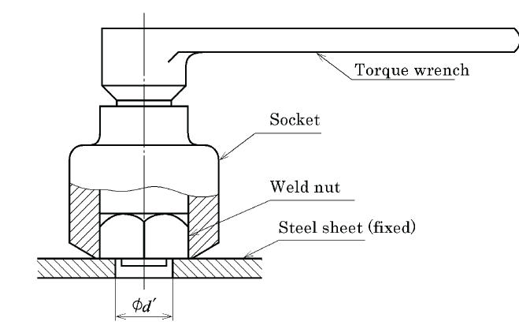

Fig. 6 Method for peel test by torque

**ANNEX D**

( *Foreword* )

**COMMITTEE COMPOSITION**

General Engineering and Fasteners Standards Sectional Committee, PGD 37

|  |  |
| --- | --- |
| *Organization* | *Representatives(s)* |
| In Personal Capacity *(9, Shantha Sadana, 4th Cross,*  *F - Block, 1st Stage, J. P. Nagar, Mysuru - 570031)* | Shri N. Srinivasa Murthy (***Chairman***) |
| Apt Tools and Machinery India Private Limited,Chennai | Shri Raghu.P |
| BEML Limited, Bengaluru | Shri M. R. Senthil Kumar |
| Best Quality Fasteners Limited, Rudrapur | Shri Ankit Khandelwal |
| Bharat Dynamics Limited, Hyderabad | Shri K. Sreenivasa Rao  Umakanth Pathipati (*Alternate*) |
| Bosch Limited, Bengaluru | Shri Venkatesh Dinnumali |
| Central Manufacturing Technology Institute, Bengaluru | Shri S K Verma |
| Deepak Fasteners Limited, Ludhiana | Shri Deepak Kalra  Shri Sukhdev Singh (*Alternate* I)  Shri Sukhjeevan Singh Nokewal (*Alternate* II) |
| EJOT - Octaqon Fastening Systems Private Limited, Gurugram | Shri Pankaj Kumar |
| Fastener Manufacturers Association of India, Ludhiana | Shri Narinder Singh Bhamra |
| Hilti India Private Limited, New Delhi | Shri Prashant Dasharath Sathe  Shri Shounak Mitra (*Alternate*) |
| Institute for Auto Parts and Hand tools Technology, Ludhiana | Shri Sanjeev Katoch  Shri Amol (*Alternate*) |
| Kaymo Fastener Company, Mumbai | Shri Vivek Asrani |
| North India Screw Manufacturers and Traders Association, Amritsar | Shri Raghav Aggarwal  Shri Ragghav Aggarwal (*Alternate*) |
| Optimas OE Solutions India Private Limited, Pune | Shri Diwakar Dubey |
| Pioneer Nuts and Bolts Private Limited, Ludhiana | Shri Garish Gupta  Smt. Archana Gupta (*Alternate*) |
| Precise Fasteners Private Limited, Mumbai | Shri Parag Prakash Shah |
| Raj Industries, Chandigarh | Shri Dhruv Khandelwal |
| Research Designs and Standards Organization (RDSO), Lucknow | Shri Pradeep Kumar |
| Sterling Tools Limited, Faridabad | Shri Jayaraman R  Shri Mohan Swaroop (*Alternate*) |
| Sundram Fasteners Limited, Chennai | Shri Atul Kumar Agrawal  Shri Kannadasan B (*Alternate*) |
| Tata Motors Limited, Pune | Shri Anoop Toby  Shri Kishore Kumar Patil (*Alternate*) |
| Universal Precision Screws Private Limited, Rohtak | Shri Vineet Raina |
| *Organization* | *Representatives(s)* |
| In Personal Capacity *(G-A/42 APHB Phase 3, Saidabad, Hyderabad)* | Shri KV Subba Reddy |
|  |  |
| In Personal Capacity *(199/1, 9th Cross, Cubbonpet Bengaluru)* | Shri Murthy |
| BIS Directorate General | Shri Rajeev Ranjan Singh, Scientist ‘F’ And Head (PGD)[ Representing Director General ( *Ex-officio*) ] |
| *Member Secretary*  Shri Monarch Joshi  Scientist ‘C’ (PGD) BIS | |