***भारतीय मानक***

***Indian Standard***

**IS 6087 : 2024**

**धातु काटने की कतरनी — विशिष्टि**

*( पहला पुनरीक्षण )*

**Metal Cutting Shears**

**— Specification**

*( First Revision )*

ICS 25.140.30

© BIS 2024



भारतीय मानक ब्यूरो

BUREAU OF INDIAN STANDARDS

मानक भवन, 9 बहादुर शाह ज़फर मार्ग, नई दिल्ली-110002

MANAK BHAVAN, 9 BAHADUR SHAH ZAFAR MARG

NEW DELHI ‒ 110002

[www.bis.gov.in](http://www.bis.org.in) [www.standardsbis.in](http://www.standardsbis.in)

**November 2024** **Price Group X**

Hand Tools Sectional Committee, PGD 34

FOREWORD

This Indian Standard (First Revision) was adopted by the Bureau of Indian Standards after the draft finalized by the Hand Tools Sectional Committee had been approved by the Production and General Engineering Division Council.

Metal cutting shears are used for cutting scrap metal to a suitable size for handling and transport to a metal recovery operation, it is usually used for cutting rough shapes out of medium-sized pieces of sheet metal. This standard has been formulated with a view to ensuring the minimum standard of quality of the tools so that they will have a longer useful life. It specifies the certain basic overall dimensions of functional importance only without imposing any limitation on details of design.

This standard was first published in 1971. This revision has been brought out to align it with the latest technological developments and international practices.

In this revision, the following major changes have been made:

1. Clause on references has been added,
2. Material designations have been updated as per the latest Indian Standard, and
3. Table no. 1 has been modified.

The composition of the Committee, responsible for the formulation of this standard is given at Annex C.

For the purpose of deciding whether a particular requirement of this standard is complied with, the final value, observed or calculated, expressing the result of a test, shall be rounded off in accordance with IS 2 : 2022 ‘Rules for rounding off numerical values (*second revision*)’*.* The number of significant places retained in the rounded off value should be the same as that of the specified value in this standard.

*Indian Standard*

METAL CUTTING SHEARS — SPECIFICATIONS

( *First Revision* )

**1 SCOPE**

This standard specifies the requirements for straight cut and circular cut hand metal cutting shears for general purposes.

**2 REFERENCES**

The standards listed in Annex A contain provisions which through reference in this text, constitute provisions of this standard. At the time of publication, the editions indicated were valid. All standards are subject to revision and parties to agreements based on this standard are encouraged to investigate the possibility of applying the most recent edition of these standards.

**3 MATERIAL**

Shears shall be manufactured from a suitable high carbon steel or tool steel meeting with the requirements laid down in **4** and **8**. Some of the suitable steels for this purpose are 80C6 of IS 1570 (Part 2/Sec 1) and TC 4 of 1570 (Part 6) with a maximum sulphur and phosphorus content of 0.035 percent each.

**4 HARDNESS**

The hardness of the blades shall be within the range of 545 HV to 655 HV when measured in accordance with IS 1501 (Part 1) or 52 HRC to 58 HRC when measured in accordance with IS 1586 (Part 1).

**5 DIMENSION**

The dimensions for the metal cutting shears shall be as given in Table 1 to 5.

**Table 1 Dimensions for Metal Cutting Shears, Type A**

(*Clause* 5)

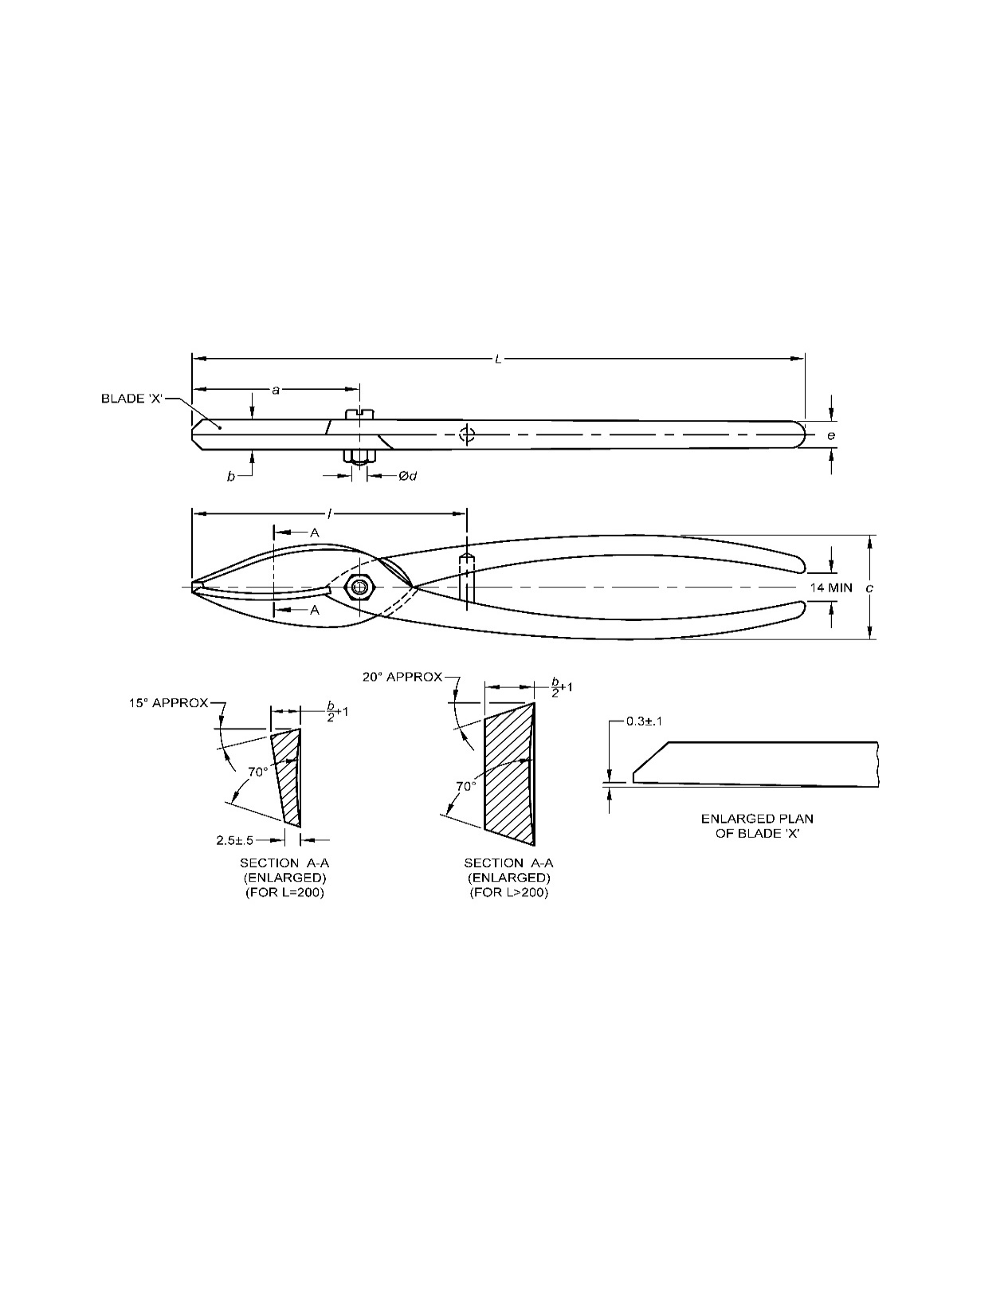All dimensions are in millimetres.

|  |  |  |  |  |  |  |  |  |
| --- | --- | --- | --- | --- | --- | --- | --- | --- |
| **Sl No.** | **Nominal**  **Size** | ***L***  ±5 | ***a***  ±2 | ***b***  ±2 | ***c***  ±5 | ***d*** | ***e***  *Min* | ***l***  *Max* |
| (1) | (2) | (3) | (4) | (5) | (6) | (7) | (8) | (9) |
| i) | 200 | 200 | 65 | 10 | 45 | M6 | 8 | 105 |
| ii) | 250 | 250 | 70 | 14 | 50 | M6 | 12 | 125 |
| iii) | 300 | 300 | 82 | 16 | 56 | M8 | 14 | 135 |
| iv) | 350 | 350 | 114 | 20 | 58 | M8 | 20 | 190 |
| v) | 400 | 400 | 122 | 21 | 62 | M10 | 20 | 210 |

**Table 2 Dimensions for Metal Cutting Shears, Type B**

(*Clause* 5)

All dimensions are in millimetres.

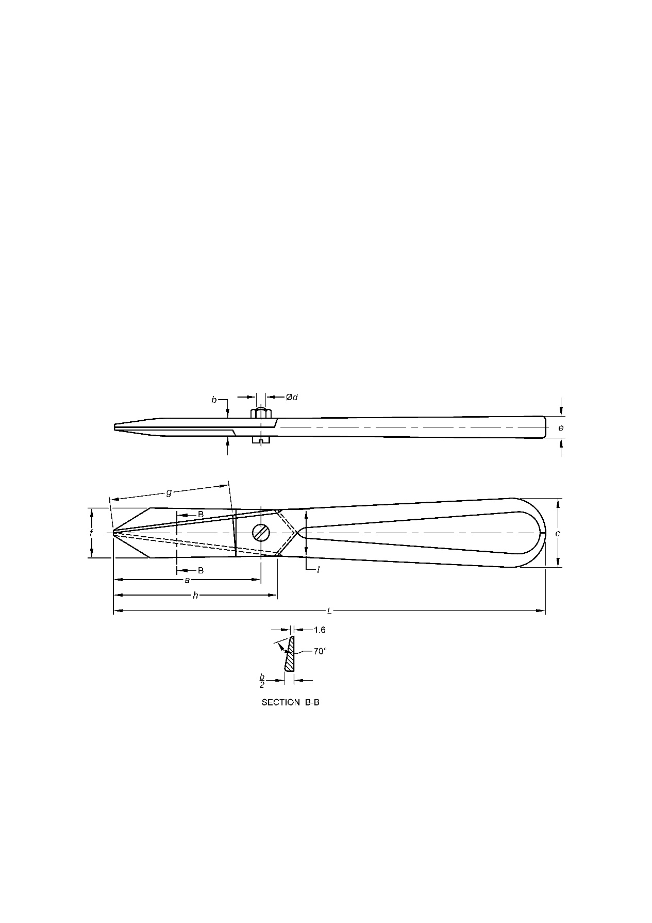

|  |  |  |  |  |  |  |  |  |  |  |  |
| --- | --- | --- | --- | --- | --- | --- | --- | --- | --- | --- | --- |
| **Sl No.** | **Nominal**  **Size** | ***L***  ±5 | ***a***  ±2 | ***b***  ±2 | ***c***  ±5 | ***d*** | ***e***  *Min* | ***f***  *Approx* | ***g***  ±2 | ***h***  ±2 | ***l***  *Approx* |
| (1) | (2) | (3) | (4) | (5) | (6) | (7) | (8) | (9) | (10) | (11) | (12) |
| i) | 160 | 160 | 55 | 10 | 40 | M6 | 12 | 30 | 43 | 65 | 24 |
| ii) | 250 | 250 | 85 | 10 | 40 | M6 | 12 | 30 | 70 | 95 | 27 |
| iii) | 300 | 300 | 105 | 14 | 50 | M8 | 14 | 45 | 85 | 110 | 42 |
| iv) | 350 | 350 | 105 | 16 | 50 | M8 | 14 | 45 | 90 | 125 | 42 |
| v) | 400 | 400 | 122 | 20 | 60 | M10 | 20 | 50 | 100 | 130 | 42 |

**Table 3 Dimensions for Metal Cutting Shears, Type C**

(*Clause* 5)

All dimensions are in millimetres.

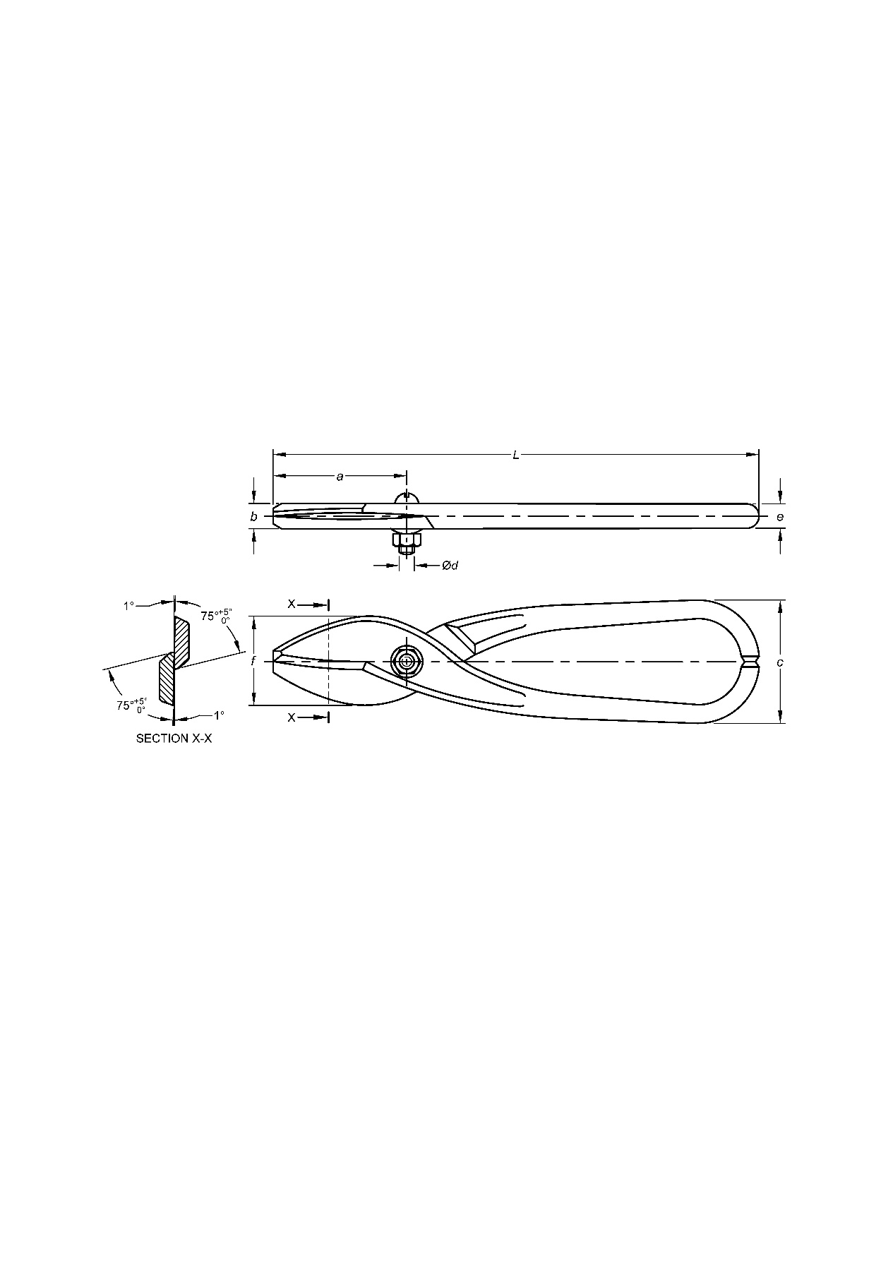

|  |  |  |  |  |  |  |  |  |
| --- | --- | --- | --- | --- | --- | --- | --- | --- |
| **Sl No.** | **Nominal Size** | ***L***  ±5 | ***a***  ±2 | ***b***  ±5 | ***c***  ±5 | ***d*** | ***e***  *Min* | ***f***  *Approx* |
| (1) | (2) | (3) | (4) | (5) | (6) | (7) | (8) | (9) |
| i) | 160 | 160 | 45 | 8 | 50 | M6 | 6 | 30 |
| ii) | 200 | 200 | 55 | 11 | 50 | M6 | 9 | 36 |
| iii) | 250 | 250 | 70 | 12 | 50 | M6 | 10 | 38 |
| iv) | 300 | 300 | 85 | 14 | 50 | M8 | 12 | 44 |

**Table 4 Dimensions for Metal Cutting Shears, Type D**

(*Clause* 5)

All dimensions are in millimetres.

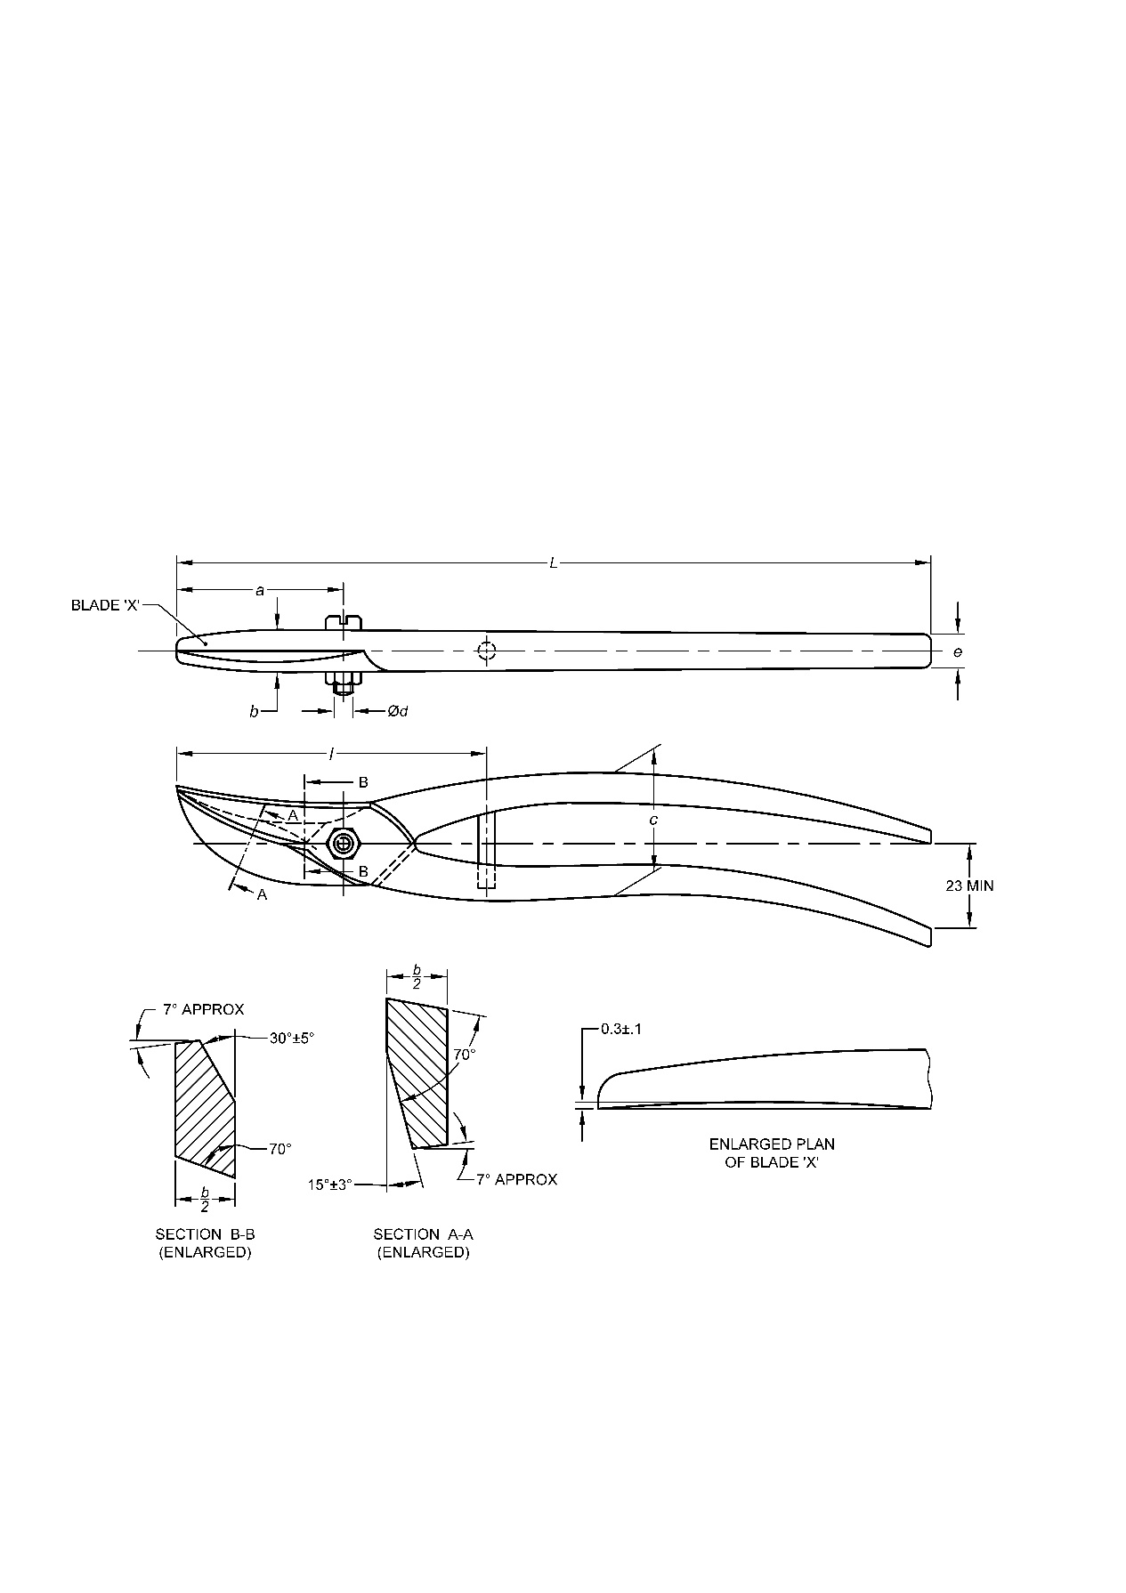

|  |  |  |  |  |  |  |  |  |
| --- | --- | --- | --- | --- | --- | --- | --- | --- |
| **Sl No.** | **Nominal Size** | ***L***  ±5 | ***a***  ±2 | ***b***  ±2 | ***c***  ±5 | ***d*** | ***e***  *Min* | ***l***  *Max* |
| (1) | (2) | (3) | (4) | (5) | (6) | (7) | (8) | (9) |
| i) | 250 | 250 | 55 | 14 | 40 | M6 | 12 | 110 |
| ii) | 300 | 300 | 65 | 16 | 50 | M8 | 14 | 125 |

**Table 5 Dimensions for Metal Cutting Shears, Type E**

(*Clause* 5)

All dimensions are in millimetres.

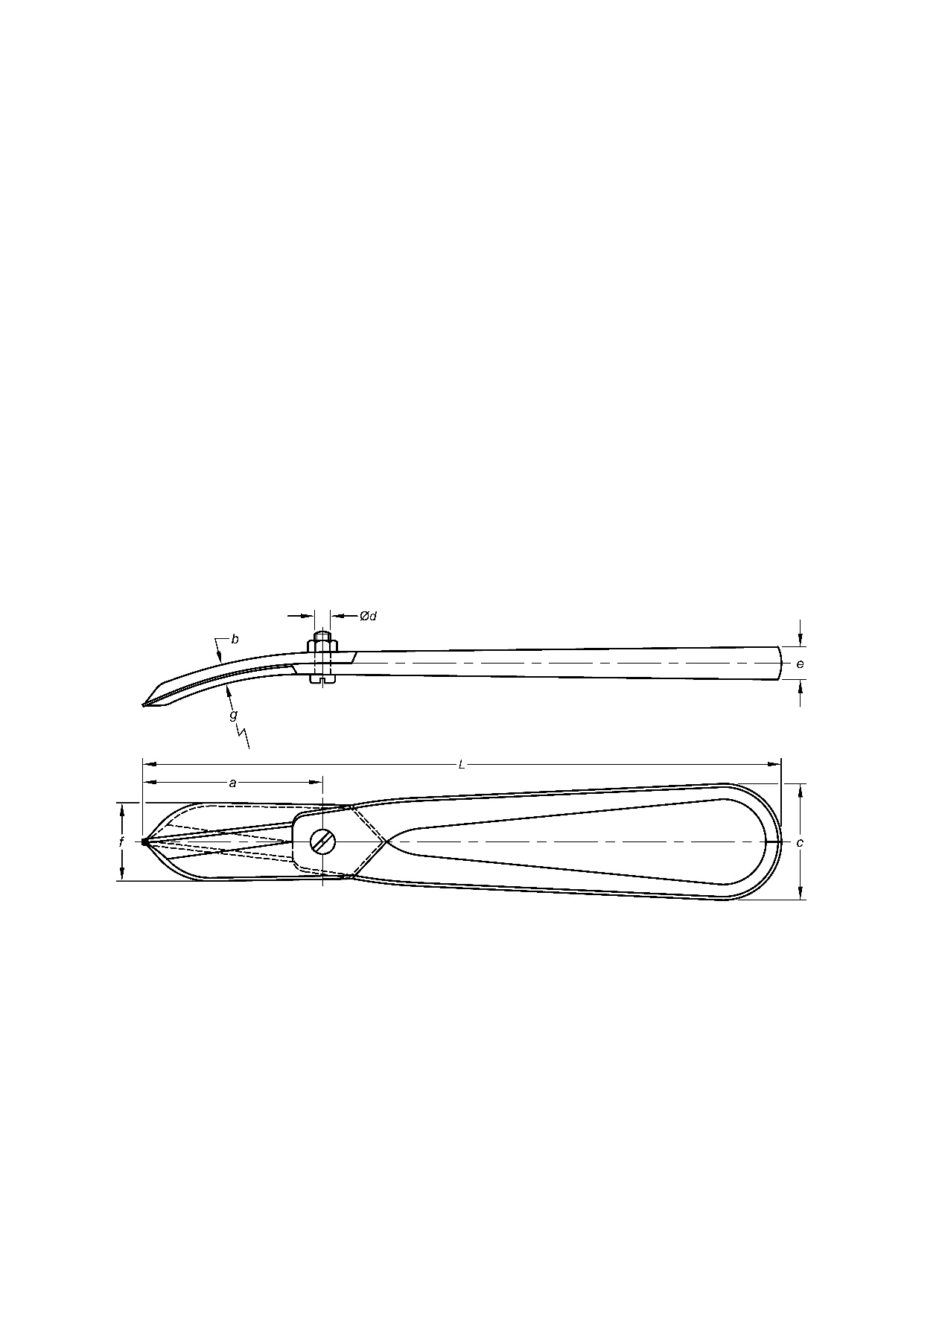

|  |  |  |  |  |  |  |  |  |  |
| --- | --- | --- | --- | --- | --- | --- | --- | --- | --- |
| **Sl No.** | **Nominal Size** | ***L***  ±5 | ***a***  ±2 | ***b***  ±2 | ***c***  ±5 | ***d*** | ***e***  *Min* | ***f***  *Approx* | ***g***  *Approx* |
| (1) | (2) | (3) | (4) | (5) | (6) | (7) | (8) | (9) | (10) |
| i) | 250 | 250 | 70 | 8 | 45 | M6 | 12 | 30 | 140 |

**6 MANUFACTURE**

**6.1** Shears shall consist essentially of two cutting blades, two handles and a bolt.

**6.2** Blades shall be of either one-piece or two-piece construction at the option of the supplier. One-piece blades shall be forged in a single piece integral with the handle. Blades of two pieces shall be forged in a single piece integral with the handle. Blades of two pieces shall be joined to handles by forge welding into a single integral unit. In case of two-piece blade construction, the cutting edges shall be at least 2 mm in depth for the grindings which may be required during the life of the tool.

**6.3** Blade cutting edge shall be suitably beveled and properly hardened and tempered. Cutting edges shall be slightly crowned so that the proper cutting angle shall be maintained throughout the full length of cut.

**6.4** Blade bearing and mating surfaces shall be ground true, shall be smooth and of ample width to prevent the blades from twisting or springing open under ordinary cutting loads likely to be encountered in service.

**6.5** The centre bolt and nut shall serve as a pivot joint holding the blades together and shall provide a means for blade adjustment. The centre bolt shall be prevented from rotating in one blade and permitted to rotate in the other. The tensioning nut shall be of self-locking type.

**6.6** The handles of shears shall be shaped to provide a smooth and comfortable grip for the hand. Handles shall be free from flash and irregular or sharp projections and edges. Shears shall be provided with handle stops so arranged as to preclude the possibility of the handles being closed beyond the effective blade-cutting point.

**6.7** The metal cutting shears of Types A, B and C shall be of straight cut and Types D and E shall be of circular cut. The shears shall be manufactured either in right hand cut (lower blade on right hand side) or left-hand cut (lower blade on left hand side).

**7 WORKMANSHIP AND FINISH**

**7.1** Shears shall be free from rust, burrs, fins, blisters and other defects that may impair serviceability and durability of the tool.

**7.2** Blades shall have all edges rounded except the cutting edges. The bearing side of the blades and beveled portions adjacent to the cutting edges shall be smoothly ground and shall have a natural finish. The outer side of each blade and handle shall have a painted, lacquered, enameled or natural finish at the option of the customer. The cutting edges shall be given a suitable rust preventive treatment.

**8 TESTS**

**8.1 Paper Cutting Test**

Each sample shear, both before and after being tested as specified in 8.2, shall be made to cut one sheet of bond (white or colored) paper conforming to 1848 (Part 1). At least 300 mm of the paper shall be cut clearly without leaving torn or rugged edges using shear’s full length of cut.

**8.2 Metal Cutting Test**

The shears shall be subjected to the following tests:

**8.2.1** *Load Cutting Test*

Each sample shear shall make 10 cuts in steel strip as specified in Table 6. The test sheets shall be 75 mm wide by 300 mm long, having a minimum thickness as specified in Table 6. The test load shall be applied by a testing machine or other suitable device or method. The first cut shall be made parallel to the 75 mm side 10 mm from the end. Each succeeding cut shall be spaced 10 mm from the proceeding cut until 10 cuts have been made. The entire length of cutting edges cuts shall not exceed the values specified in Table 6.

**Table 6 Test Requirements for Metal Cutting Shears**

(*Clauses* 8.2.1and 8.2.3)

|  |  |  |  |  |  |  |
| --- | --- | --- | --- | --- | --- | --- |
| **Sl No.** | **Nominal Size**  mm | **Strip-Cutting Capacity, Cold Rolled Steel**1) **Thickness**  *Min*  mm | **Load Cutting Test** | | | **Wire Nail Cutting Test, Diameter of Nail**  mm |
| **Point of Application of Load on Handle**2)  ± 5  mm | **Test Load**  N kgf | |
| (1) | (2) | (3) | (4) | (5) (6) | | (7) |
| i) | 160 | 0.50 | 80 | 176.5 | 18 | 1.60 |
| ii) | 200 | 0.50 | 110 | 196.1 | 20 | 1.80 |
| iii) | 250 | 0.63 | 150 | 194.2 | 30 | 1.80 |
| iv) | 300 | 1.00 | 190 | 392.3 | 40 | 2.80 |
| v) | 350 | 1.25 | 230 | 539.4 | 55 | 3.15 |
| vi) | 400 | 1.60 | 270 | 637.4 | 85 | 4.00 |

**1)** Conforming to temper No. 2 half hard of IS 513 (Part 1).

**2)** From the centre of bolt (*see* Tables 1 to 5).

**8.2.2** *Strip Cutting Test*

Following the load cutting test, each shear shall be operated by hand to make at least five cuts across strips 10 mm wide of the same material as used in the above test; the cutting being done within 25 mm of the outer and of the blades. The shear may be rested on a bench and the strip supported or held for this test.

**8.2.3** *Wire Nail Cutting Test*

After the strip cutting test, each sample shear operated by hand shall then be required to cut (at approximately the mid-point of the blade length) a common steel nail of diameter specified in Table 6. The test as specified in **8.1** shall again be carried out.

**9 DESIGNATION**

The metal cutting shears shall be designated by:

1. Commonly used name,
2. Type,
3. Nominal size, and
4. Number of this standard.

*Example:*

A metal cutting shear of Type A and of nominal size 200 mm shall be designated as:

Shears, A 200, IS 6087

**10 MARKING**

**10.1** The shears shall be clearly and legibly stamped with the manufacturer’s name, initials or recognized trademark or both. Year of manufacture shall also be marked if required by the purchaser.

**10.2 BIS Certification Marking**

The product(s) conforming to the requirements of this standard may be certified as per the conformity assessment schemes under the provisions of the *Bureau of Indian Standards Act,* 2016 and the Rules and Regulations framed thereunder, and the products may be marked with the Standard Mark.

**11 SAMPLING**

Sampling and acceptance criteria for metal cutting shear shall be as agreed to between the purchaser and the supplier. A recommended scheme for the same is given in Annex B.

**ANNEX A**

(*Clause* 2)

**LIST OF REFERRED STANDARDS**

|  |  |
| --- | --- |
| *IS No.* | *Title* |
| 513 (Part 1) : 2016 | Cold reduced carbon steel sheet and strip: Part 1 Cold forming and drawing purpose (*sixth revision*) |
| 1501 (Part 1) : 2020 | Metallic materials — Vickers hardness test: Part 1 Test method (*fifth revision*) |
| 1570 (Part 2/Sec 1) : 1979 | Schedules for wrought steels: Part 2 Carbon steels (unalloyed steels), Section 1 Wrought products (other than wires) with specified chemical composition and related properties (*first revision*) |
| 1570 (Part 6) : 1996 | Schedules for wrought steels: Part 6 Carbon and alloy tool steels (*first revision*) |
| 1586 (Part 1) : 2018 | Metallic materials — Rockwell hardness test: Part 1 Test method (*fifth revision*) |
| 1848 (Part 1) : 2018 | Writing and printing papers — Specification: Part 1 Account book, azure lead, bond, cream laid and cream wove/printing white/printing coloured/printing offset, printing maplitho, printing white super calendared and typewriting types (*fifth revision*) |
| 4905 : 2015 | Random sampling and randomization procedures (*first revision*) |

**ANNEX B**

(*Clause* 11)

**SCALE OF SAMPLING AND CRITERIA FOR CONFORMITY**

**B-1 SCALE OF SAMPLING**

**B-1.1 Lot**

In any consignment all the metal cutting shears of the same type and size manufactured under essentially similar conditions shall be grouped to constitute a lot.

**B-1.2** For ascertaining the conformity of the lot to the requirements of the specification, tests shall be carried out on each lot separately. The number of shears to be selected at random shall be in accordance with col 1 and 2 of Table 7. In order to ensure the randomness of selection IS 4905 shall be followed.

**B-2 CRITERIA FOR CONFORMITY**

**B-2.1** The shears selected according to **B-1.2** shall be examined for dimensions and workmanship and finish. Any shear failing to meet the requirements for any one of the characteristics shall considered as defective.

**B-2.1.1** If the number of defective shears found in the sample is less than or equal to the corresponding number given in col 3 of Table 7, the lot shall be declared as conforming to the requirements for dimensions, and workmanship and finish.

**Table 7 Scale of Sampling and Permissible No. of Defectives**

(*Clauses* B-1.2, B-2.1.1, B-2.2 andB-2.2.1)

|  |  |  |  |  |  |
| --- | --- | --- | --- | --- | --- |
| **Sl No.** | **Lot Size** | **For Dimensions, Workmanship and Finish** | | **For Hardness and Cutting Tests** | |
| **Sample Size** | **Permissible No. of Defectives** | **Sample Size** | **Permissible No. of Defectives** |
| (1) | (2) | (3) | (4) | (5) | (6) |
| i) | Up to 25 | 5 | 0 | 2 | 0 |
| ii) | 26 to 50 | 8 | 0 | 3 | 0 |
| iii) | 51 to 100 | 13 | 1 | 5 | 0 |
| iv) | 101 to 150 | 20 | 2 | 5 | 0 |
| v) | 151 to 300 | 32 | 3 | 8 | 0 |
| vi) | 301 and above | 50 | 5 | 8 | 0 |

**B-2.2** From those lots found satisfactory according to **B-2.1.1** the number of shears corresponding to col 4 of Table 7 shall be selected and tested for hardness and cutting tests.

**B-2.2.1** If the number of defective shears found in the sample is less than or equal to the corresponding number given in col 5 of Table 7, the lot shall be declared as conforming to the requirements of this standard.

**ANNEX C**

(*Foreword*)

**COMMITTEE COMPOSITION**

Hand Tools Sectional Committee, PGD 34

|  |  |
| --- | --- |
| *Organization* | *Representatives(s)* |
| Institute for Auto Parts and Hand tools Technology, Ludhiana | Shri Sanjeev Katoch (***Chairperson***) |
| Ajay Industries Private Limited, Jalandhar | Shri Ajay Goswami  Shri Rajat Goswami (*Alternate*) |
| Central Institute of Hand Tools, Jalandhar | Shri Amit Kumar |
| Engineering Export Promotion Council, New Delhi | Shri Ashwani Kumar  Shri Opinder Singh (*Alternate*) |
| Hand Tools Industries Association, Nagaur | Shri Ashfaq Ali  Shri Zulfiqar Ali (*Alternate*) |
| Hand Tools Manufacturers Association, Jalandhar | Shri Sukhdev Raj  Shri Ashwani Kumar (*Alternate*) |
| Inder Industries, Jalandhar | Shri Vijay Chatrath  Shri Sunil Chatrath (*Alternate*) |
| Indian Oil Corporation Limited, New Delhi | Ms Neeta Agarwal  Shri Abhishek Anupam (*Alternate*) |
| Institute for Auto Parts and Hand tools Technology, Ludhiana | Shri Pankaj Kaundal  Shivani Thakur (*Alternate*) |
| Ludhiana Hand Tools Association, Ludhiana | Shri S. C. Ralhan  Shri Ashok Gupta (*Alternate*) |
| Mansarovar Forgings Pvt. Ltd, Ludhiana | Shri Khushvir Singh |
| Oaykay Forgings Private Limited, Jalandhar | Shri Sharad Aggarwal |
| Osho Tools Private Limited, Jandiali | Shri Ashok Gupta  Shri Rajesh Peshion (*Alternate*) |
| Pahwa Metal Tech Pvt. Ltd Pune. | Shri Lalit Kumar Pahwa  Shri Aakash Pahwa (*Alternate*) |
| Precise Fasteners Private Limited, Mumbai | Shri Parag Prakash Shah |
| Pye Tools Private Limited, Ludhiana | Shri Gaurav Sehgal  Shri Rajender Pal (*Alternate*) |
| Taparia Tools Limited, Nashik | Shri Nikhil Bhutada  Shri N.B. Borse (*Alternate*) |
| Tata Motors Limited, Pune | Shri Anoop Toby  Shri Hanamant Gurav (*Alternate*) |
| Victor Forgings, Jalandhar | Shri Sukhdev Raj  Shri Anil Kumar (*Alternate*) |
| Bureau of Indian Standards, New Delhi | Shri Rajeev Ranjan Singh, Scientist‘F’ /Senior Director And Head (Pgd) [Representing Director General (*Ex* - *Officio*)] |

***Member Secretary***

Shri Vimal Kumar

Scientist ‘C’/ Deputy Director

(Production And General Engineering), Bis