**AMENDMENT NO. 1 NOVEMBER 2024**

**TO**

**IS 5912 : 1997 SPECIFICATION FOR ANEMOMETER, CUP COUNTER**

( *First Revision* )

(*Page* 5, *clause* **6.1.2**) — Substitute the following for the existing clause:

**‘6.1.2** The three cups shall be fixed firmly to the central spider in a perfect vertical plane in such a way that they are well balanced with each other without showing any bias to any particular position (*see* Fig. 2). The mounting of the cups shall be firm enough to withstand even a wind speed of 200 km/h or more’.

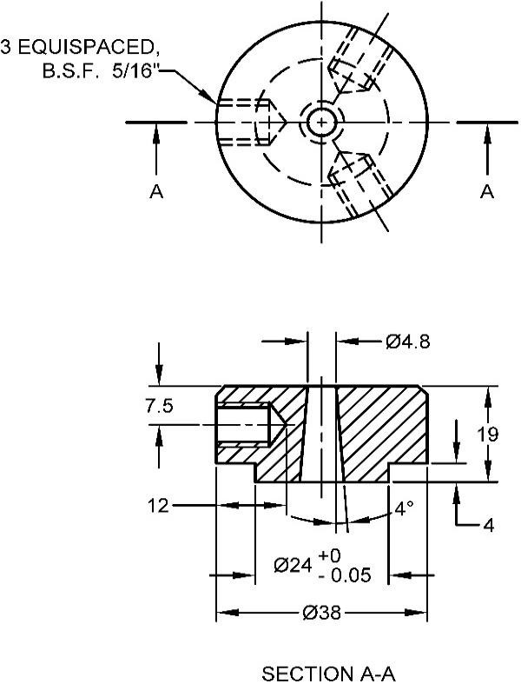

All dimensions in millimetres.

Fig. 2 Spider