**Doc: PCD 01 (21661) F**

***भारतीय मानक***

***Indian Standard***

[**IS 1448 (Part 111): 2024**](https://www.services.bis.gov.in/php/BIS_2.0/StandardsFormulationV2/Upload3.php?ID=UUhaazE3ZldpOHl6TG9tS3dnbndDdz09)

**पेट्रोलियम और उसके उत्पाद — परीक्षण पद्धतियाँ**

**भाग 111 गैस क्रोमैटोग्राफी द्वारा**

**तरलीकृत पेट्रोलियम गैस (LPG) और**  **प्रोपाइलीन**

**सांद्रताओं का विश्लेषण**

**(*पहला पुनरीक्षण)***

**PETROLEUM AND ITS PRODUCTS -**

**TEST METHODS PART 111 ANALYSIS OF LIQUEFIED**

**PETROLEUM GASES (LPG) AND**

**PROPYLENE CONCENTRATES BY GAS**

**CHROMATOGRAPHY**

**(First Revision)**

ICS 75.080

© BIS 2024

भारतीय मानक ब्यूरो

BUREAU OF INDIAN STANDARDS

मानक भवन, 9 बहादुर शाह ज़फर मार्ग, नई दिल्ली - 110002

MANAK BHAVAN, 9 BAHADUR SHAH ZAFAR MARG

NEW DELHI - 110002

[www.bis.gov.in](http://www.bis.org.in) [www.standardsbis.in](http://www.standardsbis.in)

**July 2024 Price Group X**

Methods of Sampling and Test for Petroleum and Related Products of Natural or Synthetic Origin (excluding bitumen) Sectional Committee, PCD 01

**FOREWORD**

This Indian Standard (First Revision) was adopted by the Bureau of Indian Standards, after the draft finalized by the Methods of Sampling and Test for Petroleum and Related Products of Natural or Synthetic Origin (Excluding Bitumen) Sectional Committee had been approved by the Petroleum, Coal and Related Products Division Council.

IS 1448 (Part 111): 1983 Method of test for petroleum and its products (Part 111) Analysis of liquefied petroleum gases (LPG) and propylene concentrates by Gas Chromatography was adapted from joint publication of ASTM D 2163-77 and IP 264/79 and published in 1983. IP 264/79 has been withdrawn and D 2163 has been revised as ASTM D 2163-23.

The first revision has been taken up to keep pace with the latest technological developments and international practices. In this revision, following major changes have been made:

1. Scope of the test method has been extended to determine the concentrations of component in the range of 0.01 to 100 percent by volume.

In the preparation of this standard, considerable assistance has been derived from the following standards:

ASTM D 2163-23 — Standard test method for determination of Hydrocarbons in Liquefied Petroleum (LPG) Gases and Propane/ Propene mixtures by Gas Chromatography

ASTM D 6729-20 — Standard test method for determination of determination of Individual components in spark ignition engine fuels by 100 meter capillary high resolution gas chromatography

The composition of the Committee and Subcommittee, responsible for the formulation of this standard is given at Annex A.

In reporting the result of a test or analysis made in accordance with this standard, if the final value, observed or calculated, is to be rounded off, it shall be done in accordance with IS 2: 2022 ‘Rules for rounding off numerical values (*second revision*)

*Indian Standard*

# PETROLEUM AND ITS PRODUCTS — TEST METHODS

# PART 111 ANALYSIS OF LIQUEFIED PETROLEUM GASES (LPG) AND PROPYLENE CONCENTRATES BY GAS CHROMATOGRAPHY

(*First Revision*)

# SCOPE

* 1. This standard prescribes the method for the determination of individual hydrocarbons in liquefied petroleum (LP) gases and mixtures of propane and propylene, excluding high-purity propylene in the range of C1 to C5. Component concentrations are determined in the range of 0.01 volume percent to 100 volume percent.

# TERMINOLOGY

**2.1 Propylene Concentrate,** Concentrate containing more than 50 percent propylene.

# OUTLINE OF THE METHOD

**3.1** Components in a sample of LP gas are physically separated by Gas Chromatography and compared to corresponding components separated under identical operating conditions from a reference standard mixture of known composition or from use of pure hydrocarbons. The chromatogram of the sample is interpreted by comparing peak heights or areas with those obtained on the reference standard mixture of pure hydrocarbons.

# SIGNIFICANCE

* 1. The component distribution of liquefied petroleum gases and propylene concentrates is often required as a specification analysis for end-use sale of this material. Its wide use as chemical feedstock or as fuel, require precise compositional data to ensure uniform quality of the desired reaction products.
  2. The component distribution data of liquefied petroleum gases and propylene concentrates can be used to calculate physical properties such as specific gravity, vapor pressure, average molecular weight, calorific (heating) value, combustion requirements, and products of combustion. Precision and accuracy of compositional data are extremely important when these data are used to calculate various properties of these petroleum products.

# APPARATUS

* 1. **Gas Chromatograph (GC)**

Any gas chromatographic instrument provided with a linear temperature programmable column oven. The temperature control shall be capable of obtaining a retention time repeatability of 0.05 min (3 s) throughout the scope of this analysis.

* 1. **Detector**

A flame ionization detector (FID) having a sensitivity of 0.5 ppm or less for the compounds listed in Table 1 is strongly recommended.

* + 1. Other detectors may be used (alone or in series) provided that they have sufficient response, linearity, and sensitivity to measure the components of interest at the concentration levels required.
  1. **Data Acquisition**

Any commercial integrator or computerized data acquisition system may be used for display of the chromatographic detector signal and peak area integration. The device shall be capable of calibration and reporting of the final response corrected results.

* 1. **Sample Introduction**

Whether liquid or vapor sampling, the combination of valve injection size and split ratio shall be selected such that the required sensitivity is achieved and also that no component concentration in a sample is greater than the detector upper linearity limit.

* + 1. If capillary columns will be used, then the GC must include a heated splitting type injector that is operated isothermally. Split ratios in the range of 5:1 to 200:1, with a typical value of 100:1, will be used dependent upon the sample injection volume and sensitivity required. If packed columns will be used, then a splitting type injector is not required and a suitable packed inlet port may be used.
    2. *Liquid Sampling* (*recommended*)

The GC shall be equipped with a liquid sampling valve for introduction of the sample aliquot to the splitting injector. Liquid sampling valves with an internal fixed sample volume between 0.2 µl to 0.5 µl or a size to provide the minimum detection limits given in the scope have been used satisfactorily. The valve shall be rated for at least 1380 kPa (200 psi) above the vapor pressure of the sample at the valve operating temperature. A shut-off valve shall be provided at the exit of the sampling valve waste port. A 2 µm to 7 µm packed-screen type filter should be provided at the sample inlet port of the sampling valve to remove possible particulate material from the sample. The valve shall provide for a repeatability of at least 2 percent relative sample volume introduction. The sampling valve shall be located at the GC such that it can be operated at ambient temperature. The use of floating piston sample cylinders is encouraged to minimize or eliminate the volatilization of lighter components into the headspace. Common 80 percent filled LPG storage cylinders should be pressurized with an inert gas such as helium to facilitate liquid transfer and accurate liquid injections. A minimum pressure of 200 psi above sample vapor pressure is recommended. A pressure gauge may be used to make this determination. Before pressurization, verify that the sample cylinder, transfer lines and valves are rated to safely contain the pressurized sample. It is customary to add a check valve between the helium cylinder and the sample cylinder to prevent contamination in the event the sample cylinder is higher in pressure than the pressurizing cylinder.

# Table 1 Expected Retention Order and Times

(*Clause* 5.2, 8.5.2 and 9.1)

|  |  |  |  |  |  |
| --- | --- | --- | --- | --- | --- |
| **Sl No.**  **(1)** | **Component**  **(2)** | **Estimated**  **Retention Time (min)**  **(using typical Al2O3 PLOT**  **operating conditions)**  **(3)** | **Estimated Retention Time (min)**  **(using typical 100 m Dimethylpolysiloxane column operating conditions)**  **(4)** | **FID**  **(5)** | **TCD**  **(6)** |
| (i) | C5 Olefin/C6+  Composite (backflush) | NA1) | ... | x | x |
| (ii) | Air Composite (O2, Ar, N2, Co) | NA1) | ... | x | x |
| (iii) | Methane | 1.9 | 6.5 | x | x |
| (iv) | Ethane | 2.1 | 6.7 | x | x |
| (v) | Propane | 2.7 | 7.3 | x | x |
| (vi) | Cyclopropane | 3.4 | ... | x | x |
| (vii) | Propene | 3.5 | 7.2 | x | x |
| (viii) | 2-Methyl Propane (Isobutane) | 4.0 | 8.4 | x | x |
| (ix) | Butane | 4.2 | 9.5 | x | x |
| (x) | Propadiene | 4.7 | ... | x | x |
| (xi) | Ethyne (Acetylene) | 5.0 | ... | x | x |
| (xii) | Trans-2-Butene | 5.5 | 9.9 | x | x |
| (xiii) | 1-Butene | 5.6 | 9.2 | x | x |
| (xiv) | 2-Methyl Propene (Isobutene) | 5.7 | 9.1 | x | x |
| (xv) | 2,2- Dimethylpropane (Neopentane) | 5.9 | 10.1 | x | x |
| (xvi) | Cis-2-Butene | 6.2 | 10.6 | x | x |
| (xvii) | Cyclopentane | 6.7 | 25.8 | x | x |
| (xviii) | 2-Methyl Butane (Isopentane) | 6.8 | 14.0 | x | x |
| (xix) | Pentane | 7.2 | 16.9 | x | x |
| (xx) | 1,3-Butadiene | 7.5 | 9.3 | x | x |
| (xxi) | Propyne (Methyl Acetylene) | 7.9 | ... | x | x |
| (xxii) | >nC5 (Sum C5 Olefins and  Heavier)2) | 8.1 until end of run | ... | x | x |

NOTES

1) NA denotes Not Applicable.

2) Sum C5 Olefins and Heavier is greater than nC5 components and it may be speciated and reported individually.

* + 1. *Vapor Sampling (optional)*

A six-port gas sampling valve or a ten-port sampling/column switching valve with 1.6 mm fittings and a 200 µl fixed sampling loop may be provided. This valve shall be contained in a heated enclosure and operated at a temperature above the boiling point of the highest boiling component in the sample. The use of a 2 µm to 7 µm frit or packed-screen type filter ahead of the sample introduction port is recommended. The valve shall provide for a repeatability of at least 2 percent relative sample volume introduction.

* 1. **Gas Controls**

The GC shall be provided with suitable facilities for delivery and control of carrier gas and the detector gases. This will consist of the appropriate tank and down-stream regulators and supply tubing as well as the mass or pressure controls for the precise regulation of the instrument operation.

* 1. **Column Series / Reversal Switching Valve**

If desired, a multi-port valve mentioned may be used to provide the C5 olefin / C6+ determination for this analysis. The back-flush configuration should be configured according to the manufacturer’s recommendations.

# COLUMNS

Condition all columns used according to the manufacturers’ instructions prior to use.

* 1. **Analytical Column**

The recommended analytical column is a 50 m by 0.53 mm (ID) Na2SO4 deactivated Al2O3 porous layer open tubular (PLOT) column. Relative retention order is dependent upon the deactivation method for the column.

NOTE — Specifically test the column to ensure that the column does not adsorb propadiene and butadiene. This condition can exist depending upon the degree of column deactivation.

* 1. Routine re-conditioning of the column may be required to maintain column performance. Alternatively, any column(s) that provides the appropriate component separations may be used. Columns (100 m by 0.25 mm (ID) by 0.5 µm film thickness) employed in standard methods.
  2. **Pre-column (optional)**

If an initial back flush of the C5 olefins or Hexane plus (C6+) components, or both, through the use of the sequence reversal/back flush valve is desired, a second column is required. Any pre-column that provides separation between the components of interest and the composite heavier components may be used. Choices may include lengths of column such as a 10 m to 30 m section of 0.53 mm (ID) 1 µm film thickness dimethylpolysiloxane or polyethylene glycol capillary column or a 9 cm to 15 cm section of the same column material as the analytical column or any pre-column that provides the desired retention of C5 olefins, hexanes, and heavier components. This pre-column act to keep the heavier components away from the analytical column and to back flush the heavier components as a composite peak to the detector for quantization. A pre-column that also has the ability to retain water and oxygenated hydrocarbon compounds is recommended to keep those materials from entering the analytical column.

# REAGENTS AND MATERIALS

* 1. **Carrier Gases**

For carrier gases, it is recommended to install commercial active oxygen scrubbers and water dryers, such as molecular sieves, ahead of the instrument to protect the system’s chromatographic columns. Follow supplier instructions in the use of such gas purifiers and replace as necessary.

* 1. **Hydrogen**, 99.995 percent minimum purity, < 0.1 ppm H2O.
  2. **Helium,** 99.995 percent minimum purity, < 0.1 ppm H2O.

# Detector Gases

* + 1. *Hydrogen,* 99.99 percent minimum purity.
    2. *Air*, less than 10 ppm each of total hydrocarbons and water.

# Reference Standards

* + 1. *Purity of Reagents*

Reagent grade chemicals shall be used in all tests. Unless otherwise indicated, the reagent is of sufficiently high purity to permit its use without lessening the accuracy of the determination.

* + 1. *Reference Gas Mixture*

Individual and mixed component reference materials are commercially available and may be used to establish qualitative and quantitative calibration. The calibration standard mixture should be gravimetrically prepared, supplied with both gravimetric and calculated volumetric concentrations, and certified. Due to the high partial pressure exerted by methane and ethylene, it is recommended that these components be limited to not greater than 0.2 volume percent of the mixture composition. It is strongly recommended that the calibration standards be contained in floating piston cylinders pressurized to at least 1380 kPa (200 psi) above the vapor pressure of the mixture at all times (a constant pressure source is suggested). Common LPG storage cylinders may also be used provided they can be maintained at the required pressure. Liquid mixtures containing levels of each of the analyte listed in Table 1 in a balance of the type of LPG that is being analyzed should be used to calibrate the instrumentation.

* + 1. *Calibration Gas Mixture*

A mixture of known composition similar in concentration to the samples being analyzed may be used to monitor precision and accuracy. For liquid sampling, it is strongly recommended that the mixture be contained in floating piston or other cylinders pressurized to at least 1380 kPa (200 psi) above the vapor pressure of the mixture at all times (a constant pressure source is suggested).

# PREPARATION OF APPARATUS

* 1. Set up the instrument in accordance with the manufacturer’s instructions or as specified herein.
  2. Install and condition the column according to manufacturer’s instructions. Set the GC instrument to the operating parameters. Allow the instrument to stabilize before proceeding with calibration and sample injections. Typical operating conditions for both PLOT and 100 percent dimethylpolysiloxane columns are provided in Table 2. The conditions provided for the dimethylpolysiloxane column.
  3. Obtain duplicate chromatograms of the standard or sample, or both. Ensure that none of the peaks obtained have exceeded the upper range limit of the data handling device (at full scale on the data handling device, all peaks are on scale and display symmetrical, Gaussian shapes as opposed to flat peak tops). Peak areas of like components shall agree within 2 percent. Use the same sample size (split ratio) and range for all runs. Example chromatograms are provided in Fig. 1 and Fig. 2.
  4. **Liquid Sampling Valve (recommended) —** Set valve on and off times to comply with manufacturer’s instructions.
  5. **Gas Sampling Valve (optional) —** Set valve on and off times to comply with manufacturer’s instructions.
  6. **Switching (Back-flush) Valve (optional)**

The valve rests in the “off” state, allowing a continuous back flush flow through the pre-column. Before or upon injection of the sample, the valve should be rotated to the “on” position so that the pre-column is placed at the head of the flow path from the sample valve. At a time which must be empirically determined and which is dependent upon the length and type of pre-column used, the valve must be returned to the “off” position, causing the Flow to back flush through the pre-column and flush to the detector ahead of components eluting from the analytical column. Determining this switch time may require iterative attempts and interpolation. However, once the time has been determined, it should remain repeatable for all samples of similar composition.

# Table 2 Typical Operating Conditions

(*Clause* 8.2)

|  |  |  |  |
| --- | --- | --- | --- |
| **Sl No.**  (1) | **Column Type**  (2) | **100 percent Dimethylpolysiloxane**  (3) | **Al2O3 PLOT - Na2SO4**  **deactivated**  (4) |
| (i) | Column Dimensions | 100 m by 0.25 mm by 0.5 µm | 50 m by 0.53 mm by 15 µm |
| (ii) | Back flush | No | No |
| (iii) | Initial Temperature | 0 °C | 80 °C |
| (iv) | Initial Hold Time | 15 min | 1 min |
| (v) | Program Rate 1 | 1 °C/min | 10 °C/min |
| (vi) | Final Temperature | 50 °C | 200 °C |
| (vii) | Program Rate 2 | 2 °C/min | ... |
| (viii) | Final Temperature | 130 °C | ... |
| (ix) | Program Rate 3 | 4 °C/min | ... |
| (x) | Final Temperature | 270 °C | ... |
| (xi) | Final Hold Time | 0 min | 12 min |
| (xii) | Injector Temperature | 250 °C | 250 °C |
| (xiii) | Sample Size | 0.2 µl to 0.5 µl | 0.2 µl |
| (xiv) | Split Ratio | 175:1 to 275:1 | 100:1 |
| (xv) | Detector Temperature | 300 °C to 350 °C | 250 °C |
| (xvi) | Fuel Gas Hydrogen  Flow | 30 ml/min to 40 ml/min | 40 ml/min |
| (xvii) | Oxidizing Gas Air Flow | 300 ml/min to 450 ml/min | 400 ml/min |
| (xviii) | Make-up Gas Type | N2 or He | He |
| (xix) | Make-up Gas Flow | 30 ml/min | 35 ml/min |
| (xx) | Carrier Gas, Helium | 2 ml/min  (H2 optional) | 6 ml/min |
| (xxi) | Average Linear Velocity | 25 cm/s | 45 cm/s |
| (xxii) | Data Rate | 10 Hz to 20 Hz | 5 Hz |
| (xxiii) | Approximate Run Time | 140 min | 25 min |

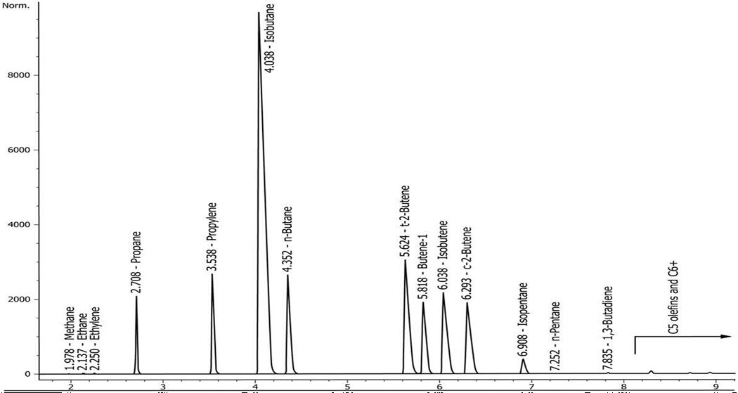

FIG.1 EXAMPLE CHROMATOGRAM USING THE PLOT COLUMN

(WITHOUT BACK FLUSH)

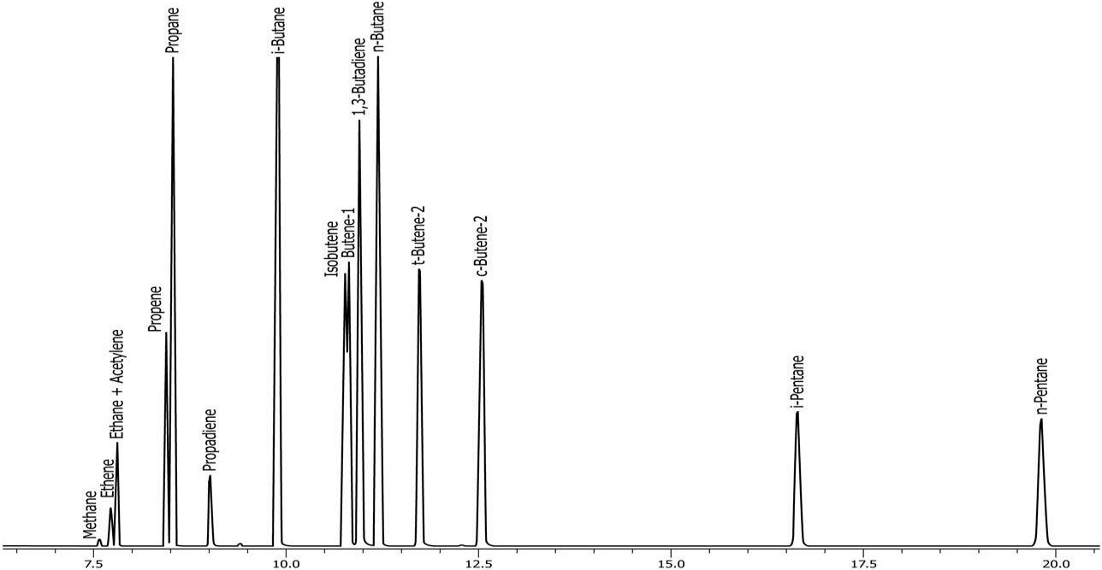

FIG. 2 EXAMPLE CHROMATOGRAM USING THE DIMETHYLPOLYSAILOXANE COLUMN.

# CALIBRATION AND STANDARDISATION

* 1. **Qualitative**

Determine the retention times of components by analyzing known reference mixtures in the same manner as the samples (*see* **11**). Typical retention times are given in Table 1.

* 1. **Quantitative, Hydrocarbons**

Use response factors for correction of the detector response of hydrocarbons determined by this test method. Experimental or theoretical response factors may be used.

* + 1. *Experimental Response Factors*

Determine the experimental response factor of components by analyzing known calibration mixtures under the same conditions of pressure and temperature as the samples (*see* **10**). For each component present in the calibration standard, calculate the response factor as given below. (Note that some integrators or computer data systems may use another formula (inverse of the formula given, in some cases) for calculating response factors.) After determining the response factors for each component, analyze a secondary standard as a sample and verify that the concentrations agree with the values for the standard within the precision and bias for this test method as determined by inter laboratory testing.

where

$$RFi=\frac{Ci}{Ai}$$

*RFi.* = response factor for component i,

*Ci* = known concentration of i, and

*Ai* = integrated area of peak i.

* + 1. *Theoretical Response Factors*

If the samples to be assayed contain only hydrocarbons and a FID is employed for the determination of those components, then theoretical response factors may be applied. The results shall then be normalized to 100 percent.

* + - 1. Table 3 provides theoretical mass response factors relative to methane (RRF). Use of these response factors will produce results in mass percent units, which may be converted to other units (liquid volume percent or mole percent) by the user as needed (*see* Table **5**). Alternately, the theoretical response factors may be converted to other units prior to quantification. Individually eluting C5 olefins or hexane-plus components, or both, may be quantified using the same RRF as the C5 / C6+ composite peak.
      2. It is necessary to compare calculated results to the certified values for a known standard before adopting the calibration. The standard should contain all of the components typically observed in the samples. Results shall agree within 5 percent of the certified value. Failure to compare may result from lack of injection split linearity or use of a standard that has not been maintained under pressure.

# Table 3 Theoretical Mass Relative Response Factors

(*Clauses* 9.2.2.1 *and* 11.2)

|  |  |  |
| --- | --- | --- |
| **Sl No.**  (1) | **Component**  (2) | **RRFi**  (3) |
| (i) | Methane | 1.0 |
| (ii) | Ethane | 0.937 |
| (iii) | Ethene (Ethylene) | 0.874 |
| (iv) | Propane | 0.916 |
| (v) | Propene (Propylene) | 0.874 |
| (vi) | Cyclopropane | 0.874 |
| (vii) | 2-Methylpropane (Isobutane) | 0.906 |
| (viii) | Ethyne (Acetylene) | 0.813 |
| (ix) | Propadiene | 0.834 |
| (x) | Butane | 0.906 |
| (xi) | Trans-2-Butene | 0.874 |
| (xii) | 1-butene | 0.874 |
| (xiii) | 2-methylpropene (isobutene) | 0.874 |
| (xiv) | cis-2-butene | 0.874 |
| (xv) | 2,2-dimethyl propane (neopentane) | 0.895 |
| (xvi) | 2-methyl butane (isopentane) | 0.899 |
| (xvii) | propyne (methyl acetylene) | 0.834 |
| (xviii) | cyclopentane | 0.849 |
| (xix) | n-pentane | 0.899 |
| (xx) | 1,3-butadiene | 0.843 |
| (xxi) | C5= /C6+ composite (backflush only) | 0.885 |
| (xxii) | > nC5 (C5= and heavier) | 0.885 |

NOTE — All response factors are relative to that of methane according to the following equation:

*RRFi* = ×

where

*RRFi* = relative response factor of each component with respect to methane,

*MWi =* molecular weight of the component,

*NCi* = number of carbon atoms in the component molecule, and

*MW*methane = molecular weight of methane.

* 1. **Quality Monitoring**

The primary or secondary standard shall be analyzed at least once a week to verify system accuracy, when the test method is in regular use. If the test method is used only occasionally, analyze a primary or secondary standard before each set of analyses.

# PROCEDURE

* 1. **Sampling**

Sampling at the sample source and at the chromatograph shall always be done in a manner that ensures that a representative sample is being analyzed. Lack of precision and accuracy in using this test method can most often be attributed to improper sampling procedures.

* 1. **Liquid Sample Valve Injection**

For propene concentrates, butane samples, or other LPG samples, the sample may be introduced as a liquid by means of a liquid sample valve. It is strongly suggested that the use of a floating piston type sample cylinder be used and that the sample be pressurized to 1380 kPa (200 psi) above the vapor pressure of the sample prior to sampling.

* + 1. In a hood, prior to connecting the cylinder, invert the cylinder and purge a small aliquot of the sample through the valve on the sample cylinder to remove any moisture or particulate matter which might be present.
    2. Connect the pressurized liquid standard to the sample in port of the liquid sampling valve and close the waste vent shut-off valve. Open the outlet valve on the standard cylinder and open the waste shut-off valve for 10 s to 15 s to allow sample to flow through the sampling valve. Flushing the valve several times prior to injection provides some local cooling, and it provides for more repeatable liquid injections. When liquid is flowing through the valve, quickly close the waste shut-off valve, then rotate the liquid sampling valve to inject the sample.
    3. If the back flush option is being used, switch the back flush valve at the pre- determined time elute the C5 / C6+ composite to the detector.
  1. **Gas Sample Valve Injection (optional)**

Vaporize the liquid sample according to the procedures given in **10.3.1** through **10.3.5**, or using an on-line heated vaporizing device that is heat traced to the gas sampling valve, as described in **10.3.6**. Flash a gas sample loop with 5 ml to 10 ml or sample, close cylinder valve, and allow the sample pressure to equilibrate to atmospheric pressure (stopped flow) before introducing the sample into the carrier gas stream.

* + 1. In a hood, prior to connecting the cylinder, invert the cylinder and purge a small aliquot of the sample through the valve on the sample cylinder to remove any moisture or particulate matter which might be present.
    2. Attach a secondary sampling vessel, consisting of two ball valves joined together and having an internal volume of approximately 1 ml to the liquid outlet on the sample vessel.
    3. Evacuate the secondary vessel to approximately 0.13 kPa (1 mm Hg), including the connection to the liquid outlet of the sample vessel. Close all valves.
    4. Slowly open the sample outlet valve of the sample cylinder to fill the connection with liquid. Open the inlet ball valve of the secondary vessel and fill the vessel with liquid. Holding the liquid sample vessel vertically with the secondary vessel on the bottom, open the outlet ball valve and allow a portion of the liquid to purge through the secondary vessel. Shut the outlet ball valve, followed by the inlet ball valve and the sample cylinder outlet valve, in that order. Disconnect the secondary vessel.
    5. Connect the secondary vessel to a container with an approximate volume of 100 ml which is fitted with needle valves or shut-off valves. Open the container valves and evacuate the container and connecting pipe work. Close the container outlet valve and slowly open the secondary vessel outlet valve to allow the liquid sample to vaporize into the evacuated vessel. Close all valves. The 100 ml container will contain a vapor that is representative of the liquid sample and have a gauge pressure of 69 kPa to 138 kPa (10 psi to 20 psi). This gas may be used to purge the sample loop of the gas sampling valve as described in **11.1**.
    6. Alternatively, an on-line heated vaporizing device, which is heat traced to the gas sampling valve, may be used. The device should consist of a volume of tubing of approximately 10 ml that is encased in a heated block (the block should be a high mass block heated to approximately 60 oC). The outlet of the tubing should be heat-traced and connected to the gas sampling valve. Connect the liquid sample cylinder to the inlet of the heated tubing. Using the sample cylinder outlet valve, pulse several small aliquots of the liquid sample through the tubing successively. Allow the sample loop of the gas sampling valve to equilibrate to ambient pressure, and then rotate the gas sampling valve to inject the vaporized sample.

# CALCULATION

* 1. **External Standard Calibration Calculation (recommended)**

Calculate the concentration of each component as per equation given below. Determine the total amount of hydrocarbons by summing the component concentrations. If the sample is known to contain only hydrocarbons, then the results shall be normalized to 100.00 percent. Occasionally, normalized results will not equal precisely 100.00 percent due to rounding. In this case, small differences are typically added to the largest component. As stated in 1.2, this test method does not fully determine non-hydrocarbon materials and normalization could cause skewed data.

*SCi = RFi × SAi*

where

*SCi* = concentration of component i in the sample,

*RFi* = response factor for component i, and

*Sai* = integrated area for peak i,

* 1. **Theoretical Relative Response Calibration Calculation**

If a FID is being employed for the determination of those components, then theoretical response factors, as listed in Table 3, may be applied in place of *RFi*. The results shall then be normalized to 100 percent. Use of these response factors will produce results in mass percent units, which may be converted to other units (liquid volume percent or mole percent) by the user as needed (*See* Table **5**). Alternately, the theoretical response factors may be converted to other units prior to quantitation. Quantitation using theoretical response factors does not account for the presence of non-hydrocarbon components. If non hydrocarbon components are present, the results using this calculation method will not be representative or valid.

# REPORT

* 1. Report the concentration of each component as liquid volume percent to the nearest 0.01 percent.
  2. Individually eluted C5 olefins and hexanes-plus components may be speciated and reported separately or summed together into groups.

# PRECISION AND BIAS

* 1. **Repeatability**

The difference between two test results obtained by the same operator using the same apparatus under constant operating conditions on identical test material would, in the long run, in the normal and correct operation of the test method, exceed values for r in Table 4 only in one case in twenty.

* 1. **Reproducibility**

The difference between two single and independent results obtained by different operators working in difference laboratories for identical test materials would in the long run, exceed the R values in Table 4 only in one case in twenty.

**13.1.3** *Bias*

The bias of this test method could not be determined at the time of the inter laboratory study as on reference materials were available.

# Table 4 Repeatability and Reproducibility

(*Clause* 13.1 *and* 13.2)

|  |  |  |  |  |
| --- | --- | --- | --- | --- |
| **Sl No.**  (1) | **Component**  (2) | **Concentration Range, vol. percent**  (3) | **Repeatability (r), vol. percent**  (4) | **Reproducibility (R), vol. percent**  (5) |
| (i) | Methane | 0.004 - 0.05 | 0.2 * (X+0.011) | 1.44 * (X+0.011) |
| (ii) | Ethane | 0.002 - 2.94 | 0.108 * X0.65 | 0.322 * X0.65 |
| (iii) | Propane | 0.96 - 98.22 | 0.397E-01 * X0.7 | 0.17415 * X0.7 |
| (iv) | Propene | 0.014 - 77.33 | 0.661E-01 * X0.66 | 0.285 * X0.66 |
| (v) | Isobutane | 0.048 - 98.35 | 0.427E-01 * X0.4 | 0.165 * X0.4 |
| (vi) | n-butane | 0.16 - 97.5 | 0.546E-01 * X0.45 | 0.1376 * X0.45 |
| (vii) | Isopentane | 0.005 - 0.543 | 0.33E-01 * X0.25 | 0.53E-01 * X0.25 |
| (viii) | n-Pentane | 0.012 - 0.829 | 0.44E-01 * X0.4 | 0.93E-01 * X0.4 |
| (ix) | C5+ | 0.009 - 2.58 | 0.341 * X0.75 | 1.965 * X0.75 |

If LPG standards are reported in liquid volume percent, the following conversion may be helpful to determine the theoretical relative mass response factors (*see* Table **5**).

# TABLE 5 Theoretical Mass Response Factor Evaluation for Liquefied Petroleum Gas

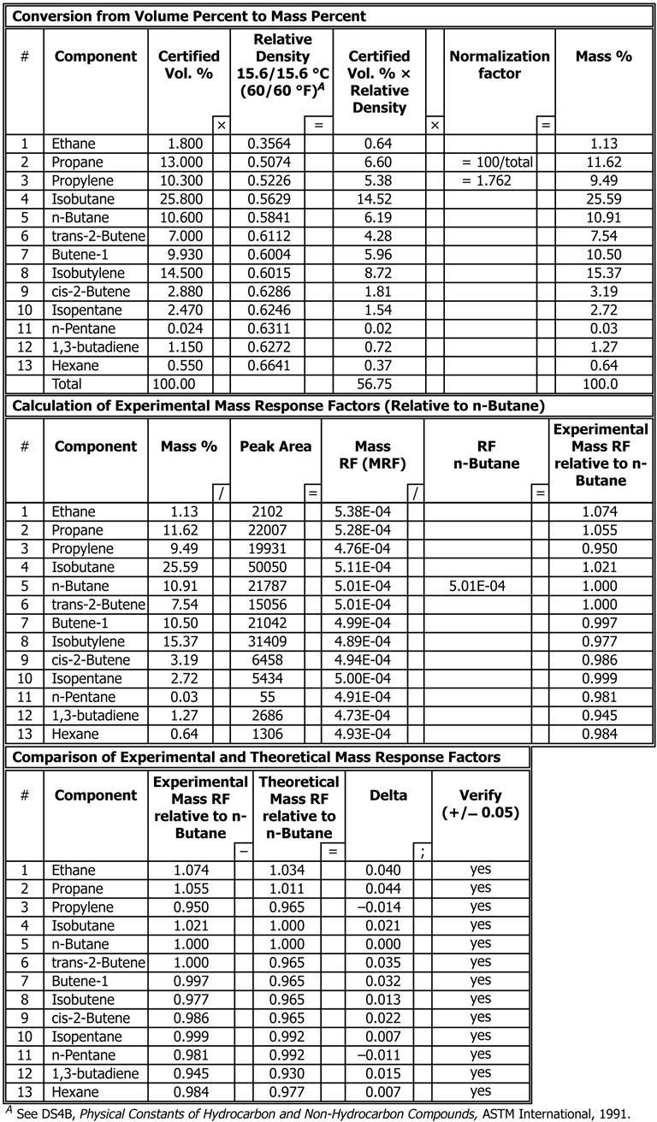

**ANNEX A**

(*Foreword*)

**COMMITTEE COMPOSITION**

**Methods of Sampling and Test for Petroleum and Related Products of Natural or Synthetic Origin (excluding bitumen) Sectional Committee, PCD 01**

| *Organization* | *Representative(s)* |
| --- | --- |
| CSIR - Indian Institute of Petroleum, Dehradun | Dr HARENDER SINGH BISHT **(*Chairperson*)** |
| Air Headquarters, Ministry of Defence, New Delhi | Wg Cdr Y Bhardwaj  Wg Cdr VS Choudhary (*Alternate* I) |
| Bharat Petroleum Corporation Limited, Mumbai | Shri R. Subramanian  Shri C. Shanmuganathan *(Alternate*) |
| CSIR - Central Institute for Mining and Fuel Research, Dhanbad | Shri S. R. K. Rao  Shri P. K. Singh (*Alternate* I)  Shri S. Dutta (*Alternate* II) |
| CSIR - Indian Institute of Petroleum, Dehradun | DR PANKAJ KUMAR KANAUJIA  DR G.D. Thakre *(Alternate*) |
| Castrol India Limited, Mumbai | Shri Raman Rai |
| Central Institute of Plastics Engineering and Technology, Bhubaneshwar | Dr Smita Mohanty  Dr. R. Ananthakumar *(Alternate*) |
| Central Revenue Control Laboratory, New Delhi | Shri V. Suresh |
| Chennai Petroleum Corporation Limited, Chennai | Shri H. Ramakrishnan  Shri M. Balaguru (*Alternate*) |
| Directorate General of Aeronautical Quality Assurance, Ministry of Defence, New Delhi | SHRI PANKAJ CHAWLA  DR MRINMOY GARAI (*Alternate*) |
| Directorate General of Quality Assurance, Ministry of Defence, Kanpur | Dr. Om Prakash Singh  SHRI A K KANAUJIA (*Alternate*) |
| Elico Limited, Hyderabad | Shri T. V. Shiva K. Rao  Shri N. Raju (*Alternate*) |
| GAIL (India) Limited, New Delhi | Dr Nityananda Panda  Dr Gopal Dayal (*Alternate*) |
| Gulf Oil Lubricants India Limited, Mumbai | Shri CT Chidambaram  SHRI MAYURESH GODBOLE (*Alternate* I)  Shri S Ganesh (*Alternate* II) |
| HPCL Mittal Energy Limited, Noida | DR Hemant Tyagi  Shri Narendra Kumar Gupta (*Alternate*) |
| Hindustan Petroleum Corporation Limited, Mumbai | Shri Elecheran Kumar  Shri SANTOSH DHAKU BHOGALE *(Alternate* I)  Shri Mahesh Totla (*Alternate* II) |
| Indian National Ship-Owners Association, Mumbai | SHRI Chitta Ranjan Dash  SHRI Shrikant Shyamkant Madiwale (*Alternate*) |
| Indian Oil Corporation Limited — Refineries and Pipelines Division, New Delhi | Dr Ashutosh Mishra  Dr Shashi Pal Singh (*Alternate*) |
| Indian Oil Corporation (MKTG), Mumbai | Shri As Krishnamoorthy  SHRI Sreekumar N. Veedu (*Alternate*) |
| Indian Oil Corporation (R and D Centre), Faridabad | Dr Ajay Kumar Arora |
| Lubrizol India Limited, Mumbai | Shri Anil Mane  Shrimati Reena Kuril (*Alternate*) |
| Mangalore Refinery and Petrochemical Limited, Mangalore | Shri Yogeesha  Shri   Anitha Shetty (*Alternate* I)  Shri R. M. Praksah (*Alternate* II) |
| Research Designs & Standards Organisation (RDSO), Lucknow | Shri Rajesh Srivastava  Shri Sonam Gupta (*Alternate*) |
| National Test House, Kolkata | Shri Vinod Kumar AmirchandRam  MS. Ishita Sur (*Alternate*) |
| Nayara Energy Limited, Mumbai | Shri Narhar Deshpande  SHRI Ketankumar Patel (*Alternate*) |
| Numaligarh Refinery Limited, Golaghat | Shri K. Srinivas  Shri Partha Jyoti Sharma (*Alternate*) |
| Oil and Natural Gas Corporation Limited, New Delhi | Shri Gour Mohan Dass  Shrimati Leena John (*Alternate* I)  SHRI DINESH S R REDDY KAKUTURI *(Alternate II)* |
| Oil India Limited, Duliajan | Shri Surajit Bora |
| Reliance Industries Limited, Mumbai | Shri Pramod Mall |
| Shriram Institute for Industrial Research, Delhi | Dr Mukesh Garg  Dr Pravesh Kumar (*Alternate*) |
| BIS Directorate General | Shrimati Meenal Passi, Scientist ‘F’/SENIOR Director and Head (Petroleum, Coal and Related Product) [Representing Director General (*Ex-officio*)] |
| *Member Secretary*  Shri Hari Mohan Meena  Scientist ‘C’/Deputy Director  (Petroleum, Coal and Related Products), BIS | |

**Methods of Test for Gaseous Fuels Subcommittee, PCD 1:5**

|  |  |
| --- | --- |
| *Organization* | *Representative(s)* |
| In Personal Capacity, New Delhi | DR ANURAG A GUPTA (***Convenor***) |
| CSIR - Indian Institute of Petroleum, Dehradun | DR SUNIL KUMAR PATHAK  DR GANESH NAIK *(Alternate)* |
| GAIL (India) Limited, New Delhi | DR. GOPAL DAYAL |
| Hindustan Petroleum Corporation Limited, Mumbai | SHRI SANTOSH DHAKU BHOGALE |
| Indian Oil Corporation Limited, New Delhi | SHRI M SITHANATHAN |
| Mangalore Refinery and Petro Chemical Limited, Mangalore | SHRI SUDHEER PAI. M  SHRI UDAY. B *(Alternate)* |
| Nayara Energy Limited, Mumbai | SHRI NARHAR DESHPANDE  SHRI ARPAN SHAH *(Alternate)* |
| Oil and Natural Gas Corporation Limited, New Delhi | SHRI DINESH S R REDDY KAKUTURI |
| Reliance India Limited, Mumbai | SHRI SHRIKANT SHINGTE |
| Shell India Markets Private Limited, Mumbai | SHRI SIVA KASTURI |