**Doc: PCD 01 (20185) F**

***भारतीय मानक***

***Indian Standard***

**IS 1448 (Part 55/ Sec 1): 2024**

***पेट्रोलियम और उसके उप्ताद —***

***परीक्षण पद्धतियाँ***

***भाग 55 / अनुभाग* 1 *पेट्रोलियम उत्पादों***

***के साबुनीकरण मूल्य का निर्धारण***

(दूसरा पुनरीक्षण*)*

**PETROLEUM AND ITS PRODUCTS**

**— METHODS OF TEST**

**PARTS 55 / SEC 1 DETERMINATION OF**

**SAPONIFICATION VALUE OF**

**PETROLEUM PRODUCTS**

*)Second Revision*)

ICS 75.080

© BIS 2023

भारतीय मानक ब्यूरो

BUREAU OF INDIAN STANDARDS

मानक भवन, 9 बहादुर शाह ज़फर मार्ग, नई दिल्ली - 110002

MANAK BHAVAN, 9 BAHADUR SHAH ZAFAR MARG

NEW DELHI - 110002

[www.bis.gov.in](http://www.bis.org.in) [www.standardsbis.in](http://www.standardsbis.in)

**June 2024 Price Group X**

Methods for Sampling and Test for Petroleum and Related Products of Natural or Synthetic Origin (excluding bitumen) Sectional Committee, PCD 01

# FOREWORD

This Indian Standard (Part 55/Sec 1) (Second Revision) was adopted by the Bureau of Indian Standards, after the draft finalized by the Methods for Sampling and Test for Petroleum and Related Products of Natural or Synthetic Origin (excluding bitumen) Sectional Committee had been approved by the Petroleum, Coal and Related Products Division Council.

This standard was originally published in 1963 based on ASTM D963-54. The standard was first revised in 2004 and was divided into two sections.

* Section 1 Determination of saponification value of petroleum products
* Section 2 Saponifiable value of petroleum products and saponifiable and unsaponifiable matter in oil fat and waxes.

During first revision considerable assistance was taken from ASTM D94 “Standard Test Methods for Saponification Number of Petroleum Products”, IP 136 Section 1 “Petroleum products - Determination of saponification number — Part 1 Colour-indicator titration method” and Section 2 “Petroleum products - Determination of saponification number — Part 2: Potentiometric titration method”.

This second revision has been brought out to keep pace with the latest technological developments and international practices. In this revision, the following major changes have been made:

1. Scope of the standard has been modified;
2. Colour indicator titration method has been aligned with ISO 6293-1:1996; and
3. Potentiometric titration method has been incorporated and aligned with ISO 6293-2:1998

The composition of the Committee, responsible for the formulation of this standard is given in Annex B.

In reporting the result of a test or analysis made in accordance with this standard, if the final value, observed or calculated, is to be rounded off, it shall be done in accordance with IS 2 : 2022 ‘Rules for rounding off numerical values (*second revision*)’.

*Indian Standard*

**PETROLEUM AND ITS PRODUCTS — METHODS OF TEST**

**PARTS 55 / SEC 1 DETERMINATION OF SAPONIFICATION VALUE OF PETROLEUM PRODUCTS**

(*Second Revision*)

# SCOPE

* 1. This standard specifies methods of determination of the amount constituents A in petroleum products like straight mineral oil, compounded mineral oils and waxes that will saponify, under the conditions of tests. Two methods have been prescribed in this standard, Method A— Colour Indicator Titration, and Method B — Potentiometric Titration. The methods are applicable to materials having saponification numbers in the range of 2 mg KOH/g to 200 mg KOH/g.
  2. Compounds of Sulphur, Phosphorus, Halogens and some other compounds interfere by reacting with the alkali and acids under the test conditions.

NOTES

1. The results on used crankcase and turbine oils, and on oils containing the interfering compounds above as additive constituents, should be interpreted with care, bearing in mind the possible higher values obtainable due to these additional reactants.
2. The interfering compounds above are contained in extraneous materials including certain organic acids and most non alkali soaps. The odour of hydrogen sulphide near the end of the back-titration step is an indication of the presence of certain reactive Sulphur compounds, but other reactive Sulphur compounds, as well as those of chlorine, phosphorus and other interfering materials, give no simple indication during the test. A gravimetric determination of fatty acid content is an alternative procedure for the estimation of such compounds.

# PRINCIPLE

A test portion of petroleum product of known mass, dissolved in butan-2-one, is reacted by heating with a known amount of alcoholic potassium hydroxide solution. The excess alkali is titrated with standard hydrochloric acid solution, using phenolphthalein as indicator, and the saponification number calculated.

# TERMINOLOGY

* 1. **Saponify —** To hydrolyze a fat with alkali to form an alcohol and the salt of a fatty acid.

# Saponification Number — The number of milligrams of potassium hydroxide consumed by 1 g of the sample under the specified conditions of this test.

# METHOD – A COLOUR INDICATOR TITRATION

* 1. **Apparatus**
     1. *Conical flask and condenser*

A conical flask, 250 ml or 300 ml capacity, alkali-resistant, to which is attached a straight or mushroom-type reflux condenser. The straight condenser shall be fitted to the flask by means of a ground-glass joint; the mushroom-type condenser shall fit loosely to permit venting of the flask. All glassware shall be chemically clean. The flasks should be cleaned by non- alkaline cleaning agent to match the cleanliness obtained by the use of chromo-sulphuric acid. For comparison of cleaning efficiency, the visual appearance and loss in mass on heating may be used. Detergent cleaning, or the use of other strong oxidizing agents, avoids the specific hazards related to chromo-sulphuric acid, and is preferred for routine analysis. Flasks of borosilicate glass are preferred. New flasks may give high values, and old flasks that have become etched by long use should not be used. Blank tests should be run concurrently on both used and new flasks.

*Caution* **—** Chromo-sulphuric acid is a health hazard. It is toxic, a recognized carcinogen as it contains Cr (VI) compounds, highly corrosive and potentially hazardous in contact with organic materials. When using chromo-sulphuric acid cleaning solution, eye protection and protective clothing are essential. Never pipette the cleaning solution by mouth. After use, do not pour cleaning solution down the drain, but neutralize it with great care owing to the concentrated sulphuric acid present, and dispose of it in accordance with standard procedures for toxic laboratory waste as chromium is highly dangerous to the environment. Non-chromium- containing, strongly oxidizing acid cleaning solutions are also highly corrosive and potentially hazardous in contact with organic materials, but do not contain chromium which has special disposal problems.

* + 1. *Hotplate*

Heated by either electricity or steam

* + 1. *Titration burette*

Having capacity of 50 ml, graduated in 0.l ml subdivisions, or of capacity 10 ml, graduated in 0.05 ml subdivisions.

* + 1. *Balance*

Capable of weighing to the nearest 0.2 mg.

# Reagents and Materials

* + 1. *Ethanol*

95 percent (*v*/*v*) ethanol, or a solution comprising 90 percent (*v*/*v*) of 95 percent (*v*/*v*) ethanol and 10 percent (*v*/*v*) of methanol, or absolute ethanol.

NOTE —Studies have shown that 99 percent (*v*/*v*) propan-2-ol can be substituted for the ethanol in routine analysis with equivalent sensitivity and precision, but should not be used in referee tests.

* + 1. *Potassium Hydroxide* *—* 0.5 mol/l, standard alcoholic solution

Prepared in accordance with **4.2.2.1** or obtained commercially, and standardized in accordance with **4.2.2.2**.

* + - 1. *Preparation*

Add approximately 29 g of solid KOH to 1 litre of ethanol (*see* **4.2.1**) in a 2 litre conical flask. Boil gently with stirring for 10 min to 15 min. Add at least 2 g of barium hydroxide Ba (OH)2 and boil gently for a further 5 min to 10 min.

Allow to cool and stand at room temperature for at least 24 h in the dark. Transfer to the storage container by filtration or pressure displacement under inert gas conditions (carbon dioxide-free).

Store the solution in a chemically resistant dispensing bottle out of contact with cork, rubber or saponifiable stopcock lubricant, and protected by a guard tube containing soda lime or non-fibrous soda silicate absorbent Glass bottles are not recommended for storage.

* + - 1. *Standardization*

Standardize frequently enough to detect changes of 0.0005 mol/l, preferably against 2.0 g to 2.1 g of pure potassium hydrogen phthalate (*see* **4.2.7**), which has been dried for 1 h at 100 °C, weighed with an accuracy of ± 0.000 2 g and dissolved in (100 ± 0.01) ml of carbon dioxide- free water, using phenolphthalein (*see* **4.2.6**) to detect the end point.

* + 1. *Hydrochloric Acid —* 0.5 mol/l, standard alcoholic solution

Prepared in accordance with **4.2.3.1** or obtained commercially, and standardized in accordance with **4.2.3.2**.

* + - 1. *Preparation*

Mix 45 ml of concentrated hydrochloric acid (35.4 percent, *m/m*) with 1 litre of ethanol (*see* **4.2.1)**

* + - 1. *Standardization*

Standardize frequently enough to detect changes of 0.000 5 mol/l, preferably by electrometric titration of 8 ml of the 0.5 mol/l alcoholic potassium hydroxide solution (*see* **4.2.2**) diluted with 125 ml of carbon dioxide- free water.

NOTES

* + - * 1. Because of the relatively large coefficient of cubic expansion of organic liquids such as ethanol or propan-2-ol, the standard alcoholic solutions should be standardized at temperatures close to those employed in the titrations of sample, and close to 20°C.
        2. Where saponification numbers below 2 are expected, better precision may be obtained by substituting potassium hydroxide and hydrochloric acid solutions of concentration 0.l mol/l for the reagents of concentration 0.5 mol/l in **4.2** and **4.2.3**, and those in clauses **4.4** and **4.5**. No exact precision values are yet available for this technique.
    1. *Butan-2-one* (*Methyl Ethyl Ketone*) — Technical grade.

Store the butan-2-one in a dark or brown glass bottle.

* + 1. *Petroleum Spirit* — 60 °C to 80 °C boiling range.
    2. *Phenolphthalein —* Neutralized indicator solution

Dissolve 1.0 g of phenolphthalein in 100 ml ethanol (*see* **4.2.1**) and neutralize to a faint pink colour with 0.1 mol/l ethanolic potassium hydroxide solution.

* + 1. *Potassium Hydrogen Phthalate*
    2. *Potassium Chloride* — 3.0 mol/l aqueous solution.

Dissolve 225 g of solid potassium chloride (KCl) in 1.0 litre of water.

* + 1. *Xylene*
    2. *Chlorobenzene*

# Blank Determination

* + 1. Carry out one or more blank determinations concurrently with each set of samples in the manner described in **4.3.2** and **4.3.3**.

NOTES — Blank determinations should be run in duplicate on samples requiring the highest accuracy. The precision data are based on duplicate blank determinations. A single blank is sufficient for routine work.

* + 1. Measure from a burette or pipette into the conical flask (25 ± 0.03) ml of the alcoholic potassium hydroxide solution and (25 ± 1) ml of the butan-2-one (*see* **4.2.4**). If a volumetric pipette is used, wait 30 s after delivery for complete drainage.

Connect the condenser to the flask, and heat for 30 min after refluxing begins.

NOTES

* + - 1. It is known that some fats are readily saponified and complete saponification takes place within 10 min after refluxing begins. On the other hand, some materials are saponifiable only with difficulty, and are known to require more than 2 h in some cases. Neither the shortened period nor the longer period should be used, except by mutual consent of the interested parties. The reflux time of the blank should be same as that of the sample in all cases. Turn off the heat source and immediately add 50 ml of the petroleum spirit (*see* **4.2.5**) by cautiously pouring it down the condenser (disconnect the condenser if a mushroom-type is used).
      2. Pouring 50 ml of petroleum spirit down the condenser at the end of the saponification not only rinses the condenser but also cools the reaction mixture. However, in the case of insulating oils, the addition of petroleum spirit is not necessary.
    1. Titrate the blank while hot, without reheating, with the hydrochloric acid solution (*see* **4.2.3**) using three drops of the phenolphthalein indicator solution (*see* **4.2.6**). When the indicator colour has disappeared, add, drop by drop, more indicator solution. If this addition of indicator restores the colour, continue the titration, making further drop-by-drop additions of indicator, if necessary, until the end-point is reached. The end-point is reached when the indicator colour has completely disappeared and does not immediately reappear upon further drop-by-drop addition of the indicator solution. To avoid emulsification of the titration mixture, but assure phase contact, swirl the flask vigorously as the end-point is approached.
  1. **PROCEDURE**

# Test portion

Estimate the saponification number and select a test portion mass from Table 1.

NOTE — The mass is based on an anticipated back-titration of between 40 percent and 80 percent of the blank, with a maximum test portion of 20 g.

**Table 1 Mass of Test Portion for Colour Indicator Titration Method**

(*Clause* 4.4.1)

|  |  |  |
| --- | --- | --- |
| **Sl No.**  **(1)** | **Estimated Saponification Number**  mg/g of KOH  **(2)** | **Mass of Test Portion**  g  **(3)** |
| (i) | 181 to 400 | 1 |
| (ii) | 111 to 180 | 2 |
| (iii) | 71 to 110 | 3 |
| (iv) | 31 to 70 | 5 |
| (v) | 16 to 30 | 10 |
| (vi) | 0 to 15 | 20 |

* + 1. *Determination*
       1. Weigh the test portion, to the nearest 0.01 g, into the conical flask (*see* **4.1.1**). Add (25 ± 1) ml of the butan-2-one (*see* **4.2.4**) followed by (25 ± 0.03) ml of the alcoholic potassium hydroxide solution (*see* **4.2.2**), measured from a burette or pipette. Connect the condenser to the flask and heat for 30 min after refluxing begins. Turn off the heat source and immediately, add 50 ml of the petroleum spirit (*see* **4.2.5**) by cautiously pouring it down the condenser (disconnect the condenser if a mushroom-type is used).
       2. Titrate while hot with the hydrochloric acid solution (*see* **4.2.3**) as specified in **4.3.3**.

NOTE —When testing waxes, it may be necessary to reheat the solution during titration to prevent solidification of the sample.

# Calculation

Calculate the saponification number, *SN*, in milligrams of KOH per gram of sample, from equation

SN = $\frac{(V_{0}-V_{1})×N×56.1}{M}$

where

*V1* = volume of hydrochloric acid solution required for titration of the test portion, in ml;

*V0* = volume of hydrochloric acid solution required for titration of the blank solution, in ml;

*N*= concentration of the standard volumetric hydrochloric acid solution, mol/l; and

*M* = mass of the test portion, g.

# Report

Report the results, calculated in **4.5**, as saponification number (milligrams KOH per gram sample), as follows.

For electrical insulating oils — to the nearest 0.l;

For saponification numbers below 50 — to the nearest 0.5; and

For saponification numbers of 50 and above — to the nearest 1.

# Precision

The precision of the method, as obtained by statistical examination of inter laboratory test results, is illustrated in Fig. 1.

NOTE — No precision can be given for highly-coloured new or used oils, or for oils which produce dark-coloured solutions upon saponification, as colour may interfere with the detection of the end-point of the titration.

* + 1. *Repeatability (r)*

The difference between successive test results obtained by the same operator with the same apparatus under constant operating conditions on identical test material would, in the normal and correct operation of the test method, exceed the value below in only one case in 20.

where

r = 0.26√x

x is the average of the two results being compared.

* + 1. *Reproducibility (R)*

The difference between two single and independent results, obtained by different operators working in different laboratories on nominally identical test material would, in the normal and correct operation of the test method, exceed the value below in only one case in 20.

R = 0.74√x

where

x is the average of the two results being compared.

# Test Report

The test report shall contain at least the following information

1. A reference to this standard;
2. The type and complete identification of the product tested;
3. The results of the test;
4. Any deviation, by agreement or otherwise, from the standard procedures specified; and
5. The date of the test.

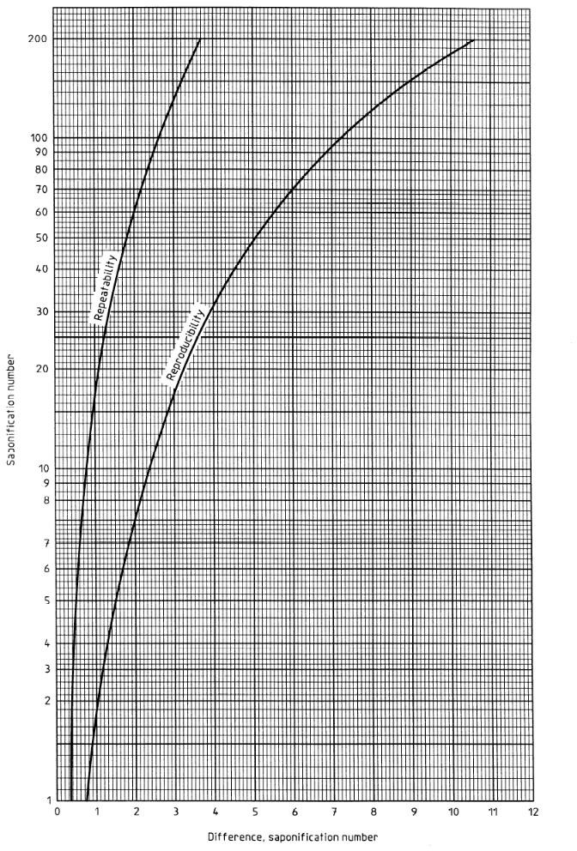

FIG. 1. PRECISION DATA

# METHOD – B POTENTIOMETRIC TITRATION METHOD

* 1. **Apparatus**
     1. *Potentiometric Titrator*

Having high precision, capable of distinguishing the carbonate ion from the hydroxide ion in the titration of reagent grade potassium hydroxide (KOH) by hydrochloric acid. Automatic, recording or manual apparatus are suitable.

* + 1. *Electrodes*, *of High Quality*

The cleaning and maintenance of the electrodes are described in Annex A.

* + - 1. Combination glass electrode, or a suitable glass electrode and a suitable reference electrode.

NOTE —Either silver chloride (AgCl), saturated lithium chloride (LiCl) or saturated potassium chloride (KCl) /calomel electrodes are suitable reference electrodes.

* + 1. *Stirrer*

Either magnetic stirring bars or a propeller stirrer, capable of providing very vigorous agitation.

NOTE —The optimum magnetic stirring bar has been found to be a 25 mm x 5 mm plain polytetra fluoroethylene (PTFE) coated cylinder.

* + 1. *Beakers*

Having capacity 250 ml or 300 ml, tall form, with or without spout.

* + 1. *Titration Assembly* — Typically as illustrated in Fig. 2.
       1. *Stirrer*

Having variable speed, either mechanical or electrical, with propeller or paddle of inert material, or a magnetic stirrer with stirring bars. All electrical devices shall be grounded (earthed) so that no permanent change to the meter reading occurs during the course of the titration.

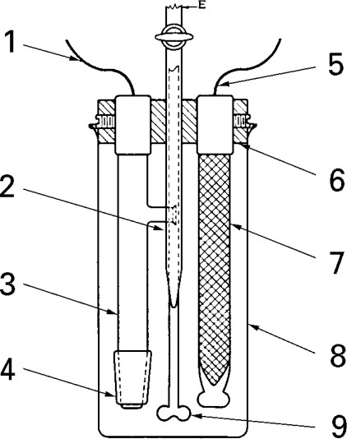

|  |  |
| --- | --- |
| 1 | Lead for reference electrode |
| 2 | Elongated burette tip (in front of  stirrer) |
| 3 | Reference electrode |
| 4 | Sleeve with ground-glass contact  joint |
| 5 | Shielded lead for glass electrode |
| 6 | Bakelite support |
| 7 | Glass electrode (internally  shielded) |
| 8 | Beaker |
| 9 | Propeller stirrer (behind burette  tip) |

FIG. 2. TYPICAL TITRATION CELL ASSEMBLY

* + - 1. *Burette*

Manual or automatic, of capacity 10 ml or 25 ml, graduated in 0.05 ml divisions, and calibrated with an accuracy of ± 0.02 ml.

* + - 1. *Titration stand*

Capable of supporting the beaker, electrodes, stirrer and burette.

NOTES

* + - * 1. An arrangement that allows for the removal of the beaker without disturbing the electrodes, burette and stirrer is desirable.
        2. Some apparatus is sensitive to interference by static electricity, shown by erratic movements of the recorder pen or meter indicator, when the titration assembly is approached by the operator. If this occurs, surround the beaker closely with a cylinder of copper gauze that is electrically grounded (earthed).

# Blank Determination

* + 1. Carry out one or more blank determinations concurrently with each set of samples in the manner described in **5.2.2** and **5.2.3**.

NOTE — Blank determinations should be run in duplicate on samples requiring the highest accuracy. The precision data are based on duplicate blank determinations. A single blank is sufficient for routine work. Duplicate blank determinations should agree within 0.5 ml. Take the average for calculations (*see* **4.6**).

* + 1. Measure, from a burette or pipette into the conical flask, (25 ± 0.03) ml of the alcoholic potassium hydroxide solution (*see* **4.2.2**) and (25 ± 1) ml of the butan-2-one (*see* **4.2.4**). Connect the condenser to the flask and heat for 30 min after refluxing begins. Turn off the heat source and immediately add 50 ml of the petroleum spirit (*see* **4.2.5**) by cautiously pouring it down the condenser (disconnect the condenser if a mushroom-type is used).

NOTES

* + - 1. If a volumetric pipette is used, wait 30 s after delivery for complete drainage.
      2. Standard procedure requires that the mixture is refluxed for 10 min. However, it is known that some fats are readily saponified and complete saponification takes place within 10 min. On the other hand, some materials are saponifiable only with difficulty and are known to require more than 2 h in some cases. Neither the shortened period nor the longer period should be used except by mutual consent of the interested parties. The reflux time of the blank should be the same as that of the sample in all cases.
      3. Pouring 50 ml of petroleum spirit down the condenser at the end of the saponification not only rinses the condenser, but also cools the reaction mixture.
      4. In the case of insulating oils, the addition of petroleum spirit is not necessary.
    1. Titrate the blank potentiometrically while hot, without re-heating, with the hydrochloric acid solution (*see* **4.2.3**).
    2. Transfer the solution to a beaker. Wash the flask with two 10 ml portions of petroleum spirit, and add these washings to the beaker.
    3. Place the beaker, with a magnetic stirring bar if used, on the titration stand (fitted with a magnetic stir plate, if stirring bars are included). Immerse the electrodes as far as possible, without interfering with the stirrer or stirring bars. Stir to the maximum agitation without causing excessive aeration or splattering of the solution.
    4. Titrate the blank solution with aqueous hydrochloric acid (*see* **4.2.3**), added at the rate of 2 ml/min, using the potentiometric titrator.

NOTE — Two inflections with corresponding equivalence points are expected. The first one corresponds to the free potassium hydroxide (KOH), and the second to the small amount of potassium carbonate (K2CO3) generally present in commercial KOH.

* + 1. Record the first inflection point.

NOTE — A pre-addition of hydrochloric acid titrant can be used in the blank to expedite the titration.

# Procedure

* + 1. *Test portion*

Estimate the saponification number and select a test portion mass from Table 2.

NOTE — The mass is based on an anticipated back-titration of between 40 percent and 80 percent of the blank, with a maximum test portion of 20 g.

# Table 2 Mass of Test Portion for Potentiometric Titration Method

(*Clause* 5.3.1)

|  |  |  |
| --- | --- | --- |
| **Sl No.**  **(1)** | **Estimated Saponification Number**  **mg/g of KOH**  **(2)** | **Mass of Test Portion**  **g**  **(3)** |
| (i) | 181 to 400 | 1 |
| (ii) | 111 to 180 | 2 |
| (iii) | 71 to 110 | 3 |
| (iv) | 31 to 70 | 5 |
| (v) | 16 to 30 | 10 |
| (vi) | 0 to 15 | 20 |

* + - 1. Weigh the test portion, to the nearest 0.01 g, into the conical flask (*see* **4.1.1**). Add (25 ± 1) ml of the butan-2-one (*see* **4.2.4**), followed by (25 ± 0.03) ml of the alcoholic potassium hydroxide solution (*see* **4.2.2**) measured from a burette or pipette. Dissolve the difficult to dissolve samples first in 15 ml to 25 ml of xylene (*see* **4.2.9**), before adding the butan-2-one.
      2. Connect the condenser to the flask and heat for 30 min after refluxing begins. Turn off the heat source and immediately add 50 ml of the petroleum spirit (*see* **4.2.5**) by cautiously pouring it down the condenser (disconnect the condenser if a mushroom-type is used).
      3. Titrate while hot, with no pre-addition of titrant, with the hydrochloric acid solution (*see* **4.2.3**) as specified in **5.2.5** and **5.2.6.** A complete titration curve is illustrated in Fig. 3.

NOTE — The potential readings are fairly constant. The reading before addition of titrant is – 520 mV. The first inflection point is moderately sharp and takes place around – 300 mV. The second inflection is extremely sharp and takes place around 50 mV.

|  |
| --- |
| A Sample |
| B Blank |

* + - * 1. 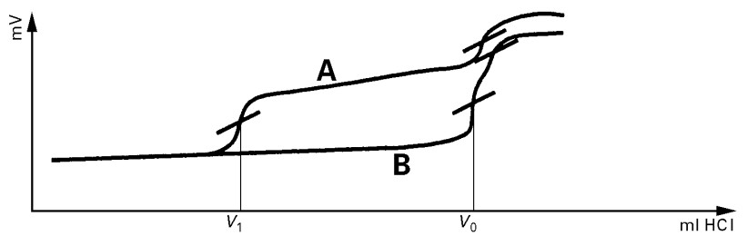**Using carbonate-containing alcoholic KOH**

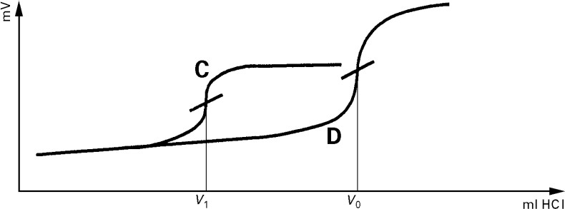

|  |
| --- |
| C Sample |
| D Blank |

**b) Using carbonate-free alcoholic KOH**

FIG. 3. TYPICAL TITRATION CURVES

# Calculation

Calculate the saponification number, SN, in milligrams of KOH per gram of sample, from equation

SN = $\frac{(V_{0}-V_{1})×N×56.1}{M}$

Where,

*V*1 = volume of hydrochloric acid solution required for titration of the test portion, ml;

*V*0 = volume of hydrochloric acid solution required for titration of the blank solution, ml;

*N* = concentration of the standard hydrochloric acid solution, mol/l; and

*M* = mass of the test portion, g.

# REPORT

Report the results, calculated in **5.4**, as saponification number (milligrams KOH per gram sample), as follows.

For electrical insulating oils —to the nearest 0.1;

For saponification numbers below 50 —to the nearest 0.5;

For saponification numbers of 50 and above —to the nearest 1

# Precision

The precision of the method, as obtained by statistical examination of inter laboratory test results is given in **5.6.1** and **5.6.2**

NOTE — No precision can be given for highly-coloured new or used oils, or for oils which produce dark-coloured solutions upon saponification, as colour may interfere with the detection of the end-point of the titration.

* + 1. *Repeatability*

The difference between successive test results obtained by the same operator with the same apparatus under constant operating conditions on identical test material would, in the normal and correct operation of the test method, exceed 2.76 mg KOH/g in only one case in 20.

* + 1. *Reproducibility*

The difference between two single and independent results, obtained by different operators working in different laboratories on nominally identical test material would, in the correct operation of the test method, exceed 10.4 mg KOH/g in only one case in 20.

# Test Report

The test report shall contain at least the following information

1. A reference to this standard;
2. The type and complete identification of the product tested;
3. The results of the test;
4. Any deviation, by agreement or otherwise, from the standard procedures specified;
5. The date of the test.

# ANNEX A

(*Clause* 5.1.2)

# PREPARATION, TESTING AND MAINTENANCE OF ELECTRODE SYSTEM

# A-1 PREPARATION OF ELECTRODES

**A-1.1** If the calomel electrode is to be changed from non-aqueous to aqueous bridge, drain out the non-aqueous solution, wash with water and methanol, then rinse the outer jacket (salt bridge) several times with potassium chloride solution (*see* **4.2.8**) and finally fill the outer jacket with this solution.

**A-1.2** When using the sleeve-type electrode, carefully remove the ground-glass sleeve and thoroughly wipe both ground surfaces. Replace the sleeve loosely and allow a few drops of electrolyte to drain through to flush the ground-glass joint and to wet the ground surfaces thoroughly with electrolyte. Set the sleeve firmly in place, refill the outer jacket with potassium chloride solution **(***see* **4.2.8)**, and rinse the electrode with chlorobenzene **(***see* **4.2.10)**.

**A-1.3** When in use, the electrolyte level in the calomel electrode shall be kept above that of the liquid in the titration beaker to prevent entry of contaminants into the salt bridge. When not in use, fill the calomel electrode with potassium chloride solution (*see* **4.2.8**), leave the bung in the filling orifice, and immerse both electrodes in water, keeping the level of the electrolyte above that of the water.

# TESTING OF ELECTRODES

Test when new electrodes are installed and retest once a month thereafter by standardizing 10 ml of potassium hydroxide solution (*see* **4.2.2**) using hydrochloric acid solution (*see* **4.2.3**).

# MAINTENANCE OF ELECTRODES

**A-3.1** Clean the glass electrode at least once every week during continual use, by immersion in cold chromo-sulphuric acid or an alternative strong oxidizing cleaner.

**A-3.2** Drain the calomel electrode at least once each week and refill with fresh potassium chloride solution (*see* **4.2.8**) as far as the filling hole. Ascertain that crystalline KCl is present. Maintain the electrolyte level in the calomel electrode above that of the liquid in the titration beaker at all times.

**A-3.3** When not in use, immerse the lower halves of the electrodes in water. Do not allow them to remain immersed in titration solvent for any appreciable period of time between titrations. Although the electrodes are not extremely fragile, handle them with care at all times.

NOTE — Thorough cleaning of the electrodes, keeping the ground-glass joint free of foreign materials, and regular testing of the electrodes are very important in obtaining repeatable potentials, since contamination can introduce uncertain and erratic liquid contact potentials, resulting in non-repeatable results.

**A-3.4** At the end of the blank titration, and between successive titrations, a thin film of potassium chloride (KCl) crystals coats the electrode and titrant delivery tip. Use a jet of water from a plastic squeeze bottle to remove it. Then rinse the electrode by immersion in a beaker full of water for a few seconds. Dry the electrode by blotting with a paper towel; do not rub the electrode.

**A-3.5** At the end of a set of sample titrations, a mixture of potassium chloride (KCl) and of sample fractions coats the electrode and titrant delivery tip. Clean these by immersion in a solution of 50 ml of xylene; 38 ml of propan-2-ol; 38 ml of water. Stir the solution for a time long enough to dissolve the coating, typically less than 1 min. Remove the traces of washing solution from the electrode with a jet of water from a plastic squeeze bottle. Then rinse the electrode further by immersion in a beaker full of water stirred for a few seconds. Dry the electrode by blotting with a paper towel; do not rub the electrode.

**A-3.6** The electrodes shall be held firmly in a steady holder so that they do not wobble when the liquid is vigorously stirred.

NOTE — Electrode wobbling creates electrical noise which interferes with the determination of end- points, resulting in non-repeatable results.

**ANNEX B**

(*Foreword*)

**COMMITTEE COMPOSITION**

Methods for Sampling and Test for Petroleum and Related Products

of Natural or Synthetic Origin (excluding Bitumen) Sectional Committee, PCD 01

| *Organization* | *Representative(s)* |
| --- | --- |
| CSIR - Indian Institute of Petroleum, Dehradun | Dr HARENDER SINGH BISHT **(*Chairperson*)** |
| Air Headquarters, Ministry of Defence, New Delhi | Wg Cdr Y Bhardwaj  Wg Cdr VS Choudhary (*Alternate* I)  WG GP CAPT ASHEESH SHRIVASTAVA (*Alternate* II) |
| Bharat Petroleum Corporation Limited, Mumbai | Shri R. Subramanian  Shri C. Shanmuganathan *(Alternate*) |
| CSIR - Central Institute for Mining and Fuel Research, Dhanbad | Shri S. R. K. Rao  Shri P. K. Singh (*Alternate* I)  Shri S. Dutta (*Alternate* II) |
| CSIR - Indian Institute of Petroleum, Dehradun | DR PANKAJ KUMAR KANAUJIA  DR G.D. Thakre *(Alternate*) |
| Castrol India Limited, Mumbai | Shri Raman Rai |
| Central Institute of Plastics Engineering and Technology, Bhubaneshwar | Dr Smita Mohanty  Dr. R. Ananthakumar *(Alternate*) |
| Central Revenue Control Laboratory, New Delhi | Shri V. Suresh  Shri Chilaka Naresh *(Alternate*) |
| Chennai Petroleum Corporation Limited, Chennai | Shri H. Ramakrishnan  Shri M. Balaguru (*Alternate*) |
| Directorate General of Aeronautical Quality Assurance, Ministry of Defence, New Delhi | SHRI PANKAJ CHAWLA  DR MRINMOY GARAI (*Alternate*) |
| Directorate General of Quality Assurance, Ministry of Defence, Kanpur | Dr. Om Prakash Singh  Shri Vikin Jain (*Alternate*) |
| Elico Limited, Hyderabad | Shri T. V. Shiva K. Rao  Shri N. Raju (*Alternate*) |
| GAIL (India) Limited, New Delhi | Dr Nityananda Panda  Dr Gopal Dayal (*Alternate*) |
| Gulf Oil Lubricants India Limited, Mumbai | Shri CT Chidambaram  Shri S Ganesh (*Alternate* I)  Shri D Vinod Kumar (*Alternate* II) |
| HPCL Mittal Energy Limited, Noida | DR Hemant Tyagi  Shri Narendra Kumar Gupta (*Alternate*) |
| Hindustan Petroleum Corporation Limited, Mumbai | Shri Elecheran Kumar  Shri S N SHESHACHALA (*Alternat*e I)  Shri Mahesh Totla (*Alternate* II) |
| Indian National Ship-Owners Association, Mumbai | SHRI Chitta Ranjan Dash  SHRI Shrikant Shyamkant Madiwale (*Alternate*) |
| Indian Oil Corporation Limited — Refineries and Pipelines Division, New Delhi | Dr Ashutosh Mishra  Dr Shashi Pal Singh (*Alternate*) |
| Indian Oil Corporation (MKTG), Mumbai | Shri As Krishnamoorthy  SHRI Sreekumar N. Veedu (*Alternate*) |
| Indian Oil Corporation (R and D Centre), Faridabad | Dr Ajay Kumar Arora |
| Lubrizol India Limited, Mumbai | Shri Anil Mane  Shrimati Reena Kuril (*Alternate*) |
| Mangalore Refinery and Petrochemical Limited, Mangalore | Shri Yogeesha  Shri   Anitha Shetty (*Alternate* I)  Shri R. M. Praksah (*Alternate* II) |
| Ministry of Railways, Lucknow | Shri Rajesh Srivastava  Shri Sonam Gupta (*Alternate*) |
| National Test House, Kolkata | Shri Vinod Kumar AmirchandRam  MS. Ishita Sur (*Alternate*) |
| Nayara Energy Limited, Mumbai | Shri Narhar Deshpande  SHRI Ketankumar Patel (*Alternate*) |
| Numaligarh Refinery Limited, Golaghat | Shri K. Srinivas  Shri Partha Jyoti Sharma (*Alternate*) |
| Oil and Natural Gas Corporation Limited, New Delhi | Shri Gour Mohan Dass  Shrimati Leena John (*Alternate* I) |
| Oil India Limited, Duliajan | Shri Surajit Bora |
| Reliance Industries Limited, Mumbai | Shri Pramod Mall |
| Shriram Institute for Industrial Research, Delhi | Dr Mukesh Garg  Dr Pravesh Kumar (*Alternate*) |
| BIS Directorate General | Shrimati Meenal Passi, Scientist ‘F’/SENIOR Director and Head (Petroleum, Coal and Related Product) [Representing Director General (*Ex-officio*)] |
| *Member Secretary*  Shri Hari Mohan Meena  Scientist ‘C’/Deputy Director  (Petroleum, Coal and Related Products), BIS | |