**Doc: PCD 01 (17545) F**

***भारतीय मानक***

***Indian Standard***

**IS 1448 Part XX: 2024**

**पेट्रोलियम और उसके उप्ताद —**

**परीक्षण पद्धतियाँ**

**गैस क्रोमैटोग्राफी द्वारा रिफाइनरी**

**गैस धाराओं में हाइड्रोकार्बन और**

**गैर-हाइड्रोकार्बन गैसों का निर्धारण**

**PETROLEUM AND ITS PRODUCTS**

**— METHODS OF TEST**

**DETERMINATION OF HYDROCARBONS**

**AND NON-HYDROCARBON GASES IN**

**REFINERY GAS STREAMS BY GAS**

**CHROMATOGRAPHY**

ICS 75.080

© BIS 2024

भारतीय मानक ब्यूरो

BUREAU OF INDIAN STANDARDS

मानक भवन, 9 बहादुर शाह ज़फर मार्ग, नई दिल्ली - 110002

MANAK BHAVAN, 9 BAHADUR SHAH ZAFAR MARG

NEW DELHI - 110002

[www.bis.gov.in](http://www.bis.org.in) [www.standardsbis.in](http://www.standardsbis.in)

**June 2024 Price Group X**

Methods of Sampling and Test for Petroleum and Related Products of Natural or Synthetic Origin (excluding bitumen) Sectional Committee, PCD 01.

**FOREWORD**

This Indian Standard was adopted by the Bureau of Indian Standards, after the draft finalized by the Methods of Sampling and Test for Petroleum and Related Products of Natural or Synthetic Origin (Excluding Bitumen) Sectional Committee had been approved by the Petroleum, Coal and Related Products Division Council.

Refinery gases consist of non-condensable light hydrocarbon gases C1 to C6 (traces), non- hydrocarbon gases such as Oxygen, Nitrogen, Hydrogen, Carbon dioxide, Carbon monoxide, Hydrogen Sulphide, and acid gases from process units. Also Liquefied Petroleum Gases (LPG) is a major product from the refinery. Toxic gases like Hydrogen Sulphide and acid gases are to be tested round the clock to ensure smooth and safe refinery operation. Liquefied petroleum gases (LPG) and Propylene are being certified in a refinery laboratory regularly. Hydro treatment and reforming processes in the refinery are generating gas samples to be estimated mainly for hydrogen and hydrocarbon impurities. Refinery furnaces are releasing flue gases continuously during operation. Uncondensable lighter hydrocarbons, mainly methane, and ethane, are used as the gaseous fuel in the refinery furnaces. Decoking operations of the process heaters are also producing gases mainly oxygen, nitrogen, carbon dioxide, and carbon monoxide.

All above stated gases need to be tested for optimum process operation, product certification, and compliance with the regulatory norms of air emission from the refinery.

This method is intended to test refinery gases in a single instrument with the multicolumn and multi detector configuration of a gas chromatograph. Both non-condensable hydrocarbon gases and non-hydrocarbon gases are tested in a single injection to the Refinery Gas Analyser (RGA).

The composition of the Committee responsible for the formulation of this standard is given in Annex B.

In reporting the result of a test or anal­­ysis made in accordance with this standard, if the final value, observed or calculated, is to be rounded off, it shall be done in accordance with IS 2: 2022 ‘Rules for rounding off numerical values (*second* *revision*)’.

*Indian Standard*

**PETROLEUM AND ITS PRODUCTS — METHODS OF TEST DETERMINATION OF HYDROCARBONS AND NON-HYDROCARBON GASES IN REFINERY GAS STREAMS BY GAS CHROMATOGRAPHY**

# 1 SCOPE

# 1.1 This standard prescribes the method of test for determination of quantitative composition of refinery gas streams containing non-condensed hydrocarbon gases with carbon numbers from C1 to C5+ and non-hydrocarbon gases such as H2, CO2, O2, N2 and CO using a preconfigured multicolumn gas chromatograph. Vaporized Liquefied Petroleum Gas (LPG) is determined for its composition, C6+ hydrocarbons are reported as a composite.

* 1. Hydrogen Sulphide can be detected with less accuracy due to the loss in sample containers and sample injection tubing, Sulphur inert sample containers and sample injection system is required to estimate Hydrogen Sulphide accurately.
  2. Non-hydrocarbon gases are estimated in the range 0.03 mole percent to 100 mole percent using thermal conductivity detector (TCD) and hydrocarbon gases are estimated in the range 0.005 mole percent to 100 mole percent using Flame Ionization Detector (FID).
  3. This test method is not used to determine individual hydrocarbons greater than C5, heavier hydrocarbons are reported as C6+.
  4. Helium and Argon in the mixture will interfere with the estimation of Hydrogen and Oxygen respectively.
  5. Water vapour will interfere with C6+ analysis when Thermal Conductivity Detector (TCD) is used.

# SUMMARY OF TEST METHOD

The representative sample in gaseous form is injected to the multicolumn gas chromatograph and components are physically separated in the columns. The detector responses are compared to calibration data obtained under identical operating conditions (*see* Annex A) from a reference standard gas mixture of known composition. The heavier hydrocarbons C6+ are eluted by back flushing and grouped together to report. The composition of the sample is calculated by comparing the peak areas with the corresponding values obtained with calibration gas mixtures.

# SIGNIFICANCE AND USE

* 1. The distribution of hydrocarbon components in the gaseous mixture is required to judge the end use suitability. The trace amount of hyd The trace amount of hydrocarbon impurities and the relative distribution of the components in the mixture are important for use as feedstock in downstream processing units.
  2. The component distribution data are used to calculate the physical properties of the gas such as relative density, vapour pressure, molecular weight, and heating value.

# APPARATUS

* 1. **Gas Chromatograph**

Any refinery gas analyzers equipped with multicolumn configurations and three detectors to analyze non-condensed hydrocarbons and non-hydrocarbon gases is suitable and given in Fig. 1. within the scope of this method. Any gas chromatographic instrument with a linear temperature programmable column oven or adequate temperature control to provide the separation of components in the gas sample may be used.

# 4.1.1 *Detector*

# The type and number of detectors are depending on model of the refinery gas analyzer. The common Refinery Gas Analyzers (RGA) are having three detector systems:

* + - 1. One Flame Ionization Detector (FID) for the determination of the hydrocarbon gases for the components listed in Table 1. Thermal Conductivity Detector (TCD) may be also used in place of the Flame Ionization Detector (FID) to determine hydrocarbon gases if the concentration is required to determine above 0.03 mole percent.
      2. One Thermal Conductivity Detector (TCD) for the determination of Hydrogen dedicatedly using nitrogen or argon as the carrier gas.
      3. One Thermal Conductivity Detector (TCD) for the determination of all other non- hydrocarbon gases.

# Table 1 Components to be Determined with FID and TCD

(*Clause* 4.1.1.1)

|  |  |  |  |
| --- | --- | --- | --- |
| **SI No.**  **(1)** | **Component**  **(2)** | **FID**  **(3)** | **TCD**  **(4)** |
| (i) | C6+ composite | Yes | Yes |
| (ii) | Oxygen/Argon | - | Yes |
| (iii) | Hydrogen | - | Yes |
| (iv) | Carbon dioxide | - | Yes |
| (v) | Hydrogen sulphide | - | Yes |
| (vi) | Nitrogen | - | Yes |
| (vii) | Carbon monoxide | - | Yes |
| (viii) | Methane | Yes | Yes |
| (ix) | Ethane | Yes | Yes |
| (x) | Ethylene | Yes | Yes |
| (xi) | Propane | Yes | Yes |
| (xii) | Propylene | Yes | Yes |
| (xiii) | Acetylene | Yes | Yes |
| (xiv) | Isobutane | Yes | Yes |
| (xv) | Propadiene | Yes | Yes |
| (xvi) | *n*-Butane | Yes | Yes |
| (xvii) | Trans-2-butene | Yes | Yes |
| (xviii) | 1-Butene | Yes | Yes |
| (xix) | Isobutylene | Yes | Yes |
| (xx) | Cis-2-butene | Yes | Yes |
| (xxi) | Neopentane | Yes | Yes |
| (xxii) | Cyclopentane | Yes | Yes |
| (xxiii) | Isopentane | Yes | Yes |
| (xxiv) | Methyl acetylene | Yes | Yes |
| (xxv) | *n*-Pentane | Yes | Yes |
| (xxvi) | 1,3-Butadiene | Yes | Yes |

# Data Acquisition

Any computerized data acquisition system may be used to display the chromatogram and peak area integration from all the detectors used in the analysis.

# Sample Introduction

Sample is injected typically with automated valves containing sampling ‘loops’ of appropriate sizes.

# System Configurations

The Fig. 1 is the typical refinery gas analyzer configuration; it may vary among manufacturers. Required sensitivity for the application is achieved by selecting the combination of valve injection size and/or splitting inlet ratio. A typical refinery gas analyzer can be summarized from the Fig. 1.

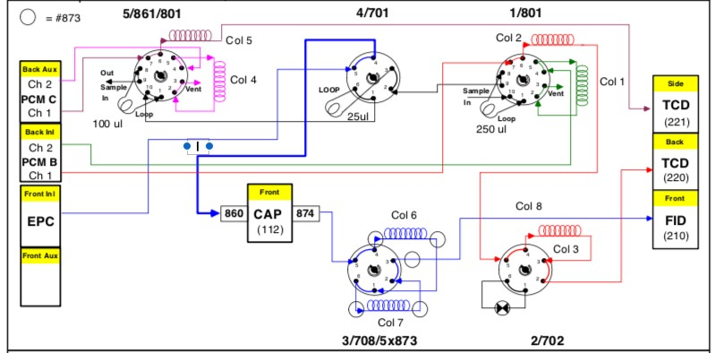

FIG. 1 TYPICAL REFINERY GAS ANALYSER CONFIGURATION

This GC System is configured with five valves and three detectors. The FID channel is configured to analyze the hydrocarbons from C1 to C5, while C6/C6+ components are back flushed and measured as one peak at the beginning of the analysis. The first TCD channel (reference gas He) is configured to analyze fixed gases, which may include CO2, CO, O2, and N2. Last, the second TCD channel (third detector, on the side, with reference gas N2) is dedicated to analyze hydrogen only.

The instrument is configured with capillary inlet (Split / Split less) and two PCM units acting as flow sources. Both the capillary inlet and the PCM identified as ‘B’ in the Fig. 1 utilize helium as carrier gas. The last PCM identified as ‘C’ in the diagram, use N2 as carrier gas in main and secondary intakes. Valves 1, 4 and 5 are gas sampling with sequence reversal and backflush of the pre-column to vent, Valve 2 is a 6 port with column isolation. Valve 3 is a 6 port column sequence reversal with backflush of the pre-column. Last, Valve 4 is a 6 port gas sampling upstream to the capillary inlet.

* + 1. *Hydrogen Sulphide and Other Reactive Gases*

Samples containing Hydrogen Sulphide and other reactive gases are required to be handled in inert sample containers such as, sulfinert and also inert sample injection system on the analyser.

* + 1. *Capillary Columns*

The gas chromatograph must have isothermally operated heated splitting type inlet, or if appropriate, direct connection to the valve may be possible as long as sample sizes are adjusted accordingly, the calibrations are linear and the required resolution of the compounds of interest is maintained. Split ratios are used depending upon the sample injection volume and sensitivity required.

* + 1. *Pre-concentrator and/or Cryogenic Trapping*

Manufacturer may provide pre-concentrator and/or cryogenic trapping prior to sample introduction into the gas chromatograph to enable to trace level of the component. Manufacturer guideline is to be followed to concentrate any component to analyze accurately.

* + 1. *Hydrogen Gas Analysis* (*TCD*)

A 10 port gas-sampling valve may be used with Nitrogen or Argon as carrier gas. Nitrogen or Argon gas is to be used to ensure that the Hydrogen ‘peak’ remains positive. By using any column or multiple columns Helium and Hydrogen are separated and also these components are separated from the other components of the sample. Typically, a dedicated TCD is used to analyse Hydrogen. Manufacture’s instruction is to be followed to estimate Hydrogen and Helium.

NOTE — When Helium is not expected the resolution of Hydrogen from Helium is not important.

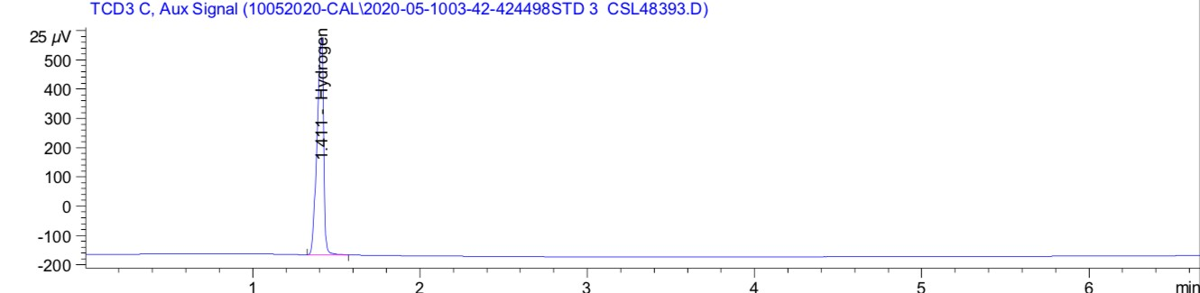

FIG. 2 HYDROGEN CHROMATOGRAM FROM TCD-3

* + 1. *Hydrocarbon Gas Analysis* (*FID*)

A 6 port gas-sampling valve in combination with a 6-port pre-column switching backflush valve for C6+ is used in refinery gas analyser. These valves are housed in a heated enclosure and the temperature is maintained as per manufacturer’s directive to prevent the condensation of C6+ components in the sample.

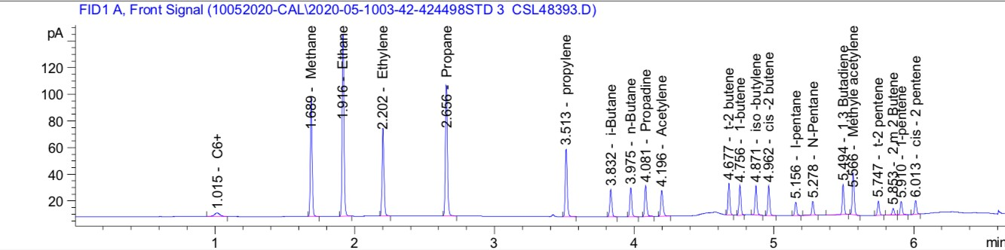

FIG. 3 HYDROCARBON CHROMATOGRAM FROM FID

* + 1. *Non-Hydrocarbon Gases*

A 10 port gas-sampling valve in combination with 6 port valve using Helium or Hydrogen gas as carrier gas to detect O2, N2, CO2 and CO by using any column or multiple columns. Also lighter hydrocarbon gases CH4, C2H6 can be analysed through TCD detection from the stated column/columns.

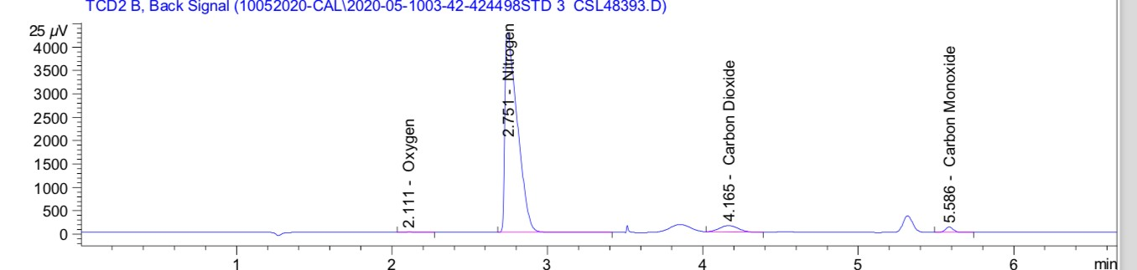

FIG. 4 NON-HYDROCARBON GASES CHROMATOGRAM FROM TCD-2

* + 1. *Column Series/Reversal Switching Valve*

A multiport valve may be used to provide the C6+ for this analysis. Manufacturer’s manual is to be followed for this configuration details.

NOTE — If Dimethyl silicone capillary is the column, the same column may be used to elute all hydrocarbon compounds using temperature programming without backflush operation.

* + 1. *Gas Controls*
    2. *Analytical Columns*

A typical refinery gas analyser (Fig. 1) contains the following analytical columns.

* + - 1. *Column* 1 — 0.61 m length, 2 mm inner diameter, 3.175 mm outer diameter, stainless steel material with silica gel beads
      2. *Column* 2 — 1.22 m length, 2 mm inner diameter, 3.175 mm outer diameter, stainless steel material with silica gel beads
      3. *Column* 3 — 2.44 m length, 2 mm inner diameter, 3.175 mm outer diameter, stainless steel material with molecular sieve 0.5 nm
      4. *Column* 4 — 1 m length, 2 mm inner diameter, 3.175 mm outer diameter, stainless steel material with porous polymer absorbent
      5. *Column* 5 — 2.44 m length, 2 mm inner diameter, 3.175 mm outer diameter, stainless steel material with molecular sieve 0.5 nm
      6. *Column* 6 — 15 m length, 0.32 mm inner diameter, 5µm film, Polysiloxane phase
      7. *Column* 7 — 25 m length, 0.32 mm inner diameter, 8µm film, Al2O3S phase
      8. *Column* 8 — 0.45m length, 0.32mm inner diameter, 8µm film, fused silica phase

NOTE — Column details and reactivation procedure may be obtained from the supplier.

# 5 REAGENTS AND MATERIALS

All chemicals are of reagent grade unless specified otherwise, and all water used is distilled or deionized.

# 5.1 Carrier Gases

Gas purifiers to remove oxygen and moisture are to be installed at the inlet to the gas chromatograph for all carrier gases.

**5.1.1** *Chromatographic Grade Hydrogen* — 99.995 percent minimum purity, <0.1 ppm H2O

**5.1.2** *Chromatographic Grade Helium* — 99.995 percent minimum purity, <0.1 ppm H2O

**5.1.3** *Chromatographic Grade Nitrogen* — 99.995 percent minimum purity, <0.1 ppm H2O

# 5.2 FID Detector Gases

**5.2.1** *Chromatographic Grade Hydrogen* — 99.995 percent minimum purity

**5.2.2** *Chromatographic Grade Air* — Less than 10 ppm-mol each of total hydrocarbons and water.

# 5.3 Calibration Standards

Individual and mixed component reference standards are available commercially and may be used to calibrate the instrument. The calibration standard mixture should be prepared gravimetrically and supplied with both gravimetric and calculated volumetric and mole percent concentrations and to be NIST traceable. The calibration standard mixture should have analytical uncertainty of less than 1 percent relative.

# Secondary Reference Standards

A mixture or mixtures of known composition that is (are) independent of the calibration standards and similar wherever possible in concentration to the samples being analyzed. The secondary reference standards are used as check standards to monitor testing precision and accuracy.

# PREPARATION OF APPARATUS

Manufacturer’s operating manual is to be followed to make the analyzer ready for testing.

# CALIBRATION AND STANDARDIZATION

* 1. After the installation of the analyzer and at least yearly thereafter, retention times of the components of reference standards are determined. The order of elution and the detections from TCD and FID detectors are verified as per the guideline of the analyzer manufacturer.
  2. The linearity of the response of the component of interest is verified using at least three concentrations of the analytics bracketing the expected concentration of the analyte. The linearity regression coefficient of the component should be at least 0.999. For low concentration points separate calibration may be required if linearity criteria are not achieved. Linearity should be confirmed annually.
  3. After the linearity is established a single calibration standard may be used to calibrate and recalibrate periodically or after any hardware change or the failure of QC check. Experimental response factors are determined for each component of the calibration standard which is tested under the same conditions of pressure and temperature as the sample. Response factors are calculated according to Eq. 1.

*RFi = Ci / Ai* (1)

where

*RFi* = the response factor of component *i*;

*Ci* = the known concentration of *i*;

*Ai* = the integrated area of peak *i.*

The response factor of C6+ when back flushed as one composite is estimated as follows.

*RFC6+ = RFC5AV* x (72/93) (2)

where

*RFC6+* = the response factor C6+

*RFC5AV* = the average response factors of *i*-C5 and *n*-C5

NOTES

**1** When urging the valve, sample loops and the inlet systems with calibration standards, high flow is to be avoided as the high flow may change the composition of the standard mixture, the typical purging flow should be approximately 10-30 mL/min.

**2** Standards containing Hydrogen Sulphide should use corrosive resistant regulators. Vents from the gas sampling valve to be vented to a well-ventilated hood to avoid the exposure to hydrogen Sulphide.

**3** Hydrocarbons with a boiling point greater than Isopentane in the standard have a potential condensation. Proper size and the pressure of the calibration gas cylinders are to be fixed in consultation with the gas standard manufacturer.

# QUALITY MONITORING

Secondary check standard (s) that approximates composition of samples being analysed is to be run periodically to assure the accuracy of the analysis. Results should agree within 2 percent relative of the certified value for components present at more than 5 volume percent.

# SAMPLING

* 1. Introduction of the sample into a chromatograph must be done in a manner to ensure the injection of representative sample from the sample container, Improper sample introduction will lead to the less precision and inaccurate results.
  2. Higher boiling components such as C5+ may condense during sampling at the process unit if the sample vessel is not at the same or higher temperature than sample stream. This will result inaccurate collection of the sample.
  3. If the hydrocarbon dew point is lower than the temperature at which the sample is exposed, the sample is not required to heat for sample introduction to the chromatograph. If the sample is expected to contain hydrocarbons heavier than C5+, the sample is to be heated prior to the introduction to gas chromatograph.
  4. Connections from sample container to the sample inlet should be of stainless tubing, copper, vinyl and rubber tubing are not to be used.
  5. Samples should be clean and free of liquid prior to injection. It is better to use filters between sample vessel and analytical instrument to minimize the risk and damage to the instrument.

# PROCEDURE

* 1. Orient the sample vessel in vertical condition.
  2. Connect the sample from the sample vessel to the gas chromatograph sample inlet through the evaporator, if heavier hydrocarbons (> C5+) is expected in the sample.
  3. Purge the sample injection system sufficiently to purge out the trapped gases with flow in the range 50 ml/min to 70 ml/min.
  4. Stop the purging and start the analysis at zero sample flow at the outlet.
  5. Take the Chromatograph output, review the results and report.

# CALCULATION

**11.1** Calculate the concentration of each component according to the following equation:

𝑆𝐶𝑖= 𝑅𝐹𝑖 × 𝑆𝐴i **(3)**

where

𝑆𝐶𝑖 = concentration of component *i* in the sample;

𝑅𝐹𝑖 = response factor for component *i*; and

𝑆𝐴*i* = integrated area for peak *i*.

**11.2** Determine the total amount of all components by summing the component concentrations.

**11.3** The sum of all component concentrations from **11.1** shall be within (100 ± 5) percent.

**11.4** Normalize the final results to 100 percent.

# REPORTING

Report the concentration of each component as mole percent nearest to 0.01 percent

# PRECISION

* 1. **Repeatability**

The difference between successive test results obtained by the same operator with the same apparatus under constant operating conditions on identical test materials.

* + 1. The Repeatability (r) is less than 1 percent.

# Reproducibility

The difference between two single and independent results obtained by different operators working in different laboratories on identical test materials.

* + 1. The Reproducibility (R) is not established for this test method.

**ANNEX A**

(*Clause* 2)

**RECOMMENDED OPERATING CONDITIONS**

**A-1 TYPICAL GC CONDITIONS FOR REFINERY GAS ANALYSER**

|  |  |
| --- | --- |
| Valve temperature | 120 °C |
| Oven temperature program | 60 °C hold 1 min, to 80 °C at 20 °C /min, to 190 °C at 30 °C /min |

**A-2 FID CHANNEL**

|  |  |
| --- | --- |
| Front inlet | 150 °C, split ratio 30:1 (uses higher or lower split ratio according to  the concentrations of hydrocarbons) |
| Column | 6 and 7 |
| Column flow (He) | 3.3 ml/min (0.89 kg/cm2 at 60 °C), constant flow mode |

**A-3 FID**

|  |  |
| --- | --- |
| Temperature | 200 °C |
| H2 flow | 40 ml/min |
| Air flow | 400 ml/min |
| Make up (N2) | 40 ml/min |

**A-4 SECOND TCD CHANNEL**

|  |  |
| --- | --- |
| Column | 1, 2 and 3 |
| Column flow (He) | 25 ml/min (2.53 kg/cm2 at 60 °C), constant flow mode |
| Precolumn flow (He) | 22 ml/min (0.49 kg/cm2 at 60 °C), constant pressure mode |

**A-5 TCD**

|  |  |
| --- | --- |
| Temperature | 200 °C |
| Reference flow | 45 ml/min |
| Make up | 2 ml/min |

**A-6 THIRD TCD CHANNEL**

|  |  |
| --- | --- |
| Column | 4 and 5 |
| Column flow (N2) | 24 ml/min (1.82 kg/cm2 at 60 °C), constant flow mode |
| Precolumn flow (N2) | 24 ml/min (0.49 kg/cm2 at 60 °C), constant pressure mode |

**A-7 TCD**

|  |  |
| --- | --- |
| Temperature | 200°C |
| Reference flow | 30 ml/min |
| Make up | 2 ml/min |

**ANNEX B**

(*Foreword*)

**COMMITTEE COMPOSITION**

Methods of Sampling and Test for Petroleum and Related Products of Natural or Synthetic Origin (excluding bitumen) Sectional Committee, PCD 01

| *Organization* | *Representative(s)* |
| --- | --- |
| CSIR - Indian Institute of Petroleum, Dehradun | Dr HARENDER SINGH BISHT **(*Chairperson*)** |
| Air Headquarters, Ministry of Defence, New Delhi | Wg Cdr Y Bhardwaj  Wg Cdr VS Choudhary (*Alternate* I)  WG GP CAPT ASHEESH SHRIVASTAVA (*Alternate* II) |
| Bharat Petroleum Corporation Limited, Mumbai | Shri R. Subramanian  Shri C. Shanmuganathan *(Alternate*) |
| CSIR - Central Institute for Mining and Fuel Research, Dhanbad | Shri S. R. K. Rao  Shri P. K. Singh (*Alternate* I)  Shri S. Dutta (*Alternate* II) |
| CSIR - Indian Institute of Petroleum, Dehradun | DR PANKAJ KUMAR KANAUJIA  DR G.D. Thakre *(Alternate*) |
| Castrol India Limited, Mumbai | Shri Raman Rai |
| Central Institute of Plastics Engineering and Technology, Bhubaneshwar | Dr Smita Mohanty  Dr. R. Ananthakumar *(Alternate*) |
| Central Revenue Control Laboratory, New Delhi | Shri V. Suresh  Shri Chilaka Naresh *(Alternate*) |
| Chennai Petroleum Corporation Limited, Chennai | Shri H. Ramakrishnan  Shri M. Balaguru (*Alternate*) |
| Directorate General of Aeronautical Quality Assurance, Ministry of Defence, New Delhi | SHRI PANKAJ CHAWLA  DR MRINMOY GARAI (*Alternate*) |
| Directorate General of Quality Assurance, Ministry of Defence, Kanpur | Dr. Om Prakash Singh  Shri Vikin Jain (*Alternate*) |
| Elico Limited, Hyderabad | Shri T. V. Shiva K. Rao  Shri N. Raju (*Alternate*) |
| GAIL (India) Limited, New Delhi | Dr Nityananda Panda  Dr Gopal Dayal (*Alternate*) |
| Gulf Oil Lubricants India Limited, Mumbai | Shri CT Chidambaram  Shri S Ganesh (*Alternate* I)  Shri D Vinod Kumar (*Alternate* II) |
| HPCL Mittal Energy Limited, Noida | DR Hemant Tyagi  Shri Narendra Kumar Gupta (*Alternate*) |
| Hindustan Petroleum Corporation Limited, Mumbai | Shri Elecheran Kumar  Shri S N SHESHACHALA (*Alternat*e I)  Shri Mahesh Totla (*Alternate* II) |
| Indian National Ship-Owners Association, Mumbai | SHRI Chitta Ranjan Dash  SHRI Shrikant Shyamkant Madiwale (*Alternate*) |
| Indian Oil Corporation Limited — Refineries and Pipelines Division, New Delhi | Dr Ashutosh Mishra  Dr Shashi Pal Singh (*Alternate*) |
| Indian Oil Corporation (MKTG), Mumbai | Shri As Krishnamoorthy  SHRI Sreekumar N. Veedu (*Alternate*) |
| Indian Oil Corporation (R and D Centre), Faridabad | Dr Ajay Kumar Arora |
| Lubrizol India Limited, Mumbai | Shri Anil Mane  Shrimati Reena Kuril (*Alternate*) |
| Mangalore Refinery and Petrochemical Limited, Mangalore | Shri Yogeesha  Shri   Anitha Shetty (*Alternate* I)  Shri R. M. Praksah (*Alternate* II) |
| Ministry of Railways, Lucknow | Shri Rajesh Srivastava  Shri Sonam Gupta (*Alternate*) |
| National Test House, Kolkata | Shri Vinod Kumar AmirchandRam  MS. Ishita Sur (*Alternate*) |
| Nayara Energy Limited, Mumbai | Shri Narhar Deshpande  SHRI Ketankumar Patel (*Alternate*) |
| Numaligarh Refinery Limited, Golaghat | Shri K. Srinivas  Shri Partha Jyoti Sharma (*Alternate*) |
| Oil and Natural Gas Corporation Limited, New Delhi | Shri Gour Mohan Dass  Shrimati Leena John (*Alternate* I) |
| Oil India Limited, Duliajan | Shri Surajit Bora |
| Reliance Industries Limited, Mumbai | Shri Pramod Mall |
| Shriram Institute for Industrial Research, Delhi | Dr Mukesh Garg  Dr Pravesh Kumar (*Alternate*) |
| BIS Directorate General | Shrimati Meenal Passi, Scientist ‘F’/SENIOR Director and Head (Petroleum, Coal and Related Product) [Representing Director General (*Ex-officio*)] |
| *Member Secretary*  Shri Hari Mohan Meena  Scientist ‘C’/Deputy Director  (Petroleum, Coal and Related Products), BIS | |