**IS 8194 : 2024**

***भारतीय मानक***

***Indian Standard***

**3-नाइट्रो-क्लोरोबेंजीन — विशिष्टि**

(*पहला पुनरीक्षण*)

**3-Nitro-Chlorobenzene — Specification**

(*First Revision*)

ICS 71.080.99

© BIS 2024

भारतीय मानक ब्यूरो

BUREAU OF INDIAN STANDARDS

मानक भवन, 9 बहादुर शाह ज़फर मार्ग, नई दिल्ली - 110002

MANAK BHAVAN, 9 BAHADUR SHAH ZAFAR MARG

NEW DELHI - 110002

[www.bis.gov.in](http://www.bis.org.in) [www.standardsbis.in](http://www.standardsbis.in)

**December 2024 Price Group X**

Dye Intermediates Sectional Committee, PCD 26

**FOREWORD**

This Indian Standard (First Revision) was adopted by the Bureau of Indian Standards, after the draft finalized by the Dye Intermediates Sectional Committee had been approved by the Petroleum, Coal and Related Products Division Council.

3-Nitro-chlorobenzene (C6H4O2NCl) is an important dye intermediate used in the manufacture of dyestuffs. It is represented by the following structural formula:

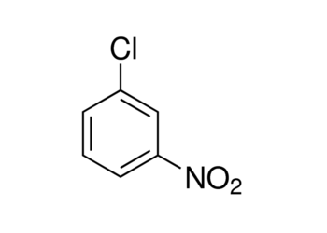

3-Nitro chlorobenzene

Molecular mass 157.5

CAS No. 121-73-3

This standard was originally published in 1976. In this (*first*) revision, determination of 3-nitro-chlorobenzene content by Gas chromatography has been updated and a new characteristic that is moisture content has been incorporated. The requirement of Dinitro compounds contents has been deleted.

The containers in which the material is stored or transported may also be labelled with pictograms, signal word, hazard statement, and precautionary statement as mentioned at Annex D, which are derived from GHS guidelines. At the time of publication, latest edition of GHS guidelines were referred and are subject to revision and parties to agreement, are encouraged to investigate the possibility of applying the most recent labels as indicated.

The composition of the Committee responsible for formulation of this standard is given in Annex E.

For the purpose of deciding whether a particular requirement of this standard is complied with, the final value, observed or calculated, expressing the result of a test or analysis, shall be rounded off in accordance with IS 2:2022 (second revision). The number of significant places retained in the rounded of value should be the same as that of the specified value in this standard.

*Indian Standard*

3-NITRO-CHLOROBENZENE –– SPECIFICATION

(*First Revision*)

**1 SCOPE**

This standard prescribes the requirements and the methods of sampling and test for 3-nitro-chlorobenzene.

**2 REFERENCES**

The following Indian standards contain provisions which through reference in the text, constitute provisions of this standard. At the time of publication the additions indicated were valid. All standards are subject to revision and parties to agreement based on the standard are encouraged to investigate the possibility of applying the most recent editions of the standards indicated below:

|  |  |
| --- | --- |
| *IS No.* | *Title* |
| 1070 : 2023 | Reagent grade water — Specification (*fourth revision*) |
| 2552 : 1989 | Steel drums (galvanized and ungalvanized) – Specification (*third revision*) |
| 5299 : 2001 | Methods of sampling and tests for dye intermediates (*first revision*) |

**3 REQUIREMENTS**

**3.1** **Description**

The material shall be in the form of yellow/brown crystalline mass or molten mass.

**3.2** The material shall also comply with the requirements given in Table 1, when tested according to the methods prescribed in col 4 and col 5 of Table 1.

**TABLE 1 REQUIREMENTS FOR 3-NITRO-CHLOROBENZENE1)**

(*Clauses* 3.2, 5.3.1 *and* 6.1)

|  |  |  |  |  |
| --- | --- | --- | --- | --- |
| **Sl No.** | **Characteristics** | **Requirement** | **Method of Test Ref to** | |
| **(1)** | **(2)** | **(3)** | **Annex** | **IS** |
| **(4)** | **(5)** |
| i) | Purity by GC, percent area, *Min* | 99.40 | A | — |
| ii) | Moisture Content by Karl Fischer, mg/kg, *Max* | 2000 | B | IS 2362 |
| iii) | Crystallization point2), *Min* | 43.5 °C | C | 8 of IS 5299 |
| iv) | Matter insoluble in methanol, percent by mass, *Max* | 0.2 | — | 11.3 of IS 5299 |
|  | | | | |
| 1)3-Nitro-chlorobenzene exists in two polymorphic forms The stable form has a crystallizing point of 43.5°C and the unstable form has a crystallizing point of 23.5°C. If the crystallizing point observed is that of the unstable form, the sample should be heated and the test is to be repeated.  2)Optional test. | | | | |

**4 PACKING AND MARKING**

**4.1 Packing**

The material shall be packed in steel drums (*see* IS 2552) or in tanker or as agreed to between the purchaser and the supplier. The containers shall be securely closed.

**4.2 Marking**

**4.2.1** Each container shall bear legibly and indelibly the following information:

a) Name of the Material;

b) Name of the manufacturer and his recognized trade-mark, if any;

c) Gross, net and tare mass;

d) Batch number, month and year of manufacturing;

e) Shelf life of the material; and

f) Any other statutory requirement.

**4.2.2** For supplies of material in bulk, a test certificate containing the details mentioned at **4.2.1** shall be provided for each consignment.

**4.2.3** *BIS Certification Marking*

The product(s) conforming to the requirements of this standard may be certified as per the conformity assessment schemes under the provisions of the *Bureau of Indian Standards Act,* 2016 and the Rules and Regulations framed thereunder, and the products may be marked with the standard mark.

**5 SAMPLING**

**5.1** The method of drawing representative samples of the material shall be as prescribed in **4** of IS 5299.

**5.2 Number of Tests**

**5.2.1** Test for the determination of all characteristics shall be conducted on the composite sample.

**5.3** **Criteria for Conformity**

**5.3.1** For declaring the conformity of the requirements of all characteristics tested on the composite sample, the test results for each of the characteristics shall satisfy the relevant requirement given in Table 1.

**6 TESTS**

**6.1** Tests shall be conducted according to the methods prescribed in col 4 and 5 of Table 1.

**6.2 Quality of Reagents**

Unless specified otherwise, pure chemicals and distilled water (see IS 1070) shall be employed in tests.

NOTE — ‘Pure chemicals' shall mean chemicals that do not contain impurities which affect the results of analysis.

**ANNEX A**[*Table* 1, *sl.no*.(i)]

**DETERMINATION ASSAY OF 3-NITRO-CHLOROBENZENE BY GAS CHROMATOGRAPHY**

**A-1 GENERAL**

Assay determination of 3-nitro-chlorobenzene shall be carried out by Gas Chromatography instrument through area percent calculation.

**A-2 APPARATUS**

**A-2.1** **Digital Balance,** 0.0001 g

**A-2.2** **Volumetric Flask** — 10 ml

**A**-**2.3 Pipette**

**A-2.3** **Micro Syringe**

**A-2.4 Gas Chromatograph**

Any gas chromatograph equipped with a flame ionization detector (FID).

**A-2.4.1** *Column*, (14% cyanopropyl-phenyl)-methylpolysiloxane with length 30 m, inner diameter 0.25 mm and film thickness 1.0 µm or equivalent.

**A-2.4.2** *Gas Chromatography Parameters*:

|  |  |
| --- | --- |
| **Carrier gas** | : Nitrogen |
| **Injector temperature** | : 275 °C |
| **Column oven programme** | |  |  |  | | --- | --- | --- | | **Rate (°C/min)** | **Temperature (°C)** | **Hold time (min)** | | -- | 100 | 2 | | 10 | 230 | 10 | |
| **Nitrogen pressure** | : 120 kPa |
| **Hydrogen flow/pressure** | : 40 ml/min |
| **Air flow/pressure** | : 400 ml/min |
| **Purge flow** | : 3.0 ml/min |
| **Make up gas** | : Nitrogen |
| **Make up flow/pressure** | : 30 ml/min |
| **Split ratio** | : 1:40 |
| **Detector type** | : FID |
| **Detector temperature** | : 275 °C |
| **Injection volume** | : 1.0 µl |

NOTE — The above gas chromatographic (GC) conditions are suggestive. However, any GC method having difference in detector, column packing material and type (like packed/capillary, diameter, length, film thickness etc.), calibration technique (internal standard, external standard, area normalization, percent area etc.), carrier gas (He, H2, N2) may be used with applicable GC operating parameters, provided standardization and calibration of the components is established after setting GC parameters for the resolution and accuracy level as specified in this standard.

**A-3 REAGENT**

**A-3.1** **Acetone**

**A-4 PROCEDURE**

Take 1.0 g of sample and make up to 10 ml with acetone. Dissolve properly and take 1.0 μl sample in a micro syringe. Confirm if there are no air bubbles in the syringe and then inject the sample and allow the instrument to complete run time.

**A-5 PEAK TIME**

3-Nitro-chlorobenzene : 13 min

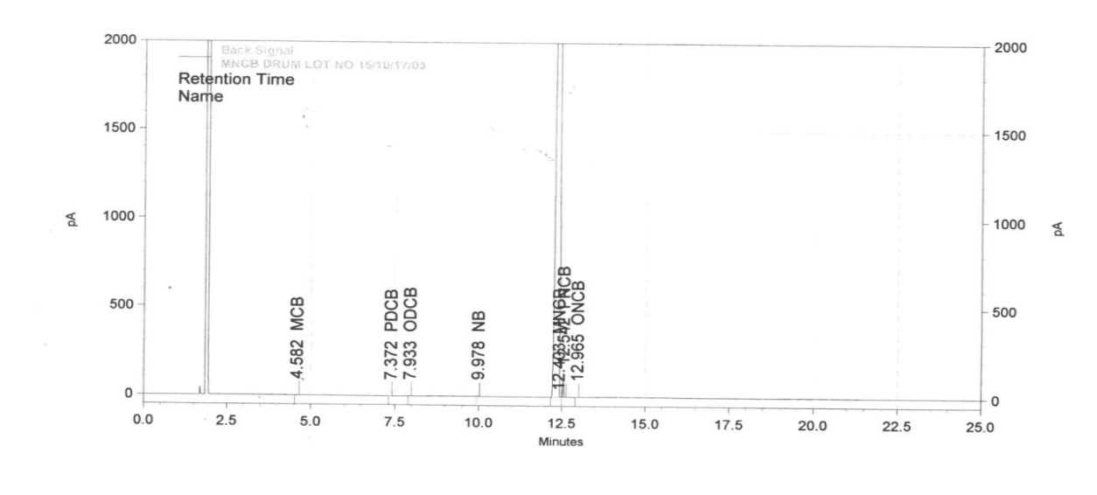  
FIG 1 A TYPICAL CHROMATOGRAM

**A-6 CALCULATION**

Calculate the peak area of individual constituent pertaining to 3-nitro-chlorobenzene on the chromatogram of the material. The concentration of the constituent may be obtained on the basis of peak area on chromatogram obtained with standard 3- nitro-chlorobenzene.

Assay, percent by area = $\frac{3-Nitrochlorobenzene peak area in the sample }{Sum Areas of all peaks in the chromatogram}$ × 100

**ANNEX B**

[*Table* 1*, sl. no. (ii*)]

**DETERMINATION OF 3-NITRO CHLOROBENZENE MOISTURE CONTENT BY KARL FISCHER**

**B-1 REAGENTS**

**B-1.1** **Karl Fischer reagent**

**B-1.2** **Methanol Dried**

**B-2 APPARATUS**

**B-2.1** **Karl Fischer Moisture Analyzer**

**B-2.2** **Dry Heating Block**

**B-2.3** **Analytical Balance**

**B-3 PROCEDURE**

Add approximately 25 ml methanol in titration vessel and stir with magnetic stirrer. Now, add Karl Fischer reagent (KF) to complete the neutralization of methanol. Now, enter sample details in the instrument and melt the sample, if required. After that, weigh 10 g of solid sample (10 ml, if liquid sample) and add in the titration vessel and press START to continue titration. Ensure proper and complete addition of sample in vessel. Once the sample is added, the instrument automatically starts addition of KF reagent in the titration vessel to titrate moisture content present in sample. Instrument will stop adding KF reagent automatically once it reaches the electrometric endpoint. Note down the burette reading.

**B-4 CALCULATION**

Moisture Content, mg/kg = $\frac{V × F }{W × 1000}$

where

*V* = volume of karl fischer reagent consumed, in ml:

*F* = karl fischer reagent factor, in mg/ml and;

*W* = weight of sample taken, in g

**ANNEX C**

[*Table* 1, *sl. no.* (iii)]

**DETERMINATION OF 3-NITRO CHLOROBENZENE CRYSTALLIZATION POINT**

**C-1 APPARATUS**

**C-1.1** **Thermometer**

NOTE –– The thermometer shall bear a certificate from any institution authorized to issue certificate traceable to international or national measurement standards.

**C-1.2** **Dry Heating Block**

**C-1.3** **Stainless Steel Wire**

**C-2 PROCEDURE**

Take approximately 15 g to 20 g of sample in a test tube and heat the sample in a dry heater till it completely melts. Remove the test tube from the dry heating block and place thermometer in the test tube in such a way that the thermometer bulb is fully covered by sample material as shown in the figure below:

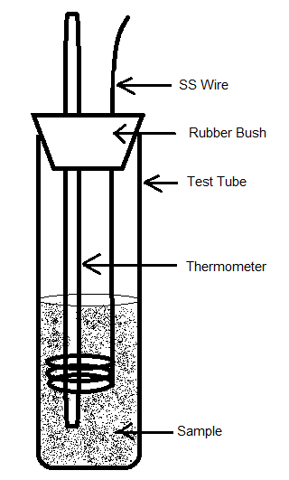

FIG. 2 APPARATUS

Now, stir the sample with stainless steel wire with vertical movement until solidification takes place. The constant temperature observed during solidification of the sample material shall be considered as crystallization point. Use water/ice batch while determination of crystallization point for products having lower crystallization point then room temperature.

**ANNEX D**

(*Foreword*)

**Pictograms, signal word, hazard statement and precautionary statement:**

|  |  |
| --- | --- |
| **Pictogram(s)** |  |
| **Signal Word** | Warning |
| **Hazard Statement** | H302 - Harmful if swallowed  H319 - Causes serious eye irritation |
| **Precautionary Statement** | P264 - Wash hands, forearms and face thoroughly after handling.  P270 - Do not eat, drink or smoke when using this product.  P280 - Wear protective gloves/protective clothing/eye protection/face protection.  P301+P312 - If swallowed: Call a poison center or doctor if you feel unwell.  P305+P351+P338 - IF IN EYES: Rinse cautiously with water for several minutes. Remove  contact lenses, if present and easy to do. Continue rinsing.  P330 - Rinse mouth.  P337+P313 - If eye irritation persists: Get medical advice/attention.  P501 - Dispose of contents/container to hazardous or special waste collection point, in  accordance with local, regional, national and/or international regulation. |

**ANNEX E**

(*Foreword*)

**COMMITTEE COMPOSITION**

Dye Intermediates Sectional Committee, PCD 26

|  |  |
| --- | --- |
| *Organization* | *Representative(s)* |
| Institute of Chemical Technology, Mumbai | PROF. GANAPATI SUBRAY SHANKARLING **(*Chairperson*)** |
| Aarti Industries Limited, Mumbai | DR. VAISHALI BHANDARY  SHRI JAYESH VASHI (*Alternate)* |
| Ankleshwar Research and Analytical Infrastructure Limited, Ankleshwar | SHRI MANSUKH H. VEKARIA |
| Archroma India Private Limited, Thane | DR. RAJESH RAMAMURTHY  SHRI HEMANT MHADESHWAR *(Alternate)* |
| Atul Limited, Gujarat | SHRI MAYUR DESAI  DR. RAIS KHAN *(Alternate)* |
| BASF India Limited, Mumbai | SHRI UDAY KULKARNI |
| Central Revenue Control Laboratory, New Delhi | SHRI V. SURESH  SHRI SHIVRAJ SINGH *(Alternate)*  SHRI MRITUNJOY MAITY *(Alternate)* |
| Colourtex Industries Limited, Mumbai | DR PANKAJ DESAI  SHRI R. K. JAISWAL *(Alternate)* |
| Deepak Nitrite Limited, Vadodara | SHRI SAILASH RAVAL  SHRI RAJENDRA SHINDE *(Alternate)* |
| Defence Research Development Organization, Ministry of Defence, New Delhi | DR. PRADEEP K. GUPTA |
| Dystar, Mumbai | DR. MONIKA SINGH |
| Gujarat Dyestuffs Manufacturers Association, Ahmedabad | SHRI NILESH DAMANI  SHRI ANKIT PATEL *(Alternate)*  SHRI SHIRIN PARIKH *(Alternate)* |
| Gujarat Narmada Valley Fertilizers Company Limited, Ahmedabad | SHRI R. M. PATEL  SHRI C. S. PATEL *(Alternate)* |
| Gujarat Pollution Control Board, Gandhinagar, Ahmedabad | SHRI D.M. THAKER |
| Heubach Colour Private Limited, Mumbai | SHRI J. I. SEVAK |
| Indian Chemical Council, Mumbai | SHRI  DHRUMIL SONI  MS. SHRADDHA RANE |
| Jay Chemicals Industries Private Limited, Ahmedabad | SHRI VILPESH YADAV  SMT MAITRI VYAS *(Alternate)* |
| Kiri Industries Limited, Ahmedabad | DR GIRISH H TANDEL  MS. SHRADDHA RANE *(Alternate)* |
| Meghmani Dyes and Intermediates Limited, Ahmedabad | SHRI MANOHAR MAHESHWARI  SHRI RAMESH SHINGARE *(Alternate)* |
| Ministry of Environment Forest and Climate Change, New Delhi | SHRI N. SUBRAHMANYAM |
| NimkarTek Technical Services Private Limited, Mumbai | SHRI ULLHAS NIMKAR  MS. ANAGHA NIMKAR *(Alternate)* |
| Sudarshan Chemical Industries Limited, Pune | DR. R. SRIDHARAN |
| The Bombay Textile Research Association, Mumbai | MS. SHITAL PALASKAR |
| The Dyestuff Manufactures Association of India Office, Mumbai | SHRI MANOJ SAPTARSHI |
| BIS Director General | SHRI CHINMAY DWIVEDI, SCIENTIST ‘E’/ DIRECTOR AND HEAD (PCD) [REPRESENTING DIRECTOR GENERAL (*Ex-Officio*)] |
| *Member Secretary*  MS ANMOL AGARWAL  SCIENTIST B/ASSISTANT DIRECTOR  (PETROLUEM, COAL AND RELATED PRODUCTS), BIS | |