***भारतीय मानक***

***Indian Standard***

**IS 10309 : 2024**

**एजवाइज़ टॉर्किंग कुंजी — विशिष्टि**

*( पहला पुनरीक्षण )*

**Edgewise Torquing Key — Specification**

( *First Revision )*

ICS 11.060.20

© BIS 2024

भारतीय मानक ब्यूरो

BUREAU OF INDIAN STANDARDS

मानक भवन, 9 बहादुर शाह ज़फर मार्ग, नई दिल्ली - 110002

MANAK BHAVAN, 9 BAHADUR SHAH ZAFAR MARG

NEW DELHI - 110002

[www.bis.gov.in](http://www.bis.org.in) [www.standardsbis.in](http://www.standardsbis.in)

**December 2024 Price Group X**

Dentistry Sectional Committee, MHD 08

FOREWORD

This Indian Standard (First Revision) was adopted by the Bureau of Indian Standards on the recommendation of the Dentistry Sectional Committee and after approval of the Medical Equipment and Hospital Planning Division Council.

This standard was first published in 1982 as ‘Specification for key, torquing, edgewise’. This revision aligns the cross references to the latest standards, incorporates revised designations for steel and revised certification clause.

The composition of the Committee responsible for formulation of this standard is given in Annex A.

For the purpose of deciding whether a particular requirement of this standard is complied with the final value, observed or calculated, expressing the result of a test or analysis shall be rounded off in accordance with IS 2 : 2022 ‘Rules for rounding off numerical values (*second revision*)’. The number of significant places retained in the rounded off value should be same as that of the specified value in this standard.

*Indian Standard*

EDGEWISE TORQUING KEY — SPECIFICATION

*( First Revision )*

1. **SCOPE**

This standard covers the dimensional and other requirements for edgewise torquing key used in dentistry.

1. **REFERENCES**

The standards given below contain provisions which, through reference in this text, constitute provisions of this standard. At the time of publication, the editions indicated were valid. All standards are subject to revision, and parties to agreements based on this standard are encouraged to investigate the possibility of applying the most recent edition of these standards.

|  |  |
| --- | --- |
| *IS No.* | *Title* |
| IS 6603 : 2024 | Stainless steel semi-finished products, bars, wire rods and bright bars — Specification (*second revision*) |
| IS 7531 : 1990 | Surgical instruments — Corrosion resistance of stainless steel surgical instruments — Methods of tests (*first revision*) |

1. **SHAPE AND DIMENSIONS**

The shape and dimension shall be as shown in Fig. 1.

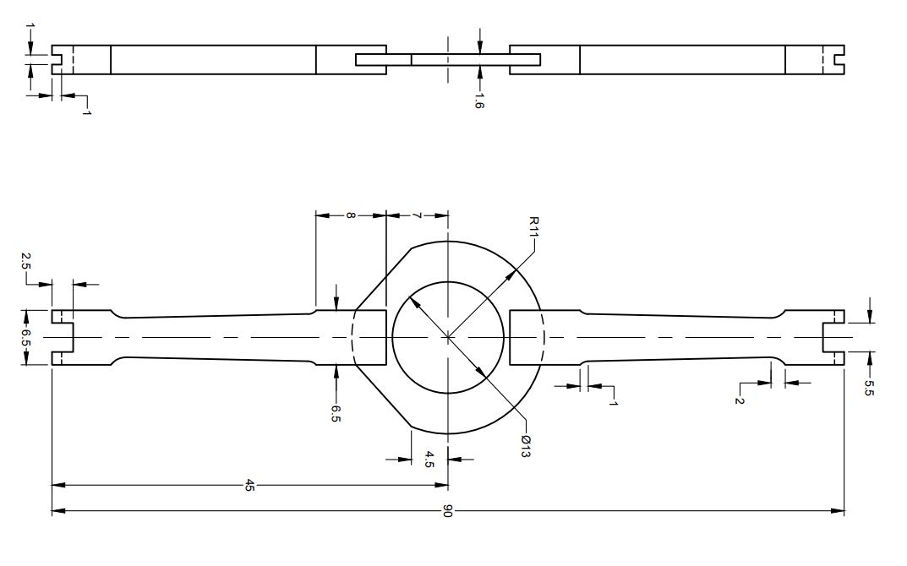

All dimensions in millimetres.

Fig. 1 Key, Torquing, Edgewise

* 1. Tolerances on depth and width of the channel shall be ± 0.05 mm.
  2. Tolerances of ± 2.5 percent shall be allowed on all other dimensions.

1. **MATERIAL**

Stainless steel conforming to designation X20Cr13 of IS 6603.

1. **WORKMANSHIP AND FINISH**
   1. The torquing key shall be free from rough edges, pits, burrs, cracks and other surface defects.
   2. The torquing key shall be forged from a single piece.
   3. The surfaces of the torquing key shall be finished smooth on all sides and the edges shall be bevelled suitably and shall not be sharp.
   4. The torquing key shall be passivated and finished bright on all sides.
2. **CORROSION RESISTANCE TEST**

Test the instrument as prescribed in IS 7531. It shall show no sign of corrosion after the test.

1. **MARKING**
   1. The torquing key shall be legibly and indelibly marked with manufacturer’s name, initials or trade-mark and the country of manufacture.
   2. **BIS Certification Marking**

The product(s) conforming to the requirements of this standard may be certified as per the conformity assessment schemes under the provisions of the *Bureau of Indian Standards Act,*2016 and the Rules and Regulations framed thereunder, and the product(s) may be marked with the Standard Mark.

1. **PACKING**

The key shall be wrapped in a polyethylene bag using suitable cushioning material like folded tissue paper and shall then be packed in individual cartons bearing the name of the item, manufacturer’s name or trade-mark, and the country of manufacture.

**ANNEX A**

(*Foreword*)

**COMMITTEE COMPOSITION**

Dentistry Sectional Committee, MHD 08

|  |  |
| --- | --- |
| *Organization* | *Representative(s)* |
|
| SRM Dental College, Chennai | Dr N. Gopi Chander ***(Chairperson)*** |
| All India Institute of Medical Sciences, New Delhi | Dr Ritu Duggal |
| Dr Krushna Vasant Kumar Bhatt (*Alternate* I) |
| Dr Siddhartha Sharma (*Alternate* II) |
| Association of Indian Medical Device Industry, New Delhi | Dr Sai Kalyan |
| Dr C. S. Prasad (*Alternate*) |
| Central Drugs Standard Control Organization, New Delhi | Shri Aseem Sahu |
| Shri Ajai Basil (*Alternate*) |
| Indian Academy of Oral Medicine and Radiology, Bengaluru | Dr Mandeep Kaur |
| Dr Abhishek Sinha (*Alternate*) |
| Indian Association of Oral and Maxillofacial Pathologists, Chennai | Dr Sushmita Saxena |
| Dr Deepak Bhargava (*Alternate* I) |
| Dr Anubhuti Sood (*Alternate* II) |
| Indian Association of Public Health Dentistry, Chennai | Dr Manjunath Puranik |
| Dr Vamsi Krishna Reddy L. (*Alternate* I) |
| Dr Tanushri Mahendra Dalvi (*Alternate* II) |
| Indian Endodontic Society, New Delhi | Dr Sanjay Miglani |
| Dr Amrita Chawla (*Alternate* I) |
| Dr Ruchika Roongta (*Alternate* II) |
| Indian Prosthodontic Society, Hyderabad | Dr Neeta Pasricha |
| Dr Aditi Nanda (*Alternate*) |
| Indian Society for Dental Research, Chennai | Prof P. Rajesh |
| Prof Deepak Chandrasekharan (*Alternate*) |
| J. Morita Corporation, Mumbai | Shri Ghanshyam Dusija |
| Shri Lokesh Jadhav (*Alternate*) |
| Kalam Institute of Health Technology, Vishakhapatnam | Dr Kavita Kachroo |
| Dr R. N. Prudhvi Teja (*Alternate*) |
| Office of Development Commissioner (MSME), New Delhi | Dr Maitreyee Talapatra |
| Tamil Nadu Government Dental College, Chennai | Dr K. Ramkumar |
| Dr T. Rohini Mds (*Alternate*) |
| In Personal Capacity (*R1/2 HIG Maraimalai nagar town center, Maraimalai nagar, Kattankulathur, Chengalpattu (DT) – 603203*) | Dr S. Jayachanadran |
| BIS Directorate General | Shri Chinmay Dwivedi, Scientist 'E' and Head (Medical Equipment and Hospital Planning) [Representing Director General (*Ex-officio*)] |
| *Member Secretary*  Ms Uroosa Warsi  Scientist ‘C’/Deputy Director  (Medical Equipment and Hospital Planning), BIS | |