***भारतीय मानक***

***Indian Standard***

**IS 6815 : 2024**

**डेंटल मैट्रिक्स रिटेनर्स — विशिष्टि**

*( पहला पुनरीक्षण )*

**Dental Matrix Retainers — Specification**

( *First Revision )*

ICS 11.060.20

© BIS 2024

भारतीय मानक ब्यूरो

BUREAU OF INDIAN STANDARDS

मानक भवन, 9 बहादुर शाह ज़फर मार्ग, नई दिल्ली - 110002

MANAK BHAVAN, 9 BAHADUR SHAH ZAFAR MARG

NEW DELHI - 110002

[www.bis.gov.in](http://www.bis.org.in) [www.standardsbis.in](http://www.standardsbis.in)

**December 2024 Price Group X**

Dentistry Sectional Committee, MHD 08

FOREWORD

This Indian Standard (First Revision) was adopted by the Bureau of Indian Standards on the recommendation of the Dentistry Sectional Committee and after approval of the Medical Equipment and Hospital Planning Division Council.

This standard was first published in 1972 as ‘Specification for retainers, matrix, dental, No. 1 and 2’. This revision aligns the cross references to the latest standards, incorporates revised designations for steel and revised certification clause.

The composition of the Committee responsible for formulation of this standard is given in Annex A.

For the purpose of deciding whether a particular requirement of this standard is complied with the final value, observed or calculated, expressing the result of a test or analysis shall be rounded off in accordance with IS 2 : 2022 ‘Rules for rounding off numerical values (*second revision*)’. The number of significant places retained in the rounded off value should be the same as that of the specified value in this standard.

*Indian Standard*

DENTAL MATRIX RETAINERS — SPECIFICATION

*( First Revision )*

1. **SCOPE**

This standard specifies dimensions and other requirements for matrix retainers No. 1 and 2 used in dentistry.

1. **REFERENCES**

The standards given below contain provisions which, through reference in this text, constitute provisions of this standard. At the time of publication, the editions indicated were valid. All standards are subject to revision, and parties to agreements based on this standard are encouraged to investigate the possibility of applying the most recent edition of these standards.

|  |  |
| --- | --- |
| *IS No.* | *Title* |
| IS 1570 (Part 5) : 1985 | Schedules for wrought steels Part 5 Stainless and heat-resisting steels (*second revision*) |
| IS 3887 : 2024 | Cutting type dental instruments — General requirements (*second revision*) |

1. **SHAPES AND DIMENSIONS**

The shape and dimensions shall be as shown in Fig. 1 and 2.

1. **MATERIAL**

The material shall be made from stainless steel conforming to Designation X20Cr13 of IS 1570 (Part 5).

1. **WORKMANSHIP AND FINISH**
   1. The instrument shall be free from defects which detract from its appearance or impair its service ability.
   2. All surfaces and edges shall be smooth to prevent pinching or scratching of mouth tissue.
   3. The instrument shall be suitably passivated and polished bright.
2. **HEAT TREATMENT**

The instrument shall be uniformity hardened and tempered to 370 HV to 410 HV.

1. **CORROSION RESISTANCE TEST**

The instrument shall be tested as given in **9.1** of IS 3887.

1. **MARKING**
   1. The instrument shall be marked with the number of the instrument, manufacturer’s name, initials or trade-mark; the letters ‘SS’; and the country of manufacture.
   2. **BIS Certification Marking**

The product(s) conforming to the requirements of this standard may be certified as per the conformity assessment schemes under the provisions of the *Bureau of Indian Standards Act, 2016* and the Rules and Regulations framed there under, and the product(s) may be marked with the Standard Mark.

1. **PACKING**

As agreed to between the purchaser and the supplier.

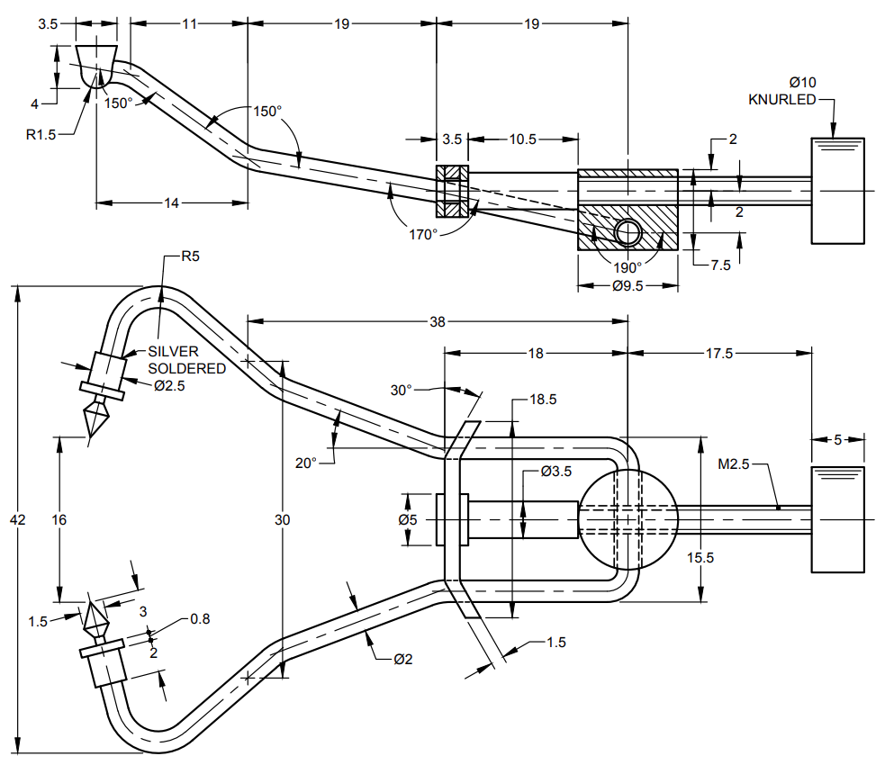

All dimensions in millimetres.

Fig. 1 Retainer, Matrix, Dental, No. 1

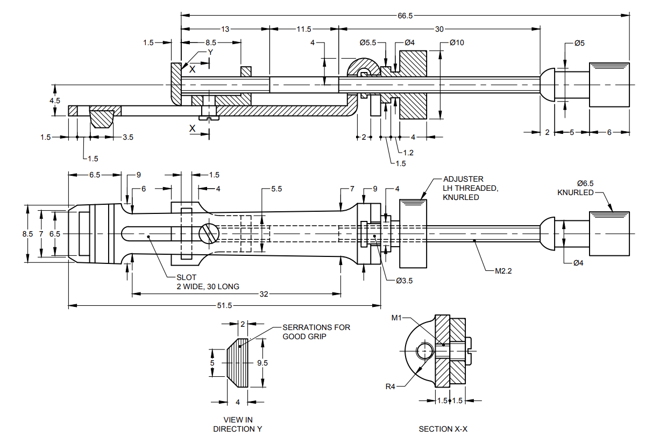

All dimensions in millimetres.

Fig. 2 Retainer, Matrix, Dental, No. 2

**ANNEX A**

(*Foreword*)

**COMMITTEE COMPOSITION**

Dentistry Sectional Committee, MHD 08

|  |  |
| --- | --- |
| *Organization* | *Representative(s)* |
|
| SRM Dental College, Chennai | Dr N. Gopi Chander ***(Chairperson)*** |
| All India Institute of Medical Sciences, New Delhi | Dr Ritu Duggal |
| Dr Krushna Vasant Kumar Bhatt (*Alternate* I) |
| Dr Siddhartha Sharma (*Alternate* II) |
| Association of Indian Medical Device Industry, New Delhi | Dr Sai Kalyan |
| Dr C. S. Prasad (*Alternate*) |
| Central Drugs Standard Control Organization, New Delhi | Shri Aseem Sahu |
| Shri Ajai Basil (*Alternate*) |
| Indian Academy of Oral Medicine and Radiology, Bengaluru | Dr Mandeep Kaur |
| Dr Abhishek Sinha (*Alternate*) |
| Indian Association of Oral and Maxillofacial Pathologists, Chennai | Dr Sushmita Saxena |
| Dr Deepak Bhargava (*Alternate* I) |
| Dr Anubhuti Sood (*Alternate* II) |
| Indian Association of Public Health Dentistry, Chennai | Dr Manjunath Puranik |
| Dr Vamsi Krishna Reddy L. (*Alternate* I) |
| Dr Tanushri Mahendra Dalvi (*Alternate* II) |
| Indian Endodontic Society, New Delhi | Dr Sanjay Miglani |
| Dr Amrita Chawla (*Alternate* I) |
| Dr Ruchika Roongta (*Alternate* II) |
| Indian Prosthodontic Society, Hyderabad | Dr Neeta Pasricha |
| Dr Aditi Nanda (*Alternate*) |
| Indian Society for Dental Research, Chennai | Prof P. Rajesh |
| Prof Deepak Chandrasekharan (*Alternate*) |
| J. Morita Corporation, Mumbai | Shri Ghanshyam Dusija |
| Shri Lokesh Jadhav (*Alternate*) |
| Kalam Institute of Health Technology, Vishakhapatnam | Dr Kavita Kachroo |
| Dr R. N. Prudhvi Teja (*Alternate*) |
| Office of Development Commissioner (MSME), New Delhi | Dr Maitreyee Talapatra |
| Tamil Nadu Government Dental College, Chennai | Dr K. Ramkumar |
| Dr T. Rohini Mds (*Alternate*) |
| In Personal Capacity (*R1/2 HIG Maraimalai nagar town center, Maraimalai nagar, Kattankulathur, Chengalpattu (DT) – 603203*) | Dr S. Jayachanadran |
| BIS Directorate General | Shri Chinmay Dwivedi, Scientist 'E' and Head (Medical Equipment and Hospital Planning) [Representing Director General (*Ex-officio*)] |
| *Member Secretary*  Ms Uroosa Warsi  Scientist ‘C’/Deputy Director  (Medical Equipment and Hospital Planning), BIS | |