**IS 7712: 2024**

***भारतीय मानक***

***Indian Standard***

**ईएनटी शल्य चिकित्सा उपकरण — एडेनोइड क्यूरेट — सेंट क्लेयर थॉमसन पैटर्न — विशिष्टि**

*(पहला पुनरीक्षण)*

**ENT Surgery Instruments — Adenoid Curette — St. Clair Thomson’s Pattern — Specification**

*(First Revision)*

ICS 11.040.30

© BIS 2024

भारतीय मानक ब्यूरो



BUREAU OF INDIAN STANDARDS

मानक भवन, 9 बहादुर शाह ज़फर मार्ग, नई दिल्ली - 110002

MANAK BHAVAN, 9 BAHADUR SHAH ZAFAR MARG

NEW DELHI - 110002

[www.bis.gov.in](http://www.bis.org.in) [www.standardsbis.in](http://www.standardsbis.in)

**XXXXXX Price Group X**

Ear, Nose, Throat and Head & Neck Surgery (ENT - H&N) Instruments Sectional Committee, MHD 04.

FOREWORD

This Indian Standard (Second Revision) was adopted by the Bureau of Indian Standards after the draft Finalized by the Ear, Nose, Throat and Head & Neck Surgery (ENT - H&N) Instruments Sectional Committee had been approved by the Medical Equipment and Hospital Planning Division Council.

This standard was originally published in 1975. The First revision of this standard has been brought out to align it with updated references and to bring the standard in line with the latest format of Indian Standards.

The composition of the committee responsible for formulation of this standard is given in **Annexure- A**

For the purpose of deciding whether a particular requirement of this standard is complied with the final value, observed or calculated, expressing the result of a test or analysis shall be rounded off in accordance with IS 2: 2022 ‘Rules for rounding off numerical values (*second revision*)’. The number of significant places retained in the rounded-off value should be same as that of the specified value in this standard.

*Indian Standard*

ENT SURGERY INSTRUMENTS — ADENOID CURETTE — ST. CLAIR THOMSON’S PATTERN — SPECIFICATION

**1 SCOPE**

This standard covers dimensional and other requirement for St. Clair Thomson’s pattern adenoid curette with cage of sizes 8, 10, 12, 14, 16 and 18 mm used in ENT surgery.

**2 REFERENCES**

The standards given below contain provisions which, through reference in this text, constitute provisions of this standard. At the time of publication, the editions indicated were valid. All standards are subject to revision, and parties to agreements based on this standard are encouraged to investigate the possibility of applying the most recent editions of these standards.

|  |  |
| --- | --- |
| ***IS No.*** | ***Title*** |
| IS/ISO 7153-1 : 2016 | Surgical instruments – Materials: Part 1 metals |
| IS 7531: 1990 | Surgical instruments – Corrosion resistance of stainless steel surgical instruments – Methods of tests (*first revision)* |
| IS 1501 (Part 1) : 2020 ISO 6507-1 : 2018 | Metallic Materials — Vickers Hardness Test Part 1 Test Method *(fifth revision)* |

**3 SHAPE AND DIMENSIONS**

**3.1** The shape and dimensions of St. Clair Thomson’s pattern adenoid curette shall be as shown in **Fig. 1** and **Fig. 2.**

**3.2** A deviation of ±2.5 percent shall be allowed on all dimensions.

**4 MATERIAL**

The materials used to manufacture curette shall be as specified in IS/ISO 7153-1.

**5 WORKMANSHIP AND FINISH**

**5.1** The surfaces of the curette shall be free from pits, dents, burrs, scale and other defects.

**5.2** All edges shall be even and rounded.

**5.3** The curette shall be well and evenly hardened.

**5.4** The handle and the shank shall be of force fit or screwed and soldered,

**5.5** The brazing and soldering shall be neat and sound. The joints shall be finished smooth.

**5.6** The teeth shall be pointed and force fit to the cage.

**5.7** The tap of the spoon shall be well and evenly made. Cut. The fenestra in the spoon shall be

neatly.

**5.8** The stainless steel components shall be polished bright and passivated.

**5.9** The lever action of the spring shall be such that when the cage is in midway between the

shank and the blade it shall spring back to fit snugly against the blade.

**5.10** There shall not be any gap between the cutting edge and the cage at the bottom. Gaps shall

be provided on both sides for opening purposes.

**5.11** Locking arrangement between the cage and the shank shall be such that there shall not be

any play after assembly.

**6 HEAT TREATMENT AND HARDNESS**

**6.1 General**

The instrument shall be heat treated using hardening and tempering procedures to produce specified hardness

**6.2 Hardness**

The Vickers hardness of the finished instrument shall be within the range of 400 to 450 HV, when tested in accordance with IS 1501 (Part 1).

**7 TESTS**

**7.1 Performance Test**

Edge of a hardwood block shall be scraped for 10 times by the sharp edge of the curette along the grain. The curette shall scrape the wood smoothly and cleanly with moderate degree of force. On completion of test the edge of the blade shall not show any sign of damage or distortion.

**7.2 Flexibility Test**

Clamp the curette in a suitable vice along its axis such that 60 mm of the shaft portion from the tip protrudes outside the vice. At a distance of 15 mm from the tip. Suspend a load of 40 N (4 kgf approx.) gradually on completion of the test the curette shall show no sign of damage or permanent set.

**7.3 Corrosion Resistance**

Test the forceps for corrosion in accordance with IS 7531. The forceps including the joints shall show no sign of corrosion.

**8 MARKING**

**8.1** The snare shall be clearly and indelibly marked with the manufacturer’s name, initial, recognized trade-mark, serial number, batch number and lot number.

**8.2** **BIS Certification Marking**

The product(s) conforming to the requirements of this standard may be certified as per the conformity assessment schemes under the provisions of the *Bureau of Indian Standards Act, 2016* and the Rules and Regulations framed thereunder, and the product(s) may be marked with the Standard Mark.

**9 PACKING**

The curette shall be wrapped in moisture-proof paper or packed in polyethylene bags, avoiding contact with one another. Purchaser and the supplier. The curette may also be packed as agreed to between the purchaser and the supplier.



13

BR

25

10

AZED

SECTION X-X

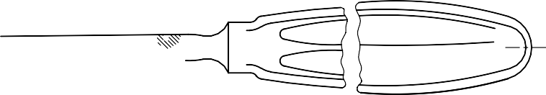

CAGE

SHANK

CAGE LEVER

HANDLE

X

 X

All dimensions in millimeters.

**FIG. 1 St. Clair Thomson’s pattern adenoid curette**

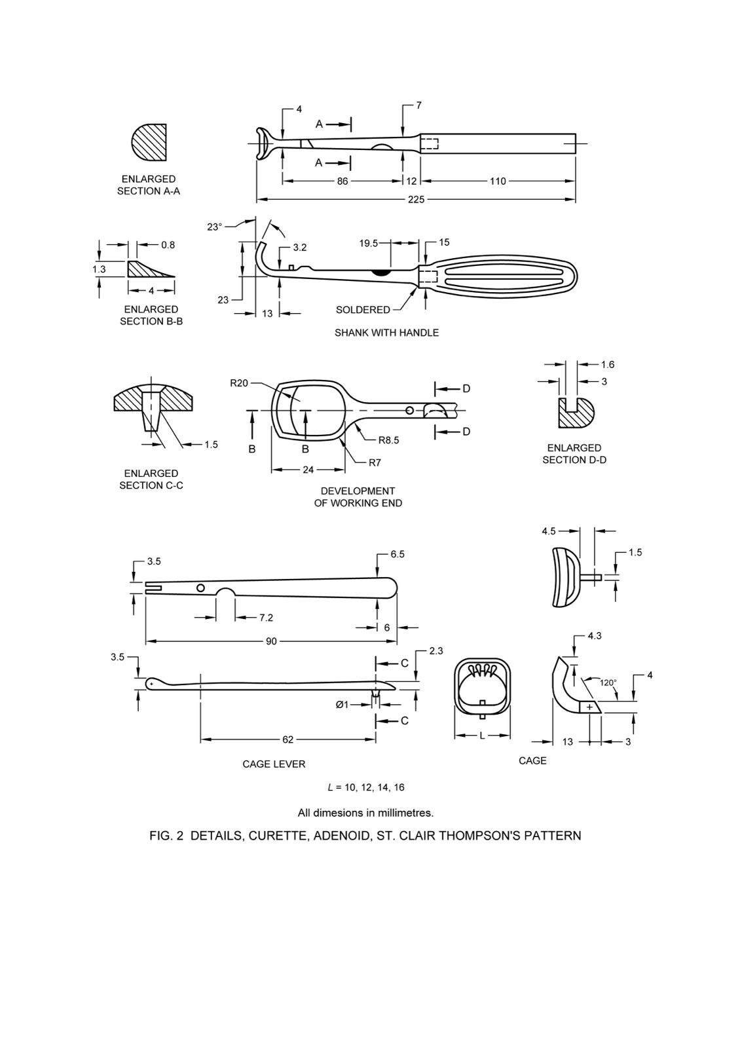

All dimensions in millimeters.

**FIG. 2 Details of St. Clair Thomson’s pattern adenoid curette**

**ANNEX A**

(*Foreword*)

**COMMITTEE COMPOSITION**

Ear, Nose, Throat and Head & Neck Surgery (ENT - H&N) Instruments Sectional

Committee, MHD 04

| ***Organization*** | ***Representative(S)*** |
| --- | --- |
| All India Institute of Medical Sciences, New Delhi | Dr. Rakesh Kumar *(Chairperson)* |
| ALPS International, New Delhi | Shri.Alok Narang, |
| Shri. Karan Narang (*Alternate*) |
| All India Institute of Medical Sciences, New Delhi | Dr. Prem Sagar |
| Dr. Arvind Kumar (*Alternate*) |
| All India Institute of Medical Sciences, Bhopal | Dr. Vikas Gupta |
| Dr. Ganakalyan Behera (*Alternate*) |
| Association of Indian Medical Device Industry, New Delhi | Shri. Tarlochan Dev |
| Shri. Ankur Bhargava (*Alternate* I*)* |
| Dr. C.S. Prasad (*Alternate* II) |
| Directorate General of Health Services, New Delhi Central | Ms. Dr. Pallika Kumar |
| Government Medical College & Hospital, Chandigarh | Dr. Surinder K Singhal |
| Shri. Nitin Gupta (*Alternate*) |
| Happy Reliable Surgeries Private Limited, Bangalore | Shri. Hemant Savale |
| Shri. Sanjeev Gautam (*Alternate*) |
| India Medtronic Private Limited, Gurugram | Smt. LATIKA VATS |
| Shri. Saurabh Sable (*Alternate* I*)* |
| Shri. Sandeep Verma (*Alternate* II) |
| Indian Institute of Technology Kanpur, Kanpur | Dr. A. R. Harish |
| Kalam Institute of Health Technology, Vishakhapatnam | Dr. Arjun Thimmaiah |
| Shri. Amit Sharma (*Alternate*) |
| Karl Storz Endoscopy India Private Limited, New Delhi | Shri. Sandeep Sethi |
| Shri. Kapil Rana (*Alternate*) |
| Serwell MediEquip, Chennai | Shri. T. Jebin Samuel |
| Shri. R. Radhakrishnan (*Alternate* I*)* |
| Shri. G. Sathish (*Alternate* II) |
| Tata Memorial Center (Hospital), Mumbai | Dr. RICHA VAISH |
| Shri. Vijay Yashwant Mestri (*Alternate* I*)* |
| Dr. Arjun Singh (*Alternate* II) |
| Postgraduate Institute of Medical Education and Research, Chandigarh | Smt. Dr Jaimanti Bakshi |
| In Personal Capacity , D-2 ,Tower 7, Type 5, East Kidwai Nagar, New Delhi-110023 | Dr. Kapil Sikka |
| BIS Directorate General | Shri A. R. Unnikrishnan Scientist ‘G’ And Head (Medical Equipment And Hospital Planning) [Representing Director General (Ex-Officio)] |

*Member Secretary*

Mr. Karthik Reddy Katipally

Scientist ‘B’/Assistant Director

(Medical Equipment And Hospital Planning). Bis