***भारतीय मानक***

***Indian Standard***

**IS 7713 : 2024**

**ईएनटी शल्य चिकित्सा उपकरण — रिट्रैक्टर — वीसलैंडर पैटर्न — विशिष्टि**

*(*पहला पुनरीक्षण)

**ENT Surgery Instruments — Retractor — Weislander’s Pattern — Specification**

*(First Revision)*

ICS 11.040.30

© BIS 2024

भारतीय मानक ब्यूरो

BUREAU OF INDIAN STANDARDS

मानक भवन, 9 बहादुर शाह ज़फर मार्ग, नई दिल्ली - 110002

MANAK BHAVAN, 9 BAHADUR SHAH ZAFAR MARG

NEW DELHI - 110002

[www.bis.gov.in](http://www.bis.org.in) [www.standardsbis.in](http://www.standardsbis.in)

**XXXXXX Price Group X**

Ear, Nose, Throat and Head & Neck Surgery (ENT - H&N) Instruments Sectional Committee

MHD 04.

FOREWORD

This Indian Standard (Second Revision) was adopted by the Bureau of Indian Standards after the draft Finalized by the Ear, Nose, Throat and Head & Neck Surgery (ENT - H&N) Instruments Sectional Committee had been approved by the Medical Equipment and Hospital Planning Division Council.

This standard was originally published in 1975. The First revision of this standard has been brought out to align it with recent developments and to bring the standard in line with the latest style and format of Indian Standards.

The composition of the committee responsible for formulation of this standard is given in **Annexure- A**

For the purpose of deciding whether a particular requirement of this standard is complied with the final value, observed or calculated, expressing the result of a test or analysis shall be rounded off in accordance with IS 2: 2022 ‘Rules for rounding off numerical values (*second revision*)’. The number of significant places retained in the rounded-off value should be same as that of the specified value in this standard.

*Indian Standard*

ENT SURGERY INSTRUMENTS — RETRACTOR — WEISLANDER’S PATTERN — SPECIFICATION

## SCOPE

This Standard covers dimensional and other requirements for light model Weislander’s pattern retractor used in ENT surgery.

## REFERENCES

The standards given below contain provisions which, through reference in this text, constitute provisions of this standard. At the time of publication, the editions indicated were valid. All standards are subject to revision, and parties to agreements based on this standard are encouraged to investigate the possibility of applying the most recent editions of these standards.

|  |  |
| --- | --- |
| ***IS No*** | ***Title*** |
| IS 6603 : 2024 | Stainless Steel Semi-Finished Products, Bars, Wire Rods and Bright Bars — Specification *( second revision )* |
| IS 1570 (Part 5) : 1985 | Schedules for wrought steels: Part 5 stainless and heat - Resisting steels *( second revision )* |
| IS 7531 : 1990 | Surgical instruments – Corrosion resistance of stainless steel surgical instruments – Methods of tests *(first revision)* |
| IS 1070 : 2023 | Reagent Grade Water Specification *(fourth revision)* |
| IS/ISO 7153-1 : 2016 | Surgical instruments – Materials: Part 1 metals |
| IS 1501 (Part 1) : 2020 ISO 6507-1 : 2018 | Metallic Materials — Vickers Hardness Test Part 1 Test Method  *( fifth revision )* |

## SHAPE AND DIMENSIONS

## The shape and dimensions of weislander’s pattern retractor as shown in Fig. 1

* 1. A deviation of ± 2.5 percent shall be allowed.

## MATERIAL

## The Materials used to manufacture retractor shall be as specified in IS/ISO 7153-1.

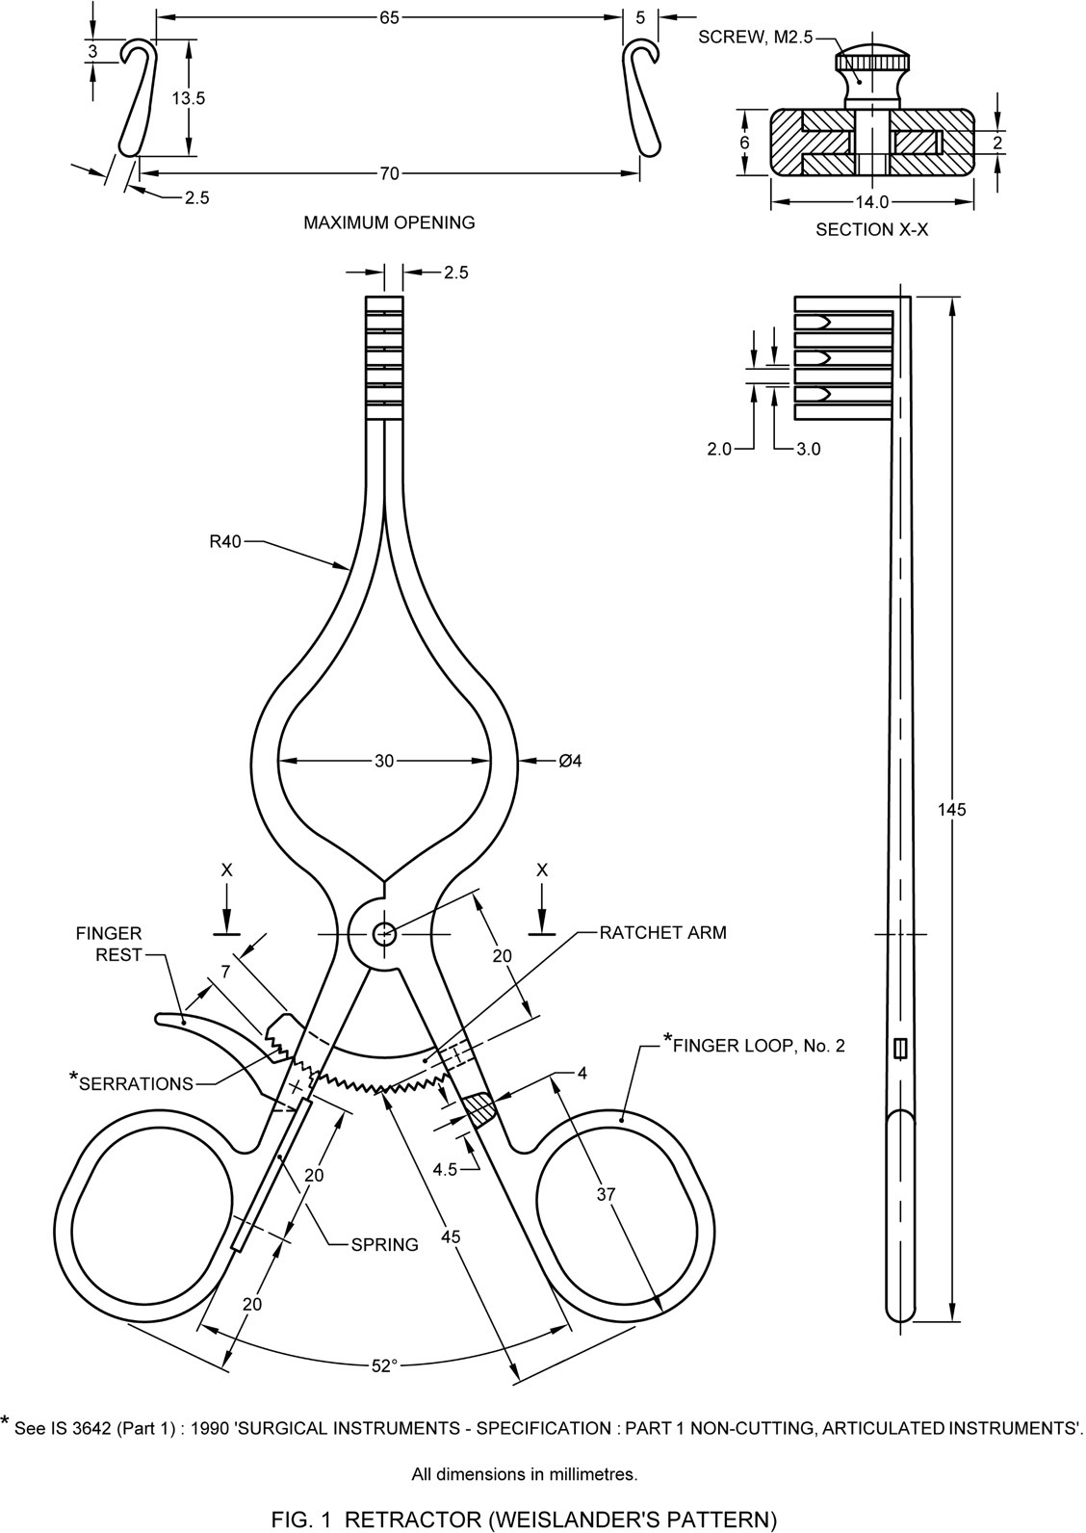

**ALL dimensions in millimeters**

**FIG. 1 Retractor (Weislander’s Pattern)**

## WORKMANSHIP AND FINISH

* 1. All the surfaces, except the ratchet teeth, shall be smooth and free from pits, and the edges shall
  2. The edges of the retracting prongs shall taper to a blunt point.
  3. The retractor arms shall open and close smoothly without any friction or undue resistance or play at the joint.
  4. The ratchet teeth shall be well cut, clean, uniform, regular and evenly spaced.
  5. The ratchet teeth shall engage accurately and securely and shall effectively lock the retractor at any desired position.
  6. The ratchet arm with the finger rest pressed shall swivel freely, the spring shall not be too stiff.
  7. The retractor shall be finished bright and passivated.

## HEAT TREATMENT AND HARDNESS

**6.1 General**

The retractor except the spring shall be heat treated using hardening and tempering procedures to produce specified hardness.

**6.2 Hardness**

The Vickers hardness of the finished instrument shall be within the range of 380 to 430 HV when tested in accordance with IS 1501 (Part 1).

## TESTS

## Open the arms of the retractor tar. about 65 mm measured at the tip. Grip the retractor at the retracting blades and apply a compressive force of 100 N (10 kgf approximately) for two minutes trying to close the blades. The ratchet shall not slip under the force and shall show no sign of damage on removal of the force. Repeat the test with two different arms openings.

* 1. **Corrosion Resistance**

The instrument shall satisfy the boiling and autoclaving test as mentioned in IS 7531. Subject to agreement between the purchaser and the supplier the instrument may be put to the following test:

* 1. **Copper Sulphate Test**

Scrub the sample with soap and warm water, rinse in hot water and then dip in 95 percent ethyl alcohol. Dry the sample. Immerse in copper sulphate solution at room temperature for 6 minutes and wash off with fresh water or wet cotton wool. No red stains or spots on the sample shall be allowed but dulling of the polished surface may be permitted. The composition of the solution shall be as follows:

|  |  |  |
| --- | --- | --- |
| **Table 1 Solution Composition** | | |
| **Sl No.**  **(1)** | **Material**  **(2)** | **Quantity**  **(3)** |
|  | Copper sulphate (Cu SO4.5H2O) | 4.0g |
|  | Sulphuric acid (H2S04) (sp gr 1.84) | 10.0 g |
|  | Distilled water [see IS 1070] | 90.0 ml |

## MARKING

## Each retractor shall be marked with the following:

1. Manufacturer’s name, initials or recognized trade-mark; and
2. The words’ stainless steel’ or letters’ SS ‘.

## BIS Certification Marking

The product(s) conforming to the requirements of this standard may be certified as per the conformity assessment schemes under the provisions of the *Bureau of Indian Standards Act,* 2016 and the Rules and Regulations framed there under, and the product(s) may be marked with the Standard Mark.

## PACKING

Each retractor shall be wrapped in moisture-proof paper or put in a polyethylene bag. Each such retractor shall be packed in an individual cardboard carton. The retractor may also be packed as agreed to between the purchaser and the supplier.

**ANNEX A**

(*Foreword*)

**COMMITTEE COMPOSITION**

Ear, Nose, Throat and Head & Neck Surgery (ENT - H&N) Instruments Sectional

Committee, MHD 04

| ***Organization*** | ***Representative(S)*** |
| --- | --- |
| All India Institute of Medical Sciences, New Delhi | Dr. Rakesh Kumar *(Chairperson)* |
| ALPS International, New Delhi | Shri.Alok Narang, |
| Shri. Karan Narang (*Alternate*) |
| All India Institute of Medical Sciences, New Delhi | Dr. Prem Sagar |
| Dr. Arvind Kumar (*Alternate*) |
| All India Institute of Medical Sciences, Bhopal | Dr. Vikas Gupta |
| Dr. Ganakalyan Behera (*Alternate*) |
| Association of Indian Medical Device Industry, New Delhi | Shri. Tarlochan Dev |
| Shri. Ankur Bhargava (*Alternate* I*)* |
| Dr. C.S. Prasad (*Alternate* II) |
| Directorate General of Health Services, New Delhi Central | Ms. Dr. Pallika Kumar |
| Government Medical College & Hospital, Chandigarh | Dr. Surinder K Singhal |
| Shri. Nitin Gupta (*Alternate*) |
| Happy Reliable Surgeries Private Limited, Bangalore | Shri. Hemant Savale |
| Shri. Sanjeev Gautam (*Alternate*) |
| India Medtronic Private Limited, Gurugram | Smt. LATIKA VATS |
| Shri. Saurabh Sable (*Alternate* I*)* |
| Shri. Sandeep Verma (*Alternate* II) |
| Indian Institute of Technology Kanpur, Kanpur | Dr. A. R. Harish |
| Kalam Institute of Health Technology, Vishakhapatnam | Dr. Arjun Thimmaiah |
| Shri. Amit Sharma (*Alternate*) |
| Karl Storz Endoscopy India Private Limited, New Delhi | Shri. Sandeep Sethi |
| Shri. Kapil Rana (*Alternate*) |
| Serwell MediEquip, Chennai | Shri. T. Jebin Samuel |
| Shri. R. Radhakrishnan (*Alternate* I*)* |
| Shri. G. Sathish (*Alternate* II) |
| Tata Memorial Center (Hospital), Mumbai | Dr. RICHA VAISH |
| Shri. Vijay Yashwant Mestri (*Alternate* I*)* |
| Dr. Arjun Singh (*Alternate* II) |
| Postgraduate Institute of Medical Education and Research, Chandigarh | Smt. Dr Jaimanti Bakshi |
| In Personal Capacity , D-2 ,Tower 7, Type 5, East Kidwai Nagar, New Delhi-110023 | Dr. Kapil Sikka |
| BIS Directorate General | Shri A. R. Unnikrishnan Scientist ‘G’ And Head (Medical Equipment And Hospital Planning) [Representing Director General (Ex-Officio)] |

*Member Secretary*

Mr. Karthik Reddy Katipally

Scientist ‘B’/Assistant Director

(Medical Equipment And Hospital Planning). Bis