***भारतीय मानक***

***Indian Standard***

**IS 6565: 2024**

**गर्भस्थ शिशु के हृदय ध्वनि के लिए फिटोस्कोप पिनार्ड पैटर्न – विशिष्टि**

*( पहला* पुनरीक्षण )

**Foetoscope For Foetal Heart Sounds, Pinard’s Pattern – Specification**

( *Frist Revision )*

ICS 11.040.30

© BIS 2024

भारतीय मानक ब्यूरो

BUREAU OF INDIAN STANDARDS

मानक भवन, 9 बहादुर शाह ज़फर मार्ग, नई दिल्ली - 110002

MANAK BHAVAN, 9 BAHADUR SHAH ZAFAR MARG

NEW DELHI - 110002

[www.bis.gov.in](http://www.bis.org.in) [www.standardsbis.in](http://www.standardsbis.in)

**December 2024 Price Group X**

Obstetric and Gynaecological Instrumentsand Appliances Sectional Committee, MHD 03

FOREWORD

This Indian Standard (Second Revision) was adopted by the Bureau of Indian Standards, after the draft finalized by the Obstetric and Gynaecological Instruments and Appliances Sectional Committee had been approved by the Medical Equipment and Hospital Planning Division Council.

This standard was originally published in 1972. The first revision of this standard has been brought out to align the standard with the latest style and format of Indian Standards. Also, the cross-references to Indian Standards have been updated with latest version.

For the purpose of deciding whether a particular requirement of this standard is complied with the final value, observed or calculated, expressing the result of a test or analysis shall be rounded off in accordance with IS 2: 2022 ‘Rules for Rounding Off Numerical Values (s*econd revision*)’. The number of significant places retained in the rounded off value should be same as that of the specified value in this standard.

**1 SCOPE**

This standard specifies the dimensional and other requirements for the foetoscope used for foetal heart sounds, Pinard’s pattern.

**2 REFERENCES**

The standards given below contain provisions which, through reference in this text, constitute provisions of this standard. At the time of publication, the editions indicated were valid. All standards are subject to revision, and parties to agreements based on this standard are encouraged to investigate the possibility of applying the most recent editions of these standards.

|  |  |
| --- | --- |
| **IS No.** | **Title** |
| IS 21: 1992 | Wrought aluminium and aluminium alloys for manufacture of utensils  specification (*fourth revision*) |
| IS 1868: 1996 | Anodic coatings on aluminium and its alloys – Specification (*third revision*) |

**3 MATERIAL**

The stethoscope shall be manufactured from aluminium complying with IS 21.

**4 SHAPE AND DIMENSIONS**

The shape & dimensions shall be as shown in Fig. 1.

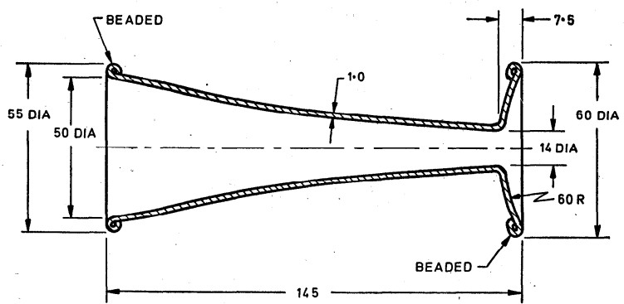

All dimensions in millimetres

Fig. 1 Stethoscope (Foetoscope) For Foetal Heart Sounds, Pinard’s Pattern

**5 WORKMANSHIP AND FINISH**

**5.1** The surfaces of the stethoscope shall be free from scales, burrs, pits and similar defects,

**5.2** All the edges shall be smoothly rounded off and shall not be sharp.

**5.3** The stethoscope shall have perfectly symmetrical dimensions around the central axis,

**5.4** The rims of the foetal end and ear end shall each be in one plane.

**5.5** The stethoscope shall be anodized (silver finish) in accordance with Grade AC 5 of IS 1868.

**6 TESTS**

**6.1** Press the stethoscope with hand with moderate degree of force at the foetal end. The stethoscope shall show no sign of damage or bending.

**6.2** Place the stethoscope on a plain glass surface with the foetal end and ear end resting on the glass surface alternatively. The rims of the two ends shall touch the glass surface on all the points and then shall be no gap at any place.

**6.3** The stethoscope shall be tested to hear heart beats or other body sounds from lungs, wind pipe etc. The body sounds shall be clearly audible to the person using the stethoscope.

**7 MARKING**

**7.1** The product shall be legibly and indelibly marked with the following:

* + 1. Manufacturer's name, initials or registered trade-mark;
    2. Country of manufacture; and
    3. The words ‘Stainless Steel’ or the letters ‘SS’

**7.2 BIS Certification Marking**

The product(s) conforming to the requirements of this standard may be certified as per the conformity assessment schemes under the provisions of the *Bureau of Indian Standards Act, 2016* and the Rules and Regulations framed there under, and the product(s) may be marked with the Standard Mark.

**8 PACKING**

The stethoscope shall be wrapped in moisture-proof paper or packed in polyethylene bags avoiding contact with one another.