***भारतीय मानक***

***Indian Standard***

**IS 6505: 2024**

**सिम्स पैटर्न डबल एंडेड, तेज़–धार और कुंठित, गर्भाशय क्यूरेट – विशिष्टि**

*( पहला पुनरीक्षण )*

**Sim's Pattern Double-Ended, Sharp and Blunt, Uterine Curette – Specification**

( *Frist Revision )*

ICS 11.040.30

© BIS 2024

भारतीय मानक ब्यूरो

BUREAU OF INDIAN STANDARDS

मानक भवन, 9 बहादुर शाह ज़फर मार्ग, नई दिल्ली - 110002

MANAK BHAVAN, 9 BAHADUR SHAH ZAFAR MARG

NEW DELHI - 110002

[www.bis.gov.in](http://www.bis.org.in) [www.standardsbis.in](http://www.standardsbis.in)

**December 2024 Price Group X**

Obstetric and Gynaecological Instruments and Appliances Sectional Committee, MHD 03

FOREWORD

This Indian Standard (Second Revision) was adopted by the Bureau of Indian Standards, after the draft finalized by the Obstetric and Gynaecological Instruments and Appliances Sectional Committee had been approved by the Medical Equipment and Hospital Planning Division Council.

This standard was originally published in 1971. The first revision of this standard has been brought out to align the standard with the latest style and format of Indian Standards. Also, the cross-references to Indian Standards have been updated with latest version.

For the purpose of deciding whether a particular requirement of this standard is complied with the final value, observed or calculated, expressing the result of a test or analysis shall be rounded off in accordance with IS 2: 2022 ‘Rules for Rounding Off Numerical Values (s*econd revision*)’. The number of significant places retained in the rounded off value should be same as that of the specified value in this standard.

**1 SCOPE**

This standard specifies dimensional and other requirements for double-ended uterine curette, Sim's pattern, having one end sharp and other blunt.

**2 REFERENCES**

The standards given below contain provisions which, through reference in this text, constitute provisions of this standard. At the time of publication, the editions indicated were valid. All standards are subject to revision, and parties to agreements based on this standard are encouraged to investigate the possibility of applying the most recent editions of these standards.

|  |  |
| --- | --- |
| IS No. | Title |
| IS 1570 (Part 5):  1985 | Schedules for wrought steels Part 5 Stainless and heat-resisting steels  (*second revision*) |
| IS 7531: 1990 | Surgical instruments – Corrosion resistance of stainless steel surgical  instruments - Methods of tests |

**3 MATERIAL**

The material shall be stainless steel conforming to designation X20Cr13 or X30Cr13 of IS 1570 (Part 5).

**4 SHAPE AND DIMENSIONS**

The shape & dimensions shall be as shown in Fig. 1.

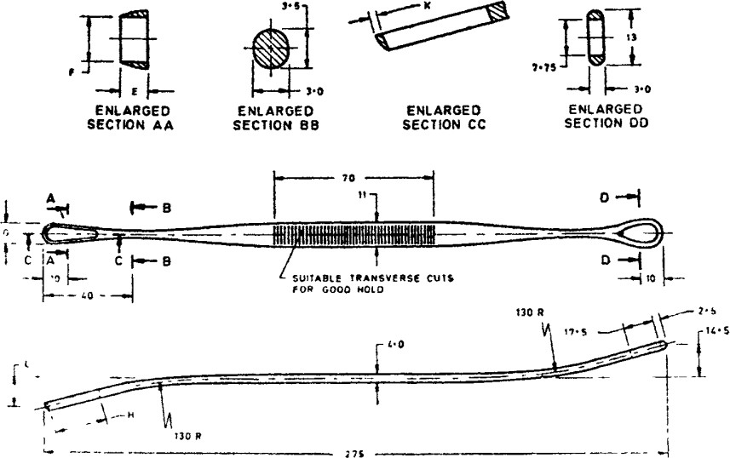

|  |  |  |  |  |  |  |
| --- | --- | --- | --- | --- | --- | --- |
| *SIZE* | *E* | *F* | *G* | *H* | *K* | *L* |
| Small | 4.0 | 6.0 | 8.0 | 22 5 | 1.0 | 13 0 |
| Medium | 4.0 | 7.0 | 9.0 | 23.5 | 1.0 | 13 5 |
| Large | 4.5 | 8.0 | 10.0 | 25 5 | 1.2 | 14.0 |

All dimensions in millimetres.

Fig. 1 Curette, Uterine. Double-Ended, Sharp And Blunt, Sim's Pattern

**5 WORKMANSHIP AND FINISH**

**5.1** The surfaces of the curette shall be free from pits, dents, burrs, scales and other defects.

**5.2** All the edges shall be even. The edges shall be rounded except the working ends, one shall be semi-sharp and the other blunt.

**5.3** The curette shall be passivated and polished bright.

**6 HEAT TREATEMENT**

The instrument shall be hardened and tempered to 400 HV to 450 HV measured as near to the working ends as possible.

**7 TESTS**

**7.1** Clamp the curette in a vice at the middle of the straight portion with its axis horizontal and one working end inclining upwards in a vertical plane. Suspend a load of 30 N gradually on this working end at a distance of 15 mm from the tip. Similarly carry out the test on the other working end. On completion of the test the curette shall show no sign of damage.

**7.2** Scrape with sharp working end of the curette a piece of 6-mm hard millboard quickly and vigorously to and fro 20 times with moderate degree of force. The surface of the millboard shall be scraped easily and cleanly, and on completion of the test the curette shall not show any sign of damage or distortion.

**7.3 Corrosion Resistance Test**

Test the sample in accordance with IS 7531. The sample shall show no sign of corrosion after the test. There shall be no red stains or spots on the curette after the test, but dulling of the polished surface may be permitted.

**8 MARKING**

**8.1** The product shall be legibly and indelibly marked with the following:

* + 1. Manufacturer's name, initials or registered trade-mark;
    2. Country of manufacture; and
    3. The words ‘Stainless Steel’ or the letters ‘SS’

**8.2 BIS Certification Marking**

The product(s) conforming to the requirements of this standard may be certified as per the conformity assessment schemes under the provisions of the *Bureau of Indian Standards Act,* 2016 and the Rules and Regulations framed there under, and the product(s) may be marked with the Standard Mark.

**9 PACKING**

The curettes shall be wrapped in moisture-proof paper or packed in polyethylene bags avoiding contact with one another.