***भारतीय मानक***

***Indian Standard***

**IS 6114: 2024**

**गायनिकोलॉजिकल उपकरण – फोर्सेप्स, गर्भाशय वुलसेलम – आकार और परिमाण**

*( दूसरा पुनरीक्षण )*

**Gynaecological Instruments – Forceps, Uterine Vulsellum – Shape and Dimensions**

( *Second Revision )*

ICS 11.040.30

© BIS 2024

भारतीय मानक ब्यूरो

BUREAU OF INDIAN STANDARDS

मानक भवन, 9 बहादुर शाह ज़फर मार्ग, नई दिल्ली - 110002

MANAK BHAVAN, 9 BAHADUR SHAH ZAFAR MARG

NEW DELHI - 110002

[www.bis.gov.in](http://www.bis.org.in) [www.standardsbis.in](http://www.standardsbis.in)

**November 2024 Price Group X**

Obstetric and Gynaecological Instruments and Appliances Sectional Committee, MHD 03

FOREWORD

This Indian Standard (Second Revision) was adopted by the Bureau of Indian Standards, after the draft finalized by the Obstetric and Gynaecological Instruments and Appliances Sectional Committee had been approved by the Medical Equipment and Hospital Planning Division Council.

This standard was originally published in 1971. The first revision published in 1991 which updated the standard to cover the requirements in respect of shape and dimensions only, as the general specifications of surgical type of instruments was covered by IS 3642 (Part 1): 1990 ‘Surgical instruments – Specification Part 1 Noncutting articulated instruments’. The second revision of this standard has been brought out to align the standard with the latest style and format of Indian Standards.

For the purpose of deciding whether a particular requirement of this standard is complied with the final value, observed or calculated, expressing the result of a test or analysis shall be rounded off in accordance with IS 2: 2022 ‘Rules for Rounding Off Numerical Values (*second revision*)’. The number of significant places retained in the rounded off value should be same as that of the specified value in this standard.

**1 SCOPE**

This standard specifies the shape and dimensions for uterine vulsellum, forceps.

**2 REFERENCES**

The standards given below contain provisions which, through reference in this text, constitute provisions of this standard. At the time of publication, the editions indicated were valid. All standards are subject to revision, and parties to agreements based on this standard are encouraged to investigate the possibility of applying the most recent editions of these standards.

|  |  |
| --- | --- |
| *IS No.* | *Title* |
| IS 3642 (Part 1):  1990 | Surgical instruments – Specification Part 1 Non-cutting, articulated instruments (*second revision*) |

**3 SHAPE AND DIMENSIONS**

**3.1** The shape & dimensions shall be as shown in Fig. 1.

**3.2 Joints**

The joints shall be either recessed – screw or box type in accordance with **13.2** of IS 3642 (Part 1).

**3.3 Teeth**

Teeth shall conform to Section 5 of IS 3642 (Part 1) with a combination of 3 in 4.

**3.4 Ratchet**

* + 1. Ratchet teeth shall conform to Section 4 of IS 3642 (Part 1) with combination of 3 in 3.

3.4.2 The force required to close the forceps on the first step of the ratchet shall be 15 N.

**3.5 Finger Loops**

The finger loops shall conform to Size No. 3 of Section 6 of IS 3642 (Part 1).

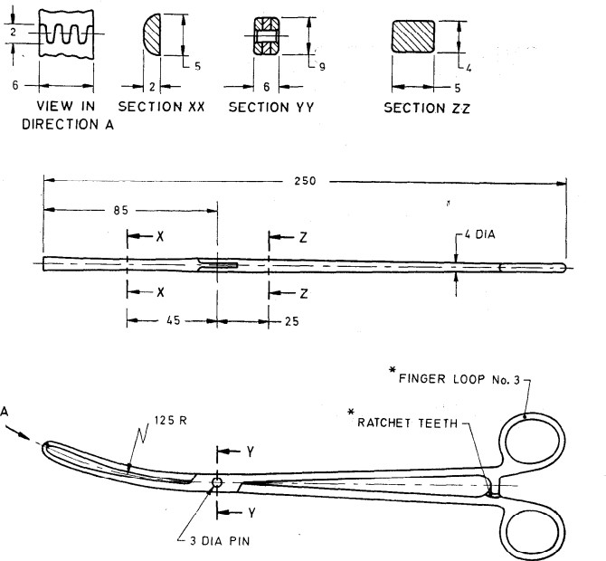

All dimensions in millimetres.

FIG. 1 FORCEPS, UTERINE, VULSELLUM

**4 MARKING**

**4.1** The product shall be legibly and indelibly marked with the following:

1. Manufacturer's name, initials or registered trade-mark;
2. Country of manufacture; and
3. The words ‘Stainless Steel’ or the letters ‘SS’

**4.2 BIS Certification Marking**

The product(s) conforming to the requirements of this standard may be certified as per the conformity assessment schemes under the provisions of the *Bureau of Indian Standards Act,* 2016 and the Rules and Regulations framed there under, and the product(s) may be marked with the Standard Mark.

**5 PACKING**

The forceps shall be wrapped in moisture-proof paper or packed in polyethylene bags avoiding contact with one another.