*भारतीय मानक*

**कुस्को पैटर्न का योनिक वीक्षणयंत्र – विशिष्टि**

*(पहला पुनरीक्षण)*

*Indian Standard*

**Vaginal Speculum, Cusco’s Pattern – Specification**

*(First Revision)*

ICS 11.040.30

Obstetric and Gynaecological Instruments and Appliances Sectional Committee

FOREWORD

This Indian Standard (First Revision) was adopted by the Bureau of Indian Standards, after the draft finalized by the Obstetric and Gynaecological Instruments and Appliances Sectional Committee had been approved by the Medical Equipment and Hospital Planning Division Council.

This standard was originally published in 1970. The first revision of this standard has been brought out to align the standard with the latest style and format of Indian Standards.

For the purpose of deciding whether a particular requirement of this standard is complied with the final value, observed or calculated, expressing the result of a test or analysis shall be rounded off in accordance with IS 2: 2022 ‘Rules for Rounding Off Numerical Values (*second revision*)’. The number of significant places retained in the rounded off value should be same as that of the specified value in this standard.

# SCOPE

This standard specifies the requirements for vaginal speculum (Cusco’s pattern).

# REFERENCES

The standards given below contain provisions which, through reference in this text, constitute provisions of this standard. At the time of publication, the editions indicated were valid. All standards are subject to revision, and parties to agreements based on this standard are encouraged to investigate the possibility of applying the most recent editions of these standards.

|  |  |
| --- | --- |
| **IS No.** | **Title** |
| IS 6911: 2017 | Stainless steel plate, sheet and strip - Specification *(second revision)* |
| IS 7531: 1990 | Surgical instruments - Corrosion resistance of stainless steel surgical |

instruments - Methods of tests *(first revision)*

# MATERIAL

The material shall be stainless steel conforming to designation X04Cr19Ni9 or X07Cr19Ni9 of IS 6911.

# SHAPE AND DIMENSIONS

The shape & dimensions shall be as shown in Fig. 1.

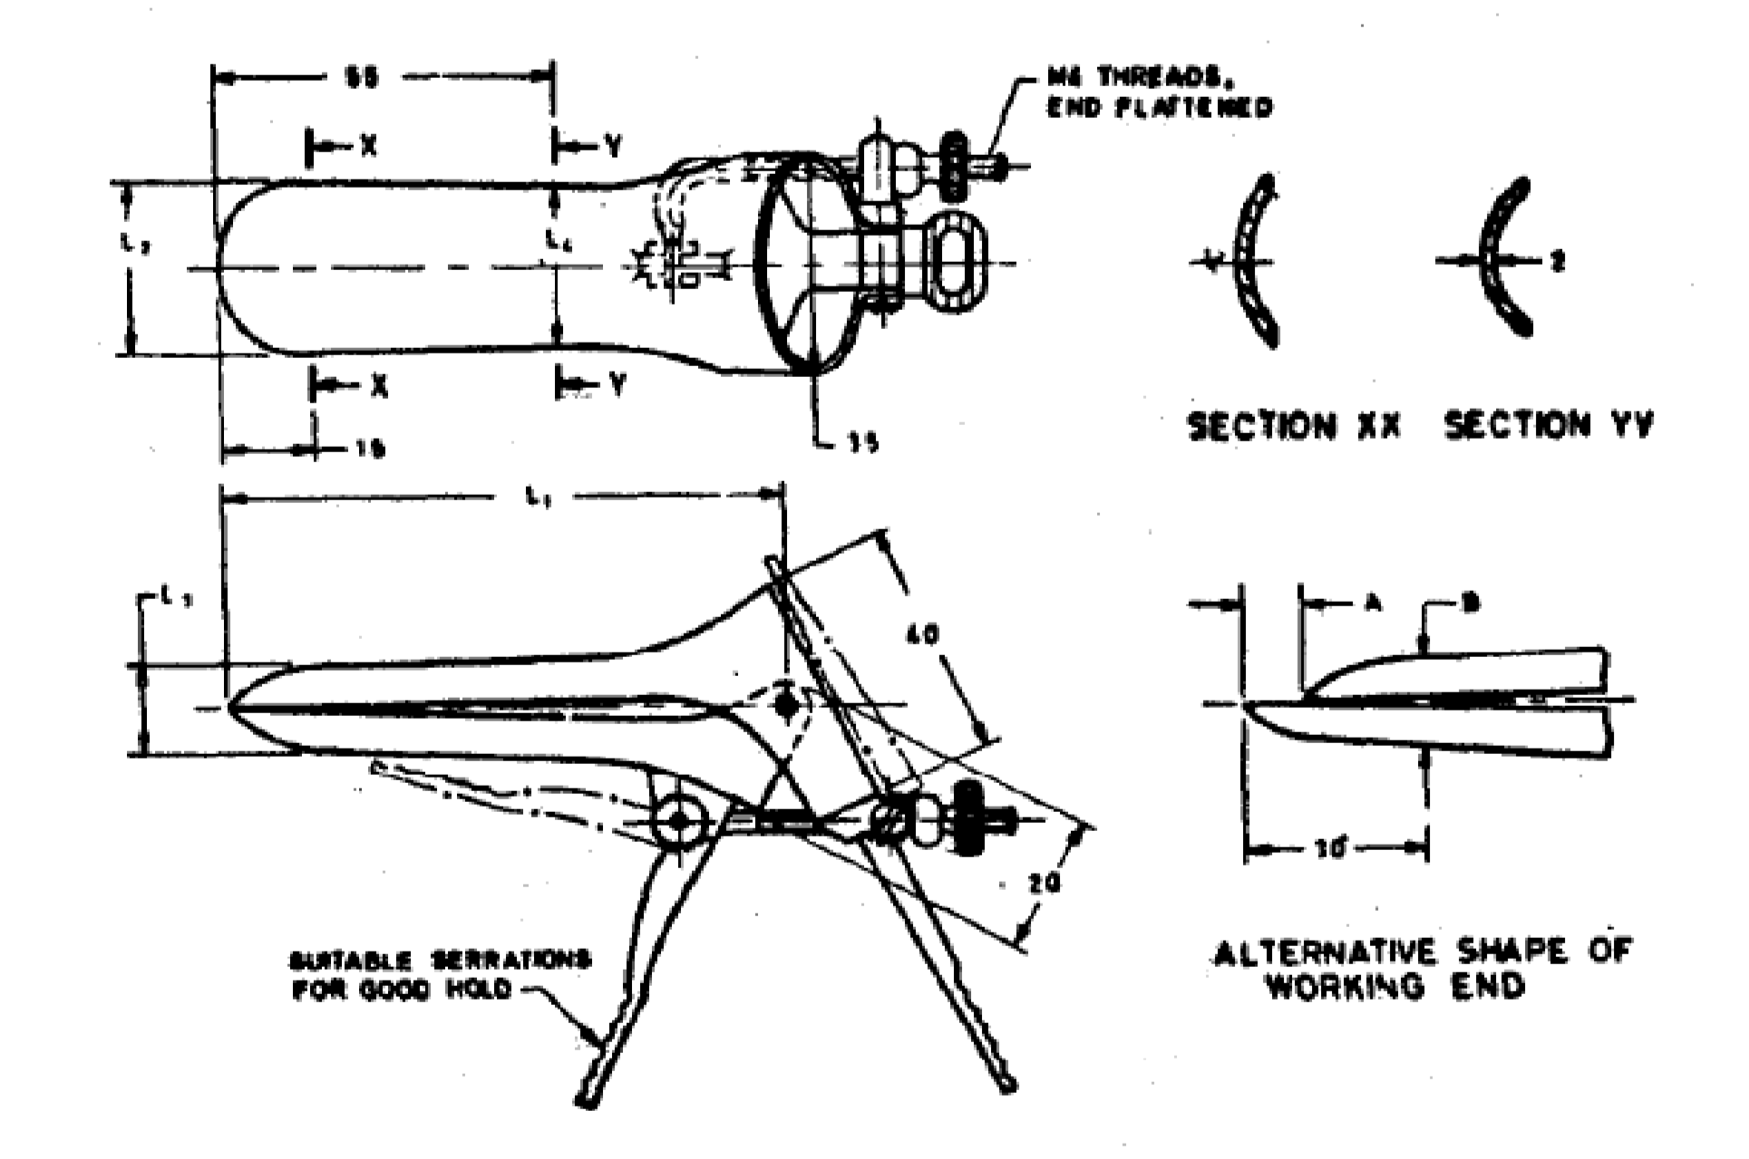

|  |  |  |  |  |  |  |  |
| --- | --- | --- | --- | --- | --- | --- | --- |
| **Sizes** | ***L1*** | ***La*** | ***La*** | ***La*** | ***A*** | ***B*** | **Maximum**  **Opening of Blades** |
| Extra Small | 75 | 15 | 10 | 14 | 5 | 12 | 45 |
| Small | 85 | 20 | 12 | 19 | 8 | 14 |
| Medium | 95 | 30 | 13 | 28 | 10 | 15 |
| Large | 110 | 35 | 15 | 32 | 12 | 17 |

All dimensions in millimetres.

FIG. 1 SPECULUM, VAGINAL (CUSCO’S PATTERN)

# WORKMANSHIP AND FINISH

**5.1** All the surfaces of the speculum shall be free from burrs, pits, cracks and other defects.

**5.2** The edges of the blades shall be smoothly-rounded and shall not be sharp.

**5.3** The blades shall move smoothly and freely on the hinge.

**5.4** Movement of the folding handles and the self-retaining screws shall be smooth.

**5.5** The speculum shall be passivated and polished bright.

# TESTS

**6.1** Fix the positioning screw for different openings of the blades and press the blades with a force of 50N. The screw shall not slip in any case and no deformation in blades shall be observed after the test.

## Corrosion Resistance Test

Test the sample in accordance with IS 7531. It shall show no sign of corrosion after the test. No red stains or spots on the instrument shall be allowed but dulling of the polished surface may be permitted.

# MARKING

**7.1** The product shall be legibly and indelibly marked with the following:

1. Manufacturer's name, initials or registered trade-mark;
2. Country of manufacture; and
3. The words ‘Stainless Steel’ or the letters ‘SS’

## BIS Certification Marking

The product(s) conforming to the requirements of this standard may be certified as per the conformity assessment schemes under the provisions of the *Bureau of Indian Standards Act, 2016* and the Rules and Regulations framed there under, and the product(s) may be marked with the Standard Mark.

# PACKING

The speculum shall be wrapped in moisture-proof or packed in polyethylene bags avoiding contact with one another.