***भारतीय मानक***

***Indian Standard***

**IS 12789 : 2024**

***घरेलू सिलाई मशीनें*** *—* ***मेज और आधार — विशिष्टि***

*(* पहला पुनरीक्षण (

**Household Sewing Machines ― Tables and Base ―** **Specification**

)*First Revision )*

ICS 61.080

© BIS 2024

भारतीय मानक ब्यूरो

BUREAU OF INDIAN STANDARDS

मानक भवन, 9 बहादुर शाह ज़फर मार्ग, नई दिल्ली - 110002

MANAK BHAVAN, 9 BAHADUR SHAH ZAFAR MARG

NEW DELHI - 110002

[www.bis.gov.in](http://www.bis.org.in) [www.standardsbis.in](http://www.standardsbis.in)

**October 2024 Price Group X**

Sewing Machines Sectional Committee, MED 29

FOREWORD

This Indian Standard (First Revision) was adopted by the Bureau of Indian Standards, after the draft finalized by the Sewing Machine Sectional Committee had been approved by the Mechanical Engineering Division Council.

This standard was first published in 1989. The present revision has been taken up with a view to incorporating the modifications found necessary as a result of experience gained on the use of this standard and amendments issued from time to time have also been incorporated. Also, in this revision, the standard has been brought into the latest style and format of Indian Standard, and references to Indian Standards, wherever applicable have been updated. The BIS certification marking clause has been modified to align with the revised *Bureau of Indian Standards Act,* 2016. In this revision, all the amendments have been incorporated.

The composition of the Committee responsible for the formulation of this standard is given in Annex B.

For the purpose of deciding whether a particular requirement of this standard is complied with, the final value, observed or calculated, expressing the result of a test or analysis, shall be rounded off in accordance with IS 2 : 2022 ‘Rules for rounding off numerical values (*second revision*)’. The number of significant places retained in the rounded off value should be the same as that of the specified value in this standard.

*Indian Standard*

HOUSEHOLD SEWING MACHINES ― TABLES AND

BASE ― SPECIFICATION

*( First Revision )*

**1 SCOPE**

This standard lays down the requirements for table and base for sewing machines for household purposes.

**2 REFERENCES**

The standards listed in Annex A contain provisions which through reference in this text, constitute provisions of this standard. At the time of publication, the editions indicated were valid. All standards are subject to revision, and parties to agreements based on this standard are encouraged to investigate the possibility of applying the most recent editions of these standards.

**3 TYPES**

Different types of tables and base are as follows:

1. Common type tables with drawers and shield bottom attached;
2. Base may be composed of base and cover; and
3. Cabinet type table tables consisting of table with side door, back, bottom, etc.

**4 DESIGNATION**

Designation shall include type of table, nominal width (*b*), nominal lengths (*l*) of the table, and the IS number of this standard.

*Example:*

A common type table having width

*b* = 400 mm, and length, *l* = 800 mm shall be designated as:

Common Type Table 400 × 800 IS 12789

NOTE — Width and length of table shall be as agreed to between the purchaser and the supplier.

**5 MATERIAL**

**5.1 Lumber**

The lumber shall conform to the following conditions:

1. Lumber shall be sufficiently dried and its moisture content shall be less than 15 percent in accordance with moisture content test specified in **12.1**; and
2. Material used in the visible portions shall be free from cracks and defects, such as knots, rot, and break in grain.

**5.2 Plywood**

The plywood shall conform to IS 303.

**5.3 Fiberboard**

The fiberboard shall conform to IS 12406. Medium-density fiberboard or particle board conforming to IS 3087.

**5.4 Face Veener**

The face veener shall be free from defects which may cause poor appearance when finished.

**5.5** Laminated sheets shall conform to IS 2046.

**5.6 Binding Agent**

The adhesive used and binding agent shall conform to IS 848.

**5.7 Drip Tray**

The drip tray shall be manufactured from suitable steel sheets conforming to IS 513 (Part 1).

**5.8** Finishing material shall conform to IS 10018.

**5.9 Hardware**

**5.9.1** *Machine Lifting Plate*

The machine lifting plate shall conform to the following:

1. The shape and dimensions of the machine lifting plate shall be in accordance with Fig. 1; and
2. The coated surface of lifting plate shall be smooth, colouring and lustre uniform, and have  
   sufficient hardness and shall be free from flaws such as cracks, mars, peeling, dents, strains, paint runs, and dust mixture.

**5.9.2** *Hinges and Lock*

Hinges and lock shall be of good quality and plated as per IS 1068 with a minimum plating thickness of 6 micrometer.

**5.9.3** *Other Hardware*

Rust preventive treatment shall be applied to other hardware, and visible portions finally finished.

**6 STRUCTURE**

The structure shall conform to the following:

1. Structure of each part shall be sufficiently strong and durable;
2. Adhesion of table board shall be satisfactory and plywood parts shall possess water resistance nature equivalent to that of normal water resistance nature specified in adhesion strength test given in **12.2**;
3. Drawer shall be firmly assembled and shall be free from excessive gap at joints, drawer assembly shall be fastened securely to the table with wood screws;
4. Shield bottom shall be firmly assembled and fastened securely to the table with hardware or wood screws. This, however, is not applicable to shield bottom for cabinet base where it is loosely placed. However, the thickness of drip tray shall not be less than 0.5 mm;
5. Cover and base shall be from excessive gap at joints as well as irregular grain. Sides, back and bottom panel of cabinet shall be assembled firmly and fastened securely to the table with hardware or wood screws;
6. Sides, back and bottom panel of cabinet shall be assembled firmly and fastened securely to the table with hardware or wood screws; and
7. Hardware shall be fastened securely with wood screws, bolts and nuts, surface of hinges and locks shall not protrude above the wooden surface any more than the chamfered portion and shall be fitted snugly in the cut-out and seat.

**7 SHAPE, DIMENSIONS AND ACCURACY**

**7.1** Shape and dimension shall be as shown in Fig. 2 and Fig. 3.

**7.2** Thickness of the table shall not be less than 19 mm.

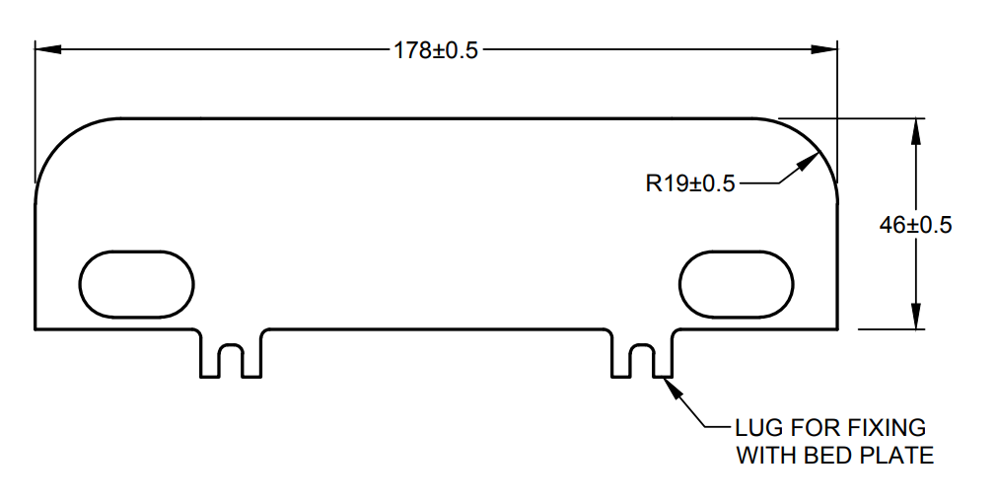

All dimensions in millimeters.

Fig. 1 Shape and Dimensions of Machine Lifting Plate

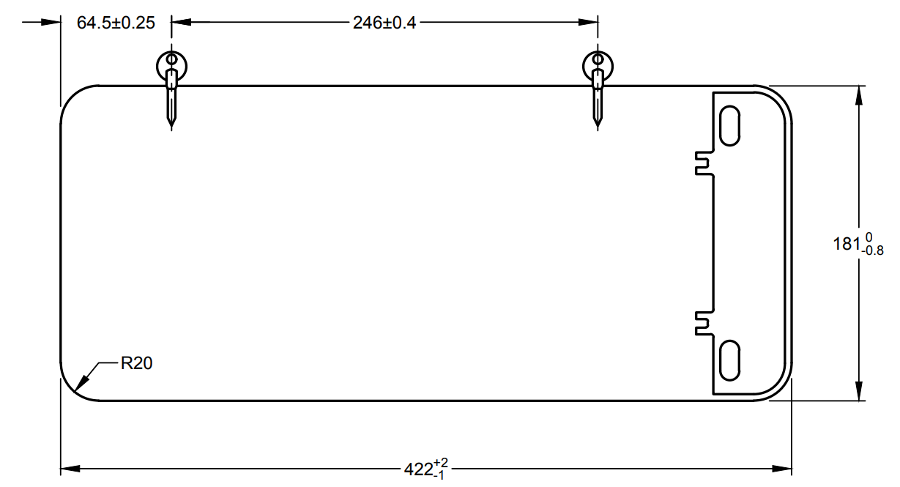

All dimensions in millimeters.

Fig. 2 Cut-Out for Bed When Machine Lifting Plate is Used

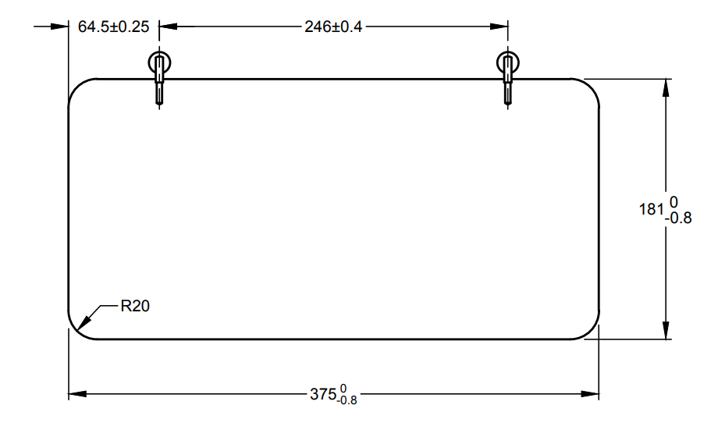

All dimensions in millimeters.

Fig. 3 Cut-out for Bed when Machine Lifting Plate is not Used

NOTE — When specially requested the bed cut-out may be made to, specified dimensions, however, the tolerance shall be in accordance with Fig. 2 and Fig. 3.

**7.3** Accuracy of assembly shall be as follows:

|  |  |  |
| --- | --- | --- |
| *Sl No.* | *Description* | *Max Dimensions*  *(in mm)* |
| (1) | (2) | (3) |
|  | Clearance at cut-off section shall be uniform all over with respect to bed | 1.5 |
|  | Misalignment of cut-off section with bed profile | 0.5 |
|  | Non-uniformity in depth of cut- off bed | 0.5 |
|  | Raise of machine bed over the table surface | 1.0 |
|  | Clearance between table and centre drawer | 2.0 |
|  | Height of machine platform above surface of table | 3.0 |
|  | Clearance between drawer and bottom face of table | 3.0 |
|  | Clearance between cover and base or cover and table | 2.0 |
| NOTE — Clearance of drawer shall be measured when the drawer is in the closed position. | | |

**8 APPEARANCE**

Appearances shall be elegant and also free from defects and shall conform to the following:

1. All parts shall be free from harmful deformation, warpage, twist and unevenness;
2. The surfaces of table bed and cover, also the face verneer on the front of cabinet shall be elegant; and
3. Hardware shall be free from defects such as mars, rust, peeling etc.

**9 COATING**

Coating shall conform to IS 101 (Part 3/Sec 4).

**10 FUNCTION**

Function shall conform to the following:

1. The folding table shall be made in such a manner that the machine head can be housed without hindrance;
2. Drawer, hinges, and hardware and also other subsidiary fixtures shall function smoothly and satisfactorily; and
3. Stability of the base shall be satisfactory.

**11 WEATHER PROOFNESS REQUIREMENTS**

It shall conform to the following requirements of the weather-proof test:

1. Wood parts shall be free from defects, such as delamination, cracks, and peeling, and shall not deform conspicuously or function abnormally;
2. Coated surface shall be free from damage to gloss, colouring and also peeling; and
3. Hardware shall be free from rust and shall function normally.

**12 TEST**

**12.1 Moisture List**

The moisture list shall be conducted in accordance with the moisture content measuring method specified in IS 1708 (Part 1).

**12.2 Adhesion Strength Test**

The test shall be conducted in accordance with the provisions of IS 1734 (Part 5).

**12.3 Water Resistance Test**

The test shall be conducted in accordance with the provisions of IS 1734 (Part 6).

**12.4 Hardness Test of Coated Film**

The test shall be conducted in accordance with IS 101 (Part 5/Sec 1).

**13 INSPECTION**

Inspection of materials, structure, shape, dimensions, accuracy, appearance, coating, function shall be carried out to determine compliance with requirements specified, in **6** to **12**. As to moisture content, inspection shall be made of materials in the stake immediately prior to the machining operation.

**14 MARKING**

The table may be marked with manufacturer’s name or trademark.

**14.1 BIS Certification Marking**

The product may also be marked with Standard Mark.

**14.1.1** The product(s) conforming to the requirements of this standard may be certified as per the conformity assessment schemes under the provisions of the *Bureau of Indian Standards Act*,2016 and the Rules and Regulations framed thereunder, and the products may be marked with the Standard Mark.

**15 PACKING**

**15.1** Each wooden table shall be individually wrapped in a draft paper after proper cleaning and removing dust, etc in such a manner that no dust can enter it.

**15.2** The wrapped wooden table shall be packed in a wooden packing box along with all the fitting parts and accessories as per the best prevailing practice in the trade. The number of wooden table to be packed in packing box shall be as agreed to between the supplier and the purchaser.

**ANNEX A**

(*Clause* 2)

**LIST OF REFERRED STANDARDS**

|  |  |
| --- | --- |
| *IS No.* | *Title* |
| IS 101 | Method of sampling and test for paints, varnishes and related products |
| (Part 3/Sec 4) : 1987 | Test on paint film formation: Section 4 Finish (*third revision*) |
| (Part 5/Sec 1) : 1988 | Mechanical test for paint films: Section 1 Hardness test (*third revision*) |
| IS 303 : 2024 | Plywood for general purposes — Specification (*fourth revision*) |
| IS 513 (Part 1) : 2016 | Cold reduced carbon steel sheet and strip: Part 1 Cold forming and drawing purpose (*sixth revision*) |
| IS 848 : 2006 | Synthetic resin adhesives for plywood (phenolic and aminoplastic) — Specification (*second revision*) |
| IS 1068 : 1993 | Electroplated coating of nickel plus chromium and copper plus nickel plus chromium — Specification (*third revision*) |
| IS 1708 (Part 1) : 1986 | Methods of testing of small clear specimens of timber (*second revision*) |
| IS 1734 | Method of test for plywood |
| (Part 5) : 1983 | Test for adhesion of plies (*second revision*) |
| (Part 6) : 1983 | Determination of water resistance (*second revision*) |
| IS 2046 : 1995 | Decorative thermosetting synthetic resin bonded laminated sheets — Specification (*second revision*) |
| IS 3087 : 2005 | Particle boards of wood and other lignocellulosic materials (medium density) for general purposes **—** Specification (*second revision*) |
| IS 10018 : 1981 | Specification for lacquer, cellulose nitrate, clear, finishing, glossy for wood |
| IS 12406 : 2021 | Medium density fibre boards for general purpose — Specification (*second revision*) |

**ANNEX B**

(*Foreword*)

**COMMITTEE COMPOSITION**

Sewing Machines Sectional Committee, MED 29

|  |  |  |
| --- | --- | --- |
| *Organization* |  | *Representative (s)* |
| Research & Development Centre for Bicycle and Sewing Machines, Ludhiana |  | Shri Sanjeev Katoch (***Chairperson***)  Shri Papinder Singh  Shri Vishwas Mehta (*Alternate* I)  Shri Manpreet Singh (*Alternate* II) |
| Brother International (India) Private Limited, Mumbai |  | Shri Mathew Yohannan |
| C.R. Auluck & Sons Private Limited, Ludhiana |  | Shri Sunil Auluck  Shri Kuljeet Singh (*Alternate*) |
| Directorate General of Quality Assurance, New Delhi |  | Shri R.V. Jain |
| G.D. Rupal Industries, Ludhiana |  | Shri Gurmukh Singh |
| Gee Tech Hooks, Ludhiana |  | Shri Manjeet Singh |
| Geminy Industrial Enterprises Private Limited, Ludhiana |  | Shri Vinay Dua  Shri B.C. Pandey (*Alternate*) |
| Ludhiana Sewing Machine Association, Ludhiana |  | Shri Hardeep Singh  Shri Rajvinder (*Alternate*) |
| Makhan Sewing Machines, Ludhiana |  | Shri Dalbir Singh Dhiman |
| Narindera and Company, Ludhiana |  | Shri S. Baldev Singh  Shri Harinder Jit Singh (*Alternate*) |
| Navrang Manufacturing Corporation, Ludhiana |  | Shri Dinesh Kapila  Shri Sudesh Kapila (*Alternate*) |
| Northern India Textile Research Association, Ghaziabad |  | Shri Vikas Sharma  Shri Vivek Agarwal (*Alternate*) |
| Novel Sewing Machine Technologies, Pune |  | Shri Bharat Narayendas Parmar  Shri Arjun Bharat Parmar (*Alternate*) |
| ORAA International, Ludhiana |  | Shri Ashish Gupta |
| Office of Development Commissioner (MSME), New Delhi |  | Shri Suvankar Santra  Ms Maitreyee Talapatra (*Alternate*) |
| Ranew Engineering (India) Private Limited, Ludhiana |  | Shri Sanjeev Kumar Jain  Shri Abhilash Jain (*Alternate*) |
| Singer India Limited, New Delhi |  | Shri Prashant Aggarwal  Shri Atul Kumar Seth (*Alternate*) |
| Swan Mechanical Works, Ludhiana |  | Shri Amarjeet Singh |
| United Sewing Machines and Parts Manufacturing Association, Ludhiana |  | Shri Dalbir Singh Dhiman |
| Usha International Limited, New Delhi |  | Shri Rup Lal Kangla  Shri Pranay Sriwastav (*Alternate*) |
| Uttam Sewing Machine Company (Private) Limited, Jalandhar |  | Shri Jagdeep Rai  Shri Manohar Lal (*Alternate*) |
| Virindra Engineering Works, Ludhiana |  | Shri Amarpreet Singh Panesar  Shri Swarn Singh (*Alternate*) |
| Voluntary Organisation in Interest of Consumer Education (VOICE), New Delhi |  | Shri M. A. U. Khan |
| BIS Directorate General |  | Shri K. Venkateswara Rao, Scientist ‘F’/Senior Director and Head (Mechanical) [Representing Director General (*Ex-officio*)] |

*Member Secretary*

Shri Shubham Tiwari

Scientist ‘D’/Joint Director

(Mechanical), BIS