***भारतीय मानक***

***Indian Standard***

**IS 4341 : 2024**

***घरेलू सिलाई मशीनें — फ़ीड दंड रोलर और स्टड — विशिष्टि***

*(* दूसरा पुनरीक्षण (

**Household Sewing Machines — Feed Bar Rollers and Studs — Specification**

)*Second Revision )*

ICS 61.080

© BIS 2024

भारतीय मानक ब्यूरो

BUREAU OF INDIAN STANDARDS

मानक भवन, 9 बहादुर शाह ज़फर मार्ग, नई दिल्ली - 110002

MANAK BHAVAN, 9 BAHADUR SHAH ZAFAR MARG

NEW DELHI - 110002

[www.bis.gov.in](http://www.bis.org.in) [www.standardsbis.in](http://www.standardsbis.in)

**October 2024 Price Group X**

Sewing Machines Sectional Committee, MED 29

FOREWORD

This Indian Standard (Second Revision) was adopted by the Bureau of Indian Standards, after the draft finalized by the Sewing Machine Sectional Committee had been approved by the Mechanical Engineering Division Council.

This standard was first published in 1967 and subsequently revised in 1997. The present revision has been taken up with a view to incorporating the modifications found necessary as a result of experience gained on the use of this standard. Also, in this revision, the standard has been brought into the latest style and format of Indian Standard, and references to Indian Standards, wherever applicable have been updated. The BIS certification marking clause has been modified to align with the revised *Bureau of Indian Standards Act,* 2016.

.

For general requirements of sewing machines IS 1610 : 2018 ‘Household sewing machines ― General requirement (*fourth revision*)’may be referred.

The composition of the Committee responsible for the formulation of this standard is given in Annex B.

For the purpose of deciding whether a particular requirement of this standard is complied with, the final value, observed or calculated, expressing the result of a test or analysis, shall be rounded off in accordance with IS 2 : 2022 ‘Rules for rounding off numerical values (*second revision*)’. The number of significant places retained in the rounded off value should be the same as that of the specified value in this standard.

*Indian Standard*

HOUSEHOLD SEWING MACHINES — FEED BAR ROLLERS AND STUDS — SPECIFICATION

*( Second Revision )*

**1 SCOPE**

This standard specifies the requirements for two types of feed bar rollers and studs for sewing machines for household purposes.

**2 REFERENCES**

The standards given below contain provisions which, through reference in this text, constitute provision of this standard. At the time of publication, the editions indicated were valid. All standards are subject to revision, and parties to agreements based on this standard are encouraged to investigate the possibility of applying the most recent edition of these standards:

|  |  |
| --- | --- |
| *IS No.* | *Title* |
| IS 1501 (Part 1) : 2020/  ISO 6507-1 : 2018 | Metallic materials — Vickers hardness test: Part 1 Test method (*fifth revision*) |
| IS 2500 (Part 1) : 2000/  ISO 2859-1 : 1999 | Sampling procedures for inspection by attributes: Part 1 Sampling schemes indexed by acceptance quality limit (AQL) for lot-by-lot inspection (*third revision*) |
| IS 4432 : 1988 | Specification for case hardening steels (*first revision*) |
| IS 4905 : 2015/  ISO 24153: 2009 | Random sampling and randomization procedures (*first revision*) |

**3 NOMENCLATURE**

The nomenclature of feed bar rollers and studs shall be as indicated in Fig. 1.

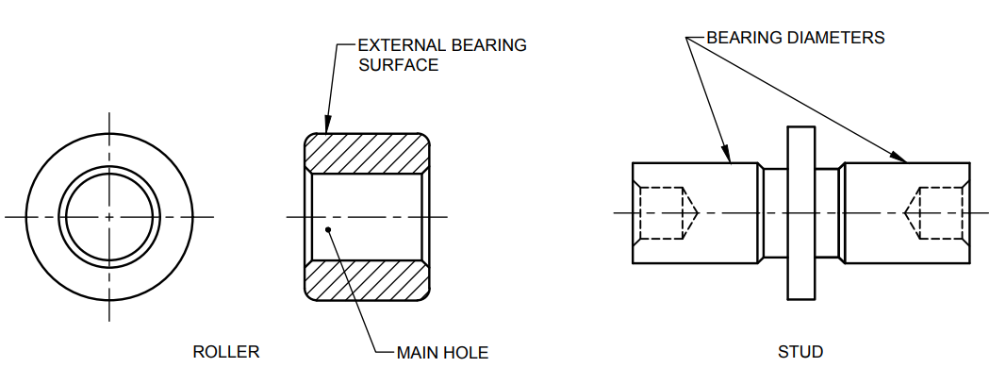

Fig. 1 Nomenclature for Feed Bar Roller and Stud

**4 TYPES**

The feed bar rollers and studs shall be either Type A or Type B.

**5 MATERIAL**

The rollers and studs shall be manufactured from any suitable case hardening steel (*see* IS 4432).

**6 HARDNESS**

The rollers shall be case hardened to attain a hardness value of 400 HV, *Min* [*see* IS1501 (Part 1)/ ISO 6507-1].

**7 DIMENSIONS AND TOLERANCES**

**7.1** The dimensions and tolerances for feed bar rollers and studs shall be as shown in Fig. 2 and Fig. 3.

**7.2** The error in the concentricity of the external bearing face of the roller when rotated about the main hole of the roller shall not exceed 0.01 mm.

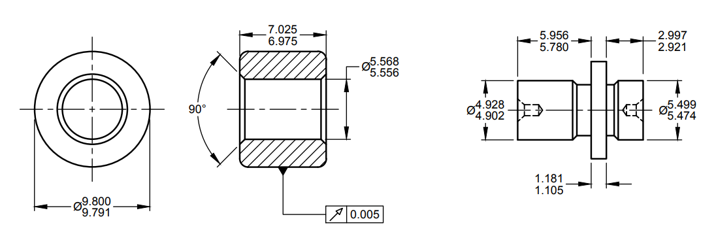

All dimensions in millimetres.

Fig. 2 Dimensions for Feed Bar Roller and Stud ― Type A

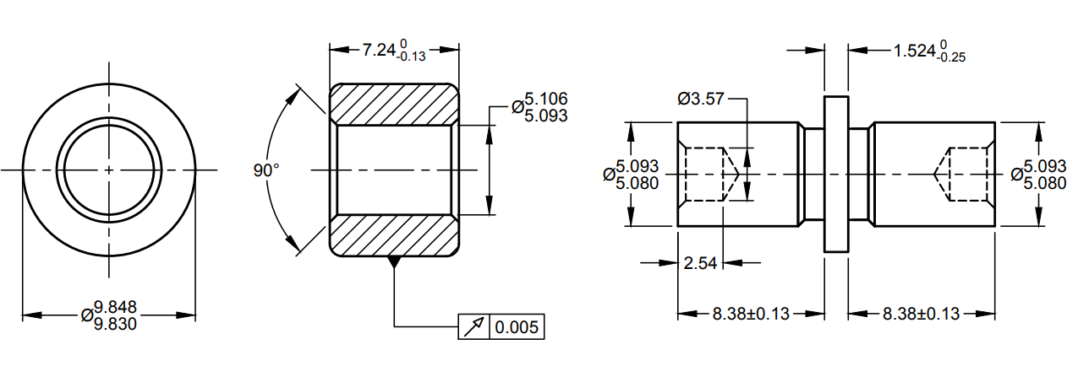

All dimensions in millimetres.

Fig. 3 Dimensions for Feed Bar Roller and Stud ― Type B

**8 WORKMANSHIP AND FINISH**

**8.1** The main hole and external bearing surface of the roller shall be ground to smooth finish and shall be free from rust, dust, etc.

**8.2** The bearing diameter of the stud shall be precision ground to a smooth finish and shall be free from rust, dust, etc.

**9 SAMPLING**

Unless otherwise agreed to between the purchaser and the supplier the sampling plan as given in Annex A shall be followed. For further information, reference may be made to IS 2500 (Part 1)/ISO 2859-1 and IS 4905/ISO 24153.

**10 MARKING**

**10.1** Each piece of the feed bar roller and stud shall be legibly and indelibly marked with the following:

1. Source of manufacture and trade-mark, if any; and
2. Type of feed bar roller and stud.

**10.2 BIS Certification Marking**

The product may also be marked with the Standard Mark.

**10.2.1** The product(s) conforming to the requirements of this standard may be certified as per the conformity assessment schemes under the provisions of the *Bureau of Indian Standards Act*, 2016 and the Rules and Regulations framed thereunder, and the product(s) may be marked with the Standard Mark.

**11 PACKING**

Each feed holder rollers and studs shall be given a suitable anti-rust coating and wrapped in polyethylene bags. The wrapped feed bar rollers and studs shall be securely packed in accordance with the best prevalent trade practice. Each package shall bear address of the source of manufacture, type and description of contents.

**ANNEX A**

(*Clause* 9)

**SCALE OF SAMPLING AND CRITERIA FOR CONFORMITY**

**A-1 SCALE OF SAMPLING**

**A-1.1 LOT**

In any consignment, all the feed bar rollers of the same type and manufactured from the same material under essentially similar conditions of manufacture shall be grouped together to constitute a lot.

**A-1.2** For ascertaining the conformity of the lot to the requirements of the specification, tests shall be carried out for each lot separately. The number of feed bar rollers to be selected at random for this purpose shall be in accordance with col (1) and col (2) of Table 1.

**A-1.3** If the items are packed individually, in order to ensure the randomness of selection, random number tables shall be used. In cases such tables are not available the following procedure may be adopted.

‘Starting from any feed bar roller in the lot, count them in one order as 1, 2, 3,….. up to *r* and so on, where *r* is the integral part of *N/n* (*N* being the lot size and *n* the sample size). Each feed bar roller thus counted shall be selected to constitute the sample.’

**A-1.4** If the feed bar rollers are packed in different cartons, a suitable number of cartons (not less than 20 percent of the total in the lot subject to a minimum of 2) shall be chosen at random. From each of the cartons so chosen, an approximately equal number of feed holder rollers shall be picked up from its different parts so as to obtain the required number of needle bar link studs specified in col (1) and col (2) of Table 1.

**A-2 NUMBER OF TESTS AND CRITERIA FOR CONFORMITY**

**A-2.1** The feed bar rollers selected according to **A-1.2** and **A-1.3** or **A-1.4** shall be examined for dimensions and tolerances (*see* **7**) and workmanship and finish (*see* **8**). If the number of feed bar rollers failing to meet one or more of the requirements mentioned above is less than or equal to the permissible number of defectives given in col (3) of Table 1, the lot shall be declared as conforming to the requirements of these characteristics.

**A-2.2** In the case of those lots which have been found satisfactory according to **A-2.1**, a number of feed bar rollers equal to the sample size indicated in col (4) of Table 1, shall be subjected to hardness test (*see* **6**). Any roller failing to meet the requirement for harness shall be considered to be defective.

**A-2.2.1** If no defectives are found among the feed bar rollers subjected to the hardness test (*see* **A-2.2**), the lot shall declared as conforming to the requirements of the specification, otherwise not.

**Table 1 Scale of Sampling and Permissible Number of Defects**

(*Clauses* A-1.2, A-1.4, A-2.1 *and* A-2.2)

|  |  |  |  |  |  |  |  |  |
| --- | --- | --- | --- | --- | --- | --- | --- | --- |
| **Sl No.** | **No. of flywheel bushes in the Lot**  *N* | **For Dimensions, Tolerances and Workmanship and Finish** | | | | **Sample Size for Hardness and Tests** | | |
| Sample Size  *n* | | | Permissible No. of Defectives1 |
| (1) | (2) | | (3) | (4) | | | (5) |
|  | Up to 15 | | 5 | 0 | | | 2 |
|  | 16 to 40 | | 8 | 0 | | | 3 |
|  | 41 to 110 | | 13 | 0 | | | 3 |
|  | 111 to 300 | | 20 | 1 | | | 5 |
|  | 301 to 500 | | 32 | 1 | | | 6 |
|  | 501 to 800 | | 50 | 2 | | | 8 |
|  | 801 to 1 300 | | 80 | 3 | | | 10 |
|  | 1 301 and above | | 125 | 5 | | | 15 |
| 1. This ensures that lots containing one and half percent or less defective will be accepted most of the time. | | | | | | | |

**ANNEX B**

(*Foreword*)

**COMMITTEE COMPOSITION**

Sewing Machines Sectional Committee, MED 29

|  |  |  |
| --- | --- | --- |
| *Organization* |  | *Representative (s)* |
| Research & Development Centre for Bicycle and Sewing Machines, Ludhiana |  | Shri Sanjeev Katoch (***Chairperson***)  Shri Papinder Singh  Shri Vishwas Mehta (*Alternate* I)  Shri Manpreet Singh (*Alternate* II) |
| Brother International (India) Private Limited, Mumbai |  | Shri Mathew Yohannan |
| C.R. Auluck & Sons Private Limited, Ludhiana |  | Shri Sunil Auluck  Shri Kuljeet Singh (*Alternate*) |
| Directorate General of Quality Assurance, New Delhi |  | Shri R.V. Jain |
| G.D. Rupal Industries, Ludhiana |  | Shri Gurmukh Singh |
| Gee Tech Hooks, Ludhiana |  | Shri Manjeet Singh |
| Geminy Industrial Enterprises Private Limited, Ludhiana |  | Shri Vinay Dua  Shri B.C. Pandey (*Alternate*) |
| Ludhiana Sewing Machine Association, Ludhiana |  | Shri Hardeep Singh  Shri Rajvinder (*Alternate*) |
| Makhan Sewing Machines, Ludhiana |  | Shri Dalbir Singh Dhiman |
| Narindera and Company, Ludhiana |  | Shri S. Baldev Singh  Shri Harinder Jit Singh (*Alternate*) |
| Navrang Manufacturing Corporation, Ludhiana |  | Shri Dinesh Kapila  Shri Sudesh Kapila (*Alternate*) |
| Northern India Textile Research Association, Ghaziabad |  | Shri Vikas Sharma  Shri Vivek Agarwal (*Alternate*) |
| Novel Sewing Machine Technologies, Pune |  | Shri Bharat Narayendas Parmar  Shri Arjun Bharat Parmar (*Alternate*) |
| ORAA International, Ludhiana |  | Shri Ashish Gupta |
| Office of Development Commissioner (MSME), New Delhi |  | Shri Suvankar Santra  Ms Maitreyee Talapatra (*Alternate*) |
| Ranew Engineering (India) Private Limited, Ludhiana |  | Shri Sanjeev Kumar Jain  Shri Abhilash Jain (*Alternate*) |
| Singer India Limited, New Delhi |  | Shri Prashant Aggarwal  Shri Atul Kumar Seth (*Alternate*) |
| Swan Mechanical Works, Ludhiana |  | Shri Amarjeet Singh |
| United Sewing Machines and Parts Manufacturing Association, Ludhiana |  | Shri Dalbir Singh Dhiman |
| Usha International Limited, New Delhi |  | Shri Rup Lal Kangla  Shri Pranay Sriwastav (*Alternate*) |
| Uttam Sewing Machine Company (Private) Limited, Jalandhar |  | Shri Jagdeep Rai  Shri Manohar Lal (*Alternate*) |
| Virindra Engineering Works, Ludhiana |  | Shri Amarpreet Singh Panesar  Shri Swarn Singh (*Alternate*) |
| Voluntary Organisation in Interest of Consumer Education (VOICE), New Delhi |  | Shri M. A. U. Khan |
| BIS Directorate General |  | Shri K. Venkateswara Rao, Scientist ‘F’/Senior Director and Head (Mechanical) [Representing Director General (*Ex-officio*)] |

*Member Secretary*

Shri Shubham Tiwari

Scientist ‘D’/Joint Director

(Mechanical), BIS