***भारतीय मानक***

***Indian Standard***

**IS 13806 : 2024**

***घरेलू सिलाई मशीन — बंद टाइप फिरकी चाल***

***समुच्च्य — विशिष्टि***

*(* पहला पुनरीक्षण )

**Household Sewing Machine — Closed Type Shuttle Race Assembly — Specification**

( *First Revision )*

ICS 61.080

© BIS 2024

भारतीय मानक ब्यूरो

BUREAU OF INDIAN STANDARDS

मानक भवन, 9 बहादुर शाह ज़फर मार्ग, नई दिल्ली - 110002

MANAK BHAVAN, 9 BAHADUR SHAH ZAFAR MARG

NEW DELHI - 110002

[www.bis.gov.in](http://www.bis.org.in) [www.standardsbis.in](http://www.standardsbis.in)

**December 2024 Price Group X**

Sewing Machine Sectional Committee, MED 29

FOREWORD

This Indian Standard (First Revision) was adopted by the Bureau of Indian Standards, after the draft finalized by the Sewing Machine Sectional Committee had been approved by the Mechanical Engineering Division Council.

This standard was first published in 1993. The present revision has been taken up with a view incorporating the modification found necessary as a result of experience gained in the use of this standard. Also, in this revision, the standard has been brought into latest style and format of Indian Standards, and references to Indian Standards, wherever applicable have been updated. BIS certification marking clause has been modified to align with the revised *Bureau of Indian Standard Act*, 2016. Table 1 Dimensions and tolerances of closed type-shuttle race assembly have been modified.

The composition of the Committee responsible for the formulation of this standard is given in Annex C.

For the purpose of deciding whether a particular requirement of this standard is complied with, the final value, observed or calculated, expressing the result of a test or analysis, shall be rounded off in accordance with IS 2 : 2022 ‘Rules for rounding off numerical values (*second revision*)’. The number of significant places retained in the rounded off value should be the same as that of the specified value in this standard.

*Indian Standard*

HOUSEHOLD SEWING MACHINE — CLOSED TYPE SHUTTLE RACE ASSEMBLY — SPECIFICATION

*( First Revision )*

**1 SCOPE**

This standard covers the requirements of closed type shuttle race assembly for sewing machine for household purposes.

**2 REFERENCES**

The standards listed in Annex A contain provisions which through reference in this text, constitute provisions of this standard. At the time of publication, the editions indicated were valid. All standards are subject to revision, and parties to agreements based on this standard are encouraged to investigate the possibility of applying the most recent editions of these standards.

**3 TERMINOLOGY**

For the purpose of this standard, the definitions given in IS 6903 shall apply.

**4 NOMENCLATURE**

Nomenclature shall be as indicated in Fig. 1.

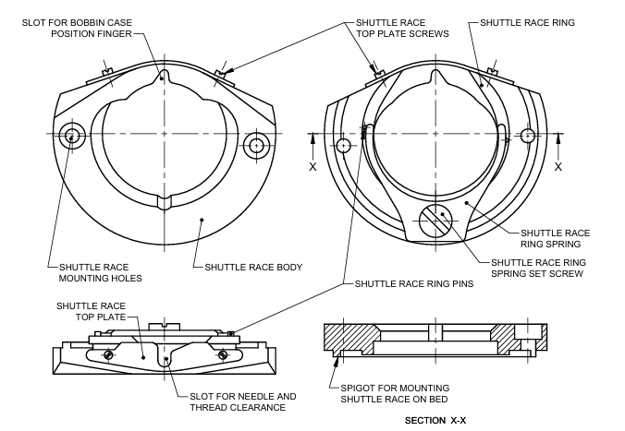

Fig.1 Nomenclature of Closed Type Shuttle Race

**5 MATERIALS**

**5.1** The material for the closed type shuttle race is specified as follows:

**5.1.1** The shuttle race body shall be made from cast iron of suitable grade conforming to IS 210.

**5.1.2** The shuttle race ring shall be made from case hardening steel designation 20Mn5Cr5 of IS 4432, so as to achieve a hardness of 450 HV in the finished state [*see* IS 1501 (Part 1)/ISO 6507-1].

**5.1.3** The shuttle race ring spring and top plate may be designed as per IS 10878 (Part 1) and IS 10878 (Part 2). Material used for spring shall conform to IS 2507. These shall be hardened and tempered.

**5.1.4** The pins and all screws to be used for closed type shuttle race assembly shall be made of mild steel and shall be case hardened.

**6 DIMENSIONS AND TOLERANCES**

The fitting dimensions and tolerances of shuttle race as indicated in Fig. 2 shall conform to values as given in Table 1.

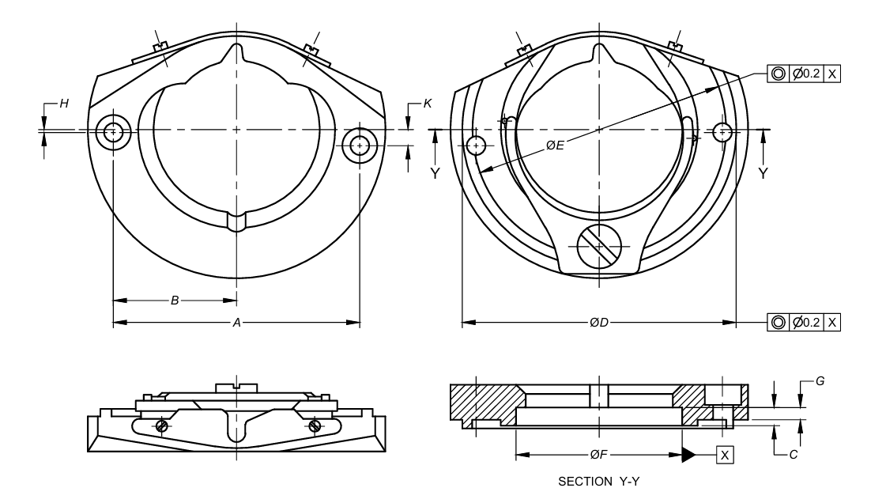

Fig. 2 Dimensions for Closed Type Shuttle Race

**Table 1 Dimensions and Tolerances of Closed Type-Shuttle Race Assembly**

(*Clause* 6)

All dimensions in millimetre.

|  |  |  |  |  |  |  |  |  |  |  |
| --- | --- | --- | --- | --- | --- | --- | --- | --- | --- | --- |
| **Sl No.** | **Dimension** | **A** | **B** | **C** | **D** | **E** | **F** | **G** | **H** | **K** |
| (1) | (2) | (3) | (4) | (5) | (6) | (7) | (8) | (9) | (10) | (11) |
|  | Type A | 62.450 | 31.363 | 4.591 | 69.5 | 64.585 | 42.615 | 4.013 | 0.038 | 4.45 |
| 62.350 | 31.337 | 4.572 | 69.4 | 64.550 | 42.600 | 3.988 | 0.013 | 4.30 |
|  | Type B | 63.55 | 31.775 | 4.60 | 69.83 | 64.72 | 42.722 | 4.064 | 2.311 | 1.311 |
| 63.45 | 31.725 | 4.58 | 67.792 | 64.57 | 42.672 | 4.014 | 2.261 | 2.261 |
|  | NOTE — Ovality shall not be more than ± 0.010 mm. | | | | | | | | | |

**7 WORKMANSHIP AND FINISH**

**7.1** Surface on sliding parts and thread passage for shuttle race shall be polished to smooth surface/edges to avoid breakage/damage to threads, while stitching.

**7.2** The external visible surface shall have bright nickle/chromium plated finish. All other components of race assembly including screws, pins and ring etc. shall have nickle plated/blackened surface finish conforming to at least Service Grade No. 1 with Designation Fe/Ni l0b Cr r of IS 1068.

**7.3** Shuttle groove diameter ‘*F*’ shall be concentric to diameter ‘*D*’ and ‘*E*’ of spigot for mounting shuttle race on bed within 0.3 mm (TIR).

**8 SAMPLING**

Unless otherwise agreed to between the supplier and the purchaser the sampling plan as given in Annex B shall be followed. For further information, reference may be made to IS 2500 (Part 1)/ISO 2859-1.

**9 MARKING**

Unless otherwise agreed to between the purchaser and manufacturer, the shuttle race may be marked with the source of manufacture or trademark.

**9.1 BIS Certification Marking**

The product(s) conforming to the requirements of this standard may be certified as per the conformity assessment schemes under the provisions of the *Bureau of Indian Standards Act,* 2016 and the Rules and Regulations framed thereunder, and the products may be marked with the Standard Mark.

**10 PACKING**

Each closed type shuttle race assembly shall be given a suitable antirust coating, packed in a polyethylene bag and then put in a card board carton bearing manufacturer’s name or trade mark, type and description of contents. The wrapped, closed type shuttle race shall be securely packed in accordance with best prevalent trade practice.

**ANNEX A**

(*Clause* 2)

**LIST OF REFERRED STANDARDS**

|  |  |
| --- | --- |
| *IS No.* | *Title* |
| IS 210 : 2009 | Grey iron castings (*fifth revision*) |
| IS 1068 : 1993 | Electroplated coatings of nickel plus chromium and copper plus nickel plus chromium on iron and steel (*third revision*) |
| IS 1501 (Part 1) : 2020/  ISO 6507-1 : 2018 | Metallic materials — Vickers hardness test Part 1 Test method ( *fifth revision* ) |
| IS 2500 (Part 1) : 2000/  ISO 2859-1 : 1999 | Sampling procedure for inspection by attributes: Part 1 Sampling schemes indexed by acceptance quality limit (AQL) for lot-by-lot inspection (*third revision*) |
| IS 2507 : 1975 | Cold-rolled steel strips for springs (*first revision*) |
| IS 4432 : 1988 | Case hardening steels (*first revision*) |
| IS 4905 : 2015/  ISO 24153 : 2009 | Random sampling and randomization procedure (*first revision*) |
| IS 10878 (Part 1) : 1984 | Specification for flat form springs: Part 1 Design and calculation for springs made from rectangular cold-rolled strips |
| IS 10878 (Part 2) : 1984 | Flat form springs: Part 2 Specification for springs made from rectangular cold-rolled strips. |

**ANNEX B**

(*Clause* 8)

**SCALE OF SAMPLING AND CRITERIA FOR CONFORMITY**

**B-1 SCALE OF SAMPLING**

**B-1.1** In any consignment all the shuttle races of the same type and manufactured from the same material under essentially similar conditions of manufacture shall be grouped together to constitute a lot.

**B-1.2** For ascertaining the conformity of the lot to the requirements of specification, tests shall be carried out for each lot separately. The number of shuttle races to be selected at random for this purpose shall be in accordance with col (2) and col (3) of Table 2.

**Table 2 Scale of Sampling and Permissible Number of Defectives**(*Clause* B-1.2, B-1.4 *and* B-2.1 )

|  |  |  |  |
| --- | --- | --- | --- |
| **Sl No.** | **No. of Shuttles Races in the Lot**  ***N*** | **For Dimensions, Tolerances and Workmanship and Finish** | |
|  | Sample Size  *n* | Permissible No. of Defectives* |
| (1) | (2) | (3) | (4) |
|  | Up to 15 | 5 | 0 |
|  | 16 to 40 | 8 | 0 |
|  | 41 to 110 | 13 | 0 |
|  | 111 to 300 | 20 | 1 |
|  | 301 to 500 | 32 | 1 |
|  | 501 to 800 | 50 | 2 |
|  | 801 to 1 300 | 80 | 3 |
|  | 1 301 and above | 125 | 5 |
|  | *This ensures that lots containing one and a half percent or less defective will be accepted most of the time | | |

**B-1.3** If the shuttle races are packed individually, in order to ensure the randomness of selection IS 4905/ISO 24153 shall be used.

**B-1.4** If the shuttle races are packed in different cartons, a suitable number of cartons (not less than 20 percent of the total in the lot subject to a minimum of 2) shall be chosen at random. From each of the cartons so chosen, an approximately equal number of shuttle races shall be picked up from its different parts so as to obtain the required number of shuttle races specified in col (3) of Table 2.

**B-2 NUMBER OF TESTS AND CRITERIA FOR CONFORMITY**

**B-2.1** The shuttle races selected according to **A-1.2** and **A-1.3** or **A-1.4** shall be examined for dimensions and tolerance (*see* **6**) and workmanship and finish (*see* **7**). If the number of shuttle races failing to meet one or more of the requirements mentioned above is less than or equal to the permissible number of defectives given in col (4) of Table 2, the lot shall be declared as conforming to the requirements of these characteristics.

**ANNEX C**

(*Foreword*)

**COMMITTEE COMPOSITION**

Sewing Machines Sectional Committee, MED 29

| *Organization* |  | *Representative*(*s*) |
| --- | --- | --- |
| Research & Development Centre for Bicycle and Sewing Machines, Ludhiana |  | Shri Sanjeev Katoch **(*Chairperson*)** |
| Brother International (India) Private Limited, Mumbai |  | Shri Mathew Yohannan |
| C. R. Auluck & Sons Private Limited, Ludhiana |  | Shri Sunil Auluck  Shri Kuljeet Singh (*Alternate*) |
| Directorate General of Quality Assurance, New Delhi |  | Shri R.V. Jain |
| G. D. Rupal Industries, Ludhiana |  | Shri Gurmukh Singh |
| Gee Tech Hooks, Ludhiana |  | Shri Manjeet Singh |
| Geminy Industrial Enterprises Private Limited, Ludhiana |  | Shri Vinay Dua  Shri B. C. Pandey (*Alternate*) |
| Ludhiana Sewing Machine Association, Ludhiana |  | Shri Hardeep Singh  Shri Rajvinder (*Alternate*) |
| Makhan Sewing Machines, Ludhiana |  | Shri Dalbir Singh Dhiman |
| Narindera and Company, Ludhiana |  | Shri S. Baldev Singh  Shri Harinder Jit Singh (*Alternate*) |
| Navrang Manufacturing Corporation, Ludhiana |  | Shri Dinesh Kapila  Shri Sudesh Kapila (*Alternate*) |
| Northern India Textile Research Association, Ghaziabad |  | Shri Vikas Sharma  Shri Vivek Agarwal (*Alternate*) |
| Novel Sewing Machine Technologies, Pune |  | Shri Bharat Narayendas Parmar  Shri Arjun Bharat Parmar (*Alternate*) |
| Office of Development Commissioner (MSME), New Delhi |  | Shri Suvankar Santra  MsShrimati Maitreyee Talapatra (*Alternate*) |
| ORAA International, Ludhiana |  | Shri Ashish Gupta |
| Ranew Engineering (India) Private Limited, Ludhiana |  | Shri Sanjeev Kumar Jain  Shri Abhilash Jain (*Alternate*) |
| Research & Development Centre for Bicycle and Sewing Machines, Ludhiana |  | Shri Papinder Singh  Shri Vishwas Mehta (*Alternate* I)  Shri Manpreet Singh (*Alternate* II) |
| Singer India Limited, New Delhi |  | Shri Prashant Aggarwal  Shri Atul Kumar Seth (*Alternate*) |
| Swan Mechanical Works, Ludhiana |  | Shri Amarjeet Singh |
| United Sewing Machines and Parts Manufacturing Association, Ludhiana |  | Shri Dalbir Singh Dhiman |
| Usha International Limited, New Delhi |  | Shri Rup Lal Kangla  Shri Pranay Sriwastav (*Alternate*) |
| Uttam Sewing Machine Company (Private) Limited, Jalandhar |  | Shri Jagdeep Rai  Shri Manohar Lal (*Alternate*) |
| Virindra Engineering Works, Ludhiana |  | Shri Amarpreet Singh Panesar  Shri Swarn Singh (*Alternate*) |
| Voluntary Organisation in Interest of Consumer Education (VOICE), New Delhi |  | Shri M. A. U. Khan |
| BIS Directorate General |  | Shri K. Venkateswara Rao, Scientist ‘F’/Senior Director and Head (Mechanical) [Representing Director General (*Ex-officio*)] |

*Member Secretary*

Shri Shubham Tiwari

Scientist ‘D’/Joint Director

(Mechanical), BIS