***भारतीय मानक***

***Indian Standard***

**IS 4340 : 2024**

***घरेलू प्रयोजनों की सिलाई***

***मशीनों के लिए सुई छड़ कड़ी — विशिष्टि***

*(* पहला पुनरीक्षण )

**Needle Bar Links for Sewing Machines for Household Purposes — Specification**

( *First Revision )*

ICS 61.080

© BIS 2024

भारतीय मानक ब्यूरो

BUREAU OF INDIAN STANDARDS

मानक भवन, 9 बहादुर शाह ज़फर मार्ग, नई दिल्ली - 110002

MANAK BHAVAN, 9 BAHADUR SHAH ZAFAR MARG

NEW DELHI - 110002

[www.bis.gov.in](http://www.bis.org.in) [www.standardsbis.in](http://www.standardsbis.in)

**December 2024 Price Group X**

Sewing Machines Sectional Committee, MED 29

FOREWORD

This Indian Standard (First Revision) was adopted by the Bureau of Indian Standards, after the draft finalized by the Sewing Machines Sectional Committee had been approved by the Mechanical Engineering Division Council.

This standard was first published in 1967. The present revision has been taken up with a view incorporating the modification found necessary as a result of experience gained in the use of this standard. Also, in this revision, the standard has been brought into latest style and format of Indian Standards, and references to Indian Standards, wherever applicable have been updated. BIS certification marking clause has been modified to align with the revised *Bureau of Indian Standard Act*, 2016.

Major changes in this revision are as follows:

1. The dimensions of the Type A needle bar link have been modified; and
2. The amendments issued till date have been incorporated.

The composition of the Committee responsible for the formulation of the standard is listed in Annex C

For the purpose of deciding whether a particular requirement of this standard is complied with, the final value, observed or calculated, expressing the result of a test or analysis shall be rounded off in accordance with IS 2 : 2022 ‘Rules for rounding off numerical values (*second revision*)’. The number of significant places retained in the rounded off value should be the same as that of the specified value in this standard.

*Indian Standard*

NEEDLE BAR LINKS FOR SEWING MACHINES FOR HOUSEHOLD PURPOSES — SPECIFICATION

*( First Revision )*

**1 SCOPE**

**1.1** This standard covers the requirements for two types of needle bar links for sewing machines for household purposes.

**1.2** This standard does not deal with needle bar links used in industrial and special purpose sewing machines.

**2 REFERENCE**

The standards listed in Annex A contain provisions which through reference in this text, constitute provisions of this standard. At the time of publication, the editions indicated were valid. All standards are subject to revision, and parties to agreements based on this standard are encouraged to investigate the possibility of applying the most recent editions of these standards.

**3 TERMINOLOGY**

For the purpose of this standard, the definitions given in IS 6903 shall apply.

**4 NOMENCLATURE**

For the purpose of this standard, the nomenclature as given in Fig. 1 shall apply.

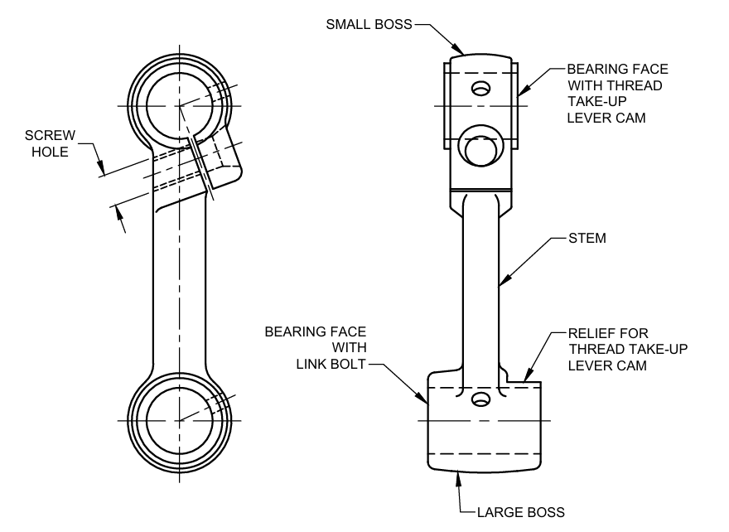

Fig. 1 Nomenclature For Needle Bar Links

**5 MATERIAL**

The needle bar links shall be forged from any suitable steel, such as C20 or C40 of IS 1570 (Part 2/Sec 1) or they shall be manufactured from grey iron castings conforming to IS 210.

**6 HARDNESS**

**6.1** The bearing faces of needle bar links forged from steel shall be case-hardened to a depth of 0.6 mm to attain a hardness within the range of 600 to 700 HV [*see* 1501 (Part 1)/ISO 6507-1]. The needle bar links manufactured from grey iron castings shall have a hardness of 190 to 210 HB [*see* IS 1500 (Part 1/ISO 6506-1].

**6.2** The stem of needle bar link forged from steel shall be kept soft with a maximum hardness value of 300 HV [*see* 1501 (Part 1)/ISO 6507-1].

**7 DIMENSIONS**

The main dimensions of needle bar links shall be as given in Fig. 2 and Table 1 and Fig. 3 and Table 2.

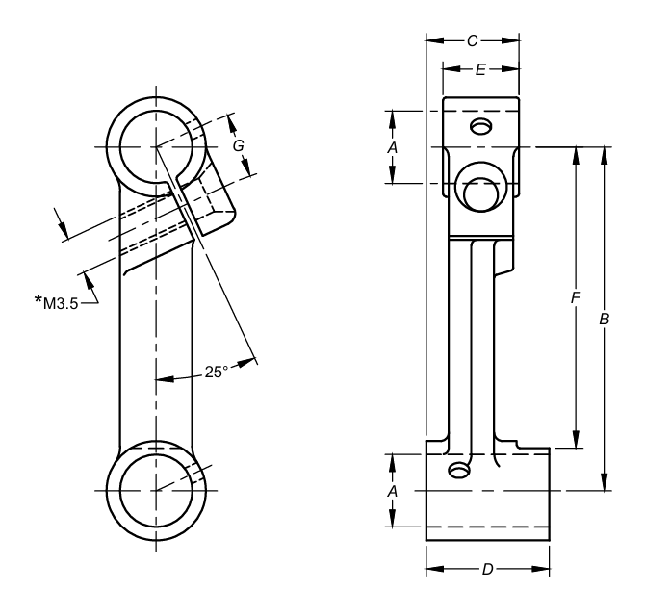

All dimensions in millimetres.

Fig. 2 Needle Bar Link, Type A

**Table 1 Dimensions for Needle Bar Link, Type A**  
(*Clause* 7)

|  |  |  |  |  |  |  |  |  |
| --- | --- | --- | --- | --- | --- | --- | --- | --- |
| **Sl No.** | **Requirement** | ***A*** | ***B*** | ***C*** | ***D*** | ***E*** | ***F*** | ***G*** |
| (1) | (2) | (3) | (4) | (5) | (6) | (7) | (8) | (9) |
|  | *Max* | 7.948 | 39.45 | 10.60 | 14.10 | 8.10 | 34.45 | 7.2 |
|  | *Min* | 7.933 | 39.35 | 10.30 | 13.90 | 7.90 | 34.35 | 6.8 |
|  | NOTE — *9/64" × 40 TPI (Threads per inch) may also be employed till the complete changeover to metric system is effective (*see* Fig. 2). | | | | | | | |

**8 TOLERANCES**

**8.1** The error in parallelism of the axes of the main holes of the needle bar link shall be within 0.2 mm per 100 mm.

**8.2** The error in parallelism of the bearing faces of the bosses of needle bar link shall be within 0.2 mm per 100 mm.

**8.3** The error in the squareness of the bearing faces of the bosses with respect to the main holes shall not exceed 0.2 mm per 100 mm.

**9 WORKMANSHIP AND FINISH**

**9.1** The main holes of needle bar link shall be precision ground to attain a minimum surface finish value of Ra 0.4 *µ*m (*see* IS 3073).

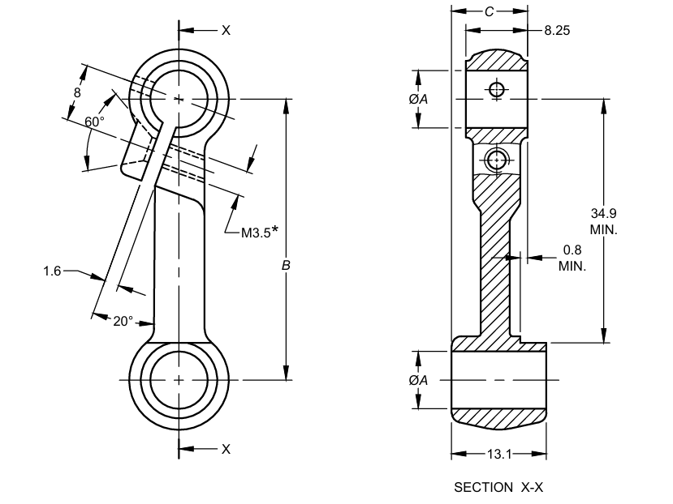

All dimensions in millimetres.

Fig. 3 Needle Bar Link, Type B

**Table 2 Dimensions for Needle Bar Link, Type A**

(*Clause* 7)

|  |  |  |  |  |
| --- | --- | --- | --- | --- |
| **Sl No.** | **Requirement** | ***A*** | ***B*** | ***C*** |
| (1) | (2) | (3) | (4) | (5) |
|  | *Min* | 7.938 | 39.50 | 10.64 |
|  | *Max* | 7.951 | 39.65 | 10.85 |
| NOTE — *4-B. A. medium fit threads may also be employed till the complete changeover to metric system is effective (*see* Fig. 3) | | | | |

**9.2** The bearing faces of the bosses of needle bar link shall be machined to a fine finish without any line mark.

**9.3** The components shall be chemically blackened or given any other adequate surface treatment to prevent rusting.

**9.4** The needle bar links shall be well finished without any crack, burr, rust and black mark on any bearing diameter.

**10 MARKING**

**10.1** The needle bar links shall be marked with the manufacturer's name or trademark.

**10.2 BIS Certification Mark**

The product(s) conforming to the requirements of this standard may be certified as per the conformity assessment schemes under the provisions of the *Bureau of Indian Standards Act*, 2016 and the Rules and Regulations framed thereunder, and the product(s) may be marked with the Standard Mark

**11 PACKING**

Each needle bar link shall be given a suitable anti-rust coating or wrapped in vapour phase inhibitor paper (commonly known as VPI paper). The wrapped needle bar links shall be securely packed in cardboard cartons in accordance with the best prevalent trade practice. Each carton shall bear the manufacturer's name or trade-mark, the type and description of contents.

**12 SAMPLING**

Unless otherwise agreed to between the supplier and the purchaser sampling plan as given in Annex B shall be followed. For further information, reference may be made to IS 2500 (Part 1)/ISO 2859-1.

**ANNEX A**

(*Clause* 2)

**LIST OF REFERRED STANDARDS**

|  |  |
| --- | --- |
| *IS No.* | *Title* |
| IS 210: 2009 | Grey iron castings ― Specification (*fifth revision*) |
| IS 1500 (Part 1) : 2019/  ISO 6506-1 : 2014 | Metallic materials — Brinell hardness test: Part 1 Test method (*fifth revision*) |
| IS 1501 (Part 1) : 2020/  ISO 6507-1:2018 | Metallic materials — Vickers hardness test: Part 1 Test method ( *fifth revision* ) |
| IS 1570 (Part 2/Sec 1) : 1979 | Schedules for wrought steels: Part 2 Carbon steels (Unalloyed steels): Section 1 Wrought products (other than, wire) with specified chemical composition and related properties (*first revision*) |
| IS 2500 (Part 1) : 2000/  ISO 2859-1:1999 | Sampling procedures for inspection by attributes: Part 1 Sampling schemes indexed by acceptance quality limit (AQL) for lot-by-lot inspection (*third revision*) |
| IS 3073: 1967 | Assessment of surface roughness |

**ANNEX B**

(*Clause* 12)

**SCALE OF SAMPLING AND CRITERIA FOR CONFORMITY**

**B-1 SCALE OF SAMPLING**

**B-1.1 Lot**

In any consignment, all the needle bar links of the same type and manufactured from the same material under essentially similar conditions of manufacture shall be grouped together to constitute a lot.

**B-1.2** For ascertaining the conformity of the lot to the requirements of the specification, tests shall be carried out for each lot separately. The number of needle bar links to be selected at random for this purpose shall be in accordance with col (2) and col (3) of Table 3.

**Table 3 Scale of Sampling and Permissible Number of Defectives**

(*Clauses* B-1.2, B-1.4, B-2.1 *and* B-2.2)

|  |  |  |  |  |
| --- | --- | --- | --- | --- |
| **Sl No.** | **No. of Needle Bar Links in the Lot**  *N* | **For Dimensions, Tolerances and Workmanship and Finish** | | **Sample Size for Hardness** |
| Sample Size  *n* | Permissible No. of Defectives* |
| (1) | (2) | (3) | (4) | (5) |
|  | Up to 15 | 5 | 0 | 2 |
|  | 16 to 40 | 8 | 0 | 3 |
|  | 41 to 110 | 13 | 0 | 3 |
|  | 111 to 300 | 20 | 1 | 5 |
|  | 301 to 500 | 32 | 1 | 6 |
|  | 501 to 800 | 50 | 2 | 8 |
|  | 801 to 1 300 | 80 | 3 | 10 |
|  | 1 301 and above | 125 | 5 | 15 |
|  | *This ensures that lots containing one and a half percent or less defectives will be accepted most of the time. | | | |
|  | | | | |

**B-1.3** If the needle bar links are packed individually, in order to ensure the randomness of selection, random number tables shall be used. In case such tables are not available the following procedure may be adopted:

‘Starting from any needle bar link in the lot, count them in one order as 1, 2, 3,…. up to r and so on, where r is the integral part of *N/n* (*N* being the lot size and *n* the sample size). Each needle bar link thus counted shall be selected to constitute the sample.’

**B-1.4** If the needle bar links are packed in different cartons, a suitable number of cartons (not less than 20 percent of the total in the lot subject to a minimum of 2) shall be chosen at random. From each of the cartons so chosen, an approximately equal number of needle bar links shall be picked up from its different parts so as to obtain the required number of needle bar links specified in col (2) and col (3) of Table 3.

**B-2 NUMBER OF TESTS AND CRITERIA FOR CONFORMITY**

**B-2.1** The needle bar links selected according to **A-1.3** or **A-1.4** shall be examined for dimensions (*see* **7**), tolerances (*see* **8**) workmanship and finish (*see* **9**). If the number of needle bar links failing to meet one or more of the requirements mentioned above is less than or equal to the permissible number of defectives given in col (4) of Table 3, the lot shall be declared as conforming to the requirements of these characteristics.

**B-2.2** In the case of those lots which have been found satisfactory according to **A-2.1**, a number of needle bar links equal to the sample size indicated in col (5) of Table 3, shall be subjected to hardness test (*see* **6**). Any needle bar link failing to meet the requirement for hardness shall be considered to be defective.

**B-2.2.1** If no defectives are found among the needle bar links subjected to the hardness test (*see* **A-2.2**), the lot shall be declared as conforming to the requirements of the specification, otherwise not.

**ANNEX C**

(*Foreword*)

**COMMITTEE COMPOSITION**

Sewing Machines Sectional Committee, MED 29

|  |  |  |
| --- | --- | --- |
| *Organization* |  | *Representative (s)* |
| Research & Development Centre for Bicycle and Sewing Machines, Ludhiana |  | Shri Sanjeev Katoch (***Chairperson***) |
| Brother International (India) Private Limited, Mumbai |  | Shri Mathew Yohannan |
| C.R. Auluck & Sons Private Limited, Ludhiana |  | Shri Sunil Auluck  Shri Kuljeet Singh (*Alternate*) |
| Directorate General of Quality Assurance, New Delhi |  | Shri R.V. Jain |
| G.D. Rupal Industries, Ludhiana |  | Shri Gurmukh Singh |
| Gee Tech Hooks, Ludhiana |  | Shri Manjeet Singh |
| Geminy Industrial Enterprises Private Limited, Ludhiana |  | Shri Vinay Dua  Shri B.C. Pandey (*Alternate*) |
| Ludhiana Sewing Machine Association, Ludhiana |  | Shri Hardeep Singh  Shri Rajvinder (*Alternate*) |
| Makhan Sewing Machines, Ludhiana |  | Shri Dalbir Singh Dhiman |
| Narindera and Company, Ludhiana |  | Shri S. Baldev Singh  Shri Harinder Jit Singh (*Alternate*) |
| Navrang Manufacturing Corporation, Ludhiana |  | Shri Dinesh Kapila  Shri Sudesh Kapila (*Alternate*) |
| Northern India Textile Research Association, Ghaziabad |  | Shri Vikas Sharma  Shri Vivek Agarwal (*Alternate*) |
| Novel Sewing Machine Technologies, Pune |  | Shri Bharat Narayendas Parmar  Shri Arjun Bharat Parmar (*Alternate*) |
| ORAA International, Ludhiana |  | Shri Ashish Gupta |
| Office of Development Commissioner (MSME), New Delhi |  | Shri Suvankar Santra  Ms Maitreyee Talapatra (*Alternate*) |
| Research & Development Centre for Bicycle and Sewing Machines, Ludhiana |  | Shri Papinder Singh  Shri Vishwas Mehta (*Alternate* I)  Shri Manpreet Singh (*Alternate* II) |
| Ranew Engineering (India) Private Limited, Ludhiana |  | Shri Sanjeev Kumar Jain  Shri Abhilash Jain (*Alternate*) |
| Singer India Limited, New Delhi |  | Shri Prashant Aggarwal  Shri Atul Kumar Seth (*Alternate*) |
| Swan Mechanical Works, Ludhiana |  | Shri Amarjeet Singh |
| United Sewing Machines and Parts Manufacturing Association, Ludhiana |  | Shri Dalbir Singh Dhiman |
| Usha International Limited, New Delhi |  | Shri Rup Lal Kangla  Shri Pranay Sriwastav (*Alternate*) |
| Uttam Sewing Machine Company (Private) Limited, Jalandhar |  | Shri Jagdeep Rai  Shri Manohar Lal (*Alternate*) |
| Virindra Engineering Works, Ludhiana |  | Shri Amarpreet Singh Panesar  Shri Swarn Singh (*Alternate*) |
| Voluntary Organisation in Interest of Consumer Education (VOICE), New Delhi |  | Shri M. A. U. Khan |
| BIS Directorate General |  | Shri K. Venkateswara Rao, Scientist ‘F’/Senior Director and Head (Mechanical) [Representing Director General (*Ex-officio*)] |

*Member Secretary*

Shri Shubham Tiwari

Scientist ‘D’/Joint Director

(Mechanical), BIS