***भारतीय मानक***

***Indian Standard***

**IS 10306 : 2024**

***घरेलू प्रयोजन की सिलाई मशीन — फ़ीड लिफ्टिंग रॉक शाफ्ट क्रैंक — विशिष्टि***

*(* पहला पुनरीक्षण )

**Sewing Machine for Household Purposes — Feed Lifting Rock Shaft Crank — Specification**

( *First Revision )*

ICS 61.080

© BIS 2024

भारतीय मानक ब्यूरो

BUREAU OF INDIAN STANDARDS

मानक भवन, 9 बहादुर शाह ज़फर मार्ग, नई दिल्ली - 110002

MANAK BHAVAN, 9 BAHADUR SHAH ZAFAR MARG

NEW DELHI - 110002

[www.bis.gov.in](http://www.bis.org.in) [www.standardsbis.in](http://www.standardsbis.in)

**October 2024 Price Group X**

Sewing Machines Sectional Committee, MED 29

FOREWORD

This Indian Standard (First Revision) was adopted by the Bureau of Indian Standards, after the draft finalized by the Sewing Machine Sectional Committee had been approved by the Mechanical Engineering Division Council.

This standard was first published in 1982. The present revision has been taken up to incorporate modifications found necessary as a result of experience gained in the use of this standard. Also, in this revision, the standard has been brought into the latest style and format of Indian Standards, and references to Indian Standards, wherever applicable have been updated. BIS certification marking clause has been modified to align with the revised *Bureau of Indian Standards Act,* 2016*.*

The major changes in the standard are given below:

1. The dimension of the small hole diameter has been revised;
2. The dimension of the feed lifting rock shaft cranks has been modified; and
3. Tolerances have been revised.

The composition of the Committee responsible for the formulation of this standard is given in Annex B.

For the purpose of deciding whether a particular requirement of this standard is complied with, the final value, observed or calculated, expressing the result of a test or analysis shall be rounded off in accordance with IS 2 : 2022 ‘Rules for rounding off numerical values (*second revision*)’. The number of significant places retained in the rounded off value should be the same as that of the specified value in this standard.

*Indian Standard*

SEWING MACHINE FOR HOUSEHOLD PURPOSES — FEED LIFTING ROCK SHAFT CRANK — SPECIFICATION

*( First Revision )*

**1 SCOPE**

This standard covers the requirements for feed lifting rock shaft cranks for sewing machines for household purposes.

**2 REFERENCES**

The standards listed below contains provisions which, through reference in this text, constitute provisions of this standard. At the time of publication, the editions indicated were valid. All standards are subjected to revision, and parties to agreements based on this standard are encouraged to investigate the possibility of applying the most recent editions of the standards listed below:

|  |  |
| --- | --- |
| *IS No.* | *Title* |
| IS 210: 2009 | Grey iron castings ― Specification (*fifth revision*) |
| IS 2500 (Part 1) : 2000/ ISO 2859-1:1999 | Sampling procedures for inspection by attributes: Part 1 Sampling schemes indexed by acceptance quality limit (AQL) for lot-by- lot inspection (*third revision*) |
| IS 4905 : 2015/  ISO 24153: 2009 | Random sampling and randomization procedures (*first revision*) |

**3 NOMENCLATURE**

The nomenclature shall be as shown in Fig. 1.

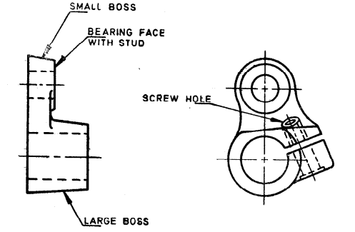

Fig. 1 Nomenclature for Feed Lifting Rock Shaft Crank

**4 MATERIAL**

The feed lifting rock shaft crank shall be made from cast iron conforming to grade FG 150 of IS 210.

**5 DIMENSIONS**

The dimensions shall be as shown in Fig. 2.

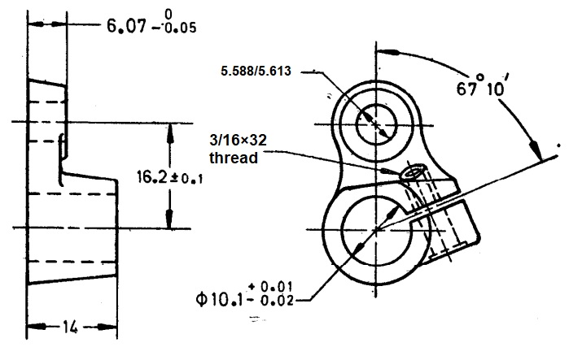

All dimensions in millimetres.

Fig. 2 Dimensions For Feed Lifting Rock Shaft Crank

**6 TOLERANCES**

**6.1** The error in parallelism of the axis of the main holes of the feed lifting rock shaft crank shall be within 0.30 mm per 100 mm.

**6.2** The error in the squareness of the bearing faces with respect to the main holes shall not exceed 0.30 mm per 100 mm.

**7 WORKMANSHIP AND FINISH**

**7.1** The main holes of the feed lifting rock shaft crank shall be finished to a good finish.

**7.2** The bearing faces of the bosses of feed lifting rock shaft crank shall be machined to a fine finish without any line mark.

**7.3** The castings shall be free from defects, such as cracks, flaws, or blow-holes and shall be chemically coloured or suitably plated.

**8 MARKING**

The feed lifting rock shaft cranks shall be marked with the manufacturer’s name or trademark if required.

**8.1 BIS Certification Mark**

The product(s) conforming to the requirements of this standard may be certified as per the conformity assessment schemes under the provisions of the *Bureau of Indian Standards Act*, 2016 and the Rules and Regulations framed thereunder, and the product(s) may be marked with the Standard Mark.

**9 PACKING**

Each feed lifting rock shaft crank shall be given a suitable anti-rust coating or wrapped in vapour phase inhibitor paper (commonly known as VPI paper). The wrapped feed lifting rock shaft cranks shall be securely packed in accordance with the best prevalent trade practice. Each packing shall bear the manufacturer’s name or trade-mark, the type and description of contents.

**10 SAMPLING**

Unless otherwise agreed between the supplier and the purchaser, the sampling plan as given in Annex A shall be followed. For further information, reference may be made to IS 2500 (Part 1)/ISO 2859-1.

**ANNEX A**

(*Clause* 10)

**SCALE OF SAMPLING AND CRITERIA FOR CONFORMITY**

**A-1 SCALE OF SAMPLING**

**A-1.1 Lot**

In any consignment, all the feed rock shaft cranks of the same type and manufactured from the same material under essentially similar conditions of manufacture shall be grouped together to constitute a lot.

**A-1.2** For ascertaining the conformity of the lot to the requirements of the specification, tests shall be carried out for each lot separately. The number of feed rock shaft cranks to be selected at random for this purpose shall be in accordance with col (2) and col (3) of Table 1.

**A-1.3** If the feed rock shaft cranks are packed individually, in order to ensure the randomness of selection, IS 4905/ISO 24153 shall be used.

**A-1.4** If the feed rock shaft cranks are packed in different cartons, a suitable number of cartons (not less than 20 percent of the total in the lot subject to a minimum of 2) shall be chosen at random. From each of the cartons so chosen, an approximately equal number of feed rock shaft cranks shall be picked up from its different parts so as to obtain the required number of feed rock shaft cranks specified in col (3) of Table 1.

**A-2 NUMBER OF TESTS AND CRITERIA FOR CONFORMITY**

**A-2.1** The feed rock shaft crank selected according to **A-1.2** and **A-1.3** or **A-l.4** shall be examined for dimensions (*see* **5**), tolerances (*see* **6**), and workmanship and finish (*see* **7**). If the number of feed rock shaft cranks failing to meet one or more of the requirements mentioned above is less than or equal to the permissible number of defectives given in column (4) of Table 1, the lot shall be declared as conforming to the requirements of these characteristics.

**Table 1 Scale of Sampling and Permissible Number of Defectives**

(*Clauses* A-1.2, A-l.4, *and* A-2.1)

|  |  |  |  |
| --- | --- | --- | --- |
| **Sl No.** | **Number of Feed Rock Shaft Cranks**  ***N*** | **For Dimensions, Tolerances, Workmanship and Finish** | |
| Sample Size  *n* | Permissible Number of Defectives* |
| (1) | (2) | (3) | (4) |
|  | Up to 15 | 5 | 0 |
|  | 16 to 40 | 8 | 0 |
|  | 41 to 110 | 13 | 0 |
|  | 111 to 300 | 20 | 1 |
|  | 301 to 500 | 32 | 1 |
|  | 501 to 800 | 50 | 2 |
|  | 801 to 1 300 | 80 | 3 |
|  | 1 301 and above | 125 | 5 |
|  | *This ensures that lots containing only 1.5 percent or less defectives shall be accepted most of the time. | | |

**ANNEX B**

(*Foreword*)

**COMMITTEE COMPOSITION**

Sewing Machines Sectional Committee, MED 29

|  |  |  |
| --- | --- | --- |
| *Organization* |  | *Representative (s)* |
| Research & Development Centre for Bicycle and Sewing Machines, Ludhiana |  | Shri Sanjeev Katoch (***Chairperson***)  Shri Papinder Singh  Shri Vishwas Mehta (*Alternate* I)  Shri Manpreet Singh (*Alternate* II) |
| Brother International (India) Private Limited, Mumbai |  | Shri Mathew Yohannan |
| C.R. Auluck & Sons Private Limited, Ludhiana |  | Shri Sunil Auluck  Shri Kuljeet Singh (*Alternate*) |
| Directorate General of Quality Assurance, New Delhi |  | Shri R.V. Jain |
| G.D. Rupal Industries, Ludhiana |  | Shri Gurmukh Singh |
| Gee Tech Hooks, Ludhiana |  | Shri Manjeet Singh |
| Geminy Industrial Enterprises Private Limited, Ludhiana |  | Shri Vinay Dua  Shri B.C. Pandey (*Alternate*) |
| Ludhiana Sewing Machine Association, Ludhiana |  | Shri Hardeep Singh  Shri Rajvinder (*Alternate*) |
| Makhan Sewing Machines, Ludhiana |  | Shri Dalbir Singh Dhiman |
| Narindera and Company, Ludhiana |  | Shri S. Baldev Singh  Shri Harinder Jit Singh (*Alternate*) |
| Navrang Manufacturing Corporation, Ludhiana |  | Shri Dinesh Kapila  Shri Sudesh Kapila (*Alternate*) |
| Northern India Textile Research Association, Ghaziabad |  | Shri Vikas Sharma  Shri Vivek Agarwal (*Alternate*) |
| Novel Sewing Machine Technologies, Pune |  | Shri Bharat Narayendas Parmar  Shri Arjun Bharat Parmar (*Alternate*) |
| ORAA International, Ludhiana |  | Shri Ashish Gupta |
| Office of Development Commissioner (MSME), New Delhi |  | Shri Suvankar Santra  Ms Maitreyee Talapatra (*Alternate*) |
| Ranew Engineering (India) Private Limited, Ludhiana |  | Shri Sanjeev Kumar Jain  Shri Abhilash Jain (*Alternate*) |
| Singer India Limited, New Delhi |  | Shri Prashant Aggarwal  Shri Atul Kumar Seth (*Alternate*) |
| Swan Mechanical Works, Ludhiana |  | Shri Amarjeet Singh |
| United Sewing Machines and Parts Manufacturing Association, Ludhiana |  | Shri Dalbir Singh Dhiman |
| Usha International Limited, New Delhi |  | Shri Rup Lal Kangla  Shri Pranay Sriwastav (*Alternate*) |
| Uttam Sewing Machine Company (Private) Limited, Jalandhar |  | Shri Jagdeep Rai  Shri Manohar Lal (*Alternate*) |
| Virindra Engineering Works, Ludhiana |  | Shri Amarpreet Singh Panesar  Shri Swarn Singh (*Alternate*) |
| Voluntary Organisation in Interest of Consumer Education (VOICE), New Delhi |  | Shri M. A. U. Khan |
| BIS Directorate General |  | Shri K. Venkateswara Rao, Scientist ‘F’/Senior Director and Head (Mechanical) [Representing Director General (*Ex-officio*)] |

*Member Secretary*

Shri Shubham Tiwari

Scientist ‘D’/Joint Director

(Mechanical), BIS