***भारतीय मानक***

***Indian Standard***

**IS 3290 : 2024**

***घरेलु सिलाई मशीने — कैम-टाइप सिलाई मशीनों के लिए थ्रैड टेक-अप***

***लीवर उप-समुच्चय — विशिष्टि***

*(* चौथा पुनरीक्षण )

**Household Sewing Machine — Thread Take-Up Lever Sub-Assembly for Cam-Type Machines — Specification**

( *Fourth Revision )*

ICS 61.080

© BIS 2024

भारतीय मानक ब्यूरो

BUREAU OF INDIAN STANDARDS

मानक भवन, 9 बहादुर शाह ज़फर मार्ग, नई दिल्ली - 110002

MANAK BHAVAN, 9 BAHADUR SHAH ZAFAR MARG

NEW DELHI - 110002

[www.bis.gov.in](http://www.bis.org.in) [www.standardsbis.in](http://www.standardsbis.in)

**September 2024 Price Group X**

Sewing Machines Sectional Committee, MED 29

FOREWORD

This Indian Standard (Fourth Revision) was adopted by the Bureau of Indian Standards, after the draft finalized by the Sewing Machine Sectional Committee had been approved by the Mechanical Engineering Division Council.

This standard was first published in 1965 and subsequently revised in 1969 and 1981. This standard is being revised to keep pace with the latest technological developments and international practices. Also, in this revision, the standard has been brought into the latest style and format of Indian Standards, and references of Indian Standards, wherever applicable have been updated. BIS certification marking clause has been modified to align with the revised *Bureau of Indian Standards Act,* 2016. Major changes in this revision are as follows:

1. Dimensions have been upgraded to be in line with correct practices; and
2. The grade for nickel-chrome plating has been updated.

This standard is one of series of standards prepared to rationalize the types and sizes of sewing machine components for manufacturing in economic quantities.

For general requirements IS 1610 : 2018 ‘Household sewing machines — General requirements (*fourth revision*)’ can be referred.

The composition of the Committee responsible for the formulation of this standard is given in Annex A.

For the purpose of deciding whether a particular requirement of this standard is complied with, the final value, observed or calculated, expressing the result of a test or analysis, shall be rounded off in accordance with IS 2 : 2022 ‘Rules for rounding off numerical values (*second revision*)’. The number of significant places retained in the rounded off value should be the same as that of the specified value in this standard.

*Indian Standard*

HOUSEHOLD SEWING MACHINE — THREAD TAKE-UP LEVER SUB-ASSEMBLY FOR CAM-TYPE MACHINES — SPECIFICATION

*( Fourth Revision* *)*

**1 SCOPE**

This standard covers the requirements for thread take-up lever sub-assembly for cam type sewing machines for household purposes.

**2 REFERENCES**

The standards given below contain provisions which, through reference in this text, constitute provision of this standard. At the time of publication, the editions indicated were valid. All standards are subject to revision, and parties to agreements based on this standard are encouraged to investigate the possibility of applying the most recent edition of these standards:

|  |  |
| --- | --- |
| *IS No.* | *Title* |
| IS 513 (Part 2) : 2016 | Cold reduced low carbon steel sheets and strips: Part 2 High tensile and multi-phase steel (*sixth revision*) |
| IS 1068 : 1993 | Electroplated coatings of nickel plus chromium and copper plus nickel plus chromium — Specification (*third revision*) |
| IS 1079 : 2017 | Hot rolled carbon steel sheet, plate and strip — Specification (*seventh revision*) |
| IS 1570 (Part 2/Sec 1) : 1979 | Schedules for wrought steels: Part 2 Carbon steels (unalloyed steels): Section 1 Wrought products (other than wire) with specified chemical composition and related properties (*first revision*) |
| IS 1501 (Part 1) : 2020/  ISO 6507-1 : 2018 | Metallic materials — Vickers hardness test: Part 1 Test method (*fifth revision*) |

**3 TERMINOLOGY**

The terminology of the thread take-up lever sub-assembly shall be as indicated in Fig. 1.

**4 TYPES**

1. Type A Sub-assembly — With offset lever (*see* *also* **7.1**); and
2. Type B Sub-assembly — With straight lever (*see* *also* **7.1**).

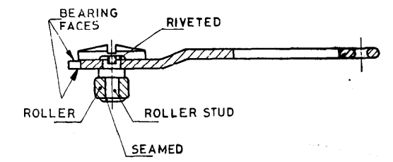

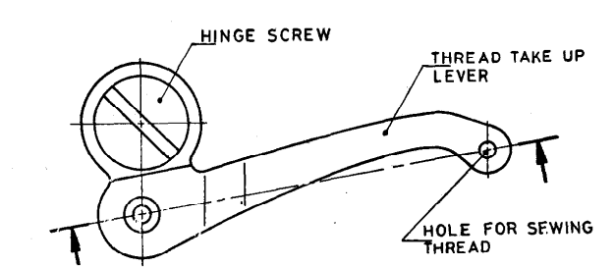

Fig. 1 Nomenclature For Thread Take-Up Lever Sub-Assembly

**5 MATERIAL**

**5.1 Lever**

The thread take-up lever shall be manufactured from a sheet or strip of any suitable steel which can be suitably hardened or any equivalent steel which is wear-resistant [*see* IS 513 (Part 2) and IS 1079].

**5.2 Hinge Screw and Roller**

The hinge screw and roller shall be manufactured from any suitable steel which after suitable heat treatment fulfils the requirement for wear resistance

**5.3 Roller Stud**

Roller stud shall be manufactured from any suitable steel, such as C 10 of Table 1 of IS 1570 (Part 2/Sec 1).

**6 HARDNESS**

**6.1** The thread take-up lever shall have a minimum hardness of 350 HV around the hole for the sewing thread and bearing surfaces. The method of test to check hardness shall conform to IS 1501 (Part 1)/ISO 6507-1.

**6.2** The hinge screw shall have a minimum hardness of 300 HV and the threaded portion shall be kept soft to avoid breakage during rigid tightening. The method of test to check hardness shall conform to IS 1501 (Part 1)/ISO 6507-1.

**6.3** The roller shall have a minimum hardness of 450 HV. The method of test to check hardness shall conform to IS IS 1501 (Part 1)/ISO 6507-1.

**7 DIMENSIONS**

**7.1** The main dimensions of thread take-up lever sub-assembly shall be as given in Table 1.

**7.2** The centre distance between the axis of the hole for the screw and roller may be measured indirectly by measuring the clearance between the outside of the fixture and the roller as shown in Fig. 2.

**Table 1 Dimensions of Thread Take-up Lever Sub-assembly**

(*Clause* 7.1)

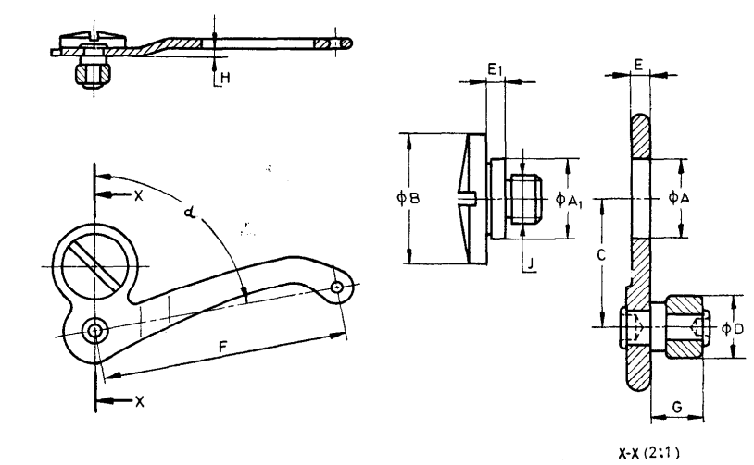

All dimensions in millimetres.

|  |  |  |  |  |  |  |  |  |  |  |  |  |
| --- | --- | --- | --- | --- | --- | --- | --- | --- | --- | --- | --- | --- |
| **STD** | ***A*** | ***A*1** | ***B*** | ***C*** | ***D*** | ***E*** | ***E*1** | ***F*** | ***G*** | ***H*** | ***J*** | ***α*** |
| Type A | 9.544 | 9.531 | 16.06 | 15.90 | 7.940 | 2.242 | 2.261 | 61.03 | 6.54 | 2.02 | M6 | 80o |
| 9.525 | 9.513 | 15.94 | 15.80 | 7.931 | 2.230 | 2.248 | 60.98 | 6.46 | 1.97 |
| Type B | 10.180 | 10.172 | 16.00 | 15.69 | 7.935 | 2.235 | 2.255 | 63.40 | 7.10 | Nil | M6 | 83o |
| 10.167 | 10.160 | 15.75 | 15.59 | 7.927 | 2.225 | 2.235 | 63.35 | 7.02 |

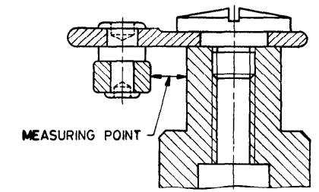

Fig. 2 Method of Measurement of Centre Distance between Axis of Hole for Screw and Roller (Dimensions *C*)

**8 TOLERANCES**

**8.1** The total indicator reading of the external sliding face of the roller when rotated about roller stud shall not exceed 0.01 mm.

**8.2** The clearance in axial direction between roller and roller stud shall not exceed 0.1 mm.

**8.3** The threaded diameter of hinge screw shall be concentric with the bearing diameter of hinge screw within 0.05 mm.

**8.4** The squareness of roller with reference to the thread take-up lever shall not exceed 0.5 mm per 100 mm.

**8.5** Out of roundness of roller shall not exceed 0.005 mm.

**8.6** The error in parallelism of two bearing faces shall be within 0.008 mm.

**8.7** The hinge screw hole shall be square with reference to the bearing faces within 0.005 mm per 10 mm.

**8.8** The error in the squareness of the bearing face of the hinge screw with reference to the centre line of the screw shall be within 0.005 mm per 10 mm.

**9 WORKMANSHIP, FINISH AND MANUFACTURE**

**9.1** The roller stud shall be firmly riveted to the thread take-up lever and the roller shall rotate freely over the roller stud without axial play.

**9.2** The hole for the sewing thread in the thread take-up lever shall be countersunk and polished  
so that the thread passes through the thread hole smoothly and freely.

**9.3** All parts shall be free from burrs, sharp edges, rust and cracks and shall be well finished.

The thread take-up lever shall be nickel-chrome plated conforming to at least condition number 1 with designation Fe/Nil0b Cr r of IS 1068.

The thickness of the coating shall not be less than 0.010 mm. The coating shall be free from flaws, unevenness, cracks, stains and other defects.

**9.4** Hinge screw shall be properly fitted to the hold on thread take-up lever and the lever shall oscillate smoothly such that there shall be no side play/tilting.

**10 MARKING**

**10.1** The thread take-up lever shall be permanently marked with the following:

1. Manufacturer’s name or trademark;
2. Type; and
3. Batch number.

**10.2 BIS Certification Marking**

The product(s) conforming to the requirements of this standard may be certified as per the conformity assessment schemes under the provisions of the *Bureau of Indian Standards Act*, 2016 and the Rules and Regulations framed thereunder, and the product(s) may be marked with the Standard Mark.

**11 PACKING**

**11.1** Each thread take-up lever sub-assembly shall be wrapped in 400 G LDPE or equivalent bag after giving a suitable antirust coating and then packed in paperboard carton in accordance with the best prevalent trade practice.

**11.2** Each packing box shall bear the manufacturer’s name, trade-mark and description of contents.

**ANNEX A**

(*Foreword*)

**COMMITTEE COMPOSITION**

Sewing Machines Sectional Committee, MED 29

| *Organization* | *Representative (s)* |
| --- | --- |
| R and D Centre for Bicycle and Sewing Machines, Ludhiana | Dr Sanjeev Katoch **(*Chairperson*)** |
| Brother International (India) Private Limited, Mumbai | Shri Mathew Yohannan |
| C. R. Auluck and Sons Private Limited, Ludhiana | Shri Sunil Auluck  Shri Kuljeet Singh (*Alternate*) |
| Directorate General of Quality Assurance, New Delhi | Shri R. V. Jain |
| G. D. Rupal Industries, Ludhiana | Shri Gurmukh Singh |
| Gee Tech Hooks, Ludhiana | Shri Manjeet Singh |
| Geminy Industrial Corporation, Ludhiana | Shri Vinay Dua  Shri B. C. Pandey (*Alternate*) |
| Ludhiana Sewing Machines Industries Association, Ludhiana | Shri Hardeep Singh  Shri Rajvinder |
| Makhan Sewing Machines, Ludhiana | Shri Dalbir Singh Dhiman |
| [Narindera and Company, Ludhiana](javascript:;) | Shri S. Baldev Singh  Shri Harinder Jit Singh (*Alternate*) |
| Navrang Manufacturing Corporation, Ludhiana | Shri Dinesh Kapila  Shri Sudesh Kapila (*Alternate*) |
| Northern India Textile Research Association, Ghaziabad | Shri Vikas Sharma  Shri Vivek Agarwal (*Alternate*) |
| Novel Sewing Machine Technologies | Shri Bharat Narayendas Parma  Shri Arjun Bharat Parmar (*Alternate*) |
| Office of Development Commissioner (MSME), Ministry of MSME, New Delhi | Shri Suvankar Santra  Ms Maitreyee Talapatra (*Alternate*) |
| ORAA International, Ludhiana | Shri Ashish Gupta |
| Ranew Engg (India) Private Limited, Ludhiana | Shri Sanjeev Kumar Jain  Shri Abhilash Jain (*Alternate*) |
| Research & Development Centre For Bicycle and Sewing Machines, Ludhiana | Shri Papinder Singh  Shri Vishwas Mehta (*Alternate-I*)  Shri Manpreet Singh (*Alternate-II*) |
| Singer India Limited, New Delhi | Shri Prashant Aggarwal  Shri Atul Kumar Seth (*Alternate*) |
| Swan Mechanical Works, Ludhiana | Shri Amarjeet Singh |
| United Sewing Machines & Parts manufacturers Association, Ludhiana | Shri Dalbir Singh Dhiman |
| Usha International Limited, Ludhiana | Shri Rup Lal Kangla  Shri Pranay Sriwastav (*Alternate*) |
| Uttam Sewing Machine Company Private Limited, Jalandhar | Shri Jagdeep Rai  Shri Manohar Lal (*Alternate*) |
| Virindra Engineering Works, Ludhiana | Shri Amarpreet Singh Panesar  Shri Swarn Singh (*Alternate*) |
| Voluntary Organisation in Interest of Consumer Education (VOICE), New Delhi | Shri M. A. U. Khan |
| BIS Directorate General | Shri K. Venkateswara Rao, Scientist ‘F’/Senior Director and Head (Mechanical Engineering) [Representing Director General (*Ex-officio*)] |

*Member Secretary*

Shri Shubham Tiwari

Scientist ‘D’/Joint Director

(Mechanical Engineering), BIS