भारतीय मानक

औद्योगिक अनुप्रयोग के लिए पम्पों के चयन, संस्थापना,
प्रचालन, और अनुरक्षण हेतु रीति सहिता

— भाग 3 प्रचालन

(प्रथम पुनरीक्षण )

Indian Standard
Code of Practice for Selection, Installation, Operation, and Maintenance of Pumps for Industrial Applications —Part 3 Operation

(First Revision)

ICS 23.080

© BIS 2024

भारतीय मानक ब्यूरो
B U R E A U O F I N D I A N S T A N D A R D S
मानक भवन, 9 बहादुर शाह ज़फर मार्ग, नई दिल्ली- 110002
MANAK BHAVAN, 9 BAHADUR SHAH ZAFAR MARG
NEW DELHI - 110002
www.bis.gov.inwww.standardsbis.in

July 2024 Price Group

Pumps Sectional Committee, MED 20

FOREWORD

This Indian Standard (First Revision) was adopted by the Bureau of Indian Standards, after the draft finalized by Pump Sectional Committee had been approved by the Mechanical Engineering Division Council.

This Indian standard (Part 3) was first published in 1983. One of the important criteria for trouble free running of pumps is the proper operation of the pumps. This standard (Part 3) lays down the broad guidelines pertaining to operation of pumps for industrial application.

This revision has been taken up to keep pace with the latest technological developments and practices followed in the pump industry. This revision incorporates:
- Figures added for better clarity
- Clause 4.1 has been modified
- Table under Annex A has been modified; and
- Other editorial corrections have been done.

The code of practice for selection, installation, operation, and maintenance of pumps for industrial applications is in four parts. This standard covers the guidelines for operation of pump. Other parts in this series under the general title are as follows:
Part 1 Selection;
Part 2 Installation; and
Part 4 Maintenance.
The composition of the committee responsible for the formulation of this standard is given in Annex B.

For the purpose of deciding whether a particular requirement of this standard is complied with, the final value, observed or calculated, expressing the result of a test or analysis, shall be rounded off in accordance with IS 2 : 2022 ‘Rules for rounding off numerical values (second revision)’. The number of significant places retained in the rounded off value should be the same as that of the specified value in this standard.

Indian Standard
CODE OF PRACTICE FOR SELECTION, INSTALLATION, OPERATION, AND MAINTENANCE OF PUMPS FOR INDUSTRIL APPLICATIONS

— PART 3 OPERATION

( First Revision )

1 SCOPE

This Indian Standard lays down general guidelines for operation of pumps for industrial applications. This standard is not applicable to pumps for residential and agricultural applications.

2 OPERATION

2.1 Before starting a pump for the first time within a new system, the check list as given in Annex A shall be filled up by engineers incharge to ensure that the pump and its main and auxiliary piping has been erected with the best technical proficiency.

2.2 Generally, pumps are selected for certain characteristics referred to as ‘rated service conditions’ and with a few exceptions, represent those conditions at or near which the pumps will operate the major part of the time. Positive displacement pumps cannot operate at flows greater than rated except by increasing their speed, nor can they operate at lower flows except by reducing the operating speed or by-passing some of the flow back to the source of supply.

2.3 Contrary to above, centrifugal pumps can operate over a wide range of capacities, from near zero to well beyond the rated capacity. Since a centrifugal pump will always operate at the intersection of its head volume rate of flow curve with system head curve [see Fig. 1 (a)], the pump’s operating volume rate of flow may be altered either by throttling the pump volume rate of flow (hence altering the system head curve [see Fig. 1 (b)] or by varying the pump speed (changing the pump head-volume rate of flow curve [see Fig. 1 (c)]. This makes the centrifugal pump very flexible in a wide range of services and applications which require the pump to operate at volume rate of flow and heads differing considerably from the rated conditions. There are, however, some limitations imposed upon such operation by hydraulic, mechanical or thermodynamic considerations.

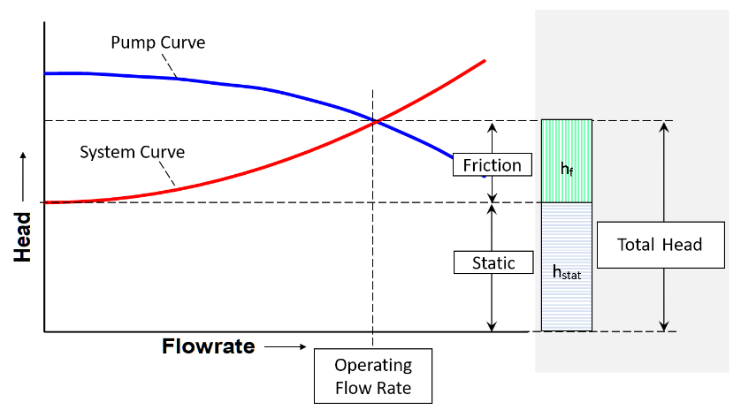
Fig 1(a) Operating Point

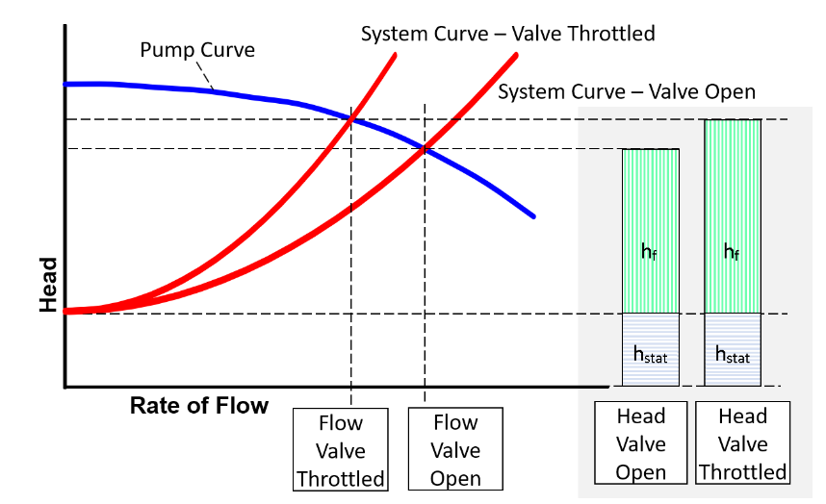

Fig 1 – (b) Throttling Discharge Valve

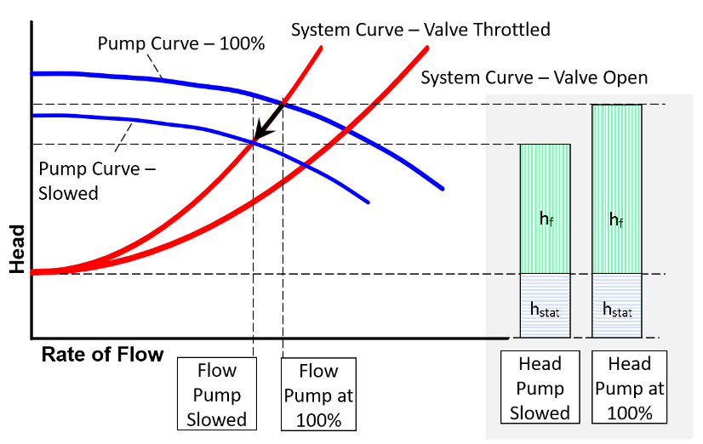
Fig 1 (c) Varying Pump Speed

Where,
h_{f} Frictional Head
h_{stat} Static Head

2.4 Centrifugal pumps should adhere to the limitations on the minimum recommended flow for sustained operation given by the manufacturer due to radial thrust and recirculation problems. The operation of a centrifugal pump at extremely reduced flows causes heating up of the fluid being handled by the pump. This is due to the conversion of work energy available to the impeller into heat energy. Where the pump handles cold water, the temperature rise may be permitted to reach 10 °C or even 20 °C. Hence the minimum safe continuous volume rate of flow based on thermodynamic consideration is then established as that volume rate of flow at which the temperature rise corresponds to the maximum permitted.

2.5 Hydraulic considerations are also there which may affect the minimum flow at which centrifugal pump may be permitted to operate. A correlation has been developed between operation at low flows and the appearance of hydraulic pulsations both in the suction andin the discharge of centrifugal impellers. It has been found out that these pulsations are caused by the development of an internal recirculation at the inlet and discharge of an impeller at flows below the volume rate of flow at best efficiency. Recommendations of the pump manufacturer about minimum flows, dictated by hydraulic considerations should be followed. Refer Fig. 2 showing a typical recommended operating range which may differ case to case.

2.6 If the service conditions call for a pump to operate at shut off or extremely low flows, means should be provided to prevent pump operation below minimum permissible flows regardless of whether the discharge valve or check valve is closed. This is accomplished by installing a bypass flow to the desired volume. When the differential pressure to be broken down by the orifice is relatively low, a single drilled orifice in a 75 to 150 mm stainless steel rod may be used. An elbow should never be located too close to an orifice. The pipe plug at the end of the coupling should be made of stainless steel.

3 PRIMING

3.1 Except for a few exceptions, all centrifugal pumps need priming before they are started. Priming refers to filling up the suction piping and pump casing with the liquid to be handled and allowing the air or gas contained in the pump to escape. The foot valve is to be used at the bottom of the suction pipe to hold the liquid in casing and pipe. The exceptions are self-priming pumps and some special large volume rate of flow, low head, and low-speed installations where it is not practical to prime the pump prior to starting. In the case the priming takes place almost simultaneously with the starting of the pump.

3.2 Reciprocating pumps are in principle self-priming, however, if quick starting is required, priming connections should be piped to a supply above the pump.

3.3 Rotary type pumps have clearances and the liquid in the pump drains back to the suction when pumping low viscosity liquids. The pump may completely dry out when it is idle. In such cases a foot valve may be used to help keep the pump primed or a vacuum device may be used to prime the pump. When handling liquids of high viscosity, foot valves are usually not required as the liquid is retained within the clearances and act as a seal when the pump is restarted. However, before the initial start of a rotating-type positive displacement pump, some of the liquid to be pumped should be introduced through the discharge side of the pump to wet the rotating element.

4 LUBRICATION

4.1 Before starting the pump for the first time, if the stocking period is extended beyond manufacturer’s recommendation or is stocked open to sky without proper covers, the bearing covers should be removed and bearings shall be thoroughly cleaned in accordance with manufacturer’s recommendations. They should then be filled with new lubricant in accordance with the manufacturer’s recommendations. If the stocking period is short, only minimum replenishing quantity of the recommended lubricant to be added.

5 STARTING AND STOPPING PROCEDURES

5.1 The necessary steps in the starting of a centrifugal pump will depend upon its type and the service for which it is installed. For example, standby pumps are generally held ready for immediate starting. The isolating and discharge valves are held open and reverse flow through the pump is prevented by the non-return check valve in the discharge line.

5.2 The methods followed in starting are greatly influenced by the shape of the power-volume-rate-of-flow curve of the pump. High and medium-head pumps (low and medium specific speeds) have power curves that rise from zero flow to the normal volume rate of flow condition. Such pumps should be started against a closed discharge valve to reduce the starting load on the prime mover. A check valve is equivalent to a closed valve for the purpose, as long as another pump is already on the line. The check valve will not lift until the pump being started comes up to a speed sufficient to generate a head high enough to lift the check valve from its seat. If a pump is started with a closed discharge valve, the recirculation bypass line must be open to prevent overheating.

5.3 Low-head pumps (high specific speed) of the mixed-flow and propeller type have power curves rising sharply with a reduction in capacity and should be started with the discharge valve wide open against a check valve if required, to prevent backflow.

5.4 Assuming that the pump in question is motor-driven, that its shut-off power does not exceed the motor power, and that it is to be started against a closed discharge valve, the starting procedure should be as follows:

- Prime the pump, opening the isolating valve, closing the drains, etc, to prepare the pump for operation. Keep air vent valve open to release the air while priming which is to be closed once priming is done;
- Open the valve in the cooling-water supply to the bearings, where applicable;
- Open the valve in the cooling-water supply if the stuffing boxes are water-cooled;
- Open the valve in the sealing-liquid supply if the pump is so fitted;
- Open the warm-up valve of a pump handling hot liquid if the pump is not normally kept at operating temperature. When the pump is warmed up, close the valve;
- Open the valve in the recirculating line if the pump should not be operated against dead shut-off;
- Start the motor;
- Open the discharge valve slowly;
j) Observe the leakage from the stuffing boxes and adjust the sealing-liquid valve for proper flow to ensure the lubrication of the packing. If the packing is new, do not tighten up on the gland immediately, but let the packing run in before reducing the leakage through the stuffing boxes;
k) Check the general mechanical operation of the pump and motor; and
m) Close the valve in the recirculating line once there is sufficient flow through the pump to prevent overheating.

5.5 If the pump is to be started against a closed check valve with the discharge valve open, the steps would be the same, except that the discharge valve would be opened some time before the motor is started.

5.6 In certain cases the cooling water to the bearings and the sealing water to the seal cages are provided by the pump itself. This, of course, eliminates the need for the steps listed for the cooling and sealing supply.

5.7 Just as in starting a pump, the stopping procedure depends upon the type and service of the pump. Generally, the steps followed to stop a pump which can operate against a closed gate valve would be:

- Open the valve in the recirculating line;
- Close the discharge valve;
- Stop the motor;
- Open the warm-up valve if the pump is to be kept up to operating temperature;
- Close the valve in the cooling-water supply to the bearings and to water-cooled stuffing boxes;
- If the sealing liquid supply is not required while the pump is idle, close the valve in this supply line; and
- Close the suction valve, open the drain valves, etc, as required by the particular installation or if the pump is to be opened up for inspection.

5.7.1 If the pump is of a type which does not permit operation against a closed discharge valve, steps (b) and (c) are reversed.

5.8 In general, the starting and stopping of steam turbine-driven pumps required the same steps and sequence prescribed for a motor-driven pump. As a rule, steam turbines have various drains and seals which must be opened or closed before and after operation. Similarly, many turbines require warming up before starting. Finally, some turbines require a turning-gear operation if they are kept on the line ready to start up. The operator should, therefore, follow the steps outlined by the turbine manufacturer in starting and stopping the turbine.

5.9 Most of the steps listed for starting and stopping centrifugal pumps are equally applicable to positive-displacement pumps. There are, however, a few notable exceptions, namely as follows:

- Never operate a positive-displacement pump against a closed discharge. If the discharge valve must be closed, always start a positive-displacement pump with the recirculation bypass valve open; and
- Always open the steam-cylinder drain cocks of a steam reciprocating pump before starting, to allow condensate to escape and to prevent damage to the cylinder heads.

6 RESTARTING MOTOR-DRIVEN PUMPS AFTER POWER FAILURE

In case of motor driven pumps, it is preferable to use starters with low load protection for such installations to prevent an automatic restart. This does not apply if the pumps are automatically primed, or if some protection device is incorporated to avoid dry running of the pump.

ANNEX A

(Clause 2.1)

PROFORMA FOR INSPECTION REPORT OF PUMP INSTALLATION AT SITE

 | Particulars to be Checked |  |  |  | Checked | Initials
A-1 | Piping |  |  |  | …….
A-1.1 | Layout, as per drawing |  |  |  | …….
A-1.2 | Hydrostatic test complete |  |  |  | …….
A-1.3 | Blowing/cleaning complete |  |  |  | …….
A-1.4 | Supports complete (Piping weight not to e supported by pump) |  |  |  | …….
A-1.5 | Insulation (if required), complete |  |  |  | …….
A-1.6 | All blinds and restriction from piping circuit removed |  |  |  | …….
A-2 | Pump temporary strainer fitted pressure gauge for checking delivery pressure |  |  |  | …….
A-3 | Valves on suction and delivery line free to operate and direction of check valve O.K. |  |  |  | …….
A-4 | Alignment with driver complete
 | DRIVER | PUMP | RADIAL | AXIAL
A-5 | Driver’s direction of rotation checked and pump couple |  |  |  | …….
A-6 | Lube oil system |  |  |  | …….
A-6.1 | Lube oil/grease filled in bearing |  |  |  | …….
A-6.2 | For high capacity pressure pumps |  |  |  | …….
 | a) All oil system pickled; and |  |  |  | …….
 | b) Oil pump started and lube oil pressure adjusted |  |  |  | …….
A-7 | Stuffing box |  |  |  | …….
A-7.1 | Mech seal/gland fitted |  |  |  | …….
A-7.2 | Adequate sealing liquid ensured |  |  |  | …….
A-7.3 | Adequate cooling water ensured for high capacity/pressure pumps |  |  |  | …….
A-7.4 | Seal water system cleaned |  |  |  | …….
A-4.5 | Seal water pump started and seal water pressure adjusted |  |  |  | …….
A-8 | For high capacity/pressure pump |  |  |  | …….
A-8.1 | Minimum bypass valve opened |  |  |  | …….
A-8.2 | Balancing drum pressure adjusted/checked as per design |  |  |  | …….
A-9 | Rotor assembly free when coupling rotated by hand |  |  |  | …….
A-10 | Pump casing and suction is full of liquid and air pockets removed (vent valves wherever provided are kept crack open). |  |  |  | …….
A-11 | 1. Delivery valve of pump is closed for high and medium head pumps. To be opened after the pressure is indicated on pressure gauge without delay.  2. Delivery valve of pump is kept open for low head pumps. To be closed suitably to set required flow after pressure is indicated on pressure gauge. |  |  |  | …….
 | PUMP IS READY TO START
 | Note - After the pump is started, all bearings/bushes, amperage, pressure gauges, glands, etc, should be watched for desired working condition as per operation manual supplied with the pump.
 | Remarks:
 | Signature of Mech Engineer |  | Signature of Process Engineer

ANNEX B
(Foreword)
COMMITTEE COMPOSITION
Pump Sectional Committee, Med 20

Organization(s) | Representative(s)
In Individual Capacity(B-184, Sarita Vihar, New Delhi – 110076) | Shri A.K. Nijhawan (Chairperson)
Aquasub Engineering, Coimbatore | Shri C. Murugesasn  SHRI P. Ramesh (Alternate)  Shri G. Prasath (Young Professional)
Best Engineers Pumps Private Limited, Coimbatore | Shrimati C. G. Sripriya  Shri T. Parthiban (Alternate)
Bharat Heavy Electrical Limited, New Delhi | Shri Anuj Jain  Shri Hardeep Singh Dogra (Alternate)
Bharat Petroleum Corporation Limited, Mumbai | Shri D. P. Chandramore  Shri Santosh N. Kale (Alternate)
Bureau of Energy Efficiency, New Delhi | Ms Pravatanalini Samal  Shri Mukhe K Sai Satvik (Alternate I)  Shri Kamran Shaikh (Alternate II)
Central Water and Power Research Station (CWPRS), Pune | Shri Abdul Rahiman
Crompton Greaves Consumer Electricals Limited, Ahmednagar | Shri Parvin Garje  Shri Parvin Murdekar (Alternate I)  Shri Rohit Bhadane (Alternate II)
Electrical Research and Development Association (ERDA), Vadodara | Shri Ravi Prakash Singh  Shri Jitendra Tahilwani (Alternate)
Engineers India Limited, New Delhi | Shri Mahesh Gupta  Ms. Rima Singh (Alternate I)  Shri Abhay Kumar (Alternate II)
GAIL (India) Limited, New Delhi | Shri Shashi Ranjan  Shri Rakesh Kumar Singh (Alternate I)
Grundfos Pumps India Private Limited, Chennai | Shri Sanjeev Choudhary  Shri Amitrup Dutta (Alternate)
Havells India Limited, Noida | Shri Anil Sukumar Akole
Hindustan Petroleum Corporation Limited, Mumbai | Shri Sourabh Sharma  Shri Akash Raj (Alternate)
Indian Pump Manufacturers Association, Ahemdabad | Shri Lalit Kumar Patel
International Copper Association India, Mumbai | ShriK N Hemanth Kumar  Shri Sanjay Namdeo (Alternate)
KSB Pumps Limited, Pune | Shri Rajesh B. Gote  Shri Dattatray Katkar (Alternate)
Kirloskar Brothers Limited, Pune | Shri Ravindra Birajdar  Shri Sudhir Mali (Alternate)
National Bank for Agriculture and Rural Development, Mumbai | Shri Sukanta K. Sahoo  Shri D. Elangovan (Alternate I)  Shri A. K. Sinha (Alternate II)
North India Pump Manufacture Association, Jalandhar | Shri C. L. Garg
Punjab Agricultural University, Ludhiana | Shri Sunil Garg  Shri Sanjay Satpute (Alternate)
Organization(s) | Representative(s)
Rajkot Engineering Association, Rajkot | Shri Vinod Asodariya  Shri Sunny R. Marvania (Alternate)
Scientific and Industrial Testing and Research Centre, Coimbatore | Shri Mohan Sendilkumar  Shri Ulaganathan (Alternate)  Shri R. Manikandan (Young Professional)
Southern India Engineering Manufacturers Association, Coimbatore | Shri K.V. Karthik  Shri D. Vignesh (Alternate)
WPIL Limited, Ghaziabad | Shri Lokesh Jayal  Shri Sanjay Ray (Alternate I)  Shri Debajyoti Das (Alternate II)
Waterman Industries Private Limited, Ahmedabad | Shri Utkarsh. A. Chhaya  Shri Dipak Darji (Alternate)
Wilo Mather and Platt Pumps Private Limited, Pune | Shri Kishor A. Dumbre  Shri Vinod Gabru Chougule (Alternate)
In Personal Capacity | Shri A. K. Jain
In Personal Capacity, Mumbai | Shri S. L. Abhyankar
BIS Directorate General | Shri K. V. Rao,  Scientist ‘F’/Senior Director and Head (Mechanical Engineering)  [Representing General (Ex-Officio)]

Member Secretary
Shri Aman Dhanawat
Scientist ‘C’/Deputy Director
(Mechanical Engineering), BIS

