*भारतीय मानक*

**औद्योगिक अनुप्रयोग के लिए पम्पों के चयन,**

**संस्थापना, प्रचालन, औरअनुरक्षण हेतु रीति सहिता**

**— भाग 2 संस्थापना**

( *प्रथम पुनरीक्षण* )

*Indian Standard*

**Code of Practice for Selection, Installation, Operation, and Maintenance of Pumps for Industrial Applications —**

**Part 2 Installation**

(*First Revision*)

ICS 23.080

 BIS 2024

भारतीय मानक ब्यूरो

**B U R E A U O F I N D I A N S T A N D A R D S**

मानक भवन, 9 बहादुर शाह ज़फर मार्ग, नई दिल्ली- 110002

MANAK BHAVAN, 9 BAHADUR SHAH ZAFAR MARG

NEW DELHI - 110002

www.bis.gov.inwww.standardsbis.in

**July 2024 Price Group**

Pumps Sectional Committee, MED 20

FOREWORD

This Indian Standard (First Revision) was adopted by the Bureau of Indian Standards, after the draft finalized by Pump Sectional Committee had been approved by the Mechanical Engineering Division Council.

This Indian standard (Part 2) was first published in 1983 and it lays down the broad guidelines pertaining to installation of pumps for industrial application.

This revision has been taken up to keep pace with the latest technological developments and practices followed in the pump industry. This revision incorporates:

1. New clause **2.2** has been added; and
2. Other editorial corrections have been done.

The code of practice for selection, installation, operation, and maintenance of pumps for industrial applications is in four parts. This standard covers the guidelines for installation of pump. Other parts in this series under the general title are as follows:

Part 1 Selection;

Part 3 Operation; and

Part 4 Maintenance.

The composition of the committee responsible for the formulation of this standard is given in Annex A.

For the purpose of deciding whether a particular requirement of this standard is complied with, the final value, observed or calculated, expressing the result of a test or analysis, shall be rounded off in accordance with IS 2 : 2022 ‘Rules for rounding off numerical values (s*econd revision*)’. The number of significant places retained in the rounded off value should be the same as that of the specified value in this standard.

*Indian Standard*

**CODE OF PRACTICE FOR SELECTION, INSTALLATION, OPERATION, AND MAINTENANCE OF PUMPS FOR INDUSTRIL APPLICATIONS**

**— PART 2 INSTALLATION**

*( First Revision )*

**1 SCOPE**

This Indian Standard lays down general guidelines for installation of pumps for industrial applications. This standard is not applicable to pumps for agricultural applications.

**2 INSTALLATIONS**

In order to ensure satisfactory operation of a hydraulic pump, prime mover or transmission, it is essential to follow the installation and operating instructions given by the manufacturer. Care shall be taken to see that the equipment, particularly the internal parts, are kept clean during installation and use. The fluid to be used for cooling, sealing and lubrication should conform as regards to the quality and purity, to the manufacturer’s specifications. The following general recommendations are common to most hydraulic power pumps but specific instructions from the manufacturer should be carefully adhered to. Special conditions of use or operation may necessitate maintenance and servicing operations particular to these uses.

**2.1 Shipment**

After final assembly, all flanges and exposed machined metal surfaces are cleaned of foreign matter and coated with an anti-corrosion compound such as grease, petroleum jelly or heavy oil. For the sake of protection during shipment and erection, all pipe flanges, pipe openings and nozzles should be protected by flange covers or by screwed-in plugs or by plastic or rubber caps.

**2.1.1** It is a good practice to deliver the prime mover to the pump manufacturer where it can be assembled and aligned with the pump on a common base plate. The base plate should be drilled for prime mover mounting but the final doweling to be performed at the site only after final alignment. If possible, the unit should be shipped assembled with pump and prime mover on a common base-plate. In cases where prime mover are shipped directly to the site, the base plate maybe drilled at the job site. However, if the details of the primer mover mounting holes are provided to the pump manufacturer which is recommended if not in their scope of supply, the pump manufacturer can provide the base-plate with pump mounted on it and duly drilled holes for prime mover.

**2.2 Incoming Inspection**

As soon as the pumps or pumpsets are received at site, the packages should be inspected for any transit damages, preferably by opening the packages to inspect the pump, primer mover or other accessories supplied are not damaged during the transportation. Inform transporter, manufacturer, supplier for any damages observed.

**2.3 Storage at Site**

The pump should be stored in a dry location if received before time. All protecting arrangements of the pump parts should be left undisturbed. The bearings and couplings shall be given due care to protect them from sand, grit and other foreign matter.

Special precautions are needed if a pump is to be stored for an extended period of time more than manufacturer’s recommendation. For extended storage of the equipment the manufacturer’s instructions shall be followed.

**2.3.1** If rust preventives have been applied on stored parts, they should be removed completely before final installation and the bearings should be relubricated.

**2.4 Location**

Location should be such that adequate accessibility for maintenance is ensured. For large pumps with heavy casings and rotors, a travelling crane or other facility for attaching a hoist should be provided above the pump location.

**2.4.1** As far as possible, location of pump should be close to the liquid source. If practicable, the pump center line should be kept below the liquid level in the reservoir.

**2.5 Site Inspection**

Just before the start of the pump installation the package containing pump shall be shifted to the site and all materials shall be inspected for possible damage to internal parts due to prolonged storage. In case the pump shaft is not free, the pump may be disassembled for internal inspection and rectification.

**2.6 Foundations**

**2.6.1** Foundation structure should be capable of offering rigid support to the full area of the base plate and to absorb shocks and strains, which are normally expected to occur. In this regard concrete foundation is found most satisfactory. Although most pumping units are mounted on base plates, very large units may be mounted directly on the foundations by using sole plates under pump and prime mover feet. Misalignment is corrected by putting suitable metallic packings between feet and sole plates.

**2.6.2** Foundation surface and pockets shall be chipped in order to roughen the concrete, and leveled to ensure 50 mm gap between base plate top face and foundation surface. The centre line and elevation shall be marked prominently on the foundation. Anchor bolt holes shall be cleaned according to the length of anchor bolts. Foundation surface and anchor bolt holes shall be free from oil, rust, sand dust and any extraneous matter.

**2.6.3** Alternatively, each foundation bolt shall be surrounded by pipe sleeve, four diameters larger than the bolt. After pouring the concrete the pipe is held solidly in place but the bolt may be moved to conform to the corresponding hole in the base plate, later the space between bolt and sleeve is filled with grout at the time of grouting.

**2.6.4** In case a unit is mounted on steelwork or other structure it should be supported in such a way that the base plate cannot be distorted or the alignment is not disturbed by any yielding or springing of the structure or of the base plate.

**2.7 Alignment**

**2.7.1** Place the base plate on a flat even surface and align the pump and prime mover in case the duly aligned set is not received. Alignment of pump and driver shaft is of extreme importance for trouble free mechanical operation of the unit. The following are the steps to establish the initial alignment of the unit:

1. Parallel Alignment — Check the two shaft axes for their concentricity. This should be done with the help of straightedge or dial gauge depending upon the type of coupling and extent of misalignment permitted by the manufacturer of the coupling (*see* Fig. 1); and

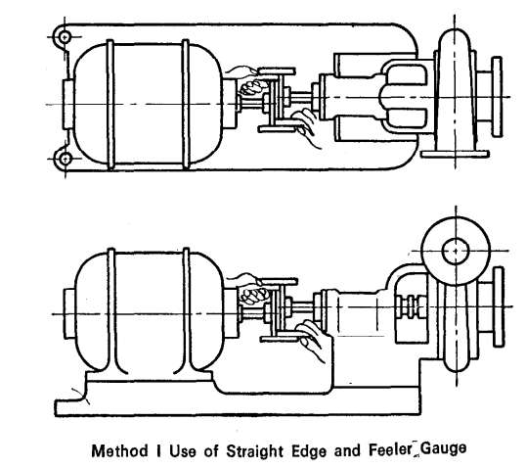

**Method I — Use of Straight Edge and Feeler Gauge**

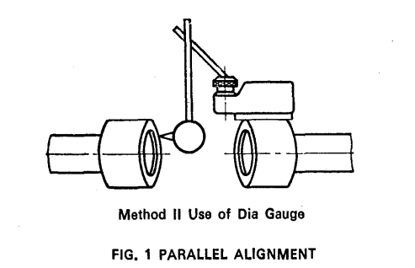

**Method II Use of Dia Gauge**

Fig. 1 Parallel Alignment

1. Angular Alignment — Check the two shaft axes for their parallelism. This should be checked with the help of feeler/taper gauge or caliper or dial gauge depending upon the type of coupling and extent of misalignment permitted by the coupling manufacturer (*see* Fig. 2).

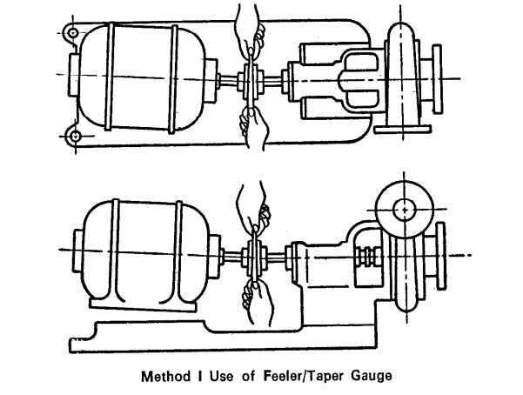

**Method I Use of Feeler/Taper Gauge**

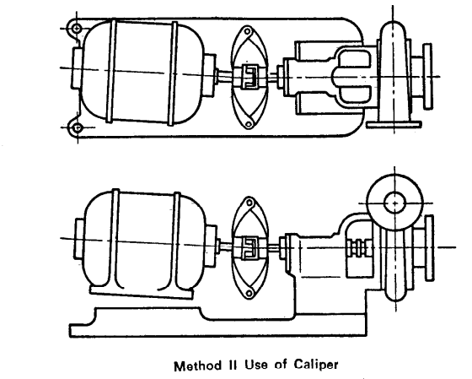

**Method II Use of Caliper**

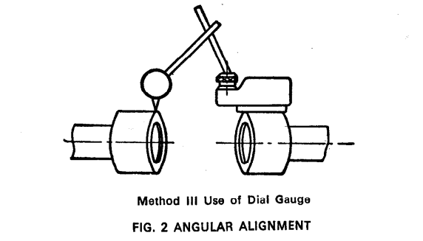

**Method III Use of Dial Gauge**

Fig. 2 Angular Alignment

**2.7.1.1** Both the above alignments should be established with the help of shims under pump or the prime mover.

**2.7.2** There should be a proper clearance between the faces of coupling hubs and shaft ends to avoid rubbing or pull on either pump or prime mover. Sufficient clearance will allow unhampered axial movement of the shaft of driving or driven elements to the limit of their axial clearances.

**2.7.3** In case of motors with sleeve bearings decide the axial position of shaft by actually rotating the motor without coupling it. Limited end float couplings should be used in cases where motors are with sleeve bearings.

**2.7.4** More sophisticated alignment methods such as optical instruments are to be used, particularly, for high speed turbine driven pumps.

**2.7.5** Place the base plate complete with the pumping set on the foundation and support the same on steel strips at frequent intervals between foundation and base plate. The steel strips should extend the full supporting edge of the base plate. Level the base plate perfectly by adjusting the thickness of steel strips by shimming. After leveling, tighten the nuts on foundation bolts by hand. Then grout the base. When the grouting (*see* **2.10**) has set, gently but firmly tighten the foundation bolt nuts taking care not to distort the base plate.

**2.7.6** The initial alignment should be rechecked after the suction and discharge piping have been bolted to the pump. Only after ensuring proper alignment at this stage, all bolts should be tightened finally.

**2.7.7** The alignment should be checked after a regular time interval especially when the pump handles hot liquid as there may be uneven strains. Pipe flanges at the pump should be disconnected after a period of operation to check the effect of the expansion of the piping and adjustment should be made to compensate for the same.

**2.8 Flushing**

Pump and piping should be copiously flushed with the fluid to be used in order to remove all the traces of the corrosion inhibitors with which they might have been treated.

**2.9 Electrical Controls**

Check that the voltage and current requirement for all electrical controls, if used, are compatible with the supply and load current including staring current.

**2.10 Grouting**

**2.10.1** Grouting prevents lateral movements of the pumpbase, increases its mass to reduce vibrations and fills in irregularities in the foundation. Normally, grout is composed of one part pure portland cement and two parts building sand, with sufficient water to flow freely under the base. In order to reduce settling, it is recommended to mix the grout and let it stand for a short period and then remix it thoroughly before use. If required, more water may be added.

**2.10.2** Before starting grouting work, the pumpset should be leveled properly, with the help of a spirit level, by adjusting the thickness of the shims and/or positions of the wedges, on which it is resting on the concrete foundation block. After satisfactory leveling, foundation bolts should be tightened initially by hand. It is recommended that a framework should be built around the pumpset base. Now the grout is poured until the entire space under the base is filled to the top of the underside. A stiff wire should be used through the grout holds to work the grout in and release air pockets. In order to prevent cracking due to rapid drying, the exposed surfaces of the grout should be covered by wet burlap. The framework should be removed and exposed surfaces of the grout and foundations finished smooth only after ensuring that the grout is sufficiently set. After 72 hours or more, the hold down foundation bolts should be finally tightened.

**2.10.3** The foundation plate has to be rigidly secured with the foundation at the areas where the maximum loads of machine are resting.

**2.10.4** Usually the grout gains its full strength after 21 days.

**2.11 Doweling of Pump and Prime Mover**

Doweling of both the pump and its prime mover should be done only after a final recheck of alignment with the coupling bolts removed and with the pump and prime mover at operating temperature. This shall be done wherever applicable and when specified by pump manufacturer.

**2.12 Piping**

The suction pipe should be as direct and short as possible. If a long suction line is required, the pipe size should be suitably increased to reduce friction losses excluding the case of boiler feed pumps. Manufacturer should be consulted in case of boiler feed pumps. If a pump has to lift the liquid from a lower level, the suction piping should have a continuous rise towards the pump avoiding high spots in the line causing the formation of air pockets. In case of a static suction head, the pump suction piping should slope continuously downward to the pump.

**2.12.1** It is recommended to provide an isolating valve between the pump suction branch and the suction pipe in case of positive suction head, so that when necessary, suction pipe can be isolated from the pump by closing the suction side isolating valve when the pump is not in operation. Under no circumstances this isolating valve should be throttled for controlling the flow when the pump is in operation.

**2.12.2** A pump should be provided with a check valve and a discharge valve in the discharge line. The check valve is placed between the pump and discharge valve to check reverse flow in the event of unexpected prime mover failure or from reverse flow from another operating pump. The discharge valve is used when pump is to be primed or shut down for inspection and repairs. Suitable arrangement should be made in cases where it is difficult to operate the discharge valve manually.

**2.13 Suction Strainer**

Proper suction strainers are required in the suction lines of pumps not specially designed to handle foreign matter as large particles may close the pump, reduce the capacity or render it altogether incapable of pumping whereas small particles of foreign matter may cause damage by lodging between close running clearances. The size of the mesh for the strainer is generally recommended by the pump manufacturer.

**2.14 Venting and Draining**

Vent valves provide a means of escape for air or vapour trapped in the casing and should be installed at high points of the pump-casing waterways according to the recommendations of pump manufacturer. These valves are used during the priming of the pump or during operation, if the pump should become air or vapour bound. Normally vented air or vapours are allowed to escape into the surrounding atmosphere except for the cases, when pumps are handling inflammable or toxic or corrosive fluids. In such cases vents should be connected in such a way that they endanger neither the operating personnel nor the installation. The suction vents of pumps taking liquids from closed vessels under vacuum should be piped to the source of the suction above the liquid level.

**2.14.1** If the drains are considered worth reclaiming, all the drain and drip connections should be piped to a point where it can be collected for reuse.

**2.14.2** Venting is not necessary if the pump is self-venting type.

**2.15 Relief Valves**

The pressure developed in a positive discharge pump may exceed maximum design pressure. To protect these pumps against excessive pressure when the discharge is throttled or shut off, a pressure relief valve should be installed. Unless operation against a closed discharge is both in frequent and of very short duration, a relief valve with an external return connection should be used and the liquid from the relief valve may be piped back to the source of supply.

**2.16 Surge Chambers**

In many cases reciprocating pump installations require surge chambers when the suction or discharge lines are of considerable length, when there is an appreciable static head on the discharge, when the liquid to be pumped is hot, or when it is required to smooth out variations in the discharge flow. Centrifugal pumps, generally, do not require surge chambers. The type, size, and arrangement of the surge chamber should be chosen on the basis of the manufacturer’s recommendations.

**2.17 Piping Strains**

Piping should be such that they should not impose excessive forces and moments on the pump to which it is connected, since these might spring the pump or pull it out of the position. Piping flanges shall be brought squarely together before the bolts are tightened. The suction and discharge piping and all valves, strainers, etc, should be supported and anchored near to but independent of the pump, so that no strain will be transmitted to the pump casing.

Allowable forces and moments on pump flanges should be considered while deciding the fixing layout and supports for the pipes.

**2.18 Expansion Joints**

These are used in the suction and discharge piping to avoid transmitting any piping strains resulting from expansion when handling hot liquids, or by misalignment. Expansion joints may be formed by looping a pipe. Generally, they are of the slip-joint or corrugated-diaphram type. However, they transmit to the pump a force equal to the area of the expansion joint times the pressure in the pipe. These forces can be of very significant magnitude, and it is impractical to design the pump casings, base plates, etc, to withstand such forces. When expansion joints are used, a suitable pipe anchor shall be installed between it and the pump proper. Alternately, the bars can be used to prevent the forces from being transmitted to the pump.

**2.19 Warm-up Piping**

In some specific cases, it becomes necessary for a pump to come up to the operating temperature before it is started. In such cases, provision should be made for a warm-up flow to pass through the pump. There may be a number of arrangements used to accomplish this. The pump manufacturer’s recommendations should be sought in all cases as to the best means to provide an adequate warm-up procedure.

**2.20 Instrumentation**

A number of instruments are needed to have a check on the performance and condition of pump. A compound pressure gauge should be connected to the suction of the pump, and a pressure gauge should be connected to its discharge at the pressure taps which may be provided in the suction and discharge flanges. The location of the gauges should be such that they can be easily observed. The pressure taps for pressure / vacuum gauge installation should be at minimum 2 D distance (D is diameter of the pipe) from the suction and delivery flanges of the pump. It should be installed on straight pipe immediately after pump flanges before any taper piece, valve or NRV.

**2.20.1** Depending upon the criticality of the installation a flow meter may be installed supplemented by recording attachments.

**2.20.2** Apart from these, pumps may have additional instrumentation such as speed indicators, vibration monitors, bearing or casing temperature indicators, etc.

A block/isolation valve shall be installed in each instrument and gauge glass take off connection and shall be located as close to the line, vessel or pump as possible.

**ANNEX A**

(*Foreword*)

**COMMITTEE COMPOSITION**

Pump Sectional Committee, Med 20

|  |  |
| --- | --- |
| *Organization(s)* | *Representative(s)* |
| In Individual Capacity(*B-184, Sarita Vihar, New Delhi – 110076*) | Shri A.K. Nijhawan (***Chairperson***) |
| Aquasub Engineering, Coimbatore | Shri C. Murugesasn  SHRI P. Ramesh (*Alternate*)  Shri G. Prasath (*Young Professional*) |
| Best Engineers Pumps Private Limited, Coimbatore | Shrimati C. G. Sripriya  Shri T. Parthiban (*Alternate*) |
| [Bharat Heavy Electrical Limited, New Delhi](javascript:;) | Shri Anuj Jain  Shri Hardeep Singh Dogra (*Alternate*) |
| Bharat Petroleum Corporation Limited, Mumbai | Shri D. P. Chandramore  Shri Santosh N. Kale (*Alternate*) |
| Bureau of Energy Efficiency, New Delhi | Ms Pravatanalini Samal  Shri Mukhe K Sai Satvik (*Alternate* I)  Shri Kamran Shaikh (*Alternate* II) |
| Central Water and Power Research Station (CWPRS), Pune | Shri Abdul Rahiman |
| Crompton Greaves Consumer Electricals Limited, Ahmednagar | Shri Parvin Garje  Shri Parvin Murdekar (*Alternate* I)  Shri Rohit Bhadane (*Alternate* II) |
| Electrical Research and Development Association (ERDA), Vadodara | Shri Ravi Prakash Singh  Shri Jitendra Tahilwani (*Alternate*) |
| Engineers India Limited, New Delhi | Shri Mahesh Gupta  Ms. Rima Singh (*Alternate* I)  Shri Abhay Kumar (*Alternate* II) |
| [GAIL (India) Limited, New Delhi](javascript:;) | Shri Shashi Ranjan  Shri Rakesh Kumar Singh (*Alternate* I) |
| [Grundfos Pumps India Private Limited, Chennai](javascript:;) | Shri Sanjeev Choudhary  Shri Amitrup Dutta (*Alternate*) |
| [Havells India Limited, Noida](javascript:;) | Shri Anil Sukumar Akole |
| [Hindustan Petroleum Corporation Limited, Mumbai](javascript:;) | Shri Sourabh Sharma  Shri Akash Raj (*Alternate*) |
| [Indian Pump Manufacturers Association, Ahemdabad](javascript:;) | Shri Lalit Kumar Patel |
| [International Copper Association India, Mumbai](javascript:;) | ShriK N Hemanth Kumar  Shri Sanjay Namdeo (*Alternate*) |
| [KSB Pumps Limited, Pune](javascript:;) | Shri Rajesh B. Gote  Shri Dattatray Katkar (*Alternate*) |
| [Kirloskar Brothers Limited, Pune](javascript:;) | Shri Ravindra Birajdar  Shri Sudhir Mali (*Alternate*) |
| National Bank for Agriculture and Rural Development, Mumbai | Shri Sukanta K. Sahoo  Shri D. Elangovan (*Alternate* I)  Shri A. K. Sinha (*Alternate* II) |
| [North India Pump Manufacture Association,](javascript:;) Jalandhar | Shri C. L. Garg |
| Punjab Agricultural University, Ludhiana | Shri Sunil Garg  Shri Sanjay Satpute (*Alternate*) |
| Rajkot Engineering Association, Rajkot | Shri Vinod Asodariya  Shri Sunny R. Marvania (*Alternate*) |
| *Organization(s)* | *Representative(s)* |
| Scientific and Industrial Testing and Research Centre, Coimbatore | Shri Mohan Sendilkumar  Shri Ulaganathan (*Alternate*)  Shri R. Manikandan (*Young Professional*) |
| Southern India Engineering Manufacturers Association, Coimbatore | Shri K.V. Karthik  Shri D. Vignesh (*Alternate*) |
| WPIL Limited, Ghaziabad | Shri Lokesh Jayal  Shri Sanjay Ray (*Alternate* I)  Shri Debajyoti Das (*Alternate* II) |
| Waterman Industries Private Limited, Ahmedabad | Shri Utkarsh. A. Chhaya  Shri Dipak Darji (*Alternate*) |
| Wilo Mather and Platt Pumps Private Limited, Pune | Shri Kishor A. Dumbre  Shri Vinod Gabru Chougule (*Alternate*) |
| In Personal Capacity | Shri A. K. Jain |
| In Personal Capacity, Mumbai | Shri S. L. Abhyankar |
| BIS Directorate General | Shri K. V. Rao,  Scientist ‘F’/Senior Director and Head (Mechanical Engineering)  [Representing General (Ex-Officio)] |

*Member Secretary*

Shri Aman Dhanawat

Scientist ‘C’/Deputy Director

(Mechanical Engineering), BIS