*भारतीय मानक*

**सेन्ट्रीफ्यूगल जेट पंप—विशिष्टि**

( *दूसरा पुनरीक्षण* )

*Indian Standard*

**CENTRIFUGAL JET PUMP — SPECIFICATION**

( *Second Revision* )

ICS 23.100.10

© BIS 2022

**भारतीय मानक ब्यूरो**

**B U R E A U OF I N D I A N S T A N D A R D S**

मानक भवन, 9 बहादुर शाह ज़फर मार्ग, नई दिल्ली 110002

MANAK BHAVAN, 9 BAHADUR SHAH ZAFAR MARG,

NEW DELHI 110002

**September 2022Price Group**

Pumps Sectional Committee, MED20

**FOREWORD**

This Indian Standard (First Revision) was adopted by the Bureau of Indian Standards, after the draft finalized by Pump Sectional Committee had been approved by the Mechanical Engineering Division Council.

As, for agricultural purposes, Centrifugal jet pumps are generally used, the Committee felt the need of preparing separate standard on centrifugal jet pumps.

This standard was first formulated in 1987 and subsequently revised in 1997.

This revision has been taken up to keep pace with the latest technological developments and practices followed in Pump industry. This revision incorporates the following major changes, apart from incorporating the amendments issued to the last version of the standard:

1. A new clause **6** has been added and clause **10.3** has been modified;
2. Last line of clause **10.1** has been modified;

In the revision of this standard, considerable assistance has been obtained from the leading manufacturers and users in this country.

The composition of the committee responsible for the formulation of this standard is given in Annex E.

For the purpose of deciding whether a particular requirement of this standard is complied with, the final value, observed or calculated expressing the result of a test or analysis, shall be rounded off in accordance with IS 2: 2022 ‘Rules for rounding off numerical values (*second revision*).’ The number of significant places retained in the rounded-off value should be the same as that of the specified value in this standard.

*Indian Standard*

**CENTRIFUGAL JET PUMP — SPECIFICATION**

( *Second Revision* )

1. **SCOPE**

This standard specifies the requirements of single and multistage centrifugal jet pump used for pumping water from wells beyond suction capacity of horizontal/vertical end suction centrifugal pumps.

**2 REFERENCES**

The standards listed in Annex A, contain provisions which, through their reference in this text, constitute provisions of this standard. At the time of publication, the editions indicated were valid. All standards are subject to revision and parties to agreements based on this standard are encouraged to investigate the possibility of applying the most recent editions of the standards in Annex A.

**3 PRINCIPLE OF OPERATION OF CENTRIFUGAL JET PUMP**

Centrifugal jet pump is a combination of a Centrifugal pump and a jet unit. This combination helps in lifting water from a depth beyond the suction lift capacity of the centrifugal pump alone.

The centrifugal pump (*see* Fig. 1) is primed, started and is made to operate on optimum total head. This head can be created by system delivery head or pressure regulating valve. For efficient operation of the combination, the maximum discharge head (delivery head of centrifugal pump) is to be maintained by adjusting the pressure regulating valve to a total head of centrifugal pump head minus six meters. A part of this pressurized water from the centrifugal jet pump passes through a pressure pipe to Jet Assembly Nozzle. Above the nozzle, a venturi tube is fitted concentrically in the Jet Assembly body. The nozzle converts the pressure energy of the water into velocity energy.

This high velocity water from the nozzle enters the venture and accelerates the surrounding water in the annular area between nozzle and venturi, thereby creating vacuum in the annular area. Due to this vacuum, water is sucked from the well into the jet body through a foot valve. The momentum transfer takes place in the mixing throat of venturi. The kinetic energy of water is converted into pressure energy in the diverging portion of the venturi, called the diffuser. This pressurized water rises in the delivery pipe of the jet Assembly, which in turn acts as a suction pipe of the centrifugal pump, to a level within the suction lift capacity of the centrifugal pump to enable the centrifugal pump to suck the water. The quantity drawn from well is delivered as net system discharge and the driving quantity is recirculated. The level from which the centrifugal pump sucks the water is taken as six metres below the centrifugal pump centre line as optimum level.

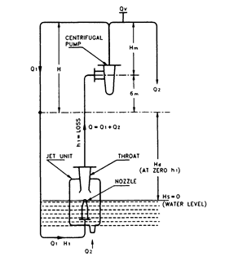

FIG. 1 SCHEMATIC OPERATIONAL DIAGRAM OF A CENTRIFUGAL JET PUMP

**4 TYPES OF JET ARRANGEMENT**

Three types of jet arrangement used in Jet Centrifugal Pumps are given in **4.1**, **4.2** and **4.3**.

**4.1 Twin Type**

In twin type of jet Assembly, delivery (suction pipe of centrifugal pump) pipe and pressure pipe connecting the centrifugal pump and jet assembly run parallel to each other (*see* Fig. 2). Delivery pipe (suction pipe of centrifugal pump) and pressure pipe are screwed together to the jet assembly body and are lowered together.

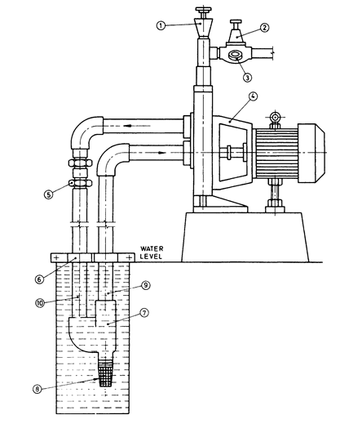

|  |  |
| --- | --- |
| * 1. Priming Unit | 6. Clamp |
| * 1. Pressure Control Valve | 7. Jet Assembly |
| * 1. Pressure Gauge | 8. Foot Valve |
| * 1. Monoset Pump | 9. Delivery Pipe Jet Pump  (Suction Pipe of Centrifugal Pump) |
| * 1. Slip Coupling | 10. Pressure Pipe |

FIG. 2 TYPICAL INSTALLATION FOR TWIN TYPE CENTRIFUGAL JET PUMP

**4.2 Duplex Type**

In duplex type of jet assembly, two concentric pipes are fitted to connect the centrifugal pump and jet assembly. The inner pipe acts as a delivery pipe of jet Assembly, which in turn is the suction pipe of centrifugal pump. The annular area between the outer pipe and the inner pipe acts as pressure pipe to supply water to the jet arrangement nozzle.

Similar to twin type jet assembly, delivery pipe (suction pipe of centrifugal pump) and outer pipe are screwed together to the jet assembly body and are lowered together. The concentric flow is bifurcated into a twin flow at the ground level by using a duplex head/well adopter, which is connected to the centrifugal pump (*see* Fig. 3).

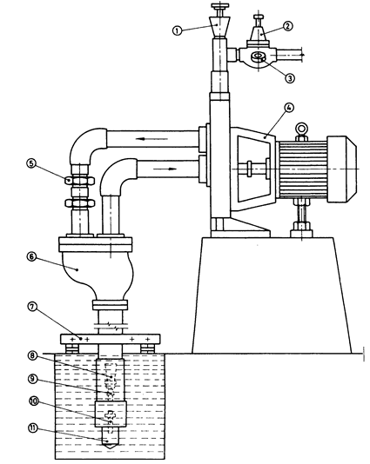

|  |  |  |  |
| --- | --- | --- | --- |
| 1. | Priming Unit | 7. | Clamp |
| 2. | Pressure Control Valve | 8. | Jet Venturi |
| 3. | Pressure Gauge | 9. | Nozzle |
| 4. | Mono Pump | 10. | Foot Valve |
| 5. | Slip Coupling | 11. | Strainer |
| 6. | Duplex Head/Well Adopter |  |  |

FIG. 3 TYPICAL INSTALLATION FOR DUPLEX TYPE CENTRIFUGAL JET PUMP

**4.3 Packer Type**

The construction of the packer type arrangement is similar to the duplex type except that the bottom portion of the annular space between the two pipes below the nozzle is sealed through a packer housing (*see* Fig. 4 and Fig. 4A). The packers are bucket washer fitted to the bottom-most point of the jet unit. The packer housing is screwed at the bottom-most point of the outer pipe. This enables to lower outer pipe and then inner pipe independently thereby resulting in ease of installation.

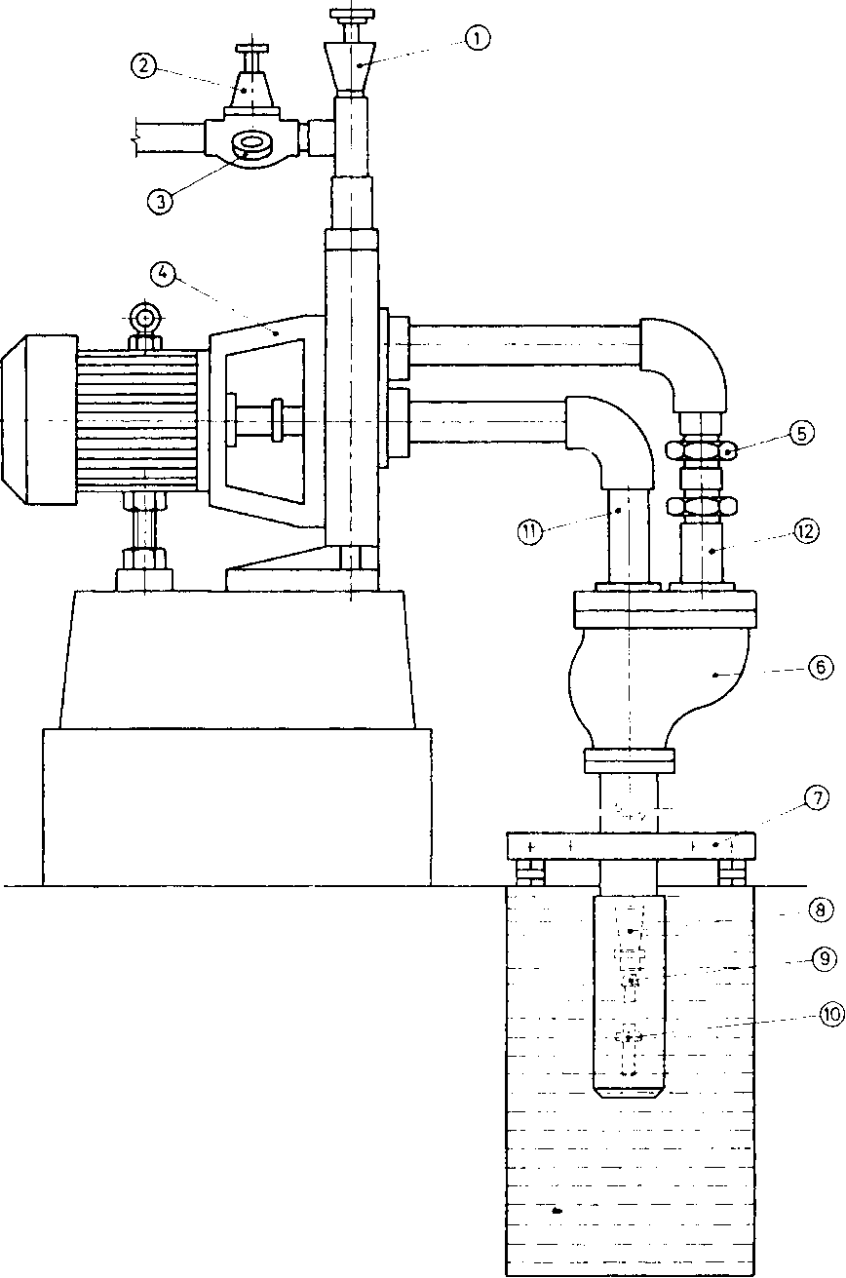

|  |  |  |  |
| --- | --- | --- | --- |
| 1. | Priming Unit | 7. | Clamp |
| 2. | Pressure Control Valve | 8. | Jet Pump Venturi | |
| 3. | Pressure Gauge | 9. | Nozzle |
| 4. | Mono Pump | 10. | Foot Valve |
| 5. | Slip Coupling | 11. | Delivery Pipe Jet Pump/Suction Pipe of Centrifugal Pump |
| 6. | Packer Head | 12. | Pressure Pipe |

FIG. 4 TYPICAL INSTALLATION FOR PACKER TYPE CENTRIFUGAL JET PUMP

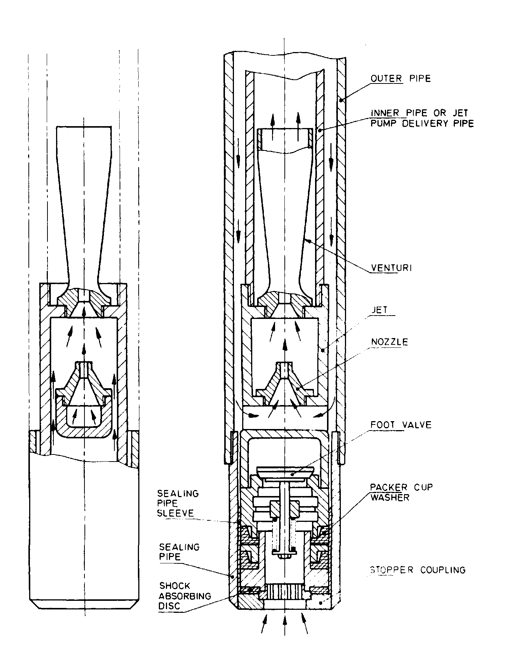

FIG. 4A SECTION THROUGH A PACKER TYPE JET PUMP ASSEMBLY

**5 PUMP AND PRIME MOVER FOR CENTRIFUGAL JET PUMP**

**5.1 Centrifugal Pumps**

Constructional features of the centrifugal pumps may conform to IS 6595 (Part 1) or IS 9079.

**5.2 Prime Movers**

**5.2.1** *Motor Drive*

In case of electric monoset pump, the motor shall conform to the testing requirements given in IS 9079 except for temperature rise test. The temperature rise test shall be conducted at the maximum current, in the operating Depth to Low Water Level (DLWL) range.The temperature rise shall not exceed the limits specified in Table 8 of IS 15999 (Part 1).

**5.2.2** *Engine Drive*

In case of Engine monoset the Engine shall conform to IS 7347 or IS 10001 or IS 11170.

**5.2.3** *Coupled and Belt Driven Set*

In case of coupled and belt driven sets calibrated prime mover shall be used for the purpose of testing.

**6 OTHER GENERAL REQUIREMENTS**

**6.1** The pump shaft should be of adequate size to transmit the required power over the entire head range.

**6.2** If the pump casing is subjected to the hydrostatic test as per **10.3**, then during routine testing of the assembled pump, the packing and seal leakage detection may be done with pressurized air at 1 kg/cm2.

**6.3** Cables used shall be as per IS 694.

**6.4 Voltage and Frequency Variation**

Motor of the monoset pumps shall be capable of delivering the rated output:

a) With the terminal voltage differing from its rated value by not more than +6 percent and -15 percent;

b) The frequency differing from its rated value by not more than ± 3 percent;

c) Any combination of (a) and (b).

**7 MATERIAL OF CONSTRUCTION**

It is recognized that a number of materials of construction are available to meet the requirements for centrifugal jet pump. A few typical materials are indicated below for guidance of the manufacturer and the user.

|  |  |  |
| --- | --- | --- |
| ***Sl. No.*** | ***Component*** | ***Materials of Construction*** |
| 1. | Nozzle | Brass Grade HTBI of IS 304 or bronze LTB2 of IS 318 or suitable thermoplastics such as polyphenylene oxide (PPO), polycarbonate (PC), acetal (polyacetals) resins, nylon 6 or nylon 66, glass filled nylon, stainless steel grade 04Cr13, 12Cr13, 20Cr13 of IS 6603, cast iron grade FG 200 of IS 210, polytetrafluoroethylene (PTFE), acrylonitrile butadiene styrene copolymers (ABS), polyethylene terephthalate (PET), ultra high molecular weight polyethylene (UHMWPE), etc. |
| 2. | Venturi | Brass grade HTB1 of IS 304 or bronze LTB2 of IS 318 or suitable thermoplastics such as polyphenylene oxide (PPO), polycarbonate (PC), acetal (polyacetals) resins, nylon 6 or nylon 66, glass filled nylon, stainless steel grade 04Cr13, 12Cr13, 20Cr13 of IS 6603, cast iron grade FG 200 of IS 210, polytetrafluoroethylene (PTFE), acrylonitrilebutadiene styrene copolymers (ABS), polyethylene terephthalate (PET), ultra high molecular weight polyethylene (UHMWPE), etc. |
| 3. | Foot Valve | Bronze grade LTB2 of IS 318 or brass grade HTB1 of IS 304 or cast iron grade FG 200 of IS 210 or suitable thermoplastics such as polyphenylene oxide (PPO), polycarbonate (PC), acetal (polyacetals) resins, nylon 6 or nylon 66, glass filled nylon, polytetrafluoroethylene (PTFE), acrylonitrile butadiene styrene copolymers (ABS), polyethylene terephthalate (PET), ultra high molecular weight polyethylene (UHMWPE), etc. |
| 4. | Strainer of Foot Valve | Brass grade HTB1 of IS 304 or suitable thermoplastics such as polypropylene, nylon 6 or nylon 66, cast iron grade FG 200 of IS 210, high density polyethylene (HDPE), low density polyethylene (LDPE), glass filled nylon, etc |
| 5. | Jet Pump (Assembly) Body | Cast iron grade FG 200 of IS 210 or bronze grade LTB2 of IS 318 or brass grade HTB1 of IS 304 or suitable thermoplastics such as polyphenylene oxide (PPO), Polycarbonate (PC), acetal (polyacetals) resins, nylon 6 or nylon 66, glass filled nylon, polytetrafluoroethylene (PTFE), etc. |
| 6. | Impeller | Brass grade HTB1 of IS 304 or bronze LTB2 of IS 318, cast iron grade FG 200 of IS 210 or suitable thermoplastics such as polyphenylene oxide (PPO), polycarbonate (PC), acetal (polyacetals) resins, nylon 6 or nylon 66, glass filled nylon, polytetrafluoroethylene (PTFE), acrylonitrile butadiene styrene copolymers (ABS), polyethylene terephthalate (PET), ultra high molecular weight polyethylene (UHMWPE), etc. |
| 7. | Casing | Cast iron grade FG 200 of IS 210 or corrosive resistance alloy steel and nickel base casting for general application (*see* IS 3444) suitable plastic or aluminium magnesium alloys. |
| 8. | Pressure Regulating Valve  a) Body  b) Diaphragm  c) Valve Seat | Brass Grade HTB1 of IS 304 or bronze LTB2 of IS 318 or suitable thermoplastics such as polyphenylene oxide (PPO), polycarbonate, acetal (polyacetals) resins, nylon 6 or nylon 66, glass filled nylon, stainless steel grade 04Cr13, 12Cr13, 20Cr13 of IS 6603, cast iron grade FG 200 of IS 210, polytetrafluoroethylene (PTFE), acrylonitrile butadiene styrene copolymers (ABS), polyethylene terephthalate (PET), ultra high molecular weight polyethylene (UHMWPE), etc.  Neoprene rubber or nitrile rubber.  Bronze grade LTB2 of IS 318 or suitable thermoplastics such as polyphenylene oxide (PPO), polycarbonate (PC), acetal (polyacetals) resins, nylon 6 or nylon 66, glass filled nylon, polytetrafluoroethylene (PTFE), acrylonitrile butadiene styrene copolymer (ABS), polyethylene terephthalate (PET), ultra high molecular weight polyethylene (UHMWPE), etc. |
| 9. | Slip Coupling (Optional) for Twin Type  a) Body  b) Sealing Ring | Cast iron grade FG 200 of IS 210.  Neoprene rubber or nitrile rubber. |
| 10. | Packer Head / Duplex Head and Flanges | Cast iron grade FG 200 of IS 210. |

**NOTE**

## 1 The materials listed are to be considered as only typical and indicative of minimum requirements of the materials properties. The use of materials having better properties is not prejudiced by the details above, provided materials for components in bearing contact with each other do not entail galling, corrosion, magnetic induction, etc.

## 2 IS 6603 is under revision and designations referred here are likely to be aligned with IS 1570 (Part 5) in the revision

**8 SELECTION OF CENTRIFUGAL JET PUMP**

Centrifugal jet pump shall be selected according to IS 12699.

**9 PERFORMANCE CHARACTERISTICS**

**9.1 Factor Affecting Performance**

The submergence of jet pump (Assembly) below water level affects the overall performance of the centrifugal jet pump. All the capacities shall be given for the pump offset from well of 1.5 m for horizontal jet and the submergence of jet pump (Assembly) shall be specified by the manufacturer along with minimum operating pressure. The method of obtaining higher submergence by supplying the input water to the jet pump (Assembly) foot valve through pressure tank shall be as given in Annex B and Fig. 5. Submergence is the level of water above the nozzle of the jet unit.

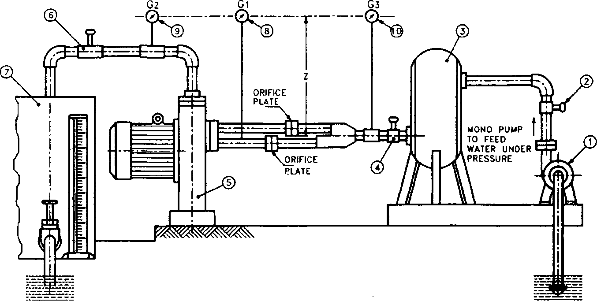

|  |  |  |  |
| --- | --- | --- | --- |
| 1. | Pump | 6. | GateValve-3 |
| 2. | Gate Valve -1 | 7. | Collecting Tank |
| 3. | Pressure Tank | 8. | Pressure Gauge *G*1 *-* (Ejector Head) |
| 4. | Gate Valve -2 | 9. | Pressure Gauge *G*2 **-** (Total Head) |
| 5. | Monoset Jet Centrifugal Pump Combination | 10. | Pressure Gauge *G*3 *-*(Submergence) |

NOTE— Net Ejector Head= (G1+ Z) (G3+ Z)

Net Total Head= (G2+Z)—(G3 + Z )

FIG.5 INSTALLATION FOR TYPICAL TEST SETUP FOR JET CENTRIFUGAL PUMP COMBINATION WITH SUBMERGENCE

**9.2 Performance Curves**

The tabulated readings shall be drawn as a set of performance curves.

* + 1. Discharge Q2 *vs* total head;
    2. Discharge Q2 *vs* depth to low water level for centrifugal jet pump;
    3. Discharge Q2 *vs* power input; and
    4. Discharge Q2 *vs* current.

**9.3** The performance of centrifugal jet pump shall be given as shown in Table 1 and Table 1A by the manufacturer.

**10 TESTING**

**10.1 Method of Testing**

Centrifugal jet pump shall be fitted with the jet assembly through proper sizes of pipes of required lengths with respective orifice plates. One pressure gauge shall be fitted to the delivery pipe of the jet assembly which is the suction pipe of the centrifugal pump. Another pressure gauge shall be fitted to the discharge pipe (delivery pipe of centrifugal pump) of the centrifugal jet pump. By throttling the discharge valve, the following readings shall be taken:

1. Total head (on the pressure gauge connected to the discharge pipe which is delivery pipe of centrifugal pump);
2. Corrected ejector head (on the pressure gauge connected to the suction pipe of the centrifugal pump which is the delivery pipe of the jet pump (Assembly);
3. Discharge;
4. Power input;
5. Speed of the motor;
6. Voltage; and
7. Current.

The above readings shall be tabulated in the form of a test report for each pump as given in Table 2.

At least three test points, that is, duty point, maximum and minimum head shall be taken. The manufacturer shall give the maximum jet setting depth (ejector head + 6m) for the various types of pumps offered at which the maximum ejector efficiency is obtained. All the heads, discharge and power shall be corrected to the rated frequency in case of electric motor driven pumpset and rated speed in case of engine driven pumpset.

**10.2 Testing Method for Centrifugal Jet Pump for Including Pipe Friction by the Use of Orifice Plate**

The depth to low water level, total head, discharge and power input shall be declared by the manufacturer at the duty point and the testing shall be carried out only for the duty point declared by the manufacturer.

Orifice plates as shown in Fig. 6 with diameters calculated in accordance with the procedure given in Annex C shall be used in the pressure pipe and the delivery pipe (suction pipe of centrifugal pump) of the centrifugal jet pump to take into account the field friction. Examples are given in Annex C with Fig. 5, 8, 10, 11, 12 and 13 which give the schematic and test set up diagram for twin, packer and duplex type centrifugal jet pump.

**10.3** Pump casing shall be of robust construction and shall be hydraulically tested to withstand 1.5 times the maximum discharge pressure for 1 min.

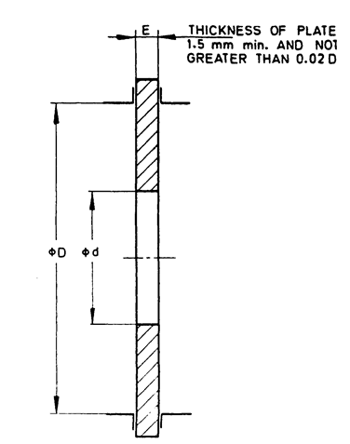

FIG.6 SYMMETRICALORIFICEPLATE

## **11 TOLERANCES**

At rated frequency, the pump shall give a minimum of 92 percent of the rated depth to low water level and minimum of 92 percent of the rated total head at a minimum of 92 percent rated discharge. The pump shall not take more than 110 percent of the declared power input in the range between 92 percent of the rated discharge to rated discharge. The maximum current in the operating range of depth to low water level shall not exceed the 107 percent values specified in IS 9079 or IS 14582 or IS 7538 as the case may be in order to avoid overloading of the prime mover. For 2 pole single phase motor, the value of maximum full load current shall be declared by the manufacturer. An example is given in Annex D.

**12 SAMPLING**

The sampling shall be as specified in IS 10572.

**13 MARKING**

**13.1** The manufacturer shall furnish the following information:

1. Depth to low water level, that is, the distance from centrifugal pump base centre line (for vertical pump) and suction inlet centre line ( for horizontal pump) to the water level in m;
2. Discharge in LPH;
3. Submergence at duty point in m;
4. (i) For duplex / packer type : Outer / Inner / Pressure / discharge (delivery of centrifugal pump) pipe sizes in mm; and

(ii) For twin type: Jet delivery (centrifugal pump suction), pressure / discharge (delivery of centrifugal pump ) pipe sizes in mm;

1. Depth to low water level range in m;
2. Total head (depth to low water level **+** discharge head) in m;
3. Power input in kW;
4. Rated speed in rev/min;
5. Maximum current in A;
6. Rated voltage;
7. Rated frequency;
8. Number of phase; and
9. Type of motor CSR/CSCR/CSIR.

**13.2 Standard Marking**

The product(s) conforming to the requirements of this standard may be certified as per the conformity assessment schemes under the provisions of the *Bureau of Indian Standards Act*, 2016 and the Rules and Regulations framed there under, and the products may be marked with the Standard Mark.

**TABLE 1: PERFORMANCE OF TWIN TYPE CENTRIFUGAL JET PUMP**

( *Clause* 9.3 )

All dimensions in millimetres.

(Single phase / Three phase)

|  |  |  |  |  |  |  |  |  |  |
| --- | --- | --- | --- | --- | --- | --- | --- | --- | --- |
| **Rating** | **Jet Unit Code** | **Pressure Pipe Dia.** | **Delivery Pipe Dia. Of Jet Assembly (Suction Pipe of Centrifugal Pump)** | **Discharge Pipe Dia (Delivery Pipe of**  **Centrifugal Pump)** | **Minimum clear Bore Dia.** | **Minimum Operating Pressure/Discharge Head (Delivery Head of Centrifugal**  **Pump)** | **Capacity for Different Depths to Low Water Level from Centrifugal Pump Centre** | | |
| mm | mm | mm | mm | m | **Litres per hour (LPH)** | | |
| 9 m | 15 m | 25 m  onwards |
| **(1)** | **(2)** | **(3)** | **(4)** | **(5)** | **(6)** | **(7)** | **(8)** | **(9)** | **(10)** |
|  |  |  |  |  |  |  |  |  |  |

**NOTE —**Depth to Low Water Level (DLWL) mentioned in column 8, 9 and 10 are only indicative and shall depend upon the individual models and the respective DLWL ranges.

**TABLE 1A:PERFORMANCE OF PACKER / DUPLEX CENTRIFUGAL JET PUMP**

( *Clause* 9.3 )

All dimensions in millimetres.

(Single phase/Three phase)

(Type: Packer / Duplex)

|  |  |  |  |  |  |  |  |  |  |  |
| --- | --- | --- | --- | --- | --- | --- | --- | --- | --- | --- |
| **Rating** | **Jet Unit Code** | **Outer Pipe Dia** | **Inner Pipe Dia** | **Pressure Pipe Dia** | **Discharge Pipe Dia (Delivery Pipe Dia of Centrifugal Pump)** | **Minimum Clear Bore Dia** | **Minimum Operating Pressure /Discharge Head (Delivery Head of Centrifugal Pump )** | **Capacity for Different Depths to Low Water Level from Centrifugal Pump Centre** | | |
| **Litres per hour (LPH)** | | |
| mm | mm | mm | mm | mm | m | 9 m | 15 m | 25 m onwards |
| **(1)** | **(2)** | **(3)** | **(4)** | **(5)** | **(6)** | **(7)** | **(8)** | **(9)** | **(10)** | **(11)** |
|  |  |  |  |  |  |  |  |  |  |  |

NOTE — Depth to Low Water Level (DLWL) mentioned in col 9, 10 and 11 are only indicative and shall depend upon the individual models and the respective DLWL ranges.

**TABLE 2: TEST REPORT FOR CONTRIFUGAL JET PUMP**

(*Clause* 10.1)

All dimensions in millimetres.

|  |  |  |
| --- | --- | --- |
| Single/Three Phase Ref: | kW/HP: | Pipe size in mm : |
| Name of the manufacturer : | Centrifugal jet pump SI.No.: | Duplex/Packer Type : |
| Dischargein1/h : | Bore size in mm: | Outer/Inner/Pressure discharge  (Centrifugal pump delivery): |
| Maximum jet OD in mm: | Total head in m: | Twin type jet pump: |
| Depth to low water level (DLWL): | Frequency: | Jet delivery/Pressure discharge  (Centrifugal pump delivery): |
| Rated speed in rev/min: |  |  |

|  |  |  |  |  |  |  |  |  |  |  |  |  |  |  |  |  |  |  |  |  |
| --- | --- | --- | --- | --- | --- | --- | --- | --- | --- | --- | --- | --- | --- | --- | --- | --- | --- | --- | --- | --- |
|  | **Sl. No.** | **Speed** | **Depth to Low Water Level** | | | | **Total Head** | | | | **Actual Discharge** | **Voltage** | **Current** | **Moter**  **Input** | **Performance at Rated Speed** | | | | | **Remarks** |
|  |  | **Ejector Head** | | **Correc-tion on head** | **DLWL** | **Discharge Gauge Reading** | **Correc-tion on Head** | | **Total Head** |  |  |  |  | **Rated DLWL** | **Rated Total Head** | **Rated Discharge** | **Rated Motor Input** | |  |
| **G1** | | **Z1** | **G1+ Z1** | **G2** | **Z2** | | **G2+ Z2** |
| **rev/min** | **m** | **m** | **m** | | **m** | **m** | | **m** | **m** | **1/h** | **V** | **A** | **kW** | **m** | **m** | **1/h** | | **kW** |  |
| **(1)** | **(2)** | **(3)** | **(4)** | | **(5)** | **(6)** | | **(7)** | **(8)** | **(9)** | **(10)** | **(11)** | **(12)** | **(13)** | **(14)** | **(15)** | | **(16)** | **(17)** |
|  |  |  |  |  | |  |  | |  |  |  |  |  |  |  |  |  | |  |  |
|  |  |  |  |  | |  |  | |  |  |  |  |  |  |  |  |  | |  |  |
|  |  |  |  |  | |  |  | |  |  |  |  |  |  |  |  |  | |  |  |
|  |  |  |  |  | |  |  | |  |  |  |  |  |  |  |  |  | |  |  |
|  |  |  |  |  | |  |  | |  |  |  |  |  |  |  |  |  | |  |  |
|  |  |  |  |  | |  |  | |  |  |  |  |  |  |  |  |  | |  |  |
|  |  |  |  |  | |  |  | |  |  |  |  |  |  |  |  |  | |  |  |
|  |  |  |  |  | |  |  | |  |  |  |  |  |  |  |  |  | |  |  |

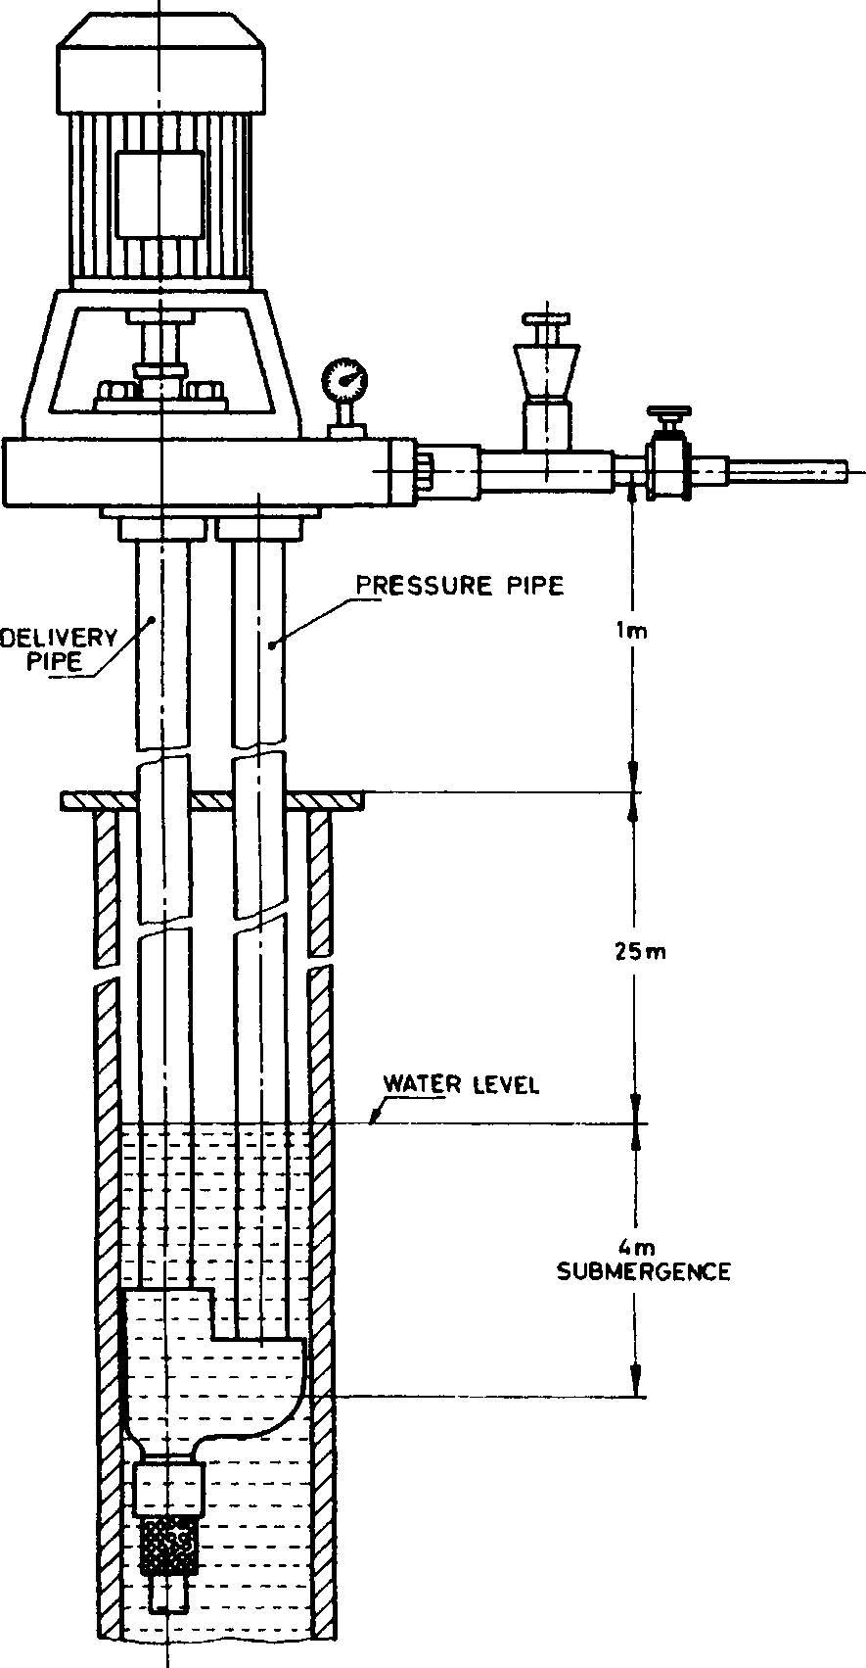

FIG.7 FIELD INSTALLATION DIAGRAM FOR VERTICAL TWIN TYPE CENTRIFUGAL JET PUMP

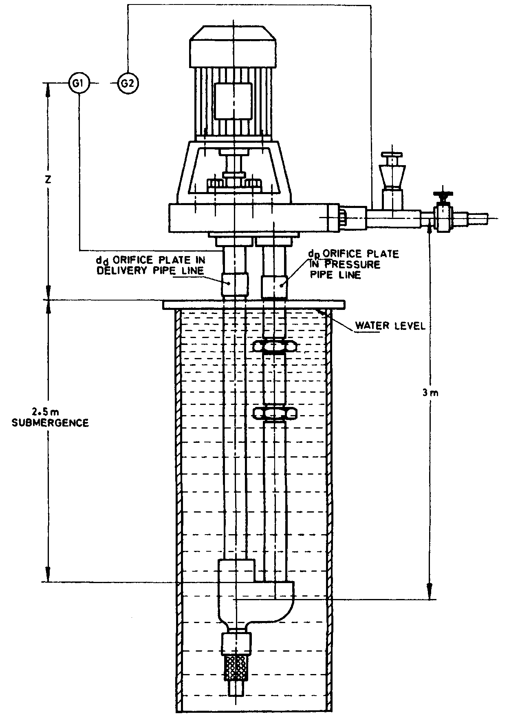

FIG.8 TESTING INSTALLATION DIAGRAM FOR TWIN TYPE CENTRIFUGAL JET PUMP

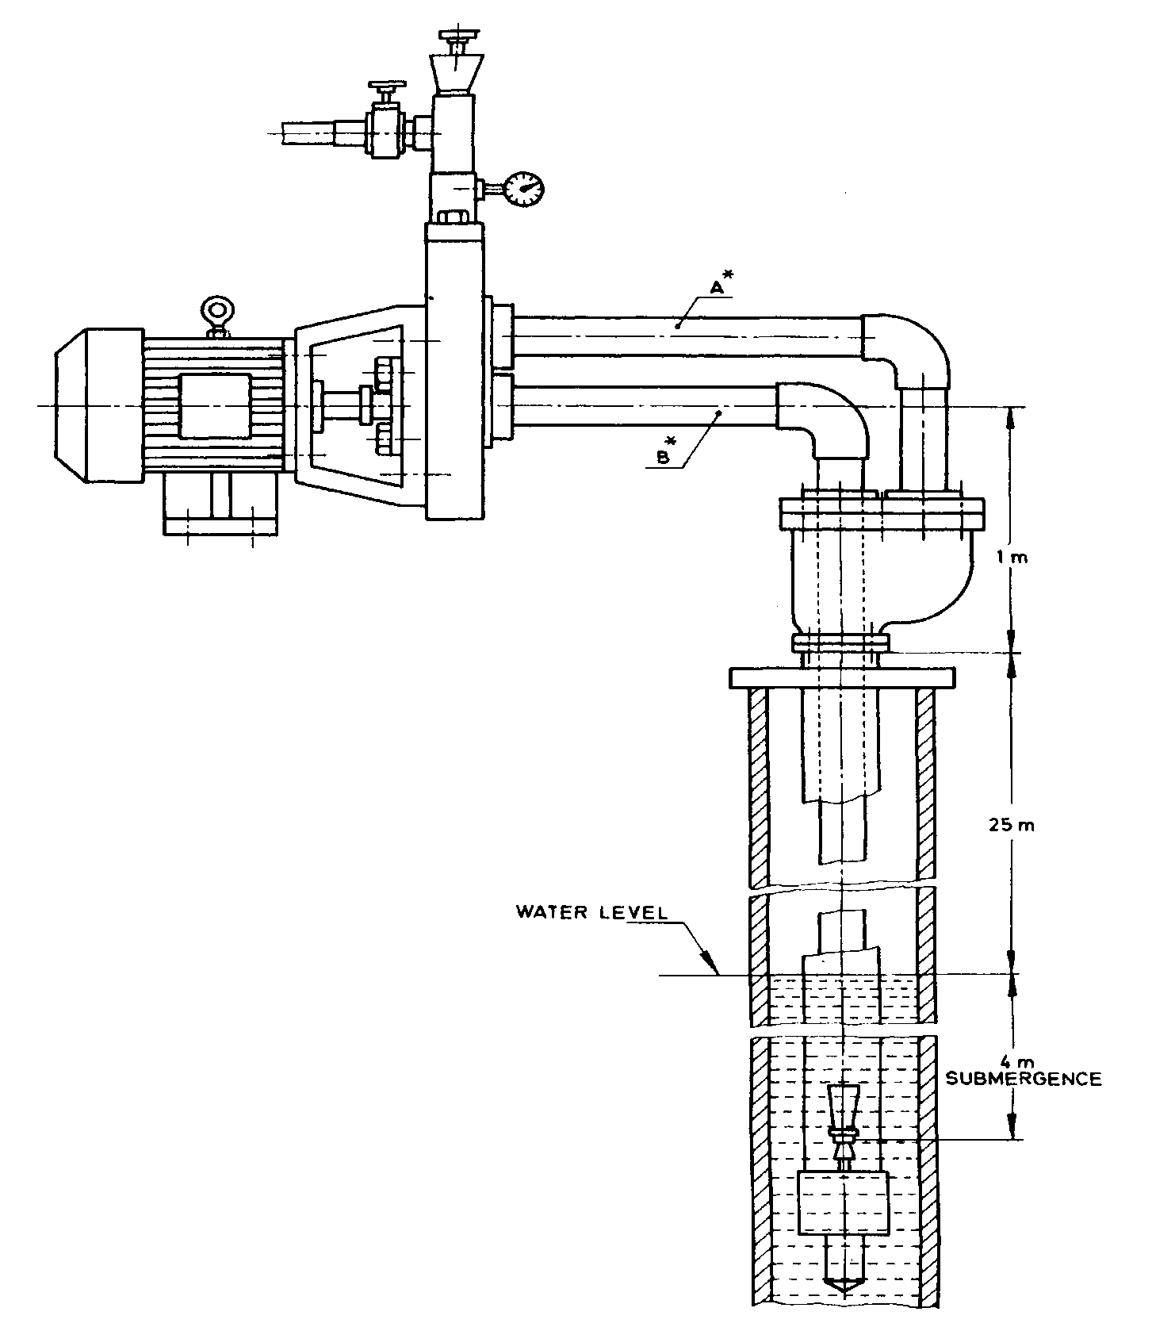

*A* = Horizontal length of pressure pipe, 3 m

*B =* Horizontal length of delivery pipe, 3 m

*Horizontal length includes equivalent length for bends also.

FIG. 9 FIELD INSTALLATION FOR HORIZONTAL DUPLEX TYPE CENTRIFUGAL JET PUMP

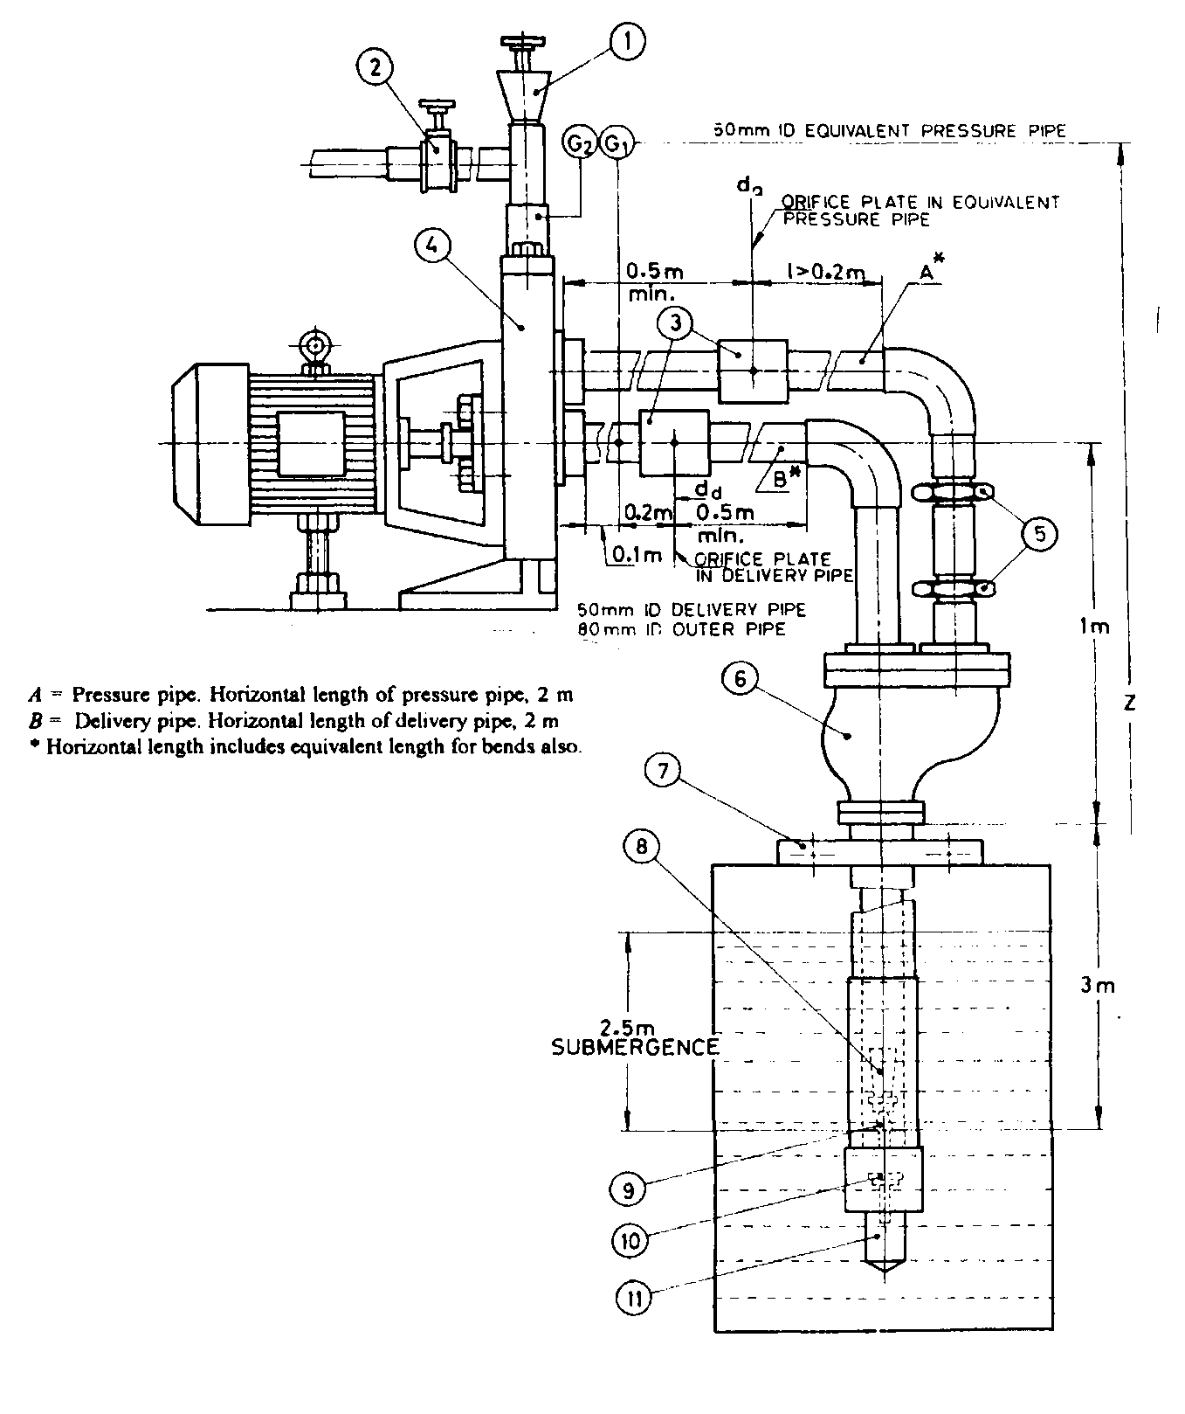

|  |  |  |  |
| --- | --- | --- | --- |
| 1. | Priming Unit | 7. | Clamp |
| 2. | Pressure Control Gate Valve | 8. | Jet Venturi |
| 3. | Orifice Plates *d*a and *d*d | 9. | Nozzle |
| 4. | Mono Pump | 10. | Foot Valve |
| 5. | Slip Coupling | 11. | Strainer |
| 6. | Duplex Head/Well Adopter |  |  |

FIG.10 TESTING INSTALLATION FOR DUPLEX TYPE CENTRIFUGAL JET PUMP FOR FACTORY SETUP

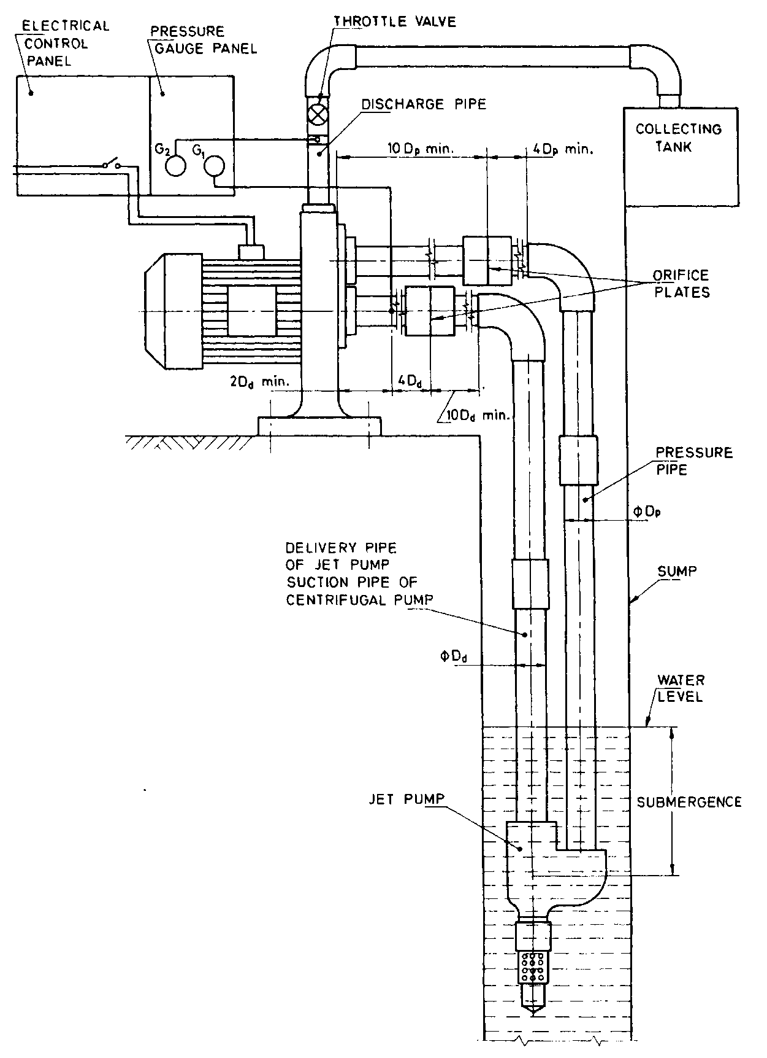

*G*1—Pressure gauge fitted in suction pipe of centrifugal pump which is the delivery pipe of jet pump.

*G*2— Pressure gauge fitted in discharge pipe.

NOTE — Ejector head = *G*1*+Z ,* Total head = *G*2*+Z*

FIG.11 SCHEMATIC TESTING ARRANGEMENT OF MONOSET CENTRIFUGAL JET PUMP

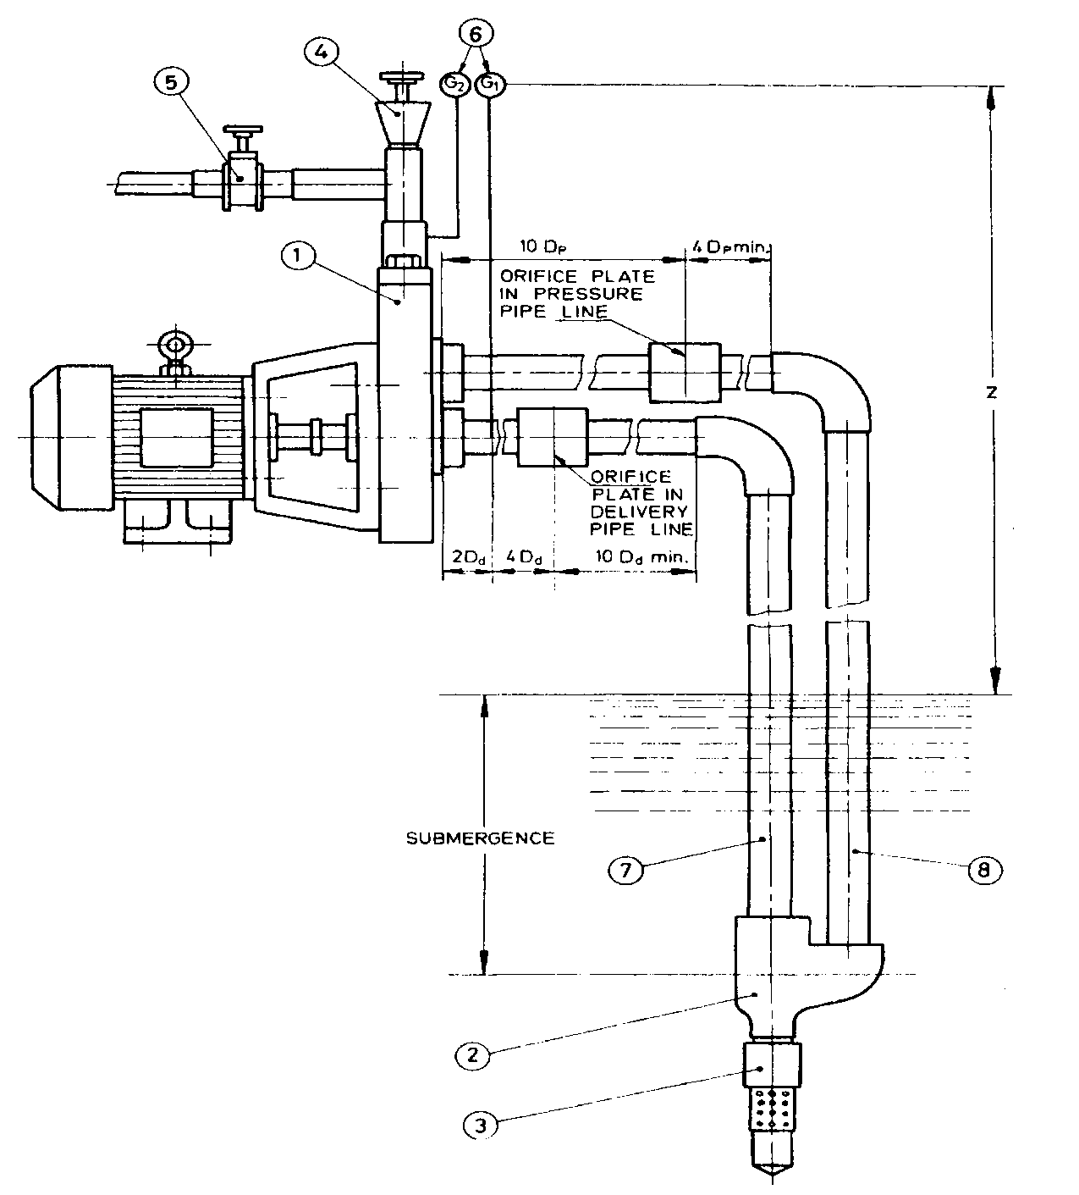

|  |  |  |  |
| --- | --- | --- | --- |
| 1. | Mono Pump | 5. | Pressure Control Gauge Valve |
| 2. | Jet Unit | 6. | Pressure Gauge *G*1 and *G*2 |
| 3. | Foot Valve with Strainer Pipe of Jet Pump (*D*d) | 7. | Suction Pipe of Centrifugal Pump/Delivery |
| 4. | Priming Unit | 8. | Pressure Pipe (*D*P*)* |

NOTE—The orifice plate shall be installed at a minimum distance of 10*D* from bend on the upstream side and pressure gauge shall be installed at minimum of 4*D* on the downstream side of orifice plate.

FIG.12 TESTING INSTALLATION FOR HORIZONTALTWIN TYPE CENTRIFUGAL JET PUMP

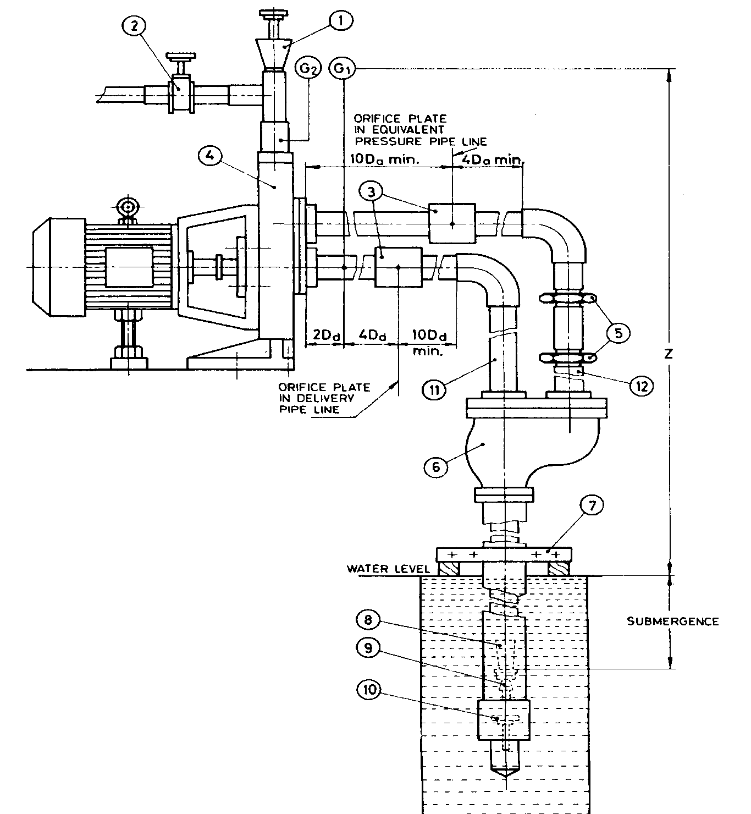

|  |  |  |  |
| --- | --- | --- | --- |
| 1. | Priming Unit | 7. | Clamp |
| 2. | Pressure Control Gate Valve | 8. | Jet Pump Venturi |
| 3. | Orifice Plates *d*a and *d*d | 9. | Nozzle |
| 4. | Mono Pump | 10. | Foot Valve |
| 5. | Slip Coupling | 11. | Delivery Pipe of Jet Pump/Suction Pipe of Centrifugal Pump (*Dd*) |
| 6. | Packer/Duplex Head | 12. | Equivalent Pressure Pipe (*D*a) |

FIG. 13 TESTING INSTALLATION FOR PACKER /DUPLEX TYPE CENTRIFUGAL JET PUMP

**ANNEX A**

( *Clause* 2 )

**LIST OF REFERRED INDIAN STANDARDS**

|  |  |  |
| --- | --- | --- |
| **S No.** | **IS No.** | **Title** |
|  | 210:2009 | Grey iron castings—Specification (*Fifth Revision*) |
|  | 304:1981 | Specification for high tensile brass ingots and castings (*Second Revision*) |
|  | 318:1981 | Specification for leaded tin bronze ingots and castings (*Second Revision*) |
|  | 694:2010 | Polyvinyl chloride insulated unsheathed and sheathed cables/cords with rigid and flexible conductor for rated voltages (*Fourth Revision*) |
|  | 6595 (Part 1) : 2018 | Horizontal centrifugal pumps for clear, cold water—Specification: part 1 agricultural and rural water supply purposes (*Fourth Revision*) |
|  | 6603:2001 | Stainless steel bars and flats—specification (*First Revision*) |
|  | 7347:1974 | Specification for performance of small size spark ignition engines |
|  | 7538:1996 | Three—phase squirrel cage induction motors for centrifugal pumps for agricultural application—specification (*First Revision*) |
|  | 9079:2018 | Monoset pumps for clear, cold water for agricultural and water supply purposes—specification (*Third Revision*) |
|  | 10001:1981 | Performance requirements for constant speed compression ignition (diesel) engines for general purposes (up to 20 kW) |
|  | 10572:1983 | Methods of sampling for pumps |
|  | 11170:1985 | Specification for 1 performance requirements for constant speed compression ignition (diesel) engines for agricultural purposes (up to 20 kW) |
|  | 12699:1989 | Selection, installation, operation and maintenance of jet centrifugal pump combination—code of practice |
|  | 14582 : 2021 | Single-phase small ac electric motors for centrifugal pumps for agricultural applications |
|  | 15999 (Part 1) : 2021 | Rotating electrical machines : part 1 rating and performance |

**ANNEX B**

( *Clause* 9.1 )

**METHOD OF TESTING CENTRIFUGAL JET PUMP WITH REQUIRED SUBMERGENCE**

**B-1 GENERAL**

The Submergence of the jet unit below the water level affects the performance of centrifugal jet pump drastically A jet assembly with inadequate submergence causes cavitation at the mixing point and great loss in performance. Every pump has to be declared with the required submergence for optimum performance of the centrifugal jet pump. In the test set up, it becomes sometimes impractical to locate the jet unit with the required submergence since it is very high. In order to stimulate a pressure tank is used in the test set up as shown in Fig.5:

1. A pressure tank of at least 5 to 6 times the maximum discharge capacity of centrifugal jet pump in litres / min to be tested;
2. A centrifugal pump with a head of at least 15 times that of the maximum submergence pressure to be created in the pressure tank, with a discharge capacity of at least twice the maximum discharge of centrifugal jet pump.

The pressurizing centrifugal pump (1) is connected to the pressure tank through throttle valve (2) and foot-valve. The pressure tank is connected to the centrifugal jet pump through throttle valve (4) at the foot-valve entry. A pressure gauge (10) reads the pressure (G3) at the entry to centrifugal jet pump. A pressure guage (8) reads the ejector head pressure (G1) in the delivery pipe of jet pump (Assembly) which in turn is the suction pipe of the centrifugal pump of centrifugal jet pump. A pressure gauge (G2) reads the total head developed by the centrifugal jet pump. Orifice plates are introduced in the pressure and delivery pipes,to take care of field pipe friction (see Fig. 5).

**B-2 TESTING PROCEDURE**

The pressurizing centrifugal pump (1) is started and the valves (2) and (4) are adjusted such that the gauge (10) shows a head nearer to the required declared submergence. The throttle valve (6) is adjusted in such a way that gauge (G1) shows the ejector head nearer to the duty point ejector head plus submergence. Adjust the valves (2) and (4) such that a steady reading of G3 (duty point submergence) and G1 (duty point ejector head + G3) is reached.

Then, measure Q1, the volume rate of flow, with the help of collecting tank and power input to the pump. Then, the head readings for given submergence of G3 are:

(G2+ Z) — (G3+Z) = Total Head

(G1+Z) — (G3+Z) = Ejector Head

**ANNEX C**

( *Clause* 10.2 )

**TESTING METHOD FOR CENTRIFUGAL JET PUMP INCLUDING PIPE FRICTION BY THE USE OF ORIFICE PLATES IN TEST SETUP**

* 1. **GENERAL**

The effect of friction in the length of delivery pipe and pressure pipe in the centrifugal jet pump is stimulated by means of orifice plates in the delivery and pressure pipes. The diameter of the orifice plate is found by means of equating the head loss in friction in the corresponding pipe lengths in field use to the head loss by sudden contraction and expansion by the introduction of orifice plates.

For twin type pumps, the orifice plates are introduced in the corresponding pipe lengths in the test setup. For packer type pump, the loss in friction is found for the annular area between the outer pipe and the delivery pipe in terms of an equivalent diameter of a pressure pipe, and in this pipe, the orifice plate is introduced. The method of locating orifice plates in the test setup is shown in Fig. 5, 8, 10, 11, 12 and 13 for different types of pumps. The methods for calculating the diameter of orifice plate shall be as given in **C-2** to **C-4**. The nominal pipe size and corresponding pipe inner diameter for calculation of orifice plates are given in Table 3:

**Table 3: Pipe Inner Diameter for Nominal Sizes of Pipes**

(*Clause* C-1)

All dimensions in millimeters.

|  |  |  |  |  |  |  |  |  |
| --- | --- | --- | --- | --- | --- | --- | --- | --- |
| **Nominal Pipe Sizes in mm** | 20 | 25 | 32 | 40 | 50 | 65 | 80 | 100 |
| **Pipe inner diameter for calculation of orifice plates in mm** | 22 | 27 | 36 | 42 | 53 | 69 | 81 | 106 |

* 1. **SELECTION OF ORIFICE DIAMETER**

**C-2.1 Terminology**

*L* = length of pipeline;

*D*d = inner diameter of delivery pipe of jet unit for twin, packer and duplex;

*D'*d = outer diameter of delivery pipe of jet unit for duplex and packer only;

*D*p = inner diameter of pressure pipe;

*Do* = inner diameter of outer pipe in duplex/packer type pump;

*dp, dd, da* =inner diameter of orifice plates for pressure pipe, delivery pipe and equivalent pipe, respectively;

*h*f *=* head loss in friction in the length;

*h* = head loss in orifice plate;

*f* = Darcy­weisbach friction factor,

*C* = discharge coefficient;

*α* = *CE=*flow coefficient;

*β* = (*dd*/*D*d) or (*d*P/*D*P) or (*d*a/*Do*);

= diameter ratio of orifice plate to pipe inner diameter;

*E* = Velocity approach factor;

$= {\left(1-β^{4}\right)}^{-1/2}$

ρ = Mass density = *w/g;*

*Q* = *qm/p* = volume rate flow; and

$V = \frac{Q}{\left(\frac{π}{4}\right)D^{2 }}$ = *Q/A*

Where,

*A* = area of pipe;

Δ*p* = pressure loss in orifice plate; and

Δ*p/w* = head loss in orifice plate

**C­2.2** The average value of *C*=0.6 and *f* =0.0278 has been taken after considering the different diameters of pipe diameter ratio and life of pipe. A 10 percent error in the above results affects only the overall result of pump performance by one percent.

If *d* is the orifice plate inner diameter:

*qm* = α $\left(\frac{π}{4}\right)$*d*2√2(Δpp)

Substituting

*qm*= *PQ*

*Q= CEd2*

= *CEd2*

= *CEd2*

= *CED2*𝛽2

= *CE*𝛽2 *D2*

*Q*= *CE*𝛽2*A*

But *Q/A = V*, therefore squaring both the sides and equating, we get:

$$h = \left(\frac{V^{2}}{2g}\right)×\left[\frac{1}{C^{2}{\left({Eβ}^{2}\right)}^{2}}\right]$$

But

$$Eβ^{2 } = \frac{β^{2}}{{\left(1-β^{4}\right)}^{1/2}}$$

$$= \frac{1}{{\left(\frac{1}{β^{4}}-1\right)}^{1/2}}$$

$${\left(Eβ^{2}\right)}^{2} = \frac{1}{\left(\frac{1}{β^{4}}-1\right)}$$

$$h = \left[\left(V^{2 }/2g\right)\right]\left[\frac{\left(\frac{1}{β^{4}}-1\right)}{C^{2}}\right]$$

For any pipe,

Allowing for pressure recovery after orifice plates, we can write

K\**h* = *h*f

Where *K* is 0.9 up to 40 mm sizes of pipe and 0.8 for higher pipe sizes.

$$h_{f} = \left[\left(fL/D\right)×\left(\frac{V^{2}}{2g}\right)\right]$$

We get,

$$\frac{1}{β^{4}} = \left[C^{2}f \left(L/KD\right)+1\right] from \left[C^{2}f\left(L/KD\right)\right]$$

$$= \left(\frac{1}{β^{4}}-1\right)$$

Substituting

*β $=$* *d/D*

$$\frac{D^{4}}{d^{4}} = \left[C^{2 }f\left(L/KD\right)+1\right]$$

$$d = \frac{D}{{\left[C^{2}f\left(L/KD\right)+1\right]}^{0.25}}$$

Substituting value of *C=*0.6 and *f* = 0.0278, the final equation for the diameter of orifice plate as:

$$h = \frac{D}{{\left[\left(10L/KD\right)+1\right]}^{0.25}}$$

This means that if *D* is diameter in millimeters of the pipe used in the field for the system and *L* is its length in meters, the equivalent friction loss shall be created by using an orifice plate of diameter *d.* It shall be noted that while using this equation, *L* value shall be taken as the length of pipe in the field minus the length of pipe used in factory setup for substituting in the equation, equivalent friction loss shall be created by using an orifice plate of diameter *d.*

* 1. **DIAMETER OF ORIFICE PLATE FOR THE ANNULAR AREA OF PACKER/DUPLEX TYPE PUMP**

The frictional loss in the annular area for the pressure pipe portion of a packer/duplex type pump is given by:

$$h_{f} = f\left[\frac{L}{\left(D_{o}-{D^{'}}_{d}\right)}\right]\left[\frac{Q}{\frac{π}{4}\left(D_{o}^{2}-{D^{'}}_{d}^{2}\right) × \left(\frac{1}{2g}\right)}\right]$$

$= \left[\frac{Q^{2}}{\left({\left(\frac{π}{4}\right)}^{2 }× 2g\right)}\right]× \left[\frac{L}{\left(D_{o}-{D'}_{d}\right)\left(D_{o}^{2}-{D'}_{d}^{2}\right)}\right]$……….(1)

If an equivalent pipe of inner diameter *D*a and length *L*e is selected to give the same amount of head loss in friction as a single pipe,

$$h_{f} = fL_{e}\left(\frac{1}{D_{a}}\right) × \left[\frac{Q^{2}}{{\left(\frac{π}{4}\right)}^{2}× D_{a}^{4}}\right]× \left(\frac{1}{2g}\right)$$

$${ h}_{f} = \left[\frac{fQ^{2}}{{\left(\frac{π}{4}\right)}^{2}× 2g}\right]× \left(\frac{L_{e}}{D_{a}^{5}}\right) ……. (2)$$

Equating equations (1) and (2), we get

$$\left(\frac{L_{e}}{D_{a}^{5}}\right) = L × \left[\frac{1}{{\left(D_{o}-{D'}_{d}\right)\left(D_{o}^{2}-{D'}_{d}^{2}\right)}^{2}}\right]$$

*D'*d is outer diameter of the delivery pipe of jet unit for packer/duplex

$$L_{e} = D_{a}^{5} × \left[\frac{L}{{\left(D_{o}-{D^{'}}_{d}\right)\left(D_{o}^{2}-{D^{'}}_{d}^{2}\right)}^{2}}\right]$$

So in the packer/duplex type, the orifice plate is set in a horizontal length above the duplex/packer head using a pipe of convenient diameter *D*a for the pressure pipe. For this pipe diameter, the equivalent length *L*e is calculated for the annular actual pipe length, *L*, used in the field.

Then to create the frictional loss, an orifice plate of diameter *d*a, is selected so that:

$$d_{a} = \left[\frac{D_{a}}{{\left[C^{2}\left(\frac{fL_{e}}{D_{a}}\right)+1\right]}^{\frac{1}{4}}}\right]$$

Where *L* is in meters and *D* is in millimeters.

Then

$$d_{a} = \left[\frac{D_{a}}{{\left[\left(\frac{10L_{e}}{KD_{a}}\right)+1\right]}^{\frac{1}{4}}}\right]$$

Diameter of orifice plate to be used in the horizontal equivalent pressure pipeline is:

$$d_{a} = \left[\frac{D_{a}}{{\left[\left(\frac{10L_{e}}{KD_{a}}\right)+1\right]}^{\frac{1}{4}}}\right]$$

**C-4 MODEL CALCULATIONS FOR SELECTION OF ORIFICE PLATE OF TWIN TYPE JET PUMP**

**C– 4.1 Example 1**: *(see* Fig.6 *and* 7*)*

Calculate the diameter of orifice plates to be used in twin type centrifugal jet pump of size 50 mm × 40 mm —delivery pipe of jet assembly (suction pipe of centrifugal pump) × pressure pipes.

The duty point ground to low water level is 25 m and at duty point, the pump requires four metres submergence and the pump is a vertical pump having one metre pipe above the ground level, medium class pipes are used in the factory setup, three metre length is used for testing with 2.5 m submergence.

*Lf* = length of pipe used in field.

= ground to low water level + submergence + vertical distance above the ground level to centrifugal pump.

= 25+4+1 = 30 m.

*L* = Length of pipe to be taken for friction calculation.

= pipe length used infield $–$ pipe length used in test setup.

= 30 $-$ 3 = 27 m.

The inner diameter of 50 mm medium class pipe is,

*D*d = 53 mm

The inner diameter of 40 mm medium pipe is,

*D*p = 42 mm

The diameter of orifice plate for the delivery side of the jet pump (which in turn is the suction pipe of centrifugal pump)

*d*d = Diameter of orifice plate in jet pump (Assembly) delivery, which is the suction pipe of centrifugal pump.

*d*d

32.99 mm

Sincethelengthofthepressurepipealsoisthesame,diameteroforificeplateinpressurepipe

$$d_{p} = \frac{D_{p}}{{\left[\left(\frac{10L}{KD_{p}} + 1\right)\right]}^{\frac{1}{4}}}$$

$$= \frac{42}{{\left[\left(\frac{270}{0.9}\right) × 42 + 1\right]}^{\frac{1}{4}}}$$

= 24.86 mm

So the above size of orifice plates are fitted to the delivery pipe of jet pump (Assembly) which is the suction pipe of centrifugal pump and pressure pipe of jet pump (Assembly). It is always convenient to have the centrifugal pumps in a horizontal position for both vertical and horizontal sets for easy test setup.

**C– 4.2 Example 2** *(see* Fig.3 and 8)

Calculate the diameter of orifice plates for the same centrifugal jet pump if it is of a horizontal packer type/duplex type using an 80 mm outer pipe, 50 mm inner pipe and in the horizontal position it uses50 mm equivalent pressure pipe. The length of vertical concentric pipe used in the field is 25 m ground to low water level, four meter submergence and three metre horizontal pipes of 50 mm each, including the equivalent length for the bend. In the factory test setup, the length of concentric pipes used is three metres and in the horizontal portion two pipes of 50 mm of two metres length is used including the equivalent length for bends. In all cases, medium class pipes are used. The submergence at factory setup is 2.5 m. The pump centre line in both field and factory setup above ground level is one metre.

***Calculation*:** *For the inner pipe*

Length of inner pipe at field = 25 + 4 + 4 = 33 metres

Length of pipe used in factory setup = 2 + 1 + 3 = 6 metres

Length of pipe *Ld* used for friction calculation = 33 – (2 + 1 + 3) = 27 metres

(Refer Fig.9 and Fig.10)

*Dd* = inner diameter of inner pipe = 53 mm

that is, delivery pipe of jet pump.

Therefore, diameter of orifice plate,

$$d_{p} = \frac{D_{p}}{{\left[\left(\frac{10L_{d}}{KD_{p}} + 1\right)\right]}^{\frac{1}{4}}}$$

For the annular pipe,

*Do* = inner diameter of outer pipe of 80 mm

= 80.8 mm

*D*d*=* outer diameter of inner pipe which is the delivery pipe of jet pump

= 60.3 mm

Length of concentric pipe used in the field: 25 + 4 = 29 m

Length of pipe used in the factory setup: 3 m

$Le$ = Length to be taken for calculating friction = 29 $–$ 3 = 26 m

Let, *D*e = Diameter of equivalent pipe

= Diameter of pipe used in pressure pipe

= 53 mm

## This equivalent length for pressure pipe,

$L'e = {\left(D_{a}\right)}^{5}× \frac{L}{\left[\left(D_{o}-{D'}_{d}\right){\left(D_{o}^{2}-{D'}_{d}^{2}\right)}^{2}\right]}$

$$= {\left(53\right)}^{5}× \frac{26}{\left[\left(80.8-60.3\right){\left({80.8}^{2}-{60.3}^{2}\right)}^{2}\right]}$$

## $= 63.39$

m

Length *L*e to be taken for friction calculation,

= *L*'e + (3 + 1 – 2 – 1)

= 64.39 m

Diameter of orifice plate to be used in equivalent pipe for the annular area,

$$= \frac{53}{{\left(\frac{643.9}{0.8×53}+1\right)}^{\frac{1}{4}}}$$

$= 26.42$ mm

**ANNEX D**

( *Clause* 11 )

**EXAMPLE TO CHECK THE DECLARED VALUES**

**D–1** A centrifugal jet pump of nominal 0.75 kW rating has following declared values:

DLWL : 25 m

DLWL Range : 18 to30 m

Discharge : 1000 1/h

Total head : 44 m

Power Input : 1.2 kW

Maximum current: 6.0 A

In this figure lines have been drawn given for the declared values and also 92 percent of discharge, 92 percent of total head, 92 percent of DLWL, 110 percent of power input and for 107 percent of the maximum current declared in the DLWL range. Characteristic curves have been drawn of four jet pumps of above declared values. The hatched portions shown in the figure show the areas of deviation permitted (on the negative side) in respect of discharge *vs* DLWL and discharge *vs* total head.

If the characteristic curve passes through the hatched portion or is above the hatched portion the sample pump conforms to the requirements. Similarly if the discharge vs input, power curve is below 110 percent line, that is, in this case 1.32 kW (= 1.2 kW × 1.1) at the duty point of 1 000 1/h the sample pump satisfies the requirements. Thus of the four pumps whose characteristic curves are given in the Fig. 14, Fig. 15 and Fig. 16.

1. Sample1: Satisfies the requirements
2. Sample2: Fails in input power, since at the duty point the input power is 1.34 kW
3. Sample3: Fails in discharge *vs* DLWL
4. Sample4: Fails in maximum current in the operating range of DLWL.

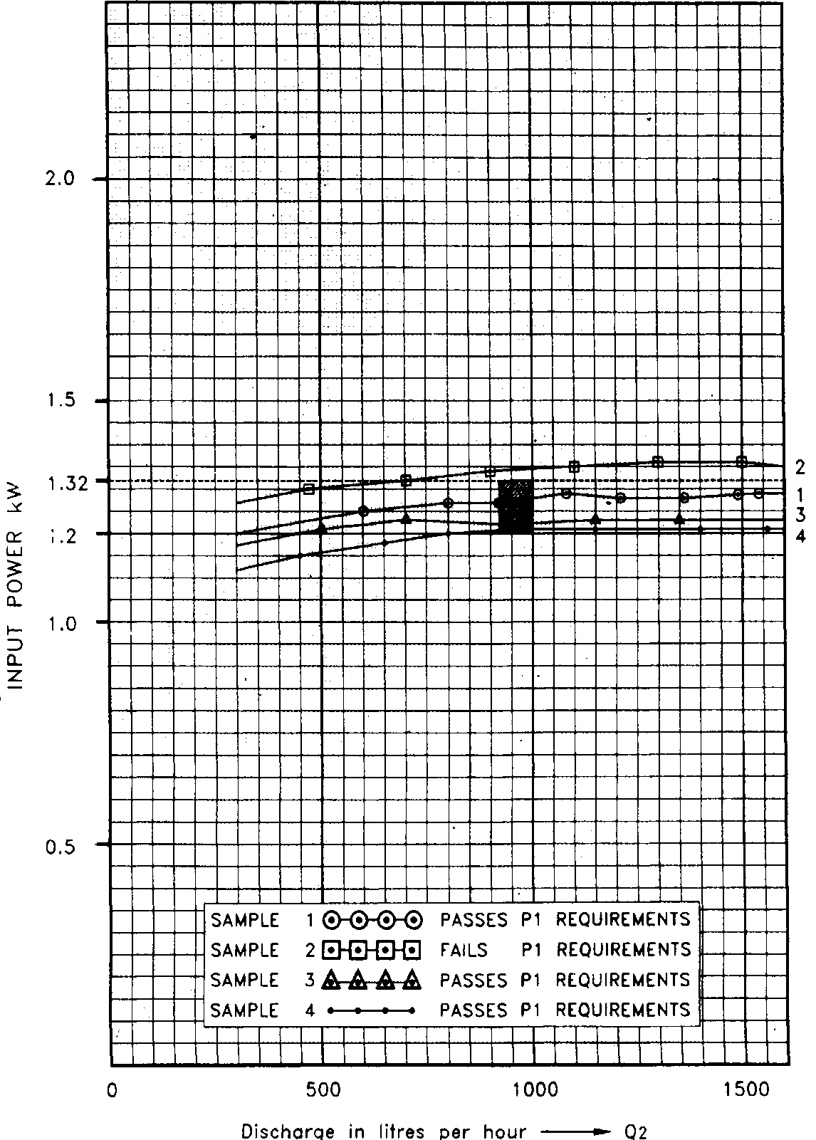

FIG. 14 INPUT POWER VS DISCHARGE

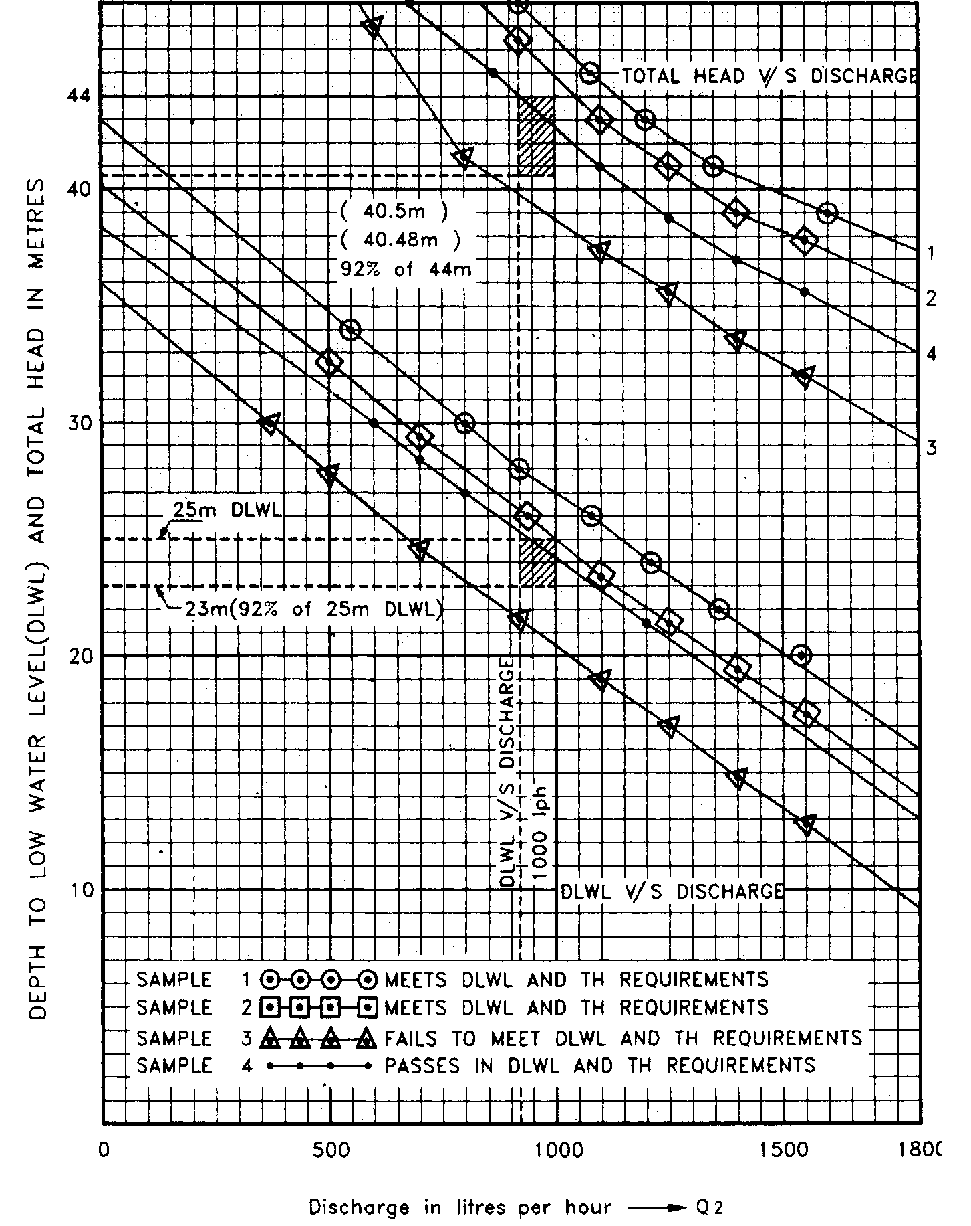

FIG. 15 DISCHARGE VS DLWL AND TOTAL HEAD

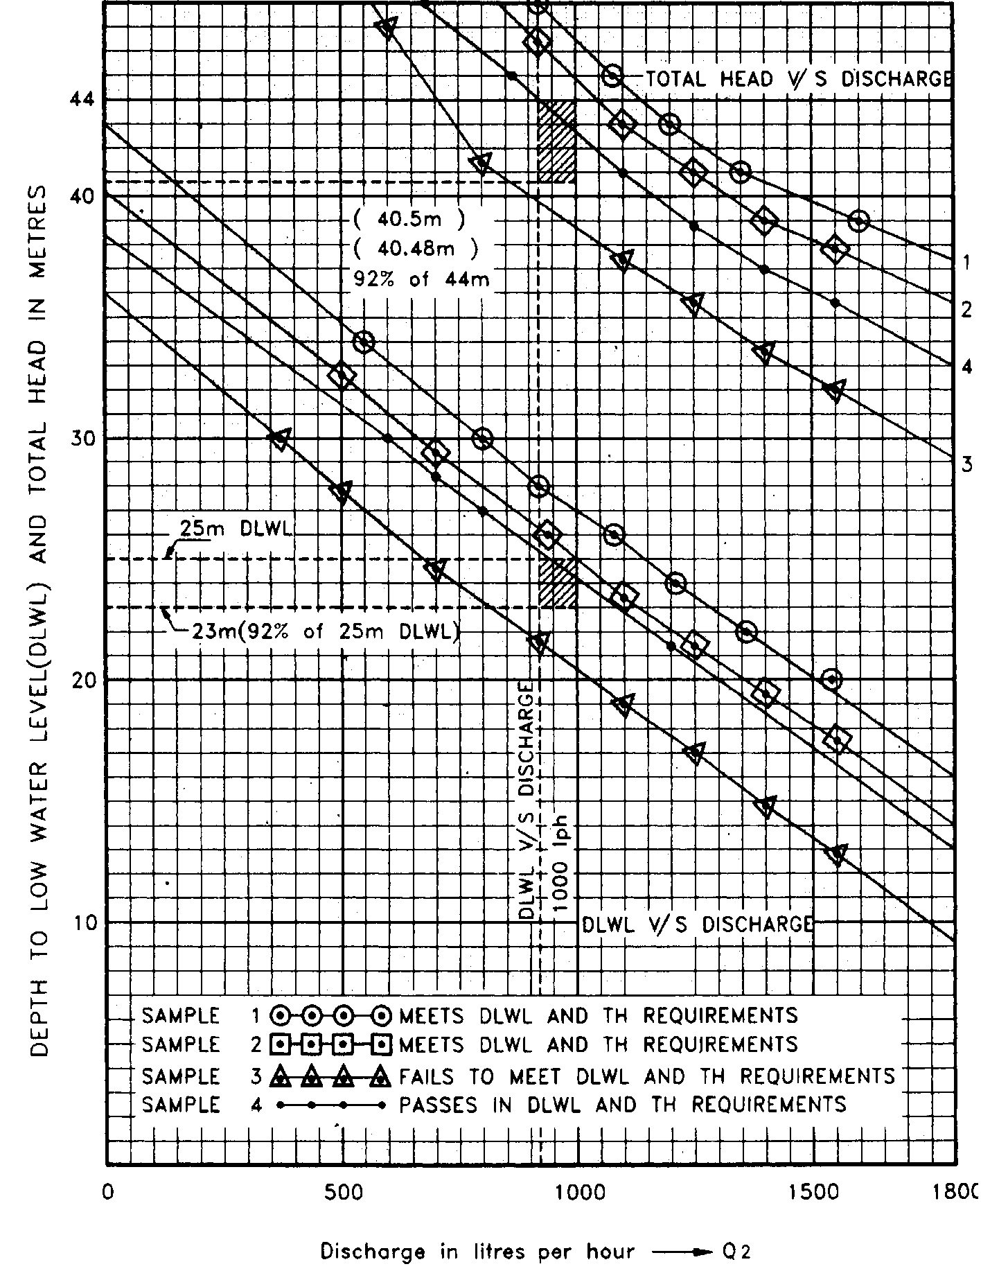

FIG. 16 DISCHARGE VS CURRENT AND DEPTH TO LOW WATER LEVEL

**Annex E**

( *Foreword*)

**COMMITTEE COMPOSITION**

Pump Sectional Committee, Med 20

|  |  |
| --- | --- |
| *Organization(s)* | *Representative(s)* |
| [Thyssenkrupp Industrial Solutions (India) Private Limited, Mumba](javascript:;) | Shri A.K. Nijhawan (***Chairman***) |
| Aquasub Engineering, Coimbatore | Shri C. Murugesn |
| Best Engineers Pumps Pvt Limited, Coimbatore | Shrimati C. G. Sripriya  Shri T. Parthiban (*Alternate*) |
| [Bharat Heavy Electrical Limited, New Delhi](javascript:;) | Shri Anuj Jain  Shri Hardeep Singh Dogra (*Alternate*) |
| Bharat Petroleum Corporation Limited , Mumbai | Shri D P Chandramore  Shri Santosh N Kale (*Alternate*) |
| Bureau of Energy Efficiency, New Delhi | Ms P Samal  Ms Neha Kumari (*Alternate*)  Shri Kamran Shaikh (*Alternate*) |
| Central Water and Power Research Station (CWPRS), Pune | Shri Abdul Rahiman |
| [Chief Quality Assurance Establishment, Ministry of Defence, New Delhi](javascript:;) | Shri G. Aravindam |
| Crompton Greaves Consumer Electricals Limited, Ahmednagar | Shri Parvin Garje  Shri Parvin Murdekar (*Alternate*)  Shri Rohit Kanase (*Young Professional*) |
| Delhi Jal Board, New Delhi | Shri Praveen Bhargava |
| [Directorate General of Quality Assurance, Ministry of Defence, New Delhi](javascript:;) | Shri Lalajee Dongre  Shri R.V. Jain |
| Electrical Research and Development Association (ERDA), Vadodara | Shri Ravi Prakash Singh  Shri Gautam Brahmbhatt (*Alternate*) |
| Engineers India Limited, New Delhi | Shri Mahesh Gupta  Shri Dinesh Bhatia (*Alternate*) |
| [GAIL (India) Limited, New Delhi](javascript:;) | Shri Satish Geda |
| [Grundfos Pumps India Pvt Limited, Chennai](javascript:;) | Shri Bibek Saha |
| [Havells India Limited, Noida](javascript:;) | Shri Anil Sukumar Akole |
| [Hindustan Petroleum Corporation Limited, Mumbai](javascript:;) | Shri Arijit Sanyal |
| [Indian Pump Manufacturers Association, Ahemdabad](javascript:;) | Shri Yogesh Mistri |
| [International Copper Association India, Mumbai](javascript:;) | Shri Abhishek Dhupar  Shri Debdas Goswami (*Alternate*) |
| *Organization(s)* | *Representative(s)* |
| [KSB Pumps Limited, Pune](javascript:;) | Shri Uday Joshi  Shri Rajesh B Gote (*Alternate*)  Shri Kiran Shinde (*Alternate*) |
| [Kirloskar Brothers Limited, Pune](javascript:;) | Shri Ravindra Birajdar  Shri Vasant Godbole (*Alternate*) |
| [Kirloskar Ebara Pumps Limited, Pune](javascript:;) | Shri A. S. Joshi |
| Mangalore Refinery and Petrochemicals Limited, Mangalore | Shri Adarsh G A  Shri P. Rajendran (*Alternate*) |
| Mecon Limited, Ranchi | Shri P.S. Rao  Shri A. Gangal (*Alternate*) |
| National Bank for Agriculture and Rural Development, Mumbai | Shri D. Elangovan  Shri A.K. Sinha (*Alternate*) |
| [North India Pump Manufacture Association, Phagwara](javascript:;) | Shri C. L. Garg  Shri Suriender Kalsi (*Alternate*) |
| Petroleum Conservation Research Association, New Delhi | Shri Manish Ranjan  MS. Anupriya Sharma (*Alternate*) |
| Projects and Development India Limited, Noida | Shri A.K. Gupta  Shri D. K. Vohra (*Alternate*) |
| [Punjab Agricultural University, Ludhiana](javascript:;) | Dr Sunil Garg  Dr Sanjay Satpute (*Alternate*) |
| [Rajkot Engineering Association, Rajkot](javascript:;) | Shri Anand Savaliya  Shri D.R. Shah (*Alternate*) |
| [Scientific and Industrial Testing and Research Centre, Coimbatore](javascript:;) | Shri A. M. Selvaraj |
| [Southern India Engineering Manufacturers Association, Coimbatore](javascript:;) | Shri K.V. Karthik |
| [Tata Consulting Engineers Limited, Navi Mumbai](javascript:;) | Shri A. K. Chaudhary  Shri R. Madhavan (*Alternate*) |
| [Wilo Mather and Platt Pumps Private Limited, Pune](javascript:;) | Shri Kishor A. Dumbre |
| [In Personal Capacity, Mumbai](javascript:;) | Shri S. L. Abhyankar |
| BIS Directorate General | Shri Rajneesh Khosla Scientist ‘E’ and Head (MED)  [Representing Director General (*Ex-officio*)] |

*Member Secretary*

Shri Aman Dhanawat

Scientist ‘B’ (MED), BIS

Agricultural and Domestic Pumps Subcommittee: 20:5

|  |  |
| --- | --- |
| *Organization(s)* | *Representative(s)* |
| [The Southern India Engineering Manufacturers' Association, Coimbatore](javascript:;) | Shri G. Rajendran (***Convenor***) |
| [Agrofab Machineries India Private Limited, Jaipur](javascript:;) | Shri Alok Gupta  Shri Siddharth Gupta (*Alternate*) |
| [Aquasub Engineering, Coimbatore](javascript:;) | Dr. C. Muthu  Shri C. Murugesasn (*Alternate*) |
| [Best Engineers Pumps India Private Limited, Coimbatore](javascript:;) | Shri S. Thangapandi  Shri N. Ranadhive (*Alternate*) |
| [CSIR-Central Mechanical Engineering Research Institute, Durgapur](javascript:;) | Shri Subrata Kumar Mandal  Shri Ashok Kumar Prasad (*Alternate*) |
| [Central Equipment and Stores Procurement, Lucknow](javascript:;) | Shri Arun Kumar  Shri M. P. Kandooi (*Alternate*) |
| [Central Ground Water Board, Nagpur](javascript:;) | Shri G. D. Ojha  Shri Ashis Chakraborty (*Alternate*) |
| Crompton Greaves Consumer Electricals Limited, Ahmednagar | Shri Parvin Garje  Shri Parvin Murdekar (*Alternate*)  Shri Prashant Mahale (*Young Professional*) |
| [Havells India Limited, Noida](javascript:;) | Shri Anil Sukumar Akole  Shri Manish Kumar Vimal (*Alternate*) |
| [Indian pump Manufacturers Association, Ahemdabad](javascript:;) | Shri Yogesh Mistri  Shri Utkarsh A. Chhaya (*Alternate*)  Shri Prabhudas Patel (*Alternate*) |
| [KSB Pumps Limited, Pune](javascript:;) | Shri Abhay A. Virkar  Shri Sanjeev Choudhary (*Alternate*) |
| [Kalsi Metal Works, Jalandhar](javascript:;) | Shri Barinder Kalsi  Shri Puneet Kalsi (*Alternate*)  Shri K. R. Kohli (*Alternate*) |
| [Kirloskar Brothers Limited, Pune](javascript:;) | Shri Ravindra Birajdar  Shri Sudhir Mali (*Alternate*) |
| [North India Pump Manufacture Association, Jalandhar](javascript:;) | Shri Cl Garg  Shri Jatin Kalsi (*Alternate*) |
| [Punjab Agricultural University, Ludhiana](javascript:;) | Dr Sunil Garg |
| [Rajkot Engineering Association, Rajkot](javascript:;) | Shri Anand Savaliya  Shri D.R. Shah (*Alternate*) |
| [Roxon Industries, Amritsar](javascript:;) | Shri Kirpal Singh |
| [Scientific and Industrial Testing and Research Centre, Coimbatore](javascript:;) | Shri A. M. Selvaraj |
| [UL India Private Limited, Bengaluru](javascript:;) | Shri V. Manjunath |
| [In Personal Capacity, Mumbai](javascript:;) | Shri S. L. Abhyankar |