भारतीय मानक

प्रक्रिया प्रवाह आरेख, पाइपिंग और मापयन्त्रण आरेख हेतु
आलेखीय प्रतीकों पर अनुशंसा

( तीसरा पुनरीक्षण )

Indian Standard

Recommendations on Graphical Symbols for
Process Flow Diagrams, Piping and
Instrumentation Diagrams

( Third Revision )

ICS 01.080.30; 23.040.01

© BIS 2023

भारतीय मानक ब्यूरो
B U R E A U O F I N D I A N S T A N D A R D S
मानक भवन, 9 बहादुर शाह ज़फर मार्ग, नई दिल्ली - 110002
MANAK BHAVAN, 9 BAHADUR SHAH ZAFAR MARG
NEW DELHI - 110002
www.bis.gov.in www.standardsbis.in

July 2023 Price Group

Chemical Engineering Plants and Related Equipment Sectional Committee MED 17

FOREWORD

This Indian Standard (Third Revision) was adopted by the Bureau of Indian Standards after the draft finalized by the Chemical Engineering Plants and Related Equipment Sectional Committee, had been approved by the Mechanical Engineering Divisional Council.

Process flow diagrams are widely used in chemical industry as an aid to show basic items of major equipments and their relations to one another in the process scheme. The important flow lines are indicated as connecting items of equipments and help to describe how the process operates.

Piping and instrumentation diagrams are used in the chemical industry to indicate all important aspects such as:
- All equipment items
- All instrument items
- All pipelines
- Important aspects such as insulations, slopes, equipment elevations, etc

This standard was first published in 1965 and then revised in 1976 and 1999. The present revision has been taken up with a view to incorporate the modification found necessary as a result of experience gained in the use of this standard. Also, in this revision, the standard has been brought into the latest style and format of Indian Standards, and references to Indian Standards, wherever applicable have been updated. In this revision, the following major changes have been made.

The composition of the Committee responsible for the formulation of this standard is listed in Annex A.

For the purpose of deciding whether a particular requirement of this standard is complied with the final value, observed or calculated, expressing the result of a test or analysis shall be rounded off in accordance with IS 2 : 2022 ‘Rules for rounding off numerical values (second revision)’. The number of significant places retained in the rounded off value should be the same as that of the specified value in this standard.

Indian Standard

RECOMMENDATIONS ON GRAPHICAL SYMBOLS FOR
PROCESS FLOW DIAGRAMS, PIPING AND
INSTRUMENTATION DIAGRAMS

( Third Revision )

1 SCOPE
This standard lays down symbols that are to be used while preparing process flow diagrams as well as piping and instrumentation diagrams in order to represent the major requirements of plant or units in the chemical industry.
2 SYMBOLS
2.1 The symbols indicated here represent only major items of plants. Two or more of the basic symbols may be combined to represent composite units.
2.2 Requirement of symbols has been covered in the following Sections:

Section 01 General
Section 02 Process quantities
Section 03 Piping
Section 04 Valves
Section 05 Fittings
Section 06 Instruments
Section 07 Pumps
Section 08 Compressors

Section 09 Heating and cooling arrangements
Section 10 Furnaces and boilers
Section 11 Process vessels
Section 12 Storage vessels/tanks

Section 13 Dryer

Section 14 Size reduction equipment

Section 15 Separators

Section 16 Filters
Section 17 Centrifuges
Section 18 Stirrers
Section 19 Mixers
Section 20 Feeders
Section 21 Conveyors
Section 22 Transport vehicle
Section 23 Miscellaneous
Section 24 Service fluid codes
Section 25 Insulation/tracings types

SECTION 01 GENERAL

Sl No. | Sym. No. | Description | Symbols | Remarks
(1) | (2) | (3) | (4) | (5)
 | 0101 | Insulation or Tracing | 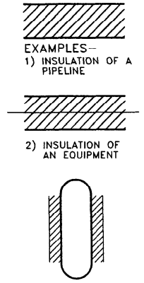 | Insulation or tracing for equipment and lines are generally not shown symbolically in PFD’S and P & ID’S.  In P&IDS, the letters indicating the type of insulation or tracing are placed on top of the line with or without line number.

SECTION 02 PROCESS QUANTITIES

Sl No. | Sym. No. | Description | Symbols | Remarks
(1) | (2) | (3) | (4) | (5)
 | 0201 | Liquid flow |  | Place numerical quantities specified within the symbol
 | 0202 | Gas flow | 
 | 0203 | Pressure and temperature | 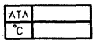

SECTION 03 PIPING

Sl No. | Sym. No. | Description | Symbols | Remarks
(1) | (2) | (3) | (4) | (5)
 | 0301 | Inflow line |  | Identify by name
 | 0302 | Outflow line |  | Identify by name
 | 0303 | Connecting line | 
 | 0304 | Cross over line | 
 | 0305 | Direction of Process Flow
 | 0306 | Slope of a Process Line |  | Indicates direction but not limits.  Degrees are to be shown separa tely
 | 0307 | Dead end
 | 0308 | Buried line | 
 | 0309 | Vendor limit line | 
 | 0310 | Tracing |  | Form of heating to be indicated by initial letter
 | 0311 | Change of Pipe Specification | 
 | 0312 | Centre line
 | 0313 | Coil
 | 0314 | Process line
 | 0315 | Jacketed line

SECTION 04 VALVE

Sl No. | Sym. No. | Description | Symbols | Remarks
(1) | (2) | (3) | (4) | (5)
 | 0401 | Gate valve
 | 0402 | Globe valve | 
 | 0403 | Check valve | 
 | 0404 | Angle valve | 
 | 0405 | Diaphragm valve | 
 | 0406 | Safety valve (pressure relief valve) | 
 | 0407 | Ball valve | 
 | 0408 | Solenoid valve | 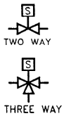
 | 0409 | Float valve | 
 | 0410 | Butterfly valve
 | 0411 | Regulating globe valve | 
 | 0412 | Foot valve with strainer | 
 | 0413 | Plug valve | 
 | 0414 | Control valve | 
 | 0415 | Piston operated hydraulic control valve | 
 | 0416 | Electrically operated control valve | 
 | 0417 | Pinch valve | 
 | 0418 | Spring loaded valve | 
 | 0419 | Control Valve with Hand Wheel | 
 | 0420 | PCV down stream | 
 | 0421 | PCV up stream | 
 | 0422 | Hand – operated valve | 
 | 0423 | Plunger–operated valve | 
 | 0424 | Pilot–operated valve | 
 | 0425 | 4–way valve | 
 | 0426 | Needle valve | 
 | 0427 | Positive choke | 
 | 0428 | Adjustable choke | 
 | 0429 | Motor operated valve | 

SECTION 05 FITTINGS

Sl No. | Sym. No. | Description | Symbols | Remarks
(1) | (2) | (3) | (4) | (5)
 | 0501 | Expansion joint | 
 | 0502 | Hose connector | 
 | 0503 | Flexible hose | 
 | 0504 | Spectacle blind | 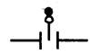
 | 0505 | Line blind | 
 | 0506 | Reducer/Expander | 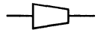
 | 0507 | Blind flange
 | 0508 | Drain funnel | 
 | 0509 | Threaded cap | 
 | 0510 | Orifice | 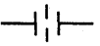
 | 0511 | Venturi meter | 
 | 0512 | Steam trap | 
 | 0513 | Vent with goose neck | 
 | 0514 | Sight glass | 
 | 0515 | Union | 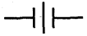
 | 0516 | Coupling | 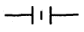
 | 0517 | Adaptor | 
 | 0518 | Flow–element | 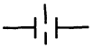
 | 0519 | Turbine meter | 
 | 0520 | Pos. disp. meter | 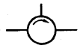
 | 0521 | Rotameter | 
 | 0522 | Sonic meter | 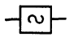
 | 0523 | Magnetic meter | 
 | 0524 | Pitot tube | 
 | 0525 | Drain Plugged | 
 | 0526 | Drain Flanged | 
 | 0527 | Straightening Vanes | 
 | 0528 | Analyser | 
 | 0529 | Filter | 
 | 0530 | Filter | 
 | 0531 | T-type strainer | 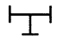
 | 0532 | Y–type strainer | 
 | 0533 | Temporary | 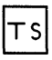
 | 0534 | Basket strainer | 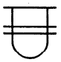
 | 0535 | Flame arrester | 
 | 0536 | Cone type strainer | 
 | 0537 | Sample point | 
 | 0538 | Pipe cap welded | 

SECTION 06 INSTRUMENTS

INSTRUMENTATION SYMBOL

Sl No. | Sym. No. | Description | Symbols | Remarks
(1) | (2) | (3) | (4) | (5)
 | 0601 | Instrument air signal | 
 | 0602 | Instrument electric signal
 | 0603 | Instrument supply lines
 | 0604 | Instrument capillary tubing | 
 | 0605 | Hydraulic lines | 
 | 0606 | Software connections | 
 | 0607 | Locally mounted instruments | 
 | 0608 | Instrument mounted on main panel | 
 | 0609 | Instrument mounted on local panel | 
 | 0610 | Transmitter locally mounted | 
 | 0611 | Transmitter panel mounted | 
 | 0612 | Computer | 
 | 0613 | Computer local panel | 
 | 0614 | DCS/DIDC | 
 | 0615 | Gas filter | 
 | 0616 | Interlock | 
 | 0617 | Rear panel instrument | 
 | 0618 | Running light (local) | 
 | 0619 | Running light (panel) | 
 | 0620 | Running light (local panel) | 
 | 0621 | Remote telemetric unit | 
 | 0622 | Inlet size | 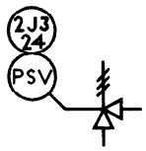
 | 0623 | Rupture disk | 
 | 0624 | Rotameter
 | 0625 | Diaphragm seal | 
 | 0626 | Breather valve | 
 | 0627 | Programmable logic control | 
 | 0628 | Programmable logic control on local panel | 

INSTRUMENT LEGEND
(See Table 1 for definition of identification letters)

Sl No. | Symbol | Definition
(1) | (2) | (3)
 | P | Pressure instruments
 | T | Temperature instruments
 | L | Level instruments
 | IL | Interface level instruments
 | F | Flow instruments
 | A | Analyser instruments
 | PCV | Self-actuated pressure control valve
 | TW | Thermowell
 | TE | Temperature element
 | PB | Push button
 | SOV | Solenoid operated valve
 | TJI | Multipoint indicator
 | DPG | Differential pressure gauge
 | DIC | Differential indicating controller
 | DRC | Differential recording controller
 | I | Indicator
 | R | Recorder
 | IC | Indicating controller
 | RC | Recording controller
 | Y | Function (modifier)
 | Q | Integrator (summator)
 | AL | Alarm low
 | AH | Alarm high
 | ALL | Alarm low
 | AHH | Alarm high
 | SL | Switch low
 | SH | Switch high
 | SLL | Switch low
 | SHH | Switch high
 | PI | Pressure indicator
 | TI | Temperature indicator
 | LI | Level indicator
 | ILG | Interface level gauge
 | FE | Flow element
 | AE | Analyser element
 | PT | Pressure transmitter
 | LT | Level transmitter
 | FT | Flow transmitter
 | AT | Analyser transmitter
 | ILT | Interface level transmitter
 | PV | Pressure control valve
 | TV | Temperature control valve
 | LV | Level control valve
 | ILV | Interface level control valve
 | FV | Flow control valve
 | AV | Gas actuated valve
 | I/P | Current to pneumatic transducer
 | P/I | Pneumatic to current transducer
 | I/E | Current to volts transducer
 | E/I | Volts to current transducer
 | E/P | Volts to pneumatic transducer
 | P/E | Pneumatic to volts transducer
 | SDV | Shut down valve
 | MOV | Motor operated valve
 | XL | Running light
 | XI | Running indications
 | TT | Temperature transmitter
 | SC | Sample cooler
 | UC | Utility connection
 | FG | Flow class
 | PSV | Pressure safety valve
 | TSV | Thermal safety valve
 | RD | Rupture disk
 | HIC | Hand indicating controller
 | HCV | Hand control valve
 | SS | Selection switch
 | FO | Control valve fail open
 | FC | Control valve fail close
 | FL | Control valve fall lock
 | TSO | Tight shut off
 | PVRV | Breather valve (pressure vacuum relief valve)
 | AF | Flame arrestor
 | EX | Excess flow check valve
 | RTU | Remote terminal unit
 | IJ | Insulation joint
 | LSS | Low signal selector
 | MSS | Manual signal selector
 | LO | Lock open
 | LC | Lock close
 | ZSH | Position switch high (valve open)
 | ZHH | Position high (valve open)
 | ZAH | Position alarm high (valve open)
 | ZSL | Position switch low (valve close)
 | ZLL | Position low (full closed valve)
 | ZAL | Position alarm low (valve closed)
 | FB | Full bore
 | NB | Normal bore
 | AS | Automatic sampler
 | DPT | Differential pressure transmitter
 | FO | Restriction orifice
 | C | Controller
 | UV | On-Off valve

Table 1 Identification Letters
(Clause 2.2)

Sl No. | Symbol | First Letter |  | Succeeding Letter
 |  | Measured or Initiating Variables | Modifier | Read out or Passive Function | Output Function | Modifier
(1) | (2) | (3) | (4) | (5) | (6) | (7)
 | A | Analysis |  | Alarm
 | B | Burner, combustion |  | User’s choice | User’s choice | User’s choice
 | C | User’s choice |  |  | Control
 | D | User’s choice | Differential
 | E | Voltage |  | Sensor (Primary Element)
 | F | Flow rate | Ratio (fraction)
 | G | User’s choice |  | Glass, viewing device
 | H | Hand |  |  |  | High
 | I | Current (electrical) |  | Indicate
 | J | Power | Scan
 | K | Time, time schedule | Time rate change |  | Control station
 | L | Level |  | Light |  | Low
 | M | User’s choice | Momentary |  |  | Middle intermediate
 | N | User’s choice |  | User’s choice | User’s choice | User’s choice
 | O | User’s choice |  | Office, restriction
 | P | Pressure, vacuum |  | Point (test) connection
 | Q | Quantity | Integrate, Totalise
 | R | Radiation |  | Record
 | S | Speed, frequency | Safety |  | Switch
 | T | Temperature |  |  | Transmit
 | U | Multivariable |  | Multifunction | Multifunction | Multifunction
 | V | Vibration mechanical analysis |  |  | Valve, damper, louver
 | W | Weight, force |  | Well
 | X | Unclassified | X-axis | Unclassified | Unclassified | Unclassified
 | Y | Event, State or Pressure | Y-axis |  | Relay, Compute, Convert
 | Z | Position, dimension | Z-axis |  | Driver, actuator unclassified final control element

SECTION 07 PUMPS

Sl No. | Sym. No. | Description | Symbols | Remarks
(1) | (2) | (3) | (4) | (5)
 | 0701 | Centrifugal Pumps | 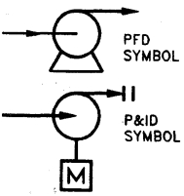 | 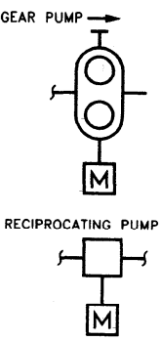
 | 0702 | Positive displacement pump | 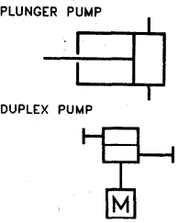
 | 0703 | Proportioning pump | 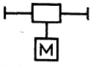
 | 0704 | Hand pump with drum | 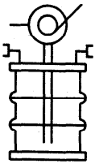
 | 0705 | Ejector (vapour service) | 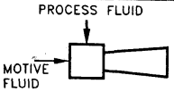
 | 0706 | Blowing egg | 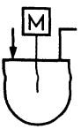

SECTION 08 COMPRESSORS

Sl No. | Sym. No. | Description | Symbols | Remarks
(1) | (2) | (3) | (4) | (5)
 | 0801 | Centrifugal compressor | 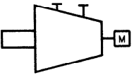
 | 0802 | Positive displacement compressor | 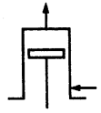
 | 0803 | Reciprocating compressor | 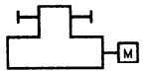
 | 0804 | Ejector compressor | 
 | 0805 | Fan | 
 | 0806 | Turbine | 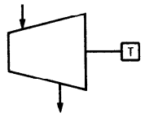

SECTION 09 HEATING OR COOLING ARRANGEMENTS

Sl No. | Sym. No. | Description | Symbols | Remarks
(1) | (2) | (3) | (4) | (5)
 | 0901 | Immersion coil | 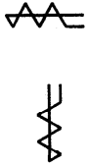 | 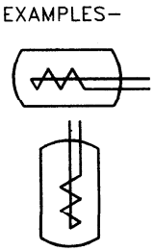
 | 0902 | Exchanger (in PFD) | 
 | 0903 | Heat exchanger | 
 | 0904 | Exchanger | 
 | 0905 | Exchanger | 
 | 0906 | Kettle reboiler | 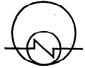
 | 0907 | Kettle reboiler | 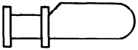
 | 0908 | Kettle reboiler 2 – bundle | 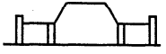
 | 0909 | Tubular coil |  | 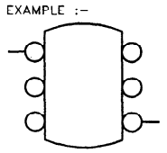
 | 0910 | Jacket |  | 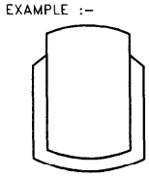
 | 0911 | natural draught cooling tower | 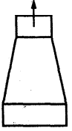
 | 0912 | Induced draught cooling tower | 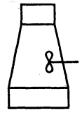
 | 0913 | Air blown cooler | 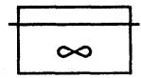 | Used for PFD
 | 0914 | Trickle cooler | 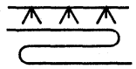
 | 0915 | Plate type heat exchanger | 
 | 0916 | Air cooler with fan and motor | 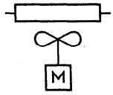 | Used for P&I
 | 0917 | Contact condenser | 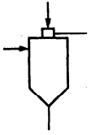
 | 0918 | Desuper heater | 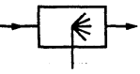
 | 0919 | One cell fired heater/furnace | 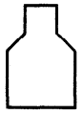
 | 0920 | Two cell fired heater/furnace | 

SECTION 10 FURNACES AND BOILERS

Sl No. | Sym. No. | Description | Symbols | Remarks
(1) | (2) | (3) | (4) | (5)
 | 1001 | Solid fuel furnace | 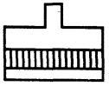
 | 1002 | Oil, gas or pulverized fuel furnace | 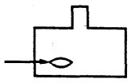
 | 1003 | Electric furnace | 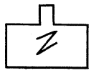
 | 1004 | Fired boiler | 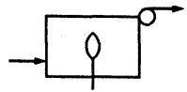
 | 1005 | Waste heat boiler | 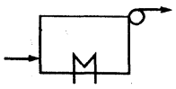

SECTION 11 PROCESS VESSELS

Sl No. | Sym. No. | Description | Symbols | Remarks
(1) | (2) | (3) | (4) | (5)
 | 1101 | Horizontal vessel | 
 | 1102 | Vertical vessel | 
 | 1103 | Jacketed vessel | 
 | 1104 | Packed vessel | 
 | 1105 | Evaporator | 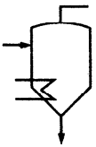
 | 1106 | Crystallizer | 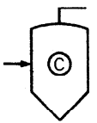
 | 1107 | Autoclave | 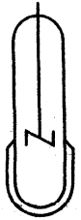
 | 1108 | Construction inside containers, columns towers and reactors
 | 1108A | Plates/trays (for mass transfer) |  | 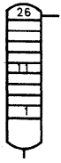  Example:  Tray should be numbered from the bottom at least the first and last should be shown. Intermediate tray should be included and numbered where they are significant.
 | 1108B | Fluidized Bed | 
 | 1109 | Multi bed packed column | 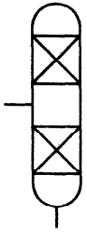
 | 1110 | Vessel with Boot | 
 | 1111 | Deaerator | 
 | 1112 | Flanged vessel | 
 | 1113 | Double flanged vessel | 
 | 1114 | Conical bottom vessel | 
 | 1115 | Vessel with one-sump | 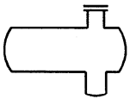
 | 1116 | Vessel with two- sumps | 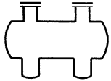

SECTION 12 STORAGE VESSELS/TANKS

Sl No. | Sym. No. | Description | Symbols | Remarks
(1) | (2) | (3) | (4) | (5)
 | 1201 | Fixed roof tank | 
 | 1202 | Floating roof tank | 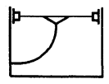
 | 1203 | Floating cum fixed roof tank | 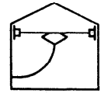
 | 1204 | Gas holder, wet seal | 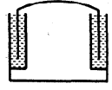
 | 1205 | Gas holder, dry seal | 
 | 1206 | Pressure storage (sphere or spheroid) Horton sphere | 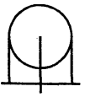

SECTION 13 DRYERS

Sl No. | Sym. No. | Description | Symbols | Remarks
(1) | (2) | (3) | (4) | (5)
 | 1301 | Batch tray drier | 
 | 1302 | Spray drier | 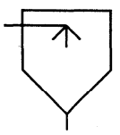
 | 1303 | Continuous drier | 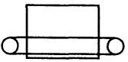
 | 1304 | Rotary drier or kiln | 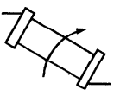

SECTION 14 SIZE REDUCTION EQUIPMENTS

Sl No. | Sym. No. | Description | Symbols | Remarks
(1) | (2) | (3) | (4) | (5)
 | 1401 | Size reducing equipment (general symbol) |  | Example: Pulverizer
 | 1402 | Breaker, gyratory | 
 | 1403 | Breaker hammer mill impact mill | 
 | 1404 | Jaw crusher | 
 | 1404A | Roller crusher | 
 | 1405 | Grinder | 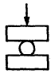
 | 1406 | Ball or Tube mill | 

SECTION 15 SEPARATORS

Sl No. | Sym. No. | Description | Symbols | Remarks
(1) | (2) | (3) | (4) | (5)
 | 1501 | Cyclone or Hydrocyclone | 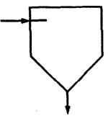
 | 1502 | Electrostatic separator (electrical purification of gas) | 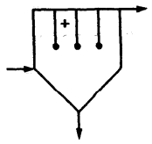
 | 1503 | Separators for liquids, decanters | 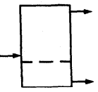
 | 1504 | Thickener | 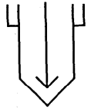
 | 1505 | Screen | 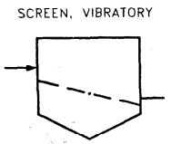 | 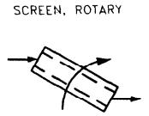

SECTION 16 FILTERS

Sl No. | Sym. No. | Description | Symbols | Remarks
(1) | (2) | (3) | (4) | (5)
 | 1601 | Filter press | 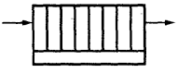
 | 1602 | Suction filter | 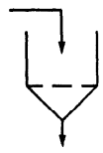
 | 1603 | Pressure filter | 
 | 1604 | Gravity filter (open settling tank) | 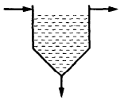
 | 1605 | Open rotary vacuum filter | 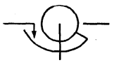
 | 1606 | Closed rotary vacuum filter | 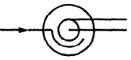
 | 1607 | Bag filter | 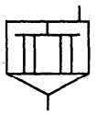 | 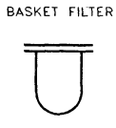

SECTION 17 CENTRIFUGES

Sl No. | Sym. No. | Description | Symbols | Remarks
(1) | (2) | (3) | (4) | (5)
 | 1701 | Centrifuges (general symbol) | 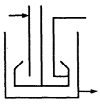 | 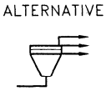
 | 1702 | Basket centrifuge batch or continuous | 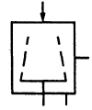
 | 1703 | Plate centrifuge | 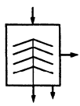

SECTION 18 STIRRERS

Sl No. | Sym. No. | Description | Symbols | Remarks
(1) | (2) | (3) | (4) | (5)
 | 1801 | General symbol |  | 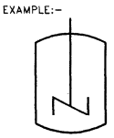
 | 1802 | Sparger |  | 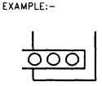

SECTION 19 MIXERS

Sl No. | Sym. No. | Description | Symbols | Remarks
(1) | (2) | (3) | (4) | (5)
 | 1901 | Ribbon blender | 
 | 1902 | Kneader | 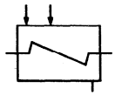
 | 1903 | Double cone blender | 
 | 1904 | Ejector mixer | 
 | 1905 | Rotary mixer | 
 | 1906 | On–line mixer | 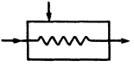
 | 1907 | Mixer | 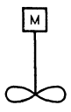
 | 1908 | Saucony mixer | 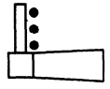

SECTION 20 FEEDERS

Sl No. | Sym. No. | Description | Symbols | Remarks
(1) | (2) | (3) | (4) | (5)
 | 2001 | General symbol | 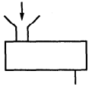
 | 2002 | Vibrator feeder | 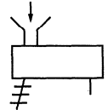
 | 2003 | Weigh feeder | 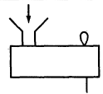
 | 2004 | Rotary table feeder, revolving plate feeder | 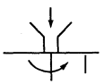
 | 2005 | Scraper feeder | 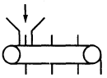
 | 2006 | Screw feeder | 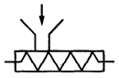
 | 2007 | Rotary feeder | 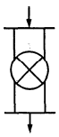

SECTION 21 CONVEYORS

Sl No. | Sym. No. | Description | Symbols | Remarks
(1) | (2) | (3) | (4) | (5)
 | 2101 | Belt conveyor | 
 | 2102 | Scraper conveyor | 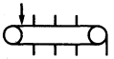
 | 2103 | Vibrating conveyor | 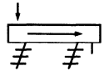
 | 2104 | Screw conveyor | 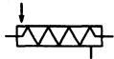
 | 2105 | Bucket conveyor | 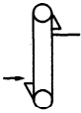
 | 2106 | Roller conveyor | 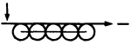
 | 2107 | Overhead conveyor with hooks | 
 | 2107B | Overhead conveyor or ropeway with buckets or carriers | 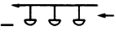
 | 2108A | Fixed hoist with hook | 
 | 2108B | Travelling hoist with hook | 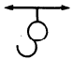
 | 2108C | Travelling hoist with grab | 
 | 2108D | Air floats | 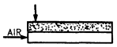

SECTION 22 TRANSPORT VEHICLES

Sl No. | Sym. No. | Description | Symbols | Remarks
(1) | (2) | (3) | (4) | (5)
 | 2201 | Ship | 
 | 2202 | Wagon, lorry, truck | 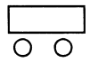
 | 2203 | Tanker | 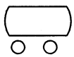
 | 2204 | Open trailer | 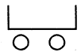
 | 2205 | Wagon with bottom hopper | 

SECTION 23 MISCELLANEOUS

Sl No. | Sym. No. | Description | Symbols | Remarks
(1) | (2) | (3) | (4) | (5)
 | 2301 | Silencer | 
 | 2302 | Launcher receiver | 
 | 2303 | Diesel generator | 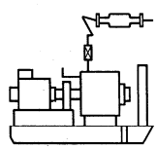
 | 2304 | Turbine generator | 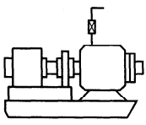
 | 2305 | Hose reel | 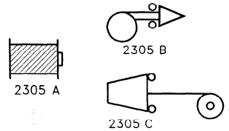
 | 2306A | Well head with one bore (single completion) | 
 | 2306B | Well head with two bore (dual completion) | 
 | 2307 | Sump caisson | 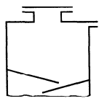
 | 2308 | Flare | 
 | 2308B | Flare stack | 
 | 2309 | Chimney | 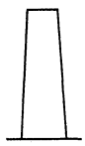
 | 2310 | Scrapper tee | 
 | 2311 | Atmospheric vent
 | 2312 | Cylinder | 
 | 2313 | Graduated cylinder
 | 2314 | Crane | 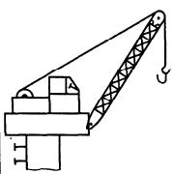
 | 2315A | Electrolytic cell without diaphragm | 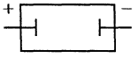
 | 2315B | Electrolytic cell with diaphragm | 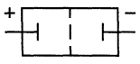
 | 2316 | Turbine drive | 
 | 2317 | Motor drive | 
 | 2318 | Swivel drain | 
 | 2319 | CBD-symbol | 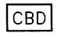
 | 2320 | Sample cooler |  | 

SECTION 24 SERVICE FLUID CODES

Sl No. | Codes | Meaning
(1) | (2) | (3)
 | P | Process
 | WCS | Cooling water supply
 | WCR | Cooling water return
 | WD | Drinking water
 | WS | Service water
 | WF | Fire water
 | WR | Raw water
 | WP | Process water
 | WT | Treated water
 | AI | Instrument air
 | AP | Plant air
 | AB | Breathing air
 | BD | Blow down
 | FL | Flare
 | FO | Fuel oil
 | FG | Fuel gas
 | GI | Instrument gas
 | IG | Inert gas
 | OWS | Only water sewer
 | SS | Strom sever
 | CBD | Closed blow down
 | D | Drain
 | UC | Utility connection
 | HM | Heating medium
 | HMS | Heating medium supply
 | HMR | Heating medium return
 | EG | 50 percent EG solution
 | CHWS | Chilled water supply
 | CHWR | Chilled water return
 | WDM | Demineralised water
 | SH | SP steam
 | SM | MP steam
 | SL | LP steam
 | CH | Condensate HP
 | CM | Condensate MP
 | CL | Condensate LP
 | N | Nitrogen
 | BR | Brine
 | CS | Caustic sewer
 | NA | Caustic
 | RE | Refrigerant ethane
 | RA | Refrigerant ammonia
 | RP | Refrigerant propane
 | AC | Acid lines

SECTION 25 INSULATION/TRACING TYPE

Sl No. | Codes | Meaning
(1) | (2) | (3)
 | IH | Hot insulation
 | IC | Cold insulation
 | IS | Safety insulation
 | IT | Steam traced
 | IE | Electric traced
 | IA | Acoustic insulation
 | IF | Thermal fluid tracing

ANNEX A
(Foreword)

COMMITTEE COMPOSITION
Chemical Engineering Plants and Related Equipment Sectional Committee, MED 17

Organization | Representative(s)
CSIR - Indian Institute of Petroleum, Dehradun | Dr Mritunjay Kumar Shukla (Chairperson)
Advance Valves Global, Noida | Shri Pranay S. Garg  Shri Chandrakant Wadkar (Alternate)
Auma India Private Limited, Bengaluru | Shri Yashwant M. Jannu
Bharat Heavy Electrical Limited, New Delhi | Shri Y. Srinivasa Rao  Shri Abhishek Kumar Pandey (Alternate)
Blast Carboblocks Private Limited, Mumbai | Shri Dhawal Saxena
Central Power Research Institute, Bengaluru | Dr P. Thomas  Shri Sadasiva Murthy P. (Alternate I)  Shri Ajith Kumar N. (Alternate II)
Chemtrols Industries Private Limited, New Delhi | Shri P. Krishna Kumar
Confederation of Indian Industry, New Delhi | Shri Nandakumar Kalath  Shri Abilash Uttam (Alternate)
Directorate General Factory Advice Service and Labour Institutes, Mumbai | Shri Tanoj Chandan  Shri Kunal Sharma (Alternate)
Engineers India Limited, Gurugram | Shri Hasmukh K. Parmar  Shri Mragang Sheakhar (Alternate)
GMM Pfaudler Limited, Anand | Shri Dhiran Panchal  Shri Satvik Patel (Alternate)
Hindustan Petroleum Corporation Limited, Mumbai | Shri Krishanu Ghosh  Shri N.K. Rai (Alternate)
Indian Oil Corporation Limited, New Delhi | Shri Karan Agrawal
Indian Rubber Manufacturers Research Association, Mumbai | Dr K. Raj Kumar  Dr Debdipta Basu (Alternate)
Indian Valve and Actuator Manufacturers Association (IVAMA), Coimbatore | Shri R. Muruganantham  Shri Jay Doshi (Alternate)
Kejriwal Casting Limited, Kolkata | Shri Sandeep Kejriwal
L&T Valves, Chennai | Shri Rohit Sharma  Shri Suriyanarayanan (Alternate)
Lathia Rubber Manufacture Company Private Limited, Mumbai | Shri Sanjiv S. Lathia
MECON Limited, Ranchi | Shri Yogendra Kumar Singh  Shri Arvind Bhushan (Alternate)
Plastics Machinery Manufacturers Association of India (PMMAI), New Delhi | Shri Nandha Kumar T.  Shri Pradip Vanwani (Alternate)
Project and Development India Limited, Noida | Shri Sanjiv Kumar Mishra  Shri Rajeev Ranjan Kumar (Alternate)
Tata Consulting Engineers Limited, Navi Mumbai | Shri Shivnarayan Pareek  Shri Shireesh S. Swami (Alternate)
BIS Directorate General | Shri Navindra Gautam Scientist ‘E’/Director and Head (Mechanical Engineering) [Representing Director General (Ex-officio)]
Member Secretary
Ms Neha Thakur
Scientist ‘B’/Assistant Director
(Mechanical Engineering), BIS

