***भारतीय मानक***

***Indian Standard***

**IS 10046 : 2024**

खदान ढुलाई ट्रैक के लिए डॉग स्पाइक्स — विशिष्टि

*(* पहला पुनरीक्षण )

**Dog Spikes for Mine Haulage Tracks — Specification**

( *First Revision )*

ICS 73.100.01

© BIS 2024

भारतीय मानक ब्यूरो

BUREAU OF INDIAN STANDARDS

मानक भवन, 9 बहादुर शाह ज़फर मार्ग, नई दिल्ली - 110002

MANAK BHAVAN, 9 BAHADUR SHAH ZAFAR MARG

NEW DELHI - 110002

[www.bis.gov.in](http://www.bis.org.in) [www.standardsbis.in](http://www.standardsbis.in)

**October 2024 Price Group X**

Mining Techniques and Equipment Sectional Committee, MED 08

FOREWORD

This Indian Standard (First Revision) was adopted by the Bureau of Indian Standards, after the draft finalized by the Mining Techniques and Equipment Sectional Committee had been approved by the Mechanical Engineering Division Council.

This standard was first published in 1981. This standard is being revised to keep pace with the latest technological developments and international practices. Also, in this revision, the standard has been brought into the latest style and format of Indian Standards, and references of Indian Standards, wherever applicable have been updated. BIS certification marking clause has been modified to align with the revised *Bureau of Indian Standards Act*, 2016.

This standard lays down the requirements for dog spikes (also called dog nails) used in laying of mine haulage -tracks. This standard covers two types of dog spikes - one with a chisel shaped tail (Type C) and other with a rounded tail (Type R).

Of the two, the Type C dog spikes find greater use in Indian mines. These dog spikes are easily driven into the wooden sleeper and are easier to manufacture (may be manufactured in mine workshops). In addition, their use involves lesser damage to sleepers thus increasing the life of sleepers. Due to these advantages, the use of these dog spikes is recommended at places where track layout is frequently changed, high speeds are not involved, rails used are comparatively of lighter section and haulage tracks are not permanent in nature. These dog spikes are therefore, normally used for laying tracks near working faces, at places where locomotive haulage is not used, etc.

On the other hand, the Type R dog spikes, though not in demand, are recommended for use where track is comparatively of permanent nature, high speeds of vehicles are involved, locomotives are expected to run on the tracks and rails are of heavier section. These dog spikes are, therefore, preferred at trunk haulage routes. pit-bottom and pit-top layouts, etc.

For laying the haulage track, Type C dog spikes are driven directly into the sleeper by hammering the head whereas Type R dog spikes are driven into the sleeper after drilling a blind hole in the sleeper with an auger.

The composition of the Committee responsible for the formulation of this standard is given in Annex A.

For the purpose of deciding whether a particular requirement of this standard is complied with, the final value, observed or calculated, expressing the result of a test or analysis, shall be rounded off in accordance with IS 2 : 2022 ‘Rules for rounding off numerical values (*second revision*)’. The number of significant places retained in the rounded off value should be the same as that of the specified value in this standard.

*Indian Standard*

DOG SPIKES FOR MINE HAULAGE TRACKS — SPECIFICATION

*( First Revision )*

**1 SCOPE**

This standard lays down the requirements for dog spikes (also called dog nails) for mine haulage and locomotive tracks.

**2 REFERENCES**

The standard listed below contain provisions which, through reference in this text, constitute provisions of this standard. At the time of publication, the edition indicated were valid. All standards are subject to revision, and parties to agreements based on this standard are encouraged to investigate the possibility of applying the most recent edition of the standard listed below.

|  |  |
| --- | --- |
| *IS No.* | *Title* |
| IS 2062 : 2011 | Hot rolled medium and high tensile structural steel — Specification (*seventh revision*) |

**3 TYPES**

1. Type C — Dog spike with chisel shaped tail.
2. Type R — Dog spike with rounded tail.

**4 DIMENSIONS**

**4.1 Type C Dog Spikes**

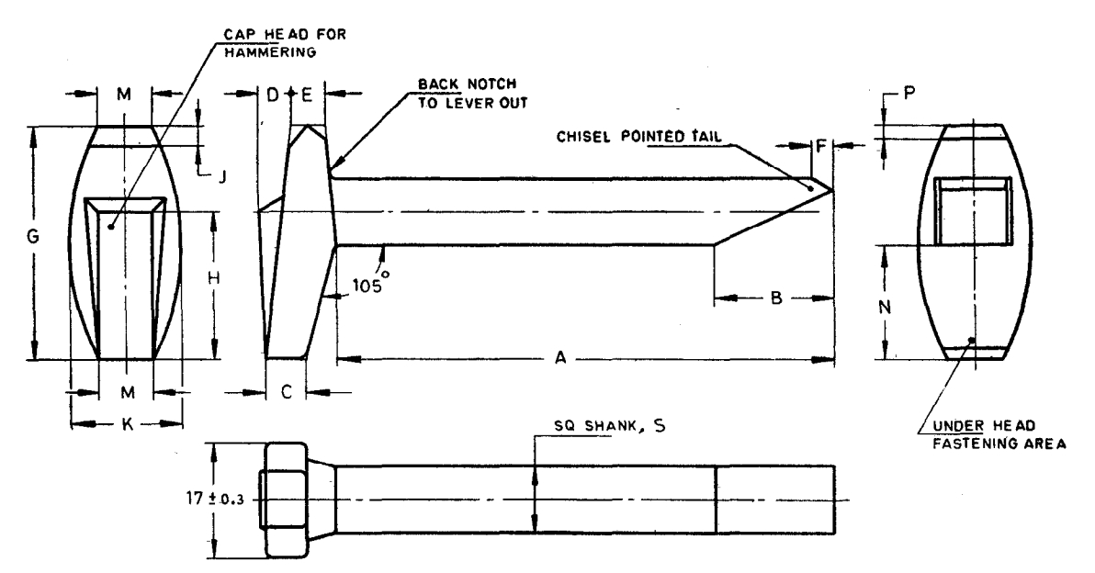

All dimension in millimeters.

|  |  |  |  |  |  |  |  |  |  |  |  |  |  |  |  |  |
| --- | --- | --- | --- | --- | --- | --- | --- | --- | --- | --- | --- | --- | --- | --- | --- | --- |
| **Sl No.** | **Nominal Size** | **Size**  **of Square Shank** | **Length of**  **Shank ,**  **A** | **B** | **C** | **D** | **E** | **F** | **G**  **±**  **0.5** | **H** | **J** | **K** | **M,**  ***Min*** | **N** | **P** | **Suitable**  **for Rail**  **Section**  kg/m |
| (1) | (2) | (3) | (4) | (5) | (6) | (7) | (8) | (9) | (10) | (11) | (12) | (13) | (14) | (15) | (16) | (17) |
|  | 10×85 | 10 | 75 ± 0.5 | 18 | 6 | 5 | 5 | 3 | 35 | 22 | 3 | 17 | 8 | 17 | 2 | 10 |
|  | 10×100 | 10 | 88 ± 1 | 18 | 8 | 5 | 7 | 3 | 35 | 22 | 3 | 17 | 8 | 17 | 2 | 10, 12 |
|  | 12×100 | 12 | 88 ± 1 | 22 | 8 | 5 | 7 | 8 | 42 | 26 | 5 | 22 | 10 | 20 | 3 | 10, 12, 15 |
|  | 12×115 | 12 | 102 ± 1 | 22 | 8 | 5 | 8 | 8 | 42 | 26 | 5 | 22 | 10 | 20 | 3 | 15, 24 |

**4.2 Type R Dog Spikes**

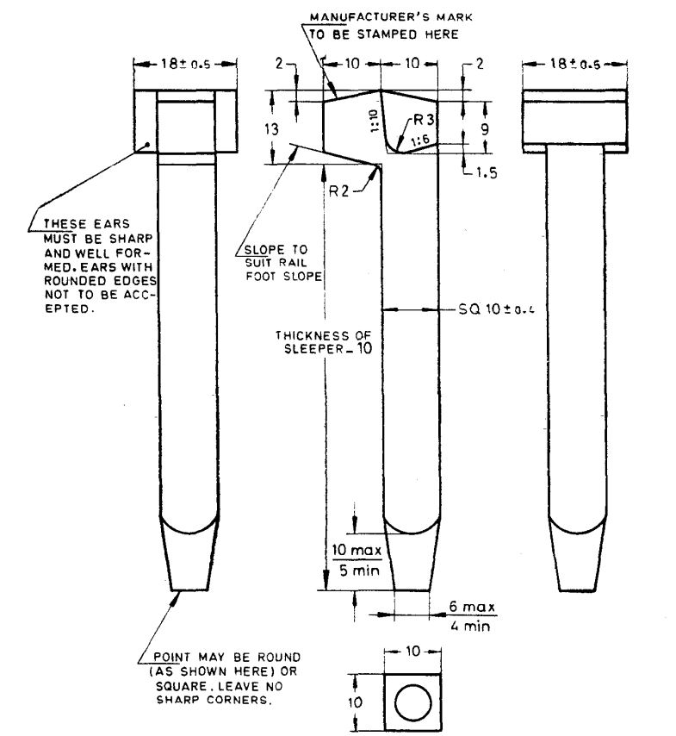

All dimension in millimeters.

**5 MATERIAL**

Steel used shall be conforming to IS 2062.

**6 DESIGNATION**

Type C dog spikes of 12 × 100 nominal size conforming to this standard shall be designated as:

Dog Spike 12 × 100C IS 10046

**7 MARKING**

Each spike shall be marked with manufacturer’s identification mark or trade-mark and nominal size.

**7.1 BIS Certification Marking**

The product(s) conforming to the requirements of this standard may be certified as per the conformity assessment schemes under the provisions of the *Bureau of Indian Standards Act*, 2016 and the Rules and Regulations framed thereunder, and the products may be marked with the Standard Mark

**ANNEX A**

( *Foreword* )

**COMMITTEE COMPOSITION**

Mining Techniques and Equipment Sectional Committee, MED 08

|  |  |
| --- | --- |
| *Organization* | *Representative(s)* |
| Directorate General of Mines Safety, Dhanbad | Shri Saifullah Ansari **(*Chairperson*)** |
| Automotive Research Association of India, Pune | Shri Milind Kandalkar  Shri Dhondiram Mole (*Alternate*) |
| BEML Limited, Bengaluru | Shri V. R. S. Prasad Rao  Shri H. G. Suresh (*Alternate*) |
| CSIR-Central Institute for Mining and Fuel Research, Dhanbad | Dr Manoj Kumar Singh  Shri Surajit Dey (*Alternate* I)  Prof S. K. Kashyap (*Alternate* II) |
| Directorate General of Mines Safety, Dhanbad | Shri M. Arumugam |
| Eastern Coalfields Limited, Dishergarh | Shri Sarvesh Kumar  Shri Ajay Bhowmik (*Alternate*) |
| Eimco Elecon (India) Limited, Vallabh Vidyanagar | Shri Ram Ramesh Kale  Shri Vinay Jaynarayan Sharma (*Alternate*) |
| Hutti Gold Mines Company Limited, Bengaluru | Dr Prabhakar Sangoormath  Shri Mallikarjun Sarapur (*Alternate* I)  Ms Mega Hiremath (*Alternate* II) |
| Indian Institute of Technology (ISM), Dhanbad | Shri L. A. Kumaraswamidhas |
| Manganese Ore Limited, Nagpur | Shri Rakesh Kumar Verma  Shri Atul Sharma (*Alternate* I)  Shri Ashwini Baghele (*Alternate* II) |
| Metso Outotec India Private Limited, Vadodara | Shri Sandeep Deokisan Bhattad |
| Nanda Millar Company, Kolkata | Shri J. P. Goenka  Shri Madhur Goenka (*Alternate*) |
| Tata Steel Limited, Dhanbad | Shri Soumendhu Manjhi  Shri Abinash Jha (*Alternate*) |
| BIS Directorate General | Shri K. Venkateswara Rao, Scientist ‘F’/Senior Director and Head (Mechanical) [Representing Director General (*Ex-officio*)] |

*Member Secretary*

Shri Shubham Tiwari

Scientist ‘D’/Joint Director

(Mechanical), BIS