***भारतीय मानक***

***Indian Standard***

**IS 8066 : 2024**

***खदान कारें — विशिष्टि***

*(* पहला पुनरीक्षण )

**Mine Cars — Specification**

( *First Revision )*

ICS 13.110; 73.100.99

© BIS 2024

भारतीय मानक ब्यूरो

BUREAU OF INDIAN STANDARDS

मानक भवन, 9 बहादुर शाह ज़फर मार्ग, नई दिल्ली - 110002

MANAK BHAVAN, 9 BAHADUR SHAH ZAFAR MARG

NEW DELHI - 110002

[www.bis.gov.in](http://www.bis.org.in) [www.standardsbis.in](http://www.standardsbis.in)

**December 2024 Price Group X**

Mining Techniques and Equipment Sectional Committee, MED 08

FOREWORD

This Indian Standard (First Revision) was adopted by the Bureau of Indian Standards after the draftfinalized by the Mining Techniques and Equipment Sectional Committee had been approved by the Mechanical Engineering Division Council.

This standard was first published in 1976. This standard is being revised again to keep pace with the latest technological developments and international practices. Also in this revision, the standard has been brought into latest style and format of Indian Standards, amendement issued from time to time has been incorporated and references to Indian Standards, wherever applicable have been updated. BIS certification marking clause has been modified to align with the revised *Bureau of Indian Standards Act, 2016*.

The composition of the committee responsible for the formulation of this standard is given in Annex C.

For the purpose of deciding whether a particular requirement of this standard is complied with, the final value, observed or calculated, expressing the result of a. test or analysis, shall be rounded off in accordance with IS 2 : 2022 ‘Rules for rounding off numerical values (*second revision*)’. The number of significant places retained in the rounded-off value should be the same as that of the specified value in this standard.

*Indian Standard*

**MINE CARS — SPECIFICATION**

*(First Revision)*

**1 SCOPE**

Covers the requirements for flat-bottomed mine cars of capacities 1.5 m3 and above.

**1.1** This standard does not cover the requirements for wheel-axle assemblies for the mine cars.

**2 REFERENCES**

The standards listed in Annex A contain provisions which, through reference in this text, constitute provisions of this standard. At the time of publication, the editions indicated were valid. All standards are subject to revision, and parties to agreements based on this standard are encouraged to investigate the possibility of applying the most recent editions of the standards listed in Annex A.

**3 DIMENSIONS**

As specified in Table 1 read with Fig. 1.

**Table 1 Dimensions for Mine Cars**

(*Clause* 3 *and* Fig. 1)

All dimensions in millimetres.

|  |  |  |  |  |  |  |  |  |  |  |
| --- | --- | --- | --- | --- | --- | --- | --- | --- | --- | --- |
| **Sl No.** | **Car**  **Sl No.** | **Capacity**  **m3** | **Rail Gauge**  ***G*** | **Pay Load for Coal Tonnes** | **Internal Width**  ***W*** | **Internal Depth**  ***h*** | **Internal Length**  ***L*** | **Height Above Rail**  ***H***  ***Max*** | **Wheel Base**  ***S*** | **Coupling Height**  ***h*1** |
|  |  |  |  |  |  |  |  |  |  |  |
|  | 01 | 1.5 | 600 | 1.35 | 900 | 750 | 2 250 | 1 120 | 900 | 300 |
|  | 02 | 1.5 | 600 | 1.35 | 900 | 950 | 1 760 | 1 320 | 750 | 300 |
|  | (03) | 1.5 | (762) | 1.35 | 1 020 | 750 | 1 910 | 1 120 | 750 | 300 |
|  | 04 | 2 | 600 | 1.8 | 900 | 950 | 2 350 | 1 370 | 900 | 300 |
|  | (05) | 2 | (762) | 1.8 | 1 050 | 750 | 2 550 | 1 120 | 1 000 | 300 |
|  | (06) | 2 | (762) | 1.8 | 1 050 | 950 | 2 000 | 1 320 | 750 | 300 |
|  | 07 | 2 | 900 | 1.8 | 1 200 | 750 | 2 220 | 1 120 | 900 | 300 |
|  | (08) | 2.5 | (762) | 2.25 | 1 050 | 950 | 2 500 | 1 370 | 1 000 | 300 |
|  | 09 | 2.5 | 900 | 2.25 | 1 200 | 750 | 2 780 | 1 170 | 1 000 | 300 |
|  | 10 | 2.5 | 900 | 2.25 | 1 200 | 950 | 2 220 | 1 370 | 900 | 300 |
|  | 11 | 2.5 | 1 000 | 2.25 | 1 300 | 750 | 2 560 | 1 170 | 1 000 | 300 |
|  | (12) | 2.5 | (1 067) | 2.25 | 1 300 | 750 | 2 560 | 1 170 | 1 000 | 300 |
|  | 13 | 3 | 900 | 2.7 | 1 200 | 950 | 2 670 | 1 370 | 1 000 | 300 |
|  | 14 | 3 | 1 000 | 2.7 | 1 300 | 750 | 3 080 | 1 170 | 1 200 | 300 |
|  | 15 | 3 | 1 000 | 2.7 | 1 300 | 950 | 2 500 | 1 370 | 1 000 | 300 |
|  | (16) | 3 | (1 067) | 2.7 | 1 300 | 750 | 3 080 | 1 170 | 1 200 | 300 |
|  | (17) | 3 | (1 067) | 2.7 | 1 300 | 950 | 2 500 | 1 370 | 1 000 | 300 |
|  | 18 | 4 | 900 | 3.6 | 1 200 | 950 | 3 560 | 1 370 | 1 350 | 350 |
|  | 19 | 4 | 900 | 3.6 | 1 200 | 1 050 | 3 180 | 1 470 | 1 200 | 350 |
|  | 20 | 4 | 1 000 | 3.6 | 1 300 | 950 | 3 330 | 1 370 | 1 350 | 350 |
|  | (21) | 4 | (1 067) | 3.6 | 1 300 | 650 | 3 330 | 1 370 | 1 350 | 350 |
|  | 22 | 5 | 900 | 4.5 | 1 200 | 1 050 | 4 000 | 1 470 | 1 500 | 350 |
|  | 23 | 5 | 1 000 | 4.5 | 1 300 | 1 050 | 3 700 | 1 470 | 1 500 | 350 |
|  | (24) | 5 | (1 067) | 4.5 | 1 300 | 1 050 | 3 700 | 1 470 | 1 500 | 350 |
| NOTE  1 Coal pay load equivalents are based on a nominal 1m3 to 0.9 tonne.  2 Approx equivalent pay load for stone shall be taken as twice of that of coal.  3 Car serial numbers given within parenthesis shall not be used for new installations. | | | | | | | | | | |

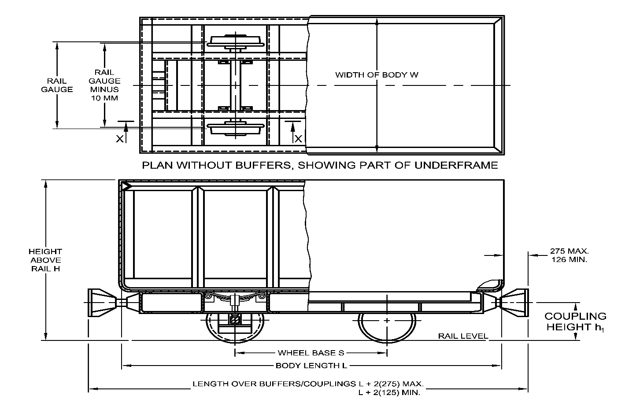

ELEVATION (PARTLY SHOWN IN SECTION THROUGH XX)

All dimensions in millimetres.

Fig. 1 Mine Car

**4 TOLERANCES**

1. Inside width and inside height ± 10mm
2. Overlapping of sheets of the body, *Min*  15 mm
3. Deviation of symmetry of longitudinal axis of the body 2.5 mm per metre body length

and the underframe with respect to each other, *Max*

1. The difference in lengths of diagonals of the body, *Max*  4.0 mm per metre body length

**5 MATERIAL**

As specified in Table 2.

**6 GENERAL REQUIREMENTS**

**6.1 General**

**6.1.1** Aluminium bodies and underframes shall not be welded. Aluminium rivets, when used, shall be of 55000 or 64430 alloys conforming to IS 740.

**6.1.2** Aluminium and steel, when combined, shall be insulated from each other either by bitumen paint or zinc chromate primer to avoid galvanic corrosion. If steel rivets are used a coat of zinc chromate primer shall be applied to the aluminium before riveting.

**6.1.3** All welds shall be appropriate to the type of joint and shall be of adequate strength.

**Table 2 Material for Components of Mine Cars**

(*Clause* 5)

|  |  |  |  |
| --- | --- | --- | --- |
| **Sl No.** | **Component** | **Material** | |
| **Steel** | **Aluminium** |
|  |  |  |  |
|  | Body and underframe | IS 2062 | 1. Plates conforming to 64430 WP or 65032 WP of IS 737 2. Extruded sections conforming to 64430 WP of IS 733 |
|  | Draw gear | 1. 11C15 or 20C15 of IS 1570 (Part 4). 2. Class 3, Class 3A or Class 4 of IS 1875 | – |
|  | Springs | 1. IS 3195 2. 55Si7 of IS 1570 (Part 4). | – |

**6.1.3.1** The welds shall be either continuous or intermittent as agreed between the manufacturer and the purchaser.

**6.1.4** Ancillary handling equipment shall be well within the confines of the buffers or couplers.

**6.2 Body**

**6.2.1** The body shall be rectangular in shape. The interior shall be free from wheel hoods, well bottoms and corrugations.

**6.2.1.1** The sides and bottom of the bodies shall be manufactured from plates of minimum thickness 3.15 mm and 6 mm respectively.

**6.2.1.2** An unequal angle (∠ 7045 or more) or equal angle (∠ 5050 or more) or channel section (ISMC 75 or more) conforming to IS 808or flats (75 ISF 12 or more) conforming to IS 1730 shall be fixed at the top edge of the body for stiffening purposes.”.

**6.2.2** The body shall be either riveted or welded to the underframe.

**6.2.3** Where vehicles are to be used on over-rope or over-chain haulage systems, the upper edges of end plates shall be fitted with renewable wearing strips.

**6.2.4** Bodies shall be so designed and constructed that there are no sharp edges liable to cause personal injury.

**6.3 Underframe**

**6.3.1**Underframe shall be manufactured by either welding or riveting suitable channel or angle sections conforming to IS 808.

**6.3.1.1** If required underframes may be manufactured from channels or angles of appropriate dimensions made of aluminium alloy.

**6.3.2** Mine cars required to be mechanically engaged -underneath by rams or creepers shall be fitted  
for the purpose with solid bar of mild steel as near as possible to the wheel axle (*see* Fig. 2).

**6.3.2.1** In addition to the welding, the bar shall be securely bolted to the underframe.

**6.4 Draw Gear**

**6.4.1**The draw gear or buffer gear shall preferably incorporate steel springs for shock absorbing purpose. Where solid buffers are used, the same shall be rigid enough to withstand the buffing shock.

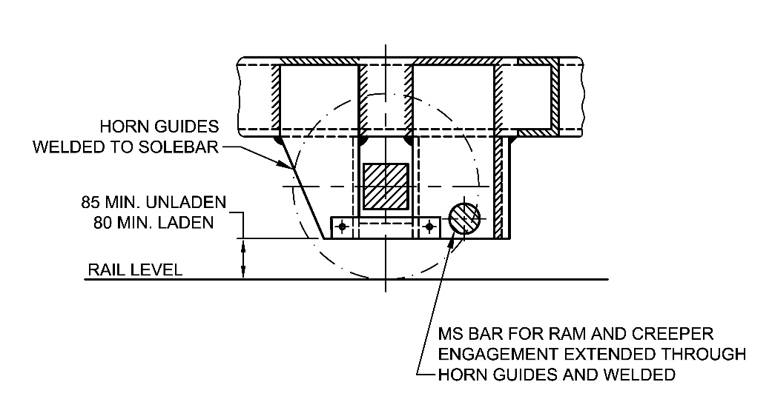

PART SECTION ON Coupler OF MINE CAR

All dimensions in millimeters.

Fig. 2 Horn Guides

**6.4.2** The coupler housingshall be incorporated in the underframe and shall be of equal breaking strength as the coupler and capable of adequately transmitting the loads from coupler to the longitudinal members of the underframe.

**6.4.3** The design of the draw gear shall ensure straight pull through the coupler, coupler housing and underframe.

**6.4.4** The coupler shall be flexible enough to allow free movement of cars on sharp curves, shall be securely connected to the underframe, and shall be easily replaceable.

**6.5 Brakes**

Brakes if provided shall be for parking purposes only.

**6.6 Suspension**

For suspension of mine car of Day load 3 tonnes and above, steel springs of laminated type (*see* Fig. 3) shall be provided between underframe and wheel axle assemblies.

**7 Heat Treatment**

**7.1** All components of draw gear shall be subjected to one of the following heat treatments as agreed to between the purchaser and the manufacturer:

1. Normalizing by heating uniformly to a temperature between 870 °C and 910 °C and cooling in still air;
2. Normalizing as (a) above and tempering at a temperature between 550 °C and 660 °C; and
3. Hardening and tempering by heating to a temperature between 870 °C and 910°C followed by quenching in oil or water and tempering at a temperature between 550 °C and 660 °C.

**7.1.1** Details of heat treatment given to the components of draw gear shall be endorsed on the certificate of test (*see* Annex B).

**8 DESIGNATION**

A mine car of reference number 04 shall be designated as:

Mine Car 04 IS 8066

**9 INFORMATION TO BE SUPPLIED BY THE PURCHASER WHILE ORDERING**

While ordering the purchaser shall supply the following information to the manufacturer:

1. Car designation;
2. Designation of ‘wheel axle assembly’ (*see* IS 8003),
3. Safe working load of draw gear required; and
4. Whether brakes are required.

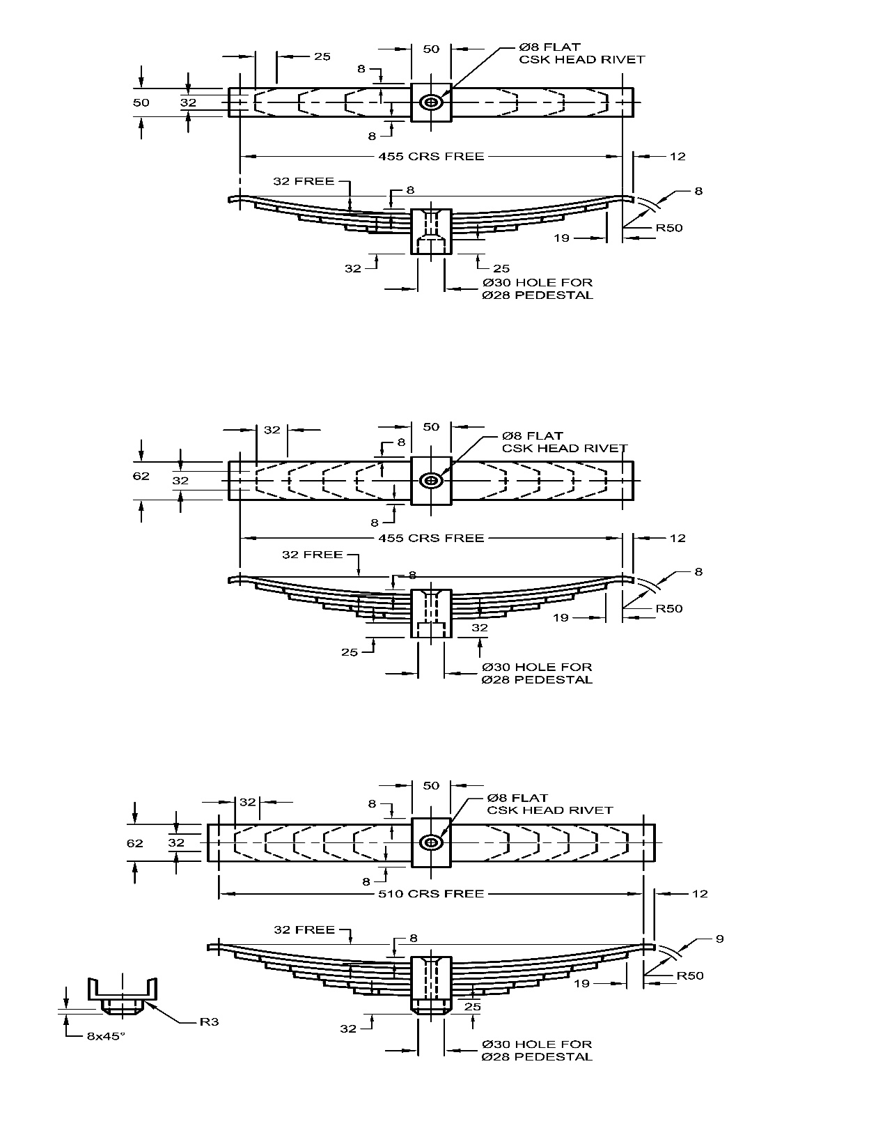

All dimensions in millimeters

Fig. 3 Springs

**10 TESTING OF DRAW GEAR**

**10.1 Destructive Test**

The manufacturer shall subject a prototype of draw gear to ultimate tensile strength test. The sample shall not fail before a load of seven times the safe working load is reached.

**10.2 Proof Load Test**

One draw gear from each production batch of 10 shall be subjected to a proof load of three times the safe working load and a certificate of test (*see* Annex B) shall be supplied with each production batch.

**11 MARKING**

**11.1** Each component of draw gear shall be legibly marked on a non-vital part as follows:

1. Normalized or normalized and tempered components with the mark M
2. Hardened and tempered components with the mark OM

**11.1.1** The letters used shall be of 5 mm size.

**11.2** Each mine car shall be marked with the following information’s:

1. Car capacity;
2. Rail gauge, and
3. Manufacturer’s name or trade-mark.

**11.3 BIS Certification Marking**.

The mine cars may also be marked with the Standard Mark.

**11.3.1** The product(s) conforming to the requirements of this standard may be certified as per the conformity assessment schemes under the provisions of the *Bureau* *of Indian Standards Act*, 2016 and the Rules and Regulations framed thereunder, and the products may be marked with the standard mark.

**ANNEX A**

( *Clause* 2)

**LIST OF REFERRED INDIAN STANDARDS**

|  |  |
| --- | --- |
| *IS No.* | *Title* |
| IS 740 : 1977 | Specification for wrought aluminium and aluminium alloy rivet stock for general engineering purposes (*second revision*) |
| IS 2062 : 2011 | Hot rolled medium and high tensile structural steel - Specification (*seventh revision*) |
| IS 1570 (Part 4) : 1988 | Schedules for wrought steels: Part 4 alloy steels (Alloy Constructional And Spring Steels) with specified chemical composition and mechanical properties (*first revision*) |
| IS 1875 : 1992 | Carbon steel billets, blooms, slabs and bars for forgings - Specification (*fifth revision*) |
| IS 3195 : 1992 | Steel for the manufacture of volute and helical springs (For Railway Rolling Stock) — Specification (*third revision*) |
| IS 737 : 2008 | Wrought aluminium and aluminium alloy sheet and strip for general engineering purposes - Specification (*fourth revision*) |
| IS 733 : 1983 | Specification for wrought aluminium and aluminium alloy bars, rods and sections (For General Engineering Purposes) (*third revision*) |
| IS 808 : 2021 | Hot Rolled Steel Beam, Column, Channel and Angle Sections —  Dimensions and Properties (*fourth revision*) |
| IS 1730 : 1989 | Dimensions for steel plates,sheets strips and flats for general engineering purposes (*second revision*) |

**ANNEX B**

(*Clause* 7.1.1 *and* 10.2)

**PRO FORMA FOR THE CERTIFICATE OF TEST AND**

**EXAMINATION DRAW GEAR**

|  |  |  |  |  |
| --- | --- | --- | --- | --- |
| **Distinguishing Mark** | **Description** | **Number Tested** | **Proof Load Applied Tonnes** | **Safe Working Load Tonnes** |
|  |  |  |  |  |

Type of heat treatment to which the draw gear has been subjected …………………………………………………………………………………………………………………………………………………………………..

We hereby certify that the draw gear described above complies in all respect with IS 8066 and that it was subjected to the appropriate proof load and subsequently examined by a competent person.

**ANNEX C**

(*Foreword*)

**COMMITTEE COMPOSITION**

Mining Techniques and Equipment Sectional Committee, MED 08

|  |  |
| --- | --- |
| *Organization* | *Representative(s)* |
| Directorate General of Mines Safety, Dhanbad | Shri Saifullah Ansari **(*Chairperson*)** |
| Automotive Research Association of India, Pune | Shri Milind Kandalkar  Shri Dhondiram Mole (*Alternate*) |
| BEML Limited, Bengaluru | Shri V. R. S. Prasad Rao  Shri H. G. Suresh (*Alternate*) |
| CSIR **-** Central Institute for Mining and Fuel Research, Dhanbad | Dr Manoj Kumar Singh  Shri Surajit Dey (*Alternate*)  Prof S. K. Kashyap (*Alternate*) |
| Directorate General of Mines Safety, Dhanbad | Shri m. arumugam |
| Eastern Coalfields Limited, Dishergarh | Shri Sarvesh Kumar  Shri Ajay Bhowmik (*Alternate*) |
| Eimco Elecon (India) Limited, Vallabh Vidyanagar | Shri Ram Ramesh Kale  Shri Vinay Jaynarayan Sharma (*Alternate*) |
| Hutti Gold Mines Company Limited, Bengaluru | Dr Prabhakar Sangoormath  Shri Mallikarjun Sarapur (*Alternate* I)  Miss Mega Hiremath (*Alternate* II) |
| Indian Institute of Technology (ISM), Dhanbad | Shri L. A. Kumaraswamidhas |
| Manganese Ore Limited, Nagpur | Shri Rakesh Kumar Verma  Shri Atul Sharma (*Alternate* I)  Shri Ashwini Baghele (*Alternate* II) |
| Metso Outotec India Private Limited, Vadodara | Shri Sandeep Deokisan Bhattad |
| Nanda Millar Company, Kolkata | Shri J. P. Goenka  Shri Madhur Goenka (*Alternate*) |
| Tata Steel Limited, Dhanbad | Shri Soumendhu Manjhi  Shri Abinash Jha (*Alternate*) |
| BIS Directorate General | Shri K. Venkateswara Rao, Scientist ‘F’/Senior Director and Head (Mechanical Engineering) [Representing Director General (*Ex-officio*)] |

*Member Secretary*

Shri Shubham Tiwari

Scientist ‘D’/Joint Director

(Mechanical Engineering), BIS