**IS 9239 : 2024**

***भारतीय मानक***

***Indian Standard***

**खदानों में वाइंडिंग — चरखी — ढ़ालना — विशिष्टि**

*( दूसरा पुनरीक्षण* )

**Winding In Mines – Sheaves – Cast — Specification**

( *Second Revision )*

ICS 73.100.99

© BIS 2024

भारतीय मानक ब्यूरो

BUREAU OF INDIAN STANDARDS

मानक भवन, 9 बहादुर शाह ज़फर मार्ग, नई दिल्ली - 110002

MANAK BHAVAN, 9 BAHADUR SHAH ZAFAR MARG

NEW DELHI - 110002

[www.bis.gov.in](http://www.bis.org.in) [www.standardsbis.in](http://www.standardsbis.in)

**November 2024 Price Group**

Mining Techniques and Equipment Sectional Committee, MED 08

FOREWORD

This Indian Standard (Second Revision) was adopted by the Bureau of Indian Standards, after the draftfinalized by the Mining Techniques and Equipment Sectional Committee had been approved by the Mechanical Engineering Division Council.

This standard was first published in 1979 and consequently revised in 1999. This standard is being revised again to keep pace with the latest technological developments and international practices. An alternative method for fixation of spoke in tread has been included.

The sheaves conforming to the requirements of this standard are suitable for use in new installations. The sheaves conforming to this standard may also be used for replacement of the sheaves in the existing installations However, in case of any difficulty, sheaves with the existing dimensions may be continued to be used.

The composition of the Committee responsible for the formulation of this standard is given in Annex C.

For the purpose of deciding whether a particular requirement of this standard is complied with, the final value, observed or calculated, expressing the result of a test or analysis, shall be rounded off in accordance with IS 2 : 2022 ‘Rules for rounding off numerical values (*second revision*)’. The number of significant places retained in the rounded off value should be the same as that of the specified value in this standard.

*Indian Standard*

WINDING IN MINES — SHEAVES — CAST — SPECIFICATION

*( Second Revision )*

**1 SCOPE**

This standard covers the requirements for cast sheaves and bearing blocks for winding in mines using locked coil ropes of different sizes.

**2 REFERENCES**

The standards listed in Annex A contain provisions which through reference in this text, constitute provisions of this standard. At the time of publication, the editions indicated were valid. All standards are subject to revision, and parties to agreements based on this standard are encouraged to investigate the possibility of applying the most recent editions of these standards.

**3 TERMINOLOGY**

**3.1 Factor of Safety**

The ratio of the nominal breaking load of the rope to the static rope tension shall be higher than 10.

**3.2 Static Rope Tension (Safe Working Load)**

The maximum static rope tension to which the head gear sheaves and the bearing blocks can be loaded. It includes the weight of the rope also.

**4 TYPES**

Following types are covered in this standard.

1. *Type* A — Sheaves cast in one piece (Sheave diameter from 1 350 to 2 800 mm); and
2. *Type* B — Sheaves cast in two halves and bolted together at hub and also at rim.

**5 DIMENSIONS**

**5.1 Sheaves**

Dimensions of sheaves shall be as specified in Table 1 for sheaves of Type A and Table 2 to Table 8 for sheaves of Type B.

**5.1.1** *Sheave Tread*

Dimensions of sheave tread shall be as specified in Table 5.

**5.1.1.1** The radius *R* (*see* Table 5) at the bottom of groove of sheave tread shall be as specified in Table 5. The surface roughness of the tread shall be N8.

**5.1.1.2** The spokes of the sheaves shall be fixed in tread as indicated in Table 5.

**5.1.1.3** Length of spoke embedded in the hub shall be two times the diameter of the spoke The portion to be embedded shall be machined to form grooves and collars to provide better grip in a similar way as shown in tread portion.

**6 MATERIAL**

Material used in the manufacture of the components of the sheaves shall be as specified below:

|  |  |  |
| --- | --- | --- |
| *Sl No.* | *Components* | *Material* |
| (1) | (2) | (3) |
|  | Rim | Grade 25 of IS 210 or equivalent |
|  | Hub | Grade 25 of IS 210 or equivalent |
|  | Axle (shaft) | Class 5 of IS 1875 or C55Mn75 of IS 1570 (Part 2/Sec 1) |
|  | Key | C40 or C55 of IS 2048 |
|  | Spokes sheet | conforming to IS 2062 |
|  | Bearings box | Grade 25 of IS 210 or Grease |
|  | (Plummer block) | Lubricated plumber block housing for spherical roller bearing |
|  | Bearings | Bronze, gun-metal, cast iron lined with white metal or babbit metal |

**7 GENERAL REQUIREMENTS**

**7.1** All castings shall be tested ultrasonically/radio-graphically to ensure that it is free from blow holes, porosity, hard sport, cold sheets, intrusions and other harmful defects.

**7.2** Axles shall be carefully forged and machined to specified tolerances in order to avoid any possible notch effect. When subjected to non-destructive testing like magnetic particle inspection method using current flow technique, etc, or equivalent, the axle shall not show any sign of internal/external/cracks/flaws/defects.

**7.3** For journal bearings, bearings lined with babbit metal shall be channeled for distribution of lubricants.

**7.4** Hoops (shrink rings) shall be provided ready for shrinking on hub.

**7.5** Spokes shall have sound connection with rim and hub.

**7.6** Arrangements shall be made on plumber blocks for drainage of lubricant and for fixing oil level indicator specially for journal bearing However, all necessary arrangements for lubrication of spherical roller bearings shall be provided if selected.

**7.7** Two inspection holes of 6 mm diameter and plugged with copper rivets shall be provided for measuring the thickness of material in tread. These holes shall be situated between the spokes and shall be diametrically opposite to each other.

**7.8** All bolts and nuts used for fastening shall conform to grade A of IS 1364 (Part 1) having precision class 12.9. Studs shall conform to IS 1862.

**8 DESIGNATIONS**

A cast sheave used for winding in mines shall be designated by its diameter, static rope tension, diameter of the rope for which the sheave is to be used and the number of this standard.

*Example*:

A sheave of 2 800 mm diameter, static rope tension of 1 115 KN and employed for rope of 21 mm diameter shall be designated as sheave 2 800 × 111 5 × 21 IS 9239.

**9 MARKING**

Headgear sheave shall be marked with the following:

1. Manufacturer's name or identification mark;
2. Diameter of sheave;
3. Static rope tension for which sheave is designed;
4. Diameter of rope; and
5. Year of manufacture.

**9.1 BIS Certification Marking**

The cast sheaves and bearing blocks may also be marked with Standard Mark.

**9.1.1** The product(s) conforming to the requirements of this standard may be certified as per the conformity assessment schemes under the provisions of the *Bureau* *of Indian Standards Act*, 2016 and the Rules and Regulations framed thereunder, and the products may be marked with the standard mark.

**10 TESTS AND CERTIFICATE OF TEST**

The results of the test conducted in accordance with **10.1, 10.2** and **10.3** shall be endorsed on a certificate of test (*see* Annex B). A copy of this test certificate shall be provided with every consignment of the headgear sheaves.

**10.1** The axles of the sheaves when subjected to non-destructive testing shall not show any sign of cracks or flaws.

**10.2 Static Balancing Test**

The static balancing test of the sheave shall be conducted at the manufacturer's works to the accuracy as agreed between the purchaser and the manufacturer.

**10.3 Proof Load Test**

The sheave assembly shall be subjected to a proof load test at the manufacturer's works. The test shall consist of applying a load of three times the static rope tension at three places 120° apart in a manner as specified in **10.3.1** to check the sheave for any deformation after the removal of proof load. The sheave shall not show any deformation or any abnormality after the removal of proof load.

**10.3.1** The rope suitable for sheave to be tested is anchored at both ends with white metal cones. The white metal cone is housed within the grip and is connected with the threaded shaft and fixed nut. For the purpose of rope length adjustment and application of initial tension for the same. Other white metal cone is housed within the grip which is connected with the loading plates and is subjected to tensile load by operating the double acting hydraulic jack The end of hydraulic jack is fixed with anchor block and the ram end is connected with loading plates. The hydraulic jack is operated by the power pack fitted with the load indicator and connecting hose A typical mg for proof load testing of sheaves is shown in Fig 1.

**11 INFORMATIONS TO BE SUPPLIED BY THE PURCHASER**

While ordering, the purchaser shall supply the following information to the manufacturer:

1. Type, diameter and material of construction of sheave required; and
2. Wire rope data, that is, type, tensile designation, lay and diameter in accordance with IS 1855 of rope to be used at the mine.

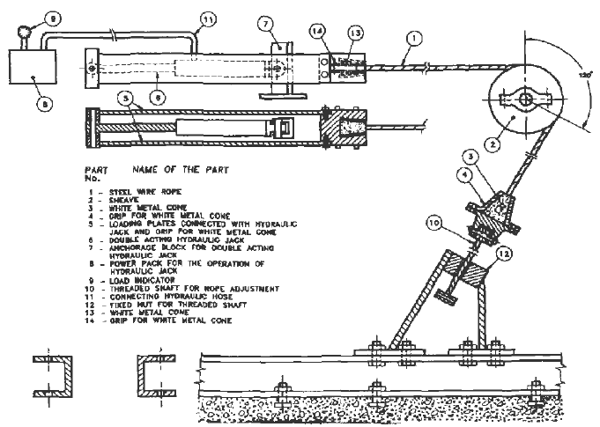

Fig 1 Typical Rig For Proof Load Testing Of Sheaves

**Table 1 Dimensions for Head Gear Sheaves — Type A**

(*Clause* 5.1)

All dimensions are in millimeters.

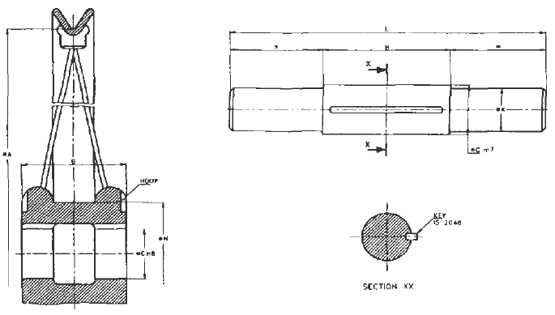

|  |  |  |  |  |  |  |  |  |  |  |  |  |  |
| --- | --- | --- | --- | --- | --- | --- | --- | --- | --- | --- | --- | --- | --- |
| **Sl No.** | **Diameter of Sheave**  **A** | **Static Rope Tension**  **KN** | | **B** | **C** | **H** | **L**  **(S>** | **K-** | **N** | **Diameter of Spoke** | **Number of Sopkes** | **Suitable for Steel Wire Rope of Size Max** | **Key Size2)** |
| (1) | (2) | (3) | (4) | (5) | (6) | (7) | (8) | (9) | (10) | (11) | (12) | (13) | (14) |
| 1. 1 | 1 350 | 130 | 1 325 | 265 | 100 | 320 | 740 | 85 | 320 | 16 | 12 | 14 | A 25 × 14 |
| 1. 2 | 1 800 | 275 | 28 | 265 | 130 | 320 | 800 | 115 | 280 | 20 | 16 | 18 | A 28 × 16 |
| 1. 3 | 2 100 | 375 | 382 | 280 | 150 | 330 | 830 | 320 | 310 | 22 | 20 | 21 | A 28 × 16 |
| 1. 4 | 2 600 | 645 | 657 | 320 | 180 | 370 | 890 | 150 | 350 | 25 | 24 | 27 | A 32 × 18 |
| 1. 5 | 2 800 | 11 115 | 1 136 | 320 | 190 | 370 | 900 | 160 | 360 | 28 | 24 | 28 | A 32 × 18 |
| NOTE — Although the table indicates the maximum size of rope which can be used with the corresponding sheave the ropes contorting to IS 1855 of same size or of size smaller than that specified in col-13 are also permitted to be used with the sheave provided that their safe working load does not exceed the static rope tension specified in col-3 for the concerned sheave.  1) According to IS 1855  2) According to IS 2048 | | | | | | | | | | | | | |

**Table 2 Dimensions for Head Gear Sheaves — Type B**

(*Clause* 5.1)

No. of spokes has been changed as follows:

Further alternative method of fixation of spoke in tread has been included.

All dimensions are in millimeters.

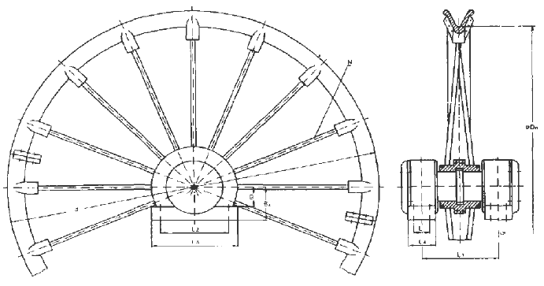

|  |  |  |  |  |  |  |  |  |  |  |  |  |  |  |
| --- | --- | --- | --- | --- | --- | --- | --- | --- | --- | --- | --- | --- | --- | --- |
| **Sl No.** | **Sheave Diameter** | **Suitable for Slevl Wire Row or Size A** | **Maximum Rope Tension (fcgf) x 1«3** | ***Dn*** | ***Dn*** | ***L*31** |  |  |  |  |  |  | **N** | **Key Size** |
| (1) | (2) | (3) | (4) | (5) | (6) | (7) | (8) | (9) | (10) | (11) | (12) | (13) | (14) | (15) |
| 1. 1 | 3 000 | ≤ 30 | 78 | 3 220 | 3 000 | 140 | 670 | 655 | 770 | 250 | 125 | 310 | 28 | 50 × 28 |
| 1. 2 | 3 200 | ≤ 32 | 88 | 3 430 | 3 200 | 140 | 680 | 730 | 860 | 260 | 125 | 110 | 28 | 50 × 28 |
| 1. 3 | 3 400 | ≤ 33 | 94 | 3 640 | 3 400 | 145 | 690 | 750 | 880 | 270 | 130 | 320 | 32 | 56 × 32 |
| 1. 4 | 3 600 | ≤ 35 | 106 | 3 860 | 3 600 | 148 | 700 | 750 | 880 | 280 | 130 | 320 | 32 | 56 × 32 |
| 1. 5 | 3 800 | ≤ 38 | 125 | 4 070 | 3 800 | 165 | 745 | 800 | 940 | 295 | 140 | 350 | 36 | 56 × 32 |
| 1. 6 | 4 000 | ≤ 40 | 139 | 4 280 | 4 000 | 165 | 790 | 800 | 940 | 310 | 140 | 350 | 36 | 56 × 32 |
| 1. 7 | 4 200 | ≤ 42 | 153 | 4 500 | 4 200 | 170 | 830 | 900 | 1 060 | 330 | 155 | 380 | 40 | 63 × 32 |
| 1. 8 | 4 400 | ≤ 44 | 168 | 4 710 | 4 400 | 195 | 865 | 940 | 1 110 | 345 | 165 | 410 | 40 | 70 × 36 |
| 1. 9 | 4 600 | ≤46 | 184 | 4 920 | 4 600 | 195 | 880 | 940 | 1 110 | 360 | 165 | 410 | 44 | 70 × 36 |
| 1. 10 | 4 800 | <48 | 200 | 5 140 | 4 800 | 195 | 930 | 940 | 1 110 | 380 | 165 | 380 | 44 | 70 × 36 |
| 1) According to IS 3626  2) According to IS 2048  3) Values are for journal bearing If spherical roller bearing is used suitable values should be adopted | | | | | | | | | | | | | | | |

**Table 3 Dimensions of Head Gear Sheaves — Hub and Rim — Type B**

(*Clause* 5*.*1)

All dimensions are in millimeters.

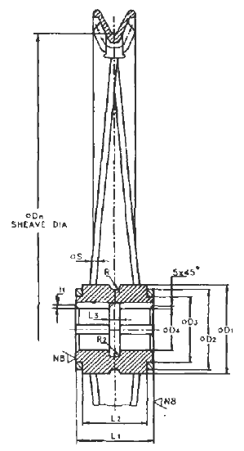

|  |  |  |  |  |  |  |  |  |  |  |  |
| --- | --- | --- | --- | --- | --- | --- | --- | --- | --- | --- | --- |
| **Sl. No.** | ***Dn***  ***±*20** | **D1** | **D2** | **D3**  **H7/B6** | **D4**  **HB** | **S** | ***L1***  **0**  **-01** | ***L2*** | ***L3*** | ***R*** | **li** |
| (1) | (2) | (3) | (4) | (5) | (6) | (7) | (9) | (10) | (11) | (12) | (13) |
|  | 3 000 | 425 | 405 | 325 | 205 | 30 | 380 | 310 | 50 | 35 | 114 |
|  | 3 200 | 440 | 425 | 345 | 215 | 32 | 380 | 310 | 50 | 35 | 114 |
|  | 3 400 | 475 | 455 | 375 | 235 | 38 | 330 | 310 | 50 | 35 | 134 |
|  | 3 600 | 500 | 480 | 400 | 235 | 38 | 380 | 310 | 55 | 35 | 134 |
|  | 3 800 | 550 | 530 | 450 | 255 | 40 | 410 | 340 | 60 | 35 | 134 |
|  | 4 000 | 600 | 580 | 500 | 255 | 40 | 440 | 370 | 60 | 40 | 134 |
|  | 4 200 | 650 | 630 | 550 | 275 | 42 | 460 | 390 | 65 | 40 | 124 |
|  | 4 400 | 700 | 680 | 600 | 295 | 45 | 480 | 410 | 70 | 40 | 144 |
|  | 4 600 | 750 | 730 | 650 | 295 | 47 | 490 | 420 | 70 | 40 | 144 |
|  | 4 800 | 800 | 780 | 700 | 315 | 50 | 510 | 440 | 75 | 40 | 144 |
| NOTE — Machining of the key-way should conform to IS 2048. | | | | | | | | | | | |

**Table 4 Dimensions of Head Gear Sheaves — Hub and Rim — Type B**

(*Clause* 5.1)

All dimensions are in millimeters.

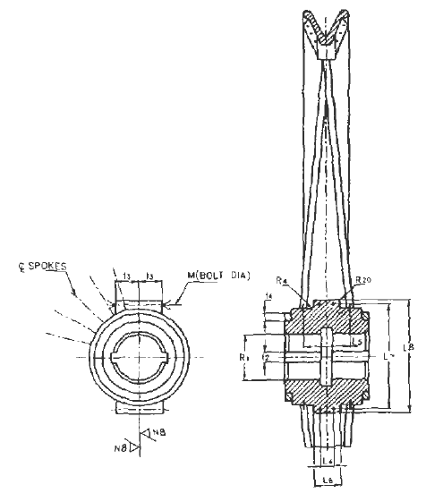

|  |  |  |  |  |  |  |  |  |  |  |  |
| --- | --- | --- | --- | --- | --- | --- | --- | --- | --- | --- | --- |
| **Sl No.** | **Sheave Diameter *Dn*** | ***L4*** | ***L5*** | ***L6*** | ***L7*** | ***L8*** | ***t2*** | ***t3*** | ***t4*** | ***R*** | **M** |
| (1) | (2) | (3) | (4) | (5) | (6) | (7) | (8) | (9) | (10) | (11) | (12) |
|  | 3 000 | 70 | 212 | 115 | 155 | 478 | 50 | 100 | 40 | 260 | M 24 |
|  | 3 200 | 70 | 212 | 115 | 470 | 499 | 50 | 100 | 40 | 270 | M 24 |
|  | 3 400 | 75 | 220 | 130 | 510 | 537 | 56 | 120 | 40 | 280 | M 27 |
|  | 3 600 | 75 | 220 | 130 | 535 | 562 | 56 | 130 | 40 | 280 | M 27 |
|  | 3 800 | 86 | 242 | 145 | 590 | 620 | 56 | 140 | 40 | 280 | M 30 |
|  | 4 000 | 86 | 257 | 145 | 640 | 670 | 56 | 150 | 40 | 280 | M 30 |
|  | 4 200 | 86 | 279 | 168 | 695 | 640 | 63 | 160 | 40 | 325 | M 36 |
|  | 4 400 | 86 | 289 | 168 | 745 | 780 | 70 | 170 | 40 | 345 | M 36 |
|  | 4 600 | 86 | 294 | 168 | 795 | 830 | 70 | 180 | 40 | 345 | M 36 |
|  | 4 800 | 86 | 304 | 168 | 845 | 880 | 70 | 190 | 40 | 380 | M 36 |
| NOTE — Machining of the key-way should confirm to IS 2048. | | | | | | | | | | | |

**Table 5 Dimensions of Head Bar Sheaves — Rim and Spoke — Type B**

(*Clause* 5.1)

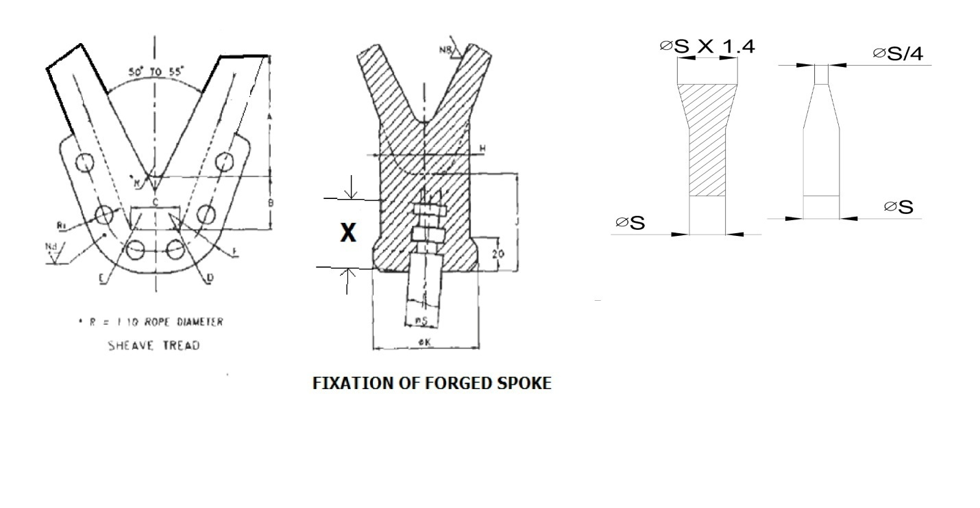All dimensions are in millimeters.

|  |  |  |  |  |  |  |  |  |  |  |  |  |  |  |
| --- | --- | --- | --- | --- | --- | --- | --- | --- | --- | --- | --- | --- | --- | --- |
| **Sl No.** | **Sheve Dia.**  **mm** | ***A*** | ***B*** | ***C*** | ***E*** | ***F*** | ***G*** | ***H*** | ***J*** | **Bolt Size for R1** | **Web Thickness** | **K** | **D** | **X** |
| (1) | (2) | (3) | (4) | (5) | (6) | (7) | (8) | (9) | (10) | (11) | (12) | (13) | (14) | (15) |
| 1 | 3 000 | 110 | 45 | 45 | 35 | 70 | 20 | 80 | 80 | M 16 | 50 | 100 | 20 | 75 |
| 2 | 3 200 | 115 | 50 | 50 | 40 | 80 | 20 | 85 | 85 | M 18 | 50 | 105 | 20 | 80 |
| 3 | 3 400 | 120 | 50 | 50 | 40 | 80 | 20 | 90 | 90 | M 18 | 50 | 110 | 20 | 85 |
| 4 | 3 600 | 130 | 55 | 55 | 45 | 90 | 20 | 100 | 100 | M 20 | 60 | 120 | 20 | 95 |
| 5 | 3 800 | 135 | 60 | 60 | 50 | 100 | 25 | 105 | 105 | M 20 | 60 | 125 | 25 | 100 |
| 6 | 4 000 | 140 | 60 | 60 | 50 | 100 | 25 | 110 | 110 | M 22 | 60 | 130 | 25 | 105 |
| 7 | 4 200 | 150 | 65 | 65 | 55 | 110 | 25 | 110 | 110 | M 24 | 70 | 130 | 25 | 105 |
| 8 | 4 400 | 155 | 70 | 70 | 60 | 120 | 25 | 115 | 115 | M 24 | 70 | 135 | 30 | 110 |
| 9 | 4 600 | 160 | 80 | 80 | 70 | 140 | 25 | 120 | 120 | M 24 | 75 | 140 | 30 | 115 |
| 10 | 4 800 | 170 | 85 | 85 | 75 | 150 | 25 | 130 | 130 | M 24 | 75 | 150 | 30 | 125 |

**Table 6 Dimensions of Head Gear Sheaves — Axle (with Journal Bearing) —Type B**

(*Clause* 5.1)

All dimensions are in millimeters.

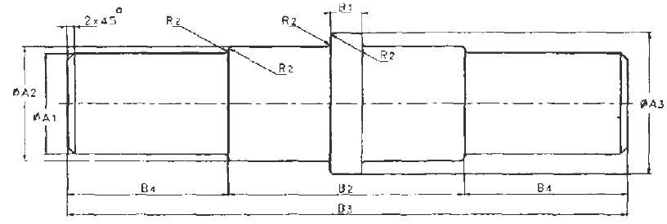

|  |  |  |  |  |  |  |  |  |
| --- | --- | --- | --- | --- | --- | --- | --- | --- |
| **Sl No.** | **Sheave Diameter** | ***A1fg*** | ***A2*** | ***A3*** |  | ***B*2** | ***B*4** | ***B*3** |
| (1) | (2) | (3) | (4) | (5) | (6) | (7) | (8) | (9) |
|  | 3000 | 180 | 205 | 255 | 50 | 400 | 270 | 940 |
|  | 3200 | 100 | 215 | 265 | 50 | 400 | 280 | 960 |
|  | 3400 | 200 | 235 | 275 | 50 | 400 | 290 | 980 |
|  | 3600 | 200 | 235 | 275 | 55 | 400 | 300 | 1 000 |
|  | 3800 | 220 | 255 | 275 | 60 | 430 | 315 | 1 060 |
|  | 4000 | 220 | 255 | 375 | 60 | 460 | 330 | 1 120 |
|  | 4200 | 240 | 275 | 325 | S5 | 480 | 350 | 1 180 |
|  | 4400 | 260 | 295 | 340 | 70 | 500 | 365 | 1 230 |
|  | 4600 | 260 | 295 | 340 | 70 | 510 | 380 | 1 270 |
|  | 4800 | 280 | 315 | 375 | 75 | 510 | 400 | 1 330 |
| NOTE — Suitable key-way as shown in Table 2 to Table 4 should be provided in the axle. | | | | | | | | |

**Table 7 Dimensions of Head Bar Sheaves — Aide (with Spherical Roller Bearing)** — **Type B**

(*Clause* 5.1)

All dimensions are in millimeters.

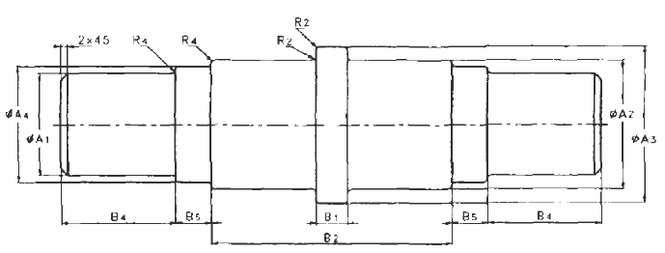

|  |  |  |  |  |  |  |  |  |  |  |  |  |
| --- | --- | --- | --- | --- | --- | --- | --- | --- | --- | --- | --- | --- |
| **Sl No.** | **Sheave Diameter** | ***A1***  **h5** | **A4** | **B3** | **B4** | **Housing No.** | **Housing No.** | **A4** | **B5** | **B4** | **Bearing No.** | **Housing No.** |
| WITH WITHDRAWAL SLEEVE | | | | | | WITH ADAPTER SLEEVE | | | | |
| (1) | (2) | (3) | (4) | (5) | (6) | (7) | (8) | (9) | (10) | (11) | (12) | (13) |
| 1 | 30 000 | 180 | 192 | 56 | 186 | 22 338 | 2 338 | 202 | 62 | 201 | 22 140 | 2 344 |
| 2 | 3 200 | 190 | 202 | 62 | 198 | 22 340 | 2 340 |  |  |  |  |  |
| 3 | 3 400 | 200 | 222 | 62 | 208 | 22 344 | 2 344 | 222 | 62 | 210 | 22 344 | 2 344 |
| 4 | 3 600 | 200 | 222 | 62 | 208 | 22 344 | 2 344 | 222 | 62 | 210 | 22 344 | 2 344 |
| 5 | 3 800 | 220 | 242 | 68 | 220 | 22 348 | 2 348 | 212 | 68 | 227 | 22 348 | 2 348 |
| 6 | 4 000 | 220 | 242 | 68 | 220 | 22 348 | 2 348 | 242 | 68 | 227 | 22 348 | 2 348 |
| 7 | 4 200 | 240 | 262 | 72 | 238 | 22 352 | 2 352 | 262 | 72 | 240 | 22 352 | 2 352 |
| 8 | 4 400 | 260 | 282 | 80 | 245 | 22 356 | 2 356 | 282 | 80 | 254 | 22 356 | 2 356 |
| 9 | 4 600 | 260 | 282 | 80 | 245 | 22 356 | 2 356 | 282 | 80 | 254 | 22 356 | 2 356 |
| 10 | 4 800 | 280 | 302 | 84 | 254 | 22 360 | 2 360 | 302 | 84 | 263 | 22 380 | 2 360 |
| NOTE — Suitable key-way as shown in Tables 2 to Table 4 should be provided in the axle values of *A2,A3,B1* and *B2* should be adopted from Table 6. | | | | | | | | | | | | |

**Table 8 Dimensions of Head Bar Sheaves — Journal Bearings — Type B**

(*Clause* 5.1)

All dimensions are in millimeters.

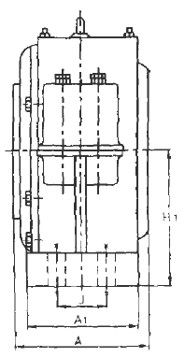

|  |  |  |  |  |  |  |  |  |  |  |  |  |  |
| --- | --- | --- | --- | --- | --- | --- | --- | --- | --- | --- | --- | --- | --- |
| **Sl No.** | **Sheave Dia** | **Axle Dia** | **For Journal Bearing** | | | **Housing Base Bolt Size** | **Bearing No.** | **Housing No.** | **For Spherical Roller Bearing** | | | | **Housing Base Bolt Size** |
| A | A1 | H1 | A | A1 | H1 | J |
| (1) | (2) | `(3) | `(4) | (5) | (6) | (7) | (8) | (9) | (10) | (11) | (12) | (13) | (14) |
| 1 | 3 000 | 180 | 270 | 250 | 300 | M 42 | 22 340  (22 338) | 2340  (2 338) | 328  (346) | 250  (225) | 310  (280) | 140  (130) | M 42  (M 36) |
| 2 | 3 200 | 199 | 280 | 260 | 300 | M 42 | (22 340) | (2 340) | (378)  330 | (250)  250 | (310)  320 | (140)  145 | (M 42)  M 42 |
| 3 | 3 400 | 200 | 290 | 270 | 310 | M 42 | 22 344 | 2 344 | (380)  330 | (250)  250 | (320)  320 | (145)  145 | (M 42)  M 42 |
| 4 | 3 600 | 200 | 300 | 280 | 310 | M 42 | 22 344 | 2 344 | (380)  360 | (250)  280 | (320)  350 | (145)  165 | (M 42)  M 42 |
| 5 | 3 800 | 220 | 315 | 295 | 340 | M 42 | 22 348 | 2 348 | (425)  360 | (280)  280 | (350)  310 | (165)  165 | (M 42)  M 42 |
| 6 | 4 000 | 220 | 330 | 310 | 340 | M 42 | 22 348 | 2 348 | (425)  384 | (280)  305 | (350)  380 | (165)  170 | (M 42)  M 48 |
| 7 | 4 200 | 240 | 350 | 330 | 350 | M 48 | 22 352 | 2 352 | (454)  420 | (305)  340 | (380)  410 | (170)  195 | (M 48)  M 48 |
| 8 | 4 400 | 260 | 365 | 345 | 380 | M 48 | 22 356 | 2 356 | (485)  420 | (340)  340 | (410)  410 | (195)  195 | (M 48)  M 48 |
| 9 | 4 600 | 260 | 380 | 360 | 380 | M 48 | 22 356 | 2 356 | (485)  384 | (340)  305 | (410)  380 | (195)  170 | (M 48)  M 48 |
| 10 | 4 800 | 280 | 400 | 380 | 400 | M 48 | 23 260 | 3 260 | (454) | (305) | (380) | (170) | (M 48) |
| NOTE — Figures shown in bracket indicate values with adapter sleeve. | | | | | | | | | | | | | |

**ANNEX A**

(*Clause* 2)

**LIST OF REFERRED STANDARDS**

|  |  |
| --- | --- |
| *IS No.* | *Title* |
| IS 210 : 2009 | Grey iron castings (*fifth revision*) |
| IS 1364 (Part 1) : 2023 | Hexagon head bolts, screws, and nuts of property grades A and B: Part 1 Hexagon head bolts (size range M1.6 to M64) (*sixth revision*) |
| IS 1570 (Part 2/Sec 1) : 1979 | Schedules for wrought steels: Part 2 Carbon steels (unalloyed steels) Section 1 Wrought products other than wire with specific chemical composition and related properties (*first revision*) |
| IS 1855 : 2022 | Stranded steel wire ropes for winding and man - Riding haulages in mines - Specification (*third revision*) |
| IS 1862 : 1975 | Studs — Specification (*second revision*) |
| IS 1875 : 1992 | Carbon steel billets, blooms, slabs and bars for forgings (*fifth revision*) |
| IS 2048 : 1983 | Parallel keys and keyways (*second revision*) |
| IS 2062 : 2011 | Hot rolled medium and high tensile structural steel - Specification (*seventh revision*) |
| IS 3626 : 2024 | Locked Coil Winding Ropes — Specification (*third revision*) |

**ANNEX B**

(*Clause* 10)

**CERTIFICATE OF TEST AND EXAMINATION**

We hereby certify that the head gear sheaves supplied here under conform in all respects to IS 9239. The following are their detailed particulars.

1. General details:
2. Serial no. of sheaves;
3. Sheave(s) designation;
4. Manufacturer's identification mark;
5. Sheave(s) diameter, mm;
6. Safe working load, kN; and
7. Remarks.
8. Particulars of material employed:
9. Rim to IS;
10. Spokes to IS;
11. Hub to IS;
12. Axle to IS; and
13. Bearing to TS.
14. Results of tests:
15. Crack detection test;
16. Static balancing test; and
17. Proof load test.
18. And other particulars/specification.

**ANNEX C**

(*Foreword*)

**COMMITTEE COMPOSITION**

Mining Techniques and Equipment Sectional Committee, MED 08

|  |  |
| --- | --- |
| *Organization* | *Representative(s)* |
| Directorate General of Mines Safety, Dhanbad | Shri Saifullah Ansari **(*Chairperson*)** |
| Automotive Research Association of India, Pune | Shri Milind Kandalkar  Shri Dhondiram Mole (*Alternate*) |
| BEML Limited, Bengaluru | Shri V. R. S. Prasad Rao  Shri H. G. Suresh (*Alternate*) |
| CSIR - Central Institute for Mining and Fuel Research, Dhanbad | Dr Manoj Kumar Singh  Shri Surajit Dey (*Alternate*)  Prof S. K. Kashyap (*Alternate*) |
| Directorate General of Mines Safety, Dhanbad | Shri m. arumugam |
| Eastern Coalfields Limited, Dishergarh | Shri Sarvesh Kumar  Shri Ajay Bhowmik (*Alternate*) |
| Eimco Elecon (India) Limited, Vallabh Vidyanagar | Shri Ram Ramesh Kale  Shri Vinay Jaynarayan Sharma (*Alternate*) |
| Hutti Gold Mines Company Limited, Bengaluru | Dr Prabhakar Sangoormath  Shri Mallikarjun Sarapur (*Alternate* I)  Miss Mega Hiremath (*Alternate* II) |
| Indian Institute of Technology (ISM), Dhanbad | Shri L. A. Kumaraswamidhas |
| Manganese Ore Limited, Nagpur | Shri Rakesh Kumar Verma  Shri Atul Sharma (*Alternate* I)  Shri Ashwini Baghele (*Alternate* II) |
| Metso Outotec India Private Limited, Vadodara | Shri Sandeep Deokisan Bhattad |
| Nanda Millar Company, Kolkata | Shri J. P. Goenka  Shri Madhur Goenka (*Alternate*) |
| Tata Steel Limited, Dhanbad | Shri Soumendhu Manjhi  Shri Abinash Jha (*Alternate*) |
| BIS Directorate General | Shri K. Venkateswara Rao, Scientist ‘F’/Senior Director and Head (Mechanical) [Representing Director General (*Ex-officio*)] |

*Member Secretary*

Shri Shubham Tiwari

Scientist ‘D’/Joint Director

(Mechanical), BIS