**IS 7649 : 2024**

***भारतीयमानक***

***Indian Standard***

**एरियल रोपवे और केबलवे के**

**संबंध में प्रयुक्त शब्दों की पारिभाषिक शब्दावली**

*(* पहला पुनरीक्षण )

**Glossary of Terms Used in**

**Connection with Aerial Ropeways**

**and Cableways**

( *First Revision )*

ICS 93.110

© BIS 2024

भारतीय मानक ब्यूरो



BUREAU OF INDIAN STANDARDS

मानक भवन, 9 बहादुर शाह ज़फर मार्ग, नई दिल्ली-110002

MANAK BHAVAN, 9 BAHADUR SHAH ZAFAR MARG

NEW DELHI - 110002

[www.bis.gov.in](http://www.bis.org.in)[www.standardsbis.in](http://www.standardsbis.in)

**December 2024 Price Group X**

Continuous Bulk Conveying, Elevating, Hoisting Aerial Ropeways and Related Equipment Sectional Committee, MED 06

FOREWORD

This Indian Standard (First Revision) was adopted by the Bureau of Indian Standards, after the draft finalized by Continuous Bulk Conveying, Elevating, Hoisting Aerial Ropeways and Related Equipment Sectional Committee had been approved by the Mechanical Engineering Division Council.

This standard was first published in 1975.This revision has been taken up to keep pace with the latest technological developments and the practices followed in ropeways industry and the standard has been brought into the latest style and format of Indian Standards. This revision incorporates the following major changes:

1. More terminologies have been added;
2. Standard divided in three sections; and
3. Editorial changes have been made.

To cover specific terminologies related to different types of aerial ropeways, the standard is divided in three sections as follows:

1. Section I **—** Passenger ropeways;
2. Section II **—** Material ropeways; and
3. Section III —Cableways.

The composition of the committee responsible for the formulation of this standard is given in Annex B.

For the purpose of deciding whether a particular requirement of this standard is complied with, the final value, observed or calculated, expressing the result of a test or analysis, shall be rounded off in accordance with IS 2 : 2022 ‘Rules for rounding off numerical values (*second revision*)’. The number of significant places retained in the rounded off value should be the same as that of the specified value in this standard.

*Indian Standard*

**GLOSSARY OF TERMS USED IN CONNECTION WITH AERIAL**

**ROPEWAYS AND CABLEWAYS**

**SECTION I PASSENGER ROPEWAY**

**1 SCOPE**

This standard lays down the definitions of the terms commonly used in connection with aerial ropeways.

**2 TERMINOLOGIES**

**2.1 Aerial Ropeways —** It is a form of transport in which cars or carriers are suspended from and hauled by single or multiple ropes used for conveying passengers or goods.

**2.2 Types of Aerial Ropeway**

**2.2.1** *Monocable Ropeways* — Single rope used both for carrying and hauling.

**2.2.2** *Bicable/Tricable Ropeways* — Two different types of ropes used for carrying and hauling, where carrying rope remains stagnant but haul rope moves.

**2.3 Application of Ropeway**

**2.3.1** *Monocable Ropeway*

**2.3.1.1** *Fixed clip (grip) type*

1. *Continuous movement —* A ropeway system consisting basically of an endless rope which acts as both carrying and hauling rope. Several carriers are clamped to the rope at regular intervals and pass round the terminal sheaves without stopping and moves unilaterally.

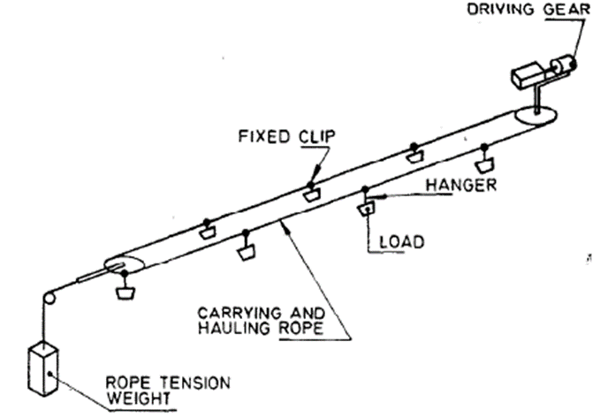

Fig.1 Continuous Movement Monocable Ropeway Fixed Grip Type

1. *Pulsed movement—* Unidirectional system where carrying hauling rope moves intermittently. A single or group of carriers are attached to the rope through fixed grip in a pre-determined spacing.

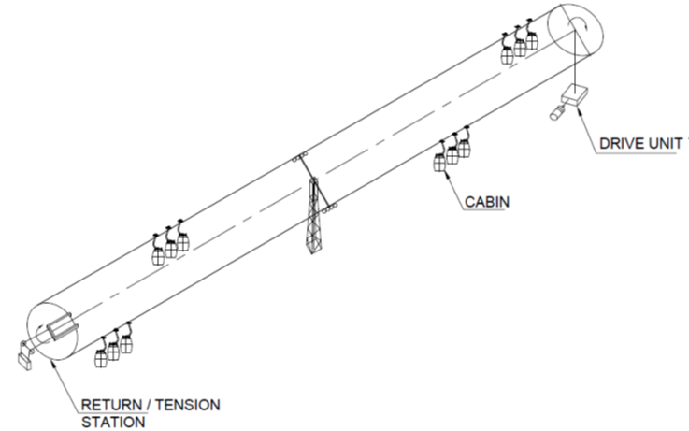

Fig 2Pulsed Movement Monocable Ropeway Fixed Grip Type

1. *Single to and fro (Jigback) movement —* A ropeway system consisting basically of a single reversing endless rope which acts as both carrying and hauling rope. A single carriage with bucket is attached to the rope, and travels to-and-fro between the driving and return stations.

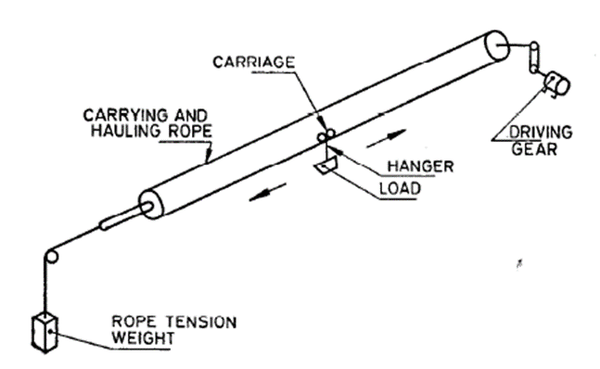

Fig 3 Single Jigback Movement Monocable Ropeway Fixed Grip Type

1. *Double to-and-fro (Jigback) movement —* A bi-directional ropeway system consisting basically of a single reversing endless rope which acts as both carrying and hauling rope. A single or group of carriers are attached to the rope on diametrically opposite side and so arranged that when one is moving away from the starting station the other is travelling towards it.

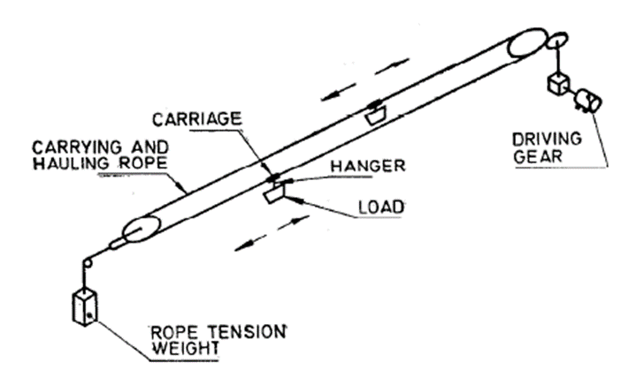

Fig 4 Double Jigback Movement Monocable Ropeway Fixed Grip Type

**2.3.1.2** *Detachable clip (Grip) type*

1. *Continuous movement —* A ropeway system consisting basically of anendless rope which acts as both carrying and hauling rope, to which a number of carriages (boxheads) areattached at regular intervals. The carriages are automatically transferred to, or transferred from, the ropeon to rails at the stations.

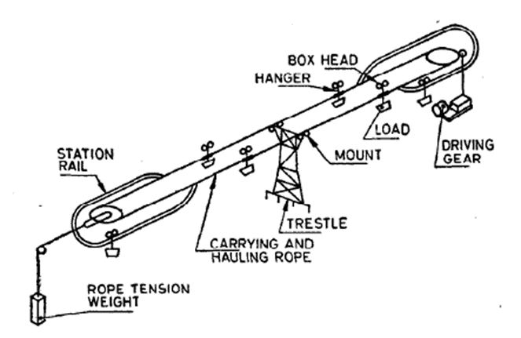

Fig.5 Continuous Movement Monocable Ropeway Detachable Grip Type

**2.3.1.3** *Application of bi-cable ropeway*

1. *Detachable clip (grip) typ*e— A ropeway system consisting basically of two carrying track ropes withconnecting rails and endless hauling rope. Several carriages are automatically coupled to, oruncoupled from, the hauling rope at the stations;

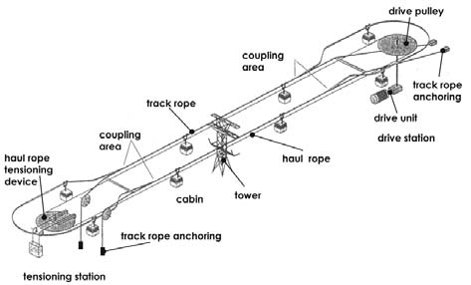

Fig.6 Continuous Movement Bi-cable Ropeway Detachable Grip Type

1. *Single to-and-fro (jig back) —* A ropeway system consisting basically of a single-track rope with a reversing endless hauling rope. A single or group of carriers is attached to the hauling rope and travels to-and-fro between the driving and return station;

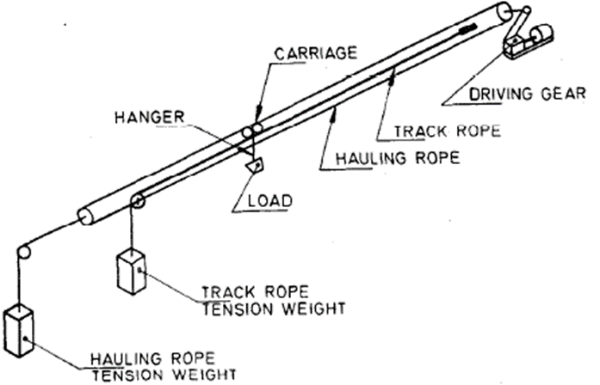

Fig.7 Single Jigback Bi-cable Ropeway

1. *Double to-and-fro (jig back) —* A ropeway system consisting basically of track ropes and a reversing endless hauling rope to which a single or group of carriers are attached, each carriage being supported on a separate track rope and so arranged on diametrically opposite side that, when one carriage is moving away from the starting station, the other is travelling towards it;

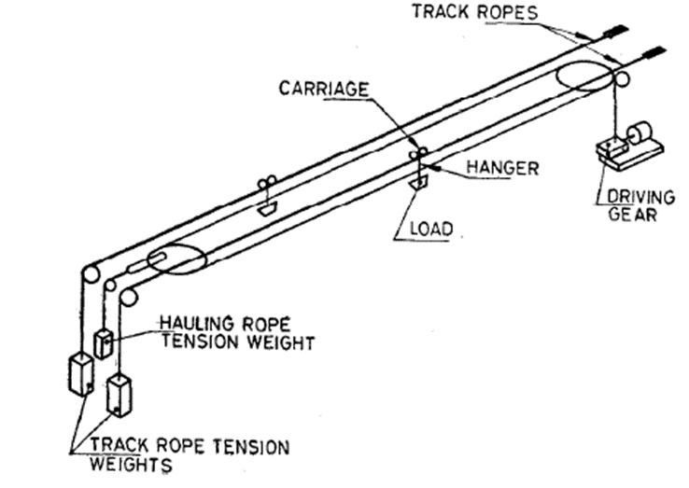

Fig.8 Double Jigback Bi-cable Ropeway

1. *Aerial Tramway —* It is similar to double jig back bicable ropeway but used for transporting large capacity; and

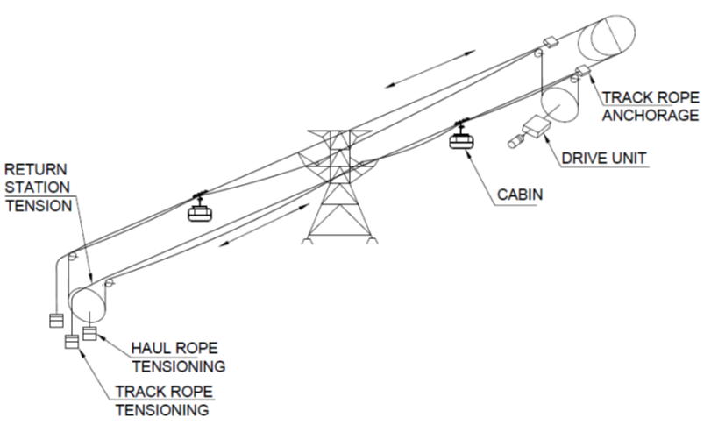

Fig.9 Aerial Tramway

1. *Tri-cable Ropeway —* In this system, unlike bicable ropeway, there are two carrying track ropes and one haul rope to transport large capacity loads and works like a detachable system.

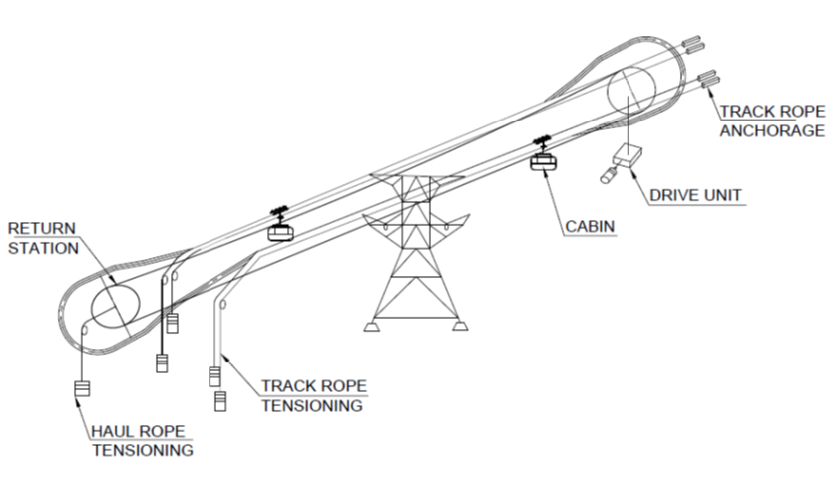

Fig.10 Tri-cable Ropeway

**2.4 Other Usage**

**2.4.1** *Chair Lift*— The types of aerial lift which transport passengers in chairs.

* + 1. *Gondola Lift*— The types of aerial lift which transport passengers in small carriers or gondolas.

**2.4.3** *Ski Tow*— A means of cable transport used by the skiers to glide up hill on snow:

1. *Low level Tow*— Ski-tow when rope runs at such a height that the skiers can hold it directly or by means of a short tow bar; and
2. *High level Ski-Tow*— Ski-tow, where the rope is installed at a height not reachable to the skiers.

**2.4.4** *Tow Hanger*— An element of ski-tow which is attached to the rope for towing skiers.

**2.4.5** *Platter* — A disc shaped component of tow hanger which constitutes the skier’s attachment.

**2.4.6** T-bar — An inverted ‘U’ type component of tow hanger for direct contact with the skiers.

**2.4.7** *Rod*— Rigid component of a tow-hanger connected between the platter and the grip.

**2.4.8** *Spring box* — A component of a tow hanger to adjust automatically the height between grip and platter or T-bar according to the surface contour.

**2.4.9** *Funicular Railway*— A special type of transport system where the car runs along a laid track on the ground or on a fixed structure and hauled by a traction rope.

**2.5 Aerial Ropeway Components**

**2.5.1** *Ropes*

1. *Track rope* — The stationary rope which provides the track and supports the weight of the carriers conveyed;

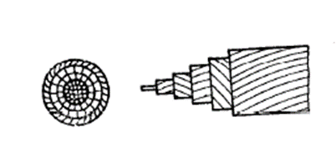

Fig.11 Track Rope

1. *Hauling rope* — The moving rope which applies the tractive effort to the carriers as also supporting them;

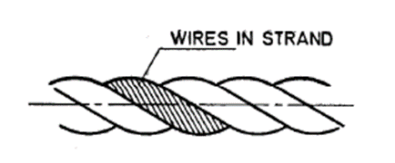

Fig.12 Hauling Rope

1. *Carrying-Hauling rope* — The moving rope which supports the carriers as also applies the tractive effort to them;
2. *Tension rope* — The rope used for connecting the free end of a stationary rope or the terminal sheave of a rope loop to the tensioning device;
3. *Ballast rope* — Moving rope attached to the carriers by end fixings but not operated through the driving sheave; and
4. *Signal rope*— Stationary rope used for the transmission of signals for system control or telephone communication.
   * 1. *Rope fixing*
5. *End fixing*— Element connecting one of the ends of a rope to the other unit;
6. *Socket end fixing —* End fixing where the end of rope is immobilized using molten metal; and
7. *Bollard* — An anchorage post made of steel or concrete structure around which a track rope is wound and secured.
   * 1. *Rope Splice*— Joining the ends of a rope to form a complete loop.

**2.5.4** *Rope Supports on Line*

1. *Sheave* — Sheave mounted on Towers to support the moving rope;
2. *Saddle*— A member located atop a tower or terminal structure and design to support a track cable;
3. *Rollers*—Grooved wheel having small radius to support the rope in motion;
4. *Roller Battery*— Set of rollers arranged one after the other and their mounting unit;
5. *Rope Catcher* — Unit to catch a derailed rope; when a rope or a carriage with rope comes out of its installed supports;
6. *Rope Guard —* Unit to prevent derailed rope going towards interior of the supports; and
7. *Guide*— Unit to guide the carrier for the purpose of preventing contact with a fixed object.

**2.5.6** *Carriers*— "Carrier" means any vehicle or receptacle hung or suspended from or hauled by a rope on which the passenger ride and are transported:

1. *Closed carrier or Cabin or Gondola* — Weather protected enclosed unit for accommodating standing or seated passengers from which they cannot go out during transportation;
2. *Open carrier* — Carrier for seating or standing passengers which is neither protected against weather nor have provision to prevent passengers going out during travel; and
3. *Chair* — Open type carrier having chair shaped seating arrangement for one or more passengers.

**2.5.7** *Rope Grip (Clip) —* Device to engage a carrier to wire rope in a manner adequate to transport a supporting or traction force to a carrier:

1. *Fixed grip* — Grip which remains fixed in position on the rope during operation; and

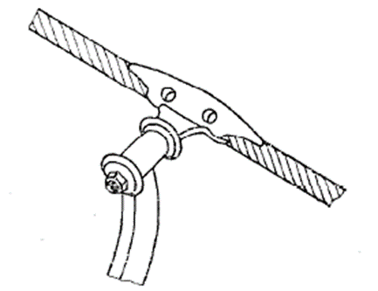

Fig.13 Fixed Grip

1. *Detachable grip* — Grip which is detached from the rope when it is within the stations.

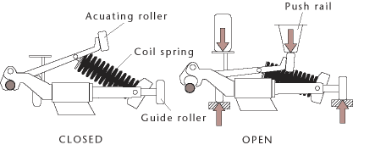

Fig.14 Detachable Grip

**2.5.8** *Brake*

1. *Carrier Brake* — Brake installed in a carrier to stop it on the line.
2. *Track Brake* — Onboard brake which acts on the track rope(s) of a bi-cable aerial ropeway.

**2.5.9** *Sheaves —* A grooved wheel intended to support a rope while in motion:

1. *Drive Sheave or Bull wheel* —The sheave which imparts a pulling force to the rope to move it;
2. *Return*— Sheave assigned to reversing the direction of a rope;
3. *Tension Sheave*— Moveable sheave connected to a Tension Device; and
4. *Deflection*— Sheave assigned to changing the direction of a rope.

**2.5.10** *Ropeway Station* — Structures and Buildings siting the Ropeway operating machineries, boarding/de-boarding platforms and any associated facilities.

**2.5.11** *Terminal Station* — Where the Ropeway cars end its journey and return to the originating station. It can be lower and upper depending on the ground level of the terminals.

1. *Intermediate Station* — Where the ropeway cars do not end its journey and proceed to the distant station; and
2. *Angle Station* — Where the ropeway line is angularly diverted to suit ground contour.

**2.5.12** *Ropeway Station Equipment*

1. *Locking/Unlocking or Coupling/Uncoupling device* — Attachment or detachment of a detachable grip to the moving rope;
2. *Accelerating/Decelerating unit* — For a continuously circulating system, the unit used for accelerating the speed of the outgoing carrier to the rope speed or decelerating the speed of an incoming carrier;
3. *Position Indicator —* The device which indicates the position of the carriers on line;
4. *Main Drive* — Drive system intended for ensuring normal operation;
5. *Auxiliary Drive* — Drive system, other than the main drive, used for ropeway operation under a different operating parameter;
6. *Service Brake* — System brake to stop the ropeway during normal operation as also to hold it against rotation;
7. *Emergency Brake* — To stop the ropeway during emergent condition as also in the event of failure of service brake;
8. *Emergency Stop* — Quick stopping of the installation in the event of any emergent condition; and
9. *Tensioning Device* — Device or components used for providing and maintaining Tension of a rope.

**2.5.13** *Ropeway Operation —* Action taken for driving the installation for the purpose of transportation of passengers.

1. *Operators/Operating personnel* — Personnel required for the operation of a installation;
2. *Inspection* — Set of actions intended to establish and assess the actual condition of an installation and its components;
3. Repair/Maintenance — Set of actions for assessing the actual condition of the installation and its components and for maintaining and restoring the specified condition;
4. Evacuation/Rescue — Set of procedures used, if the installation is immobilized, to move passengers to a safe place; and
5. Evacuation Drive — Special operating system for evacuation of passengers in the event of unavailability of any other drive.

**SECTION II MATERIAL ROPEWAY**

**3 ROPEWAY SYSTEM**

Material ropeway may be defined as a transport system in which the transit material is carried in buckets, suspended from overhead ropes. The ropes are carried by trestles, typically fabricated from rolled steel angle sections, but may be of timber or concrete construction, as local conditions dictate. The distance between trestles can be considerable and thus the span may traverse extremely undulating terrain including otherwise inaccessible such as a deep gorge.

**3.1** Types of material ropeway

1. *Monocable ropeways* — Single rope used both for carrying and hauling; and
2. *Bicable/Tricable ropeways* — Two different types of ropes used for carrying and hauling, where carrying rope remains stagnant but haul rope moves.

**3.1.1 Application of Ropeway**

These applications are same like a passenger ropeway barring loading and unloading arrangement. Moreover, instead of cabin/chair, a bucket is used for material transportation. Usually, mono-cable detachable, bi-cable detachable and Jig Back systems are used for material transportation. A typical schematic drawing of a bi-cable detachable system is given below for understanding:

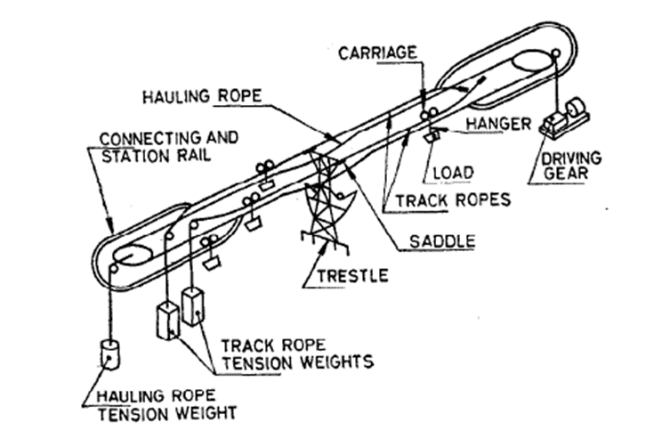

Fig 15 Bi-cable Detachable System

**3.2 COMPONENTS**

**3.2.1** *Rope*

*See* **2.5.1**.

**3.2.2** *Carriage*

1. *Under-type bi-cable carriage* — A carriage for supporting the ropeway bucket or load and hanger on a bi-cable track rope. It is provided with a clamp positioned below the track rope for attaching to the hauling rope;

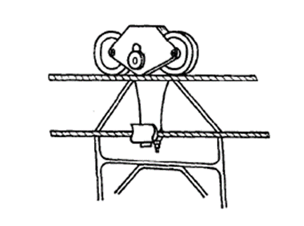

Fig 16 Under Type Bi-cable Carriage

1. *Over-type bi-cable carriage* — A carriage for supporting the ropeway bucket or load and hanger on a bi-cable track rope. It is provided with a clamp positioned above the track rope for attaching to the hauling rope.

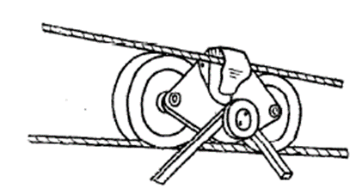

Fig 17 Over Type Bi-cable Carriage

1. *Monocable carriage (boxhead)* — A carriage for attaching a ropeway bucket and hanger to a carrying hauling rope. The carriage is not clamped to the rope but equipped with clips, which straddle the rope. It is provided with wheels to enable it to transfer between rope and rails at the stations.

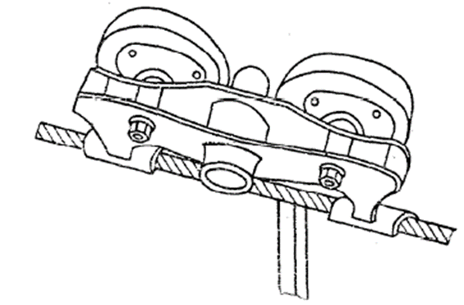

Fig 18 Monocable Carriage

1. *Mono-cable fixed clip (Grip)* — A clamp for attaching a load-carrying hanger to the hauling rope. The clamp does not detach from the rope during the ropeway operation.

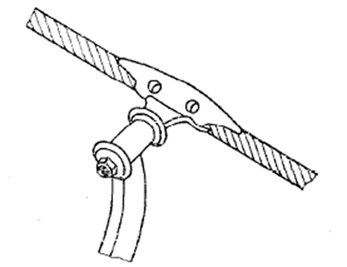

Fig 19 Monocable Fixed Grip

* + 1. *Load Carrier (Bucket)*

1. *Bi-cable load carrier* — The carriage and the hanger which support a load. A typical rotating tipping bucket and hanger are illustrated below:

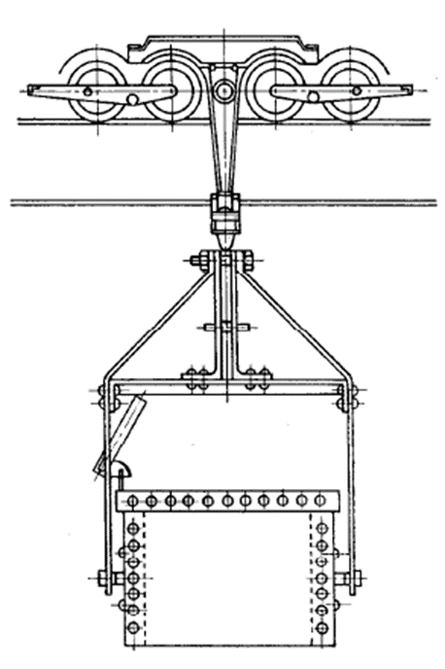

Fig 20 Bi-cable Load Carrier

1. *Mono-cable load carrier* — A carrier similar to the bi-cable load carrier, but usually restricted to lighter loads.

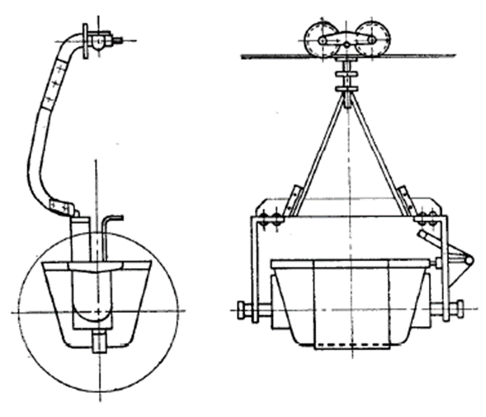

Fig 21 Monocable Load Carrier

**3.2.4** *Aerial ropeway supports (Trestle)*

1. *Mono-cable trestle* — A structure supporting a mono-cable ropeway between the ropeway stations. It is equipped with mounts to support the rope;

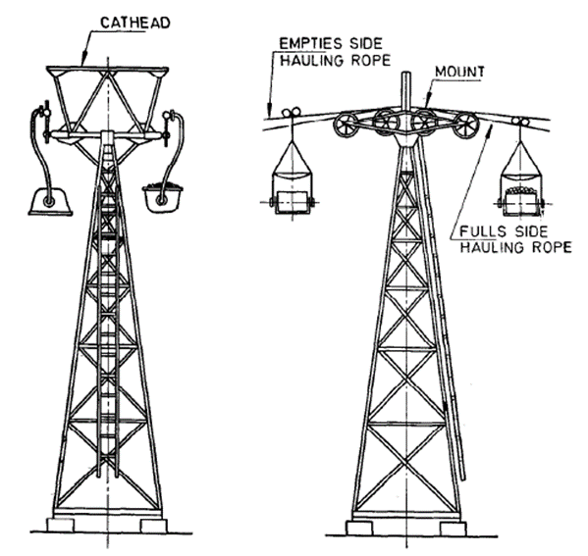

Fig 22 Monocable Trestle

1. *Bi-cable trestle* —A structure supporting a bi-cable ropeway between the ropeway stations. It is equipped with saddles to support the track ropes. Flying stay rollers are provided to prevent excessive sag of the hauling rope when the carriers are removed;

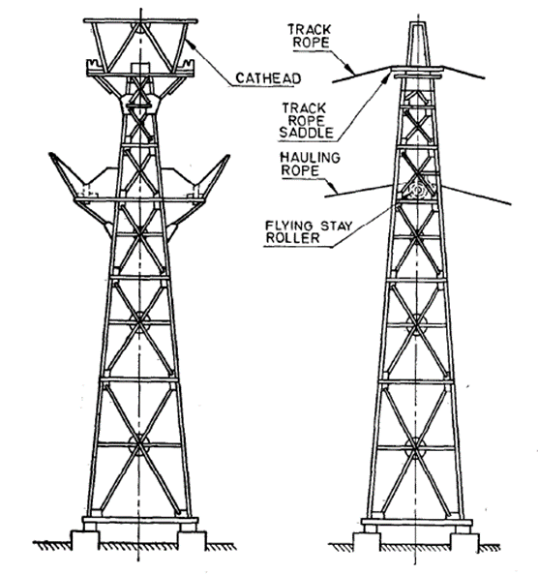

Fig 23 Bi-cable Trestle

1. *Pressure frame* — A structure for distributing the severe loading at crests in a ropeway;

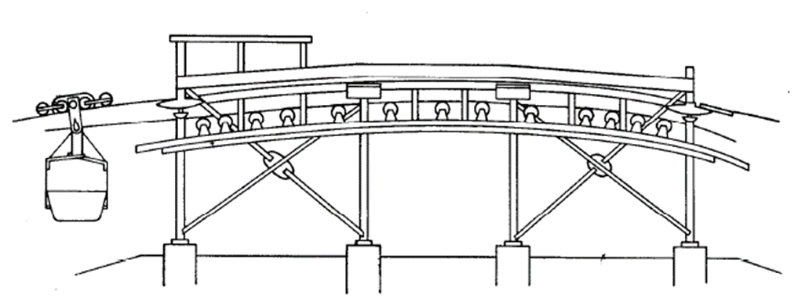

Fig 24 Pressure Frame

1. *Tipping gantry* — A structure situated between ropeway stations to enable buckets to tip and form intermediate stockpiles of materials. It is used on mono-cable ropeways only; and

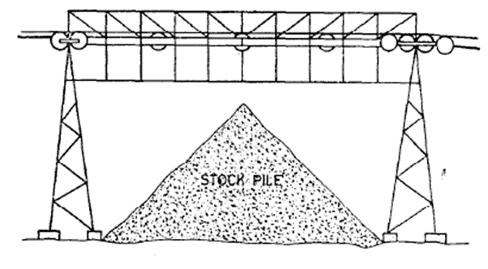

Fig 25 Tipping Gantry

1. *Tipping frame* — A movable device positioned on a bi-cable ropeway that causes loaded carriers to discharge.

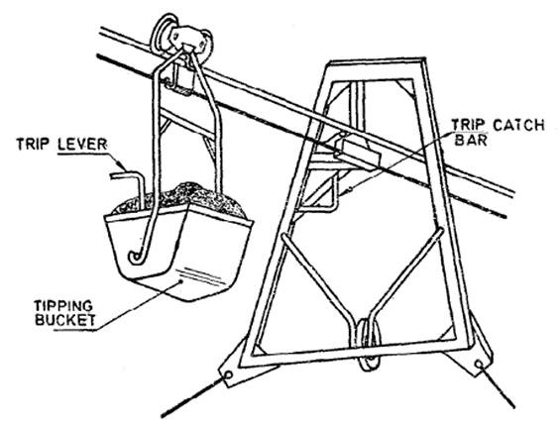

Fig 26 Tipping Frame

**3.2.4** *Protection bridge* — The structure positioned beneath a ropeway where protection is required from possible falling materials. It can be of rigid girder construction or flexible netting supported from wire ropes.

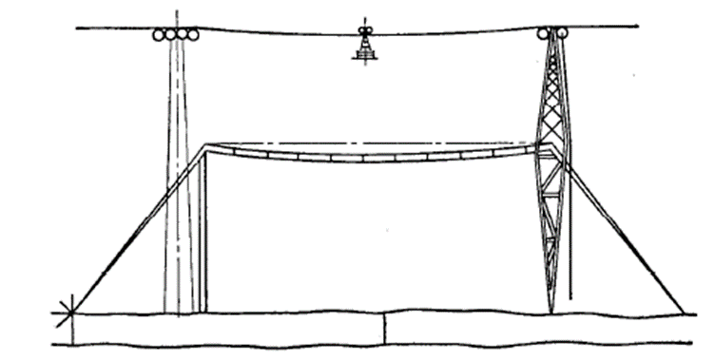

Fig 27 Protection Bridge

**3.2.5** *Ropeway Stations and Components*

1. *Loading station* — A structure for supporting ropeway rolling stock whilst being loaded. It is usually at ground level, but may be elevated and can be arranged for any combination of driving, tensioning or anchoring of the ropes;

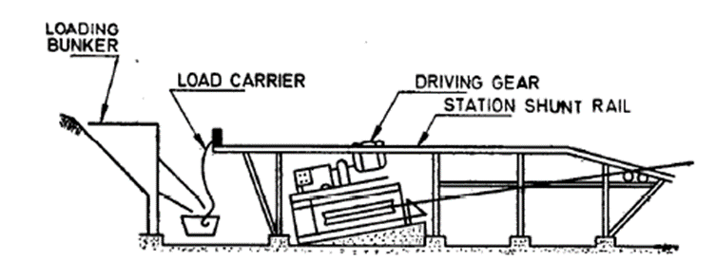

Fig 28 Loading Station

1. *Unloading Station* — A structure for supporting the ropeway rolling stock whilst being unloaded. Usually elevated but may be at ground level and can be arranged for any combination of driving, tensioning or anchoring of ropes;

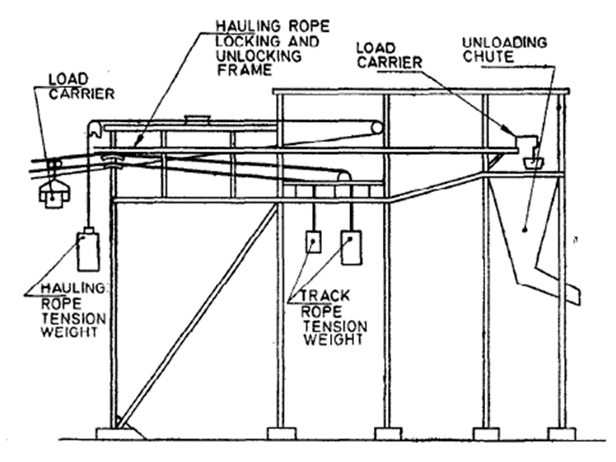

Fig 29 Unloading Station

1. *Track rope divide (TRD) station* — A structure for supporting ropeway rolling stock whilst transferring from the end of one track rope to the beginning of another track rope. Each of the two track ropes is either anchored or tensioned at the station; and

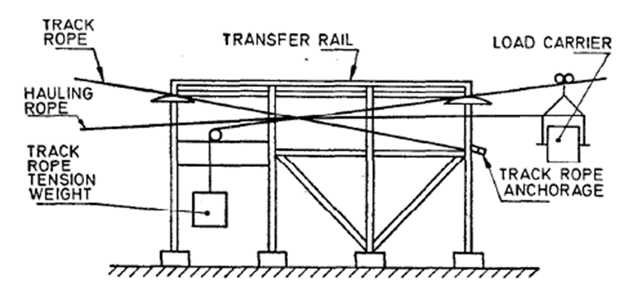

Fig 30 Track Rope Divide Station

1. *Angle Station* — A structure at which the lateral direction of the path of the ropeway changes.

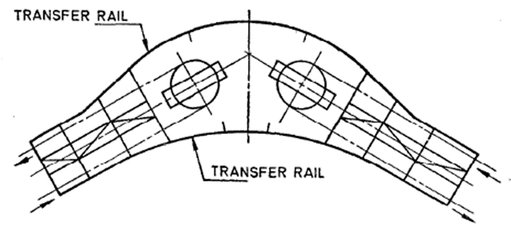

Fig 31 Angle Station

**3.2.6** *Sheaves*

1. Drive sheave or bull wheel — The sheave which imparts a pulling force to the rope to move it;
2. Return sheave — Sheave assigned to reversing the direction of a rope; and
3. Deflection sheave— Sheave assigned to changing the direction of a rope.

**3.2.7** *Saddle* — A member located at the top of a tower or terminal structure and design to support a track cable.

**SECTION III CABLEWAYS**

**4 CABLEWAYS**

A single-span rope between two fixed or mobile supports, over which a load may be conveyed, with provision for raising and lowering the load.

**4.1 TYPES OF CABLEWAYS**

1. *Single-Motor Cableway (Blonding*) — A cableway system consisting basically of a load car running on a single span of track rope and with the hoist and traverse ropes driven by a single motor. This system cannot hoist and travel the load simultaneously and thus gives a rectangular path. The hoist rope is reeved through blocks and is anchored on the carriage.

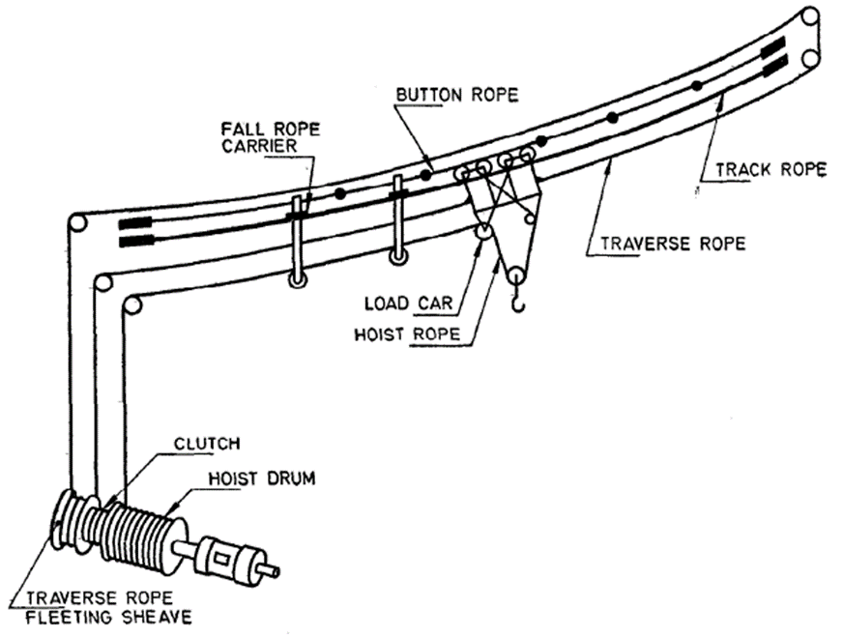

Fig 32 Single Motor Cableway

1. *Two-Motor Cableway (Blonding)* — A cableway system consisting basically of a load car running on a single-track rope, and with the hoist and traverse ropes driven by separate motors. This system can hoist or lower the load whilst travelling the load in either direction and give a diagonal or curved path. The hoist rope is reeved through blocks and is anchored at the end cable support from the operating winch.

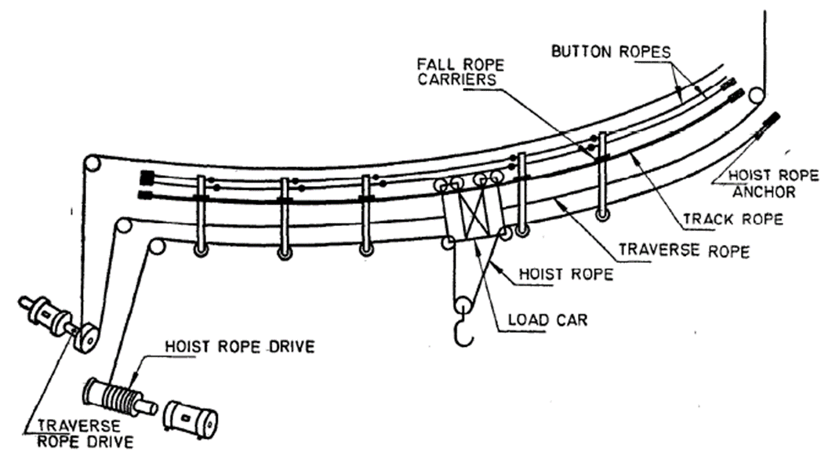

Fig 33 Two Motor Cableway

1. *Cable Crane*— A crane consisting of two fixed or movable masts with a tensioned track rope between, on which a trolley complete with hoisting gear travels to-and-fro. The travelling and hoisting motions are by means of wire ropes from a suitable winch controlled from one of the masts.

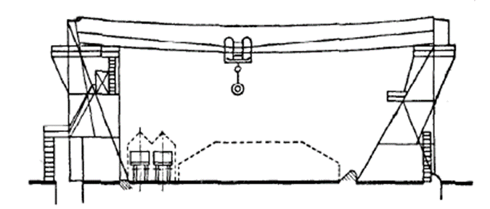

Fig 34 Two Motor Cableway

* 1. **CABLEWAY COMPONENTS**

1. *Track rope* — The rope which provides the track and supports the weight of the load conveyed;
2. *Traverse rope* — The rope which applies the tractive effort to cause the load to traverse the span of a cableway;
3. *Hoist rope* — The rope which raises and lowers the load conveyed by a cableway, by means of an appropriate purchase;
4. *Button rope* — A rope used to locate fall rope carriers at predetermined positions across the track rope span, by means of graded stops or buttons;
5. *Fall rope carrier* — A device by which the hoist rope is supported from the track rope to prevent excessive sag on long spans*; and
6. *Single-motor cableway load car* — A carriage for supporting a load on a single-motor cableway. The hoist rope is reeved through fall blocks and is anchored to the carriage.

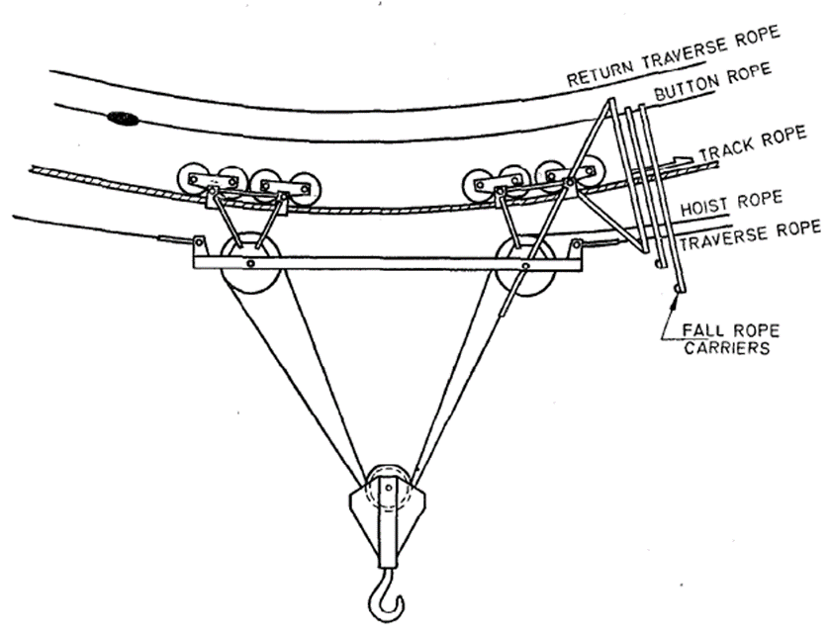

Fig 35 Single Motor Cableway Load Car

Note - *By this definition the term might be expected to be ‘hoist rope carrier’ but the term given is generally used.

1. *Two-motor cableway load car* — A carriage for supporting a load on a two-motor cableway. The hoist rope is reeved through fall blocks and is anchored at the cable end support remote from the operating winch.

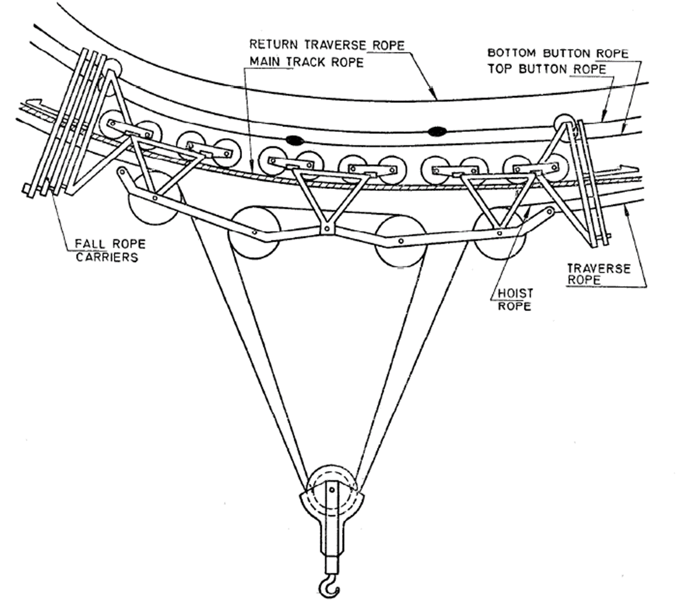

Fig 36 Two Motor Cableway Load Car

**4.3 CABLEWAY SUPPORTS**

1. *Cableway Travelling Tower* — A structure anchoring one end of the track rope of a cableway. It can be arranged to run on a radial track whereby a segmental area would be served by the cableway, or can be utilized on a parallel track with a similar travelling tower at the other end whereby a rectangular area would be served;

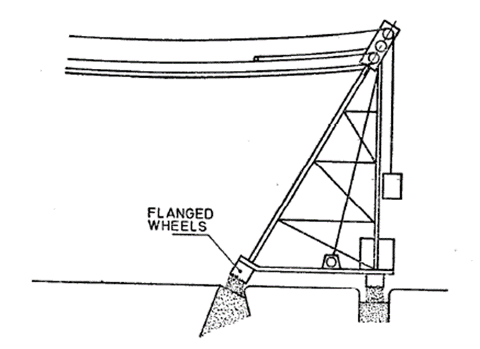

Fig 37 Cableway Travelling Tower

1. *Cableway Needle Mast* — A fixed guyed structure anchoring one end of a cableway track rope. It can be arranged with a travelling tower at the other end, whereby a segmental area would be served, or can be arranged with a similar fixed mast, whereby a narrow rectangular area would be served; and

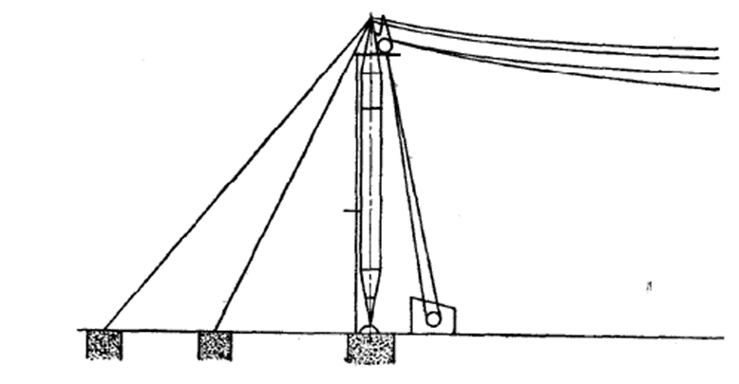

Fig 38 Cableway Needle Mast

1. *Cableway Luffing Mast* — A structure, one of a pair, anchoring the ends of a cableway track rope. They are arranged to luff with auxiliary winches, thereby serving a rectangular area.

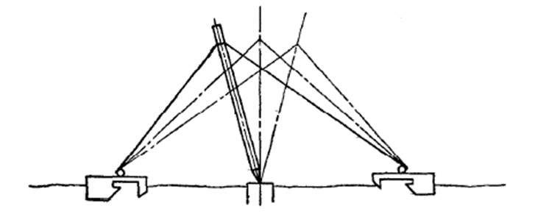

Fig 39 Cableway Luffing Mast

**4.3** *Driving and Control Gear*

**4.3.1** *Driving Gear* — The mechanical unit for driving the haulage rope of a ropeway system.

**4.3.2** *Control Gear* — The electrical equipment which is provided to control the driving motors of the ropeway driving gears.

**ANNEX B**

(*Foreword*)

**COMMITTEE COMPOSITION**

Continuous Bulk Conveying, Elevating, Hoisting Aerial

Ropeways And Related Equipment Sectional Committee, MED 06

|  |  |
| --- | --- |
| *Organization(s)* | *Representative(s)* |
| Rites Limited, Gurugram | Shri R. K. Sharma *(CHAIRPERSON)* |
| Adventure Tour Operator Association, New Delhi | Shri Ajeet Bajaj  Shri Pradeep Murthy (*Alternate* I)  Shri Nirat Bhatt (*Alternate* II) |
| Bharat Heavy Electricals Limited, Project Engineering Management, Noida | Shri Pankaj Kapsimay  Shri Vivek Hemrom (*Alternate*) |
| CSIR - Central Institute of Mining And Fuel Research (CIMFR), Dhanbad | Shri Debasis Basak  Shri Girendra M. Prasad (*Alternate*) |
| Conveyor and Ropeway Services Pvt Ltd, Kolkata | Shri S. Shekhar Chakravarty  Shri Kamal Kumar Bose (*Alternate*) |
| [Damodar Ropeways & Infra Limited, Kolkata](javascript:;) | Shri D. L. Das |
| Directorate General Factory Advice Service And Labour Institutes, Mumbai | Shri Dev Kumar Saxena  Shri Karunesh Srivastava (*Alternate*) |
| Directorate General of Mines Safety, Dhanbad | Shri D B Nayak  Shri Vijay Yadaorao Barapatre (*Alternate*) |
| Elecon Engineering Company Limited, Gujarat | Shri Naineshkumar Anilkumar Patel  Shri Taxay G. Solanki (*Alternate* I)  Shri Sanket A. Patel (*Alternate* II) |
| Indian Association of Amusement Parks and Industries, Mumbai | Shri Pradeep Sharma  Shri Anil Padwal (*Alternate*) |
| Lepton Projects Private Limited, Ghaziabad | Shri Sanjay Kumar  Shri Piyush Rathi (*Alternate*) |
| Mecon Limited, Ranchi | Shri Shri Satya Praksh  Shri Manoj Kumar Mahto (*Alternate*) |
| Ministry of Ports, Shipping and Waterways, New Delhi | Shri Anil Pruthi  Shri Ramji Singh(*Alternate*) |
| National Thermal Power Corporation Ltd., New Delhi | Shri Manish Kumar |
| National Highways Logistics Management Limited, New Delhi | Shri Ravinder |
| National Mineral Development Corporation Ltd., Hyderabad | Shri Alok Kumar Mehta  Shri S Surender (*Alternate*) |
| Phoenix Conveyor Belt India (P) Ltd., New Delhi | Shri Rajeev Sharma  Shri Asoke Kumar Ghosh (*Alternate*) |
| Projects and Development India Limited, Noida | Shri Narendra Singh |
| Rites Limited, Gurugram | Shri Dinesh Kumar (*Alternate*) |
| Ropeway and Resorts Pvt Ltd, Kolkata | Shri Biplab Das  Shri Sudipta Krishana Mandal (*Alternate*) |
| Tata Consulting Engineers Limited, Navi Mumbai | Shri Shireesh S. Swami |
| *Organization(s)* | *Representative(s)* |
| Usha Breco Limited Ghaziabad | Shri Manoj Panwar  Shri Sanjeev Dhariwal (*Alternate*) |
| Usha Martin Limited, Ranchi, Jharkhand | Shri Tushar Mukherjee  Shri Sandeep Jaiswal (*Alternate*) |
| In Individual Capacity, New Delhi | Shri S C Gandhi |
| In Individual Capacity, Faridabad | Shri Ashutosh Bhadra |
| In Individual Capacity, Kolkata | Shri Ranjan Mukherjee |
| BIS Directorate General | Shri K. Venkateswara Rao, Scientist ‘F’/Senior Director and Head (Mechanical Engineering) [Representing Director General (*Ex-officio*)] |

*Member Secretary*

Shri Aman Dhanawat

Scientist ‘C’/Deputy Director

(Mechanical Engineering), BIS