**IS 7465 : 2024**

***भारतीयमानक***

***Indian Standard***

**पोर्टेबल और परिवर्तनशील कन्वेयर बेल्ट — विशिष्टि**

*(* पहला पुनरीक्षण )

**Portable and Mobile Troughed Belt Conveyors — Specification**

( *First Revision )*

ICS 21.240

© BIS 2024

भारतीय मानक ब्यूरो



BUREAU OF INDIAN STANDARDS

मानक भवन, 9 बहादुर शाह ज़फर मार्ग, नई दिल्ली-110002

MANAK BHAVAN, 9 BAHADUR SHAH ZAFAR MARG

NEW DELHI - 110002

[www.bis.gov.in](http://www.bis.org.in)[www.standardsbis.in](http://www.standardsbis.in)

**December 2024 Price Group X**

Continuous Bulk Conveying, Elevating, Hoisting Aerial Ropeways and Related Equipment Sectional Committee, MED 06

FOREWORD

This Indian Standard (First Revision) was adopted by the Bureau of Indian Standards, after the draft finalized by Continuous Bulk Conveying, Elevating, Hoisting Aerial Ropeways and Related Equipment Sectional Committee had been approved by the Mechanical Engineering Division Council.

This standard was first published in 1974.

This revision has been taken up to keep pace with the latest technological developments and practices followed in Pump industry. This revision incorporates the following major changes:

1. Editorial corrections have been done.
2. Reference clause updated mentioning the latest version of the referred standards.
3. A clause **11.1** regarding BIS certification has been added

The purchaser shall, at the time of enquiry, disclose to the manufacturer any statutory requirements to which the conveyor shall be subjectedto, when in use and which are intended to ensure its safe working. Theconveyors shall be so constructed as to comply with these requirements.Guards shall also comply with the appropriate statutory requirements. The manufacturer shall inform the purchaser to the extent of guardingallowed for.

The composition of the committee responsible for the formulation of this standard is given in Annex B.

For the purpose of deciding whether a particular requirement of this standard is complied with, the final value, observed or calculated, expressing the result of a test or analysis, shall be rounded off in accordance with IS 2 : 2022 ‘Rules for rounding off numerical values (Second Revision)’. The number of significant places retained in the rounded off value should be the same as that of the specified value in this standard.

*Indian Standard*

**PORTABLE AND MOBILE TROUGHEDBELT**

**CONVEYORS — SPECIFICATION**

*(First Revision)*

**1 SCOPE**

This standard specifies dimensional and other requirements for portable and mobile troughed belt conveyors.

**2 REFERENCES**

The Indian Standard listed in below contain provisions which, through reference in this text, constitute provision of this standard. At the time of publication, the editions indicated were valid. All standards are subject to revision, and parties to agreements based on this standard are encouraged to investigate the possibility of applying the most recent editions of the standards listed below:

|  |  |
| --- | --- |
| *IS No.* | *Title* |
| 4240 : 1984 | Glossary of conveyor terms and definitions*(first revision)* |
| 1891 (Part 1) : 2021 | Conveyor and elevator textile belting – Specification part 1 general purpose belting *(fifth revision)* |

**3 DEFINITIONS**

For the purpose of this standard, the terms and definitions as given in IS 4240 shall apply along with the following definitions.

**3.2Amount of Take-Up** — The total sliding movement of the take-up pulley or pulleys and the percentages are based on the centre-to-centre length of the conveyor measured along the path of the carrying side of the belt.

**3.3 Nominal Volumetric Capacity of Belt —** The cross-sectional area of the load stream, of average flowing material, established in accordance with the principles given in Annex A, multiplied by the belt speed, when the belt structure is horizontal.

**4 MATERIAL**

The material used in the construction of the conveyors shall comply with, or be at least equivalent to the requirements specified in the appropriate Indian Standards.

**5 DIMENSIONS**

**5.1 Belt Widths**

The belt widths, *b*, shall be as follows:

300, 400, 500, 650, 800 and 1 000 mm.

**5.2 Idler Arrangement**

The idlers for portable and mobile conveyors consist of carrying and return idlers. The carrying idler set consists either of two idlers inclined to each other at a suitable angle to form a V or of a central idler and two side idlers. The idlers which support the return run of the belt consists of single idler.

**5.3 Idler Diameters**

The diameters, d1, of the idler shall be as follows:

51, 76.1, 88.9, 101.6, 108, 115 and 127 mm.

**5.4 Idler Inclination**

**5.4.1** *Carrying Idler Inclination*

The angle of inclination of the side idlers (*λ*) is the angle which the side idler axis makes with the horizontal(*see* figure in Table 1). It shall be one of the following in the case of3 idler sets:

20º, 30º and 45º.

When using value of greater than 30º the user should satisfy himself that the belt will trough adequately on the idler set.

**5.4.2** *Tilt*

The tilt (θ), the angle formed by the projections of the side idler axis and the axis of the central idler on the belt plane in the case of S-idler sets (*see* figure in Table 1), is a function of the idler inclination (λ) and the belt speed. It should be as small as possible but shall not exceed 3”. The tilt should be towards the direction of the belt run.

**5.4.3** *Gap*

The gap between the side idler and central idler in the case of 3-idler sets should not exceed 10 mm. It may be necessary to adopt minor modifications in design in certain cases.

**Table 1 Dimensions for Carrying and Return Idlers Sets**( *Clauses*5.4.1 *and*5.4.2 )  
All dimensions in millimetres.

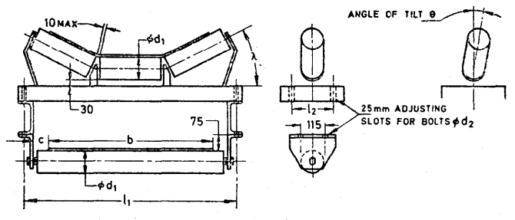

|  |  |  |  |  |  |  |
| --- | --- | --- | --- | --- | --- | --- |
| **Sl No*.*** | ***b*** | ***d*1** | ***l*1** | ***l*2** | ***d*2** | ***c*** |
| (1) | (2) | (3) | (4) | (5) | (6) | (7) |
|  | 300 | (*See* 4.3) | 540 | 150 | 12 | 50 |
|  | 400 | 640 | 150 | 12 | 50 |
|  | 500 | 740 | 200 | 12 | 50 |
|  | 650 | 890 | 200 | 16 | 50 |
|  | 800 | 1 040 | 200 | 16 | 75 |
|  | 1 000 | 1 240 | 200 | 16 | 75 |

**5.5 Nominal Distance between Head and Tail Pulley Centres**

The nominal distance between head and tail pulley centres shall be as follows:

|  |  |
| --- | --- |
| Mobile Conveyors, m | 5, 6, 7, 8, 9, 10, 11, 12, 15, 18, 21, 24, 27 and 30 |
| Portable | 3, 4, 5, 6 and 7 |

**5.6 Pulley Widths**

Pulley widths shall not be less than the following:

|  |  |
| --- | --- |
| Belt width, mm | 300, 400, 500, 650, 800, 1 000 |
| Minimum Pulley width, mm | 400, 500, 600, 750, 950, 1 150 |

**5.7 Pulley Diameters**

Diameters of pulleys shall be as follows: 100, 125, 160, 200, 250, 315, 400, 500, 650, 800 and 1 000 mm.

**5.7.1** For minimum pulley diameter for belting reference may be made to IS 1891 (Part 1).

NOTE - The use of pulleys with diameters smaller than recommended for various belt’s thickness of belting and types of fabrics may lead to ply separation and in extreme cases to actual fracture of the fabric.

**6 GENERAL REQUIREMENTS**

**6.1 Belt Capacities and Speeds**

Belt width and speed should, where possible, be chosen to make it operate under full load, special regard should be given to the nature, size-grading, characteristics and angle of repose of the material to be handled, and to the problems posed by high speed and the use of skirt plates.

**6.2 Angle of Inclination**

As portable and mobile conveyors can be made to move in a vertical plane, consideration should be given to the maximum angle of inclination depending on the material carried.

**6.3 Take-Up Devices**

A take-up device, to be approved shall be provided for all belt conveyors. The recommended amount of take-up for belt tensioning is given in Table 2.

**6.4 Skirt Plates**

Where skirt plates are fitted to feed chutes to guide the material into the centre of the belt and to prevent spillage, the average width between them shall, in general, be not more than two-thirds of the belt width. It is recommended that the total length of the feed hopper and its associated skirt plates should be not less than 1 200 mm, adjacent to the belt.

**6.5 Luffing Gear**

Luffing gear, where fitted, shall be self-sustaining, and shall not require a manual force of more than 147 N to operate.

**6.6 Lubrication**

Provision shall be made for the lubrication of bearings including ball and roller bearings. Where fitted, all lubricating points shall be readily accessible without removing the guards.

**6.7 Power Unit**

The power unit shall be appropriate to the operating and local conditions, and particular attention shall be paid to the maximum starting torque required. Electric motors, in general, shall be rated continuously and shall comply with relevant Indian standard.

**Table 2 Recommended Amount of Tare-Up for Belt Tensioning**  
(*Clause* 6.3)

|  |  |  |  |  |
| --- | --- | --- | --- | --- |
|  | Centre to centre length of conveyor (does not include the take up allowance) | Not over 10 m | Over 10 m but not over 25 m | Over 25 m |
|  | For belts required to run always with mechanical fasteners | Minimum 2 percent plus 150 mm | Minimum 2 percent plus 200 mm | $1\frac{3}{6}$ percent but not less than 700 mm minimum |
|  | For belts to be installed initially with a temporary joint but finally to be made endless on site with a permanent vulcanized spliced joint | It is unnecessary to consider using mechanical fasteners initially, and belts may be initially vulcanized ‘endless’ on site | | 2 percent but not less than 1 m minimum |
|  | For belts initially to be made ‘endless’ on site with a permanent vulcanized spliced joint | Minimum 2 percent plus 250 mm | Minimum $3\frac{1}{2}$ percent plus 250 mm | $4\frac{1}{2}$ percent |
|  | For belts to be ordered and fitted endless at the minimum lengths of the conveyor circuit plus 0.5 percent | Minimum $4\frac{1}{2}$ percent plus 150 | Minimum 5 percent plus 250 mm | 6 percent |

**7 SAFETY PRECAUTIONS**

**7.1 Access**

Handrails and intermediate rails shall be fitted to all sloping gangways, and gangways from which a person is likely to fall a distance of more than 2 m, on the side remote from the conveyors, in addition to any handrail which may be required to guard the conveyor. The top rail shall be at least 1 m above the level of the walkway. A toe board shall be placed at walkway level.

**7.2 Guarding**

Guards shall be provided at:

1. all pulleys and belt nips (*see* Fig. 1);
2. carrying idlers and (if accessible) return idlers, where an upward movement of the belt may be restricted, for example, loading points and some convex curves, or where the tension in the belt is sufficient to give rise to risk of trampling; and
3. Rotating shafts and couplings, chains and chain wheels, gears, driving belts and pulleys, etc.

Guards shall be securely fixed in position and shall be capable of removal and replacement without dismantling any other part.

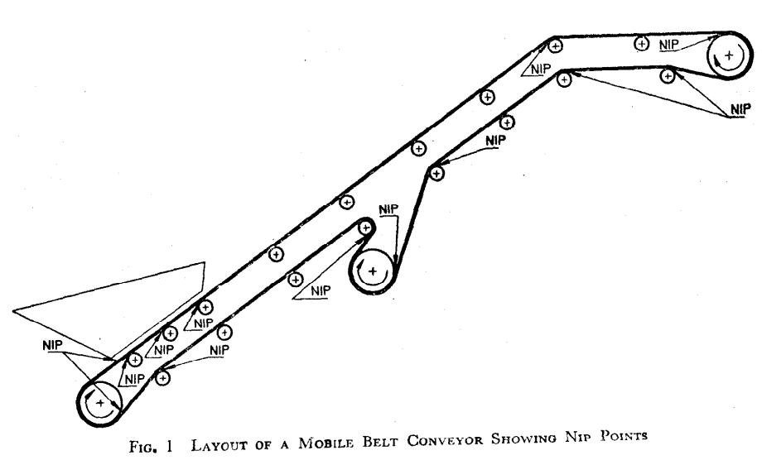

Fig. 1 Layout Of Mobile Belt Conveyor Showing Nip Points

**7.3 Size of Mesh Opening and Clearance**

The minimum clearance between the guard and the moving parts and the size of opening in guards of perforated metal, woven wire or similar material shall be in accordance with the following requirements:

|  |  |  |
| --- | --- | --- |
| *Sl No.* | *Size of opening* | *Minimum Clearance* |
| mm | mm |
| (1) | (2) | (3) |
|  | Not exceeding 10 | 25 |
|  | Over 10, up to and including 13 | 65 |
|  | Over 13, up to and including 30 | 100 |
|  | Over 30, up to and including 38 | 130 |

The size of opening shall be taken to refer to the maximum dimension of the opening, except that where the openings are in the form of slots, the length may be ignored if the width does not exceed 13 mm.

**7.3.1** Slots 30 mm wide, suitably reinforced, may be provided in guards for the insertion of bars for cleaning. The minimum distance between any moving part of the conveyor and any part of the slot shall be 300 mm.

**7.3.2** Guards for nip points between belts and pulleys shall either prevent access to the nip or extend at least 1 m from the nip.

**7.4 Safe Starting and Emergency Stopping**

All starting operations on the conveyor should be preceded by an inspection to ensure that it is safe to start. Means shall be provided at suitable points for stopping the conveyor in an emergency.

Starting after an emergency or accidental stoppage should not only be preceded by the inspection referred to above, but should also be allowed only after the inspection has determined the cause of the emergency or accidental stoppage, and the fault has been rectified.

**8 MARKING**

**8.1** The portable and mobile troughed belt conveyors shall be marked with the following information on the name plate provided on the conveyor at suitable prominent place:

1. Manufacturer’s identification; and
2. Any other information required by the purchaser.

**8.2 BIS Marking**

The product(s) conforming to the requirements of this standard may be certified as per the conformity assessment schemes under the provisions of the *Bureau of Indian Standards Act, 2016* and the Rules and Regulations framed thereunder, and the products may be marked with the Standard Mark.

**ANNEX A**

**(***Clause* 3.3)

**NOMINAL CROSS-SECTIONAL AREA OF LOAD STREAM**

**A-1 LOAD STREAM AREA WITH THREE-ROLL IDLERS**

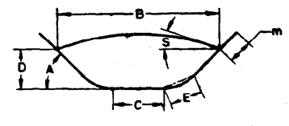

$$Load stream area=DC+2E^{2}ɀ+ED cos α+\frac{B-C}{2}\left(D-E\sin{α}\right)+B^{2}X$$

Where:

*B*, *C*, *D* and *E* are measurements inside the troughed belt,

*A* = troughing angle,

*S* = surcharge angle, and

*m* = edge margin = 0.05b + 25 mm (*b* being the belt width)

Read *X* from A-3 under angle *S*

Read γ from A-3 under angle *A*

Read ɀ from A-3 under angle α, where angle α = $\frac{1}{2}$ A

Example:

If surcharge angle *S* = 20º than *X* = 0.059

If troughing angle *A* = 30º then γ = 0.090 ɀ = 0.044

Cos α = 0.966, sin α = 0.259

**A-2 SURCHARGE ANGEL**

|  |  |  |
| --- | --- | --- |
| *Sl No.* | *Material* | *Surcharge Angle*  *S* |
| (1) | (2) | (3) |
|  | Flued material and grain | 0º to 5º |
|  | Fine dry free-flowing material | 10º |
|  | Average flowing materials | 20º |
|  | Non-flowing materials | 25º |
|  | Mixed lumps and fins | 30º |

**A-3 VALUES**

|  |  |  |  |  |  |  |  |
| --- | --- | --- | --- | --- | --- | --- | --- |
| *Sl No.* | *Angle: S, A or α* | *5º* | *10º* | *15º* | *20º* | *25º* | *30º* |
| (1) | (2) | (3) | (4) | (5) | (6) | (7) | (8) |
|  | *X*, γ or ɀ | 0.014 5 | 0.029 2 | 0.044 | 0.059 | 0.075 | 0.090 |
|  | Cos | 0.996 | 0.985 | 0.966 | 0.940 | 0.906 | 0.866 |
|  | Sin | 0.087 | 0.174 | 0.259 | 0.342 | 0.423 | 0.500 |

**A-4 ELEVATION REDUCTION FASTER**

|  |  |  |
| --- | --- | --- |
| *Sl No.* | *For Smooth Belts Elevating at* | *Multiply Stream Area by* |
| (1) | (2) | (3) |
|  | 0º -10º | 1.0 |
|  | 10º -15º | 0.95 |
|  | 15º -20º | 0.90 |
|  | Over 20º | 0.85 |

**A-5 CAPACITY**

Nominal volumetric capacity in m3/h

= Load stream area (m2) × Belt speed (m/s) × 3 600

**ANNEX B**

(*Foreword*)

**COMMITTEE COMPOSITION**

Continuous Bulk Conveying, Elevating, Hoisting Aerial

Ropeways And Related Equipment Sectional Committee, MED 06

|  |  |
| --- | --- |
| *Organization(s)* | *Representative(s)* |
| Rites Limited, Gurugram | Shri R. K. Sharma *(CHAIRPERSON)* |
| Adventure Tour Operator Association, New Delhi | Shri Ajeet Bajaj  Shri Pradeep Murthy (*Alternate* I)  Shri Nirat Bhatt (*Alternate* II) |
| Bharat Heavy Electricals Limited, Project Engineering Management, Noida | Shri Pankaj Kapsimay  Shri Vivek Hemrom (*Alternate*) |
| CSIR - Central Institute of Mining And Fuel Research (CIMFR), Dhanbad | Shri Debasis Basak  Shri Girendra M. Prasad (*Alternate*) |
| Conveyor and Ropeway Services Pvt Ltd, Kolkata | Shri S. Shekhar Chakravarty  Shri Kamal Kumar Bose (*Alternate*) |
| [Damodar Ropeways & Infra Limited, Kolkata](javascript:;) | Shri D. L. Das |
| Directorate General Factory Advice Service And Labour Institutes, Mumbai | Shri Dev Kumar Saxena  Shri Karunesh Srivastava (*Alternate*) |
| Directorate General of Mines Safety, Dhanbad | Shri D B Nayak  Shri Vijay Yadaorao Barapatre (*Alternate*) |
| Elecon Engineering Company Limited, Gujarat | Shri Naineshkumar Anilkumar Patel  Shri Taxay G. Solanki (*Alternate* I)  Shri Sanket A. Patel (*Alternate* II) |
| Indian Association of Amusement Parks and Industries, Mumbai | Shri Pradeep Sharma  Shri Anil Padwal (*Alternate*) |
| Lepton Projects Private Limited, Ghaziabad | Shri Sanjay Kumar  Shri Piyush Rathi (*Alternate*) |
| Mecon Limited, Ranchi | Shri Shri Satya Praksh  Shri Manoj Kumar Mahto (*Alternate*) |
| Ministry of Ports, Shipping and Waterways, New Delhi | Shri Anil Pruthi  Shri Ramji Singh(*Alternate*) |
| National Thermal Power Corporation Ltd., New Delhi | Shri Manish Kumar |
| National Highways Logistics Management Limited, New Delhi | Shri Ravinder |
| National Mineral Development Corporation Ltd., Hyderabad | Shri Alok Kumar Mehta  Shri S Surender (*Alternate*) |
| Phoenix Conveyor Belt India (P) Ltd., New Delhi | Shri Rajeev Sharma  Shri Asoke Kumar Ghosh (*Alternate*) |
| Projects and Development India Limited, Noida | Shri Narendra Singh |
| Rites Limited, Gurugram | Shri Dinesh Kumar (*Alternate*) |
| Ropeway and Resorts Pvt Ltd, Kolkata | Shri Biplab Das  Shri Sudipta Krishana Mandal (*Alternate*) |
| Tata Consulting Engineers Limited, Navi Mumbai | Shri Shireesh S. Swami |
| *Organization(s)* | *Representative(s)* |
| Usha Breco Limited Ghaziabad | Shri Manoj Panwar  Shri Sanjeev Dhariwal (*Alternate*) |
| Usha Martin Limited, Ranchi, Jharkhand | Shri Tushar Mukherjee  Shri Sandeep Jaiswal (*Alternate*) |
| In Individual Capacity, New Delhi | Shri S C Gandhi |
| In Individual Capacity, Faridabad | Shri Ashutosh Bhadra |
| In Individual Capacity, Kolkata | Shri Ranjan Mukherjee |
| BIS Directorate General | Shri K. Venkateswara Rao, Scientist ‘F’/Senior Director and Head (Mechanical Engineering) [Representing Director General (*Ex-officio*)] |

*Member Secretary*

Shri Aman Dhanawat

Scientist ‘C’/Deputy Director

(Mechanical Engineering), BIS