*भारतीय* *मानक*

**स्टेनलेस स्टील के बर्तन** — **विशिष्टि**

(*तीसरा संशोधन* )

*Indian Standard*

**Stainless Steel Utensils — Specification**

( *Third Revision*)

ICS 77.140.20: 97.040

BIS © 2024

भारतीय मानक ब्यूरो

B U R E A U O F I N D I A N S T A N D A R D S

मानक भवन, 9 बहादुरशाह ज़फर मार्ग, नई दिल्ली 110002

MANAK BHAVAN, 9 BAHADUR SHAH ZAFAR MARG,

NEW DELHI 110002

**August 2024 Price Group X**

Utensils, Cutlery and Domestic Hardware Sectional Committee, MED 33

FOREWORD

This Indian Standard (Third Revision) was adopted by the Bureau of Indian Standards, after the draft finalized by the Utensils, Cutlery and Domestic Hardware Sectional Committee had been approved by the Mechanical Engineering Division Council.

This standard was first published in 2000 after superseding IS 3257 : 1980 ‘Stainless steel compartmental trays’, IS 3258 : 1980 ‘Stainless steel serving utensils’, IS 3411 : 1985 ‘Stainless steel cooking utensils’ and IS 3424 : 1985 ‘Stainless steel table utensils’ and subsequently revised in 2017 and 2022. This revision was taken up in view of the representation received from various stakeholders and to ensure smooth implementation of the standard. The following major modifications have been incorporated in this revision of the standard:

1. Scope of the standard has been modified for better clarification on coverage and exemption of different type of utensils;
2. Permissible reduction in pressing and spinning process has been increased;
3. Classification criteria has been added;
4. Definitions have been added for all types of utensils covered in the standard.
5. The tolerances for 3 Ply material have been added
6. Requirement on minimum thickness of the sheet to be used for manufacturing the utensil has been modified; and
7. Marking requirements have been modified;

The composition of the Committee responsible for the formulation of this standard is given in Annex F.

For the purpose of deciding whether a particular requirement of this standard is complied with the final value, observed or calculated, expressing the result of a test or analysis, shall be rounded off in accordance with IS 2 : 2022 ‘Rules for rounding off numerical values (*second revision*)’. The number of significant places retained in the rounded off value should be the same as that of the specified value in this standard.

*Indian Standard*

**Stainless Steel Utensils — Specification**

(*Third Revision*)

## 1 SCOPE

This standard lays down the minimum requirements for following types of stainless steel utensils:

1. Cooking utensil;
2. Serving utensils;
3. Table utensils; and
4. Storage utensils

NOTES

1. Utensils above 15 litres and 500 mm in diameter/length/width (where capacity cannot be measured), shall be classified as commercial.
2. The figures of the utensils included in this standard are for representation only.
3. Cutlery items (spoons/ladle, forks, knives) are not covered in this standard.
   1. **Applicability of Clauses**

**1.1.1** All clauses are applicable to cooking utensils and serving utensils (Type CS).

**1.1.2** Clauses **2**, **3**, **4**, **5**, **8** and **9** (reference, materials, classification, workmanship, marking and packaging) are applicable for:

1. Serving utensils (Type S);
2. Table utensils; and
3. Storage utensils.

## REFERENCES

The Indian Standards listed in Annex A contain provisions which, through reference in this text, constitute provisions of this standard. At the time of publication, the editions indicated were valid. All standards are subject to revision, and parties to agreements based on this standard are encouraged to investigate the possibility of applying the most recent editions of the standards listed in Annex A.

## MATERIAL

**3.1** The stainless steel used for manufacture of utensils shall confirm to IS 5522/ grades of IS 5522 as per IS 6911 or IS 15997/ grades of IS 15997 as per IS 6911.

**3.2** The material used for composite bottom shall be as per IS 15960. For thicknesses, please refer to **4.4**.

**3.3** If the body of the utensil is made of a 3-ply construction, it shall conform to IS 18755.

**3.4** If the utensil is provided with a stainless steel lid, the material of lid shall be as per IS 5522/ grades of IS 5522 as per IS 6911 or IS 15997/ grades of IS 15997 as per IS 6911.

**3.5** If the utensil is provided with a tempered glass lid, the lid shall conform to the performance requirements as given in IS 2347. The minimum thickness of glass shall be 3.5 mm. If the stainless steel rim is provided on the glass lid, the material of rim shall be as per IS 5522/ grades of IS 5522 as per IS 6911 or IS 15997/ grades of IS 15997 as per IS 6911. The minimum thickness of the rim shall be 0.25 mm.

NOTE — If material for utensil as per IS 15997 is used, then it shall comply with the requirements given in Annex C, D, and E. (for welded utensils only)

## SHAPES, DIMENSIONS, CLASSIFICATIONS AND DEFINITIONS

**4.1** The shapes and dimensions for various types of utensils shall be as per the agreement between the purchaser and the manufacturer. However, some of the shapes of different types of utensils are given in Annex B for guidance.

**4.2** The minimum thickness of the sheet used for manufacturing of utensils shall conform to Table 1 and 2.

**4.2.1** The permissible reduction in the thickness of the finished utensils, taking into account the pressing or spinning process, shall not be more than 25 percent for pressing and 60 percent for spinning on the minimum sheet thickness specified as per Table 1. For fabricated utensils, the reduction in the thickness of the sheet is not applicable.

NOTE — The permissible reduction in the thickness of the finished utensils includes reduction for all operations.

## 4.3 Classification

**4.3.1** Where specified, the utensil shall be classified as follows:

1. Heavy;
2. Medium;
3. Light; and
4. Commercial

**Table 1 Minimum Sheet Thickness for Body of Utensil**

(*Clauses* 4.2 and 4.2.1)

|  |  |  |  |  |  |  |  |
| --- | --- | --- | --- | --- | --- | --- | --- |
| **Sl No.** | **Type of Utensil** | **Minimum Thickness of sheet in mm** | | | | | |
| **Heavy** | | **Medium** | | **Light** | |
| **Vessel with cladding** | **Vessel** | **Vessel with cladding** | **Vessel** | **Vessel with cladding** | **Vessel** |
|  |  |  |  |  |  |  |  |
|  | Cooking Utensil | 0.7 | 0.9 | 0.6 | 0.7 | 0.5 | 0.5 |
|  | Serving Utensil Type CS | 0.7 | 0.9 | 0.6 | 0.7 | 0.5 | 0.5 |
|  | Serving Utensil Type S | - | 0.7 | - | 0.6 | - | 0.3 |
|  | Table Utensil | - | 0.7 | - | 0.5 | - | 0.3 |
|  | Storage Utensil | - | 0.7 | - | 0.5 | - | 0.3 |

NOTE— For commercial utensils (cooking utensils and serving utensils type CS), the minimum thickness of the sheet shall be ≥ 1 mm. For other types of commercial utensils, the minimum thickness shall be ≥ 0.4 mm.

**Table 2 Minimum Sheet Thickness for Lid of Utensil**

(*Clause* 4.2)

|  |  |  |  |  |
| --- | --- | --- | --- | --- |
| **Sl No.** | **Type of Utensil** | **Minimum Thickness of sheet in mm** | | |
| **Heavy** | **Medium** | **Light** |
|  |  |  |  |  |
|  | Cooking Utensil | 0.6 | 0.4 | 0.3 |
|  | Serving Utensil Type CS | 0.6 | 0.4 | 0.3 |
|  | Serving Utensil Type S | 0.6 | 0.4 | 0.3 |
|  | Table Utensil | 0.6 | 0.4 | 0.3 |
|  | Storage Utensil | 0.6 | 0.4 | 0.3 |

NOTE — The permissible reduction in the thickness of the lid, taking into account the pressing or spinning process, shall not be more than 20 percent.

**4.4** The thickness of Aluminium Disc/Core and protector/cowl for composite bottom utensils shall be as given below:

|  |  |  |  |  |
| --- | --- | --- | --- | --- |
| **Sl No.** | **Composite Bottom –**  **2-ply and 3-ply** | **Thickness in mm** | | |
| **Heavy** | **Medium** | **Light** |
| i) | Aluminium Disc / Core | ≥ 3 | ≥ 2.5 | ≥ 1.8 |
| ii) | Protector / Cowl | ≥ 0.4 | | |

NOTE — The material thickness for 2-ply and 3-ply composite bottom of stainless steel utensil can also be as per IS 15960.

**4.5** The minimum sheet thickness of 3-ply utensil shall be 2.5 ± 0.15 mm.

**4.5.1.** The permissible reduction in the thickness of the 3-ply finished utensils, taking into account the pressing with a radius at the bottom (base with the side wall):

1. The base shall be same as the circle thickness.
2. The maximum permissible reduction in the thickness shall be 30 percent of the base thickness

**4.6 Definitions**

**4.6.1** *Cooking Utensils or Cookware* **—** Utensils intended for use in the preparation and/or cooking of food or beverages on the top of a stove, or any other heating appliance.

NOTE —Accessories like separators/containers, idli plate, steamer plate, dhokla plate, etc., are not covered in this standard.

**4.6.2** *Serving Utensils —* Utensils intended for use in serving of food or beverages, it could be hot or cold.

1. *Serving Utensils Type CS* — can be used for cooking also; and
2. *Serving Utensils Type S* — cannot be used for cooking.

**4.6.3** *Table Utensils* — Utensils intended for use on the table, for eating of food or drinking of water or beverages, it could be hot or cold. It cannot be used for cooking.

**4.6.4** *Storage Utensils* — Utensils intended for storage of food, could be hot or cold. It cannot be used for cooking.

## WORKMANSHIP AND FINISH

**5.1** The utensils shall be free from any manufacturing defects, sharp edges, cuts, when checked with naked eyes or corrected vision. The utensils generally be bright finish, matt finish or combination of both finish and shall not rock when placed on a gas stove (*see* Note). In case of electrolytic copper deposition on the utensils at the bottom, the coating shall be free from defects such as uncoated area and their superficial blemishes visible to the naked eye.

NOTE— Flat bottom utensil shall not rock when placed on flat surface (except tadka pan).

**5.2** The construction of the utensils shall be such that, it is possible to clean them thoroughly and all surfaces are accessible for cleaning by hand or brush.

**5.3** Metal handles shall be fitted to the utensils by spot welding or riveting. Spot welded joints shall not have any crevices. In case of plastic handles, it shall be suitably fitted to the body through a metal bracket or ferrule fixed to the utensil by spot welding or riveting. Stainless steel rivets or stainless-steel capped aluminium rivets can be used to fix the handles on utensils. The material for the stainless-steel rivets shall be as per IS 6527/IS 6528. The material of the stainless-steel cap shall be as per IS 5522/ grades of IS 5522 as per IS 6911 or IS 15997/ grades of IS 15997 as per IS 6911.

**5.4** Where handles are required, the requirements for handles shall conform to IS 13395.

**5.5** Welding if done, the weld shall be free from welding defects. The welding electrode shall conform to grade 308 L (07Crl8Ni9) or higher grade as per IS 5856. The weld shall be finished properly so that when a finger is passed on the joint, it shall be smooth.

NOTES

* + - 1. **5.5** is not applicable for spot welded utensils.
      2. The welding shall comply with Annex E.

**5.6** After processing 3-ply utensils, there shall be no oozing of the middle layer or any delamination of the layers when checked visually at the edges.

**5.7** If required by the purchaser, the utensils (cooking utensil and serving utensils Type CS) may be supplied with non-stick unreinforced coating or ceramic coating conforming to IS 9730. The coating should be PFOA and BPA free (supplier certificate is only acceptable).

NOTES

* 1. In case of utensils, which have a honeycomb/square type of etching/embossing structure in the inner side of the utensil, the sample used for tests conforming to IS 9730 shall be as given below in note 2.
  2. Similar utensil without a honeycomb/square type of etching/embossing structure would go through all the process of manufacture and coating. This plain sample would be tested as per IS 9730 instead of the utensil with honeycomb structure.

**5.8** The cookware, if coated with powder coating or ceramic coating or high temperature resistant liquid coating, fully or partially externally, shall conform to the thickness test, adhesion test as per IS 9730. The coating shall comply with IS 9806. The minimum thickness of the coating shall be 30 microns (powder coating) and 15 micron (ceramic coating, high temperature resistant liquid coating). The externally coated cookware shall be subjected to thermal shock test as given in **5.8.1.**

**5.8.1** Dry heat the cookware on gas stove to ${250 °C }_{- 0 °C }^{+25 }$ and then quench in water at ambient temperature. Repeat the test 25 times. There shall be no blistering of coating from the cookware during or on completion of 25 gas heat cycles.

## TESTS

## Staining Test (Type Test - Frequency once in a year)

## The surface of the utensil (vessel and lid) shall be thoroughly washed with hot soapy water. Thoroughly rinse and then degrease the test specimens in acetone or methylated spirits, then wipe using a soft cloth. The utensils, when filled with any of the following solutions at ambient  temperature and kept for 16 h, shall not show any sign of staining after removal from the solutions at the end of above period and washing with hot soapy water, thoroughly rinse with water and wipe with soft cloth .

* 1. Ten grams of glacial acetic acid (99 percent) dissolved in distilled water to make 100 ml; or
  2. 0.5 grams of pure sodium chloride dissolved in distilled water to make 100 ml.

NOTES

1 The vessel and lid can be tested separately in case of lid. The lid should be dipped in the solution.

2 It is a type test and applicable only for cooking utensil and serving utensils Type CS.

### **6.2** **Mechanical Shock Test (for Cladded Utensils Only)**

The utensil body shall be supported in air with the bottom side up and a steel ball weighing half a kg ± 5 g dropped on to it from the height of 500 mm five times. After completion of the test, the cladded or deposited layer shall not show sign of peeling off or coming off.

### **6.3 Thermal Shock Test (for Cladded Utensils Only)**

The utensil body only shall be kept in an oven to attain a temperature of ${250 °C }_{- 0 °C }^{+25 }$. Thereafter the utensil shall be removed and dipped immediately in water maintained at ambient temperature. This process shall be repeated three times and at the end of the process the deposited layer/cladding shall not show any sign of peeling off or coming off.

### **6.4 Dry Heat Test (for Cladded Utensils Only)**

The utensil body only shall be heated up to ${250 °C }_{- 0 °C }^{+25 }$ on induction and immediately quench in water (water temperature before quenching shall be around (35 °C ± 5 °C ). Repeat the cycle for 25 times on induction and repeat the cycle for 25 times on gas. Check the bottom for bulge, separation of disc or blisters after cooling every cycle. There shall be no separation of cowl or disc from the utensil after cooling.

### **6.5 Coating Thickness Test (for Copper Deposit)**

The total thickness of the utensil including copper deposit shall be measured. Then, the copper deposit shall be stripped off in two areas of required size and thickness of the stainless steel sheet shall be measured. The difference between the total thickness including copper deposited and the thickness of stainless steel sheet be considered as the thickness of the copper deposited. This test is for electro deposition of copper only. The thickness of the copper-deposited shall be as agreed to between the purchaser and manufacturer.

**6.6** For 3-ply construction utensil body, the body shall be tested as per **6.6.1**. The body shall not show any separation (or delamination) of the 3-ply or shall not show blisters, after the completion of 50 heat cycles.

**6.6.1** Heat the utensil body to ${250 °C }_{- 0 °C }^{+25 }$ and quench in water at ambient temperature. Before quenching, the utensil body shall be checked at a minimum of two locations to confirm, that the temperature of the utensil body has attained to ${250 °C }_{- 0 °C }^{+25 }$.Temperature to be measured at inside bottom and top edge (mouth portion) of the utensil (record the temperature for at least the first and the last cycle). Repeat this cycle 50 times.

#### NOTES

1. Hold (soak) the utensil body for 2 min at ${250 °C }_{- 0 °C }^{+25 }$ under heating condition, before measuring and subsequent quenching in ambient temperature water.
2. For guidance purposes, the heating source may be a hot air oven or any other equipment which can be used to achieve such temperature.

### **6.7 Nominal Capacity Test**

**6.7.1** The nominal capacity of cookware shall be expressed only in complete or 10 ml units for utensils less than 1 litre capacity and 50 ml units for utensils above 1 litre capacity. No negative tolerances shall be allowed on the nominal capacity.

**6.7.2** In case the marking or labelling is in terms of diameter, the internal diameter of utensil shall be marked (except for tawa, where the diameter is outer diameter). The dimensions shall be exclusive of the handles. The diameter shall be expressed only in complete or 0.1cm units. No negative tolerances shall be allowed on the diameter.

NOTE — If the diameter is 39.25 cm, its diameter shall be marked as the nearest lower complete of 0.1 cm units, the diameter to be marked as 39.2 cm or less (39.1 cm, 39 cm).

**7 SAMPLING**

**7.1** Unless agreed to between the purchaser and the manufacturer, the sampling of utensils and criteria of conformity shall be done in accordance with IS 9040 for dimensional and staining test.

**7.2** The tests **6.2**, **6.3**,**6.4, 6.5, and 6.6** are type tests applicable to clad utensils and shall be done on separate sample in every month or one in 50,000 utensils manufactured, which every is less. To ensure the quality of the utensils, additional tests shall be conducted on one utensil selected at random once a month or one in 50,000 utensils, whichever is less in the order as specified in Table 3.

**Table 3 Additional Tests**

(*Clause* 7)

|  |  |  |
| --- | --- | --- |
| **Sl No.** | **Tests** | **Remarks** |
|  |  |  |
|  | Sample 1:   1. Mechanical shock test (*see* **6.2**) 2. Thermal shock test (*see* **6.3**) | If found OK subject to next test  Only cladded utensils |
|  | Sample 3: Dry heat test (*see* **6.4**) | For bottom cladded 2-ply and 3-ply construction utensils |
|  | Sample 4: Dry heat test (*see* **6.6**) | For 3 ply full body utensils |

## 8 MARKING

**8.1** Each utensil shall have the following details:

1. Capacity in litre/millilitre or size in cm/mm of utensil;
2. Thickness of sheet (mm) or Classification;
3. Material grade (Lid-SS 304 or SS 304/Al 19000/SS 430, Body-SS 304 or SS304/Al 19000/ SS 430) ;
4. Manufacturer name or initials or trademark; and
5. Batch number

NOTES

1. The details can be marked in the form of a sticker/leaflet in case it cannot be stamped, embossed or etched.
2. For cooking utensils, (a), (b), (d), to be marked on utensils only, (c) and (e ) can be marked on primary packaging.
3. For other utensils not used for cooking, (b) and (d) to be marked on utensils only, (a), (c), and (e ) can be marked on primary packaging.
4. Details can also be put up on primary packaging for lid.
5. Details can be put on primary packaging for small utensils.

**8.2 BIS Certification Marking**

The product(s) conforming to the requirements of this standard may be certified as per the conformity assessment schemes under the provisions of the *Bureau of Indian Standards Act*, 2016 and the rules and regulations framed thereunder, and the product(s) may be marked with the standard mark.

**9 PACKING**

Each utensil shall be suitably packaged to avoid any damage during transit.

**ANNEX A**

(*Clause* 2)

**LIST OF REFERRED INDIAN STANDARDS**

|  |  |
| --- | --- |
| *IS No.* | *Title* |
| IS 5522 : 2014 | Stainless steel sheets and strips for utensils — Specification (*third revision*) |
| IS 6527 : 1995 | Stainless steel wire rod — Specification (*first revision*) |
| IS 6528 : 1995 | Stainless steel wire - Specification (First Revision) |
| IS 6911 : 2017 | Stainless steel plate, sheet and strip — Specification (*second revision*) |
| IS 9040 : 1978 | Methods for sampling of utensils |
| IS 9730 : 2008 | Non-Stick unreinforced plastics coatings on domestic cooking utensils — specification (*first revision*) |
| IS 13395 : 2021 | Performance of handles and handle assemblies attached to cookware — Specification (*first revision*) |
| IS 15960 : 2013 | Composite bottom stainless-steel cooking utensils — Specification |
| IS 15997 : 2012 | Low nickel austenitic stainless steel sheet and strip for utensils and kitchen appliances — Specification |
| IS 18755 : 2024 | Tri-ply (SS-Al-SS) material used for manufacture of utensils and kitchen appliances — Specification |

**ANNEX B**

(*Clause* 4.1)

**DIAGRAMMATIC SHAPE OF DIFFERENT TYPES OF UTENSILS**

**A-1** Diagrammatic shape of different types of utensils shall be as shown in Fig. 1 to Fig. 14. In these figures, ‘H’ is the height and ‘D’ is the diameter:

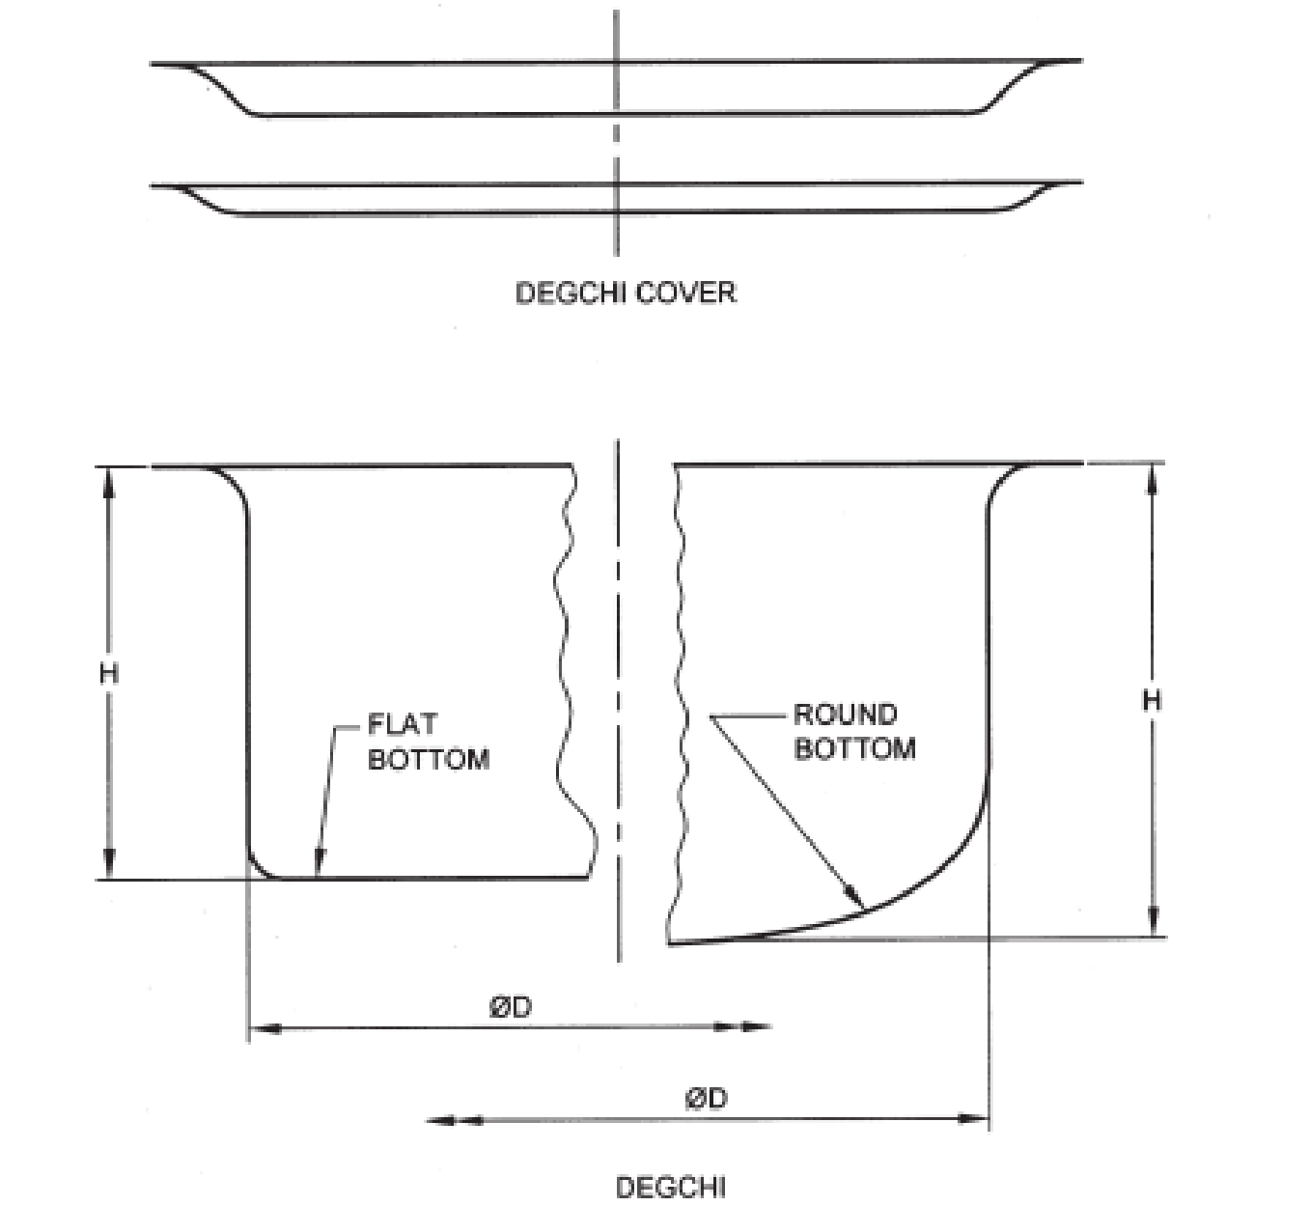

Fig. 1 Deep Degchi

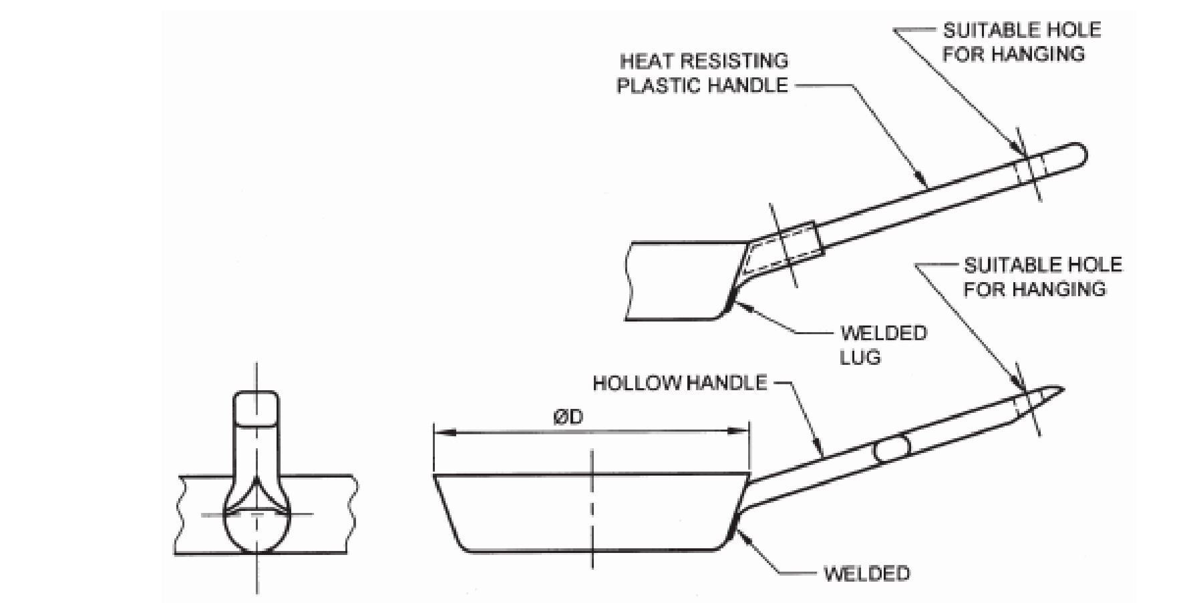

Fig. 2 Frying Pan

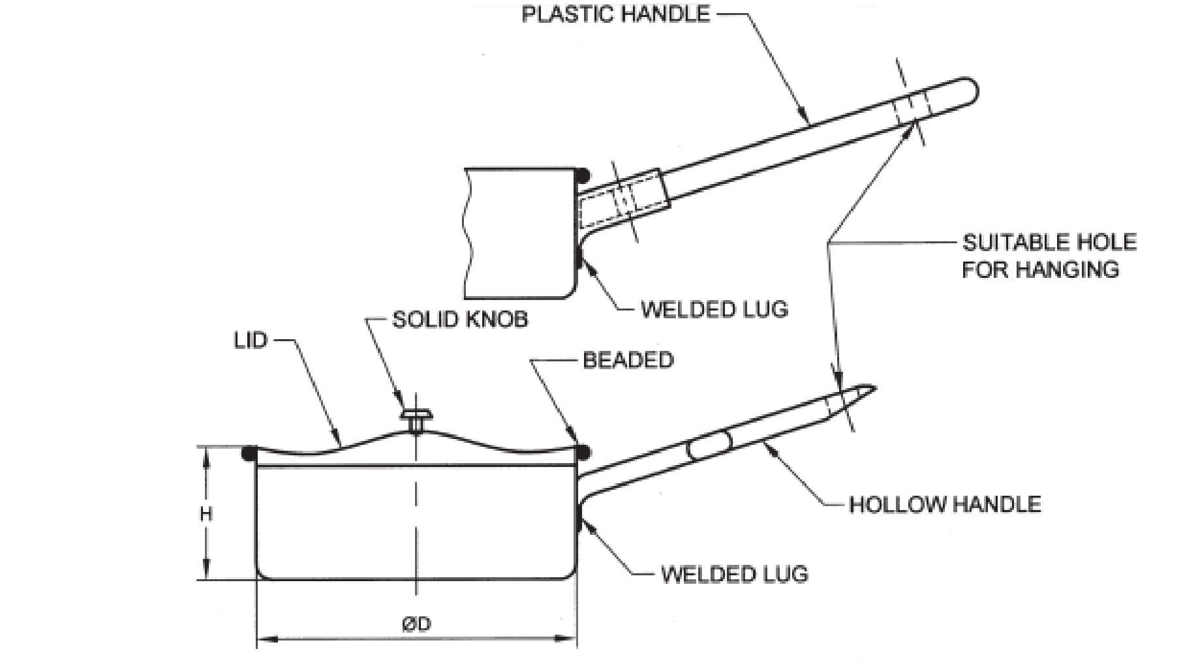

Fig. 3 Saucepan

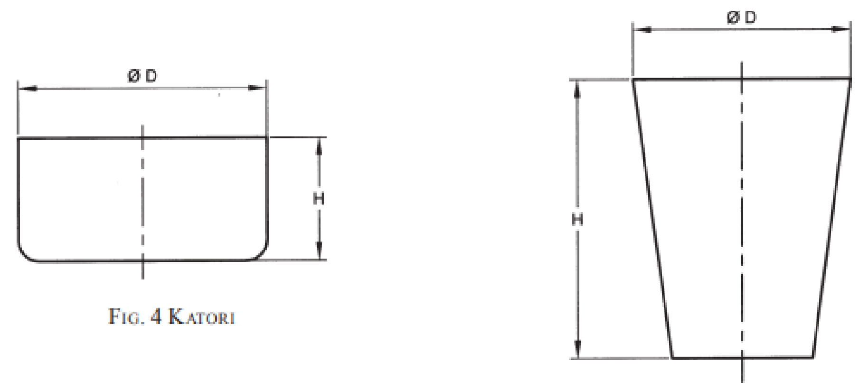 

Fig. 4 Katori Fig. 5 Tumbler

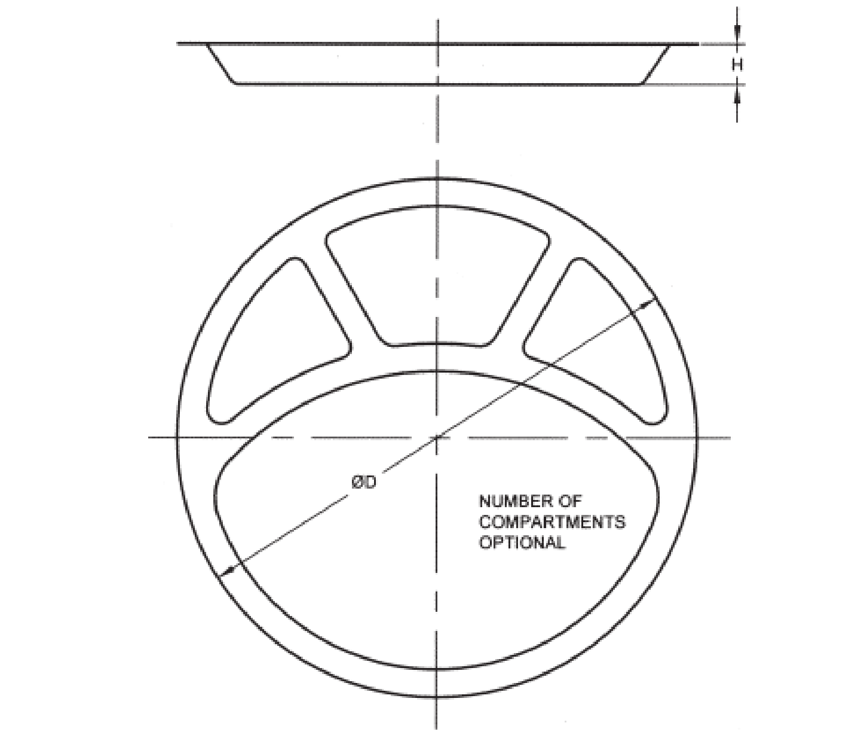

Fig. 6 Compartmental Tray, Round

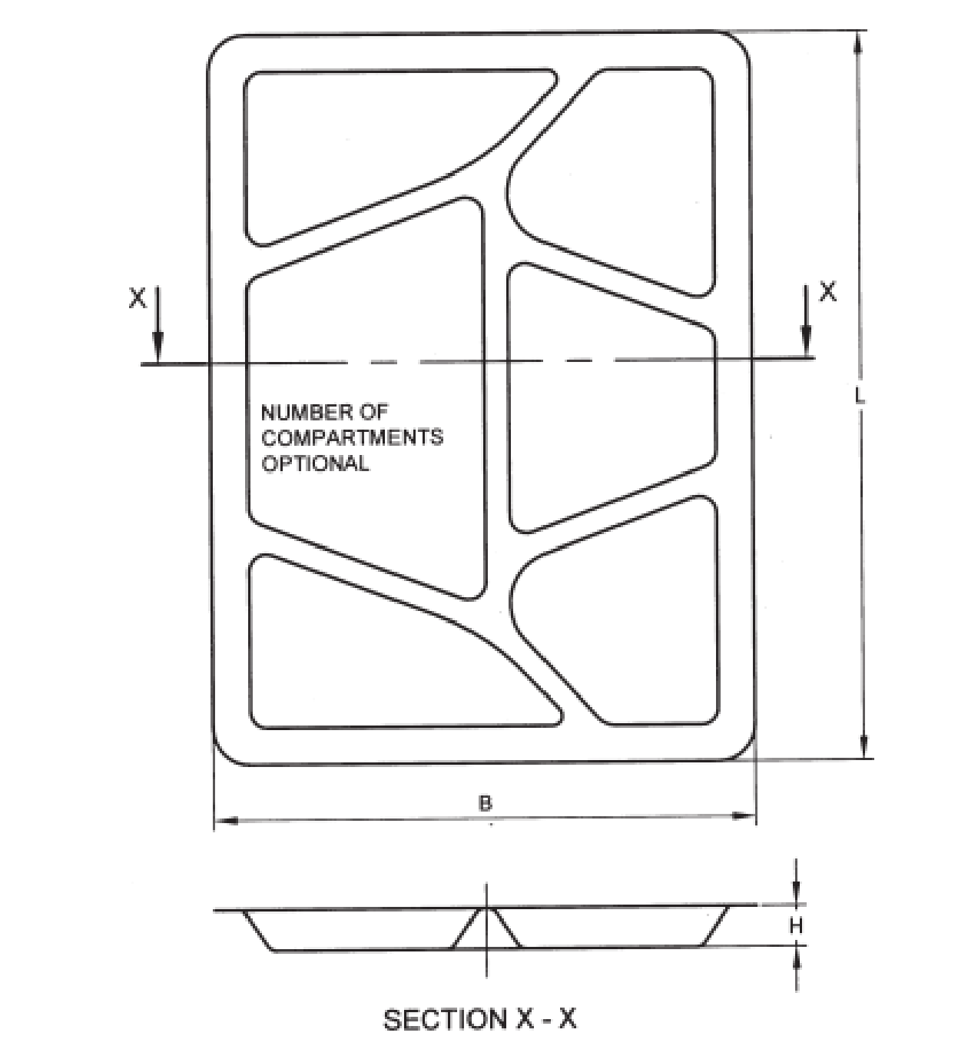

Fig. 7 Compartmental Tray, Rectangular

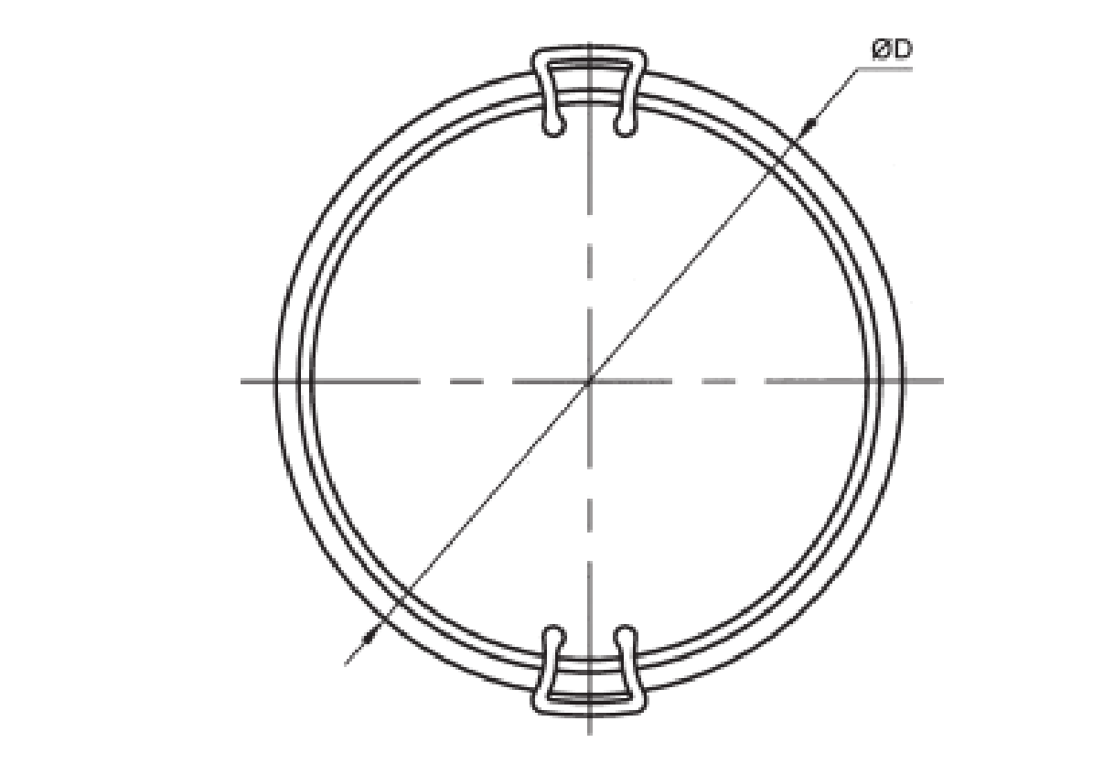

Fig. 8 Entree Dish, Round

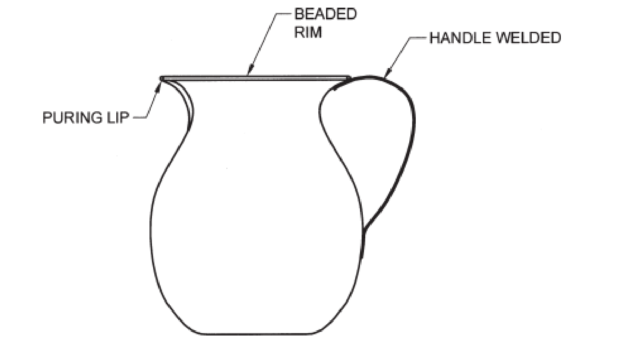

Fig. 9 Jug Typical

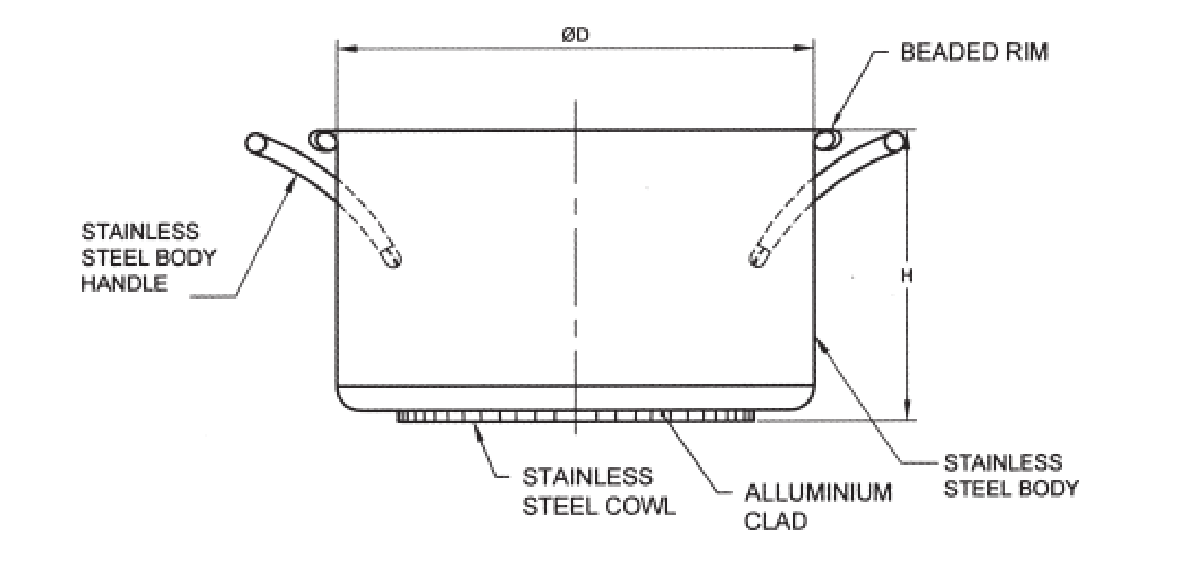

Fig. 10 Casserole With Cladded Base

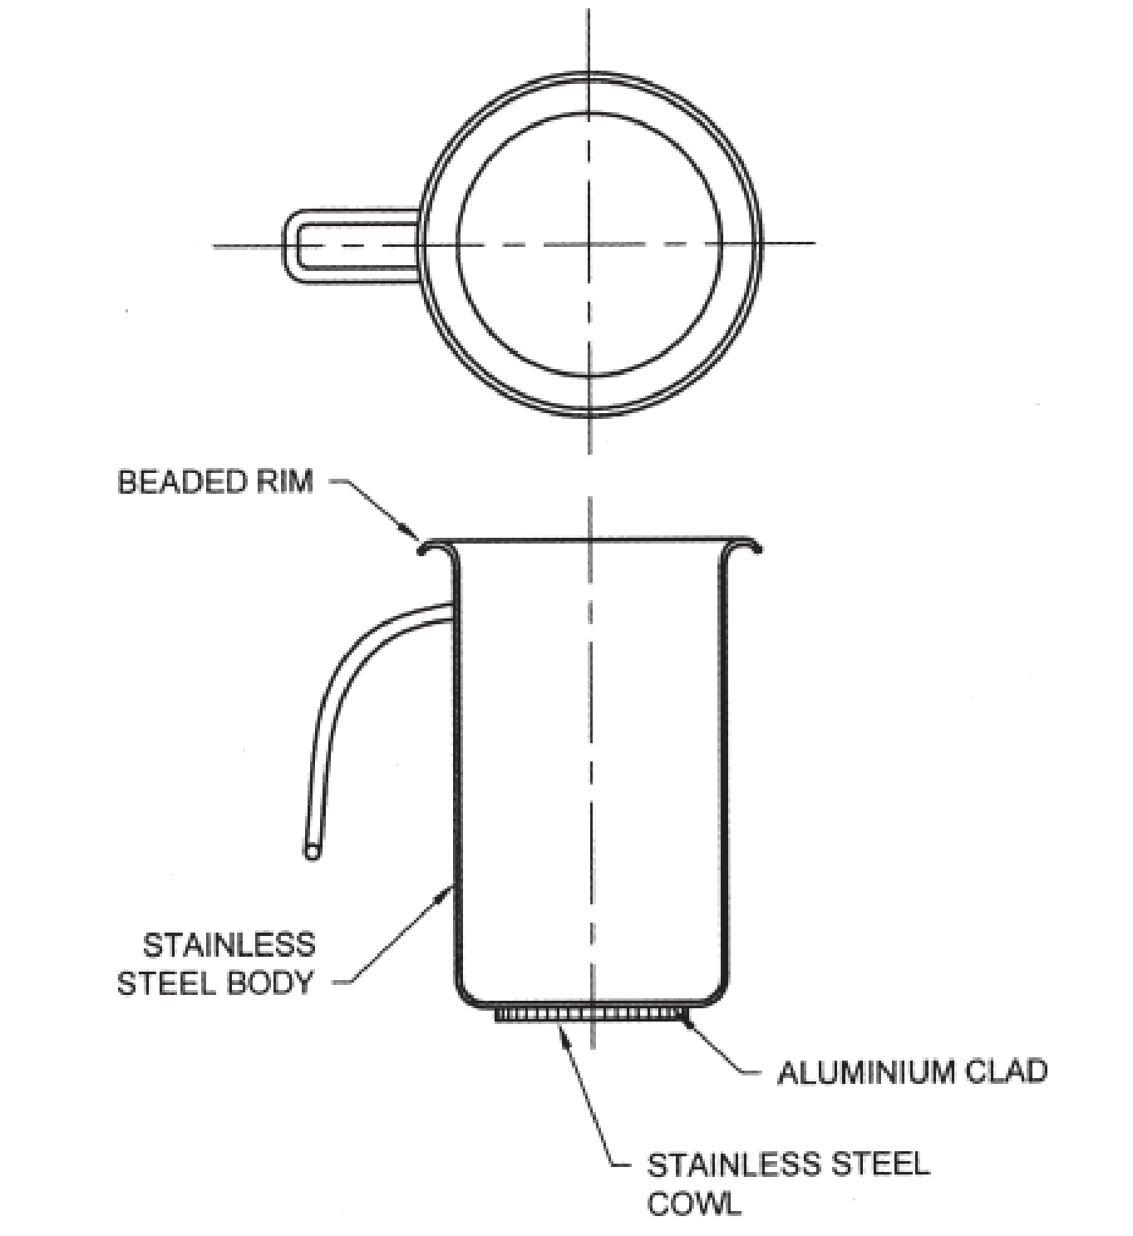

Fig. 11 Jug With Cladded Base

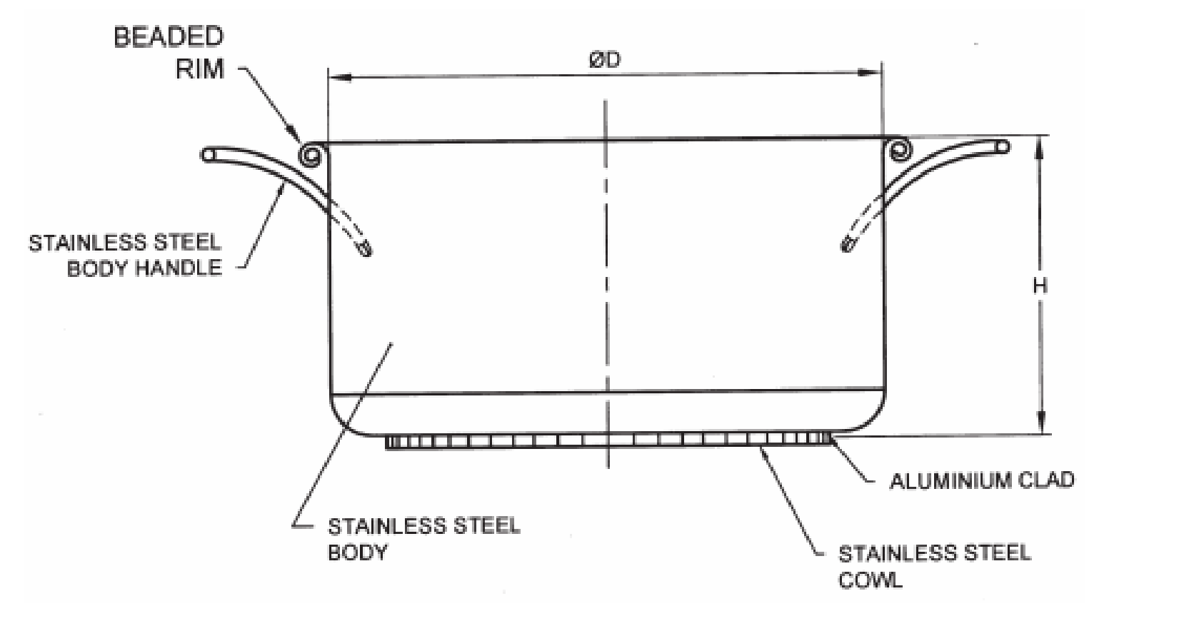

Fig. 12 Deep Pot With Cladded Base

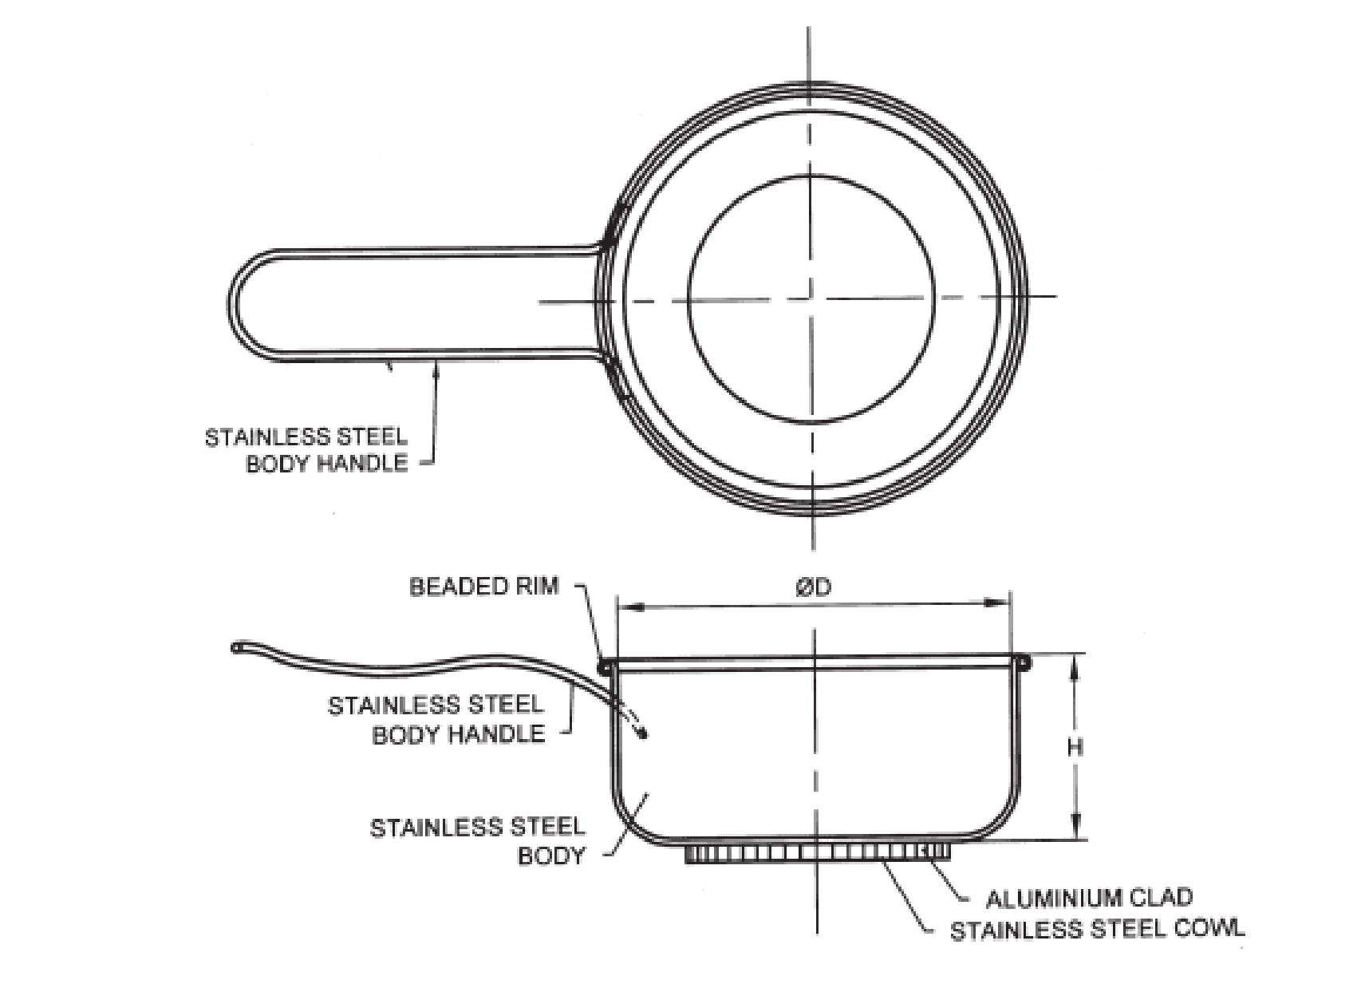

Fig. 13 Fry Pan With Cladded Base

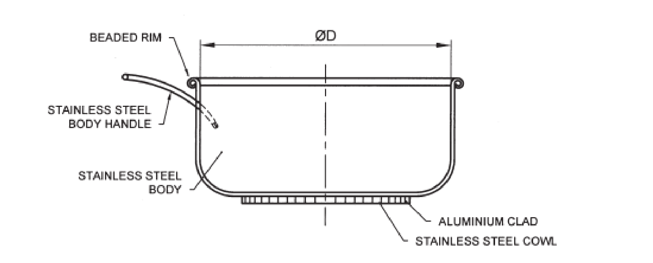

Fig. 14 Sauce Pan With Cladded Base

# ANNEX C

**TEST METHOD FOR LEACHING OF FOOD GRADE**

**STAINLESS STEEL (TYPE TEST)**

(*Clause* 3.5)

# GENERAL

**C-1**.**1** Stainless steel coupons are collected/made to conduct leaching in food simulated medium through analytical studies. Coupons shall be of dimensions 70 mm (length) × 50 mm (breath) × t mm (thickness of RM sheet used) with weld in the center parallel to the breadth. For welding and finish, please refer to Annex E.

**C-1.2** Details of stimulants are given below:

* + 1. 3% acetic acid — Solution prepared by diluting 30 g of acetic acid with distilled water to a volume of 1 litre and;
    2. 4% NaCl (common salt) — Solution prepared by diluting 40 g of NaCL (common salt) with distilled water to a volume of 1 litre.

**C-1.3** Following instruments / equipment’s are required for carrying out this test:

1. Inductively coupled plasma – mass spectrometer (ICP – MS);
2. Millipore water purification system or Distilled water;
3. Hot plate ambassador, with energy regulator; and
4. Calibrated Vernier calliper.

# PROCEDURE

**C-2.1** Different beaker/Petri Dish containing one coupon each in the different simulated food are to be heated to boiling temperature and soaked at the same temperature for 30 minutes*. At the same time, prepare a sample blank also. The sample blank shall contain only simulated food medium without coupon.

**C-2.2** After soaking, remove the coupons using cleaned tongs and cool to ambient temperature.

NOTE — *Soaking can be in boiling temperature for 30 minutes / 70 °C for 2 hours / 40 °C for 10 days

# METHOD OF ANALYSIS ON ICP-MS

The leaching solution shall be analysed for the presence of Fe, Cu, Ni, Cr and Mn and other elements on the ICP-MS.

# CALCULATIONS

The values of the presence of Fe, Cu, Ni, Cr and Mn and other elements are analysed using ICP-MS. The value of sample blank shall be subtracted from it. Then, resultant values shall be normalized with respect to the area of the coupon in contact with simulated food medium, per unit volume of the simulator food item, so that the final concentration is given in mg/kg. Resultant values for Fe, Cu, Ni, Cr and Mn and other elements shall not be more than specific release limits (SRLs) given below:

|  |  |
| --- | --- |
| *Element(s)* | *Specific Release Limit*  *(SRL)*  *(mg/kg)* |
| Antimony | 0.04 |
| Arsenic | 0.002 |
| Chromium | 0.25 |
| Cobalt | 0.02 |
| Copper | 4 |
| Iron | 40 |
| Lead | 0.01 |
| Manganese | 1.8 |
| Mercury | 0.003 |
| Molybdenum | 0.12 |
| Nickel | 0.14 |
| Tin | 100 |

# ANNEX D

**SENSORIAL TEST METHOD (TYPE TEST)**

(*Clause* 3.5)

**D-1** **FOOD STIMULANT**

Distilled Water

**D-2** **TEST PROCEDURE**

Fill the flask / Bottle with 95 °C distilled water, ensure the welded portion is in touch with the water, close the cap/lid and soak till the temperature of distilled water reaches ambient water temperature. At the same time, similarly prepare a sample blank, the water should not touch the welded portion, follow the protocol as cited above.

**D-3** **ACCEPTANCE CRITERIA**

Transfer of taste and smell to the distilled water shall be less than 3. The distilled water samples of soaked and blank are smelled and tasted by a minimum of 5 personnel and results tabulated. The average of the results tabulated shall be taken for acceptance criteria.

NOTE — Evaluation criteria for transfer of taste and smell are as follows:

0 = No Discernible Deviation

1 = Barely Discernible Deviation

2 = Weak Deviation

3 = Clear Deviation

4 = Strong Deviation

**ANNEX E**

**WELDING AND FINISHING**

(*Clause* 3.5 *and* 5.5)

**E-1 GENERAL**

Tungsten Inert Gas Welding (TIG) welding is the preferred process because there is no flux or cleaning agent involved. The metal joints shall have clean TIG welding. Mechanical cleaning followed by chemical cleaning shall be done on joints.

NOTE — Mechanical processes may include any of the processes like grinding, filing, sanding, sandblasting, and brushing. Chemical processes use solvents and acids to remove paint, oil, grease, and oxide.

**E-2 PROCEDURE**

1. TIG welding shall be used.
2. Preferred filler material grade 308L (07Cr18Ni9) as per IS 5856 to be used.
3. After the weld, the weld surface and adjacent area to be grinded using 60 Grit wheel.
4. Clean the weld surface and adjacent area using a brush.
5. Polish the weld and adjacent area in the following sequence:
6. 120 Grit.
7. 200 Grit.
8. 400 Grit.
9. Jute brush.
10. Hard buff; and
11. Clean with chalk powder or electro polishing.

**ANNEX F**

(*Foreword*)

**COMMITTEE COMPOSITION**

Utensils, Cutlery Domestic Hardware Sectional Committee, MED 33

|  |  |
| --- | --- |
| *Organization* | *Representative(s)* |
| In Personal Capacity, Chennai | Shri G. Shanmuganathan (***Chairperson***) |
| All India Stainless Steel Industries Association, Mumbai | Shri Sailesh Shah  Shri Jagesh Jain (*Alternate*) |
| Anna Aluminium Company Private Limited, Kizhakkambalam, Kerala | Shri K. Chandrashekran Pillai  Shri V. Thulasidharan (*Alternate*) |
| Autopress India Private Limited, Pune | Shri Rajiv Agarwal  Shri Kush Agarwal (*Alternate* I)  Shri Dhruv Agarwal (*Alternate* II) |
| Butterfly Gandhimathi Appliances Private Limited, Chennai | Shri S. R. Sivakumar  Shri Kumar A (*Alternate*)  Shri Ramasubramanian (*YP*) |
| Central Public Works Department, New Delhi | Shri Prem Mohan  Shri Dinesh K Ujjainia (*Alternate*) |
| Consumer Voice, New Delhi | Shri B. K. Mukhopadhyay  Mr. M. A. U. Khan (*Alternate*) |
| D. P. Garg and Company Private Limited, Noida | Shri S. M. Garg  K.S. Arya (*Alternate*) |
| Delhi Test House, Delhi | Shri Dinesh Goel  Shri Rohit Goel (*Alternate*) |
| Directorate General Quality Assurance, Ministry of Defence, Kanpur | Shri M. Satyanarayana  Shri Amiya Kumar Mallick (*Alternate*) |
| Federation of All India Aluminium Utensils Manufacturers, Rourkela | Shri Bharat Garg  Shri Tarun Kumar Goyal (*Alternate*) |
| Federation of Hardware MFG and Traders Welfare Association, Gurgaon | Shri Takshay Bansal  Shri Naveen Handa (*Alternate* I)  Shri Vikas Narwal (*Alternate* II) |
| Godrej and Boyce Manufacturing Company Limited, Mumbai | Shri Deodatta Joshi  Shri Kshitij R. Gaikar (*Alternate*) |
| Hamilton Housewares Private Limited, Mumbai | Shri Sanjay Moreshwar Mhatre  Shri Induprakash Singh (*Alternate* I)  Shri Vikas Surendra Kumar Bhatia (*Alternate* II) |
| Hawkins Cookers Limited, Thane | Shri Rajesh Sharma  Shri Sanjay Sasikumar (*Alternate* I)  Shri Ravindra Mali (*Alternate* II) |
| Hindalco Industries Limited, Mumbai | Shri Devesh Kumar  Shri Atul Gupta (*Alternate*) |
| Indian Stainless Steel Development Association, Gurugram | Shri Rohit Kumar  Shri Akshaya Kumar Sharma (*Alternate*) |
| Jindal Stainless Limited, Hisar, Haryana | Shri Biswabasu Roy  Smt Nisha Goel (*Alternate*) |
| Nanobot Housewares Solutions Private Limited, Jodhpur | Shri Vikas Jain  Shri Manoj Jain (*Alternate*)  Shri Shantanu Rajpurohit (*YP*) |
| Office of Development Commissioner (MSME), New Delhi | Shri Suvankar Santra |
| Pritam International, New Delhi | Shri Rahul Khera  Shri Rohit Khera (*Alternate*) |
| Royal Kitchen Appliances Private Limited, Haryana | Shri Suresh Agarwal |
| Sat Rattan Engineering Works, New Delhi | Shri G. L. Khera |
| Shriram Institute for Industrial Research, Delhi | Shri Alok Kumar  Shri Aneesh Kumar (*Alternate* I)  Shri Puneet Kapoor (*Alternate* II) |
| Sivanesan Company, Chennai | Shri N. Manikanda Raja  Smt. K S Nethra Manjari (*Alternate*) |
| Steel Authority of India Limited (SAIL) - Salem Steel Plant, Salem, Tamil Nadu | Shri L. Sivakumar  Shri Sunil Kumar Murathia (*Alternate*) |
| TTK Prestige Limited, Bengaluru | Shri Anto Vimal Anand  Shri S. Rajasekaran (*Alternate*) |
| *In Personal Capacity*  *179, Sri Sai, 13th Cross, Ananthnagar Phase 1, Electronic City Post*), *Bengaluru* | Shri B. Viswanath Shenoy |
| BIS Directorate General | Shri K Venkateswara Rao, Scientist ‘F’/Senior Director and Head (Mechanical Engineering)  [Representing Director General (*Ex-officio*)] |

*Member Secretary*

Shri Lokraj Meena

Scientist ‘C’/Deputy Director

(Mechanical Engineering), BIS

Panel for Review of IS 14756, MED 33: Panel 1

|  |  |
| --- | --- |
| *Organization(s)* | *Representative(s)* |
| *In Personal Capacity*  *179, Sri Sai, 13th Cross, Ananthnagar Phase 1, Electronic City Post*), *Bengaluru* | Shri B. Viswanath Shenoy (***Convener***) |
| All India Stainless Steel Industries Association, Mumbai | Sailesh Shah  Shri Jagesh Jain (*Alternate*) |
| Autopress India Private Limited, Pune | Shri Rajiv Agarwal |
| Avon Appliances Private Limited, Ankleshwar | Shri Ashwin Vora |
| Butterfly Gandhimathi Appliances Private Limited, Chennai | Shri S. R. Sivakumar  Shri Kumar A (*Alternate* I)  Shri Ramasubramanian (*Alternate* II) |
| Directorate General of Quality Assurance, Ministry of Defence, Kanpur | Shri M Satyanarayana |
| Hawkins Cookers Limited, Thane | Shri B. S. Sethi  Shri Ravindra Mali (*Alternate*) |
| Indian Stainless Steel Development Association, Gurugram | Shri Rohit Kumar |
| Jindal Stainless Limited, Hisar | Smt. Nisha Goel |
| Rajasthan Stainless Steel Utensils Manufacturer Association, Jodhpur | Shri Rajesh Jeerawla  Shri Rohan Jeerawla (*Alternate*) |
| Rajlaxmi Stainless Steel Utensils Manufacturers, Jodhpur | Shri Sushil Jain |
| Sat Rattan Engineering Works, New Delhi | Shri G. L. Khera |
| Shriram Institute for Industrial Research, Delhi | Shri Aneesh Kumar |
| Sivanesan Company, Chennai | Shri N. ManikandaN Raja  K S Nethra Manjari (*Alternate*) |
| Stainless Steel Merchants Association, Mumbai | Shri Sunil Agarwal  Shri Ramsesh Kotadia (*Alternate*)  Shri Kalpesh Shah (*Alternate*) |
| TTK Prestige Limited, Bengaluru | Shri S. Rajasekaran  Shri Anto Vimal Anand (*Alternate*) |
| Voluntary Organisation in Interest of Consumer Education (VOICE), New Delhi | SHRI M. A. U. Khan |
| Wazirpur Bartan Nirmata Sangh, Wazirpur | Shri Jai Kumar Bansal  Shri Neeraj Jain (*Alternate*) |