भारतीय मानक

*नगरपालिका प्रशासन –*

*भाग 5: नगरपालिका शिकायत निवारण –*

*अनुभाग 1: वर्गिकी*

Indian Standard

*Municipal Governance –*

*Part 5: Municipal Grievance Redressal –*

*Section 1: Taxonomy*

***ICS 33.020, 35.020***

**© BIS 2024**

**BUREAU OF INDIAN STANDARDS**

**MANAK BHAVAN, 9 BAHADUR SHAH ZAFAR MARG**

**NEW DELHI 110002**

**December 2024 Price Group: XXXX**

Smart Infrastructure Sectional Committee LITD 28

**FOREWORD**

This Indian Standard (Part 5/Sec 1) was adopted by the Bureau of Indian Standards, after the draft finalized by the Smart Infrastructure Sectional Committee LITD 28, had been approved by the Electronics and Information Technology Division Council.

Over the past two decades, India has witnessed the role of technology as an enabler for development and progress. India is poised to lead the digital revolution and our cities can be the primary beneficiary. Our ability to seamlessly adopt emerging technologies into urban governance holds the key to a powerful story of transformation in India’s journey towards becoming an economic powerhouse. Responding to this pressing necessity, National Institute of Urban Affairs is instituting the Centre for Digital Governance (CDG), an initiative to convene the digital efforts of the Ministry of Housing and Urban Affairs and also consolidate its existing efforts. National Urban Digital Mission (NUDM) launched in February 2021, aims to build a shared digital infrastructure that will strengthen the capacity of the urban ecosystem to solve complex problems at scale and speed. Thus improve the ease of living for citizens through accessible, inclusive, efficient and citizen centric governance across India’s 4800 towns and cities. The NUDM inherits the guiding principles of the National Urban Innovation Stack (NUIS) - Strategy and Approach paper, released by MoHUA in 2019 as a vehicle to accelerate the ecosystem for urban transformation. One of the key deliverables under NUDM is the creation/ adoption of standards which will enable improved information consistency, analytics, secure data access & transfer, smarter business processes; while also enabling diverse stakeholders to collaborate and their corresponding platforms and processes to interoperate seamlessly.

The other parts in this series of standards consist of the following individual parts of IS 18006.

Part 1: Reference Architecture

Part 3: Property Tax

Part 4: Fire NoC

Part 6: Trade License

Part 7: Water and Sewerage

Part 8: Building Plan Approval

For the purpose of deciding whether a particular requirement of this standard is complied with, the final value, observed or calculated, expressing the result of a test or analysis, shall be rounded off in accordance with IS 2: 2022 ‘Rules for rounding off numerical values (*Second Revision*)’. The number of significant places retained in the rounded off value should be the same as that of the specified value in this standard.

The composition of the LITD 28 Sectional Committee and Panel 13 responsible for the formulation of this standard is given at **Annex D**.

Contents

0 INTRODUCTION 5

0.1 Governing Principles in the Design of Knowledge Standard 5

**0.1.1** Minimalist 5

**0.1.2** Evolvable 6

**0.1.3** Modular 6

**0.1.4** Extendible 6

**0.1.5** Open 6

**0.1.6** Accessible & Inclusive 6

0.2 Sample Use Cases 6

0.2.1 Direct application 6

By storing, generating and using these important data elements (entities, stakeholders, processes & reports) in day-to-day operations 6

0.2.2 Indirect Application 7

1 SCOPE 7

2 REFERENCE 7

3 TERMINOLOGY AND ABBREVIATIONS 8

3.1 Terminology 8

3.2 Depicted Symbols 9

3.3 Abbreviations 9

4 Municipal Grievance Redressal 11

5 Taxonomy for Municipal Grievance Redressal 12

5.1 Municipal Grievance Redressal 12

**5.1.1** Grievance ID 14

**5.1.2** Grievance Details 14

**5.1.3** Grievance Location 14

**5.1.4** Originator Details 14

**5.1.5** MGR SLG Factors 14

**5.1.6** Grievance Status 16

**5.1.7** Grievance Severity 17

**5.1.8** Grievance Priority 17

**5.1.9** Nature of Grievance 17

**5.1.10** Grievance Function 18

**5.1.11** Grievance Resolution 19

**5.1.12** Grievance Rating 20

**5.1.13** Assigned To 20

**5.1.14** Evidence 20

**5.1.15** Grievance Instance 20

**5.1.16** ULB Type 21

5.2 Municipal Grievance Channel 21

**5.2.1** Digital 22

**5.2.2** Non-Digital 22

5.3 MGR Stakeholders 23

**5.3.1** Stakeholder Matrix 24

5.4 MGR Processes 28

**5.4.1** Grievance Creation 29

**5.4.2** Grievance Acknowledgement 30

**5.4.3** Grievance Assessment 30

**5.4.4** Grievance Tracking 31

**5.4.5** Grievance Monitoring 31

**5.4.6** Grievance Escalation 32

**5.4.7** Grievance Closure 33

**5.4.8** Grievance Feedback 33

**5.4.9** Grievance Verification 34

**5.4.10** Grievance Analysis 34

5.5 MGR Reports & KPIs 35

**5.5.1** MGR Reports 36

**5.5.2** MGR KPIs 37

ANNEX A: Sample Parameters And Specifications For Location 38

ANNEX B: Sample details of sub-functions with definitions within each function described in section 4.2.10 grievance function 39

ANNEX C: Sample Grievance Mapping Within Sub Function 46

Annex D: Committee Composition 47

BIBLIOGRAPHY 50

0 INTRODUCTION

Urban Governance in India is predominantly the constitutional domain of the State Government, who delegates power to Municipal Bodies/Urban Local Bodies (ULBs) through a specific legislation. The ULBs perform these functions, which allow them to interact with the citizens on a day-to-day basis, providing, managing and maintaining the community needs. A ULB manages its administration, budgeting and planning process to provide the basic needs to the communities. They promote the social and economic development of the communities. The ULB services provided to citizens include roads, water supply, sewerage, sanitation, street lighting, solid waste management etc. Since most of the citizen interaction happens at municipal level, these ULBs need to orient their activities towards the satisfaction of the citizens in their cities. Considering the scale at which these municipalities undertake their responsibilities, it is imperative that citizens often tend to report issues across various matters, in areas mentioned above, making it critical for any ULB to have an efficient Grievance Redressal system to ensure efficient, reliable and transparent functioning of any municipal body.

Initially the mechanism primarily existed at central and state level where citizens registered their grievances, which were redirected to the concerned department/institution. The systems at city level were manual/telephonic and mostly non-existent in many small towns and cities despite of Municipal Acts that empowered the ULBs to set up the grievance mechanism at local level.

ULBs across India have inconsistent taxonomies (terminology & vocabulary) for Municipal Governance. The Indian federal structures makes way for disparate laws and definitions that may have caused this natural incompatibility in definitions and standards and different eGovernance system implementations. Non-standardized interfaces and storage also lead to data interpretation and interoperability issues. Hence, when municipal performance is measured, there are glaring inconsistencies, not merely from city to city but also from state to state, Thus, without clear definitions, vocabulary, specifications and benchmarks for municipal governance, it is difficult to enable ‘Data Driven Governance’.

The municipal governance standards are being designed to have minimum base elements common across ULBs to ensure interoperability, harmonization and data driven governance. These can then be adopted and built upon by ULBs with higher process complexities.

The Municipal Grievance Redressal taxonomy defined in this standard includes common Municipal Grievance entities, channels, processes, stakeholders, reports and KPIs and their definitions. All definitions in this standard are notional definitions for conceptual purposes. The actual definition of entities for trade license purposes should be considered as per state and local legislations. The taxonomy structure in this document is scalable both vertically and horizontally to accommodate ULB specific complexities as well as change in people, process and technology over time. Municipal Grievance Taxonomy will be used in developing Municipal Grievance Data Models and API Specifications as well as for creating metadata specifications. This document is also interrelated with other Indian standards for eGovernance such as IS 18000 and IS 18006 (Part 1).

0.1 Governing Principles in the Design of Knowledge Standard

To ensure this taxonomy fits the needs of interested stakeholders the following principles have been followed in designing it.

0.1.1 Minimalist

The standards are designed to have minimum base elements common across ULBs to ensure interoperability, harmonization and data driven governance. These can then be adopted and built upon by some ULBs with higher process complexities.

0.1.2 Evolvable

The standard is designed to evolve over a period of time thereby adapting to changing needs and emerging technologies thus making the system comprehensive progressively.

0.1.3 Modular

The classifications and categorizations in the knowledge standard are designed modularly, yet they function together as a whole. They are independent and self-contained and may be combined and configured with similar units to suit separate contexts. E.g., The Property “Use” element and its sub classifications can be easily reapplied in the context of any Building Plan Approval System or Trade License System.

0.1.4 Extendible

The standard is designed to be exhaustive and the elements of Urban Governance are positioned in a hierarchy which can accommodate both horizontal and vertical additions. This leaves room for wider adoption and innovation to suit contexts of any ecosystem. The end goal is to build a knowledge practice that supports Open Standards with the Data Element taxonomy as a base.

0.1.5 Open

The standard is designed to be ‘open’ to enable wider ecosystem participation and use. The standard is intended to be used by State Governments, Urban Local Bodies, industry and technology providers, academia and civil society organizations who are either working in the domain or are providing services to the ULBs in any manner.

0.1.6 Accessible & Inclusive

The standard is designed to be inclusive and accessible in nature for all types of stakeholders. The standard will enable the technology to reach every section of society. For e.g.: Interactive Voice Responses and non- digital channels as included in the section 2 will enable the marginalized and differently abled citizen to use the service in a more efficient manner. Also, stakeholders such as intermediators can also help in building capacities or creating awareness.

0.2 Sample Use Cases

Samples of Municipal Grievance Redressal Taxonomy use cases are mentioned below for reference

0.2.1 Direct application

By storing, generating and using these important data elements (entities, stakeholders, processes & reports) in day-to-day operations

1. Designated ULB official can use this to add channels and ULB type (such as Nagar Panchayat, Municipal Corporation or Municipal Council) in the MGR system. This will help the ULBs to assess the application while acknowledging and processing the grievance request.
2. While registering grievance, nature of grievance (short term for issues vs long term for service requests) is also captured which will bring clarity to designated ULB departments while grievance resolution and expected nature of resolution.
3. Monitoring grievances based on grievance instances and grievance functions will help in empowering ULB officials to take data driven actions and achieve SLGs, thereby improving overall service delivery to the citizen.
4. Monitoring of grievances by their status, their SLB adherence and channels from which the transaction happens also empowers ULB Officials to take corrective and preventive steps as needed.

0.2.2 Indirect Application

By using these data elements in evidence-based governance and long- term planning

1. Analysing grievances based on SLGs, priority and severity can help check quality of service. This helps in improving the efficiency, accountability, responsiveness and transparency of a ULB, ultimately leading to improvement in service delivery and maintaining trust of citizens.

0.2.3 Information consistency

By using these data elements while using and sharing data (via Metadata tags in reports and dashboard)

1. Consistent use of data elements, processes, KPIs and their definitions from this Knowledge Standard helps in implementing Information consistency across ULBs. To ensure information consistency, ULBs may use new or existing platforms for delivering MGR services. They should use Metadata tags from the data elements defined in this knowledge standard.
2. Section 5.1 captures Key data elements associated with the MGR services Data Entity.
3. Section 5.2 captures key channels of transactions i.e., new application/ grievance registration/ payment etc.
4. Section 5.3 captures key stakeholders involved in MGR service delivery
5. Section 5.4 captures key processes within the MGR Service domain with clearly defined input & output data elements Section
6. Section 5.5 captures key Reports and KPIs that ULBs and states/UTs are encouraged to use.

1 SCOPE

This Indian standard provides a unified view of the Municipal Grievance Redressal and processes in a municipal corporation and introduces common and widely accepted terminologies and semantics that can be used across multiple systems. Taxonomy for MGR captures the most important entities, their properties, categories, subcategories, parameters, and specifications within this domain as well as other associated areas.

2 REFERENCE

The standard given below contains provisions which, through reference in this text, constitute provisions of this standard. At the time of publication, the editions indicated were valid. The standard is subject to revision, and parties to agreements based on this standard are encouraged to investigate the possibility of applying the most recent editions of these standards.

IS 18006 (Part 1) Municipal Governance - Reference Architecture

3 TERMINOLOGY AND ABBREVIATIONS

3.1 Terminology

For the purpose of this standard, the definitions given in IS 18006 shall apply, in addition to the following:

* + 1. *Aadhaar*

Aadhaar is a verifiable 12-digit identification number issued by Unique Identification Authority of India (UIDAI) to the resident of India.

* + 1. *Application Programming Interface (API)*

The term Application Programming Interface (API) means any mechanism that allows a system or service to access data or functionality provided by another system or service. The API is generally used to interact (like query, list, search, sometimes submit & update) directly with the specific information on a system, to trigger some action on other systems, or to perform some other action on other systems.

*iii. Data Elements*

The basic principle of data modelling is the combination of an Object class and an Attribute to form a more specific ‘data element concept’. For E.g.: Application ID, building details that are associated with a Data Entity (Such as Building Plan Approval)

iv. *Data Entities*

Entities were created to help users to locate their data elements from the entire list. However, this grouping should not be confused with data sets. Data sets are list of data elements required for a certain program or application to function and should be created choosing relevant data elements from various entities e.g. BPA, Trade License, Property Tax etc.

*v. DigiLocker*

DigiLocker is a secure cloud based platform for storage, sharing and verification of documents & certificates

*vi. Domain*

A sub-category under an Information Technology field is a Domain; specific purpose within a “Domain” is known as “Area”. For example, “Document type for Web publishing content” is one Area under the “Presentation” domain.

*vii. E-governance*

A procedural approach in which the Government and the citizens, businesses, and other stakeholders are able to transact all or part of their activities using Information and Communication Technology tools

*viii. Interoperability*

The ability of different information technology systems and software applications to communicate, exchange data, and use the information that has been exchanged.

*ix. Metadata*

Metadata is data about data. Metadata describes how and when and by whom a particular set of data was collected. Metadata is essential for understanding the information stored

3.2 Depicted Symbols

Domain is depicted as for e.g. Municipal Grievance Redressal

Data Entities are depicted as for e.g. Grievance Details

Channels are depicted as for e.g. MGR Channels

Stakeholders are depicted as for e.g. Stakeholder Matrix

Processes are depicted as for e.g. Grievance Creation, Grievance Acknowledgement

Reports & KPIs are depicted as for e.g. Feedback Report

3.3 Abbreviations

|  |  |
| --- | --- |
| AMRUT | Atal Mission for Rejuvenation and Urban Transformation |
| ACE | Assistant Chief Engineer |
| ATP | Assistant Town Planner |
| BIS | Bureau of Indian Standards |
| CAA | Constitution Amendment Act |
| CCTV | Closed Circuit Television |
| CDG | Centre for Digital Governance |
| CE | Chief Engineer |
| CM | Chief Minister |
| CPGRAMS | Centralized Public Grievance Redress and Monitoring System |
| CSC | Common Service Center |
| CSI | Chief Sanitation Inspector |
| DPR | Detail Project Report |
| DTMF | Dual Tone Multi-Frequency |
| GIS | Geographic Information System |
| GRO | Grievance Redressal Officer |
| ICT | Information and Communication Technology |
| ID | Identification Document/Number |
| IVR | Interactive Voice Response |
| KPI | Key Performance Indicators |
| MGR | Municipal Grievance Redressal |
| MoHUA | Ministry of Housing & Urban Affairs |
| MTP | Municipal Town Planner |
| NIUA | National Institute of Urban Affairs |
| NMAM | National Municipal Accounting Manual |
| NOC | No Objection Certificate |
| NUDM | National Urban Digital Mission |
| O&M | Operation & Maintenance |
| PM | Prime Minister |
| SI | Sanitation Inspector |
| SLB | Service Level Benchmark |
| SLG | Service Level Guarantee |
| SMS | Short Message Service |
| UPYOG | Urban Platform for delivery of Online Governance |
| ULB | Urban Local Body/Bodies |

4 MUNICIPAL GRIEVANCE REDRESSAL

Urban Governance in India is predominantly the constitutional domain of the State Government, who delegates power to Municipal Bodies/Urban Local Bodies (ULBs) through a specific legislation. The ULBs perform these functions, which allow them to interact with the citizens on a day-to-day basis, providing, managing and maintaining the community needs. A ULB manages its administration and budgeting planning process to provide the basic needs to the communities. They promote the social and economic development of the communities. The ULB services provided to citizens include roads, water supply, sewerage, sanitation, street lighting, solid waste management etc. Most of the citizen interaction happens at Municipal level, thus these ULBs need to orient their activities towards the satisfaction of the citizens in their cities. Grievance redressal is hence an important function of an efficient, reliable and transparent municipal body

As ULBs are to interact with citizens on a day-to-day basis it is important that they provide a robust mechanism to redress their grievances as well. Initially the mechanism primarily existed at central and state level where citizens register their grievances, which were redirected to the concerned department/institution. The systems at city level were manual/telephonic and moreover many small towns and cities didn't have the mechanism, whereas the Municipal Acts empower the ULBs to set up the grievance mechanism at local level6 (Department Related Parliamentary Standing Committee on Personnel, Public Grievances, Law and Justice, 2008).

Post JNNURM reforms some cities developed the provisions of municipal grievance redressal through electronic mediums. Directive principle for the reform was - “*Along with area Sabha, Ward Councillor, committees and council, as platforms for citizen grievance redressal, there should be a formal technology enabled platform to register grievances. The grievance redressal mechanism should be centralized for all the public services delivered in the city (through any agency city/state/central) and then directed to the concerned department*.

As part of National Urban Digital Mission (NUDM), NIUA is also offering a platform UPYOG to states which offers Public Grievance Redressal functionality using Municipal Grievance Redressal (MGR) module.

The Grievance at municipal level should be addressed by the ULB. The grievances made by the citizens need to be categorized according to the different functions as provisioned under 74th Amendment and NMAM so as to enable harmonized access to information and a streamlined way of connecting urban departments to serve citizens better.

Municipal Grievance Redressal (MGR) is the multi-channel single window delivery mechanism where citizens can lodge their grievances to the ULB on various services rendered by the ULB for their ‘redressal’.

5 TAXONOMY FOR MUNICIPAL GRIEVANCE REDRESSAL

While building the knowledge models for Municipal Grievance Redressal systems, it is imperative to consider entities that are interlinked with Municipal Grievance Redressal. Municipal Grievance Redressal is a non-fee based service provided at ULB level, to directly interact with citizens and address their issues, take suggestions and fulfil various service requests, creation of grievance acknowledgement, assessment, resolution and feedback are the processes that operationalise the mobilization within a ULB. Hence, taxonomy for Municipal Grievance cannot be built in a silo and needs to be accompanied by entities like Municipal Grievance Redressal, Channels, Stakeholders, associated processes reports and KPIs.

A well-structured MGR taxonomy helps by:

1. Identification of recurring systemic problems enabling effective resolution of grievances
2. Building accountability and ensuring transparency
3. Building confidence among the citizens and encouraging public participation

The categorizations and sub-categorizations of terms used in the Municipal Grievance Redressal taxonomy are summarized in **5.1** to **5.5**. The categorizations and classifications primarily establish hierarchical relationship, and as a whole yield the taxonomy around Municipal Grievance Redressal. **See Fig 1.**

5.1 Municipal Grievance Redressal

Municipal Grievance is a complaint (against an unjust or unfair act’ or non-delivery of service, promised quality of service), service requests, feedback or suggestions to the ULB for services provided by them.

Additionally, ULBs may also capture further details as per their requirements such as compensation details (amount paid, days outside Service Level Benchmarks and Service Level Guarantees, cause of delay, date of payment) etc.

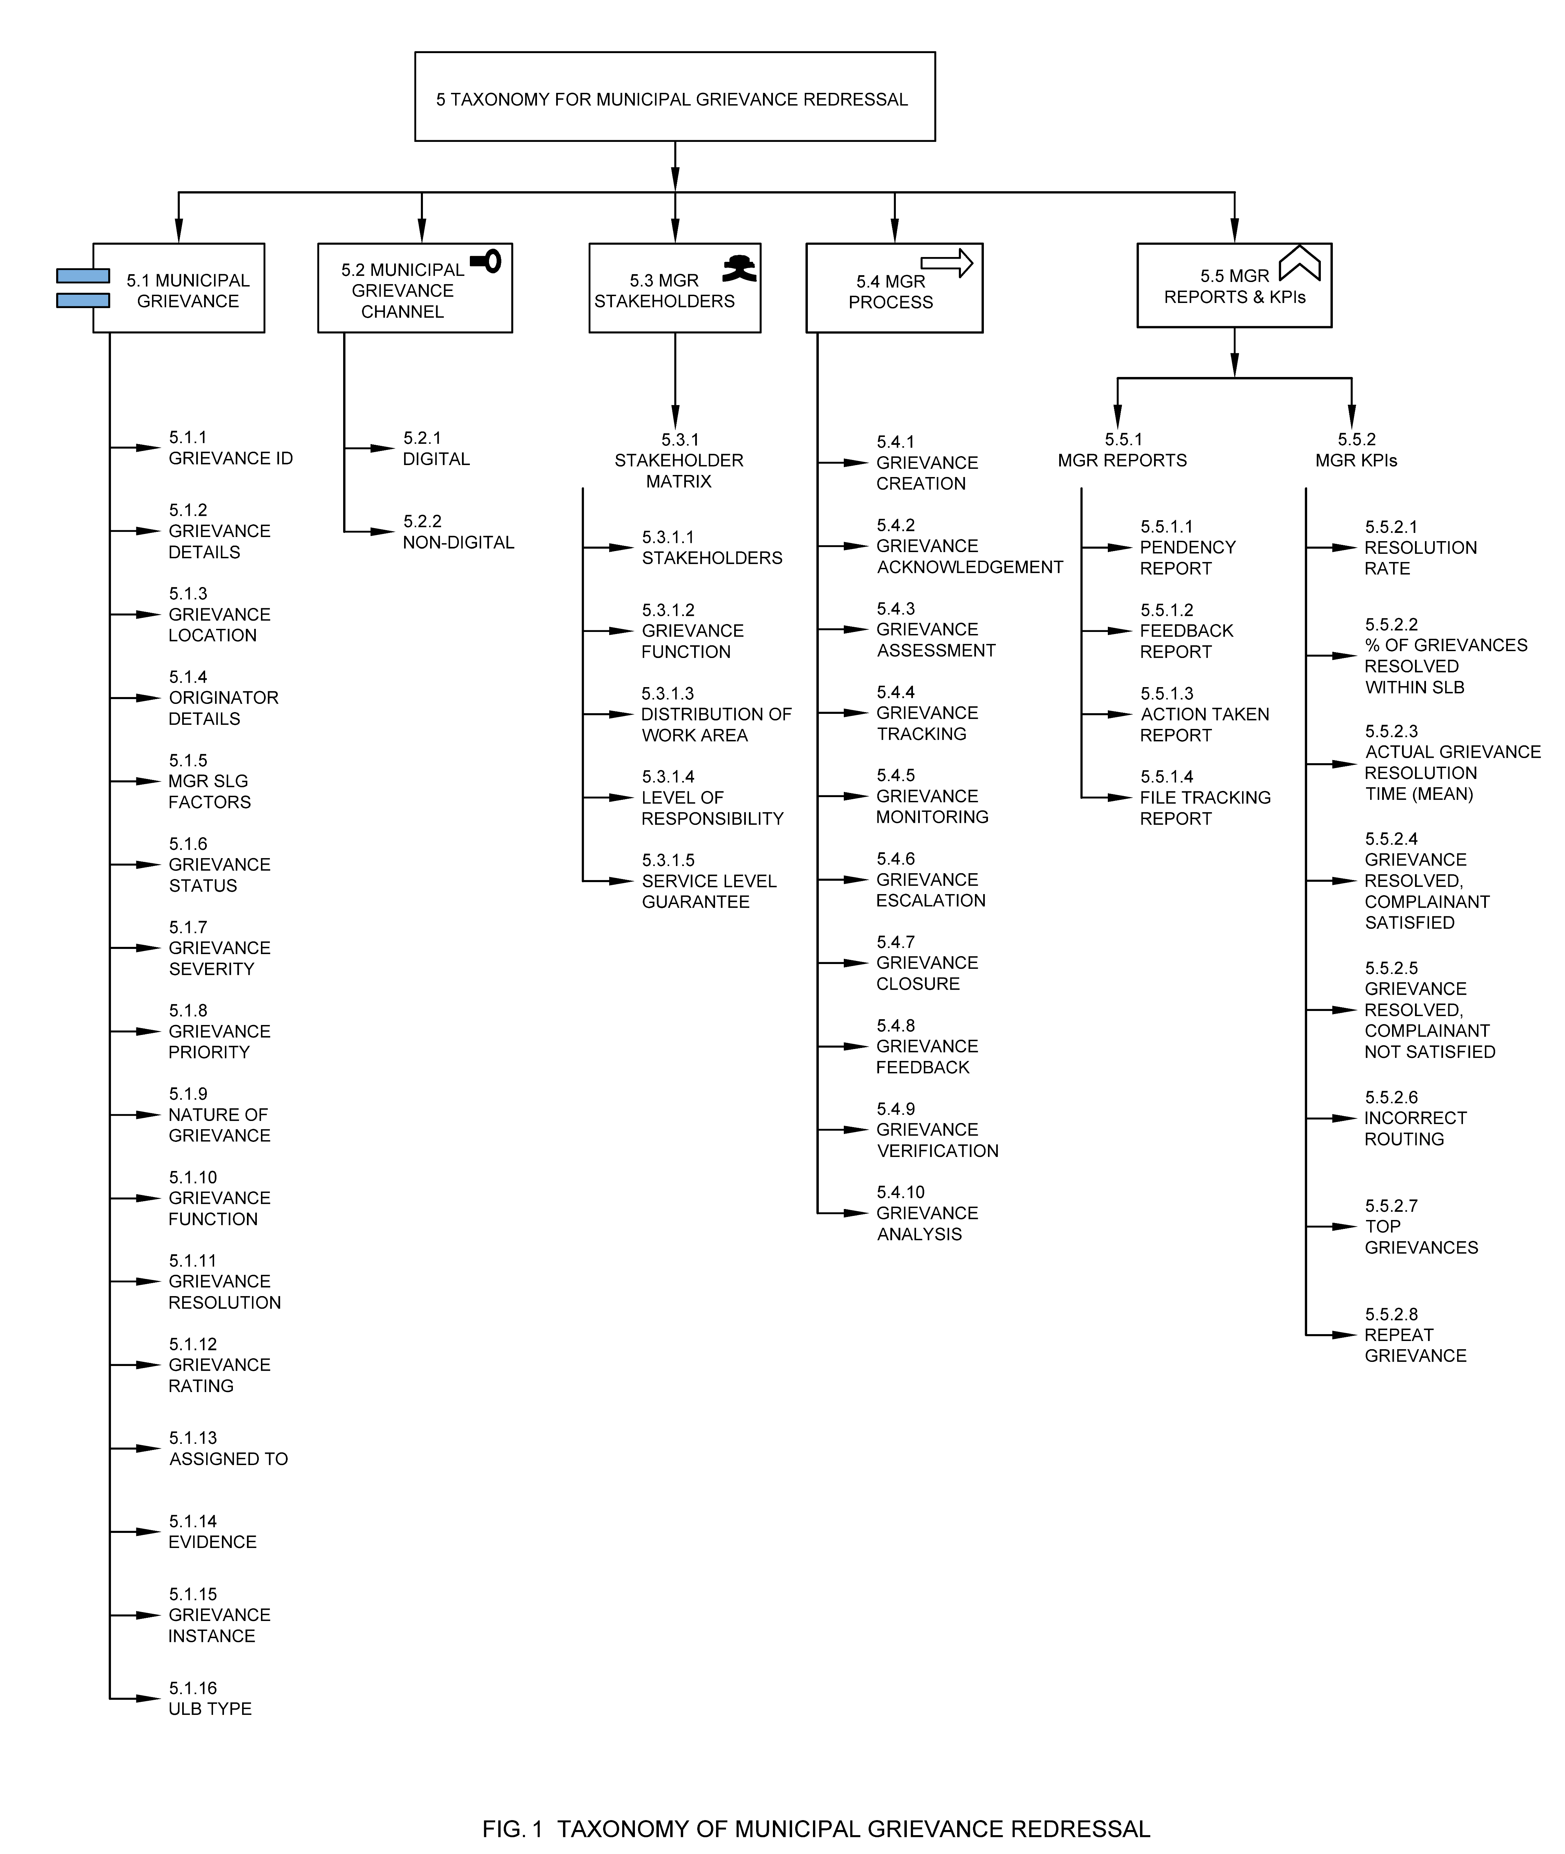

5.1.1 Grievance ID

Grievance ID is a unique identifier allotted to the grievance by the ULB for the purpose of grievance recording, allocation, assessment, follow up, and appeal.

5.1.2 Grievance Details

Grievance Details are the important details of the grievance captured by the citizen to explain the issue, request or suggestion that the citizen is making during grievance registration. It gives a picture of the grievance from the citizen's perspective.

5.1.3 Grievance Location

Grievance location is an important characteristic of the grievance that includes address, floor number, ward, zone etc. It also indicates the GIS positioning of a place where grievance occurred with respect to the urban base map. In the context of municipal grievance redressal, location does not have any categorizations, however, it does have certain specifications associated. They are exemplified in Annex-A Sample Parameters and Specifications for Location.

5.1.4 Originator Details

Details of the originator of the grievance, which can be an Individual or an organization. This may include their name, phone number, email ID and address. It is recommended that automated authentication be incorporated with other government documents and services such as Aadhaar, PAN, etc. **See Fig 2.**

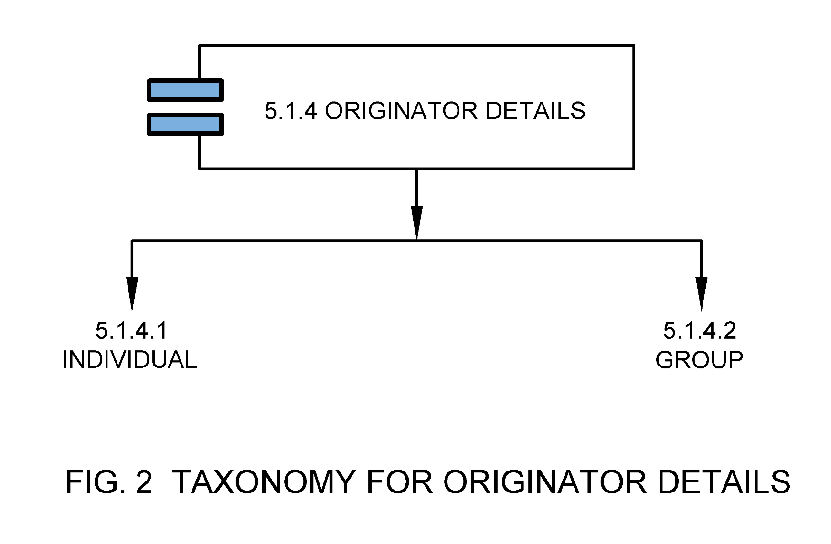

5.1.4.1 Individual

Grievance raised by an individual.

5.1.4.2 Group

Grievance raised by a group.

5.1.5 MGR SLG Factors

These are important factors associated with a grievance that determine or represent the timeliness aspect of grievance redressal. This includes time when grievance first occurred, time taken for redressal, SLG (Service Level Guarantee) and grievance dispatch date to department. **See Fig 3.**

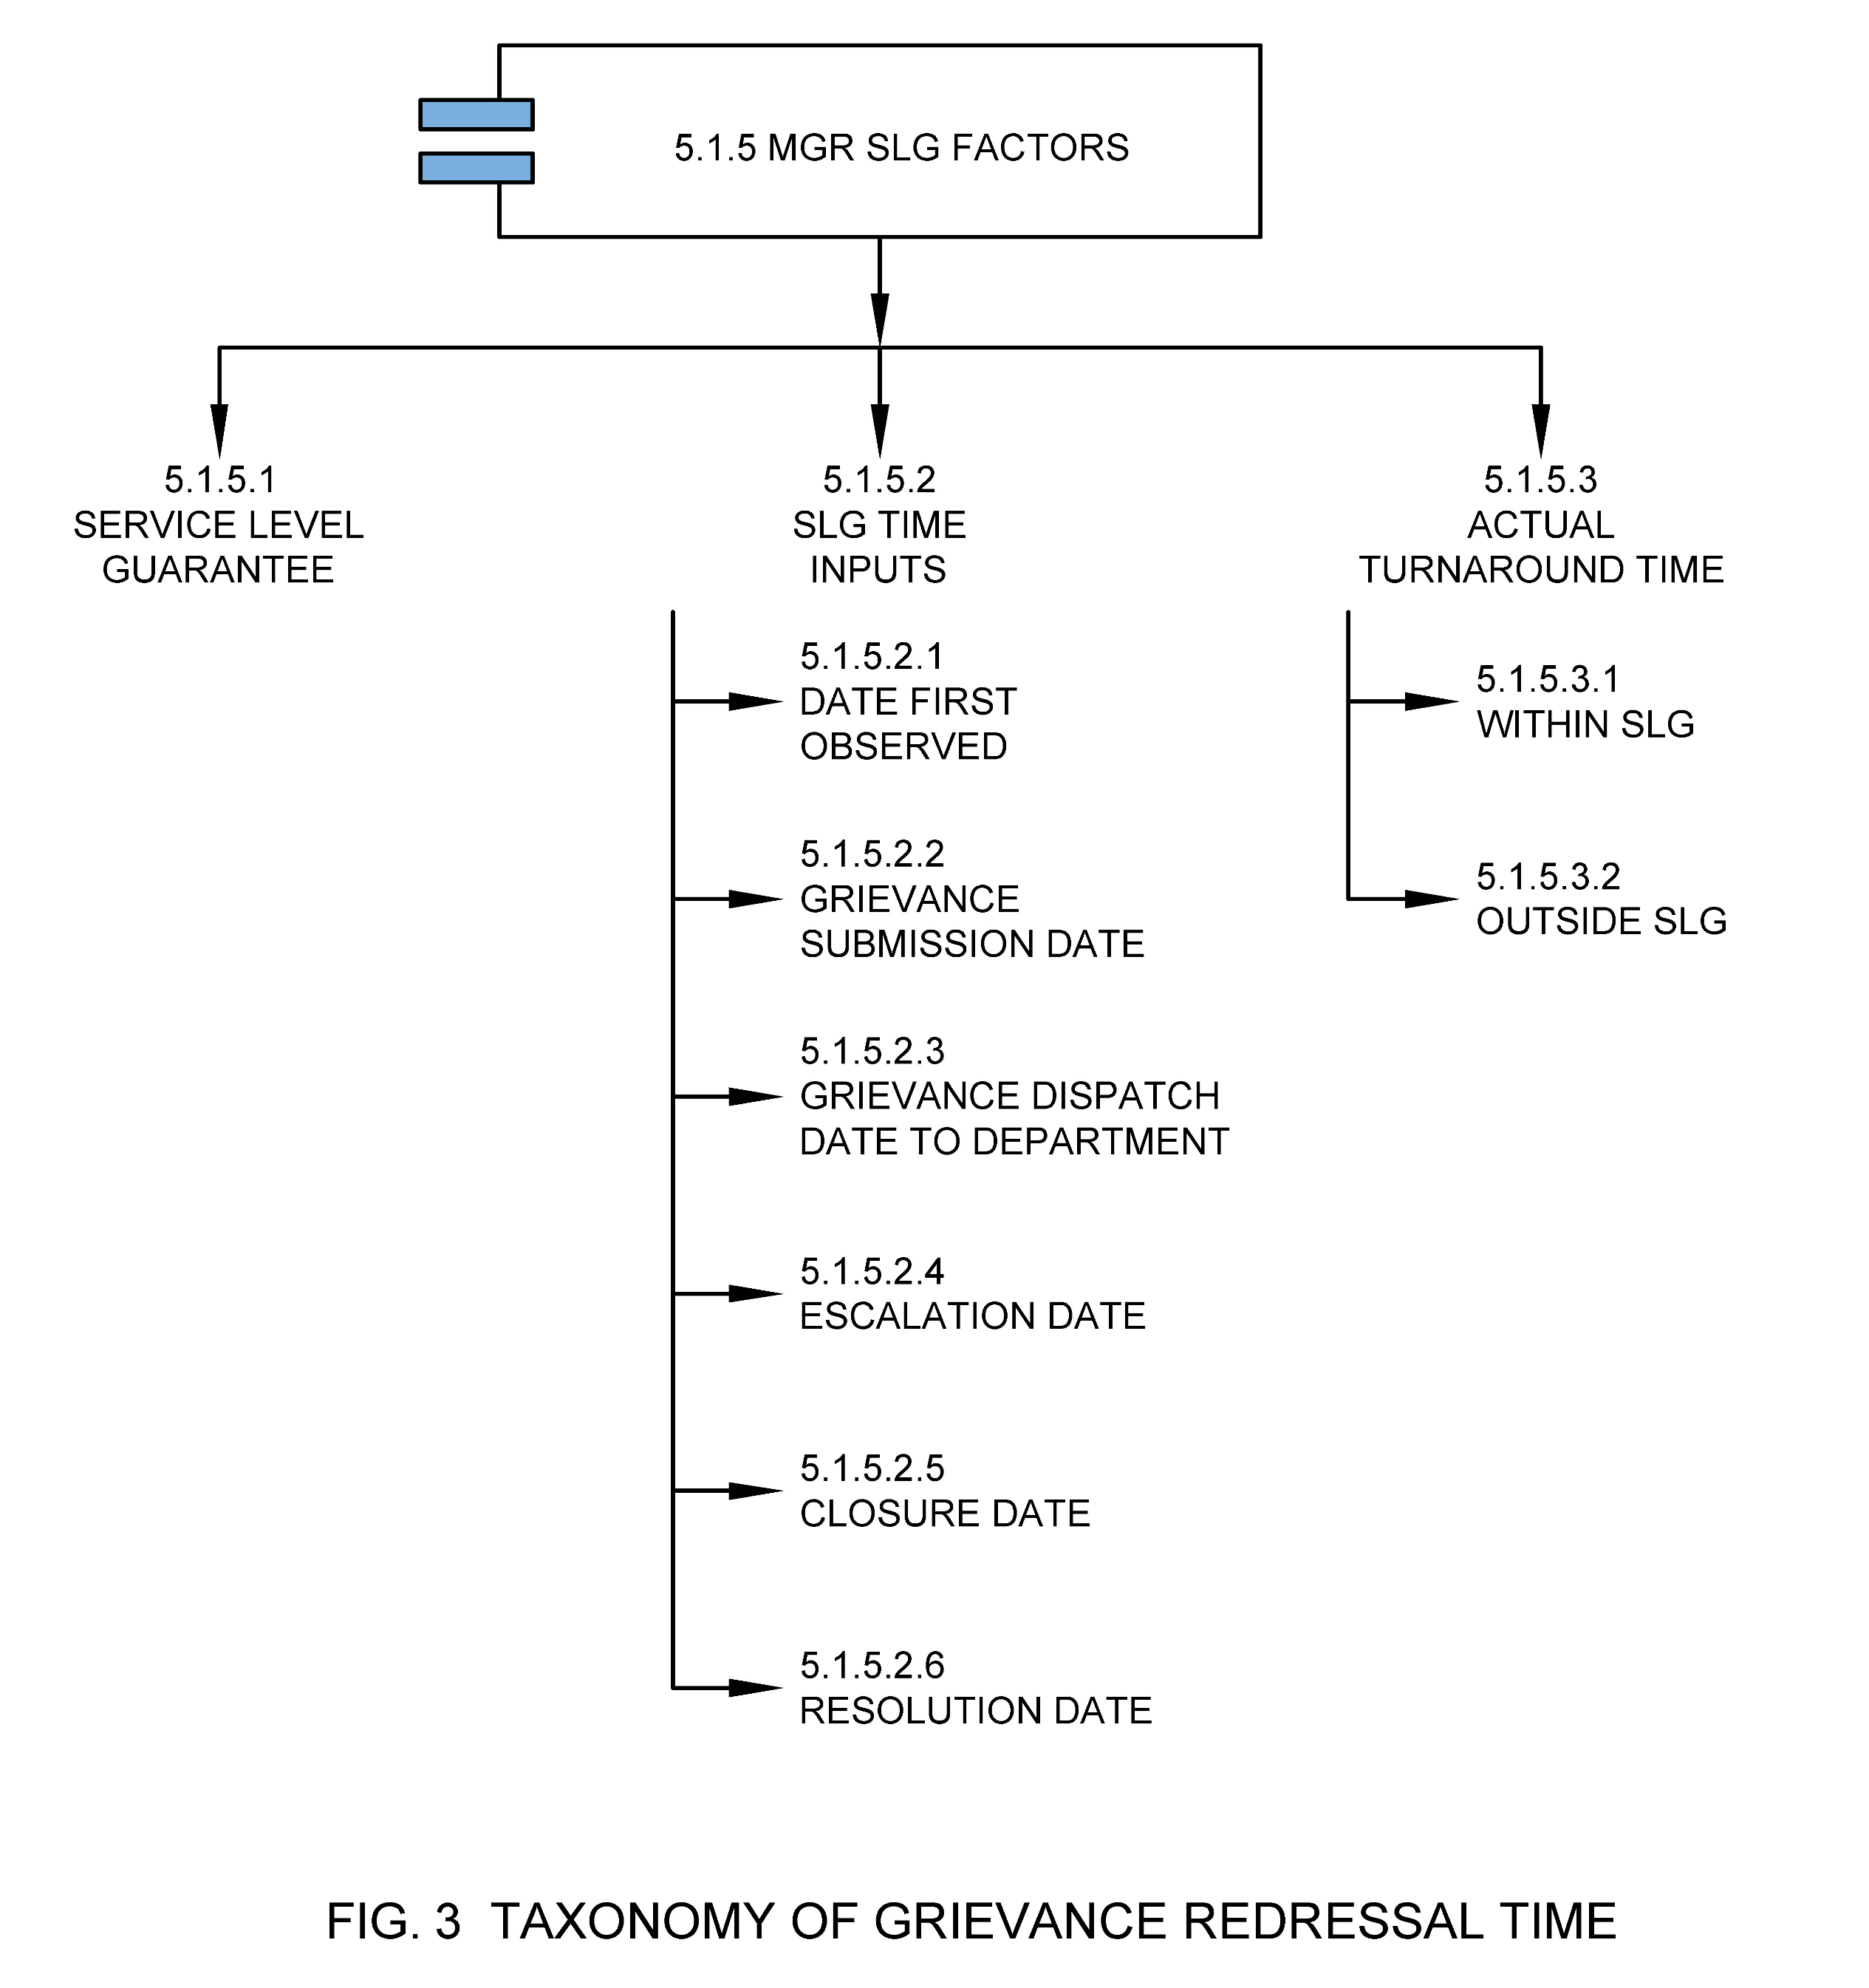

5.1.5.1 Service Level Guarantee

The maximum time that ULB departments expect to take to redress a grievance. Also called expected compliance time set by the ULB in their citizen charter or any public disclosed document for a service in which a municipal grievance should be addressed and resolved. Different categories of grievances have different redressal times. Public sharing of a comparative picture of various SLG in the ULB may introduce competition to improve performance.

5.1.5.2 SLG Time Inputs

These are important time inputs that help capture service level compliances as determined by the ULB.

5.1.5.2.1 Date First Observed

Date first observed is the date on which the grievance was first observed by the citizen. It may be the same or earlier from the grievance submission date.

5.1.5.2.2 Grievance Submission Date

Grievance submission date is the date on which grievance was submitted on system.

5.1.5.2.3 Grievance Dispatch Date to Department

Grievance dispatch date is the date on which the submitted grievance has been send to the concerned department.

5.1.5.2.4 Escalation Date

Escalation date is the date on which a grievance is escalated to the next higher stakeholder as per ULB process. Escalation dates can be multiple dates based on multilevel escalation done.

5.1.5.2.5 Closure Date

Closure date is the date on which a grievance is closed on system by the ULB official.

5.1.5.2.6 Resolution Date

Resolution date is the date on which a grievance is marked as resolved on system by the ULB official based on customer feedback on the grievance.

5.1.5.3 Actual Turnaround Time

Actual turnaround time is the actual time taken by the ULB in which a municipal grievance is resolved or cancelled.

5.1.5.3.1 Within SLG

When actual turnaround time is within SLG (Service Level Guarantee).

5.1.5.3.2 Outside SLG

When actual turnaround time is beyond SLG (Service Level Guarantee).

5.1.6 Grievance Status

Grievance status is the status of the progress of a particular grievance. A well-defined system should capture the following status. **See Fig 4.**

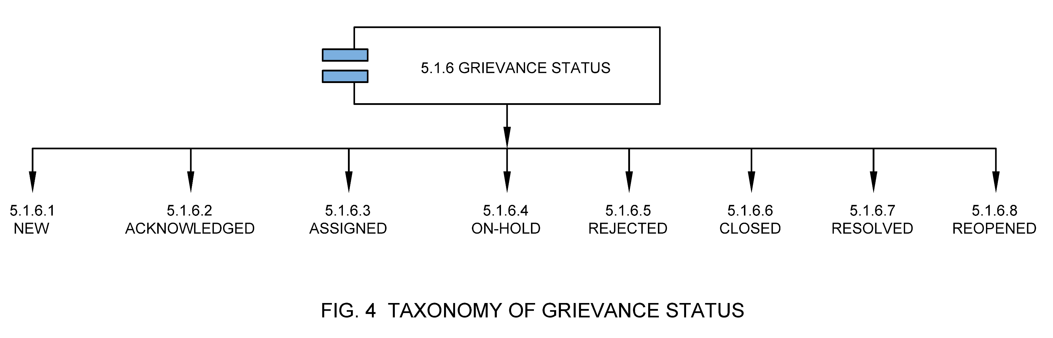

5.1.6.1 New

This indicates that a new grievance application has been filed through any of the grievance channels.

5.1.6.2 Acknowledged

This indicates that the new grievance application has been acknowledged by the municipal department.

5.1.6.3 Assigned

This indicates that the grievance application is assigned to the concerned team and the resolution to the grievance is in process. If the application is in process, the grievance officer checks for the SLG breach and escalates the issue to the Commissioner and Head of the Section.

5.1.6.4 On-hold

This indicates that the grievance application has been put on-hold by the concerned department due to given reason or cause.

5.1.6.5 Rejected

This indicates that the grievance application has been rejected due to a given reason or cause.

5.1.6.6 Closed

This indicates that the grievance application has been successfully closed from the ULB end.

5.1.6.7 Resolved

This indicates that the originator has closed the grievance after the ULB changes the status to 'closed', to indicate the originator’s agreement with the solution.

5.1.6.8 Reopened

This indicates that the grievance application has been reopened due to given reason or cause.

5.1.7 Grievance Severity

Level of impact magnitude in terms of coverage i.e., individual/locality or potential issues.

5.1.8 Grievance Priority

Priority levels are the definitions that the ULB grievance team uses to determine how quickly a grievance needs to be handled, along with any escalation steps that need to be taken. Setting up priority levels correctly can drive team urgency, drive automations, and get citizens their answer quickly. **See Fig 5.**

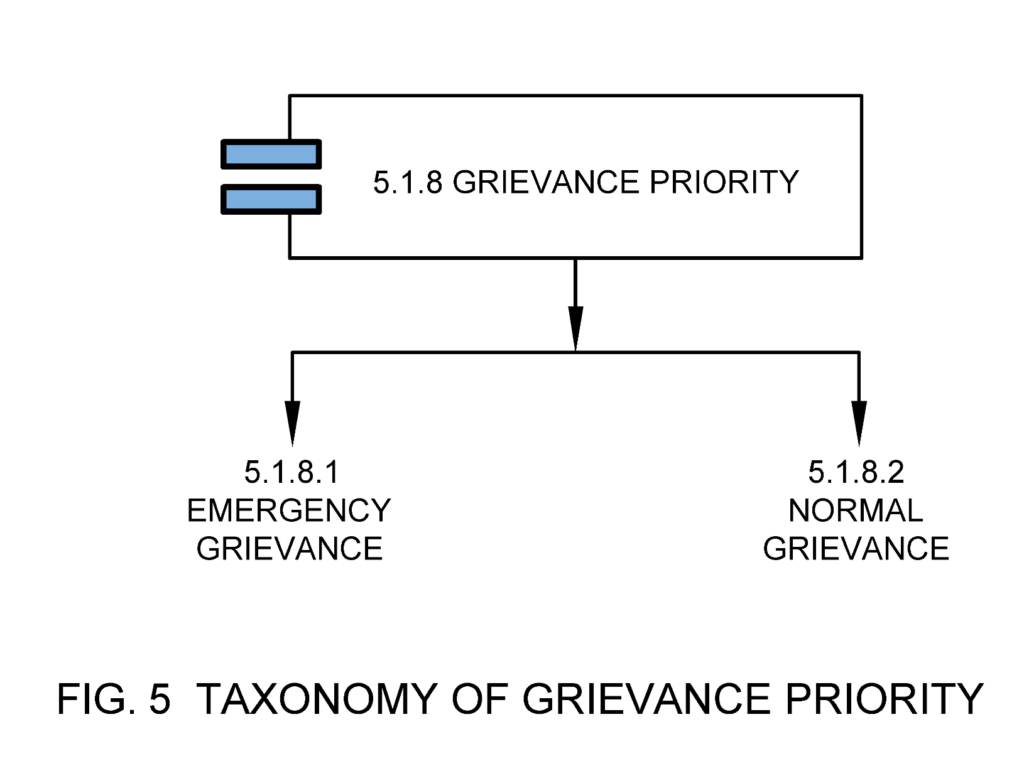

5.1.8.1 Emergency Grievance

Grievances which have maximum priority as per citizen charter or any other relevant laws.

5.1.8.2 Normal Grievance

Grievances which have normal priority as per citizen charter or any other relevant laws.

5.1.9 Nature of Grievance

Nature of grievance is the classification based on the nature of service against which a grievance is raised i.e., whether it deals with request for services or it is an issue w.r.t municipal service or a suggestion. **See Fig 6.**

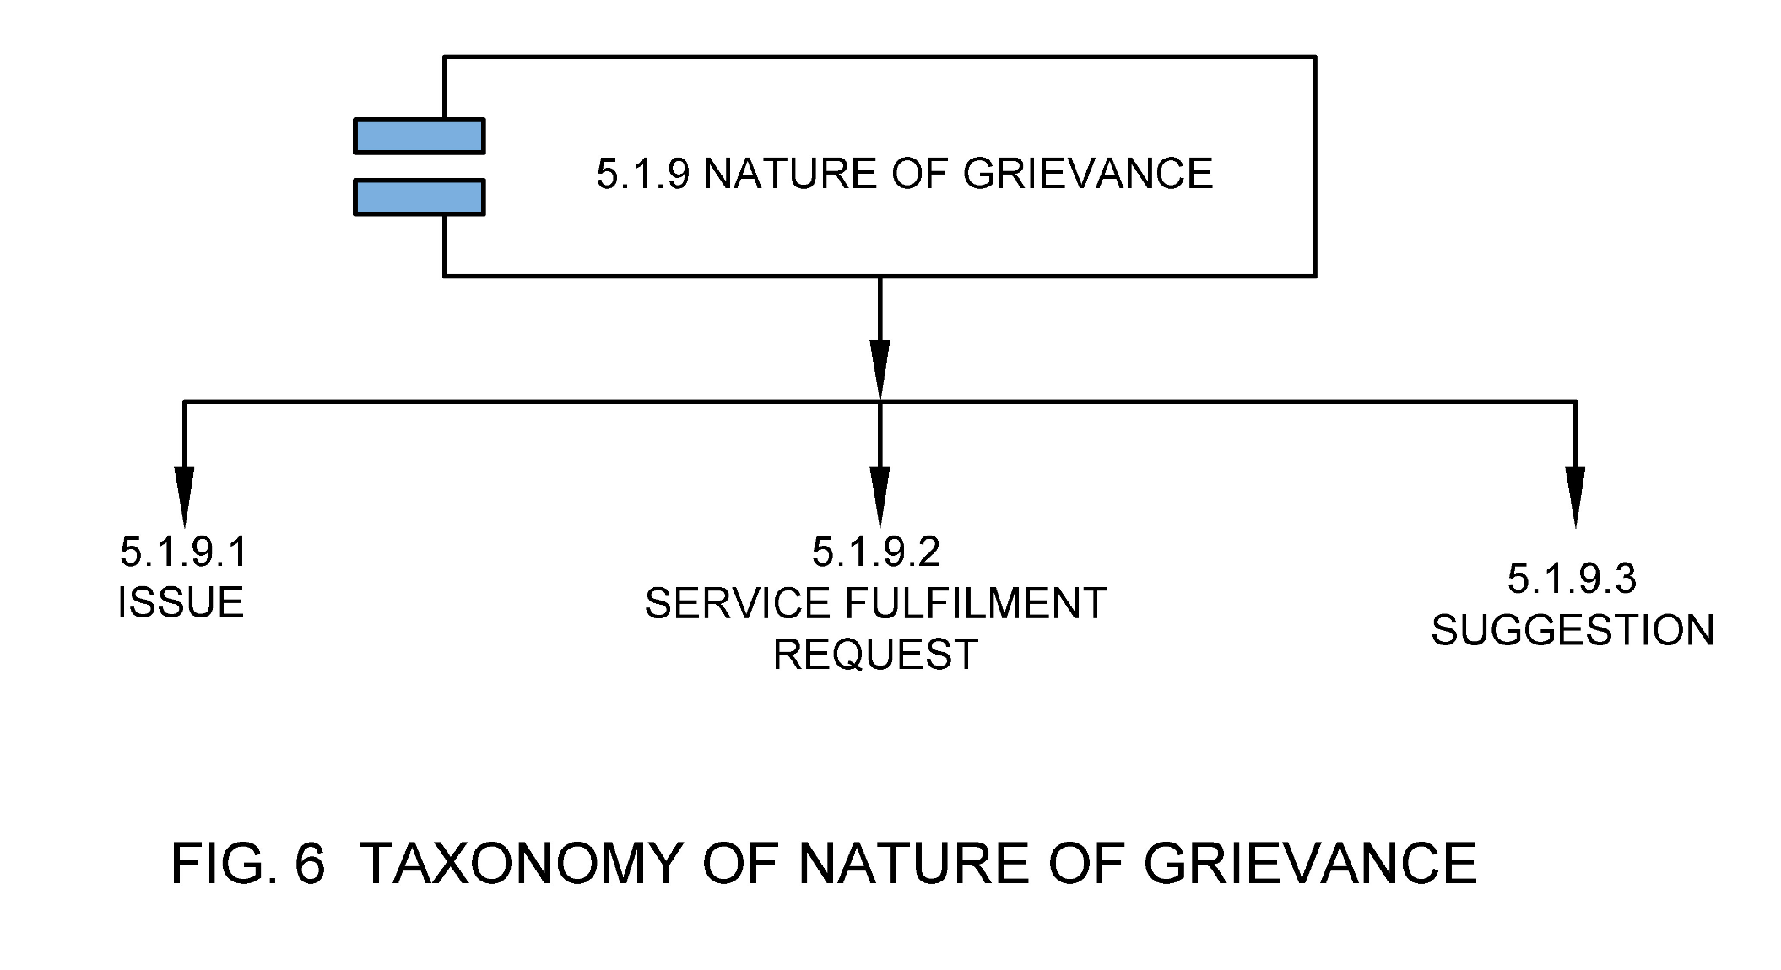

5.1.9.1 Issue

Grievance that pertains to an issue or non-delivery of service.

5.1.9.2 Service Fulfilment Request

Grievance that pertains to new service requests to the ULB.

5.1.9.3 Suggestions

Grievances that are suggestions for improvement of service delivery.

5.1.10 Grievance Function

Grievance function captures the ULB function against which a grievance is registered. Details of sub-functions within each function are captured in Annex B. Please note that this is not the issue or service request list that is presented to citizens when they are submitting their grievance, but the mapping done by the ULB Official once they acknowledge the grievance as per municipal functions provided to the citizens in that ULB. A sample mapping of grievances with functions and sub-functions is provided in Annex C and **See Fig 7.**

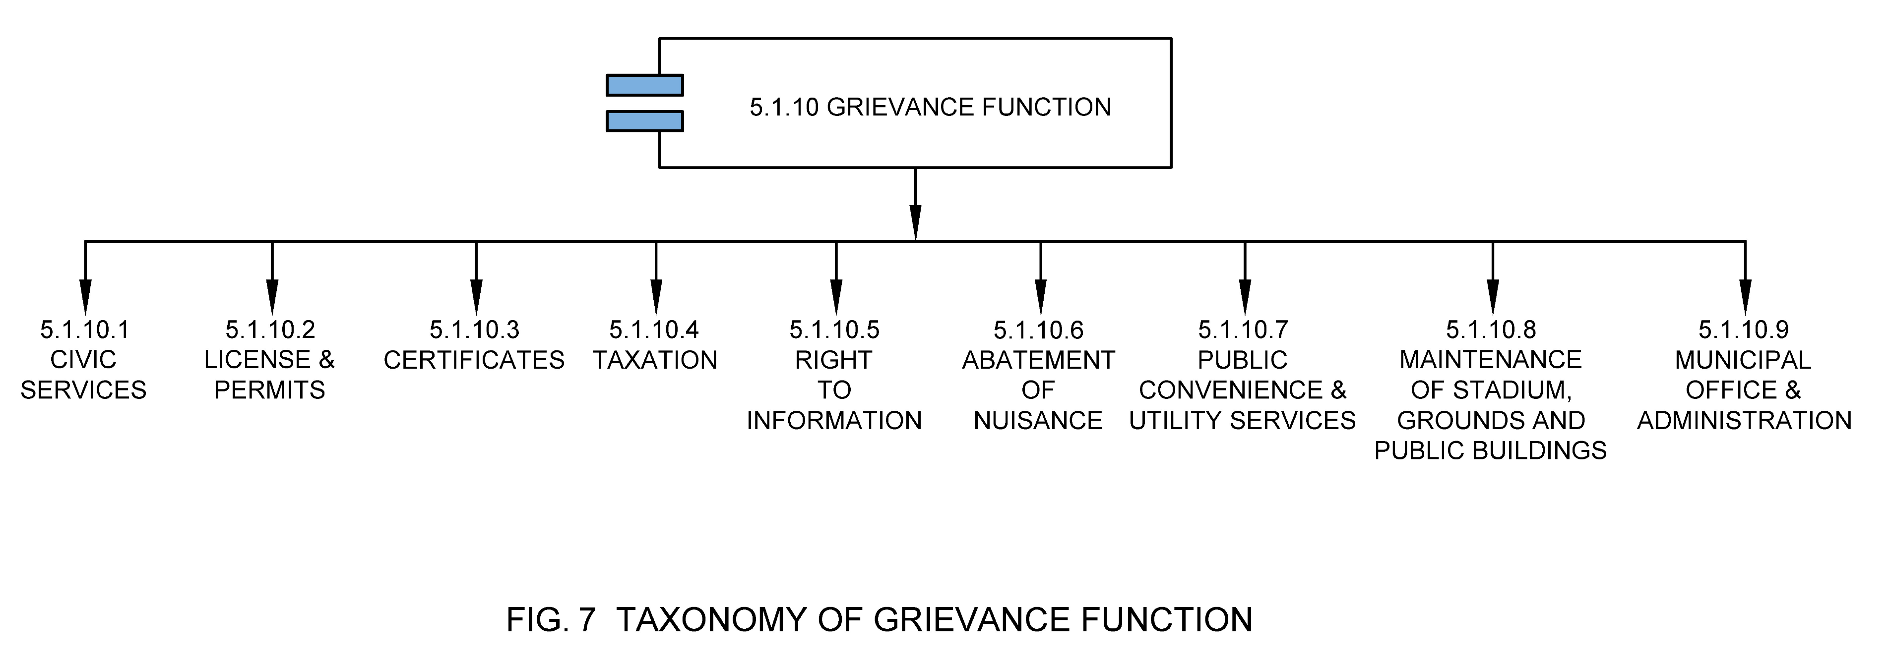

5.1.10.1 Civic Services

It means issues, service requests and suggestions related to civic services such as water supply, sewerage, public health and sanitation, storm water drains, road infrastructure maintenance, parking & street light, solid waste management, traffic signals, CCTV & surveillance, power supply and any other services that ULB provides.

5.1.10.2 License & Permits

It means issues, service requests and suggestions related to issuance of certificates and licenses such as trade license, vehicle permits, building permissions, advertisements and hoardings or any other licenses provided by the ULBs.

5.1.10.3 Certificates

It means issues, service requests and suggestions related to issuance of certificates and licenses such as birth & death registration and certificates, vehicle permits, NOCs, fire NOCs or any other licenses provided by the ULBs.

5.1.10.4 Taxation

It means issues, service requests and suggestions related to tax assessments, appeals, rebates, subsidies, refund claims, payment issues, user charges or any other licenses provided by the ULBs.

5.1.10.5 Right to Information

It means service requests and suggestions related to extraction of information from ULBs such as budgets, any project or planning related information, citizen charters or any other as under purview of the ULBs.

5.1.10.6 Abatement of Nuisance

It means issue, service requests and suggestions related to Control of stray animals, Replacement of damaged slabs over drains, Removal of dangerous building/ construction, Encroachment Removal or any other as under purview of the ULBs.

5.1.10.7 Public Convenience & Utility Services

It means issue, service requests and suggestions related to maintenance of urban forestry, recreation grounds, parks, gardens, library & reading rooms, community & marriage centers, maintenance of markets, bus/lorry stands, town hall/community hall.

5.1.10.8 Maintenance of Stadium, Grounds and Public Buildings

Maintenance of public toilets, maintenance of tanks, wells, ambulances & fire services, maintenance of public infrastructure, municipal schools or any other as provided by the ULBs.

5.1.10.9 Municipal Office & Administration

It means issues, service requests or suggestions related to general feedback, accounting & finance, administration, corruption or misbehaviour, regulation of buildings and vacant lands, city or town planning, poverty alleviation & slum development, social welfare, citizen charter or any other as per ULBs rule or official notification.

5.1.11 Grievance Resolution

It captures the final resolution of the grievance. **See Fig 8.**

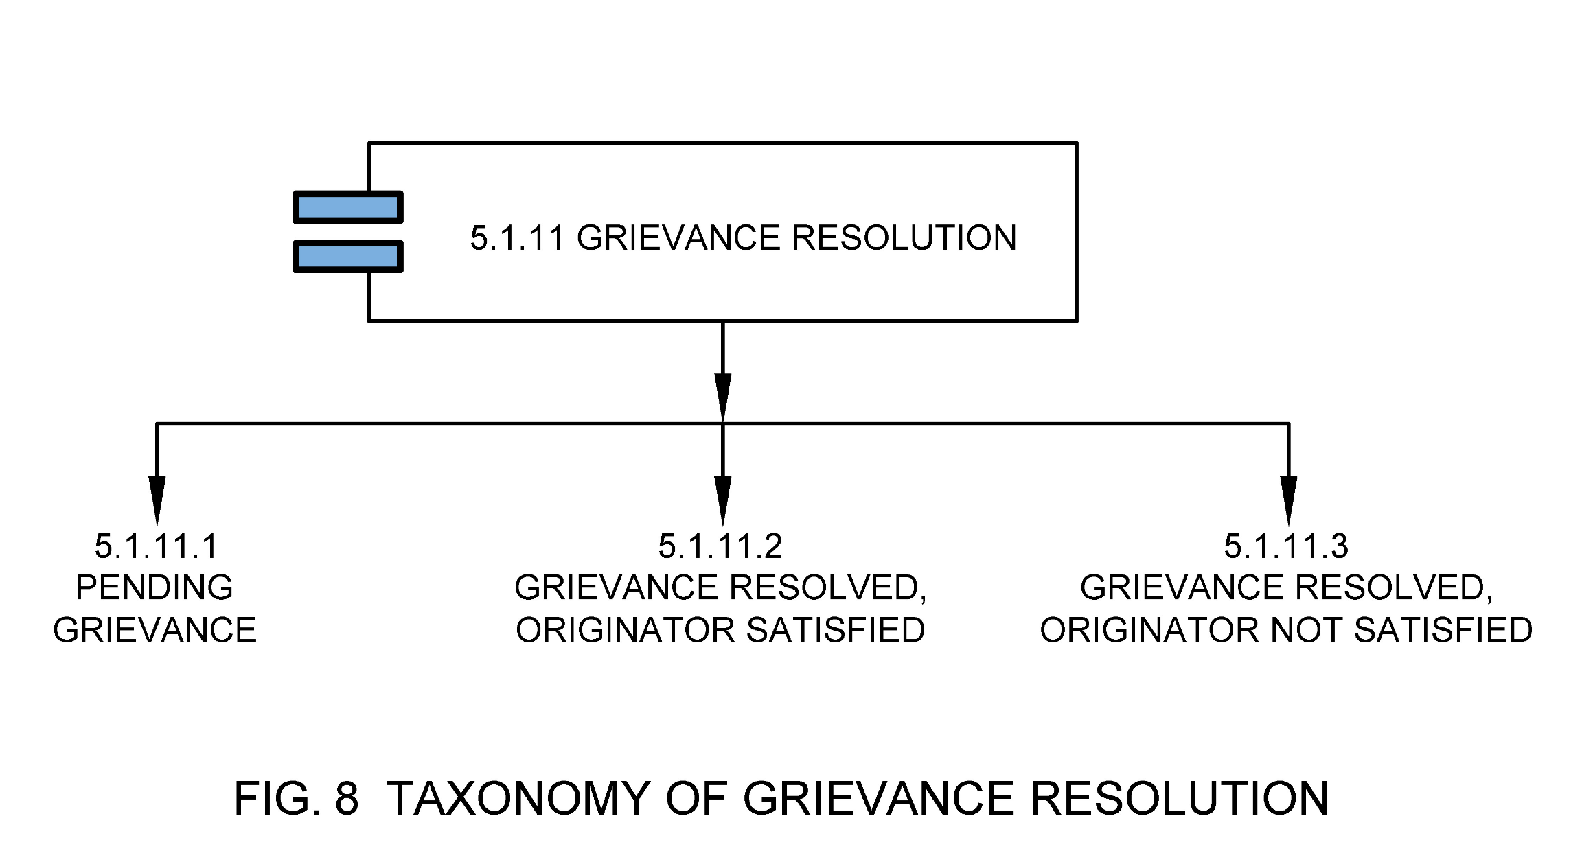

5.1.11.1 Pending Grievance

These are cases which are pending for resolution. A grievance that has a pending feedback from citizen can be classified here.

5.1.11.2 Grievance Resolved; Originator Satisfied

These are the cases where immediate resolution is provided to mitigate the original grievance. Grievances can be marked as ‘resolved, originator satisfied’ when originator has sent a final reply.

5.1.11.3 Grievance Resolved; Originator Not Satisfied

These are the cases where the grievance cannot be resolved immediately due some reasons such as financial requirements to fulfil the request which need approvals from higher authorities (such as, construction of roads, suggestions, building parks etc.), coordination with different departments, delays and approvals from different agencies, or grievance is not addressed properly by the ULBs etc. Grievances can be marked as ‘resolved, originator not satisfied’ and originator has been notified by an interim reply. In such cases the grievances will be auto escalated or citizen can reopen grievance.

5.1.12 Grievance Rating

Grievance rating is a type of feedback mechanism by the concerned authorities to monitor citizen satisfaction towards grievance redressal.

5.1.13 Assigned To

This is the ULB official or third party to which the grievance has last been assigned to.

5.1.14 Evidence

Proof of the grievance raised by the complainant. This can be informed of a picture or video or audio or any other document. Evidence may also be included as proof of resolution of grievance.

5.1.15 Grievance Instance

Grievance instance helps in capturing repetitiveness of a grievance. **See Fig 9.**

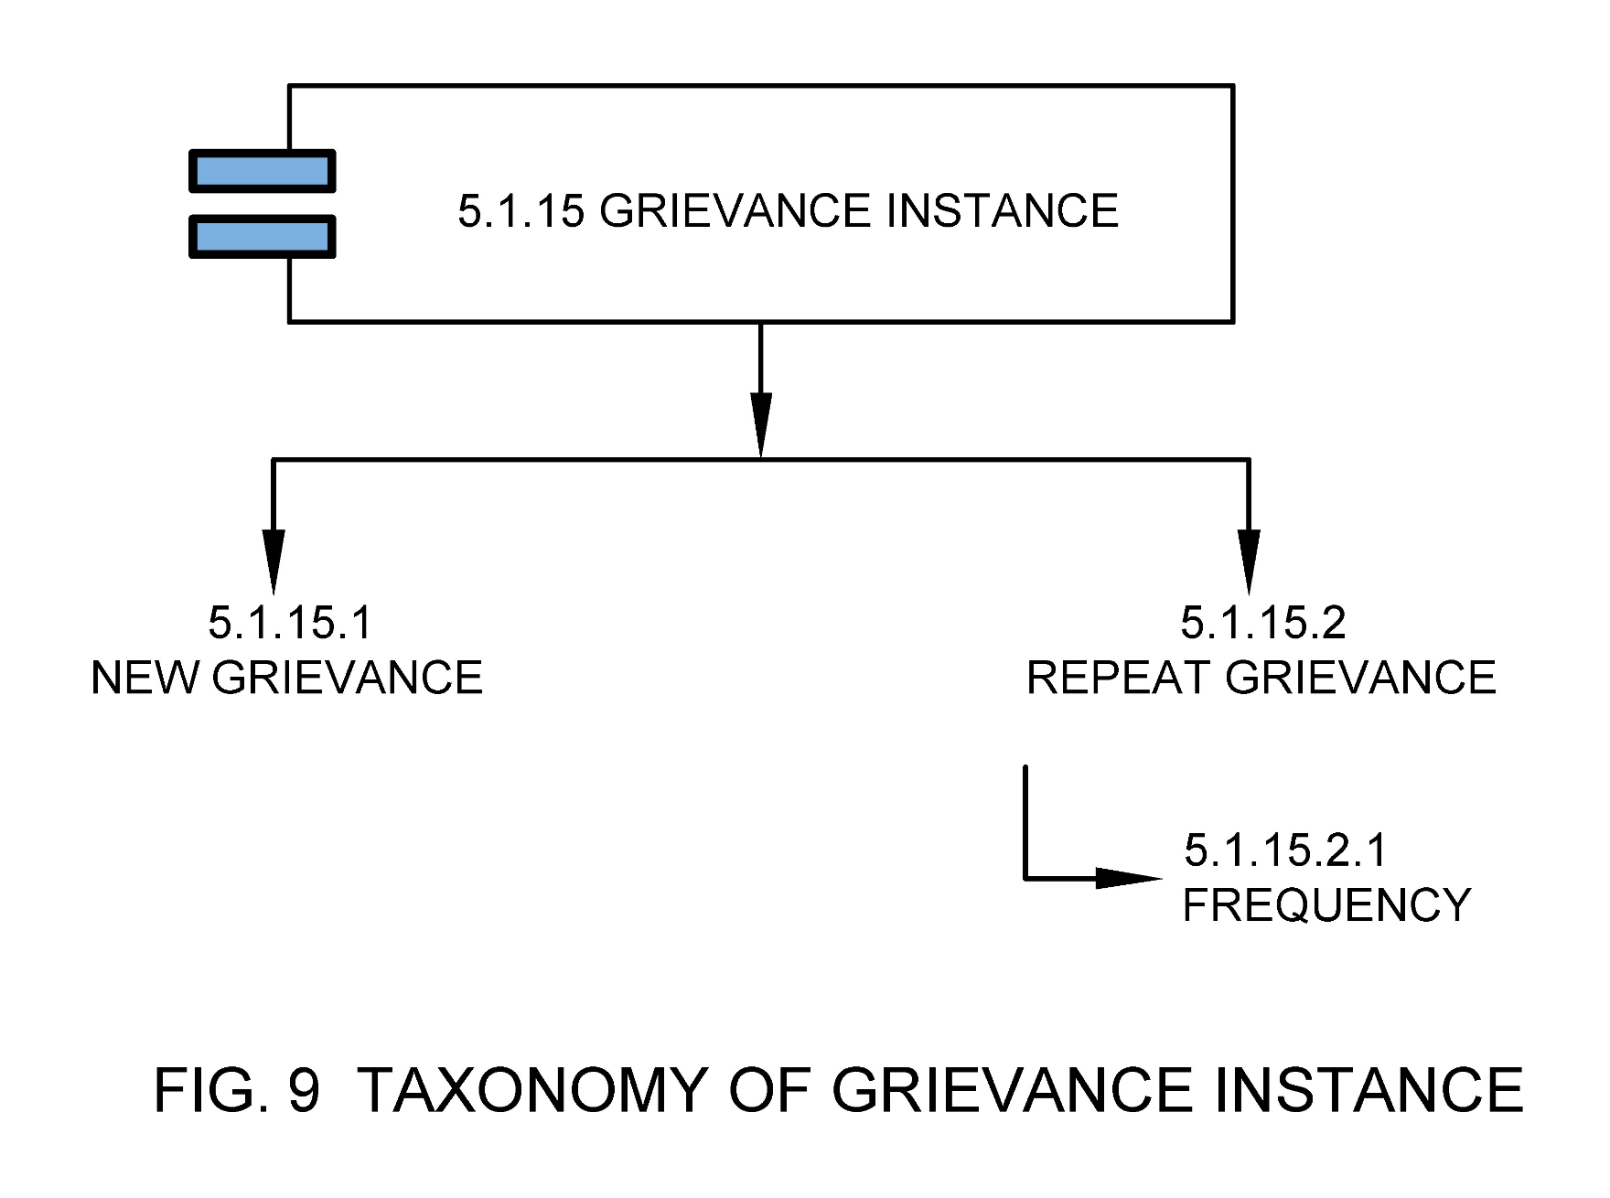

5.1.15.1 New Grievance

Grievance submitted by the originator the first time.

5.1.15.2 Repeat Grievance

Grievance submitted by the same originator on the same topic within a specified time frame.

5.1.15.2.1 Frequency

Frequency at which the same grievance was repeated.

5.1.16 ULB Type

Type of ULB as per the definition of MoHUA such as Nagar Panchayat, Municipal Council or Municipal Corporation.

5.2 Municipal Grievance Channel

Channel / Mode / Method through which grievance is being reported by the citizen or information and response is shared by the ULBs. **See Fig 10.**

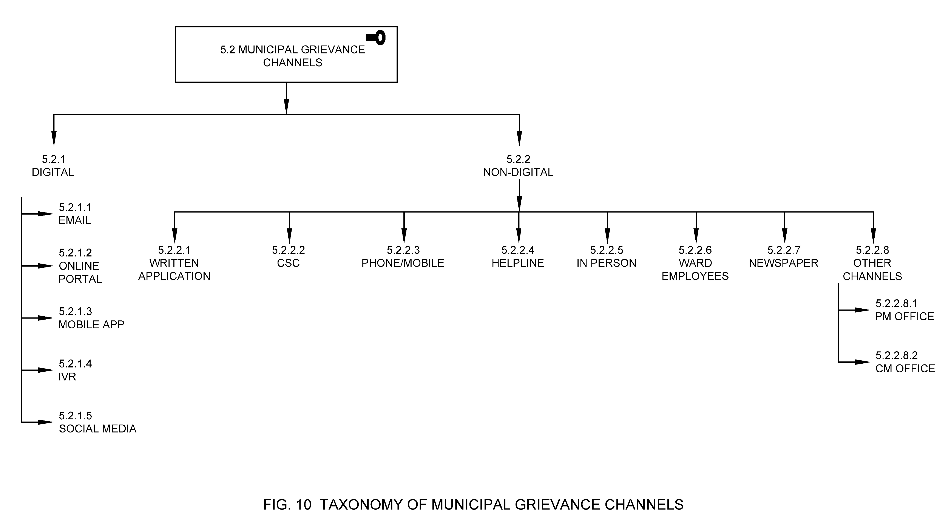

5.2.1 Digital

Digital means an electronic way to collect, store, process and transmit data in the desired form. In the context of municipal grievance redressal, this refers to processes and corresponding data used by the authority and the individual for grievance redressal which is collected or generated in digital form for the purpose of grievance recording, allocation, assessment, follow up, and appeal.

5.2.1.1 Email

Electronic media for transfer of messages and information through the internet.

5.2.1.2 Online Portal

Web portals or web applications refers to the websites developed for grievance management. These portals also include the websites developed by the National, State or ULB for e-governance service delivery.

5.2.1.3 Mobile App

A mobile application, also referred to as a mobile app or simply an app, is a computer program or software application designed to run on a mobile device such as a phone, tablet, or watch.

5.2.1.4 IVR

Interactive Voice Response (IVR) is a technology that allows humans to interact with a computer-operated phone system through the use of voice and DTMF tones input via a keypad. The call center operator will listen to the IVR recorded grievance and register the same in the system. The call center operator may contact the citizen in case information provided is insufficient or any clarification required.

5.2.1.5 Social Media

Social media are interactive technologies that allow the creation or sharing/exchange of information, ideas, interests, and other forms of expression via virtual communities and networks such as Twitter, WhatsApp and Facebook etc.

5.2.2 Non-Digital

These are other means (non-digital) by which a grievance is collected in the grievance management system.

5.2.2.1 Written application

A written application refers to a channel for grievance registration which includes an application in a prescribed Form/Format, addressing to Municipal Commissioner with respect to issues suggestions or requests for a municipal service.

5.2.2.2 CSC

Common Service centers are the access points for delivery of various services using Information and Communication Technology (ICT). CSCs were created under National E-government Project by the Government of India.

5.2.2.3 Phone/Mobile

Mobile telephone, also called mobile, is a portable device for connecting to a telecommunications network in order to transmit and receive voice, video, or other data.

5.2.2.4 Helpline

Helpline is a telephonic service that provides advice and information about particular problems, in reference to municipal grievances this channel has been used to register an issue, suggestion or service request to the ULB authority.

5.2.2.5 In Person

A person can walk into the municipal office/ward office, CSCs, Government Schools, PHCs etc. to register their grievances.

5.2.2.6 Ward Employees

Ward employees are the employees of municipal council or municipal authority, concerned with administrative wards of the city.

5.2.2.7 Newspaper

A newspaper is a periodical publication containing written information about current events.

5.2.2.8 Other Channels

Means any other channel that may be used by the citizen or group of citizens to lodge a municipal grievance.

5.2.2.8.1 PM Office

Means the grievances redirected from either national portal such as CPGRAMS, or directly from PM Office.

5.2.2.8.2 CM Office

Means the grievances redirected from either state portals such as State Municipal Grievance Portals, or directly from CM Office.

5.3 MGR Stakeholders

Municipal grievance stakeholders are the stakeholders involved in planning, implementation and maintenance of municipal governance functions. Participation by all relevant stakeholders ensures sharing a common understanding and involvement in the decision-making process as well as accountability in urban governance. Participation by all stakeholders leads to empowerment and to joint ownership and harmonized access to information connecting multiple urban departments to serve citizens better. **See Fig 11.**

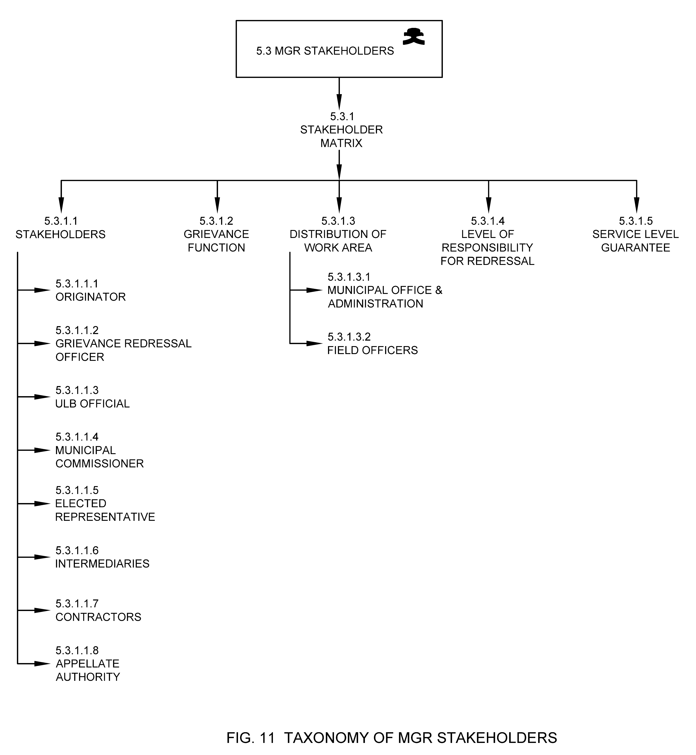

5.3.1 Stakeholder Matrix

Stakeholder matrix captures ULB function, distribution of work area, level of responsibility and Service Level Guarantee of various stakeholders within the ULB and/ or contracted organizations based on ward / locality/jurisdiction, service / issue category.

**Table 1 Stakeholder Matrix**

*(Clause 5.3.1)*

|  |  |  |  |  |
| --- | --- | --- | --- | --- |
| **S.No.** | **Types of Services** | **Services Details** | **Timeline (In Working Days)** | **Designation of Officer Responsible for Delivery of Services** |
| 1. | Water Supply And Sewerage | * New water connection * Change of title in water bill * Approval of water disconnection * Water reconnection * New sewerage connection * Change of title in sewerage bill * Approval of sewerage disconnection * Sewerage reconnection * complaint regarding leakage of water/sewerage | 07 Days*  07 Days*  07 Days*  07 Days*  07 Days*  03 Days*  03 Days*  03 Days*  03 Days* | 1) Jr. Engineer 2) A.C.E 3) C.E |
| 2. | Street Light | * Complaint Regarding Street Light Not Working | 10 Days* | 1) Jr. Engineer  2) A.C.E 3) C.E |
| 3. | Building Regulations | * Sanction of Building Plan (Residential) * Sanction of Building Plan (Commercial) * Issue of Completion Certificate * Approval of Additional Construction (Residential) * Approval of additional Construction (Commercial) | 30 Days*  30 Days*  30 Days*  30 Days*  30 Days* | 1. Building Inspector 2. A.T.P 3. M.T.P |

5.3.1.1 Stakeholders

MGR Stakeholders are individuals, groups of people or organizations who have interests tied in the MGR process or functioning. This includes originator, grievance redressal officer, departmental officials, third parties and Municipal Commissioner.

5.3.1.1.1 Originator

Originator of the grievance is the individual or group of persons who initiated the grievance request or application.

5.3.1.1.2 Grievance Redressal Officer

A grievance redressal officer (GRO) is a ULB official who assesses the grievance once it’s registered.

5.3.1.1.3 ULB Official

ULB official means and includes all the officers, employees and other staff employed in the ULB.

5.3.1.1.4 Municipal Commissioner

Commissioner of the ULB or municipal body means an officer appointed by the Government, and includes an Additional Director, a Joint Director, Deputy Director, or any other officer of the Government authorized by it to perform the functions of the Commissioner and Director of Municipal Administration.

5.3.1.1.5 Elected Representatives

Elected representatives are elected by the citizen of India or by the constituency in the ULB (generally known as ward).

5.3.1.1.6 Intermediaries

Intermediary is the individual, group of persons (Volunteers) or organizations (NGOs, Trusts etc.) who initiated the grievance request or application on the behalf of the originator who lacks the capacity to use any channels which are provided by the ULB. These Intermediaries should be registered with the ULBs in order to provide their services to the originator (who is either from marginalized section, illiterate or differently abled) and should not charge extra money from the originator.

The application submitted by the intermediaries for the originator who is capable of filling their own request will not be considered by the ULBs.

5.3.1.1.7 Contractors

Contractors are any person or organization with whom the ULB has entered into contract in relation with the construction works and/ or O&M requirements.

5.3.1.1.8 Appellate Authority

Appellate Authority is the authority or representative of the authority assigned to review the procedures and decisions pertaining to a grievance to make sure that the proceedings were fair and that the proper law/regulation are applied appropriately. Final appellate authority for a municipal grievance redressal maybe commissioner or deputy commission in a ULB.

5.3.1.2 Grievance Function

Refer section 5.1.10

5.3.1.3 Distribution of Work Area

This refers to the functions and/or ward and sectors within ULB for which each of the stakeholders are responsible for.

5.3.1.3.1 Municipal Office & Administration

They are responsible for grievances captured under section 5.1.10.9.

5.3.1.3.2 Field Officers

They are responsible for grievances captured under section 5.1.10.1 to 5.1.10.8

5.3.1.4 Level of Responsibility for Redressal

In order to ensure that grievances are addressed within the prescribed time norm, escalation levels of responsibility for redressal are mapped against each category of grievances.

**Table 2 Indicative Level of Responsibility for Redressal**

*(Clause 5.3.1.4)*

|  |  |  |  |  |  |
| --- | --- | --- | --- | --- | --- |
| **S.No.** | **Services** | **1st Level** | **2nd Level** | **3rd Level** | **4th Level** |
| 1. | **Water Supply and Sewerage** | Jr. Engineer | A.C.E | C.E | Commissioner |
| **Time Norm** | 03 Days | 02 Days | 01 Days | 01 Days |
| 2. | **Street Light** | Jr. Engineer | A.C.E | C.E | Commissioner |
| **Time Norm** | 03 Days | 02 Days | 01 Days | 01 Days |
| 3. | **Building Regulations** | Building Inspector | A.T.P | M.T.P | Commissioner |
| **Time Norm** | 15 Days | 07 Days | 05 Days | 03 Days |
| 4. | **Sanitation/Public Health** | S.I | C.S.I | M.O.H | Commissioner |
| **Time Norm** | 01 Days | 01 Days | 01 Days | 01 Days |
| 5. | **Birth and Death Certificate** | Clerk | Inspector | Local Registrar | Commissioner |

5.3.1.5 Service Level Guarantee

Refer section 5.1.5.1

**Table 3 Indicative Service Level Guarantee**

*(Clause 5.3.1.5)*

|  |  |  |  |  |
| --- | --- | --- | --- | --- |
| **S.No** | **Name and Designation** | **Type of Service** | **No. of Days to resolve complaints** | **Mobile Number of concerned officer** |
| 1 | ABC, ACE | Sanitation | 1 day | 9889304xxx |
| 2 | ABC, Superintendent | Water supply | 3 Days | 9899543xxx |
| 3 | ABC, Engineer | Horticulture | 2 Days | 9999921xxx |
| 4 | ABC, Junior Engineer | Others | 7 Days | 9876534xxx |

5.4 MGR Processes

MGR Processes are a series of actions or steps taken in order to achieve a timely resolution of grievances by the ULBs such as grievance creation, acknowledgement, assessment, tracking, monitoring, escalation, resolution, verification and feedback. **See Fig 12.**

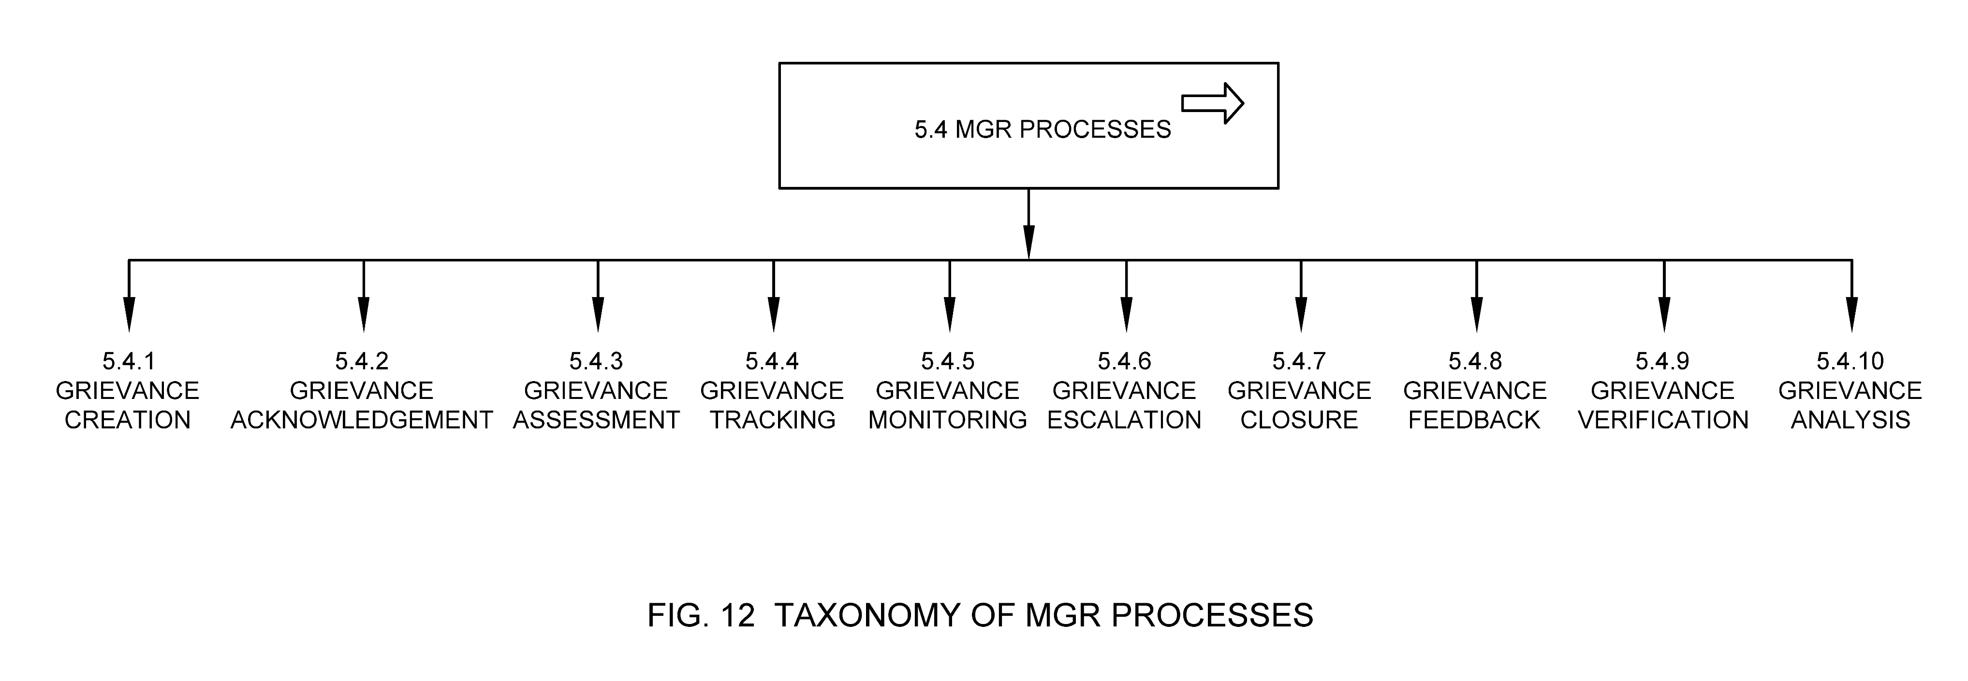

5.4.1 Grievance Creation

Grievance creation is the process by which a grievance is submitted to the ULB by the citizen. Grievance status in this case is new. **See Fig 13.**

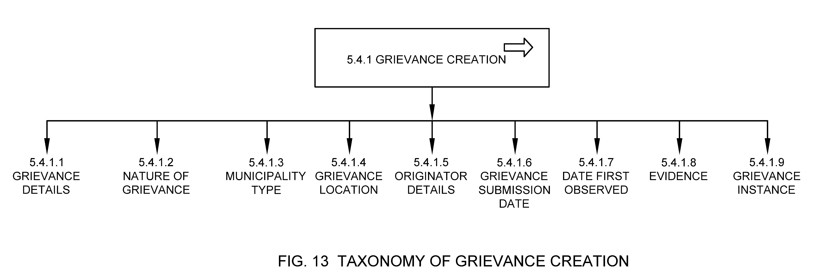

5.4.1.1 Grievance Details

Refer section 5.1.2

5.4.1.2 Nature of Grievance

Refer section 5.1.9

5.4.1.3 ULB Type

Refer section 5.1.16

5.4.1.4 Grievance Location

Refer section 5.1.3

5.4.1.5 Originator Details

Refer section 5.1.4

5.4.1.6 Grievance Submission Date

Refer section 5.1.5.2.2

5.4.1.7 Date First Observed

Refer section 5.1.5.2.1

5.4.1.8 Evidence

Refer section 5.1.14

5.4.1.9 Grievance Instance

Refer section 5.1.15

5.4.2 Grievance Acknowledgement

Grievance Acknowledgment is the process by which a grievance is acknowledged in the system. This process is combined with grievance creation if the grievance is directly captured on the MGR system. An acknowledgment ID/ unique grievance number is generated in this case. Grievance acknowledgement may be automatic or manual (if the grievance is received through non-digital channel). Grievance status post acknowledgment is changed to acknowledge. **See Fig 14.**

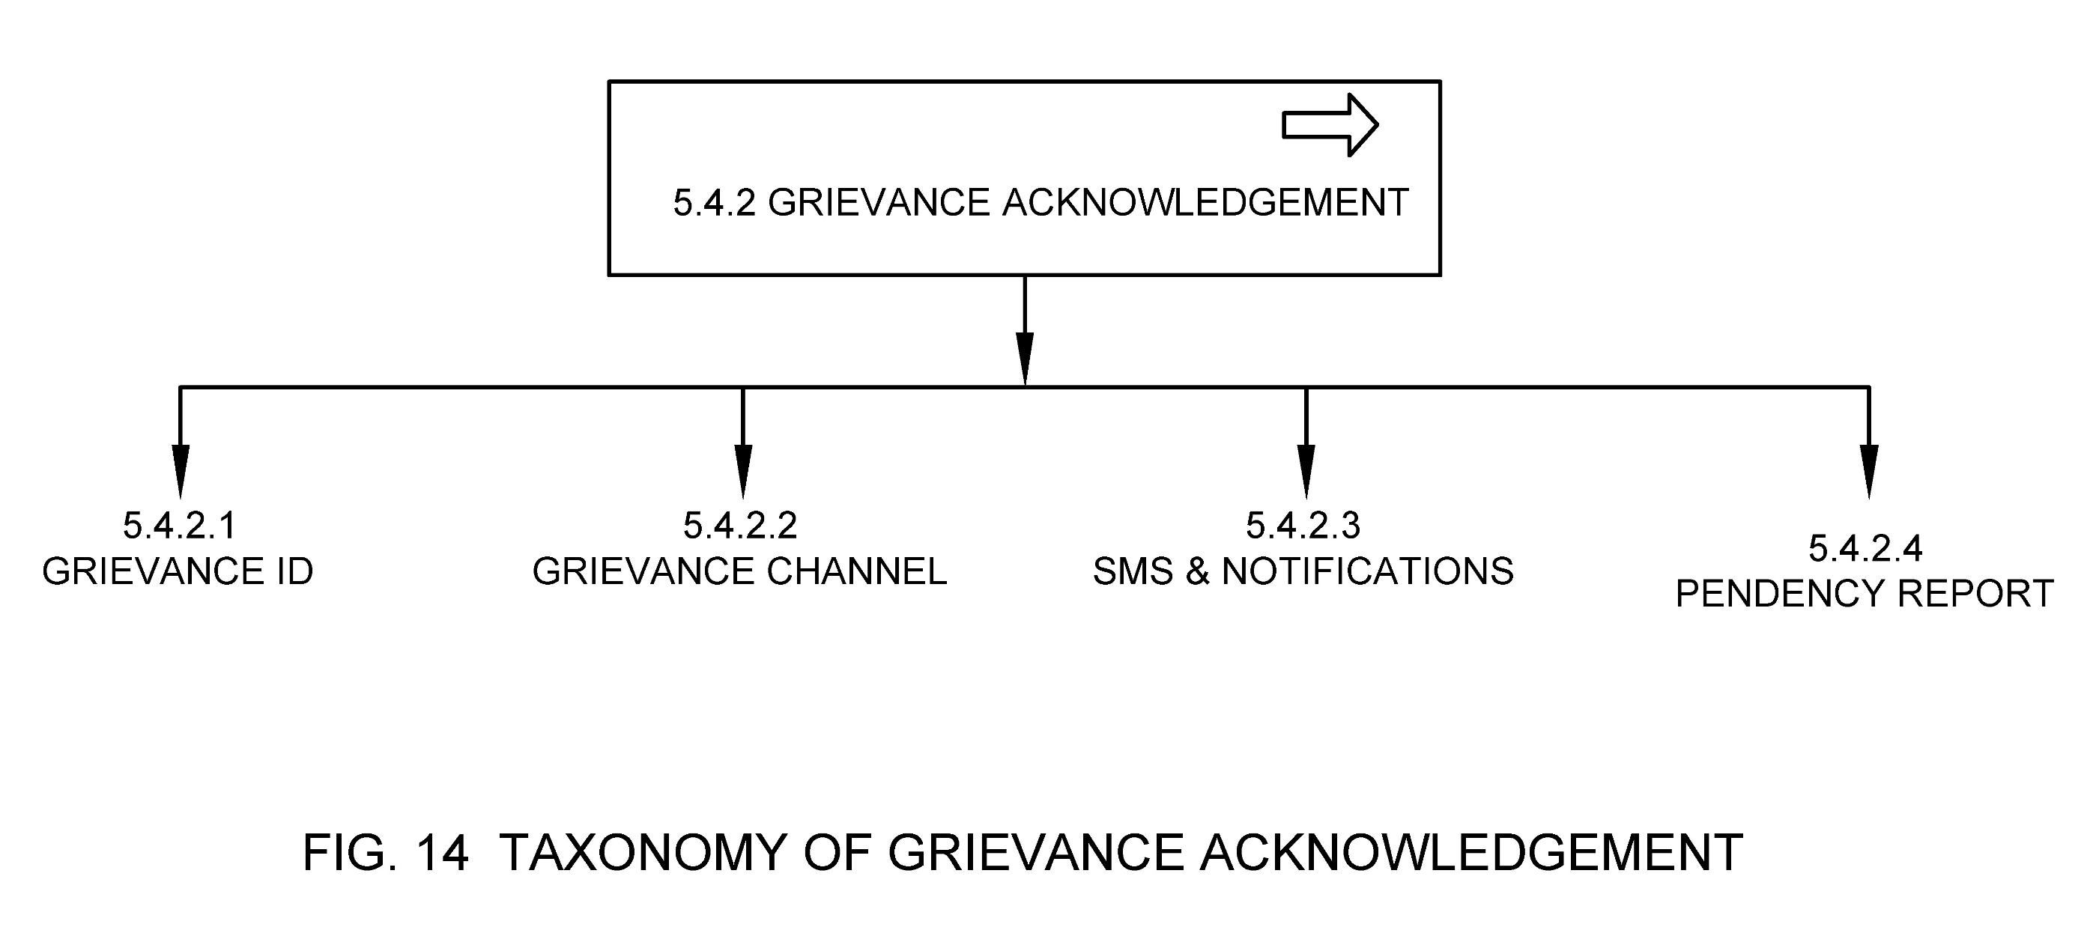

5.4.2.1 Grievance ID

Refer section 5.1.1

5.4.2.2 Grievance Channel

Refer section 5.2

5.4.2.3 SMS & Notifications

These are the notifications sent to citizens informing them about the grievance being registered on the system.

5.4.2.4 Pendency Report

Refer section 5.5.1.1

5.4.3 Grievance Assessment

Process by which the acknowledged grievance is assessed by the grievance officer and appropriate grievance category, severity and priority is assigned to the grievance. Grievance status is changed to assigned, on-hold or rejected based on first assessment by the grievance officer. **See Fig 15.**

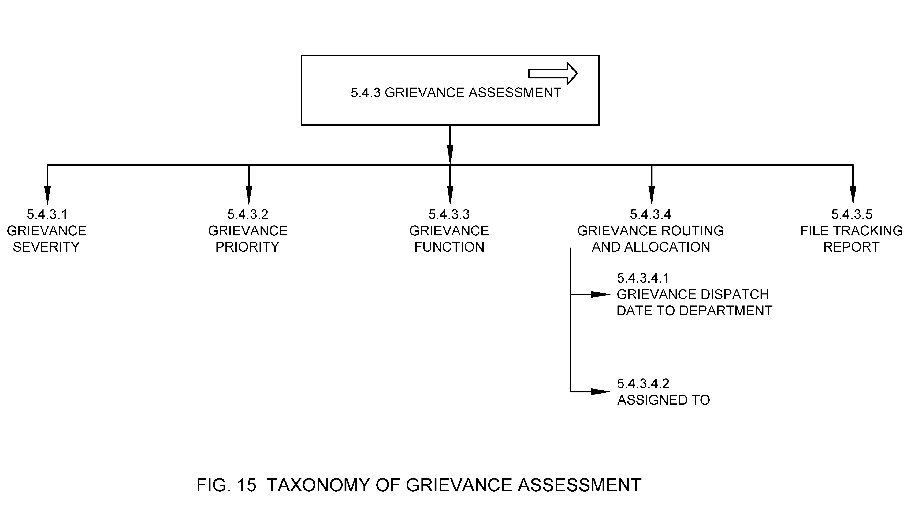

5.4.3.1 Grievance Severity

Refer section 5.1.7

5.4.3.2 Grievance Priority

Refer section 5.1.8

5.4.3.3 Grievance Function

Refer section 5.1.10

5.4.3.4 Grievance Routing & Allocation

Process by which assessed grievance is directed to the concerned department based on grievance category and transferred directly to the field official or the concerned department based on stakeholder matrix (refer section 5.3.1). The status of the grievance is then updated to in-process. Assigned to field is changed to the ULB official to whom the grievance is allocated to.

5.4.3.4.1 Grievance Dispatch Date to Department

Refer section 5.1.5.2.3

5.4.3.4.2 Assigned to

Refer section 5.1.13

5.4.3.5 File Tracking Report

Refer section 5.5.1.4

5.4.4 Grievance Tracking

Grievance tracking is the monitoring process undertaken by the originator of the grievance where they can track the status of grievance till its eventual closure.

5.4.5 Grievance Monitoring

Grievance monitoring is the monitoring process undertaken by the ULB official from the time a grievance is lodged on system until it's resolved and feedback is taken on the resolution. The grievances are classified based on instance, grievance redressal time, grievance type, function based, originator based, priority and resolution based.

5.4.6 Grievance Escalation

Grievance escalation is the process through which a grievance is escalated to a higher level by the originator in case of dissatisfaction with the resolution or in case of delayed compliance. Some of the ULBs allow for automated escalation if a grievance is pending in 'in process' period beyond a predefined time period. **See Fig 16.**

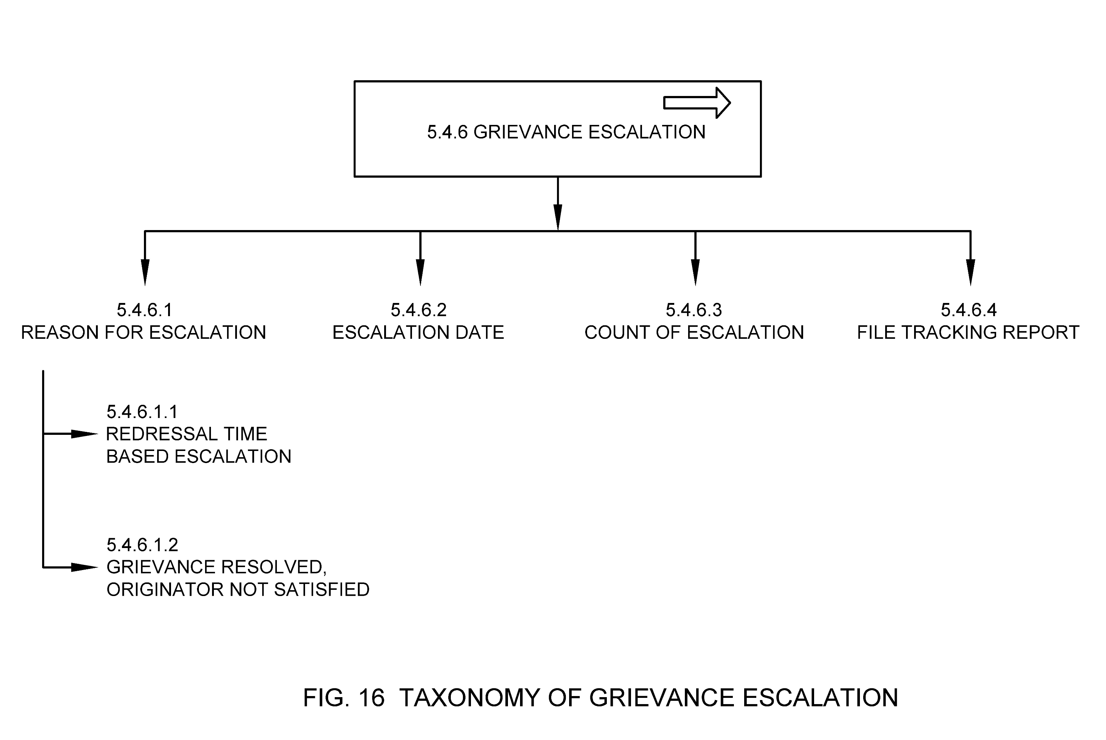

5.4.6.1 Reason for Escalation

It is the reason because of which a grievance is escalated.

5.4.6.1.1 Redressal Time-Based Escalation

It means escalating a grievance if it has not been resolved as per the redressal time defined in the SLB or SLG.

5.4.6.1.2 Grievance Resolved, Originator Not Satisfied

Refer section 5.1.11.3

5.4.6.2 Escalation Date

Refer section 5.1.5.2.4

5.4.6.3 Count of Escalation

It means the number of times same grievance has been escalated for various reasons.

5.4.6.4 File Tracking Report

Refer section 5.5.1.4

5.4.7 Grievance Closure

Grievance closure is the process of recording the final action taken by the responsible ULB official or designated 3rd party. Thereafter status is updated for the originator with appropriate reply from the concerned department. Grievance status is updated as closed on system. **See Fig 17.**

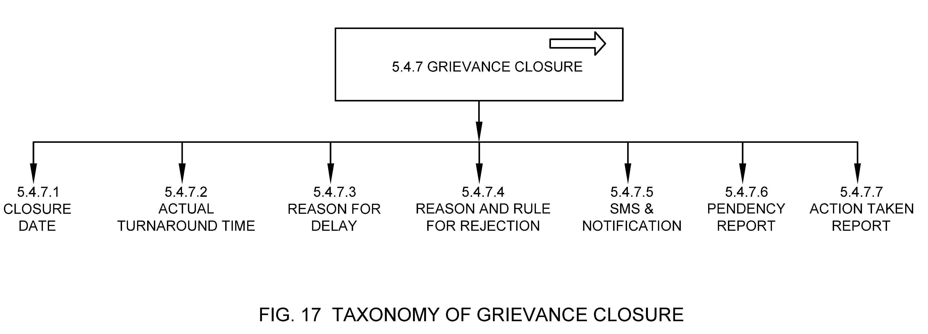

5.4.7.1 Closure Date

Refer section 5.1.5.2.5

5.4.7.2 Actual Turnaround Time

Actual Turnaround Time is the actual time taken by the ULB in which a municipal grievance is closed or rejected.

5.4.7.3 Reason for Delay

Reason for delay in cases where actual turnaround time exceeds service level benchmarks for that service category.

5.4.7.4 Reason and Rule for Rejection

It is the reason and subsequent rule (if any) provided to reject the grievance.

5.4.7.5 SMS & Notifications

Refer section 5.4.2.3.

5.4.7.6 Pendency Report

Refer section 5.5.1.1.

5.4.7.7 Action Taken Report

Refer section 5.5.1.3.

5.4.8 Grievance Feedback

It is the process of collecting feedback on grievance resolution from the originator wherein satisfaction of the originator with the resolution is checked. Thereafter the status of the application can finally be marked as resolved or reopened based on satisfaction of the originator. **See Fig 18.**

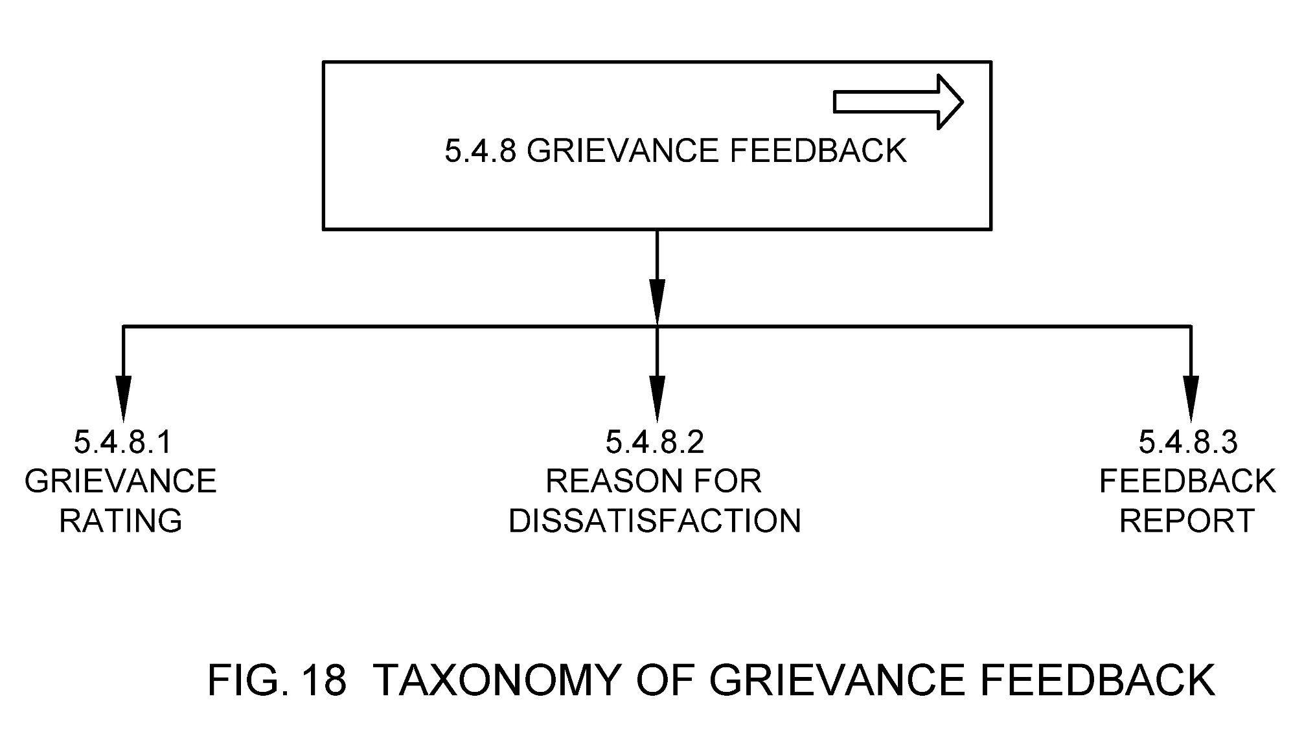

5.4.8.1 Grievance Rating

Grievance rating captures citizen satisfaction on a resolved grievance. It is basically a classification or ranking of resolution, based on a comparative assessment of their quality, standard, or performance.

5.4.8.2 Reason for Dissatisfaction

Reason for dissatisfaction is captured as a part of feedback mechanism for continuous improvement in service delivery by the ULBs in case citizen is not satisfied with the resolution.

5.4.8.3 Feedback Report

Refer section 5.5.1.2

5.4.9 Grievance Verification

It is the process when once the grievance has been marked as resolved, the resolution along with the evidence of resolution may be subject to a quality check at random by senior ULB officials. **See Fig 19.**

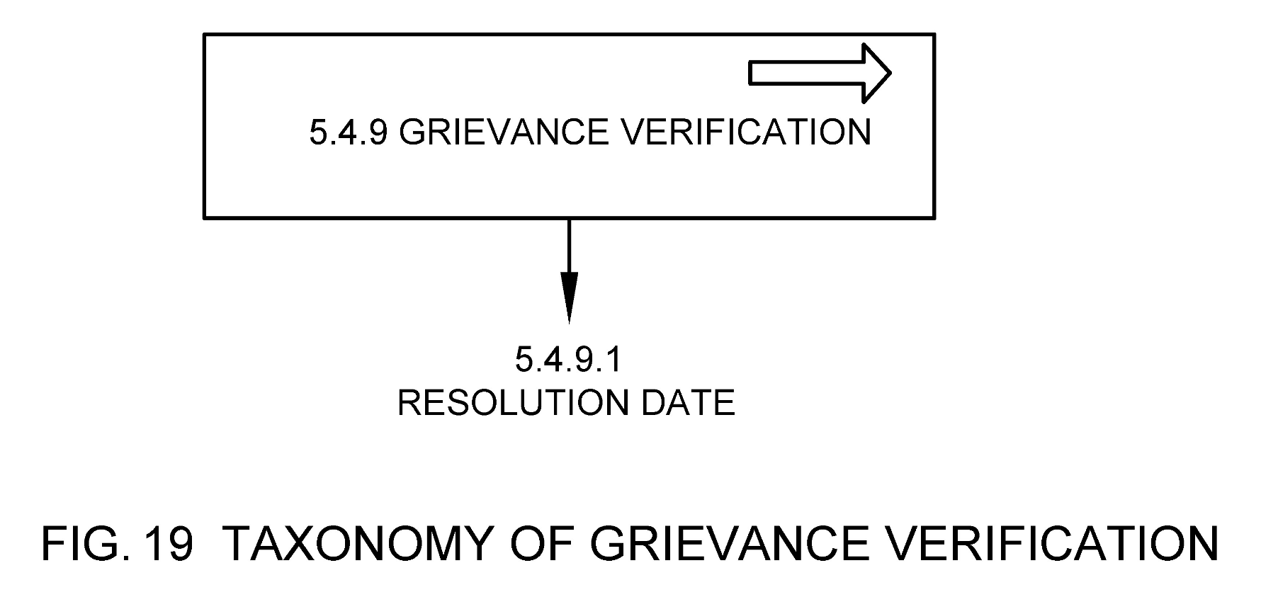

5.4.9.1 Resolution Date

Refer section 5.1.5.2.6

5.4.10 Grievance Analysis

Grievance analysis is the process through which all grievances are analysed to check quality of service and become aware of (and eventually rectify) any deficiency in services. This helps in improving the efficiency, accountability, responsiveness and transparency of a ULB, ultimately leading to improvement in service delivery. **See Fig 20.**

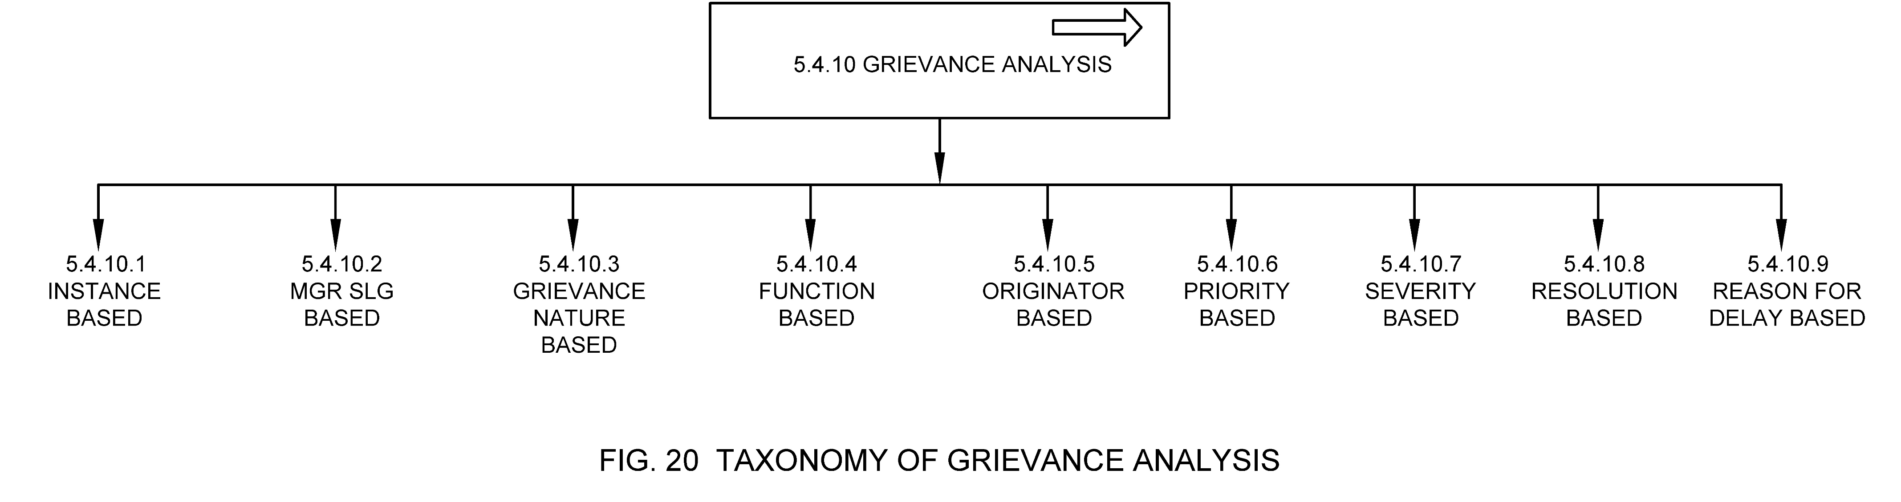

5.4.10.1 By Instance

Classification based on occurrence of a grievance. Refer section 5.1.15.

5.4.10.2 By MGR SLG

Classification based on timeliness of resolution for a grievance. Refer section 5.1.5.

5.4.10.3 By Grievance Nature

Classification based on the nature of grievance raised. E.g., If it's an issue or suggestion. Refer section 5.1.9.

5.4.10.4 By Function

Classification based on type of municipal functions. Refer section 5.1.10.

5.4.10.5 By Originator

Classification based on type of originator. Refer section 5.1.4.1 and 5.1.4.2.

5.4.10.6 By Priority

Classification based on priority of attendance. Refer section 5.1.8.

5.4.10.7 By Severity

Classification based on severity of the grievance. Refer section 5.1.7.

5.4.10.8 By Resolution

Classification based on resolution provided to grievance. Refer section 5.1.11.

5.4.10.9 By Reason for Delay

Classification based on the reasons for delay for providing resolution. Refer section 5.4.7.3.

5.5 MGR Reports & KPIs

MGR Reports and KPIs present information in an organized format for various stakeholders, especially in the form of an official document, after thorough investigation or consideration by an appointed person or body at the ULB. The reports and KPIs ensure a uniform set of indicators, definitions and calculation methodology to enable meaningful comparisons of municipal performance with an emphasis on performance improvement planning based on the data generated. **See Fig 21.**

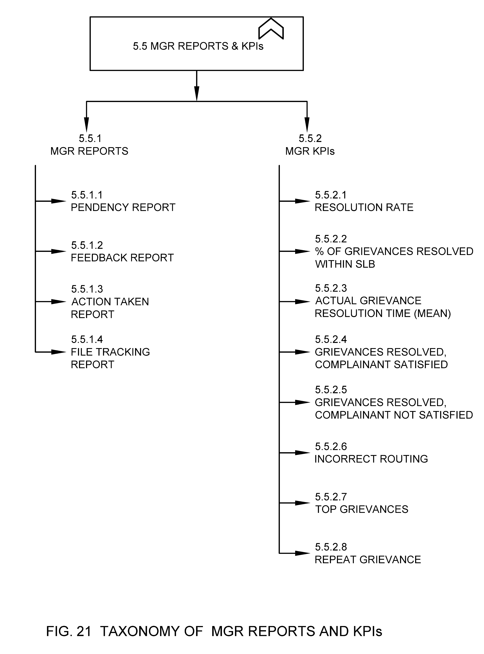

5.5.1 MGR Reports

The MGR Reports notifies the Urban Local Body about the complete information of all grievances which are raised through various governance channels.

5.5.1.1 Pendency Report

This report notifies the Urban Local Body about the complete information of all grievances which are raised through various governance channels. This report gives the clear idea about the details like grievance type, grievance number, grievance raised date, grievance officer, status, expected date of completion and delay, number of pending grievances, number of days beyond SLG, location wise, section wise, ULB officer wise, escalation etc.

5.5.1.2 Feedback Report

This report provides information about the feedback provided by the citizen over a grievance, location wise, originator wise.

5.5.1.3 Action Taken Report

This report provides information about the action taken on the grievance, by the assigned officer as per SLG, as per stakeholder matrix or escalation wise, location wise.

5.5.1.4 File Tracking Report

This report provides the details of status of grievances. This report provides information about the number of grievances, grievance type and status of the grievance such as new, acknowledged, assigned, resolved, rejected, reopened, on-hold etc. for a particular grievance.

5.5.2 MGR KPIs

This refers to the minimal KPIs that should be captured by the ULB for municipal grievance redressal.

5.5.2.1 Resolution Rate

Resolution Rate is the metric that compares the number of grievances assigned to the ULB to the total count of grievances. The resolution rate formula looks like this: resolved grievances / received grievances x 100.

5.5.2.2 Percentage of Grievances Resolved within SLB

Refers to the percentage of grievances resolved within the agreed SLB parameters (time, priority, others as needed).

5.5.2.3 Actual Grievance Resolution Time (mean)

Refers to the mean of mean time of grievance resolution in that month. It can be within or outside SLG.

5.5.2.4 Grievance Resolved; Complainant Satisfied

Refers to the count of instances where the complainant is satisfied with the resolution provided by the ULB for the resolved grievance in a given month.

5.5.2.5 Grievance Resolved; Complainant Not Satisfied

Refers to the count of instances where the complainant is not satisfied with the resolution provided by the ULB for the resolved grievance in a given month.

5.5.2.6 Incorrect Routing

Refers to the count of incorrect transfers of the grievance to the various municipal departments in a given month. For e.g., Issue/suggestion/request for health department routed to the administration department. This may also be accompanied with average time spent in incorrect routing.

5.5.2.7 Top Grievances

Refers to the top 10 grievances which are registered the most in a given month.

5.5.2.8 Repeat Grievance

Refers to the count of grievances in a current month which is repeatedly registered by the same originator on the same issue.

ANNEX A: SAMPLE PARAMETERS AND SPECIFICATIONS FOR LOCATION

*(Clause 5.1.3)*

|  |  |  |  |
| --- | --- | --- | --- |
| **Attribute Name** | **Locational Specification** | **Data Type** | **Mandatory (Yes/No)** |
| Address | House No, Building Name, Plot/Survey No, Street Name, Locality, Zone/Ward, City/Town, District, Region, State, Country, Pin code | Varchar (256) | No |
| Geo Location | Latitude, Longitude, Polygon | Numeric (9,6) | Yes |
| Other evidences | This can include Geo tagged images of Property, DDN, QR codes etc. |  | No |

**Address:** The address of the property provides the particulars of the place as per the administrative boundaries or norms defined by the local governing body.

**Geo Location:** Geolocation is the identification or estimation of the real-world geographic location of property. This refers to the latitude and longitude coordinates of a particular location where property is located.

**Digital Numbers:** Property Numbers defined using scientific methods and often assigned with QR code for traceability and usability.

ANNEX B: SAMPLE DETAILS OF SUB-FUNCTIONS WITH DEFINITIONS WITHIN EACH FUNCTION DESCRIBED IN SECTION 4.2.10 GRIEVANCE FUNCTION

*(Clause 5.1.10)*

|  |  |
| --- | --- |
| **Water Supply** | It means issues, service requests or suggestions related to water supply services through new connection, replacing flat rate billing to meter-based billing, line extension, line maintenance |
| **Sewerage** | It means issues, service requests or suggestions related to sewerage services by undertaking new scheme, new service connection, line extension etc. |
| **Public health and sanitation** | It means issues, service requests or suggestions related to public health and sanitation service like removal carcasses, Sweeping and cleaning of Roads, lanes, public drains and epidemic/ pandemic management, primary healthcare, family planning, pest control etc. |
| **Storm water Drains** | It means issues, service requests or suggestions related to existing storm water drainage system across ULBs and laying new drainage system, regular cleaning, removal slits. |
| **Road Infrastructure Maintenance** | It means issues, service requests or suggestions related to the maintenance of existing road network by filling pot holes, patches and relaying of road surface. Converting high traffic zone roads to concrete surface |
| **Parking & Street Light** | It means issues, service requests or suggestions related to the maintenance of parking lots, existing street light network and new street light connections. |
| **Solid Waste Management** | It means issues, service requests or suggestions related to solid waste disposal system by collection of waste from Door to Door, Predefined pick-up points, segregating waste, transporting, processing of waste. |
| **Traffic Signals, CCTV & Surveillance** | It means issues, service requests or suggestions related to security and safety by managing and maintaining traffic signals, installing, operations, managing and maintain CCTVs and any other surveillance related infrastructure |
| **Power Supply** | Improving Power supply services through new connection, replacing flat rate billing to meter-based billing, line extension, line maintenance |

**Sub- Functions within section** **License & Permits** **function**

|  |  |
| --- | --- |
| **Building/development permission** | It means issues, service requests or suggestions related to the Building/Permission system covering receipt of application, processing and issue of permits. |
| **Permit exhibiting advertisement, posters and Hoardings.** | It means issues, service requests or suggestions related to systems for handling permits for exhibiting advertisement, hoardings, posters etc. covering receipt of application, processing and issue of permits. |
| **Trade License** | It means issues, service requests or suggestions related to Trade License covering receipt of application, processing and issue of licenses. |
| **License for Installation of machineries.** | It means issues, service requests or suggestions related to Licensing for installation of machinery in ULBs, covering receipt of application, processing and issue of licenses. |

**Sub- Functions within section** **Certificates** **function**

|  |  |
| --- | --- |
| **Residential Certificate** | It means issues, service requests or suggestions related to issuing residential certificates in ULBs, covering receipt of applications, processing and issue of certificates. |
| **Ownership Certificate** | It means issues, service requests or suggestions related to issuing ownership certificates in ULBs, covering receipt of applications, processing and issue of certificates. |
| **Age Certificate of the building** | It means issues, service requests or suggestions related to issuing age certificate of building in ULBs, covering receipt of applications, processing and issue of certificates. |
| **BPL certificates** | It means issues, service requests or suggestions related to issuing BPL certificates in ULBs, covering receipt of applications, processing and issue of Certificates. |
| **No Objection Certificates** | It means issues, service requests or suggestions related to issuing No objection certificates in ULBs, covering receipt of applications, processing and issue of Certificates. |
| **No Due Certificate** | It means issues, service requests or suggestions related to issuing No due certificates in ULBs, covering receipt of applications, processing and issue of Certificates. |
| **Registration of Births, Deaths and Still Births** | It means issues, service requests or suggestions related to registration of Births, Deaths and Still Births in ULBs, covering receipt of applications, processing and issue of certificates |
| **Registration of private hospitals and paramedical institutions.** | It means issues, service requests or suggestions related to registration of Private Hospitals and Paramedical Institutions in ULBs, covering receipt of applications, processing and issue of certificates |
| **Registration of tutorial institutions.** | It means issues, service requests or suggestions related to registration of tutorial Institutions in ULBs, covering receipt of applications, processing and issue of certificates |
| **Registration of contractors** | It means issues, service requests or suggestions related to registration of contractors in ULBs, covering receipt of applications, processing and issue of certificates |
| **Registration of NRI’s** | It means issues, service requests or suggestions related to registration of NRI’s in ULBs, covering receipt of applications, processing and issue of certificates |
| **Registration of Mentally challenged persons.** | It means issues, service requests or suggestions related to registration of mentally challenged persons in ULBs, covering receipt of applications, processing and issue of certificates |
| **Issue of commencement Certificate** | It means issues, service requests or suggestions related to issue of Commencement certificate in ULBs, covering receipt of applications, processing and issue of certificates |
| **Issue of Plinth Check Certificate** | It means issues, service requests or suggestions related to issue of Plinth Check certificate in ULBs, covering receipt of applications, processing and issue of certificates. |
| **Issue of Occupancy Certificate** | It means issues, service requests or suggestions related to issue of occupancy certificate in ULBs, covering receipt of applications, processing and issue of certificates. |

**Sub- Functions within section** **Taxation** **function**

|  |  |
| --- | --- |
| **Tax Assessment & Demand Extract** | It means issues, service requests or suggestions related to tax assessment and extracts of demands in ULBs, covering receipt of applications and processing and issue of Demand notice. |
| **Tax appeal petition** | It means issues, service requests or suggestions related to tax appeal petition in ULBs, covering receipt of applications and processing |
| **Change of title/ownership of property** | It means issues, service requests or suggestions related to change of ownership of property in ULBs, covering receipt of applications and processing. |
| **User Charges** | It means issues, service requests or suggestions related to Registration for user charges in ULBs, covering receipt of applications and processing |
| **Tax Rebates and Refunds** | It means issues, service requests or suggestions related to refund claims by the dealer in ULBs, covering receipt of applications and processing |
| **Online payment issue** | It means issues, service requests or suggestions related to Online payment issue by the citizens in ULBs, covering receipt of applications and processing |
| **Other Tax Related Issues** | It means issues, service requests or suggestions related to any other tax related issues by the citizens in ULBs, covering receipt of applications and processing |

**Sub- Functions within section** **Right to Information** **function.**

|  |  |
| --- | --- |
| **Information on Municipal Services** | It means issues, service requests or suggestions related to information on municipal services in ULBs, covering receipt of applications and processing. |
| **Extract of records and registers** | It means issues, service requests or suggestions related to providing extracts of records and registers in ULBs, covering receipt of applications and processing |

**Sub- Functions within section** **Abatement of Nuisance** **function**

|  |  |
| --- | --- |
| **Control of stray animals** | It means issues, service requests or suggestions related to control of Stray animals in ULBs, covering receipt of applications and processing. |
| **Replacement of damaged slabs over drains** | It means issues, service requests or suggestions related to replacement of damaged slabs over drains in ULBs, covering receipt of applications and processing. |
| **Removal of dangerous building/ construction** | It means issues, service requests or suggestions related to for removal of dangerous building/ construction in ULBs, covering receipt of applications and processing. |
| **Encroachment Removal** | It means issues, service requests or suggestions related to encroachment removal in ULBs, covering receipt of applications and processing. |

**Sub- Functions within section** **Public Convenience & Utility Services** **function**

|  |  |
| --- | --- |
| **Maintenance of urban forestry, recreation grounds, parks, gardens** | It means issues, service requests or suggestions related to maintenance of recreation grounds, parks and gardens covering maintenance of structure, lighting, drainage, water supply and sanitation etc. |
| **Library & Reading rooms** | It means issues, service requests or suggestions related to running of library and reading room including systems for issue of books, cataloguing of books and non-book material etc. |
| **Community & Marriage Centers** | It means issues, service requests or suggestions related to maintenance of community & marriage Centers covering, maintenance of lighting systems, maintenance of structures, drainage, sanitation etc. |
| **Maintenance of markets** | It means issues, service requests or suggestions related to maintenance of markets covering, maintenance of lighting systems, maintenance of structures, drainage, sanitation etc. |
| **Bus/lorry stands** | It means issues, service requests or suggestions related to maintenance of bus stands/lorry stands/cart stands including lighting systems, maintenance of structures, drainage, sanitation etc. |
| **Town Hall/Community Hall** | It means issues, service requests or suggestions related to town hall/community hall covering, maintenance of air conditioning system, lighting systems, public address system, maintenance of structures, furniture, drainage, sanitation, garden etc. |
| **Maintenance of stadium/grounds** | It means issues, service requests or suggestions related to maintenance of stadiums covering, maintenance of lighting systems, maintenance of structures, furniture, drainage, sanitation, gallery lawn etc. |
| **Maintenance of public buildings** | It means issues, service requests or suggestions related to maintenance of public buildings covering, maintenance of lighting systems, maintenance of structures, furniture, drainage, sanitation, garden etc. |
| **Maintenance of public toilets** | It means issues, service requests or suggestions related to maintenance of public toilets covering, maintenance of lighting systems, maintenance of structures, sanitation etc. |
| **Maintenance of tanks, wells** | It means issues, service requests or suggestions related to maintenance of public tanks, wells maintenance etc. |
| **Ambulances & Fire Services** | It means issues, service requests or suggestions related to Maintaining ambulance services. |
| **Maintenance of public infrastructure** | It means issues, service requests or suggestions related to maintenance of any other public infrastructure not covered above such as creation and maintenance of crematoriums and burial grounds. |
| **Municipal Schools** | It means issues, service requests or suggestions related to maintenance of municipal schools covering, maintenance of lighting systems, maintenance of structures, furniture, drainage, sanitation, garden etc. |

**Sub- Functions within section Maintenance of Stadium, Grounds and Public Buildings function**

|  |  |
| --- | --- |
| **Maintenance of Stadium/ Grounds** | It means issues, service requests or suggestions related to maintenance of the stadium/grounds such as grass cutting, fencing, painting, repairing etc. |
| **Maintenance of Public Toilets** | It means issues, service requests or suggestions related to maintenance of the public toilets inside the premises of stadium/grounds/public buildings |
| **Other Maintenance at Stadium/ Grounds** | It means issues, service requests or suggestions related to other maintenance inside the premises of stadium/grounds/public buildings |

**Sub- Functions within section** **Municipal Office & Administration** **function**

|  |  |
| --- | --- |
| **General Feedback** | It means issues, service requests or suggestions related to General feedback on functioning of municipal office. |
| **Accounting & Finance** | It means issues, service requests or suggestions related to accounting and finance updating and operationalization. |
| **Administration** | It means issues, service requests or suggestions related to administration and operationalization. |
| **Corruption or misbehaviour** | It means issues, service requests or suggestions related to corruption and misbehaviour by the municipal officials. |
| **Regulation of Buildings and Vacant Lands** | It means issues, service requests or suggestions related to regulation of buildings and vacant lands such as unauthorized construction, encroachment, sanitation, drainage etc. |
| **City or Town Planning** | It means issues, service requests or suggestions related to city or town planning updating and operationalization |
| **Poverty Alleviation & Slum Development** | It means issues, service requests or suggestions related to poverty alleviation & slum development updating and operationalization |
| **Social Welfare** | It means issues, service requests or suggestions related to social welfare updating and operationalization |
| **Citizen Charter** | It means issues, service requests or suggestions related to citizen charter updating and operationalization. |

ANNEX C: SAMPLE GRIEVANCE MAPPING WITHIN SUB FUNCTION

*(Clause 5.1.10)*

|  |  |  |  |  |
| --- | --- | --- | --- | --- |
| Grievance Function | Sub-function | Grievance Detail | Nature of Request | Duration of Grievance Redressal |
| Civic Services | Public Health & Sanitation | Ambulances | Service Fulfilment Request | Short Term |
| Civic Services | Public Health & Sanitation | Crematorium area maintenance and services | Issue | Short Term |
| Civic Services | Public Health & Sanitation | COVID 19 | Suggestion | Long Term |
| Civic Services | Public Health & Sanitation | Fogging for mosquito control | Issue | Short Term |
| Civic Services | Public Health & Sanitation | Mosquito Nuisance | Issue | Short Term |
| Civic Services | Public Health & Sanitation | Nuisance due to cockroaches | Issue | Short Term |
| Civic Services | Public Health & Sanitation | Municipal Hospital Sanitization | Service Fulfilment Request | Short Term |
| Civic Services | Public Health & Sanitation | Registration of private hospitals and paramedical institutions. | Service Fulfilment Request | Short Term |
| Civic Services | Public Health & Sanitation | Nuisance due to white ants | Issue | Long Term |
| Civic Services | Public Health & Sanitation | Rat Nuisance | Issue | Long Term |
| Civic Services | Public Health & Sanitation | Unauthorized Food Selling/ Preparation (MOH) | Issue | Long Term |
| Civic Services | Public Health & Sanitation | Report a health issue | Issue | Short Term |
| Civic Services | Public Health & Sanitation | Registration of Births, Deaths and Still Births | Issue | Short Term |

ANNEX D: COMMITTEE COMPOSITION

*(Foreword)*

|  |  |
| --- | --- |
| **Organization** | **Member Name and Role** |
| Indian Institute of Science, Bengaluru | Shri Inder S Gopal *(Chairperson)* |
| Aveva Software Private Limited, Bengaluru | Shri MSNR Harish |
| Centre for Development of Telematics, New Delhi | Shri Aurindam Bhattacharya  Shri Anupama Chopra *(Alternate)* |
| CyanConnode Private Limited, Bengaluru | Shri Manish Widhani  Shri Deepak Nimare *(Alternate)* |
| ERNET India, New Delhi | Dr A. Paventhan  Shri Hari Krishna Atluri *(Alternate)* |
| ESRI India Technologies Private Limited, Noida | Shri Vijay Kumar  Shri Rupesh Kumar *(Alternate)*  Ms Seema Joshi *(Alternate)* |
| IEEE India, Bengaluru | Shri Munir Mohammed |
| India Smart Grid Forum, New Delhi | Shri Reji Kumar Pillai |
| Ministry of Housing and Urban Affairs,  New Delhi | Shri Kunal Kumar  Shri Padam Vijay *(Alternate)* |
| National Smart Grid Mission, Ministry of Power, Gurugram | Shri Arun Misra  Smt Kumud Wadhwa *(Alternate)*  Shri Gyan Prakash *(Alternate)* |
| PHYTEC Embedded Private Limited, Bengaluru | Shri B. Vallab Rao Vasu |
| Qualcomm India Private Limited, Bengaluru | Dr Punit Rathod  Dr Vinosh Babu James *(Alternate)* |
| Renesas Electronics, Bengaluru | Shri Ravindra Chaturvedi  Shri Saurabh Goswami *(Alternate)* |
| Seconded European Standardization Expert for India (SESEI), New Delhi | Shri Dinesh Chand Sharma |
| Secure Meters Limited, Gurugram | Shri Madhur Kumar Srivastava  Shri Puneet khurana *(Alternate)*  Shri Kaustubh Patil *(Alternate)*  Shri Uttam Kotdiya *(Alternate)*  Shri Anil Mehta *(Alternate)* |
| Senra Tech Private Limited, New Delhi | Shri Dhiraj Kumar  Shri Ankush Kochhar *(Alternate)* |
| Sharma Technologies Private Limited, Bangalore | Shri Amarjeet Kumar |
| Siemens Limited, Mumbai | Shri Ravi Madipadga  Shri Manoj Belgaonkar *(Alternate)*  Shri Pradeep Kapoor *(Alternate)*  Shri Vikram Gandotra *(Alternate)* |
| Standardization Testing and Quality Certification (STQC), Pune | Ms Lipika Kaushik |
| Tata Consultancy Services Limited, Mumbai | Shri Ramesh Balaji  Shri Debashis Mitra *(Alternate)* |
| Tata Consulting Engineers Limited, Navi Mumbai | Shri Jagdish Shivraj Shige  Shri Manoj Kumar *(Alternate)* |
| Tejas Networks Limited, Bengaluru | Dr Kanwar Jit Singh |
| Telecommunication Engineering Center, New Delhi | Ms Ashima  Shri Sushil Kumar *(Alternate)*  Shri Uttam Chand *(Alternate)* |
| Telecommunications Standards Development Society India, New Delhi | Ms Bindoo Srivastava |
| eGovernments Foundation, Bengaluru | Shri Krishna Kumar Thiagarajan |
| In Personal Capacity (IUDX, IISc) CV Raman Road, Bengaluru – 560012 | Shri Vasanth Rajaraman |
| BIS Director General | SHRIMATI REENA GARG, SCIENTIST ‘G’ AND HEAD (ELECTRONICS AND INFORMATION TECHNOLOGY) [REPRESENTING DIRECTOR GENERAL (Ex-officio)] |

**Panel 13 Composition - Urban Domain Standards**

|  |  |
| --- | --- |
| **Organization** | **Member Name and Role** |
| National Institute of Urban Affairs, New Delhi | Ms. Sheika Arora  Mr. Sushant Anand *(Alternate)*  Ms. Gautamai Ghumatkar *(Alternate)*  Ms. Aparajita Dubey *(Alternate)* |

Member Secretary

SHRI DEVANSH DEOLEKAR

SCIENTIST ‘D’/JOINT DIRECTOR

(ELECTRONICS AND INFORMATION TECHNOLOGY), BIS

# BIBLIOGRAPHY

1. Commissionerate of Municipal Administration, Govt. of Tamil Nadu. (2014). *System Requirements Specification for Grievance Redressal Module.* Tamil Nadu: Commissionerate of Municipal Administration, Govt. of Tamil Nadu.
2. Department Related Parliamentary Standing Committee on Personnel, Public Grievances, Law and Justice. (2008, October 23). Twenty Ninth Report on Public Grievance Redressal Mechanism. *Department Related Parliamentary Standing Committee on Personnel, Public Grievances, Law and Justice, Twenty Ninth Report on Public Grievance Redressal Mechanism*. Delhi, India: Parliament of India, Rajya Sabha. From <http://164.100.47.5/newcommittee/reports/EnglishCommittees/Committee%20on%20Personnel,%20PublicGrievances,%20Law%20and%20Justice/29th%20Committee%20Report-Law&Justice.pdf>
3. Earley, S. (2015, August 18). *Why Information Taxonomy Must Represent the Landscape of the Business*. From www.earley.com: <https://www.earley.com/insights/why-information->