भारतीय मानक

नगरपालिका प्रशासन –

भाग 4: अग्नि अनापत्ति प्रमाण पत्र –

अनुभाग 1: वर्गिकी
Indian Standard

Municipal Governance –

Part 4: Fire No Objection Certificate (NOC) –

Section 1: Taxonomy

ICS 33.020, 35.020

© BIS 2024
BUREAU OF INDIAN STANDARDS
MANAK BHAVAN, 9 BAHADUR SHAH ZAFAR MARG
NEW DELHI 110002

December 2024 Price Group: XXXX
Smart Infrastructure Sectional Committee LITD 28
FOREWORD
This Indian Standard (Part 4/Sec 1) was adopted by the Bureau of Indian Standards, after the draft finalized by the Smart Infrastructure Sectional Committee LITD 28, had been approved by the Electronics and Information Technology Division Council.
In the last two decades, India has recognized the significant impact of technology in facilitating progress and development, particularly in its urban areas. As a result, India is poised to lead the digital revolution with a focus on its cities. By embracing emerging technologies in urban governance, India aims to transform its journey to economic power. To achieve this, the Ministry of Housing and Urban Affairs (MoHUA) launched the National Urban Digital Mission (NUDM) in February 2021. The mission seeks to establish a shared digital infrastructure that strengthens the capacity of the urban ecosystem to address complex problems efficiently and at scale. This initiative aims to enhance citizens' ease of living through inclusive, accessible, efficient, and citizen-centric governance in India's 4800+ towns and cities. To drive this effort, the National Institute of Urban Affairs has established the Centre for Digital Governance (CDG) to bring together the MoHUA’s digital initiatives and to help drive urban standardisation effort The NUDM builds on the guiding principles outlined in MoHUA's 2019 National Urban Innovation Stack (NUIS) - Strategy and Approach paper, which was developed to accelerate urban transformation.
The CDG has been working on a set of standards on Taxonomy, Data Models and APIs, and process lists for few domains such as Property Tax, Municipal Grievance Redressal, Building Plan Approval, Trade License, Water and Sewerage etc. to enable integrated e-governance and digital delivery of municipal services.
The taxonomy for Fire No Objection Certificate was initially created by the Centre for Digital Governance (CDG) at National Institute of Urban Affairs (NIUA).
The other parts in this series of standards consist of the following individual parts of IS 18006.
Part 1: Reference Architecture
Part 3: Property Tax - Section 1: Taxonomy
Part 5: Municipal Grievance Redressal Section 1: Taxonomy
Part 6: Trade License Section 1: Taxonomy
Part 7: Water and Sewerage Section 1: Taxonomy
Part 8: Building Plan Approval Section 1: Taxonomy

For the purpose of deciding whether a particular requirement of this standard is complied with, the final value, observed or calculated, expressing the result of a test or analysis, shall be rounded off in accordance with IS 2: 2022 ‘Rules for rounding off numerical values (second revision)’. The number of significant places retained in the rounded off value should be the same as that of the specified value in this standard.
The composition of the LITD 28 Sectional Committee and Panel 13 responsible for the formulation of this standard is given at Annex B.

CONTENTS
0 INTRODUCTION 4
0.1 Governing Principles in the Design of Knowledge Standard 4
0.1.1 Minimalist 5
0.1.2 Evolvable 5
0.1.3 Modular 5
0.1.4 Extendible 5
0.1.5 Open 5
0.1.6 Accessible & Inclusive 5
0.2 Sample Use Cases 5
0.2.1 Direct application 5
0.2.2 Indirect Application 6
1 SCOPE 7
2 REFERENCE 7
3 TERMINOLOGY AND ABBREVIATIONS 7
3.1 Terminology 7
3.2 Depicted Symbols 8
3.3 Abbreviations 8
4 FIRE NO OBJECTION CERTIFICATE 9
5 Taxonomy for fire no objection certificate (NOC) 10
5.1 Fire NOC 11
5.1.1 Fire NOC ID 12
5.1.2 Application ID 12
5.1.3 Applicant Details 12
5.1.4 Professional on record details 12
5.1.5 Building details 12
5.1.6 Renewal Details 19
5.1.7 Fire Zone 19
5.1.8 ULB Type 19
5.1.9 Evidence 19
5.1.10 Penal Provisions 20
5.1.11 Fire NOC Type 20
5.1.12 Validity 20
5.1.13 Certificate Status 20
5.1.14 Application Status 21
5.1.15 Fire NOC Request Type 22
5.1.16 Assessment Year 22
5.1.17 Billing Details 22
5.1.18 Payment Details 23
5.1.19 Fire NOC Checklist 24
5.1.20 Fire NOC SLG Factors 24
5.2 Fire NOC Channels 26
5.2.1 Digital 27
5.2.2 Non-Digital 28
5.3 Fire NOC Stakeholders 28
5.3.1 Stakeholder Matrix 29
5.4 Fire NOC Processes 31
5.4.1 Application Creation 31
5.4.2 Acknowledgement 33
5.4.3 Application Billing & Payment 33
5.4.4 Assessment 35
5.4.5 Appellate 40
5.4.7 Recovery 44
5.4.8 Write-off 45
5.4.9 Approval & Certification 45
5.4.10 Fire NOC Monitoring 45
5.4.11 Analysis 48
5.4.12 Taxpayer Services 49
5.5 Fire NOC Reports & KPIs 50
5.5.1 Fire NOC Reports 50
5.5.2 KPIs 51
ANNEX A: Sample Parameters and Specifications for Location 53
ANNEX B COMMITTEE COMPOSITION 54
Bibliography 56

0. INTRODUCTION
The terminology and vocabulary used for municipal governance differ among ULBs across India due to the federal structure of governance, state-specific laws, and varying eGovernance system implementations. Non-standardized interfaces and storage also result in challenges related to data interpretation and interoperability. As a consequence, measuring municipal performance can lead to significant inconsistencies not only from city to city but also from state to state. Therefore, without clear definitions, vocabulary, specifications, and benchmarks for municipal governance, it is challenging to enable 'Data-Driven Governance.'
The municipal governance standards are being designed to include minimum base data elements common across municipal services in ULBs/development authorities or parastatals to ensure interoperability, harmonization, and data-driven governance. ULBs with more complex processes can adopt and expand on these initiatives. The Knowledge Standards will help,
- identifying and categorizing important data elements for a domain
- resolving differences in terminology for Urban Governance
- to analyse current city domain models, processes, reports & KPIs; thus, retrofitting existing data models with missing data
The Fire NoC taxonomy defined in this standard includes common Fire NOC entities, channels, processes, stakeholders, reports and KPIs and their definitions. All definitions in this standard are notional definitions for conceptual purposes. The actual definition of entities for Fire NOC purposes should be considered as per state and local legislations. The taxonomy structure in this document is scalable both vertically and horizontally to accommodate ULB specific complexities as well as change in people, process and technology over time.
Fire NOC Taxonomy will be used in developing Fire NOC Data Models and API Specifications as well as for creating metadata specifications. Few sample parameters and specifications are also given in the Annex-A for understanding purposes.
Together these standards will ensure semantic and syntactic interoperability among all eGovernance systems in India.
The audience for this standard includes but is not limited to government organisation, industry, academics, architects, customers, users, tool developers, regulators, auditors and standards development organizations. This Fire NOC Taxonomy is developed as an open standard under National Urban Digital Mission by National Institute of Urban Affairs. No part(s) of the document can be sublicensed further by any other organisation. Any attempted sublicense, whether voluntarily or otherwise, shall be null and void, and will attract penal actions.
This document is also interrelated with other Indian standards for e-Governance such as SP7: 2016, IS 18000, IS 18006 (Part 1) and IS 18006 (Part 3/Sec 1): 2021

0.1 Governing Principles in the Design of Knowledge Standard
To ensure this taxonomy fits the needs of interested stakeholders the following principles have been followed in designing it.

0.1.1 Minimalist
The standards are designed to have minimum base elements common across ULBs to ensure interoperability, harmonization and data driven governance. These can then be adopted and built upon by some ULBs with higher process complexities.

0.1.2 Evolvable
The standard is designed to evolve over a period of time thereby adapting to changing needs and emerging technologies thus making the system comprehensive progressively.

0.1.3 Modular
The classifications and categorizations in the knowledge standard are designed modularly, yet they function together as a whole. They are independent and self-contained and may be combined and configured with similar units to suit separate contexts. E.g., The Property “Use” element and its sub classifications can be easily reapplied in the context of any Building Plan Approval System or Trade License System.

0.1.4 Extendible
The standard is designed to be exhaustive and the elements of Urban Governance are positioned in a hierarchy which can accommodate both horizontal and vertical additions. This leaves room for wider adoption and innovation to suit contexts of any ecosystem. The end goal is to build a knowledge practice that supports Open Standards with the Data Element taxonomy as a base.

0.1.5 Open
The standard is designed to be ‘open’ to enable wider ecosystem participation and use. The standard is intended to be used by State Governments, Urban Local Bodies, industry and technology providers, academia and civil society organizations who are either working in the domain or are providing services to the ULBs in any manner.

0.1.6 Accessible & Inclusive
The standard is designed to be inclusive and accessible in nature for all types of stakeholders. The standard will enable the technology to reach every section of society. For e.g.: Interactive Voice Responses and non- digital channels as included in the section 2 will enable the marginalized and differently abled citizen to use the service in a more efficient manner. Also, stakeholders such as intermediators can also help in building capacities or creating awareness.

0.2 Sample Use Cases
Samples of Fire NOC Taxonomy use cases are mentioned below for reference

0.2.1 Direct application
By storing, generating and using these important data elements (entities, stakeholders, processes & reports) in day-to-day operations
- Designated ULB officials can use this to add channels and ULB type (such as Nagar Panchayat, Municipal Corporation or Municipal Council) in the Fire NOC system. This will help the ULBs to assess the application while acknowledging and processing the Application/ Assessment request.
- While submitting the application form for the connection, the property Id is also captured. This PID can be used to fetch property details like use, location, ownership, payment details which will help in eliminating redundant or bulky forms. This will also result in re-use and harmonization of data across departments.
- Monitoring of applications by their status, SLB adherence and channels by which the transaction happens, empowers ULB Officials to take corrective and preventive steps as needed.
- Timely updating and monitoring of DCB register also enable ULBs to better plan and revenue management.

0.2.2 Indirect Application
By using these data elements in evidence-based governance and long- term planning
- Analysing Fire NOC applications by certificate status and location may help the ULBs in planning and managing the fire incidents in an efficient manner. It will also help in planning the inspection schedules better with respect to the types of regulations needed.
- Analysing and monitoring existing buildings wherein the Fire NOC certifications has been approved based on change in property use, built up area or FAR will help in interlinking data with the interdependent services such as Property Tax or Building Plan Approval. It will also help in better planning and strategizing the provisioning of services.

0.2.3 Information consistency
By using these data elements while using and sharing data (via Metadata tags in reports and dashboard)
- Consistent use of Data elements, processes, KPIs and their definitions from this Knowledge Standards helps in implementing Information consistency across ULBs. To ensure information consistency, ULBs may use new or existing platforms for delivering Fire NOC services. They should use Metadata tags from the data elements defined in this knowledge standards

1. SCOPE
This Indian standard provides a unified view of the Fire No Objection Certificate and processes in an urban local body/governing authority and introduces common and widely accepted terminologies and semantics that can be used across multiple systems. Taxonomy for Fire NOC capture the most important entities, their properties, categories, subcategories, parameters, and specifications within this domain as well as other associated areas.

2. REFERENCE
The standards given below contain provisions which, through reference in this text, constitute provisions of this standard. At the time of publication, the editions indicated were valid. All standards are subject to revision, and parties to agreements based on this standard are encouraged to investigate the possibility of applying the most recent editions of these standards.
SP 7:2016 National Building Code of India (Third Revision)
IS 18006 (Part 1) Municipal Governance - Reference Architecture

3. TERMINOLOGY AND ABBREVIATIONS

3.1 Terminology
For the purpose of this standard, the definitions given in IS 18006 shall apply, in addition to the following:
- Aadhaar
Aadhaar is a verifiable 12-digit identification number issued by Unique Identification Authority of India (UIDAI) to the resident of India.
- Application Programming Interface (API)
The term Application Programming Interface (API) means any mechanism that allows a system or service to access data or functionality provided by another system or service. The API is generally used to interact (like query, list, search, sometimes submit & update) directly with the specific information on a system, to trigger some action on other systems, or to perform some other action on other systems.
iii. Data Elements
The basic principle of data modelling is the combination of an Object class and an Attribute to form a more specific ‘data element concept’. For E.g.: Application ID, building details that are associated with a Data Entity (Such as Building Plan Approval)
iv. Data Entities
Entities were created to help users to locate their data elements from the entire list. However, this grouping should not be confused with data sets. Data sets are list of data elements required for a certain program or application to function and should be created choosing relevant data elements from various entities e.g. BPA, Trade License, Property Tax etc.
v. DigiLocker
DigiLocker is a secure cloud based platform for storage, sharing and verification of documents & certificates
vi. Domain
A sub-category under an Information Technology field is a Domain; specific purpose within a “Domain” is known as “Area”. For example, “Document type for Web publishing content” is one Area under the “Presentation” domain.
vii. E-governance
A procedural approach in which the Government and the citizens, businesses, and other stakeholders are able to transact all or part of their activities using Information and Communication Technology tools
viii. Interoperability
The ability of different information technology systems and software applications to communicate, exchange data, and use the information that has been exchanged.
ix. Metadata
Metadata is data about data. Metadata describes how and when and by whom a particular set of data was collected. Metadata is essential for understanding the information stored

3.2 Depicted Symbols
Domain is depicted as for e.g. Fire NOC

Data Entities are depicted as for e.g. Building Details

Channels are depicted as for e.g. Fire NOC Channels

Stakeholders are depicted as for e.g. Stakeholder Matrix

Processes are depicted as for e.g. Application Creation, Acknowledgement

Reports & KPIs are depicted as for e.g. Demand Balance Collection Register

3.3 Abbreviations

BIS | Bureau of Indian Standards
CDG | Centre for Digital Governance
COA | Council of Architecture
CSC | Common Service Centre
DTMF | Dual Tone Multi-Frequency
FAR | Floor Area Ratio
ICT | Information and Communication Technology
ID | Identification Document/Number
IVR | Interactive Voice Response
KPI | Key Performance Indicators
MBBL | Model Building Bye Laws
MoHUA | Ministry of Housing & Urban Affairs
NBC | National Building Code
NIUA | National Institute of Urban Affairs
NOC | No Objection Certificate
NUDM | National Urban Digital Mission
O&M | Operation & Maintenance
PAN | Permanent Account Number
PID | Property Identification Number
PTIN | Property Tax Identification Number
SLB | Service Level Benchmark
SLG | Service Level Guarantee
SMS | Short Message Service
ULB | Urban Local Body/Bodies
UPIC | Unique Property Identification Code
UPYOG | Urban Platform for delivery of Online Governance
UT | Union Territory
W&S | Water & Sewerage

4. FIRE NO OBJECTION CERTIFICATE
The fire services are state subject and have been included as a municipal function in the XII Schedule of the Constitution of India under Article 243 (W). It is therefore primarily the responsibility of the State Governments to ensure safety of life and property in their area of jurisdiction. States/Union Territories (UTs) are implementing fire safety measures either through the provisions as stipulated in the State Fire Services Acts or through their building bye-laws. The construction of any building such as public buildings, guest house, restaurants and fire safety preventive and curative measures thereof have to be ensured as per the norms and standards prescribed by the State Building Bye Laws/ Development Control Regulations of the States / UTs.
The Model Building Bye Laws 2016, issued by the Ministry of Housing and Urban Affairs, have been prepared for guiding the States / UTs for revising their respective Building Bye Laws and it also contains a chapter on fire protection and fire safety requirements which prescribes the norms and standards for fire protection. Its effective enforcement is the responsibility of States/ UTs. The department of fire services in the States/UTs is one of the agencies to issue No Objection Certificate (NOC) to the building from fire and life safety aspects and it is for the State/UT Governments to provide stringent norms for issuing NOC for the same.
Taxonomy for Fire NOC tries to capture the most important entities, their properties, categories, subcategories, parameters, and specifications within this domain as well as other associated areas. Sub-sections in Section 2 also define all the key terms in the Fire NOC domain comprehensively. A well-structured Fire NOC taxonomy helps by:
- Identification and regulation of NOC enabling effective enforcement and regulation
- Building accountability and ensuring transparency
- Building confidence among the citizens, encouraging them to abide with the regulations for their safety
- Identification and process key data elements to enable evidence-based decision & policy making

5. Taxonomy for fire no objection certificate (NOC)
While building the knowledge models for Fire NOC systems, it is imperative to consider entities that are interlinked with Fire NOC approvals. Fire NOC is a fee-based Municipal Revenue charged against Fire no Objection certificate which certifies that the building adheres to fire safety norms/rules/regulations, Assessment, Inspection and Billing and Payment are the processes that operationalize the Revenue mobilization within a ULB. Hence, taxonomy for Fire NOC cannot be built in a silo and needs to be accompanied by entities like Fire NOC, Channels, Stakeholders, associated processes reports and KPIs.
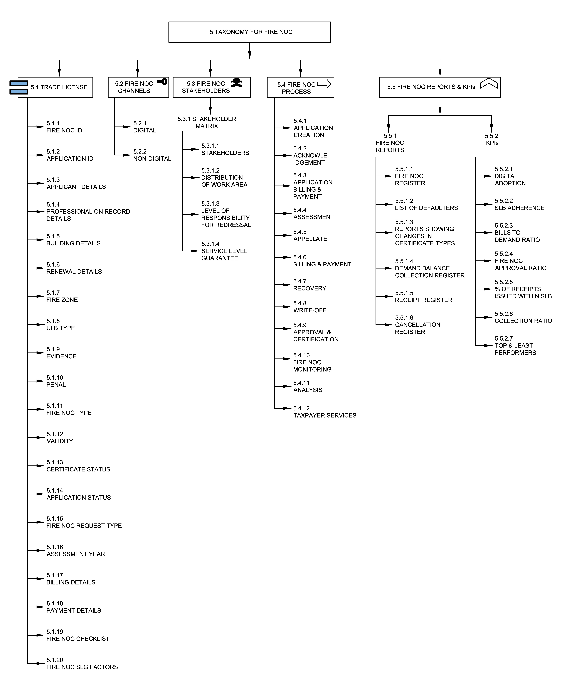
Fig 1 Taxonomy of Fire NOC

5.1 Fire NOC
Fire NOC is a document issued by the respective ULBs which certifies that a building is resistant and is unlikely to observe any fire related accidents. By meeting certain guidelines laid down by the fire department, an applicant can obtain NOC for any building. Sub-components in this section describe important components of a Fire NOC entity.

5.1.1 Fire NOC ID
A Fire NOC ID is the unique identifier allotted to a Fire NOC document by the ULB for the purpose of NOC record management. Typically, the Fire NOC ID is generated after the completion of assessment, inspection of the property by the ULB officials, payment of Fire NOC fees by the applicant and subsequent approval by the ULB.

5.1.2 Application ID
An Application ID is a unique application identifier that is generated after submitting the application form successfully. The application ID can be used to check the status of the filled application, get duplicate bills, receipts etc.

5.1.3 Applicant Details
Applicant details means the details of the individual or group of individuals who hold the Fire NOCs for the building such as name of all partners, mobile numbers, addresses, age, proofs of identity, email ids, photographs and partnerships. It is recommended that automated authentication be incorporated with other government documents and services such as Aadhaar, PAN, etc.

5.1.4 Professional on record details
This means the details of the professional of the building who is responsible for drafting or approving the building layout plan before submitting it to the ULB such as the name of the professional, address of the professional, email id or mobile number of the professional etc. The professional could be fire safety expert, architect, designer etc.

5.1.5 Building details
Building is any structure for whatsoever purpose and of whatsoever materials constructed and every part thereof whether used as human habitation or not and includes foundation, plinth, walls, floors, roofs, chimneys, plumbing and building services, fixed platforms, verandah, balcony, projection (National Building Code Sectional Committee, CED 46, 2016).
Building details in a NOC includes physical attributes of the building such as area, built-up space, number of floors, etc. which are used during the assessment process. A Fire NOC should be linked with property ID to fetch relevant property details from the municipal property system and online building approval system respectively.
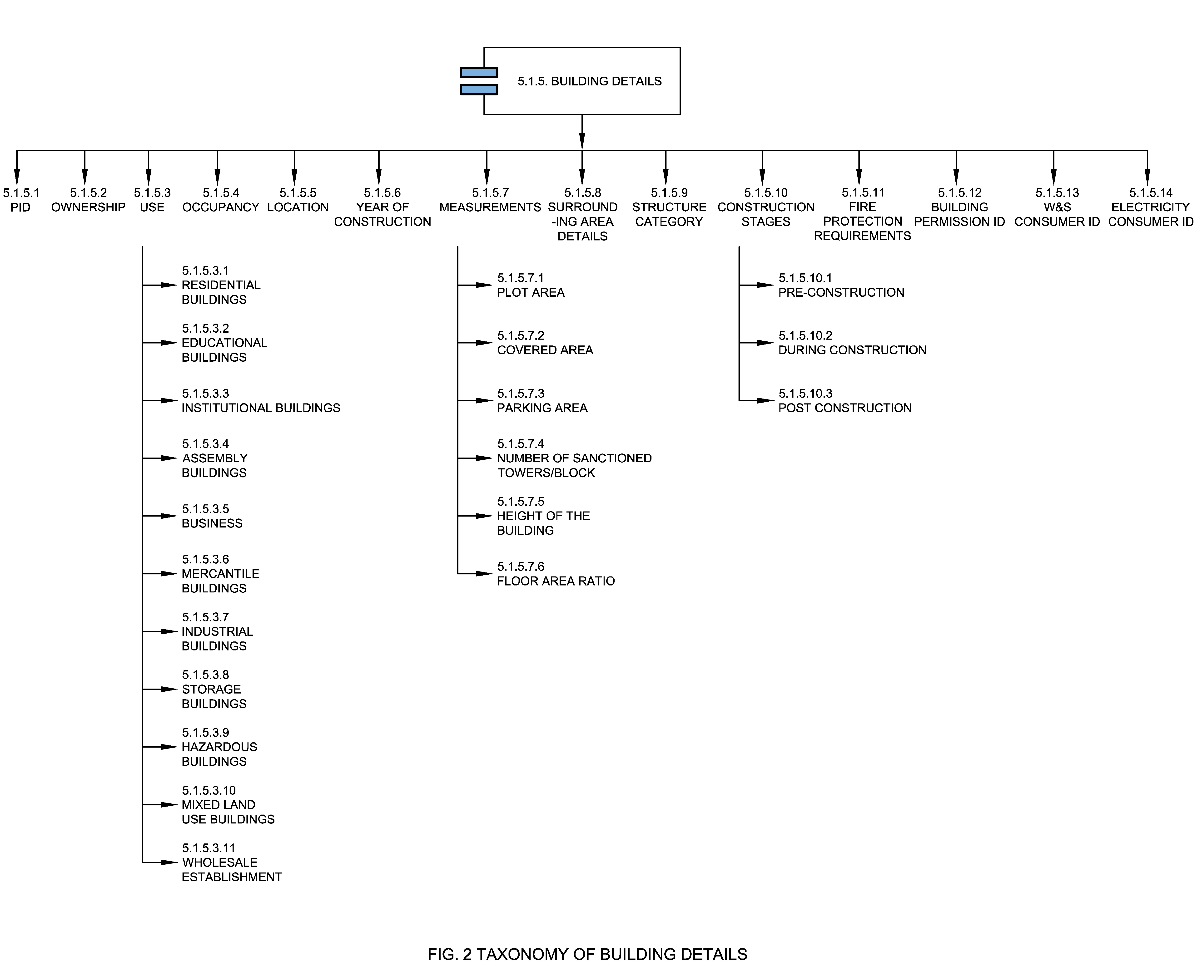

5.1.5.1 PID
A property ID (PID) or Property Tax Identification Number (PTIN) or Unique Property Identification Code (UPIC) is the unique identification number allotted to a property by the ULB for the purpose of property tax records. Typically, the PID/ PTIN is generated after the first-time enumeration of the property and its verification by the ULB officials.

5.1.5.2 Ownership
Property ownership is the state or fact of exclusive rights and control over immovable property. Property may be owned by individuals or organizations.

5.1.5.3 Use
The purpose to which a property is being put to use is again a vital characteristic that defines the entity ‘Property’. It determines factors like the rate of property tax, Fire NOC etc. The usage of the building for which a Fire NOC is applied can be residential buildings, educational buildings, institutional buildings or any other as defined by the ULB rules.

5.1.5.3.1 Residential Buildings
Residential buildings include any building in which sleeping accommodation is provided for normal residential purposes with or without cooking or dining or both facilities except as mentioned in section 5.1.5.3.5 of this document. These can be subdivided as follows (National Building Code Sectional Committee, CED 46, 2016);
  - Lodging or rooming houses
  - One- or two-family private dwellings
  - Dormitories
  - Apartment houses (flats)
  - Hotels
  - Hotels (starred)

5.1.5.3.2 Educational Buildings
These shall include any building used for school, college, and other training institutions, for day care purposes involving assembly for instructions, education or recreation for not less than 20 students. These can be subdivided as follows (National Building Code Sectional Committee, CED 46, 2016);
  - Schools up to senior secondary levels
  - All other/training institutes under single management with no less than 100 students

5.1.5.3.3 Institutional Buildings
These shall include any building or part thereof which is used for purposes, such as medical or other treatment or care of persons suffering from physical or mental illness, disease or infirmity; care of infants, convalescents or aged persons and for penal or correctional detention in which the liberty of the inmates is restricted. Institutional buildings may provide sleeping accommodation for the occupants. These can be subdivided as follows (National Building Code Sectional Committee, CED 46, 2016);
- Hospitals and sanatoria
- Custodial institutes
- Penal and mental institutes

5.1.5.3.4 Assembly Buildings
These shall include any building or part of a building, where number of persons not less than 50 gather for amusement, recreation, social, religious, patriotic, civil, travel and similar purposes, for example, theatre’s, motion picture houses, assembly halls, museums, skating, rinks, gymnasiums, restaurants, places of worship, dance halls, club rooms, passenger stations and terminals of air, surface and marine public transportation services recreation piers and stadia etc. These can be subdivided as follows (National Building Code Sectional Committee, CED 46, 2016);
- Buildings having a theatrical or motion picture or any other stage and fixed seats for over 1000 persons
- Buildings having a theatrical or motion picture or any other stage and fixed seats for up to 1000 persons
- Buildings without a permanent stage having accommodation for 300 or more persons but no permanent seating arrangement
- Buildings without a permanent stage having accommodation for less than 300 persons with no permanent seating arrangements
- All other structures including temporary structures designed for assembly of people not covered by other subdivisions
- Building having mixed occupancies providing facilities such as shopping, cinema halls, theatres and restaurants
- All other structures elevated or underground, for assembly of people not covered

5.1.5.3.5 Business Buildings
These shall include any building or part of a building which is used for transactions of business other than covered in section 5.1.5.3.1 of this document. These can be subdivided as follows (National Building Code Sectional Committee, CED 46, 2016);
- Offices, banks, professional establishments, like offices of architects, engineers, doctors, lawyers and police stations
- Laboratories, research establishments, libraries and test houses
- Computer installations
- Telephone exchanges
- Broadcasting stations and TV stations

5.1.5.3.6 Mercantile Buildings
These shall include any building or part of a building which is used as shops, stores, market, for display and sale of merchandise, either wholesale or retail. These can be subdivided as follows (National Building Code Sectional Committee, CED 46, 2016);
- Shops, stores, departmental stores markets with area up to 500 m²
- Shops, stores, departmental stores markets with area more than 500m ²
- Underground shopping centers, storage and service facilities incidental to sale of merchandise and located in the same building shall be included under this group

5.1.5.3.7 Industrial Buildings
These shall include any building or part of a building or structure, in which products or materials of all kinds and properties are fabricated, assembled, manufactured or processed for example, assembly plants, industrial laboratories, dry cleaning plants, power plants, generating units, pumping stations, fumigation chambers, laundries, buildings or structures in gas plants, refineries, dairies and saw mills etc. These can be subdivided as follows (National Building Code Sectional Committee, CED 46, 2016);
- Buildings used for low hazard industries
- Buildings used for moderate hazard industries
- Buildings used for high hazard industries

5.1.5.3.8 Storage Buildings
These shall include any building or part of a building used primarily for the storage or sheltering (including servicing, processing or repairs incidental to storage) of goods, ware or merchandise (except those that involve highly combustible or explosive products or martials) vehicles or animals, for example warehouses, cold storage, freight depots, transit sheds, storehouses, truck and marine terminals, garages hangers, grain elevators, barns and stables. Storage properties are characterized by the presence of relatively small persons in proportion to the area (National Building Code Sectional Committee, CED 46, 2016).

5.1.5.3.9 Hazardous Buildings
These shall include any building or part of a building which is used for the storage, handling, manufacture or processing of highly combustible or explosive materials or products which are liable to burn with extreme rapidity and or which may produce poisonous fumes or explosions for storage, handling, manufacturing or processing which involve highly corrosive, toxic or noxious alkalis, acids or other liquids or chemicals producing flames, fumes and explosive, poisonous , irritant or corrosive gases; and for the storage , handling or processing of any material producing explosive mixtures of dust which result in the division of matter into fine particles subject to spontaneous ignition (National Building Code Sectional Committee, CED 46, 2016).

5.1.5.3.10 Mixed Land Use Building
A building partly used for non-residential activities and partly for residential purposes.

5.1.5.3.11 Wholesale Establishment
An establishment wholly or partly engaged in wholesale trade and manufacture, wholesale outlets, including related storage facilities, warehouses and establishments engaged in truck transport, including truck transport booking agencies.

5.1.5.4 Occupancy
The principal occupancy for which a building or a part of a building is used or intended to be used; for the purposes of classification of a building according to occupancy, occupancy shall be deemed to include the subsidiary occupancies which are contingent upon it (National Building Code, 2016).

5.1.5.5 Location
Location (address of the building) provides the particulars of the place where the building is situated such as ward, zone, tehsil in which the building is located, nearby fire station etc. It also indicates the GIS positioning of a property with respect to the urban base map.

5.1.5.6 Year of Construction
This means the year in which the construction of the property mentioned in the Fire NOC application.

5.1.5.7 Measurements
Measurements of a property are values discovered by measuring the corresponding size, shape and/or area of property. For a building whose Fire NOC is needed, applicants need to provide information and evidence related to plot area, covered area, parking area, number of sanctioned towers, height of the building or any other measurements related to the building that are required for provisioning of fire & life safety.

5.1.5.7.1 Plot Area
Plots to be used for high rise development should be located in an approved layout plan, comprehensive plans of subdivision plan as prepared and approved by competent authorities/ as per policy of the Government of India / State Governments.

5.1.5.7.2 Covered Area
The ground area covered immediately above the plinth level covered by the building but does not include the space covered by:
- Garden, rockery, well and well structures, plant nursery, water pool, swimming pool (if uncovered), platform round a tree, tank, fountain, bench, chabutra with open top and unenclosed on sides by walls and the like;
- Drainage culvert, conduit, catch-pit, gully-pit, chamber, gutter and the like;
- Compound wall, gate, slide/ swing door, canopy, and areas covered by chajja or similar projections and staircases which are uncovered and open at least on three sides and also open to sky

5.1.5.7.3 Parking Area
Total ground area covered by the building for the parking facility inside the premises.

5.1.5.7.4 Number of Sanctioned Towers/Blocks
This means number of towers or blocks sanctioned as per the building regulations, master plan or bye laws by the ULBs.

5.1.5.7.5 Height of the Building
The vertical distance measured
i) In the case of flat roofs from the average level of the front road and continuance to the highest point of the building.
ii) In case of pitched roofs up to the point where the external surface of the outer wall intersects the finished surface of the sloping roof and,
iii) In the case of gables facing the road midpoint between the eaves level and the ridge. Architectural features serving no other function except that of decoration shall be excluded for the purpose of measuring heights. The height of the building shall be taken up to the terrace level for the purpose of fire safety requirement as per Model Building Bye Laws, MOHUA, 2016.

5.1.5.7.6 Floor Area Ratio
The quotient obtained by dividing the combined covered area (plinth area) of all floors, excepting areas specifically exempted under these regulations, by the total area of the plot, viz.:
$$FAR=\frac{Total covered area on all floors}{Plot Area}$$

5.1.5.8 Surrounding Area Details
This means details of the surrounding area of the building such as open spaces, vertical openings, fire stop etc.

5.1.5.9 Structure Category
The construction of the building is based on the type of materials, design which are important factors in making the building resistant to a complete burn out and in preventing the rapid spread of fire, smoke or fumes which may contribute to the loss of lives and property.

5.1.5.10 Construction Stage
This means the current stage of construction of a building during which the Fire NOC is applied, such as pre-construction, during construction or post construction.

5.1.5.10.1 Pre-Construction
The pre-construction phase includes creating a strategic plan for the project, creating a design, securing permits or entitlements, and gathering the labour and resources required for construction. The builder may apply for Fire NOC at this stage by submitting layout designs and plans.

5.1.5.10.2 During Construction
The during construction phase is where the physical construction is ongoing. The builder may apply for Fire NOC at this stage by submitting layout designs and plans.

5.1.5.10.3 Post Construction
The post-construction phase is where the physical construction is completed. The builder may apply for Fire NOC at this stage.

5.1.5.11 Fire Protection Requirements
Fire Protection Requirements are measures and equipment as defined in National Building Codes or Fire Safety Acts, rules or regulations by the state or ULB such as firefighting equipment, wet wiser, first aids etc. Buildings shall be planned, designed and constructed to ensure fire safety and this shall be done in accordance with part IV Fire Protection of National Building Code of India, unless otherwise specified in these Bye-Laws.

5.1.5.12 Building Permission ID
Building Permission ID is a unique connection identifier for Building plan Approval of the building for which Fire NOC is applied. A Fire NOC ID should be linked with Building Permission ID to fetch relevant building details and green building provisions such as solar panels for electricity, rainwater harvesting etc. from municipal building plan registry and vice versa. This linking may also be used to identify revenue leakages.

5.1.5.13 W&S Consumer ID
Water & Sewerage (W&S) Consumer ID is a unique connection identifier for water & sewerage connection of the building for which Fire NOC is applied. A Fire NOC ID may be linked with W&S consumer ID to fetch relevant water connection details from municipal W&S registry and vice versa. This linking may also be used to identify revenue leakages.

5.1.5.14 Electricity Consumer ID
Electricity Consumer ID is a unique connection identifier for electricity connection of a building. A Fire NOC ID may be linked with electricity consumer ID to fetch relevant details from municipal electricity registry and vice versa. This linking may also be used to identify revenue leakages.

5.1.6 Renewal Details
These are details associated with the previous Fire NOC. The renewal of the NOC has to be done within a specific time frame as per the ULB. Renewal details may include:
- Old Fire NOC ID
- Property tax receipt
- Old Application ID
- Professional on record details

5.1.7 Fire Zone
The city or area under the jurisdiction of the authority shall for the purpose of Fire and Life Safety Code, be demarcated into the distinct zones, and based on fire hazard inherent in the buildings and structures according to occupancy which shall be called as fire zones (National Building Code Sectional Committee, CED 46, 2016). The number of fire zones in a city or area under the jurisdiction of the authority depends upon the existing layout, types of building construction, classification of existing buildings based on occupancy and expected future development of the city or area. In larger cities, three fire zones may be necessary, while in smaller ones, one or two may be adequate.

5.1.8 ULB Type
Type of Urban Local Body as per the definition of MoHUA such as Nagar Panchayat, Municipal Council or Municipal Corporation (Ministry of Housing and Urban Affairs, 2014).

5.1.9 Evidence
Proof of the building and owner details submitted during application of Fire NOC. These can be;
- Address proof of the building
- ID proof of the applicant
- Aadhaar card
- Layout plans of the building
- License details of professional on record

5.1.10 Penal Provisions
These are the penalties for violation or non-compliance of terms, provisions, rules, and regulations that are required to be followed by the registered entity. Some of the penalties for contravention of the provisions of the Fire NOC are stated below:
- If an entity violates the conditions of certificate or cause nuisance in the neighbourhood or surrounding, then the certificate might be cancelled or revoked;
- The entity committing a breach of the terms of the certificate or applicable laws shall make it liable to pay prescribed penalty;
- A fine of 50% of the NOC fees may be levied in case of any delay in the certificate renewal process.
- An appropriate legal action can also be taken against the defaulting entity.

5.1.11 Fire NOC Type
Fire NOC Type means type of NOC based on the period of validity such as permanent Fire NOC, usually valid for the financial year, and provisional Fire NOC usually valid for a shorter period of time.
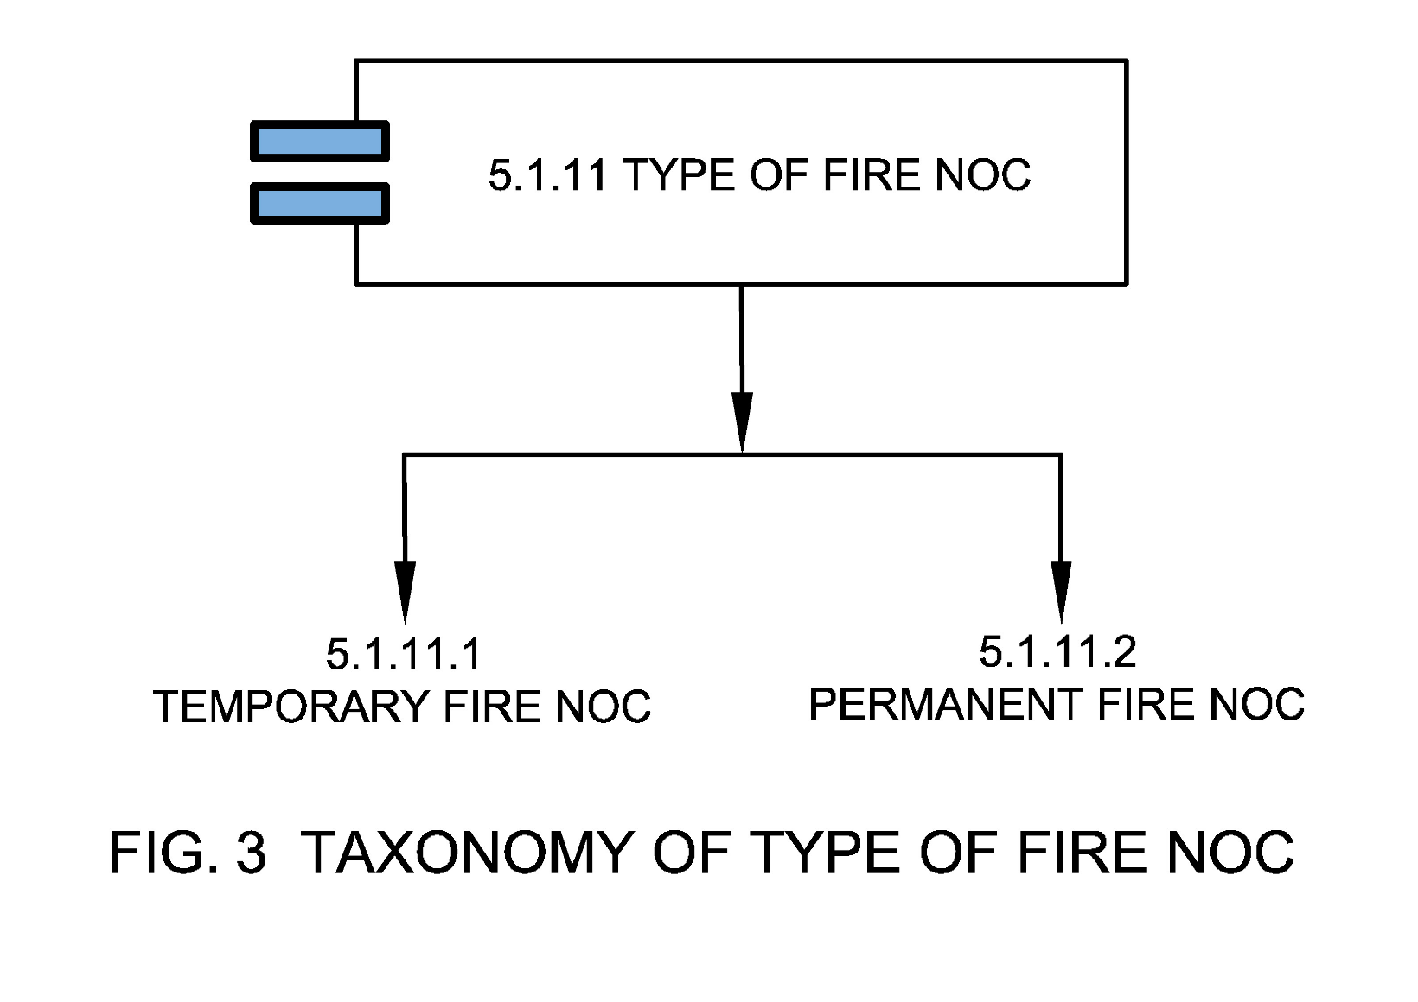

5.1.11.1 Temporary Fire NOC
A temporary Fire NOC or provisional Fire NOC is the NOC applied for the validity of a short period i.e., less than a financial year.

5.1.11.2 Permanent Fire NOC
A Permanent Fire NOC is the NOC applied for the validity of the financial year that can be renewed as per the Fire NOC guidelines.

5.1.12 Validity
Validity is the time period through which a Fire NOC is valid.

5.1.13 Certificate Status
This is the current status of validity of Fire NOC.
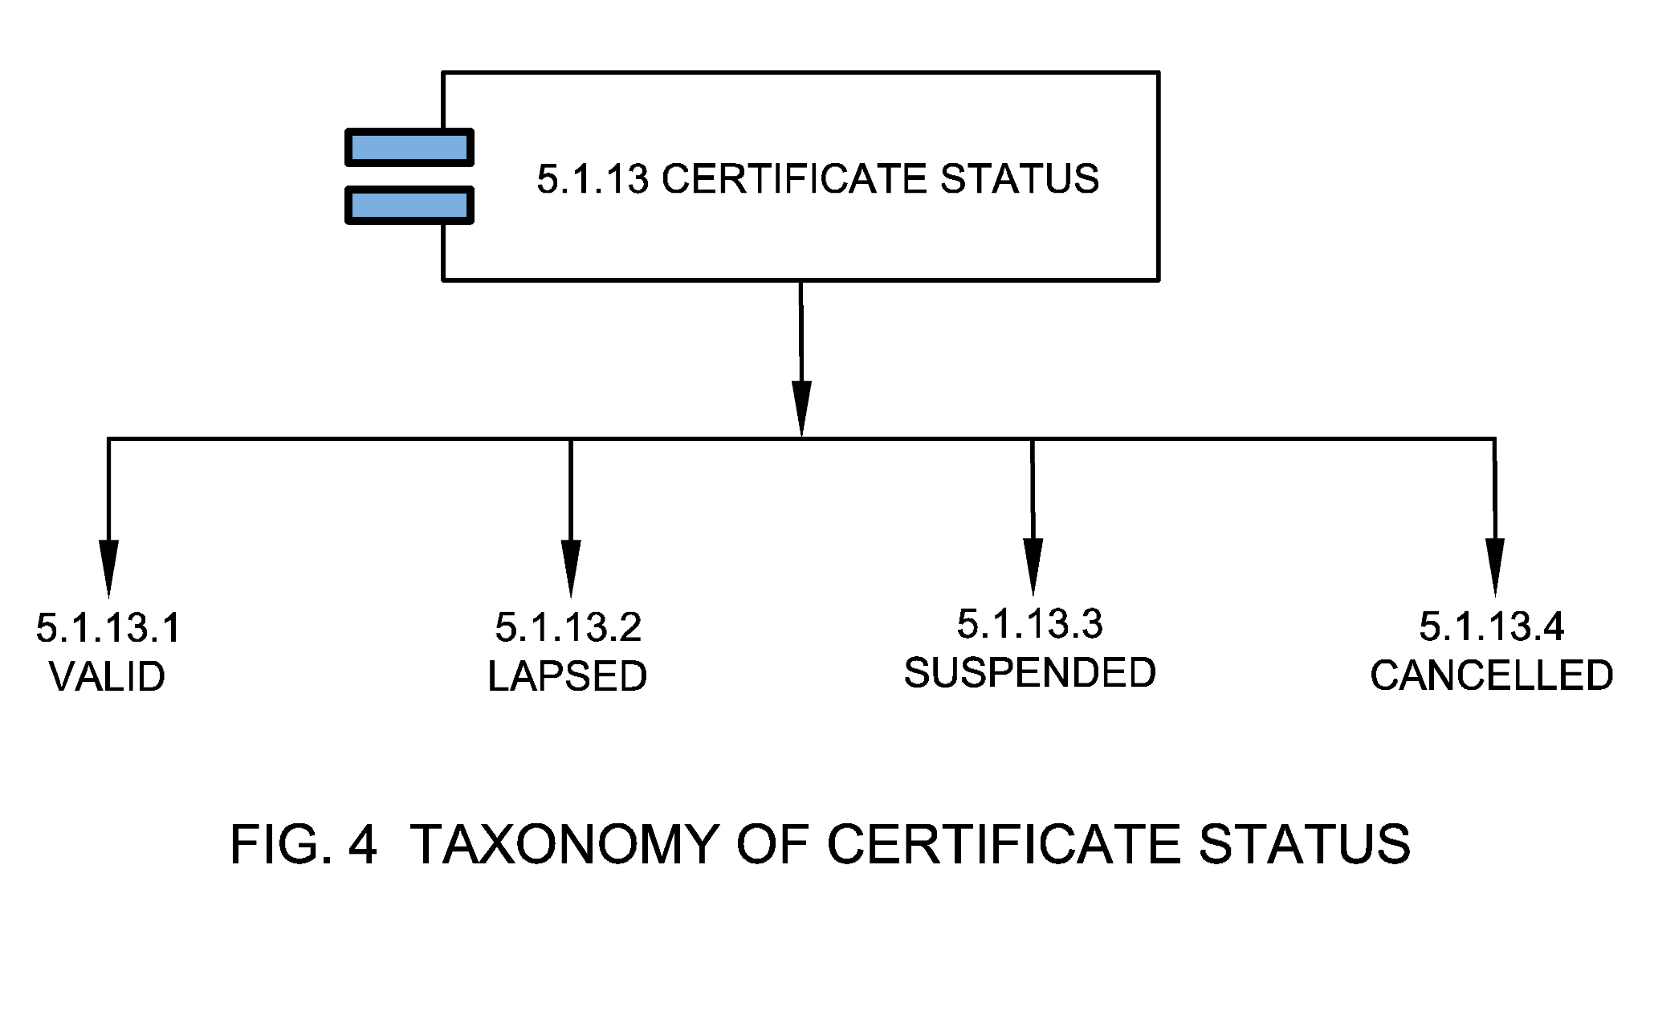

5.1.13.1 Valid
This is the status of Fire NOC when it's within validity.

5.1.13.2 Lapsed
This is the status of Fire NOC when it's beyond validity.

5.1.13.3 Suspended
This is the status of Fire NOC when it is beyond validity if a certificate issued is suspended for a reason by the ULB.

5.1.13.4 Cancelled
This is the status of Fire NOC when it’s beyond validity if a certificate issued is cancelled for a reason by the ULB.

5.1.14 Application Status
This is the current status of the Fire NOC application.
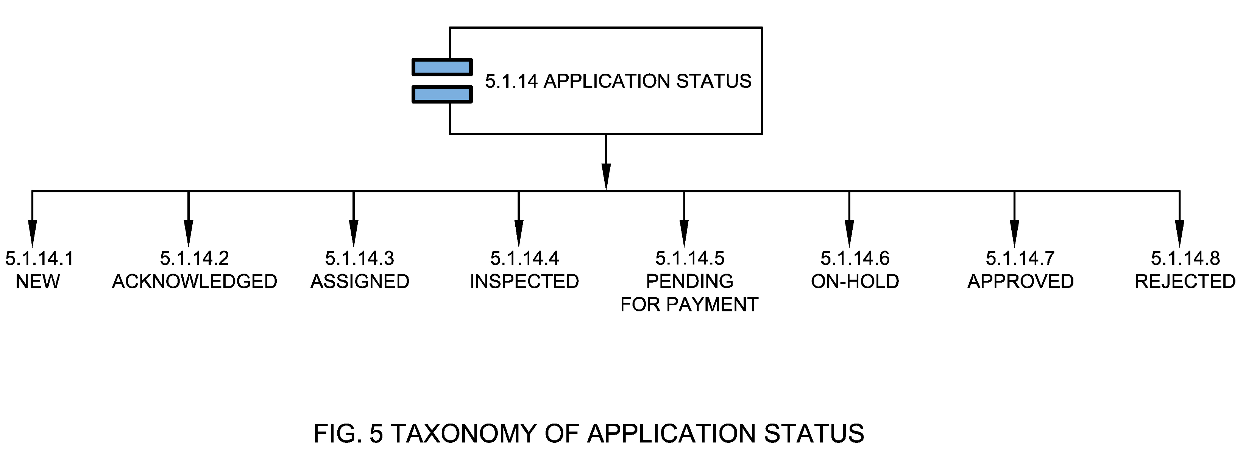

5.1.14.1 New
New application status means that a Fire NOC application has been filed.

5.1.14.2 Acknowledged
Acknowledged application status means that the Fire NOC application has been acknowledged by the ULB department.

5.1.14.3 Assigned
Assigned application status means that the Fire NOC application is assigned to inspection team and the inspection is in process.

5.1.14.4 Inspected
Inspected application status means that the Fire NOC inspection is completed.

5.1.14.5 Pending for Payment
Pending for payment application status means that that the Fire NOC application is pending for payment after successful inspection.

5.1.14.6 On-hold
On-hold application status means that the Fire NOC application is put on hold for a reason.

5.1.14.7 Approved
Approved application status means that the Fire NOC application is approved. A Fire NOC ID is generated in this case.

5.1.14.8 Rejected
Rejected application status means that the Fire NOC application is rejected after inspection.

5.1.15 Fire NOC Request Type
Request type is the classification of application is applied based on the nature of application.
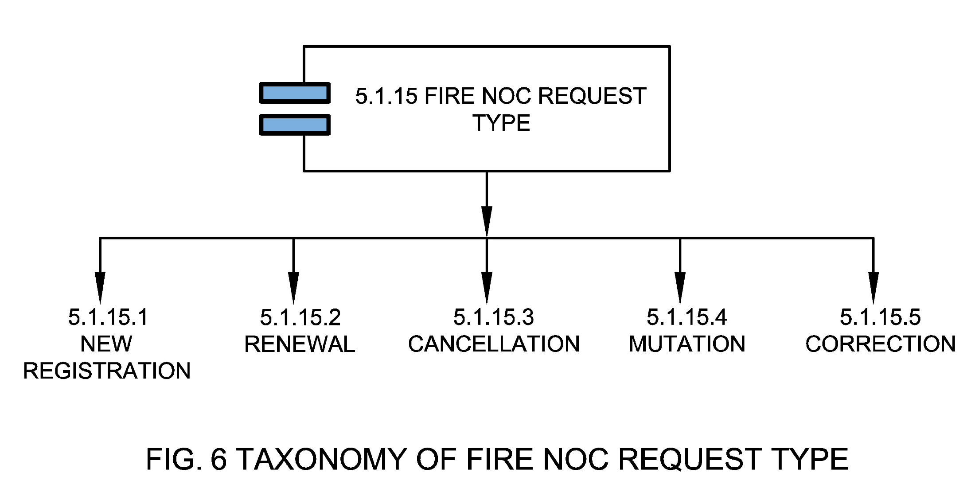

5.1.15.1 New Registration
New registration means an application for registration for fresh Fire NOC is to be submitted with requisite documents and registration & processing fee along with applicable Fire NOC fee.

5.1.15.2 Renewal
Renewal means the application to renew the Fire NOC for any kind of Fire NOC category. The renewal of the Fire NOC has to be done within a specific time frame as per the municipal authority.

5.1.15.3 Cancellation
Cancellation means an application type to cancel existing Fire NOC. The ULB officer, after receiving the application with required information, if not satisfied about its correctness will remove such establishment/buildings from the register of building approvals and cancel the Fire NOC.

5.1.15.4 Mutation
Mutation means an application type for transfer of title to existing Fire NOC.

5.1.15.5 Correction
Correction means an application type for correction of building-related information of an existing Fire NOC.

5.1.16 Assessment Year
Assessment year is the year for which assessment was done for an obtained Fire NOC.

5.1.17 Billing Details
These are the details of bill generated during the process of application for a new NOC or while renewing an old NOC.
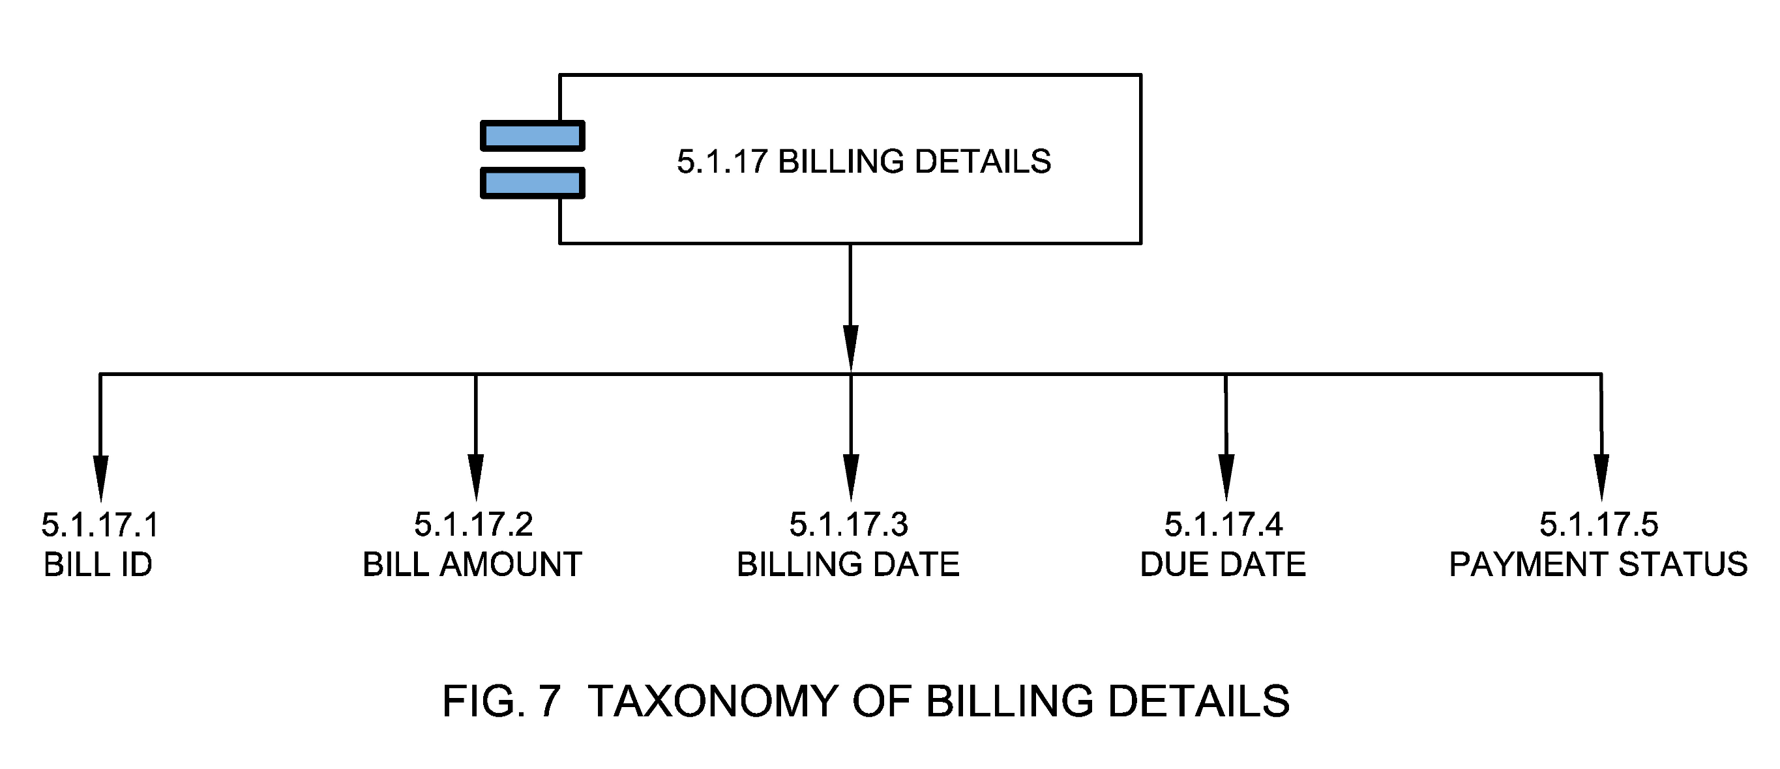

5.1.17.1 Bill ID
Bill ID is a unique identifier that identifies an applicant's bill for accounting purposes.

5.1.17.2 Bill Amount
An amount of money paid by the applicant during the application of the Fire NOC.

5.1.17.3 Billing Date
Billing date is the date on which a bill is generated during the application process.

5.1.17.4 Due Date
Due date is the date on which the bill for a particular application (application fees or the bill for a particular NOC is due for the current assessment duration) is due for the new application. Upon non-payment of bill by the given due date, a surcharge may be levied on the initial demand by the imposition of a penalty.

5.1.17.5 Payment Status
Payment status is the status of payment against a raised bill.

5.1.18 Payment Details
These are the details of payment made during the process of application for a new NOC or while renewing an old NOC.
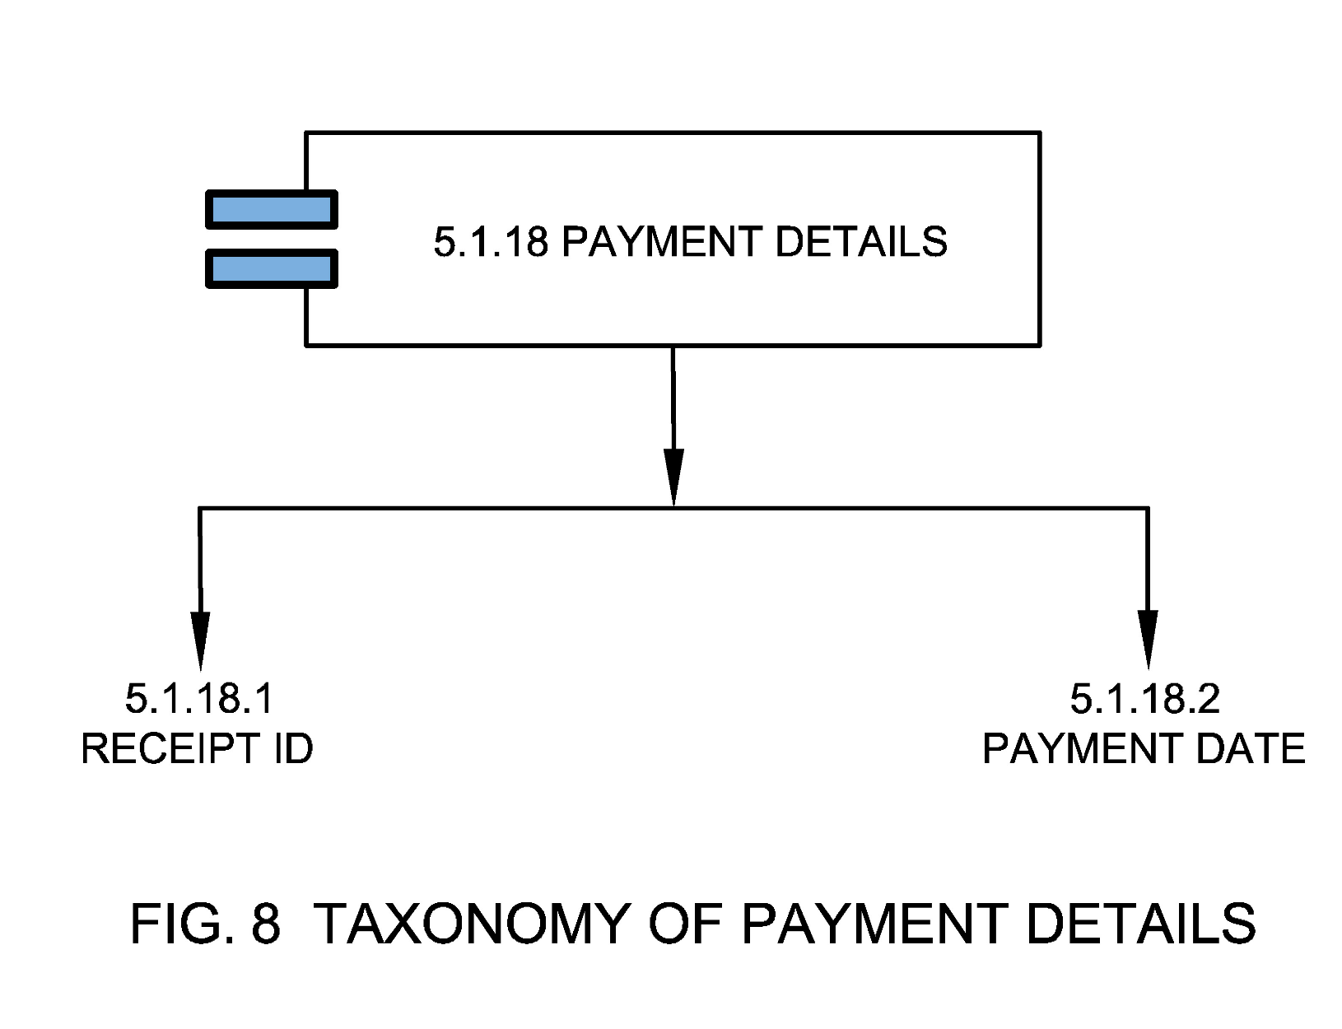

5.1.18.1 Receipt ID
Receipt ID is a unique identifier which is generated once payment is completed and payment details are captured on the accounting system.

5.1.18.2 Payment Date
The date on which the Fire NOC fees (application for NOC) is paid by the applicant.

5.1.19 Fire NOC Checklist
Fire NOC checklist is a list of items, as names or tasks, for comparison, verification, or other checking purposes. These checklists can be pre construction checklists, post construction checklists, Inspection checklists and/or Owner’s Checklist.
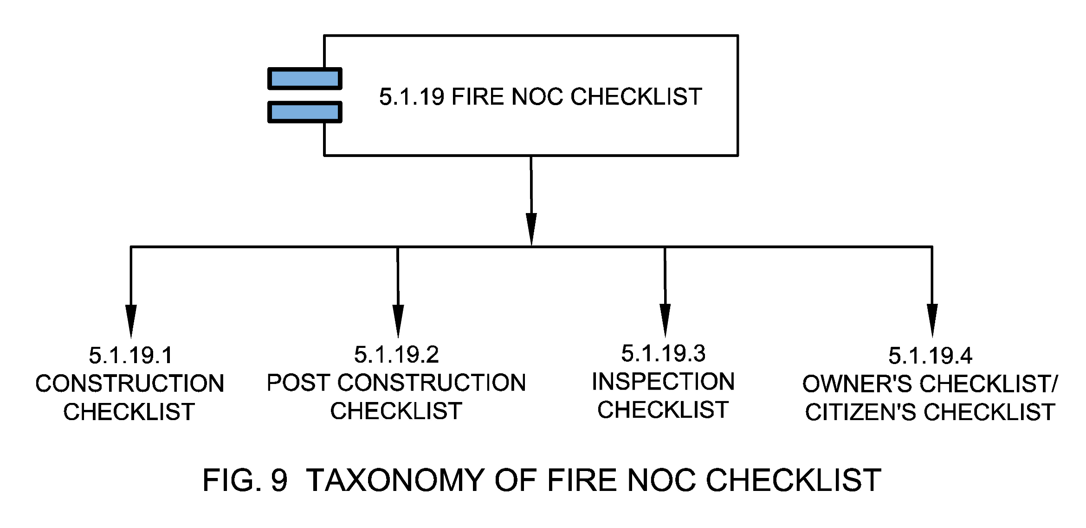

5.1.19.1 Pre-Construction Checklist
This means a list of items or tasks to compare or verify fire safety regulations at pre-construction stage.

5.1.19.2 Post Construction Checklist
This means a list of items or tasks to compare or verify fire safety regulations at post construction stage.

5.1.19.3 Inspection Checklist
Inspection checklist is used by ULB inspectors to check conformance to relevant rules, safety measures and guidelines, workforce, labor, any illegal activity, etc.

5.1.19.4 Owner’s Checklist/Citizen’s Checklist
This means a list of building fire safety related information that needs to be furnished by the owner/applicant during the application of the Fire NOC. The checklist is usually available at the website of ULB or at the ULB office for ready reference of the citizen.

5.1.20 Fire NOC SLG Factors
These are important time factors associated with a NOC application that determine the timeliness aspect of Fire NOC approval with respect to Service Level Guarantee (SLG) set by the ULB or state.
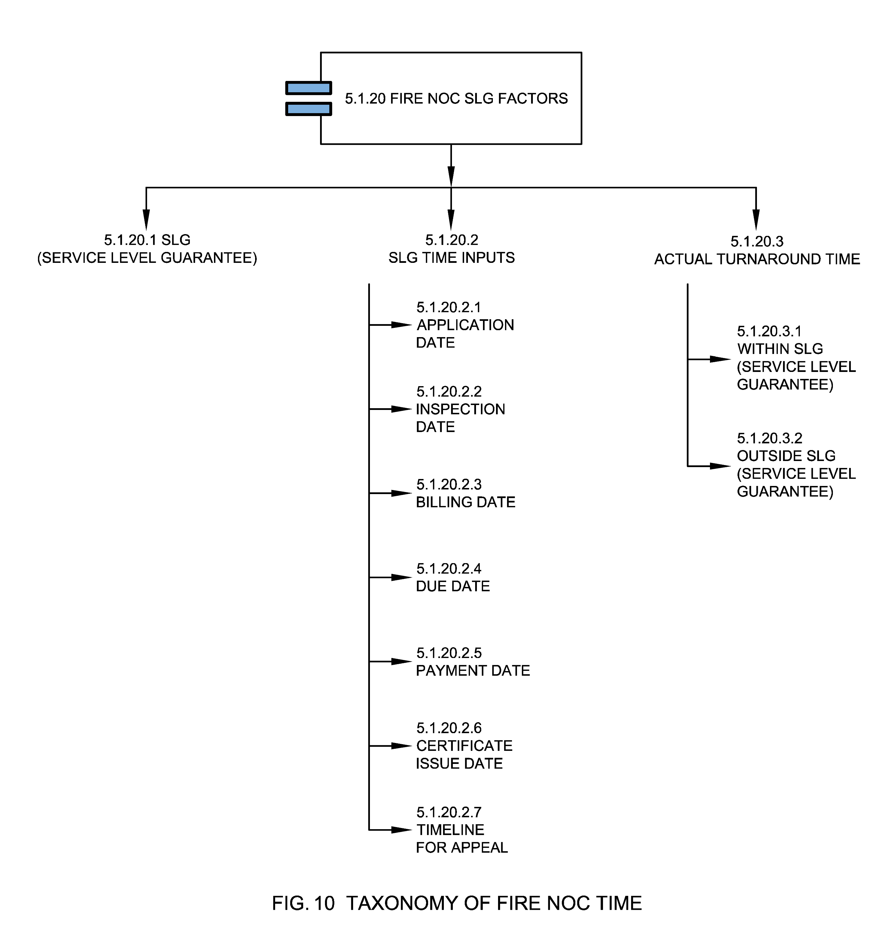

5.1.20.1 SLG (Service level Guarantee)
The maximum time that service departments expect to take to complete a Fire NOC process. Also called expected compliance time set by the ULB in citizen charter or any public disclosed document for a service in which it should be issued or managed. Public sharing of a comparative picture of various SLG in the municipal corporation may introduce competition to improve performance.

5.1.20.2 SLG Time Inputs
These are important dates that help capture service level compliances.

5.1.20.2.1 Application Date
Application is the date on which the application was first observed by the citizen.

5.1.20.2.2 Inspection Date
It is the date on which an inspection has been conducted by the ULB inspector.

5.1.20.2.3 Billing Date
Refer section 5.1.17.3.

5.1.20.2.4 Due Date
Refer section 5.1.17.4.

5.1.20.2.5 Payment Date
Refer section 5.1.18.2.

5.1.20.2.6 Certificate Issue Date
Certificate issue date is the date on which Fire NOC ID was issued to the applicant by the ULB.

5.1.20.2.7 Timeline for Appeal
This is the timeline mentioned in an assessment notice by when an aggrieved person can appeal to the appellate authority.

5.1.20.3 Actual Turnaround Time
Actual Turnaround Time is the actual time taken by the ULB in which a Fire NOC is issued, cancelled, restored, renewed, or suspended.

5.1.20.3.1 Within SLG (Service level Guarantee)
When a Fire NOC is issued in the given SLG (Service Level Guarantee) without exceeding the time period defined.

5.1.20.3.2 Outside SLG (Service level Guarantee)
When a Fire NOC is issued beyond the SLG (Service Level Guarantee) exceeding the time period defined.

5.2 Fire NOC Channels
Channel / Mode / Method through which Fire NOC application is being registered by the citizen or information and response is shared by the ULBs.
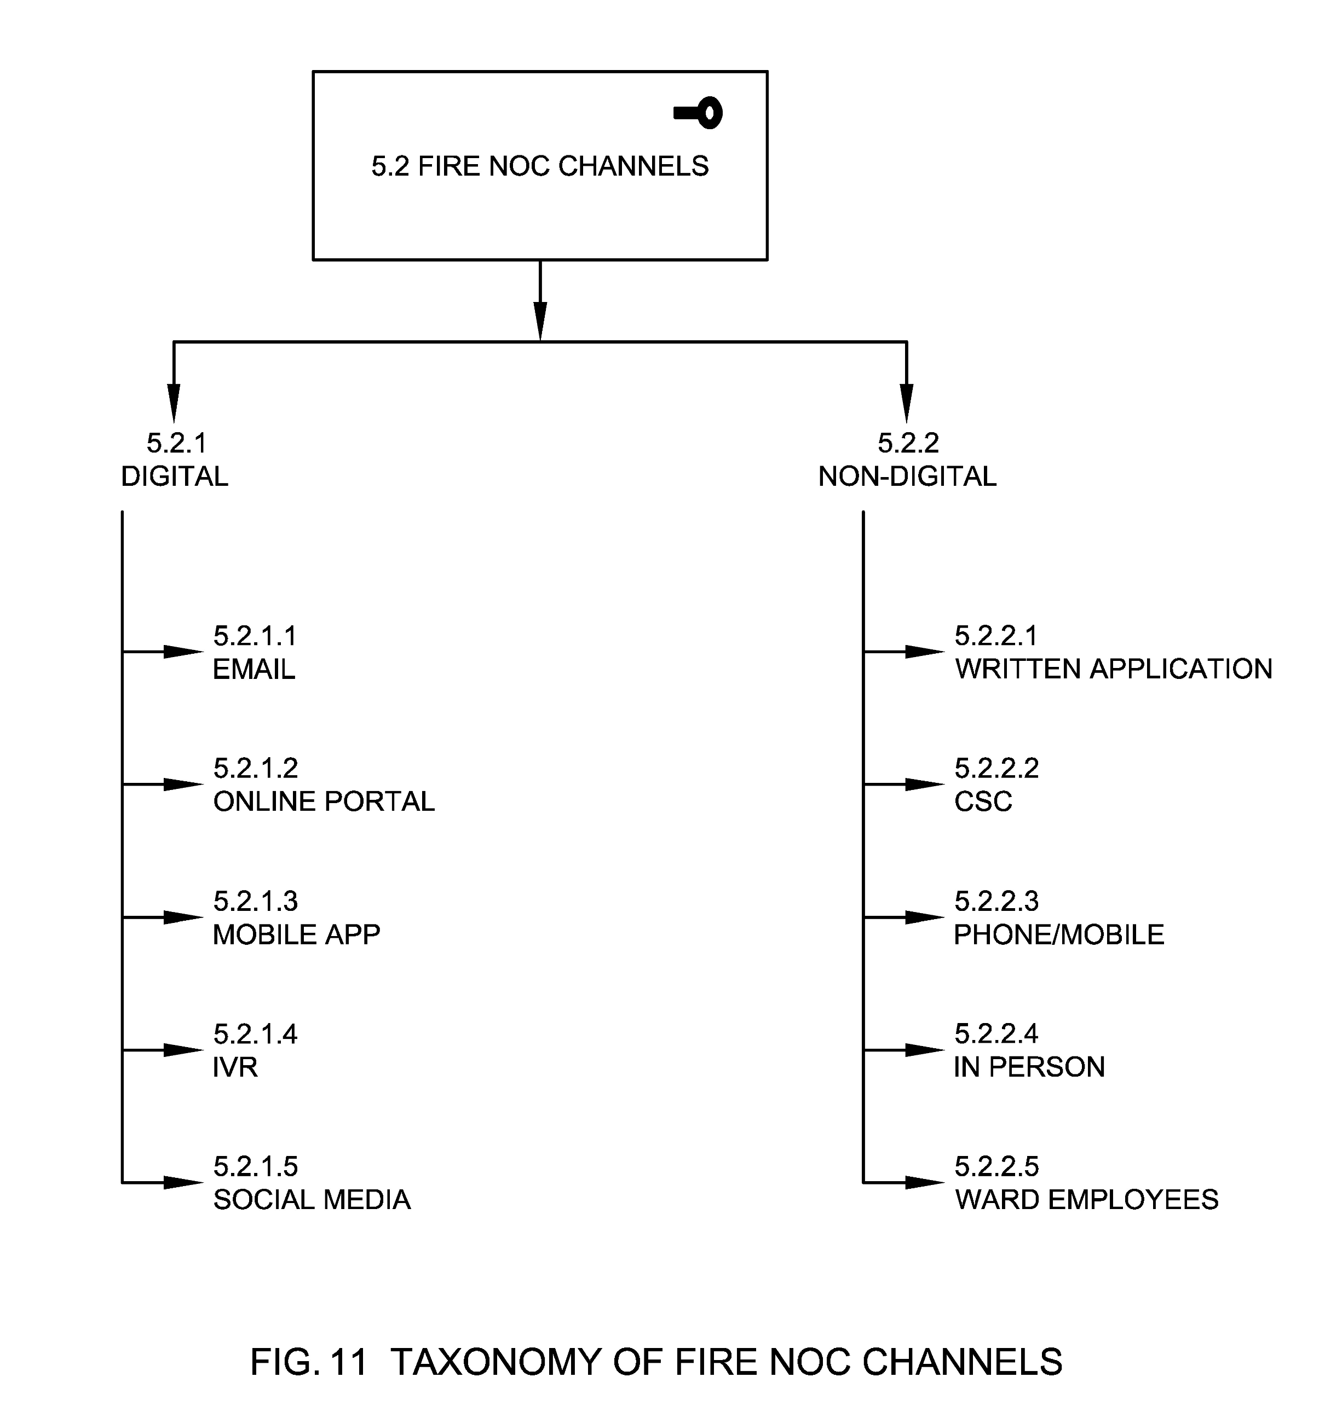

5.2.1 Digital
Digital means an electronic way to collect, store, process and transmit data in the desired form. In the context of Fire NOC, this refers to processes and corresponding data used by the authority and the individual for Fire NOC which is requested or generated in digital form for the purpose of recording, allocation, assessment, follow up, and appeal.

5.2.1.1 Email
Electronic media for transfer of messages and information through the internet.

5.2.1.2 Online Portal
Web portals or web applications refers to the websites developed for Fire NOC management. This broadly includes an assessment calculator, Fire NOC data, owner’s information and facility to pay the Fire NOC fees through payment gateways linked to the portals. These portals also include the websites developed by the National, State or ULB for e-governance service delivery.

5.2.1.3 Mobile App
A mobile application, also referred to as a mobile app or simply an app, is a computer program or software application designed to run on a mobile device such as a phone, tablet, or watch.

5.2.1.4 IVR
Interactive Voice Response (IVR) is a technology that allows humans to interact with a computer-operated phone system through the use of voice and DTMF tones input via a keypad. The call center operator will listen to the IVR recorded Fire NOC and register the same in the system. The call center operator may contact the citizen in case information provided is insufficient or any clarification required.

5.2.1.5 Social Media
Social media are interactive technologies that allow the creation or sharing/exchange of information, ideas, interests, and other forms of expression via virtual communities and networks such as Twitter, WhatsApp, Facebook etc.

5.2.2 Non-Digital
These are other means (non-digital) by which a request for Fire NOC is captured.

5.2.2.1 Written application
A written application refers to a channel for Fire NOC which includes an application in a prescribed Form/Format, addressed to Municipal Commissioner, requesting for new or renewal of Fire NOC.

5.2.2.2 CSC
Common Service centers are the access points for delivery of various services using Information and Communication Technology (ICT). CSCs were created under the National E-government Project by the Government of India.

5.2.2.3 Phone/Mobile
Mobile telephone, also called mobile, is a portable device for connecting to a telecommunications network in order to transmit and receive voice, video, or other data.

5.2.2.4 In Person
A person/s can walk in to the municipal office/ ward office to submit their Fire NOC application.

5.2.2.5 Ward Employees
Ward employees are the employees of municipal council or municipal authority, concerned with administrative wards of the city. In terms of Fire NOC an application can be submitted through the respective ward employees where the Fire NOC is established.

5.3 Fire NOC Stakeholders
Fire NOC stakeholders are the stakeholders involved in planning, implementation and maintenance of Fire NOC function. Participation by all relevant stakeholders ensures sharing a common understanding and involvement in the decision-making process as well as accountability in urban governance. Participation by all stakeholders leads to empowerment and to joint ownership and harmonized access to information connecting multiple urban departments to serve citizens better.
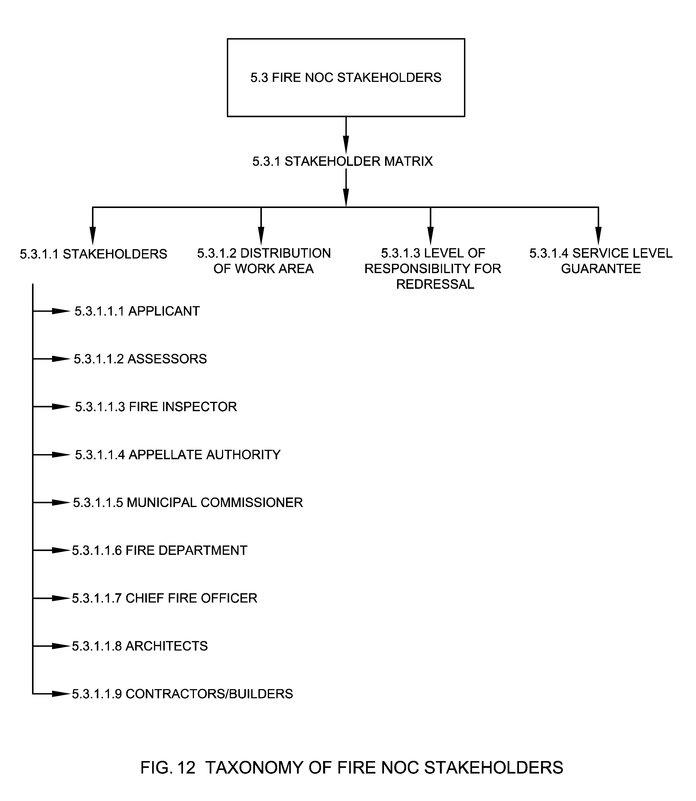

5.3.1 Stakeholder Matrix
Stakeholder matrix captures distribution of work area, level of responsibility and Service Level Guarantee of various stakeholders within the ULB and/ or contracted organizations based on ward / locality/jurisdiction, service / issue category.

5.3.1.1 Stakeholders
This refers to the types of stakeholders who are involved in a Fire NOC system such as the citizen, assessor, inspectors, appellate authority and Municipal Commissioner.

5.3.1.1.1 Applicant
Applicant means the originator of the Fire NOC application who requests the service.

5.3.1.1.2 Assessors
An assessor is a ULB official who determines the value of a Fire NOC fee for revenue purposes. The value an assessor derives are used to calculate future Fire NOC rate.

5.3.1.1.3 Fire Inspector
A Fire Inspector is a person who has been appointed by a government department or agency to perform Fire NOC compliance and enforcement duties.

5.3.1.1.4 Intermediaries
Intermediary is the individual, group of persons (Volunteers) or organizations (NGOs, Trusts etc.) who initiated the Fire NOC request or application on the behalf of the originator who lacks the capacity to use any channels which are provided by the ULB. These Intermediaries should be registered with the ULBs in order to provide their services to the originator (who is either from marginalized section, illiterate or differently abled) and should not charge extra money from the originator.
The application submitted by the intermediaries for the originator who is capable of filling their own request will not be considered by the ULBs.

5.3.1.1.5 Appellate Authority
Appellate Authority is the authority or representative of the authority assigned to review the procedures and decisions or assessment of Fire NOC fee to make sure that the proceedings were fair and that the proper law/regulation are applied appropriately.

5.3.1.1.6 Municipal Commissioner
Commissioner of the ULB or municipal body means an officer appointed by the Government, and includes an Additional Director, a Joint Director, Deputy Director, or any other officer of the Government authorized by it to perform the functions of the Commissioner and Director of Municipal Administration.

5.3.1.1.7 Fire Department
The department of a local or municipal authority in charge of preventing and fighting fires.

5.3.1.1.8 Chief Fire Officer
Chief Fire Officer means the person in charge of a service as contemplated in section 5 of Fire Brigade Services Act of 1987. The Chief Fire Officer shall examine the plans to ensure that they are in accordance with the provisions of fire safety and means of escape as per these bye- laws and shall forward two sets of plans duly have signed for implementation to the building sanctioning authority.

5.3.1.1.9 Architects
Architects means a person whose name is for the time being entered in the register of Council of Architecture (Council of Architecture, 1972). The architects may be responsible to design the building as per Fire and Life Safety Code, byelaws or any other building bye laws by the ULBs. The Architect of the project will be responsible for making provisions for fire protection and firefighting measure and for that they may consult an expert in this field, as in case of other professionals for structural, sanitary and others (Ministry of Housing and Urban Affairs, 2016).

5.3.1.1.10 Contractors/Builders
Contractors are any person or organization with whom the ULB has entered into contract in relation with the construction works and/ or O&M requirements.

5.3.1.2 Distribution of Work Area
This refers to the ward and/or sectors within ULB for which each of the stakeholders are responsible for.

5.3.1.3 Level of Responsibility for Redressal
In order to ensure that applications are resolved within the prescribed time norm, escalation levels of responsibility for redressal are mapped.

5.3.1.4 Service Level Guarantee
Refer section 5.1.20.1.

5.4 Fire NOC Processes
Fire NOC Processes are a series of actions or steps taken in order to achieve a timely delivery of Fire NOCs by the ULBs such as Fire NOC application creation, assessment, suspension, restoration, cancellation, appellate, billing, approval & certification.
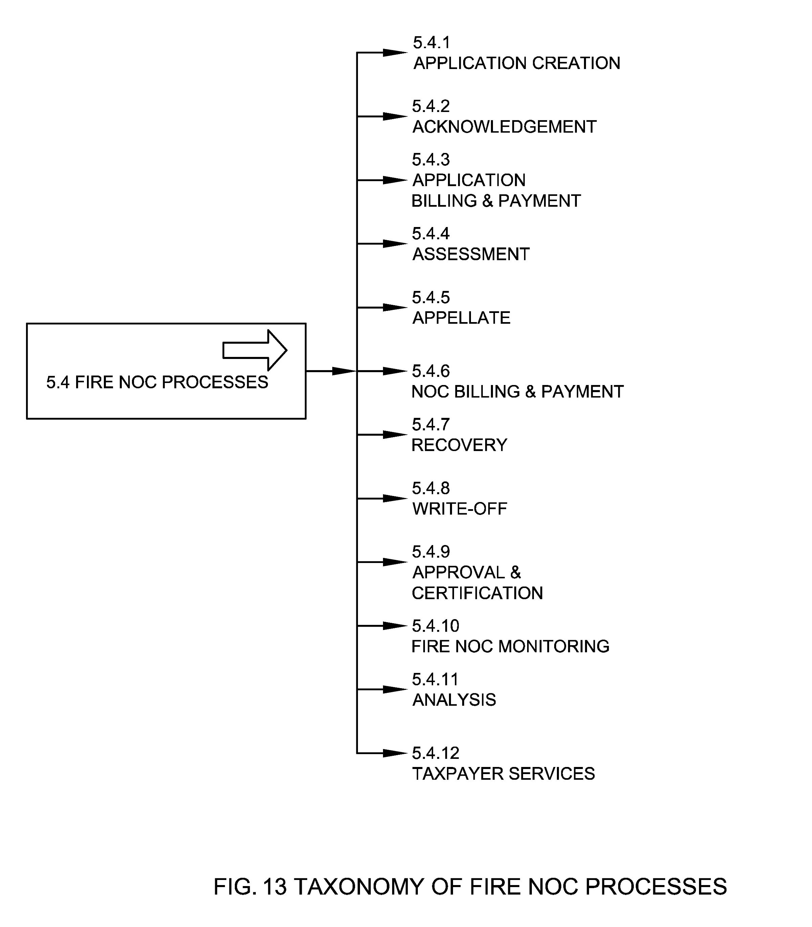

5.4.1 Application Creation
A process by which an application is created for Fire NOC at the municipal authority such as new Fire NOC, renewal of Fire NOC, or transfer of Fire NOC. Application status in this case is new.
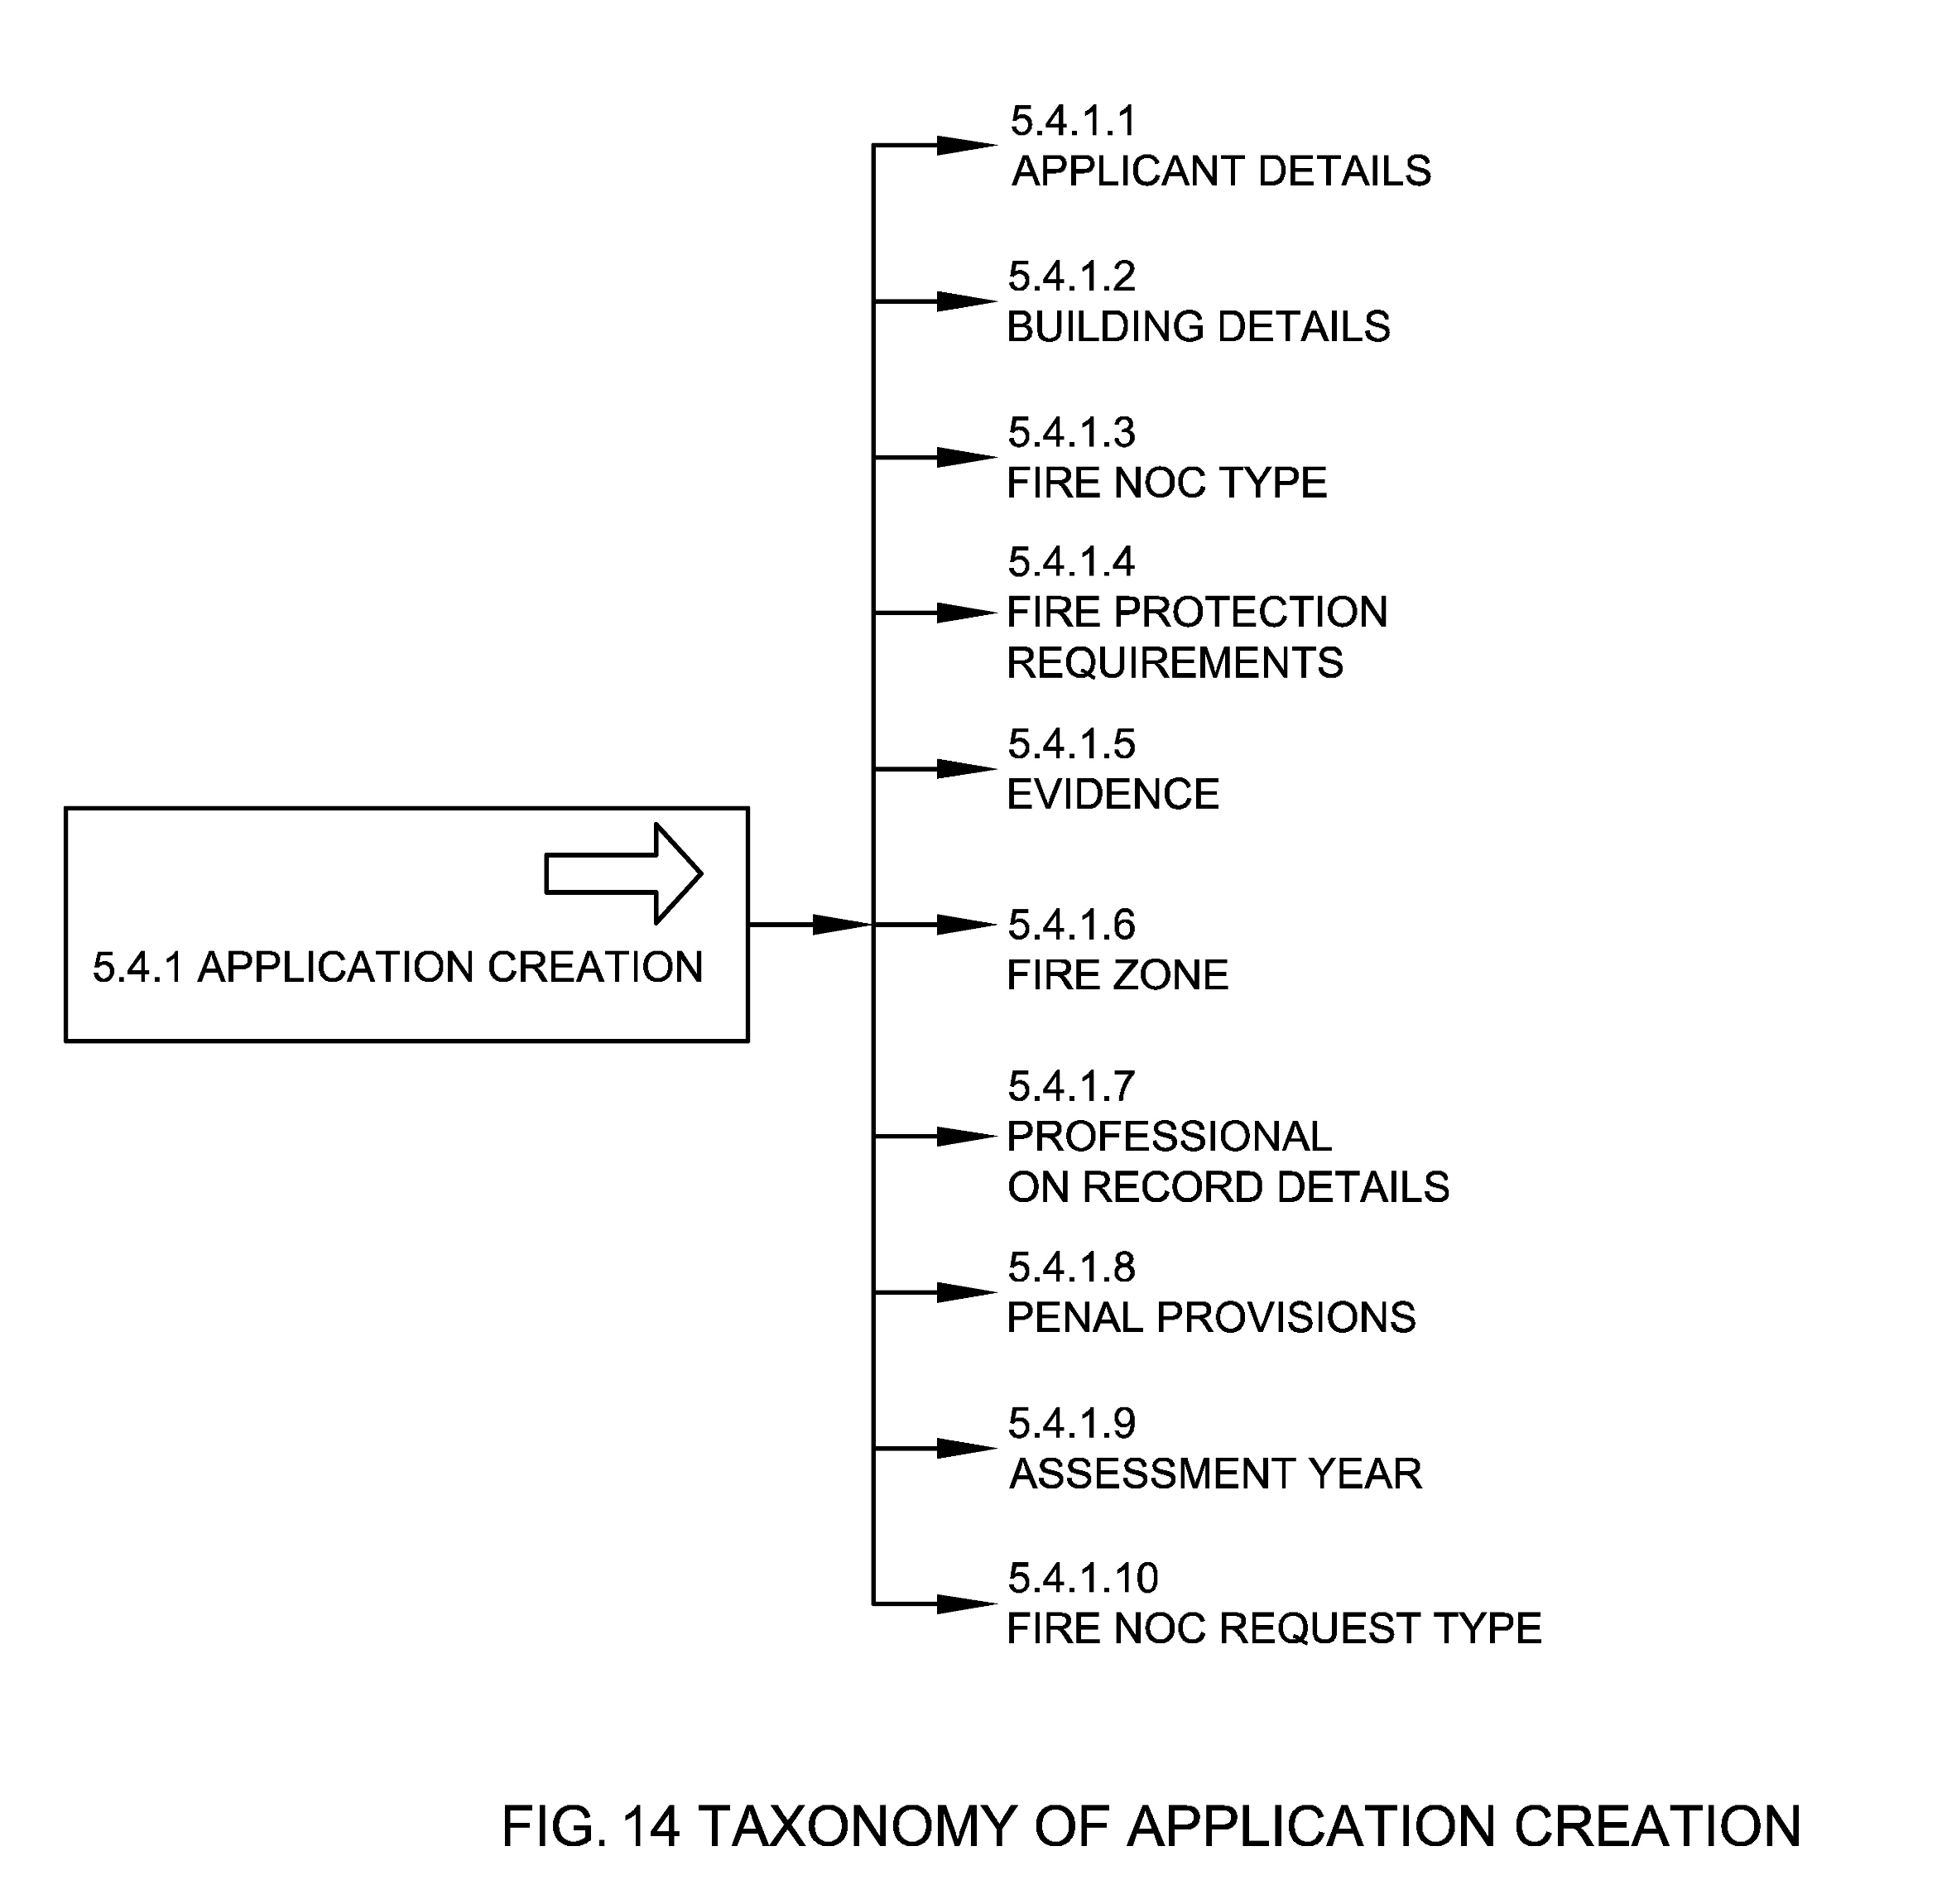

5.4.1.1 Applicant Details
Refer section 5.1.3.

5.4.1.2 Building Details
Refer section 5.1.5.

5.4.1.3 Fire NOC Type
Refer section 5.1.11.

5.4.1.4 Fire Protection Requirements
Refer section 5.1.5.11

5.4.1.5 Evidence
Refer section 5.1.9.

5.4.1.6 Fire Zone
Refer section 5.1.7.

5.4.1.7 Professional on Record Details
Refer section 5.1.4.

5.4.1.8 Penal Provisions
Refer section 5.1.10.

5.4.1.9 Assessment Year
Refer section 5.1.16.

5.4.1.10 Fire NOC Request Type
Refer section 5.1.15.

5.4.2 Acknowledgement
The process to acknowledge the new registration/renewal by the ULBs. An acknowledgement slip or receipt is generated post acknowledgement of the application. An application ID is generated in this case. Acknowledgement may be automatic or manual (if the Fire NOC request is received through a non-digital channel). Application status post acknowledgment is changed to acknowledged.
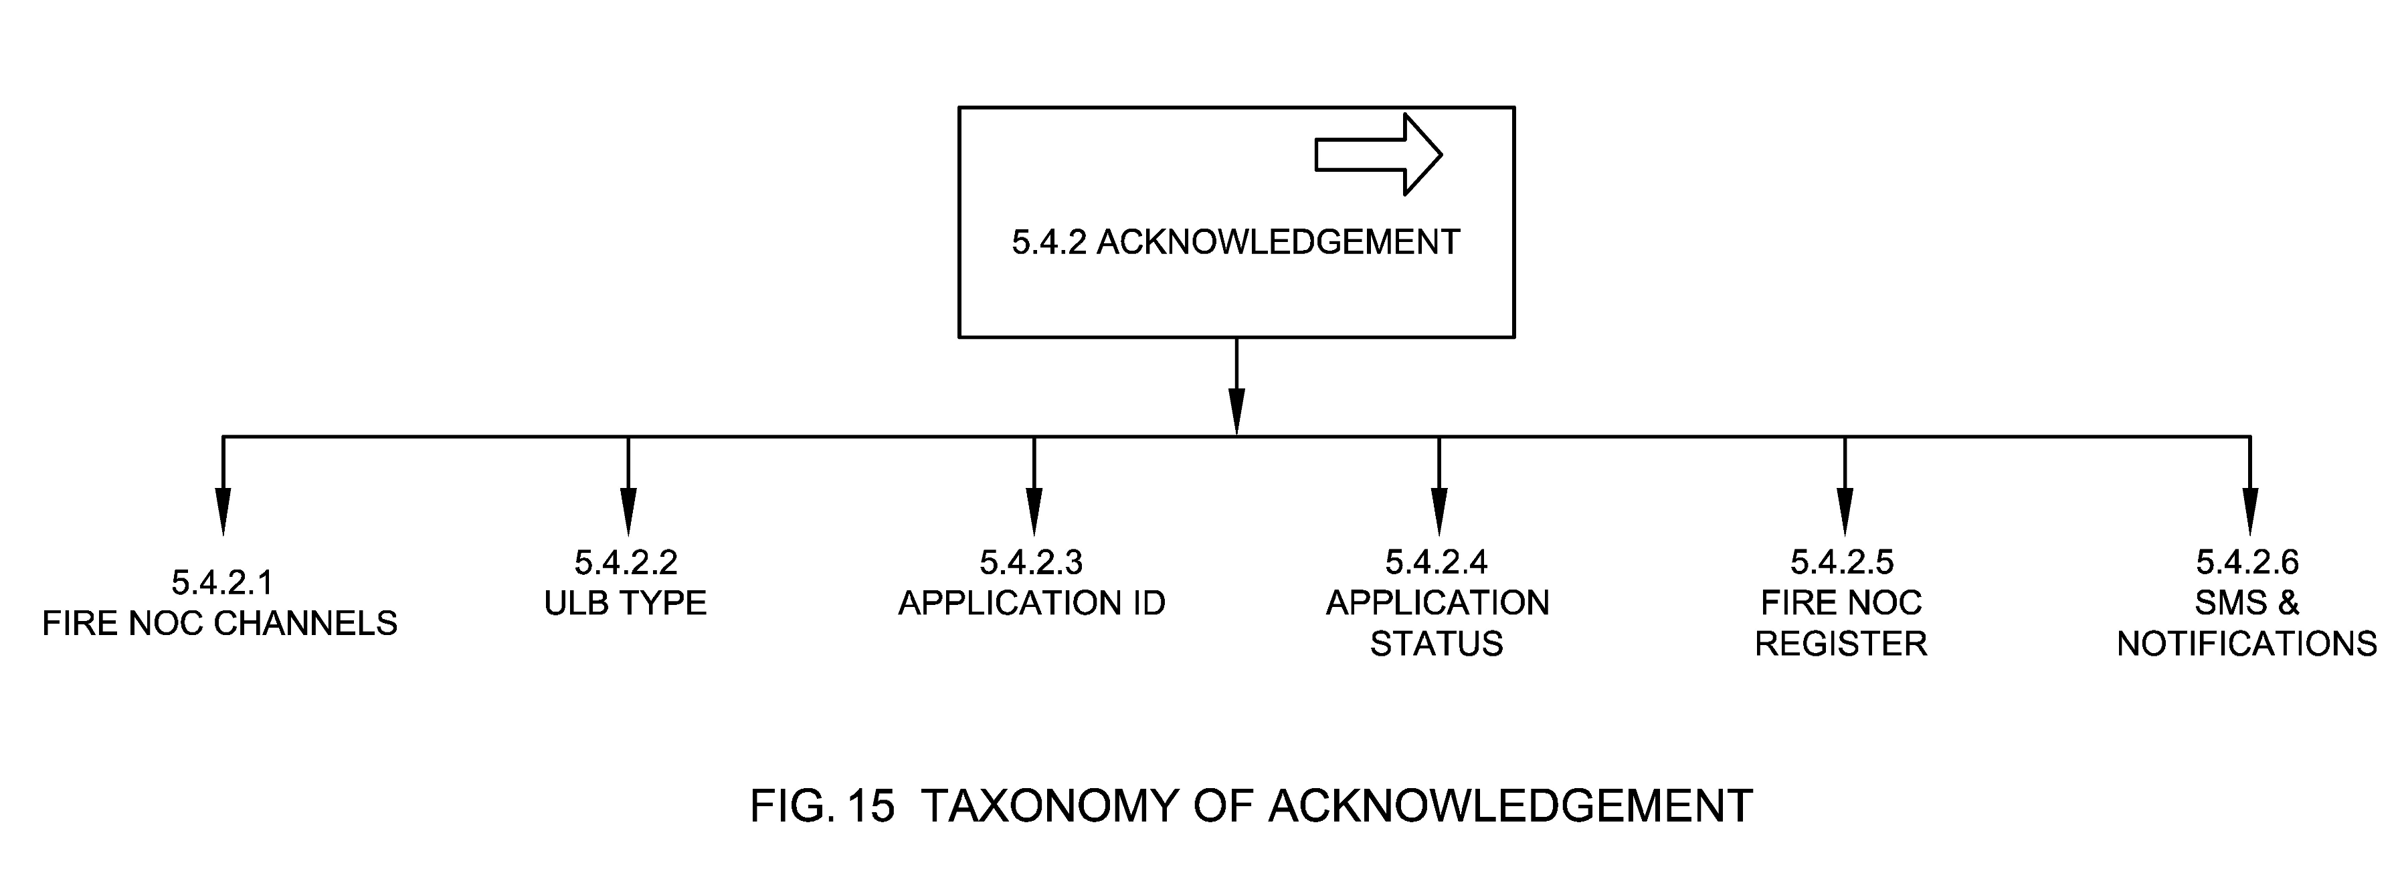

5.4.2.1 Fire NOC Channels
Refer section 5.2.

5.4.2.2 ULB Type
Refer section 5.1.8.

5.4.2.3 Application ID
Refer section 5.1.2.

5.4.2.4 Application Status
Refer section 5.1.14.

5.4.2.5 Fire NOC Register
Refer section 5.1.1.1.

5.4.2.6 SMS & Notifications
These are the notifications sent to citizens informing them about the Fire NOC being registered on the system.

5.4.3 Application Billing & Payment
Application Billing & Payment is the process of generating bill (demand) against a new application by the ULB and subsequent payment of the same by the applicant.
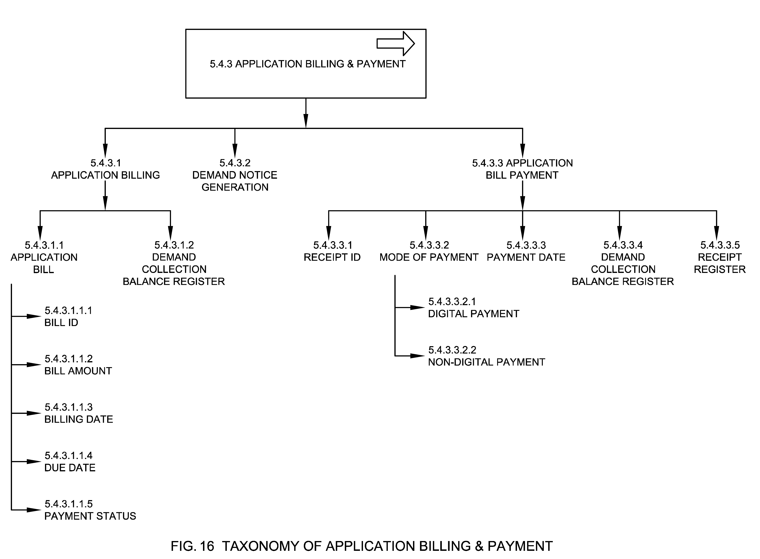

5.4.3.1 Application Billing
The process by which an application bill is generated during the process of a new application.

5.4.3.1.1 Application Bill
It is the initial bill generated for the application/inspection fee for the applied NOC. Inspection bill consists of application processing fee and inspection fee amount.

5.4.3.1.1.1 Bill ID
Refer section 5.1.17.1.

5.4.3.1.1.2 Bill Amount
Refer section 5.1.17.2.
The fee and application processing fee are included in the overall fee calculation. ULB may ask for inspection fees to be based on number of times inspection is done.

5.4.3.1.1.3 Billing Date
Refer section 5.1.17.3.

5.4.3.1.1.4 Due Date
Refer section 5.1.17.4.

5.4.3.1.1.5 Payment Status
Refer section 5.1.17.5.

5.4.3.1.2 Demand Collection Balance Register
Refer section 5.5.1.4.

5.4.3.2 Demand Notice Generation
This is the process in which a bill (demand) is generated and served to the applicant.

5.4.3.3 Application Bill Payment
Payment is the voluntary tender of money or its equivalent paid by citizen against the bill generated.

5.4.3.3.1 Receipt ID
Refer section 5.1.18.1.

5.4.3.3.2 Mode of Payment
It means mode of payment of bill amount by the applicant.

5.4.3.3.2.1 Digital payment
A digital payment occurs when the payment for processing the application and NOC fees could be done via digital and electronic medium, such as using debit card, credit card, payment gateway etc.

5.4.3.3.2.2 Non-Digital payment
Non-digital payment refers to the mode of payment of money in physical form like cash, demand draft, cheque etc.

5.4.3.3.3 Payment Date
Refer section 5.1.18.2.

5.4.3.3.4 Demand Collection Balance Register
Refer section 5.5.1.4.

5.4.3.3.5 Receipt Register
Refer section 5.5.1.5.

5.4.4 Assessment
The process by which the documents were scrutinized by the fire department with the support of other related departments. The assessment is conducted online or offline by the fire officer assigned based on the location/area. Application status in this case is assigned
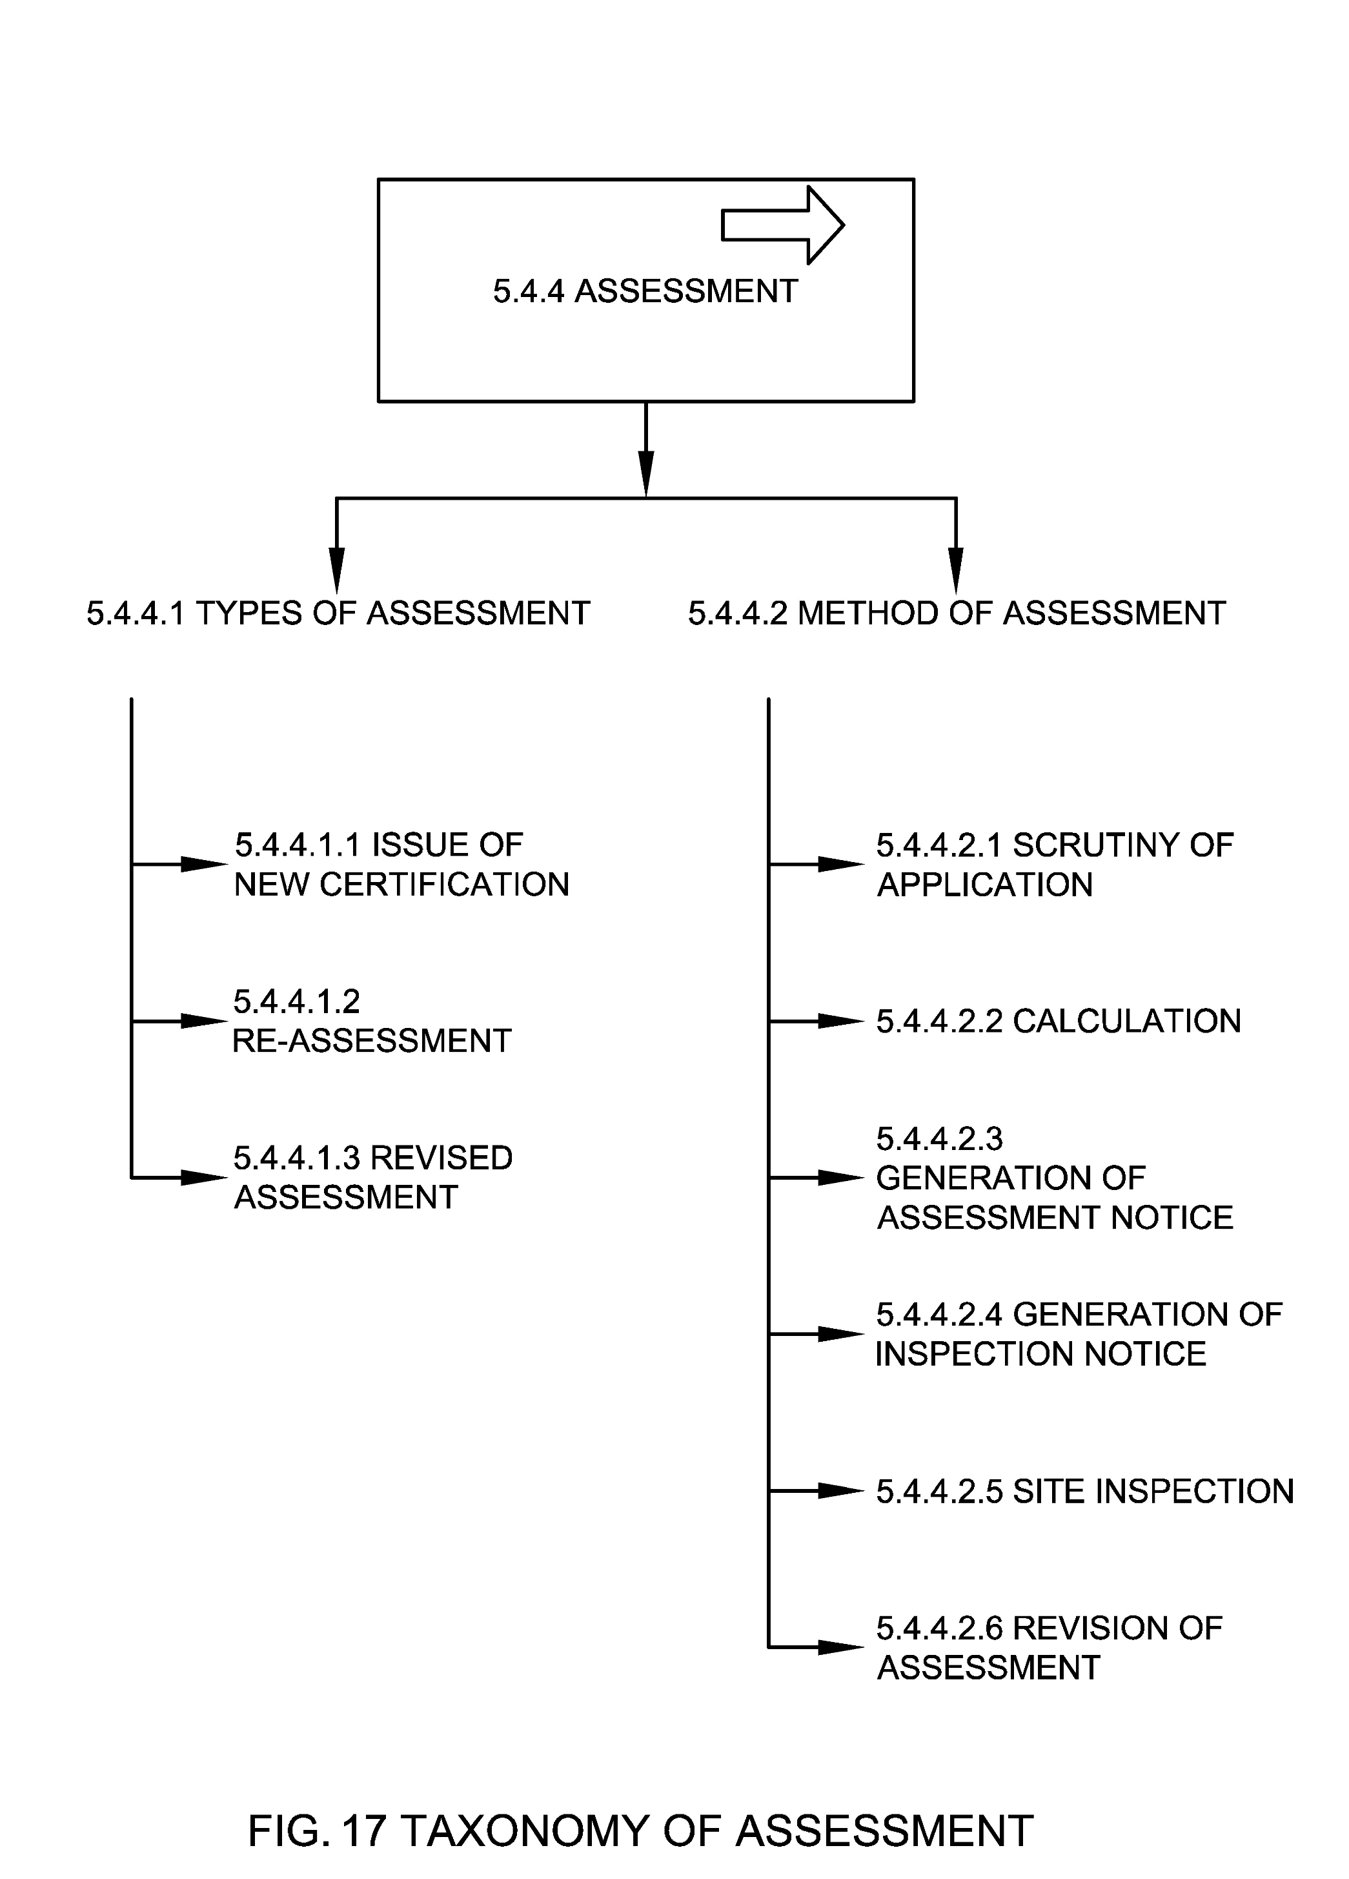

5.4.4.1 Types of Assessment
Types of assessment is the classification of assessment processes undertaken to provide Fire NOC service.
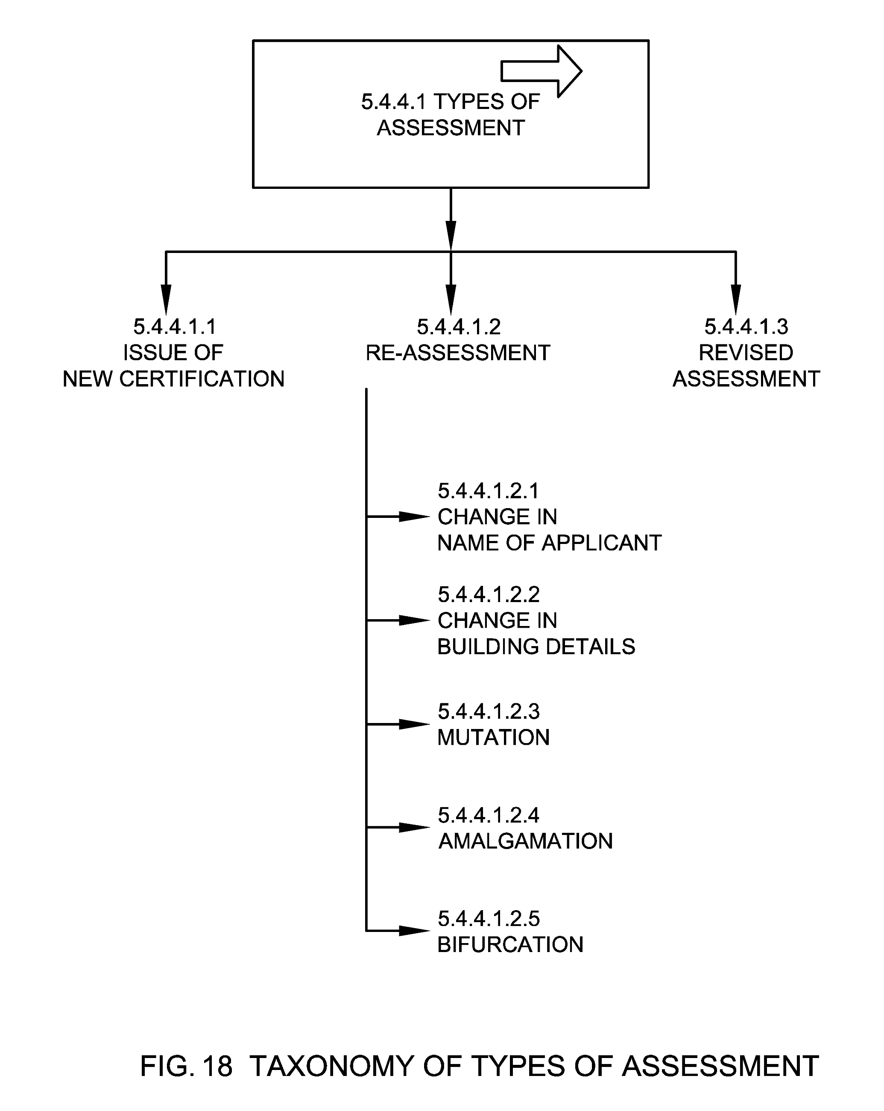

5.4.4.1.1 Issue of New Certificate
Assessment process undertaken while issuing a certificate for the first time.

5.4.4.1.2 Re-Assessment
Assessment process undertaken to determine new fee based on the change in the usage of an existing Fire NOC or change in the building details.

5.4.4.1.2.1 Change in Name of Applicant
Assessment process undertaken during change in name of applicant.

5.4.4.1.2.2 Change in Building Details
Assessment process undertaken during change in building details which is mentioned in the Fire NOC.

5.4.4.1.2.3 Mutation
Assessment process undertaken during transfer of Fire NOC from one owner to another owner.

5.4.4.1.2.4 Amalgamation
Assessment process undertaken when two or more NOCs are merged into a single NOC with a Single or Joint owner.

5.4.4.1.2.5 Bifurcation
Assessment process undertaken when a NOC is bifurcated into two or more Fire NOCs.

5.4.4.1.3 Revised Assessment
Assessment process undertaken during changing the assessed value for a Fire NOC based on the periodic increase in rates (based on Local acts) or based on noticed changes in the Fire NOC factors. Revised assessment may also take place after appellate decision to change the Fire NOC fees amount.

5.4.4.2 Method of Assessment
This means different methods undertaken to assess the Fire NOC application based on Fire NOC factors.
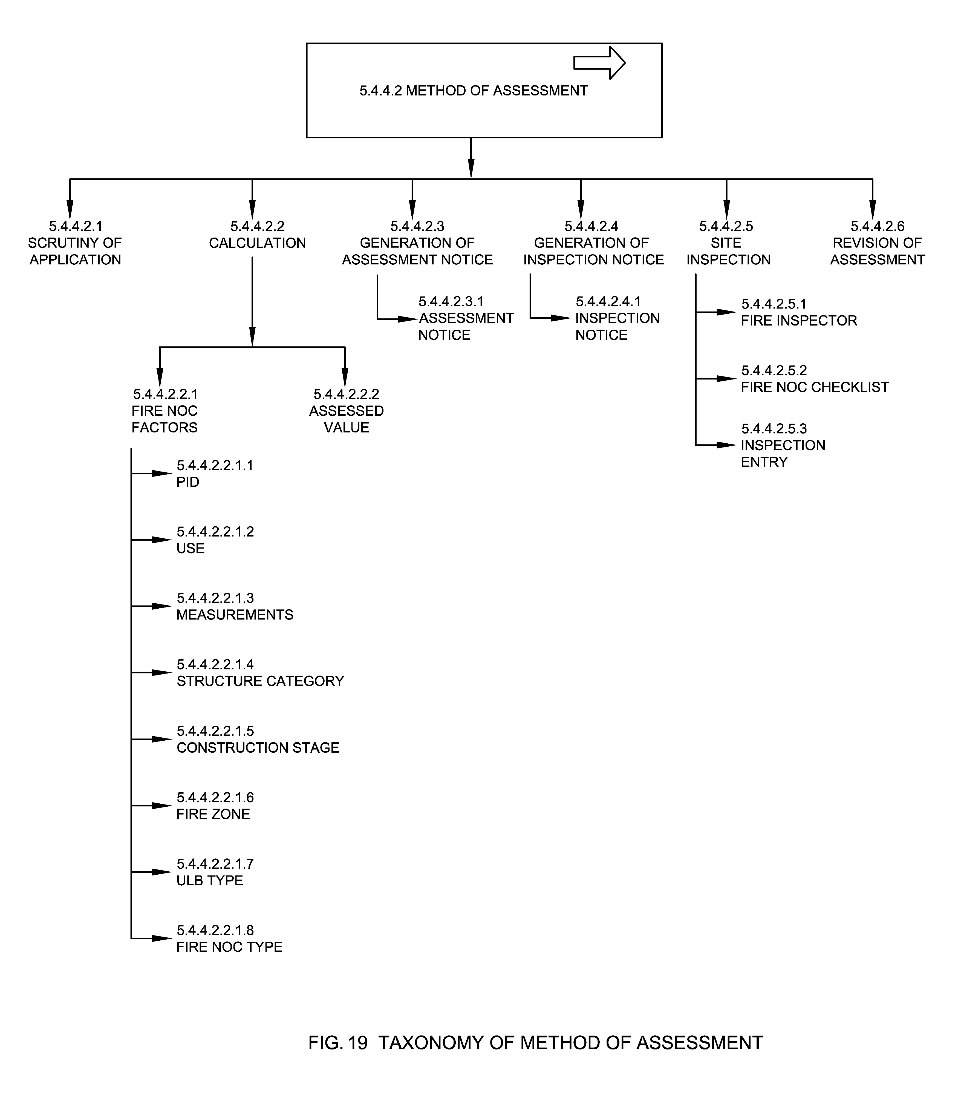

5.4.4.2.1 Scrutiny of Application
It is the assessment conducted on the application as soon as it is been applied by the citizen and the scrutiny is conducted by the assessing officer. During the initial assessment scrutiny of documents may be done by the ULB officials and appropriate inspection fees, NOC fees and inspection notice are generated.

5.4.4.2.2 Calculation
Calculation is the process of calculating the fees for applied Fire NOC based on the specified criteria as mentioned in the State Municipal Acts or as decided by the Municipal Commissioner. Fire NOC calculation process comprises the use of any one or combination of methods using various attributes of Fire NOC such as Fire NOC type, building details, construction stages, fire zone, Fire NOC request type and any other related amount to calculate Fire NOC bill amount.

5.4.4.2.2.1 Fire NOC Factors
These are the factors associated with a Fire NOC and used in various Fire NOC processes like assessment, calculation of tax and billing.

5.4.4.2.2.1.1 PID
Refer section 5.1.5.1.

5.4.4.2.2.1.2 Use
Refer section 5.1.5.3.

5.4.4.2.2.1.3 Measurements
Refer section 5.1.5.7.

5.4.4.2.2.1.4 Structure Category
Refer section 5.1.5.9.

5.4.4.2.2.1.5 Construction Stage
Refer section 5.1.5.10.

5.4.4.2.2.1.6 Fire Zone
Refer section 5.1.7.

5.4.4.2.2.1.7 ULB Type
Refer section 5.1.8.

5.4.4.2.2.1.8 Fire NOC Type
Refer section 5.1.11.

5.4.4.2.2.2 Assessed Value
For the purpose of Fire NOC fee, a building is assessed over its location, type, height, design, Floor Area Ratio (FAR) etc. This ascertained price is known as assessed value. Assessed value is converted to Fire NOC fee (demand) once inspection is completed and Fire NOC factors are verified. This may include inspection fee value.

5.4.4.2.3 Generation of Assessment Notice
This is the process in which assessment notice is generated and shared with the applicant.

5.4.4.2.3.1 Assessment Notice
Assessment notice is the notice served to the applicant indicating the assessed value of Fire NOC assessed on the basis of the Fire NOC factors. This notice is not considered as the final bill. The assessment notice is the interim notice to confirm the fee of the Fire NOC.

5.4.4.2.4 Generation of Inspection Notice
This is the process in which Inspection notice is generated and shared with the applicant.

5.4.4.2.4.1 Inspection Notice
Inspection notice is the notice served to the applicant notifying them about the planned time of inspection-by-inspection officer.

5.4.4.2.5 Site Inspection
It is the ground inspection conducted post scrutiny of application, an ULB Inspector is assigned to verify the application details viz-a-viz building details with respect to conformance to inspection checklist.

5.4.4.2.5.1 Fire Inspector
Refer section 5.3.1.1.3

5.4.4.2.5.2 Fire NOC Checklist
Refer section 5.1.19.

5.4.4.2.5.3 Inspection Entry
It means reporting the details of inspection post ground inspection by the inspector such as inspection time, details, notes etc. Application status in this case is inspected or rejected.

5.4.4.2.6 Revision of Assessment
Revised assessment notice is the notice served to the applicant indicating the revised assessed value of Fire NOC assessed on the basis of the actual ground inspection. Thereafter a revised assessment notice is shared with the applicant.

5.4.5 Appellate
Appellate is the process followed after the assessment is presented and the applicant is aggrieved by the fixation or the charging of the Fire NOC fees. The appeal process is initiated with a simple appeal letter or through Fire NOC application.
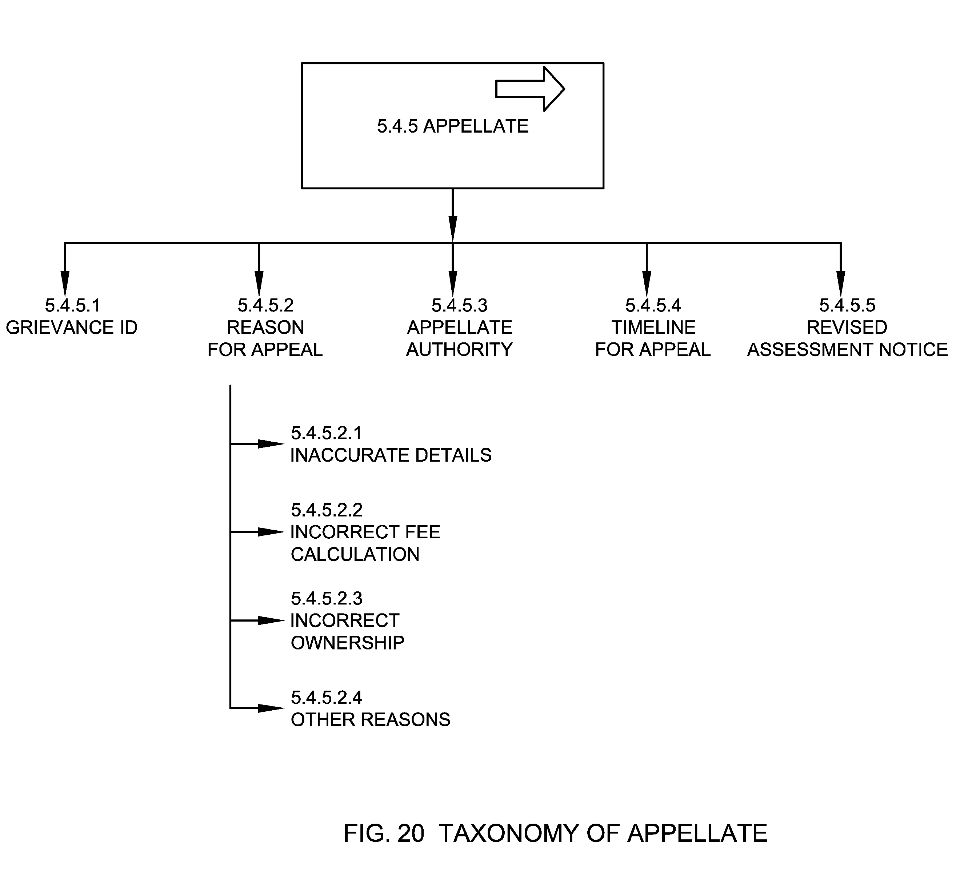

5.4.5.1 Grievance ID
Grievance ID is a unique identifier allotted to the grievance by the ULB for the purpose of grievance recording, allocation, assessment, follow up, and appeal.

5.4.5.2 Reason for Appeal
Reason for appeal is the reason as captured in assessment notice or bill because of which an aggrieved person appeals to the appellate authority for necessary action.

5.4.5.2.1 Inaccurate Details
This means the aggrieved person has appealed given the reason of inaccurate details such as incorrect name, building details, NOC type etc. in an assessment notice.

5.4.5.2.2 Incorrect Fee Calculation
This means the aggrieved person has appealed given the reason of incorrect fee calculation in an assessment notice.

5.4.5.2.3 Incorrect Ownership
This means the aggrieved person has appealed given the reason of incorrect ownership in an assessment notice.

5.4.5.2.4 Other Reasons
This means the aggrieved person has appealed given the any other reason as per the assessment notice.

5.4.5.3 Appellate Authority
Refer section 5.3.1.1.4

5.4.5.4 Timeline for Appeal
Refer section 5.1.20.2.7.

5.4.5.5 Revised Assessment Notice
Revised assessment notice is the notice served to the applicant indicating the revised assessed value of Fire NOC assessed on basis of the revised assessment.

5.4.6 NOC Billing & Payment
NOC billing & payment is the process of generating bill (demand) against the calculated and approved Fire NOC fee by the ULB and subsequent payment of the same by the applicant.
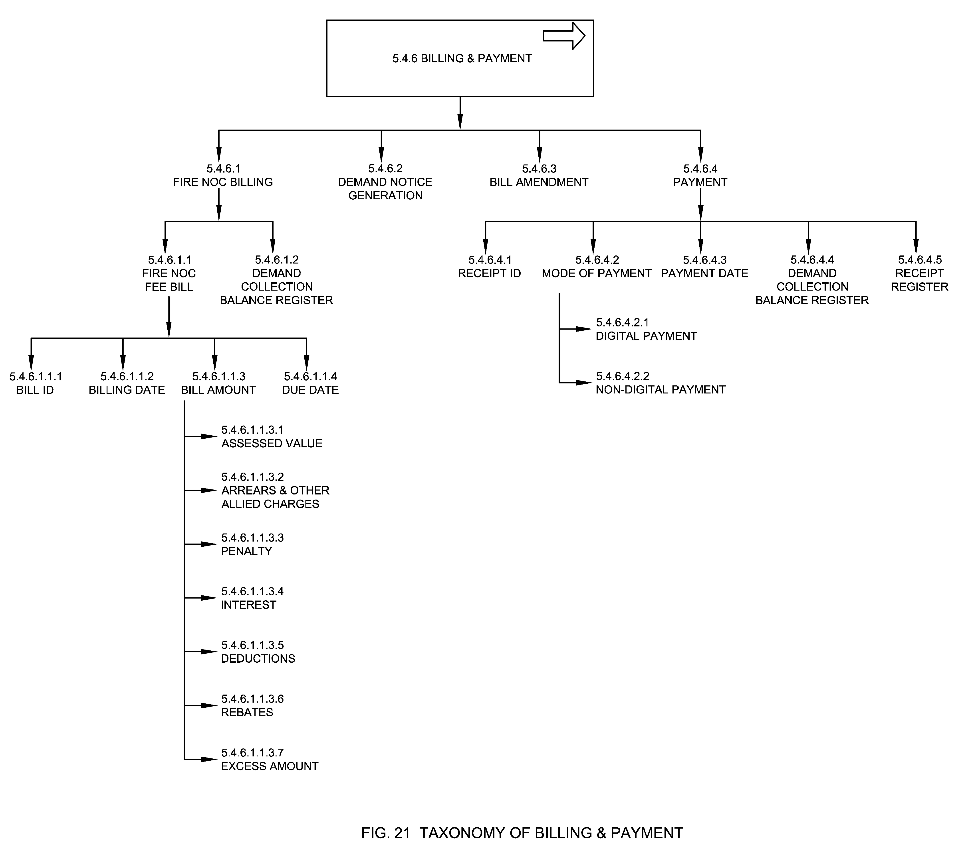

5.4.6.1 Fire NOC Billing
The process by which a Fire NOC fee bill is generated based on Fire NOC factors post assessment and verification of the application. Application status in this case is pending for payment.

5.4.6.1.1 Fire NOC Fee Bill

It means the final bill generated in reference to the Fire NOC application based on assessed value for the certificate.

5.4.6.1.1.1 Bill ID
Refer section 5.1.17.1.

5.4.6.1.1.2 Billing Date
Refer section 5.1.17.3.

5.4.6.1.1.3 Bill Amount
Refer section 5.1.17.2.

5.4.6.1.1.3.1 Assessed Value
Refer section 5.4.4.2.2.2.

5.4.6.1.1.3.2 Arrears & Other allied Charges
Arrears are defined as previous years and/or unpaid bill amount or Fire NOC fees.

5.4.6.1.1.3.3 Penalty
The amount of extra money the citizen has to pay for failing to adhere to Fire NOC rules and/or/laws, timelines.

5.4.6.1.1.3.4 Interest
The amount collected above the Fire NOC bill in the event of late payment. It is usually determined at a particular rate of Fire NOC.

5.4.6.1.1.3.5 Deductions
Deductions is the component of Fire NOC fee which has been deducted from the gross fee in lieu of advance or any other exemptions made subject to the rules of assessment of Fire NOC application.

5.4.6.1.1.3.6 Rebates
Discount given to the citizen for paying Fire NOC bill in advance or before end of the statutory period or for undertaking certain listed activities as per the applicable rules.

5.4.6.1.1.3.7 Excess amount
This means any other amount that may be added in the bill as per assessment, rule or law.

5.4.6.1.1.4 Due Date
Refer section 5.1.17.4.

5.4.6.1.2 Demand Collection Balance Register
Refer section 5.5.1.4

5.4.6.2 Demand Notice Generation
Refer section 5.5.3.2.

5.4.6.3 Bill Amendment
Bill amendment is the process of amending Fire NOC bill when applicant notices a discrepancy in the calculation of the bill and submits a request for amendment or when the ULB realizes discrepancy in the calculation of bill and amends it.

5.4.6.4 Payment
Payment is the voluntary tender of money or its equivalent paid by applicant against the bill generated.

5.4.6.4.1 Receipt ID
Refer section 5.4.18.1.

5.4.6.4.2 Mode of Payment
Refer section 5.4.3.3.2.

5.4.6.4.2.1 Digital Payment
Refer section 5.4.3.3.2.1.

5.4.6.4.2.2 Non-Digital payment
Refer section 5.4.3.3.2.2.

5.4.6.4.3 Payment Date
Refer section 5.1.18.2.

5.4.6.4.4 Demand Collection Balance Register
Refer section 5.5.1.4.

5.4.6.4.5 Receipt Register
Refer section 5.5.1.5.

5.4.7 Recovery
Recovery means, recovery of fees from the applicant or defaulters. In some cases, recovery may be in terms of impounding any movable or immovable asset of the defaulter. Few methods of recovery in Fire NOC are:
  - by presenting a bill
  - by serving a written notice of demand
  - by a suit
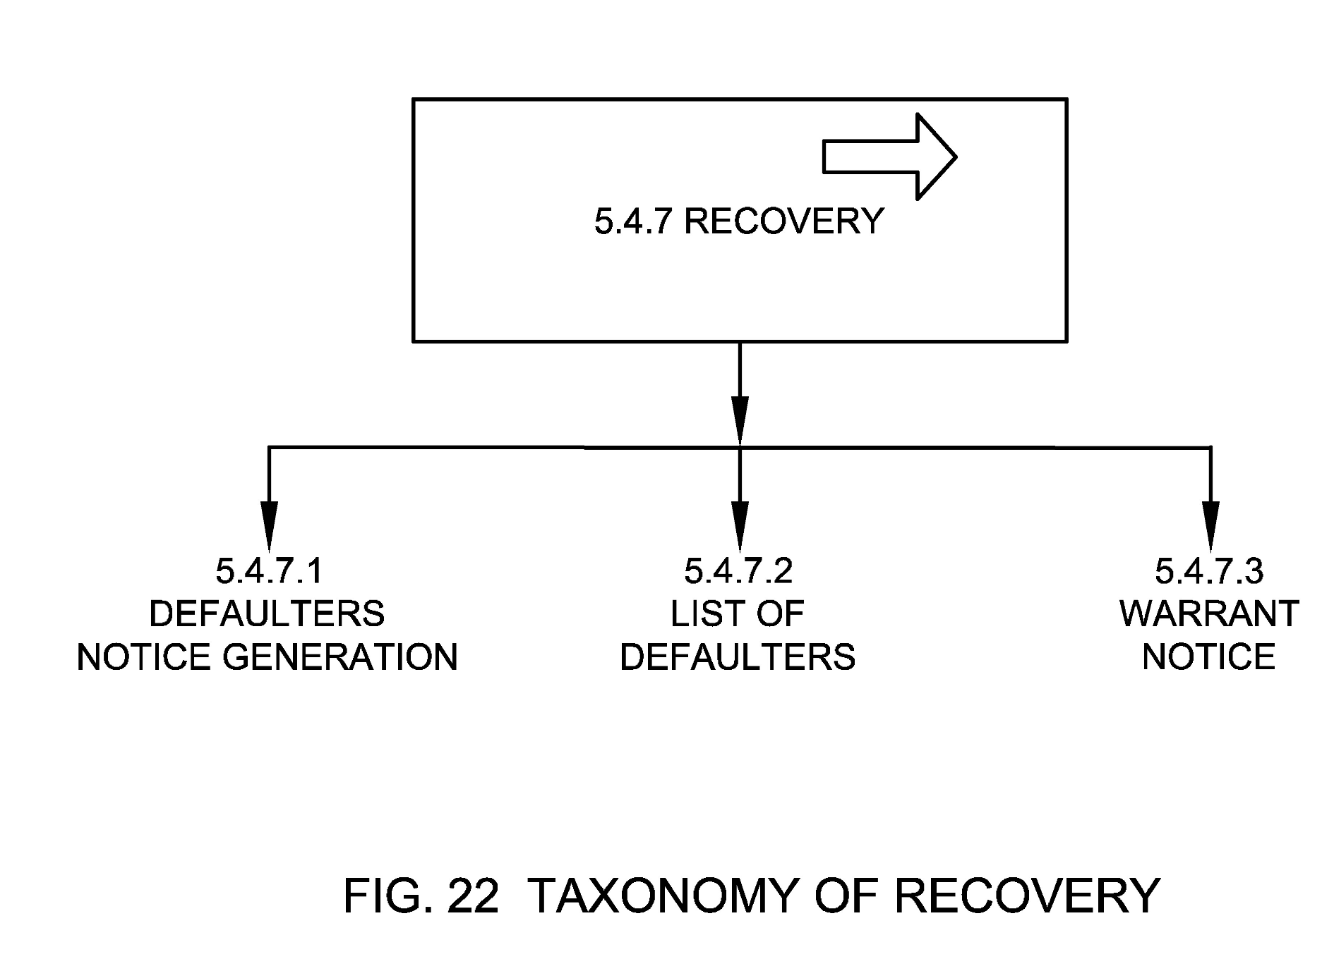

5.4.7.1 Defaulters Notice Generation
This means generation and service of notice to the defaulters who have not paid the Fire NOC bill by the due date. In these cases, bills are amended to include penalties or late fee for defaulting.

5.4.7.2 List of Defaulters
Refer section 5.5.1.2

5.4.7.3 Warrant Notice
Warrant notice is the bill that is served by the authority on the service seeker for recovery.

5.4.8 Write-off
Write-Off of Fire NOC fee is the process of deductions or exemptions of fee, in compliance with any law, or through the guidelines of the ULB or the court of law.

5.4.9 Approval & Certification
The process of approving the applied application for Fire NOC post assessment and inspection and issues Fire NOC by the municipal commissioner of the ULBs. Application status in this case is approved.
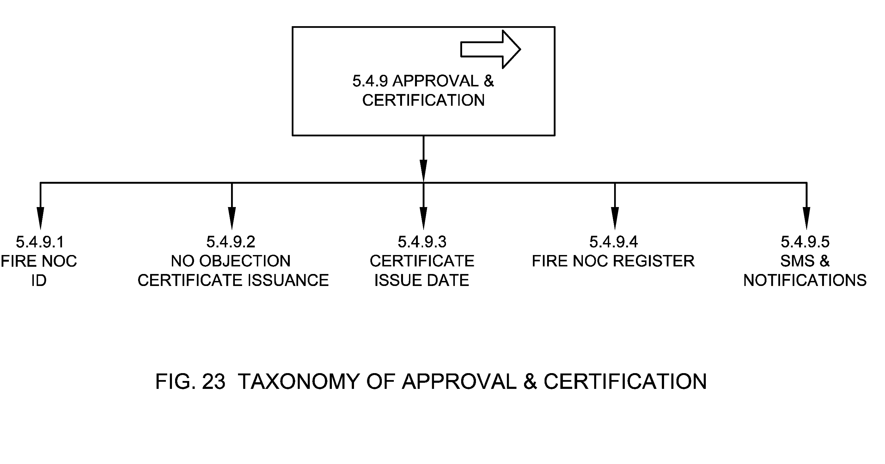

5.4.9.1 Fire NOC ID
Refer section 5.1.1

5.4.9.2 No Objection Certificate Issuance
This means issuing No Objection Certificate post assessment and approval of Fire NOC application. It is recommended that the certificates should be digitally or manually signed by the relevant ULB officer such as Commissioner or Deputy Commissioner etc. along with water marked with ULB or relevant logo as per the ULB rules and/or regulations. It is also recommended to add digitally signed certificates into DigiLocker to make it easier to access and integrate with other services.

5.4.9.3 Certificate Issue Date
Refer section 5.1.20.2.6.

5.4.9.4 Fire NOC Register
Refer section 5.5.1.1.

5.4.9.5 SMS & Notifications
Refer section 5.4.2.6.

5.4.10 Fire NOC Monitoring
Fire NOC monitoring is the monitoring process undertaken by the ULB officials from the time a Fire NOC application is lodged on system until it's approved and remains valid. The NOCs and associated revenue are monitored based on the purpose of Fire NOC, Service Level Benchmarks, building type, regulation purpose and need for renewal.
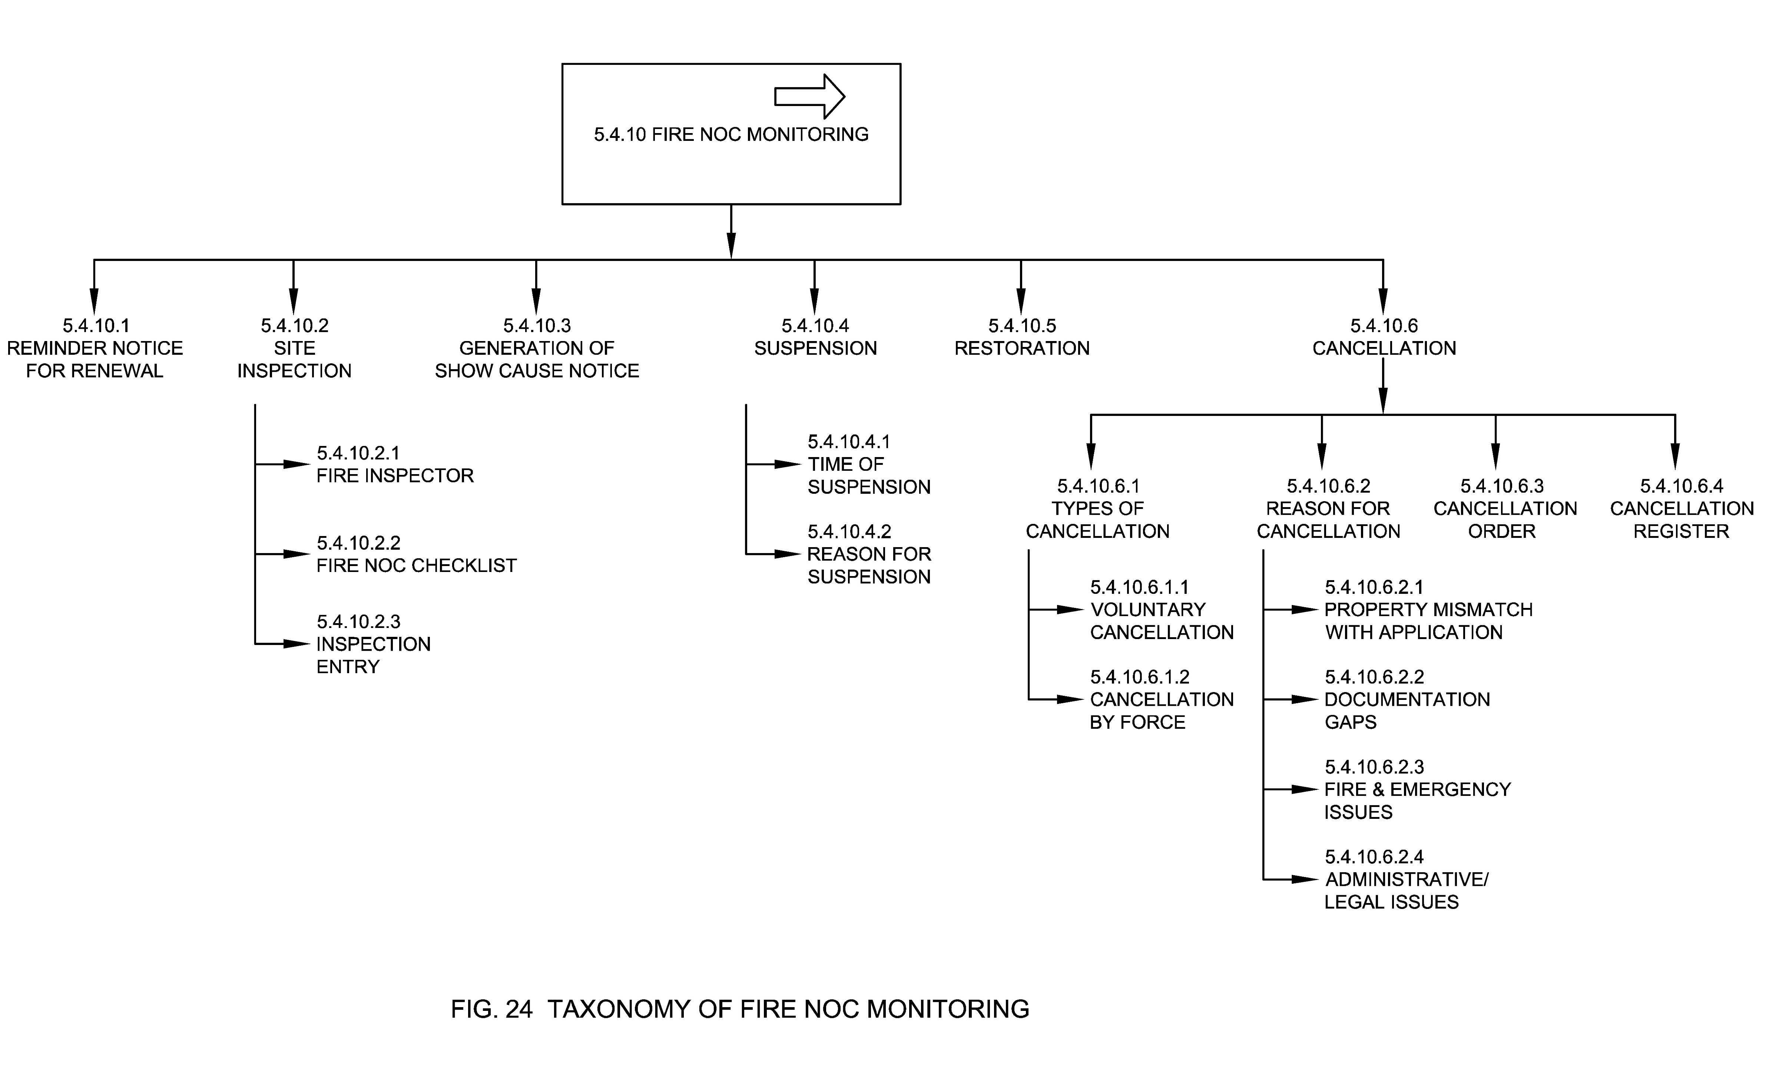

5.4.10.1 Reminder Notice for Renewal
The process of issuing a notice for renewal by the ULBs to the applicant for renewal of expired certificate. The notice may be issued via SMS, Email, or by sending physical letter to the owner of the NOC.

5.4.10.2 Site Inspection
Site Inspection is the process by the ULB officials to check that the building is carrying out safety measures and guidelines. This form of inspection may occur whenever the ULB find suitable. Show Cause Notice can be issued to the applicant if they violate the rules or if a complaint is raised against them.

5.4.10.2.1 Fire Inspector
Refer section 5.3.1.1.3

5.4.10.2.2 Fire NOC Checklist
Refer section 5.1.19

5.4.10.2.3 Inspection Entry
Refer section 5.4.4.2.5.3.

5.4.10.3 Generation of Show Cause Notice
The process of issuing a show cause notice to Fire NOC owners who have offended any rule and/or regulations as per the ULB. The notice is served to give an opportunity to defend the charges made against the Fire NOC owner by explanations and reasons in writing and/or by personal hearing. If the offender justified the charges/actions then the charges will be dropped. NOCs of owners who fail to justify the charges will be suspended by the ULB.

5.4.10.4 Suspension
The process by which a valid Fire NOC is suspended by the ULB by giving a reason for suspension.

5.4.10.4.1 Time of Suspension
This means recording of the time at which the certificate has been suspended by the ULB.

5.4.10.4.2 Reason for Suspension
This means recording the reason for which the certificate has been suspended by the ULB.

5.4.10.5 Restoration
The process by which the applicant may restore a previously expired NOC.

5.4.10.6 Cancellation
The process of cancelling the certificate for the owners. The cancellation of NOC is issued when there is no satisfactory response received from the owner for which show cause notice was issued.

5.4.10.6.1 Type of Cancellation
Type of cancellation captures classification of Fire NOC cancellation such as voluntary cancellation or cancellation by force.

5.4.10.6.1.1 Voluntary Cancellation
This means cancellation of application by the applicant.

5.4.10.6.1.2 Cancellation by Force
This means cancellation of application or NOC by force by giving reason for cancellation such as safety issues, legal issues, documentation gaps or any other reason.

5.4.10.6.2 Reason for Cancellation
ULBs may cancel the application by providing relevant reasons, if applicant didn’t respond to show cause notice on time.

5.4.10.6.2.1 Property Mismatch with Application
ULB may cancel the application if the property use mentioned in application didn’t match during site inspection.

5.4.10.6.2.2 Documentation Gaps
ULB may cancel the application if there are any documentation gaps in the application submitted post show cause notice.

5.4.10.6.2.3 Fire & Emergency Issues
ULB may cancel the application if the assessing officer or inspection officer reported any fire & emergency issue.

5.4.10.6.2.4 Administrative/Legal Issues
ULB may cancel the application if there are any administrative/legal issues.

5.4.10.6.3 Cancellation Order
A cancellation order is generated post cancellation of the application or Fire NOC.

5.4.10.6.4 Cancellation Register
Refer section 5.5.1.6.

5.4.11 Analysis
Fire NOC analysis is the process through which all Fire NOC applications are analyzed to check quality of service and become aware of (and eventually rectify) any deficiency in services. This helps in improving the efficiency, accountability, responsiveness and transparency of a ULB, ultimately leading to improvement in service delivery.
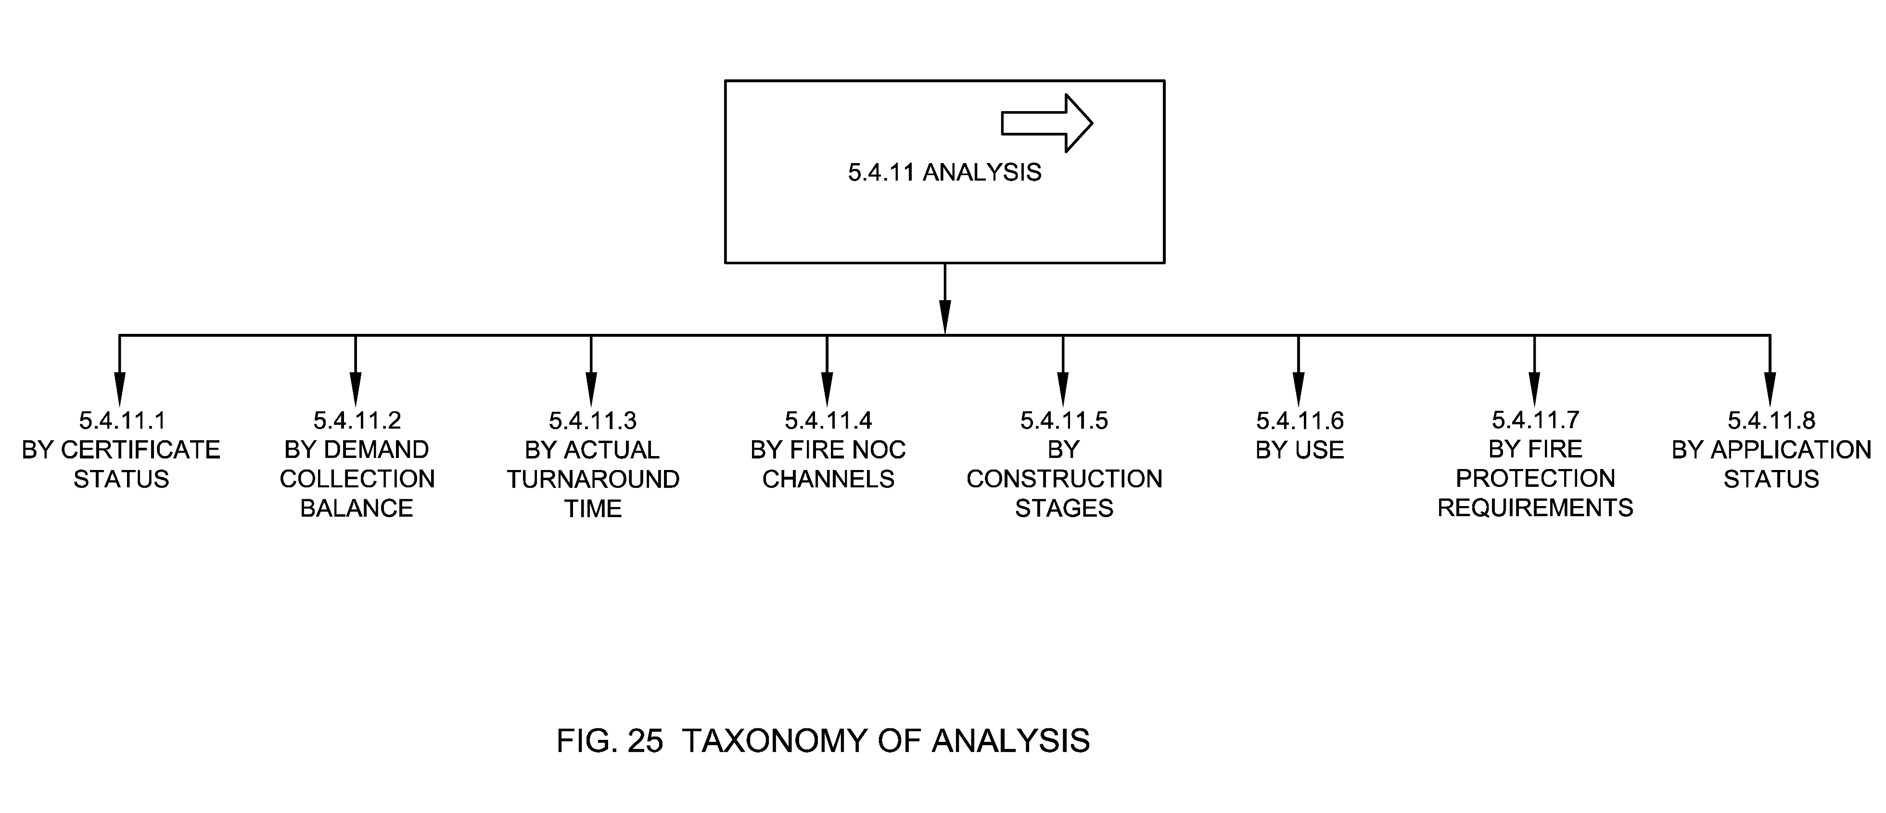

5.4.11.1 By Certificate Status
Refer section 5.1.13

5.4.11.2 By Demand Collection Balance
Refer section 5.5.1.4

5.4.11.3 By Actual Turnaround Time
Refer section 5.1.20.3.

5.4.11.4 By Fire NOC Channels
Refer section 5.2

5.4.11.5 By Construction Stages
Refer section 5.1.5.10.

5.4.11.6 By Use
Refer section 5.1.5.3.

5.4.11.7 By Fire Protection Requirements
Refer section 5.1.5.11

5.4.11.8 By Application Status
Refer section 5.1.14.

5.4.12 Taxpayer Services
These are the services available to all taxpayers in a municipality. In the context of Fire NOC these are no due certificate, duplicate bills, occupancy certificates and duplicate certificates.
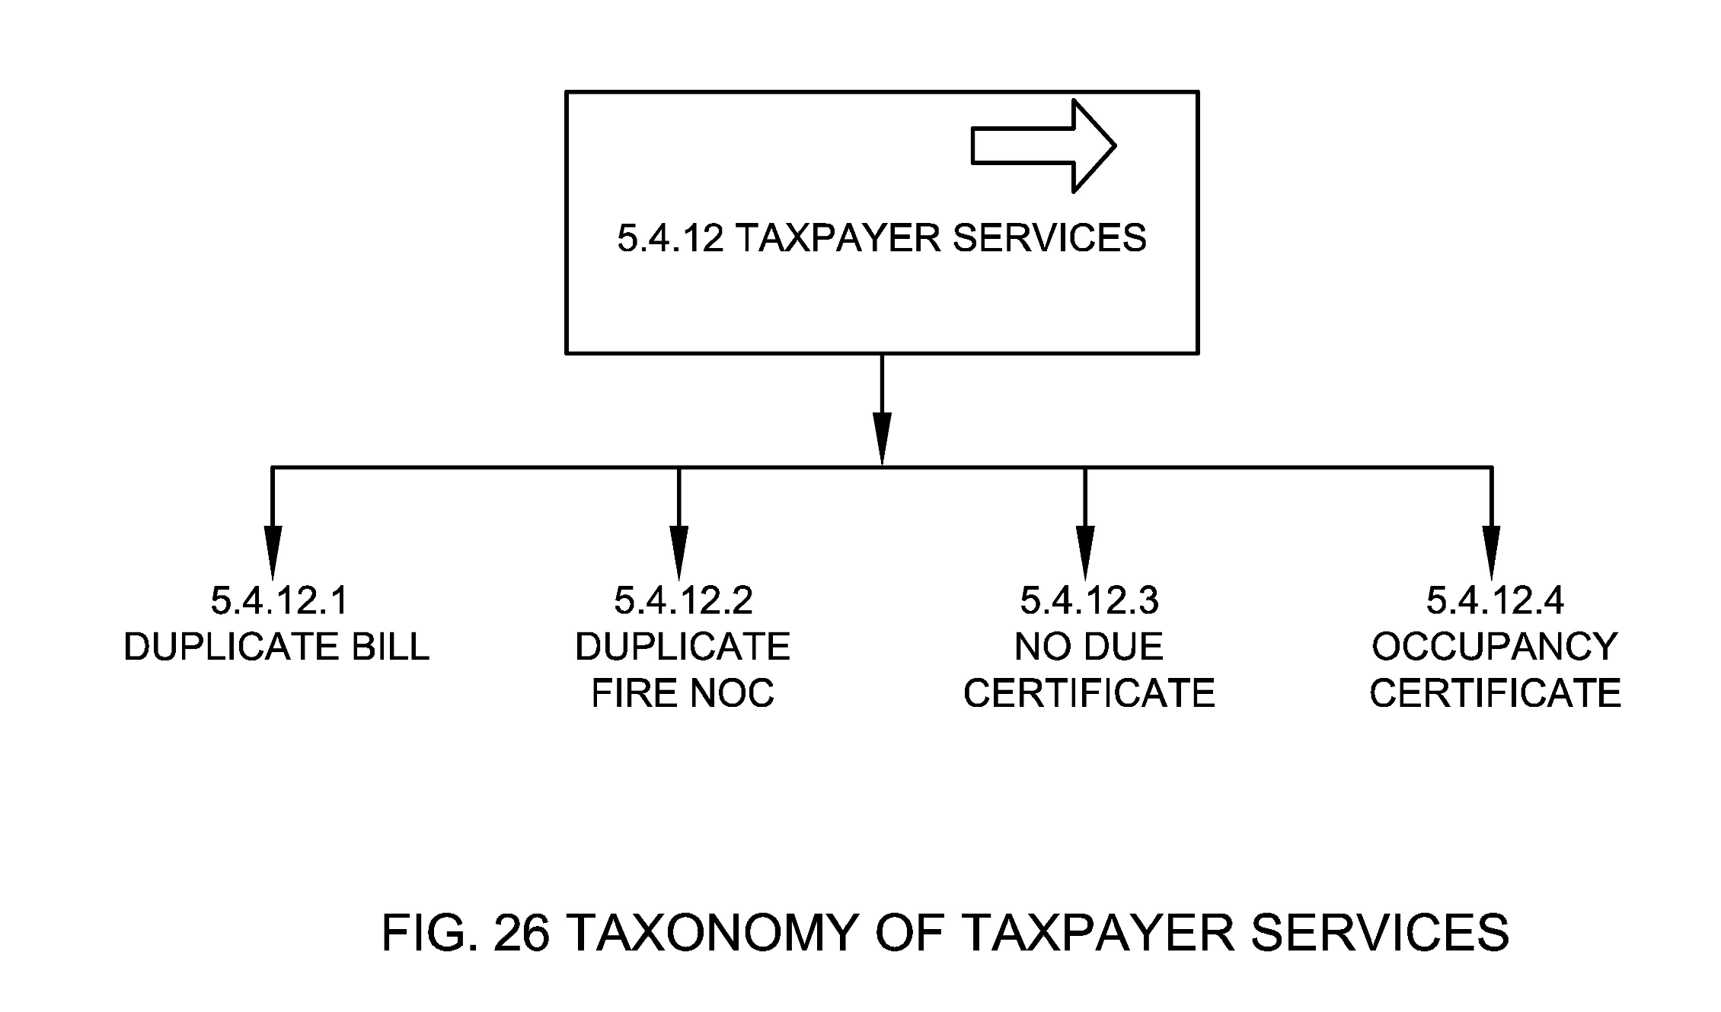

5.4.12.1 Duplicate Bill
These are duplicate copies of bill that an applicant can ask for.

5.4.12.2 Duplicate Fire NOC
These are duplicate copies of certificate that an applicant can ask for and/or these can be accessed on DigiLocker by the citizen post signing in DigiLocker as per prescribed rules (Department of Electronics and Information Technology, 2016).

5.4.12.3 No Due Certificate
No Dues Certificate (NDCs) is a certification provided to the citizen by the ULB confirming and testifying that the asset / property held by them is free from any encumbrances.

5.4.12.4 Occupancy Certificate
A certificate of occupancy is a document issued by a ULB or building department certifying a building's compliance with applicable building codes and other laws, and indicating it to be in a condition suitable for occupancy.

5.5 Fire NOC Reports & KPIs
Fire NOC Reports and KPIs are documents that presents information in an organized format for various stakeholders especially in the form of an official document, after thorough investigation or consideration by an appointed person or body at the ULB.
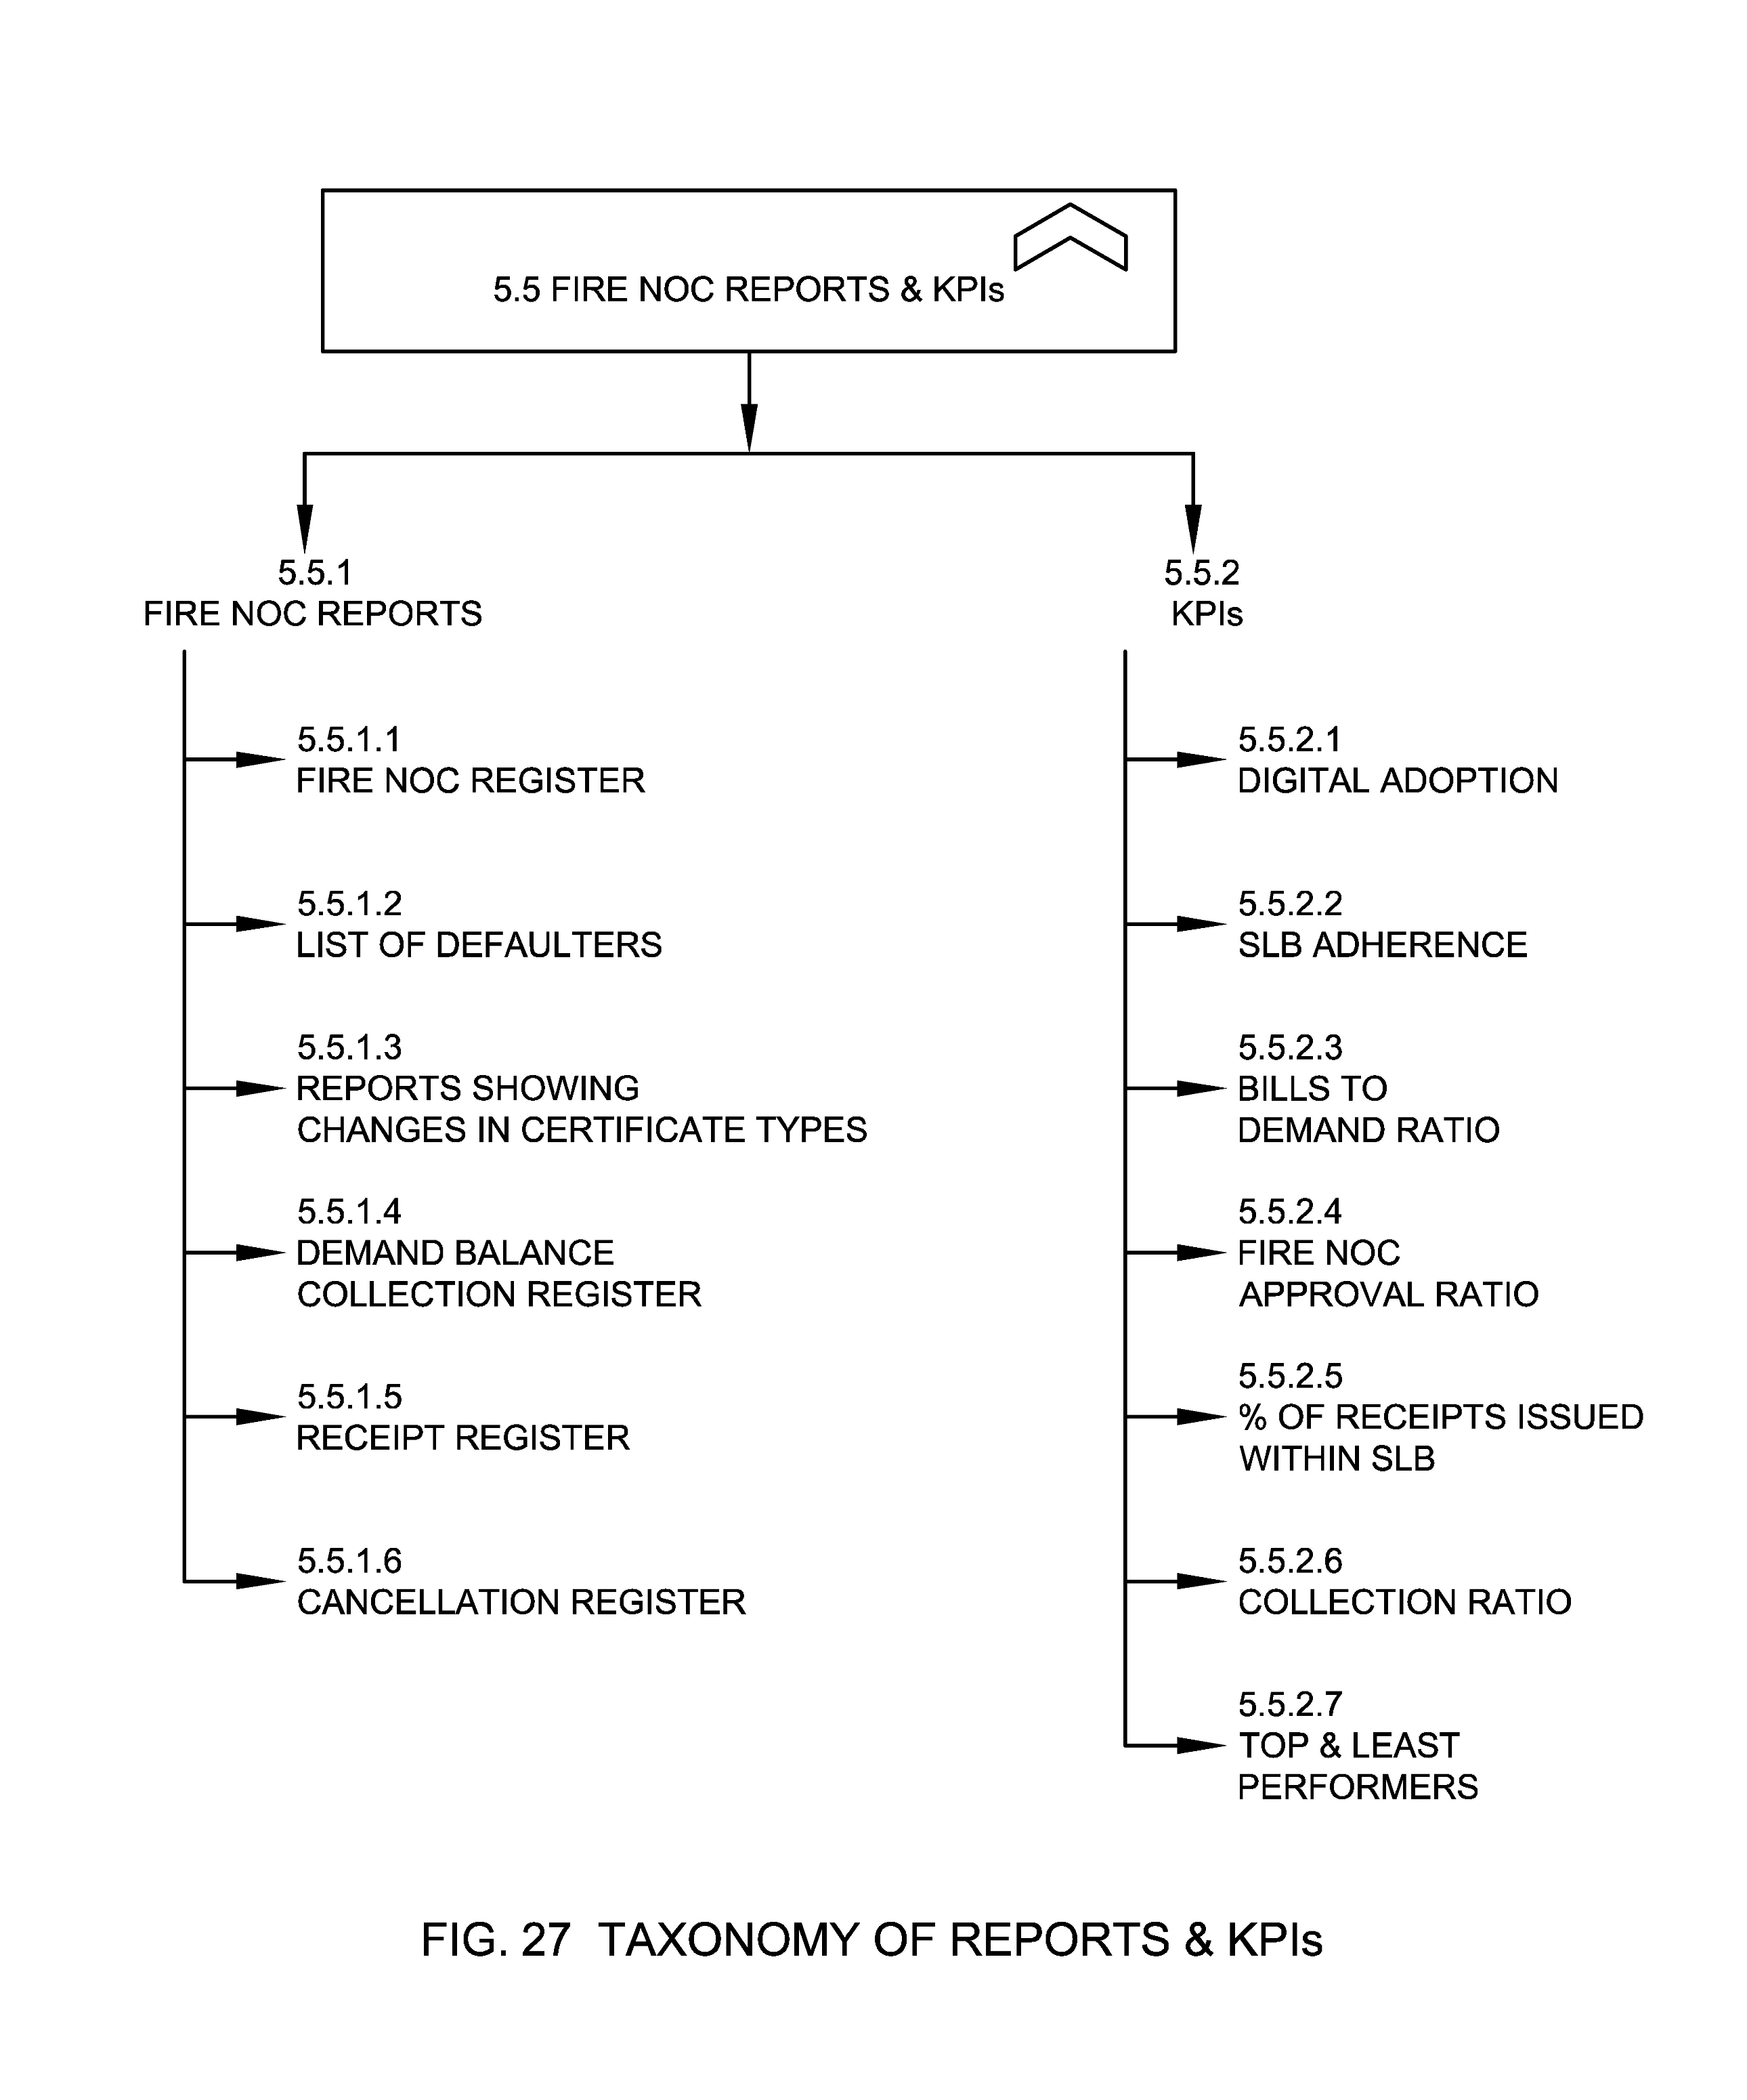

5.5.1 Fire NOC Reports
The Fire NOC Reports notifies the ULBs about the complete information of all Fire NOCs which are raised through various governance channels. These reports should be maintained by the ULBs.

5.5.1.1 Fire NOC Register
Fire NOC register provides the information about the total number of Fire NOC that are registered to their respective ULBs. The NOCs issued are categorized based on the applicant’s name and occupant name and this report gives the clear idea about the details like number of certificates, number of new certificates, number of certificates renewed, number of pending certificates for renewal, inspection details and amount collected.

5.5.1.2 List of Defaulters
List of Defaulters or Defaulter register provide details of Fire NOC defaulters, as on date. Defaulter is a person or body that has not paid last or previous Fire NOC bills. This covers assessment number, owner details, building details, demand year and arrears.

5.5.1.3 Reports Showing Changes in Certificate Types
Reports showing changes in NOC types as based on change in Fire NOC requests, date of requests, status of requests etc.

5.5.1.4 Demand Collection Balance Register
This report provides details about Demand, Collection, Balance and Collection Percentage details.

5.5.1.5 Receipt Register
This report provides details about the payment made and receipt issued after the payment of fees.

5.5.1.6 Cancellation Register
Cancellation register report provides the information about the total number of Fire NOC that are cancelled in a given interval. This report gives the clear idea about the details like building details, and applicant details, zone/ ward/ SI Ward, current owner and status about the Fire NOC.

5.5.2 KPIs
This refers to KPIs that should be captured for Fire NOC management.

5.5.2.1 Digital Adoption
Digital Adoption means attaining a state where an individual is capable enough to utilize an application, software, or tools to its fullest capacity or the potential to carry out a variety of digital processes. Digital adoption of Fire NOC can be measured in the following terms:
  - % of citizens using digital channels for Fire NOC payment
  - % of citizens using digital channels for accessing services
  - % volume from different channels
  - % of NOCs allocated within SLB

5.5.2.2 SLB Adherence
SLB Adherence means the number of applications processed by the ULB within SLB (time, escalation matrix) as determined by the rule or the law.

5.5.2.3 Bills to Demand Ratio
This means comparing the number of generated bills with respect to number of demands generated for the applied Fire NOC requests to account collections by the Fire NOC fees.

5.5.2.4 Fire NOC Approval Ratio
This means the number of total Fire NOCs issued in comparison to total number of applications received for Fire NOCs in an area.

5.5.2.5 Percentage of Receipts Issued within SLB
This means percentage of receipts issued within the agreed SLB parameters (time, priority, others as needed).

5.5.2.6 Collection Ratio
This means percentage of collections as per billing period, time and area.

5.5.2.7 Top and Least Performers
Top and Least Performers list provides information about the zones/wards who have highest and least collection ratios as well as bills to demand ratio in the ULB.

ANNEX A: Sample Parameters and Specifications for Location
(Clause 5.1.5.5)

Attribute Name | Locational Specification | Data Type | Mandatory (Yes/No)
Address | House No, Building Name, Plot/Survey No, Street Name, Locality, Zone/Ward, City/Town, District, Region, State, Country, Pin code | Varchar (256) | No
Geo Location | Latitude, Longitude, Polygon | Numeric (9,6) | Yes
Other evidences | This can include Geo tagged images of Property, DDN, QR codes etc. |  | No
Address: The address of the property provides the particulars of the place as per the administrative boundaries or norms defined by the local governing body.
Geo Location: Geolocation is the identification or estimation of the real-world geographic location of property. This refers to the latitude and longitude coordinates of a particular location where property is located.
Digital Numbers: Property Numbers defined using scientific methods and often assigned with QR code for traceability and usability.

ANNEX B COMMITTEE COMPOSITION
(Foreword)

Organization | Member Name and Role
Indian Institute of Science, Bengaluru | Shri Inder S Gopal (Chairperson)
Aveva Software Private Limited, Bengaluru | Shri Harish Mokkarala
Centre for Development of Telematics, New Delhi | Shri Aurindam Bhattacharya  Shri Anupama Chopra (Alternate)
CyanConnode Private Limited, Bengaluru | Shri Manish Widhani  Shri Deepak Nimare (Alternate)
ERNET India, New Delhi | Dr A. Paventhan  Shri Hari Krishna Atluri (Alternate)
ESRI India Technologies Private Limited, Noida | Shri Vijay Kumar  Shri Rupesh Kumar (Alternate)  Ms Seema Joshi (Alternate)
IEEE India, Bengaluru | Shri Munir Mohammed
India Smart Grid Forum, New Delhi | Shri Reji Kumar Pillai
Ministry of Housing and Urban Affairs, New Delhi | Shri Kunal Kumar  Shri Padam Vijay (Alternate)
National Smart Grid Mission, Ministry of Power, Gurugram | Shri Arun Misra  Smt Kumud Wadhwa (Alternate)  Shri Gyan Prakash (Alternate)
PHYTEC Embedded Private Limited, Bengaluru | Shri B. Vallab Rao Vasu
Qualcomm India Private Limited, Bengaluru | Dr Punit Rathod  Dr Vinosh Babu James (Alternate)
Renesas Electronics, Bengaluru | Shri Ravindra Chaturvedi  Shri Saurabh Goswami (Alternate)
Seconded European Standardization Expert for India (SESEI), New Delhi | Shri Dinesh Chand Sharma
Secure Meters Limited, Gurugram | Shri Madhur Kumar Srivastava  Shri Puneet khurana (Alternate)  Shri Kaustubh Patil (Alternate)  Shri Uttam Kotdiya (Alternate)  Shri Anil Mehta (Alternate)
Senra Tech Private Limited, New Delhi | Shri Dhiraj Kumar  Shri Ankush Kochhar (Alternate)
Sharma Technologies Private Limited, Bangalore | Shri Amarjeet Kumar
Siemens Limited, Mumbai | Shri Ravi Madipadga  Shri Manoj Belgaonkar (Alternate)  Shri Pradeep Kapoor (Alternate)  Shri Vikram Gandotra (Alternate)
Standardization Testing and Quality Certification (STQC), Pune | Ms Lipika Kaushik
Tata Consultancy Services Limited, Mumbai | Shri Ramesh Balaji  Shri Debashis Mitra (Alternate)
Tata Consulting Engineers Limited, Navi Mumbai | Shri Jagdish Shivraj Shige  Shri Manoj Kumar (Alternate)
Tejas Networks Limited, Bengaluru | Dr Kanwar Jit Singh
Telecommunication Engineering Center, New Delhi | Ms Ashima  Shri Sushil Kumar (Alternate)  Shri Uttam Chand (Alternate)
Telecommunications Standards Development Society India, New Delhi | Ms Bindoo Srivastava
eGovernments Foundation, Bengaluru | Shri Krishna Kumar Thiagarajan
In Personal Capacity (IUDX, IISc) CV Raman Road, Bengaluru – 560012 | Shri Vasanth Rajaraman
BIS Director General | SHRIMATI REENA GARG, SCIENTIST ‘G’ AND HEAD (ELECTRONICS AND INFORMATION TECHNOLOGY) [REPRESENTING DIRECTOR GENERAL (Ex-officio)]

Panel 13 Composition - Urban Domain Standards

Organization | Member Name and Role
National Institute of Urban Affairs, New Delhi | Ms. Sheika Arora  Mr. Sushant Anand (Alternate)  Ms. Gautamai Ghumatkar (Alternate)  Ms. Aparajita Dubey (Alternate)

Member Secretary
SHRI DEVANSH DEOLEKAR
SCIENTIST ‘D’/JOINT DIRECTOR
(ELECTRONICS AND INFORMATION TECHNOLOGY), BIS

BIBLIOGRAPHY
Earley, S. (2015, August 18). Why Information Taxonomy Must Represent the Landscape of the Business. Retrieved from www.earley.com: https://www.earley.com/insights/why-information-taxonomy-must-represent-landscape-business
National Building Code Sectional Committee, CED 46. (2016). National Building Code of India, Part 4 Fire & Life Safety. Bureau of Indian Standards.
Council of Architecture. (1972). Architects Act. Ministry of Education, Government of India. Retrieved from https://www.coa.gov.in/index1.php?lang=1&level=2&sublinkid=117&lid=130
Ministry of Housing and Urban Affairs. (2016). Model Building Bye laws. Ministry of Housing and Urban Affairs.
Ministry of Housing and Urban Affairs. (2016). Model Building Bye-Laws. Ministry of Housing and Urban Affairs. Retrieved from https://mohua.gov.in/upload/uploadfiles/files/Chap-7.pdf
New Delhi Municipal Council. (2021). Delhi Building Bye Laws. Retrieved from New Delhi Municipal Council: https://dfs.delhigovt.nic.in/content/delhi-building-bye-law-related-fire
Ministry of Housing and Urban Affairs. (2014). Urban and Regional Development Plans Formulation and Implementation (URDPFI) Guidelines. Ministry of Housing and Urban Affairs.
Ministry of Home Affairs. (2019). Amendments In Building Bye-Laws To Improve Fire Safety. Rajya Sabha.
Department of Electronics and Information Technology. (2016). Information Technology (Preservation and Retention of Information by Intermediaries Providing Digital Locker Facilities) Rules, 2016. Ministry Of Communications and Information Technology.

1 National Building Code Sectional Committee, CED 46. (2016). National Building Code of India, Part 4 Fire & Life Safety. Bureau of Indian Standards.
2 National Building Code Sectional Committee, CED 46. (2016). National Building Code of India, Part 4 Fire & Life Safety. Bureau of Indian Standards.
3 National Building Code Sectional Committee, CED 46. (2016). National Building Code of India, Part 4 Fire & Life Safety. Bureau of Indian Standards.
4 National Building Code Sectional Committee, CED 46. (2016). National Building Code of India, Part 4 Fire & Life Safety. Bureau of Indian Standards
5 National Building Code Sectional Committee, CED 46. (2016). National Building Code of India, Part 4 Fire & Life Safety. Bureau of Indian Standards.
6 National Building Code Sectional Committee, CED 46. (2016). National Building Code of India, Part 4 Fire & Life Safety. Bureau of Indian Standards.
7 National Building Code Sectional Committee, CED 46. (2016). National Building Code of India, Part 4 Fire & Life Safety. Bureau of Indian Standards.
8 National Building Code Sectional Committee, CED 46. (2016). National Building Code of India, Part 4 Fire & Life Safety. Bureau of Indian Standards.
9 National Building Code Sectional Committee, CED 46. (2016). National Building Code of India, Part 4 Fire & Life Safety. Bureau of Indian Standards
10 National Building Code Sectional Committee, CED 46. (2016). National Building Code of India, Part 4 Fire & Life Safety. Bureau of Indian Standards.
11 National Building Code Sectional Committee, CED 46. (2016). National Building Code of India, Part 4 Fire & Life Safety. Bureau of Indian Standards.
12 National Building Code Sectional Committee, CED 46. (2016). National Building Code of India, Part 4 Fire & Life Safety. Bureau of Indian Standards.
13 Ministry of Housing and Urban Affairs. (2014). Urban and Regional Development Plans Formulation and Implementation (URDPFI) Guidelines. Ministry of Housing and Urban Affairs.
14 Council of Architecture. (1972). Architects Act. Ministry of Education, Government of India. From https://www.coa.gov.in/index1.php?lang=1&level=2&sublinkid=117&lid=130
15 Ministry of Housing and Urban Affairs. (2016). Model Building Bye-Laws. Ministry of Housing and Urban Affairs. From https://mohua.gov.in/upload/uploadfiles/files/Chap-7.pdf
16 “DigiLocker” means the Government owned and operated web and mobile based hosting of Digital Locker system. Digital Locker System.– (i) For the purpose of providing preservation and retention of machine readable, printable, shareable, verifiable and secure State or Central department or agency or body corporate issued electronic records, the Government and other service providers to provide a Digital Locker system of limited electronic storage to all users. (ii) The Government through Digital Locker authority and in accordance with the technical standards as laid down by the DeitY from time to time shall provide for the administration of Digital Locker system. (iii) Subject to sub-rule (1), the Digital Locker system shall act as web and mobile based portal for State or Central department or agency or body corporate issued electronic records maintained in a prescribed format.
17 Department of Electronics and Information Technology. (2016). Information Technology (Preservation and Retention of Information by Intermediaries Providing Digital Locker Facilities) Rules, 2016. Ministry Of Communications and Information Technology.

