भारतीय मानक

नगरपालिका प्रशासन –

भाग 6: व्यापार लाइसेंस –

अनुभाग 1: वर्गिकी
Indian Standard

Municipal Governance –

Part 6: Trade License –

Section 1: Taxonomy

ICS 33.020, 35.020

© BIS 2024
BUREAU OF INDIAN STANDARDS
MANAK BHAVAN, 9 BAHADUR SHAH ZAFAR MARG
NEW DELHI 110002

December 2024 Price Group: XXX
Smart Infrastructure Sectional Committee LITD 28
FOREWORD
This Indian Standard (Part 6/Sec 1) was adopted by the Bureau of Indian Standards, after the draft finalized by the Smart Infrastructure Sectional Committee, had been approved by the Electronics and Information Technology Division Council.
Over the past two decades, India has witnessed the role of technology as an enabler for development and progress. India is poised to lead the digital revolution and our cities can be the primary beneficiary. Our ability to seamlessly adopt emerging technologies into urban governance holds the key to a powerful story of transformation in India’s journey towards becoming an economic powerhouse. Responding to this pressing necessity, National Institute of Urban Affairs is instituting the Centre for Digital Governance (CDG), an initiative to convene the digital efforts of the Ministry of Housing and Urban Affairs and also consolidate its existing efforts. National Urban Digital Mission (NUDM) launched in February 2021, aims to build a shared digital infrastructure that will strengthen the capacity of the urban ecosystem to solve complex problems at scale and speed. Thus improve the ease of living for citizens through accessible, inclusive, efficient and citizen centric governance across India’s 4800 towns and cities. The NUDM inherits the guiding principles of the National Urban Innovation Stack (NUIS) - Strategy and Approach paper, released by MoHUA in 2019 as a vehicle to accelerate the ecosystem for urban transformation.
One of the key deliverables under NUDM is the creation/ adoption of standards which will enable improved information consistency, analytics, secure data access & transfer, smarter business processes; while also enabling diverse stakeholders to collaborate and their corresponding platforms and processes to interoperate seamlessly.
The other parts in this series of standards consist of the following individual parts of IS 18006.
Part 1: Reference Architecture
Part 3: Property Tax
Part 4: Fire NoC
Part 5: Municipal Grievance Redressal
Part 7: Water and Sewerage
Part 8: Building Plan Approval

For the purpose of deciding whether a particular requirement of this standard is complied with, the final value, observed or calculated, expressing the result of a test or analysis, shall be rounded off in accordance with IS 2: 2022 ‘Rules for rounding off numerical values (second revision)’. The number of significant places retained in the rounded off value should be the same as that of the specified value in this standard.
The composition of the LITD 28 Sectional Committee and Panel 13 responsible for the formulation of this standard is given at Annex B.

CONTENTS
0 INTRODUCTION 4
0.1 Governing Principles in the Design of Knowledge Standard 4
0.1.1 Minimalist 4
0.1.2 Evolvable 5
0.1.3 Modular 5
0.1.4 Extendible 5
0.1.5 Open 5
0.1.6 Accessible & Inclusive 5
0.2 Sample Use Cases 5
0.2.1 Direct application 5
0.2.2 Indirect Application 6
0.2.3 Information Consistency 6
1 SCOPE 7
2 REFERENCE 7
3 TERMINOLOGY AND ABBREVIATIONS 7
3.1 Terminology 7
3.2 Depicted Symbols 8
3.3 Abbreviations 9
4 Trade License 12
5 TAXONOMY FOR Trade License 13
5.1 Trade License 15
5.1.1 Trade License ID 15
5.1.2 Application ID 15
5.1.3 License Holder Details 15
5.1.4 Trade License Type 15
5.1.5 Trade Details 16
5.1.6 Trade License Zone 22
5.1.7 Evidence 22
5.1.8 Penal provisions 22
5.1.9 Validity 22
5.1.10 License Status 23
5.1.11 Application Status 23
5.1.12 TL Request Type 24
5.1.13 Assessment Year 25
5.1.14 Billing Details 25
5.1.15 Payment Details 25
5.1.16 TL SLG Factors 26
5.1.17 ULB Type 28
5.2 Trade License Channel 28
5.2.1 Digital 28
5.2.2 Non-Digital 29
5.3 Trade License Stakeholders 29
5.3.1 Stakeholder Matrix 30
5.4 Trade License Processes 31
5.4.1 Application Creation 32
5.4.2 Acknowledgement 32
5.4.3 Application Billing & Payment 33
5.4.4 Assessment 35
5.4.5 Appellate 40
5.4.6 License Billing & Payment 42
5.4.7 Recovery 44
5.4.8 Write-off 45
5.4.9 Approval & Certification 45
5.4.10 TL Monitoring 46
5.4.11 Analysis 48
5.4.12 Taxpayer Services 50
5.5 Trade License Reports and KPIs 51
5.5.1 Trade License Reports 52
5.5.2 Trade License KPIs 53
ANNEX A 54
ANNEX B: COMMITTEE COMPOSITION 60
BIBLIOGRAPHY 62

INTRODUCTION
The terminology and vocabulary used for municipal governance differ among ULBs across India due to the federal structure of governance, state-specific laws, and varying eGovernance system implementations. Non-standardized interfaces and storage also result in challenges related to data interpretation and interoperability. As a consequence, measuring municipal performance can lead to significant inconsistencies not only from city to city but also from state to state. Therefore, without clear definitions, vocabulary, specifications, and benchmarks for municipal governance, it is challenging to enable 'Data-Driven Governance.'
The municipal governance standards are being designed to include minimum base data elements common across municipal services in ULBs/development authorities or parastatals to ensure interoperability, harmonization, and data-driven governance. ULBs with more complex processes can adopt and expand on these initiatives. The Knowledge Standards will help,
- identifying and categorizing important data elements for a domain
- resolving differences in terminology for Urban Governance
- to analyse current city domain models, processes, reports & KPIs; thus, retrofitting existing data models with missing data.
The trade license taxonomy defined in this standard includes common trade license entities, channels, processes, stakeholders, reports and KPIs and their definitions. All definitions in this standard are notional definitions for conceptual purposes. The actual definition of entities for trade license purposes should be considered as per state and local legislations. The taxonomy structure in this document is scalable both vertically and horizontally to accommodate ULB specific complexities as well as change in people, process and technology over time.
Trade License Taxonomy will be used in developing Trade License Data Models and API Specifications as well as for creating metadata specifications. Few sample parameters and specifications are also given in the Annex-A for understanding purposes.
Together these standards will ensure semantic and syntactic interoperability among all e-Governance systems in India.
The audience for this standard includes but is not limited to government organisation, industry, academics, architects, customers, users, tool developers, regulators, auditors and standards development organizations. Trade License Taxonomy is developed as an open standard under National Urban Digital Mission by National Institute of Urban Affairs. No part(s) of the document can be sublicensed further by any other organisation. Any attempted sublicense, whether voluntarily or otherwise, shall be null and void, and will attract penal actions.
This document is also interrelated with other Indian standards for e-Governance such as SP7: 2016, IS 18000, IS 18006 (Part 1) and IS 18006 (Part 3/Sec 1): 2021.

0.1Governing Principles in the Design of Knowledge Standard
To ensure this taxonomy fits the needs of interested stakeholders the following principles have been followed in designing it.

0.1.1 Minimalist
The standards are designed to have minimum base elements common across ULBs to ensure interoperability, harmonization and data driven governance. These can then be adopted and built upon by some ULBs with higher process complexities.

0.1.2 Evolvable
The standard is designed to evolve over a period of time thereby adapting to changing needs and emerging technologies thus making the system comprehensive progressively.

0.1.3 Modular
The classifications and categorizations in the knowledge standard are designed modularly, yet they function together as a whole. They are independent and self-contained and may be combined and configured with similar units to suit separate contexts. E.g., The Property “Use” element and its sub classifications can be easily reapplied in the context of any Building Plan Approval System or Trade License System.

0.1.4 Extendible
The standard is designed to be exhaustive and the elements of Urban Governance are positioned in a hierarchy which can accommodate both horizontal and vertical additions. This leaves room for wider adoption and innovation to suit contexts of any ecosystem. The end goal is to build a knowledge practice that supports Open Standards with the Data Element taxonomy as a base.

0.1.5 Open
The standard is designed to be ‘open’ to enable wider ecosystem participation and use. The standard is intended to be used by State Governments, Urban Local Bodies, industry and technology providers, academia and civil society organizations who are either working in the domain or are providing services to the ULBs in any manner.

0.1.6 Accessible & Inclusive
The standard is designed to be inclusive and accessible in nature for all types of stakeholders. The standard will enable the technology to reach every section of society. For e.g.: Interactive Voice Responses and non- digital channels as included in the section 2 will enable the marginalized and differently abled citizen to use the service in a more efficient manner. Also, stakeholders such as intermediators can also help in building capacities or creating awareness.

0.2 Sample Use Cases
Samples of Trade License Taxonomy use cases are mentioned below for reference.

0.2.1 Direct application
By storing, generating and using these important data elements (entities, stakeholders, processes & reports) in day-to-day operations.
- Designated ULB officials can use this to add channels and ULB type (such as Nagar Panchayat, Municipal Corporation or Municipal Council) in the TL system. This will help the ULBs to assess the application while acknowledging and processing the Application/ Assessment request.
- While submitting the application form for the license, the property Id is also captured. This PID can be used to fetch property details like use, location, ownership, payment details which will help in eliminating redundant or bulky forms. This will also result in re-use and harmonization of data across departments
- Monitoring of applications by their status, SLB adherence and channels by which the transaction happens, empowers ULB Officials to take corrective and preventive steps as needed.
- Timely updating and monitoring of DCB register also enable ULBs to better plan and revenue management.

0.2.2 Indirect Application
By using these data elements in evidence-based governance and long-term planning
- Analysing trade applications by purpose for which the application was made may help the ULBs in regulation of land use, planning revenue management models etc. It can also help in planning the inspection schedules better with respect to the types of regulations needed.

0.2.3 Information Consistency
By using these data elements while using and sharing data (via Metadata tags in reports and dashboard)
- Consistent use of Data elements, processes, KPIs and their definitions from this Knowledge Standard helps in implementing Information consistency across ULBs. To ensure information consistency, ULBs may use new or existing platforms for delivering TL services. They should use Metadata tags from the data elements defined in this knowledge standard.
0.3 How to read this Document
- Section 5.1 captures key data elements associated with the Trade License data entity.
- Section 5.2 captures key channels of transactions i.e., new application/ grievance registration/ payment etc.
- Section 5.3 captures key stakeholders involved in Trade License service delivery.
- Section 5.4 captures key processes within the Trade License domain with clearly defined input & output data elements.
- Section 5.5 captures key Reports and KPIs that ULBs and states/UTs are encouraged to use.

1. SCOPE
This Indian standard provides a unified view of the Trade License Taxonomy, data and processes in urban local bodies and introduces common and widely accepted terminologies and semantics that can be used across multiple systems.

2. REFERENCE
The standards given below contain provisions which, through reference in this text, constitute provisions of this standard. At the time of publication, the editions indicated were valid. All standards are subject to revision, and parties to agreements based on this standard are encouraged to investigate the possibility of applying the most recent editions of these standards.
SP 7:2016 National building code of India (Third Revision)
IS 18006 (Part 1) Municipal Governance - Reference Architecture
IS 18006 (Part 3/Sec 1): 2021 Municipal Governance - Part 3 Property Tax - Section 1 Taxonomy

3. TERMINOLOGY AND ABBREVIATIONS

3.1 Terminology
For the purpose of this standard, the definitions given in IS 18006 and IS 18006 (Part 3/Sec 1): 2021 shall apply, in addition to the following:
    - Aadhaar
Aadhaar is a verifiable 12-digit identification number issued by Unique Identification Authority of India (UIDAI) to the resident of India.
    - Application Programming Interface (API)
The term Application Programming Interface (API) means any mechanism that allows a system or service to access data or functionality provided by another system or service. The API is generally used to interact (like query, list, search, sometimes submit & update) directly with the specific information on a system, to trigger some action on other systems, or to perform some other action on other systems.
    - Data Elements
The basic principle of data modelling is the combination of an Object class and an Attribute to form a more specific ‘data element concept’. For E.g.: Application ID, building details that are associated with a Data Entity (Such as Building Plan Approval)
    - Data Entities
Entities were created to help users to locate their data elements from the entire list. However, this grouping should not be confused with data sets. Data sets are list of data elements required for a certain program or application to function and should be created choosing relevant data elements from various entities e.g. BPA, Trade License, Property Tax etc.
    - DigiLocker
DigiLocker is a secure cloud-based platform for storage, sharing and verification of documents & certificates
    - Domain
A sub-category under an Information Technology field is a Domain; specific purpose within a “Domain” is known as “Area”. For example, “Document type for Web publishing content” is one Area under the “Presentation” domain.
    - E-governance
A procedural approach in which the Government and the citizens, businesses, and other stakeholders are able to transact all or part of their activities using Information and Communication Technology tools.
    - Interoperability
The ability of different information technology systems and software applications to communicate, exchange data, and use the information that has been exchanged.
    - Metadata
Metadata is data about data. Metadata describes how and when and by whom a particular set of data was collected. Metadata is essential for understanding the information stored.

3.2 Depicted Symbols

Domain is depicted as for e.g. Trade License
Data Entities are depicted as for e.g. Building Details

Channels are depicted as for e.g. Trade License Channels

Stakeholders are depicted as for e.g. Stakeholder Matrix

Processes are depicted as for e.g. Application Creation, Acknowledgement

Reports & KPIs are depicted as for e.g. Demand Balance Collection Register

In processes section (section 5.4),
- Input criteria (whether from citizen or ULB) of the process is shown in italics text (For Example “5.4.3.3.2 Mode of Payment”)
- Output of the process is shown in Bold text (For example “5.5.1.1 License Register”)
- Direct sub-classifications or sub-components are shown as normal text (For Example 5.4.4.1.1 Issue of New License, which is sub-classification under Section 5.4.4.1 Types Of
Assessment)

3.3 Abbreviations

AMRUT | Atal Mission for Rejuvenation and Urban Transformation
BIS | Bureau of Indian Standards
CAA | Constitution Amendment Act
CDG | Centre for Digital Governance
CSC | Common Service Centre
DMA | Directorate of Municipal Administration
FY | Financial Year
GST | Goods and Services Tax
ICT | Information and Communication Technology
ID | Identification Document/Number
IVR | Interactive Voice Response
KPI | Key Performance Indicators
LLP | Limited Liability partnership
Ltd. | Limited
MOA | Memorandum of Association
MoHUA | Ministry of Housing & Urban Affairs
NIUA | National Institute of Urban Affairs
NUDM | National Urban Digital Mission
UPYOG | Urban Platform for delivery of Online Governance
NOC | No Objection Certificate
PAN | Permanent Account Number
PID | Property Identification Number
PTIN | Property Tax Identification Number
Pvt. Ltd | Private Limited
SLG | Service Level Guarantee
SMS | Short Message Service
TL | Trade License
TLID | Trade License Identification Number
UGD | Under Ground Drainage
ULB | Urban Local Body/Bodies
UPIC | Unique Property Identification Code
AMRUT | Atal Mission for Rejuvenation and Urban Transformation
BIS | Bureau of Indian Standards
CAA | Constitution Amendment Act
CDG | Centre for Digital Governance
CSC | Common Service Centre
DMA | Directorate of Municipal Administration
FY | Financial Year
GST | Goods and Services Tax
ICT | Information and Communication Technology
ID | Identification Document/Number
IVR | Interactive Voice Response
KPI | Key Performance Indicators
LLP | Limited Liability partnership
Ltd. | Limited
MOA | Memorandum of Association
MoHUA | Ministry of Housing & Urban Affairs
NIUA | National Institute of Urban Affairs
NUDM | National Urban Digital Mission
UPYOG | Urban Platform for delivery of Online Governance
NOC | No Objection Certificate
PAN | Permanent Account Number
PID | Property Identification Number
PTIN | Property Tax Identification Number
Pvt Ltd. | Private Limited
SLG | Service Level Guarantee
SMS | Short Message Service
TL | Trade License
TLID | Trade License Identification Number
UGD | Under Ground Drainage
ULB | Urban Local Body/Bodies
UPIC | Unique Property Identification Code

4. Trade License
Urban Governance in India is predominantly the constitutional domain of the State Government, who delegates power to Municipal Bodies/Urban Local Bodies (ULBs) through a specific legislation. The Trade License (TL) module in a municipal governance system provides the facilitation to all the business owners in order to register their business/ trade under the Urban Local Body and is governed by the revenue department for collection of the tax. The license also establishes certain operational protocols and safety measures for the general welfare of all commercial establishments and the workforce involved.
- The trade license that is issued by the municipal corporation is regulated by the state government of that particular state
- A trade license ensures that no one is affected by the nuisance and the health hazards of any trade or business
- To make sure that no business carries any unethical business practices or trade it has been made necessary by the government. So, to carry out any business in any particular area it is to be ensured that the person has a trade license
- This license makes sure that there is harmony in the society that every business is following the rules and the guidelines that are set by the government and they are obeying the safety measures
- A trade license registration makes sure that the trade activities in the country are aligned.
The government has made it necessary for any business entity to obtain a trade license to ensure that the person is not carrying out unethical business practices and is following the relevant rules, safety measures and guidelines. A licensed business protects its owners against certain types of liability. If damage or injury occurs in the business actions or doings, the personal finances would not be at stake in any settlement. The various types of trade licenses offer different levels of protection. TL also covers various businesses under the Shop & Establishment Act, 1948 which means to regulate the working and employment conditions of workers employed in shops and establishments including commercial establishments. The Act generally provides for fixation of working hours, rest intervals, overtime, holidays, leave, termination of service, maintenance of shops and establishments and other rights and obligations of the employers and employees.
As a part of National Urban Digital Mission (NUDM), NIUA is also offering a platform called as UPYOG to ULBs within States that offer Trade License Issuance & Payment functionality using Trade License module.
The government of India authorizes the license in a manner to regulate businesses in cities across the country. It grants permission by the way of letters or documents/certificates to carry on any business or trade where it is located. The issuance of the license varies from state to state depending on the local government agencies (Municipal) rule and regulations and State Municipal Acts.
It is issued by the licensing department of the municipal corporation in various departments like industries, engineering, health etc. The ULB authorities are hence mandated to identify the trade running in the designated territory and perform assessment of fee value and the result of which the trade running in their respective ULB should be registered and a unique Trade License ID (TLID) will be issued to the owner for making the necessary payment.
The traders have to renew their license issued once the period of the license gets over and the result of which the existing unique Trade License ID will be renewed.
ULB officials need to carry out the enforcement and other functions prescribed under the Municipalities Act. Inspections are carried out to ensure the opening and closing hours of shops and establishments fixed under the Shops and Establishment Act, 1948. Challans may be filed against the defaulting employers by the Chief Inspector of shops on the report of the area Inspector before the area Magistrate.
Taxonomy for Trade License tries to capture the most important data elements, entities, their properties, categories, subcategories, parameters, and specifications within this domain as well as other associated areas. Subsections in section 2 also define all the key terms in the trade license domain comprehensively.

5. TAXONOMY FOR TRADE LICENSE
While building the knowledge models for Trade License systems, it is imperative to consider entities that are interlinked with Trade License. Trade License is a fee-based Municipal Revenue charged against permission for permission to operate a trade, Assessment, Inspection and Billing and Payment are the processes that operationalise the Revenue mobilization within a ULB. Hence, taxonomy for Trade License cannot be built in a silo and needs to be accompanied by entities like Trade License, Channels, Stakeholders, associated processes reports and KPIs. See Fig. 1
A well-structured TL taxonomy helps by:
- Identification and regulation of trades enabling effective enforcement and regulation
- Building accountability and ensuring transparency
- Building confidence among the traders and business owners to run a trade
- Identification and process key data elements to enable evidence-based decision & policy making
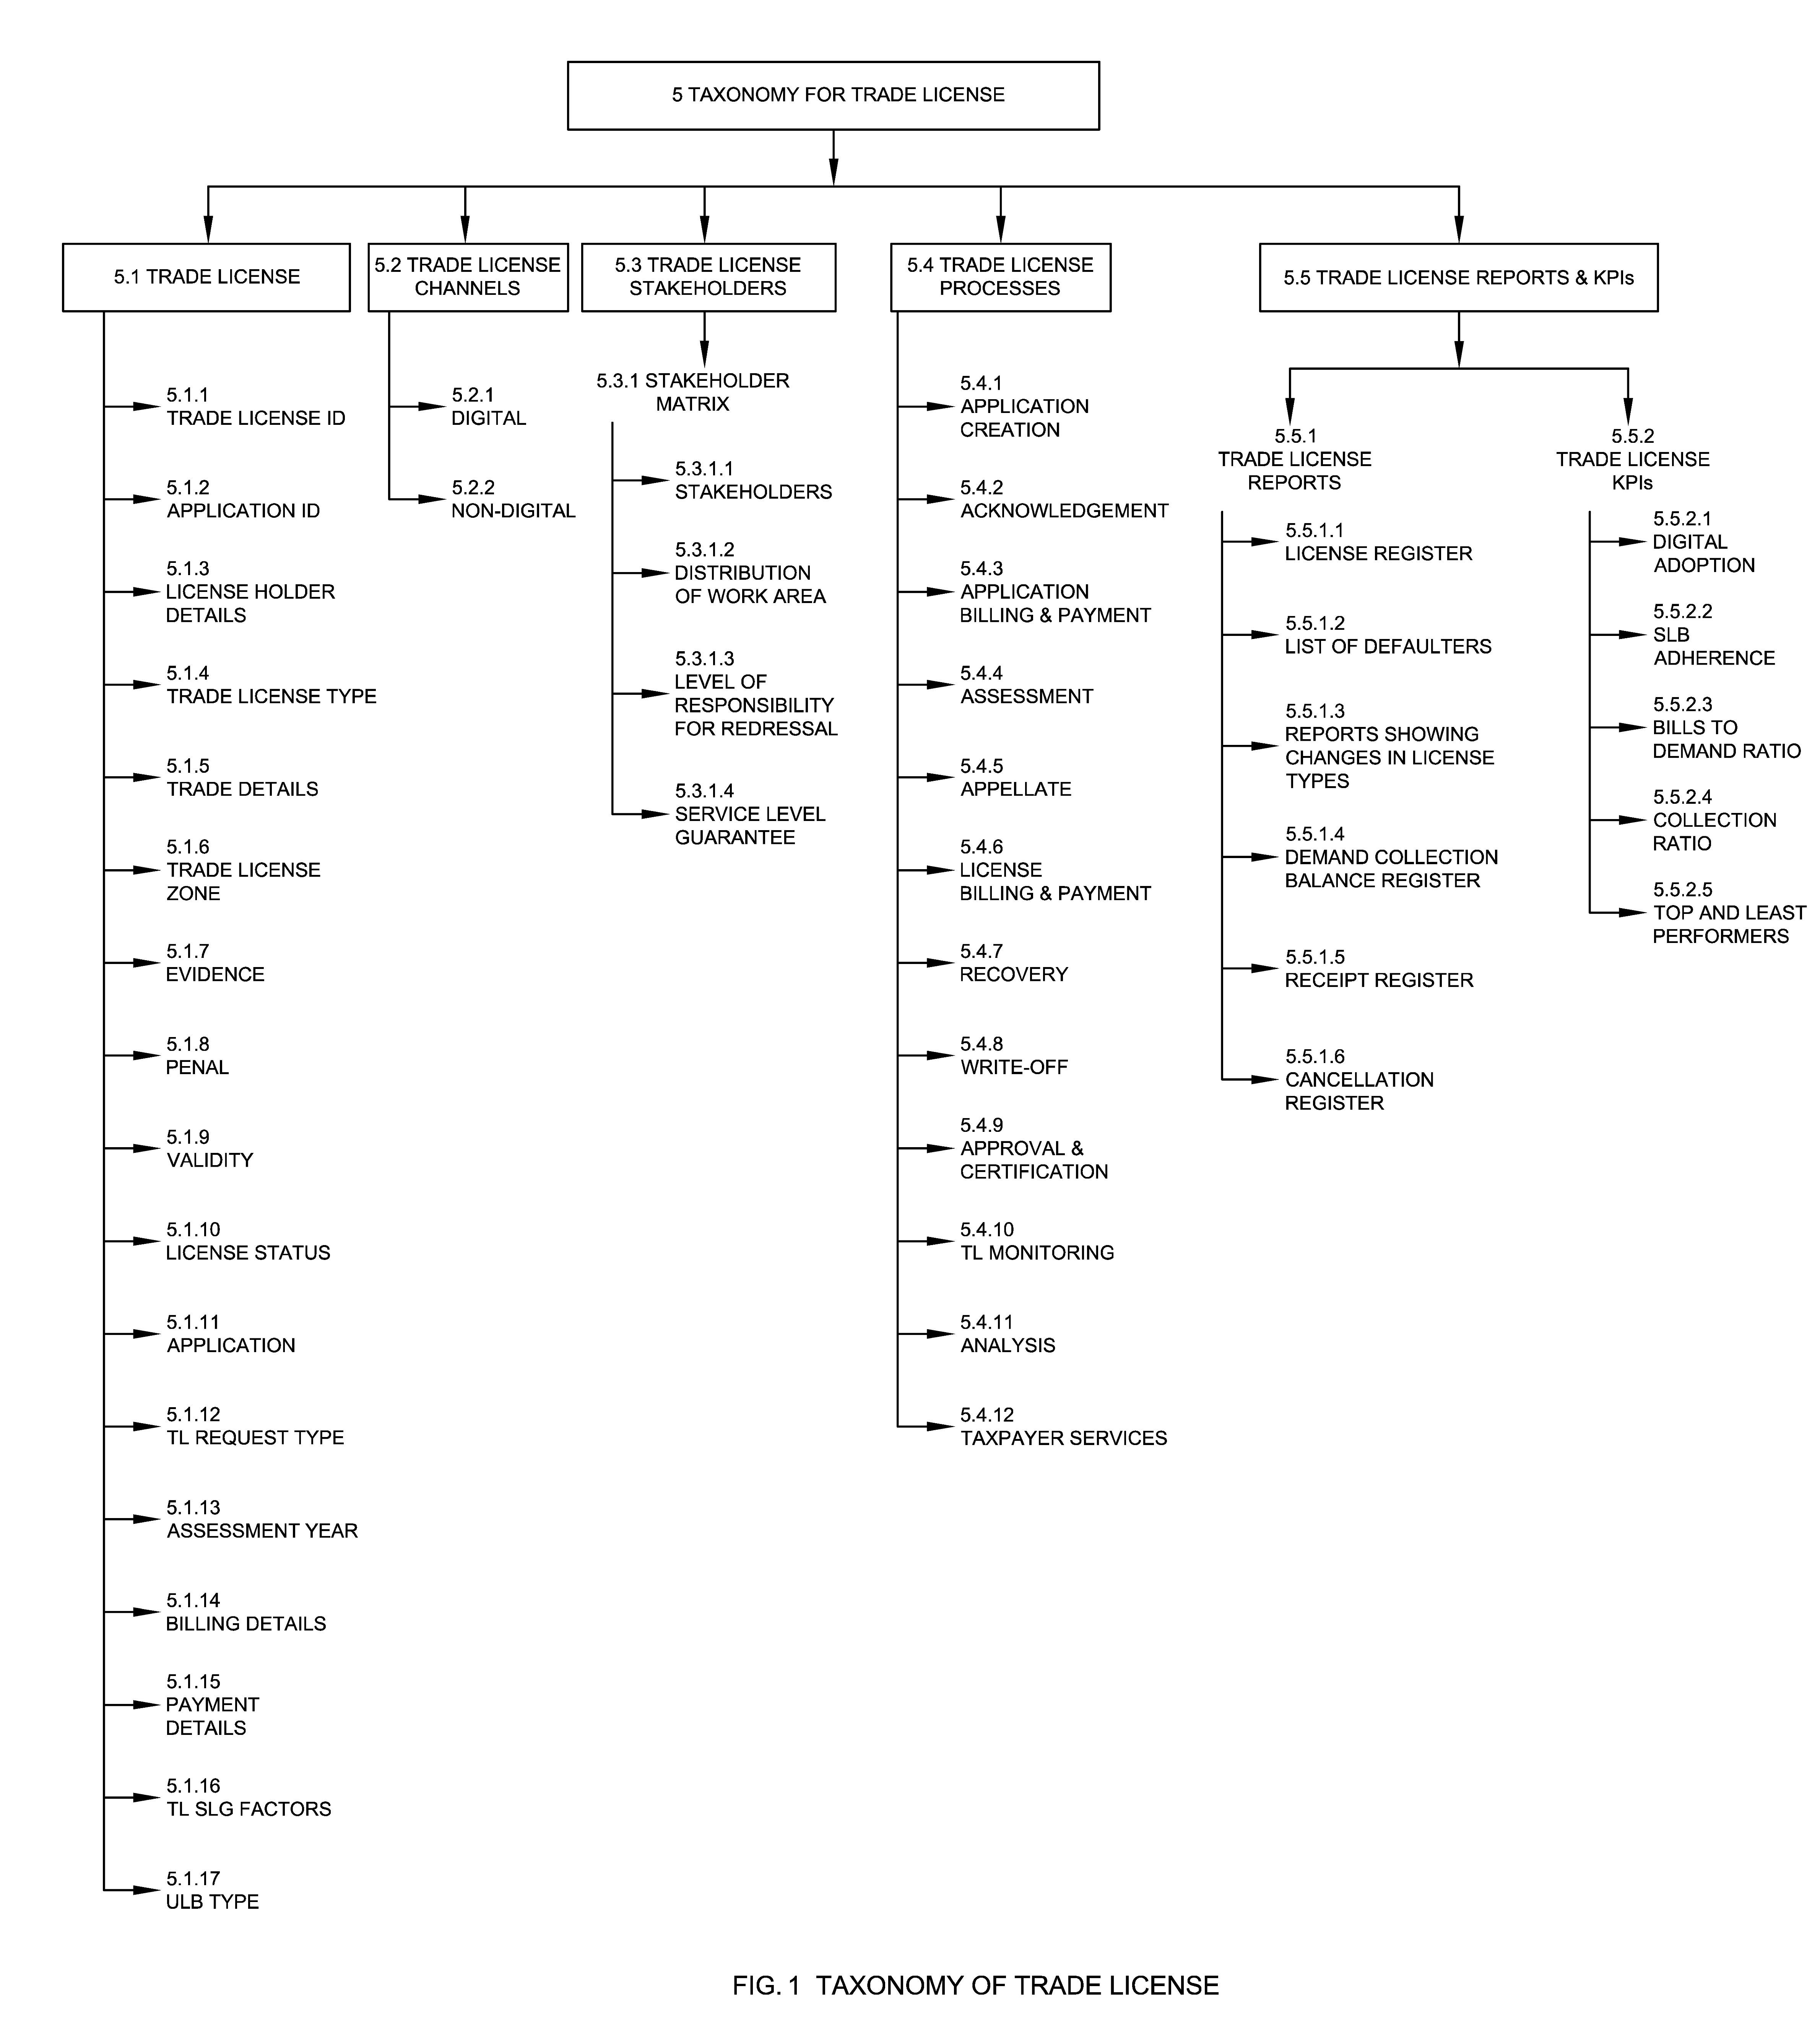
The categorizations and sub-categorizations of terms used in Trade License taxonomy are summarized in 5.1 to 5.5. The categorizations and classifications primarily establish hierarchical relationships, and as a whole yield the taxonomy around Trade License.

5.1 Trade License
A Trade License is permission issued by an Urban Local Body (ULB) to conduct specific trade or business according to the relevant rules, standards and safety guidelines on premises for which it has been issued. The license also establishes certain operational protocols and safety measures for the general welfare of all commercial establishments and the workforce involved. Sub-components in this section describe important components of a trade license entity.

5.1.1 Trade License ID
A Trade License ID (TLID) is the unique identifier allotted to a trade by the ULB for the purpose of trade license records. Typically, the TLID is generated after the completion of assessment and inspection of the trade by the ULB officials and payment of license fees by the applicant.

5.1.2 Application ID
An Application ID is a unique application identifier that will be generated after submitting the application form successfully. The Application ID can be used to check the status of the filled application, get duplicate bills, receipts etc.

5.1.3 License Holder Details
License holder details mean the details of the individual or group of individuals who hold the license for the trade or establishments such as name of all partners, mobile numbers, addresses, age, proofs of identity, email ids, photographs and partnerships. It is recommended that automated authentication be incorporated with other government documents and services such as Aadhaar, PAN, etc. Trade in a city may be further classified and analysed based on the eligibility of the owner of the trade needed to commence the particular trade such as legally permissible age to work or register for the trade, criminal records etc. See Fig. 2.
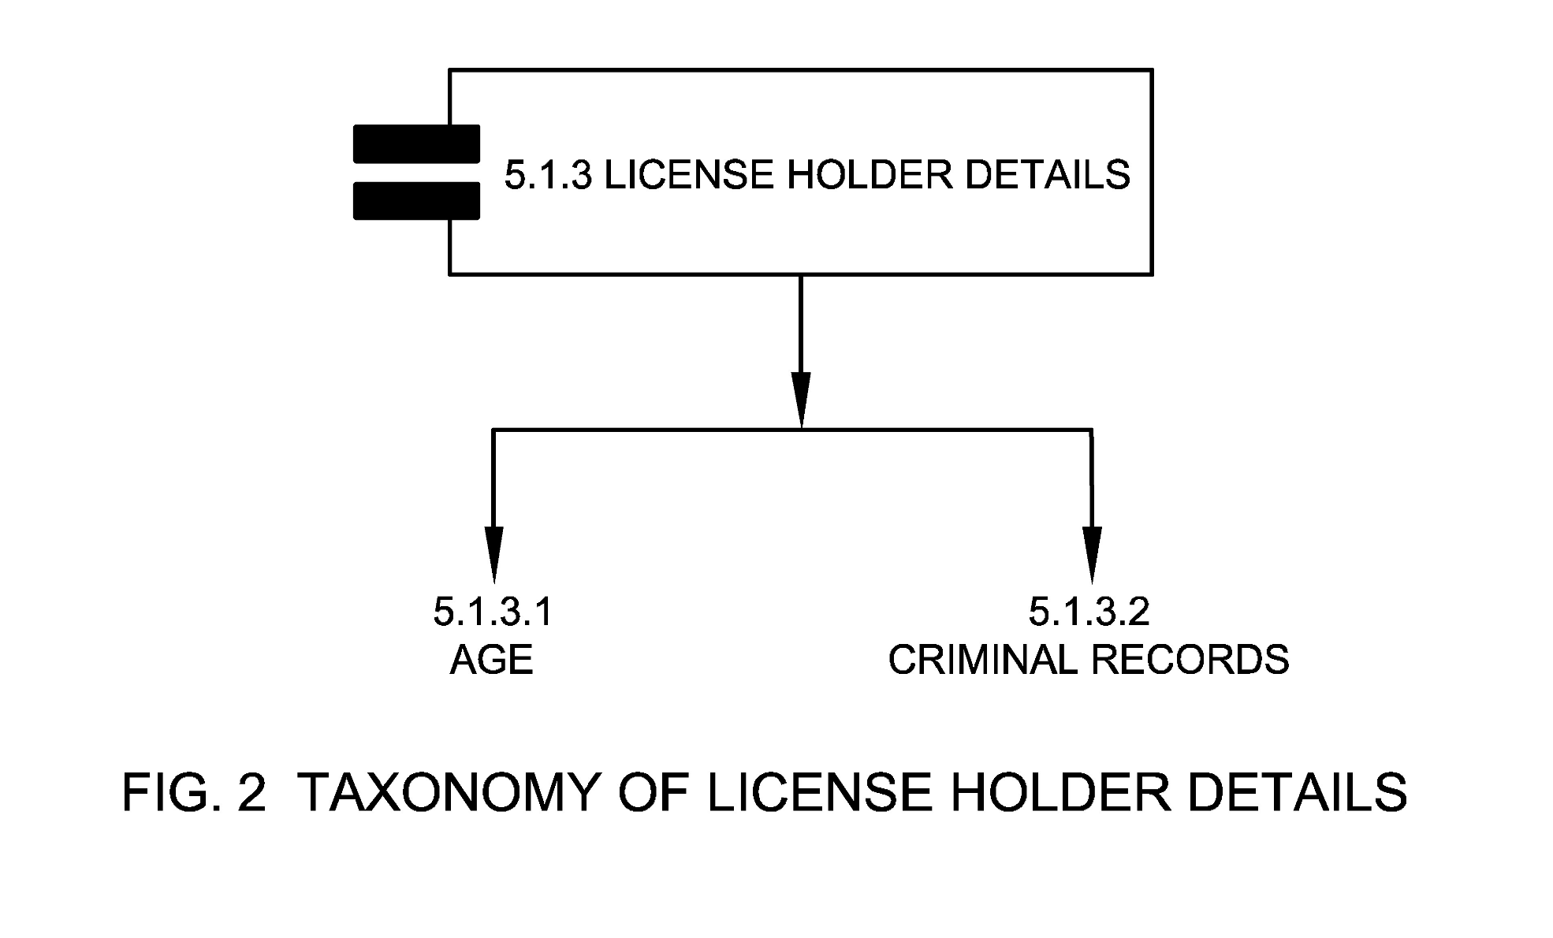

5.1.3.1 Age
It means the age of the individual who applies for the particular trade.

5.1.3.2 Criminal Record
It means the owner of the trade should furnish information or record of any criminal cases registered against their name in any police station across the country.

5.1.4 Trade License Type
Trade License type means type of license based on the period of validity such as permanent license, usually valid for the financial year, and temporary license usually valid for a shorter period of time. See Fig. 3.

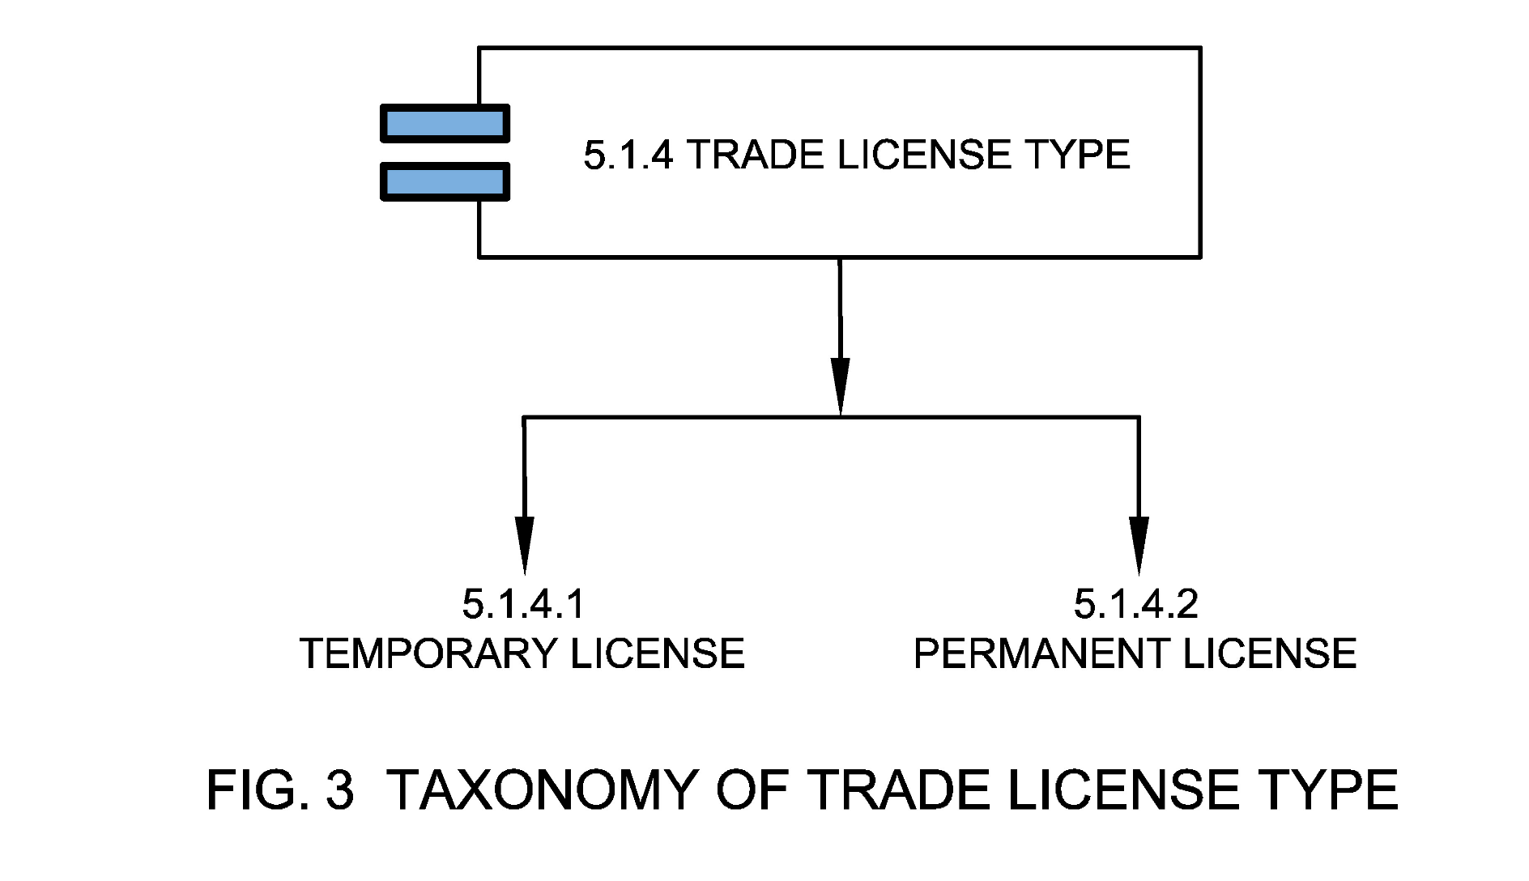
5.1.4.1 Temporary License
Figure SEQ Figure \* ARABIC 3 Taxonomy of Trade License Type
A temporary license is the license applied for the validity of a short period i.e., less than a financial year.

5.1.4.2 Permanent License
A permanent license is the license applied for the validity of the financial year that can be renewed as per the trade license guidelines.

5.1.5 Trade Details
Trade is a basic economic concept involving the buying and selling of goods and services. In terms of trade license, this may include name of business/trade, owner of trade, location of trade, nature of trade, year of inception, PAN, TIN number and GST Number. See Fig. 4.
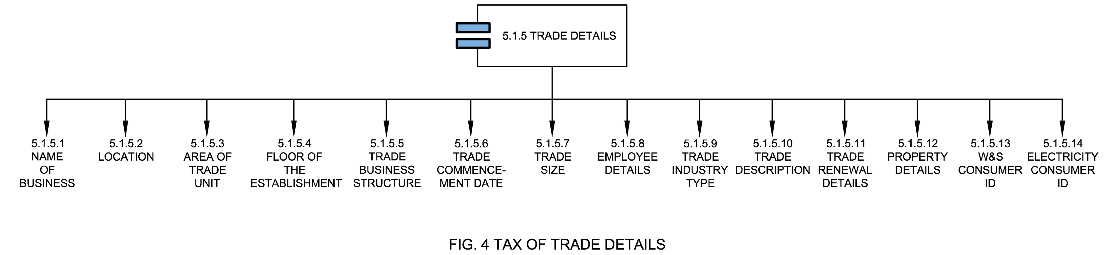

5.1.5.1 Name of Business
Name of a business is the name by which a business is known. Business names should be used on all official correspondence, such as letters and invoices.

5.1.5.2 Location
Location (address of trade unit) provides the particulars of the place where the applicant will conduct trade for e.g., registered office address, warehouse address, market location, shop number and geospatial location with respect to the urban base map.

5.1.5.3 Area of Trade Unit
Area of trade unit means coverage area of the business unit where the trade establishment is functioning. This in many cases also determines the license fees.

5.1.5.4 Floor of the Establishment
Floor of the establishment means the floor at which the trade establishment is functioning. This in many cases also determines the license fees.

5.1.5.5 Trade Business Structure
Trade Business Structure means type of business constitution as prescribed by the Companies Act, 2013 or local laws such as proprietorship, PVT. Ltd., Ltd., LLP and partnership. This may also determine license fees.

5.1.5.6 Trade Commencement Date
Trade commencement date means the first date on which the trade makes a commercial sale of any product/ service under the business category where it is registered.

5.1.5.7 Trade Size
Trade Size means the size of the business or trade for the purpose of determining the unit of measurement value of a trade license. Trade or business could be small size, medium size or large size. This may also determine license fees.

5.1.5.8 Employee Details
Employee details mean the details of the employees of the registered trade such as number of employees, type of employees (temporary/ permanent) etc. This in many cases also determines the license fee. See Fig. 5.
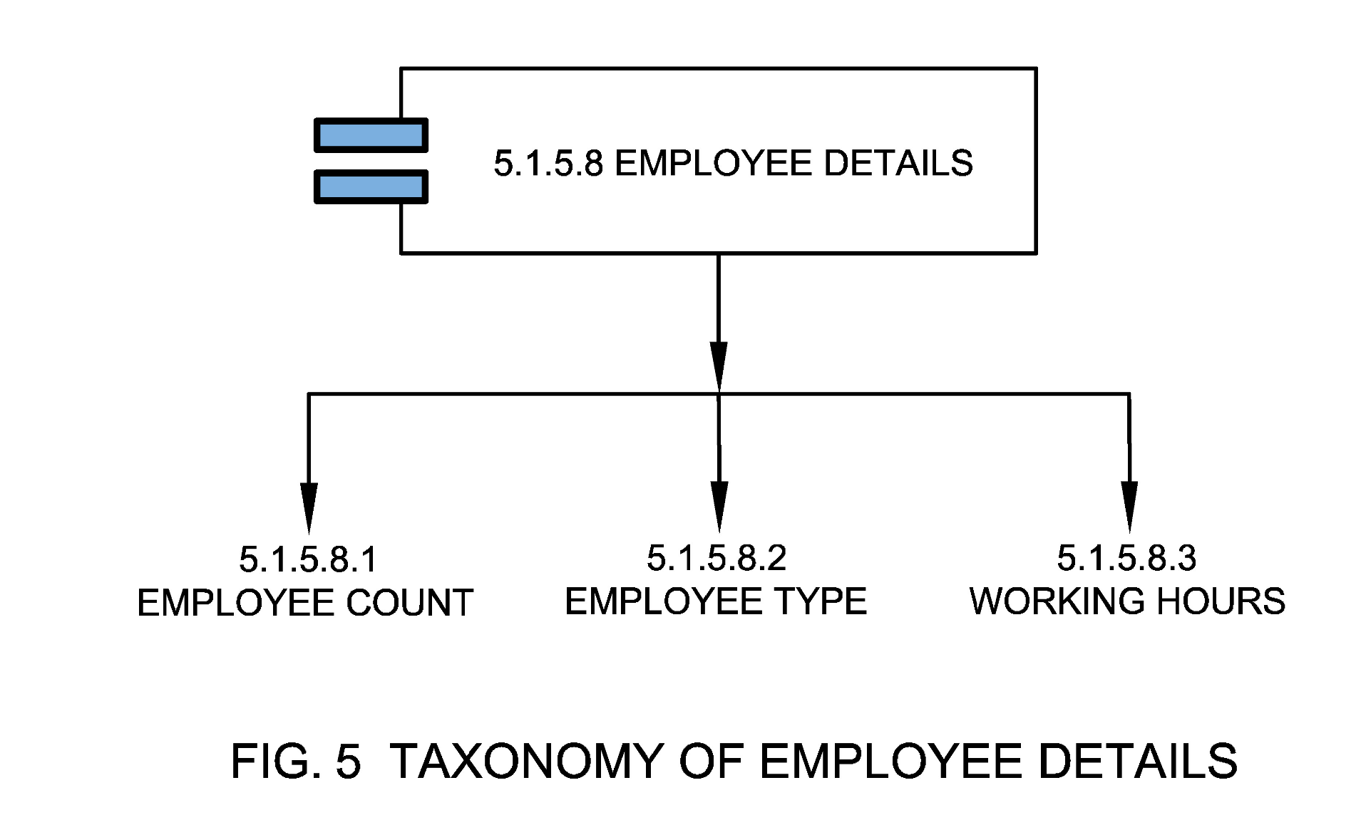

5.1.5.8.1 Employee count
Employee count means the number of employees currently working in the established trade.

5.1.5.8.2 Employee Type
Employee type means the type of employees currently working in the established trade such as contractual, permanent or non-contractual helpers or staff.
- Permanent employees work for an employer and are paid directly by that employer. Permanent employees do not have a predetermined end date to employment. In addition to their wages, they often receive benefits like subsidized health care, paid vacations, holidays, sick time, or contributions to a retirement plan
- A contract employee is an individual retained by a company for a predetermined time, for a predetermined price. Following this approach, a company is not responsible for providing a variety of traditional employer benefits, including: taxes, social security, workers’ compensation, unemployment benefits, health benefits, sick leave, or retirement or profit sharing. In terms of TL, it means the number of contractual employees/staffs working in the established trade
- Non-contractual staff/helpers mean count of employees who are not bound or secured by a contract or agreement

5.1.5.8.3 Working Hours
Working hour’s means the total official working hours an employee spends in the established trade.

5.1.5.9 Trade Industry Type
Trade industry type is classification of trade license based on the primary business activities. This may also determine license fees. See Fig. 6.
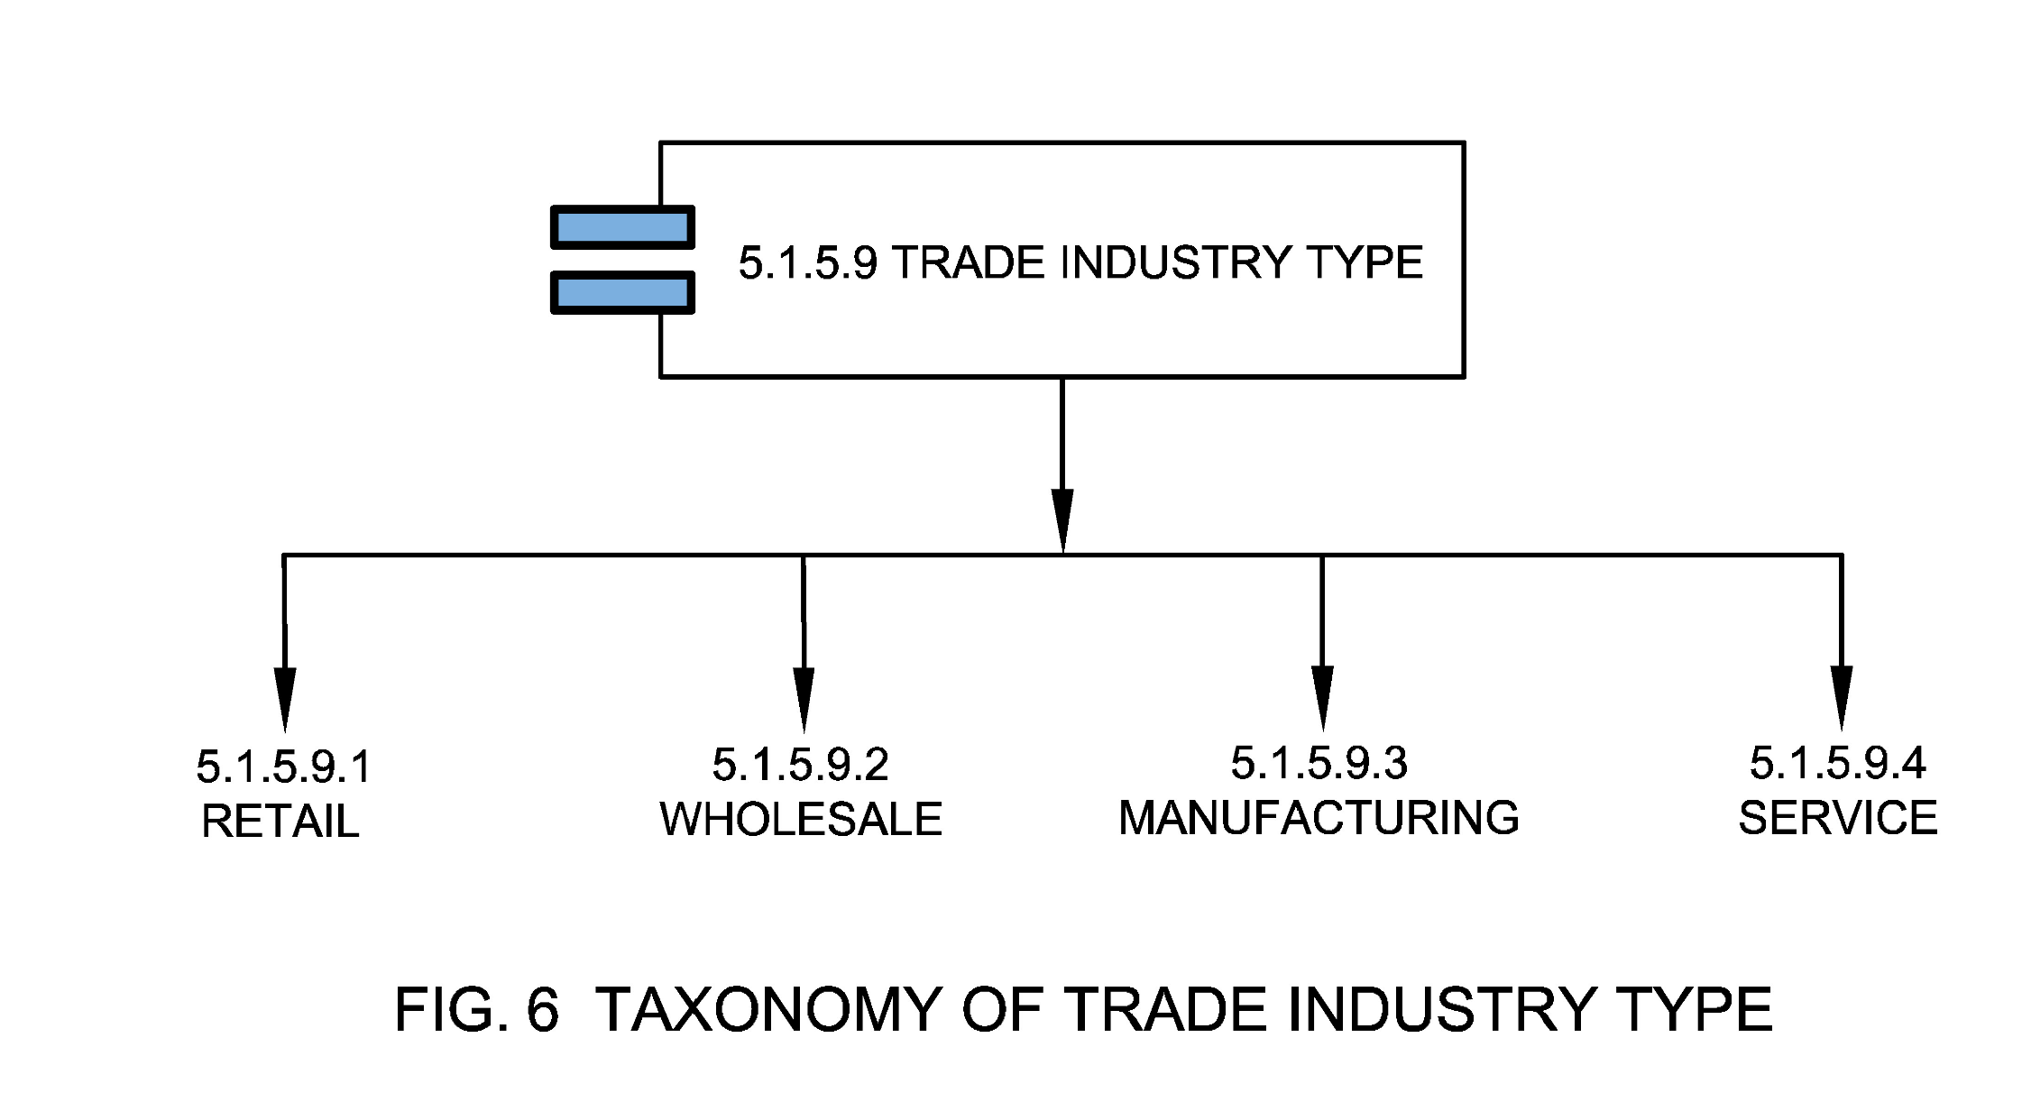

5.1.5.9.1 Retail
Retail means businesses or trade which sell goods and services to consumers.

5.1.5.9.2 Wholesale
Wholesale means businesses or trade which sell goods and services to businesses.

5.1.5.9.3 Manufacturing
Manufacturing means businesses or trade which manufactures goods.

5.1.5.9.4 Service
Service means businesses or trades which provide services such as hospitality, waste management etc.

5.1.5.10 Trade Description
Trade description means sub-categorization of industry as defined by the ULB rules. This may also determine license fees. See Fig. 7.
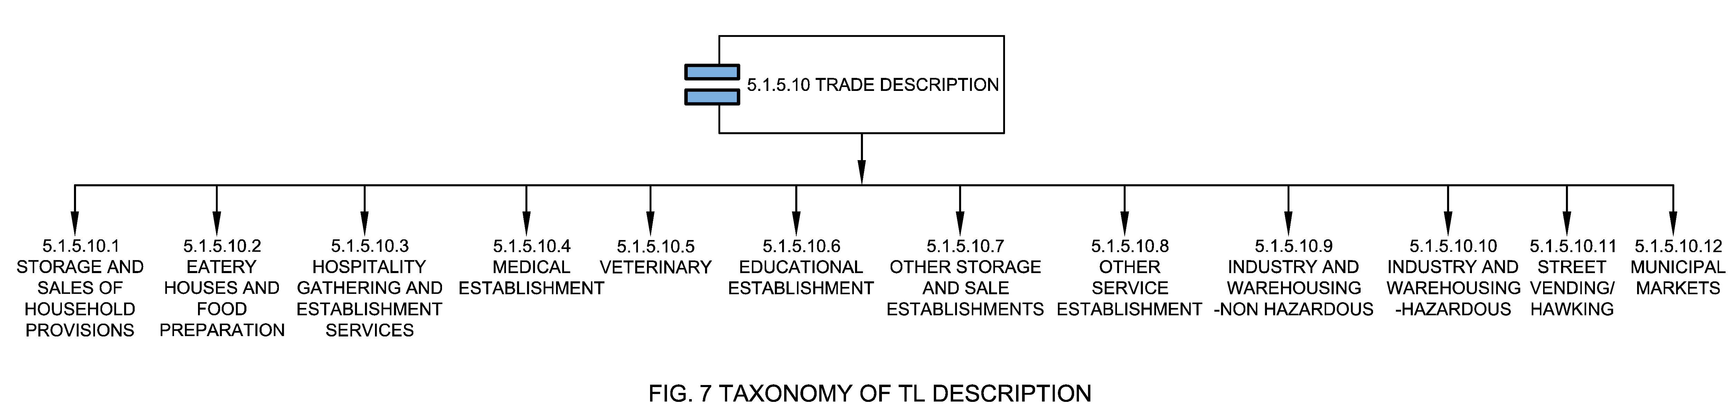

5.1.5.10.1 Storage and Sale of Household Provisions
This category includes trades of all sizes related to storage and sale of household provisions such as grocery & condiments; Perishables such as fruits, vegetables, flowers; Bakery products; Non-alcoholic beverages; tobacco and tobacco products, including pan masala and gutkha with or without tobacco; whether branded or not; Branded meat products, or any other except negative products list as notified by the states or ULBs.

5.1.5.10.2 Eatery Houses and Food Preparation
This category includes trades of all sizes related to eatery houses and food preparations such as Tea/coffee; Sweets & Savories; Bakery; Fast food; Juice/milk-shake shops without separate kitchen space, restaurant, bakery, cafeteria or any other eating house with kitchen in separate space, bar or pub, with or without restaurant and separate kitchen or beer brewery or establishment selling locally produced alcoholic beverage, with or without sale of tobacco and tobacco related products etc. or any other related trade as notified by the state or ULBs.

5.1.5.10.3 Hospitality, Gathering and Entertainment Services
This category includes trades of all sizes related to hospitality, gatherings and entertainment services such as accommodation facility without or with kitchen or function hall or health, sports or recreation-related facilities, hotel, resort or club with accommodation facilities, restaurants, kitchen or other F&B arrangements, function hall, conference halls, convention center, health, sports or recreation related facilities, shopping center or mall with any combination of shops and storage, eating houses, hospitality, gathering and entertainment facilities, Banquet hall, function hall, single-screen or multiplex cinema hall, auditorium or conference/convention center, without restaurant or kitchen or any other related trade as notified by the state or ULBs.

5.1.5.10.4 Medical Establishment
This category includes trades of all sizes related to medical establishments excluding large hospitals and clinics such as Chemist, druggist, medical and general store, including surgical store or any other related service.

5.1.5.10.5 Veterinary
This category includes trades of all sizes related to veterinary services such as pet services including pet shops, material for pets, clinics, boarding, pet chemists etc.

5.1.5.10.6 Educational Establishment
This category includes trades of all sizes related to education and educational establishments such as municipal schools, of any education system, across any classes, municipal colleges, of any education system, across all streams or any other related establishment.

5.1.5.10.7 Other Storage and Sale Establishments
This category includes any other trades of all sizes related to storage and sale establishments such as construction materials, tools and machinery parts, automobile parts and accessories or any other related trade.

5.1.5.10.8 Other Service Establishment
This category includes any other trade of all sizes related to services and service establishments such as Tent house, printing, stamp-making, signboards, photo studio with or without sale of photographic equipment, photo-framing, key-makers; Internet or other communication, legal, architecture, CA, engineering, real-estate, astrology, matchmaking, travel agency or other professional service.

5.1.5.10.9 Industry and Warehousing – Non-Hazardous
This category includes trades of all sizes related to manufacturing, warehousing and sale of non-hazardous goods.

5.1.5.10.10 Industry and Warehousing – Hazardous
This category includes trades of all sizes related to manufacturing, warehousing and sale of hazardous goods as permitted by the state or the ULBs.

5.1.5.10.11 Street Vending/Hawking
This category includes vending of all sizes and types as per the ULBs or The Street Vendors (Protection of Livelihood and Regulation of Street Vending) Act, 2014.

5.1.5.10.12 Municipal Markets
This category includes trades in municipal markets of all sizes and regulation of municipal markets as notified by the states or ULBs.

5.1.5.11 Trade Renewal Details
These are the additional details needed while the applicant wants to renew existing/ expired trade license. The renewal of the license has to be done within a specific time frame as per the existing laws of ULB. See Fig. 8.
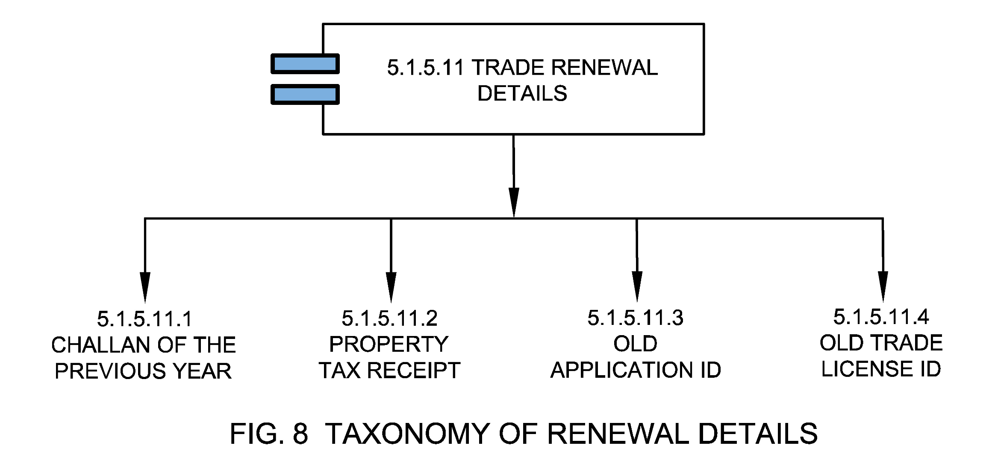

5.1.5.11.1 Challan of the Previous Year
Means the challan generated for the previous financial year.

5.1.5.11.2 Property Tax Receipt
Means any evidence of payment or compensation of taxes.

5.1.5.11.3 Old Application ID
An old application ID is the number generated when the applicant initiated an application for the first time and has been awarded with the trade license in lieu of that application. The old application number may be used to renew an old trade license.

5.1.5.11.4 Old Trade License ID
An old Trade License ID is the number generated when the license is issued for the first time in lieu of that application. The old trade license ID may be used to renew an old trade license.

5.1.5.12 Property Details
Property details include the attributes of the property which are required for assessment and identification of the trade. This includes PID, locational information, complete address of the property, physical attributes of the property such as area, built-up space, number of floors, etc. A trade license may be linked with property ID to fetch relevant details from the municipal property register appropriately and vice versa. See Fig. 9.
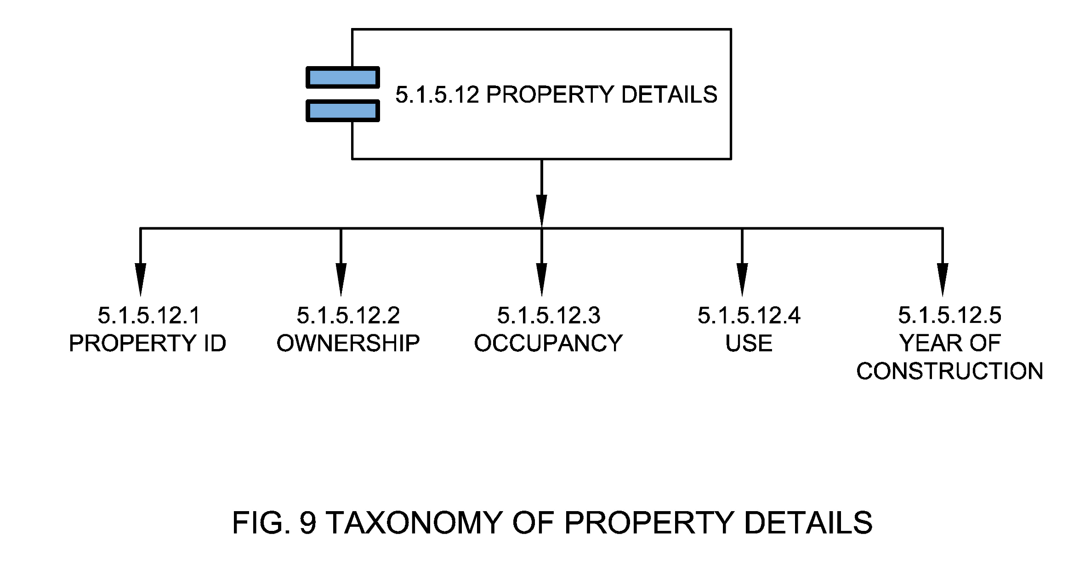

5.1.5.12.1 Property ID
A property ID (PID) or property tax identification number (PTIN) or Unique Property Identification Code (UPIC) is the unique identification number allotted to a property by the ULB for the purpose of property tax records. Typically, the PID/ PTIN is generated after the first-time enumeration of the property and its verification by the ULB officials.

5.1.5.12.2 Ownership
Property ownership is the state or fact of exclusive rights and control over immovable property. Property may be owned by individuals or organizations.

5.1.5.12.3 Occupancy
The principal occupancy for which a building or a part of a building is used or intended to be used; for the purposes of classification of a building according to occupancy, occupancy shall be deemed to include the subsidiary occupancies which are contingent upon it (National Building Code Sectional Committee, 2016).

5.1.5.12.4 Use
The purpose to which a property is being put to use is again a vital characteristic that defines the entity ‘Property’. It determines factors like the rate of property tax, trade license etc.

5.1.5.12.5 Year of Construction
Year of construction means the year in which the construction of the property mentioned in the TL application has been completed.

5.1.5.13 W&S Consumer ID
Water & Sewerage (W&S) Consumer ID is a unique connection identifier for water & sewerage connection of a trade. A TLID may be linked with W&S consumer ID to fetch relevant details from the municipal W&S registry and vice versa. This linking may also be used to identify revenue leakages.

5.1.5.14 Electricity Consumer ID
Electricity Consumer ID is a unique connection identifier for electricity connection of a trade. A TLID may be linked with electricity consumer ID to fetch relevant details from municipal electricity registry and vice versa. This linking may also be used to identify revenue leakages.

5.1.6 Trade License Zone
Trade License Zone or ‘TL Zone’ means the classification of different areas or streets into value zones for the purpose of determining the unit of measurement value of a trade license.

5.1.7 Evidence
Proof of the trade and owner details submitted during registration/ renewal of trade license. These can be,
- Address proof of the business
- ID proof of the applicant
- Aadhaar card
- PAN of the individual in case of proprietorship, else PAN of the firm of company
- Memorandum of Association (MOA) in case of companies
- Certification of incorporating in case of companies

5.1.8 Penal provisions
These are the penalties for violation or non-compliance of terms, provisions, rules, and regulations that are required to be followed by the registered entity. Some of the penalties for contravention of the provisions of the trade license are stated below:
- If an entity violates the condition of license or cause nuisance in the neighbourhood or surrounding, then the license might be cancelled or revoked;
- The entity committing a breach of the terms of the license or applicable laws shall make it liable to pay prescribed penalty;
- A fine of 50% of the license fees may be levied in case of any delay in the trade license renewal process
- An appropriate legal action can also be taken against the defaulting entity

5.1.9 Validity
Validity is the time period through which a trade license is valid.

5.1.10 License Status
This is the current status of validity of trade license. See Fig. 10.
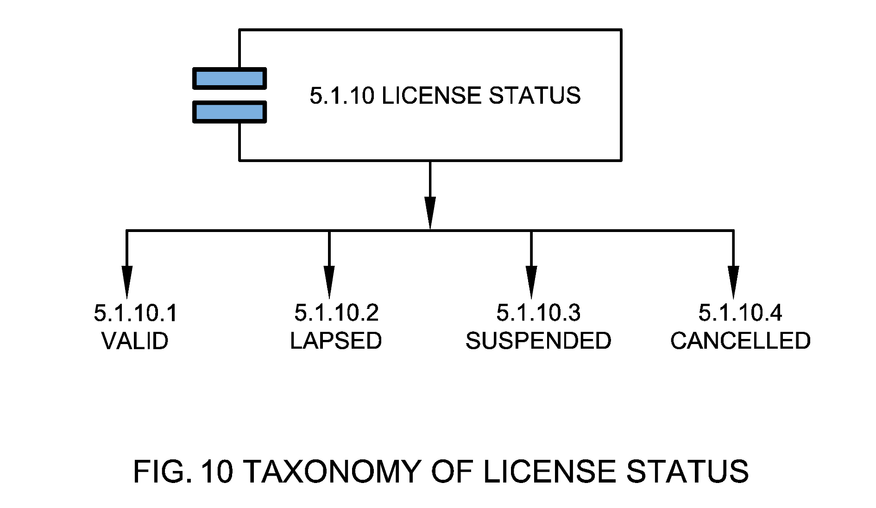

5.1.10.1 Valid
This is the status of a trade license when it's within validity.

5.1.10.2 Lapsed
This is the status of a trade license when it’s beyond validity.

5.1.10.3 Suspended
This is the status of a trade license when you lose the right to trade temporarily.

5.1.10.4 Cancelled
This is the status of a trade license when you lose the right to trade permanently cancelled.

5.1.11 Application Status
This is the current status of the trade license application. See Fig. 11.
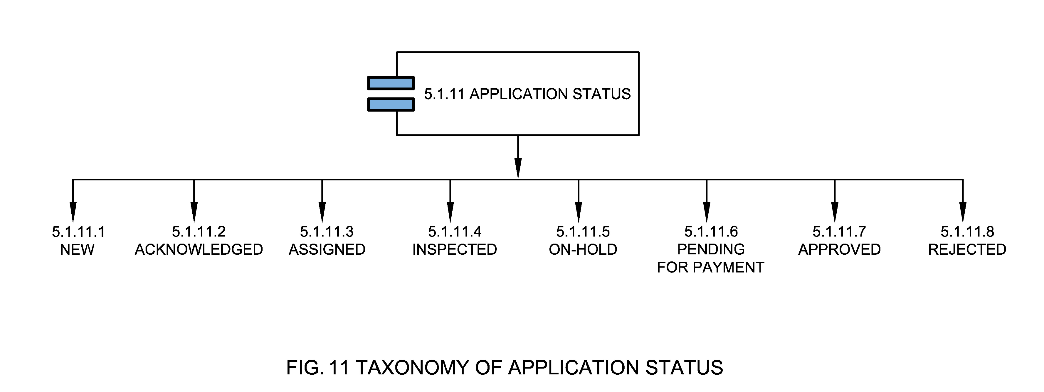

5.1.11.1 New
New application status means that a new trade license application has been filed. This may or may not be on the system.

5.1.11.2 Acknowledged
Acknowledged application status means that the trade license application has been acknowledged by the municipal department.

5.1.11.3 Assigned
Assigned application status means that the trade license application is assigned to the inspection team and the inspection is planned or in process.

5.1.11.4 Inspected
Inspected application status means that the trade license inspection is completed.

5.1.11.5 On-hold
On-hold application status means that the trade license application is put on hold for a reason.

5.1.11.6 Pending for Payment
Pending for payment application status means that the trade license application is pending for payment after successful inspection.

5.1.11.7 Approved
Approved application status means that the trade license application is approved. A TLID is generated in this case.

5.1.11.8 Rejected
Rejected application status means that the trade license application is rejected after inspection.

5.1.12 TL Request Type
TL request type is the type of application made to the ULB for a trade license. It can be for a new license, renewal of license or cancellation of existing license. See Fig. 12.
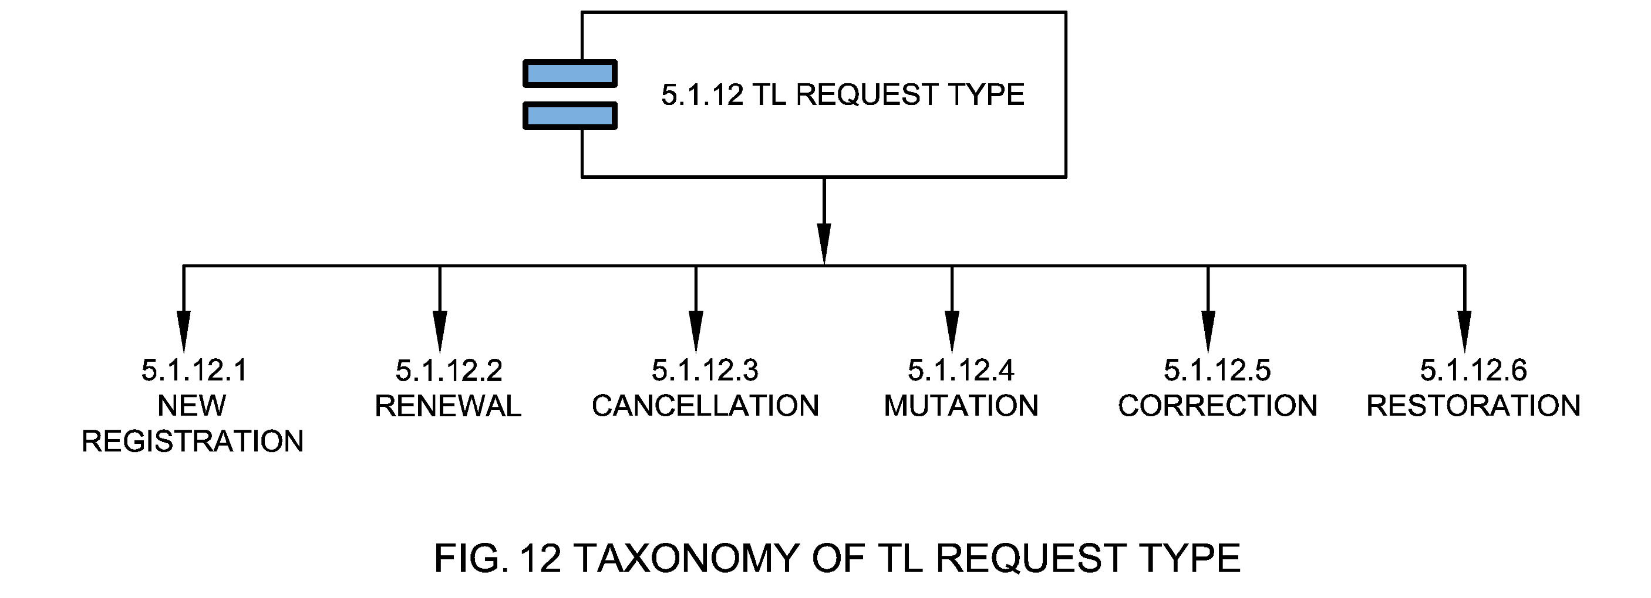

5.1.12.1 New Registration
New registration means an application for registration for a fresh trade license is to be submitted with requisite documents and registration & processing fee along with applicable license fee.

5.1.12.2 Renewal
The application type to renew the trade license for any kind of business or trade. The renewal of the license has to be done in a specific time frame as per the ULB.

5.1.12.3 Cancellation
Application type to cancel existing trade license. The ULB Officer, after receiving the application with required information, if satisfied about its correctness will remove such establishments from the register of establishments and cancel the trade license.

5.1.12.4 Mutation
Application type for transfer of title to an existing trade license.

5.1.12.5 Correction
Application type for correction of business-related information of an existing trade.

5.1.12.6 Restoration
Application type to restore a suspended trade license. The restoration of the trade license needs to be done within a specific time frame as per the applicable laws within ULB.

5.1.13 Assessment Year
Assessment year is the year for which assessment was done for a trade.

5.1.14 Billing Details
These are the details of bills generated during the process of application for a new trade license or while renewing an old license. See Fig. 13.
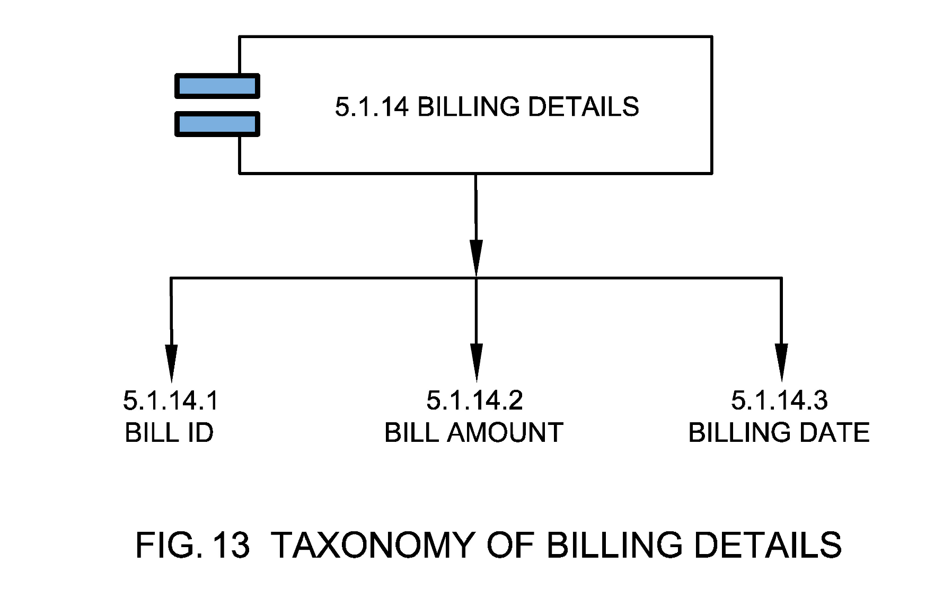

5.1.14.1 Bill ID
Bill ID is a unique identifier that identifies a license holder’s bill for accounting purposes.

5.1.14.2 Bill Amount
An amount of money paid by the applicant during the application of the trade license.

5.1.14.3 Billing Date
Billing Date is the date on which a bill is generated during the application process.

5.1.15 Payment Details
These are the details of payment made during the process of application for a new license or while renewing an old license. See Fig. 14.
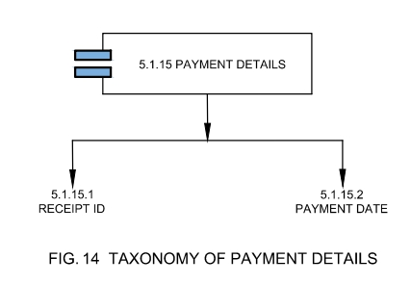

5.1.15.1 Receipt ID
Receipt ID is a unique identifier which is generated once payment is completed and payment details are captured on the accounting system.

5.1.15.2 Payment Date
The date on which the TL fees (application or license) is paid by the applicant.

5.1.16 TL SLG Factors
These are important time factors associated with a trade application that determine the service level aspect of trade license approval with respect to timeliness of service provided. This includes time when application first registered, inspection days, SLG (Service level Guarantee) and actual turnaround time. See Fig. 15.
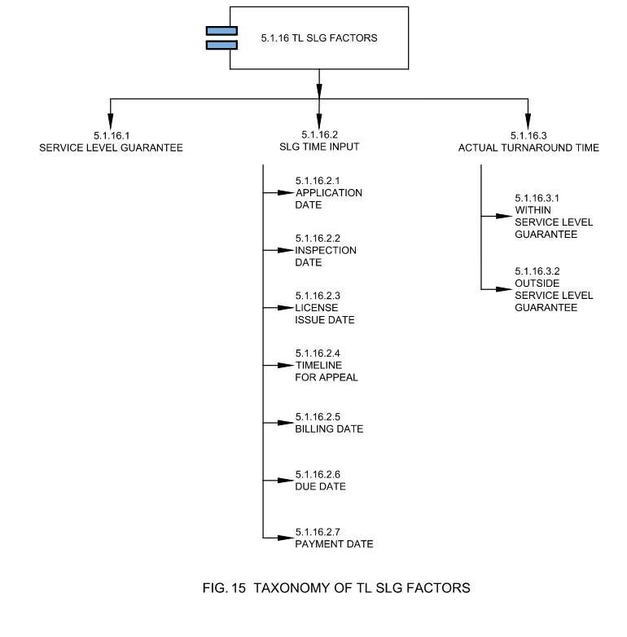

5.1.16.1 SLG (Service Level Guarantee)
The maximum time that service departments expect to take to complete the trade licensing process. Also called expected compliance time set by the ULB in citizen charter or any public disclosed document for a service in which it should be issued or managed. Public sharing of a comparative picture of various SLGs in the ULB may introduce competition to improve performance.

5.1.16.2 SLG Time Input
These are important dates that help capture service level compliances.

5.1.16.2.1 Application Date
Application date is the date on which the application is first submitted by the citizen.

5.1.16.2.2 Inspection Date
Inspection date is the date on which an inspection has been conducted by the ULB inspector.

5.1.16.2.3 License Issue Date
License issue date is the date on which License ID was issued to the trade owner by the ULB.

5.1.16.2.4 Timeline for Appeal
This is the timeline mentioned in an assessment notice within which an aggrieved person can appeal to the appellate authority.

5.1.16.2.5 Billing Date
Billing Date is the date on which a bill is generated during the application process.

5.1.16.2.6 Due Date
Due date is the date on which the bill for a particular trade is due for the current assessment duration. Upon non-payment of bill by the given due date, a surcharge may be levied on the initial demand by the imposition of a penalty.

5.1.16.2.7 Payment Date
The date on which the TL fees are paid by the applicant.

5.1.16.3 Actual Turnaround Time
Actual turnaround time is the actual time taken by the ULB in which a trade license is issued, cancelled, restored, renewed, or suspended.

5.1.16.3.1 Within SLG (Service level Guarantee)
When a trade license service is provided within the given SLG (Service level Guarantee) i.e., without exceeding the time period defined.

5.1.16.3.2 Outside SLG (Service level Guarantee)
When a trade license service is provided beyond the SLG (Service Level Guarantee) i.e., exceeding the time period defined.

5.1.17 ULB Type

Type of the Urban Local Body as per the definition of MoHUA such as Nagar Panchayat, Municipal Council or Municipal Corporation (Ministry of Housing and Urban Affairs, 2014).

5.2 Trade License Channel
Channel / Mode / Method through which trade license application is being registered by the citizen or information and response is shared by the ULBs. See Fig. 16.
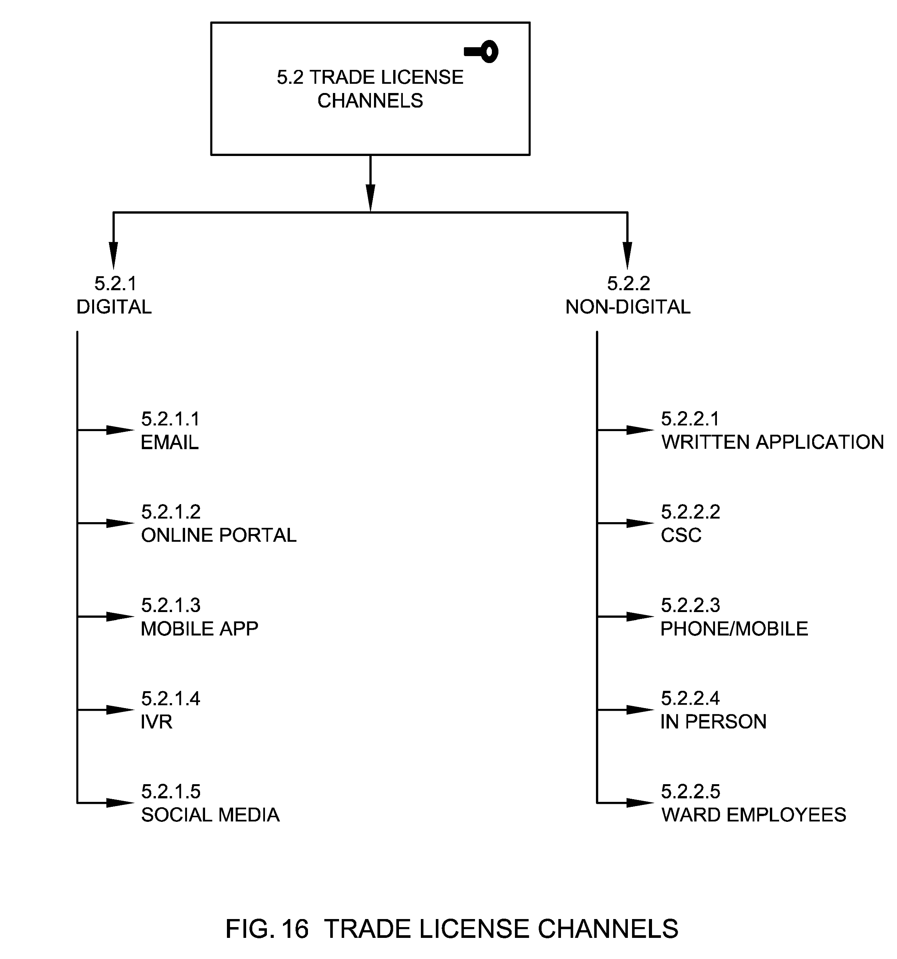
Figure SEQ Figure \* ARABIC 16 Trade License Channels

5.2.1 Digital
Digital means an electronic way to collect, store, process and transmit data in the desired form. In the context of trade license, this refers to processes and corresponding data used by the authority and the individual for trade licensing which is requested or generated in digital form for the purpose of recording, allocation, assessment, follow up, and appeal.

5.2.1.1 Email
Electronic media for transfer of messages and information through the internet.

5.2.1.2 Online Portal
Web portals or web applications refers to the websites developed for trade license management. This broadly includes an assessment calculator, trade data, owner’s information and facility to pay the license fees through payment gateways linked to the portals. These portals also include the websites developed by the National, State or ULB for e-governance service delivery.

5.2.1.3 Mobile App
A mobile application, also referred to as a mobile app or simply an app, is a computer program or software application designed to run on a mobile device such as a phone, tablet, or watch.

5.2.1.4 IVR
Interactive Voice Response (IVR) is a technology that allows humans to interact with a computer-operated phone system through the use of voice and DTMF tones input via a keypad. The call center operator will listen to the IVR recorded TL and register the same in the system. The call centre operator may contact the citizen in case information provided is insufficient or any clarification required.

5.2.1.5 Social Media
Social media are interactive technologies that allow the creation or sharing/exchange of information, ideas, interests, and other forms of expression via virtual communities and networks such as Twitter, WhatsApp and Facebook etc.

5.2.2 Non-Digital
These are other means (non-digital) by which a request for a trade license is captured.

5.2.2.1 Written Application
A written application refers to a channel for trade license which includes an application in a prescribed Form/Format, addressed to Municipal Commissioner requesting for new or renewal of trade license.

5.2.2.2 CSC
Common Service centers are the access points for delivery of various services using Information and Communication Technology (ICT). CSCs were created under the National E-government Project by the Government of India.

5.2.2.3 Phone/Mobile
Mobile telephone, also called mobile, is a portable device for connecting to a telecommunications network in order to transmit and receive voice, video, or other data.

5.2.2.4 In Person
A person/s can walk in to the municipal office/ ward office to submit their trade license application.

5.2.2.5 Ward Employees
Ward employees are the employees of Municipal Council or Municipal Authority, concerned with administrative wards of the city. In terms of trade license an application can be submitted through the respective ward employees during their visits where the trade is established.

5.3 Trade License Stakeholders
Trade license stakeholders are the stakeholders involved in planning, implementation and maintenance of trade licensing functions. Participation by all relevant stakeholders ensures sharing a common understanding and involvement in the decision-making process as well as accountability in urban governance. Participation by all stakeholders leads to empowerment and to joint ownership and harmonized access to information connecting multiple urban departments to serve citizens better. See Fig. 17.
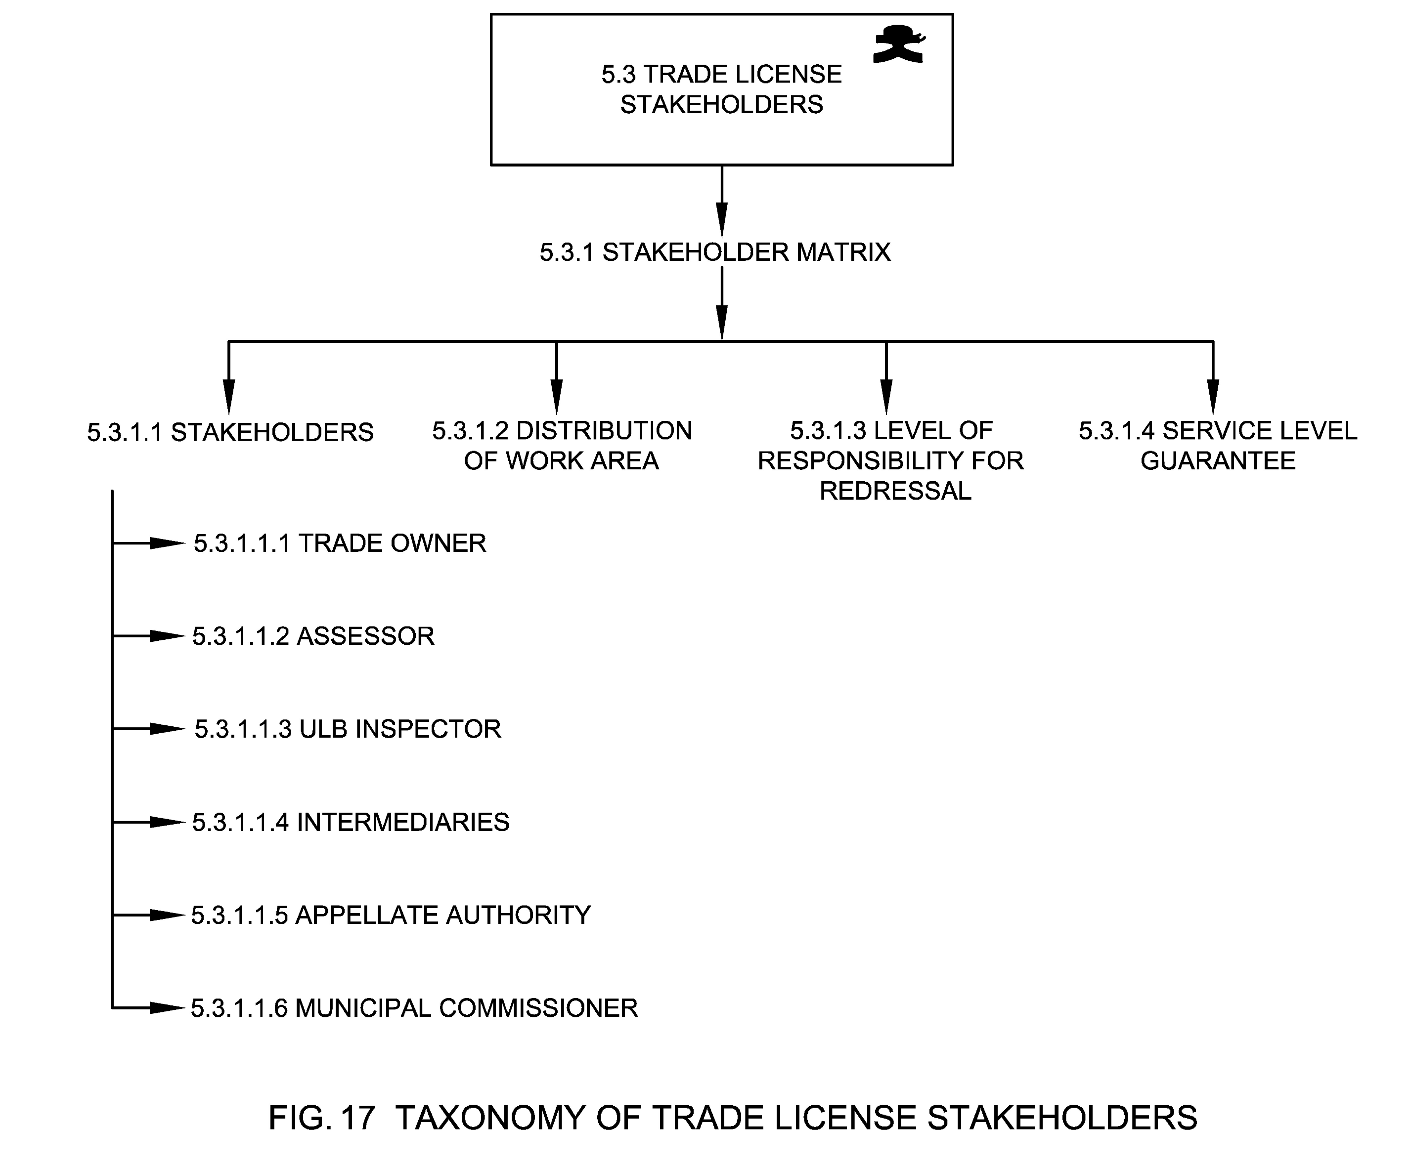

5.3.1 Stakeholder Matrix
Stakeholder matrix captures distribution of work area, level of responsibility and Service Level Guarantee of various stakeholders within the ULB and/ or contracted organizations based on ward / locality/jurisdiction, service / issue category.

5.3.1.1 Stakeholders
This refers to the types of stakeholders who are involved in a TL system such as the trade owners, assessor, inspectors, appellate authority and Municipal Commissioner.

5.3.1.1.1 Trade Owner
Trade owner in relation to a TL means any person or group who acquires that trade license for the purposes of running the trade.

5.3.1.1.2 Assessor
An assessor is a ULB official who determines the value of a TL for revenue purposes. The figures assessors derive are used to calculate future TL fees. The assessor estimates the value of Trade within a city or town’s boundaries. This value (assessed value) is converted into an assessment, which is one component in the computation of TL bills.

5.3.1.1.3 ULB Inspector
A ULB Inspector is a person who has been appointed by a government department or agency to perform TL compliance and enforcement duties.

5.3.1.1.4 Intermediaries
Intermediary is the individual, group of persons (Volunteers) or organizations (NGOs, Trusts etc.) who initiated the TL request or application on the behalf of the originator who lacks the capacity to use any channels which are provided by the ULB. These Intermediaries should be registered with the ULBs in order to provide their services to the originator (who is either from marginalized section, illiterate or differently abled) and should not charge extra money from the originator.
The application submitted by the intermediaries for the originator who is capable of filling their own request will not be considered by the ULBs.

5.3.1.1.5 Appellate Authority
Appellate Authority is the authority or representative of the authority assigned to review the procedures and decisions or assessment of TL to make sure that the proceedings were fair and that the proper law/regulation are applied appropriately.

5.3.1.1.6 Municipal Commissioner
Commissioner of the ULB or municipal body means an officer appointed by the Government, and includes an Additional Director, a Joint Director, Deputy Director, or any other officer of the Government authorized by it to perform the functions of the Commissioner and Director of Municipal Administration.

5.3.1.2 Distribution of Work Area
This refers to the ward and/or sectors within ULB for which each of the stakeholders are responsible for.

5.3.1.3 Level of Responsibility for Redressal
In order to ensure that applications are resolved within the prescribed time norm, escalation levels of responsibility for redressal are mapped.

5.3.1.4 Service Level Guarantee
See Clause 5.1.16.1

5.4 Trade License Processes
TL Processes are a series of actions or steps taken in order to achieve a timely delivery of trade licenses by the ULBs such as trade license application creation, assessment, suspension, restoration, cancellation, appellate, billing, approval & certification. See Fig. 18.
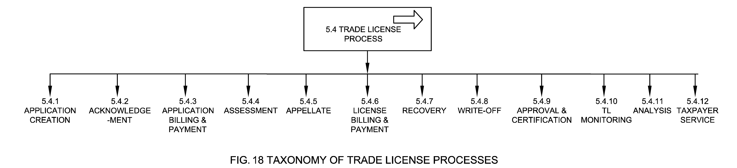

5.4.1 Application Creation
A process by which an application is created for a trade license at the municipal authority such as new trade license, renewal of trade license, or transfer of trade license. Application status in this case is new. See Fig. 19.
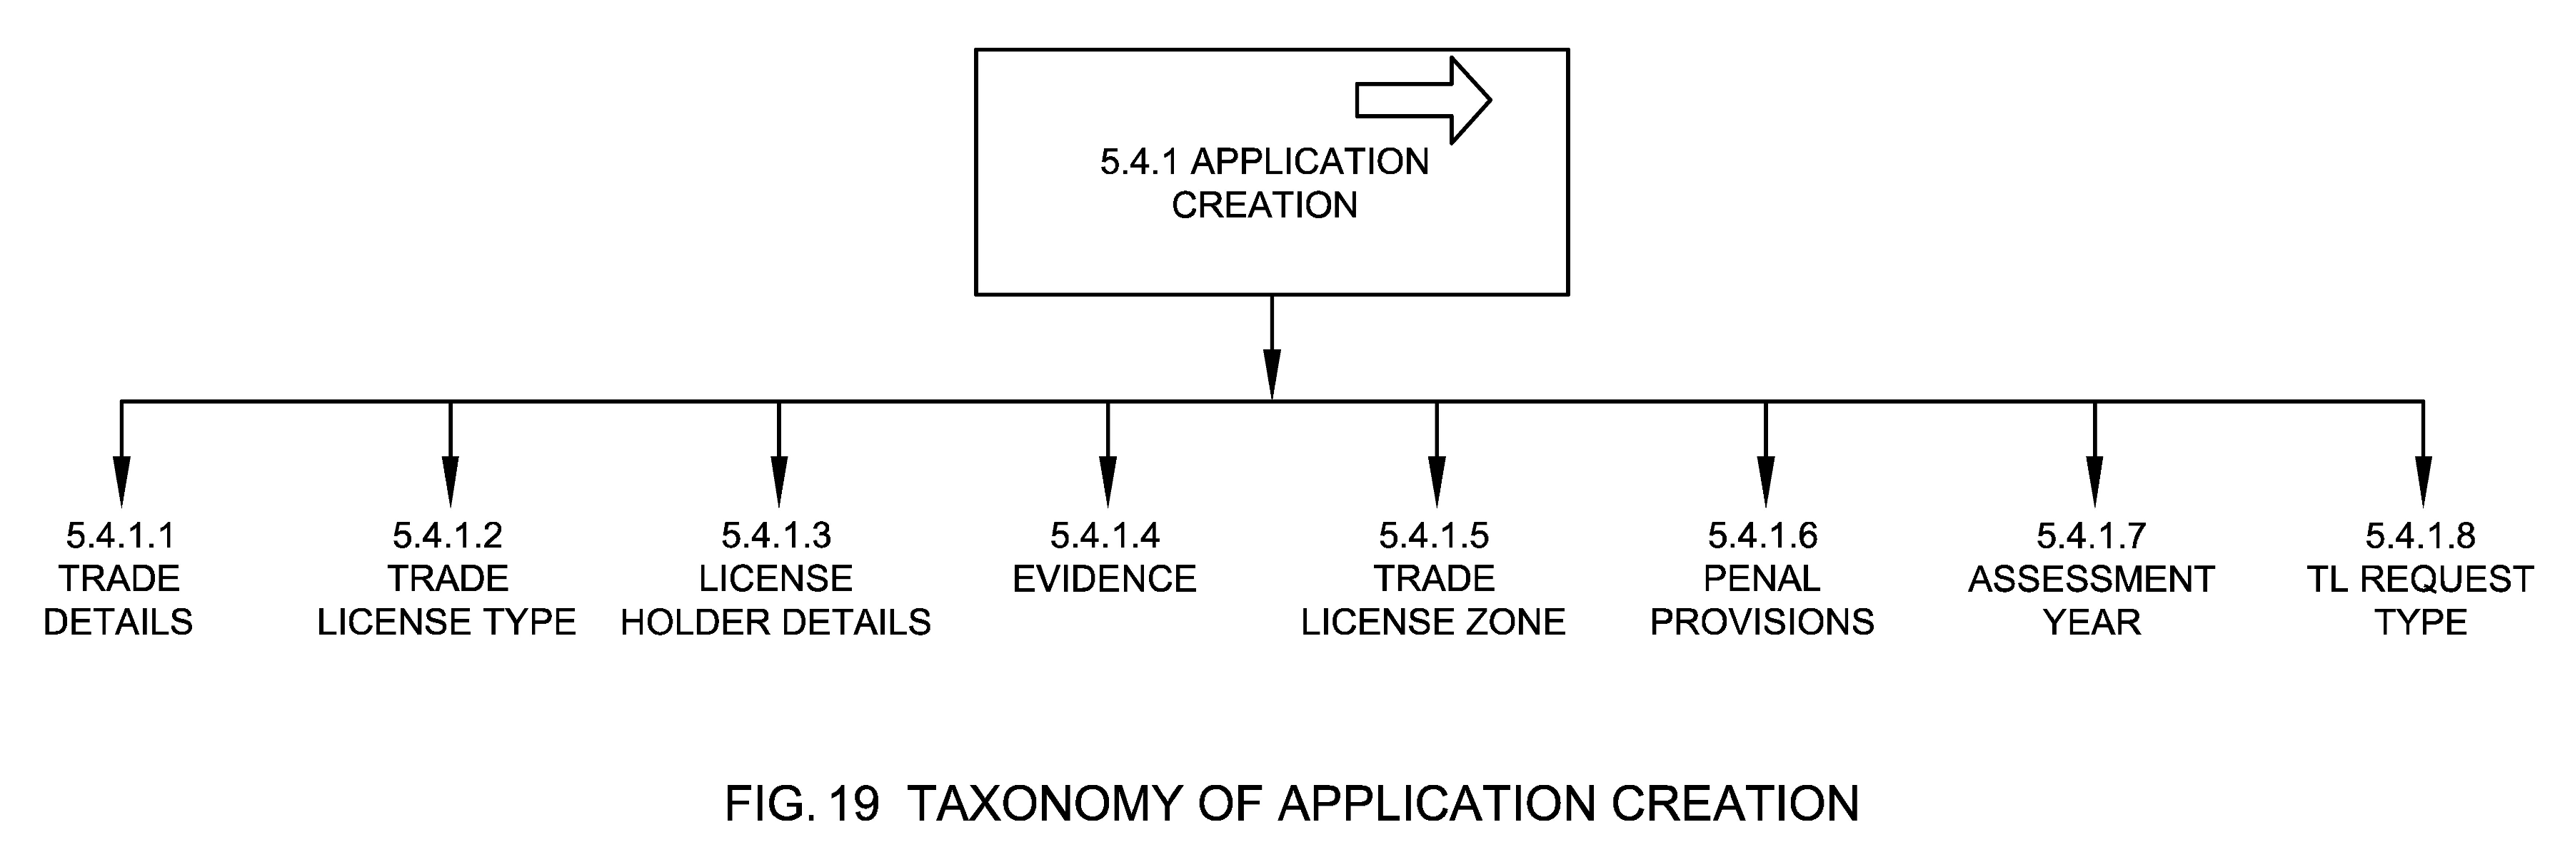

5.4.1.1 Trade Details
See Clause 5.1.5

5.4.1.2 Trade License Type
See Clause 5.1.4

5.4.1.3 License Holder Details
See Clause 5.1.3

5.4.1.4 Evidence
See Clause 5.1.7

5.4.1.5 Trade License Zone
See Clause 5.1.6

5.4.1.6 Penal provisions
See Clause 5.1.8

5.4.1.7 Assessment Year
See Clause 5.1.13

5.4.1.8 TL Request type
See Clause 5.1.12

5.4.2 Acknowledgement
Acknowledgement is the process by which a new TL application is acknowledged in the system. This process is combined with application creation if the application is directly captured on the TL system. An application ID may be generated in this case. TL acknowledgement may be automatic or manual (if the application is received through a non-digital channel). Application status post acknowledgment is changed to acknowledged. See Fig. 20.
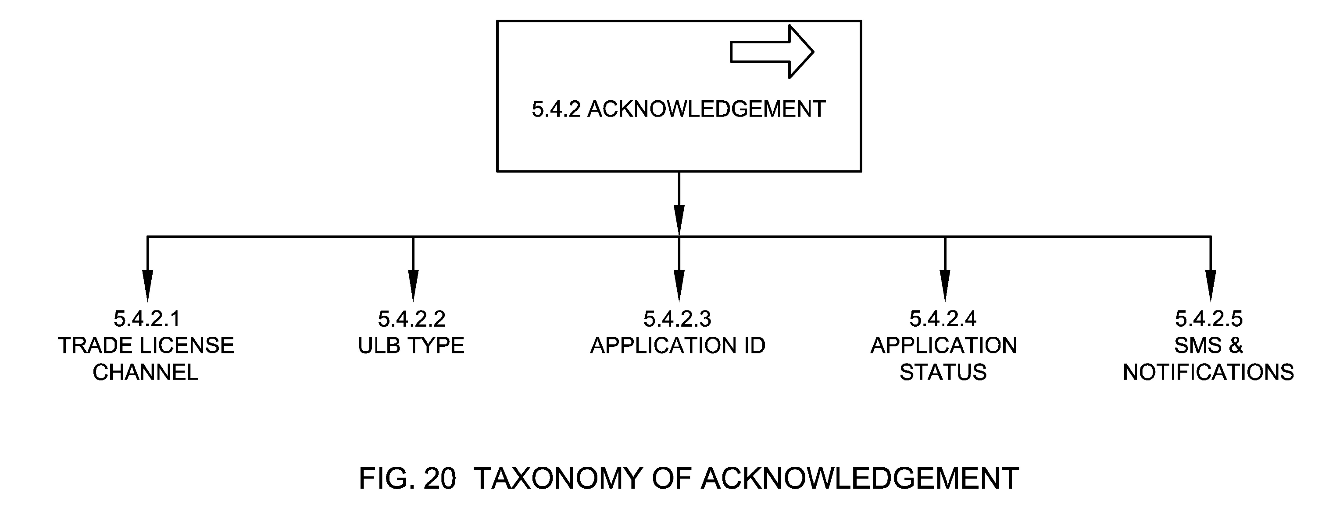

5.4.2.1 Trade License Channel
See Clause 5.2

5.4.2.2 ULB Type
See Clause 5.1.17

5.4.2.3 Application ID
See Clause 5.1.2

5.4.2.4 Application Status
See Clause 5.1.11

5.4.2.5 SMS & Notifications
These are the notifications sent to citizens informing them about the trade license application being registered on the system.

5.4.3 Application Billing & Payment
Application Billing & Payment is the process of generating bill (demand) against a new application by the ULB and subsequent payment of the same by the trade owner. See Fig. 21.
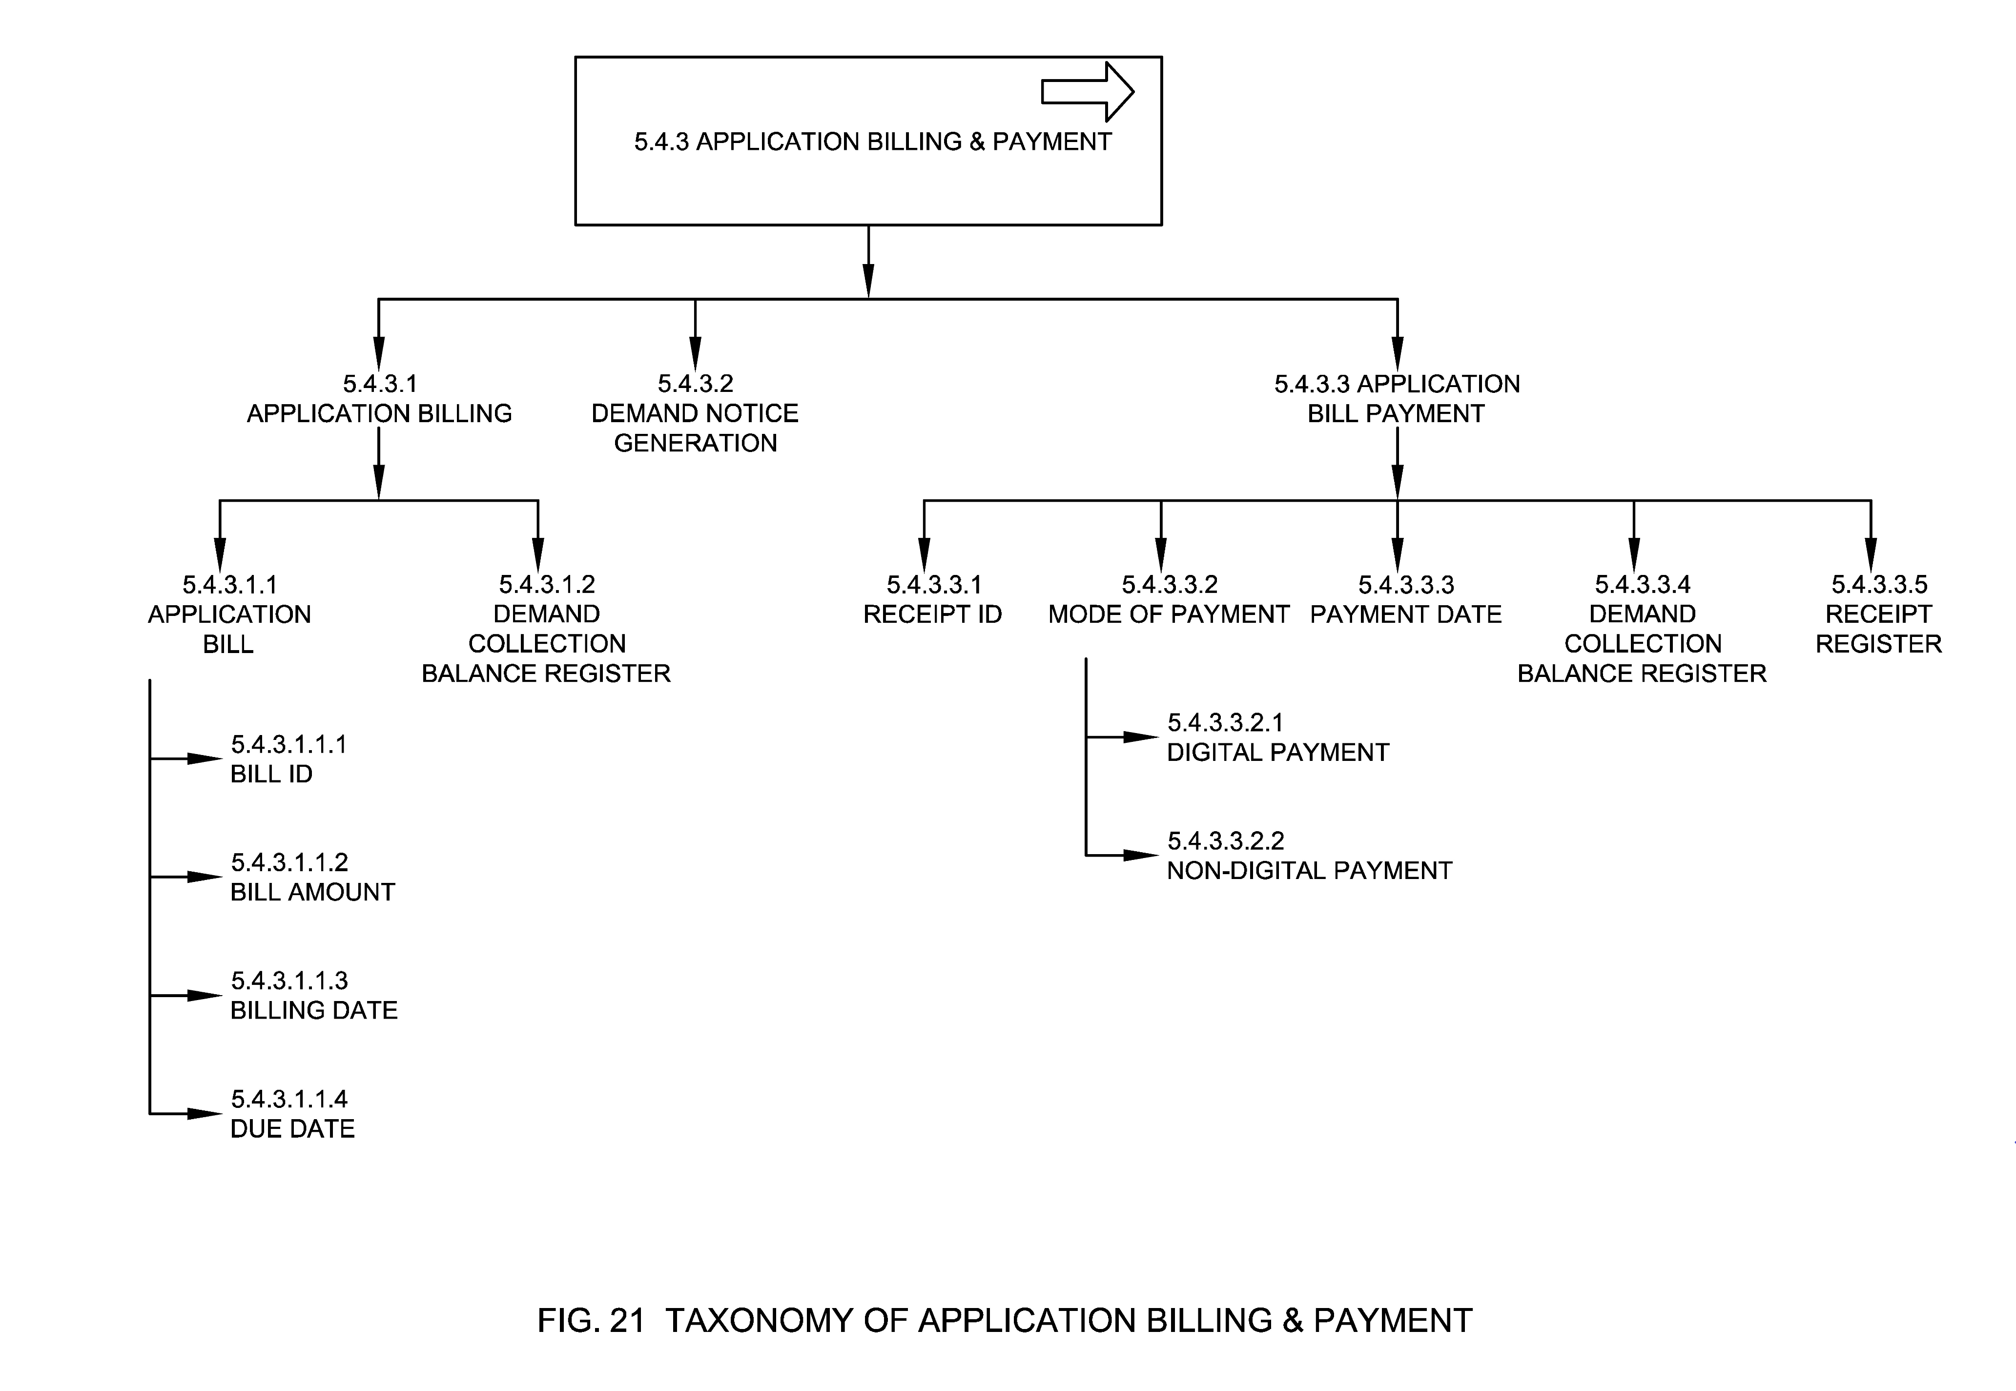

5.4.3.1 Application Billing
The process by which an application bill is generated during the process of a new application.

5.4.3.1.1 Application Bill
It is the initial bill generated for the application/inspection fee for the applied TL. Inspection bill consists of application processing fee and inspection fee amount.

5.4.3.1.1.1 Bill ID
See Clause 5.1.14.1

5.4.3.1.1.2 Bill Amount
See Clause 5.1.14.2
The inspection fee and application processing fee are included in the overall fee calculation. ULB may ask for inspection fees to be based on the number of times inspection is done.

5.4.3.1.1.3 Billing Date
See Clause 5.1.14.3

5.4.3.1.1.4 Due Date
See Clause 5.1.16.2.6

5.4.3.1.2 Demand Collection Balance Register
See Clause 5.5.1.4

5.4.3.2 Demand Notice Generation
This is the process in which bill (demand) is generated and served to the trade owner.

5.4.3.3 Application Bill Payment
Payment is the voluntary tender of money or its equivalent or of things of value by trade owner against the bill generated.

5.4.3.3.1 Receipt ID
See Clause 5.1.15.1

5.4.3.3.2 Mode of Payment
It means mode of payment of bill amount by the trade owner.

5.4.3.3.2.1 Digital Payment
A digital payment occurs when the payment for processing the application and trade fees could be done via digital and electronic medium, such as using debit card, credit card, payment gateway etc.

5.4.3.3.2.2 Non-Digital Payment
Non-digital payment refers to the mode of payment of money in physical form like cash, demand draft, cheque etc.

5.4.3.3.3 Payment Date
See Clause 5.1.15.2

5.4.3.3.4 Demand Collection Balance Register
See Clause 5.5.1.4

5.4.3.3.5 Receipt Register
See Clause 5.5.1.5

5.4.4 Assessment
The process by which the documents are scrutinized by the license department with the support of other related departments. For e.g. If the application was made for the trade of food related business the application and the supporting documents were verified and assessed by the license department, food department and health department. The assessment is conducted online or offline by the nodal officer assigned based on the location/area or department/ domain handling the trade description of the application. Application status in this case is assigned. See Fig. 22.
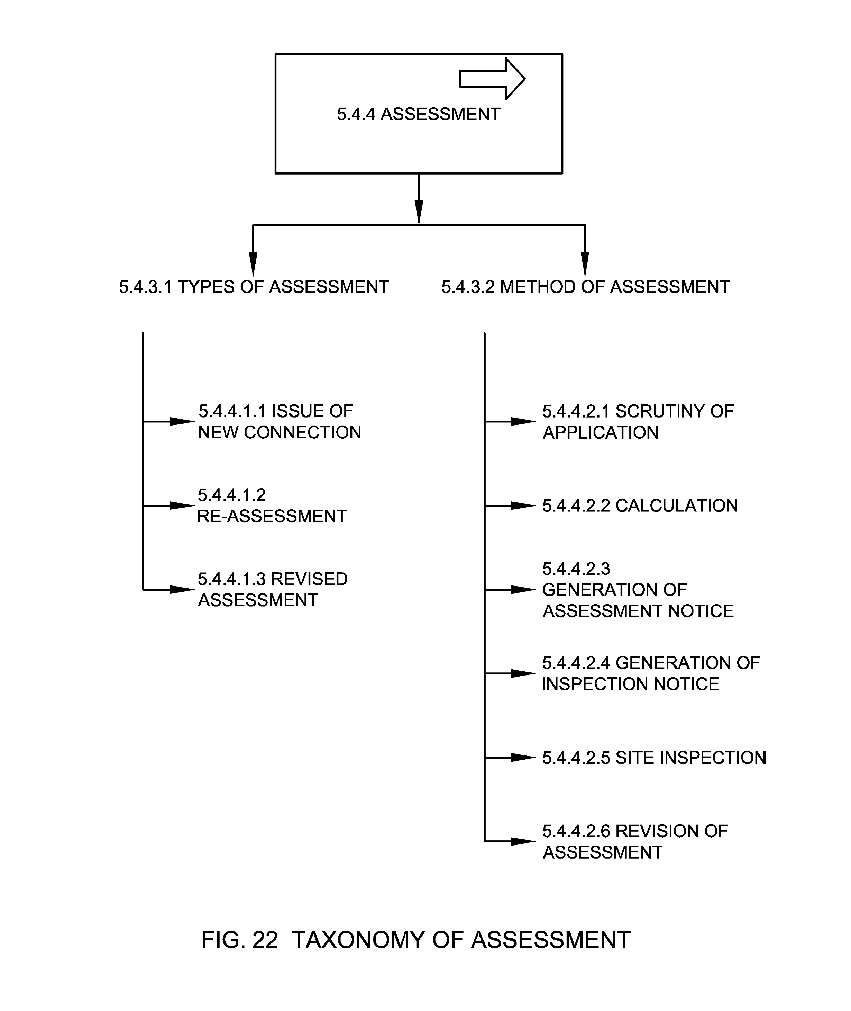

5.4.4.1 Types of Assessment
Types of assessment is the classification of assessment processes for trade license service. See Fig.23.
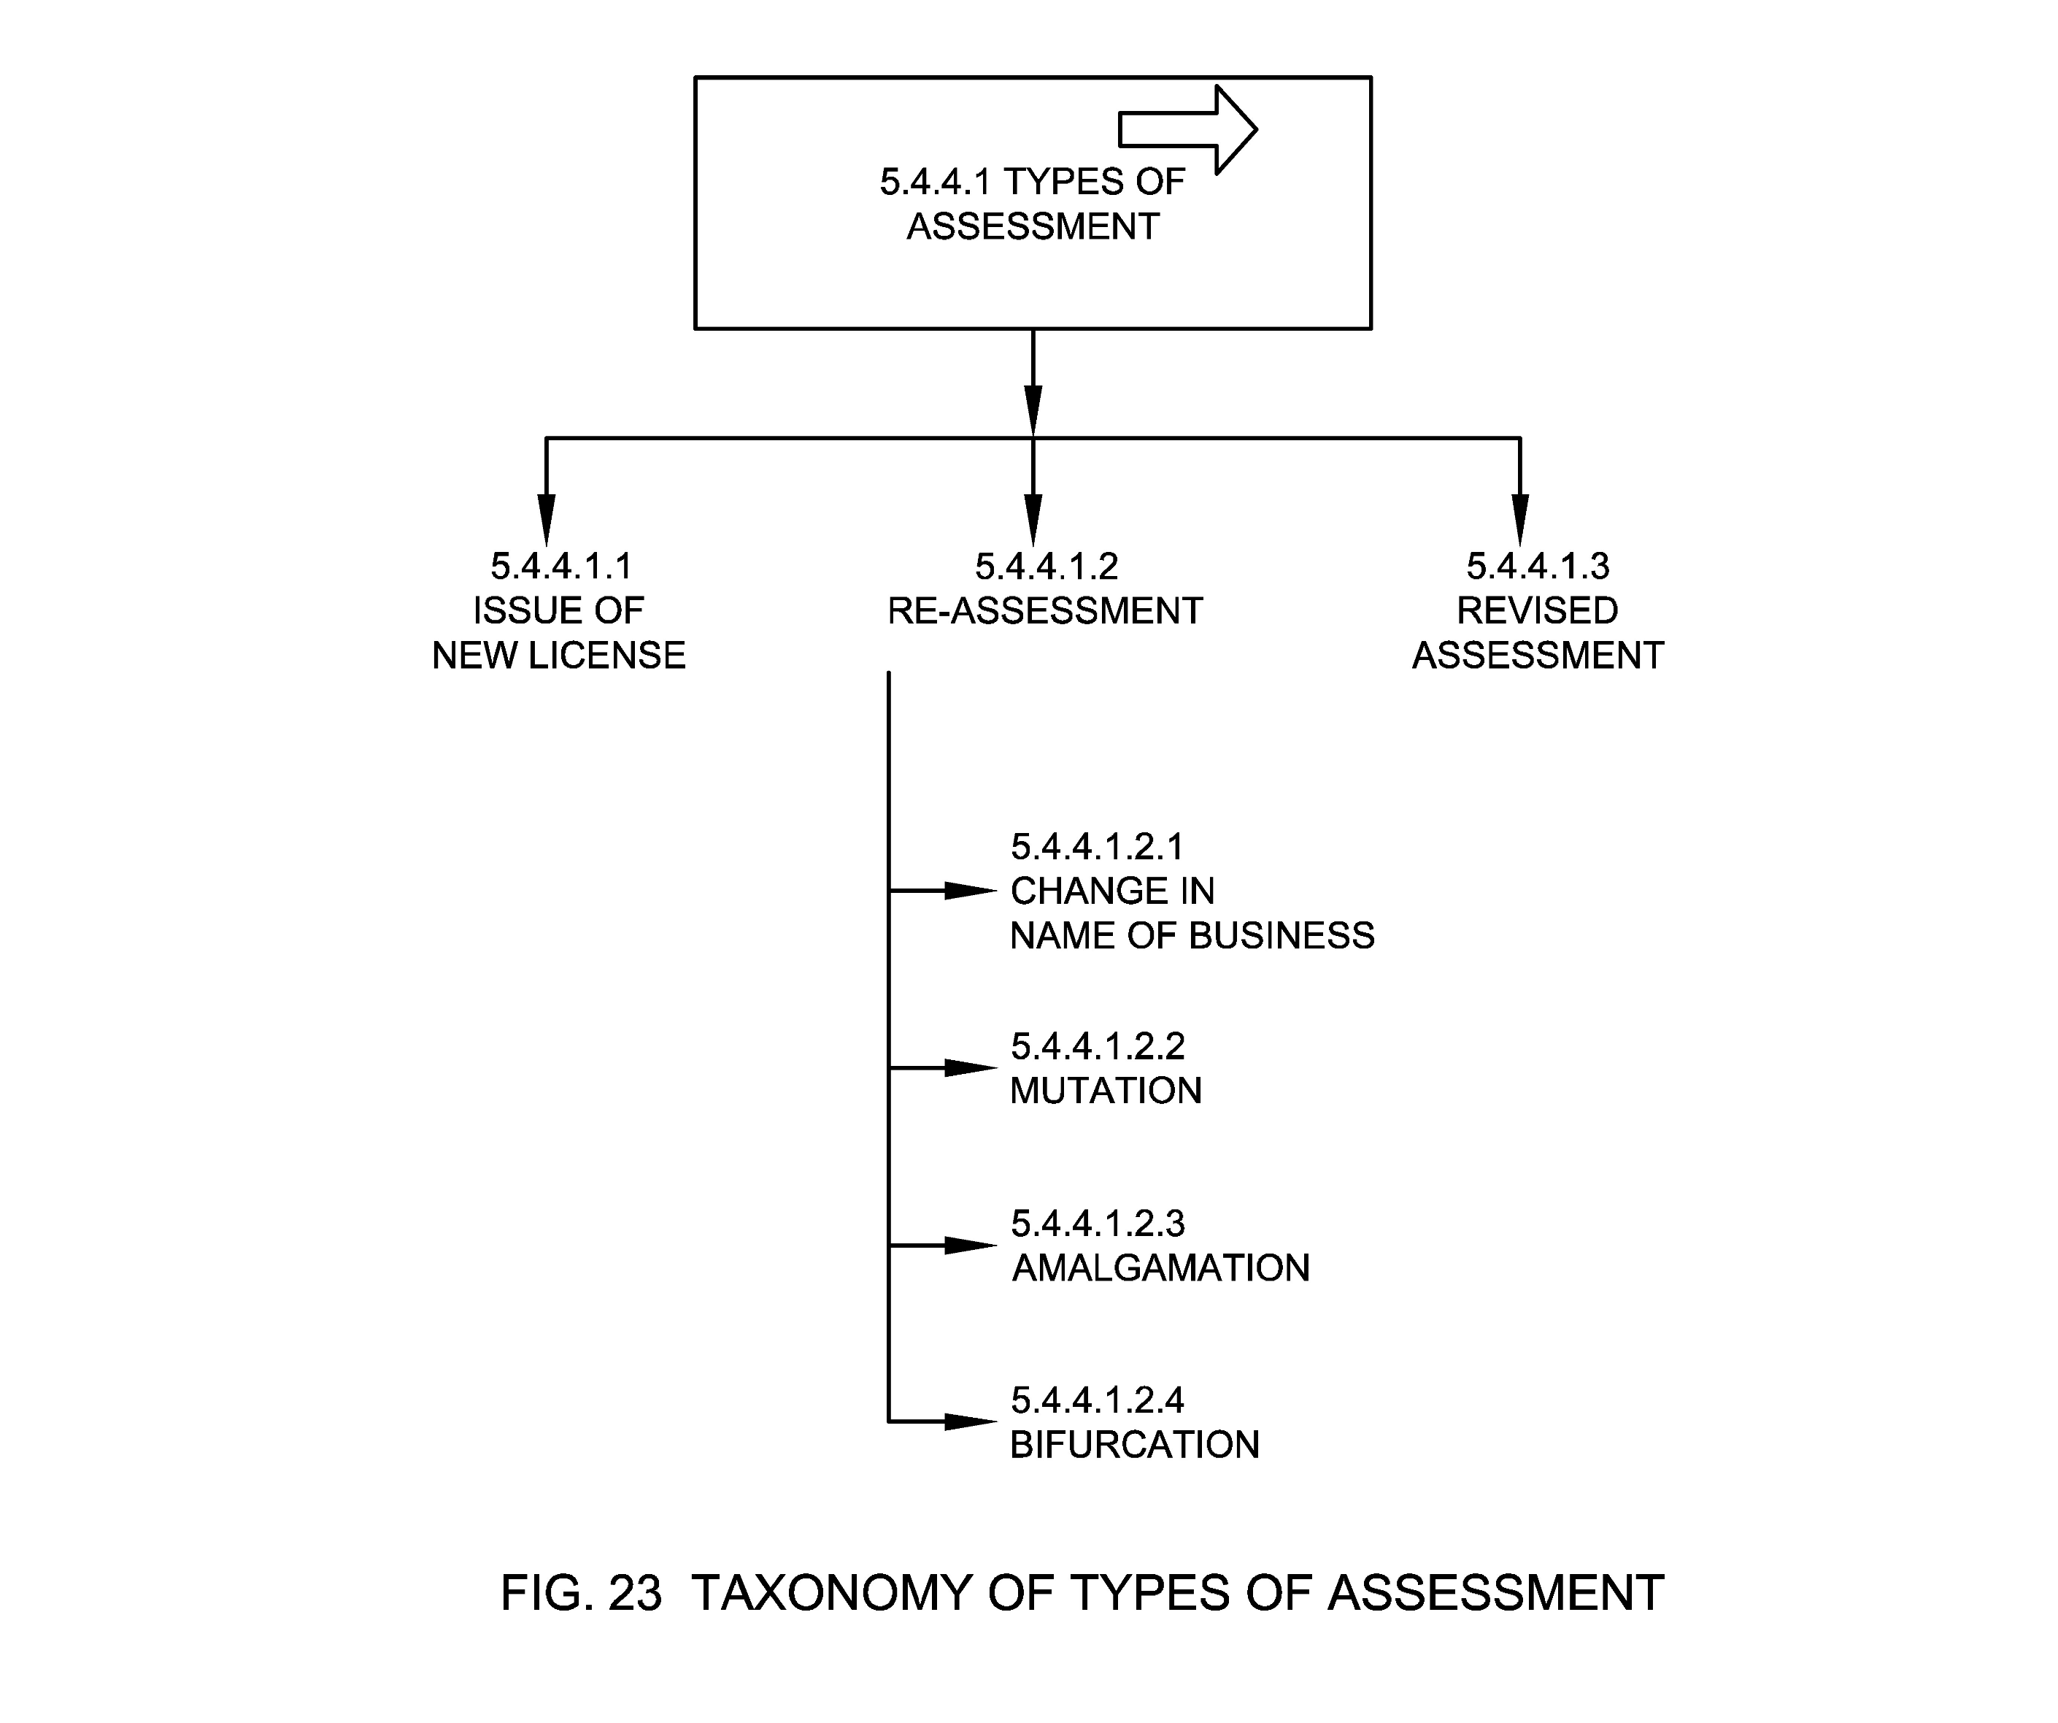

5.4.4.1.1 Issue of New License
Assessment process undertaken while issuing a license for the first time.

5.4.4.1.2 Re-Assessment
Assessment process undertaken to determine new fee based on the change in the usage of an existing trade or change in the trade details.

5.4.4.1.2.1 Change in Name of Business
Assessment process undertaken during change in name of business.

5.4.4.1.2.2 Mutation
Assessment process undertaken during transfer of trade license from one owner to another owner.

5.4.4.1.2.3 Amalgamation
Assessment process undertaken when two or more trades are merged into a single trade with a Single or Joint owner.

5.4.4.1.2.4 Bifurcation
Assessment process undertaken when a trade is bifurcated into two or more trades.

5.4.4.1.3 Revised Assessment
Assessment process undertaken during changing the assessed value for a trade based on the periodic increase in rates (based on Local acts) or based on noticed changes in the TL factors. Revised assessment may also take place after appellate decision to change the license fees amount.

5.4.4.2 Method of Assessment
This means different methods undertaken to assess the trade license application based on trade factors. See Fig. 24.
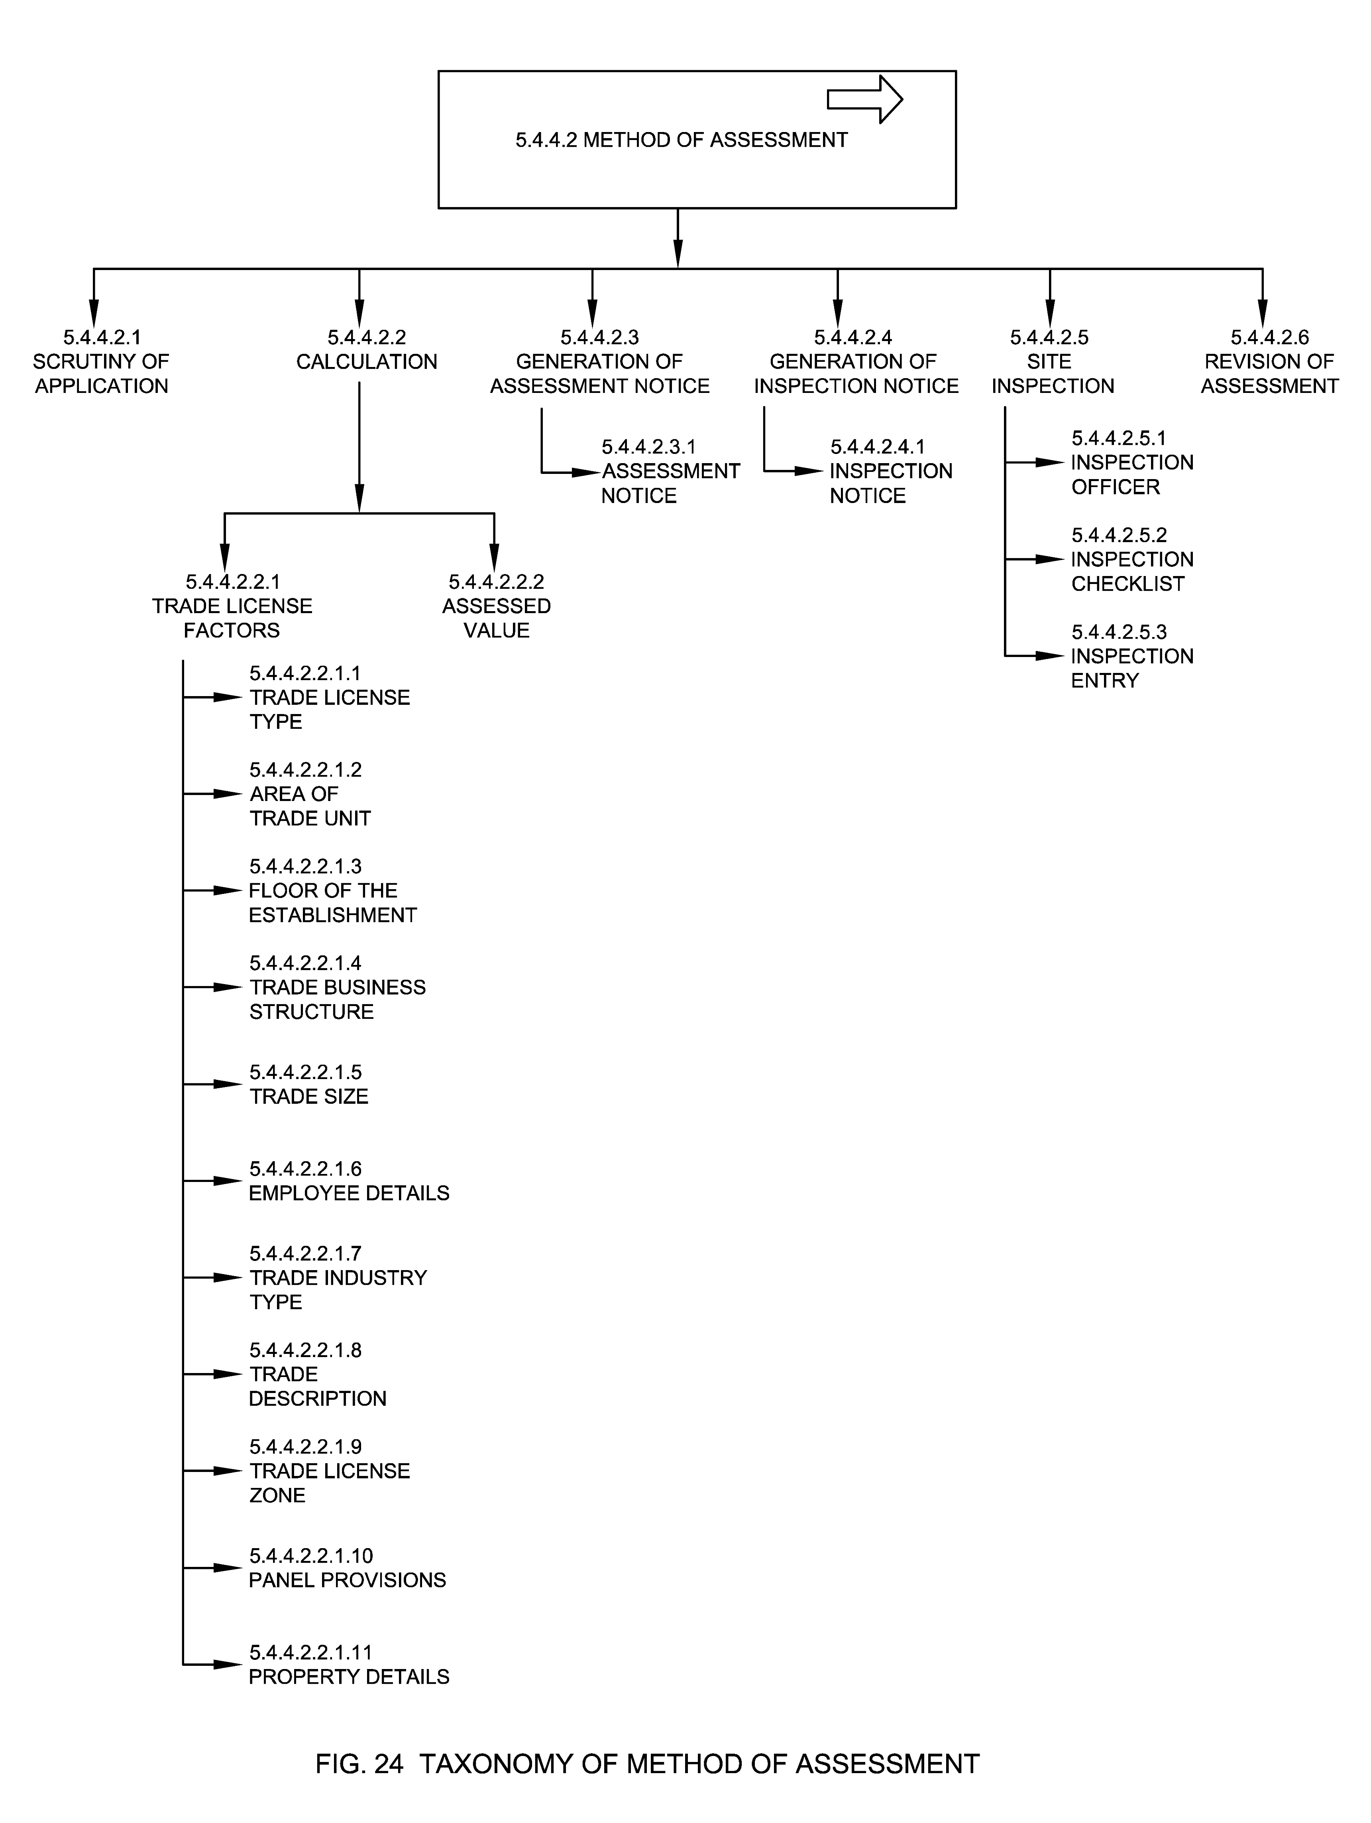

5.4.4.2.1 Scrutiny of Application
It is the assessment conducted on the application as soon as it is been applied by the citizen and the scrutiny is conducted by the assessing officer. During the initial assessment scrutiny of documents may be done by the ULB officials and appropriate inspection fees, license fees and inspection notice are generated.

5.4.4.2.2 Calculation
Calculation is the process of calculating the fees for applied TL based on the specified criteria as mention in their Municipal Act or as decided by the Municipal Commissioner for varied trades. TL calculation process comprises the use of any one or combination of methods using various attributes of trade such as license type, trade details, trade categorization, type of constitution of trade, trade year, penal provisions, type of location and any other related amount to calculate trade license bill amount.

5.4.4.2.2.1 Trade License Factors
These are the factors associated with a trade and used in various trade license processes like assessment, calculation of tax and billing. State DMAs/ ULBs may consider all or some of these factors or use their own factors.

5.4.4.2.2.1.1 Trade License Type
See Clause 5.1.4

5.4.4.2.2.1.2 Area of Trade Unit
See Clause 5.1.5.3

5.4.4.2.2.1.3 Floor of the Establishment
See Clause 5.1.5.4

5.4.4.2.2.1.4 Trade Business Structure
See Clause 5.1.5.5

5.4.4.2.2.1.5 Trade Size
See Clause 5.1.5.7

5.4.4.2.2.1.6 Employee Details
See Clause 5.1.5.8

5.4.4.2.2.1.7 Trade Industry Type
See Clause 5.1.5.9

5.4.4.2.2.1.8 Trade Description
See Clause 5.1.5.10

5.4.4.2.2.1.9 Trade License Zone
See Clause 5.1.6

5.4.4.2.2.1.10 Penal Provisions
See Clause 5.1.8

5.4.4.2.2.1.11 Property Details
See Clause 5.1.5.12

5.4.4.2.2.2 Assessed Value
TL License fee is assessed for its monetary worth. This ascertained price is known as assessed value. Assessed value is converted to license fee (demand) once inspection is completed and TL factors are verified.

5.4.4.2.3 Generation of Assessment Notice
This is the process in which assessment notice is generated and shared with the trade owner.

5.4.4.2.3.1 Assessment Notice
Assessment notice is the notice served to the trade owner indicating the assessed value of a trade license assessed on the basis of the trade details. This notice is not considered as the final bill. The assessment notice is the interim notice to confirm the fee of the license.

5.4.4.2.4 Generation of Inspection Notice
This is the process in which inspection notice is generated and shared with the trade owner.

5.4.4.2.4.1 Inspection Notice
Inspection notice is the notice served to the trade owner notifying them about the planned time of inspection-by-inspection officer.

5.4.4.2.5 Site Inspection
It is the ground inspection conducted post scrutiny of application, an ULB Inspector is assigned to verify the application details viz-a-viz trade property with respect to conformance to inspection checklist.

5.4.4.2.5.1 Inspection Officer
Inspection officer is the ULB official assigned to inspect trade property.

5.4.4.2.5.2 Inspection Checklist
Inspection checklist is used by ULB inspectors to check conformance to relevant rules, safety measures and guidelines workforce, labor, any illegal activity, etc.

5.4.4.2.5.3 Inspection Entry
It means reporting the details of inspection post ground inspection by the inspector such as inspection time, details, notes etc. Application status in this case is inspected or rejected.

5.4.4.2.6 Revision of Assessment
Revised assessment notice is the notice served to the trade owner indicating the revised assessed value of trade license assessed on the basis of the actual ground inspection. Thereafter a revised assessment notice is shared with the trade owner.

5.4.5 Appellate
Appellate is the process followed after the assessment is presented and the trade owner is aggrieved by the fixation or the charging of the trade license fees. The appeal process kicks off with a simple appeal letter or through a trade license system. See Fig. 25.
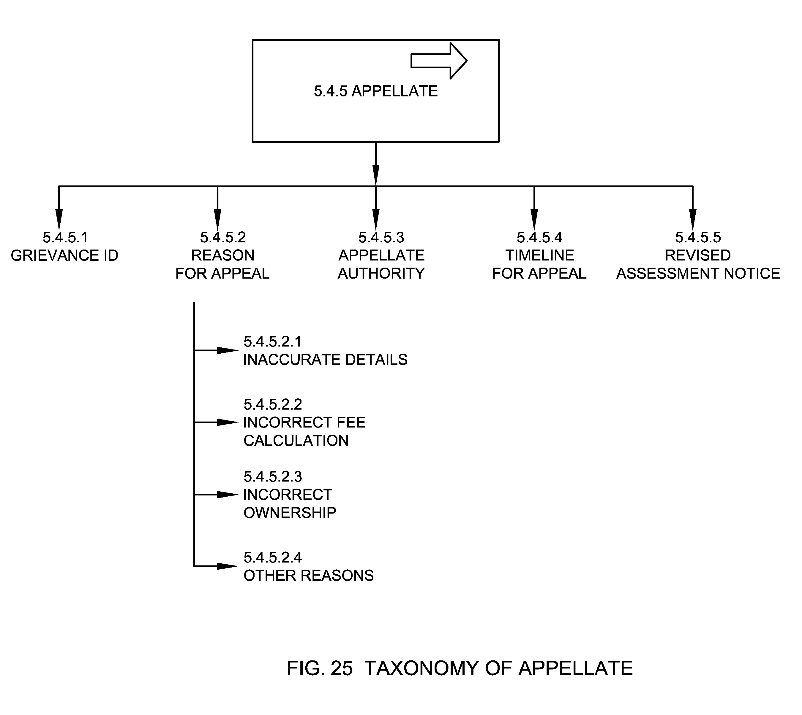

5.4.5.1 Grievance ID
Grievance ID is a unique identifier allotted to the grievance by the ULB for the purpose of grievance recording, allocation, assessment, follow up, and appeal.

5.4.5.2 Reason for Appeal
Reason for appeal is the reasons as captured in assessment notice or bill because of which an aggrieved person appeals to the appellate authority for necessary redressal.

5.4.5.2.1 Inaccurate Details
This means the aggrieved person has appealed given the reason for inaccurate details such as incorrect name, owner name, business name, type of trade etc. in an assessment notice.

5.4.5.2.2 Incorrect Fee Calculation
This means the aggrieved person has appealed given the reason for incorrect fee calculation in an assessment notice.

5.4.5.2.3 Incorrect Ownership
This means the aggrieved person has appealed given the reason for incorrect ownership in an assessment notice.

5.4.5.2.4 Other Reasons
This means the aggrieved person has appealed given any other reason as per the assessment notice.

5.4.5.3 Appellate Authority
Appellate Authority is the authority or representative of the authority assigned to review the procedures, decisions and/or assessment of trade license to make sure that the proceedings were fair and law/ regulation are applied appropriately.

5.4.5.4 Timeline for Appeal
See Clause 5.1.16.2.4

5.4.5.5 Revised Assessment Notice
Revised assessment notice is the notice served to the trade owner indicating the revised assessed value of trade license assessed on the basis of the revised assessment done after appeal completion.

5.4.6 License Billing & Payment
License Billing & Payment is the process of generating bill (demand) against the calculated and approved license fee by the ULB and subsequent payment of the same by the trade owner. See Fig. 26.
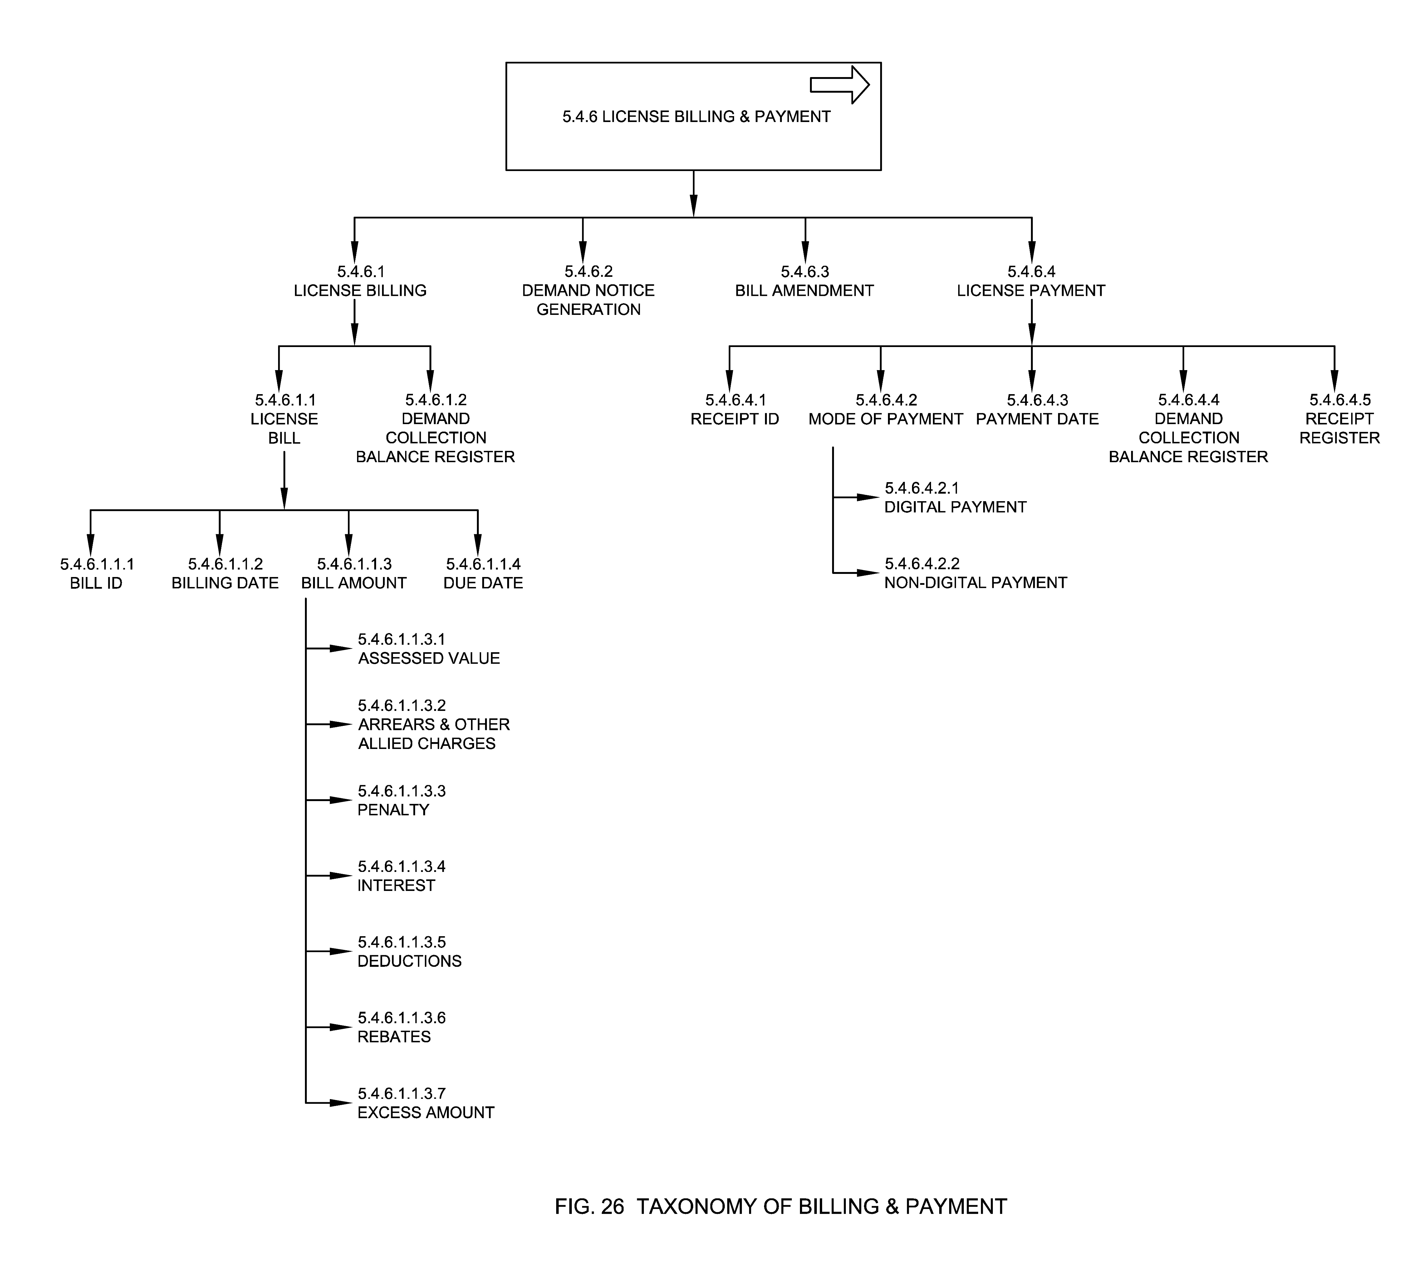

5.4.6.1 License Billing
The process by which a license fee bill is generated based on TL factors post assessment and verification of the application.

5.4.6.1.1 License Bill
It means the final bill generated in reference to TL application based on assessed value for the license. Application status in this case is pending for payment.

5.4.6.1.1.1 Bill ID
See Clause 5.1.14.1

5.4.6.1.1.2 Billing Date
See Clause 5.1.14.3

5.4.6.1.1.3 Bill Amount
See Clause 5.1.14.2

5.4.6.1.1.3.1 Assessed Value
See Clause 5.4.4.2.2.2

5.4.6.1.1.3.2 Arrears & Other allied Charges
Arrears are defined as previous years and/or unpaid bill amount or license fees.

5.4.6.1.1.3.3 Penalty
The amount of extra money the citizen has to pay for failing to adhere to TL rules and/or/laws, timelines.

5.4.6.1.1.3.4 Interest
The amount collected above the license bill in the event of late payment. It is usually determined at a particular rate of trade.

5.4.6.1.1.3.5 Deductions
Deductions is the component of license fee which has been deducted from the gross fee in lieu of advance or any other exemptions made subject to the rules of assessment of TL application.

5.4.6.1.1.3.6 Rebates
Discount given to the citizen for paying license bill in advance or before end of the statutory period or for undertaking certain listed activities as per the applicable rules.

5.4.6.1.1.3.7 Excess amount
This means any other amount that may be added in the bill as per assessment, rule and/or law.

5.4.6.1.1.4 Due Date
Due date is the date on which the bill for a particular trade is due for the current assessment duration. Upon non-payment of bill by the given due date, a surcharge may be levied on the initial demand by the imposition of a penalty.

5.4.6.1.2 Demand Collection Balance Register
See Clause 5.5.1.4

5.4.6.2 Demand Notice Generation
See Clause 5.4.3.2

5.4.6.3 Bill Amendment
Bill amendment is the process of amending TL bill when applicant notices a discrepancy in the calculation of the bill and submits a request for amendment or when the ULB realizes discrepancy in the calculation of bill and amends it.

5.4.6.4 License Payment
License Payment is the voluntary tender of money or its equivalent or of things of value by trade owner against the bill generated.

5.4.6.4.1 Receipt ID
See Clause 5.1.15.1

5.4.6.4.2 Mode of Payment
See Clause 5.4.3.3.2

5.4.6.4.2.1 Digital Payment
See Clause 5.4.3.3.2.1

5.4.6.4.2.2 Non-Digital Payment
See Clause 5.4.3.3.2.2

5.4.6.4.3 Payment Date
See Clause 5.1.15.2

5.4.6.4.4 Demand Collection Balance Register
See Clause 5.5.1.4

5.4.6.4.5 Receipt Register
See Clause 5.5.1.5

5.4.7 Recovery
Recovery means, recovery of fees from the trade owner or defaulters. In some cases, recovery may be in terms of impounding any movable or immovable asset of the defaulter. Few methods of recovery in TL are: See Fig. 27.
- by presenting a bill
- by serving a written notice of demand
- by a suit
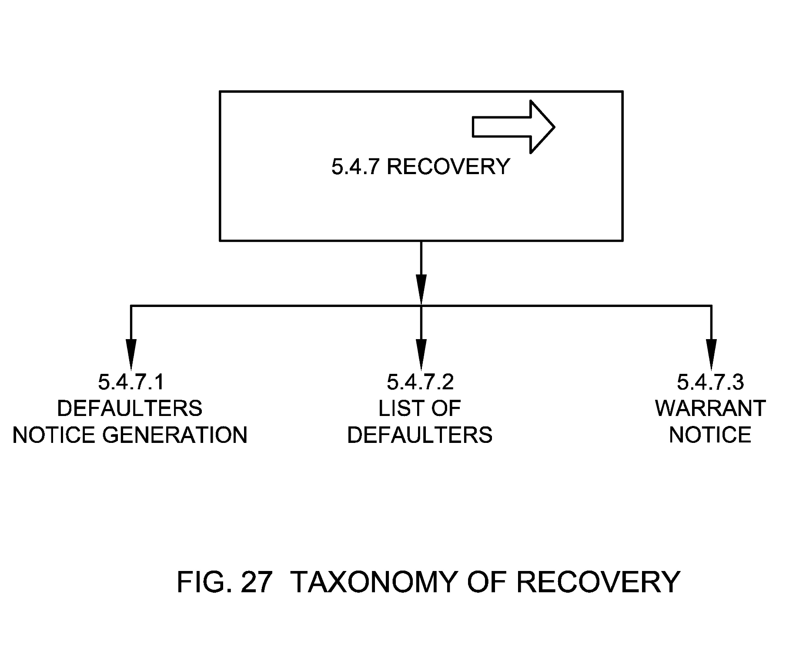

5.4.7.1 Defaulters Notice Generation
This means generation and service of notice to the defaulters who have not paid the license bill by the due date. In these cases, bills are amended to include penalties or late fee for defaulting.

5.4.7.2 List of Defaulters
See Clause 5.5.1.2

5.4.7.3 Warrant Notice
Warrant notice is the bill that is served by the authority on the trade owner for recovery.

5.4.8 Write-off
Write-Off of trade license fee is the process of deductions or exemptions of fee, in compliance with any law, or through the guidelines of the ULB or the court of law.

5.4.9 Approval & Certification
The process of approving the applied application for trade license post assessment and inspection and issuing trade license certificate by the municipal commissioner of the ULBs. See Fig. 28.
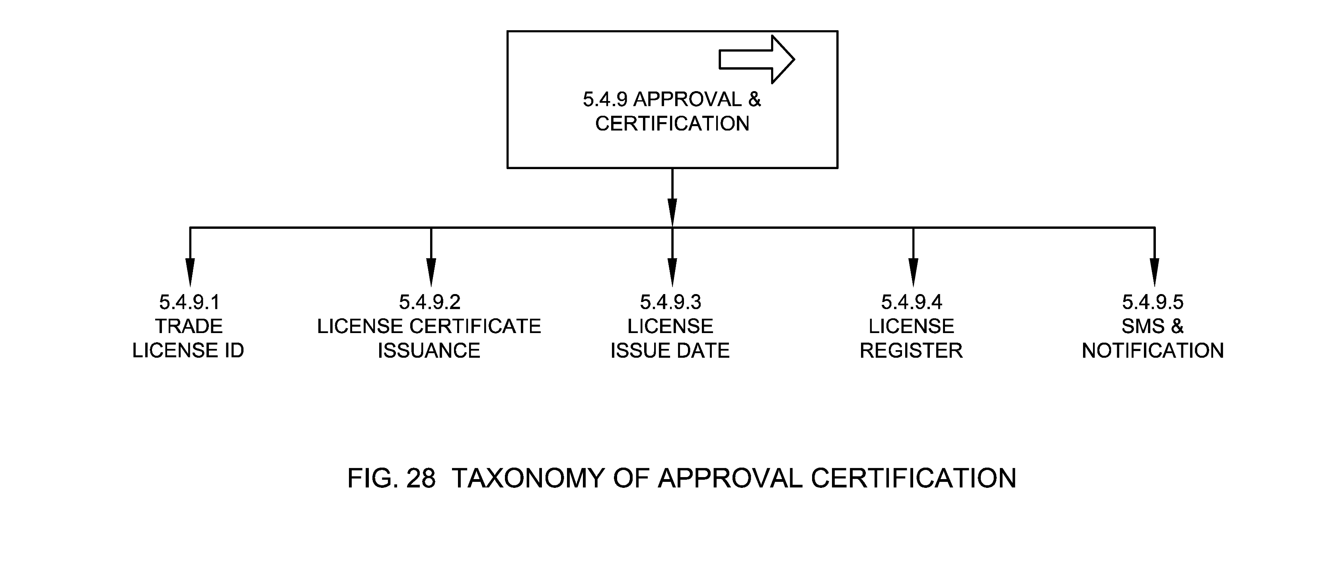

5.4.9.1 Trade License ID
See Clause 5.1.1

5.4.9.2 License Certificate Issuance
This means issuing trade license certificate post assessment and approval of TL application. Application status in this case is approved. It is recommended that the licenses should be digitally or manually signed by the relevant ULB officer such as Commissioner or Deputy Commissioner etc. along with water marked with ULB or relevant logo as per the ULB rules and/or regulations. It is also recommended to add digitally signed licenses into DigiLocker to make it easier to access and integrate with other services.

5.4.9.3 License Issue Date
See Clause 5.1.16.2.3

5.4.9.4 License Register
See Clause 5.5.1.1

5.4.9.5 SMS & Notifications
See Clause 5.4.2.5

5.4.10 TL Monitoring
TL monitoring is the monitoring process undertaken by the ULB officials from the time a TL application is lodged on system until it's approved and remains valid. The trade licenses and associated revenue are monitored based on the purpose of TL, Service Level Benchmarks, industry type, regulation purpose and need for renewal. See Fig. 29.
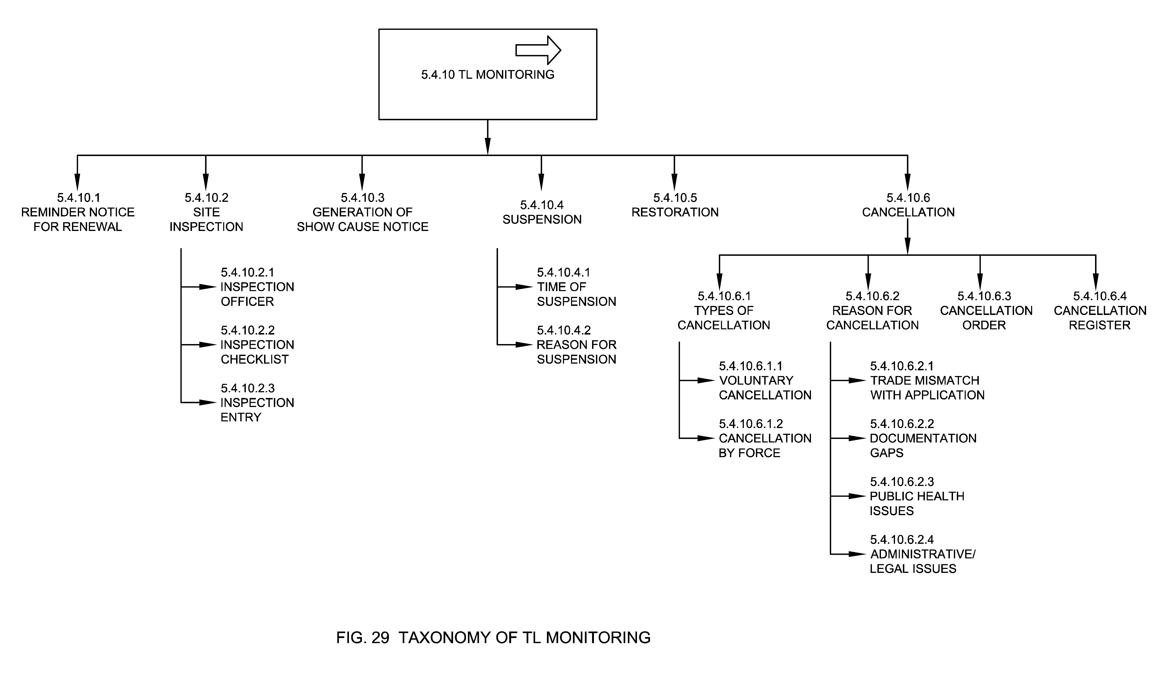

5.4.10.1 Reminder Notice for Renewal
The process of issuing a notice for renewal by the ULBs to the applicant for renewal of expired license. The notice may be issued via SMS, email, or by sending a physical letter to the owner of the trade.

5.4.10.2 Site Inspection
Site Inspection is the process by the ULB officials to check unethical business practices at the trade establishments as per relevant rules, safety measures and/or guidelines. This form of inspection may occur whenever the ULB is found suitable. Show cause notice can be issued to following traders if they violate the rules or if a complaint is raised against them.

5.4.10.2.1 Inspection Officer
See Clause 5.4.4.2.5.1

5.4.10.2.2 Inspection Checklist
See Clause 5.4.4.2.5.2

5.4.10.2.3 Inspection Entry
See Clause 5.4.4.2.5.3

5.4.10.3 Generation of Show Cause Notice
The process of issuing a show causes notice to trade owners who have offended any rule and/or regulations as per the ULB. The notice is served to give an opportunity to defend the charges made against the trade owner by explanations and reasons in writing and/or by personal hearing. If the offender justified the charges/actions then the charges will be dropped. Licenses of trade owners who fail to justify the charges will be suspended by the ULB.

5.4.10.4 Suspension
The process by which a valid trade license is suspended by the ULB by giving a reason for suspension.

5.4.10.4.1 Time of Suspension
This means recording of the time at which the license has been suspended by the ULB.

5.4.10.4.2 Reason for Suspension
This means recording the reason for which the license has been suspended by the ULB.

5.4.10.5 Restoration
The process by which the applicant may restore a previously expired trade license.

5.4.10.6 Cancellation
The process of cancelling the license for the traders. The cancellation of trade license is issued when there is no satisfactory response received from the traders for which show cause notice was issued.

5.4.10.6.1 Type of Cancellation
Type of cancellation captures classification of TL cancellation such as voluntary cancellation or cancellation by force.

5.4.10.6.1.1 Voluntary Cancellation
This means cancellation of application by the applicant.

5.4.10.6.1.2 Cancellation by Force
This means cancellation of application or trade license by force by giving reason for cancellation such as public health issues, legal issues, documentation gaps, trade mismatch or any other reason.

5.4.10.6.2 Reason for cancellation
ULBs may cancel the application by providing relevant reasons, if the applicant didn’t respond to show cause notice on time.

5.4.10.6.2.1 Trade Mismatch with Application
ULB may cancel the application if the trade mentioned in application did not match the trade during ground inspection.

5.4.10.6.2.2 Documentation Gaps
ULB may cancel the application if there are any documentation gaps in the application submitted post show cause notice.

5.4.10.6.2.3 Public Health Issues
ULB may cancel the application if the assessing officer or inspection officer reported any public health issue.

5.4.10.6.2.4 Administrative/Legal Issues
ULB may cancel the application if there are any administrative/legal issues.

5.4.10.6.3 Cancellation Order
A cancellation order is generated post cancellation of the application or trade license.

5.4.10.6.4 Cancellation Register
See Clause 5.5.1.6

5.4.11 Analysis
TL analysis is the process through which all TL applications are analysed to check quality of service and become aware of (and eventually rectify) any deficiency in services. This helps in improving the efficiency, accountability, responsiveness and transparency of a ULB, ultimately leading to improvement in service delivery. See Fig. 30.
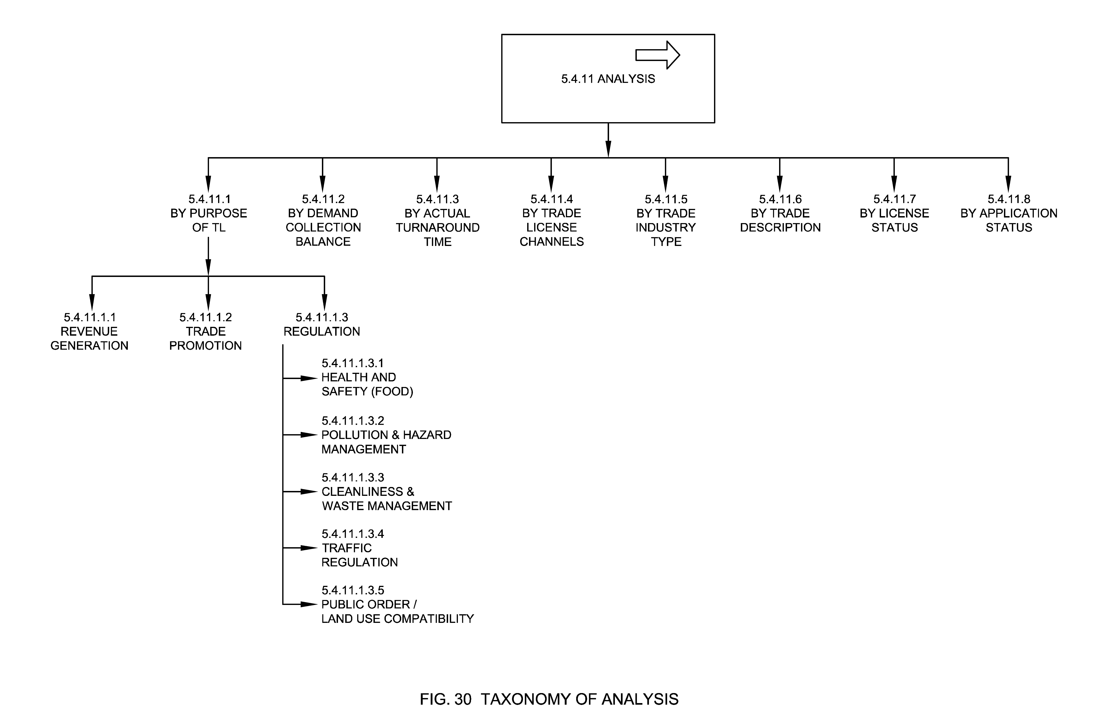

5.4.11.1 By Purpose of TL
This means analysis of TL application based on the aim or intention of issuing TL by the ULBs for e.g., revenue generation, trade promotion / livelihood, and regulation.

5.4.11.1.1 Revenue Generation
ULBs generate revenue through various sources such as trade license, building plan/license approval fees, rent from shops/markets/commercial establishments, water charges, parking fee, UGD charges, cable laying charges etc. to provide timely services and basic infrastructure. Trade license is one of the key sources of revenue generation for the ULB.

5.4.11.1.2 Trade Promotion
Trade promotion is the promotion of a certain trade in the ULB. Trend of trade licenses generated in a ULB can help shape vision of the ULB.

5.4.11.1.3 Regulation
Regulation is the management of offensive and dangerous trades or practices by the ULBs.

5.4.11.1.3.1 Health and Safety (Food)
Health and safety (Food) means the regulating and adoption of good manufacturing practices, good hygienic practices, hazard analysis and critical control point and such other practices as may be specified by regulation, for the food businesses.

5.4.11.1.3.2 Pollution & Hazard Management
Regulating safe handling, generation, processing, treatment, package, storage, transportation, use, reprocessing, collection, conversion, and offering for sale, destruction and disposal of Hazardous Waste by hazardous trade and pollution control. The ULBs may refer to end of use disposal norms by the Ministry of Environment and Forest Protection.

5.4.11.1.3.3 Cleanliness & Waste Management
Regulating collection, processing, transportation and disposal of waste by the businesses.

5.4.11.1.3.4 Traffic Regulation
Regulating and coordinating traffic in the ULB boundaries with respect to allowed trades such as street vendors.

5.4.11.1.3.5 Public Order / Land Use Compatibility
Regulation and enforcement as per public order and land use defined by the rule of law.

5.4.11.2 By Demand Collection Balance
See Clause 5.5.1.4

5.4.11.3 By Actual Turnaround Time
See Clause 5.1.16.3

5.4.11.4 By Trade License Channels
See Clause 5.2

5.4.11.5 By Trade Industry Type
See Clause 5.1.5.9

5.4.11.6 By Trade Description
See Clause 5.1.5.10

5.4.11.7 By License Status
See Clause 5.1.10

5.4.11.8 By Application Status
See Clause 5.1.11

5.4.12 Taxpayer Services
These are the services availed to all taxpayers in a ULB. In the context of trade license, these are grievance redressal, NOCs and duplicate license. See Fig. 31.
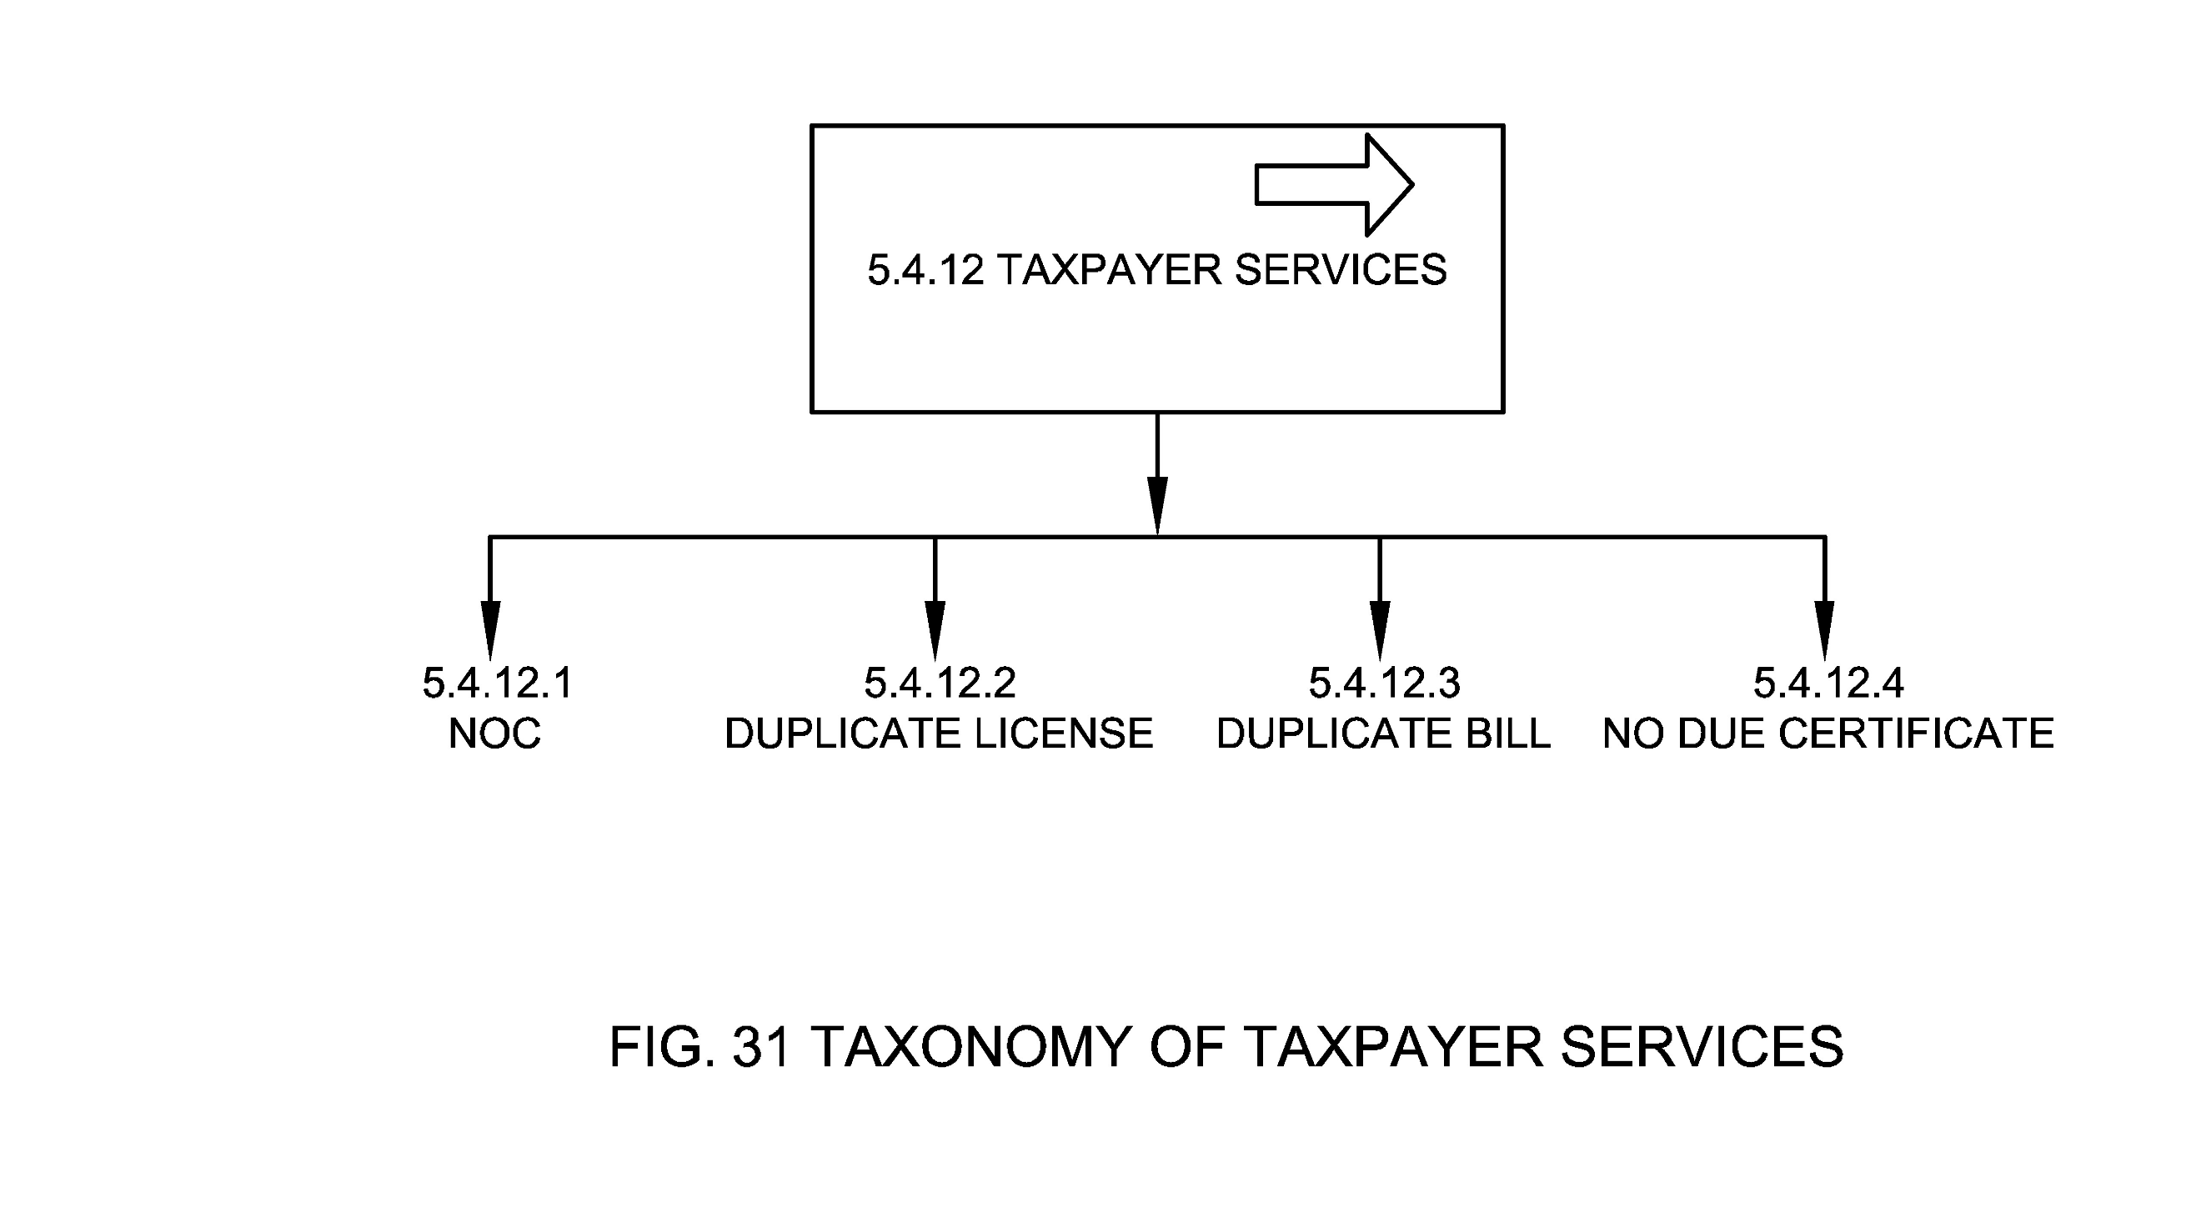

5.4.12.1 NOC
No Objection Certificate (NOC) is a legal document, issued by the ULB or an individual to say that they have no objection to the mentioned details in the document. Following NOCs may be needed for trade license:
  - NOC from neighbour
  - NOC from landlord
  - NOC from property tax department

5.4.12.2 Duplicate License
These are duplicate copies of Trade license that an applicant can ask for and/or these can be accessed on DigiLocker by the citizen post signing in DigiLocker as per prescribed rules (Department of Electronics and Information Technology, 2016)

5.4.12.3 Duplicate Bill
These are duplicate copies of the TL bill that an applicant can ask for.

5.4.12.4 No Due Certificate
This certificate is issued to the trade owners who have duly paid their charges for the TL.

5.5 Trade License Reports and KPIs
TL reports and KPIs are documents and performance measurement indices that present information in an organized format for various stakeholders especially in the form of an official document, after thorough investigation or consideration by an appointed person or body at the ULB. See Fig. 32.
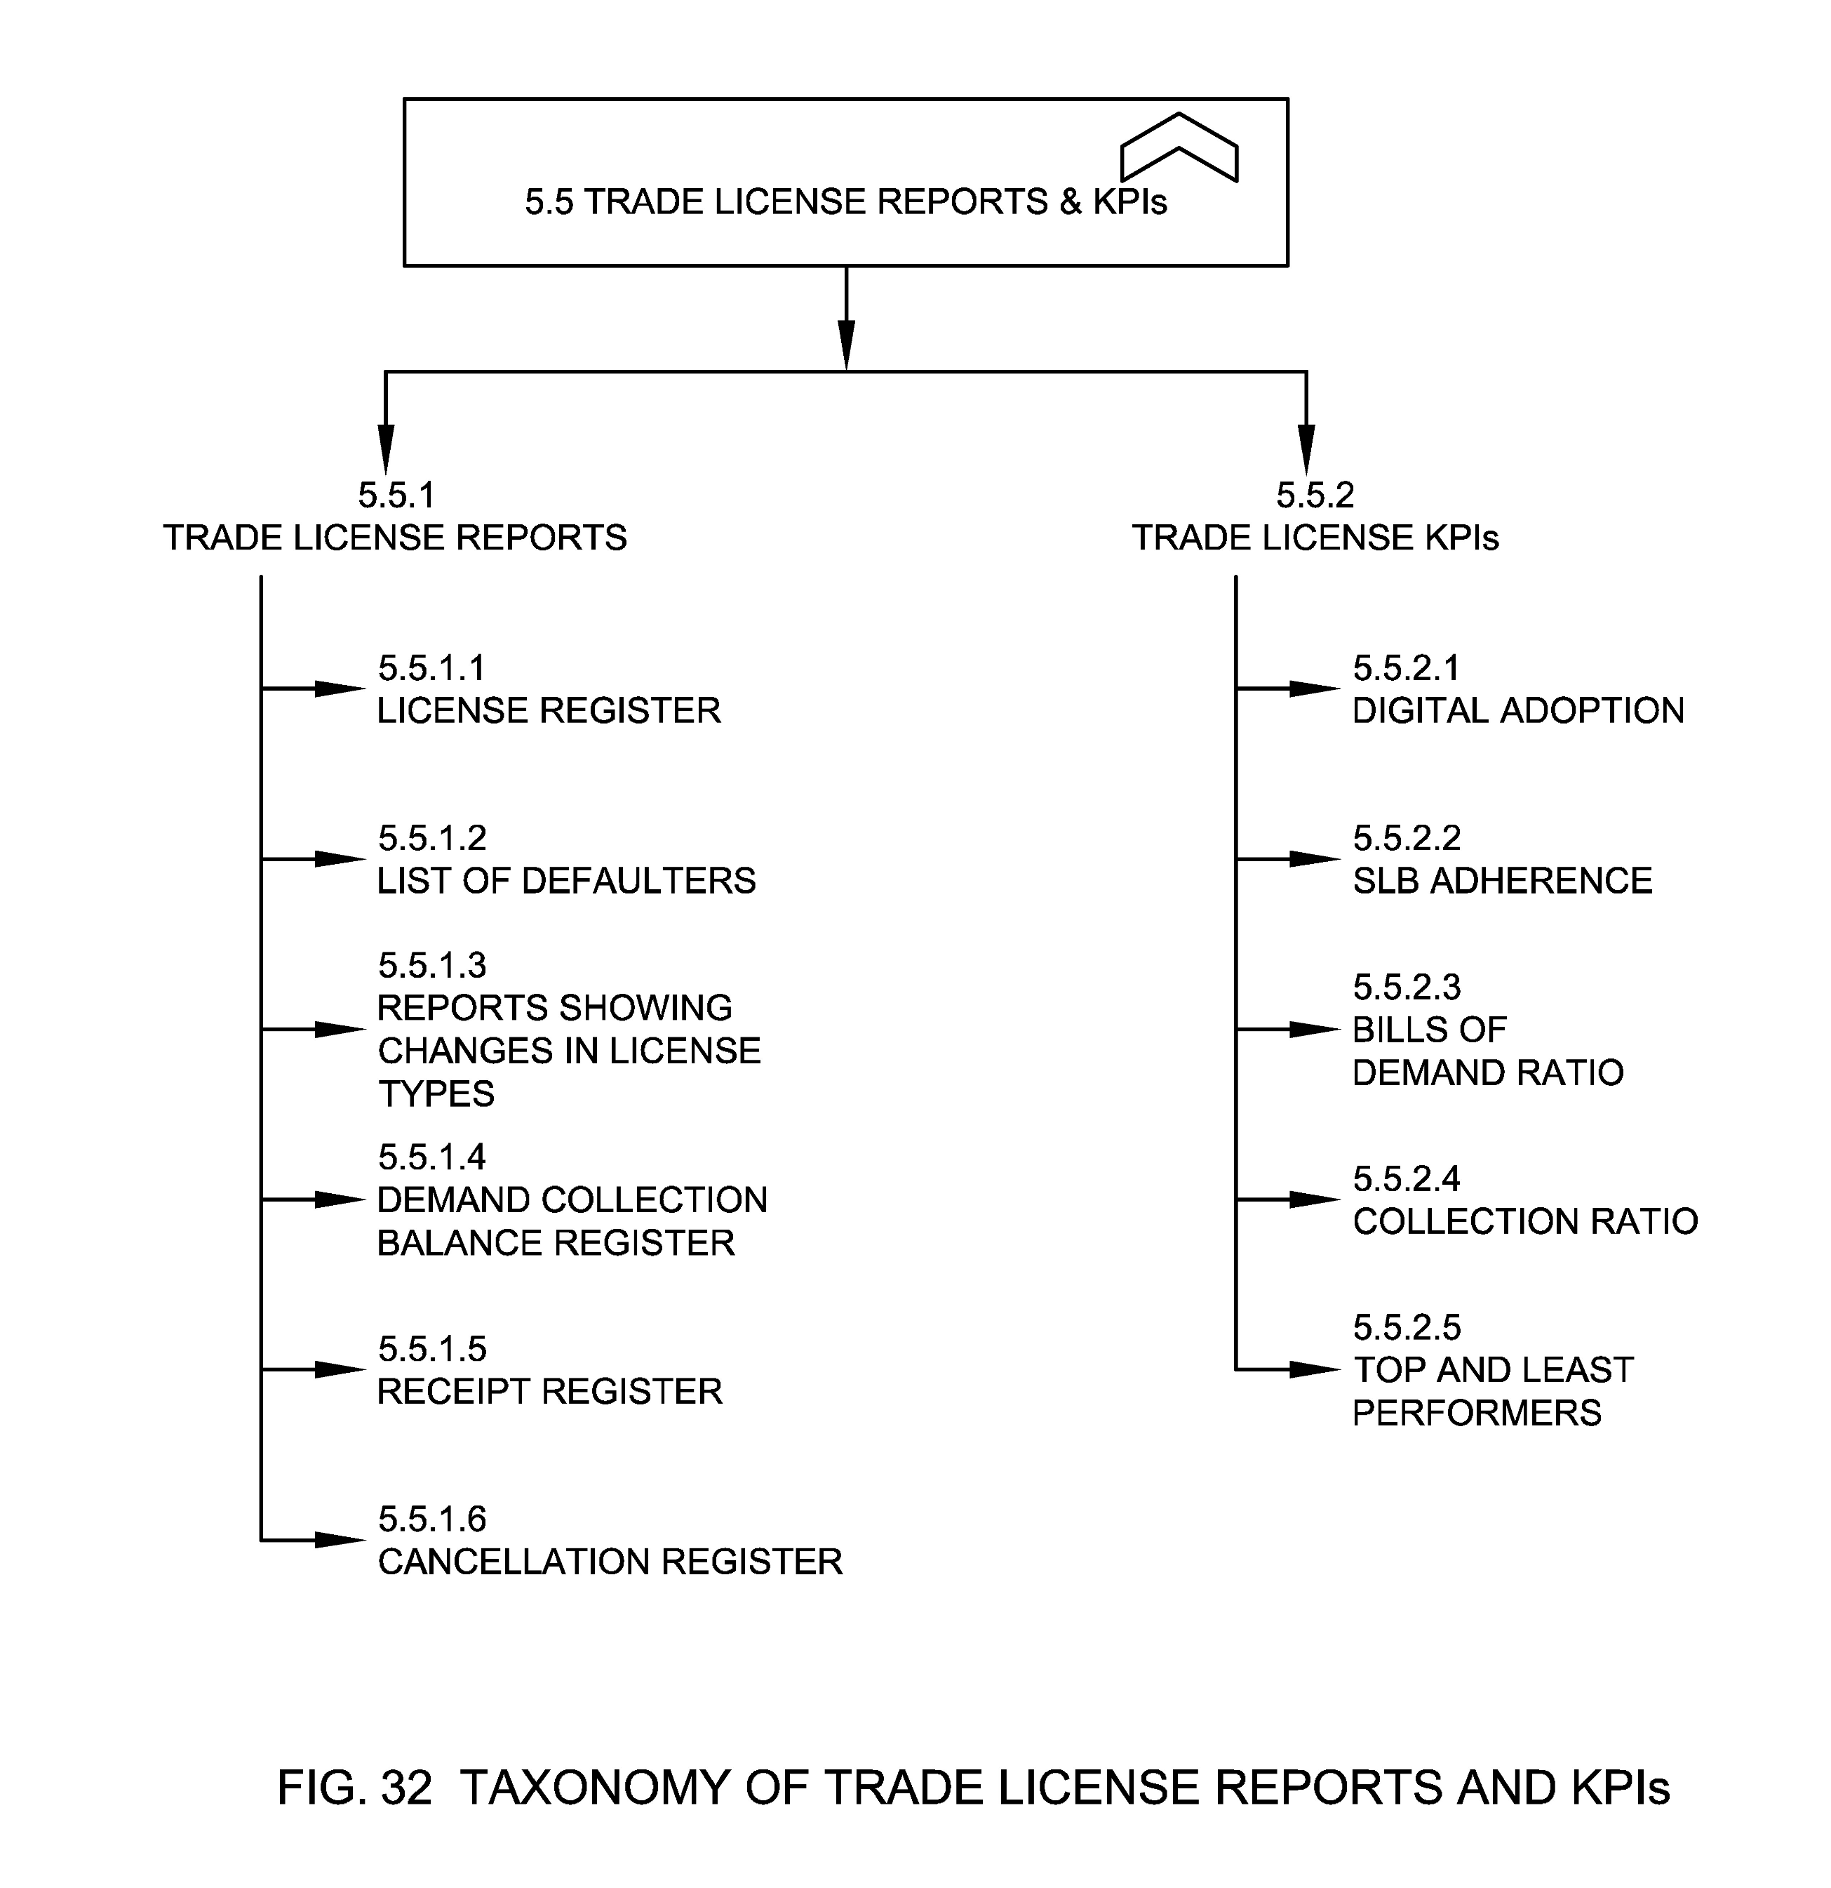

5.5.1 Trade License Reports
The TL reports notifies the Urban Local Body about the complete information of all trade licenses which are raised through various governance channels. These reports should be maintained by the ULBs.

5.5.1.1 License Register
License register provides the information about the total number of trades that are registered by the ULBs. The trade license issued is categorized based on the trade name and sub trade name and this report gives the clear idea about the details like trade name, sub trade name, number of licenses, number of new licenses, number of licenses renewed, number of pending licenses for renewal and amount collected.

5.5.1.2 List of Defaulters
TL defaulters List is the list of TL fee defaulters, as on date. Defaulter is a person or body that has not paid last or previous years TL fees. This covers assessment number, owner details, property details, demand year and arrears.

5.5.1.3 Reports showing Changes in License Types
Reports showing changes in license types as based on change in trade type requests, date of requests, status of requests etc.

5.5.1.4 Demand Collection Balance Register
This report provides details about current demand, arrears and demand under litigation/dispute (if any), collection and balance of trade license fees for that financial year.

5.5.1.5 Receipt Register
This report provides details about the payment made and receipt issued after the payment of fees.

5.5.1.6 Cancellation Register
Cancellation register report provides the information about the total number of trade licenses that are cancelled in a given interval. This report gives the clear idea about the details like trade name, sub trade name, and applicant details, zone/ ward/ SI ward, current owner and status about the trade license (Commissionerate of Municipal Administration, 2017).

5.5.2 Trade License KPIs
This refers to KPIs that should be captured for TL management.

5.5.2.1 Digital Adoption
Digital adoption means attaining a state where an individual is capable enough to utilize an application, software, or tools to its fullest capacity or the potential to carry out a variety of digital processes. Digital adoption of TL can be measured in the following terms:
  - Percentage of citizens using digital channels for TL payment
  - Percentage of citizens using digital channels for accessing services
  - Percentage Volume from different channels
  - Percentage of trade licenses issued within SLG

5.5.2.2 SLB Adherence
SLB Adherence means the number of applications processed by the ULB within SLB as determined by the rule or the law.

5.5.2.3 Bills to Demand Ratio
This means the ratio of the number of generated bills with respect to the number of assessments completed.

5.5.2.4 Collection Ratio
This means the ratio of actual collection with respect to demand generated to account collections.

5.5.2.5 Top and Least Performers
Top and Least Performers list provides information about the zones/wards who have highest and least collection ratios as well as bills to demand ratio in the ULB.

ANNEX A
(Clause 5.1.5.2)
Sample Parameters and Specifications in Property
A-1 Sample Parameters and Specifications for Location
Attribute Name | Locational Specification | Data Type | Mandatory (Yes/No)
Address | House No, Building Name, Plot/Survey No, Street Name, Locality, Zone/Ward, City/Town, District, Region, State, Country, Pin code | Varchar (256) | No
Geo Location | Latitude, Longitude, Polygon | Numeric (9,6) | Yes
Other evidences | This can include Geo tagged images of Property, DDN, QR codes etc. |  | No

- Address: The address of the property provides the particulars of the place as per the administrative boundaries or norms defined by the local governing body.
- Geo Location: Geolocation is the identification or estimation of the real-world geographic location of property. This refers to the latitude and longitude coordinates of a particular location where property is located.
- Digital Numbers: Property Numbers defined using scientific methods and often assigned with QR code for traceability and usability.

A-2 Sample Parameters and Specifications of Measurements for Different Types of Property
Type of Property | Area of Measurement | Representation on Map
Vacant Land | Polygon Area (square feet or m²) | Polygon
Built Structure | Built Up Area of Premise (square feet or m²) | Polygon, Centroid
 | Appurtenant Area (square feet or m²) | Polygon, Centroid

A-3 Sample list of trades against Trade Description
Trade Description | Reference List of Trades
Storage and sale of household provisions | Household daily provisions, grocery & condiments; Perishables such as fruits, vegetables, flowers; Bakery products; Non-alcoholic beverages; Tobacco and tobacco products, including pan masala and gutkha with or without tobacco; whether branded or not; Branded meat products  Household articles such as plastic, metal, ceramic, stoneware, pottery or cloth items, cleaning materials, utensils; Household consumables such as electrical consumables, watches and clocks, stationery, personal hygiene products, battery cells, or any other household items; whether branded or not  Fresh meat, in combination with household provisions or without, not including abattoirs and slaughterhouses  Wine, beer, alcohol shop or shop selling locally produced alcohol, with or without permit room
Eatery houses and food preparation | Tea/coffee; Sweets and savories; Bakery; Fast food; Juice/milk-shake shops without separate kitchen space  Restaurant, bakery, cafeteria or any other eating house with kitchen in separate space  Bar or pub, with or without restaurant and separate kitchen or beer brewery or establishment selling locally produced alcoholic beverage, with or without sale of tobacco and tobacco related products  Catering service, including stand-alone kitchen  Part of any other establishment (hospitality, gathering and entertainment establishment)
Hospitality, gathering and entertainment services | Accommodation facility (2-star and below hotel, resort, boarding house, lodge, Dharamshala, hostel, Paying Guest accommodation, guest house, home-stay, serviced apartments), without kitchen or function hall or health, sports or recreation-related facilities  Accommodation facility (2-star and below hotel, resort, boarding house, lodge, Dharamshala, hostel, Paying Guest accommodation, guest house, home-stay, serviced apartments), with kitchen or function hall or health, sports or recreation-related facilities  Hotel, resort or club with accommodation facilities, restaurants, kitchen or other F&B arrangements, function hall, conference halls, convention centre, health, sports or recreation related facilities, 3-star and above  Shopping centre or mall with any combination of shops and storage, eating houses, hospitality, gathering and entertainment facilities  Banquet hall, function hall, single-screen or multiplex cinema hall, auditorium or conference/convention centre, without restaurant or kitchen  Accommodation facility (3-star and below 7 star)hotel, resort, boarding house, lodge, Dharamshala, hostel, Paying Guest accommodation, guest house, home-stay, serviced apartments), with kitchen or function hall or health, sports or recreation-related facilities  Sports facilities or clubs, indoor and outdoor playing arenas, spa, massage rooms, amusement or theme parks, with or without restaurant or kitchen  Museum, exhibition centre or library, with or without restaurant or kitchen
Medical establishment | Chemist, druggist, medical and general store, including surgical store  Clinic or hospital of any system of medicine, general or specialized care centre, diagnostic centre, physiotherapy centre, rehabilitation service, gymnasium, blood bank  Medicine/surgical material production and storage, of all systems of medicine
Veterinary | Pet services including pet shops, material for pets, clinics, boarding
Educational establishment | School, of any education system, across any classes  College, of any education system, across all streams  Coaching or tuition centre
Other storage and sale establishments | Construction material, such as bricks and blocks, cement, steel, plumbing, fixtures, electrical, hardware, etc.  Tools, machinery and machine parts of all manner  Auto-parts and automobiles, auto accessories, including all forms of motorized vehicles, new or used, including electric vehicles  Cycles, cycle-rickshaws and cycle parts, new or used, including push-carts and trams  Stationery, book, art supplies; Cloth and clothing, including footwear; Sports equipment store, including toys; Household electrical and electronic items, including computer and mobiles; Household linen and soft furnishing, including mattresses; Jewellery in any material; musical instruments, new or used, or any combination of these items  Cash and carry stores (B2B or B2C) selling any items or combination of items  Nurseries, agriculture, horticulture, aquaculture, or any other related materials  Hazardous materials, including explosives, laboratory chemicals, arms, ammunition, firecrackers, fuel in any form, etc.
Other service establishment | Tent house, including rental of event material with or without catering  Printing, stamp-making, signboards, photo studio with or without sale of photographic equipment, photo-framing, key-makers; Internet or other communication  Legal, architecture, CA, engineering, real-estate, astrology, matchmaking, travel agency or other professional service  Construction services, such as borewell, repair of buildings, demolition, cartage  Hair-dresser, saloon, tattoo parlour or beauty parlour or any other personal grooming service  Dry cleaning or laundry  Repair of motor vehicles and non-motor vehicles  Personal and household services such as tailors, cobblers, cleaners, electrical and electronic works and repairs, plumbing works and repairs  Recycling services, including purchase and processing and sale of all manner of waste  Crematoria, including burial grounds, or any service related to the disposal of dead bodies
Industry and warehousing – non hazardous | Manufacture, storage including cold storage, preparing and packaging of all food products including filtered drinking water, edible oil, condiments, groceries, preserves, pickles, milk and milk products, other non-alcoholic beverages, bakery items, confectionery items, tobacco products and meats  Manufacture, storage, preparing and packaging of clothing and footwear items, from all materials such as fabric and leather, using any method including power- and manual-based processing  Manufacture, storage, preparing and packaging of furniture of soil products, plastic, wood or metal products, or any composite thereof  Manufacture, storage including cold storage, preparing and packaging alcohol for human consumption  Slaughterhouse or abattoir with or without storage, including cold storage, preparing and packaging of fresh meat
Industry and warehousing – hazardous | Manufacture, storage including cold storage, preparing and packaging of industrial alcohol  Manufacture, storage, preparing and packaging of chemicals & pesticides of all kinds manufacturing, mixing, storing, selling  Manufacture, storage, preparing and packaging of automobile and other battery cells  Manufacture, storage, preparing and packaging of ammunition and fireworks  Manufacture, storage, preparing and packaging of paint, lacquers and shellac  Manufacture, storage including cold storage, preparing and packaging of furniture of wood or metal or any composite of the two  Manufacture, storage including cold storage, preparing and packaging alcohol for human consumption
Street Vending/Hawking | Stationary Vendor / Mobile Vendor
Municipal Markets | Community Centre (CC) Local Shopping Centre (LSC) / Convenience Shopping Centre (CSC) - These Centers may have Retail Shopping, Commercial and Government Offices, Local Body / Public Sector Undertaking offices, Cinema / Cineplexes, Hotels, Restaurants, Banquet halls and Guest House, Nursing Home, Dispensary, Clinical Laboratory, Clinic & Poly Clinic facilities together with other community facilities  Service Markets – Informal Bazars, weekly markets, informal shops, organized eating places, handicrafts shops, Kabaris etc., Organized Informal sector places- Haats service shops, booths

ANNEX B: COMMITTEE COMPOSITION
(Forword)

Organization | Member Name and Role
Indian Institute of Science, Bengaluru | Shri Inder S Gopal (Chairperson)
Aveva Software Private Limited, Bengaluru | Shri Harish Mokkarala
Centre for Development of Telematics, New Delhi | Shri Aurindam Bhattacharya  Shri Anupama Chopra (Alternate)
CyanConnode Private Limited, Bengaluru | Shri Manish Widhani  Shri Deepak Nimare (Alternate)
Comminent Private Limited, Bengaluru | Shri Amarjeet Kumar
ERNET India, New Delhi | Dr A. Paventhan  Shri Hari Krishna Atluri (Alternate)
ESRI India Technologies Private Limited, Noida | Shri Vijay Kumar  Shri Rupesh Kumar (Alternate)  Ms Seema Joshi (Alternate)
IEEE India, Bengaluru | Shri Munir Mohammed
India Smart Grid Forum, New Delhi | Shri Reji Kumar Pillai
Ministry of Housing and Urban Affairs, New Delhi | Shri Kunal Kumar  Shri Padam Vijay (Alternate)
National Smart Grid Mission, Ministry of Power, Gurugram | Shri Arun Misra  Smt Kumud Wadhwa (Alternate)  Shri Gyan Prakash (Alternate)
PHYTEC Embedded Private Limited, Bengaluru | Shri B. Vallab Rao Vasu
Qualcomm India Private Limited, Bengaluru | Dr Punit Rathod  Dr Vinosh Babu James (Alternate)
Renesas Electronics, Bengaluru | Shri Ravindra Chaturvedi  Shri Saurabh Goswami (Alternate)
Seconded European Standardization Expert for India (SESEI), New Delhi | Shri Dinesh Chand Sharma
Secure Meters Limited, Gurugram | Shri Madhur Kumar Srivastava  Shri Puneet Khurana (Alternate)  Shri Kaustubh Patil (Alternate)  Shri Uttam Kotdiya (Alternate)  Shri Anil Mehta (Alternate)
Senra Tech Private Limited, New Delhi | Shri Dhiraj Kumar  Shri Ankush Kochhar (Alternate)
Sharma Technologies Private Limited, Bangalore | Shri Amarjeet Kumar
Siemens Limited, Mumbai | Shri Ravi Madipadga  Shri Manoj Belgaonkar (Alternate)  Shri Pradeep Kapoor (Alternate)  Shri Vikram Gandotra (Alternate)
Standardization Testing and Quality Certification (STQC), Pune | Ms Lipika Kaushik
Tata Consultancy Services Limited, Mumbai | Shri Ramesh Balaji  Shri Debashis Mitra (Alternate)
Tata Consulting Engineers Limited, Navi Mumbai | Shri Jagdish Shivraj Shige  Shri Manoj Kumar (Alternate)
Tejas Networks Limited, Bengaluru | Dr Kanwar Jit Singh
Telecommunication Engineering Center, New Delhi | Ms Ashima  Shri Sushil Kumar (Alternate)  Shri Uttam Chand (Alternate)
Telecommunications Standards Development Society India, New Delhi | Ms Bindoo Srivastava
eGovernments Foundation, Bengaluru | Shri Krishna Kumar Thiagarajan
In Personal Capacity (IUDX, IISc) CV Raman Road, Bengaluru – 560012 | Shri Vasanth Rajaraman
BIS Director General | SHRIMATI REENA GARG, SCIENTIST ‘G’ AND HEAD (ELECTRONICS AND INFORMATION TECHNOLOGY) [REPRESENTING DIRECTOR GENERAL (Ex-officio)]

Panel 13 Composition - Urban Domain Standards

Organization | Member Name and Role
National Institute of Urban Affairs, New Delhi | Ms. Sheika Arora  Mr. Sushant Anand (Alternate)  Ms. Gautamai Ghumatkar (Alternate)  Ms. Aparajita Dubey (Alternate)

Member Secretary
SHRI DEVANSH DEOLEKAR
SCIENTIST ‘D’/JOINT DIRECTOR
(ELECTRONICS AND INFORMATION TECHNOLOGY), BIS

BIBLIOGRAPHY
Ministry of Housing and Urban Affairs. (2014). Urban and Regional Development Plans Formulation and Implementation (URDPFI) Guidelines. Ministry of Housing and Urban Affairs.
National Building Code Sectional Committee. (2016). National Building Code of India. Bureau of Indian Standards.
Department of Electronics and Information Technology. (2016). Information Technology (Preservation and Retention of Information by Intermediaries Providing Digital Locker Facilities) Rules, 2016. Ministry Of Communications and Information Technology.
Ministry of Housing and Urban Affairs. National Institute of Urban Affairs, Trade License Knowledge Standard (2022). Retrieved from https://niua.in/intranet/sites/default/files/2452.pdf
Ministry of Housing and Urban Affairs. National Institute of Urban Affairs - Fire NOC Knowledge Standard (2022). Retrieved from https://niua.in/intranet/sites/default/files/2451.pdf
Ministry of Housing and Urban Affairs. National Institute of Urban Affairs - Water and Sewerage Knowledge Standard (2022). Retrieved from https://niua.in/intranet/sites/default/files/2454.pdf
Ministry of Housing and Urban Affairs. National Institute of Urban Affairs - Municipal Grievance Redressal Knowledge Standard (2022). Retrieved from https://niua.in/intranet/sites/default/files/2453.pdf

1 National Building Code Sectional Committee. (2016). National Building Code of India. Bureau of Indian Standards.
2. Ministry of Housing and Urban Affairs. (2014). Urban and Regional Development Plans Formulation and Implementation (URDPFI) Guidelines. Ministry of Housing and Urban Affairs.
3 DigiLocker” means the Government owned and operated web and mobile based hosting of the Digital Locker system. Digital Locker System. – (1) For the purpose of providing preservation and retention of machine readable, printable, shareable, verifiable and secure State or Central department or agency or body corporate issued electronic records, the Government and other service providers to provide a Digital Locker system of limited electronic storage to all users. (2) The Government through Digital Locker authority and in accordance with the technical standards as laid down by the DeitY from time to time shall provide for the administration of the Digital Locker system. (3) Subject to sub-rule (1), the Digital Locker system shall act as web and mobile based portal for State or Central department or agency or body corporate issued electronic records maintained in a prescribed format.
4 Department of Electronics and Information Technology. (2016). Information Technology (Preservation and Retention of Information by Intermediaries Providing Digital Locker Facilities) Rules, 2016. Ministry Of Communications and Information Technology.

