FAD 11 (21505)

IS 2565 : 2024

**भारतीय मानक**

**पशु द्वारा संचालित रिड्गर — विशिष्टि**

(*दूसरा पुनरीक्षण*)

**Indian Standard**

**ANIMAL DRAWN RIDGER — SPECIFICATION**

(*Second Revision*)

ICS 65.060.20

© BIS 2024

**B U R E A U O F I N D I A N S T A N D A R D S**

MANAK BHAVAN, 9 BAHADUR SHAH ZAFAR MARG

NEW DELHI 110002

*March*, 2024 **Price Group**

Agricultural Machinery and Equipment Sectional Committee, FAD 11

FOREWORD

This Indian Standard (Second Revision) was adopted by the Bureau of Indian Standards, after the draft finalized by the Agricultural Machinery and Equipment Sectional Committee had been approved by the Food and Agriculture Division Council.

Ridger is an implement used to form ridges required for certain row-sown or row-planted crops in well-tilled soil. The ridger is also used for forming field furrows or channels, earthing up and similar other operations. It is also known by the names ridging plough or ridger plough or double-mouldboard plough. The ridger generally has a V-shaped or wedge-shaped share fitted to the frog. The nose or point of the share penetrates into the soil and breaks the soil. The mouldboards lift, invert and cast aside the soil, forming channels and ridges of the required size.

This standard was first published in 1963 and subsequently revised in 1979 in order to make it more implementable. The second revision incorporates the following modifications:

1. Material of construction for components have been modified with grades.
2. Additional unit for hardness has been specified for better comprehension.

This standard contains **10.3** which call for agreement between the purchaser and the supplier.

In revision of this standard, considerable assistance has been derived from the technical information provided by Agricultural Machinery Manufacturers Association, Pune, India.

The composition of the Committee, responsible for the formulation of this standard is given in Annex A.

For the purpose of deciding whether a particular requirement of this standard is complied with, the final value, observed or calculated expressing the result of a test or analysis, shall be rounded off in accordance with IS 2: 2022 ‘Rules for rounding off numerical values (*second revision*)’. The number of significant places retained in the rounded off value should be the same as that of the specified value in this standard.

**Indian Standard**

**ANIMAL DRAWN RIDGER — SPECIFICATION**

(*Second Revision*)

**1 SCOPE**

**1.1** This standard prescribes material, sizes and other requirements for animal-drawn ridger.

**2 REFERENCES**

The standards given below contain provisions which, through reference in this text, constitute  
provisions of this standard. At the time of publication, the editions indicated were valid. All  
standards are subject to revision and parties to agreements based on this standard are encouraged  
to investigate the possibility of applying the most recent editions of these standards.

|  |  |
| --- | --- |
| *IS No.* | *Title* |
| IS 210 : 2009 | Grey iron castings — Specification (*fifth revision*) |
| IS 399 : 1963 | Classification of commercial timbers and their zonal distribution (*first revision*) |
| IS 1500 (Part 1) : 2019 / ISO 6506-1 : 2014 | Metallic materials — Brinell hardness test: Part 1 Test method (*fifth revision*) |
| IS 1570 (Part 2/Sec 1) : 1979 | Schedules for wrought steels: Part 2 carbon steels (Unalloyed Steels): Sec 1 Wrought products (other than wires) with specified chemical composition and related properties (*first revision*) |
| IS 1586 (Part 1) : 2018/ISO 6508 : 1989 | Metallic materials — Rockwell hardness test: Part 1 Test method (*fifth revision*) |
| IS 2062: 2011 | Hot rolled medium and high tensile structural steel — Specification (*seventh revision*) |
| IS 7201 (Part 1): 1987 | Methods of sampling for agricultural machinery and equipment: Part 1 Hand-tools and hand-operated/animal drawn equipment (*first revision*) |

**3 TERMINOLOGY**

For the purpose of this standard, the following definitions shall apply (*see* Fig. 1, 2 and 3).

**3.1 Angle of Cut** — The angle formed by the lines joining point of share and wings of share (*see $α$* in Fig. 3).

**3.2** **Angle of Penetration** — The angle of inclination of share in the direction of travel when share is fitted in its working position (*see $β$* in Fig. 3).

**3.3 Bridle Hook** — The clamp used for adjusting hitch point vertically.

**3.4 Beam** — A rigid member which transmits the power from the yoke to the plough bottom.

**3.5 Clevis** — The parts fitted at the front end of the short-beam ridger which permits both horizontal and vertical hitch adjustments.

**3.6 Frog** — The part to which other components of plough bottom are attached.

**3.7 Gauge Wheel** — An auxilliary wheel to maintain a uniform depth of working.

**3.8 Gauge Wheel Strap** — The part(s) used for adjusting the height of gauge wheel.

**3.9 Handle** — The part(s) for controlling and manoeuvring the ridger.

**3.10 Mouldboards** — The parts that lift, turn and compact the soil slice. In some cases, also breaks the soil slice.

**3.11 Mouldboard Brace(s)** — The adjustable or fixed part(s) which is attached to the back of the mouldboards to provide them support.

NOTE — The adjustable brace(s) also helps in controlling the width of furrow by adjusting the width of wing of mouldboards.

**3.12 Plough Bottom** — An assembly comprising the share, the mouldboards, the sole plate all attached to the frog.

**3.13 Ridger** — An implement which cuts and turns the soil in two directions simultaneously for forming ridges.

**3.14 Share** — The V-shaped or wedge-shaped part which penetrates into the soil and makes cut below the surface.

**3.14.1** *Cleavage Edges* — The edge of the share which forms joint between mouldboard and share.

**3.14.2** *Cutting Edges* — The front edges of the share which make the cut in the soil.

**3.14.3** *Edge Clearance* — The maximum clearance between the cutting edge and a line joining point and wing of share.

**3.14.4** *Point of Share* — The leading end of the cutting edge which affects the penetration of share into the soil. This may be integral or detachable.

**3.14.5** *Wing of Share* — The rear end of the cutting edge of the share.

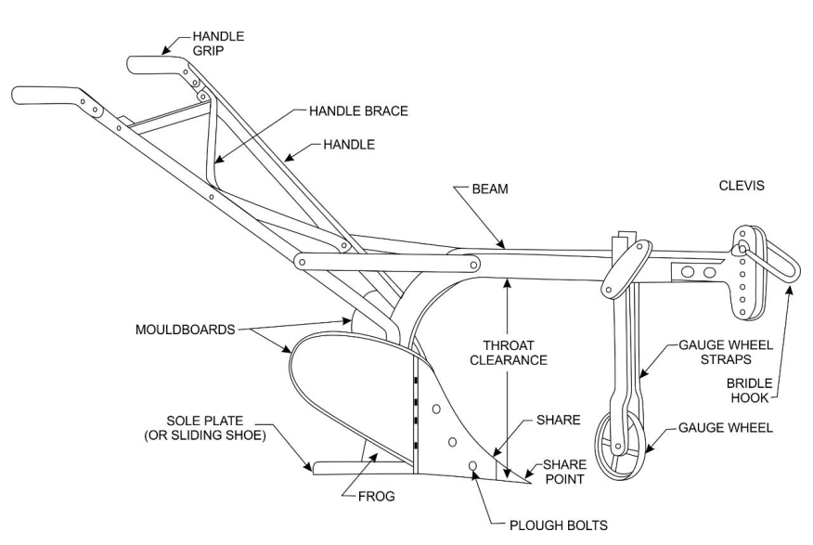

FIG. 1 NOMENCLATURE OF THE MAIN PARTS OF THE RIDGER (SHORT BEAM)

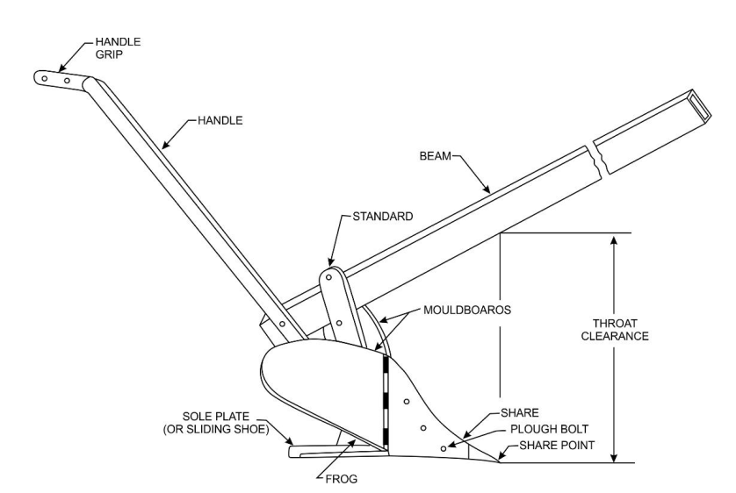

FIG. 2 NOMENCLATURE OF THE MAIN PARTS OF THE RIDGER (LONG BEAM)

FIG. 3 MEASUREMENT OF THE RIDGER, VERTICAL SUCTION AND THROAT CLEARANCE

**3.15 Size** — The horizontal distance between the outside ends of the mouldboards, expressed in mm.

NOTE — In case of mouldboards fitted with adjustable brace(s), it shall be placed at position to indicate minimum distance. However, the maximum width should also be indicated.

**3.16 Sole Plate** — The part which slides against the bottom providing stability to it during operations. This is also known as sliding shoe.

**3.17 Sole Plate Knife** — A blade attached to the heel of sole plate which cuts into the soil and prevents the ridger from dodging to the side.

**3.18 Throat Clearance** — The perpendicular distance between point of share and lower position of beam.

**3.19 Standard** — The part connecting the plough bottom to the beam.

**3.20 Vertical Suction** — The maximum clearance under the sole plate with knife, if fitted, placed at minimum setting and horizontal surface when the ridger is resting on a horizontal surface in the working position.

**4 TYPES**

**4.1** On the basis of shape of share, the ridger shall be of two types, namely, V-shape and wedge-shape (*see* Fig. 3).

**4.2** On the basis of size, the ridger shall be of three types, namely, light, medium and heavy (*see* **7.1**).

**5 MATERIALS**

**5.1** The material of construction of share including detachable share point and sole plate knife shall be chilled cast iron or steel conforming to Grade C75 [*see* IS 1570 (Part 2)] or C80 (equivalent to EN42 carbon steel) or 27MnCrB5 (Boron steel).

**5.2** The material of construction for components other than those specified in **5.1** shall be cast iron preferably conforming to Grade 20 of IS 210 or mild steel preferably conforming to IS 2062. Well-seasoned hard timber (*see* IS 399) may also be used for beam, handle and handle grip.

**5.3** The components along with their material of construction shall be declared by the manufacturer.

**6 HARDNESS**

**6.1** Cast iron used for different components, other than share and sole plate knife, shall have the hardness in range of 160 to 220 HB [*see* IS 1500 (Part 1)].

**6.2** The chilled cast iron share including detachable share point and sole plate knife shall have hardness in range of 360 to 400 HB when tested in accordance with IS 1500 (Part 1) or in the range of 38 to 42 HRC when tested in accordance with IS 1586 (Part 1) up to a distance of 50 mm from cutting edge; depth of chilling shall be not less than 1.5 mm.

**6.3** The steel share including detachable share point and sole plate knife shall have hardness in range of 350 to 450 HB when tested in accordance with IS 1500 (Part 1) or in the range of 38 to 48 HRC when tested in accordance with IS 1586 (Part 1) up to a distance of 50 mm from the cutting edge.

**7 DIMENSIONS**

**7.1** The size of ridger shall be as follows:

a) *Ligh*t ⎯ up to and including 400 mm,

b) *Medium* ⎯ above 400 and up to and including 900 mm, and

c) *Heavy* ⎯ above 900 mm

**7.1.1** The size shall be declared. The tolerance on declared size shall be ± 5 mm.

**7.2** In case the ridger is provided with sole plate, the vertical suction for V-shaped share and wedge-shaped share shall be in the range of 3 mm to 8 mm and 8 mm to 22 mm respectively. The suction shall be declared by the manufacturer. The suction shall not differ by ± 1 mm of the declared value.

**7.3** When the ridger is set at its working position, the throat clearance shall be in the range of 250 to 500 mm.

**7.4** The ridger shall be provided with one or two handles. If two handles are provided, the distance between the handle grips shall be between 550 and 650 mm.

**7.5** When the plough is set at its working position, the vertical distance between the ground and the centre of the grip shall be adjustable. The value shall lie between 800 and 1100 mm.

**7.6** The handle grip shall be circular or oval in cross section. The diameter or minor axis shall be between 25 and 30 mm. The grip shall be not less than 125 mm. The angle between the handle grip and the handle shall be between 100° to 105° (*see* Fig. 2).

**7.7** The gauge wheel, if provided, shall be not less than 150 mm in diameter and its face width not less than 50 mm.

**7.8** The gap between cleavage edge of share and mouldboard shall be not more than 2 mm.

**7.9** The cutting edge of the share shall be beveled to a distance between 5 mm and 10 mm. The thickness of the cutting edge should be between 0.5 mm to 2 mm. The variation in edge thickness in a share shall be not more than ± 0.5 mm.

**7.10** The angle of cut for V-shaped share shall be 50° to 80° and for wedge-shaped share shall be 30° to 60°. The variation from declared angle shall be not more than ± 3°.

**7.11** The angle of penetration shall be 15° to 30°. The variation from declared angle shall be not more than ± 3°.

**8 OTHER REQUIREMENTS**

**8.1** All the components should preferably be detachable.

**8.2** The fasteners coming in contact with soil should have coarse thread. The head of the fasteners, coming in contact with soil, shall be flush with the working surface. As far as possible, bolt of 10 mm size should be used for all fastening to facilitate the use of minimum number of tools. Each bolt should have spring or flat washer of appropriate size for better contact.

**8.3** The gauge wheel, if fitted, shall roll smoothly on its axis. The height of the wheel should be adjustable.

**8.4** The ridger shall have the shares of V-shape or wedge-shape.

**8.5** The ridger may be provided with sole plate. A sole plate knife may be fitted with sole plate.

**8.6** The mouldboard brace(s) may be fixed or of adjustable type.

**8.7** The ridger shall be symmetrical on both sides along with the longitudinal axis of the plough bottom.

**8.8** When the ridger is set at its working position and is placed on a plane surface, its bearing points (point of share and wing of share and heel of sole plate if present) should touch the ground and the ridger shall be well-balanced.

**8.9** The mass of the ridger including beam (if provided) shall be not more than 20 kg.

**9 WORKMANSHIP AND FINISH**

**9.1** The components of the ridger should be free from pits, burrs, cracks and other visual defects. The castings shall be free from blow holes. Welded joints shall not be porous.

**9.2** The surface of the parts of the plough shall be evenly dressed and shall have a protective coating which will prevent surface deterioration in transit and storage.

**10. MARKING AND PACKING**

**10.1 Marking**

Each ridger shall be marked on non-wearing surface with the following particulars:

a) Manufacturer’s name and recognized trade-mark, if any;

b) Batch or code number;

c) Type and size: and

d) Any other markings required under the *Standards of Legal Metrology* (*Packaged Commodities*) *Rules,* 2011 and any other statutory requirement.

**10.2 BIS Certification Marking**

The product(s) conforming to the requirements of this standard may be certified as per the  
conformity assessment schemes under the provisions of the *Bureau of Indian Standards Act*,  
2016 and the Rules and Regulations framed thereunder, and the products may be marked with  
the Standard Mark.

**10.3 Packing**

The ridgershall be packed as agreed to between the purchaser and the supplier. The packing shall ensure safety of the parts in transit.

**11 SAMPLING FOR LOT ACCEPTANCE**

**11.1** Unless otherwise agreed to between the purchaser and the supplier, the sampling of the ridger for lot acceptance shall be as per IS 7201 (Part 1).

**11.1.1** The classification of different requirements of this standard for the purpose of testing for lot acceptance is given below for guidance:

a) Dimensional and Visual Requirements ⎯ *see* *Clause* **7**, **8** and **9**.

b) Other than Dimensional and Visual Requirements ⎯ *see* *Clause* **5** and **6**.

**ANNEX A**

(*Foreword*)

**COMMITTEE COMPOSITION**

Agricultural Machinery and Equipment Sectional Committee, FAD 11

| *Organization* | *Representative(s)* |
| --- | --- |
| ICAR - Central Institute of Agricultural Engineering, Bhopal | Dr C. R. MEHTA **(*Chairperson*)** |
| Agricultural Machinery Manufacturers Association, Pune | Dr Surendra Singh  Shri Mitul Panchal (*Alternate*) |
| All India Farmers Alliance, New Delhi | Dr RAJARAM TRIPATHI  ShriMATI APURVA TRIPATHI (*Alternate*) |
| Aspee Agro Equipment Private Limited, Mumbai | Shri JATIN S. PATEL  Shri GANGADHAR VARPE (*Alternate*) |
| Automotive Research Association of India, Pune | Shri A Akbar Badusha  Shri GIRISH TANAWADE (*Alternate* I)  Shri GANGARAM AUTI (*Alternate* II) |
| CCS Haryana Agricultural University, Hisar | Dr VIJAYA RANI |
| CLAAS India Private Limited, Chandigarh | Shri KRISHNA PRABHAKAR SIngh |
| CNH Industrial India Private Limited, Pune | Shri SANTHOSH RAO  Shri SUJIT HINGE (*Alternate*) |
| Central Farm Machinery Training and Testing Institute, Budni | SHRI ANIL KUMAR UpadhYAY  SHRI BABUL NATH DIXIT (*Alternate* I)  SHRI PARTH LODH (*Alternate* II) |
| Consumer Guidance Society of India, Mumbai | Shri Sitaram Dixit |
| Dasmesh Mechanical Works Private Limited, Malerkotla | Shri Sarbjeet Singh Panesar  Shri Gurdeep Singh Panesar (*Alternate*) |
| ICAR - All India Coordinated Research Project on Ergonomics and Safety in Agriculture, Bhopal | Dr Sukhbir Singh  Dr Rahul R Potdar (*Alternate* I)  Smt Sweeti Kumari (*Alternate* II) |
| ICAR - All India Coordinated Research Project on Farm Implements and Machinery, Bhopal | Dr K. N. AGRAWAL |
| ICAR - All India Coordinated Research Project on Mechanization of Animal Husbandry, Bhopal | Dr S. P. Singh |
| ICAR - Central Institute of Agricultural Engineering, Bhopal | Dr V. P. Chaudhary  Dr U. R. BADEGAONKAR (*Alternate* I)  Dr DILIP JAT (*Alternate* II) |
| Indian Council of Agricultural Research, New Delhi | Dr Panna Lal Singh (*Alternate*) |
| John Deere India Private Limited, Pune | Shri ANAND RAJ  Shri CHANDRASHEKHAR DESHMUKH (*Alternate I*)  SHRI PRATIK DURAPHE (*Alternate* II) |
| Kerala Agro Machinery Corporation Ltd. (KAMCO), Athani | Shri A. Unnikrishnan  Shri P. C. SAJIMON (*Alternate*) |
| KisanKraft Limited, Bangalore | Shri Ravindra Agarwal  Shri Ankit Chitalia (*Alternate* I)  Shri Sunil Prasad (*Alternate* II) |
| Kubota Agricultural Machinery India Private Limited, Faridabad | Shri ASHOK KUMAR  Shri Ashish Kumar Mallarh (*Alternate*) |
| Maharana Pratap University of Agricultural and Technology, Udaipur | Dr Sanwal Singh Meena |
| Mahatma Phule Krishi Vidyapeeth, Rahuri | Dr Sachin Madhukar Nalawade  Shri Vikram Parasharam Kad (*Alternate* I)  Dr Avdhut Ashok Walun (*Alternate* II) |
| Mahindra and Mahindra Limited, Mumbai | Shri PRADEEP SHINDE (*Alternate*) |
| Ministry of Agriculture, Department of Agriculture, New Delhi | Dr V.N. KALE  Shri ARVIND N. MESHRAM (*Alternate*) |
| National Innovation Foundation, New Delhi | Shri Rakesh Maheshwari  Shri MAHESH PATEL (*Alternate*) |
| National Institute of Plant Health Management, Hyderabad | Dr VIDHU KAMPURATH P.  Shri MUTYALA UDAYA (*Alternate*) |
| North Eastern Region Farm Machinery Training and Testing Institute, Biswanath Chariali | Dr P. P. Rao  Shri S. G. Pawar (*Alternate* I)  Shri KHAGENDRA BORA (*Alternate* II) |
| Northern Region Farm Machinery Training and Testing Institute, Hisar | Dr Mukesh Jain  Shri Sanjay Kumar (*Alternate*) |
| Power Tillers Manufacturers Association, Kolkata | Shri A. R. Ganesh Kumar |
| Punjab Agricultural University, Ludhiana | Dr Mahesh Kumar Narang  Dr Rajesh Goyal (*Alternate* I)  Shri APOORV PRAKASH (*Alternate* II) |
| Southern Region Farm Machinery Training and Testing Institute, Anantpur | Dr B. M. Nandede |
| Tamil Nadu Agricultural University, Coimbatore | Dr R. Kavitha  Dr A. Surendra Kumar (*Alternate* I)  Dr A.P. Mohan kumar (*Alternate* II) |
| Tirth Agro Technology Pvt. Ltd. 'Shaktiman', Rajkot | Shri Parag Devidas Badgujar  Shri V. Audhi Narayan Reddy (*Alternate*) |
| Tractor and Mechanization Association, New Delhi | Shri Philip Koshy  Shri Veenit Negi (*Alternate* I)  Shrimati Devyani (*Alternate* II) |
| Tube Investments Clean Mobility Private Limited, Chennai | Shri ABHISHEK SINHA  Shri S. O. TYagi (*Alternate*) |
| Voluntary Organisation in Interest of Consumer Education (VOICE), New Delhi | Shri B. K. Mukhopadhyay |
| In Personal Capacity | Shri Vivek Gupta |
| BIS Directorate General | SHRIMATI SUNEETI TOTEJA, SCIENTIST ‘F’/SENIOR DIRECTOR AND HEAD (FOOD AND AGRICULTURE DEPARTMENT) [REPRESENTING DIRECTOR GENERAL (*Ex-officio*)] |

*Member Secretary*

SHRI VIKRANT CHAUHAN

SCIENTIST ‘B’/ASSISTANT DIRECTOR

(FOOD AND AGRICULTURE), BIS

Panel to Formulate and Review Indian Standards on Gardening and Forestry Tools and Agricultural Implements, FAD 11/P 3

|  |  |
| --- | --- |
| **Organization** | **Representative** |
| Agriculture Machinery Manufacturers Association, Pune | DR SURENDRA SINGH (***Convenor***) |
| ICAR- Central Institute of Agricultural Engineering, Bhopal | DR DILIP JAT |
| Falcon Garden Tools Pvt., Ltd., Ludhiana | SHRI GURCHINTAN SINGH |
| John Deere India Private Limited, Pune | SHRI CHANDRASHEKAR DESHMUKH |