FAD 11 (25122) F

IS 12337 : 2024

**भारतीय मानक**

**मैन्युअल रूप से संचालित उर्वरक प्रसारणकर्ता ⎯ विशिष्टि**

(*पहला पुनरीक्षण* )

**Indian Standard**

**MANUALLY OPERATED FERTILIZER BROADCASTER ⎯ SPECIFICATION**

(*First Revision*)

ICS **65.060.01**

© BIS 2024

**B U R E A U O F I N D I A N S T A N D A R D S**

MANAK BHAVAN, 9 BAHADUR SHAH ZAFAR MARG

NEW DELHI 110002

*September*, 2024 **Price Group**

Agricultural Machinery and Equipment Sectional Committee, FAD 11

FOREWORD

This Indian Standard (First Revision) was adopted by the Bureau of Indian Standards, after the draft finalized by the Agricultural Machinery and Equipment Sectional Committee had been approved by the Food and Agriculture Division Council.

Fertilizers are broadcasted in the field mostly by hand. But hand broadcasting is a time-consuming operation and also the distribution is not uniform. To overcome this issue, simple hand-operated fertilizer broadcasters were developed. As demand of these broadcasters increased among the farmers, a need was felt to develop a standard for the manufacturers to produce and users to select good quality fertilizer broadcasters. The standard was published in 1988 deriving assistance from technical information provided by Punjab Agricultural University, Ludhiana.

The first revision of the standard has been brought out to incorporate necessary editorial corrections and to bring it in the latest style and format of Indian Standards. One amendment issued to the earlier version has also been included. Reference to Indian Standards wherever applicable have also been updated.

The figure given in the standard is meant only for illustration of components. This should not be considered as suggestive of any standard design.

The composition of the committee responsible for the formulation of this standard is given in Annex A.

For the purpose of deciding whether a particular requirement of this standard is compiled with, the final value, observed or calculated, expressing the result of a test or analysis, shall be rounded-off in accordance with IS 2 : 2022 ‘Rules for rounding off numerical values (*second revision*)’. The number of significant places retained in the rounded off value should be the same as that of the specified value in this standard.

**Indian Standard**

**MANUALLY OPERATED FERTILIZER BROADCASTER ⎯ SPECIFICATION**

(*First Revision*)

**1 SCOPE**

This standard prescribes the material, constructional and other requirements of manually operated fertilizer broadcaster.

**2 REFERENCES**

The following standards contain provisions which, through reference in this text, constitute provisions of this standard. At the time of publication, the edition indicated was valid. All standards are subject to revision, and parties to agreements based on this standard are encouraged to investigate the possibility of applying the most recent edition of the standards indicated below:

|  |  |
| --- | --- |
| *IS No.* | *Title* |
| IS 2062 : 2011 | Hot rolled medium and high tensile structural steel **⎯** Specification (*seventh revision*) |
| IS 277 : 2018 | Galvanized steel strips and sheets (plain and corrugated) **⎯** Specification (*seventh revision*) |
| IS 617 : 2024 | Aluminium and aluminium alloys ingots for remelting and castings  for general engineering purposes ― Specification ( *fourth revision* ) |
| IS 620 : 1985 | Specification for wooden tool handles general requirements (*fourth revision*) |
| IS 2062 : 2011 | Hot rolled medium and high tensile structural steel **⎯** Specification (*seventh revision*) |
| IS 4454 (Part 2) : 2001 | Steel wire for mechanical springs — Specification: Part 2 Oil hardened and tempered steel wire (*second revision*) |
| 5517 : 1993 | Steels for hardening and tempering **⎯** Specification (*second revision*) |
| IS 7201 (Part 1) : 1987 | Methods of sampling for agricultural machinery and equipment: Part 1 Hand-tools and hand-operated/animal drawn equipment (*first revision*) |

**3 TERMINOLOGY**

For the purpose of this standard, the following definitions shall apply (*see* also Fig. 1).

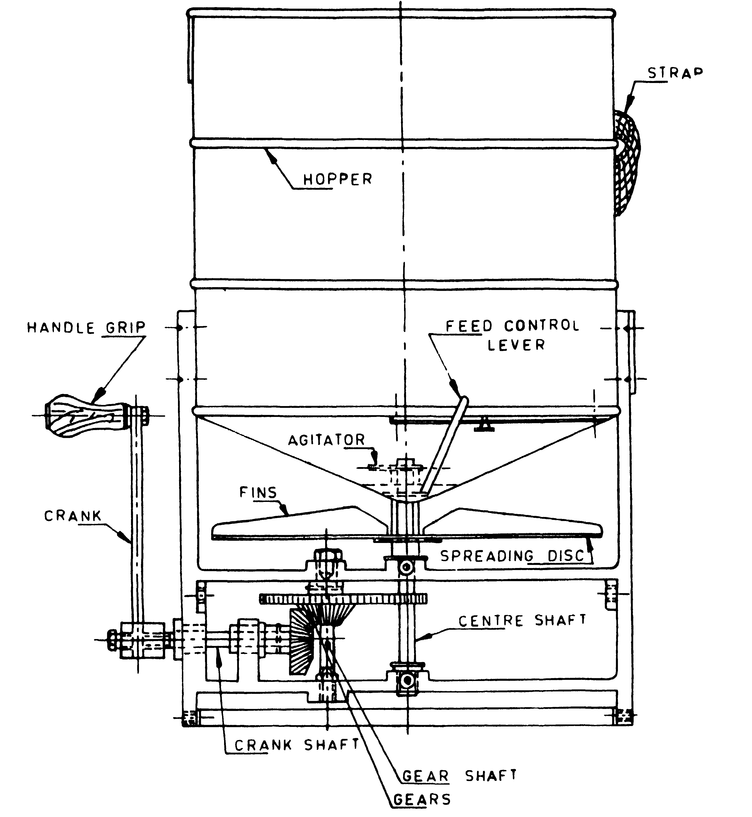

FIG. 1 NOMENCLATURE OF A MANUALLY OPERATED FERTILIZER BROADCASTER

**3.1 Agitator** ⎯ A device which mechanically initiates the movement of the fertilizer within the hopper (*see* Fig. 1).

**3.2 Broadcasting** ⎯ The process of scattering of agricultural inputs, such as seed, fertilizer and manure on the surface of the soil.

**3.3 Crank** ⎯ A component to help in rotating the gear train.

**3.4 Feed Control** ⎯ A device to control the feed of the fertilizer.

**3.5 Fertilizer Broadcaster** ⎯ A fertilizer distributor with a spreading width substantially greater than the width of the machine.

**3.6 Hopper** ⎯ A container for holding the fertilizer.

**3.7 Spreading Disc** ⎯ A circular disc having equally spaced fins for spreading the material falling on the disc by centrifugal force.

**3.8 Total Mass** ⎯ The mass of the broadcaster with all its mountings and attachments but without any fertilizer in the hopper.

**4 MATERIAL**

**4.1** The materials for construction of various components of manually operated fertilizer broadcasters are given in Table 1 for guidance.

**4.2** The material used for different components shall be declared by the manufacturer in the parts catalogue (*see* **5.10**).

**5 CONSTRUCTIONAL REQUIREMENTS**

**5.1 Hopper**

The hopper shall have a concave shaped or conical bottom with a slope of 30 to 50° so that the fertilizer contained in it easily moves towards the feeding aperture. The hopper bottom shall have a circular hole for metering the fertilizer. The ratio between the diameter and the height of the hopper shall be in the range of 0.8 to 1.25. The hopper should be covered with a lid. The lid if provided, should have a peeping hole of at least 75 mm in diameter for observing the quantity of fertilizer left in the hopper during operation. The hopper should be sufficiently strong and should not buckle when fully filled with fertilizer.

The thickness of the mild steel and galvanized steel sheet for hopper shall be not less than 0.63 mm and 0.56 mm respectively.

**5.2 Spreading Disc**

The spreading disc mounted at the bottom of the hopper shall have 6 or 8 equally spaced fins. The spreading disc shall have a vertical clearance of at least 30 mm from the hopper bottom.

**Table 1 Material for construction of different components**

|  |  |  |  |
| --- | --- | --- | --- |
| **Sl. No.** | **Name of Component** | **Material** | **Applicable Standard** |
| (1) | (2) | (3) | (4) |
| (i) | Hopper | Mild steel  Galvanized steel sheet  Aluminium  Fibre glass reinforcement plastics  Plastics | IS 2062  IS 277  IS 617  -  - |
| (ii) | Spreading disc | Plastics | - |
| (iii) | Lid | Plastics | - |
| (iv) | Handle grip | Seasoned wood  Plastics | IS 620  - |
| (v) | Gears | Mild steel  Nylon | IS 2062  - |
| (vi) | Agitators | Mild steel  Spring steel | IS 2062  IS 4454 ( Part 2 ) |
| (vii) | Gear shaft | Mild steel  Carbon steel | IS 2062  IS 5517 |
| (viii) | Centre shaft | Carbon steel | IS 5517 |
| (ix) | Crank shaft | Mild steel | IS 2062 |
| (x) | Feed control mechanism | Mild steel  Galvanized steel sheet  Nylon | IS 2062  IS 277  - |
| (xi) | Strap | Woven web cotton  Synthetic yarn | -  - |

**5.3 Feed Control Mechanism**

A suitable feed control mechanism with locking device shall be provided to control the flow of fertilizer through the aperture. The mechanism shall be controlled by 8 levers from outside of the hopper and shall not require any tool for the operation. Provision of an Index pointer with marking for the aperture opening of hopper at positions closed 1/4, 1/2, 3/4 and full shall be provided. Provision of a scale indicating the discharge rate in kg/ha at different settings of the aperture opening is preferred.

**5.4 Agitator**

A suitable agitator shall be provided near the orifice of the hopper to avoid the clogging of the aperture and for feeding the fertilizer to the aperture. The agitator shall be kept at a vertical clearance of at least 3 mm above the aperture.

**5.5 Gear Box and Gears**

A suitable gear arrangement shall be provided for giving a peripheral speed of 500 ± 50 cm/s to the spreading disc. The gear box shall be so designed as to allow easy access to gears for lubricating and inspection. Suitable provision for lubrication shall be provided. The gears shall mate correctly and shall move smoothly.

**5.6 Crank**

A crank shall be fitted with the crank shaft which should function in a clockwise motion. The crank shall be fitted with a handle of sufficient size. The handle shall be in easy reach of the operator.

**5.7 Straps**

**5.7.1** Two straps of suitable length shall be provided in order to help easy carriage of the broadcaster. The provision for easy adjustment of the length of the straps shall be provided. At the option of the purchaser, a cushion of minimum 40 mm width and 20 mm thickness shall be provided with the straps at least on that portion which rests on the shoulder of the operator. The cushion, if provided shall be covered with cotton, canvas, rexin, PVC or plastic-coated fabrics. The straps and their assembly shall withstand the test prescribed in **5.7.2**.

**5.7.2** The hopper shall be filled with granular fertilizer to its total capacity. The broadcaster shall be hung from a solid support by its straps, simulating its carriage by the operator. It shall be lifted to a height of 30 cm and allowed to drop and hang by straps 25 times. The straps and their assembly shall be deemed to have passed this test, if no breakage, deformation, etc. are found during the test.

**5.8 Bearings**

The crank shaft, gear shaft and the centre shaft shall be provided with bearings. The bearings shall be dust proof.

**5.9 Total Mass**

The total mass of the broadcaster shall not exceed 5 kg (*see* **3.8**).

**5.10** **Other Requirements**

**5.10.1** Operational and maintenance manual and parts catalogue shall be provided with each broadcaster. The manual should also contain the safety precautions, recommended forward speed, handle speed, effective width of spread, calibration chart indicating the discharge rate in kg/ha at different settings of the aperture opening, etc.

**5.10.2** Each broadcaster shall also be supplied with necessary tools.

**6 CAPACITY**

The total capacity of the hopper shall be 12 to 15 litres. The capacity shall be declared by the manufacturer. The tolerance on the declared capacity shall be ± 5 percent.

**7 WORKMANSHIP AND FINISH**

**7.1** The components of the broadcaster shall have a smooth finish and shall be free from pits, burrs. Sharp edges and other defects that may be detrimental for their use.

**7.2** The exposed metallic parts shall have a protective coating to prevent surface deterioration in transit and storage.

**8 MARKING AND PACKING**

**8.1 Marking**

Each broadcaster shall be marked with the following particulars:

a) Manufacturer's name or recognized trademark, if any;

b) Batch or code number; and

c) Hopper capacity.

**8.2 BIS Certification Marking**

The products conforming to the requirements of this standard may be certified as per the conformity assessment schemes under the provisions of the *Bureau of Indian Standards Act*, 2016 and the Rules and Regulations framed thereunder, and the products may be marked with the Standard Mark.

**8.3 Packing**

Each broadcaster shall be packed, as agreed to between the purchaser and the supplier, for safe handling in transit.

**9 SAMPLING FOR LOT ACCEPTANCE**

Unless otherwise agreed to between the purchaser and the supplier, sampling of the broadcaster for lot acceptance shall be done in accordance with **3** of IS 7201 (Part 1). The classification of different requirements of this specification for the purpose of lot acceptance is given below for guidance:

a) Dimensional and visual requirements ⎯ *see* **5** (except **5.7.2** and **5.9**).

b) Other than visual and dimensional requirements ⎯ *see* **5.7.2**, **5.9** and **6**.

**ANNEX A**

(*Foreword*)

**COMMITTEE COMPOSITION**

Agricultural Machinery and Equipment Sectional Committee, FAD 11

| *Organization* | *Representative(s)* |
| --- | --- |
| ICAR-Central Institute of Agricultural Engineering, Bhopal | Dr C. R. MEHTA **(*Chairperson*)** |
| Agricultural Machinery Manufacturers Association (AMMA-India), Gandhinagar | Dr Surendra Singh  Shri Mitul Panchal (*Alternate*) |
| All India Farmers Alliance, New Delhi | Dr RAJARAM TRIPATHI  ShriMATI APURVA TRIPATHI (*Alternate*) |
| ASPEE Agro Equipment Private Limited, Mumbai | Shri JATIN S. PATEL  Shri GANGADHAR VARPE (*Alternate*) |
| Automotive Research Association of India, Pune | Shri A Akbar Badusha  Shri GIRISH TANAWADE (*Alternate* I)  Shri GANGARAM AUTI (*Alternate* II) |
| CCS Haryana Agricultural University, Hisar | Dr VIJAYA RANI |
| CLAAS India Private Limited, Chandigarh | Shri KRISHNA PRABHAKAR SIngh |
| CNH Industrial India Private Limited, Pune | Shri SANTHOSH RAO  Shri SUJIT HINGE (*Alternate*) |
| Central Farm Machinery Training and Testing Institute, Budni | SHRI ANIL KUMAR UpadhYAY  SHRI BABUL NATH DIXIT (*Alternate* I)  SHRI PARTH LODH (*Alternate* II) |
| Consumer Guidance Society of India, Mumbai | Shri Sitaram Dixit |
| Dasmesh Mechanical Works Private Limited, Malerkotla | Shri Sarbjeet Singh Panesar  Shri Gurdeep Singh Panesar (*Alternate*) |
| ICAR-All India Coordinated Research Project on Ergonomics and Safety in Agriculture, Bhopal | Dr Sukhbir Singh  Dr Rahul R Potdar (*Alternate* I)  Smt Sweeti Kumari (*Alternate* II) |
| ICAR-All India Coordinated Research Project on Farm Implements and Machinery, Bhopal | Dr K. N. AGRAWAL |
| ICAR-All India Coordinated Research Project on Mechanization of Animal Husbandry, Bhopal | Dr S. P. Singh |
| ICAR-Central Institute of Agricultural Engineering, Bhopal | Dr V. P. Chaudhary  Dr U. R. BADEGAONKAR (*Alternate* I)  Dr DILIP JAT (*Alternate* II) |
| Indian Council of Agricultural Research, New Delhi | Dr Panna Lal Singh (*Alternate*) |
| John Deere India Private Limited, Pune | Shri ANAND RAJ  Shri CHANDRASHEKHAR DESHMUKH (*Alternate I*)  SHRI PRATIK DURAPHE (*Alternate* II) |
| Kerala Agro Machinery Corporation Ltd. (KAMCO), Athani | Shri A.Unnikrishnan  Shri P. C. SAJIMON (*Alternate*) |
| KisanKraft Limited, Bangalore | Shri Ravindra Agarwal  Shri Ankit Chitalia (*Alternate I*)  Shri Sunil Prasad (*Alternate* II) |
| Kubota Agricultural Machinery India Private Limited, Faridabad | Shri ASHOK KUMAR  Shri Ashish Kumar Mallarh (*Alternate*) |
| Maharana Pratap University of Agricultural and Technology, Udaipur | Dr Sanwal Singh Meena |
| Mahatma Phule Krishi Vidyapeeth, Rahuri | Dr Sachin Madhukar Nalawade  Shri Vikram Parasharam Kad (*Alternate* I)  Dr Avdhut Ashok Walun (*Alternate* II) |
| Mahindra and Mahindra Limited, Mumbai | Shri PRADEEP SHINDE (*Alternate*) |
| Ministry of Agriculture, Department of Agriculture, New Delhi | Dr V.N. KALE  Shri ARVIND N. MESHRAM (*Alternate*) |
| National Innovation Foundation, New Delhi | Shri Rakesh Maheshwari  Shri MAHESH PATEL (*Alternate*) |
| National Institute of Plant Health Management, Hyderabad | Dr VIDHU KAMPURATH P.  Shri MUTYALA UDAYA (*Alternate*) |
| North Eastern Region Farm Machinery Training and Testing Institute, Biswanath Chariali | Dr P. P. Rao  Shri S. G. Pawar (*Alternate* I)  Shri KHAGENDRA BORA (*Alternate* II) |
| Northern Region Farm Machinery Training and Testing Institute, Hisar | Dr Mukesh Jain  Shri Sanjay Kumar (*Alternate*) |
| Power Tillers Manufacturers Association, Kolkata | Shri A. R. Ganesh Kumar |
| Punjab Agricultural University, Ludhiana | Dr Mahesh Kumar Narang  Dr Rajesh Goyal (*Alternate* I)  Shri APOORV PRAKASH (*Alternate* II) |
| Southern Region Farm Machinery Training and Testing Institute, Anantpur | Dr B. M. Nandede |
| Tamil Nadu Agricultural University, Coimbatore | Dr R. Kavitha  Dr A. Surendra Kumar (*Alternate* I)  Dr A.P. Mohan kumar (*Alternate* II) |
| Tirth Agro Technology Pvt. Ltd. 'Shaktiman', Rajkot | Shri Parag Devidas Badgujar  Shri V. Audhi Narayan Reddy (*Alternate*) |
| Tractor and Mechanization Association, New Delhi | Shri Philip Koshy  Shri Veenit Negi (*Alternate* I)  Shrimati Devyani (*Alternate* II) |
| Tube Investments Clean Mobility Private Limited, Chennai | Shri ABHISHEK SINHA  Shri S. O. TYagi (*Alternate*) |
| Voluntary Organisation in Interest of Consumer Education (VOICE), New Delhi | Shri B. K. Mukhopadhyay |
| In Personal Capacity (*201, Memnon Tower, Omaxe*  *the Nile, Sector 49, Sohna Road, Gurugram -*  *122018*) | Shri Vivek Gupta |
| BIS Directorate General | SHRIMATI SUNEETI TOTEJA, SCIENTIST ‘F’/SENIOR DIRECTOR AND HEAD (FOOD AND AGRICULTURE DEPARTMENT) [REPRESENTING DIRECTOR GENERAL (*Ex-officio*)] |

*Member Secretary*

SHRI VIKRANT CHAUHAN

SCIENTIST ‘B’/ASSISTANT DIRECTOR

(FOOD AND AGRICULTURE), BIS

Panel to review and formulate Indian Standards on Plant Protection Equipment, FAD 11/P 8

| *Organization* | *Representative(s)* |
| --- | --- |
| ICAR-Central Institute of Agricultural Engineering, Bhopal | Dr K. N. AGRAWAL **(*Convenor*)** |
| Agricultural Machinery Manufacturers Association (AMMA-India), Gandhinagar | Dr Surendra Singh |
| ASPEE Agro Equipment Private Limited, Mumbai | Shri JATIN S. PATEL |
| Dr. Balasaheb Sawant Konkan Krishi Vidyapeeth, Dapoli | Dr P U Shahare |
| John Deere India Private Limited, Pune | Shri Chandrashekhar Deshmukh |
| Ministry of Agriculture, Department of Agriculture, New Delhi | Shri ARVIND N. MESHRAM |
| National Institute of Plant Health Management, Hyderabad | Dr Vidhu Kampurath P. |
| Northern Region Farm Machinery Training and Testing Institute, Hisar | Dr Mukesh Jain |
| Punjab Agricultural University, Ludhiana | Dr Mahesh Kumar Narang |
| Southern Region Farm Machinery Training And Testing Institute, Tractor Nagar | Dr B.M. Nandede |