**Doc: FAD 01(25870)F**

**IS 6940 : 2024**

***भारतीय मानक***

***Indian Standard***

**कीटनाशक और उनके सूत्रीकरण — *परीक्षण पद्धतियाँ***

(*दूसरा* पुनरीक्षण*)*

**PESTICIDES AND THEIR FORMULATIONS — TEST METHODS**

(*Second Revision*)

ICS No. 65.100.99

© BIS 2024

**B U R E A U O F I N D I A N S T A N D A R D S**

MANAK BHAVAN, 9 BAHADUR SHAH ZAFAR MARG

NEW DELHI 110002

**December 2024** **Price Group**

Pesticides Sectional Committee, FAD 01

FOREWORD

This Indian Standard (Second Revision) was adopted by the Bureau of Indian Standards, after the draft finalized by the Pesticides Sectional Committee had been approved by the Food and Agriculture Division Council.

About 350 Indian Standard specifications for technical grade pesticides and their formulations have been published. The standards for technical grade pesticides include insecticides, fungicides, herbicides, rodenticides, and fumigants. The Indian Standard specifications for different kinds of formulations for the above pesticides include emulsifiable concentrates, water dispersible powders, dusting powders, granules, seed dressing formulations, suspension concentrate, wettable powders, oil dispersible powder and concentrates such as bait concentrates and ready-to-use concentrates of certain pesticides themselves etc. The Indian Standards for technical grade as well as for the formulations of various pesticides include certain methods of test that are common to all these standards. With a view to avoid duplication and to provide an easy reference, it was found desirable to publish a separate standard on test methods for parameters that are commonly applicable to various technical grade pesticides and their formulations.

This standard was first published in 1973. While preparing this standard, due consideration was given to the methods of test as arrived at in the WHO specifications; and also the methods of test, prepared by the Collaborative Analytical Pesticides Committee of the Food and Agricultural Organization.

It was first revised in 1982 to cover comprehensively the general analytical details and methods which were not covered in the earlier version. Also, general methods of test for granules were included.

In this revision, the following major changes have been made:

1. The applicability tables indicating the methods of test corresponding to the technical grade pesticides and their formulations have been incorporated.
2. The methods of test for determination of water content, insolubility, wettability, sieve analysis, attrition resistance and suspensibility have been modified.
3. The methods of test for determination of appearance (physical state and colour), loss on drying, density of solid and liquid pesticides by oscillating density meter, pour and tap bulk density, persistent foam, dustiness, dispersibility, spontaneity of dispersion, dispersion stability, pourability, pH range, adhesion to tread seed, viscosity, rate of dissolution of water soluble bags/pouches, miscibility with hydrocarbon oil, degree of dissolution and solution stability, solution property of water soluble tablets, dilution stability of aqueous solution, tablet integrity and disintegration of tablet have been incorporated.

Cross-reference of corresponding method of test between this standard and earlier revision (IS 6940 : 1982) has been given in Annex B for information.

The composition of the Committee responsible for the formulation of this standard is given in Annex C.

In reporting the result of a test or analysis made in accordance with this standard, if the final value, observed or calculated, is to be rounded off, it shall be done in accordance with IS 2 : 2022. ‘Rules for rounding off numerical values (*second revision*)’.

**1 SCOPE**

This standard specifies general methods of test for technical grade pesticides and their different formulations.

**2 REFERENCES**

The following standards contain provisions which, through reference in this text, constitute provisions of this standard. At the time of publication, the editions indicated were valid. All standards are subject to revision, and parties to agreements based on this standard are encouraged to investigate the possibility of applying the most recent editions of the standards indicated below:

|  |  |
| --- | --- |
| *IS No.* | *Title* |
| IS 460 (Part 1) : 2020 | Test Sieves: Part 1 Wire cloth test sieves — Specification (*fourth revision*) |
| IS 878 : 2008 / ISO 4788 : 2005 | Laboratory glassware – Graduated measuring cylinders (*second revision*) |
| IS 1448 (Part 20) : 2024/ ISO 13736 : 2021 | Petroleum and its products - Test methods: Part 20 Determination of flash point - Abel closed - Cup method (*fourth revision*) |
| IS 2362 : 1993 | Determination of water by Karl Fischer method – Test method (*second revision*) |
| IS 3400 (Part 2/Sec 2) : 2023 | Methods of test for rubber, vulcanized or thermoplastic: Part 2 Determination of hardness: Section 2 Hardness between 10 IRHD and 100 IRHD (*fifth revision*) |
| IS 5717 : 2003 | Laboratory glassware – Pyknometers (*second revision*) |
| IS 13360 (Part 11/Sec 11) : 1999/ISO 3219 : 1993 | Plastics – Methods of testing: Part 11 Special properties: Section 11 Polymers/resins in the liquid state or as emulsions or dispersions – Determination of viscosity using a rotational viscometer with defined shear rate |

**3 APPLICABILITY OF METHOD OF TESTS**

**3.1** The applicability of the test methods corresponding to the solid pesticidal formulations is given in Table 1, for liquid pesticidal formulation is given in Table 2 and for technical grade pesticides and manufacturing used products (MUPs) is given in Table 3. The term corresponding to the abbreviations of the formulations and their definitions is provided in Annex A.

NOTE – These tables are only indicative. The parameters provided in the particular product specification may vary and only those shall be for compliance.

**3.2** Test should normally be performed at the specified temperature and if not specified then should be conducted at room temperature and the temperatures should be reported (Room temperature should be within the range of (25°C ± 2) °C.

**3.3** The standard hard water used during the tests shall be prepared by the method given in **6**.

**3.4** If the formulation type is intended to be packed in water soluble pouches/bags; the solubility/dissolution of the pouch/bag (**Cl 25**) shall also be determined in addition to all the applicable parameters of the intended formulation type and the test such as degree of dissolution and solution stability, persistent foam and suspensibility should be tested including the water-soluble bag/pouch in the actual ratio of application.

**3.5** The accelerated storage stability of the pesticide shall be determined by the method given in **34.**

**4 GENERAL**

**4.1** There are several methods which are generally applicable to all technical grade pesticides and their formulations and they are given under various clauses.

**5 APPEARANCE (PHYSICAL STATE AND COLOUR)**

### **5. 1 Physical State**

Approximately 2 g of the test item is placed in a vial and the physical state of the test item is described based on visual inspection. The test has to be conducted at room temperature. The room temperature is measured and recorded. The same test item should be subsequently used for color determination.

### **5.2 Colour**

The test sample is observed by visual inspection with white background and as such colour is recorded. A description of the colour in terms of hue, chroma, and Munsell value is observed visually by comparing to a colour chart. This test should be conducted in day light by an observer with normal colour vision. This study shall be conducted at room temperature. The room temperature is measured and recorded.

Note – The temperature measurement and the use of the colour chart may be done depending on the product to be analysed.

**Table 1 Test Requirements for Solid Formulation**

|  |  |  |  |  |  |  |  |  |  |  |  |  |  |  |  |  |  |  |
| --- | --- | --- | --- | --- | --- | --- | --- | --- | --- | --- | --- | --- | --- | --- | --- | --- | --- | --- |
| **Sl No.** | **Parameter** | **Requirement** | | | | | | | | | | | | | | | | **Methods of tests Ref to Clause** |
|  | | DP | DS | GR | WP | WS | WG | SP | SG | EG | DT | ST | WT | GD | RB | EP | SS |  |
| (1) | (2) | (3) | (4) | (5) | (6) | (7) | (8) | (9) | (10) | (11) | (12) | (13) | (14) | (15) | (16) | (17) | (18) | (19) |
| i) | Appearance | X | X | X | X | X | X | X | X | X | X | X | X | X | X | X | X | **5** |
| ii) | [Water Content](file:///C:\Users\ee4068\OneDrive%20-%20Corteva\Desktop\BIS\Formulation%20Complexity%20Chart.xlsx#'Water Content'!A1) |  |  |  |  |  |  |  |  |  |  |  |  |  |  |  |  | **7** |
| iii) | [Bulk (Pour & Tap) Density](file:///C:\Users\ee4068\OneDrive%20-%20Corteva\Desktop\BIS\Formulation%20Complexity%20Chart.xlsx#'Bulk Density'!A1)/Relative Density | X |  | X |  |  |  |  |  |  |  |  |  |  |  |  |  | **9** |
| iv) | [Wettability](file:///C:\Users\ee4068\OneDrive%20-%20Corteva\Desktop\BIS\Formulation%20Complexity%20Chart.xlsx#Wettability!A1) |  |  |  | X | X | X | X |  | X |  |  |  |  |  | X |  | **10** |
| v) | [Persistent Foam](file:///C:\Users\ee4068\OneDrive%20-%20Corteva\Desktop\BIS\Formulation%20Complexity%20Chart.xlsx#'Persistent Foam'!A1) |  |  |  | X | X | X | X | X | X |  | X | X |  |  | X | X | **11** |
| vi) | [Wet Sieve](file:///C:\Users\ee4068\OneDrive%20-%20Corteva\Desktop\BIS\Formulation%20Complexity%20Chart.xlsx#'Wet Sieve'!A1) |  |  |  | X | X | X |  |  | X |  |  | X |  |  | X |  | **12.1** |
| vii) | [Dry Sieve](file:///C:\Users\ee4068\OneDrive%20-%20Corteva\Desktop\BIS\Formulation%20Complexity%20Chart.xlsx#'Dry Sieve'!A1) | X | X |  |  |  |  |  |  |  |  |  |  |  |  |  |  | **12.2** |
| viii) | [Nominal Size Range](file:///C:\Users\ee4068\OneDrive%20-%20Corteva\Desktop\BIS\Formulation%20Complexity%20Chart.xlsx#'Nominal Size Range'!A1) |  |  | X |  |  |  |  |  |  |  |  |  |  |  |  |  | **12.3** |
| ix) | [Dustiness](file:///C:\Users\ee4068\OneDrive%20-%20Corteva\Desktop\BIS\Formulation%20Complexity%20Chart.xlsx#Dustiness!A1) |  |  | X |  |  | X |  | X | X |  |  |  |  |  |  |  | **13** |
| x) | [Attrition Resistance](file:///C:\Users\ee4068\OneDrive%20-%20Corteva\Desktop\BIS\Formulation%20Complexity%20Chart.xlsx#'Attrition Resistance'!A1) |  |  | X |  |  | X |  | X | X | CR1) | CR1) | CR1) |  |  |  |  | **14** |
| xi) | Dispersibility |  |  |  |  |  | X |  |  |  |  |  |  |  |  |  |  | **15** |
| xii) | [Suspensibility](file:///C:\Users\ee4068\OneDrive%20-%20Corteva\Desktop\BIS\Formulation%20Complexity%20Chart.xlsx#Suspensibility!A1) |  |  |  | X |  | X |  |  |  |  |  | X |  |  |  |  | **17** |
| xiii) | [Dispersion Stability](file:///C:\Users\ee4068\OneDrive%20-%20Corteva\Desktop\BIS\Formulation%20Complexity%20Chart.xlsx#'Dispersion Stability'!A1) |  |  |  |  |  |  |  |  | X |  |  |  |  |  | X |  | **18** |
| xiv) | [Acidity/Alkalinity/pH](file:///C:\Users\ee4068\OneDrive%20-%20Corteva\Desktop\BIS\Formulation%20Complexity%20Chart.xlsx#Acidity_Alkalinity_pH!A1) | X | X | X | X | X | X | X | X | X | X | X | X | X | X | X | X | **21** |
| xv) | Adhesion to seed |  | X |  |  | X |  |  |  |  |  |  |  |  |  |  |  | **23** |
| xvi) | [Degree of dissolution and solution stability](file:///C:\Users\ee4068\OneDrive%20-%20Corteva\Desktop\BIS\Formulation%20Complexity%20Chart.xlsx#'Degree of dissolution_solution'!A1) |  |  |  |  |  |  | X | X |  |  |  |  |  |  |  | X | **27** |
| xvii) | Solution properties of water-soluble tablets |  |  |  |  |  |  |  |  |  |  | X |  |  |  |  |  | **28** |
| xviii) | Tablet Integrity |  |  |  |  |  |  |  |  |  | X | X | X |  |  |  |  | **30** |
| xix) | Disintegration of Tablets |  |  |  |  |  |  |  |  |  | X | X | X |  |  |  |  | **31** |
| NOTE – X indicates Required and CR indicates conditional requirement.  1) Required only for bulk packaged tablets with a diameter < 1 cm that may exhibit surface wear during transport and handling. | | | | | | | | | | | | | | | | | | |

**Table 2 Test Requirements for Liquid Formulation**

|  |  |  |  |  |  |  |  |  |  |  |  |  |  |  |  |  |  |  |  |  |  |
| --- | --- | --- | --- | --- | --- | --- | --- | --- | --- | --- | --- | --- | --- | --- | --- | --- | --- | --- | --- | --- | --- |
| Sl. No. | Parameter | **Requirement** | | | | | | | | | | | | | | | | | | | **Methods of tests Ref to Clause** |
|  |  | FS | ES | SE | SL | SC | DC | EC | EW | GD | OL | UL | OD | CS | ZE | ZW | ZC | ME | SU | LS |  |
| (1) | (2) | (3) | (4) | (5) | (6) | (7) | (8) | (9) | (10) | (11) | (12) | (13) | (14) | (15) | (16) | (17) | (18) | (19) | (20) | (21) | (22) |
| i) | Appearance | X | X | X | X | X | X | X | X | X | X | X | X | X | X | X | X | X | X | X | **5** |
| ii) | [Water Content](file:///C:\Users\ee4068\OneDrive%20-%20Corteva\Desktop\BIS\Formulation%20Complexity%20Chart.xlsx#'Water Content'!A1) |  |  |  | CR2) |  |  |  |  | CR2) |  |  |  |  |  |  |  |  |  | CR2 | **7** |
| iii) | [Persistent Foam](file:///C:\Users\ee4068\OneDrive%20-%20Corteva\Desktop\BIS\Formulation%20Complexity%20Chart.xlsx#'Persistent Foam'!A1) | CR3) | X | X | X | X | X | X | X |  |  |  | X | X | X | X | X | X |  |  | **11** |
| iv) | [Wet Sieve](file:///C:\Users\ee4068\OneDrive%20-%20Corteva\Desktop\BIS\Formulation%20Complexity%20Chart.xlsx#'Wet Sieve'!A1) | X |  | X |  | X | X |  |  |  |  |  | X | X | X | X | X |  |  |  | **12.1** |
| v) | [Spontaneity of dispersion](file:///C:\Users\ee4068\OneDrive%20-%20Corteva\Desktop\BIS\Formulation%20Complexity%20Chart.xlsx#'Spontaneity of Dispersion'!A1) |  |  |  |  | X |  |  |  |  |  |  |  | X |  |  | X |  |  |  | **16** |
| vi) | [Suspensibility](file:///C:\Users\ee4068\OneDrive%20-%20Corteva\Desktop\BIS\Formulation%20Complexity%20Chart.xlsx#Suspensibility!A1) | CR4) |  |  |  | X |  |  |  |  |  |  |  | X |  |  | X |  |  |  | **17** |
| vii) | [Dispersion Stability](file:///C:\Users\ee4068\OneDrive%20-%20Corteva\Desktop\BIS\Formulation%20Complexity%20Chart.xlsx#'Dispersion Stability'!A1) |  |  | X |  |  | X |  |  |  |  |  | X |  | X | X |  |  |  |  | **18** |
| viii) | [Emulsion Stability](file:///C:\Users\ee4068\OneDrive%20-%20Corteva\Desktop\BIS\Formulation%20Complexity%20Chart.xlsx#'Emulsion Stability'!A1) |  | X |  |  |  |  | X | X |  |  |  |  |  |  |  |  | X |  |  | **19** |
| ix) | [Pourability](file:///C:\Users\ee4068\OneDrive%20-%20Corteva\Desktop\BIS\Formulation%20Complexity%20Chart.xlsx#Pourability!A1) | X |  | X |  | X |  |  | X |  |  |  | X | X | X | X | X |  |  |  | **20** |
| x) | [Acidity/Alkalinity/pH](file:///C:\Users\ee4068\OneDrive%20-%20Corteva\Desktop\BIS\Formulation%20Complexity%20Chart.xlsx#Acidity_Alkalinity_pH!A1) | X | X | X | X | X | X | X | X | X | X | X | X | X | X | X | X | X | X | X | **21** |
| xi) | Adhesion to seed | X | X |  |  |  |  |  |  |  |  |  |  |  |  |  |  |  |  | X | **23** |
| xii) | [Viscosity](file:///C:\Users\ee4068\OneDrive%20-%20Corteva\Desktop\BIS\Formulation%20Complexity%20Chart.xlsx#Viscosity!A1) |  |  |  |  |  |  |  |  |  |  | X |  |  |  |  |  |  |  |  | **24** |
| xiii) | Miscibility with hydrocarbon oil |  |  |  |  |  |  |  |  |  | X |  |  |  |  |  |  |  |  |  | **26** |
| xiv) | [Dilution](file:///C:\Users\ee4068\OneDrive%20-%20Corteva\Desktop\BIS\Formulation%20Complexity%20Chart.xlsx#'Degree of dissolution_solution'!A1) Stability |  |  |  | X |  |  |  |  |  |  |  |  |  |  |  |  |  |  | X | **29** |
| xv) | Flash point |  |  |  |  |  |  | X |  |  |  |  |  |  |  |  |  |  |  |  | **32** |
| xvi) | Cold test |  |  |  |  |  |  | X |  |  |  |  |  |  |  |  |  |  |  |  | **33** |
| xvii) | Release Rate# |  |  |  |  |  |  |  |  |  |  |  |  | CR5) | CR5) | CR5) | CR5) |  |  |  | **-** |
| xviii) | Free Active Ingredient# |  |  |  |  |  |  |  |  |  |  |  |  | CR5) | CR5) | CR5) | CR5) |  |  |  | **-** |
| # Method to be specified in the product specification | | | | | | | | | | | | | | | | | | | | | |
| NOTE – X indicates Required and CR indicates conditional requirement.   |  |  | | --- | --- | | 2) | Applicable for non-aqueous solutions and non-applicable for water-based formulations. Results are considered reliable only if the water content is within the range (1%) of Karl Fisher testing limits. | | 3) | The mass of sample should be specified at the highest recommended use rate, implicit upper limit 10 percent (w/v). | | 4) | Not applicable when the formulation is intended for use without dilution or at dilution rates exceeding the scope of the method (10 %). Chemical assays are normally relied upon to measure the mass of active ingredient remaining in the suspension; the simpler gravimetric method may also be used for routine purposes provided the results are comparable. In cases of dispute, chemical assay shall be the referee method. | | 5) | Complete details supported with appropriate method validation data must be submitted by the proposer of the specification. Separate tolerances for total content must be provided for each active ingredient. Separate clauses must be provided for each relevant impurity. Clauses for free active ingredient content and release rate of the active ingredient are required only for the encapsulated active ingredient(s) and only if appropriate to the intended properties of the capsules. A clause to control release rate is usually required for capsules intended to possess slow- or controlled-release properties. If more than one active ingredient is encapsulated, limits must be provided for each. Methods for determination of free active ingredient and release rate may be product specific. | | | | | | | | | | | | | | | | | | | | | | |

**Table 3 Test Requirements for Technical Material and MUPs**

|  |  |  |  |  |
| --- | --- | --- | --- | --- |
| **Sl. No.** | **Parameter** | **Requirement** | | **Methods of tests Ref to Clause** |
|  |  | Technical | MUP |  |
| (1) | (2) | (3) | (4) | (5) |
| (i) | Appearance | X | X | **5** |
| (ii) | [Water Content](file:///C:\Users\ee4068\OneDrive%20-%20Corteva\Desktop\BIS\Formulation%20Complexity%20Chart.xlsx#'Water Content'!A1) | CR6) |  | **7** |
| (iii) | Acetone/ Other organic solvent/ Water [Insoluble](file:///C:\Users\ee4068\OneDrive%20-%20Corteva\Desktop\BIS\Formulation%20Complexity%20Chart.xlsx#Insolubles!A1) | X |  | **8** |
| (iv) | [Bulk (Pour & Tap) Density](file:///C:\Users\ee4068\OneDrive%20-%20Corteva\Desktop\BIS\Formulation%20Complexity%20Chart.xlsx#'Bulk Density'!A1)/Relative Density |  | X | **9** |
| (v) | [Acidity/Alkalinity/pH](file:///C:\Users\ee4068\OneDrive%20-%20Corteva\Desktop\BIS\Formulation%20Complexity%20Chart.xlsx#Acidity_Alkalinity_pH!A1) | X | X | **21** |
| (vi) | [Melting Point Range](file:///C:\Users\ee4068\OneDrive%20-%20Corteva\Desktop\BIS\Formulation%20Complexity%20Chart.xlsx#'Melting Point Range'!A1) | CR7) |  | **22** |
| NOTE – X indicates Required and CR indicates conditional requirement.  6) Required only when water is present as a byproduct and is part of the composition.  7) Melting point range is not applicable for liquid technical(s) | | | | |

**6 PREPARATION OF STANDARD HARD WATER**

**6.1 Preparation of Standard Hard Water Stock Solution**

Dissolve 3.04 g of calcium chloride anhydrous (preferably fused calcium chloride) and 1.39 g of magnesium chloride hexahydrate in distilled water and make up to one litre and transfer to a polyethylene bottle. This is the hard water stock solution and will be approximately 10 times the required strength of 342 ppm.

* 1. **Standardisation of Hard Water Stock Solution**

**6.2.1** *Preparation of EDTA (0.01M) Solution*

Weigh an amount of 3.7224 g of disodium EDTA (AR grade) in to a 1 litre standard flask, dissolve in distilled water and make up to the mark with distilled water.

**6.2.2** *Preparation of Buffer Solution (pH 10.0)*

Weigh an amount of 17.5 g of ammonium chloride, in to a 250 ml standard flask, dissolve in small quantity of distilled water, add 142 ml of concentrated ammonia solution (0.88 – 0.9 sp.gr) to it, mix and make up to the mark with distilled water.

**6.2.3** *Preparation of Eriochrome Black T Indicator*

Dissolved 0.2 g of Eriochrom black T indicator in 15 ml of tri-ethanolamine and 5 ml of absolute ethanol.

**6.2.4** Standardisation of EDTA Solution

Weigh an amount of 70 mg of zinc chloride or 90 mg of zinc sulphate AR grade in to a conical flask, dissolve in 50 ml distilled water, add 1 ml of buffer and approximately 30-40 mg of Eriochrom black T indicator as given in **6.2.3** or 1 percent Eriochrom black T in KNO3 (solid). Titrate against EDTA solution till blue colour appears.

Calculation of Molarity of EDTA = $\frac{Mass of zinc salt taken × 1000}{Molar mass of zinc salt taken × total volume of EDTA}$

**6.2.5** *Standardisation of Hard Water Stock Solution*

Pipette out 10 ml of hard water stock solution in to a conical flask, add 30 to 40 ml distilled water, add 1 ml buffer (*p*H 10.0) and titrate against standard EDTA solution using Eriochrom black T as indicator. The colour changes from wine red to pure blue. Calculate the molarity of hard water stock solution using the formula; M1V1 = M2V2

**6.3 Preparation of Standard Hard Water of 342 ppm**

Calculate the amount/volume of hard water stock solution required to make 1 litre standard hard water of 342 ppm solution and transfer such quantity using a graduated pipette in to a 1000 ml standard flask and make up to mark with distilled water.

**7 DETERMINATION OF WATER CONTENT**

**7.1** For the determination of water content, two methods, namely, the Karl Fisher method (*see* **7.1.1**) and the Dean and Stark method (*see* **7.1.2**) have been specified. The Karl Fisher method may be followed if the expected water content is below 1.0 percent and the Dean and Stark method in cases where the expected water content is 1.0 percent and above.

**7.1.1** *Karl Fischer Method*

The water content of the sample is determination by using the Karl Fischer method prescribed in IS 2362 or by the following method.

**7.1.1.1** *Principle*

The sample is dissolved or dispersed in the solvent solution and titrated with the titration solution of known water equivalent.

NOTE – Where a sample is not fully dissolved, the entrained portion of the water may not be completely determined due to incomplete extraction.

**7.1.1.2** *Apparatus/Equipment*

1. *Automatic Karl Fischer titrator*
2. *Titration device –* including titration cell, double platinum electrode, magnetic stirrer, pump unit for dispensing the solvent solution and removing the contents of the titration cell, equipped with a drying tube filled with dried molecular sieve.
3. *Titration stand*
4. *Burette exchange unit* – 10 ml, equipped with a micro valve burette tip in order to reduce back diffusion

**7.1.1.3** *Reagents/Solutions*

1. *Solvent solution* *or equivalent* - The solvent solution contains parts of the reaction components (SO2 and base), it has a limited water capacity. Therefore, 20 ml of solvent can only titrate a maximum of 100 mg of water.
2. *Standard hard water – see* **6**
3. *Sodium tartrate dihydrate* {[CH(OH)COONa]2∙2H2O} – of primary standard quality, water content: (15.66 ± 0.05) %
4. *Titration solution* water equivalent: (5.00 ± 0.02) mg/ml

**7.1.1.4 Procedure**

**7.1.1.4.1** *Pre-titration*

Dispense enough solvent solution into the empty titration cell so that the platinum tips of the electrode are completely immersed. Adjust the burette tip to a position that ensures that the excess of the added titration solution travels the longest possible distance before reaching the electrode. Operate the titrator according to the instructions of the manufacturer. Titrate the water in the solvent solution with the titration solution, stirring until the chosen end-point is reached, and refill the titration burette.

NOTE – Instead of using solvent solution alone, a mixture with appropriate solubilizers may be used as working medium. The proportion of solvent solution should not be less than 50% (*v*/*v*).

**7.1.1.4.2** *Determination of the water equivalent of the titration solution*

1. *Use of water as calibration substance*

After finishing the pre-titration, dispense 30 – 50 µl (approx. 30 - 50 mg) of water into the titration cell by using a micro syringe. Weigh (to the nearest 0.1 mg) the micro syringe before and after dispensing the water (mass difference: *m1* g). Carry out the titration (*b* ml). This step may be repeated two or three times before removing the contents of the titration cell.

1. *Use of standard hard water as calibration substance*

After finishing the pre-titration weigh (to the nearest 0.1 mg) 3 to 4 g (*m2* g) of standard hard water into the titration cell and carry out the titration (*b* ml). This step may be repeated two or three times before removing the contents of the titration cell.

1. *Use of sodium tartrate dihydrate as calibration substance*

After finishing the pre-titration weigh (to the nearest 0.1 mg) 0.20 to 0.25 g (*m*3 g) sodium tartrate dihydrate into the titration cell and carry out the titration (*b* ml). Before repeating this calibration step, remove the contents of the titration cell and start again the pre-titration.

Note – In case of any dispute, sodium tartrate dihydrate shall be used as calibration substance

**7.1.1.4.3** *Determination*

Remove the contents of the titration cell after finishing the calibration and repeat the pre-titration. Then weigh (to the nearest 1 mg) into the titration cell an appropriate amount of the sample (*w* g) given below:

|  |  |  |
| --- | --- | --- |
| **Expected water content of the sample (g/kg)** | **Mass of sample (g)** | **Expected consumption of titration solution (ml)** |
| 0.5 | 10 | 1 |
| 1 | 10 | 2 |
| 2 | 10 | 4 |
| 5 | 10 | 10 |
| 10 | 5 | 10 |
| 20 | 2.5 | 10 |
| 50 | 1 | 10 |
| 100 | 0.5 | 10 |
| 200 | 0.25 | 10 |

Wait until the material has dissolved or dispersed and carry out the titration (*T* ml).

**7.1.1.5** *Calculation*

Calculate the amount of water (*W*) titrated.

For [**7.1.1.4.2 a**)] *W* = *m1*

For [**7.1.1.4.2 b**)] *W = $\frac{Actual percentage of water content in standard solution ×amount of sample weighed}{100}$*

For [**7.1.1.4.2 c**)] *W* = $\frac{15.66 × m_{3}}{100}$

Water equivalent of the titration solution, E = $\frac{W}{b}$

Water content of the sample, percent by mass = $\frac{T × E}{w} × 100$

where

*m1* = mass, in g, of water taken for the calibration;

*m2* = mass, in g, of standard hard water taken for the calibration;

*m3* = mass, in g, of sodium tartrate dihydrate taken for the calibration;

*W* = mass, in g, of water in amount of calibration substance used;

*E* = water equivalent, in g/l, of the titration solution;

*b* = volume, in ml, required for the calibration;

*T* = volume, in ml, required for the sample determination; and

*w =* mass, in g, of sample taken.

**7.1.2** *Dean and Stark Method*

**7.1.2.1** *Apparatus*

1. *Distillation flask* — made of hard glass with 500 ml capacity and provided with a ground-glass socket.
2. *Reflux condenser* — made of glass, water cooled, having the outside diameter of the inner tube 16 to 17 mm, and that of the jacket 23 to 25 mm. The lower end of the condenser is provided with a ground- glass cone. The tip of the condenser is ground at an angle of approximately 30° from the vertical axis.
3. *Receiver (or trap)* — made of hard glass and consisting esseritially of an upper chamber, provided with a side-arm leading to the distillation flask, and a cylindrical graduated portion, the lower end of which is sealed. The opening of the upper chamber is provided with a ground-glass socket fitting the cone of the condenser. The lower end of the side-arm is provided with a ground-glass cone fitting the socket of the distillation flask. The graduated portion has a capacity of 5 ml when filled to the highest graduation mark. The scale covers the range 0 to 5 ml, with graduation marks at 0.1 ml, intervals. The error at any indicated capacity should not exceed 0.02 ml.
4. *Heat source*— either an oil-bath or an electric heater provided with a sliding rheostat or other means of heat control. The temperature of the oil in the bath should not be very much higher than the boiling point of petroleum naptha [*see* **7.1.2.2 b)**].
5. *Copper wire* — long enough to extend through the condenser with one end twisted into a spiral. The diameter of the spiral should be such that it fits snugly within the graduated portion of receiver and yet can be moved up and down.

**7.1.2.2** *Reagents*

1. Chromic acid cleaning solution
2. One of the following solvents may be used:

i) Petroleum naphtha with a boiling range of 90 to 210 °C;

ii) n-Heptane, boiling point around 98 °C; and

iii) Toluene boiling point around 110 °C.

**7.1.2.3** **Procedur**e

Clean the entire apparatus (*see* Fig. 1) with chromic acid solution to minimize the adherence of water droplets to the sides of the condenser and the receiver. Rinse thoroughly with distilled water and dry completely before using.

Place an appropriate amount of the sample accurately weighed into the distillation flask. The amount of sample taken should be such that the distillation flask is not more than one-third full; it should not contain more than 18 ml of water. Add sufficient volume of the solvent (100 to 200 ml) so that the sample shall be completely covered by the solvent while the distillation is in progress. Swirl to mix and add pumice stone to ensure steady boiling. Assemble the apparatus and fill the receiver with the solvent by pouring the solvent through the condenser until it begins to overflow into the distillation flask. Attach a guard tube containing anhydrous calcium chloride at the top of the condenser to prevent condensation of atmospheric moisture within the tube. In order that the refluxing may be under control, wrap the distillation flask and the tube leading to the receiver with asbestos fibre. Heat the flask at such a rate that about 100 drops are distilled over, increase the distillation rate to about 200 drops/min and continue heating until no more water is collected. Purge the condenser occasionally during the distillation with 5 ml portions of the solvent in order to down wash down any moisture adhering to the walls of the condenser. The water in the trap may be made to separate from the solvent by means of a copper wire, one end of which is twisted into a helix. The copper wire if moved up and down in the condenser and receiver occasionally causes the water to settle down at the bottom of the trap. Reflux until the water level in the receiver remains unchanged for 30 minutes and then shut off the source of heat. Flush the condenser with the solvent, making use of the copper wire to disengage any moisture droplets. Allow to stand for about 15 minutes and then read the volume of water.

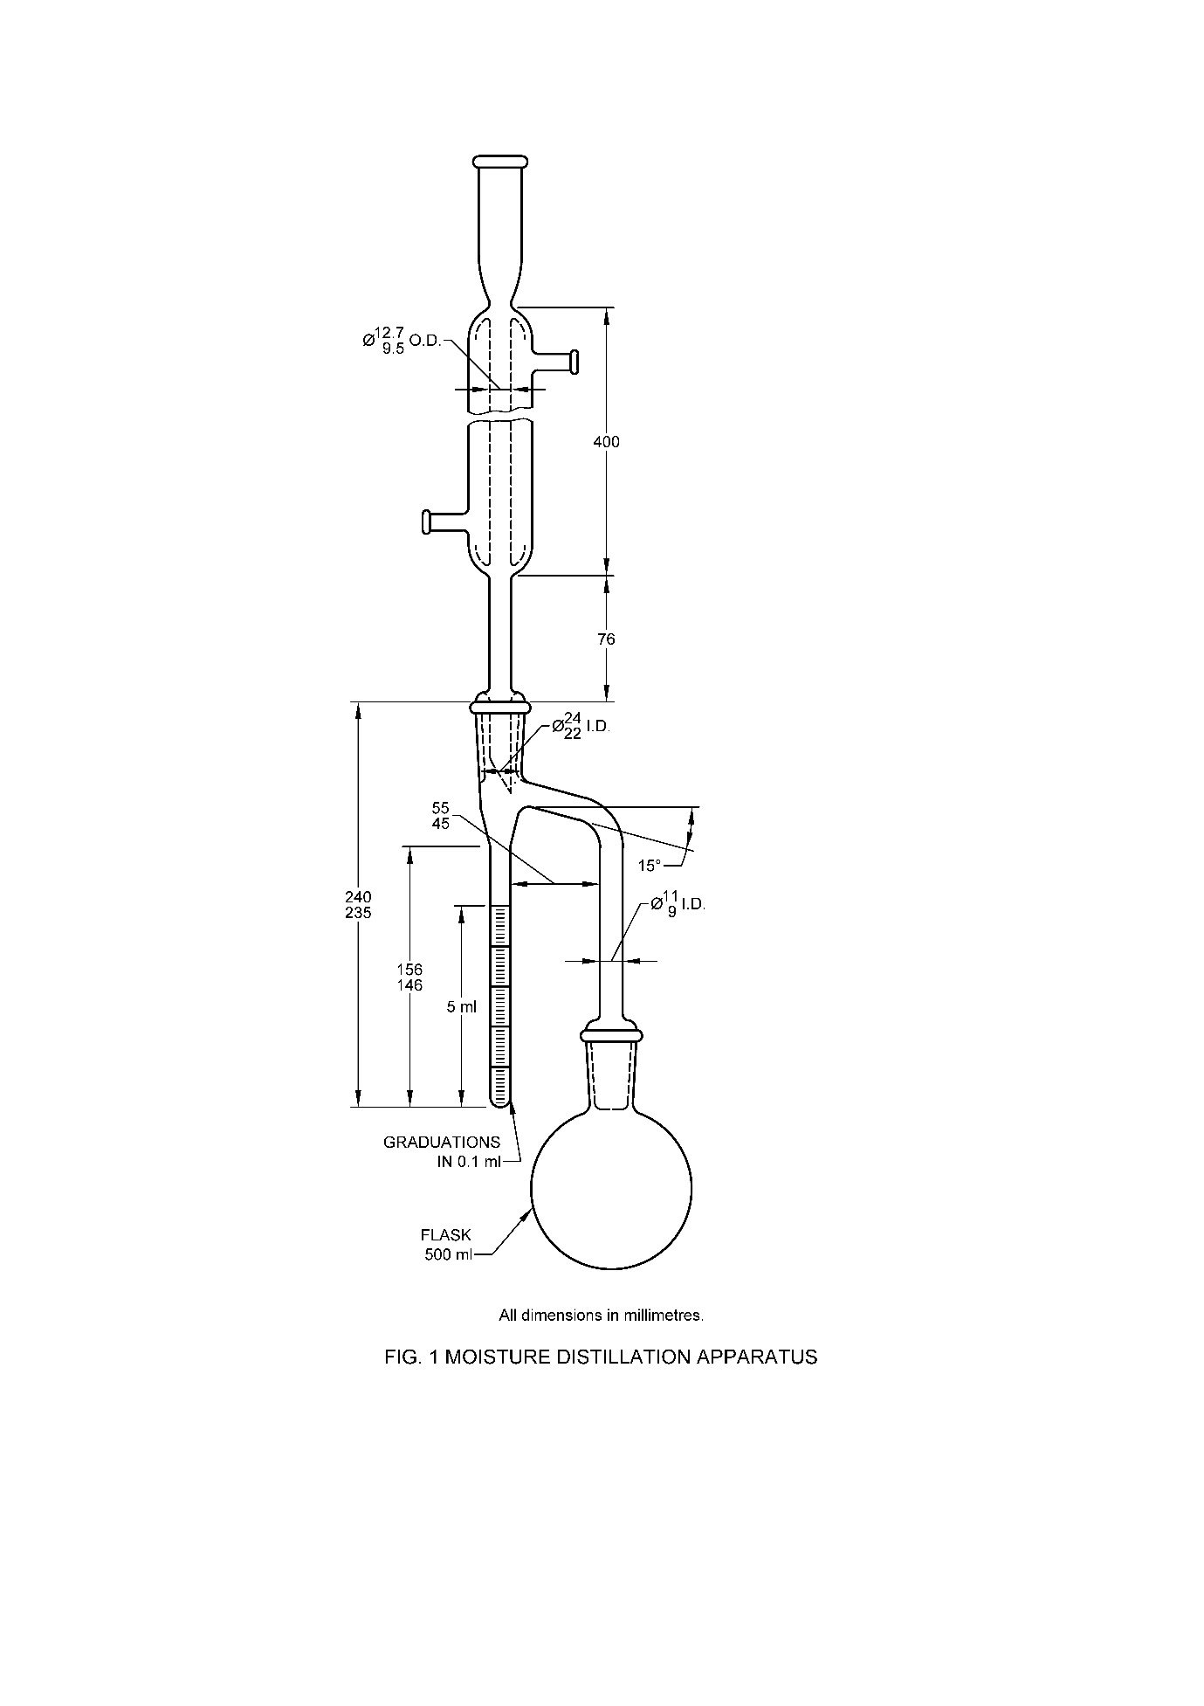

**7.1.2.4 Calculation**

Moisture content, percent by mass = $\frac{100 V}{M}$

Where

*V* = volume, in ml, of water collected; and

*M* = mass, in g, of the material taken for the test.

**7.1.2.5 Precision** — The results of a duplicate determination of moisture content of the material, percent by mass, should not vary by more than ± 0.05 from that of the first determination.

**7.2 Loss on Drying Method**

**7.2.1** *Principle*

The sample of solid formulation or technical material is heated to a given temperature and the loss in weight is measured directly as percentage moisture lost. This method is not suitable for materials with volatile components other than water.

**7.2.2** *Apparatus*

**7.2.2.1** *For Heating in oven*

1. *Petri dish or wide mouth beaker*
2. *Oven with thermostat control* – of memmert type
3. *Desiccator with desiccant.*

**7.2.2.2** *For IR Balance*

1. *Mettler infrared drying unit and balance or equivalent*
2. *Appropriate aluminium weighing pan*

**7.2.3** *Procedure*

**7.2.3.1** *By oven*

Heat the petri dish or wide mouth beaker in the oven at the specified temperature for 1 h. Cool the petri dish or wide mouth beaker to room temperature inside a desiccator and weigh (*a* g). It should read a constant weight before actual experiment/test is conducted. Weigh about 5 g of sample (free from lumps), note down the weight to nearest 1 mg (*w* g) and it is spread evenly inside the bottle. Transfer the bottle to the oven and leave it at the specified temperature for 1 h. After the end of 1 h, the petri dish or wide mouth beaker is removed, cooled in a desiccator and weighed (*b* g)

**7.2.3.2** *Calculation*

Loss in weight, percent by mass = $\frac{w-b}{w-a} × 100$

**7.2.3.3** *By IR balance*

The instrument is set up before testing by selecting the required temperature and runtime. The aluminium weighing pan is placed in the balance and tared. Add the quantity of formulation required (based on estimated moisture content, generally ranging from 1.0 to 5.0 gm) using a spatula. The instrument records the change in weight between initial, weight change at each interval and final weight and the percent moisture

**8 DETERMINATION OF INSOLUBILITY**

**8.1 Material Insoluble in Acetone/Organic Solvents**

**8.1.1** *Principle*

The sample is refluxed with acetone or other organic solvents, the solution is filtered, and the weight of insoluble material is determined.

**8.1.2** *Apparatus*

1. *Flask,* 250 ml fitted with ground glass joint

1. *Reflux condenser,* to fit flask

1. *Sintered glass crucible,* porosity P40 (pore size 16-40 µm)
2. *Flameproof* *Oven,* with thermostat control of memmert type.

**8.1.3** *Reagent*

1. *Acetone {(CH3)2CO}*, dried over anhydrous sodium sulphate.
2. *Other organic solvent under test*

**8.1.4** *Procedure*

Weigh about 10 g of sample (w g) into the conical flask, add acetone/organic solvent (150 ml) and reflux (at appropriate temperature depending upon the nature of solvent) for a period of 10 min. Filter the hot solution through the tared crucible of constant weight (x g) and wash well with more acetone/organic solvent (3 × 20 ml). Dry at 110 °C for 30 min, cool and weigh (z g).

**8.1.5** *Calculation*

Material insoluble in acetone/organic solvent, percent by mass = $\frac{\left(z-x\right)}{w} × 100$

**8.2 Material Insoluble in Water**

**8.2.1** *Scope*

The method is used for the determination of impurities in water-soluble technical grade pesticides or insoluble materials in water-soluble formulations which could cause blockage of sieves or jets in spray machinery. Use of hot water or cold water should be as per the nature of the material.

**8.2.2** *Hot Solution of the Sample*

**8.2.2.1** *Principle*

The sample is dissolved in boiling water; any insoluble matter is filtered off, dried, and weighed.

**8.2.2.2** *Apparatus*

1. *Weighing bottle*
2. *Sintered glass crucible* – Porosity P16 (pore size 10-16 µm)

1. *Oven,* with thermostat control of memmert type
2. *Beaker* – 250 ml
3. *Measuring cylinder* – 100 ml
4. *Buchner flask* *and crucible adapter* – 500 ml
5. *Glass stirring rod*

**8.2.2.3** *Procedure*

Dry the crucible at 105 °C to constant weight (*x* g). Weigh (to the nearest 10 mg) the prescribed amount of sample (*w* g) and rinse with water (100 ml) into the beaker. Heat to boiling and stir until all water-soluble material has dissolved. Filter hot through the crucible and wash with hot distilled water (3 × 25 ml). Dry the crucible and residue to constant weight at 105 °C (*y* g).

**8.2.2.4** *Calculation*

Material insoluble in water, percent by mass = $\frac{\left(y-x\right)}{w} × 100$

**8.2.3** *Cold Solution of the sample*

**8.2.3.1** *Principle*

The sample is dissolved in cold water; any insoluble material is filtered off, dried, and weighed.

**8.2.3.2** *Apparatus*

1. *Weighing bottle*
2. *Sintered glass crucible* – Porosity P16 (pore size 10-16 µm)

1. *Oven,* with thermostat control of memmert type
2. *Beaker* – 250 ml
3. *Measuring cylinder* – 100 ml
4. *Buchner flask* *and crucible adapter* – 500 ml
5. *Glass stirring rod*
6. *Stoppered measuring cylinder* – 200 ml

**8.2.3.3** *Procedure*

Dry the crucible to constant weight (*x* g) at 105 °C. Weigh (to the nearest 10 mg) the prescribed amount, or otherwise 20 g of sample (*w* g), rinse with water (200 ml) into the measuring cylinder, stopper and shake vigorously until all water-soluble material has dissolved. Filter the solution through the crucible, and wash the residue in the crucible with distilled water (3 × 25 ml). Dry the crucible and residue to constant weight at 105 °C (*y* g).

**8.2.3.4** *Calculation*

Material insoluble in water, percent by mass = $\frac{\left(y-x\right)}{w} × 100$

**9 DETERMINATION OF DENSITIES OF LIQUIDS AND SOLIDS**

**9.1 Determination of Relative Density/ Specific Gravity of Liquid Pesticides**

**9.1.1** *Terminology*

For the purpose of pesticides, the relative density of the material shall be the ratio of the mass in air of a given volume of the material generally at 27 °C to that of an equal volume of water at the same temperature.

**9.1.2** *Apparatus*

**9.1.2.1** *Relative Density Bottle* — Castell Evans modification with ground-in stopper and ground-on cap (*see* Fig. 2) or a Perkin type pyknometer tube (*see* Fig. 3 and also IS 5717).

**9.1.3** *Procedure*

Weigh a clean and dry relative density bottle or a pyknometer of 25 ml capacity. Fill the tared relative density bottle or the pyknometer with freshly boiled water, place it in a bath maintained at 27 ± 1 °C and allow sufficient time to attain the temperature of the bath. Then insert the ground-in stopper which has also been brought to 27 ± 1 °C. Wipe off the excess from the stopper and place the cap in position. Remove the relative density bottle or the pyknometer from the bath, and weigh. Empty the relative density bottle or the pyknometer, clean and dry it, and then repeat the operation with the material at 27 ± 1 °C.

**9.1.4** *Calculation and Reporting*

**9.1.4.1** Specify the temperature of testing in the report.

**9.1.4.2** The relative density is calculated by the following formula:

Relative density at 27 °C/ 27 °C = $\frac{C-A}{B-A}$

where

*C* = mass in g of the relative density bottle or the pyknometer filled with the material at 27 °C,

*A* = mass in g of the dry relative density bottle or the pyknometer, and

*B* = mass in g of the relative density bottle or the pyknometer filled with water at 27 °C.

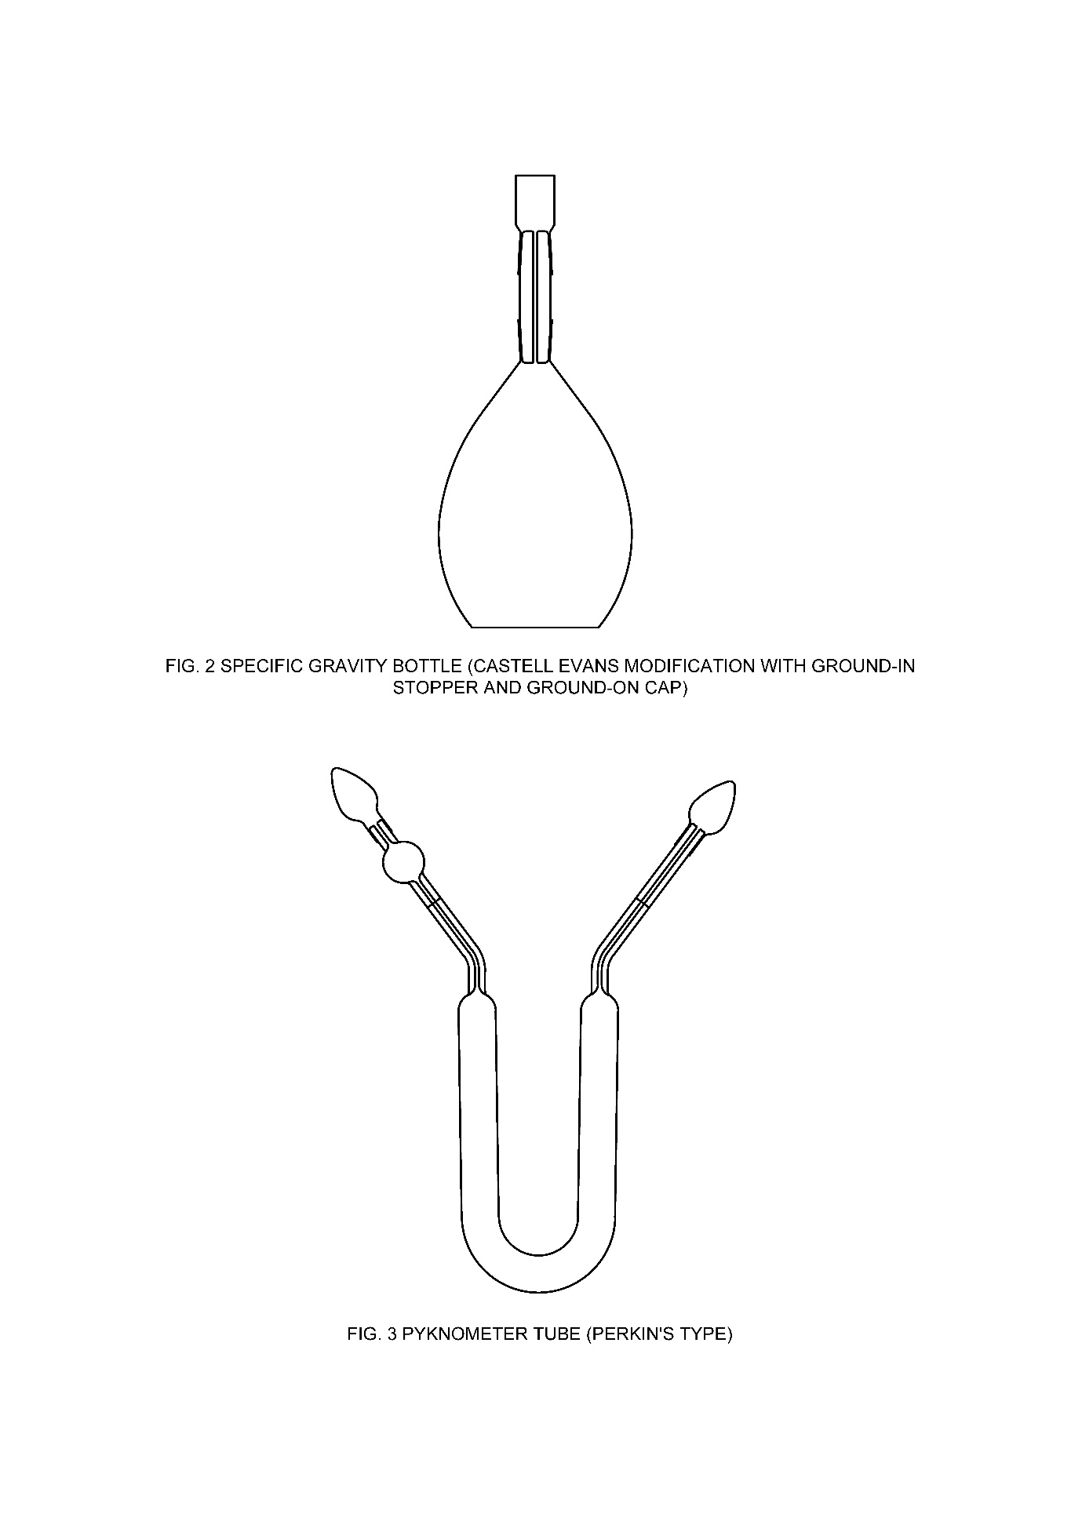

**9.2 Determination of Density of Solid and Liquid Pesticides by Oscillating Density Meter**

**9.2.1** *Principle*

Relative Density is determined by filling a tube of the oscillating density meter with the test material/solution and vibrating the tube at a specific frequency. The resonance frequency of the tube will vary with the density of the test material.

**9.2.2** *Apparatus*

1. *Oscillating density meter;*
2. *Standard laboratory glassware; and*
3. *Syringes*

**9.2.3** *Reagents*

1. *Distilled Water*

**9.2.4** *Procedure*

**9.2.4.1** *Formulations containing solids*

Prepare a 1 : 2 dilution of the test formulation. For example, weigh to the nearest 0.1 mg approximately 2.0 g of sample (*M*1) and 4.0 g diluent (*M*2) into a 10 ml screw capped vial. Stopper the vial and shake to mix ensuring the solution is homogeneous and free from any sediment.

Inject the solution, using a suitable syringe, into the oscillating density meter at the specified temperature and record the density (*D*1). Repeat using diluent and record density (D2). The density should be reported to 4 decimal places. Calculate density of formulations containing solids as follows:

Density (g/ml) = $\frac{weight of sample}{volume of sample}$ = $\frac{M_{1}}{\left[\frac{M_{1}+M_{2}}{D_{1}}\right]-\left(\frac{M_{2}}{D_{2}}\right)}$

where

*M*1 = mass, in g, of the sample;

*M*2 = mass, in g, of the diluent;

*D*1 = density, in g/ml of the solution; and

*D*2 = density, in g/ml, of the diluent.

**9.2.4.2** *Formulations containing liquids*

Inject the sample, using a suitable syringe, into the oscillating density meter at the specified temperature and record the density. The density should be reported to 4 decimal places.

**9.3 Bulk Density After Compacting**

**9.3.1** *Apparatus*

1. *Graduated cylinder* – of 100 ml capacity (*see* IS 878) with internal diameter of 27 to 29 mm
2. *Funnel* – wide and short-stemmed.

**9.3.2** *Procedure*

**9.3.2.1** *Bulk density before compacting*

Rest the funnel over the top edge of the tared graduated cylinder. Fill the cylinder to the 100 ml mark by pouring the material through the funnel, without tapping, and level the powder with the minimum of disturbance. Leave the cylinder untouched for 5 min and add more powder, if necessary, to bring the contents to the 100 ml mark, level again with the minimum of disturbance. Weigh the filled cylinder and calculate the bulk density before compacting (mass of the material/volume occupied by the material).

**9.3.2.2** *Bulk density after* *compacting*

Stopper the filled cylinder (*see* **9.3.2.1**), and drop it 20 times through a height of 15 cm on to a felt pad resting on a hard surface. Note the volume of the material after compacting. Calculate the bulk density of the material after compacting (mass of the material/volume occupied by the material after compacting).

**9.3.3** *Test Evaluation*

The value obtained in **9.3.2.2** shall not exceed the value obtained in **9.3.2.1** by more than 60 percent.

**9.4 Pour And Tap Bulk Density of Granular Materials**

**9.4.1** *Principle*

A known weight of a test formulation is placed in a glass measuring cylinder and its volume measured (to determine the 'pour density'). The cylinder is then raised and allowed to fall vertically through a distance of 25 mm on to a rubber pad 50 times. The volume is measured once again (to determine the ‘tap density’).

**9.4.2** *Definitions*

1. *Pour density* – It is the apparent density of a bed of material formed in a container of standard dimensions when a specified amount of the material is introduced without settling.
2. *Tap density* – It is the density after the material is vibrated or tapped under standard conditions.

**9.4.3** *Apparatus*

1. *Measuring cylinder* – 250 ml (*see* IS 878)
2. *Rubber base pad* – Hardness of 35-50 IRHD [*See* IS 3400 (Part 2/Sec 2)]. Other materials of similar hardness have been found satisfactory, e.g. neoprene sheet.
3. *Timing device* – to indicate seconds
4. *Balance* – with an accuracy of at least ± 0.1 g
5. *Dropping box* – firmly screwed to a rigid table or bench
6. *Glazed sampling paper*.

**9.4.4** *Procedure*

Place the sample onto a glazed paper. Transfer the sample smoothly into the cylinder through a dry funnel until approximately 90 percent of its capacity is filled. Weigh this amount of sample (*W* g), to the nearest 0.1 g. Gently level off the surface with a hair brush and measure the volume to the nearest 2 ml (*V*1 ml). Fit the rubber bung into the cylinder without jolting. Put the cylinder carefully in the dropping box for the manual tapping procedure and start the timing device. Gently grasp the upper part of the cylinder and raise it 25 mm, allow it to drop on to the rubber base pad and repeat until a total of 50 taps has been made, making 1 tap every 2 seconds. Measure and record the volume of the material to the nearest 2 ml (*V*2 ml). Calculate the densities (g/ ml).

NOTE – Rotation of the cylinder through about 10 degrees should be made during the lifting to help impart a level surface to the granules*.*

**9.4.5** *Calculation*

Pour density (DP), g/ml = $\frac{W}{V_{1}}$

Tap density (DT), g/ml = $\frac{W}{V_{2}}$

**10 DETERMINATION OF WETTABILITY**

**10.1 Scope**

The method describes a procedure for the determination of the time of complete wetting of formulation with or without swirling depending upon the nature of formulation.

**10.2 Principle**

A weighed amount of the formulation sample is dropped on water in a beaker from a specified height. The time for complete wetting is determined.

**10.3 Reagent**

1. *Standard hard water – see* **6**

**10.4 Apparatus**

1. *Beaker* – 250 ml capacity, internal diameter 6.5 ± 0.5 cm, height 9.0 ± 0.5 cm
2. *Weighing bottle*
3. *Stopwatch* – accurate to the nearest second
4. *Measuring cylinder* – 100 ml capacity.

**10.5 Procedure**

**10.5.1** *Without swirling*

Pour standard hard water (100 ± 1 ml) into the beaker. Weigh out 5 ± 0.1 g of a representative sample of the formulation, taking care that it remains in a non-compacted state. Add all the sample at once, by dropping it on the water from a position level with the rim of the beaker, without undue agitation of the liquid surface. When the powder is added, start the stopwatch and note the time taken (to the nearest second) for it to become completely wetted. Report the time, to the nearest second, required for complete wetting of the powder as the wetting time.

**10.5.2** *With swirling*

Carry out the above mentioned except that the contents of the beaker should be swirled by hand at the rate of 120 swirls per minute after the addition of the powder. Report the results as wetting time with swirling.

**11 DETERMINATION OF PERSISTENT FOAM**

**11.1** **Principle**

The method is intended for determining the persistent foam created when formulations are added to water before use. The formulation is diluted in a measuring cylinder of standard dimensions which is inverted 30 times. The amount of foam created and remaining after certain times is measured.

**11.2 Apparatus / Equipment**

1. *Graduated Cylinder* – glass stoppered, 250 ml capacity with 2 ml graduations, the distance between the 0 mark and the 250 ml mark being 20 cm - 21.5 cm and between the 250 ml mark and the bottom of the stopper, 6 cm to 8 cm.

NOTE — The cylinder should be clean and free from grease

1. *Stopwatch*
2. *Top pan balance*
3. *Thermometer*

**11.3 Reagents/Solutions**

1. *Standard hard water – see* **6**

**11.4 Procedure**

The mass of sample to be taken is that mass required to make 200 ml of a diluted formulation with a concentration recommended in the directions for use supplied with the product. When several concentrations are recommended, the maximum concentration shall be used.

Put about 180 ml of standard hard water into the 250 ml measuring cylinder standing on a top pan balance and weigh in the required amount of the sample. Fill to 200 ml with standard hard water and record the temperature. The recommended temperature is 25 ± 2°C. Stopper the cylinder and then invert it 30 times by hand through 180 degrees and back to its original position, the whole operation being completed in approximately 60 sec. Place the stoppered cylinder upright on the bench and immediately start the stopwatch. Read the volume of foam produced and remaining after 1 min. A few bubbles round the periphery are not significant. Any volumes above the 250 ml mark should be marked on the outside and the volume of foam thus determined.

**12 SIEVE TEST**

**12.1 Determination of Wet Sieve**

**12.1.1** *Principle*

A sample of formulation is dispersed in water and the suspension formed is transferred to a sieve and washed. The amount of the material retained on the sieve is determined by drying and weighing.

**12.1.2** *Apparatus*

1. *Weighing balance*
2. *Beaker* – 250 ml capacity
3. *Magnetic stirrer* *and magnetic flea (stirring bar)*
4. *Rubber hose* – of 10 mm internal diameter
5. *Oven –* with thermostat control of memmert type
6. *Desiccator –* with desiccant
7. *Test Sieve* – specified IS Sieve [*see* IS 460 (Part 1)] prepared for the test by removing any film, grease or other water repellent material and then by drying.

**12.1.3** *Procedure*

**12.1.3.1***Wetting*

Weigh (to the nearest 0.1 g) 10 g (or if necessary, a more appropriate quantity) of the sample into a beaker (250 ml) and tap water (100 ml) is added. The solution is allowed to stand for 60 sec and then stirred gently with the magnetic stirrer for 5 min, making no deliberate attempt to break up any lumps.

NOTE – The speed of the rotation of the magnetic flea should be chosen such that a vortex just forms on the surface of the liquid. The shear forces generated this way approach those found in commercial spray equipment. Care should be taken that the dispersion does not become aerated by over-vigorous dispersion of the sample.

**12.1.3.2***Wet sieving*

The slurry is then transferred to the specified IS sieve, rinsing with tap water, removing the magnetic flea (having washed any dispersed material from the flea into the sieve). The material on the sieve is washed with a jet of tap water using a rubber hose of 10 mm internal diameter delivering 4-5 litres of water per minute. The tap water may contain solids and should, if required be screened before use. The washing is continued until the visible quantity of residue remains constant (max 10 min). The water is directed from the circumference of the sieve towards the center and kept the end of the hose at a distance of 2 – 5 cm from the sieve surface. The residue is transferred to a tared glass dish with a jet of deionized water from a wash bottle. The residue dried to constant weight. A temperature of 60 oC to 70 oC is recommended. If necessary, the temperature shall be varied to avoid decomposition or volatilization at the drying temperature. Record the weight of the sample to the nearest 0.01 g.

**12.1.4** *Calculation*

Material passing through specified IS Sieve, percent by mass = 100 (1 – $\frac{m}{M}$)

where

*m* = mass, in g, of the dry residue obtained (*see* **12.1.3.2**) and

M = mass, in g, of the material taken for the test.

**12.2 Determination of Dry Sieve**

**12.2.1** *Scope*

This method is suitable for the determination of the particle size distribution of granular formulations.

**12.2.2** *Outline of Method*

Sieve analysis consists of the quantitative separation of granular formulations into fractions of different particle size ranges by use of the machine sieving. If the apparatus required is not available, a simple method of hand sieving can be used.

**12.2.3** *Apparatus*

1. *Test sieves –* about 20 cm diameter. Preferred mesh sizes are 3350, 2000, 1000, 500, 250, 125 or 75 µm as specified for the formulation.
2. *Lid and receiver pan –* for the above sieves
3. *Soft brush (2.5 cm flat)* – for cleaning the finer mesh sieves
4. *Stiff brush –* for cleaning the coarser sieves
5. *Balance –* sensitive to 0.1 g, with a precision of ± 0.05 g.
6. *Glazed paper sheets –* of not less than 38 cm square
7. *Inclyno test sieve shaker* *or equivalent equipment or equivalent –* for machine sieving only
8. *Three retort stands –* for hand sieving only
9. *Three socket fittings –* for hand sieving only
10. *Three metal rods –* with diameter of about 1 cm and length of about 10 cm (for hand sieving only).
11. *Hard-rubber sheet* – size min. 20 x 20 cm2 (for hand sieving only).
12. *Assembly of component parts* – *see* Fig. 4 (for hand sieving only).

**12.2.4** *Procedure*

For each determination, the mass *M* of the sample is calculated as:

*M* = *n* x *D* x 20 ml

where

n = number of sieves used

D = tap density (g/ml) of the formulation

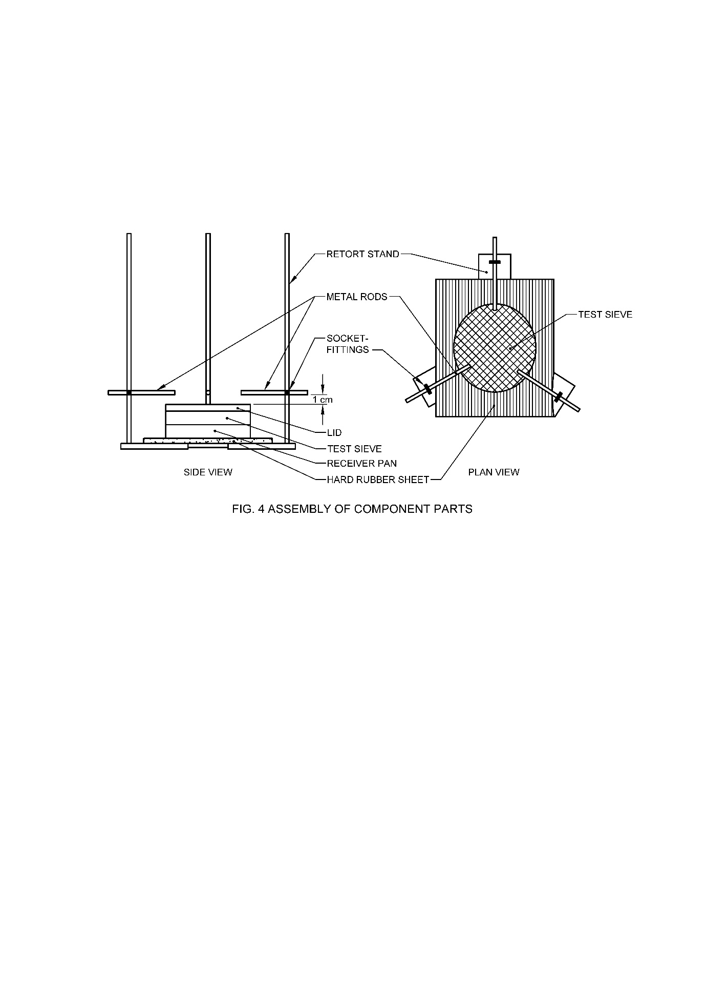

**12.2.4.1** *Machine sieving procedure*

Assemble the nest of x sieves in the correct order with the coarsest at the top and the finest at the bottom, and mount then on the receiver pan. Weigh a sample of specified weight (*M* g) to the nearest 0.1 g and transfer it to the coarsest sieve. Fit the lid to the nest of sieves and put it in the sieving machine. Start the machine and let it run for a period of 5 min. Remove the nest of sieves from the machine after allowing time for airborne particles to settle (about 2 min). Take off the lid carefully and invert each sieve over a separate sheet of paper, tap the side of the sieve frame and carefully brush the uppermost surface. Reverse the sieve and repeat the process to dislodge any loose particles remaining. Add the brushings to the bulk of material taken from each sieve. Follow this procedure for each sieve x and record the individual masses (gx) to the nearest 0.1 g.

The residue (rx) on each sieve x is calculated as:

rx, percent by mass = $\frac{g_{x} × 100}{M}$

where

gx = the amount of material retained by the sieve x

The sum of residues (Rx) on all the x sieves is calculated as:

Rx =

The particle size distribution of the granular formulations is specified by the range [x1, x2] of two sieves where Rx1 ≥ 90% and Rx2 ≤ 10%.

**12.2.4.2** *Hand sieving procedure*

1. Put the test sieve x above the receiver pan into the sieve assembly according to Fig. 4. Add the sample of specified weight (*M* g) carefully and quantitatively on to the sieve and then fit the lid.
2. Lift the assembly of sieve, lid and pan by hand until the lid touches the lower surface of the metal rods. The sieve assembly should be symmetrical in the apparatus.
3. Allow the sieve assembly to fall freely for 1 cm on to the hard-rubber sheet (*see* Fig 3).

Repeat the procedure (b) to (c) 25 times.

1. Take off the lid and the sieve and invert the receiver pan over a sheet of paper. Record the mass to the nearest 0.1 g as the material passing the sieve (dx g). Repeat procedures (a) to (d) with all test sieves using fresh 10 g samples.
2. The residue (Rx) is calculated as:

Rx = 100 – ($\frac{d_{x} × 100}{M}$)

The calculation shall be done for each sieve x. The range [x1, x2] of the two sieves where Rx1 ≥ 90% and Rx2 ≤ 10% has to be estimated.

Note – Since only one sieve is used in the hand sieving method, residue Rx should correspond to the sum of the residues Rx in the machine sieving method, assuming that no significant attrition occurs using the machine sieving method.

**12.3 Determination of Particle Size**

**12.3.1** *Apparatus*

1. *Test sieve* — specified IS Sieve [*see* IS 460 (Part 1)] prepared for the test by removing any film, grease or other water repellent material and then by drying.

**12.3.2 Procedure**

**12.3.2.1** *Dusting powders* — Weigh accurately 10.0 g of the material and transfer it to the test sieve. Cover the sieve and screen the material in a Ro-Tap or a similar machine for 20 min. Two small square rubber cubes are introduced along with the material on the sieve to facilitate the breaking up of any soft lumps of the caked material. After 20 min, stop the machine and brush the residue on the sieve into a tared weighing dish. Weigh the dish and determine the mass of the residue.

**12.3.2.2** *Granules* — Weigh 100 g of the material and transfer to a deck of sieves consisting of sieves of upper declared limit, lower declared limit and a receiver. Screen for 15 min. Collect separately the fractions retained on sieves. Weigh separately fractions retained on the sieve of upper declared limit and collected in the receiver. Determine the oversize retained on the sieve of upper declared limit and that passing through the sieve of lower declared limit.

**12.3.3 Calculation**

Material passing through specified IS Sieve, percent by mass = 100 (1- $\frac{m}{M} )$

Where

*m* = mass, in g, of the material retained on the test sieve, and

*M =* mass, in g, of the material taken for the test.

**13 DETERMINATION OF DUSTINESS**

**13.1 Scope**

Dustiness in this method is defined as the property of a granular product to liberate dust into the air when handled under specified conditions. These conditions are related to typical handling in agricultural practice (i.e. measuring out and pouring the product into the spray tank).

**13.2 Outline of Method**

The determination of the dustiness of a granular product involves two operations. Firstly, a weighed amount of a granular product is allowed to fall under standard conditions in a test chamber, thus releasing dust. The second operation is the collection and/or assessment of the amount of airborne dust. This can be achieved by a gravimetric method, in which the generated dust is removed by an airflow, collected on a filter and weighed, or by an optical method in which the obscuration of a light beam by the airborne dust is measured.

**13.2.1** *Gravimetric Method*

**13.2.1.1** *Apparatus*

1. *Dust-measuring apparatus* – consisting of a measuring box and a pouring tube. The top of the measuring box is a removable lid, connected with the pouring tube. At the opening of the box there is a fitting into which the glass filter is plugged. The glass filter is connected via and air flow meter to a vacuum pump (Fig. 5).
2. *Sintered glass filter –* porosity P100 (pore size 40-100 µm), diameter 40 mm
3. *Air flow meter* range – 10 l/min - 20 l/min
4. *Filter discs –* diameter 35 mm
5. *Balance –* sensitive to 0.1 mg with a precision of ± 0.1 mg
6. *Stopwatch*
7. *Beaker –* 100 ml capacity
8. *Tweezers*

**13.2.1.2** *Procedure*

**13.2.1.2.1** *Sampling*

It is important to measure dustiness with the sample 'as received'. Wherever possible, take the sample from previously unopened commercial container. Changes in water content caused by 'conditioning' of the sample under certain temperature and/or humidity conditions can change dustiness significantly. For each determination, take a representative sample of the granular products of 30.0 g, weighed to the nearest 0.1 g.

**13.2.1.2.2** *Determination of dust*

Weigh a filter disc to the nearest 0.1 mg (*W*1 g) and put it on the filter plate of the glass filter. Connect the glass filter with tubing to an air flow meter and a vacuum pump and then plug the glass filter into the fitting at the measuring box. Start the vacuum pump and adjust the air flow to 15 litre per min. In a glass beaker, weigh 30.0 g of sample to the nearest 0.1 g, and transfer it with a single action into the pouring tube. At the same time, start the stopwatch. The liberated airborne dust is sucked off for 60 sec and collected on the filter. Remove the filter disc with tweezers and weigh it to the nearest 0.1 mg (*W*2 g). The difference in weights (*W*2 – *W*1) x 1000 is calculated and present as the 'dust content in mg'.

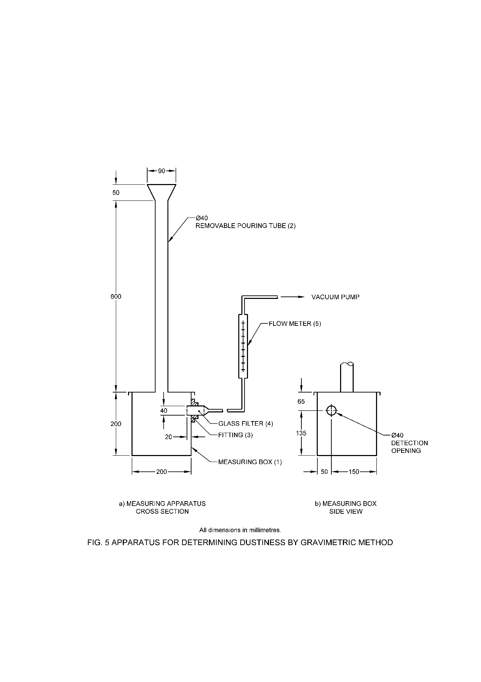

**13.2.2** *Optical Method*

**13.2.2.1** *Apparatus*

1. *Instrument description and settings*

*Dust-measuring apparatus, Cassella Instrument or equivalent* – In the electronic dust-measuring apparatus the change is measured in the intensity of a light beam resulting from the introduction of airborne dust. The apparatus (Fig. 6) consists of an electronic measuring device (1) and a cubic box with removable case (2). A tube (3) is fitted to the top of the cubic box. On its upper part the tube has a funnel with trap (4) which is opened magnetically. The sample drops to the bottom of the case, dust is released thus reducing the intensity of a light-beam as measured by a photocell on the opposite side. The lamp (5) and photocell (6) are positioned off-center from the tube centre line. The 'maximum-value' and 'dust-value' are then recorded, and the values used to reset the equipment when a new measurement is made. Optical filters (7) for readjustment can be fitted in front of the photocell.

**13.2.2.2** *Procedure*

a) *Sampling*

It is important to measure dustiness with the sample 'as received'. Wherever possible, take the sample from previously unopened commercial container. Changes in water content caused by conditioning of the sample under certain temperature and/or humidity conditions can change dustiness significantly. For each determination, take a representative sample of the granular products of 30.0 g, weighed to the nearest 0.1 g.

b) *Determination of dust*

Before starting a measurement, adjust the meter reading of the dust measuring apparatus. For each investigation, put 30 g of the sample-material in the funnel. Start the machine, which opens the trap for 2 sec, and allows the sample to drop to the bottom of the case, releasing dust and reducing the intensity of the light-beam Make the first measurement directly after the fall of the sample, the 'maximum value'. Make the second measurement after 30 sec. and add this value to the 'maximum value'. Take the sum of both values as the 'dust-value'. The difference between the 'dust value' and the 'maximum-value' gives an indication of the length of time the generated dust is suspended in the air.

c) *Assessment of Dustiness*

With the 'collected dust' (gravimetric method) and 'dust-factor' (optical method) the dustiness of a granular product can be categorized as follows:

|  |  |  |  |
| --- | --- | --- | --- |
| **Category** | **Range of results (in mg)** | | **Interpretation** |
|  | gravimetric collected dust | Optical dust factor |  |
| 1. | 0 – 12 | 0 – 10 | Nearly dust-free |
| 2. | 12 – 30 | 10 – 25 | Essential non dusty |
| 3. | > 30 | > 25 | Dusty |

Note – The table is only indicative. The parameters provided in the particular product specification may vary and only those shall be for compliance.

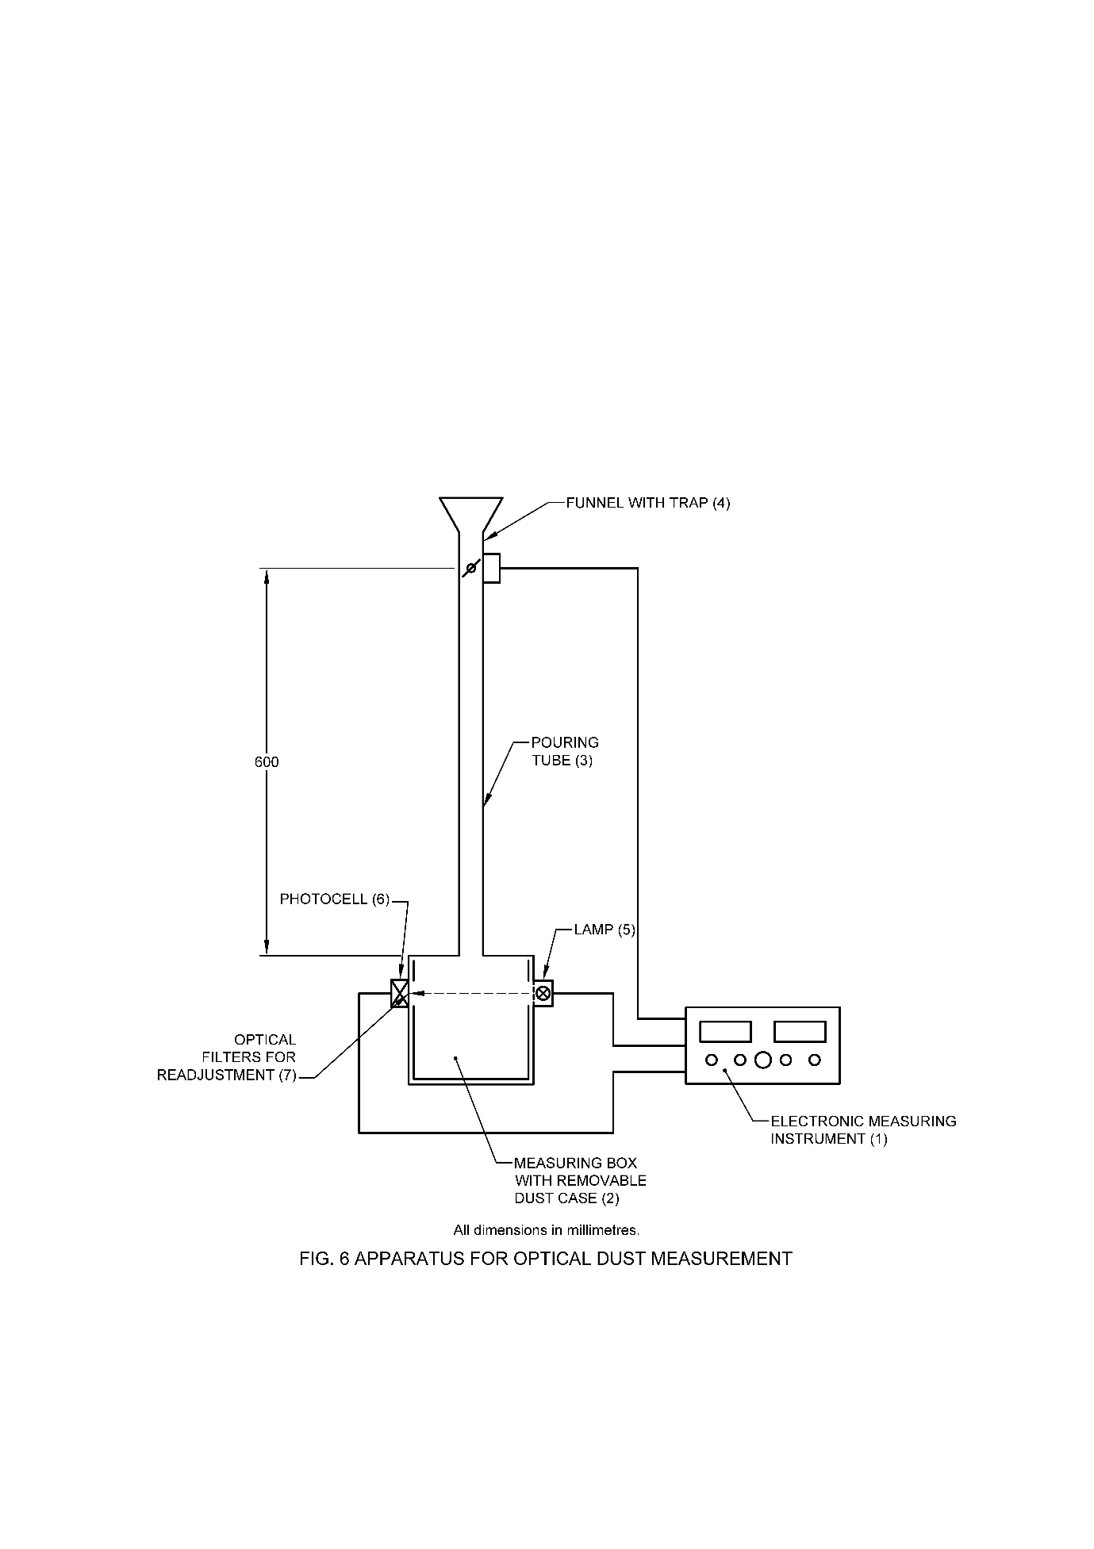

**14 DETERMINATION OF ATTRITION RESISTANCE**

**14.1 Principle**

Prior to test, the granules are sieved on a 125 µm IS Sieve in order to remove fine particles. A known amount of the dust free granules is transferred to a glass bottle and then subjected to a rolling movement. After rolling for a specified period of time, the attrition resistance is determined by sieving again on a 125 µm IS Sieve and weighing the material remaining on the sieve.

**14.2 Apparatus**

1. *Roller bank system* – of two or more rollers forming a drive bed.
2. *Inclyno test sieve vibrator No. 1 –* platform about 20 cm or other sieving machines as*: Air jet sieving/* *Ro-tap sieve shaker or equivalent*
3. *Shaking and vibrating machines*
4. *Test Sieve –* 125 µm IS Sieve
5. *Sieve lid and receiver pan*
6. *Glass bottle –* 500 ml with lid, outer diameter: 8.0 cm, height: about 15 cm
7. *Crystallizing dish*
8. *Soft brush*
9. *Glass rod –* with a rubber cap
10. *Stopwatch*

**14.3 Procedure**

Prior to the test homogenize the sample by inverting the container with the sample 5 times through 180° and back. Weigh about 60 g of the sample (*see* Note 1), transfer it onto a 125 µm IS Sieve and remove the fine particles by sieving the granules with the shaker for 3 min. Transfer 50.0 g (*w* g) of the sieved granules (*see* Note 2) to the glass bottle. Close the bottle and place it with the side of the bottle horizontally on the roller. Let the bottle carry out about 4500 revolutions with a rotational speed of 75 to 125 rpm (*see* Note 3). Mount the 125 µm sieve on the receiver pan. Carefully transfer the content of the glass bottle onto the 125 µm sieve. Remove the material remaining inside the lid of the flask or adhering to the surface of the flask using the brush and/or the glass rod. Add it to the sieve. Fit the lid of the shaker to the sieve and mount it in the shaker. Shake for a period of 3 min. Remove the sieve from the machine, take off the lid and transfer the material on the 125 µm sieve to a tared crystallizing dish. Tap the side of the sieve frame five times and brush the lower surface. Discard this fraction. Then brush the upper surface, reverse the sieve, and add the brushings to the material on the dish. Determine the mass of the material on the dish (*a* g).

NOTES

1. In case of samples containing large amount of dust, weigh more sample to ensure that after removing the fine particles at least 50 g of sieved sample is available for the attrition test.
2. Perform the test with a clean flask.
3. Measure the rotational speed of the bottle and adjust the time period for the rolling accordingly.

Time period (mins) = 4500/N

where, N = measured rotational speed of the bottle.

**14.4 Calculation**

Attrition resistance, percent by mass = $\frac{a × 100}{w}$

where

*a* = mass, in g, of the granules remaining on the 125 µm sieve

*w* = mass, in g, of sample taken (g)

**15 DETERMINATION OF DISPERSIBILITY OF WATER DISPERSIBILITY GRANULES**

**15.1** **Principle**

A known amount of a water dispersible granule (WG) is added to a defined volume of water and mixed by stirring to form a suspension. After standing for a short period, the top nine-tenths are drawn off and the remaining tenth dried and determined active ingredient by the method prescribed in product specification.. The method is virtually a shortened test of suspensibility and is appropriate for establishing the ease with which a WG dispersed uniformly in water.

**15.2 Apparatus**

1. *Beaker* – 1000 ml with a diameter of 102 ± 2 mm (low form)
2. *Stirrer motor*, with speed control
3. *Stainless steel stirrer*, propeller type with four fixed stirrer blades twisted at an angle of 45°.
4. *Drying cabinet*, with temperature control
5. *Rotary vacuum evaporator*
6. *Stopwatch*
7. *Glass suction tube* – About 40 cm long and about 5 mm i.d. drawn to a point at one end with an opening of about 2 to 3 mm. The other end of the tube is connected to a vacuum pump protected by a suitable reservoir.

**15.3 Reagent**

1. *Standard hard water – see* **6**

**15.4** **Procedure**

Fill the tared beaker with 900 ml of standard hard water (342 ppm) at (20 ± 1) °C. The stirrer should be centrally located in the beaker and is positioned in such a way that the bottom of the stirrer blades is 15 mm above the base of the beaker. The pitch of the stirrer blades and the direction of rotation are such that the propeller pushes the water upwards. Switch on the stirrer with the speed set to 300 rpm.

Add a sample of WG (approximately 9 g weighed to ± 0.1 g) to the stirred water and continue the stirring 1 min. Then switch off the stirrer and transfer the suspension into a 1000 ml measuring cylinder. Allow to stand undisturbed for 1 min. Withdraw, by means of a vacuum pump, nine-tenths (810 ml) of the suspension. Carry out the operation in 30 to 60 s by maintaining the tip of the glass tube just below the falling level of the suspension, taking care to minimize any disturbance of the suspension.

Determine the active ingredient by the method prescribed in the product specification in the remaining 90 ml in the beaker.

**15.5 Calculation**

Dispersibility, percent by mass = $\frac{111 (m -W)}{m}$

where

*W* = mass, in g, of the residue after drying

*m* = mass, in g, of the sample taken

**16 DETERMINATION OF SPONTANEITY OF DISPERSION**

**16.1 Scope**

The method is applicable for formulation containing one or more suspended active ingredient (s). A known amount of a formulation is added to a defined volume of water and mixed by stirring to form a suspension. After standing for a short period, the top nine-tenths are drawn off and the remaining tenth dried and determined chemically. The method is virtually a shortened test of suspensibility and is appropriate for establishing the ease with which a formulation is dispersed uniformly in water.

**16.2 Principle**

The method is broadly like that used for determining suspensibility except that it employs only one inversion and 5 min standing time. It involves preparing 250 ml of a mixture formulation and water, mixed with only one inversion of the measuring cylinder. After standing under defined condition the top nine-tenth is removed, and the remaining one-tenth assayed chemically. The spontaneity of dispersion is readily calculated.

**16.3 Apparatus/ Equipment**

1. *Constant temperature water bath*;
2. *Graduated cylinders ­*- of capacity 250 ml with a ground glass stopper. The distance between 0 ml and 250 ml marks shall be (21.0 ± 0.5) cm with a clearance of 6.0 to 8.0 cm between 250 ml mark and the neck of the cylinder (*see* IS 878);
3. *Glass suction tube* – about 40 cm long, 5 mm internal diameter, drawn out at one end to 2-3 mm internal diameter

**16.4 Reagents/ Solutions**

1. *Standard hard water – see* **6**

**16.5 Procedure**

Normally the whole procedure is carried out in duplicate. Homogenize the sample by gently stirring. The standard hard water, measuring cylinder and sample to be used in the determination should be equilibrated to the required temperature before starting the test. Determine the density of the formulation and calculate the mass of formulation equivalent to 12.5 ml (W). Pour standard water (237.5 ml) at 30 °C ± 2 °C into the graduated cylinder and stand this on a top-pan balance; add the calculated mass of formulation from a small beaker held so that the tip is 1 cm above the top of the cylinder. Complete the addition within a time limit of 15 s.

As soon as the formulation is added, stopper the cylinder and invert once and back. Stand the cylinder in an upright position on a bench free from vibration or direct sources of heat for 5 min ± 10 s. At the end of this time, carefully remove the stopper and withdraw the top 225 ml of suspension by means of the suction tube connected to a reservoir and suitable pump. Carry out the operation in 10 – 15 s by maintaining the tip of the tube just below the falling level of the suspension, care being taken to minimize any disturbance of the suspension. Ensure that the tip of the tube is always only a few mm below the surface of the suspension. Proceed with the remaining 25 ± 1 ml (one-tenth) of dilute suspension for the determination of active ingredient by the method prescribed in specific Indian Standard.

**16.6 Calculation**

Spontaneity of dispersion, percent by mass = $\frac{111 (C-Q)}{C}$

where

C = $\frac{W × a}{100}$ = mass, in g, of the active ingredient in sample actually taken;

*a =* percentage of active ingredient by mass in formulation;

*W =* mass, in g, of formulation actually added to the cylinder; and

*Q =* mass, in g, of active ingredient in 25 ml sample at the bottom.

**17 DETERMINATION OF SUSPENSIBILITY**

**17.1 Principle**

A suspension of known concentration is prepared in Standard hard water, using a prescribed measuring cylinder at a constant temperature, and allowed to remain undisturbed for a specified time. Thereafter, the top nine-tenth part of the solution is drawn off and the remaining one-tenth (bottom 25 ml) is assayed using the analytical method recommended for the molecule(s), and the suspensibility is calculated. If the formulation is packed in water soluble bags or pouches, the suspensibility test should be performed in presence of dissolved water-soluble bag or pouch material.

**17.2 Apparatus**

1. *Measuring cylinder* 250 ml, glass stoppered. The distance between the graduations 0 and 250 ml should be between 20 and 26 cm, and between the 250 ml mark and the bottom of the stopper, 3 to 7 cm.
2. *Suction tube* about 40 cm long and with an internal diameter of about 5 mm, drawn to a point at one end with an opening of about 2 to 3 mm. the other end of the tube is connected to a suitable source of suction.
3. *Stopwatch*
4. *Suction Pump*
5. *Water bath* capable of maintaining a specified temperature.
6. *Extraction apparatus* only required if (a) gravimetric or (b) solvent extraction procedure is adopted.
7. *Centrifuge (for gravimetric procedure)*, capable of a speed of 3000 rpm and suitable for at least 50 ml tubes
8. *Filtration assembly* *(for extraction procedure)*, consisting of a suction filter flask, together with either a Buchner funnel or a sintered glass crucible, Porosity P16 (pore size 10 – 16 µm)

**17.3** **Reagents**

1. *Standard hard water*
2. *Solvent* suitable for extraction of the a.i (s) only if required if solvent extraction procedure is adopted

**17.4 Procedure**

**17.4.1** *Preparation of the Suspension*

Weigh out sufficient sample (*W* g) to make up to 250 ml of a suspension in water. The suspension is prepared with a concentration that is recommended or highest concentration when multiple concentrations are recommended.

**17.4.1.1** *Solid formulations*

Disperse the sample with creaming [Method a)] or without creaming [Method b)] according to the direction of use of the product. If no instruction is provided, then *Method b* should be used. If the formulation is packed in water-soluble bags, then suspend the water-soluble bag material in the test water in the actual ratio of the application prior to performing the suspensibility test. If the product is sold in a range of bag sizes, use the highest concentration of bag material for the test. The stock solution for the bag material (1 g/l) is prepare as follows:

‘Weigh approximately a 100 mg sample (*n* mg) of the bag material to the nearest mg and dissolve this sample by stirring in the standard hard water used for the test to give a final volume on *n* ml. Store this solution in a stoppered bottle prior to use. Calculate the volume (*V* ml) of the stock solution of the bag to be added to the test suspension according to the below equation:’

*V* = $\frac{X × B × 1000}{F}$

Where,

B = mass, in g, of the emptied and cleaned bag;

F = nominal mass, in g, of the formulation contained in the bag; and

X = mass, in g, of the formulation sample used in the test

1. *With creaming (pre-slurring)*

Place the weighed sample in the beaker, add a small quantity of standard hard water (about 5 ml) and mix for 2 min with a glass rod fitted at one end with a rubber bunge, to produce a smooth paste. Add standard water (50 ml) while stirring the mixture and allow to stand the suspension for 15 mins in a water bath at the same temperature to bring it to the room temperature. Transfer the suspension with more standard hard water quantitatively to the measuring cylinder, which had previously been brought to the specified/ room temperature. Then proceed fordetermination of sedimentation as prescribed in **17.4.2**.

1. Without creaming (pre-slurring)

Add the weighed sample slowly to the beaker containing standard hard water (50 ml). Swirl by hand in a circular motion at a rate of approximately 120 turns per min for 2 min. Allow to stand the suspension for 5 min in a water bath at the same temperature to bring it to the room temperature. Transfer the suspension with more standard hard water quantitatively to the measuring cylinder, which had previously been brought to the specified/room temperature. Then proceed for determination of sedimentation as prescribed in **17.4.2**.

**17.4.1.2** *Liquid formulations*

Homogenize the sample by gentle stirring. Weigh the sample into a beaker (50 ml) and transfer the suspension with more standard hard water quantitatively to the measuring cylinder, which had previously been brought to the specified/room temperature. Then proceed for determination of sedimentation as prescribed in **17.4.2**.

**17.4.2** *Determination of the Sediment*

Make up to 250 ml with standard hard water at room temperature/specified temperature. stopper the cylinder and invert 30 times end to end at 180°. Place the cylinder in the water bath at specified temperature in upright position free from vibrations and away from direct sunlight. At the end of 30 minutes time, quickly withdraw 9/10th (225 ml) of the suspension by inserting a glass tube into the cylinder and by means of a vacuum pump and reservoir assembly. Carry out the operation in 10 to 15 sec by maintaining the tip of the glass tube below the falling level of the suspension, taking care not to agitate or mix the sediment in the cylinder.

**17.4.3** *Assay of the Remaining One-tenth Part*

The remaining of the one-tenth part of the cylinder must be assayed Chemically, Gravimetrically or by Solvent Extraction

**17.5 Calculation**

Suspensibility, percent by mass = $\frac{111 (C-Q)}{C}$

where

C = $\frac{W × a}{100}$ = mass, in g, of the active ingredient in sample actually taken;

*a =* percentage of active ingredient by mass in formulation;

*W =* mass, in g, of formulation actually added to the cylinder; and

*Q =* mass, in g, of active ingredient in 25 ml sample at the bottom.

**18 DETERMINATION OF DISPERSION STABILITY**

**18.1** **Principle**

A dispersion of prescribed concentration in standard hard water is prepared and aliquots are placed in two graduated emulsion tubes, which are then allowed to remain undisturbed for specified time in an upright and inverted positions at a constant temperature. The dispersion characteristics are observed immediately after the preparation of the dispersion, after a specified time, and re-dispersion.

**18.2 Apparatus/Equipments**

1. *Emulsion tube*
2. *Rubber stoppers –* fitting in the emulsion tube and provided with an 80 mm glass ventilation tube (external diameter: 4.5 mm, internal diameter: 2.5 mm) (Fig. 7)
3. *Graduation cylinders* – 250 ml capacity
4. *Adjustable lamp* – fitted with a 60 W bulb
5. *Pipette –* 10 ml

**18.3 Reagents/Solutions**

1. *Standard hard water – see* **6**

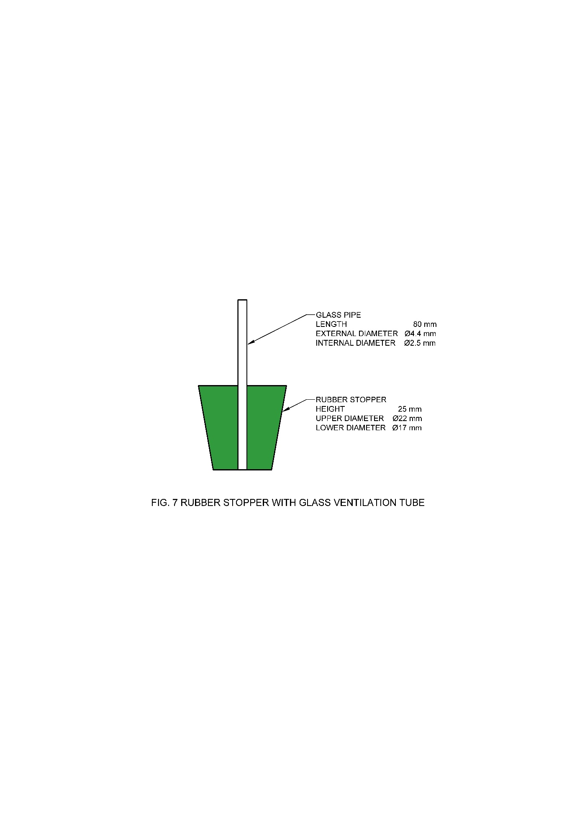

**18.4 Procedure**

Fill at room temperature (25 ± 2) °C (report the temperature and range if they are outside the range indicated) two 250 ml graduated cylinders to the 240 ml mark with standard hard water. To each cylinder, add drop wise by pipette 5 g of sample (or such an amount as otherwise is specified). Dispense the sample with the tip of the pipette as closely as possible to the surface of the water but not beneath it. Fill to the mark with standard hard water (In case of solid formulations, shake 5 g of powder carefully onto the surface of the water). Invert the cylinder 30 times by holding the cylinder with one hand at each end, insulated with a cloth, and rotating it through 180 degrees and back again through an imaginary fixed-point midway between the hands. Ensure that no bouncing occurs. Each inversion should take 2 seconds. Use the content of one cylinder for the sedimentation (**18.4.2**) and creaming tests (**18.4.3**) and keep the second one for the determination of the re-dispersion test (**18.4.4**).

**18.4.1** *Initial Determination*

Observe the dispersions and note any sediment or cream or oil.

**18.4.2** *Determination of Sediment Volume*

Immediately after forming of the dispersion, transfer a 100 ml aliquot from the first graduated cylinder to an emulsion tube. Stopper and allow to stand in an upright position at room temperature for 30 min. Illuminate the cylinder with the lamp. Adjust the position and the angle of the light for optimal viewing of the phase boundary, if present. Record the sediment volume with an accuracy of + 0.05 ml.

**18.4.3** *Determination of Top Cream (or Oil) Volume*

Immediately after forming of the dispersion, fill an emulsion tube to within about 1 mm from the top of the tube with the dispersion. Wearing disposable protection gloves, stopper the tube with the rubber stopper (fitted with ventilation tube) in such a way that all air is expelled from the tube. Carefully remove from the apparatus any expelled dispersion. Invert the tube and maintain it in an upside-down position at room temperature for 30 min. No liquid will escape from the emulsion tube, and it is not necessary to seal the open end of the glass tube. Record the volume of cream or oil that has formed. Determine the total volume of the tube and correct the measured volume of cream or oil in the following way:

F = $\frac{100}{V_{o}}$

where

*F* = correction factor to be applied to the measured volume of cream or oil

*V*o = total volume of the emulsion tube

**18.4.4** *Determination of Re-dispersion*

After the initial dispersion, allow the second cylinder to stand undisturbed for 24 h at room temperature. To re-disperse the contents, invert the cylinder 30 times through 180o and back, as described above. Note any bottom sediment that is not re-dispersed completely. Add the dispersion to fresh emulsion tubes as described under **18.4.2** and **18.4.3** and measure the sediment volume or top cream or oil volume of the re-dispersed product after standing for 30 min.

**18.5 Results**

Report the results of the dispersibility test as under:

a) Initial determination (after standing for 30 min)

Sediment volume = ……..ml

Top cream (or oil) = …….ml

b) Re-dispersibility (after standing for 24 h)

Sediment volume = ……..ml

Top cream (or oil) = …….ml

**19 DETERMINATION OF EMULSION STABILITY**

Two methods are prescribed for the determination of emulsion stability of the material. The method to be employed shall depend upon the manufacturer's instructions for the preparation of the diluted emulsion from the material. Method I shall be employed for material which is required to be added to standard hard water for the preparation of the diluted emulsion, while Method II shall be employed for material to which standard hard water should be added to prepare the diluted emulsion.

**19.1 Method I**

**19.1.1** *Apparatus*

a) *Beaker* – capacity 250 ml, with an internal diameter of 6.0 to 6.5 cm and marked at 100 ml;

b) *Mohr-type pipette*;

c) *Glass-rod* – 4 to 6 mm in diameter and of a convenient length; and

d) *Graduated cylinder* – capacity 100 ml.

**19.1.2** *Reagent*

**19.1.2.1** *Standard hard water* – Dissolve 0.3040 g of calcium chloride anhydrous and 0.1390 g of magnesium chloride hexahydrate in distilled water and make up to one litre in a volumetric flask.

NOTE – Standard hard water is defined as 'water', which provides a hardness of 342 ppm, calculated as calcium carbonate.

**19.1.3** *Procedure*

Pour 75 to 80 ml of standard hard water, brought to a temperature of (30 ± 1) °C, in the beaker. By means of the pipette, add 5 ml of the concentrate if meant for public health use and 2 ml of the concentrate if meant for agricultural use, while stirring with a glass rod, at about 4 rev/s. The concentrate should be added to water at the rate of 25 to 30 ml/min, with the point of the pipette 2 cm inside the beaker, the flow of the concentrate being directed towards the centre, and not against the sides of the beaker. Make up to 100 ml with water with continuous stirring and immediately pour into the clean and dry cylinder. The stirring time should be 3 min from the beginning of the addition of the concentrate until the emulsion is poured into the 100 ml cylinder. Close the cylinder with the stopper and invert it sharply to give 10 complete cycles within 20 sec. Keep at (30 ± 1) °C for 1 h and examine for any creaming or separation.

**19.1.4** *Report*

Report the total volume in ml of the creamed matter at the top and the sediment at the bottom in the cylinder.

**19.2 Method II**

**19.2.1** *Apparatus*

a) *Beaker* – of 6.0 to 6.5 cm and 250 ml capacity;

b) *Dropping funnel*;

c) *Glass-rod* – 4 to 6 mm in diameter and of a convenient length; and

d) *Graduated cylinder* – capacity 100 ml.

**19.3 Reagents**

a) Standard hard water – *see* **6**

**19.4 Procedure**

Take 5 ml of concentrate if meant for public health use and 2 ml of concentrate if meant for agricultural use. Pour standard hard water at (30 ± 1) oC into the dropping funnel, and add it to the material contained in the beaker at the rate of 15 to 20 ml/min. During the addition, stir the contents of the beaker continuously with the glass rod, and stop the addition of standard hard water just when the volume of diluted emulsion in the beaker reaches 100 ml. Transfer the diluted emulsion immediately to the clean and dry graduated cylinder. Keep the cylinder with its contents at (30 ± 1) oC for one hour. After this period, note the volume of the creamed matter at the top and the sediment at the bottom, if any.

**19.5 Report**

Report the total volume in ml of the creamed matter at the top and the sediment at the bottom in the cylinder.

**20 DETERMINATION OF POURABILITY**

**20.1 Principle**

A sample of the formulation is allowed to stand for a defined time and the amount remaining in a test cylinder after a standardized pouring procedure is determined. The container is rinsed and the amount then remaining is determined. Where the proposed limit for the residue values is high (>5 percent), it shall be necessary to demonstrate that the residue can be rinsed readily from containers i.e. the rinsed residue value is less than 0.5 percent.

**20.2 Apparatus / Equipment**

A 500 ml stoppered measuring cylinder as per following requirements:

a) Volume equivalent to 1 subdivision of the scale : 5 ml

b) Capacity corresponding to lowest graduation mark : 50 ml

c) Capacity corresponding to highest graduation mark : 500 ml

d) Length of scale : 250 mm

e) Overall height : 39 cm

f) Diameter of base : 10 cm

g) Stopper : B 34

NOTES

1. High density polyethylene bottles, 1 000 ml volume and Kilner jars, 700 ml volume, can be used but this must be recorded with the result.
2. A measuring cylinder of capacity 100 ml or 250 ml may also be used.

**20.3 Procedure**

Weigh the empty container and stopper (W0) and add enough of the test item taken from a recently mixed bulk sample to leave approximately 20 percent of the volume of the container as ullage. Replace the stopper and reweigh the container (W1). Allow the container to stand undisturbed for 24 h and then pour out the test item (*see* Note 1) for 60 s at an angle of 45° and then finally invert the container for 60 s (*see* Note 2). Re-weigh the container and stopper (W2). Add distilled water at 20°C (a volume of 80 percent of that of the container) and replace the stopper. Invert the container 10 times (*see* Note 3) and empty the container as before and re-weigh the container and stopper (W3). Calculate the residue (R) and the rinsed residue (R1).

**20.4 Calculation**

Residue (R), percent by mass = $\frac{W_{2}-W_{0}}{W_{1}-W_{0}}$ $×$ 100

Rinsed residue (R1), percent by mass = 100

where

*W*0 = mass, in g, of the empty container;

*W*1 = mass, in g, of the container with the sample;

*W*2 = mass, in g, of the container after the pouring out of the sample;

*W*3 = mass, in g, of the container after removal of distilled water, in g;

NOTES

1 The length of the standing period and the temperature should be agreed previously.

2 A square sided container should be held so that a flat side is underneath.

3 The term invert the container means that the container’s vertical axis is turned through 180 °C and then brought back to its original position, the whole operation taking about 2s

**21 DETERMINATION OF ACIDITY/ALKALINITY/*p*H RANGE**

**21.1** **Determination of Acidity**

**21.1.1** *Reagents*

a) *Methyl red indicator solution* — aqueous one percent (*m*/*v*).

b) *Bromocresol purple indicator solution* — one percent (*m*/*v*) in ethyl alcohol.

c) *Standard sodium hydroxide solution* — 0.05 N.

d) *Standard hydrochloric acid* — 0.05 N.

**21.1.2** *Procedure*

Weigh accurately about 10 g of the material into a dry conical flask and dilute with 100 ml of water. Titrate the contents of the flask immediately with the standard sodium hydroxide solution using methyl red or bromocresol purple as the indicator. Alternatively, the end-point may be determined electrometrically (*see* **21.3**).

Carry out a blank determination on 100 ml of water.

**21.1.3** *Calculation*

Acidity (as H2SO4), percent by mass = $\frac{4.9 \left(V-v\right)N}{M}$

where

*V* = volume, in ml, of the standard sodium hydroxide solution required for the test;

*v* = volume, in ml, of the standard sodium hydroxide solution required for the blank determination;

*N* = normality of the standard sodium hydroxide solution; and

*M* = mass, in g, of the material taken for the test.

In case the blank determination shows alkaline reaction, neutralize with the standard hydrochloric acid and calculate the acidity as follows:

Acidity (as H2SO4), percent by mass =

where

*V* = volume, in ml, of the standard sodium hydroxide solution required for the test,

*N*1 = normality of the standard sodium hydroxide solution,

*v* = volume, in ml, of the standard hydrochloric acid required for the blank determination,

*N*2 = normality of the standard hydrochloric acid, and

*M* = mass, in g, of the material taken for the test.

**21.2** **Determination of Alkalinity**

**21.2.1** *Reagents*

a) *Methyl red indicator solution* — Aqueous one percent (*m/v*).

b) *Bromocresol purple indicator solution* — One percent (*m/v*) in ethyl alcohol.

c) *Standard hydrochloric acid* — 0·05 N.

d) *Standard sodium hydroxide solution* — 0·05 N.

**21.2.2** *Procedure* — Weigh accurately about 10 g of the material into a dry conical flask and dilute with 100 ml of water. Titrate the contents of the flask immediately with the standard hydrochloric acid, using methyl red or bromocresol as the indicator. Alternatively, the end-point may be determined potentiometrically.

Carry out a blank determination with 100 ml of water.

**21.2.3** *Calculation*

Alkalinity (as NaOH), percent by mass = $\frac{4.0\left(V-v\right)N}{M}$

where

*V* = volume in ml of the standard hydrochloric acid required for the test,

*v* = volume in ml of the standard hydrochloric acid required for the blank determination,

*N* = normality of the standard hydrochloric acid, and

*M* = mass in g of the material taken for the test.

In case the blank determination shows an acid reaction, neutralize with the standard sodium hydroxide solution and calculate the alkalinity as follows:

Alkalinity (as NaOH), percent by mass = $\frac{4.0\left(VN_{1}+vN_{2}\right)}{M}$

where

*V* = volume in ml of the standard hydrochloric acid for the test,

*N*1= normality of the standard hydrochloric acid,

*v* = volume in ml of the standard sodium hydroxide solution required for the blank determination,

*N*2 = normality of the standard sodium hydroxide solution, and

*M* = mass in g of the material taken for the test.

**21.3****Electrometric Procedure for Determination of Acidity or Alkalinity**

**21.3.1** *Reagents*

a) *Methyl alcohol* – distilled

b) *Sodium hydroxide* – 0.05 N

c) *Hydrochloric acid* – 0.05 N

**21.3.2** *Apparatus*

a) *pH meter*

**21.3.3** *Procedure*

Weigh accurately about 2 g of the sample in a conical flask. Add 25 ml methyl alcohol and stir for 5 min. Filter through a Buchner funnel into the filter flask. Rinse the conical flask and the Buchner funnel with methyl alcohol (3 x 5 ml). Transfer the combined methyl alcohol extracts to the titration vessel rinsing the filter flask with 10 ml of methyl alcohol. Add 10 ml of distilled water and titrate electrometrically with sodium hydroxide solution or hydrochloric acid to *p*H 5 at 27 oC. Calculate the acidity or alkalinity whatsoever by the factor given in **21.1.3** or **21.2.3**.

**21.4 pH Range**

**21.4.1** *Principle*

The pH value of a mixture of a sample with water or of an undiluted aqueous formulation is determined by means of a pH meter and an electrode system.

**21.4.2** *Apparatus / Equipment*

a) *pH meter* capable of at least two-point calibration

b) *Electrode system* e. g. glass electrode system or equivalent

c) *Measuring cylinder* stoppered, 100 ml

**21.4.3** *Reagents / Solutions*

a) *Di-sodium tetraborate buffer solution* 0.05 mol/l*, p*H *(see* below),commercially available or self—prepared solution – Dissolve 19.07 g di-sodium tetraborate (Na2B4O7∙10 H2O) in water and make up to 1000 ml. The solutions are prepared in calibrated standard flask and then transferred, and stored in a plastic bottle. Do not keep the solution for longer than one month.

pH values:

|  |  |  |  |  |  |
| --- | --- | --- | --- | --- | --- |
| Temperature [°C] | 10 | 15 | 20 | 25 | 30 |
| *p*H | 9.29 | 9.26 | 9.22 | 9.18 | 9.14 |

b)*Potassium hydrogen phthalate buffer solution* 0.05 mol/l, *p*H 4.00, commercially available or self-prepared solution – Dissolve 10.21 g potassium hydrogen phthalate (HOOC-C6H4-COOK) in water and make up to 1000 ml. The temperature coefficient of the pH of this buffer solution can be neglected between 10 and 30 °C. The solutions are prepared in calibrated standard flask and then transferred, and stored in a plastic bottle. Do not keep the solution for longer than one month.

c)*Water*, distilled, in equilibrium with CO2 from the air.

NOTE – The water used to prepare the buffer solutions should be freshly prepared and tested before use.

**21.4.4** *Procedure*

**21.4.4.1** *Calibration*

Operate the *p*H meter and the electrode system according to the manufacturer's instructions. Calibrate the measuring system (*p*H meter and electrode) according to the manufacturer's instructions using at least two appropriate buffer solutions.

**21.4.4.2** *Measurement of pH values*

a) *Measurement of diluted samples* – Weigh 1.0 g of sample (*see* Note 1) into a measuring cylinder containing about 50 ml distilled water (pH 6-7), make up to 100 ml with water and shake vigorously until completely mixed or dispersed. If necessary, transfer the solution or dispersion to a beaker (200 ml) and allow any suspended material to settle for 1 min. Ensure that the temperature of the sample/water mixture does not differ from the temperature of the borate buffer used the time of calibration. Immerse the electrode into the liquid and immediately start the stopwatch (*see* Note 2). Record the pH values after 1 and 2 minutes, without stirring during the measurement. If the two pH values differ by more than 0.1 pH units, record and report the pH value 2 min after immersing the electrode.

NOTES

1. In case of liquid samples which are not too viscous, e. g. emulsion concentrates, 1 ml (or more) of the sample may be used.
2. During the measurement of pH values of samples, a randomly fluctuating reading of the pH meter may be observed. The reason is normally that the concentration of ions in the sample (diluted or undiluted) is too low, or because of an interaction between the particles or droplets in suspension with the electrode. If the ion concentration is too low, some drops of a concentrated sodium chloride solution may be added to stabilize the reading.

b) *Measurement of undiluted aqueous formulations –* Transfer enough sample to a beaker (100 ml). Ensure that the temperature of the sample/water mixture does not differ from the temperature of the borate buffer used the time of calibration. Immerse the electrode into the liquid and immediately start the stopwatch. Record the *p*H values after 1 and 2 minutes, without stirring during the measurement. If the two *p*H values differ by more than 0.1 *p*H units, record and report the pH value 2 min after immersing the electrode.

NOTE – When using an automatic pH meter, where the measurement stops automatically as soon as the pH changes are less than a pre-set drift value of 0.1 *p*H units/min, a measurement period less than 10 min is acceptable and the resulting *p*H value should be reported

**22 DETERMINATION OF MELTING POINT RANGE**

**22.1 Principle**

The sample, in a capillary tube, is heated at a controlled rate in a stirred liquid bath, and the temperature observed at which a meniscus is formed on the sample, and/or complete liquefaction of the sample occurs.

**22.2 Apparatus / Equipment**

1. *Thermometer* — A long-stem and short-bulb thermometer with a range of 0 °C to 200 °C or 100 °C to 200 °C and with subdivisions of 0.5 °C.
2. *Bath and Heating Assembly* — This consists of a suitable chamber with a glass front. Inside, there is a long-necked flask (250 ml Kjeldahl flask) three-fourths full with liquid paraffin and placed on a suitable mounting for heating with a heating mantle. The flask is loosely fitted with a stopper which carries a thermometer. The chamber is provided with appropriate illumination to observe the melting of the material and the reading of temperature

**22.3 Procedure**

Take a small quantity of finely powdered substance and dry the same in a vacuum desiccator over silica gel or phosphorus pentoxide for 24 hours or according to the requirements given in the specification. Transfer the same in the capillary tube with one end sealed. Ensure proper packing of the material in the tube by gently tapping it on the table. The material in the capillary tube should be sufficient to cover the entire length of the thermometer bulb. Introduce the filled capillary tube into the heated bath at a temperature 10 °C below the expected lower limit of the melting range. Attach the capillary tube with the thermometer such that the material is very close to the bulb. Introduce the thermometer in the bath in such a way that the thermometer bulb is well below the surface of the liquid. Now heat slowly and carefully so that the rise in bath temperature is about 1 °C per minute. Note the temperature of initial melting (when first liquid drop appears) and completion of melting (when no solid particle is left). Report the temperature of melting point completion and the difference of temperatures as melting range.

NOTE — Ensure that two consecutive determinations do not differ by more than 0.5 °C.

**23 DETERMINATION OF ADHESION TO TREATED SEED**

**23.1 Scope**

Poor adhesion of seed treatment products to seeds can adversely affect the biological efficacy. The method is designed to determine the quantity of seed treatment formulation remaining on the seeds treated with it. The method should not be used to classify fine and coarse particle or to quantify the part of the seed treatment product that is not retained on the seeds.

**23.2 Principle**

The treated seeds are poured through a funnel and is allowed to fall on a slide. When the slide is opened, the seeds are allowed to fall on a sieve at a further distance during which loose material gets separated. Five such passes are conducted, and the seed loading analysis is conducted to determine the retention of the seed treatment on the stressed samples in comparison to the unstressed samples.

**23.3 Apparatus –** As shown in Fig. 8.

1. *Glass Cylinder*, length 410 to 470 mm with internal diameter (i.d) of 80 to 85mm and sealed at one end to a glass funnel with a stem of around 15 to 30mm i.d and length of 15 to 30mm.
2. *Glass Funnel*, internal diameter (i.d) should be 145 to 175mm with a stem of around 15 to 30mm i.d and length of 15 to 30 mm.
3. *Slide Gate*, at the bottom funnel.
4. *Supporter*
5. *Sieve*, the mesh size should be sufficient enough to prevent passing of seeds through the sieve.
6. *Erlenmeyer flasks*, 250 ml with spectrophotometer or chromatographic system, depending on the method of analysis
7. *Filter units for syringes*
8. *Filter*, e.g. Cellulose-Acetate-Filter, 25 mm, 0.45 µm or glass fibre filter.
9. *Magnetic stirrer or shaker or ultrasonic bath*
10. *Centrifuge climatic chamber*
11. *Desiccator,* with a salt/water mixture with the required relative humidity, if a climatic chamber is not available

**23.4 Reagent**

1. *Extraction mixture* – The components of the extraction mixture (= solvent mixture) have to be selected depending on the solubility of the active ingredient(s).

**23.5 Procedure**

Clamp the cylinder upright so that the funnel stem is 100 mm from the surface of the sieve. Close the stem with the slide gate held up in place. Place a wide funnel at the top of the cylinder. The seeds to be used for the test should be free from extraneous matter which can be achieved using a 2 mm sieve.

**23.5.1** *Seed Treatment*

Treat a minimum of 330 gm of the seeds with the formulation under test as per the prescribed amount. The treated seeds are allowed to dry. The time required for drying treated seeds depends on the component of the seed treatment formulation. The treated seeds should be stored for at least 24 h under controlled condition at a relative humidity of 40-60% and temperature of (23 ± 5) °C.

**23.5.1.1** *Unstressed Seeds Sample –* Three sets (20 g each) of samples (US1, US2, US3) are tested to determine the seed loading.

**23.5.1.2** *Stressed Seed Sample –* The remaining quantity of seeds is divided into three sets (of 90 g each) and is subjected to the stress condition. Each set is poured slowly in the steady stream through the funnel into the cylinder. Once all the seeds are at the base of the cylinder, the slide gate is opened, and the seeds are allowed to fall onto the sieve. The slide gate is then closed. Without cleaning the apparatus, the procedure is repeated four more times with the same seeds. After the five passes are completed, 20 g if sub sample (S1) is removed using a spoon from the sieved and kept separate for the seed loading determination.

The Apparatus in then cleaned thoroughly to remove the fine particles from the cylinder and sieve and the procedure is repeated next set of the seed samples followed by the third set. The samples (S1, S2 and S3) are then tested to determine the seed loading either by chromatographic method to determine the active ingredient.

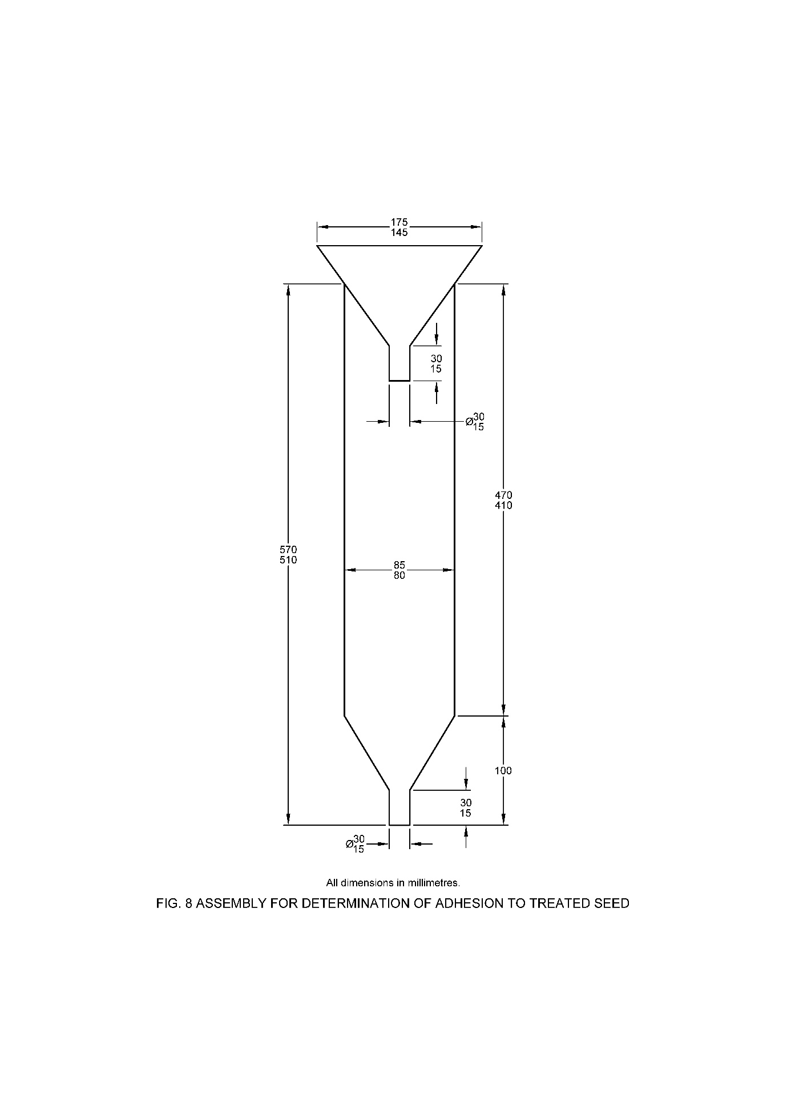

**23.5.2** *Determination of Seed Loading*

**23.5.2.1** *Preparation of test solution*

Extract the treated seeds samples (approx. 20 g) with an appropriate solvent (or solvent mixture) by adding a defined volume of the solvent (or solvent mixture) and sonicating for 15 to 30 min. The completeness if the extraction should be check before proceeding ahead. In case of incomplete extraction, mill/grind the treated samples, before adding the extraction mixture.

**23.5.2.2** *Determination*

The active ingredient(s) is determined by an appropriate and qualified chromatographic method. The interference of the other actives, co-formulant or other seed related impurities should be check.

**23.6 Calculation**

Adhesion to treated seeds, percent by mass = $\frac{C_{S}}{C_{US}}$ $×$ 100

Where,

*C*S = average content of active ingredient of the stressed seeds; and

*C*US = average content of active ingredient of the stressed seeds.

**24 DETERMINATION OF VISCOSITY OF LIQUIDS BY ROTATIONAL VISCOMETRY**

**24.1 Scope**

This method is intended for characterizing the flow behavior of liquid crop protection formulations. The measurement of non-Newtonian liquids is best carried out by rotational viscometer.

**24.2 Principle**

A sample is transferred to a standard measuring system. The measurement is carried out under different shear conditions and the apparent viscosities are determined. During the test, the temperature of the liquid is kept constant.

**24.3 Apparatus/ Equipments**

1. *Rotational viscosimeter* – with standard measuring system according to IS 13360 (Part 11/Sec 11)

NOTE – These systems (concentric cylinders or cone and plate systems) are capable of releasing a homogeneous shear rate over the total measuring zone.

1. *Thermostat* – attached to the test system

**24.4 Procedure**

**24.4.1** *General Operation Instruction*

Calibrate the viscosimeter and operate it according to the manufacturer's instructions.

**24.4.2** *Sampling and Pre-conditioning*

Use a representative sample. if necessary, degas the sample by slow stirring with a magnetic stirrer under a moderate vacuum. If the flow behavior of the liquid changes with time, apply an appropriate shear and relaxation pre-conditioning procedure before carrying out the measurement.

**24.4.3** *Measurement*

Pour the liquid into the measuring system brought to 20 °C (unless otherwise specified). Then carry out the measurement at least two different shear rates beginning with the lowest one. Determine a number of viscosities covering a range of shear rates, either in steps or continuously in a ramp. Once the highest shear rate has been applied repeat the measurements at the lower shear rates in decreasing order. Instead of measuring at controlled shear rates some instruments measure at controlled shear stresses. In both cases viscosity results at different shear rates can be obtained.

NOTE – Unless otherwise specified, shear rates within the range from 20 to 100 s-1 are recommended.

**24.4.4** *Reporting of Results*

Report the apparent viscosities determined at different shear rates in table or graph form, preferably in the order of increasing shear rates. Report all measurement conditions such as temperature, type of instrument and measuring system and pre-conditioning treatment of the sample.

**25 DETERMINATION OF RATE OF DISSOLUTION OF WATER-SOLUBLE BAGS/POUCHES**

**25.1 Principle**

An aqueous suspension of the test powder is prepared. A piece of the bag is immersed in the suspension for a certain period of time and finally stirred together with the suspension. The suspension is then passed through a filter and the flow time is measured or any blockage of the filter is observed.

**25.2 Apparatus/ Equipments**

1. *Beaker* – 1000 ml capacity, 18.0 ± 0.5 cm height and 9.0 ± 0.5 cm diameter;
2. *Cover* – rigid, plywood (thickness about 4 cm) or plastic, 150 × 150 cm, in its centre provided with a 5 cm long metal wire ending in a hook.
3. *Magnetic stirrer* – with adjustable stirring speed
4. *Filter funnel* – provided with a 250 µm filter
5. *Measuring cylinder* -1000 mlcapacity
6. *Stopwatch*
7. *Safety gloves*

**25.3 Reagent**

1. *Standard hard water* – *see* **6**

**25.4 Procedure**

**25.4.1** *Preparation of the Sample*

Cut a piece of 50 × 100 mm from the bag in such a way that the piece includes a part of the welding seal, as shown in Fig. 9. Attach the sample of the bag in the middle of its weld to the metal hook (*see* Fig. 10) of the cover as shown in Fig. 11.

**25.4.2** *Preparation of the Suspension*

Put the stirring bar into the beaker, add 1000 ml standard hard water at (20 ± 2) °C and place the beaker on the magnetic stirrer. Pour the sample of the corresponding powder (10 ± 1) g into the middle of the beaker and allow to stand for 1 min. Then stir for 1 min at (120 ± 10) rev/min

**25.4.3** *Dissolution of the Bag*

Stop stirring the suspension and place the cover with the attached piece of the bag into the suspension in such a manner that the bag is immersed completely within 5 sec and that contact with the wall of the beaker is avoided (Fig. 12). Allow to stand for 10 min. Then unhook any undissolved fragments of the bag and return them to the suspension. Stir for 5 min at (120 ± 10) rev/min. Remove the cover and the stirring bar (e.g. with an iron rod) and return to the beaker any undissolved fragments of the bag sticking to the stirring bar.

**25.4.4** *Flow Test*

Place the filter above 1000 ml measuring cylinder and keep the outlet of the funnel blocked. Quantitatively, transfer the content of the beaker (including any undissolved fragments sticking to the wall of the beaker) to the funnel, remove the blockage of the funnel, start the stopwatch and measure the time (T) needed for the suspension to reach the 950 ml mark. Inspect the funnel for the presence of any fragments of the bag remaining. If so, neglect the measured flow time.

NOTE – Normally, it will take 7 to 12 seconds (15 seconds maximal) for a 10 g/l suspension to pass the filter. A limit of 30 seconds is proposed.

|  |  |
| --- | --- |
|  |  |
|  |  |

**26 DETERMINATION OF MISCIBILITY WITH HYDROCARBON OIL**

**26.1 Principle**

The test is intended to determine whether a pesticide solution prepared by dilution in oil instead of water, is suitable for application. The formulation sample is mixed with a suitable oil and allowed to stand at 30 °C for 1 h. The solution is examined for layering or separation of solid material.

**26.2 Apparatus/Equipments**

1. *Beaker* – 250 ml capacity
2. *Burette* – 50 ml
3. *Measuring cylinder* – 100 ml capacity
4. *Thermostatic controlled water bath* – maintained at 30 °C

**26.3 Reagent**

**26.3.1** *Hydrocarbon Oil –* The specification of hydrocarbon oil is as given in **26.3.1.1** and **26.3.1.2** or as specified in the relevant Indian Standard.

**26.3.1.1** *Hydrocarbon oil specification for diluting insecticide formulations*

1. *Description* – The oil shall be a mineral oil in the form of a colorless, homogeneous mobile liquid, free from dirt, water, and other extraneous impurities
2. *Specific gravity* – The specific gravity shall not exceed 0.850 at 20 °C
3. *Distillation* – The volume distilling at 184 °C shall not exceed 5 percent
4. *Flash point* – The flash point shall not be less than 66 °C
5. *Kinematic viscosity* – The kinematic viscosity at 20 °C shall not exceed 10-5 m2 s-1 (10 centistokes)
6. *Sulphur content* – The Sulphur content shall not exceed 0.3 percent

**26.3.1.2** *Hydrocarbon oil specification for diluting herbicide formulations*

1. *Description* – The oil shall be a Fuel oil free from extraneous impurities.
2. *Specific gravity* – The specific gravity shall be between 0.82 to 0.85 at 20 °C
3. *Distillation* – 90 percent shall distill at an oil temperature of 375 °C
4. *Flash point* – The flash point shall not be less than 55 °C
5. *Kinematic viscosity* – 1.6 – 6.0 × 10-6 m2 s-1 (1.6 - 6.0 centistokes)
6. *Water* – *Max*, 0.05 percent

**26.4 Procedure**

Pour into the beaker a sufficient quantity of the sample to obtain 100 ml of final solution at the dilution for use recommended by the manufacturer/recommended for the respective formulation. Use the highest and lowest dilutions recommended in the instructions for use. Add the oil from a burette to make up the volume to 100 ml. The oil is added at the rate of about 25 ml per minute while the solution is stirred with a glass rod at the rate of three turns per second. Pour the resulting solution obtained into a clean, dry, graduated measuring cylinder. Maintain for 1 h at (30 ± 1) °C or for the prescribed time and temperature. At the end of 1 h if the solution is homogeneous, material passes the test.

**27 DETERMINATION OF DEGREE OF DISSOLUTION AND SOLUTION STABILITY**

**27.1 Scope**

The test is intended for the determination of the degree of dissolution and the solution stability of solid, water-soluble formulations.

**27.2 Principle**

The formulation is dissolved in standard water in a graduated 250 ml cylinder. After 15 inversions of the test cylinder and a standing time of 5 min, the degree of dissolution is determined by pouring the content of the test cylinder through a 75 µm IS Sieve. Any residue on the sieve is quantified. The stability of the solution is checked by allowing the filtrate to stand for a period of 24 h and filtering it again through 75 µm IS Sieve. Again, any residue on the sieve is quantified.

**27.3 Apparatus/Equipments**

1. *Test Sieve –* 75 µm[*see* IS 460 (Part 1)]
2. *Measuring cylinder* – 250 ml with stopper. The distance between the graduations 0 and 250 ml should be 20 and 26 cm, and between the 250 ml mark and the bottom of the stopper 3 to 7 cm.
3. *Beaker* – 500 ml
4. *Analytical balance* – with an accuracy of at least ± 0.1 mg
5. *Glass dishes*
6. *Thermostatically controlled oven or water bath* – capable of maintaining a temperature of 60-70 ℃
7. *Thermometer*

**27.4 Reagent**

1. *Standard hard water – see* **6**
2. *Distilled water*

**27.5 Procedure**

**27.5.1** *Preparation of the Solution*

Calculate the required amount of test sample according to the highest recommended use rate. If the highest recommended use rate is less than 1.2 percent (*w*/*v*), then the test shall be carried out at 1.2 percent (*w*/*v*) (corresponding to 3 g sample weight). Fill approximately 150 ml standard hard water, with a temperature of (25 ± 5) °C into the 250 ml cylinder. Weigh the test sample to the nearest 0.01 g (*w* g), add the test sample to the cylinder and fill to 250 ml with standard hard water. Insert the stopper. Allow to stand undisturbed for 30 sec. Then invert the cylinder 15 times.

NOTE – The expression "invert the cylinder', as used above, implies that the stoppered cylinder is turned by hand through 180 degrees and is brought back to its original position, the whole operation being completed in approximately 2 s.

**27.5.2** *Degree of Dissolution* (5 min test)

Allow the cylinder to stand undisturbed for 5 min at a temperature of (25 ± 5) oC. After the standing time, transfer the content of the cylinder to a 75 µm IS Sieve and collect the filtrate in a 500 ml beaker for further testing. If any insoluble matter is observed in the cylinder, transfer it quantitatively to the sieve by washing the cylinder with distilled water. Discard the wash water. Weigh a glass dish to the nearest 0.00l g (*a* g). Transfer any residue from the sieve to the glass dish with distilled water from a wash bottle. Dry to constant weight and record the weight of the glass dish to the nearest 0.001 g (*b* g). Calculate and report the residue.

**27.5.3** *Solution Stability* (24 h test).

Allow the 500 ml beaker (with the filtrate) to stand undisturbed for 24 h at (25 ± 5) °C. After the standing time, pour the content of the 500 ml beaker through a 75 µm IS Sieve. Rinse the beaker with distilled water and transfer the rinsate to the sieve. Weigh a glass dish to the nearest 0.001 g (*a'* g). Transfer any residue from the sieve to the glass dish with distilled water from a wash bottle. Dry to constant weight. A temperature of 60-70 ℃ is recommended. If necessary, the temperature must be varied to avoid decomposition of the active ingredient or volatilization of the residue at the drying temperature. Record the weight of the glass dish to the nearest 0.00l g (*b'* g). Calculate and report the residue.

NOTE – The gravimetric analysis can be misleading when formulations with insoluble inerts do not completely disintegrate and disperse.

**27.6 Calculation**

Residue after 5 mins, percent by mass = $\frac{(b-a)×100}{w}$

Residue after 24 hrs, percent by mass = $\frac{(b'-a')×100}{w}$

where

*a* and *a'* = mass, in g, of the glass dish;

*b* and *b'* = mass, in g, of the glass dish plus the dried residue; and

*w* = mass, in g, of the sample taken

**28 DETERMINATION OF SOLUTION PROPERTY OF WATER-SOLUBLE TABLETS**

**28.1 Scope**

The method is intended for measuring the properties of solutions of water-soluble tablets (ST).

**28.2 Principle**

The test aims to ensure that water soluble tablets produce stable solutions without precipitation or flocculation. A water-soluble tablet, or a fragment of a water-soluble tablet is dissolved in standard hard water at maximum use rate and stirred for a specified time. The solution is allowed to stand undisturbed for 2 h and then poured onto a 75 μm IS Sieve and residue, if any is recorded. The method is gravimetric and provides ample time for tablets to disintegrate and for the active substance to dissolve.

**28.3 Apparatus/ Equipment**

1. *Beaker –* 1000 ml with a diameter of (102 ± 2) mm (short)
2. *Watch glass*
3. *Glass dish*
4. *Analytical balance,* with an accuracy of ± 0.1 mg
5. *Top loader balance,* with a capacity of at least 2 kg and an accuracy of ± 1g
6. *Stirrer motor*, with speed control
7. *Stainless steel stirrer,* propeller type with four fixed stirrer blades set at an angle of 45°, shaft length: 350 mm, propeller diameter: 50 mm, blade width:10 mm
8. *Stopwatch*
9. *Thermometer*
10. *Test Sieves –* 75 μm IS Sieve [*see* IS 460 (Part 1)]
11. *Thermostatically controlled heating oven*
12. *Desiccator*

**28.4 Reagent**

1. *Standard hard water – see* **6**
2. *Distilled water*

**28.5 Procedure**

**28.5.1** *Determination*

Based on the measured weight of the tablet, or the tablet fragment, calculate the volume of standard hard water to give the maximum recommended use concentration. Ensure that the volume of standard hard water used for the test is between 400 ml and 900 ml. Weigh the mass of standard hard water (to the nearest 1 g) which has previously been brought to a temperature of (25 ± 5) °C into the tared 1 litre beaker. The stirrer should be centrally located in the beaker and is positioned in such a way that the bottom of the stirrer blades is 15 mm above the bottom of the beaker. The pitch of the stirrer blades and the direction of rotation are such that the propeller pushes the water upwards. Switch on the stirrer with a speed set to 300 rpm. Add the tablet or a tablet fragment of it, to the water and continue stirring for the time specified in relevant Indian Standard. If the stirring time is not specified, stir for 10 min.

Note the stirring time. Switch off and remove the stirrer. Briefly, rinse the stirrer with standard hard water (about 10 ml) and collect the rinsing fluid in the beaker. Cover the beaker with a watch glass and allow to stand for 2 h at (25 ± 5) °C.

After 2 h, transfer the contents of the beaker onto a 75 μm IS Sieve. Collect the filtrate and rinse the beaker and the sieve with distilled water. Transfer the residue to a glass dish of known weight (to the nearest 0.1 mg) (*a* g) with a jet of distilled water from a wash bottle. Dry to constant weight at 60-70 °C. If necessary, adapt the temperature to avoid any decomposition or volatilization of formulation components at the drying temperature. Weigh the glass dish (*b* g) and calculate the residue.

Note – The gravimetric analysis can be misleading when tablets with insoluble inerts do not completely disintegrate and disperse

**28.6** **Calculation**

Residue (R) after 2 h, percent by mass = $\frac{b-a}{w}×100$

where

*a* = mass, in g, of the glass dish;

*b* = mass, in g, of the glass dish and residue; and

*w* = mass, in g, of tablet/fragment added.

**29 DETERMINATION OF DILUTION STABILITY OF AQUEOUS SOLUTION**

**29.1 Principle**

The purpose of this method is to identify potential sprayability concerns of formulation forming an aqueous solution of active ingredient(s). The method identifies nozzle blockage or spray solution inhomogeneity issues. A formulation sample is diluted in water and allowed to stand for 24 h after which the quantity and nature of any separated material is assessed.

**29.2 Apparatus**

1. *Measuring cylinder* – 100 ml
2. *Water bath*, capable of maintaining a specified temperature (*see* Note)

NOTE –The temperature should be consistent with the use condition of the product. Often (30 ± 2) °C is readily maintained in the thermostat bath. In practice however, lower temperature (e.g. ambient) may be appropriate.

1. *Test Sieves –* 75 μm IS Sieve [*see* IS 460 (Part 1)]

**29.3 Reagent**

1. *Standard hard water – see* **6**

**29.4 Procedure**

Dilute the specified amount of the formulation, or 5 ml if not specified to 100 ml of standard hard water and allow the solution to stand at (30 ± 2) °C for 2 h. Note if any material has separated after standing for 30 min and 24 h.

If any material is separated after 24 h, then pour the test solution through a 75 µm IS Sieve according to the wet sieving procedure (*see* **12.1.3.2**). Determine the amount of residue and the content of the active ingredient in this residue.

**30 METHOD FOR DETERMINATION OF TABLET INTEGRITY**

**30.1 Principle**

A visual inspection of the test formulation at room temperature is used to describe its physical state as tablet integrity.

**30.2** **Physical State**

The test formulation (tablet) samples are taken in a vial and the physical state is described based on visual inspection of its colour, texture, fragments and dust. Unless otherwise indicated, at least one pack/package containing multiple tablets should be inspected.

Observations: if any of broken or dusty with fragments or soft and sticky tablets is observed, the same is to be reported.

**31 METHOD FOR DETERMINATION OF DISINTEGRATION OF TABLETS**

**31.1 Principle**

One entire tablet is added to a defined volume of standard hard water and mixed by gentle stirring for the specified disintegration time of the tablet. The suspension is then passed through a 2000 μm IS Sieve to ascertaincomplete disintegration of the tablet. The method is designed for, but not limited to the disintegration of effervescent tablets and is to be used with tablets designed to disintegrate completely and disperse in water

**31.2 Apparatus/Equipments**

1. *Beaker –* 2000 ml with a diameter of (130 ± 2) mm (short)
2. *Stirrer motor –* with speed control
3. *Stainless steel stirrer –* propellertype with four fixed stirrer blades set at an angle of 45°, shaft length: 350 mm, propeller diameter: 50 mm, blade width:10 mm (Fig. 13)
4. *Thermometer*
5. *Test sieve -* 2000 μm*,* 200 mm diameter [*see* IS 460 (Part 1)]
6. *Analytical balance –* with an accuracy of± 1 mg
7. *Glass dish*
8. *Dryer –* with temperature control
9. *Desiccator*

**31.3 Reagent**

1. *Standard hard water – see* **6**
2. *Distilled water*

**31.4 Procedure**

Fill the beaker with 1800 ml of standard hard water at a temperature of (25 ± 5) °C. Locate the stirrer centrally in the beaker and place in such a way that the underside of the stirrer blades is about 30 mm (*see* Note 1) above the bottom of the beaker. The pitch of the stirrer blades and the direction of rotation are such that the propeller pushes the water upwards. Weigh the tablet to the nearest 0.01g (*w* g). Switch on the stirrer with the speed set at (300 ± 10) rpm (*see* Note 2). Add the tablet to the water and stir for the time specified by the manufacturer (*see* Note 3). Note the stirring time. Switch off, remove the stirrer, rinse it briefly with distilled water and immediately transfer the content(s) of the beaker onto the 2000 μm IS Sieve. Rinse the beaker to remove any remaining residue and the sieve briefly with distilled water. Transfer the residue(s) with a jet of distilled water to a glass dish which is weighed to the nearest l mg (*a* g). Dry to constant weight at 60-70 ℃ (*see* Note 4) and record the weight of the glass dish to the nearest 1 mg (*b* g).

NOTES

1. If the diameter of the tablet exceeds 30 mm adapt the position of the stirrer plates to a distance of more than 30 mm.
2. Decrease the stirrer speed if the tablet breaks by impact of the stirrer plates.
3. If the stirring time is not specified by the manufacturer of the tablet, then stir for 10 min.
4. If necessary, adapt the temperature to avoid decomposition or volatilization of formulation components at the drying temperature.

**31.5 Calculation**

Residue (R) after 2 hours, percent by mass = $\frac{\left(b-a\right) × 100}{w}$

where

*a* = mass, in g, of the glass dish;

*b* = mass, in g, of the glass dish and residue; and

*w* = mass, in g, of tablet/fragment added.

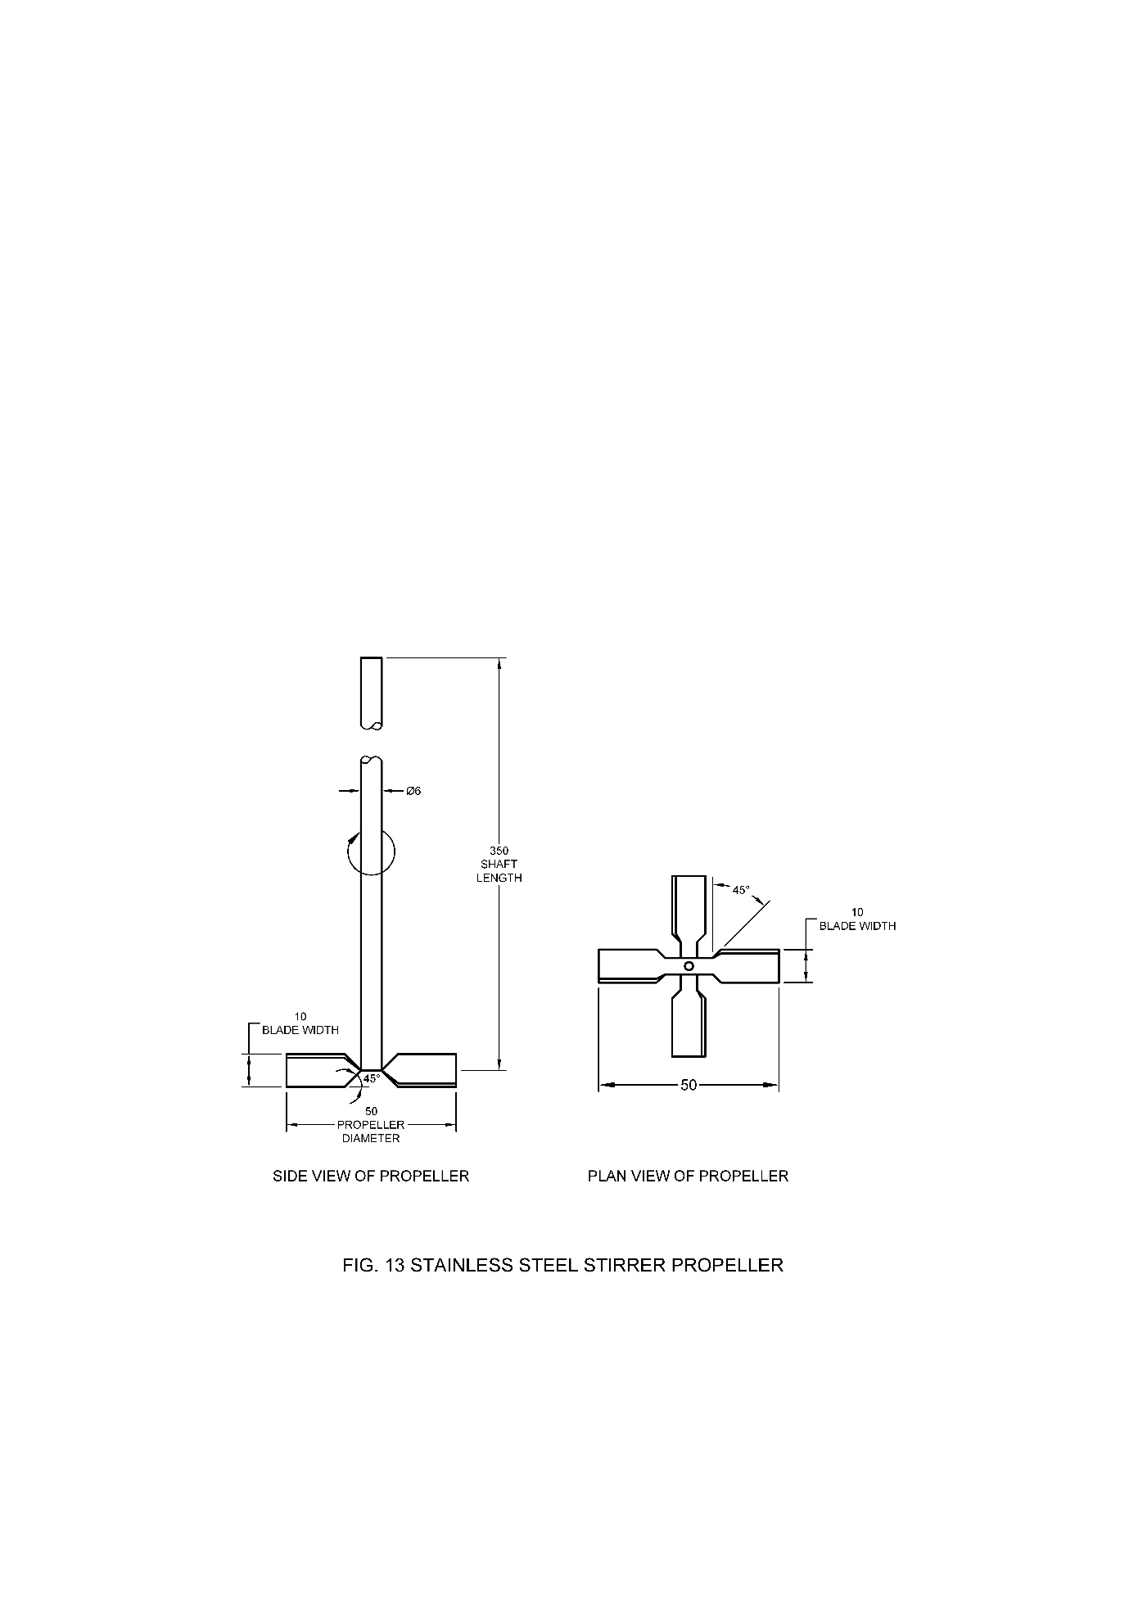

**32 FLASH POINT (ABEL)**

When determined by the method as prescribed in IS 1448 (Part 20), the flash point of the material shall be above 24.5 oC.

**33 COLD TEST**

**33.1 Procedure**

Take 50 ml of the material in a 100 ml transparent glass container and close it with a cork or stopper fitted with the thermometer. Cool the material to 10 °C (*see* Note) by placing the container in ice cold water. When the temperature of the material in the container reaches 10 oC, add to it a small seeding crystal of the pesticide with minimum opening of the stopper within the shortest possible duration of time. In case the formulation has been prepared from technical liquid pesticides, there is no need to seed with crystal. Gently stir the material in the container at short intervals for 1 h maintaining the temperature of the material at 10 oC. At the end of 1 h, examine the material for any turbidity or separated solid or oily matter or both.

NOTE – In case the purchaser specifies that the test is required to be carried out at 0 oC, the material in a container shall be cooled to 0 oC by placing the container in a bath of crushed ice and the test carried out at 0 oC instead of 10 °C.

**34 ACCELERATED STORAGE STABILITY**

**34.1 Scope**

The objective of this method is to stimulate the normal long-term aging of a formulation under conditions accelerated by heating. It is applicable for all type of formulations. The method describes the condition for storage and does not give results. Tests performed after accelerated storage are not part of this method.

NOTE – Although real time data of formulations in sales pack and stored e.g. in a warehouse are preferable, the concept of the accelerated storage test is recognised to provide predictive guidance on the stability and performance of a formulation after long-term storage. Accelerated storage testing may therefore be used to propose a shelf life for a product. For Products being stable under accelerated storage conditions, a shelf life of at least 2 years in excepted.

**34.2 Outline of the Method**

A sample is transferred to a suitable container (glass bottle or commercial container) which is subsequently closed and place in an oven at a specified temperature for a defined period of time. After removal from the storage the container with the samples is left to equilibrate conditions before performing any test.

**34.3 Apparatus**

**34.3.1** *Oven*, thermostatically maintainer at the required temperature (±2 °C).

**34.3.2***Container*, for storage (Note 2)

1. *For solid or liquid formulations* – Glass bottle with suitable sealing mechanism or commercial pack.
2. *For aerosol formulations* – Suitable containers, preferably commercial pack.
3. *For Long lasting insecticidal nets (LN) and Long-Lasting storage bag (LB)* – Large wide mouth glass bottle or suitable container sufficiently large to allow introducing of samples without damaging the net, alternatively commercial pack.
4. *For matrix release formulations (MR)* – Aluminium foil wrapping, alternatively commercial pack.
5. *Other formulation types –* A suitable container for storage should be used. In this case consideration should be given to ensure minimum impact on test to be performed after storage, alternatively commercial pack.

NOTE – ‘Container’ used in this method is used as a general descriptor and can represent e.g. bottle or a pouch or a bag. For development purpose and quality control, storage of small amount e.g. in a glass bottle or may be more suitable due to limited availability of sample, commercial package or storage space. Glass bottles are inert against penetration of air and solvents but must be sealed tightly with screw caps and using inert inserts to avoid loss of solvents by evaporation through caps. Use fresh inserts each time and the inserts should be tightly fit in the neck of the bottle to form a tight seal. Storage in a commercial pack or good representation thereof is acceptable. Preferably the container should contain the amount representative for the market to reflect a representative ratio of sample volume to headspace volume. Storage containers and sealing mechanism may need to be adapted individually for size and shape, e.g. in case the formulation type is a device.

**34.4 Procedure**

**34.4.1** *General Procedure* – Transfer the samples into the container for storage and seal it tightly. Alternatively, formulation in commercial packs can be stored as delivered. Put the container/commercial pack in an oven and keep it at the specified temperature for a defined period of time. Afterwards, remove the container/commercial pack from the oven and allow it to reach room temperature before opening and carrying out the required test.

Note – A pressure assembly shall also be used for WP formulation.

Using the following, alternative storage condition is possible:

1. (54 ±2) °C for 14 days

NOTE – This is the most suitable and widely acceptable condition, however the other temperature and time period can also be considered based on formulation sensitivity.

1. (50 ±2) °C for 4 weeks
2. (45 ±2) °C for 6 weeks
3. (40 ±2) °C for 8 weeks
4. (35 ±2) °C for 12 weeks
5. (30 ±2) °C for 18 weeks

The temperature and time condition adapted for the test shall be mentioned in the procedure as well as in reporting.

**34.4.2** *LN and LB Formulation* – Unless storage of entire LN/LB in a commercial pack is intended, prepare the required size and number of LN/LB sample in accordance with the specification and / or analytical method for the tests performed after storage. Fold and / or roll each sample carefully and transfer it into the container. Continue the general procedure for storage.

**34.4.3** *MR Formulations* – Unless storage of entire MR device(s) in commercial pack is intended, individually wrap each MR devices tightly in aluminium foil and seal it in a plastic bag or alternatively seal the MR e.g. in a bag without an inner plastic layer to avoid migration of active ingredient during storage. Continue the general procedure for storage.

**Annex A**

**(Glossary)**

|  |  |  |  |
| --- | --- | --- | --- |
| **Sl No.** | **Code** | **Term** | **Definition** |
| 1. | CS | Capsule suspension | A stable suspension of capsules in a fluid, normally intended for dilution with water before use. |
| 2. | DC | Dispersible concentrate | A liquid homogeneous formulation to be applied as a solid dispersion after dilution in water. (Note: there are some formulations which have characteristics intermediate between DC and EC). |
| 3. | DP | Dustable Powder | A free-flowing powder suitable for dusting. |
| 4. | DS | Powder for dry seed treatment | A powder for application in the dry state directly to the seed. |
| 5. | DT | Tablet for direct application | Formulation in the form of tablets to be applied individually and directly in the field, and/or bodies of water, without preparation of a spraying solution or dispersion. |
| 6. | EC | Emulsifiable concentrate | A liquid, homogeneous formulation to be applied as an emulsion after dilution in water. |
| 7. | EG | Emulsifiable granule | A granular formulation, which may contain water insoluble formulants, to be applied as an oil-in-water emulsion of the active ingredient(s) after disintegration in water. |
| 8. | EO | Emulsion, water in oil | A fluid, heterogeneous formulation consisting of a solution of pesticide in water dispersed as fine globules in a continuous organic liquid phase. |
| 9. | EP | Emulsifiable powder | A powder formulation, which may contain water insoluble formulants, to be applied as an oil-in-water emulsion of the active ingredient(s) after dispersion in water. |
| 10. | ES | Emulsion for seed treatment | A stable emulsion for application to the seed either directly or after dilution. |
| 11. | EW | Emulsion, oil in water | A fluid, heterogeneous formulation consisting of a solution of pesticide in an organic liquid dispersed as fine globules in a continuous water phase. |
| 12. | FS | Flowable concentrate for seed treatment | A stable suspension for application to the seed, either directly or after dilution. |
| 13. | GD | Gel for direct application | A gel like preparation to be applied undiluted. |
| 14. | GL | Emulsifiable Gel | A gelatinized formulation to be applied as an emulsion in water. |
| 15. | GR | Granules | A free-flowing solid formulation of a defined granule size range ready for use. |
| 16. | LS | Solution for seed treatment | A clear to opalescent liquid to be applied to the seed either directly or as a solution of the active ingredient after dilution in water. The liquid may contain water insoluble formulants. |
| 17. | MC | Mosquito coil | A coil which burns (smoulders) without producing a flame and releases the active ingredient into the local atmosphere as a vapour or smoke. |
| 18. | ME | Micro-emulsion | A clear to opalescent, oil and water containing liquid, to be applied directly or after dilution in water, when it may form a diluted micro-emulsion or a conventional emulsion. |
| 19. | OD | Oil Dispersion | A stable suspension of active ingredient(s) in a water immiscible fluid, which may contain other dissolved active ingredient(s), intended for dilution with water before use. |
| 20. | OL | Oil miscible liquid | A liquid, homogeneous formulation to be applied as a homogeneous liquid after dilution in an organic liquid. |
| 21 | RB | Bait (ready for use) | A formulation designed to attract and be eaten by the target pests. |
| 22. | SC | Suspension concentrate (= flowable concentrate) | A stable suspension of active ingredient(s) with water as the fluid, intended for dilution with water before use. |
| 23. | SE | Suspo-emulsion | A fluid, heterogeneous formulation consisting of a stable dispersion of active ingredient(s) in the form of solid particles and of water-non miscible fine globules in a continuous water phase. |
| 24. | SG | Water soluble granule | A formulation consisting of granules to be applied as a true solution of the active ingredient after dissolution in water, but which may contain insoluble inert ingredients. |
| 25. | SL | Soluble concentrate | A clear to opalescent liquid to be applied as a solution of the active ingredient after dilution in water. The liquid may contain water-insoluble formulants. |
| 26. | SP | Water soluble powder | A powder formulation to be applied as a true solution of the active ingredient after dissolution in water, but which may contain insoluble inert ingredients. |
| 27. | SS | Water Soluble Powder for Seed Treatment | A powder to be dissolved in water before application to the seed |
| 28. | ST | Water soluble tablet | Formulation in form of tablets to be used individually, to form a solution of the active ingredient after disintegration in water. The formulation may contain water-insoluble formulants. |
| 29. | SU | Ultra-low volume (ULV) suspension | A suspension ready for use through ULV equipment. |
| 30. | TB | Tablet | Pre-formed solids of uniform shape and dimensions, usually circular, with either flat or convex faces, the distance between faces being less than the diameter. |
| 31. | TC | Technical material | A material resulting from a manufacturing process comprising the active ingredient, together with associated impurities. This may contain small amounts of necessary additives. |
| 32. | MUP | Manufactured Use Product | A material resulting from a manufacturing process comprising the active ingredient, together with associated impurities. This may contain small amounts of necessary additives and appropriate diluents. |
| 33. | UL | Ultra-low volume (ULV) liquid | A homogeneous liquid ready for use through ULV equipment. |
| 34. | WG | Water dispersible granules | A formulation consisting of granules to be applied after disintegration and dispersion in water. |
| 35. | WP | Wettable powder | A powder formulation to be applied as a suspension after dispersion in water. |
| 36. | WS | Water dispersible powder for slurry seed treatment | A powder to be dispersed at high concentration in water before application as a slurry to the seed. |
| 37. | WT | Water dispersible tablet | Formulation in the form of tablets to be used individually, to form a dispersion of the active ingredient after disintegration in water. |
| 38. | ZC | A mixed formulation of CS and SC | A stable suspension of capsules and active ingredient(s) in fluid, normally intended for dilution with water before use. |
| 39. | ZE | A mixed formulation of CS and SE | A fluid, heterogeneous formulation consisting of a stable dispersion of active ingredient(s) in the form of capsules, solid particles, and fine globules in a continuous water phase, normally intended for dilution with water before use. |
| 40. | ZW | A mixed formulation of CS and EW | A fluid, heterogeneous formulation consisting of a stable dispersion of active ingredient(s) in the form of capsules and fine globules in a continuous water phase, normally intended for dilution with water before use. |

**ANNEX B**

(Foreword)

**CORRESPONDING TEST METHODS IN IS 6940 : 1982 (*first revision*) AND IS 6940 : 2024 (*second revision*)**

|  |  |  |  |
| --- | --- | --- | --- |
| *Sl No.* | *Test Method* | *Clause Ref in* IS 6940 : 1982 (*first revision*) | *Clause Ref in* IS 6940 : 2024 (*second revision*) |
| (1) | (2) | (3) | (4) |
|  | Determination of moisture content | **4** | **7** |
|  | Determination of relative density of liquid pesticides | **5** | **9.1** |
|  | Determination of melting point | **6** | **22** |
|  | Determination of softening point | **7** | **-** |
|  | Determination of setting point | **8** | **-** |
|  | Determination of material insoluble in acetone | **9** | **8.1** |
|  | Sieving test after accelerated storage/without pretreatment | **11.1** | **12** |
|  | Accelerated storage | **11.1.2.1** | **34** |
|  | Suspensibility test after accelerated storage/without pretreatment | **11.2** | **17** |
|  | Acidity or alkalinity test | **11.3** | **21** |
|  | Wettability test | **11.4** | **10** |
|  | Test for sieving requirement for particle size | **12.1** | **12.3** |
|  | Bulk density after compacting | **12.2** | **9.3** |
|  | Test for acidity or alkalinity | **12.3** | **21** |
|  | Cold test | **13.1** | **33** |
|  | Flash point (Abel) | **13.2** | **32** |
|  | Emulsion stability | **13.3** | **19** |
|  | Test for heat stability | **13.4** | **-** |
|  | Acidity or alkalinity test | **13.5** | **21** |
|  | Attrition test | **14.1.1** | **14** |
|  | Water run-off test | **14.1.2** | **-** |
|  | Wet test for encapsulation | **14.1.3** | **-** |
|  | Liquid holding capacity | **14.1.4** | **-** |

**ANNEX C**

(*Foreword*)

**COMMITTEE COMPOSITION**

Pesticides Sectional Committee, FAD 01

| *Organization* | *Representative(s)* |
| --- | --- |
| Directorate of Plant Protection Quarantine and Storage,  Faridabad | Dr J P SINGH (***Chairperson***) |
| All India Biotech Association, New Delhi | Shri Saurabh Singhal  Shri Shah Ji Dhar (*Alternate*) |
| Bio-Agri Solution Association of India, New Delhi | Mr Vipin Saini  Dr Sandeepa Kanitkar (*Alternate*) |
| Central Insecticide Board and Registration Committee, Faridabad | Secretary  Dr Vandana Seth (*Alternate*) |
| Central Insecticide Laboratory, Faridabad | Dr Archana Sinha  Shri Subhash Chaudhary (*Alternate*) |
| Crop Care Federation of India, New Delhi | Dr J. C. Majumdar |
| Crop Life India, New Delhi | Shri Asitava Sen  DR. RAKESH DAHIYA (*Alternate*) |
| CSIR -Indian Institute of Toxicology Research, Lucknow | Dr Sheelendra P. Singh |
| IDMA Laboratories Limited, Chandigarh | Dr Indra Rai  Dr Parkash Kaur (*Alternate*) |
| Institute of Pesticide Formulation Technology, Gurgaon | Dr Mohana Krishna Reddy Mudiam  Dr Lalitesh Thakur (*Alternate*) |
| National Centre for Integrated Pest Management, New Delhi | Dr Sumitra Arora |
| National Institute of Plant Health Management, Hyderabad | Dr Mahesh Saini  Ms T. Sridevi (*Alternate*) |
| PI Industries Limited, Panoli | Mr Ashish Vyas  Dr Shailendra Bharambe (*Alternate*) |
| Pesticide Manufactures and Formulators Association of India (PMFAI), Mumbai | Dr Archana Srivastava |
| Punjab Agriculture University, Ludhiana | Dr Amit Choudhary (*Alternate*) |
| Regional Pesticides Testing Laboratory, Chandigarh | Dr Rohit Singh  Mr Nilesh Shah (*Alternate*) |
| In Personal Capacity (*6/12, PAU Campus, Punjab Agriculture University, Ludhiana - 141004*) | DR PARDEEP K. CHHUNEJA |
| In Personal Capacity (*37, Rail Vihar, Saraswati Vihar, Pitampura, Delhi - 110034)* | DR UDAY KUMAR |
| In Personal Capacity (*4-6-90/2/8/2, Sri Devi Nilayam Tejaswinagar Coloni, Attapur, Hyderabad – 500048*) | Shri C. V. Rao |
| BIS Directorate General | Shrimati Suneeti Toteja,  Scientist ‘F’/Senior Director And Head  (Food And Agriculture Department)  [Representing Director General (*Ex- officio*)] |

*Member Secretary*

Shri Kuldeep Mittal

Scientist ‘B’/Assistant Director

(Food And Agriculture Department), BIS