भारतीय मानक
Indian Standard

मोटा अनाज (श्रीअन्न) के लिए पर्लर सह पॉलिशर — विशिष्टि
एवं परीक्षण संहिता

PEARLER CUM POLISHER FOR MILLETS — SPECIFICATION
AND TEST CODE

ICS 65.060

© BIS 2024

भारतीय मानक ब्यूरो
B U R E A U O F I N D I A N S T A N D A R D S
मानक भवन, 9 बहादुर शाह जफर मार्ग नई दिल्ली 110002
MANAK BHAVAN, 9 BAHADUR SHAH ZAFAR MARG,
NEW DELHI 110002

www.bis.gov.in www.standardsbis.in

June 2024 Price Group
Agriculture and Food Processing Equipment Sectional Committee, FAD 20

FOREWORD

This Indian Standard was adopted by the Bureau of Indian Standards, after the draft finalized by the Agriculture and Food Processing Equipments Sectional Committee had been approved by the Food and Agriculture Division Council.

Millets are important food grains that contain layers of husk (pericarp) and bran, over the starchy edible endosperm. The presence of these layers is considered as a protection to store the grain/seed for a longer time. The outer husk layers of millets are removed by dehusking. Unlike in most millet grains, in case of ragi, sorghum and pearl millet, the pericarp (husk) layer is fused to endosperm and therefore needs pearling to make them more palatable. Though bran (aleurone layers) is nutrient rich, some millet consumers prefer dehulled polished grains for better palatability. Pearling is the operation, where the removal of husk and bran are done in a single operation by the gradual removal of grain tissues (by abrasive or friction action) starting from the outer grain tissues/layers, bran (i.e., pericarp, testa, aleurone, and sub aleurone layers), and germ. Equipment used in millet pearling and polishing are crucial for ensuring the quality of processed millets.

This standard has been developed to help in maintaining the overall quality and promoting the consumption of this valuable and nutritious grain. This standard will benefit all the equipment manufacturers, millet millers and consumers.

A series of Indian Standards have been developed for the equipment used in the primary processing of grains. Apart from this standard, four other standards on millets processing equipment have been published, which are as under:

IS 19039: 2023 Cleaner cum grader for millets with pre-cleaner ⎯ Specification and Test code
IS 19040: 2023 Millet Dehusker — Centrifugal Type — Specification and Test code
IS 19041: 2023 Destoner for Millets ⎯ Specification and Test code
IS 19042: 2023 Symbols and flow diagram for primary processing of millets

The composition of the Committee responsible for the formulation of this standard is given in Annex M.

For the purpose of deciding whether a particular requirement of this standard is complied with, the final value, observed or calculated, expressing the result of a test or analysis, shall be rounded off in accordance with IS 2: 2022 ‘Rules for rounding off numerical values (second revision)’. The number of significant places retained in the rounded off value should be the same as that of the specified value in this standard.

Indian Standard

PEARLER CUM POLISHER FOR MILLETS — SPECIFICATION

AND TEST CODE

1 SCOPE

This standard specifies material, performance, constructional and other requirements of Pearler cum Polisher for millets, and it also prescribes the test methods for performance evaluation of this equipment.

2 REFERENCES

The standards given below contain provisions which, through reference in this text, constitute provisions of this standard. At the time of publication, the editions indicated were valid. All standards are subject to revision, and parties to agreements based on this standard, are encouraged to investigate the possibility of applying the most recent editions of these standards.

IS No. | Title
IS 210: 2009 | Grey iron castings — Specification (fifth revision)
IS 277: 2018 | Galvanized steel strips and sheets (Plain And Corrugated) — Specification (seventh revision)
IS 399: 1963 | Classification of commercial timbers and their zonal distribution (first revision)
IS 715: 2002 | Coated Abrasives — Specifications (fourth revision)
IS 816: 1969 | Code of practice for the use of metal arc welding for general construction in mild steel (first revision)
IS 2062: 2011 | Hot rolled medium and high tensile structural steel — Specification (seventh revision)
IS 2405 (Part 1): 2023 | Industrial Sieves Specification Part 1 Wire Cloth Sieves (second revision)
IS 2405 (Part 2): 2023 | Industrial Sieves Specification Part 2 Wire Sieves (second revision)
IS 4333 (Part 2): 2017/  ISO 712: 2009 | Methods of analysis for food grains: Part 2 Determination of moisture content (second revision)
IS 6911: 2017 | Stainless Steel Plate, Sheet and Strip — Specification (Second revision)
IS 10520: 2024 | Agricultural produce milling machinery — Emery stones for burr flour mills — Specification and Test Code

3 TERMINOLOGY

For the purpose of this standard, the following definitions shall apply.

3.1 Abrasive type Polisher/Pearler — Polisher/pearler that uses abrasive surfaces as mechanism to remove husk/bran layers of millets.

3.2 Bran — The aleurones layers removed from the outermost part of the dehulled millet, may be with or without admixture of the husk/hull.

3.3 Broken Millet — Dehulled millet kernels which are broken and whose size (length/diameter) is less than three-fourths of the original size.
3.4 Degree of Polish — The quantity of bran removed from dehulled millet kernel during polishing, expressed as a percentage of edible mass (bran, endosperm) removed from dehusked/dehulled unpolished millet kernel.

3.5 Degree of Pearling — The quantity of husk/hull removed from millet during pearling, expressed as a percentage calculated based on the quantity of feed taken for pearling.

3.6 Emery-Coated Polishing Unit — Emery of specific grit size bonded with magnesium oxide and magnesium chloride coated on the surface to provide necessary abrasion for polishing. The surface may be a cone, drum/roller, disc, etc.

3.7 Feed Rate — The quantity of millets fed into the pearler/polisher per unit time.

3.8 Feed Regulating Mechanism — The mechanism which regulates the feed rate to the polisher/pearler.

3.9 Friction Type Polisher/Pearler — The polisher/pearler that uses predominantly grain to grain friction as a mechanism for removal of bran.

3.10 Millet Polisher — Equipment used for the removal of the bran layer from the raw or parboiled millets after dehusking/dehulling.

3.11 Pearling — This is a mechanical operation of removal of husk/hull and bran layers in a single operation by abrasion/friction. Both husk/hull and bran will be obtained as a mixture.

3.12 Polish Regulating Mechanism — The arrangement for varying the retention time for the millets inside polishing unit during pearling/polishing to achieve various levels of degree of polish/pearling.

3.13 Polishing — Removal of the bran layer from the dehusked/dehulled millet kernel by the mechanical action of abrasion or friction. It is also known as whitening.

3.14 Rated Input Capacity — Feed rate at which the degree of polish/pearling and the brokens are within the specified limit.

3.15 Whole peraled/polished Millet — Millet kernel/grains of size (length/diameter) three-fourths and above of the whole dehusked/unpolished millet grain.

4 TYPES OF MILLETS AND EQUIPMENT

4.1 Millet Grains

The following crops classified under millets (see Table 1) can be processed by this equipment. Though they look similar in shape and size, the thickness of the husk/hull vary, demanding different types and parameters for polishing/pearling.

Table 1 Common Names and Botanical Names of Millet Crops
(Clause 4.1)

Sl  No. | Common Name of Millets | Botanical Name
(1) | (2) | (3)
i) | Sorghum/Jowar/Great Millet | Sorghum bicolor
ii) | Pearl millet/Bajra | Pennisetum glaucum
iii) | Finger millet/Ragi | Elusine corocana
iv) | Kodo millet | Paspalum scrobiculatum
v) | Foxtail/Italian millet/Kangni | Setaria italica
vi) | Little millet/ Kutki millet | Panicum sumatrense
vii) | Proso/Common millet | Panicum miliaceum
viii) | Barnyard millet/Samwa | Echinocloa colona
ix) | Brown top millet/Makra | Urochloa ramosa

4.2 Pearler

The pearler normally uses abrasion force to scratch and remove husk/hull and bran in layers. Pre-treatment, like moistening the millet, is followed for easy removal of bran with less breakage. Roller/drum and disc type pearlers are in vogue.

4.2.1 Roller/Drum Type Pearler

The abrasive surface is made into a roller or drum, either with or without a tapper, for a required length. This roller/drum is placed inside a concave, concentric to roller and is made of perforated sheet/sieve of length according to the size of the roller/drum. The roller/drum and concave constitute pearling/polishing chamber. The feed hopper with a feed regulator is placed above the cover. The clearance between the concave and the roller/drum should be at least the mean size (diameter/thickness) of the millet being pearled and provisions may be made to adjust the clearance. On the drum/roller shaft, a feed screw may be provided at the feed end for uniform feeding of the millets for pearling. The millet grains after pearling are discharged through the outlet given on the far side of the pearling chamber opposite to the feed hopper end. This outlet is a self-loaded type to regulate the retention time of the millets for pearling as well as grain pressurized inside the pearling chamber. The concave holds the millets; on the bed of millets, the rotor/drum rotate through a suitable power source and abrasive force is to be applied for pearling. The husk/hull and bran are passed through the perforated concave and collected through an outlet.

4.2.2 Disc Type Pearler

This mechanism is like an under runner sheller with a pair of abrasive discs (see Fig. 1). The discs are placed on a horizontal shaft with one stationary and the other one rotating with a suitable drive. The millet grains to be pearled are passed through the clearance between the discs. The clearance is adjusted according to the size (diameter/thickness) of the millet grains. Between the discs, the millet grains undergo compression, shear and abrasion, resulting in the removal of husk/hull and bran layers. The hull and bran removed are separated using sieve/aspirator. The pearled/polished millets are received through the appropriate outlet.

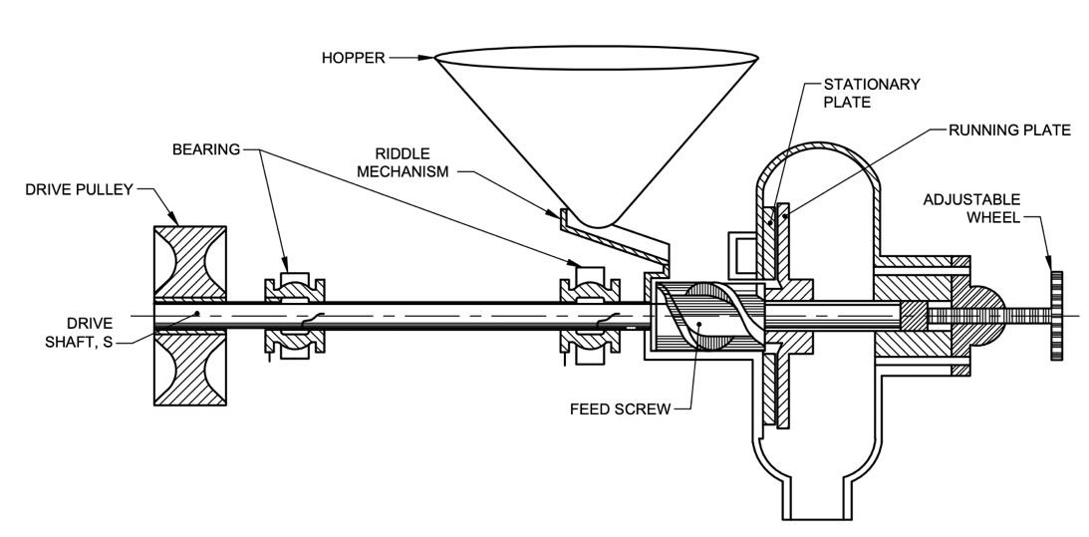

FIG. 1 DISC TYPE PEARLER

4.3 Polisher

The following type of polisher can be used for polishing of millets.

a) Abrasive horizontal polisher (see Fig. 2)
b) Metallic Friction type polisher (see Fig. 3)
c) Stone type abrasive polisher (see Fig. 4)

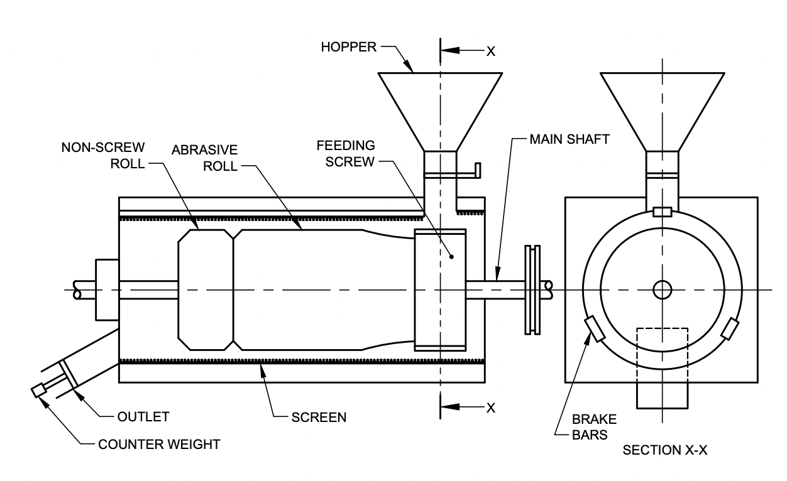

FIG. 2 SCHEMATIC DIAGRAM OF ABRASIVE HORIZONTAL POLISHER

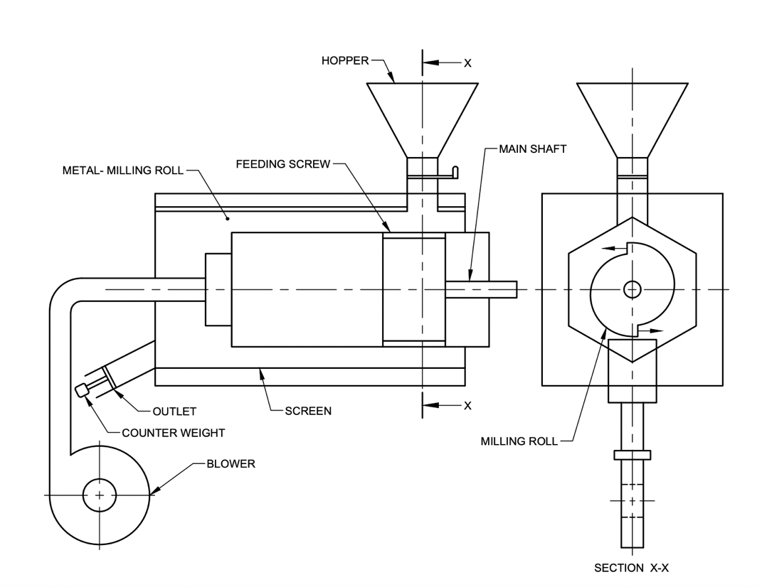

FIG. 3 SCHEMATIC DIAGRAM OF FRICTION TYPE POLISHER

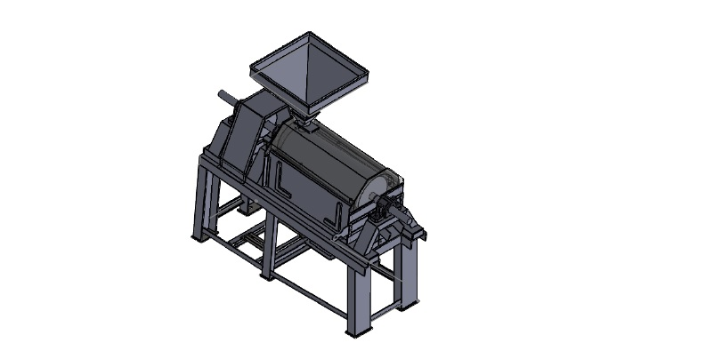

FIG. 4 (A) STONE TYPE ABRASIVE POLISHER
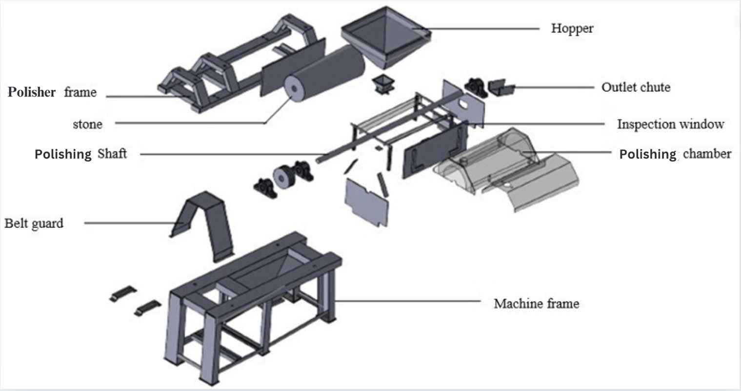

FIG. 4 (B) SCHEMATIC DIAGRAM OF COMPONENTS OF STONE TYPE ABRASIVE POLISHER

5 MATERIALS

5.1 The material of construction of various components of pearler cum polisher shall be as given in col 3 of Table 2 and the material shall conform to the relevant Indian Standards given in co1 4.

Table 2 Material of Construction
(Clause 5.1)

Sl.  No. | Component | Material | Reference to IS
(1) | (2) | (3) | (4)
1. | Bearing housing/Plummer block | Cast iron | IS 210
2. | Blower casing | Mild steel | IS 2062
 |  | Cast iron | IS 210
3. | Blower impeller (blade holder) | Cast iron | IS 210
4. | Bottom and top drum of Elevator | Cast iron | IS 210
5. | Bucket/cups | Mild steel/plastics | IS 2062
6. | Concave | Mild steel | IS 2062
 |  | Galvanized sheet | IS 277
 |  | Stainless steel (SS 204/SS 304) | IS 6911
7. | Discharge spout | Mild steel | IS 2062
 |  | Galvanized sheet | IS 277
 |  | Stainless steel (SS 204/SS 304) | IS 6911
8. | Elevator body/frame | Mild steel | IS 2062
 |  | Wood | IS 399
9. | Feed hopper | Mild steel | IS 2062
 |  | Stainless steel (SS 204/SS 304) | IS 6911
10. | Frame | Mild steel | IS 2062
11. | Gears | High carbon steel | -
12. | Hand wheels/adjustment levers | Cast iron | IS 210
 |  | Mild steel | IS 2062
 |  | Stainless steel (SS 204/SS 304) | IS 6911
13. | Pulley | Cast iron | IS 210
 |  | Mild steel | IS 2062
14. | Screens/sieves | Mild steel | IS 2062
 |  | Stainless steel (SS 204/SS 304) | IS 6911
15. | Shafts | Mild steel | IS 2062
16. | Emery disc/drum | Emery | IS 10520

5.2 The wire cloth sieve and perforated type sieve should conform to IS 2405 (Part 1) and IS 2405 (Part 2), respectively.

6 CONSTRUCTIONAL REQUIREMENTS

6.1 Abrasive Surface

It shall be made of emery of 3.60 minimum specific gravity with hardness on Moh’s Scale of 8 (see IS 715) or silicon carbide of 3.12 minimum specific gravity with hardness on Moh’s Scale of 9.5. The emery grit size and preparations of each grit shall be declared by the manufacturer. The emery coating shall be homogeneous and shall adhere firmly. The thickness of the emery coating above the dovetail shall be minimum of 12 mm for cone polishers and 25 mm for horizontal polishers and statically balanced. The thickness of emery coating or vitrified silicon carbide coating shall be uniform and shall be specified.

6.2 Concave

The concave should be made of non-corrosive material and perforations should be punched according to the size of the millet grains. The size of the concave for various millets shall be declared by the manufacturer and provided as accessories. The perforation size should be such that it should permit the husk/hull and bran and not permit millet grains to pass through it freely.

6.3 Feed Screw

A feed screw should be placed appropriately as an optional attachment to feed the millets uniformly into the pearling/polishing chamber.

6.4 Frame

The main frame shall be made of mild steel of suitable size with channels/angle sections and shall be covered wherever required with mild steel sheet/galvanised sheet/stainless steel sheet of adequate thickness, depending on the requirements, and with provision to open the covers for any adjustments/maintenance.

6.5 Hopper

The hopper shall be made of metal sheet with a minimum thickness of 1 mm. It shall be provided with a feed regulating device and side slope of 30-35° for easy flow of the grains. The feed hopper should be located at an appropriate height from ground level for easy manual filling. Alternatively, the unit may be provided with a bucket elevator for filling the hopper.

It is recommended that the hopper should be either permanently attached or firmly secured so it cannot be removed without the aid of tools. The servicing and adjustments should be possible without removing the guards completely.

6.6 Outlet for Grains, Kernels, Husk and Bran

The outlet for the millet kernel after polishing or pearling should be placed at a suitable height from ground for easy collection/filling in gunny bags. A regulating mechanism should also be provided in the outlet to adjust the retention time of the grains inside the polishing/pearling chamber. The aspirator, as an optional attachment, may be provided to collect the husk/bran.

6.7 Polishing or Pearling Chamber

The chamber shall house the drum, disc, or any other mechanism employed for pearling or polishing the millet grains. The chamber shall be made of a minimum thickness of 1 mm. Provision shall be made for easy replacement/inspection of drum/discs. An appropriate mechanism should be provided to regulate the degree of polish/pearling.

6.8 Power Transmission

A suitable system for transmitting the power shall be provided. It may consist of V-belt and pulley, gears or sprocket and chain. Transmission guards shall be provided to prevent accidental contact with persons or parts of clothing being caught in the transmission system unless the system is so constructed or placed as to be safe without guards.

6.8.1 The guards shall be designed so as not to hinder in easy adjustment, servicing and operation of the separator.

6.8.2 The guards shall have sufficient strength to support a load of 600 N applied at any point over an area of 0.1 m² without a permanent set.

6.9 Shafts

The shafts shall be supported with suitable bearings and housings on the stable part of the machine.

6.10 Surface Finish

All the joints and surfaces shall be made smooth and protected from weather conditions.

7 PERFORMANCE REQUIREMENTS

7.1 The pearler cum polisher, after installation on the level and the hard surface, shall not show any break down when undergoing all the tests mentioned in 11.

7.2 When tested in accordance with the method given in 11.2.4, the capacity per hour and rated capacity per kWh energy consumed shall be recorded. Various adjustments, clearances and speeds for the rated capacity shall be declared by the manufacturer.

7.3 The capacity of the pearler/polisher shall not be less than by 5% of the manufacturer’s claim.

7.4 The dehusked millet shall not get any visible stain.

7.5 When tested in accordance with 11.2.4, no breakdown or defects shall develop in any component of the pearler/polisher.

7.6 The pearling/polishing operation shall be capable of removing the outer layer (husk/bran) from at least 50% of the grains in the case of raw millet and at least 60% of the grains in the case of parboiled millet in the first pass, and in the subsequent passes, the removal will be from 70 and 80%, respectively.

7.7 The maximum per cent breakage shall be 20% in raw millet and 10% in parboiled millet in one pass.

7.8 The husk/bran aspiration unit shall remove minimum of 95% of the husk present. Not more than 5% of brokens/kernels/grains shall go along with husk/bran.

7.9 The degree of polishing (after dehusking/dehulling) shall not be more than 5%. The degree of pearling (without dehusking/dehulling) shall not be more than 20%.

7.10 The specific energy consumption for polishing/pearling shall not be more than 5 kWh/100 kg.

8 OTHER REQUIREMENTS

8.1 Provision shall be made for lubrication of bearings, and they shall be dust-proof.

8.2 A feed regulating system shall be provided

8.3 Various controls shall be easily accessible and capable of being locked in a chosen position.

8.4 In the case of belt drive, provisions shall be made for adjusting the belt tightness.

8.5 Transmission guards shall be provided to prevent accidental contact of persons on parts or clothing being caught in the transmission system unless the system is so constructed or placed as to be safe without guards.

8.6 The guards shall be so designed as not to hinder in easy adjustment, servicing and operation of pearler/polisher.

8.7 It is preferable that all guards shall be either permanently attached or firmly secured to prevent their removal without the aid of the tools. Servicing and adjustments should be possible without complete removal of the guards.

8.8 The pearler cum polisher shall be provided with the operator's manual.

9 WORKMANSHIP AND FINISH

9.1 The components of pearler cum polisher shall be free from cracks, pits, holes and other visual defects which may be detrimental to their use.

9.2 The welding, if done, shall be smooth and not porous (see IS 816).

9.3 A rust preventive coating shall be provided to the steel components.

10 MARKING AND PACKING

10.1 Marking

Each polisher shall be marked with the following particulars:

a) Manufacturer’s name with recognized trade-mark, if any;
b) Batch or code number;
c) Power rating and capacity;
d) Type;
e) Model No.;
f) Year of manufacturing; and
g) Direction of rotating parts and rated speed.

10.1.1 A minimum cautionary notice worded as follows shall be written in vernacular language legibly and prominently on the main body of the polisher/pearler:

a) Do not wear loose dress, bangles, watch, etc., while working with polisher/pearler;
b) Do not work under the influence of intoxicants like liquor, opium, etc;
c) Children and aged persons should be discouraged from working in polisher/pearler;
d) Do not cross over moving belts;
e) Do not operate polisher/pearler without guards and safety devices;
f) Do not make adjustments when the polisher/pearler is running; and
g) Do not put or take-off the belt while pulley is running.

10.2 BIS Certification Marking

The product(s) conforming to the requirements of this standard may be certified as per the conformity assessment schemes under the provisions of the Bureau of Indian Standards Act, 2016 and the Rules and Regulations framed thereunder, and the products may be marked with the Standard Mark.

10.3 Packing

10.3.1 The polisher shall be packed as agreed to between the purchaser and the supplier for safe handling in transit.

11 METHODS OF TEST

11.1 Test Material

Sufficient quantity of raw or parboiled millets of the same variety shall be taken. Moisture content of the millet, in accordance with IS 4333 (Part 2), shall be between 12 and 14 per cent (w.b.). Alternatively, the test materials (millets) will be conditioned to the required level of moisture content as recommended by the manufacturer.

11.2 Type Tests

11.2.1 General

a) Checking of specifications (Annex A),
b) Checking of material of construction (Annex B), and
c) Visual observations and checking of provisions for adjustments (Annex C).

11.2.2 Running-In and Preliminary Adjustments

The polisher/pearler shall be installed on level ground, preferably on a hard surface, using foundation bolts and nuts or anti-vibration mounts. All adjustments shall be made in accordance with the manufacturer’s recommendation.

The polisher/pearler shall be attached with a suitable prime mover as recommended by the manufacturer, preferably with an electric motor and auto-voltage stabilizer. An energy meter or some form of transmission dynamometer shall be fitted. The power delivered to the polisher/pearler may be supplied in the following ways:

a) Direct coupling the prime mover with the main shaft of the polisher, and
b) Connecting the prime mover with the help of a flat or V-belt and pulleys with the main shaft of the
polisher.

In the case of (a), the power delivered to the polisher would be the power output of the prime mover, whereas in the case of (b), the allowances for flat and V-belt drive losses may be taken at 6 and 3 per cent, respectively.

11.2.3 Test at No-Load

After the running-in is over, the polisher/pearler shall be run at no load for 30 min at the specified speed. The data shall be recorded as per Annex D, and after a no-load run, the pearler cum polisher shall not have any visual observation as given in Annex D.

11.2.4 Test at Load

The data for all the tests mentioned in 11.2.4.1, 11.2.4.2 and 11.2.4.3 shall be recorded appropriately in Annex E and Annex H.

11.2.4.1 Operation and collection of data after the stabilization of the operation, the pearler/polisher shall be operated at its rated speed for minimum of 30 minutes at a feed rate equal to rated input capacity specified by the manufacturer. The quantity of the raw material used during the test will be recorded. During the run period, the following samples and data shall be collected:

a) Three sets of samples at an interval of 10 minutes at the following outlets for one minute:

i) Polished/pearled millet kernel outlet, and
ii) Husk/bran outlet.

b) The speed of the main shaft and the readings of the energy meter or dynamometer shall be recorded.

11.2.4.2 At the end of 30 min feeding, the polisher shall be run for some time so that practically no more material already fed comes out. At the end of the test, the material received at polished/pearled millet kernel outlet shall be collected and weighed. The mass of the sample collected at polished/pearled millet kernel outlet [see 11.2.4.1 (a)] shall be added.

11.2.4.3 The husk/bran received through its outlet during the polishing/pearling operation shall be collected and weighed. The mass of the husk/bran collected at its outlet [see 11.2.4.1(a)] shall be added. The husk/bran collected after each pass of pearling/polishing will be sieved using a hand sieve of appropriate sieve perforations, and both the whole and broken kernels will be weighed.

Depending on the number of passes the millets are subjected to polishing/pearling, samples will be collected during each pass, and the time taken for polishing/pearling will also be recorded along with the energy meter reading.

11.2.5 Preparation and Analysis of Sample

The three sets of samples obtained at feed, polished/pearled millet kernel outlet and husk/bran outlet during each pass shall be weighed separately and thoroughly mixed to form composite samples. Out of these composite samples, 100 g of sample shall be taken and analyzed for the following:

a) Raw material (feed) — To be analyzed for good grains and foreign matter.
b) Polished/pearled millet kernel outlet — To be analyzed for the whole kernel, broken millet, foreign matter, and husk/bran.
c) Husk/bran outlet — To be analyzed for foreign matter, polished/pearled millet kernel (broken millet and whole millet kernel).

The data shall be recorded appropriately in Annex F.

11.2.6 Determination of Capacity

The capacity of polishing/pearling of the unit will be determined from the quantity of raw materials fed and the corresponding time taken, as follows, and recorded in Annex G. If the operation involves a number of passes to achieve a higher level of polishing/pearling, the time taken for each pass will also be considered.

Polishing/pearling capacity,
(Q × 60)
C = kg/hour
(t₁+t ₂+t₃+…)

where,

C = capacity in kg/hour
Q = quantity of feed taken for testing, kg
t₁+t₂+t_{3 …} = t_{t}, sum of duration of polishing/pearling through the number of passes, min.
1, 2, 3, = suffix denote the number of the pass.

11.2.7 Determination of Degree of Polishing/Pearling

The degree of polishing/pearling shall be calculated using the following formula and recorded in Annex G:

D₁ = [Q₁ − (q₁ + g₁)] × 100/Q₁ %

D₂ = [Q₂ − (q₂ + g₂)] × 100/Q₂ %

D₃ = [Q₃ − (q₃ + g₃)] × 100/Q₃ %
….
….
….

where,

D = degree of polishing/pearling, %; D = D₁+D₂ +D₃+…
q = quantity of polished/pearled kernel, including brokens obtained after each pass, kg
g = quantity of polished/pearled kernel, including brokens obtained by sieving from husk/bran after each
pass, kg
Q = quantity of feed taken for polishing/pearling, kg
1, 2, 3… = suffix denote the number of the pass.

11.2.8 Determination of Percent Breakage

The percent breakage during polishing/pearling shall be calculated by the following formula given below and recorded as per Annex F.

Breakage in polishing/pearling,

B₁ = (b₁/s₁) × 100, %
where,

B = per cent breakage of millet kernels, %; B₁+B₂ +B₃+…
b = mass of broken millet grain/kernel separated from the sample taken from polished/pearled kernel
outlet, b1, b2, b3 ….g.
s = mass of sample (100 g) taken from polished/pearled kernel outlet, g.
1, 2, 3… = suffix denote the number of the pass.

11.2.9 Determination of Millet Kernel Lost Along Husk/Bran

The millet kernel, both whole and brokens lost along the husk/bran, is calculated as follows and recorded in Annex G:

Millet kernel lost along husk/bran,

L = (g/Q) × 100, %
where,

L = millet kernel lost along husk/bran, % ; L₁+L₂ +L₃+…
g = quantity of polished/pearled kernel, including brokens obtained by sieving from husk/bran after each
pass, kg
Q = quantity of feed taken for polishing/pearling, kg
1, 2, 3… = suffix denote the number of the pass.

11.2.10 Power Consumption

The power requirement during the test run shall be calculated/measured in accordance with the following methods and recorded in Annex G.

11.2.10.1. In the case of a prime mover fitted with an energy meter, from the initial and final readings taken during the test, the power consumption per hour giving due allowance to the type of drive shall be calculated and reported.

11.2.10.2. In the case of a prime mover fitted with the dynamometer, the reading taken shall indicate the torque required. The power consumption per hour, giving due allowance to the type of drive, shall be calculated by the following formula:

T × S
P =
9549.30

where,

P = power, kW;
T = torque, Nm; and
S = speed, rev/min.

NOTE — For the purpose of certification, the power consumption at the declared feed rate shall only be calculated.

11.2.11 Determination of the Specific Capacity and Specific Power Consumption

From the quantity of millet (Q kg) taken for the test and the total time (sum of all passes) taken (min.) for polishing/pearling this quantity, capacity is calculated and expressed as kg/h. The capacity in terms of the energy consumed shall be calculated by dividing the capacity by the power consumed and shall be expressed in tonnes/kWh. The specific power consumption will be expressed as kWh/tonne. Record the data in Annex G.

11.2.12 Long Run Test

The pearler cum polisher shall be operated for a minimum duration of 20 hours at no load, which could be covered by a continuous run of at least 5 hours. During and after the operation, no break down or defects shall develop in the polisher/pearler. Record the major breakdowns, defects developed, and repairs made in the data sheet given in Annex J.

11.3 Summary Report

For the guidance of the user, compile a summary report on the proforma as given in Annex K.

ANNEX A
[Clause 11.2.1(a)]

SPECIFICATION SHEET

A-1 General

a) Name and address of manufacturer
b) Make
c) Model
d) Type and function
e) Serial number
f) Year of manufacture
g) Rated capacity (kg/hour)
h) Maximum capacity (kg/hour)

A-2 Power Unit

a) Type of recommended prime mover
b) Type of drive
c) Recommended power rating, kW

A-3 Main Drive

a) Type
b) Size of pulley on prime mover
c) Size of pulley on main shaft of polisher/pearler, mm
d) Size and number of belts
e) Type of belt tightening arrangement
f) Details of gear system, if used
g) Recommended speed of main shaft, rpm
h) Size of pulley (mm) and speed of blower/aspirator, rpm
i) Provision for changing speed of main shaft

A-4 Feeding Arrangement

a) Type of feed mechanism
b) Storage capacity of feed hopper, kg
c) Type of drive for feed mechanism
d) Arrangement for controlling feed
e) Arrangement for uniform feeding of millet grains
f) Location of feed hopper from ground level, m
g) Provision of elevator

A-5 Polishing/Pearling Chamber

a) Diameter of the chamber, mm
b) Width of the chamber, mm
c) Height of the chamber, mm
d) Length of the chamber, mm
e) Type of polishing surface
f) Diameter of the drum/roller, mm
g) Length of drum/roller, mm
h) Diameter of the abrasion disc, mm
j) Thickness of the abrasion disc, mm
k) Method of mounting of roller/drum/disc on the shaft
m) Method of mounting of main shaft on the frame
n) Provision to control the outlet for the kernel after polishing/pearling to adjust the retention time for the grains

A-6 Concave

a) Type of concave (full rotor/half cylinder)
b) Length of rotor, mm
c) Diameter of rotor, mm
d) Depth of concave, mm
e) Type of perforation
f) Size of perforation, mm
g) Method of fixing on the frame

A-7 Aspirator/Blower

a) Type of blower/aspirator
b) Diameter of the impeller, mm
c) Width of the blower, mm
d) Type and number of bearings
e) Provision for adjusting airflow
f) Speed of impeller/blade, rpm
g) Provision of husk outlet

A-8 Overall Dimensions

a) Length, mm
b) Width, mm
c) Height, mm
d) Ground clearance for discharge, mm
e) Total mass, kg

A-9 Tools, Accessories, Operation Manual And Spare Parts List Provided

NOTES:
1 The item which is not applicable in a particular pearler cum polisher should be crossed while filling.
2 If any other items are provided, their details should be given.

Test Engineer

ANNEX B
[Clause 11.2.1(b)]

DATA SHEET FOR MATERIAL OF CONSTRUCTION

Sl  No. | Component | Material
(1) | (2) | (3)
i) | Abrasive/Emery - disc/drum
ii) | Bearing housing/Plummer block
iii) | Belt guard
iv) | Blower/aspirator
v) | Blower/aspirator casing
vi) | Blower/aspirator Impeller
vii) | Blower/aspirator impeller (blade holder)
viii) | Blower/aspirator shaft
ix) | Bottom and top drum of Elevator
x) | Bucket cups
xi) | Concave
xii) | Discharge spout for husk/bran
xiii) | Discharge spout for miller kernels
xiv) | Elevator body/frame
xv) | Feed hopper
xvi | Feed screw
xvii) | Frame
xviii) | Gears
xix | Hand wheels/adjustment levers
xxx | Inspection doors
xxi) | Plummer block
xxii) | Polished/pearled millet outlet
xxiii) | Polishing/pearling chamber
xxiv) | Pulleys
xxv) | Screens/sieves
Xxvi | Shafts

NOTE — The item which is not applicable in a particular pearler cum polisher should be crossed while filling.

Test Engineer

ANNEX C
[Clause 11.2.1(c)]

DATA SHEET FOR VISUAL OBSERVATIONS AND PROVISIONS FOR
ADJUSTMENTS

C-1 Observations:

a) Provision for inspection window/cover
b) Provision for lubrication of moving parts
c) Adequacy of safety guards on moving parts
d) Provision for belt tightening
e) Provision for easy changing of components requiring frequent replacement
f) Provision for lifting and transport
g) Adequacy of protection of bearings from dust
h) Welding of seams
j) Tightness of fasteners
k) Provision for feed regulating and spreading system
m) Other observations

C-2 Provision for Adjustment Of:

a) Feed rate
b) Speed of abrasive drum/disc
c) Clearance between abrasive drum/disc and concave
d) Speed of blower/aspirator impeller
e) Air displacement
f) Air pressure in pneumatic system, if any
g) Retention time for millet grains in the polishing/pearling chamber during operation.

Test Engineer

ANNEX D
(Clause 11.2.3)

DATA SHEET FOR TEST AT NO-LOAD

D-1 Details of Power Supply

D-2 Power Rating, Kw

D-3 Type of Drive

D-4 Air Flow from The Blower, M³/Min.

D-5 Atmospheric Conditions:

a) Temperature, °C
b) Pressure, kPa
c) Relative humidity, %

D-6 Visual Observations:

a) Presence of any marked vibration during operation
b) Presence of any undue noise in the pearler cum polisher
c) Any unusual heating of any component
d) Any slippage of belts
e) Vibration in blower running
f) Non smooth running of shafts in their respective bearings, and
g) Any marked unusual wear or slackness in any components

Test Engineer

ANNEX E
(Clause 11.2.4)

DATA SHEET FOR TEST AT LOAD

E-1 Details of Power Supply

E-2 Power Rating, Kw

E-3 Type of Drive

E-4 Type of Millet

E-5 Variety of Millet

E-6 Moisture Content of Millet, Per Cent (W.B.)

E-7 Air Flow from The Blower, M/Min.

E-8 Atmospheric Conditions:

a) Temperature, °C
b) Pressure, kPa
c) Relative humidity, %

E-9 Test Data

Sl No. | Date | Starting Time | Stopping Time | Duration of Operation | Speed of Main Shaft (rev/min) | Feed Rate (kg/h) | Energy Meter Reading in Relation To Time |  |  | No. And Quantity Of Samples |  |  |  |  | Polished/Pearled Millet Kernel Output, Kg
 |  |  |  |  |  |  | Time  (min) |  | Energy  meter  Reading  (kWh) | No. |  | Quantity, g
 |  |  |  |  |  |  |  |  |  |  |  | Pearled/polished kernel outlet | Husk/bran outlet
(1) | (2) | (3) | (4) | (5) | (6) | (7) | (8) |  | (9) | (10) |  | (11) | (12) |  | (12)
Pass Number - 1
 |  |  |  |  |  |  |  | 0  10  20  30 |  |  | i)  ii)  iii)  iv)
Pass Number - 2
 |  |  |  |  |  |  |  | 0  10  20  30 |  |  | i)  ii)  iii)  iv)
Pas Number – 3
 |  |  |  |  |  |  |  | 0  10  20  30 |  |  | i)  ii)  iii)  iv)

E-10 Observations:

a) Presence of any marked vibration during operation
b) Presence of any undue noise in the pearler cum polisher
c) Smooth running of shafts in their respective bearings
d) Undue heating of any component
e) Vibration free running of blower/aspirator
f) Any marked rise in bearing temperature
g) Frequent slippage of belts
h) Rise in temperature in the polishing/pearling chamber
j) Any marked deformation, wear or breakdown
k) Frequent loosening of fasteners
m) Any other observations

Test Engineer

ANNEX F
(Clause 11.2.5, 11.2.8)

DATA SHEET FOR ANALYSIS OF SAMPLES

Sl No. | Pass Number | Mass of different fractions, g |  |  |  |  |  |  |  |  |  |  | Remarks
 |  | Feed |  |  | Polished/pearled kernel outlet |  |  |  | Husk/bran outlet
 |  | Good grains (gg) | Impurities  (i) | Total  (F) | Whole kernel (w) | Brokens  (b) | Husk/bran  (hg) | Total  (s) | Husk/bran  (hb) | Whole kernel  (wb) | Brokens  (bb) | Total  (h)
(1) | (2) | (4) | (5) | (6) | (7) | (8) | (9) | (10) | (11) | (12) | (13) | (14) | (12)
Feed rate = kg/h
Total
Feed rate = kg/h
Total
Feed rate = kg/h
Total

Test Engineer

ANNEX G
(Clause 11.2.6, 11.2.7, 11.2.9, 11.2.10 & 11.2.11)

CALCULATION SHEET FOR PERFORMANCES

Sl. No. | Pass No. | Quantity fed, kg  (Q) | Time taken, min.  (t) | Total duration, min.  (t_{t}) | quantity of polished/pearled kernel received, kg  (q) | Quantity of husk/bran  obtained, kg  (hb) | Quantity of polished/pearled kernel obtained by sieving from husk/bran, kg (g) | Energy consumed, kWh  (E) | Capacity, kg/h.  (C)  [(3)*60/(5)] | Degree of polishing/pearling, %  (D)  [(3)-(6)-(8)] * 100/(3) | Millet kernel lost along husk/bran, %  (L)  (8)*100/(3) | specific capacity, tonnes/kWh  (S)  (3)*1000/(9) | Specific power consumption, kWh/tonne.  (P)  (9)/(3)* 1000
(1) | (2) | (3) | (4) | (5) | (6) | (7) | (8) | (9) | (10) | (11) | (12) | (13) | (14)

Test Engineer

ANNEX H
(Clause 11.2.4)

DATA SHEET FOR EFFICIENCY, CAPACITY AND
POWER REQUIREMENT

Sl. No. | Details | Test No.
 |  | 1 |  |  | 2 |  |  | 3
 |  | Pass Number |  |  | Pass Number |  |  | Pass Number
 |  | 1 | 2 | 3/total | 1 | 2 | 3/total | 1 | 2 | 3/total
1. | Speed of abrasive roller/disc, rpm
2. | Capacity, kg/h
3. | Degree of polishing/pearling, %
4. | Percentage brokens during polishing/pearling
5. | Percentage of polished/pearled millet kernel in husk/bran.
7. | Power required, kW
8. | Specific capacity, tonnes/kWh
9. | Specific power, kWh/tonne

Test Engineer

ANNEX J
(Clause 11.2.12)

DATA SHEET FOR LONG-RUN REST

J-1 Total Running Time, h

J-2 Continuous Running Time, h

J-3 Any Major Breakdown

J-4 Any Repairs Conducted

J-5 Any Other Observations

Test Engineer

ANNEX K
(Clause 11.3)

SUMMARY REPORT

K-1 Name of Testing Station

K-2 Name of Manufacturer

K-3 Model Number

K-4 Brief Description of The Polisher/Pearler

K-5 Type of Millet Used

K-6 Variety of Millet Used for Test

K-7 Nature of Millet (Raw/Parboiled)

K-8 Moisture Content of Millet, % (W.B.)

K-9 Adjustments:

a) Feed rate
b) Speed of abrasive drum/disc shaft
c) Flow rate from the polishing/pearling chamber to vary the retention time
d) Clearance between the concave and the abrasive drum/disc.

K-10 Power Requirements:

a) At no load, kW
b) At load on rated capacity, kW

Sl  No. | Performance Parameters | No. of passes
 |  | 1 | 2 | 3 | Total
1. | Capacity (Pass-Wise), kg/h
2. | Degree of Polishing/Pearling (Pass-Wise), %
3. | Percentage of Brokens (Pass-Wise)
4. | Percentage of Millet Grain/Kernel in Husk/Bran Outlet (Pass-Wise)
5. | Specific Capacity (Pass-Wise), tonne/kWh
6. | Specific Power (Pass-Wise), kWh/tonne

K-11 Observations:

- Any Marked Observation Affecting Performance
- Any Major Breakdowns during Test
- Other Observations, If Any Test Engineer

ANNEX M
(Foreword)

COMMITTEE COMPOSITION

Agriculture and Food Processing Equipment Sectional Committee, FAD 20

Organization | Representative(s)
Indian Council of Agricultural Research, New Delhi | DR SHYAM NARAYAN JHA (Chairperson)
Agriculture Machinery Manufacturers Association, Pune | DR SURENDRA SINGH  MR MITUL PANCHAL (Alternate)
CCS Haryana Agricultural University, Hisar | DR RAVI GUPTA
Confederation of Food and Agro-Processing Machinery Enterprises , Ludhiana | MR GURWANT SINGH  DR RAJENDER PAL SINGH AULAKH (Alternate)
Dr Panjabro Deshmukh Krishi Vidyapeeth, Akola | DR SUCHITA V. GUPTA  DR BHAGYASHREE N. PATIL (Alternate)
ICAR-Central Institute for Research on Cotton Technology, Mumbai | DR V. G. ARUDE
ICAR-Central Institute of Agricultural Engineering, Bhopal | DR RAVINDRA NAIK  DR SUBIR CHAKRABORTY (Alternate)
ICAR-Central Institute of Post-Harvest Engineering and Technology, Ludhiana | DR SANDEEP MANN  DR SANDEEP P. DAWANGE (Alternate)
ICAR-Indian Institute of Horticultural Research, Bengaluru | DR A. CAROLINA RATHINA KUMARI  DR S. BHUVANESWARI (Alternate)
Indian Council of Agricultural Research, New Delhi | DR K. NARSAIAH  DR KRISHNA PRATAP SINGH (Alternate)
Indosaw Industrial Products Private Limited, Ambala Cantt. | DR VINOD H. KALBANDE
Mahatma Phule Krishi Vidyapeeth, Rahuri | MR VIKRAM PARASHARAM KAD
Ministry of Agriculture, Department of Agriculture, New Delhi | MR C. R. LOHI  MR Y. K. RAO (Alternate)
National Committee on Precision Agriculture and Horticulture, New Delhi | MR ANAND ZAMBRE  MR KRISHNA KUMAR KAUSHAL (Alternate)
National Institute of Food Technology, Entrepreneurship and Management, Thanjavur | DR S. BHUVANA
North Eastern Region Farm Machinery Training and Testing Institute, Biswanath Chariali | DR P. P. RAO  MR S. G. PAWAR (Alternate)
Northern Region Farm Machinery Training and Testing Institute, Hisar | DR MUKESH JAIN  MR SANJAY KUMAR (Alternate)
Punjab Agricultural University, Ludhiana | DR SANDHYA SINGH  DR MANINDER KAUR (Alternate I)  DR ROHIT SHARMA (Alternate II)
Sahyadri Farmers Producer Company, Nashik | MR RUPESH H. KHISHTE  MR SHRIKANT KULKARNI (Alternate)
Tamil Nadu Agricultural University, Coimbatore | DR P. RAJKUMAR  DR P. SUDHA (Alternate)
In Personal Capacity, 12/36 Sowbhagya Nagar, A Block Civil, Aerodrome Post, Coimbatore - 641014, Tamil Nadu, India | DR R. VISVANATHAN
In Personal Capacity, MIG-154, E-7 Sector Area Colony, Bhopal - 462061, Madhya Pradesh, India | DR S. D. DESHPANDE
BIS Directorate General | SHRIMATI SUNEETI TOTEJA,  SCIENTIST ‘F’/  DIRECTOR AND HEAD (FOOD AND AGRICULTURE DEPARTMENT)  [REPRESENTING DIRECTOR  GENERAL (Ex-officio)]
Member Secretary
MR PRADEEP SHARMA
SCIENTIST ‘B’/ASSISTANT DIRECTOR
(FOOD AND AGRICULTURE DEPARTMENT), BIS

Panel to Formulate New Standards on Equipment Used in Primary Processing of Millet,
FAD20/P16

Organization | Representative(s)
ICAR-Central Institute of Agricultural Engineering, Bhopal | DR RAVINDRA NAIK (Convenor)  DR DEBABANDYA MOHAPATRA
ICAR-Central Institute of Post-Harvest Engineering and Technology, Ludhiana | DR R. K. VISHWAKARMA
Indian Institute of Millet Research, Hyderabad | DR B. DAYAKAR RAO
Tamil Nadu Agricultural University, Coimbatore | DR P. SUDHA
National Institute of Food Technology, Entrepreneurship and Management, Thanjavur | DR V PALANIMUTHU
University of Agricultural Sciences, Raichur | DR UDAI KUMAR NIDONI
In Personal Capacity, 12/36 Sowbhagya Nagar, A Block Civil, Aerodrome Post, Coimbatore - 641014, Tamil Nadu, India | DR R. VISVANATHAN

