Doc No.: FAD 17 (24374) F
IS 14483 (Part 2) : 2024

भारतीय मानक

उर्वरक एव रासायनिक अन्त: श्रेपण पद्धति
भाग 2 जल संचालित रासायनिक अन्त:श्रेपण पंप — विशिष्टि
(पहला पुनरीक्षण)

Indian Standard

FERTILIZER AND CHEMICAL INJECTION SYSTEM
PART 2 WATER-DRIVEN CHEMICAL INJECTOR PUMP — SPECIFICATION

(First Revision)

ICS 65.060.35

© BIS 2024

B U R E A U O F I N D I A N S T A N D A R D S
MANAK BHAVAN, 9 BAHADUR SHAH ZAFAR MARG
NEW DELHI 110002

October, 2024 Price Group

Farm Irrigation and Drainage Systems Sectional Committee, FAD 17

FOREWORD
This Indian Standard (First Revision) was adopted by the Bureau of Indian Standards, after the draft finalized by the Farm Irrigation and Drainage Systems Sectional Committee had been approved by the Food and Agriculture Division Council.

These water-driven chemical injector pumps are used to inject chemicals into irrigation systems. The chemicals include liquid fertilizer, solutions of fertilizers and other soluble agricultural chemicals such as acids and pesticides.

In order to standardize operational requirements of this appliance, the standard was first published in 2002. In preparation of this standard considerable assistance was derived from ISO/DIS 13457 ‘Agricultural irrigation equipment — Water-driven chemical injector pump’.

In this revision, following modifications have been made:
- Additional classification of chemical injector pump based on working principal has been added.
- Testing temperature for various test has been changed from range of 5 °C to 50 °C to (27 ± 3) °C aligning to other parts of the standard.
- For durability testing, the injection fluid has been replaced with a chemical solution instead of water.
- Necessary editorial changes have been made including updating of referred Indian Standards and schematic diagrams given in the standard.

The standard is published in three parts. Other two parts are:

- Part 1 Venturi Injector — Specification
- Part 3 Fertilizer Tank — Specification
The composition of the committee responsible for the revision of this standard is given in Annex A.
For the purpose of deciding whether a particular requirement of this standard is complied with the final value, observed or calculated, expressing the result of a test or analysis, shall be rounded off in accordance with IS 2 : 2022‘Rules for rounding off numerical values (second revision)’. The number of significant places retained in the rounded off value should be the same as that of the specified value in this standard

Indian Standard
FERTILIZER AND CHEMICAL INJECTION SYSTEM
PART 2 WATER-DRIVEN CHEMICAL INJECTOR PUMP — SPECIFICATION
[First Revision]
1 SCOPE

1.1 This standard specifies the construction and operational requirements and methods for water driven chemical injector pumps.

These injector pumps are intended to operate at water temperatures of up to 50°C and with the types and concentrations of chemicals routinely applied in irrigation.

This standard does not relate to back-flow prevention devices (which are not an integral part of an injector pump).

This standard does not relate to venturi-principle injection devices to inject chemicals into an irrigation system.

2 REFERENCES

The following Indian Standards contain provisions which, through reference in this text, constitute provisions of this Indian Standard. At the time of publication, the editions indicated were valid. All standards are subject to revision and parties to agreements based on this standard are encouraged to investigate the possibility of applying the most recent editions of the standards indicated below:

IS No | Title
IS 554 : 1999/ISO 7-1: 1994 | Pipe threads where pressure-tight joints are made on the threads- dimensions, tolerances and designation (fourth revision)
IS 6392 : 2020 | Steel pipe flanges –Specification (first revision)
IS 6418 : 2020 | Specification for cast iron and malleable cast iron flanges for general engineering purposes
IS 2500 (Part1) : 2021/ISO 2859-1 : 1999 | Sampling inspection procedures: Part 1 Attributes sampling plans  indexed by acceptable quality level (AQL) for lot-by-lot inspection (third revision)

3 DEFINITIONS

For the purpose of this standard following definitions shall apply.

3.1 Water-Driven Chemical Injector Pump
Hydraulic pump intended to inject routinely used chemicals into an irrigation system, It operates by the energy of the irrigation water, through means of a hydraulic motor such as a piston, turbine, diaphragm, etc. No other source of energy is used. Also referred to herein as injector pump.
3.2 Nominal Size
Conventional numerical designation used to define the nominal size of the device for connecting the injector pump to the irrigation system, by means of threads, flanges or other connecting devices. This designation is used to define the size of an in-line injector pump.

3.3 Minimum Working Pressure (P_{min})
Lowest pressure declared by the manufacturer at the inlet of an injector pump at which the injector pump functions properly.

3.4 Maximum Working Pressure (P_{max})
Highest pressure declared by the manufacturer at the inlet of an injector pump at which the injector pump fictions properly.

3.5 Range of Working Pressure
Pressure range between the minimum working pressure, P_{min} and the maximum working pressure, P_{max}.

3.6 Drive Water
Irrigation water used to operate an on-line injector pump. The drive water may be ejected from the injector pump or maybe returned to the irrigation system.

3.7 Drive Water Ratio
Ratio of one unit volume of injected chemicals to the volume of drive water required to inject the same unit volume of chemicals, for example, 1:2 or 1:3.

3.8 Irrigation Water Flow Rate
Rate of flow of irrigation water through the body of an injector pump [see 4.1 (a) in-line injector, pumps] or through the irrigation system to which the injector pump is connected in parallel [see 4.1(b) on-line injector pumps].

3.9 Injection Rate
Rate of flow of chemicals injected into an irrigation system during operation of an injector pump expressed in litre/h. May also be called pumping rate.

3.10 Chemical
Chemical fertilizers or other chemicals used in agriculture in liquid, solution or water soluble form, normally applied through or otherwise injected into irrigation systems.

3.11 Chemical Solution
Water in which one type or several types of chemicals have been dissolved.

3.12 Irrigation System Water Flow Rate
Sum of the irrigation water flow rate and the injection rate.

3.13 Mixing Ratio
Ratio of the injection rate to the irrigation system water flow rate. For example, an injection rate of 1 litre/h into an irrigation water flow rate of 199 litres/h, and a mixing ratio of 1:200.

3.14 Pulse or Stroke Volume
Volume of chemicals injected into an irrigation system in one injector pump cycle, for example, one stroke in a piston or membrane activated injector pump.

3.15 Proportional Water-Driven Chemical Injector Pump
Injector pump intended to maintain a relatively constant mixing ratio throughout the period of its operation within the range of irrigation water flow rates declared by the manufacturer. Also referred to herein as proportional injector pump.

3.16 In-line Water-Driven Chemical Injector Pump
Injector pump installed in the main irrigation system piping or in bypass piping and featuring three ports as given below:

a) One inlet for chemical,
b) One inlet for irrigation water, and
c) One outlet for irrigation water mixed with chemical injected.

The injection of chemical occurs inside the injector pumps. Also referred to herein as in line injector pump. (see Fig.1).

3.17 On-line Water-Driven Chemical Injector Pump
Water driven chemical injector pump installed off the main irrigation system piping and featuring four ports as given below:

a) One inlet for chemical,
b) One outlet for chemical,
c) One inlet for drive water, and
d) One outlet for drive water.

The injection of chemical into the irrigation water occurs outside the injector pump. The outlet for chemical is intended to be connected to the main irrigation system piping. The drive water from the drive water outlet cannot be returned to the main irrigation system piping. Also referred to herein an on-line injector pump (see Fig. 2).

3.18 Chemical Storage Tank
Container for storing chemical and supplying it to an injector pump.

4 CLASSIFICATION

4.1 According to Installation Type

a) In-1ine injector pump:
1) Full Flow installation
2) Bypass flow installation

b) On-line injector pump

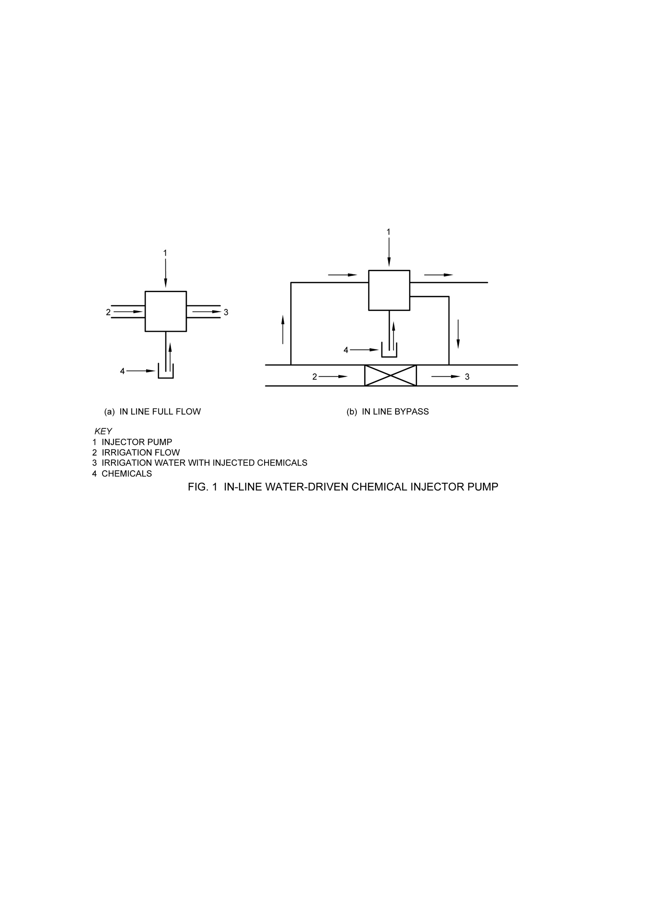
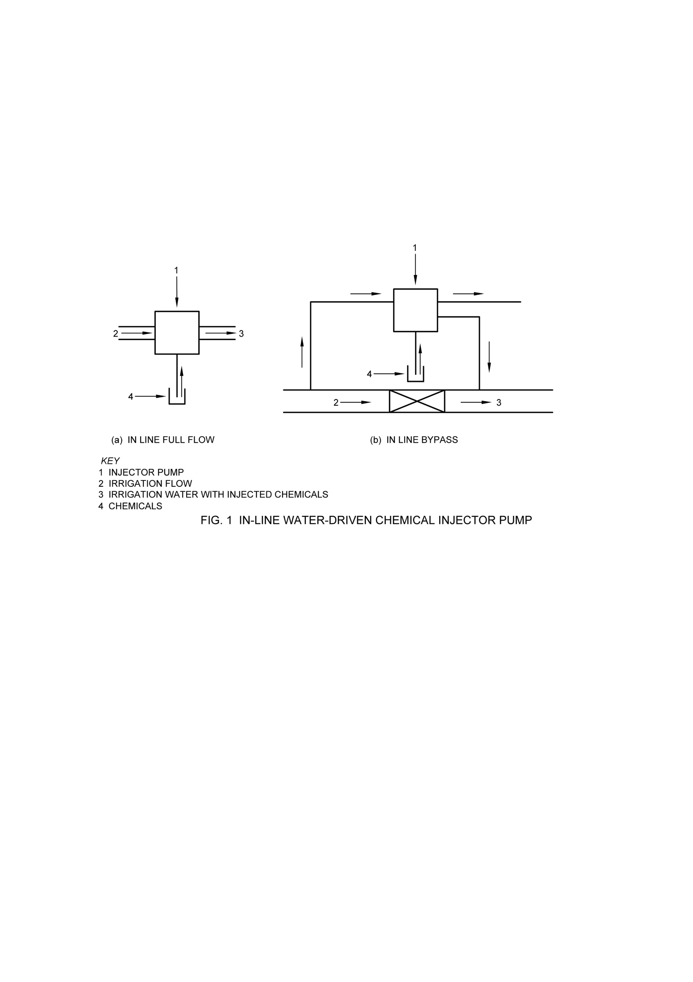

a) IN LINE FULL FLOW b) IN LINE BYPASS

where
1 Injector pump 2 Irrigation flow
3 Irrigation water with injected chemicals 4 Chemicals

FIG. 1 IN-LINE WATER-DRIVEN CHEMICAL INJECTOR PUMP

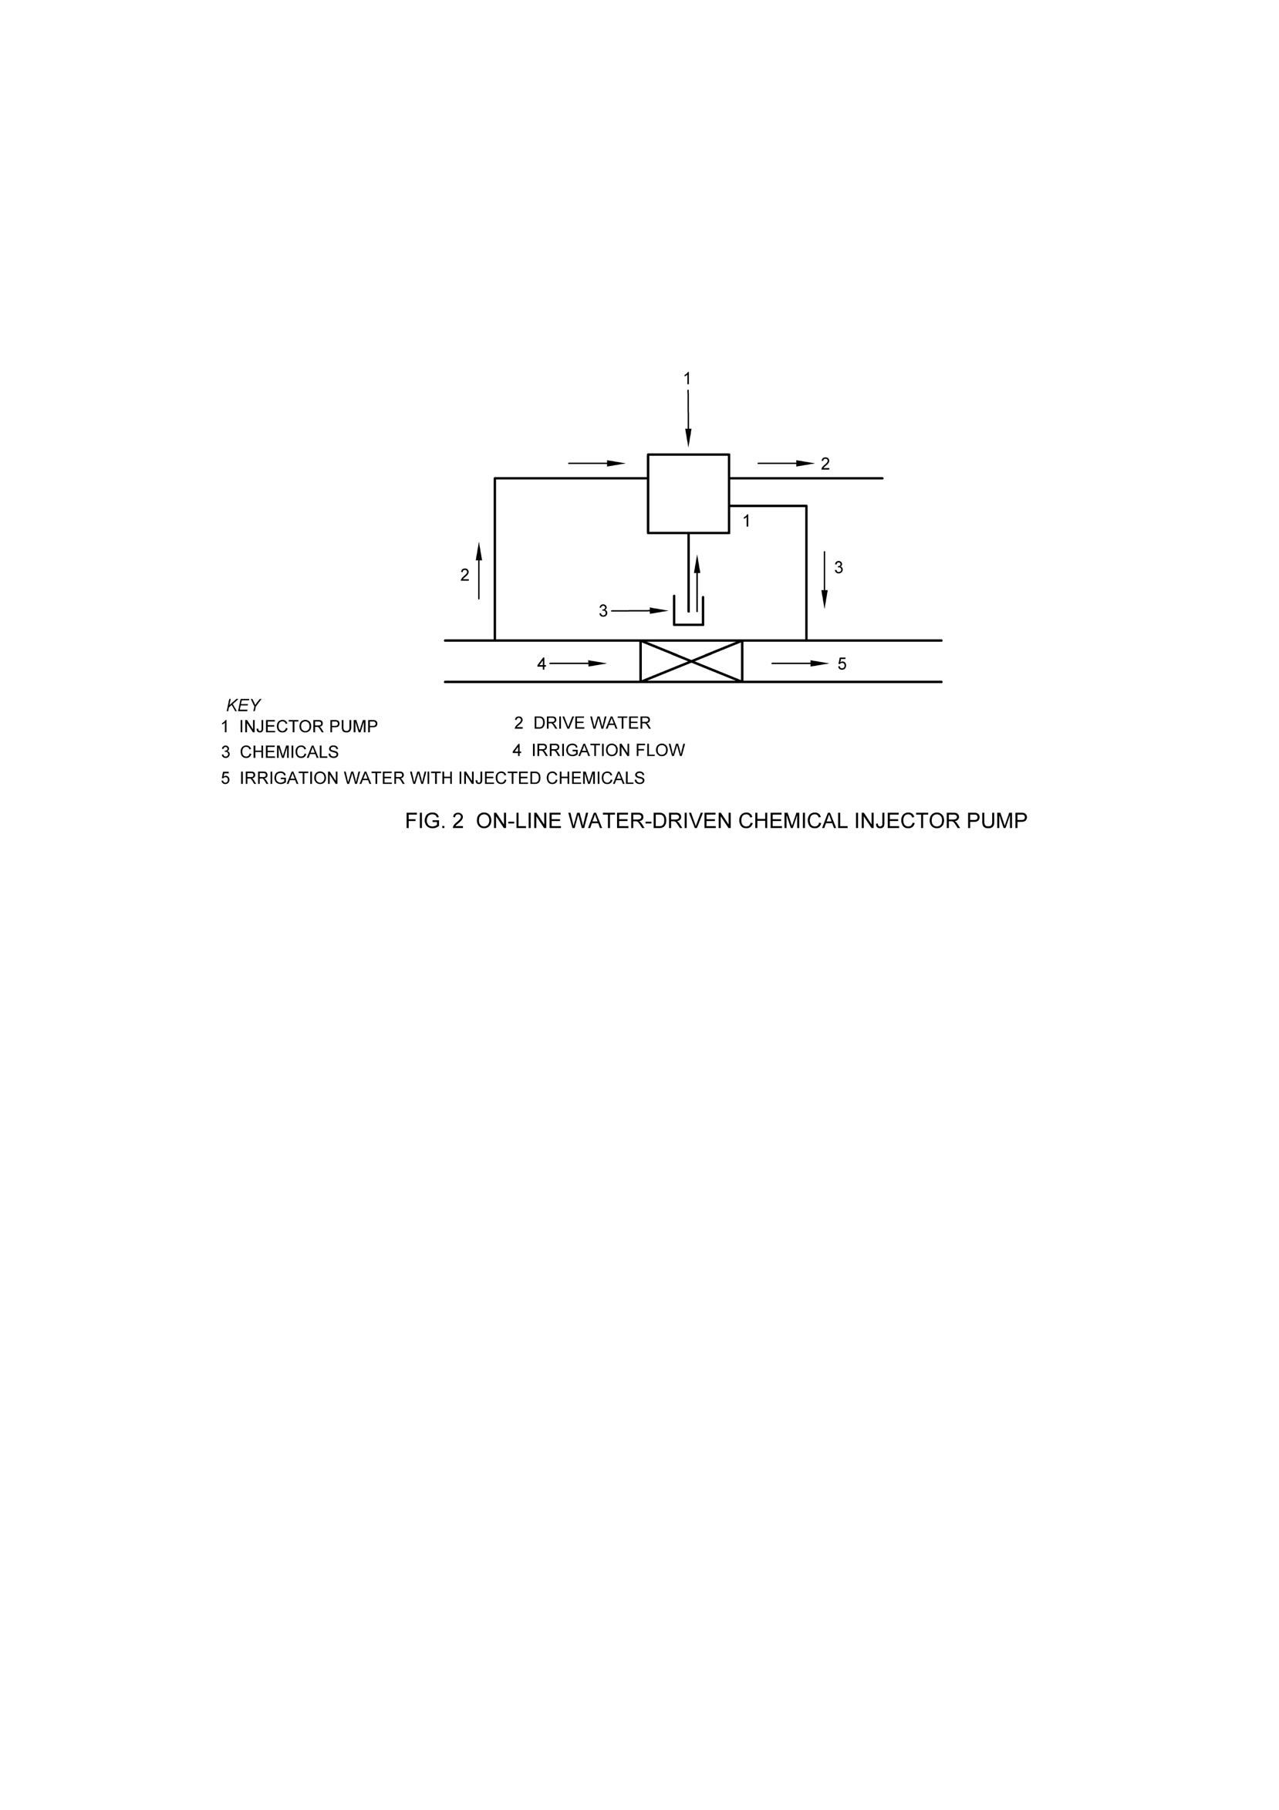

where
1 Injector pump 2 Drive water
3 Chemicals 4 Irrigation flow
5 Irrigation water with injected chemicals

FIG. 2 ON-LINE WATER-DRIVEN CHEMICALS INJECTOR PUMP

4.2 According to Mixing Ratio

a) Proportional injector pump:

1) Fixed mixing ratio, and
2) Adjustable mixing ratio;

b) Non-proportional injector pump.

4.3 According to Working Principle

- Rotodynamic, and
- Positive displacement

5 TECHNICAL REQUIREMENTS

5.1 General

The injector pump shall contain means, such as a vacuum breaker valve, to prevent emptying of the chemical storage tank to the irrigation system through the injector pump in the event that the pressure in the injector pump falls below the pressure in the chemical storage tank.

The injector pump shall employ means such as a check valve, to prevent irrigation water that passes through the injector pump from entering the chemical storage tank.

It shall be possible to disassemble and clean those parts of the injector pump subject to clogging by the chemical or the debris in the irrigation water. These parts may be fitted with a suitable filtration device accessible for the purpose of cleaning.

For on-line injector pumps [see 4. l(b)]in which drive water is ejected from the injector pump, the outlet for ejecting the drive water shall be fitted with suitable means, such as a thread or connector, to enable connection of a pipe for disposal of the drive water away from the vicinity of the water source.

5.2 Materials

Plastics parts of an injector pump that are exposed to ultra-violet (UV) radiation under normal field conditions in which the injector pump operates shall include additives to improve their resistance to UV radiation. Plastics parts that enclose waterway shall be opaque or shall be provided with an opaque cover designed to block all light from reaching clear waterway enclosure.

Plastics pipes conveying chemical may be transparent or accessible to light.

All parts of an injector pump shall be resistant to, or protected from, those chemicals in concentrations approved or recommended for injection into irrigation systems, except as annoted in the manufacturer’s literature.

5.3 Connection of an Injector Pump to an Irrigation System

An injector pump shall be connected to an irrigation system by one of the following means.

5.3.1 Thread complying with IS 554 except that other threads shall be allowed, provided that a suitable adopter is supplied with each threaded connection.

5.3.2 Flanges complying with IS 6418 if the flanges made of cast-iron, or to IS 6392 if the flanges are made of steel; flanges made of other materials shall comply with the assembly dimensions (diameter of the distributing circle, number of holes), specified in IS 6418.

5.3.3 Compression victaulic or other special fittings.

6 MECHANICAL AND FUNCTION TESTS

6.1 General

Unless otherwise specified, perform all tests using water in place of a chemical solution as the injection liquid. Ensure that both irrigation and injection water are at a temperature between (27 ± 3) °C and that they are filtered with a mesh filter body of 120 mesh or a filter with parallel capacities, or larger than a lower limit specified by the manufacturer in product literature.

Ensure that measuring instruments used during the tests are accurate within ± 2 percent of the true value.

Ensure that the chemical storage tank used for the test has, or is fitted with a sight tube (manometer or level indicator), or is translucent so that water levels can be monitored. Markings on the side are helpful.

6.2 Test of Resistance to Pressure

Close the suction port (inlet of chemical) from non-return valve by suitable means.

With the injector pump not operating, apply a pressure equal to 1.6 times the maximum pressure (P_{max} $×$ 1.6) to all parts of the injector pump that would come under pressure during normal operation. Hold this pressure for five minutes.

The injector pump and all its parts shall withstand this test pressure without sustaining any damage and without the appearance of any permanent deformation.

6.3 Test of Water-Tightness of Check Valves

6.3.1 Seal the inlet of irrigation/drive water of the injector pump and leave the chemical inlet orifice of the injector pump open to the atmosphere. Apply a pressure to the outlet of the injector pump equal to 25 percent, 50 percent, 75 percent and 100 percent of the maximum working pressure P_{max}. Apply the pressure at each stage for approximately 20 minutes.

There shall be no leakage through the check valve for chemical of the injector pump.

6.3.2 For injector pumps with an integral check valve intended to prevent the flow of water in the opposite direction to the intended direction of flow, repeat the test described in 6.3.1 with the inlet of the injector pump open to the atmosphere.

6.4 Range of Working Pressure

6.4.1 Install the injector pump in the test apparatus according to the manufacturer’s instructions so that the top level of the water in the chemical storage tank is 0.5 m lower than the centreline of the outlet of the injector pump.

Apply a pressure equal to the minimum working pressure P_{min} at the inlet of irrigation drive water of the injector pump for one minute. Ensure that the water flow rate is approximately equal to the flow rate at the mid-point of the range of irrigation water flow rates declared by the manufacturer and for an on-line pump, ensure that the drive water flow rate is approximately equal at the mid-point of the drive water flow declared by the manufacturer.

6.4.1.1 The injector pump shall inject chemical as required for normal operation at pressure and irrigation drive water flow rate not deviating by ±10 percent than the rate declared by the manufacturer.

6.4.2 Repeat the test described in 6.5.1, once with the pressure at the inlet of irrigation drive water of an in-line injector pump or at the outlet of chemical of an in-line injector pump or at the outlet of chemical of an on-line injector pump equal approximately to the mid-point of the range of working pressure.

6.4.2.1 The injector pump shall inject chemical as required for normal operation at the flow and pressure declared by the manufacturers not deviating ±10 percent than the rate declared by the manufacturer.

6.5 Test of Resistance to Draining

6.5.1 Install the injector pump in the test apparatus according to the manufacturer’s instructions so that the upper level of the water in the chemical storage tank is 0.5 m lower than the centre line of the outlet of the injector pump. The level of vacuum (anti-siphon valve) shall be at least 0.5 m above the level of the centre line of the outlet of the pump.

- For the purpose of this test, the chemical storage tank must be situated so one can observe and/or measure the upper level of the fluid throughout the test.
- Operate the injector pump for two minutes with the pressure at the inlet of irrigation/drive water of the injector pump approximately equal to the mid-point of the range of working pressure.

- Ensure that the water flow rate is approximately equal to the flow rate at the mid-point of the drive water flow declared by the manufacturer.
- Discontinue the operation of the injector pump. Immediately afterwards apply pressure (suction) equal to 10 kPa lower than the atmospheric pressure at the outlet of the injector pump.
- Apply this pressure (suction) for one minute and, during this period, observe the level of the water in the chemical storage tank

6.5.1.1 The level of the water in the chemical storage tank shall not vary during the time interval from injector pump shut-off until the conclusion of the test.

6.5.2 For injector pumps intended to operate with the level of the fluid in the chemical storage tank higher than the centreline of the outlet of the injector pump, repeat this test with the injector pump installed according to the manufacturer’s instructions and the level of the water in the chemical storage tank at the maximum level above the centreline of the injector pump as declared by manufacturer.

6.5.2.1 The level of the water in the chemical storage tank shall not vary during the time interval from injector pump shut-off until the conclusion of the test.

6.6 Test of Injection Rate

Install the injector pump as described in 6.5.1 for proportional injector pumps [see 4.2(a)] with an adjustable mixing ratio, adjust the mixing ratio approximately to the mid-point of the adjustable range declared by the manufacturer.

Set the drive water flow rate approximately equal to the flow rate at the mid-point of the range of flow rates declared by the manufacturer and maintain this flow rate throughout the test.

Apply five different pressures at the inlet of irrigation drive water of the injector pump at approximately equal intervals to cover the range of working pressure, including the minimum working pressure P_{min} and the maximum working pressure P_{max}.

At each pressure stage, operate the injector pump for at least two minutes and measure the pumping rate of the injector pump volumetrically.

6.6.1 The injection rate at any inlet pressure shall not deviate from that declared by the manufacturer by more than ±10 percent.

6.7 Drive Water Ratio Test

For an injector pump in which the drive water is ejected, measure the volume of drive water during performance of the test described in 6.6.

6.7.1 The drive water ratio shall comply with the ratio declared by the manufacturer within an allowable deviation of ±10 percent.

6.8 Test of Injection Rate for Proportional Injector Pump

Install the proportional injector pump as described in 6.5.1 and illustrated in Fig. 1.

6.8.1 For proportional injector pumps [see 4.2(a)] perform the test specified in 6.8.3 at the fixed mixing ratio for the proportional injector pump. Present the injection rate in tabular or graphical forms as a function of the drive water flow rate.

6.8.2 For non-proportional injector pumps [see 4.2(b)] perform the test specified in 6.8.3 for the following three different mixing ratios:

a) Minimum mixing ratio declared by the manufacturer,
b) Maximum mixing ratio declared by the manufacturer, and
c) At some convenient mixing ratio between (a) and (b).

6.8.3 Operate the in-line injector pump at the upper and the lower limits of the range of irrigation water flow rates, as specified by the manufacturer, and at four or more other irrigation water flow rates within this range, Select a test pressure at some convenient pressure near the midpoint of the range of working pressure. For each irrigation water flow rate measure the injection rate and calculate the actual mixing ratio achieved by the injector pump.

Operate the on-line injector pump at the upper and the lower limits of the range of drive water flow rates, as specified by the manufacturer, and at four or more other drive water flow rates within this range and ensure that the irrigation water flow rate is approximately at the midpoint of the range of the irrigation water declared by the manufacturer. Select a test pressure at some convenient pressure near the midpoint of the range of working pressure. For each irrigation water flow rate measure the injection rate and calculate the actual mixing ratio achieved by the injector pump.

The mixing ratio should not deviate by ±10 percent from valve declared by the manufacturers.

6.9 Test of Head Loss for In-line Injector Pump

With the injector pump installed in the test apparatus as described in 6.4.1 measure the head loss through the injector pump at the midpoint of the range of working pressure. Measure the head loss for five different irrigation water flow rates within the range of irrigation water flow rates declared by the manufacturer.

The head loss for any irrigation flow rate shall not exceed the head loss declared by the manufacturer by more than 10 percent.

7 DURABILITY

7.1 Connect the injector pump to the test apparatus according to the manufacturer’s instructions so that the surface of the water in the chemical storage tank is about 0.5 m lower than the centre line of the outlet of injector pump. All tests shall be performed a chemical solution as the injection fluid.

NOTE — The manufacturer shall specify the chemical solution used to perform durability test.

7.1.1 Ensure that both irrigation and injection fluid are at a temperature between (27 ± 3) °C and that they are filtered with a mesh filter body of 120 micron or a filter with parallel capacities, or larger than a lower limit specified by the manufacturer in product literature. Ensure that the water flow rate is approximately equal to the flow rate at the mid-point of the range of irrigation water flow rates declared by the manufacturer and for an on-line pump, ensure that the drive water flow rate is approximately equal at the mid-point of the drive water flow declared by the manufacturer.

Operate the injector pump for eight periods of 125 h each followed by interval of approximately 30 h. The total operating time for eight periods is not less than 1 000 h. Make the test after last operating period.

7.1.2 Ensure that the following operating condition are compiled during the test:

- Operating pressure – At the mid-point of the range of working pressure declared by the manufacturer;

- Drive water flow rate – For in-line injector pumps an irrigation water flow rate at the mid-point of the range of irrigation water flow rate at the mid-point of the range of drive water flow rates declared by the manufacturer; and

- Injection rate – For injector pumps with an adjustable injection rate, and injection rate at the mid-point of the range of injection declared by the manufacturer.

7.2 After operating the injector pump for 1 000 h, repeat the following tests.

7.2.1 Resistance to Pressure (see 6.2)

7.2.2 Water-Tightness of Check Valve (see 6.3)

7.2.3 Range of Working Pressure (see 6.4) - with the inlet pressure approximately equal to the mid-point of the range of working pressure.

7.2.4 Injection Rate as a Function of Pressure at the Inlet of an Injector Pump (see 6.6)

The injection rate shall not deviate from the injection rate declared by the manufacturer by more than ± 15 percent.

7.2.5 Drive Water Ratio

The drive water ration shall not deviate from the drive water ratio declared by manufacturer by more than ± 20 percent.

7.2.6 Injection Rate for Proportional Injector Pump

Perform tests with the mixing ratio set approximately at the mid-point of the range of mixing ratios declared by the manufacturer and with the drive water flow rate set at approximately the mid-point of the range of the drive water flow rates declared by the manufacturer.

The measured mixing ratio shall not deviate from the mixing ratio declared by the manufacturer by more than ± 15 percent.

8 SAMPLING AND CRITERIA FOR CONFORMITY
8.1 Type Test

Select test specimens for each test at random from a sample at least 25 units. The number of specimens selected for each test shall be as listed in Table 1.

Table 1 Number of Test Specimen and Acceptance Number
(Clauses 8.1 and 8.2)
Clause | Subject of Test | Number of Test Specimens | Acceptance Number
(1) | (2) | (3) | (4)
6.2 | Resistance to the pressure | 3 | 0
6.3 | Water-tightness of check valves | 3 | 0
6.4 | Range of working pressure | 3 | 0
6.5 | Resistance to draining | 3 | 0
6.6 | Injection rate | 3 | 0
6.7 | Drive water ratio | 3 | 0
6.8 | Injection rate for proportional injector pump | 3 | 0
6.9 | Head loss for in-line injector pumps | 2 | 0
7 | Durability | 2 | 0

If the number of defective test specimens in the sample is equal to the acceptance number given in Table 1 the sample shall be considered as complying with the requirements of this Indian Standard.

If the number of defective test specimens in the sample is greater than the acceptance number given in Table 1, the sample shall be considered as not complying with the requirements of this Indian Standard.

8.2 Acceptance Test

When acceptance of manufacturing lots or shipments is required, ensure that the sampling is done according to IS 2500 (Part 1) based on AQL 2.5 and special inspection level S-4.

Ensure that the test specimens are selected at random according to Table II A of IS 2500 (Part 1) and that they are tested according to 6.2.

The manufacturing lot or shipment shall be considered as complying with the requirements of this Indian Standard if the number of defective test specimens found in the test does not exceed the acceptance number specified in IS 2500 (Part 1).

For the other tests, select test specimens at random to conform with the number specified in Table 1. Test the test specimens in accordance with 6.3 to 6.9.

The manufacturing lot or shipment shall be considered as complying with this International Standard (so far as these clauses are concerned) if the number of defective specimens found in the test does not exceed the acceptance number specified in Table 1.

Durability test (see 7.1) shall be performed only as type test provided the manufacturer has not introduced changes in the structure of the injector pump since the performance of the type test.
9 MARKING

9.1 The injector pump shall bear a clear, legible and durable marking which shall include the following particulars:

a) Name of manufacturer or the manufacturer’s trade-mark;
b) Nominal size;
c) Maximum and minimum working pressure;
d) Maximum and minimum irrigation water flow rate;
e) Injection rate;
f) Model number identical with that given in the manufacturer’s catalogue;
g) Year of production or a marsk which identifies the production series; and
h) Arrows indicating the direction of flow of water and chemical into and out of the injector pump.

9.2 BIS Certification Marking

9.2,1 Each product may also be marked with the Standard Mark.

9.2.1.1 The product(s) conforming to the requirements of this standard may be certified as per the conformity assessment schemes under the provisions of the Bureau of Indian Standards Act, 2016 and the Rules and Regulations framed thereunder, and the products may be marked with the Standard Mark.

10 INFORMATION TO BE SUPPLIED BY THE MANUFACTURER

The manufacturer shall provide the following information in the catalogue or information sheets, these shall include the date of publication.

  - General Information

- Catalogue number of the injector pump;
- Type and size of connections of the injector pump to the irrigation system;
- General dimensions and weight of the injector pump;
- Operating principle of the injector pump;
- List of spare parts and a drawing showing a cross section of the injector pump and the parts which can be replaced;
- Type and size of flow regulators, if it is an integral part of the injector pump; and
- Head loss.
10.2 Operating Instructions

a) Installation instructions;
b) Calibration instructions;
c) Maintenance and storage instructions;
d) Precision of the injection rate as a function of pressure at the inlet of the injector pump:
e) Instructions for filtration of the chemicals and of the irrigation water;
f) Stroke volume of piston type injector pumps:
g) Drive water ratio;
h) Maximal suction head;
j) Range of mixing ratios and method of setting mixing ratio (manual, hydraulic electronic):
k) Data on electric output, flow volume and timing and relevant graphical description and tables for operating data;
m) Influence on pump operation of head loss in drive water ejection pipe. if applicable:
n) Range of working water flow;
p) Injection rate; and
q) Verify that there is no problem to use the irrigation water and chemical.

ANNEX A
(Foreword)
COMMITTEE COMPOSITION
Farm Irrigation and Drainage Systems Sectional Committee, FAD 17
Organization | Representative(s)
In Personal Capacity (D-26, Pusa Campus, Agricultural Research Institute, New Delhi-110012) | Dr T.B.S. Rajput (Chairperson)
Automat Industries Private Limited, New Delhi | Shri Dinesh Kumar  Shri Nawal Kishore Shah (Alternate)
CIPET, Chennai | Dr Sandesh Kumar Jain  Shri Vishal Verma (Alternate)
Dr Y.S. Parmar University of Horticulture and Forestry, Solan | Prof. Rajeshwar Singh Chandel  Shri Sudhir Verma (Alternate)
Finolex Plasson Industries Limited, Pune | Shri Vijay Jadhav  Shri Bajirao Bhosale (Alternate)
Gujarat Green Revolution Company Limited, Vadodara | Dr Ashutosh Vasant Vadawale  Shri R. V. Limbashia (Alternate I)  Shri Hardik Pancholi (Alternate II)
Indian Council of Agricultural Research, New Delhi | Dr Kondapally V. Ramanarao
ICAR-Central Institute of Agricultural Engineering, Bhopal | Dr Ranjay Kumar Singh  Dr Yogesh A. Rajwade (Alternate)
ICAR-Central Soil Salinity Research Institute, Karnal | Dr Devendra Singh Bundela  Dr Satyendra Kumar (Alternate)
Jain Irrigation Systems Limited, Jalgaon | Shri Sunil Lodha  Shri Abhijeet B. Joshi (Alternate)
Mahatma Phule Krishi Vidyapeeth, Rahuri | Dr Sachinkumar Nandgude  Dr Shrimant Rahod (Alternate)
Mahindra EPC Irrigation Limited, Nashik | Shri Rajeev Deshpande  Shri Ashish Kumar (Alternate)
NITI Aayog, New Delhi | Dr Neelam Patel  Smt Anuradha Batana (Alternate)
National Committee on Precision Agriculture and Horticulture, New Delhi | Shri Anand Zambre  Shri Rohit Lall (Alternate)
Netafim Irrigation Private Limited, Vadodara | Shri Sethuramalingam S.  Shri Manish Kumar Patel (Alternate)
Nimbus Pipes Limited, Jaipur | Shri Ashish KUMAR Lath  Shri Haridwar Tiwari (Alternate)
Premier Irrigation Adritec Limited, Nagpur | Shri A.K. Pradhan  Shri G. K. Kumar (Alternate)
Punjab Agricultural University, Ludhiana | Dr J.P. Singh  Dr Sunil Garg (Alternate)
Reliance Industries Limited, Mumbai | Shri Amit Shah
Rivulis Irrigation India Private Limited, Vadodara | Shri Gopi Kethavath
Saurashtra Plastics Manufacturer's Association, Rajkot | Shri Arun Rokad  Shri J. K. Patel (Alternate I)  Shri Bharat Kumar V. Siroya (Alternate II)
School of Agriculture, Indira Gandhi National Open University, New Delhi | Dr Mukesh Kumar
Visvesvaraya Technological University (VTU), Belgavi | Dr Nagraj S. Patil
Water Technology Centre, ICAR-Indian Agricultural Research Institute, New Delhi | Dr Anil Kumar Mishra  Dr Susama Sudhishri (Alternate)
BIS Directorate General | SHRIMATI SUNEETI TOTEJA SCIENTIST ‘E’/DIRECTOR  AND HEAD (FOOD AND AGRICULTURE) [REPRESENTING  DIRECTOR GENERAL (Ex-officio)]

Member Secretary
SHRI VIKRANT CHAUHAN
SCIENTIST ‘B’/ASSISTANT DIRECTOR
(FOOD AND AGRICULTURE), BIS

Panel to Review of Indian Standards on Micro-Irrigation Component, FAD17/P 2

Organization | Representative(s)
Visvesvaraya Technological University (VTU), Belgavi | Dr NAGRAJ S. PATIL (Convener)
Finolex Plasson Industries Limited, Pune | SHRI BAJIRAO BHOSALE
Jain Irrigation Systems Limited, Jalgaon | SHRI SUNIL LODHA  SHRI ABHIJEET B. JOSHI (Alternate)
Mahindra EPC Irrigation Limited, Nashik | SHRI RAJEEV DESHPANDE  SHRI ASHISH KUMAR (Alternate)
National Committee on Precision Agriculture and Horticulture, New Delhi | SHRI ROHIT LALL
Netafim Irrigation Private Limited, Vadodara | SHRI SETHURAMALINGAM S.
Premier Irrigation Adritec Limited, Nagpur | SHRI G. K. KUMAR

