***भारतीयमानक***

***Indian Standard***

**IS 7537 : 2024**

सड़क यातायात संकेतों के लिए विनिर्देश

*(प्रथम पुनरीक्षण)*

**SPECIFICATION FOR ROAD**

**TRAFFIC SIGNALS**

*(First Revision)*

ICS 29.140.50

© BIS 2024



भारतीय मानक ब्यूरो

BUREAU OF INDIAN STANDARDS

मानक भवन, 9 बहादुर शाह ज़फर मार्ग, नई दिल्ली-110002

MANAK BHAVAN, 9 BAHADUR SHAH ZAFAR MARG

NEW DELHI - 110002

[www.bis.gov.in](http://www.bis.org.in)[www.standardsbis.in](http://www.standardsbis.in)

**July 2024 Price Group**

Illumination Engineering and Luminaries Sectional Committee, ETD 49

**FOREWORD**

This Indian Standard (First Revision) was adopted by the Bureau of Indian Standards, after the draft finalized by the Illumination Engineering and Luminaries Sectional Committee had been approved by the Electrotechnical Division Council.

The Committee responsible for the preparation of this standard took cognizance of the effect of transmitted vibration due to traffic on road traffic signals and felt that at the moment it was not possible to exactly specify requirements in this regard and that manufacturers should take adequate care in the design of the equipment by providing means, such as anti-vibration mount.

The first revision of this standard has been contemplated to incorporate the traffic light signals incorporating LED as the light source which are extensively manufactured and used in used across the country from the point of view of energy conservation and also the operating and maintenance cost.

With the advent of LED which is considered as the most efficient light source, there was a need to revise and update this standard to specify the requirements of traffic signals incorporating LED lamps and light source. LED traffic signals are considered as more reliable and efficient compared to incandescent, and offer significant increases in visibility and brightness, and major reductions in maintenance hassles. LEDs being sensitive to heat, has an effect on the life time since overheating cause rapid degradation of the light output and life time. Therefore, this standard has addressed specific requirement to ensure that traffic signals incorporating LED as light source does not affect its intended use and its life time.

The composition of Committee responsible for formulation of this standard is given in Annex E.

For the purpose of deciding whether a particular requirement of this standard is complied with, the final value, observed or calculated, expressing the result of a test or analysis, shall be rounded off in accordance with IS 2: 2022 ‘Rules for rounding off numerical values *(revised).* The number of significant places retained in the rounded off value should be the same as that of the specified value in this standard.

**1 SCOPE**

**1.1** This standard specifies requirements for electric light signal installations for use with tungsten filament, LED, LED modules and other discharge lamps operated from mains, generator or battery supply for controlling road traffic with working voltages up to 250 V a.c. or 1000 V d.c. It also includes reference to operational requirements for the signals and their controller.

This standard also covers solar power operated traffic signal lights.

**1.2** The information which should be given with enquiries and orders for equipment is covered in Annex A.

**2 REFERENCES**

The following standards are necessary adjunct to this standard.

|  |  |
| --- | --- |
| *IS number* | *Title* |
| 736 :1986 | Specification for wrought aluminium and aluminium alloy plate for general engineering purposes (Third Revision) |
| 732 : 2019 | Code of practice for electrical wiring installations (Fourth Revision) |
| 694: 2010 | Polyvinyl chloride insulated unsheathed and sheathed cables/cords with rigid and flexible conductor for rated voltages up to and including 1100 V (Fourth Revision) |
| 1340 :1977 | Code of practice for chromate conversion coating on zinc and cadmium coated articles and zinc base alloys |
| 1554 (Part 1) : 1988 | PVC insulated (heavy duty) electric cables, Part 1 For working voltages up to and including 1 100 V |
| 1776: 1989 | Folding box board, uncoated - Specification (First Revision) |
| 1868:1996 | Anodic coatings on aluminium and its alloys - Specification (Third Revision) |
| 6701 : 1985 | Specification for tungsten filament miscellaneous electric lamps (First Revision) |
| 1885 (Part 16/Sec 1 to 3): 2023 | Electrotechnical Vocabulary Part 16 Lighting |
| 2407: 1963 | Specification for photometric integrators |
| 3043: 2018 | Code of practice for earthing (Second Revision) |
| 14700 (Part 4/Sec 12) : 2019 | Electromagnetic compatibility (EMC) Part 4 Testing and measurement techniques Section 12 Ring wave immunity test (Second Revision) |
| 1766 : 1998 | Time switches for metering and load control (Second Revision) |
| 3438 : 2023 | Silvered glass mirrors for general purposes |
| 9000 (Part 11) : 1983 | Basic environmental testing procedures for electronic and electrical items Part 11 salt mist test |
| 10276 (Part 1) :1982 | Edison screw lamp holders Part 1 Requirements and tests |
| 10276 (Part 2) :1982 | Specification for edison screw lamp-holders Part 2 standard data sheets for lamp-holders and gauges |
| 16101:2012 | General lighting - LEDs and led modules - Terms and definitions |
| 10322 (Part 1) : 2014 | Luminaires Part 1 general requirements and tests (First Revision) |
| 10322 (Part 5/Sec 3) : 2012 | Luminaires Part 5 particular requirements Section 3 luminaires for road and street lighting (First Revision) |
| IS/IEC 60127-2: 2003 | Miniature Fuses Part 2 Cartridge Fuse - Links (First Revision) |
| IS/IEC 60947-1: 2020 | Low-Voltage Switchgear and Controlgear Part 1 General Rules |

**3 TERMINOLOGY**

For the purpose of this standard, the following definitions in addition to those given in IS 1885 (Part 16/Sec 1 to 3) and IS 16101 shall apply.

**3.1 Beam Axis** — The straight line passing through the light centre of the optical system in the direction of maximum intensity of the beam.

**3.2 Co-ordinated Control System** — A system in which the changes of the signals at a series of road junctions are interrelated.

**3.3 Geometric Axis** — A straight line passing through the centre of the lens and perpendicular to it.

**3.4 Isolated Controller** — A device which governs the time of the cycle and changes the signals without reference to any other controller.

**3.5 Local Controller** — A device which controls the signals and which is subject to the governing influence of another controller, a master controller or a coordinated control system.

**3.6 Master Controller** — A device which governs the time of the cycle and the changes of signals controlled by local controllers in a local coordinated control system.

**3.7 Nominal Time** — A given time period which may be selected from a range of available time periods.

**3.8 Optical System** — Anassembly of components to produce a light or light pattern of specified size, colour, intensity and shape.

**3.9 Phantom Mask** — Abuilt-in device to reduce phantom effects as produced by direct incidence of external light on the signal face.

**3.10 Restrictive Traffic Signal** — The light signals exhibited by a signal face at any given time, consisting of or including one or more optical systems presenting a symbolic appearance when such light signals are required to have application only to a particular class of traffic or to a particular movement of traffic.

**3.11 Signal Face** — That part of a signal head provided for controlling traffic in a single direction.

**3.12 Signal Head** — An assembly consisting of one or more signal faces which may be designated accordingly as one-way, two-way, etc.

**3.13 VZr** **—** A hood attached to the signal face to minimize phantom effects due to extraneous light sources and to reduce the possibility of a signal being seen by traffic for which it is not intended.

**3.14 Way —** The term ‘one-way’, two-way’ etc., as applied to signals, indicates the number of signal faces used in a signal head assembly.

**3.15 Load Switch** — Series of devices used to switch power to signal indicators

**3.16 Minimum Maintained Luminous Intensity** —The minimum luminous intensity a module is required to provide throughout the service as a traffic control signal

**3.17 Conditioning** — Energising a LED Signal Module at a specified temperature for a specified period of time to any early electronic component failures to occur and detect any component reliability

**3.18 Hard Coat** — A surface coating or film to provide front surface abrasion resistance

**3.19 Catastrophic Failure** — The total loss of visible illumination from an LED light source

**3.20 Turn Off Time** — The amount of time required after removal of the nominal operating voltage for the LED signal Module to show no visible illumination

**3.21 Turn Off Voltage** — The voltage below which the LED Signal Emits no visible illumination.

**3.22 Turn On Time** — The amount of time required for the LED Signal Module to reach 90 % of full illumination.

**4 CONSTRUCTIONAL REQUIREMENTS**

**4.1 Signal Head Assembly**

The signal head assembly shall be suitable for the type of mounting specified by the purchaser. The signal head, the fixing brackets and the necessary parts thereof shall be so designed that, when installed, the signals shall be capable of adjustment both vertically and horizontally to meet the requirements of **5.2** in respect of all approach roads and pedestrian crossings to which the signals apply. The adjustment shall be such that no signal shall obstruct the view of optical systems of any other signal head within 25° of the axis of the beam. The signal head assembly shall be capable of being locked securely after adjustment.

Unless otherwise specified, a backing board (*see* Fig. 1) shall be provided with each signal face intended for vehicle drivers, extending not less than 300 mm above the centre of the upper optical system nor less than 230 mm below the centre of the lower optical system. It shall extend not less than 280 mm horizontally either side of the vertical centre line of the optical system, unless there is an adjacent backing board associated with another signal face in which case this dimension may be reduced to 220 mm on the adjacent side. Where there are subsidiary signal heads attached to the main signal head, the backing board shall extend not less than 230 mm vertically above the centre of the upper subsidiary signal optical system and, below the centre of the lower subsidiary signal optical system, and horizontally not less than 230 mm from the vertical centre line of the subsidiary signal optical system. The backing board shall have a white border not less than 45 mm nor more than 55 mm wide. Backing boards are not required with portable signals.

**4.1.1** Enclosures containing the power supply shall be preferably of aluminum or any other heat transmitting material for good thermal management.

The Back housing of the module shall be made preferably of aluminum or any other heat transmitting material preferably with heat sink at the back so that the heat generated by the LEDs is taken out of the housing.

**4.2** **Signal Head**

The signal head shall be reasonably weatherproof and dustproof and neither corrodible nor brittle over a temperature range of −10°C to +70°C. Compliance shall be checked by IS 9000 (Part 11). Any other lower temperature shall be a matter of agreement between the purchaser and the supplier. It shall be of such form as to resist deterioration over this temperature range and to resist distortion in wind velocities up to145 km/h. Compliance shall be checked as per clause 7.3.1 of IS 10322 (Part 5/Sec 3). Means shall be provided for securely fixing and accurately locating the optical systems into the signal head.

Where non-metallic material is used, special precautions shall be taken to ensure that all fixings are firmly anchored in the material.

The lamp holders shall be suitable for lamp caps of type E27/27 cap as specified in IS 10276 (Part 1) and (Part 2). The lamp holders for halogen lamps shall be suitable for lamp bases of type GY 6.35- 13 and shall be checked with gauges given in Annex B.

The dielectric of the lamp holder shall be of porcelain or tough incombustible insulating material which will not soften when heated to a temperature of 250°C and, after 24 hours’ immersion in water, it shall not have increased in weight by more than 0.5 % after all moisture has been removed from the surface. The spring contact material shall be so designed as to maintain adequate electrical conductivity and to ensure that the lamp remains securely located under traffic vibration.

NOTE— Any other lower temperature shall be a matter of agreement between the purchaser and the supplier.

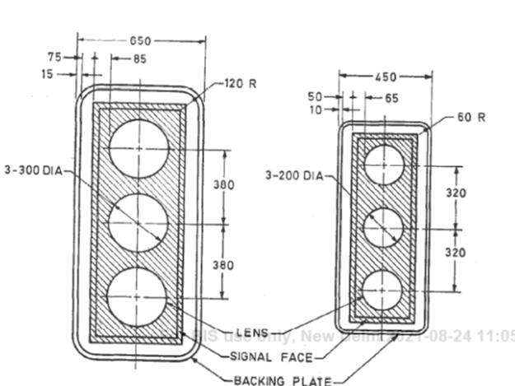

**Fig. 1 Light Signal Head**

**4.3 Optical Systems**

The optical system shall be rainproof, reasonably dustproof and manufactured from materials which are neither corrodible nor brittle over a temperature range of −10°C to +70 °C. It shall be of such form as to resist deterioration over this temperature range.

The component parts shall be so designed that when assembled they shall be accurately located relative to one another. Means shall be provided so that when mounted the optical system cannot be rotated from its normal position. If the lens be of plastics, it shall have a Vicat softening point of not less than 109°C.

**4.3.1** Consideration should be given to the permanence of the colour of lenses at the operating temperatures specified and to the mounting of the lenses, to avoid undue deformation within this temperature range.

**4.3.2** In the case of LED module, the lens of the module shall be integral to the unit, with a smooth outer surface and made of plastic or of glass. The lens may be tinted or any use transparent film or materials with similar characteristics to enhance ON/OFF contrasts.

The use of tinting or other materials to enhance ON/OFF contrasts shall not affect chromaticity and shall be uniform across the face of the lens. The LED module lens shall be UV stabilized and shall be capable of withstanding ultraviolet (direct sunlight) exposure without exhibiting any evidence of deterioration over its life. If a polymeric lens is used, a surface coating or chemical surface treatment shall be used to provide from surface abrasion resistance.

The Module lens shall not become yellow, crazed or cracked under UV radiation from sunlight due to high solar radiation. The lens shall be scratch and abrasion resistant to withstand sand and dust abrasion in such areas which may be prone to dust and sand.

**4.4 Reflector**

Where a reflector is fitted it shall comply with the requirements of **4.4.1, 4.4.2** or **4.4.3**.

**4.4.1** *Silvered Glass Reflector*

The silvering and its protective backing shall be in accordance with the provisions of IS 3438.

**4.4.2** *Aluminum Reflector*

It shall be of aluminum alloy according to IS 736 with an anodic coating of grade AC 25 conforming to IS 1868. The reflector shall be of sufficient thickness to retain its shape during assembly re-lamping or cleaning operation. Reflecting surfaces shall be free from flaws, scratches, defacement or mechanical distortion.

**4.4.3** *Other Reflector*

Reflectors of this class shall have a general performance equivalent to that of **4.4.1** and **4.4.2**. They shall be sufficiently strong to retain their shape and position during assembly, relamping and cleaning, at temperatures to which they are exposed in normal operation and over the temperature range given in **4.3**.

**4.5 Lamp and Lamp Holder**

**4.5.1** *Tungsten Lamp*

The lamp used in the optical system shall meet the requirements of IS 6701.

**4.5.2** *Halogen Lamp*

The lamp used in the optical system shall be at 12 V, 50 W long life tungsten halogen lamp. The bulb shall be clear, uncolored and the filament shall only be used in the horizontal position. The lamp shall meet the following specification:

|  |  |
| --- | --- |
| Nominal lumens | 900 lm at 12 V input |
| Nominal Life | 2 000 hours continuous burning at12 V input |
| Nominal colour temperature | 2 850 K at 12 V input |
| Overall length | 44 mm maximum |
| Overall diameter | 2 mm maximum |
| Light Centre | 30 ± 25 mm |
| Base | Single ended bi-pin to International designation GY 6.35-13 |
| Nominal Operating Voltage | 11.7 V |

**4.5.3** *LED**Module*

Each LED module shall consist of an assembly that utilizes LEDs as the light source for use in traffic signal sections. The LED Modules shall fit into existing Traffic Signal housings and should have all accessories to directly operate from ac/dc supplies. The maximum mass of single LED Traffic Signal module shall not exceed 1.8 kg.

Module shall be a sealed unit to include all parts necessary for operation (printed circuit board, lens and gasket, etc.), power supply can be internal or external, but shall be sealed weather proof moisture proof, after installation and connection.

The material for the LEDs used in the module shall of suitable material ontinuous hours of operation and suitable to work satisfactorily between a temperature range from -15°C to + 75°C.

The individual LEDs shall be wired such that a catastrophic loss or the failure of one LED will not make the module inoperative.

NOTE — Typical materials of LED generally used for road traffic signals are alloy of Aluminium indium gallium phosphorus (AlInGaP) for Red, Amber or Yellow and Indium Gallium Nitride (InGaN)or Gallium Phosphide (GaP) for Green indications. However, these are only indicative and manufacturers are free to use any other material provided it meets all the requirements of this standard.

The individual LED packages shall be evenly distributed across the face of the LED Traffic Signal, either circular (ball) or arrow configuration. The module shall be properly sealed in the doorframe with ethylene propylene rubber/ silicone gasket.

NOTE — A typical example of the module dimensions is 200 mm or 300 mm for both circular or arrow configuration.

The module shall fit into existing 200 mm or 300 mm traffic signal section housings built to the standard specification. Depth behind the lens rim shall be max 100 mm.

The Round LED signal module shall be single, self-contained device, not requiring onsite assembly for installation into existing traffic signal housing. The power supply for the module shall be integral to the unit, or can be an external module.

The Module consists of a front Lens, a LED Circuit PCB which contains the LEDs, and/or the LED driver circuit, a back cover to seal the same, and if the LED Driver is not on the LED board, a separate LED Driver units which is housed in Heat Conducting preferably Aluminium housing.

The encapsulation of the LED, should be UV resistant and contain additives to prevent yellowing

of the encapsulate by UV from Sunlight.

**4.6 Visor**

A visor shall be fitted to each of the optical systems and, unless otherwise specified, shall be as shown in Fig. 2 for visors for 200 mm signals and as in Fig. 3 for visors for 300 mm signals. It shall be manufactured from material which is neither corrodible nor brittle over a temperature range of - 10°C to +75°C. It shall be of such form as to resist deterioration over this temperature range, to resist substantial distortion in winds of up to 145 km/h and to prevent permanent deformation from the same cause.

NOTE— Square type of visors may also be used, provided they fulfil the requirements given in 6.8. The dimensional requirements for such visors are under consideration**.**

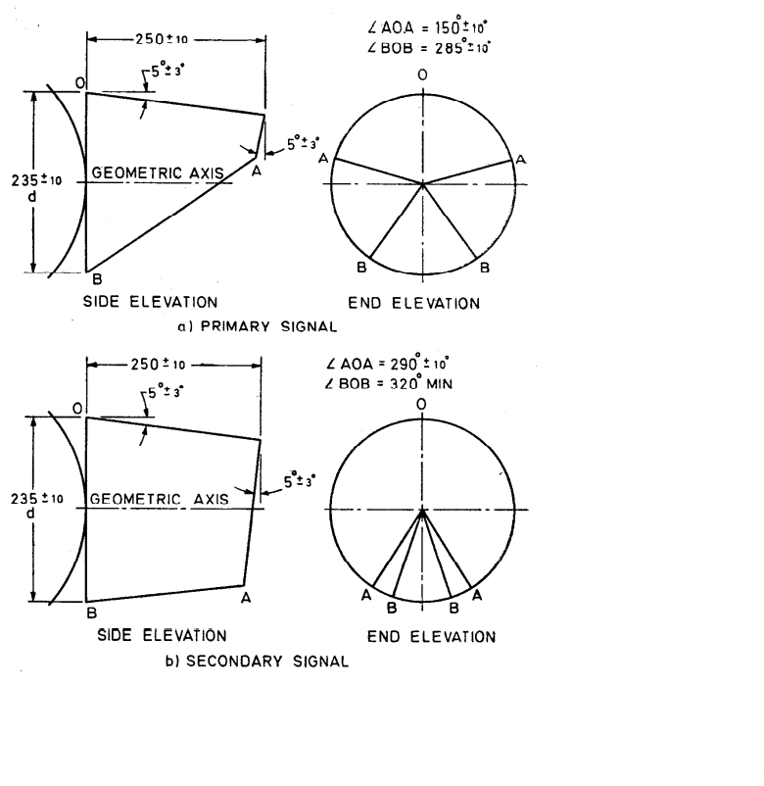

All dimensions in millimeters

**Fig. 2 200 mm Signal Visor**

**4.6.1** All materials used in the LED module shall be of fire-retardant grade except for the front lens and other optical components of the equipment. Compliance shall be checked as per clause 13.2 and 13.3 of IS 10322 (Part 1).

**4.7 Post**

The post shall have an outside diameter of between l00 mm and 115 mm and a strength and rigidity at least equivalent to that for a seamless steel tube of outside diameter of 100 mm and 3 mm thickness and a tensile strength of 375 MN/m2.

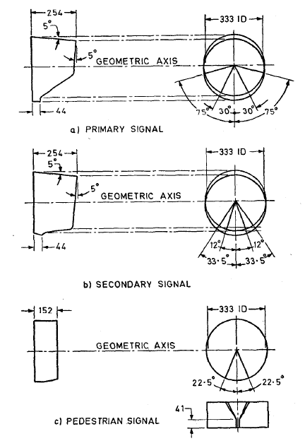

**Fig. 3 300 mm Signal Visors**

It shall be so designed and constructed as to provide adequate support and stability for the signal head and shall be fitted with a weatherproof cap. At the request of the purchaser, it may also be fitted with a ground plate.

Where an aperture is required to permit the entry of an electric supply cable, unless otherwise specified by the purchaser, it shall be not less than150 mm high and 50 mm wide and the top of the slot shall be between 75 mm and 130 mm below ground level. The top and bottom of the aperture shall be radiused with radii equal to half the slot width. Where an, aperture is required to permit the entry of cables which are not supply cables, it shall be capable of accommodating four cables each of 32 mm diameter and any aperture above ground level shall be fitted with a suitable gland or grommet maintaining as far as possible a smooth surface of the same colour as the post.

A pole cap of helmet shape of any suitable material shall be provided. It shall be finished either with white or aluminum colour. Unless otherwise specified the post shall be of sufficient length to allow a minimum of 700 mm below ground level when correctly erected. The interior of steel posts shall be protected by:

a) a finish complying with the requirements of IS 1340 or

b) an anti-corrosive paint which shall be effective over the temperature range −10°C to + 70°C.

The exterior portion of the steel posts below ground level, and extending to at least 450 mm above ground level, shall be protected:

c) by spraying with molten zinc; or

d) as in (a) or (b).

Any surface cut after galvanizing, painting, or the application of the plastics finish shall be protected by one of the methods (a) to (c) as appropriate. The following colours shall be applied for the different parts of the traffic signal:

1. Yellow (traffic yellow) for pole and signal head
2. Dull black for internal portion of visor and signal face
3. Dull black and white for backing board

Although not essential, it is preferable that the supports for portable signals should comply with the requirements of this clause, where applicable. Supports shall meet the mounting height requirements of **4.8**. In addition, the supports shall be suitable for use on uneven ground on gradients of upto 1 in 5. Winds of up to 145 km/h shall not cause the signal to be blown over when positioned on level ground.

**4.8** **Supports for Overhead Mounted Signals**

Overhead signals maybe mounted on mast arms or gantries, finished grey or on double catenaries supporting the top and bottom of the signal head or heads. The assembly shall be of such a form as to resist distortion in wind velocities up to 145km/h and shall provide minimum clearance of the carriageway of 5.5m. Backing boards are to be provided with overhead signals in accordance with the requirements of **4.1**. When an acceptable black background can be provided as part of the gantry structure separate backing boards need not be provided.

**4.9** **Equipment Housing**

Housings for the control mechanism, pushbuttons, detectors and other auxiliary apparatus shall be rainproof, reasonably dustproof, and shall be constructed of one of the following:

a) Cast iron;

b) Cast aluminum;

c) Sheet steel:

The interior of housings constructed from sheet steel shall be protected against corrosion by an anticorrosive paint which shall be effective over the temperature range - 10°C to + 70°C or by one of the finishes specified below for the exterior of such housings. The exterior of sheet steel housings shall be protected against corrosion;

d) Sheet aluminum; or

e) Non-metallic material which is neither corrodible nor brittle, reinforced where necessary by internal framework so as to give atleast equal protection to equipment as that provided by housings (a), (b), (c) or (d).

Sheet metal housings as in (c) and (d) shall be constructed of not less than 2 mm thickness material where the unsupported area is not greater than 0.25m2, or not less than 3 mm thickness material where the unsupported area is greater than 0.25m2. Areas over 0.75 m2 shall be adequately stiffened or supported. In all cases the length to breadth ratio shall not exceed 3:1.

Where any part is below ground level it shall be constructed of cast iron or non-ferrous material, or hot-dip galvanized steel. The equipment shall be easily removable and apparatus readily accessible for maintenance purposes.

All external corners and edges in excess of 40 mm, excepting lower edges, shall be rounded to at least 4 mm radius and all other external edges shall have a radius of at least l.5 mm. Appropriate means of entry and support for cables shall be provided. Equipment housings and pedestrian push-button signal housing, wherever provided, shall be grey in colour.

**4.10 Locks**

Access to the switch for selecting hand-operation, fixed-time working or automatic operation, the lamps’ on/off switch, detector fault alarm test and re-set special facility keys and the telephone jack if provided shall be by means of a door separate from that giving access to the control apparatus, including cables, wiring terminations and the timing adjustments.

All means of access shall be protected by locks of different patterns and the corresponding locks and keys shall be identical for controller housings of the same make, type and series. Not less than two keys of each type shall be supplied with each controller.

Portable signals are not required to comply with the above, but means of access to the controller and manual controls or adjustments shall be protected by at least one lock provided with not less than two keys.

**4.11 Interconnecting Cables**

Interconnecting cables shall have conductor cross-sectional area not less than 1.0 mm2 in case of copper and not less than 1.5 mm2 in case of aluminum cables conforming to IS 694.

**4.11.1** In the case of LED module the cable shall be three core heat resisting cable conforming to IS 694 for electrical connection for each LED signal module.

**4.12 Earthing**

Non-current carrying metal parts of the equipment, including signal posts and housings, shall be bonded together and effectively earthed in accordance with IS 3043.

**4.13** **Mains Termination**

A single pole fuse in accordance with IS/IEC 60127-2 a neutral link and a double pole switch to IS/IEC 60947-1 shall be provided for connection to the mains supply. Sufficient space shall also be provided for mounting the electricity supply authority cable termination.

In addition to the main switch and fuse, a switch to control the lamp current only shall be provided. Unless the control is designed to be intrinsically immune to the effect of a lamp becoming short-circuited or to others urges, a fuse of suitable rating or a similar device shall be provided for this purpose.

The controller mechanism shall be separately and suitably fused or protected.

This clause is not applicable to battery or low-voltage generator operated equipment.

**4.14 Safety Requirements**

**4.14.1** *General Requirements*

Where right of way signals are provided for any controlled traffic, the design of any control equipment shall be such that when the right of way signal is shown to one phase, it shall not be possible through failure of any operating component of the controller to give a right of way signal to a conflicting traffic signal. A device shall be provided in the equipment housing which continuously monitors the controller signal and if the controller fails to cycle for any reason (other than power failure), it shall cause automatic change over to flashing of amber lights or turnoff all signal lights.

**4.14.2** *Product Safety*

The road traffic signal shall meet all the safety requirements specified in IS 10322 (Part 1).

**4.14.3** *Surge Protection*

The road traffic signal incorporating LED module shall be provided with 10 kV ± 3% for 50 µs ± 20 % surge protection to withstand high repetition noise transients and lightening surge. Compliance shall be checked in accordance with IS 14700 (Part 4/ Sec 12).

NOTE— Applicable for ac luminaires only.

**4.15 Controller Electrical Components**

**4.15.1** The controller components including the lamp switching arrangements shall be of adequate rating to ensure a normal life of at least five years. The control circuitry shall be designed to preclude as far as is reasonably possible the chance of wrong switching and shall be proof against failure from current or voltage surges present in the electric mains or signal cables.

NOTE — By agreement with the purchaser, alternative components with a more limited life may be acceptable provided they are easily replaceable.

The construction of the controller shall be in accordance with the relevant Indian Standard, if any, where appropriate, in regard to insulation, rectifiers, capacitors, resistors, transistors, any other solid state switching devices and any motors. The general construction and finish shall be in accordance with accepted standards of good workmanship.

**4.15.2** The road traffic signal incorporating LED shall prevent perceptible flicker to the unaided eye over the voltage range of 200 V to 250 V. There shall be no visible illumination from the LED signal when the applied voltage is less than 75V a.c. The LED traffic module shall reach 90 % of full illumination (Turn ON) within 75 ms of the application of 230 V a.c. The LED traffic module shall cease to emit illumination (Turn Off) within 75 ms of removal of 230 V a.c.

The LED modules shall be operationally compatible with currently used controller assemblies (solid state load switches, flashers).

LED Traffic Modules may also be provided with a Dimming option, to allow the lights to be dimmed upto 30 % of their initial brightness during Night Time operation, to prevent Glare.

**4.16 Time Switch**

Provision shall be made for a time switch to be accommodated. The time switch shall be of carry-over type conforming to IS 1766

NOTE**—** Alternatively, electronic type time switch may be used; in such cases they shall be fitted with standby batteries and shall have an accuracy not less than that specified in IS 1766.

**4.17 Wiring Installation**

The external installation of cables and cable terminations shall comply with IS 732.

**4.18 Interchangeability**

All parts shall be interchangeable with like parts for equipment of the same make, type and series.

Compliance is checked by inspection.

**4.19 Vibration and Noise**

The apparatus shall be reasonably quiet and the mechanism shall not cause undue vibration. The apparatus shall be constructed so as to reduce to a minimum damage to light sources and equipment due to vibration caused by traffic and also to withstand high winds.

**4.20 Ambient Air Temperature**

The equipment shall operate satisfactorily within an ambient air temperature range of -15 ° C to 55°C under normal operating conditions except where otherwise specified. However, equipment incorporating LED module shall operate satisfactorily within an ambient temperature of -15 ° C to + 75 ° C.

**N**OTE **—** Where specially agreed between -the purchaser and the supplier, the lower limit may be - 15°C.

**5 OPTICAL REQUIREMENTS**

**5.1 Distribution of Light**

**5.1.1** *Optical Systems for Providing Non-restrictive Traffic Signals*

When fitted with the appropriate standard lamp in accordance with the requirements of **4.5**, with a coloured lens such that the colour of the light transmitted falls within the limits specified in **5.7** for the red, amber and green signals as appropriate; and without any signal visor the distribution of light shall, for red and green signals, be not less than the values set out in Table 1for signals on normal roads or in Table 2 for signals on high speed roads; and for amber signals shall be not less than twice the values set out in Table 1 and Table 2 respectively.

Each signal shall present a uniform appearance, free from excessively right spots or sectors, over the whole area of the lens when viewed from any direction within the cone of directions for which the intensities are specified in Table 1 or Table 2. Polar curves shall be reasonably smooth hand reasonably free from secondary maxima.

Phantom effects, when measured by the method specified in **6.8**, shall not, for signals on normal roads and on high speed roads, have an intensity greater than 1.5 **x** 10-~~s~~3 cd/lux of incident light.

Subject to agreement between the purchaser and supplier, the lamp intensities shall be capable of an automatic reduction during the hours of darkness to between 1/4 & and 1/12 of the normal intensities. When the light intensity of any signal is so reduced it shall still comply fully with the requirements of colour given in **5.7**.

The light intensity requirements of this sub-clause will not necessarily apply to traffic signals at railway level crossings or to portable signals.

NOTE — Normally, high speed road optical systems will be appropriate where approach speeds greater than 80 km/h are expected and where signals are visible on approaches greater than 200 m.

**Table 1**

**Distribution of Red and Green Light for signals on Normal Roads**

(*Clause* **5.1.1**)

|  |  |  |  |  |
| --- | --- | --- | --- | --- |
| **Sl. No** | **Horizontal/Vertical** | **On Geometric Axis** | **10° on Either Side of Geometric Axis** | **25° on Either Side of Geometric Axis** |
| (1) | (2) | (3) | (4) | (5) |
| i) | On geometric axis | 400 | 150 | 2.5 |
| ii) | 1° below geometric axis | 475 | 200 | 30 |
| iii) | 10° below geometric axis | 200 | 100 | 25 |

**Table 2**

**Distribution of Red and Green Light for signals on High Speed Roads**

(*Clause* **5.1.1**)

|  |  |  |  |  |
| --- | --- | --- | --- | --- |
| **Sl. No** | **Horizontal/Vertical** | **On Geometric Axis** | **10° on Either Side of Geometric Axis** | **25° on Either Side of Geometric Axis** |
| (1) | (2) | (3) | (4) | (5) |
| i) | On geometric axis | 800 | 380 | 50 |
| ii) | 10° below geometric axis | 375 | 200 | 40 |

**5.1.2** *Optical Systems for Providing Restrictive Traffic Signals*

**5.1.2.1** *Green arrow and pedestrian optical systems*

When fitted with the appropriate standard lamp in accordance with the requirements of **4.5,** with a coloured lens such that the colour of the light transmitted falls within the limits specified for the green arrow or pedestrian symbol in **5.7,** and without any signal visor, the mean minimum luminance values shall be as specified in Table 3 when tested in accordance with the requirements of **6.6**.

Subject to agreement between the purchaser and supplier, the lamp intensities shall be capable of an automatic reduction during the hours of darkness to between l/4 and l/12 of the normal intensities. When the light intensity of any signal is so reduced it shall still comply fully with the requirements of colour given in **5.7**.

**Table 3**

**Minimum Values of Luminance for Green Arrow**

**and Red and Green Pedestrian Signals**

(*Clause* **5.1.2.1**)

|  |  |  |  |  |
| --- | --- | --- | --- | --- |
| **Sl. No** | **Horizontal/Vertical** | **On Geometric Axis**  **(cd/m2)** | **10° on Either Side of Geometric Axis**  **(cd/m2)** | **30 °on Either Side of Geometric Axis**  **(cd/m2)** |
| (1) | (2) | (3) | (4) | (5) |
| i) | On geometric axis | 35001 | 2200 | 700 |
| ii) | 10° below geometric axis | 25001 | 1350 | 600 |
| iii) | 15° below geometric axis | 15001 | 1000 | 400 |
| NOTE— 1The variation of luminance over the surface of the green arrow or pedestrian symbol shall not exceed the ratio 10:1, at the test points marked with an asterisk. | | | | |

Each signal shall present a uniform appearance, free from excessively bright spots or sectors, over the whole area of the signal face when viewed from any direction within the cone of directions for which luminance values are specified in Table 3. Polar curves shall be reasonably smooth and free from secondary maxima.

Phantom effects, when measured by the method specified in **6.8,** shall not, for green arrows and green and red pedestrian signals, have a luminance greater than 4 x 10 -2 cd/m2 per lux of incident light. Where in particular situations due to exceptional site conditions, optical systems complying with this requirement give rise to unacceptable phantom effects, agreed means of reducing the phantom effect shall be provided.

**5.1.2.2** *Optical systems for providing other restrictive traffic signals*

These shall conform to the requirements of **5.1.2.1** so far as is practicable, unless otherwise specified.

**5.2 Directions of Beam**

**5.2.1** *Light Signals Intended for Drivers*

On high speed roads, the light signals shall be directed at a point approximately 200 m from the primary signal face and approximately 1.5 m above ground level at the centre line of the carriageway allocated to approaching traffic. Where signals are mounted above the carriageway on mast arms or gantries or suspended on catenaries, the light signals shall be directed at a point approximately 1.5 m above the carriageway allocated to approaching traffic between 200 m

and 400 mm (depending on site conditions) from the primary signal face.

In other situations, the corresponding distances from the primary signal face shall be approximately 50 m for post-mounted signals and approximately100 m for overhead signals, these dimensions may be varied where special circumstances require otherwise.

**5.2.2** *Light Signals Intended for Pedestrians*

The light signals shall be directed towards the centre line of that part of the carriageway allocated

to pedestrian movement unless special circumstances require otherwise.

**5.3** **Arrangement of Optical Systems**

**5.3.1** *Traffic Signals at Road Junctions, Road Works, etc. and/or Pedestrian Crossings*

**5.3.1.1***Light signals intended for drivers*

Each signal face shall, unless otherwise specified, contain three optical systems arranged vertically, each having a diameter of not less than 200 mm nor more than 215 mm. The coloured lens of the upper optical system shall be red, the middle one amber, and the lower one green. Where green arrows are used they shall have an optical system having a diameter of not less than 295 mm nor more than 305 mm which shall incorporate green arrows in accordance with the requirements of **5.4**. The green arrows may either replace the green light or be additional to such light in one of the permitted arrangements shown in Fig. 4. Where prescribed traffic signs are incorporated in the signal face they shall be internally illuminated and shall have an optical system having a diameter not less than 295 mm nor more than 305 mm. The optical system spacing shall be in accordance with the dimensions given in Fig. 5.

**5.3.1.2** *Light signals intended for pedestrians*

Each signal face shall contain optical systems arranged vertically, each having a diameter of not less than 295 mm nor more than 305 mm, which shall incorporate pedestrian symbols in accordance with the requirements of **5.5**. The upper optical system shall illuminate a red symbol and the lower one a green symbol. The optical system spacing shall be in accordance with the details given in Fig. 6.

**5.3.1.3** *Light signals for cyclists*

Each signal face shall contain optical systems arranged vertically, each having a diameter of not less than295 mm nor more than 305 mm, which shall incorporate cyclist symbols in accordance with the requirements of **5.6**. The upper optical system shall illuminate a red symbol and the lower one a white symbol. The optical system spacing shall be in accordance with details given in Fig. 5. The outline of the light signals for cyclists shall be as given in Fig. 7.

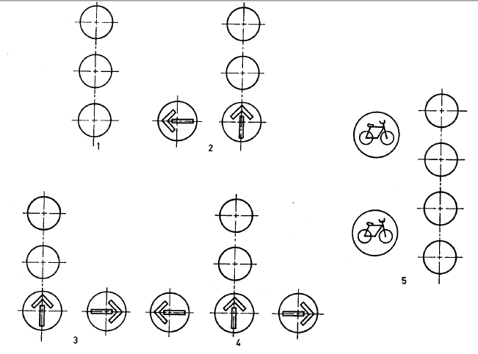

**Fig. 4 Permitted Arrangements of Signals**

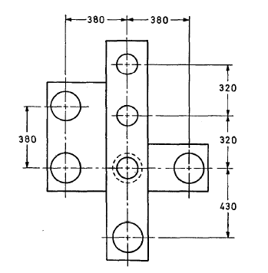

**Permitted Tolerances**

|  |  |  |
| --- | --- | --- |
| Dimension (mm) | Minimum (mm) | Maximum (mm) |
| 320* | 310 | 355 |
| 380** | 370 | 435 |
| 430 | 420 | 435 |

**Fig. 5 Optical System Spacings**

**\*also applies to Fig. 1**

**\*\* also applies to Fig. 6**

**5.4** **Green Arrow**

Where an optical system incorporating a green arrow is used, the background for the arrow shall be obtained by coating the lens or filter as may be appropriate with heat-resisting black paint or enamel, or by other suitable means, such as stencils. The green arrow shall be of the shape and dimensions shown in Fig. 8.

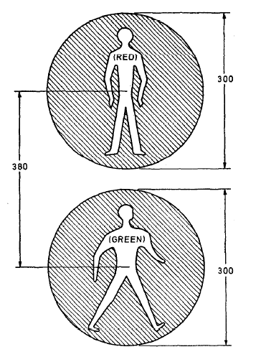

**Fig. 6 Symbols for Pedestrian Signals**

**5.5** **Pedestrian Signal**

Where optical systems incorporating red or green pedestrian symbols are used, the background for the symbols shall be obtained by coating the lens or filter as may be appropriate with heat resistant black paint or enamel, or by other suitable means. The red and green symbols shall be of the shape and dimensions shown in Fig. 6.

**5.6 Cyclist Signals**

Where optical systems for cyclist signals are used, background for the symbols shall be obtained by coating the lens or filter as may be, appropriate with heat-resistant black paint or enamel,

or by other suitable means.



**Fig. 7** **Symbol for Cyclists**

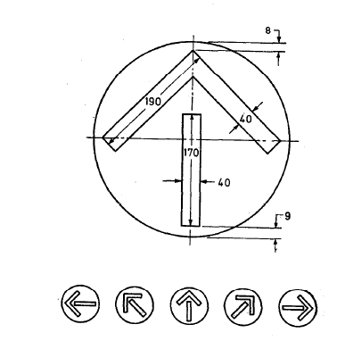

**Fig. 8 Green Arrow**

**5.7 Limits of Chromaticity of Signals**

Thecolour of the light transmitted by the signals shall comply with the limits set out as follows:

*a) Vehicle Signal:*

|  |  |
| --- | --- |
| **Colour** | **Limits** |
| Red | Signal red class B1 |
| Amber | Signal yellow class A |
| Green | Signal green class B 2 |
| Green | Arrow Signal green class B 2 |

b) *Pedestrian Signal:*

|  |  |
| --- | --- |
| **Colour** | **Limits** |
| Red symbol | Signal red class B1 |
| Green symbol | Signal green class B 2 |

c) *Cyclist Signal:*

|  |  |
| --- | --- |
| **Colour** | **Limits** |
| Red symbol | Signal red class B1 |
| White symbol | Signal white class B 1 |

Limits for the colour shall be as given in Annex C.

**5.8** **Height of Signal**

**5.8.1** *Post-Mounted Traffic Control Light Signals*

***5.8.1.1*** *Fixed light signals intended for drivers*

Theheight of signals be such that when erected the centre of the amber optical system shall be not less than 2.4 m nor more than 4 m above the carriageway level.

**5.8.1.2** *Portable light signals intended for drivers*

The height of the signals shall be such that when erected the centre of the amber optical system shall be not less than 1.5 m nor more than 3.5 m above the carriageway level.

**5.8.1.3** *Light signals intended for pedestrians and cyclists*

The height of signals shall be such that when erected the height of the lower edge of the housing enclosing the green signal shall be not less than 2.1 m nor more than 2.6 m above the carriageway level.

**5.8.2** *Overhead Mounted Traffic Control Light Signals*

The height of overhead mounted signals shall be such that when erected the centre of the amber optical system shall be not less than 6.1 m nor more than 9 m above the carriageway level.

NOTE — Variation from the minimum height should only be contemplated when there are definite reasons for making such variations obligatory.

**6** **TESTS**

**6.1 Classification of Tests**

**6.1.1** *Type Tests*

The following shall constitute type tests:

1. Visual examination (*see* **6.2**)
2. Test for insulation resistance and electric strength (*see* **6.3**),
3. Test for optical system (*see* **6.4**),
4. Test for timing (see **6.5**),
5. Test for chromaticity (*see* **6.6**),
6. Test for luminance measurements (green arrow and red and green pedestrian and cyclist signals) (*see* **6.7**), and
7. Test for measurement of phantom effects (*see* **6.8**).
8. Test for marking

**6.1.2** *Routine Tests*

The following shall constitute the routine tests:

1. Visual examination (*see* **6.2**),
2. Insulation resistance
3. Electric strength (*see* **6.3**)
4. Test for optical system (*see* **6.4**)
5. Test for marking

**6.2** **Visual Examination**

The traffic signals shall be visually examined for proper functioning and workmanship.

**6.3 Test for Insulation Resistance and Electrical Strength**

**6.3.1** *Controller*

A high voltage test shall be carried out by applying 1000 V ac for one minute between the mains line and neutral input terminals coupled together and earth. The low voltage connection to any mains transformer shall be disconnected during this test. The test voltage shall be at 50 Hz ± 20 % and be of approximately sine-wave form.

During this test no breakdown of the insulation shall occur.

**6.3.2** *Completed Installation*

The insulation resistance of the main leads excluding these to any transformer providing low voltage power supplies which are connected to the main supply by plug and socket shall be tested on a dc supply at 500 volts and shall have a resistance of not less than 1 MΩ.

**6.4 Test for Optical System**

As agreed between the purchaser and the manufacturer, optical systems may, from time to time, be subjected to photometric tests to check that production units meet the optical requirements

of the standard.

The lamp (as specified in **4.5**) used in the optical system under test should have its lumen output at-the rated voltage measured in an integrating photometer as specified in IS 2407.

The intensity/luminance values obtained in these tests shall be multiplied by the following factor before comparing them with the values given in the appropriate tables:

|  |  |  |
| --- | --- | --- |
| 900 lm | OR | 1800 lm |
| measured lamp lumen output | measured lamp lumen output |

as appropriate.

For the purpose of the test, the photometric requirements specified in the appropriate table as specified in **4.1** shall be deemed to have been met when:

1. the mean of the measured intensity/luminance values, corrected as above, for not less than six optical systems is not less than the minimum intensity/luminance values specified in the appropriate table, and
2. no intensity/luminance values obtained in (a) for any optical system are less than the minimum values specified in the appropriate table adjusted in accordance with the factors shown in Table 4.

**Table 4**

**Multiplying Factors for Adjusting the Minimum Intensity/**

**Luminance Values Shown in Table 1, Table 2 and Table 3**

(*Clause* **6.4**)

|  |  |  |  |  |  |
| --- | --- | --- | --- | --- | --- |
| **Sl. No** | **Horizontal (Clause 4.1)** | **Geometric Axis** | | | |
| On axis | 10 ° Either Side | 25 ° Either Side | 30 ° Either Side |
| (1) | (2) | (3) | (4) | (5) | (6) |
| i) | Table 1 | 1.00 | 0.85 | 0.80 | - |
| ii) | Table 2 | 1.00 | 0.85 | 0.80 | - |
| iii) | Table 3 | 0.80 | 0.80 | - | 0.80 |

**6.5** **Test for Timing**

**6.5.1** *Mains Operated Equipment (Including Generator Operated)*

When the equipment is tested at works the duration of all periods timed by the controller shall be within ±7.5 % of the nominal time when the applied voltage varies in the range between -20 to +15 % of its nominal value and ± 4 % of its nominal frequency and over an ambient

temperature range of 0°C to 55°C. The equipment shall be tested in its normal housing in accordance with IS 9000 (Part xx) for the lower temperature limit of 0% and to IS 9000 (Part xx) for the upper temperature limit of 55°C. The period of exposure at these temperatures of 0°C to 55°C respectively shall be 16 hours in both cases. The equipment shall perform within its specification:

1. before the equipment is introduced into the test chamber,
2. after the period of exposure and before the period of recovery,
3. at about 5 ° increments during the period of recovery, and
4. after the period of recovery.

A visual inspection shall be made before and after the test.

The above applies to those timing arrangements which measure selected fixed periods and those conditioned by variable functions, such as speed or number of vehicles. The controller shall continue to function correctly (except for the accuracy of timed periods) within supply voltage limits of -20 % and +15 %, from the nominal value.

When installed on site the duration of all periods timed by the controller shall be within -20 and + 15 % of the nominal time when the applied mains voltage is within the range between ± 10 % of its nominal value and ± 4 % of its nominal frequency. This shall apply to those timing arrangements which measure selected fixed periods. The flashing rate of any flashing signal shall be between 50 and 60 flashes per minute within the same mains voltage and frequency limits.

**6.5.2** *Battery Operated Equipment*

The test requirements for battery-operated equipment shall be the same as those for mains operated equipment detailed in **5.5.1**, excepting the provisions relating to variations in supply frequency.

**6.6 Chromaticity**

The colour of the light emitted for compliance with the requirement of **5.7** shall be measured with a lamp of the correct colour temperature as used in service. The colour shall be defined by the chromaticity of the light reflected at an angle of 45 ° from a magnesium oxide screen placed normal to the beam axis at a distance of not less than ten signal diameters from the front of the signal. Alternatively, the signal may be operated in an integrating photometer and the colour shall be defined by the chromaticity of the integrated light.

**6.7 Test for Luminance Measurements (Green Arrow and Red and Green Pedestrian and Cyclists Signals)**

The luminance values for compliance with the requirements of **5.1**, Table 3 shall be taken over circular areas approximately 25 mm in diameter. A matt black mask with circular openings arranged as shown in Fig. 9 shall be placed against the front face of a full green signal, that is, a green signal without the symbol, and the luminance measurements over the nine holes averaged for each direction specified in Table 3.

Luminance values for a red signal may be determined from those obtained for a green signal by multiplying the green signal values by the factor as given below:

Red transmission factor/Green transmission factor

**6.8 Test for Measurement of Phantom Effects**

A light source subtending an angle of approximately ½° at the signal under test shall be located at a vertical angle of + 10° and a horizontal angle of 0° in front of, and shall be aimed at, the signal under test. The illumination from this source measured at the signal shall be not less than 1000 lux. The intensity of the resulting phantom signal for optical systems complying with **5.1.1** shall be measured at a vertical angle of 0° and a horizontal angle of 0° in the same manner as that in which the emitted intensity of the signal is measured.

The luminance of the resulting phantom signal for optical systems complying with the requirements of **5.1.2** shall be measured at a vertical angle of 0° and a horizontal angle of 0°. The luminance values shall be averaged over five circular areas approximately 25 mm in diameter at the spacing shown in Fig. 9 but covering the luminous area of the symbol or green arrow. The mask (Fig. 9) shall not be used.

**6.8.1** The circuit board of the LED PCB and power supply shall be glass epoxy and painted black to improve contrast as well as to prevent Phantom Effect (False reflection) in face of oncoming light from the vehicle coming from opposite direction.

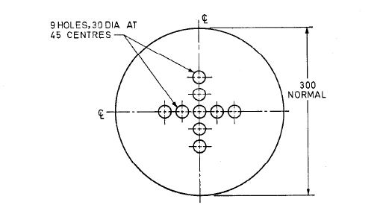

**Fig. 9 Mask for Luminance measurements on 300 mm Signal**

For the purpose of these tests the visor shall be removed and allowance shall be made for any specular reflection from the front face of the signal.

**7 MARKING AND PRODUCT INFORMATION**

* 1. Each road traffic signal assembly shall be indelibly marked with the following information.

a) Manufacturer’s name, trade-name of fan (if any) and Sl. Number, if any;

b) Model number;

b) Rated voltage(s) or voltage range;

c) Type of traffic signal, fan, ac or dc;

d) Frequency or frequency range of power supply;

e) Input in watts;

f) Country of manufacture.

**7.1.1** In the case of road traffic signal incorporating LED lamps or module, following shall be marked on the equipment.

Each module shall have a symbol of the type of module (i.e. circle, arrow, etc.) in the colour of the module. The symbol shall be 25.4 mm in diameter. Additionally, the colour shall be written out in 12.7 mm letters next to the symbol.

If a specific mounting orientation is required, each module shall have prominent and permanent marking(s) for correct indexing and orientation within signal housing. The markings shall consist of an up arrow, or the word “UP” or “TOP”

**7.2** The information which should be given with enquiries and orders for equipment is covered in Annex A.

**7.3 BIS Certification Marking**

The road traffic signal may also be marked with the Standard Mark.

**7.3.1** The road traffic signal lights may also be marked with the Standard Mark. The product(s) conforming to the requirements of this standard may be certified as per the conformity assessment schemes under the provisions of the Bureau of Indian Standards Act, 2016 and the Rules and Regulations framed thereunder, and the products may be marked with the Standard Mark

**ANNEX A**

(*Clause* **7.2**)

**INFORMATION TO BE GIVEN WITH ENQUIRY AND ORDER**

**A-l. INFORMATION**

**A-l.1** The following information shall be given with enquiry or order:

1. Location of proposed installation.
2. Electricity supply authority and address.
3. Voltage and frequency of electrical supply.
4. Number of stages required in control equipment.
5. Allocation of stages and detector connections.
6. Scale plan(s) to not less than l/500 scale showing layout of all signal heads; pedestrian push buttons; control equipment including automatic dimming apparatus, if required; associated traffic signs forming an integral part of the signal head assembly, etc., the positions and dimensions of detectors, if required; and any special requirements relating to the omission of backing boards on particular signals and/or the automatic reduction of light intensities during the hours of darkness. Such places should make use of typical symbols given in Indian Standard Graphical symbols for layout of traffic signals (under preparation).
7. The number and position of signal heads for high-speed roads (*see* **4.1.1**, Table 2).

NOTE**—**Normally, high speed road optical systems will be appropriate where approach speeds greater than 80 km/h are expected and where signals are visible on approaches greater than 200 m.

1. Details of any special requirement for mounting signals, that is, brackets from existing posts or buildings, mast arm, gantry or catenary suspension and any variation from minimum allowable mounting height of signals or of standard visors.
2. Details of any linking arrangement where isolated controllers are not involved. If a master controller or a coordinated control system is to be provided, the number of local controllers to be connected to the master controller within the system is to be stated.
3. Details of any special facilities, traffic or other requirements not already specified under **5** and **8**.
4. Setting and/or ranges of all time periods including inter green periods. When a required inter green period following a stage varies according-to the next stage to be served, the requirements for each possible change of stage shall be scheduled.
5. Proposed maintenance arrangements for optical and equipment maintenance.
6. Address for delivery of equipment.
7. Any special instructions regarding installation work.
8. Whether flashing arrangement during night hours is to be provided or not.
9. Whether provision for manual control of equipment should be provided or not.
10. Whether three cycle timings in each phase for morning, afternoon and evening peaks and timing panel for indicating all such timings should be provided or not.
11. Whether mimic display panel indicating phase diagrams illuminated, should be provided or not inside the control housing.

**ANNEX B**

(*Clause* **4.2**)

**GAUGES FOR LAMP HOLDERS GY 6-35**

**B-l. DIMENSIONS**

**B-l.1** Dimensions for ‘GO’ gauges for lamp holders shall be as given in Fig. 10.

The drawing is intended only to illustrate the essential dimensions of the gauges

Reference Dimension

|  |  |
| --- | --- |
| **Reference** | **Dimension** |
| A | 1.32 |
| B1 | 6.62 |
| B2 | 6.08 |
| C | 7.5 |
| C | - |
| E | 9.5 |
| E1 | 11.5 |
| L | 17 |
| L1 | 19 |
| N | 9.45 |

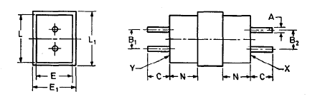

**FIG. 10 ‘GO’ GAUGES FOR LAMP HOLDERS GY 6.35**

**B-2. TESTS**

**B-2.1** The tests on these lamp holders shall be carried out in the following order:

a) Each end of the ‘GO’ gauge for the corresponding GZ6.35 lamp holder (that is with pins of 1.07 mm diameter) shall in turn be inserted into the lamp holder until the pins come to an abutment.

b) It shall be possible to insert each end of the ‘GO’ gauge for lamp holders GY 6.35 in turn until the pins come to an abutment. In this position there shall be a noticeable clearance between each of the surfaces X and r and the adjacent surface of the lamp holder.

**ANNEX C**

(*Clause* **5.7**)

**COLOURS FOR SIGNALLING GLASSES**

**C-l. CHROMATICITY OF LIGHT SIGNALS**

**C-l.1** The colour of the light emitted by a signal, shall comply with the limits set out below:

|  |  |  |  |  |
| --- | --- | --- | --- | --- |
| **Colour Name** | **Class** | **Chromaticity Co-ordinates** | | |
| *x* | *Y* | *z* |
| Signal Red | B1 | - | Not greater than 0.320 | Not greater than 0.010 |
| Signal Yellow | A | Not less than y + 0.120 | Not less than 0.382 | Not greater than 0.201- 0.333 x |
| Signal Green | B2 | Not greater than 0.650 y – 0.060 and not greater than 1.420 – 2.326 y | Not less than 0.390 – 0.171x |  |
| Signal White | B1 | Not less than 0.285 and not greater than 0.5000 | Not less than 0.050 + 0.750 x or not less than 0.390. Not greater than 0.640 – 0.400 x and not greater than 0.150 + 0.640 x |  |

**C-2. LIMITS FOR CHROMATICITY CO-ORDINATES**

**C-2.1** The approximate limit for signal colours in terms of x and y coordinates of the colours of their boundaries shall be as follows:

|  |  |  |  |  |  |  |  |  |  |  |  |  |
| --- | --- | --- | --- | --- | --- | --- | --- | --- | --- | --- | --- | --- |
| **Colour** | **x** | **y** | **x** | **y** | **x** | **y** | **x** | **y** | **x** | **y** | **x** | **y** |
| Red B1 | 0.670 | 0.320 | 0.680 | 0.320 | 0.700 | 0.300 | 0.690 | 0.300 | - | - | - | - |
| Yellow | 0.546 | 0.426 | 0.560 | 0.440 | 0.618 | 0.382 | 0.612 | 0.382 | - | - | - | - |
| Green | 0.004 | 0.599 | 0.258 | 0.489 | 0.174 | 0.361 | 0.027 | 0.386 | - | - | - | - |
| White | 0.285 | 0.332 | 0.471 | 0.452 | 0.500 | 0.440 | 0.550 | 0.390 | 0.453 | 0.390 | 0.285 | 0.264 |

|  |  |  |  |  |  |  |  |  |  |
| --- | --- | --- | --- | --- | --- | --- | --- | --- | --- |
| **C-2.1**: The approximate limit for signal colour in terms of x, y coordinates of the colour of their boundaries shall be as follows: | | | | | | | | | |
|  |
| **Colour** | **x1** | **y1** | **x2** | **y2** | **x3** | **y3** | **x4** | **y4** |  |  |
| **Red** | 0.676 | 0.3 | 0.7 | 0.3 | 0.72 | 0.256 | 0.735 | 0.256 |  |  |
| **Yellow** | 0.54 | 0.426 | 0.555 | 0.443 | 0.575 | 0.403 | 0.58 | 0.415 |  |  |
| **Green** | 0.005 | 0.595 | 0.023 | 0.393 | 0.193 | 0.373 | 0.26 | 0.485 |  |  |
| **White** | 0.287 | 0.263 | 0.287 | 0.33 | 0.44 | 0.373 | 0.44 | 0.433 |  |  |

**ANNEX D**

**(Informative)**

**RELIABILITY OF TRAFFIC SIGNALS**

**D-1** The purpose of this annexure is to increase reliability of traffic signals and reduce their down time to increase the safety. Dynamic timing, based on flow of traffic, and synchronization of signals would help save fuel. Enhancements to existing and future LED based Traffic Signals is proposed.

Failure of Signals: The signals fail owing to failure of electricity, failure of control panel, on account of failure of components internal to the Traffic signals and on account of accidents.

Effects of failure of road signal: Chaos like traffic jams, accidents are common. Both lead to unwarranted expenses for road users.

It is well established that the time indication helps in fuel saving. The traffic signal be designed to show the minutes:seconds for which the coloured signal will operate, no separate attachment will be necessary. The timing can be set in a dynamic manner, preferably using an algorithm, from the control room based on traffic flow and other day to day requirements.

**D-2 CENTRALIZED CONTROL ROOM**

The facility of a centralized control room, with satellite imaging, to monitor traffic on various roads is presently available. The Control Room software will be in continuous communication with each traffic signal through a Control Panel situated at each crossing. This will be accomplished with the help of RF based on communication system. This will permit the following:

1. Monitoring of failure of electricity at any crossing.
2. Monitoring of failure of any control panel.
3. Monitoring failure of any traffic signal.
4. Dynamically setting the timing of the traffic signal based on traffic flow.
5. Communication of breakdown information to all concerned by e-mail and text message at all hours of the day and night as per information provided to the control room computer.
6. Generating reports on breakdowns, down time, fault analysis of traffic signals, etc.

**D-3 CONTROL PANEL**

Each crossing has a control panel which controls all traffic signals installed at the crossing. This control panel will remain in communication with the centralized control room, at pre-determined timings, to communicate the following information to the control room:

1. Failure of electricity at any crossing.
2. Failure of any traffic signal.

The control panel will use RF communication with the slave panel to perform the following functions:

1. Receive information from the control room for dynamically setting the timing of each traffic signal based on traffic flow.
2. Receive information on working of the traffic signal.

**D-4 SLAVE PANEL**

Each pole mounted group of traffic signals will have a slave panel to exchange RF signals with the control panel and perform the following operations: -

1. Monitor the working of the traffic signal.
2. Control the timing for which each light of the respective colour is to glow and display the timing for which the signal will be ON.
3. Communicate failure parameters, like signal partially working, of each traffic signal to the control panel.

All RF communications will be suitably encrypted to avoid interference by other RF signals and possible virus attacks.

**ANNEX E**

(*Foreword*)

**COMMITTEE COMPOSITION**

Illumination Engineering and Luminaires Sectional Committee, ETD 49

|  |  |
| --- | --- |
| *Organization* | *Representative(s)* |
| Jadhavpur University, Kolkata | Dr Saswati Mazumdar **(*Chairperson*)** |
| [Bajaj Electricals Limited, Mumbai](javascript:;) | Shri Hrishikesh Ta  Shri Razi Khan(*Alternate*) |
| Binay Opto Electronics Private Limited, Kolkata | Shri Vineet K. Rohatgi  Shri Bhanu Pratap Singh (*Alternate* I)  Shri Rajeev Rohatgi (*Alternate* II) |
| [Central Electricity Authority, New Delhi](javascript:;) | Ms. Bhaavya Pandey |
| Central Power Research Institute, Bengaluru | Shri R. Sudhir Kumar  Shri N. Rajkumar (*Alternate*) |
| Consumer Voice, New Delhi | Shri B. K. Mukhopadhyay  Shri H. Wadhwa (*Alternate*) |
| Crompton Greaves, Mumbai | Ms Uma Lanka |
| CSIR - National Physical Laboratory, New Delhi | Dr Parag Sharma  Shri V. K. Jaiswal (*Alternate*) |
| Development Commissioner Micro-Small and Medium Enterprises | Shri S. Dharmaselvan |
| Directorate General Factory Advice Service and Labour Institutes, Mumbai | Shri Vipul Mishra  Shri Sourish Datta Choudhury (*Alternate*) |
| Electric Lamp and Component Manufacturers Association of India, New Delhi | Shri Amal Sengupta  Shri Santosh Agnihotri (*Alternate*) |
| Electrical Contractors Association of Maharashtra, Pune | Shri Anil Gachke  Shri Sanjay Kolhatkar (*Alternate*) |
| Electrical Research and Development Association, Vadodara | Shri N. L. Patel  Shri Avainsh Trivedi (*Alternate*) |
| Energy Efficiency Services Limited, New Delhi | Shri Anil Kumar Choudhary  Shri Pankaj Mohan (*Alternate*) |
| Havells India Limited, Noida | Shri Pankaj Mittal  Shri Pushpraj Giri (*Alternate*)  Shri Sudeshna Mukhopadhyay(*Alternate* II) |
|  |  |
| Indian Society of Lighting Engineers, New Delhi | Dr Rajat Subhra Mandal  Shri P. K. Sood (*Alternate* I)  Shri B. M. Bhatia (*Alternate* II) |
| Jadhavpur University, Kolkata | Shri B. Roy  Shri S. Chakraboraty (*Alternate*) |
| [Ledvance India Private Limited, Gurugram](javascript:;) | Shri Vishal Bhardwaj  Shri Dhirendra Agrahari(*Alternate*) |
| Luminaries Accessories Components Manufacturers Association, Maharashtra | Shri Jignesh Shah |
| [MLS India Private Limited, New Delhi](javascript:;) | Shri Krishan Sujan |
| Signify Innovations India Limited, Gurugram | Shri Shreekant Dattatray Phanse  Shri Nitish Poonia (*Alternate*) |
| Surya Roshni Limited, Delhi | Shri Amit Tyagi |
| The Brihanmumbai Electricity Supply and Transport, Mumbai | Shri S. P. Sontakke  Shri M. M. Rane (*Alternate*) |
| UL India Private Limited, Bengaluru | Shri Satish Kumar  Shri Gautam Brahmbhatt (*Alternate*) |
| [University of Engineering & Management, Jaipur](javascript:;) | Dr. Aniruddha Mukherjee |
| In Personal Capacity, A 207, Sector 26, Noida 201302 | Dr. Ranjana Mehrotra |
| In Personal Capacity, 506/2 Kirti Apartments,  Mayur Vihar Phase-1 Extension,Delhi-110091 | Shri P. K. Mukherjee |
| BIS Directorate General | Shri Asit Kumar Maharana Scientist ‘E’ and Head (Electrotechnical) [Representing Director General (***Ex-officio*)**] |

*Member Secretary*

Ms Neha Agarwal

Scientist ‘C’/Deputy Director

(Electrotechnical), BIS