***भारतीय मानक***

***Indian Standard***

**Doc: CHD 35 (25082) F**

**December 2024**

**वायु प्रदूषण — मापने की पद्धतियाँ**

**भाग 3 हवा में रेडियोधर्मिता (कण)**

*( पहला पुनरीक्षण)*

**Air Pollution**— **Method For measurement**

Part 3 Radioactivity (Particulate) In Air

*(First Revision)*

ICS 13.040.20

© BIS 2024

 भारतीय मानक ब्यूरो

BUREAU OF INDIAN STANDARDS

मानक भवन, 9 बहादुर शाह ज़फर मार्ग, नई दिल्ली –110002

MANAK BHAVAN, 9 BAHADUR SHAH ZAFAR MARGNEW DELHI - 110002

[www.bis.gov.in](http://www.bis.org.in) [www.standardsbis.in](http://www.standardsbis.in)

**December 2024 Price Group X**

Air Quality Sectional Committee, CHD 35

FOREWORD

This Indian Standard (Part 3) (first Revision) was adopted by the Bureau of Indian Standards, after the draft finalized by the Air Quality Sectional Committee had been approved by the Chemical Division Council.

Radioactivity in air arises out of natural processes and manmade activities in the field of nuclear energy. It can be present either as particulates or in the form of gases and vapours.

Natural radioactivity in the atmosphere is due principally to radon and thoron, which are inert gases, and their daughter products which are particulate and hence get attached readily to minute dust particles present in the atmosphere. As radon-222 and thoron ( radon-220 ) diffuse into the atmosphere from the earth’s crust where they are formed by decay from the naturally occurring radioactive material (NORM), the concentrations of these gases and their daughter products vary quite widely with place, time and meteorological conditions. Certain radionuclides (such as C-14 and H-3) are produced in small quantities in the upper layers of the atmosphere by the action of cosmic rays.

Among the contributions from manmade activities to the radioactivity in air, fallout from nuclear weapon tests and releases from mining and processing of radioactive minerals, radiochemical laboratories and from operation of nuclear facilities, may be mentioned.

Measurement of airborne radioactivity in the environment is required when it is necessary to obtain its value at a given place, to know how it changes from time to time or to determine how it is affected by different known parameters.

This Indian Standard was first published in 1970. The Committee responsible for formulation of this standard decided to revise the standard keeping in line with the recent development that taken place in this field. In this revision following modifications have been done:

1. Figure 1 has been changed;
2. Clause **3.1.2.2** and **3.1.2.3** have been deleted;
3. Clause **4.4.1**, **4.3** and 5 have been modified;
4. Equation for long-lived beta activity has been modified;
5. In clause **4.4.2**, Radium B has been replaced by 214 Pb and Thorium B by 212 Pb. This Indian

This Indian Standard is published in several parts The other parts in this series are:

Part 1 Dust fall

Part 2 Sulphur dioxide

Sec 1 Tetrachloromercurate/Pararosaniline method

Sec 2 Ultraviolet fluorescence method

Part 4 Suspended particulate matter

Part 5 Sampling of gaseous pollutants

Part 6 Oxides of nitrogen

Sec 2 Chemiluminescence method

Part 7 Hydrogen sulphide

Part 8 Sulphation rate

Part 9 Oxidants

Part 10 Carbon monoxide

Part 11 Benzene, toluene and xylene (BTX)

Part 12 Polynuclear aromatic hydrocarbons (PAHs) in air particulate matter

Part 13 Total fluorides in ambient air

Part 14 Guidelines for planning the sampling of atmosphere

Part 15 Mass concentration of particulate matter in the atmosphere

Sec 2 Beta-ray absorption method

Part 16 Recommended practice for collection by filtration and determination of mass, number and optical sizing of atmospheric particulates

Part 17 C1 to C5 hydrocarbons in air by gas chromatography

Part 18 Continuous analysis and automatic recording of the oxidant content of the atmosphere

Part 19 Chlorine

Part 20 Carbon disulphide

Part 21 Non methane hydrocarbons in air by gas chromatography

Part 22 Lead

Part 23 Respirable suspended particulate matter (PM 10), cyclonic flow technique

Part 24 Fine particulate matter (PM2.5)

Part 25 Ammonia

Part 26 Nickel

Part 27 Vapour-phase organic chemicals vinyl chloride to nC22 hydrocarbons in air and gaseous emissions by diffusive passive sampling onto sorbent tubes or followed by thermal desorption TD

Part 28 Vapour-phase organic chemicals C3 to nC30 hydrocarbons in air and gaseous emissions Sampling by pumped sorbent tubes followed by thermal desorption TD and capillary gas chromatography GC analysis (Under Preparation with Document No. CHD/35/19221)

Part 29 Vapor Phase Mercury in Ambient Air

Sec 1 Cold-Vapor Atomic Fluorescence Spectrometer Method by Amalgamation Principle ((Under Preparation with Document No. CHD/35/25505)

Sec 2 Cold-Vapor Atomic Absorption or Fluorescence Spectroscopy (CVAFS) Method Using Acidified solution of KMnO4 (Under Preparation with Document No. CHD/35/ 25502)

Part 30 Metals in Particulate Matter in Ambient Air (Under Preparation with Document No. CHD/35/26418)

The composition of the technical committee responsible for formulation of this standard is given in Annex A

In reporting the result of a test or analysis made in accordance with this standard, if the final value, observed or calculated, is to be rounded off, it shall be done in accordance with IS 2 : 2022 ‘Rules for rounding off numerical values (*second revision*)’

*Indian Standard*

Method for Measurement of Air Pollution

**Part 3 Radioactivity (Particulate) in Air**

( *First Revision* )

**1 SCOPE**

This standard prescribes the method for the collection and measurement of particulate radioactivity in air. It describes methods of calculation to obtain the gross and the long-lived beta radioactivity in the atmosphere.

**2 REFERENCES**

The standards given below contain provisions which, through reference in this text, constitute provisions of this standard. At the time of publication, the editions indicated were valid. All standards are subject to revision, and parties to agreements based on this standard are encouraged to investigate the possibility of applying the most recent edition of these standards:

|  |  |
| --- | --- |
| *IS No.* | *Tittle* |
| 4167: 2020 | Glossary of Terms Relating to Air Pollution (*second revision*) |

**3 TERMINOLOGIES**

For the purpose of this standard, the definitions given in IS 4167 shall apply.

**4 SAMPLING**

**4.1 General**

The most easily available and convenient method for sampling of particulates from air is the filtration technique. It consists of collecting the radioactive material from a measured volume of air on a filter paper or mat.

**4.2 Filtration Assembly**

The assembly illustrated in Fig. 1 consists essentially of a sampling head, flowmeter for reading the rate of flow of air through the system and a suction device. A means of regulating the flow may also be incorporated.

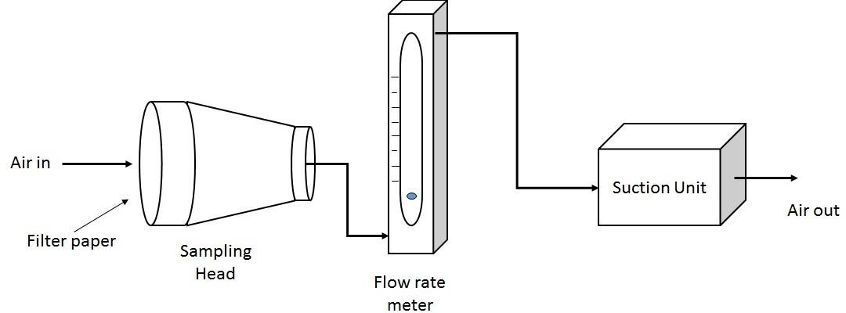

FIG.1 ASSEMBLY OF FILTERATION APPARATUS

**4.2.1** *Sampling Head*

The sampling head or a filter holder should be so designed as to provide uniform air velocity (known as face velocity) across the entire face of the sampling area of the filter. A typical sampling head is shown in Fig. 2.

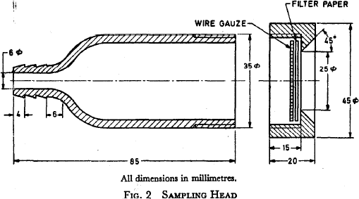

FIG. 2 SAMPLING HEAD

This specific sampling head provides an effective filter area of 25 mm diameter. When the size of the filter to be accommodated is smaller than that represented in the figure, a smaller filter head has to be used. A mechanical support such as a wire gauze, sometimes with a ‘O’ ring, is provided to hold the filter paper air-tight at the edges and to prevent displacement or rupture of the filter during sampling. The back-up screen or the support used is normally firmly fixed on the main piece when required to hold brittle filters (such as the membrane type) or soft filters such as of the glass fibre type.

**4.2.2** *Filter*

The filter paper for any specific sampling work is selected after considering many factors: cost, availability, resistance to flow that may be permitted, efficiency of collection desired, etc. It may be noted here that papers of high filter efficiency are usually those of high resistance also.

**4.2.2.1**The all-cellulose filter papers such as whatman-41 offer high mechanical strength and are widely used for air sampling mainly because of low cost. However, being not very uniform, the resistance to air flow and consequently the collection efficiency varies from sample to sample.

**4.2.3** *Flow*-*Measuring Device*

Dry or wet gas metres may be employed to record the total volume of air passed directly. Rotameters or float-type gauges may be used to give rates of flow of air.

**4.2.4** *Suction Device* (*or a Source of Vacuum*)

This may be a pump or an ejector which uses steam or compressed air, having the capacity for sampling rate varying between 200 l/min to 500 l/min.

**4.3 Period of Sampling**

When the long-lived radioactivity in air is required, it is sometimes necessary to choose a high rate of sampling and the sampling may be performed for a long time such as a few hours, whereas if the gross activity is required, the sample need be taken for a large volume of air from a relatively small volume of air including short lived and hence a low flow rate would be adequate.

**5 MEASUREMENT OF RADIOACTIVITY**

**5.1 General**

After the sampling is over, the radioactivity of the filter paper with the collected material on it is measured. Knowing the total volume of air sampled, the specific radioactivity of the particulate in the atmosphere may be calculated.

**5.2 Counting**

**5.2.1** A typical arrangement used for counting the beta radioactivity of filter paper air samples is shown in Fig. 3. It consists of an end-window Geiger-Muller counter. A lead housing for the counter is used in practice (not shown in figure) in order to keep the background count rate low. The filter paper sample is kept below the counter soon after the sampling is over. When the location of sampling is not near the counting laboratory, however, some delay is involved between the end of sampling and the start of counting, and this should be reported.

**5.2.1.1** Instead of a Geiger-Muller counter as the detector, beta sensitive thin plastic scintillator may also be used.

**5.2.1.2** By using electronic counting set-up the total counts registered in any given time may be obtained and hence the count rate in counts per second (cps).

**5.2.2** When the count rate is high, as in the initial stages, the counting time may be sufficient. But when the activity is low, larger counting periods may have to be employed.

**5.2.3** By subtracting the background count rate of the counter obtained without using any sample, the net count rates due to the sample may be calculated.

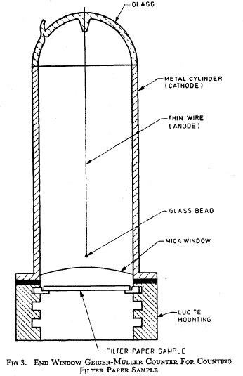

FIG. 3 END WINDOW GEIGER-MULLER COUNTER FOR COUNTING FILTER PAPER SAMPLE

**5.3 Counter Efficiency**

The efficiency factor of the counting set-up (the fraction of the total disintegrations in the sample that is actually counted) should be first obtained by using a standard source of beta radiation. This factor, *f*, should be used to convert the net counts per seconds (cps) into disintegration per second (dps) or Becquerel.

**5.4 Calculation**

Let the period of collection of samples be equal to *t* min and the average rate of sampling be *v* litres per minute. Then total volume of air sampled V = *vt* litres.

**5.4.1** *Gross Activity*

Let the net count rate of the filter sample (after subtracting the background of the counter) be *C* counts per second. The air activity may then be expressed as 103 C/*Vf* disintegrations per second per cubic metre.

**5.4.2** *Long-Lived Activity*

**5.4.2.1** By counting the filter paper again after delay time, by allowing short lived radio – isotopes to decay out, it is possible to evaluate the long-lived component of the activity in air.

**5.4.2.2** The natural activity of the air is largely a mixture of 214Pb and 212Pb. The former has a half-life of 26.8 min and accounts usually for about 90 percent of the natural air activity. 212Pb has a half-life of 10.6 hours.

**5.4.2.3** A period of about 4 h which is more than 8 half-lives of 214Pb is permitted to elapse before the sample is counted for the first time. This ensures that more than 99.5 percent of the 214Pb component will have decayed. If one has to wait till almost all 212Pb disintegrates it would delay obtaining the results for three days. Instead, a calculation based upon two counts separated by approximately 24 hours is applied as follows to remove the fraction of the total count due to 212Pb.

Let cl be the net count rate obtained at a delay time of t1 h and c2 the net count rate at a delay time, t2 h after the end of sampling, the second counting being done after 24 h of the first counting.

The count rate due to the long-lived beta activity Bq or dps in is then given by





where, *t* is the time interval between the counts, (*t*2 — *t*1) in hours and λ the decay constant of 212Pb (0.065 4 h-l).

Then the long-lived beta activity will be C/V*f* in Bq per litre .

**5.5 Correction for Efficiency of Filter Paper**

The calculations in **5.4** assume that the efficiency of the filter paper is 100 percent for retention of particulates carrying the radioactivity. When this assumption is not correct, the values are to be corrected after evaluating efficiency of the filter paper.

Efficiency for retention of the particles on the filter paper used may be experimentally obtained if an absolute filter paper (such as the millipore filter) is kept behind the routine filter while collecting the sample. By obtaining the gross count rates for the two filter papers for the same delay time (time elapsed after the end of sampling), the efficiency of the routine filter paper may be calculated.

**6 REPORTING THE RESULTS**

**6.1** The results of measurement of the radioactivity in air may be reported in a suitable form, such as the proforma given below:

**MEASUREMENT OF RADIOACTIVITY IN AIR**

1. Location: ………
2. Date of collection: ………...
3. Period of collection: …….. h to h, *t* =…….. min
4. Average rate of sampling, *v* = l/min
5. Total volume of air sampled , *V* = v.t= l
6. Background of the counting set-up = counts per second, (cps)
7. Efficiency factor of the counter, *f* =………..

observed count rate (cps) with the standard source activity (dps) of the standard source

1. Count rate of the filter paper sample for a counting period of = ……. seconds (cps) and …….. second after collection……cps
2. Net count rate, *C* = (h) — (f) = cps
3. Gross beta activity in air = 103 *c/V f =* dps/m3
4. Count rate of the filter paper sample after a delay of *t*1 h = cps
5. Net count rate at delay of *t*1 hours, *c*1 = cps
6. Count rate of the filter paper sample after a delay of *t*2 h =…… cps
7. Net count rate at delay of *t*2 h, *c*2 = cps
8. Count rate due to long-lived activity, c = $\frac{c_{2 }-c_{1 }e^{-λ t} }{1- e^{-λ t}}$ = ………cps



1. Long-lived beta activity in air = *c*/*Vf* = Bq/m3

**ANNEX A**

(*Foreword*)

**COMMITTEE COMPOSITION**

Air Quality Sectional Committee, CHD 35

|  |  |
| --- | --- |
| *Organization Represented* | *Representative(s)* |
|
| In Personal Capacity (*Former Head, Environmental Testing and Analysis Division, BARC*) | **DR. GAURI PANDIT, (*Chairperson*)** |
| Bhabha Atomic Research Centre, Mumbai | DR. A VINOD KUMAR  DR. S. K SAHU (*Alternate*) |
| CSIR- National Physical Laboratory | DR. SHANKAR AGARWAL  DR. TUHIN KUMAR MANDAL (*Alternate*) |
| Central Pollution Control Board (MOEFCC), GOI, New Delhi | MR. ADITYA SHARMA  DR. R C SRIVASTAVA (*Alternate*) |
| CSIR -National Environmental Engineering Research Institute, Nagpur | DR. S.K. GOYAL  DR. SMITHA AGGARWAL |
| Confederation of Indian Industry, New Delhi | MR. MOHIT SHARMA  MR. SHUBHAM MISHRA (*Alternate*) |
| Dyson Technology India Pvt Ltd, | MR. SHEKH TAZIMUL HAQUE FARIDI |
| Ecotech Instruments, Greater Noida | DR RAJENDRA PRASAD |
| Envirotech Instruments Pvt. Ltd. | DR. BALBIR SINGH  MR. ASHISH GUPTA (*Alternate*) |
| Envirotech East Private Limited, Kolkata | MR. ASOKE KUMAR BANERJEE  MR. SANJIB KUMAR GOSWAMI (*Alternate*) |
| Green Economy Initiatives Pvt. Ltd., Mohali | DR. R S SAINI  MS. SONIKA PAWAR (*Alternate*) |
| Indian Association for Air Pollution Control, New Delhi | DR. J S SHARMA |
| Indian Chemical Council, Mumbai | MR. DHRUMIL SONI  MS. SHRADDHA RANE (*Alternate*) |
| Maharashtra State Pollution Control Board, Govt of Maharashtra, Mumbai | DR. P D KHADKIKAR  MR KISHORE GAWANKAR (*Alternate*) |
| NTPC Ltd, New Delhi | MR RAJESH MALIK  MR. RAJIV RANJAN (*Alternate*) |
| National Council for Cement and Building Materials, Ballabhgarh | MR ANAND BOHRA  MR. K R P NATH (*Alternate*) |
| The Fertilizer Association of India, New Delhi | MR. MANISH GOSWAMI  MR. ARUN KUMAR MANDAL (*Alternate*) |
| UNIPHOS Envirotronics Pvt. Ltd., Gujarat | MR VIJAY PANDEY  MR. VINAYAKA PRABHAKAR VALSANGKAR (*Alternate I*)  DR. R C NAIK (*Alternate II*) |
| In Personal Capacity (*Flat 403, Neha apartment Vinayaka Nagar, Gachibowli Hyderabad — 500032*) | DR. N RAVEENDHAR |
| In Personal Capacity (*Development House Pvt. Ltd C-10, Sector 06, NOIDA-201301)* | DR. S.N.A RIZVI |
| In Personal Capacity (*B-31/F3, Rampuri, Suryanagar*  *Ghaziabad - 201011*) | DR. S.K TYAGI |
| BIS Directorate General | SHRI AJAY KUMAR LAL, SCIENTIST ‘F’/SENIOR  DIRECTOR AND HEAD (CHEMICAL) [REPRESENTING  DIRECTOR GENERAL (Ex-officio)] |

*Member Secretary*

SHRIMATI PREETI PRABHA

SCIENTIST ‘D’/JOINT DIRECTOR

(CHEMICAL), BIS