**IS 6053 (Part 5) : 2024**

***भारतीय मानक***

***Indian Standard***

**Doc: CHD 19 (25347) F**

**October 2024**

फुटवियर उद्योग के लिए हाथ के

उपकरण — विशिष्टि

भाग 5 सीधा हैंकिंग चाकू

(***पहला पुनरीक्षण***)

**HAND TOOLS FOR FOOTWEAR**

**INDUSTRY — SPECIFICATION**

Part 5 Straight hacking knife

(*First Revision*)

ICS 61.060

© BIS 2024

 भारतीय मानक ब्यूरो

BUREAU OF INDIAN STANDARDS

मानक भवन, 9 बहादुर शाह ज़फर मार्ग, नई दिल्ली –110002

MANAK BHAVAN, 9 BAHADUR SHAH ZAFAR MARGNEW DELHI - 110002

[www.bis.gov.in](http://www.bis.org.in) [www.standardsbis.in](http://www.standardsbis.in)

October 2024 Price Group X

Footwear Sectional Committee, CHD 19

# FOREWORD

# This Indian Standard (First Revision) was adopted by the Bureau of Indian Standards, after the draft finalized by the Footwear Sectional Committee had been approved by the Chemical Division Council.

The straight hacking knife is used for trimming of extra upper leather to make it of uniform shape. It is also used for rounding of sole leather to give it a regular shape.

This standard was first published in 1972. This revision has been taken up in order to bring out the standard in latest style and format of the Indian Standards. The relevant clauses have been added and the references have been updated.

This Indian Standard is published in several parts. The other parts in this series are:

Part 1 Upper clicking knife

Part 2 Bottom cutting knife (Rampi)

Part 3 Designers' knife

Part 4 Half Round Knife

For the purpose of deciding whether a particular requirement of this standard is complied with, the final value, observed or calculated, expressing the result of a test or analysis, shall be rounded off in accordance with IS 2: 2022 ‘Rules for rounding off numerical values (*second revision*)’. The number of significant places retained in the rounded off value should be the same as that of the specified value in this standard

*Indian Standard*

HAND TOOLS FOR FOOTWARE INDUSTRY—SPECIFICATION

**PART 5 STRAIGHT HACKING KNIFE**

(*First Revision*)

**1 SCOPE**

This standard prescribes the requirements, method of sampling and tests for straight hacking knife used in footwear industry for cutting leather.

**2 REFERENCES**

The Indian standards given below contain provisions which through reference in this text, constitute provisions of this standard. At the time of publication, the editions indicated were valid. All standards are subject to revision, and parties to agreements based on this Indian standard are encouraged to investigate the possibility of applying the most recent editions of the standards.

|  |  |
| --- | --- |
| *IS No.* | *Title* |
| IS 347 : 2023 | Varnish Shellac For General Purposes — Specification *(second revision)* |
| IS 579 : 2017 | Vegetable tanned sole leather - Specification *(fourth revision)* |
| IS 620 : 1985 | Specification for wooden tool handles general requirements |
| IS1501(Part1):2020/  ISO 6507-1 : 2018 | Metallic Materials — Vickers Hardness Test Part 1 Test Method ( *fifth revision* ) |
| IS 2050 : 1991 | Glossary of terms & elating to footwear (*First Revision*) |
| IS 4905 : 2015  ISO 24153 : 2009 | Random sampling and randomization procedures (*first revision*) |

**3 TERMINOLOGY**

For the purpose of this standard, the definition given in IS 2050 shall apply.

**4 REQUIREMENTS**

**4.1 Materials**

**4.1.1** *Blades*

The knife blade shall be made from steel conforming to the performance test given in **4.5.1, 4.5.2** and **4.3.3.**

**4.1.2** *Handle*

Handle of the knife shall be made from wood conforming generally to the requirements of Class V of IS 620.

**4.1.3** *Washers*

The washer shall be of mild steel, 16 mm diameter and 0.8 mm thickness.

**4.1.4** *Rivets*

The rivets shall be of mild steel, flat head 6 mm diameter and 16 mm long.

**4.2 Design and Dimensions**

A typical design with recommendatory dimensions is given in Fig. 1

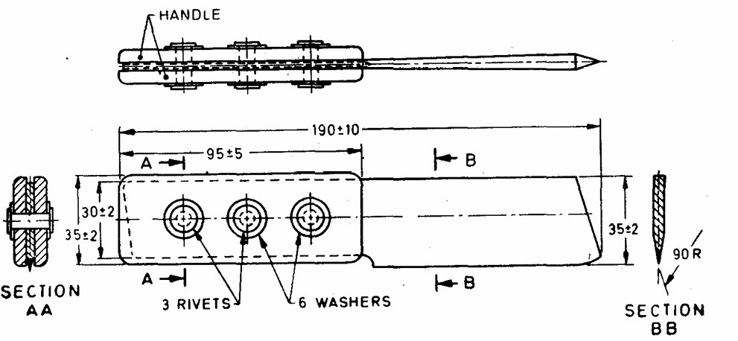

All dimensions in millimetres.

FIG. 1 STRAIGHT HACKING KNIFE

**4.3 Hardnes**

The hardness of the finished steel blades of the knife, measured as near to the cutting edge as possible shall be within 625 HV to 725 HV when tested according to IS 1501 (Part 1).

**4.4 General Requirements and Finish**

**4.4.1** The blades shall be suitably hardened and tempered. The blades shall be free from cracks, seams, pits, burns and other visible defects. They shall be smoothly ground and capable of being sharpened by means of an oil stone to a fine cutting edge**.**

**4.4.2** The tang shall be well drawn and securely fitted to the handle with rivets.

**4.4.3** The handle shall be evenly and smoothly finished and shall be coated with shellac varnish **(*see*** IS 347).

**4.5 Performance Requirements**

**4.5.1** The knife when suitably sharpened and subjected to a practical cutting test on butt portion of vegetable tanned sole leather (*see* IS 579), approximately 5 mm thick, shall cut easily and shall give a clean-cut edge. The cutting edge shall fully retain its keenness and shall show no sign of distortion or any other defects on completion of the test.

**4.5.2** The blades of the knife shall not show any sign of blunting, cracking, permanent set or loosening or tendency to fold from the handle being struck sharp blows on one of the hard timbers given in Annex A from a height of 250 mm with the cutting edge facing downwards.

**4.5.3** The blades of each knife shall be struck four hard blows across the edge of any of the hard timbers given in Annex A along its flat surface. The blades shall show no sign of damage or distortion during or after the test.

**5 Packing and Marking**

**5.1 Packing**

The blades of the knife shall be wrapped in greased paper and securely tied. The wrapped knives shall then be packed as agreed to between the purchaser and the supplier**.**

**5.2 Marking**

**5.2.1** Each blade of the knife or the package or both shall be marked legibly with the following particulars**:**

1. Name of the manufacturer or trade-mark, if any; and
2. Date and year of manufacture

**5.2.2** *BIS Certification Marking*

The product(s) conforming to the requirements of this standard may be certified as per the conformity assessment schemes under the provisions of the *Bureau of Indian Standards Act, 2016* and the Rules and Regulations framed thereunder, and the products may be marked with the standard mark.

**6 SCALE OF SAMPLING AND CRITERIA FOR CONFORMITY**

The scale of sampling and criteria for conformity shall be as prescribed in Annex B.

**ANNEX A**

(*Clause* **4.5.2** and **4.5.3**)

**HARD TIMBERS**

**A-1** The following timbers may be used for testing the performance of the knives:

|  |  |
| --- | --- |
| TRADE NAME | BORANICAL NAME |
| Kusum | *Schleicher oleosa* Merr. |
| Babul | *Acaicia nilotica* ( Linn.) Del. Syn *Acacia arbica Llinn, Fam. Leguminosae* |
| Sissoo | *Dalbergia sissoo* Roxb. |
| Sal | *Shorea robusta* Gaertn.f. |
| Hopea | *Hopea* sp. |
| Mesua | *Mesua Ferres* |

**ANNEX B**

(*Clause* 6)

**SCALE OF SAMPLING AND CRITERIA FOR CONFORMITY**

**B-1 SCALE OF SAMPLING**

**B-1.1 LOT**

In a consignment all the knives of the same shape and dimensions shall be grouped together to constitute a lot.

**B-1.2** Each lot shall be tested separately for determining its conformity to the requirements of this specification.

**B-1.3** Th**e** number of knives to be selected in the sample depends on the size of the lot and shall be in accordance with col 2 and 3 of Table 1.

**TABLE 1 SACLE OF SAMPLING AND PREMISSIBLE NUMBER OF DEFECTIVES**

|  |  |  |  |
| --- | --- | --- | --- |
| **Sl No.** | **Lot Size** | **Sample Size** | **Permissible No. of Defectives.** |
| (1) | (2) | (3) | (4) |
|  | Up to 25 | 5 | 0 |
|  | 26 to 50 | 8 | 0 |
|  | 51 and above | 13 | 1 |

**B-1.4** These sample knives shall be selected at random from the lot. For random selection procedures, IS 4905 may be referred.

**B-2 CRITERIA FOR CONFORMITY**

**B-2.1** All the selected knives shall be examined for material, construction, dimensions and finish and shall also be tested for performance requirements given in **4.5**. A knife failing in any one of the above requirements shall be taken as a defective. The number of defectives shall not exceed the permissible number given in co1 4 of Table 1 if the lot is to be accepted as satisfactory.

**B-2.2** Two knives, if the lot size is 100 and below, shall be tested for hardness of steel blade. There shall be no failure if the lot is to be accepted under this clause.

**ANNEX C**

(*Foreword*)

**COMMITTEE COMPOSITION**

Footwear Sectional Committee, CHD 19

|  |  |
| --- | --- |
| *Organization* | *Representative(s)* |
| In Personal Capacity, Chennai *(Flat F1, Bhoopathy Apartment, 10, Ethiraj Street, Palipattu, Chennai –600113*) | DR B. N. DAS **(*Chairperson*)** |
| Atharva Laboratories Private Limited, Noida | MS. APARNA PARVATIKAR  MR. J. BASAK |
| Bata India Limited, Kolkata | MR. HITESH KAKKAR  MR. GOVINDARAJU |
| CSIR - Central Leather Research Institute, Chennai | DR R. MOHAN  DR. MAHESH KUMAR .J |
| Central Footwear Training Institute, Chennai | MR. K MURALI |
| Central Reserve Police Force, New Delhi | MR. SANJEEV KUMAR SINGH  MR. D. P. UPADHYAY |
| Confederation Of Indian Footwear Industries, New Delhi | MR. RAJ KR. GUPTA  MR. V NOUSHAD |
| Council For Leather Exports, Chennai | MR. A. FAYAZ AHMAD  MR. D. GOKULAKRISHNAN |
| Directorate General Of Mines Safety, Dhanbad | MR. SAIFULLAH ANSARI  MR. A RAJESHWAR RAO |
| Footwear Design And Development Institute, Noida | MR. SHAILENDAR SAXENA  MR. SAROJ KUMAR PANDA |
| Indian Footwear Components Manufacturers Association, Noida | MR. SHARAD KANT VERMA  MR. SANJAY GUPTA |
| Laghu Udyog Bharati, New Delhi | MR. JATINDER PAUL CHUGH  MR. AMIT SANCHETI |
| Lancer Footwear India Private Limited, New Delhi | MR. SAURABH GUPTA |
| Liberty Shoes Limited (P.U. Division), Karnal | MR. SHRI S. S. LAHIRI  MR. ADESH GUPTA |
| MB Rubber Private Limited, Delhi | MR. VIPAN MEHTA |
| MSME Technology Development Centre (PPDC), Meerut | MR. ADITYA PRAKASH SHARMA  MR. TULARAM BHARTI |
| Pinza Footwear, New Delhi | MR. PREM MEHANI |
| Prolific Engineers, Noida | MR. G P KEDIA |
| SGS India Private Limited, Gurugram | MR. P. VENKATESAN  MR. K PACHAIYAPPAN |
| Top Lasts, Agra | MR. ANURAG SHARMA  MR. DEEPAK MANCHANDA |
| Xo Footwear Private Limited, Delhi | MR. NALIN GUPTA  MR. MANOJ KUMAR |
| BIS Directorate General | SHRI AJAY KUMAR LAL, SCIENTIST ‘F’/SENIOR  DIRECTOR, (CHEMICAL) [REPRESENTING DIRECTOR GENERAL (*Ex*-*officio*)] |

*Member Secretary*

MS PREETI PRABHA

SCIENTIST ‘D’/JOINT DIRECTOR

(CHEMICAL), BIS