**IS 9167 : XXXX Doc No.: CHD 08 (23595)F**

***भारतीय मानक***

***Indian Standard***

**श्रवण रक्षक — विशिष्टि**

(*पहला पुनरीक्षण*)

**Hearing Protectors — Specification**

*(First Revision)*

ICS 13.340.20

© BIS 2024

**भारतीय मानक ब्यूरो

BUREAU OF INDIAN STANDARDS

मानक भवन, 9 बहादुर शाह ज़फर मार्ग, नई दिल्ली –110002

MANAK BHAVAN, 9 BAHADUR SHAH ZAFAR MARGNEW DELHI - 110002

[www.bis.gov.in](http://www.bis.org.in) [www.standardsbis.in](http://www.standardsbis.in)

**June 2024 Price Group**

Occupational Safety and Health Sectional Committee, CHD 08

FOREWORD

This Indian Standard (First Revision) was adopted by the Bureau of Indian Standards, after the draft finalized by the Occupational Safety and Health Sectional Committee had been approved by the Chemical Division Council.

Noise, unwanted sound, is present in all environments, predominantly in industrial environments. Exposure to high-intensity noise may cause hearing impairment. The degree of such impairment depends on the noise level and duration as well as the sensitivity of the individual.

This standard was originally published in 1979. In this first revision, terminology, classification, marking and maintenance clauses have been updated. New requirements like size range, Ignitability, cup rotation, cushion pressure, mechanical durability test (drop test), fluid leakage test, and user information’s have been added. Test methods have been updated and added in form of annexures. Amendment No. 1 also has been incorporated and the references have been updated.

During this revision assistance has been derived from the following:

CSA Standard Z 94.2 Ear protectors. Canadian standards association.

ISO 4869 (Part 1 to 6) Acoustics — Hearing protectors, International Organization for Standardization

EN 352 (Part 1 to 3) Hearing protector’s general requirements, European Committee for Standardization

EN 13819 -1 Hearing protector physical test methods, European Committee for Standardization

ANSI S 3.19 Methods for the measurement of real ear protection of ear protectors and physical attenuation of earmuffs. American National Standards Institute.

The composition of the Committee responsible for the formulation of this standard is given at Annex N.

For the purpose of deciding whether a particular requirement of this standard is complied with, the final value, observed or calculated, expressing the result of a test or analysis, shall be rounded off in accordance with IS 2 : 2022 ‘Rules for rounding off numerical values (*second revision*)’. The number of significant places retained in the rounded off value should be the same as that of the specified value in this standard.

*Indian Standard*

HEARING PROTECTORS — SPECIFICATION

(*First Revision*)

**1** **SCOPE**

This standard covers the performance requirements for devices for personal hearing protection.

**2 REFERENCES**

The Indian standards given below contain provisions which through reference in this text, constitute provisions of this standard. At the time of publication, the editions indicated were valid. All standards are subject to revision, and parties to agreements based on this Indian standard are encouraged to investigate the possibility of applying the most recent editions of the standards indicated below:

|  |  |
| --- | --- |
| *IS No.* | *Title* |
| IS 1885 (Part 3) : 2023  IEC 60050-801:1994 | International electrotechnical vocabulary IEV Part 3: Acoustics and electroacoustics |
| IS 6229 : 1980 | Method for measurement of real - Ear protection of hearing protectors and physical attenuation of earmuffs (*first revision*) |
| IS 7194 : 2018  ISO 1999: 2013 | Acoustics - Estimation of noise Induced hearing loss (*second revision*) |

**3 TERMINOLOGY**

For the purpose of this standard, the terms and definitions given in IS 1885 (Part 3) and IS 6229, and the following, shall apply.

**3.1 Acceptance Tests** —Tests carried out on samples selected from a lot for the purpose of acceptance of the lot.

**3.2 Acoustic Test Fixture (ATF)** — Device that approximates certain dimensions of an average adult human head and is used for measuring the insertion loss of earmuffs.

**3.3** **Behind-the-Head Earmuff** — Earmuff designed to be worn with the headband passing behind the head.

**3.4 Carrier** — Head protection and/or face protection device, primarily intended to protect the upper part of the user's head and/or face.

NOTE- Examples of suitable PPE carriers are industrial safety helmets, rigid head tops of powered and supplied air respirator systems, climbing and rescue helmets, face shields, visors.

**3.5 Corded Earplug** — Earplugs that are connected to each other with a cord of suitable length to allow the earplugs to be worn in the left and right ears while being connected.

**3.6 Cup Supporting Arms** — Arm, usually of metal or plastics, attached to the head protection and/or face protection device shell and designed to enable the earmuffs' cup to fit securely around the ear by exerting force against the cup and pressure through the cushion.

**3.7 Cushion** — Deformable component, usually containing a foam plastic or fluid filling, fitted to the rim of the cup to improve the comfort and fit of the earmuff on the head.

**3.8 Disposable Earplug** — Earplug intended for one fitting only

**3.9 Earmuff** — Hearing protector consisting of an ear cup to be pressed against each pinna (supra-aural) or of an earcup to be pressed against the head, around the pinna (circumaural).

**3.10 Earplug** — Hearing protector worn within the external ear canal (aural) or in the concha against the entrance to the external ear canal (semi-aural).

**3.11 Headband** — A device, usually made of metal and/or plastics, other than a helmet, designed to hold the earplug or earmuff in proper position.

**3.12 Hearing Protector** — Device worn by a person for the purpose of reducing noise and other Loud Acoustic Stimuli

NOTE- Hearing protectors can include electronic devices for communication, or devices designed to play an active role in the reduction of the noise level between the hearing protector and the eardrum.

**3.13 Lot** — All Hearing protectors of the same type, category and rating manufactured by the same factory during the same period using the same materials and processes.

**3.14 Noise Reduction Rating (NRR)** — A single number noise reduction factor in decibels, determined by an empirically derived technique which takes into account performance variation of protectors in noise reducing effectiveness due to differing noise spectra, fit variability and the mean attenuation of test stimuli at the one-third octave band test frequencies

**3.15 Over-the-Head Earmuff** — Earmuff designed to be worn with the headband passing over the top of the head.

**3.16 Parking Position** — Position of the earmuffs in which the cups are located above the level of the lower edge of the carrier shell.

**3.17 Passive Hearing Protection** —Hearing protection that provides attenuation of external sounds not by means of electronics. All hearing protectors that have the characteristics of reducing noise by their design and type of material used are called passive hearing protection.

**3.18 Reusable Earplug** — Earplug intended for more than one fitting

**3.19 Sound Attenuation** — Difference between the threshold of hearing with and without the hearing protector in place for a test subject for a given test signal.

**3.20 Stand-by Position** — Position of the earmuffs in which the cups are located below the level of the lower edge of the carrier shell and in which the cushions are held away from the side of the head or pinna.

**3.21 Type Tests** — Tests carried out to prove conformity with the requirement of the relevant specification. These are intended to check the general qualities and design of a given type.

**3.22 Uncorded Earplug** — Earplugs that are not connected to each other with a cord.

**3.23 Under-the-Chin Earmuff** —Earmuff designed to be worn with the headband passing under the chin.

**3.24 Universal Earmuff** — Earmuff designed to be worn as over-the-head, behind-the-head and under-the-chin earmuff.

## **4 CLASSIFICATION**

The Hearing protectors covered in this standard are classified as follows:

**4.1 Earplugs** — Reusable or disposable.

**4.2 Earmuff** — Over the Head/ Behind the Head/Under the Chin/ Helmet Mounted Type

NOTE — The Hearing protectors may also be classified according to the noise reduction performances, for example: those which reduce all sounds inclusively from high to low tones.

**5 REQUIREMENTS**

All tests specified in this standard shall constitute type test and shall be carried out on 10 samples.

**5.1** **Earplug**

**5.1.1** *Materials and Construction*

**5.1.1.1** *Material*

The materials used in parts of earplugs that coming into contact with the user's skin shall not be likely to cause skin irritation, skin disorders, and allergic reactions or have any other adverse effects to health within the lifetime of the use of the product.

When subject to contact with sweat, ear wax or with other materials likely to be found in the ear canal, the materials shall not be known to undergo changes within the lifetime of the use of the earplugs that would result in significant alteration to those properties of the earplugs that are required to be assessed when the earplugs are examined for compliance with **5.1.**

All materials shall be visibly unimpaired after cleaning and disinfection by the methods specified by the manufacturer.

**5.1.1.2** *Construction*

The Hearing protectors should be so constructed that no deleterious changes occur between - 25 °C and + 55 °C.

Earplug shall be finished smooth and be free from sharp edges that could cause excessive irritation or injuries.

Earplugshall be designed and manufactured such that they are not liable to cause physical damage to the user when fitted and used according to the guideline provided by manufacturer. Also, earplug shall be capable of being readily and completely removed from the ear canal by the user, without the use of tools or instruments.

**5.1.2** *Size Range*

**5.1.2.1** *Earplugs (corded & uncorded)*

The nominal diameter or, if appropriate, the range of nominal diameters of the earplugs, shall be tested in accordance with **A-1** and reported.

**5.1.2.2** *Banded earplug*

Size range for each combination shall be tested in accordance with **A-2**. The range of fitting of the headband shall enable the earplugs to be fitted to the fixture.

In the case of earplugs incorporating a means to adjust the headband force, these requirements shall be satisfied at both the maximum and the minimum force setting.

**5.1.3** *Mechanical Durability Test (Drop Test)*

The earplugs shall remain intact and fully functional as a passive hearing protection when tested in accordance with Annex C. Neither shall any part of the earplugs become detached, such that correct re-assembly requires the use of either a tool or a replacement part.

**5.1.4** *Low Temperature Test*

If the earplug design to perform at low temperature, the earplug shall remain intact and fully functional as a passive hearing protection when tested in accordance with Annex D. Neither shall any part of the hearing protectors become detached, such that correct re-assembly requires the use of either a tool or a replacement part.

**5.1.5** *Cleaning and Disinfection*

If the earplug is marked re-usable, after the hearing protector has been cleaned once, in accordance with the manufacturer guideline, after subjecting the hearing protector for cleaning and disinfection procedure defined by manufacturer, there shall be:

During type testing, no significant alteration to those initial properties of the earplugs that are required to be assessed when the earplugs are examined for compliance with **5.1.1** and **5.1.2**; and no changes observed that can cause any significant alteration to the attenuation characteristics.

For banded earplugs fitted with disposable eartips, the eartips can be excluded from the cleaning.

**5.1.6** *Ignitability*

Any part of earplug shall neither ignite upon application of the heated rod and nor continue to glow after the removal of the heated rod, when tested in accordance with Annex E.

**5.1.7** *Sound attenuation measurement*

The measurement of the sound attenuation of a hearing ear protector shall be carried out in accordance with IS 6229 using real ear experimenter-fit method (IS 6229; Type testing) or by the physical attenuation method (clause 4, IS 6229; For routine test) or both and shall meet the requirements specified in Table 1. The objective method of measurement of sound attenuation is for comparison purposes only.

**Table 1 Sound Attenuation Requirements**

(*Clause* 5.1.7)

|  |  |  |  |  |  |
| --- | --- | --- | --- | --- | --- |
| **Group** | **Test Frequency (Hz)** | | **Group sound attenuation Min. (dB)** | | |
|  |  | | **Muffs** | | **Plugs** |
| (1) | (2) | | (3) | | (4) |
| A | 125 | | 25 | | 25 |
| 250 | |
| B | 500 | | 175 | | 135 |
| 1000 | |
| 2000 | |
| 3000 | |
| 4000 | |
| 5000 | |
| C | 6000 | | 60 | | 80 |
| 8000 | |
| NOTE 1 The minimum group attenuation is the sum of mean attenuation for each of the test frequencies contained in that group. | | | | | |
| NOTE 2 The acceptable minimum sound attenuation for each of the single test frequencies contained in Group B shall be as follows. | | | | | |
| Test Frequency (Hz) | | Sound Attenuation, Min | | | |
|  | | Muffs | | Plugs | |
| 500 | | 25 | | 20 | |
| 1000, 2000 | | 35 | | 25 | |
| 3000, 4000 | |
| NOTE 1 — For the method to calculate Noise reduction rating (NRR) value please refer Annex M. | | | | | |
| NOTE 2 — Real ear test (type testing) is applicable on calculation of NRR and test report from global lab shall suffix the purpose. | | | | | |

**5.2 Earmuff and Hearing Protector Mounted with Head Protection**

**5.2.1** *Materials and Construction*

**5.2.1.1** *Material*

Those materials used in parts of hearing protector coming into contact with the user's skin shall comply with the following requirements:

1. The materials shall not be likely to cause skin irritation, skin disorders, and allergic reactions or have any other adverse effects to health within the lifetime of the use of the product.

NOTE — A written statement confirming this requirement can be provided to the test house by the manufacturer.

1. Those parts of the earmuffs that come into contact with the skin shall be non-staining, soft and pliable.
2. All materials shall be visibly unimpaired after cleaning and disinfection by the methods specified by the manufacturer.

**5.2.1.2** *Construction*

The Hearing protectors should be so constructed that no deleterious changes occur between -25 °C and + 55 °C.

All parts of the earmuff shall be finished smooth and be free from sharp edges that could cause excessive irritation or injuries.

Earmuffare suitable for wearing only in the behind-the-head or under-the-chin modes, and that have a mass in excess of 150 g, shall be provided with a head strap and all universal earmuffs that have a mass in excess of 150 g shall be provided with a head strap.

Earmuffs / mounted earmuff whose cushions and/or liners are intended by the manufacturer to be replaced by the user shall not require the use of tools for this purpose.

**5.2.2** *Size Range*

Size range shall be tested in accordance with Annex F and the following requirements shall be satisfied, as appropriate.

The range of adjustment of the cups/equivalent headband and of the width between the cushions shall enable the earmuff / mounted earmuffs to be fitted to the Fixture / head form as applicable.

In the case of earmuffs incorporating a means to adjust the headband force, these requirements shall be satisfied at both the maximum and the minimum force setting.

**5.2.3** *Cup Rotation*

Earmuff when tested in accordance with Annex G, the contact between the cushions and the plates of the fixture shall be continuous in so far as it provides an unbroken barrier between the inside and outside perimeter of the cushions.

**5.2.4** *Headband Extension Test*

When tested in accordance with Annex H, the headband force of each specimen shall not greater than 14 N and change in specimen shall not be more than ± 15 percent.

For universal earmuffs tests shall be performed for all wearing modes and the ± 15 percent limit shall apply only to the size adjustment which gave the highest initial force. The comparison between the results before and after conditioning shall be performed for the headband force of each specimen separately, additionally and in all cases, the final headband force of each specimen shall not be less than 7N or greater than 14 N

For universal earmuffs tests shall be performed for over the head wearing mode only.

If the earmuff is designed to work under water immersion for short duration, the specimen need to test in accordance to Annex L and below statement shall be supplied to user with earmuff.

“These earmuffs have satisfied the requirements of the stress test under water at + 50 °C.”

**5.2.5** *Cushion Pressure*

When tested in accordance with Annex J, the cushion pressure of each specimen shall be not greater than 4 500 Pa. For earmuffs incorporating means to adjust the headband force, this requirement shall apply to the maximum force setting or 14 N, whichever is the lower.

**5.2.6** *Mechanical Durability Test (Drop Test)*

The earmuffs (except for replaceable cushions and Unless **5.2.7** is to be satisfied) and mounted earmuff (including carrier shell, cups and cup supporting arms) shall remain intact and fully functional as a passive hearing protection when tested in accordance with Annex C. Neither shall any part of the earmuff become detached, such that correct re-assembly requires the use of either a tool or a replacement part.

**5.2.7** *Low Temperature Test* *(Optional)*

If hearing protector design to perform at low temperature, the specimen (except for replaceable cushions and including carrier shell, the cups and the cup supporting arms in case mounted earmuff) shall remain intact and fully functional as a passive hearing protection when tested in accordance with Annex D. Neither shall any part of the hearing protectors become detached, such that correct re-assembly requires the use of either a tool or a replacement part.

**5.2.8** *Fluid Leakage Test (for fluid filled cushions only)*

In the case of fluid filled cushions, they shall not leak when the earmuffs are tested in accordance with Annex K.

**5.2.9** *Cleaning and Disinfection*

If hearing protector are marked re-usable, after the hearing protector have been cleaned once, in accordance with the manufacturer guideline, after subjecting the hearing Protector for cleaning and disinfection procedure prescribe by manufacturer, there shall be:

1. During type testing, no significant alteration to those initial properties of the earplugs that are required to be assessed when the earplugs are examined for compliance with clause **5.2.1** and **5.2.2**; and
2. No changes observed that can cause any significant alteration to the attenuation characteristics.

**5.2.10** *Ignitability Test*

Any part of each specimen (including cup supporting arm in case of mounted earmuff) shall neither ignite upon application of the heated rod and nor continue to glow after the removal of the heated rod, when tested in accordance with Annex E.

**5.2.11** *Sound Attenuation Measurement*

The measurement of the sound attenuation of a hearing protector shall be carried out in accordance with **5.1.7**.

**6** **USER INFORMATION**

Following Information may be supplied by the manufacturer on the user Information manual

1. Number of the IS standard ,CML number
2. Name and trade-mark or designation of the manufacturer.
3. Life time of product including shelf life and time to expiry
4. Recommended storage conditions before and after use;
5. The mass of the earmuff and mass of Ear Plug to the nearest gram
6. For banded earplugs, the size range of the earplugs for each mode of use,
7. Method of fitting/adjustment of ear plugs/ear muff, including instructions regarding the setting of any means to adjust the headband force;
8. The size range(s) of the earmuffs for each mode of use,
9. If the Ear Muff /banded ear plug has been tested to drop at low temperatures then a statement “These earmuffs have satisfied the requirements of the drop test at −25 °C.”;
10. Sound attenuation in decibels at 125, 250, 500, 1 000, 2 000, 4 000, and 8 000 Hz;
11. Hearing protector fit test in order to achieve the desired attenuation, hearing protectors should be fitted in accordance with the manufacturer's instructions and fit tested where applicable. Please refer Guidance -1 for more details.
12. NRR Value and Derating in information to user: During usage Inaccuracies in NRR values and derating to be followed as Guidance -2.
13. Dual Ear protector (Informative), for details please refer Guidance – 3.

**7 MARKING**

**7.1** The following information regarding the construction, performance and use of Hearing protectors shall be provided by the manufacturer to the user.

**7.2** Following marking shall be based on product or on packaging.

1. Sound attenuation in decibels at 125, 250, 500, 1 000, 2 000, 4 000, and 8 000 Hz; NRR Value.
2. Test tension of headband if applicable.
3. Overall mass.
4. Temperature range.
5. Instructions for cleaning,
6. Instructions for use. The information shall include: Read user information properly
7. ISI marking, Standard, and CML number
8. Date of manufacture
9. In the case of earmuffs intended by the manufacturer to be worn in a particular orientation, an indication of the FRONT and/or TOP of the cups, and/or an indication of the LEFT and RIGHT cup.
10. where the product does not meet the ‘medium size range’, the following statement:
11. “Warning: Small size range or large size range (as appropriate) earmuffs. Refer to user information.”

**8 MAINTENANCE**

**8.1** Instructions for correct use, care and maintenance.

**8.1.1** The following instructions shall be added in the user information.

1. The earmuffs /earplugs are worn at all times in noisy surroundings.
2. The earmuffs /reusable earplugs are regularly inspected for serviceability; a statement that earmuffs, and in particular cushions, may deteriorate with use and, for example; should be examined at frequent intervals for cracking and leakage
3. A warning that, if the recommendations are not adhered to, the protection afforded by the earmuffs /earplugs will be severely impaired.
4. for banded earplugs, the following warning:
5. “Warning: Harmful noise levels may be induced if the headband is struck.”
6. Methods of cleaning and disinfection, which shall specify, and require the use of, agents that are not known to be harmful to the user.
7. For preformed earplugs provide warning “Sudden or fast removal of earplugs out of the ear canal may damage the ear drum.” And for earplugs fitted with an interconnecting cord and do not remove earplugs by pulling the interconnecting cord”.
8. Warning that “The product may be adversely affected by certain chemical substances. Refer to the manufacturer guideline for further information.”
9. A statement that the fitting of hygiene covers to the cushions may affect the acoustic performance of the earmuffs.
10. Designation/reference and other information required when ordering replacement cushions or ear tips of earplugs.
11. If appropriate, the method of cushion or ear tip replacement.

**ANNEX A**

(*Clauses* 5.1.2.1 *and* 5.1.2.2)

**ASSESSMENT OF NOMINAL DIAMETER DESIGNATION**

**A-1 PRINCIPLE**

In order to assign a nominal diameter designation to each ear-plug, the dimensions of that part or those parts of the ear-plug that are intended to seal the ear canal are assessed using a gauge comprising a set of circular holes. When the ear-plug is available in a range of diameters this test shall be carried out for each nominal diameter of the range.

**A-2 APPARATUS**

**A-2.1 Gauge**

This shall consist of a flat rigid plate, with a thickness of (5.0 ± 0.5) mm, enclosing ten circular holes, the respective diameters of which are given in Table 3.

**Table 3 Nominal diameter designations of ear-plugs**

(*Clause* A-2.1)

|  |  |  |  |  |  |  |  |  |  |  |
| --- | --- | --- | --- | --- | --- | --- | --- | --- | --- | --- |
| **Nominal diameter designation** | 5 | 6 | 7 | 8 | 9 | 10 | 11 | 12 | 13 | 14 |
| **Diameter of circular holes in gauge (in mm) (limit deviation ± 0.1 mm)** | 5.0 | 6.0 | 7.0 | 8.0 | 9.0 | 10.0 | 11.0 | 12.0 | 13.0 | 14.0 |

**A-2.2 Procedure**

**A-2.2.1** In cases when the manufacturer's instructions indicate that the shape or dimensions of the ear-plug are formable by the user, configure the ear-plug in accordance with the manufacturer's instructions in such a manner as to facilitate the procedure of **A-2.2.2**.

**A-2.2.2** Assess which is the smallest hole in the gauge into which the appropriate parts of the ear-plug will enter and make circumferential contact without the deformation of the geometrical configuration of the ear-plug being such as to impair its sealing function.

**A-2.2.3** In cases when the manufacturer's instructions indicate that the shape or dimensions of the ear-plug are formable by the user, configure the ear-plug in accordance with the manufacturer's instructions in such a manner as to facilitate the procedure of **A-2.2.4**.

**A-2.2.4** Assess which is the largest hole in the gauge into which the appropriate parts of the ear-plug will make continuous circumferential contact.

**A-2.3 Report**

Report the nominal diameter designations of the ear-plugs corresponding to the holes denominated in **A-2.2.2** and **A-2.2.4** respectively.

**ANNEX** **B**

**RANGE OF FITTING OF BANDED EARPLUG**

**B-1 PRINCIPLE**

The ability of the banded earplugs to fit specified head dimensions is tested using a suitable mounting fixture.

**B-2 APPARATUS**

**B-2.1 Mounting fixtures**

An example of the mounting fixture, in three sizes, is shown in Fig 1.

Mounting holes all equal, All dimensions in millimeters

|  |  |  |  |  |  |
| --- | --- | --- | --- | --- | --- |
| **A** | | **B** | | **C** | |
|  | = 100 mm ± 2.0 mm |  | = 100 mm ± 2.0 mm |  | = 100 mm ± 2.0 mm |
|  | = 125 mm ± 0.5 mm |  | = 145 mm ± 0.5 mm |  | = 155 mm ± 0.5 mm |
|  | = 100 mm ± 2.0 mm |  | = 155 mm ± 2.0 mm |  | = 100 mm ± 2.0 mm |
|  | = 62.5 mm ± 0.5 mm |  | = 67.5 mm ± 0.5 mm |  | = 77.5 mm ± 0.5 mm |
|  | = 90 mm ± 1 mm |  | = 90 mm ± 1 mm |  | = 90 mm ± 1 mm |
|  | = 130 mm ± 1 mm |  | = 130 mm ± 1 mm |  | = 130 mm ± 1 mm |
|  |  |  | = 115 mm ± 1 mm |  |  |
|  |  |  | = 140 mm ± 1 mm |  |  |
|  |  |  | = 75 mm ± 1 mm |  |  |
|  |  |  | = 105 mm ± 1 mm |  |  |
|  |  |  | = 10 mm ± 0.5 mm |  |  |

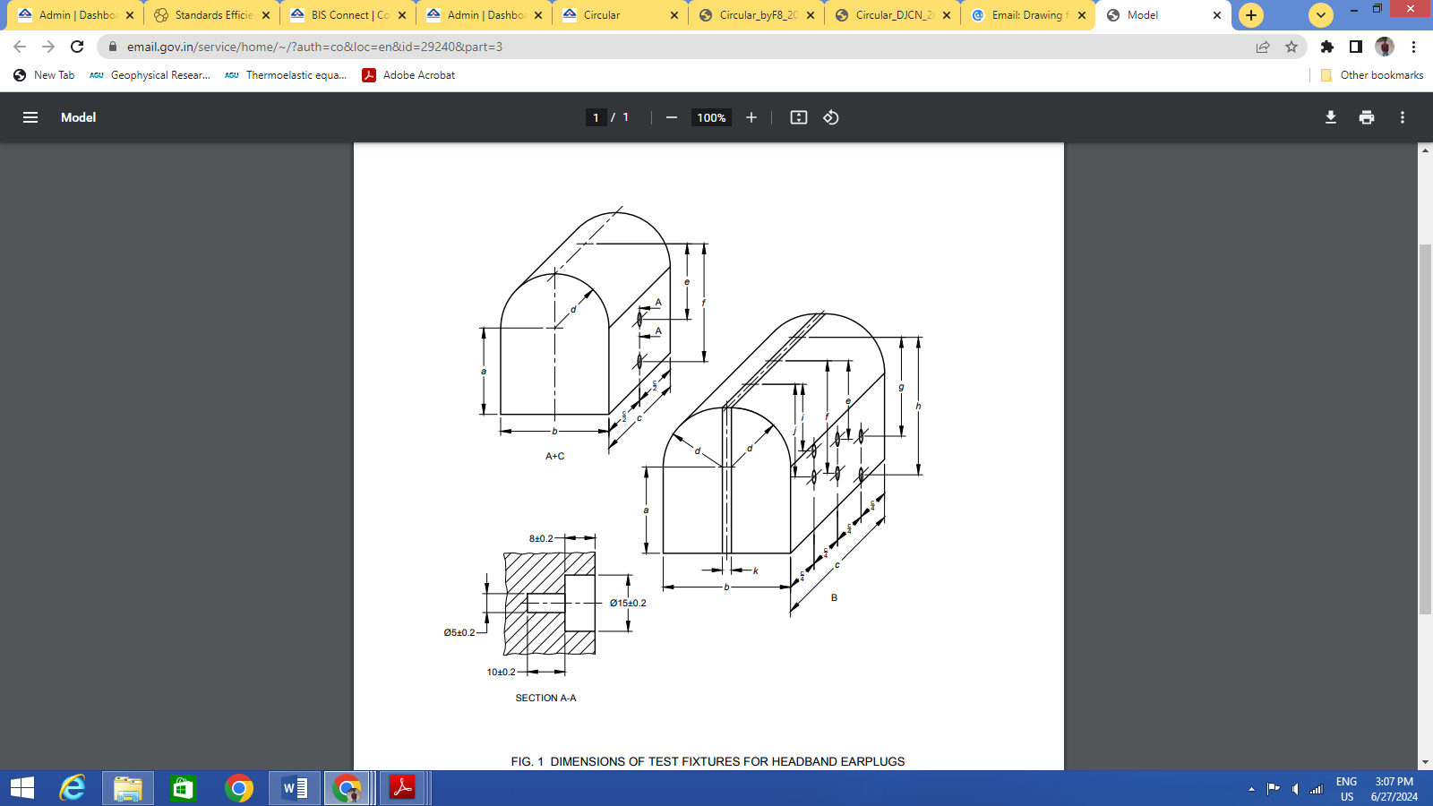

**Key**

A is the text fixture 1;

B is the text fixture 2;

C is the text fixture 3

FIG. 1 DIMENSIONS OF TEST FIXTURES FOR HEADBAND EARPLUGS

**B-2.2 Procedure**

Place the banded earplug on the fixtures in turn so that the band is vertical and the plugs enter the cavities.

**B-2.2.1** For each of the combinations of dimensions of width and height/depth, given by Table 4 as appropriate, check that the range of fitting of the band is such that:

1. The internal apex of the band either touches or lies beyond the apex of the fixtures;
2. The ear-plugs are not subjected to vertical shear.

**Table 4 Combinations of test dimensions for banded earplug**

(*Clause* B-2.2.1)

|  |  |  |  |  |  |  |
| --- | --- | --- | --- | --- | --- | --- |
| **Test Width(mm)** | **Behind-the-head headband earplugs** | | | **Over-the-head and under-the-chin headband earplugs** | | |
| **Test depth (mm)** | | | **Test height (mm)** | | |
|  | **75** | **90** | **105** | **115** | **130** | **140** |
| **125** | S | S/M | - | S | S/M | - |
| **145** | S/M | S/M/L | M/L | S/M | S/M/L | M/L |
| **155** | - | M/L | L | - | M/L | L |
| M indicates ear-muffs of ‘medium’ size range; S indicates ear-muffs of 'small' size range; L indicates ear-muffs of 'large' size range; - indicates no requirement. | | | | | | |

NOTE— The dimensions given in Table 4 have been chosen to cover appropriate combinations of the head width, head height and head depth of the 5th, 50th and 95th percentiles of the adult population.

**B-2.3 Report**

Report the observations noted according to **B-2.2**.

**ANNEX C**

(*Clauses* 5.1.3 *and* 5.2.6)

**MECHANICAL DURABILITY TEST (DROP TEST)**

**C-1 PRINCIPLE**

The Hearing protector (ear-plugs and earmuff) are dropped from a specified height on to a solid surface (concrete surface or steel plate)

**C-2 APPARATUS**

**C-2.1** Smooth Solid surface (concrete surface or steel plate).

**C-2.2** Solid surface (concrete surface or steel plate) shall be not less than 10 mm thick.

NOTE — A suitable size would be 500 mm × 500 mm.

**C-2.2 Means of Suspending**

**C-2.2.1** Ear plug and headband ear-muffs, shall be approximately 1.5 m above the surface.

**C-2.2.2** Helmet mounted ear-muffs, shall be a bifilar suspension, effective length 1.0 m, separation of wires to be approximately equal to the length of the helmet (*see* Fig. 2).

**C-3 PROCEDURE**

**C-3.1 Earplug**

1. Place the solid surface on a level floor.
2. Suspend the ear-plugs so that the height of the lowest point of the ear-plugs is (1500 ± 10) mm above the solid surface.
3. Drop the ear-plugs on to the surface and note whether any part of the ear-plugs has cracked or has become detached.

NOTE — If any part of the ear-plugs becomes detached, it should be re-assembled and the testing scheme continued, provided that correct re-assembly can be performed without the use of either a tool or a replacement part.

**C-3.2 Headband Ear-Muffs**

1. Place the solid surface on a level floor.
2. Set the cups/headband to the mid-point of their range of adjustment.
3. Suspend the ear-muffs by the center of the headband with the longest axis of the cups vertical, so that the height of the lowest point of the ear-muffs is (1 500 ± 10) mm above the solid surface.
4. Drop the ear-muffs on to the surface and note whether any part of the ear-muffs (except for replaceable cushions) has cracked or has become detached.

NOTE 1 — It can be necessary to remove the cushions and/or liners in order to examine the ear-muffs, and then to replace them.

NOTE 2 — If any part of the ear-muffs becomes detached, it should be re-assembled and the testing scheme continued, provided that correct re-assembly can be performed without the use of either a tool or a replacement part.

**C-3.3 Helmet Mounted Ear-Muffs**

1. Affix the solid surface to a vertical wall and arrange the bifilar suspension as shown in Fig. 2.
2. Set the ear-muffs to the in-use position on the helmet, and the cups/supporting arm’s length to their maximum.
3. Clamp the bifilar suspension to the front and rear apex of the helmet shell, adjusting the plane of symmetry of the suspended helmet mounted ear-muffs parallel to the solid surface. Suspend the helmet mounted ear-muffs so that the helmet is inverted and horizontal and so that the lowest point of the crown of the helmet is (1000 ± 10) mm below the suspension line. *See* Figure 2.
4. Lift the helmet mounted ear-muffs so that the bifilar suspension is taut and lying in a horizontal plane.
5. Drop the helmet mounted ear-muffs once onto the solid surface and note whether any part (except for replaceable cushions) has cracked or has become detached.

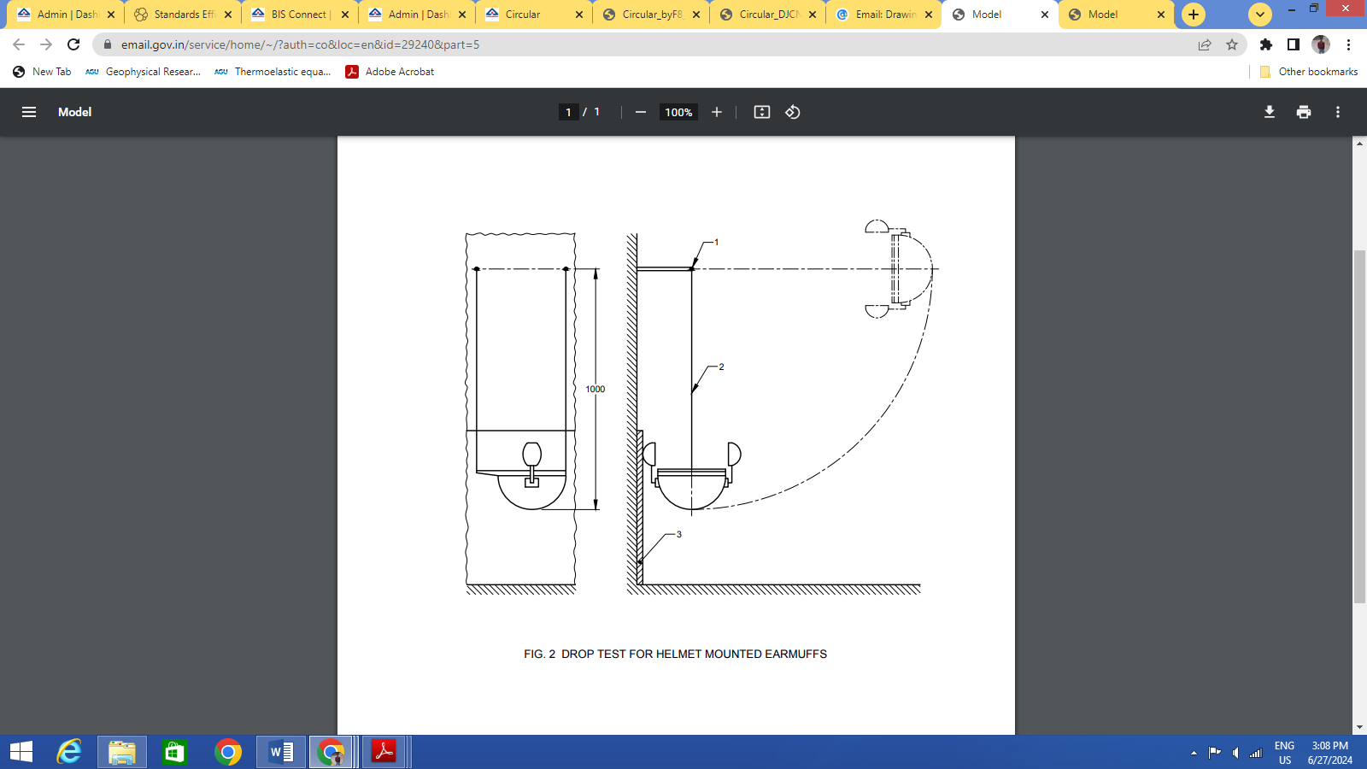

**Key**

* 1. Suspension axis
  2. Bifilar suspension
  3. Smooth Solid surface (concrete surface or steel plate)

FIG 2 — DROP TEST FOR HELMET MOUNTED EARMUFFS

NOTES

1 — It can be necessary to remove the cushions and/or liners in order to examine the earmuffs, and then to replace them.

2 — If any part of the helmet mounted earmuffs becomes detached, it should be re-assembled and the testing scheme continued, provided that correct re-assembly can be performed without the use of either a tool or a replacement part.

**C-4 REPORT**

Report whether any part of the hearing protector (earplugs, earmuff) has cracked or has become detached.

**ANNEX D**

(*Clauses* 5.1.4 *and* 5.2.7)

**LOW TEMPERATURE TEST (OPTIONAL)**

**D-1 PRINCIPLE**

The Hearing protector (earplugs and earmuff) are conditioned at -25 °C and dropped from a specified height on to a solid surface (concrete surface or steel plate)

**D-2 APPARATUS**

**D-2.1 Refrigerated Chamber**

This shall be maintained at a constant temperature of (-25 ± 3) °C.

**D-2.2 Smooth Solid Surface**

Solid surface (concrete surface or steel plate) shall be not less than 10 mm thick.

NOTE — A suitable size would be 500 mm × 500 mm.

**D-2.3 Means of suspending earplugs,** approximately 1.5 m above the plate

**D-3 PROCEDURE**

**D-3.1 Earplug**

**D-3.1.1** Place the solid surface on a level floor.

**D-3.1.2** Store the ear-plugs within the refrigerated chamber for a period of at least 4 h.

**D-3.1.3** Remove the ear-plugs from the refrigerated chamber and, within 10 s, complete below steps.

* + 1. Suspend the ear-plugs so that the height of the lowest point of the ear-plugs is (1 500 ± 10) mm above the solid surface.
    2. Drop the ear-plugs on to the surface and note whether any part of the ear-plugs has cracked or has become detached.

NOTE — If any part of the ear-plugs becomes detached, it should be re-assembled and the testing scheme continued, provided that correct reassembly can be performed without the use of either a tool or a replacement part.

**D-3.2 Headband Earmuffs**

**D-3.2.1** Place the solid surface on a level floor.

**D-3.2.2** Set the cups/headband to the mid-point of their range of adjustment.

**D-3.2.3** Store the ear-muffs within the refrigerated chamber for a period of at least 4 h.

**D-3.2.4** Remove the ear-muffs from the refrigerated chamber and, within 10 s, complete below steps.

* + 1. Suspend the ear-muffs by the center of the headband with the longest axis of the cups vertical, so that the height of the lowest point of the ear-muffs is (1 500 ± 10) mm above the solid surface.
    2. Drop the ear-muffs on to the surface and note whether any part of the ear-muffs (except for replaceable cushions) has cracked or has become detached.

NOTES

1. It can be necessary to remove the cushions and/or liners in order to examine the earmuffs, and then to replace them.

2. If any part of the ear-muffs becomes detached, it should be re-assembled and the testing scheme continued, provided that correct re-assembly can be performed without the use of either a tool or a replacement part.

**D-3.3 Helmet Mounted Earmuffs**

**D-3.3.1** Affix the solid surface to a vertical wall and arrange the bifilar suspension as shown in Fig. 2.

**D-3.3.2** Set the ear-muffs to the in-use position on the helmet, and the cups/supporting arm’s length to their maximum.

**D-3.3.3** Store the helmet mounted ear-muffs within the refrigerated chamber for a period of at least 4 h.

**D-3.3.4** Remove the helmet mounted ear-muffs from the refrigerated chamber and within 10 s, complete below steps.

**D-3.3.5** Clamp the bifilar suspension to the front and rear apex of the helmet shell, adjusting the plane of symmetry of the suspended helmet mounted ear-muffs parallel to the solid surface. Suspend the helmet mounted ear-muffs so that the helmet is inverted and horizontal and so that the lowest point of the crown of the helmet is (1 000 ± 10) mm below the suspension line. *See* Fig. 2.

1. Lift the helmet mounted ear-muffs so that the bifilar suspension is taut and lying in a horizontal plane.
2. Drop the helmet mounted ear-muffs once onto the solid surface and note whether any part (except for replaceable cushions) has cracked or has become detached.

NOTES

1. It can be necessary to remove the cushions and/or liners in order to examine the ear-muffs, and then to replace them.

2. If any part of the helmet mounted ear-muffs becomes detached, it should be re-assembled and the testing scheme continued, provided that correct re-assembly can be performed without the use of either a tool or a replacement part.

**D-4 REPORT**

Report whether any part of the hearing protector (earplugs, earmuff) has cracked or has become detached.

**ANNEX E**

(*Clauses* 5.1.6 *and* 5.2.10)

**IGNITABILITY TEST**

**E-1 PRINCIPLE**

A steel rod is heated to a known temperature and applied to the ear-plugs/ear muff.

**E-2 APPARATUS**

**E-2.1 Steel Rod**

This shall be (300 ± 3) mm long and 6 mm nominal diameter with end faces which are flat and perpendicular to its longitudinal axis.

**E-2.2 Heat Source**

Thermocouple temperature measuring device.

**E-3 PROCEDURE**

**E-3.1** Heat one end of the rod over a length of approximately 50 mm to a temperature of (650 ± 20) °C.

**E-3.2** Position the rod vertically, check that its temperature 20 mm from the heated end is (650 ± 20) °C and apply its heated end face against the surface of hearing protector with the force exerted by its own mass, for a period of (5.0 ± 0.5) s.

**E-3.3** Reheat the rod and repeat the test as many times as is necessary to assess the behavior of all the material of the earplug and earmuff which would be exposed when they are worn and the cup supporting arms in case of helmet mounted earmuffs.

**E-4 REPORT**

Report if any part of earplug / earmuff and the cup supporting arms in case of helmet mounted earmuffs, ignites upon application of the heated rod or continues to glow after removal of the rod.

**ANNEX F**

(*Clause* 5.2.2)

**SIZE RANGE**

**F-1 PRINCIPLE**

The ability of the earmuffs to be adjusted to fit specified test dimensions is assessed using a suitable mounting fixture (headband earmuffs) or test headforms (helmet mounted ear-muffs).

The ability of the headband earplugs and earmuffs to fit specified head dimensions is tested using a suitable mounting fixture.

**F-2 APPARATUS**

**F-2.1 Mounting fixture**

The outline of an example is shown in Fig. 3.

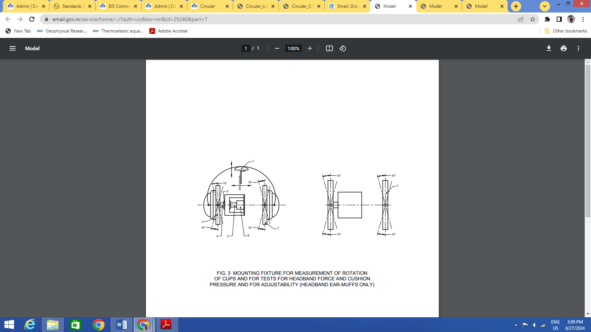

**Key**

1 Headband support pad

2 Linear ball bearing

3 Thrust plate

4 Spindle

5 Coupling pin

6 Force transducer

7 Adjustable plate

NOTE — The pinna simulators shown in Fig. 5 are fitted to the plates of the fixture so that the holes at the centre of the simulators lie on the horizontal axis through the force transducer.

FIGURE 3 MOUNTING FIXTURE FOR MEASUREMENT OF ROTATION

OF CUPS AND FOR TESTS FOR HEADBAND FORCE AND CUSHION

PRESSURE AND FOR ADJUSTABILITY (HEADBAND EAR-MUFFS ONLY)

**F-2.2 Test Head forms**

These shall be in accordance with the dimensions given in IS 7692, for sizes B, J and N. Details are given in Fig. 4.

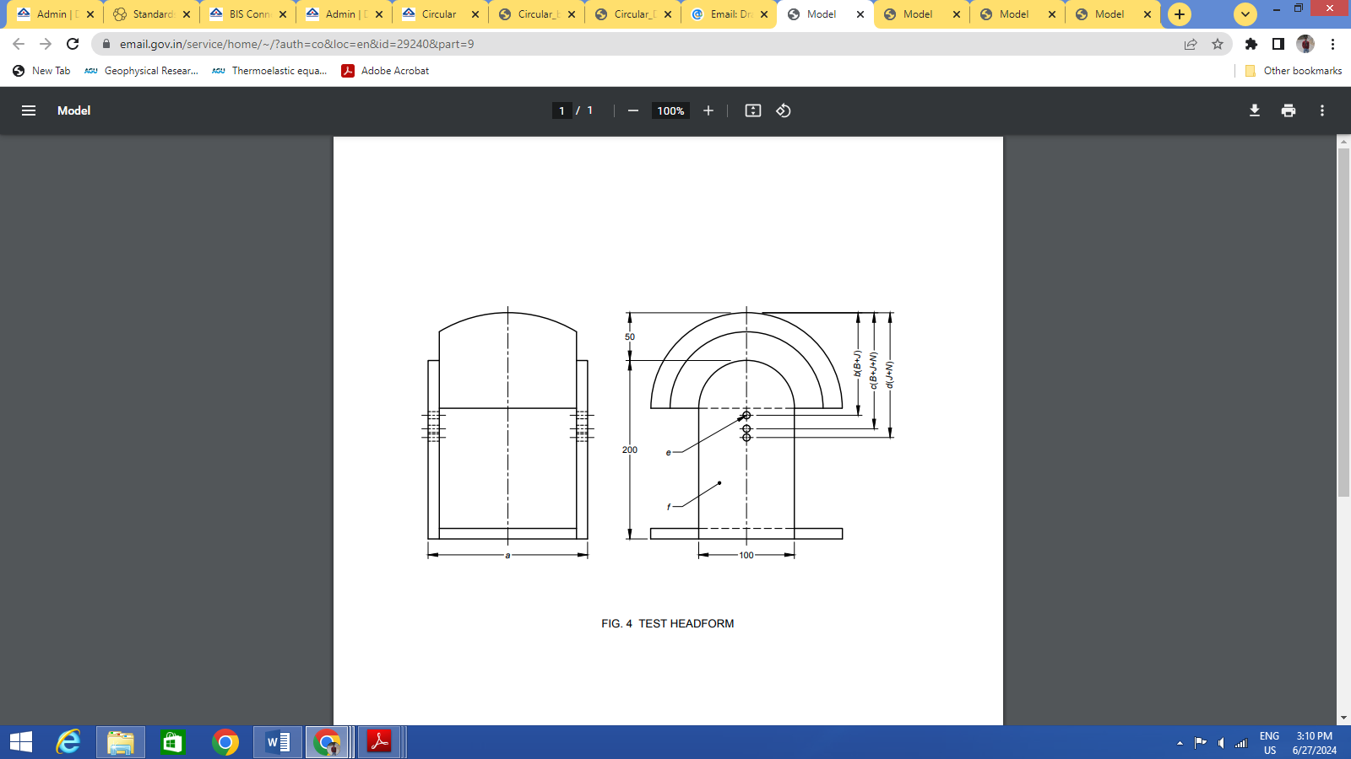

|  |
| --- |
| **Key** |
| Headform B, J or N earmuff of IS 7692 dimensionally above reference plane only and modified for width |
| a is the test width (*see* table 5- Over-the-head & under-the-chin |
| b is the test height 115 |
| c is the test height 130 |
| d is the test height 140 |
| e is the pinna mounting holes |
| f is the transparent plastic plates |
| Dimensions in mm with a limit deviation of 1 mm |

FIG. 4 TEST HEADFORM

**F-2.3 Pinna Simulators**

The required dimensions are shown in Fig. 5.

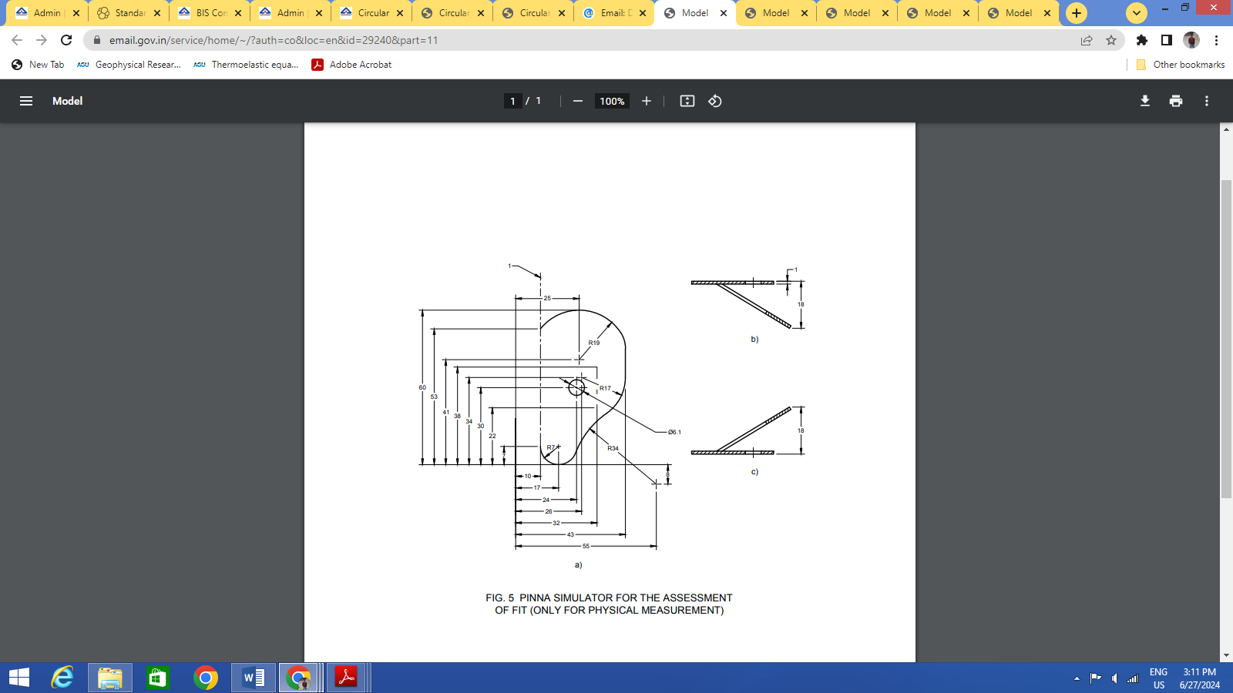

a) Pinna development;

b) Development below folded to form left hand pinna as shown;

c) Development below folded to form right hand pinna as shown;

Key

1 is the Fold line

All dimensions are in mm with a limit deviation of ± 0.2 mm

FIG. 5 PINNA SIMULATOR FOR THE ASSESSMENT

OF FIT (ONLY FOR PHYSICAL MEASUREMENT)

**F-2.4 Non-Planar Cushion Adaptor**

For earmuffs with non-planar cushions, the manufacturer shall supply suitable adaptors which shall be fitted to the mounting fixture, such that, when the earmuffs are then fitted to the mounting fixture, and with the plates of the latter set parallel, the centres of the openings of the earmuffs cushions lie on the horizontal axis through the centre of the force transducer.

**F-3 PROCEDURE**

**F-3.1 Headband earmuffs**

**F-3.1.1** Fit the pinna simulators to the plates of the apparatus so that their longer axes are vertical for over-the-head and under-the-chin earmuffs or so that their shorter axes are vertical for behind-the-head earmuffs.

**F-3.1.2** Adjust the cups/headband to their longest position and, if the earmuffs incorporate a means to adjust the headband force, adjust the force to its maximum setting.

**F-3.1.3** Place the ear-muffs on the fixture so that the headband is vertical and the pinna simulators are enclosed by the cushions.

**F-3.1.4** Adjust the separation of the plates and the height of the headband support to correspond in turn and as appropriate with each of the combinations of dimensions of width and height respectively shown in Table 5 or Table 6, as appropriate.

**F-3.1.5** For each of the combinations of dimensions of width and height respectively, check whether the range of adjustment of the cups/headband and of the width between the cushions enable the earmuffs to be fitted so that:

1. for over-the-head earmuffs, the internal apex of the headband touches the headband support pad, or, for behind-the-head or under-the-chin earmuffs, the internal apex of the headband touches or lies beyond the headband support pad;
2. the contact between the cushions and the plates of the fixture is continuous insofar as it provides an unbroken barrier between the inside and outside perimeters of the cushions.

NOTE — Discontinuity in contact between the cushions and the plates is acceptable in the region where the pinna simulator mounting area (46 mm × 10 mm) lies on the plates.

**F-3.1.6** If the ear-muffs incorporate a means to adjust the headband force, adjust the force to its minimum setting and repeat steps **F-3.1.4** and **F-3.1.5**.

**Table 5 The combinations of test dimensions for Behind-the-head**

**earmuff & Over-the-head & under-the-chin earmuff**

(*Clause* F-3.1.4)

|  |  |  |  |  |  |  |
| --- | --- | --- | --- | --- | --- | --- |
| **Test Width(mm)** | **Behind-the-head earmuff** | | | **Over-the-head & under-the-chin earmuff** | | |
| **Test depth (mm)** | | | **Test height (mm)** | | |
|  | **75** | **90** | **105** | **115** | **130** | **140** |
| **125** | S | S/M | - | S | S/M | - |
| **145** | S/M | S/M/L | M/L | S/M | S/M/L | M/L |
| **155** | - | M/L | L | - | M/L | L |
| M indicates ear-muffs of ‘medium’ size range; S indicates ear-muffs of 'small' size range; L indicates ear-muffs of 'large' size range; - indicates no requirement. | | | | | | |

NOTES

1 — The dimensions given in Table 5 have been chosen to cover appropriate combinations of the head width, head height and head depth of the 5th, 50th and 95th percentiles of the adult population.

2 — If non-planar cushion adaptors are fitted to the mounting fixture, test width is the dimension between the two outermost points of the cushion adaptors measured along the horizontal axis through the center of the force transducer.

**Table 6 The combinations of test dimensions for Mounted earmuff**

(*Clauses* F-3.1.1.4, F-3.2, *and* F-3.2.5)

|  |  |  |  |  |
| --- | --- | --- | --- | --- |
| **Test Width(mm)** | **Mounted earmuff** | | | |
| **Test height (mm)** | | | **Corresponding head form** |
|  | **115** | **130** | **140** |  |
| **125** | S | S/M | - | B |
| **145** | S/M | S/M/L | M/L | J |
| **155** | - | M/L | L | N |
| M indicates ear-muffs of ‘medium’ size range; S indicates ear-muffs of 'small' size range; L indicates ear-muffs of 'large' size range; -- indicates no requirement. | | | | |

NOTES

1 — The dimensions given in Table 6 have been chosen to cover appropriate combinations of the head width and head height of the 5th, 50th and 95th percentiles of the adult population.

2 — If non-planar cushion adaptors are fitted to the mounting fixture, test width is the dimension between the two outermost points of the cushion adaptors measured along the horizontal axis through the center of the force transducer.

**F-3.2 Helmet Mounted Ear-Muffs**

**F-3.2.1** Fit the pinna simulators to the side plates of the test head forms so that their longer axes are vertical and coincident with the transverse vertical axis of the head form. Adjust their vertical position as necessary to correspond with the test heights given in Table 6.

**F-3.2.2** Adjust the harness of the helmet to give the minimum wearing height and the maximum external vertical distance, in accordance with the helmet manufacturer’s instructions.

**F-3.2.3** If the helmet mounted ear-muffs incorporates a means to adjust the headband force, adjust the force to its maximum setting.

**F-3.2.4** Place the helmet mounted ear-muff on each head form in turn, in the as-worn position, and so that the pinna simulators are enclosed by the cushions. Maintain the helmet in position by the application of a force of nominally 50 N acting along the vertical axis.

**F-3.2.5** For each of the combinations of dimensions of width and height respectively shown in Table 6, check whether the adjustment of the cups/support arms and of the width between the cushions enable the helmet mounted ear-muff to be fitted to the fixture so that:

1. the contact between the cushions and the plates of the head form is continuous insofar as it provides an unbroken barrier between the inside and outside perimeters of the cushions;

NOTE — Discontinuity in contact between the cushions and the plates is acceptable in the region where the pinna simulator mounting area (46 mm × 10 mm) lies on the plates and in any region where the headband of the helmet harness lies under the cushions.

1. The stand-by position of the ear-muffs is not induced.

**F-3.2.6** If the helmet mounted ear-muffs incorporate a means to adjust the headband force, adjust the force to its minimum setting and repeat steps **F-3.2.4** and **F-3.2.5**.

**F-4 REPORT**

Report the observations noted in accordance with **F-3.1.5** or **F-3.2.5**.

**ANNEX G**

(*Clause* 5.2.3)

**CUP ROTATION**

**G-1 PRINCIPLE**

The ear-muffs are set to be at a given adjustment and the ability of the cups to accommodate a range of angular movement is tested using a suitable mounting fixture.

**G-2 APPARATUS**

**G-2.1 Mounting Fixture**

The outline of examples are shown in Fig. 3 and Fig. 6.

**G-2.2 Pinna Simulators**

The required dimensions are shown in Fig. 5.

**G-2.2.1** *Non-Planar Cushion Adaptor*

For ear-muffs with non-planar cushions, the manufacturer shall supply suitable adaptors which shall be fitted to the mounting fixture, such that, when the ear-muffs are then fitted to the mounting fixture, and with the plates of the latter set parallel, the centers of the openings of the ear-muffs cushions lie on the horizontal axis through the center of the force transducer.

**G-3 PROCEDURE**

**G-3.1 Headband Ear-Muffs**

**G-3.1.1** Fit the pinna simulators to the plates of the mounting fixture so that their longer axes are vertical for over-the-head and under-the-chin ear-muffs or so that their shorter axes are vertical for behind-the-head ear-muffs.

**G-3.1.2** Adjust the two plates so that they are angled at 5 degrees to the vertical with their top edges out and their separation, measured on the horizontal center line, corresponds to the appropriate test width given in Table 7.

**Table 7 Test Dimensions - Cup Rotation, Headband Force, and Cushion Pressure**

(*Clause* G-3.1.2)

|  |  |  |  |
| --- | --- | --- | --- |
| **Size range** | **Test height (mm)** | | **Test width**  **(mm)** |
| **Over-the-head earmuffs and under-the-chin earmuffs and helmet mounted earmuffs** | **Behind-the-head earmuffs1** |
| S | 122 | 82 | 135 |
| M | 130 | 90 | 145 |
| L | 135 | 98 | 150 |
| 1 In the case of products that cannot be adjusted to these heights, use the least height adjustment. | | | |

**G-3.1.3** If the earmuffs incorporate a means to adjust the headband force, adjust the force to its maximum setting.

**G-3.1.4** Place the earmuffs on the mounting fixture so that the headband is vertical and the pinna simulators are enclosed by the cushions. Adjust the cups/headband to correspond to the appropriate test height given in Table 7.

**G-3.1.5** Rotate the plates ± 5° about a horizontal axis through the center and in the plane of the plates and ± 5° about a second axis still in the plane of the plates but orthogonal to the horizontal axis used, so as to maintain symmetry of the arrangement about the vertical axis of the mounting fixture.

**G-3.1.6** Observe whether the contact between the cushions and the plates is continuous throughout this range.

NOTE — Discontinuity in contact between the cushions and the plates is acceptable in the region where the pinna simulator mounting area (46 mm × 10 mm) lies on the plates.

**G-3.1.7** If the ear-muffs incorporate a means to adjust the headband force, adjust the force to its minimum setting and repeat steps **G-3.1.4** to **G-3.1.6.**

**G-3.1.8** In the case of multiple size range models, repeat steps **G-3.1.2** to **G-3.1.7** at the other appropriate test widths and heights.

**G-3.2 Helmet mounted earmuffs**

**G-3.2.1** Fit the pinna simulators centrally on the plates of the mounting fixture so that their longer axes are vertical.

**G-3.2.2** Adjust the two plates so that they are angled at 5 degrees to the vertical with their top edges out and their separation, measured on the horizontal center line, corresponds to the appropriate test width given in Table 7.

**G-3.2.3** Remove the harness from the helmet and drill as small a diameter hole as possible through the shell on the central vertical axis, so as to enable the mounting bolt to pass through and to secure the shell to the helmet support pad of the mounting fixture.

**G-3.2.4** Place the helmet mounted ear-muffs on the mounting fixture and secure with the mounting bolt.

**G-3.2.5** If the helmet mounted ear-muffs incorporate a means to adjust the headband force, adjust the force to its maximum setting.

**G-3.2.6** Adjust the cups/support arms to correspond to the appropriate test height given in Table 7 and adjust the height of the mounting fixture helmet support pad (to which the helmet shell is bolted) so that the pinna simulators are enclosed by the cushions.

**G-3.2.7** Rotate the plates ± 5° about a horizontal axis through the center and in the plane of the plates and ± 5° about a second axis still in the plane of the plates but orthogonal to the horizontal axis used - so as to maintain symmetry of the arrangement about the vertical axis of the mounting fixture.

NOTE — It can be necessary to re-adjust the height of the support pad as the plates are rotated.

**G-3.2.8** Observe whether the contact between the cushions and the plates is continuous throughout this range.

NOTE — Discontinuity in contact between the cushions and the plates is acceptable in the region where the pinna simulator mounting area (46 mm × 10 mm) lies on the plates.

**G-3.2.9** If the helmet mounted earmuffs incorporate a means to adjust the headband force, adjust the force to its minimum setting and repeat steps **G-3.2.6** to **G-3.2.8**.

**G-3.2.10** In the case of multiple size range models, repeat steps **G-3.2.2** to **G-3.2.9** at the other appropriate test widths and heights.

**G-4 Report**

Report the observations noted in accordance with **G-3.1.6** or **G-3.2.8**

**ANNEX H**

(*Clauses* 5.2.4 *and* J-3)

**HEADBAND FORCE**

**H-1 PRINCIPLE**

The earmuffs are set to a given adjustment and the force exerted through the cushions on to plates which are supporting them is then measured by a method which does not involve a significant change in the separation of the plates.

**H-2 APPARATUS**

**H-2.1 Mounting Fixture**

The outline of an example is shown in Figure 3. This fixture measures electronically the force exerted. The pinna simulators are not fitted for this test.

**H-2.2 Non-Planar Cushion Adaptor**

For ear -muffs with non-planar cushions, the manufacturer shall supply suitable adaptors which shall be fitted to the mounting fixture, such that, when the ear-muffs are then fitted to the mounting fixture, and with the plates of the latter set parallel, the center’s of the openings of the earmuffs cushions lie on the horizontal axis through the Centre of the force transducer.

**H-3 PROCEDURE**

NOTE — It is recommended that, for earmuffs without means to adjust the headband force, this test is performed simultaneously with the measurement of cushion pressure described in Annex K.

**H-3.1 Headband Ear-Muffs**

**H-3.1.1** Adjust the two plates so that they are parallel and the separation of their outer surfaces corresponds to the appropriate test width given in Table 7.

This test to be performed on specimen, later to (24 h ± 10 h) min after removal from water bath and then immediately measure the headband force by using the settings of width and height which gave the highest headband force.

**H-3.1.2** Place the ear-muffs on to the fixture with the headband vertical. Position the opening in the cushions so that their center’s coincide with the mounting holes in the plates for the pinna simulators (*see* Fig. 3).

Adjust the cups/headband to correspond to the appropriate test height given in Table 7.

Ensure that the headband is not in contact with any part of the fixture.

**H-3.1.3** In the case of earmuffs incorporating means to adjust the headband force, adjust the force to its minimum setting.

**H-3.1.4** Read the force indicator (120 ± 5) s after first releasing the ear-muffs in **H-3.1.2** and remove the ear- muffs from the fixture.

**H-3.1.5** In the case of multiple size range models, repeat the measurement at the other appropriate test widths and heights, each after a period of not less than 4 h.

**H-3.2 Helmet Mounted Ear-Muffs**

NOTE — If the helmet incorporates a detachable harness, this should be removed before the test.

**H-3.2.1** Adjust the two plates of the fixture so that they are parallel and the separation of their outer surfaces corresponds to the appropriate test width given in Table 7.

This test to be performed on specimen, later to (24 h ± 10 h) min after removal from water bath and then immediately measure the headband force by using the settings of width and height which gave the highest headband force.

**H-3.2.2** Place the helmet mounted ear-muff on the fixture so that the openings in the cushions are positioned with their centres approximately coincident with the mounting holes in the plates for the pinna simulators (*see* Fig. 6).

Adjust the cups/support arms to correspond to the appropriate test height given in Table 7.

Ensure that no part of the helmet mounted earmuffs is in contact with any part of the fixture in such a way as to affect the force measurement.

NOTE — Additional means to prevent the helmet twisting may be required with some designs.

**H-3.2.3** In the case of helmet mounted ear-muff incorporating means to adjust the headband force, adjust the force to its minimum setting.

**H-3.2.4** Read the force indicator (120 ± 5) s after first releasing the support arms in **H-3.2.2** and remove the helmet mounted ear-muff from the fixture.

**H-3.2.5** In the case of multiple size range models, repeat the measurement at the other appropriate test widths and heights, each after a period of not less than 4 h.

**H-4 REPORT**

Report the headband force(s) in Newtons of each specimen from **H-3.1.4** or **H-3.2.4**. Determine and report the mean value of headband force for the specimens 1 to 6, for each size range tested.

**ANNEX J**

(*Clauses* 5.2.5 *and* H-3)

##### **CUSHION PRESSURE**

**J-1 PRINCIPLE**

The ear-muffs are set to a given adjustment and the force exerted through the cushions on to plates which are supporting them is then measured by a method which does not involve a significant change in the separation of the plates. The area of contact between one of the cushions and the plate is also measured.

NOTE — This latter requirement is necessary as the force exerted by the headband should not be uniformly distributed around the surface of the cushion and the area of actual contact will almost certainly be less than the superficial area of the cushion. This requirement precludes the use of special rigs or mountings for the cups in isolation or merely pressing them on to a plane surface by hand.

**J-2 APPARATUS**

**J-2.1 Mounting Fixture**

The outline of an example is shown in Fig. 3. This fixture measures electronically the force exerted. The pinna simulators are not fitted for this test.

**J-2.2 Marking Medium**

For example, dilute lithographic ink, white petroleum jelly or emulsion paint.

**J-2.3 Measuring Means for Contact Area**

For example, planimeter.

**J-2.4 Non-Planar Cushion Adaptor**

For earmuffs with nonplanar cushions, the manufacturer shall supply suitable adaptors which shall be fitted to the mounting fixture, such that, when the earmuffs are then fitted to the mounting fixture, and with the plates of the latter set parallel, the centers of the openings of the earmuffs cushions lie on the horizontal axis through the center of the force transducer.

**J-3 PROCEDURE**

NOTE — It is recommended that for ear-muffs without means to adjust the headband force, this test is performed simultaneously with the measurement of headband force described in Annex J.

**J-3.1 Headband Ear-Muffs**

**J-3.1.1** Adjust the two plates so that they are parallel and the separation of their outer surfaces corresponds to the appropriate test width given in Table 7.

**J-3.1.2** Fasten a piece of paper, of size just larger than that of the surface of the cushion, to the outer surface of one of the plates.

**J-3.1.3** Coat one of the cushions with the marking medium.

**J-3.1.4** Place the earmuffs on to the fixture with the headband vertical. Position the opening in the cushions so that their center’s coincide with the mounting holes in the plates for the pinna simulators (*see* Fig. 3). Adjust the cups/headband to correspond to the appropriate test height given in Table 7. Ensure that an impression of the coated cushion is obtained on the paper.

Ensure that the cups, headband or any part of the earmuffs are not in contact with any part of the fixture in such a way as to affect the force measurement.

**J-3.1.5** In the case of earmuffs incorporating a means to adjust the headband force, adjust the force to its maximum setting, ensure headband force shall not be less than 7 N and greater than 14 N.

**J-3.1.6** Read the force indicator (120 ± 5) s after first releasing the headband in **J-3.1.4** and remove the earmuffs from the fixture.

**J-3.1.7** Remove the piece of paper from the fixture, ensure that a complete impression of the coated cushion is obtained on the paper and, if necessary, trace around the impression in pencil. Measure the area of the impression of the cushion contact area. Include in the measurement the area of any voids falling totally within the contact area.

**J-3.1.8** Calculate the cushion pressure in Pascals.

**J-3.1.9** In the case of multiple size range models, repeat the measurement at the other appropriate test widths and heights, each after a period of not less than 4 h.

**J-3.2 Helmet mounted ear-muffs**

NOTE — If the helmet incorporates a detachable harness, this should be removed before the test.

**J-3.2.1** Adjust the two plates of the fixture so that they are parallel and the separation of their outer surfaces corresponds to the appropriate test width given in Table 7.

This test to be performed on specimen, later to 24 h ± 10 min after removal from water bath and then immediately measure the headband force by using the settings of width and height which gave the highest headband force.

**J-3.2.2** Fasten a piece of paper, of size just larger than that of the face of the cushion, to the outer surface of one of the plates.

**J-3.2.3** Coat one of the cushions with the marking medium.

**J-3.2.4** If applicable the headband force should be adjusted to its minimum settings according to **J-3.2.6**.

**J-3.2.5** Place the helmet mounted ear-muff on the fixture so that the openings in the cushions are positioned with their centres approximately coincident with the mounting holes in the plates for the pinna simulators (*see* Fig. 6).

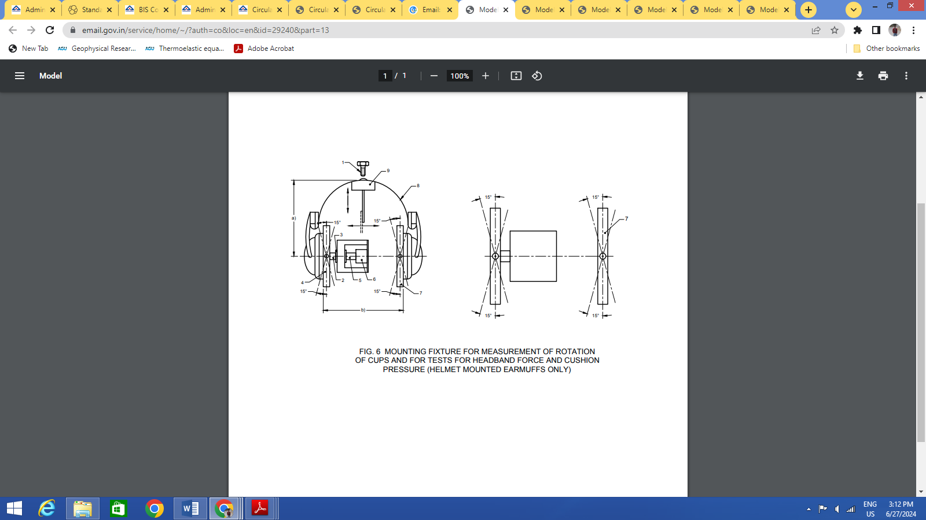

**Key**

|  |  |
| --- | --- |
| 1 Mounting bolt | 2 Spindle |
| 3 Linear ball bushing | 4 Thrust plate |
| 5 Coupling pin | 6 Force transducer |
| 7 Adjustable plate | 8 Helmet shell with harness removed |
| 9 Helmet support pad spherical radius 95 mm |  |
| a) is the test height |  |
| b) is the test width |  |

NOTE — When required, the pinna simulators shown in Figure 5 are fitted to the plates of the fixture so that the holes at the centre of the simulators lie on the horizontal axis through the force transducer.

FIG. 6 MOUNTING FIXTURE FOR MEASUREMENT OF ROTATION OF

CUPS AND FOR TESTS FOR HEADBAND FORCE AND CUSHION

PRESSURE (HELMET MOUNTED EARMUFFS ONLY)

Adjust the cups/support arms to correspond to the appropriate test height given in Table 7.

Ensure that no part of the helmet mounted earmuff is in contact with any part of the fixture in such a way as to affect the force measurement.

NOTE — Additional means to prevent the helmet twisting may be required with some designs.

**J-3.2.6** In the case of helmet mounted ear-muffs incorporating a means to adjust the headband force, adjust the force to its maximum setting, or 14 N whichever is the lower. If, because of the design of the force adjusting mechanism, 14 N cannot be set, use the highest force possible, not exceeding 14 N.

**J-3.2.7** Read the force indicator (120 ± 5) s after first releasing the supporting arms, in **J-3.2.5** and remove the ear-muffs from the fixture.

**J-3.2.8** Remove the piece of paper from the fixture, ensure that a complete impression of the coated cushion is obtained on the paper and, if necessary, trace around the impression in pencil. Measure the area of the impression of the cushion contact area. Include in the measurement the area of any voids falling totally within the contact area.

**J-3.2.9** Calculate the cushion pressure in Pascals.

**J-3.2.10** In the case of multiple size range models, repeat the measurement at the other appropriate test widths and heights, each after a period of not less than 4 h.

**J-5 REPORT**

Report the cushion pressure(s) in Pascals from **J-3.1.8** or **J-3.2.9**, for each size range tested.

**ANNEX K**

(*Clause* 5.2.8)

**RESISTANCE TO LEAKAGE** **(FLUID FILLED CUSHIONS ONLY)**

**K-1 PRINCIPLE**

Fluid filled cushions are subjected to a force and examined for leakage.

**K-2 APPARATUS**

**K-2.1 Smooth Solid Surface (Concrete Surface or Steel Plate)**

This shall be not less than 10 mm thick and of an area sufficient to accommodate the cushion when deformed.

**K-2.2 Means for Loading the Cushion**

**K-3 PROCEDURE**

**K-3.1** Position the Solid surface horizontally on a firm surface.

**K-3.2** Place one of the cups on the plate so that its cushion is in contact with the plate at all points around its periphery.

**K-3.3** Apply a vertical load of (28 ± 1) N to the cup for (15 ± 1) min.

**K-3.4** Remove the load and examine the cushion for any rupture or leakage of fluid.

**K-3.5** Repeat **K-3.2** to **K-3.4** with the other cup/cushion.

**K-4 REPORT**

Report any rupture or leakage from either cushion.

**ANNEX L**

(*Clause* 5.2.4)

**WATER IMMERSION TEST - HEADBAND UNDER STRESS (OPTIONAL)**

**L-1 PRINCIPLE**

After removal of the liners the ear-muffs are conditioned by immersion in water, with a plane parallel spacer between the cushions.

**L-2 APPARATUS**

**L-2.1 Water Bath**

This shall contain water maintained at a constant temperature of (50 ± 2) °C.

**L-2.2** Means to hold the ear-muffs beneath the surface of the water.

**L-2.3 A Plane Parallel Spacer**

This shall separate the cushions by a distance of (145.0 ±1.5) mm.

**L-3 PROCEDURE**

After removal of the liners (but without removal of the cushions), place the ear-muffs over the spacer with the cups/headband (headband ear-muffs) or cup supporting arms (helmet mounted ear-muffs) set to the position specified in **L-3.1.2** or **L-3.2.2**. Immerse the ear-muffs with the spacer in the water bath for (24 ± 1) h. If the cushions are not replaceable, protect them from water immersion during testing.

Exclude from this test ear-muffs which do not rely on plastics parts to provide the headband force.

**ANNEX M**

(*Table 1, Note 1*)

**METHOD TO CALCULATE NRR VALUE**

**M-1** During this testing, a qualified experimenter fits ten different people with the hearing protection device being tested and measures the reduction level for each subject, using a test called real-ear attenuation at threshold (REAT). Each subject is tested three times for each of the seven different standard frequencies of the test (125, 250, 500, 1 000, 2 000, 4 000, and 8 000 Hertz).

**M-2** With ten subjects, this produces 30 different results for each frequency. The mean values for those frequencies are then included in the overall attenuation mean, which becomes the NR.

**M-3 EXAMPLE**

**M-3.1** Noise Reduction Rating (NRR) Calculation - Calculate the [NRR](https://www.law.cornell.edu/definitions/index.php?width=840&height=800&iframe=true&def_id=2762205aa82b37bf05a09f7448d17bd8&term_occur=999&term_src=Title:40:Chapter:I:Subchapter:G:Part:211:Subpart:B:211.207) for hearing protective devices by substituting the average attenuation values and standard deviations for the pertinent protector [category](https://www.law.cornell.edu/definitions/index.php?width=840&height=800&iframe=true&def_id=eaf42be8ea19294922e0d3f3364065f3&term_occur=999&term_src=Title:40:Chapter:I:Subchapter:G:Part:211:Subpart:B:211.207) for the sample data used in steps #6 and #7 in Table 2. The values of −.2, 0, 0, 0, −.2, −.8, −3.0 in Step 2 and −16.1, −8.6, −3.2, 0, + 1.2, + 1.0, −1.1 in Step 4 of Table 2 represent the standard “C”- and “A”-weighting relative response corrections applied to any sound levels at the indicated octave band center frequencies.

NOTE - The [manufacturer](https://www.law.cornell.edu/definitions/index.php?width=840&height=800&iframe=true&def_id=2a55eb8bb9dc3f9eedbed5d136270136&term_occur=999&term_src=Title:40:Chapter:I:Subchapter:G:Part:211:Subpart:B:211.207) may [label](https://www.law.cornell.edu/definitions/index.php?width=840&height=800&iframe=true&def_id=c672f96ac89d04221b7f44f71c9f3ca9&term_occur=999&term_src=Title:40:Chapter:I:Subchapter:G:Part:211:Subpart:B:211.207) the protector at values lower than indicated by the test results and this computation procedure, e.g. lower [NRR](https://www.law.cornell.edu/definitions/index.php?width=840&height=800&iframe=true&def_id=2762205aa82b37bf05a09f7448d17bd8&term_occur=999&term_src=Title:40:Chapter:I:Subchapter:G:Part:211:Subpart:B:211.207) from lower attenuation values.

**Table 8 - Computation of the Noise Reduction Rating**

|  |  |  |  |  |  |  |  |
| --- | --- | --- | --- | --- | --- | --- | --- |
| Octave band center frequency (Hz) | 125 | 250 | 500 | 1 000 | 2 000 | 4 000 | 8 000 |
| 1 Assumed Pink noise (dB) | 100 | 100 | 100 | 100 | 100 | 100 | 100 |
| 2 “C” weighting corrections (dB) | −.2 | 0 | 0 | 0 | −.2 | −.8 | −3.0 |
| 3 Unprotected ear “C”-weighted level (dB) | 99.8 | 100 | 100 | 100 | 99.8 | 99.2 | 97.0 |
| (The seven logarithmically added “C”-weighted sound pressure levels of Step #3 = 108.0 dB) |  |  |  |  |  |  |  |
| 4 “A”-weighting corrections (dB) | −16.1 | −8.6 | −3.2 | 0 | + 1.2 | + 1.0 | −1.1 |
| 5 Unprotected ear “A”-weighted level (step #1-step #4) (dB) | 83.9 | 91.4 | 96.8 | 100 | 101.2 | 101 | 98.9 |
| 6 Average attenuation in dB at frequency | 21 | 22 | 23 | 29 | 41 | (43 + 47)/2 = 45 | (41 + 36)/2 = 38.5 |
| 7 Standard deviation in dB at frequency | 3.7 | 3.3 | 3.8 | 4.7 | 3.3 | (3.3 + 3.4) = 6.7 | (6.1 + 6.5) = 12.6 |
|  | × 2 | × 2 | × 2 | × 2 | × 2 |  |  |
|  | 7.4 | 6.6 | 7.6 | 9.4 | 6.6 |  |  |
| 8 Step #5-(step #6-step #7) develops the protected ear “A” weighted levels (dB) | 70.3 | 76.0 | 81.4 | 80.4 | 66.8 | 62.7 | 73.0 |
| (The seven logarithmically added “A”-weighted sound pressure levels of Step #8 using this sample data = 85.1 dB) |  |  |  |  |  |  |  |

*Spectral uncertainty -

The value for #3 is constant. Use Logarithmic mathematics to determine the combined value of protected ear levels (Step #8) which is used in Step #9 to exactly derive the [NRR](https://www.law.cornell.edu/definitions/index.php?width=840&height=800&iframe=true&def_id=2762205aa82b37bf05a09f7448d17bd8&term_occur=999&term_src=Title:40:Chapter:I:Subchapter:G:Part:211:Subpart:B:211.207); or use the following table as a substitute for logarithmic mathematics to determine the value of Step #8 and thus very closely approximate the [NRR](https://www.law.cornell.edu/definitions/index.php?width=840&height=800&iframe=true&def_id=2762205aa82b37bf05a09f7448d17bd8&term_occur=999&term_src=Title:40:Chapter:I:Subchapter:G:Part:211:Subpart:B:211.207).

|  |  |
| --- | --- |
| Difference between any two sound pressure levels being combined (dB) | Add this level to the higher of the two levels (dB) |
| 0 to less than 1.5 | 3 |
| 1.5 to less than 4.5 | 2 |
| 4.5 to 9 | 1 |
| Greater than 9 | 0 |

**M-4 GUIDANCE 1**

**M-4.1 Hearing Protector Fit Test**

**M-4.1.1** Hearing protector is required to the workers, are working in the areas potentially exposed the excessive noise, i.e. in factories, construction sites, mine sites etc.

**M-4.1.2** However, the wearing of hearing protector is important to protect wearers from excessive noise, an inappropriate fit can lead to a compromised level of hearing protection and therefore exposing workers to harmful levels of noise. We can use dual ear validation system to ensure proper fit of hearing protectors.

**M-4.2 Hearing fit Validation system (F-MIRE Based)-**

**M-4.2.1** F - MIRE based dual ear validation system consists of a loudspeaker, Dual element microphone and software.

**M-4.2.2** *Loudspeaker* - loudspeaker shall be equipped with a digital signal processor capable to generate tests frequencies between 125 Hz - 8 kHz and allow consistent test signal and communication between the microphones, speaker and software.

**M-4.2.3** *Dual Element microphone* (capable to connect with Hearing protection device)- Dual‐element microphones make it possible to measure the sound level at 2 different locations and for both ears simultaneously. The external microphones measure the level of the test signal outside the ear and the internal microphones are connected to hearing protectors to allow measurement of the sound level inside the wearer’s ear canal while the hearing protector is worn.

**M-4.2.4** Software specially designed software capable to calculate and display personal attenuation rating (PAR). Manufacturer to ensure availability of such software compatible to their product.

**M-4.2.5** The Dual Ear Validation System measures the level of protection by generating a Personal Attenuation Rating (PAR). The PAR indicates a workers' noise reduction levels for a given fitting and hearing protector.

**M-4.3 Process Flow**

**M-4.3.1** Workers to fit their earplugs or earmuffs and generate generates a personal attenuation rating (PAR) for worker using system. This PAR indicates worker's noise reduction levels for a given fitting.  
**M-4.3.2** Connect dual-element microphone and measures the noise reduction of earplug or earmuff as worn by the worker across the wide range (7 frequencies between 125 Hz - 8 kHz) of industrial noise frequencies.

**M-4.3.3** Run the test for Personal Attenuation Rating (PAR), system to analyze real-ear data to provide Personal Attenuation Rating (PAR) and fit variability.

**M-4.4 Impact**

**M-4.4.1** F-MIRE* based dual ear validation system makes hearing fit-testing easy and feasible for all hearing loss prevention programs. Fit testing measures the noise reduction of HPD** provided to the worker and calculates worker’s Personal Attenuation Rating (PAR) and identify those at risk for developing hearing loss due to poor HPD fit. Implementation of HPD fit-testing could help to reduce the incidence of hearing loss among noise-exposed workers.

*F-MIRE- Field microphone-in-real-ear

** HPD – Heading protector device

**M-5 GUIDANCE 2**

**M-5.1 NRR Value & Derating,**

**M-5.1.1** The NRR is intended to represent the attenuation of the hearing protector, however, in most cases it has been shown to overestimate the amount of attenuation achieved by actual workers. The NRR is not well-correlated with field attenuation values. Therefore, it is recommended that the NRR be adjusted or “derated” to account for variability in fit and differences between laboratory and work settings.

**M-5.1.2** Although NRR seem a reasonable approach, it is fraught with error. The largest source of error is reliance an optimized fitting scenario in a controlled laboratory environment that bears little resemblance to the conditions under which workers wear HPDs on a daily basis. The other key problem with the laboratory measurements, as commonly utilized, is that averaged (mean) values for a group of 10 subjects are used to predict the performance for an individual wearer in an occupational setting. Even if the laboratory data were representative of the actual group using the device, the individual variability is large enough that attempts at predicting one person’s performance from group data can easily err by up to 20 dB

**M-5.1.3** As a result of these inconsistencies, there is a need to “correct” the calculated value of the NRR into something more realistic. This process is known as derating. The following formula may be used.

If TWA*(dBC***):100dBC, TWA(dBA**):105 dBA

Ex. If NRR of hearing protector is: 28 dB,

If the TWA is measured in dBC, 50 percent reduction factor has to be applied on NRR

Derated NRR Value will be : 28 × 0.5 = 14dB

Estimated Exposure (dBC): 100 – 14 = 86dBC

Where dBC is C weightage Noise exposer in dB

If the TWA is measured in dBA, the NRR has to be subtracted by 7 decibel before applying a 50 percent reduction factor.

Derated NRR Value: (28 – 7) × 0.5 = 10.5dB

Estimated Exposure (dBA): 105 – 10.5 = 94.5dBA

*Where TWA- Time-weighted average for 8 Hour.

**dBA - is A weightage Noise exposer in dB, The A-weighted scale represents the contours for which human hearing is most responsive; that is, 500 Hz to 6 000 Hz

***dBC- C-weighted scale measures a wider range of noise frequencies; typically, from 30 Hz to 10,000 Hz. But unlike the A-weighted scale, these frequencies are measured more evenly, without any consideration to the human perception of how we sense noise from the lower and higher ends.

**M-6 GUIDANCE 3**

**M-6.1 Dual Ear Protector (Informative)**

Add 5 dBA to the highest noise reduction rating of the higher-rated hearing device. For example, if you’re using an earplug with a 30 NRR and an earmuff with a 26 NRR, you would add 5 dB to the 30 NRR for the earplug. Your protection level would then increase to 35 dB, assuming the earplug is worn properly. One downside to wearing double protection is that it may put the worker in danger if he or she be unable to hear warning sounds in the surrounding area. For this reason, double hearing protection should be carefully considered for certain worksites.

**ANNEX N**

**(***Foreword***)**

**COMMITTEE COMPOSITION**

Occupational Safety and Health Sectional Committee, CHD 08

| *Organization* | *Representative(s)* |
| --- | --- |
| National Safety Council, Navi Mumbai | Shri Lalit R. Gabhane **(*Chairperson*)** |
| 3M India Limited, Bengaluru | Shri Giridhar M.  Shri Rishi Raj Arya (*Alternate I*)  Shri Bidyut Chetia (*Alternate* II) |
| Atomic Energy Regulatory Board, Mumbai | Shri Diptendu Das  Srimati Pammy Goswami (*Alternate* I)  Srimati Ankita Govindrao Choudhari (*Alternate* II) |
| Bhabha Atomic Research Centre, Mumbai | Shri G. Nagaraju  Shri Praveen Dubey (*Alternate*) |
| Bureau of Indian Standards (BIS), New Delhi | Shri Barun Das |
| Cement Manufacturers Association, New Delhi | Shri Shubho Chakravarty  Shri Ashutosh Shrivastava (*Alternate I*)  Shri Sujeet Kumar Singh (*Alternate* II) |
| Centre for Fire and Explosive Environment Safety, Defence Institute of Fire Research, Delhi | Dr Arti Bhatt  Dr S. Marry Celin (*Alternate*) |
| Defence Research Development Organization, Ministry of Defence, New Delhi | Shri Amit Pasi  Shri Ajay Kumar Shaw (*Alternate*) |
| Directorate General Factory Advice Service and Labour Institutes, Mumbai | Shri Sumit Roy  Shri Kunal Sharma (*Alternate*) |
| Directorate General of Mines Safety, Dhanbad | Shri Saifullah Ansari  Shri A Rajeshwar Rao (*Alternate*) |
| Draeger India Pvt. Ltd, Mumbai | Shri Hirendar Chaterjee  Shri Ganesan Murugesan (*Alternate*) |
| Intech Safety Private Limited, Kolkata | Shri Subrata Mukherjee  Shri Gautam Banerjee (*Alternate*) |
| Honeywell International India Private Limited, Bengaluru | Shri Samit Vasant Chaudhari  Shri Alok Singh (*Alternate* I)  Shrimati Pooja Chetri (*Alternate* II) |
| Joseph Leslie Dynamics Manufacturer Private Limited, Nehru Place, New Delhi | Shri Dean Leslie Roy  Shri Cyril Pereira (*Alternate*)  Shri Sachin Patil |
| Karam Industries, Noida | Shri Rajesh Nigam  Shri Mohammad (*Alternate*) |
| Larsen and Toubro Limited, Mumbai | Shri P. V. Balaramakrishna  Shri Pranav B. Baxi |
| National Safety Council, Navi Mumbai | Shri A. Y. Sundkar  Shri K. D. Patil (*Alternate*) |
| Nuclear Power Corporation of India Limited, Mumbai | Shri Alok Varshney  Shri M. U. Vincy (*Alternate*) |
| Reliance India Limited, Mumbai | Dr Prasad Tipnis  Shri Neeraj Sharma (*Alternate*) |
| Unicare Emergency Equipment Private Limited, Mumbai | Shri Clint Leslie Pereira  Shri Shirish Sathe (*Alternate* I)  Shri Rajasekharan M. K. (*Alternate* II) |
| Venus Safety and Health Private Limited, Navi Mumbai | Shri Harshal Patil  Shri Mahesh Kudav  Shri Sanjeev Minhas (*Alternate*) |
| In Personal Capacity (*T02/103 and 104 Plot No. 64 & 65, Mayuresh Trinity Opp. Poonam Tower Sector 16A Nerul, Navi Mumbai-400706)* | Shri S. D. Bharambe |
| BIS Directorate General | Shri Ajay Kumar Lal, Scientist ‘F’/Senior Director and Head (Chemical) [Representing Director General (*Ex-officio*)] |

*Member Secretary*

SUSHANT KUMAR

Scientist ‘D’/JOINT Director

(Chemical), BIS