*भारतीय मानक*

संयुक्त पाइल-राफ्ट नींवों का डिज़ाइन

और निर्माण **—** रीति संहिता

*Indian Standard*

**Design and Construction of Combined Piled-Raft**

**Foundations ― Code of Practice**

(ICS 93.020)

© BIS 2024

भारतीय मानक ब्यूरो

BUREAU OF INDIAN STANDARDS

मानक भवन, 9, बहादुरशाह ज़फर मार्ग, नई दिल्ली — 110002

MANAK BHAVAN, 9, BAHADUR SHAH ZAFAR MARG NEW DELHI-110002

[www.bis.gov.in](http://www.bis.gov.in) [www.standardsbis.in](http://www.standardsbis.in)

*September* 2024

**Price Group XX**

Soil and Foundation Engineering Sectional Committee, CED 43

**FOREWORD**

This Indian Standard was adopted by the Bureau of Indian Standards, after the draft finalized by the Soil and Foundation Engineering Sectional Committee had been approved by the Civil Engineering Division Council. This standard has been formulated to cover provisions for design and construction of combined piled raft foundations (CPRF). This composite foundation which combines load carrying capabilities of raft and pile foundations together may be implemented in any one of the following situations:

1. Where a raft cannot provide an adequate bearing capacity; and/ or
2. Where the raft is unable to perform under the serviceability requirement (for example, if settlement exceeds permissible limit for raft) of the structure.

In both cases, piles can be introduced below the raft to improve the safety against failure or to reduce the settlement to an acceptable level.

In the formulation of this standard, considerable assistance has been derived from the following international standards:

1. [DIN 1054:2021-04](https://www.beuth.de/en/standard/din-1054/335418422) Subsoil – Verification of the safety of earthworks and foundations – Supplementary rules to DIN EN 1997-1
2. [DIN EN 1997-1:2014-03](https://www.beuth.de/en/standard/din-en-1997-1/195288391) Eurocode 7: Geotechnical design – Part 1: General rules

The composition of the Committee responsible for formulation of the standard is given in Annex C.

For the purpose of deciding whether a particular requirement of this standard is complied with, the final value, observed or calculated, expressing the result of a test or analysis, shall be rounded off in accordance with IS 2 : 2022 ‘Rules for rounding of numerical values (*second revised*)’. The number of significant places retained in the rounded off value should be the same as that of the specified value in this standard.

*Indian Standard*

**DESIGN AND CONSTRUCTION OF COMBINED PILED RAFT**

**FOUNDATIONS ― CODE OF PRACTICE**

**1 SCOPE**

**1.1** This standard covers the design and construction of combined piled raft foundation (CPRF) for residential, commercial, and industrial structures, tall structures, store houses, storage tanks, etc.

**1.1.1** CPRF transmits the load to soil by resistance developed by the components of the foundation, that is, piles and raft, the raft being placed on competent ground. The piles develop resistance along the pile shaft by skin friction and at the pile tip by end bearing. The raft develops the resistance by generating the contact pressure below the raft.

**1.2** CPRF shall not be used in cases where soil layers of relatively low stiffness (for example, very soft cohesive soil, organic soil, collapsible soil, liquefiable soil) are situated closely beneath the raft. Provisions of this standard shall not be applicable to layered soil with significantly high stiffness (modulus) contrast between the top and bottom layers.

**2 REFERENCES**

The standards listed in Annex A contains provisions, which through reference in this text, constitute provisions of this standard. At the time of publication, the editions indicated were valid. All standards are subjected to revision and parties to agreement based on this standard are encouraged to investigate the possibility of applying the most recent editions of the standards listed in Annex A.

**3 TERMINOLOGY**

For the purpose of this standard, the following definitions shall apply.

**3.1 Angular Distortion ($θ$)** ― Vertical distance after deformation due to applied load between the points of maximum and minimum settlement divided by the horizontal distance between the two points (*see* Fig. 1).

**3.2 Allowable Load** ― The load which can be applied on the combined pile-raft foundation system by taking into account the load capacities of piles and raft, soil-pile-raft interaction effects and allowable displacement from serviceability criteria, negative skin friction on pile and other relevant loading types including reversal of loads, if any. In other words, it is the load at which the allowable settlement reduction ratio considering serviceability is achieved.

**3.3 Combined Piled Raft Foundation** ― A pile group in which the raft connecting all the pile heads positively contributes to the overall foundation behaviour. The presence of raft is recognized and its contribution in sharing the load with the pile group is taken into account. This composite foundation which combines load carrying capabilities of raft and pile foundations together, considers four interactions, namely, pile-pile interaction, pile-soil interaction, pile-raft interaction and raft-soil interaction (*see* Fig. 2A).

**3.3.1** *Large CPRF* ― CPRF in which the ratio of raft width (*B*r) to pile length (*L*p) is greater than 1, that is, $\frac{B_{r}}{L_{p}}>1$.

**3.3.2** *Small CPRF* ― CPRF in which the ratio of raft width (*B*r) to pile length (*L*p) is less than or equal to 1, that is, $\frac{B_{r}}{L_{p}}≤1$.

**3.4 Cut-off Level** ― The level where a pile is cut-off in order to make structural connection to the pile caps or beams or raft or any other structural component at that level.

**3.5 Design Load** ― The loads (compression, tension, lateral, moment or any combination thereof) considered to act on the CPRF during the life of the structure satisfying provisions mentioned in other relevant Indian Standards.

**3.6 Design Stress** ― The stress (compressive, tensile or combination) imposed on the CPRF by the design load and calculated in accordance with engineering practice.

**3.7 Differential Settlement of CPRF (*S*pr,diff)** ― The difference between the maximum and the minimum settlement, across any section of the CPRF (*see* Fig. 1).

**3.8 Limiting Capacity** ― The vertical load at which for a CPRF, bearing capacity failure occurs due to exceedance of the combined capacity of raft resistance and that of piles in terms of shaft resistance and end bearing resistance. The assessed value of the total resistance *R*tot,k(*s*) of the CPRF depends on the settlements of the foundation and consists of the sum of the assessed pile resistances $ΣR_{pile,k,j}$ (*s*) and the assessed raft resistance, *R*raft,k (*s*) (*see* Fig. 2A). The assessed raft resistance results from the integration of the settlement dependent contact pressure, $σ(s,x,y)$ in the ground plan area of the raft and can be expressed as, $R_{raft,k}(s)=\iint{σ(s,x,y)dxdy}$. Similarly, due considerations for horizontal load capacity and moment capacity should be considered for the CPRF system.

**3.9 Load Eccentricity (*e*L or *e*B)** ― Distance between the point of application of applied resultant load and the centre of gravity of the pile-raft system along length and width, respectively (*see* Fig. 1).

**3.10 Maximum CPRF Settlement (*S*pr,max)** ― The maximum value of settlement occurred at a particular point of the CPRF system (*see* Fig. 1).

**3.11 Pile-Pile Interaction** ― The result of pile group effect, defined as the changes in the load-displacement response of a pile group and single piles due to superimposition of stress and displacement field of a single pile in a group (*see* Fig. 2A).

**3.12 Pile-Raft Interaction** ― The changes in the load-displacement response of pile group when the raft is being rested to the soil surface (see Fig. 2A).

**3.13 Pile-Raft Coefficient or Load Sharing Ratio ($α_{CPRF}$)** ― The ratio between the sum of the pile resistances and the value of the total resistance.

NOTE ― $α_{CPRF}=\frac{R_{piles}}{R_{total}}$, in which *R*piles is the resistance provided by piles and *R*total is the total resistance provided by the CPRF system under vertical load as shown in Fig. 2B. Whenever, $α_{CPRF}$ is equal to 1, all the vertical loads are taken up by the pile component which essentially makes the system to behave as a pile group foundation. Whereas, $α_{CPRF}$ equal to 0 indicates that the vertical loads are borne by raft component, hence, the foundation behaviour will be like spread raft foundation. To utilize both the foundation components effectively, the value of $α_{CPRF}$ should be chosen carefully and the standard is not valid for $α_{CPRF}$ ≥ 0.9.

**3.14 Pile-enhanced Raft** ― CPRF in which the piles are designed to mobilize their total ultimate capacity and the raft carries majority of the design load (*see* Fig. 3A).

**3.15 Raft-Pile Interaction** ― The modification in the load carrying mechanism of the raft when piles are introduced beneath (*see* Fig. 2A).

**3.16 Raft-Enhanced Pile** ― CPRFs in which both the piles and raft work within a pseudo-elastic range of behaviour. The pile group capacity is not fully mobilized at working load and the pile group carries majority of the design load (*see* Fig. 3B).

**3.17 Settlement Reduction Ratio (*SRR*)** — The ratio of the difference of settlement of the unpiled raft under the given loading, 𝑆r and the settlement of the piled raft under the same loading considered in the case of the unpiled raft, 𝑆pr to the settlement of the unpiled raft, that is, under any given loading conditions, .

1A ALONG RAFT LENGTH

1B ALONG RAFT WIDTH

FIG.1 SCHEMATIC REPRESENTATION OF CPRF SYSTEM AND VARIOUS PARAMETERS FOR DESIGN CONSIDERATION BASED ON SERVICEABILITY LIMIT STATE

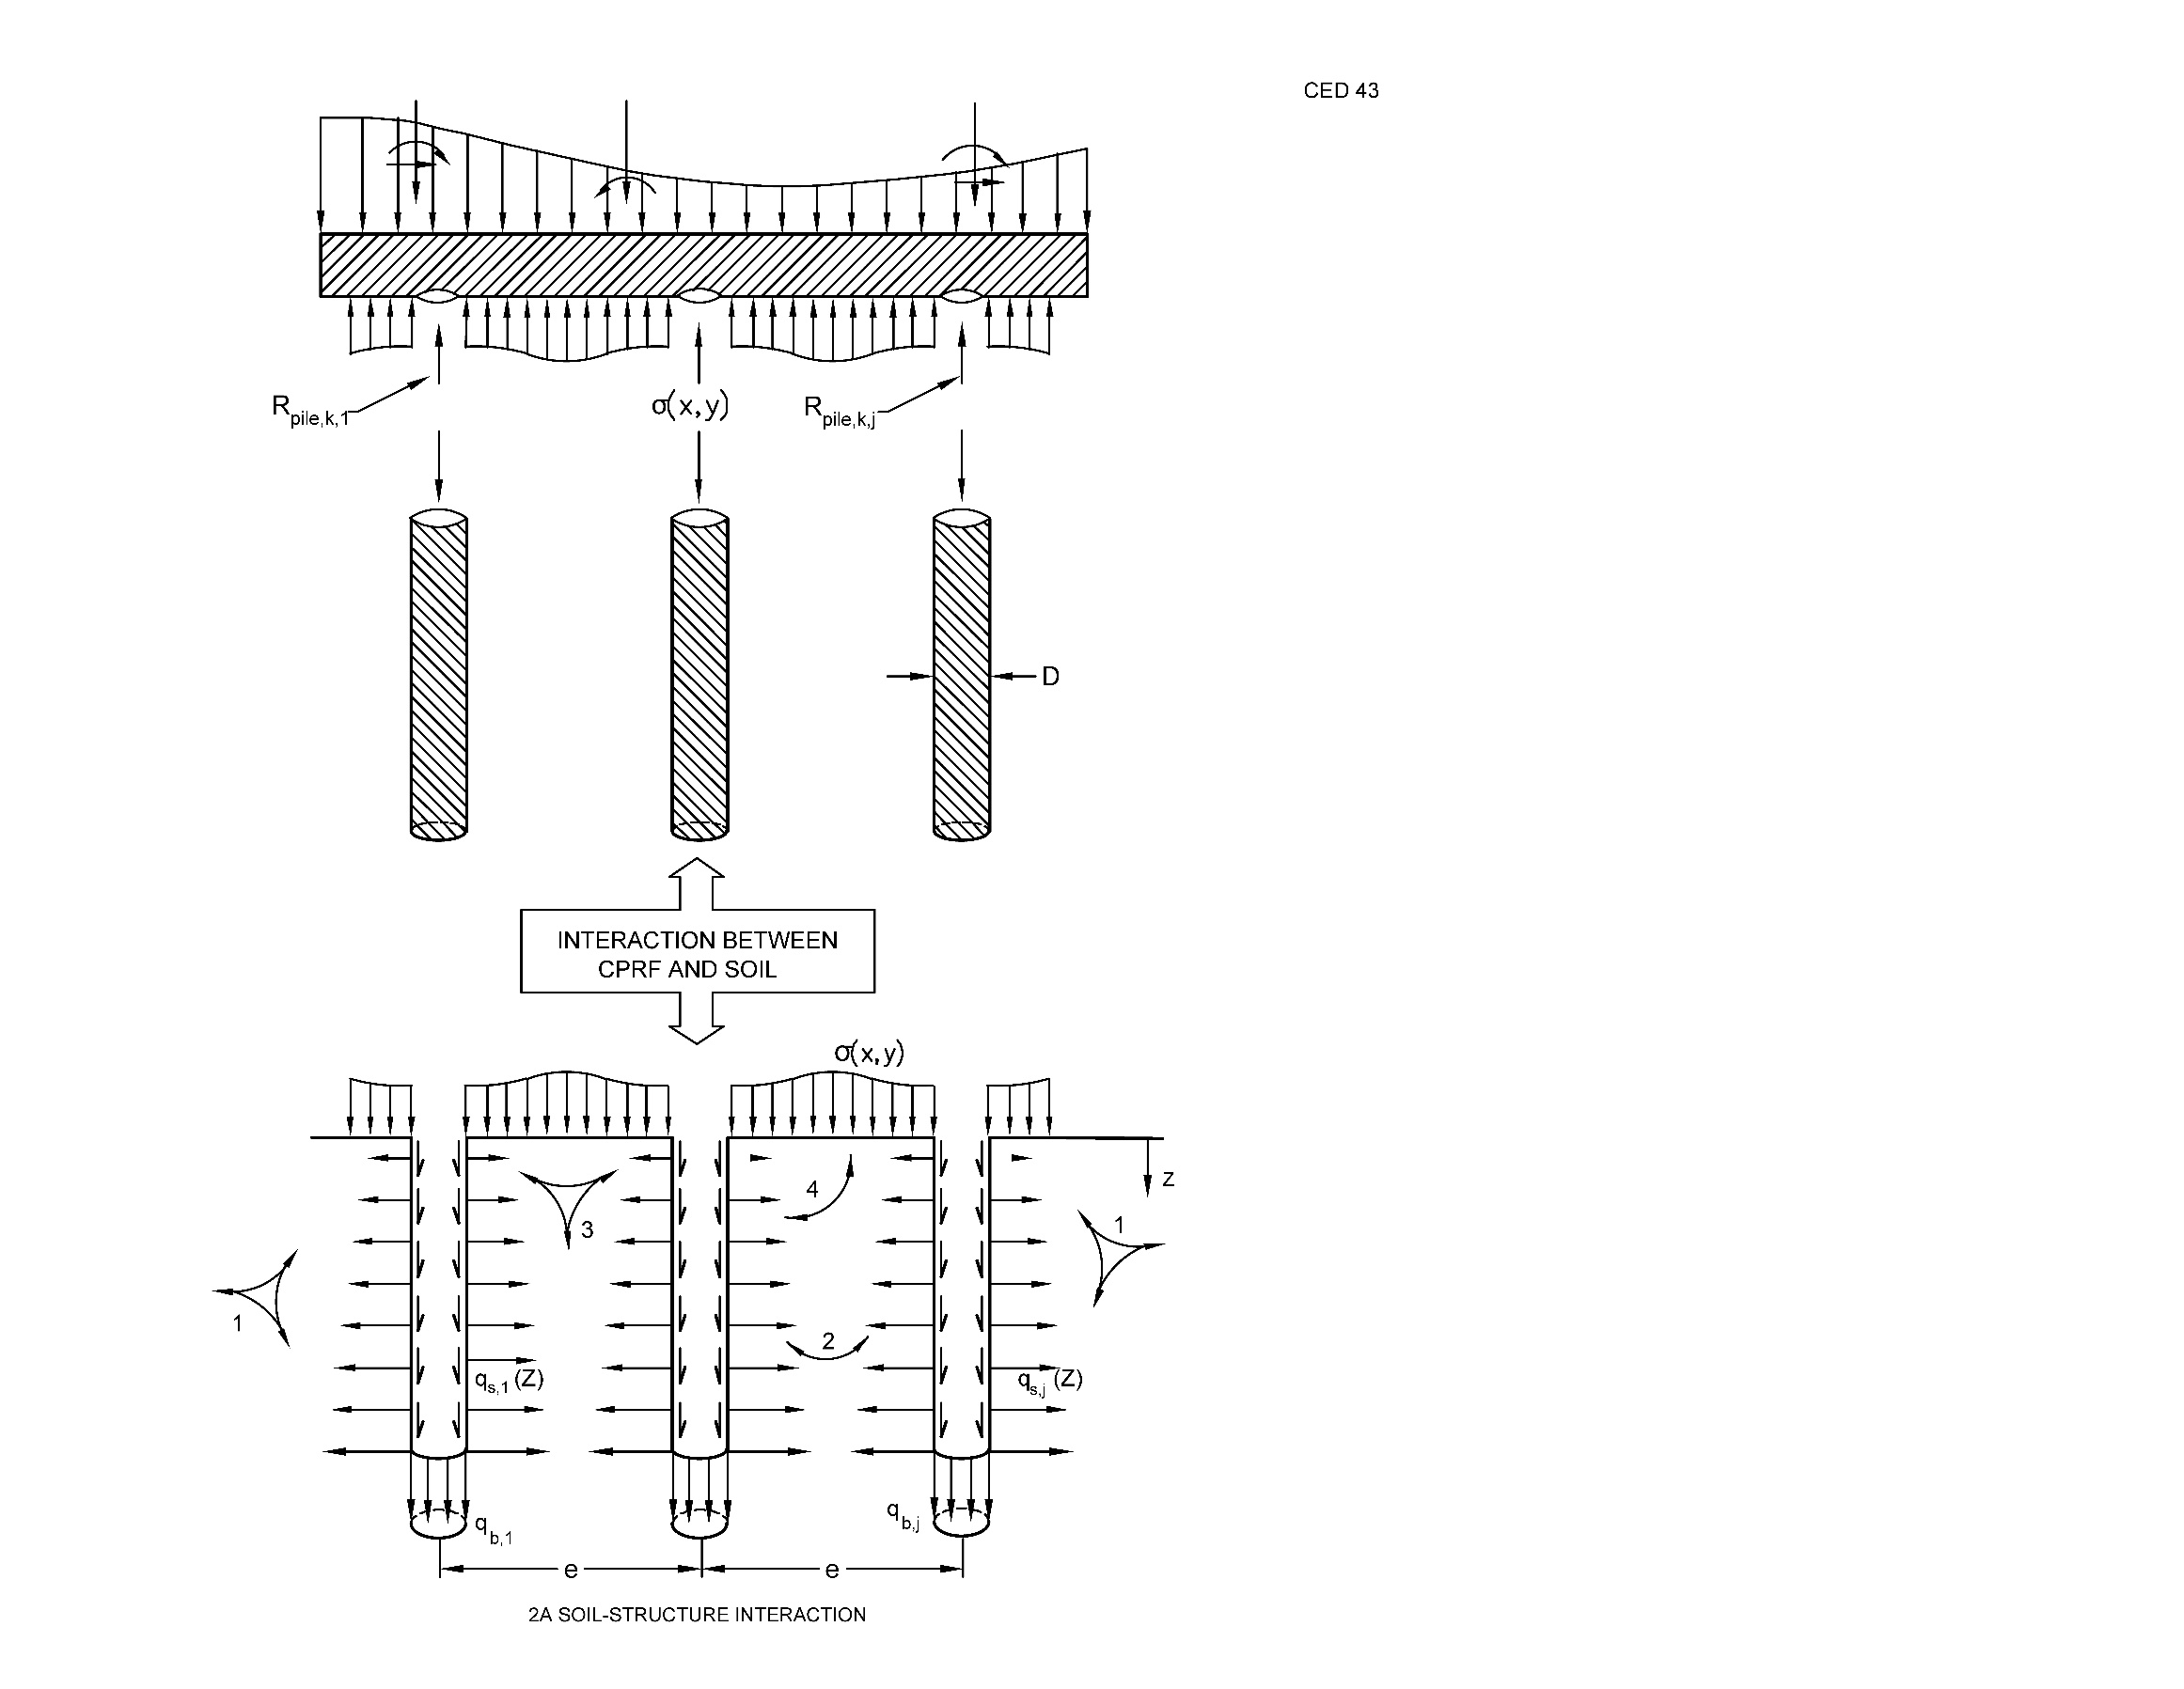

*Key*

1 PILE-SOIL INTERACTION

2 PILE-PILE INTERACTION

3 RAFT-SOIL INTERACTION

4 PILE-RAFT INTERACTION

Fig. 2A SOIL-STRUCTURE INTERACTION

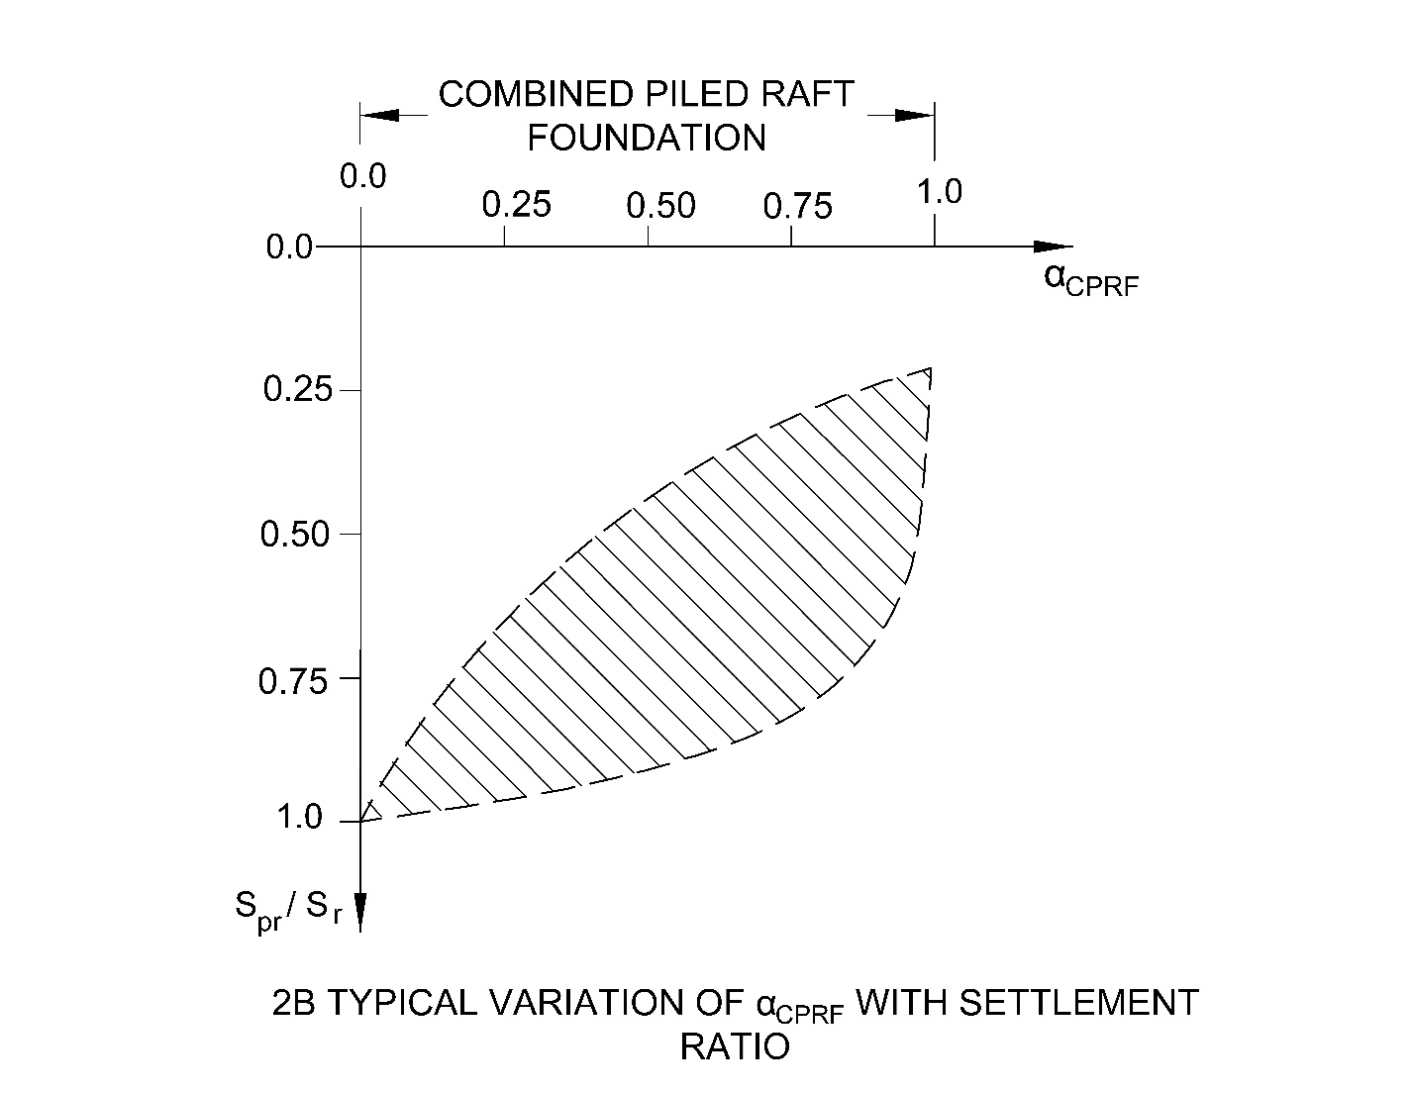

Where

Spr = Settlement of combined piled raft foundation; and

Sr = Settlement of raft foundation

2B TYPICAL VARIATION OF $α_{CPRF}$ WITH SETTLEMENT RATIO

Fig. 2 SOIL-STRUCTURE INTERACTION AND VARIATION OF $α_{CPRF}$ FOR A CPRF

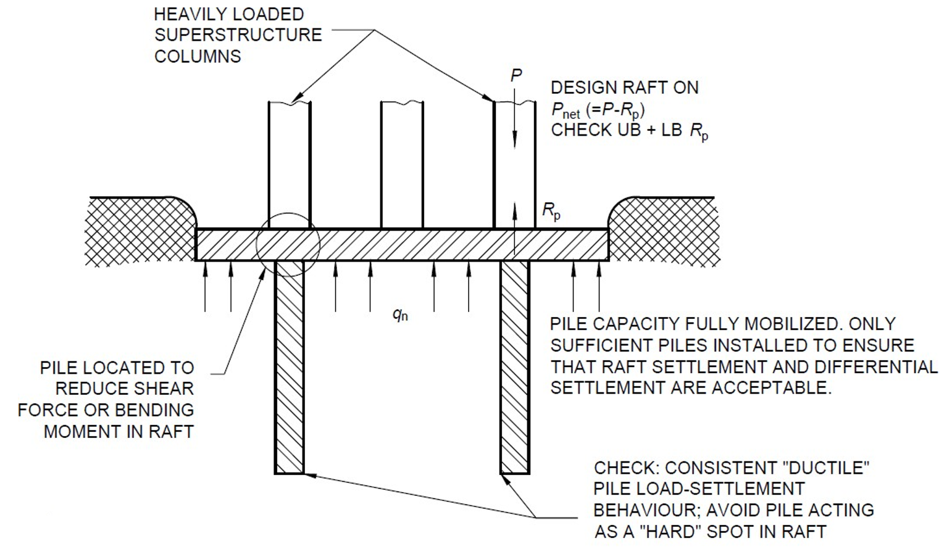

where

|  |  |  |
| --- | --- | --- |
| qn | = | Net contact stress on underside of raft |
| P | = | Column load |
| RP | = | Pile capacity |
| UB | = | Upper bound |
| LB | = | Lower bound |

**Favourable ground conditions**: Deep deposits of homogenous clays; typically stiff clays at raft level.

**Typical design scenario**: A raft which does not quite work, a small number of piles are added to resolve local non-compliances (for example, differential settlement, shear or bending moment).

3A PILE-ENHANCED RAFT

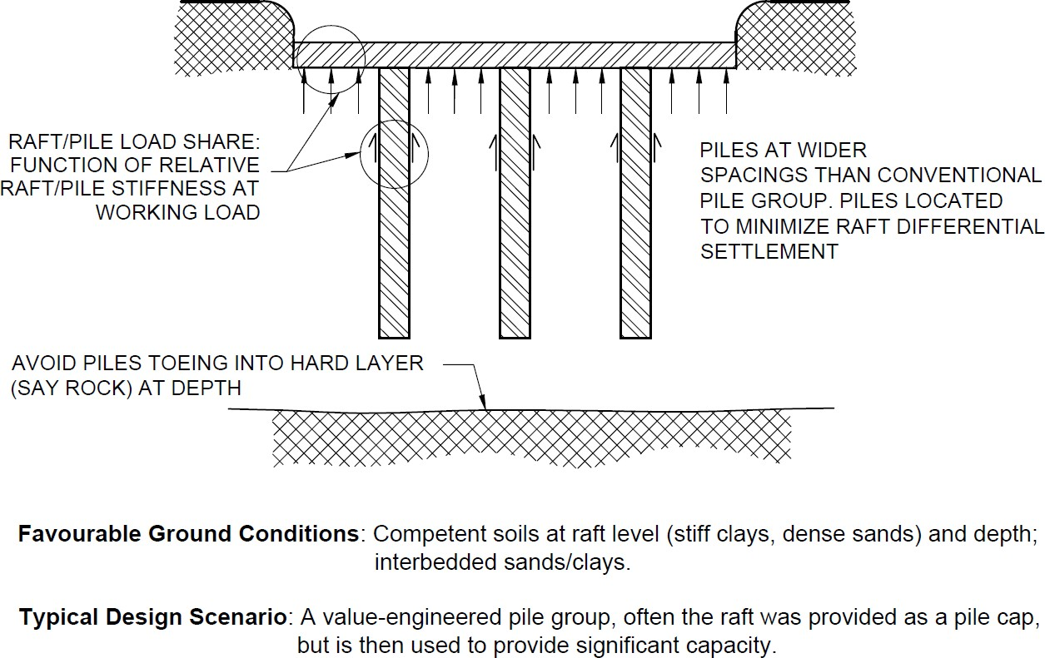

**Favourable ground conditions**: Competent soils at raft level (stiff clays, dense sands) and depth; interbedded sands/clays.

**Typical Design Scenario**: A value-engineered pile group, often the raft was provided as a pile cap, but is then used to provide significant capacity.

3B RAFT-ENHANCED PILE

FIG. 3 PILE-ENHANCED RAFT AND RAFT-ENHANCED PILE

**4 NECESSARY INFORMATION**

**4.1** For satisfactory design and construction of a combined pile-raft foundation, the following information is necessary:

a) Details of site plan showing location of proposed and adjacent structures.

b) Details of plan and vertical cross-section of the proposed building with position of beam and columns.

c) Different load combinations and their intensity indicating design loads, preferably shown in schematic plan.

d) All the loads due to seismic, wind, and water current, etc indicated separately.

e) Limiting values of performance parameters, such as allowable bearing pressure, allowable total settlement, allowable differential settlement, allowable angular distortion, that the foundation and superstructure can withstand.

f) Information on geological history, seismicity, seasonal variation of ground water, climatic factors, for example, sudden flooding, erosion, etc.

g) The design and construction of CPRF requires rigorous geotechnical investigations by using both field and laboratory techniques. The proper dimensioning of CPRF will purely depend up on the outcome of geotechnical investigations. The data obtained from the both the investigations, that is, preliminary investigation for feasibility study and detailed investigation for analyses and design shall be analysed by geotechnical experts.

h) *Geotechnical Information* —Sub-surface profile with stratification details, engineering and index properties of founding media as per IS 1892, IS 2720 (relevant parts) and other relevant standards which are essential for the design of CPRF system. Any supplementary investigations should be carried out to obtain additional geotechnical information for design of CPRF.

j) *Extent of Geotechnical Investigations* — The structure and properties of the substrata and the groundwater conditions shall be known in sufficient detail for any piled-raft construction project. This is necessary to reliably assess the stability and serviceability of the pile and piled-raft foundations and of the overall structure as required by relevant Indian Standards and to assess the effects of foundations on their surroundings. The geotechnical investigations shall extend to sufficient depth below pile tip to record all ground formations and strata influencing the structure and its execution, and to identify the load-bearing and deformation properties of the ground. The geotechnical investigations shall be done as per IS 1892, IS 2720 (relevant parts).

k) The geotechnical investigation report and the geotechnical design report, respectively, shall contain all relevant data that can affect CPRF capacity, choice of the execution method and the pile installation. Design soil parameters shall be derived for the CPRF system. The ground information and the parameters related not only to pile capacity, but also to drilling ability, drivability, etc shall be provided.

m) The results of field test on single piles (both ultimate capacity and load- displacement curve). Static test as initial test can be used for design of CPRF, whereas dynamic test is not essential for CPRF design. Dynamic test may be used for additional check, if necessary, on later stage, but not directly related to CPRF design.

n) Dynamic properties of founding media to be taken from geotechnical investigation report.

p) A review of performance of CPRF in similar locality or ground conditions, if available.

**4.2** The work as per this standard should be carried out by a professional practicing geotechnical engineer having current experience and qualification in the pile and raft foundation design, construction and understanding of verification methods as per the project’s requirement.

**5 DESIGN CONSIDERATIONS FOR STATIC LOAD**

**5.1 General Design Considerations**

**5.1.1** The design of CPRF should consider the following criteria:

a) Fluctuation in the water table condition and long-term stability of the bearing strata;

b) Consideration for handling sensitive clays and loose bearing soils;

c) Effect of soil excavations;

d) The soil stratigraphy shall be considered when calculating pile responses in the CPRF system;

e) Differential movement of the foundations between the old and new structures;

f) Wherever possible, the centre area of the foundation should be located directly beneath the centre of gravity of the imposed load or else effect of eccentricity should be considered;

g) The load carrying capacity of the combined system subjected to vertical, lateral and moment loadings, total and differential settlement;

h) Some of the key design considerations are,

1) Load carrying capacity of the combined system at the desired settlement level for vertical, lateral and moment loadings;

2) Maximum settlement;

3) Differential settlement;

4) Raft moments and shears for the structural design of the raft; and

5) Pile loads and moments, for the structural design of the piles.

**5.2 Stages of CPRF Design**

**5.2.1** The three main stages of CPRF design are,

a) *Preliminary Stage* (*Feasibility Study*) — Assessment of the performance of raft without piles that includes estimation of vertical and lateral bearing capacity and the settlements. Assessment of the feasibility of using a pile raft and the required number of piles to satisfy the design requirement.

b) *General Pile Characteristics* (*Preliminary Design Stage*) — Pile should be designed for the combined resistances.

c) *Final Detailed Design* — Final detailed design to obtain the number of piles, location and configuration, settlement, bending moment and shear forces in raft and the pile loads and moments.

**5.3 Design Steps**

Design philosophy is illustrated in Fig. 4 and the subsequent design steps to be followed are given in **5.3.1** to **5.3.5**, **5.4** and **5.5**.

**5.3.1** The static pile formula based on the ground parameters as per IS 2911 can be used for estimation of ultimate load capacity. The provision made in IS 2911 (Parts 1/Sec 1 to 4) as applicable should be followed for the design and construction of piles unless otherwise stated. The procedure for pile load testing should be as per IS 2911 (Part 4). Information obtained (load-settlement response) from pile load test shall be interpreted by geotechnical engineer to arrive at the allowable load with reference to a particular settlement. Pile loads and moment for the structural design of the piles should be considered.

**5.3.2** The stability and capacity of raft based on the ground parameters as per IS 6403 and IS 2950 (Part 1) can be estimated. The provision made in IS 2950 (Part 1) should be followed for the design and construction of raft foundation unless otherwise stated. For estimation of raft settlement, the guidance given in IS 8009 (Part 1) may be used. However, the calculation of settlement for entire CPRF system will be different as described in subsequent section of this standard. Raft moment and shear forces for structural design of raft should be considered.

**5.3.3** The following are the design philosophies:

a) *Conventional Approach* — Piles are designed as a group while making some allowances for contribution of the raft, primarily to load carrying capacity.

b) *Settlement Control Approach* — Piles are placed strategically below the raft in order to reduce the total and differential settlement. However differential settlement reduction is more important than to reduce the overall average settlement.

c) *Creep Piling Approach* — Piles are designed to operate at a working load at which significant creep starts to occur at some fraction, typically 70-80 percent, of the ultimate load capacity.

**5.3.3.1** For CPRF, the design philosophy is generally governed by settlement control approach to meet the serviceability criteria.

**5.3.4** The vertical load carrying capacity (*Q*CPRF) of CPRF should be calculated as per Annex B.

**5.3.5** Dimensionless factors for CPRF design with practical range of parameters are given in Table 1. This guideline should ensure the complete behavioural mechanism of CPRF system.

**Table 1 Dimensionless Factors for Combined Piled Raft Foundations**

(*Clause* 5.3.5)

|  |  |  |  |
| --- | --- | --- | --- |
| **Sl No.** | **Dimensionless Factors** | **Definition** | **Practical Range** |
| (1) | (2) | (3) | (4) |
| i) | Pile slenderness ratio | $${L_{p}}/{D_{p}}$$ | 10 ‒ 100 |
| ii) | Pile spacing ratio | $${S_{p}}/{D_{p}}$$ | 2.5 ‒ 8 |
| iii) | Pile-soil stiffness ratio | $$K_{ps}={E_{p}}/{E_{s}}$$ | 100 ‒ 10 000 |
| iv) | Raft plan aspect ratio | $${L_{r}}/{B_{r}}$$ | 1 ‒ 10 |
| v) | Raft-soil stiffness ratio | $$K_{rs}=\frac{4E_{r}B_{r}t_{r}^{3}(1-ϑ_{s}^{2})}{3πE_{s}L_{r}^{4}(1-ϑ_{r}^{2})}$$ | 0.001 ‒ 10 |
|  | where  𝐿p = length of the pile;  𝐷p = diameter of the pile;  𝑆p = spacing between the piles;  𝐸p = elastic modulus of pile material; $E_{r}$ = elastic modulus of raft material; 𝐸s = elastic modulus of soil;  𝐿r = length of the raft;  𝐵r = width of the raft;  𝑡r = thickness of raft;  𝜗s = Poisson’s ratio of soil; and  𝜗r = Poisson’s ratio of raft material. | |  |

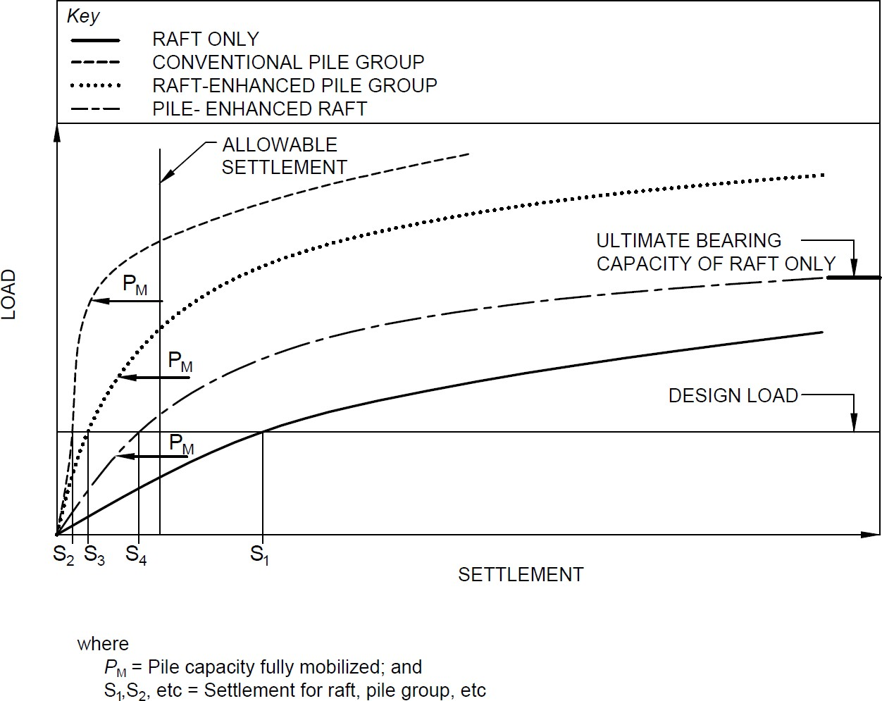

4A LOAD-SETTLEMENT BEHAVIOUR OF RAFTS, CONVENTIONAL PILE GROUPS AND DIFFERENT TYPES OF CPRF

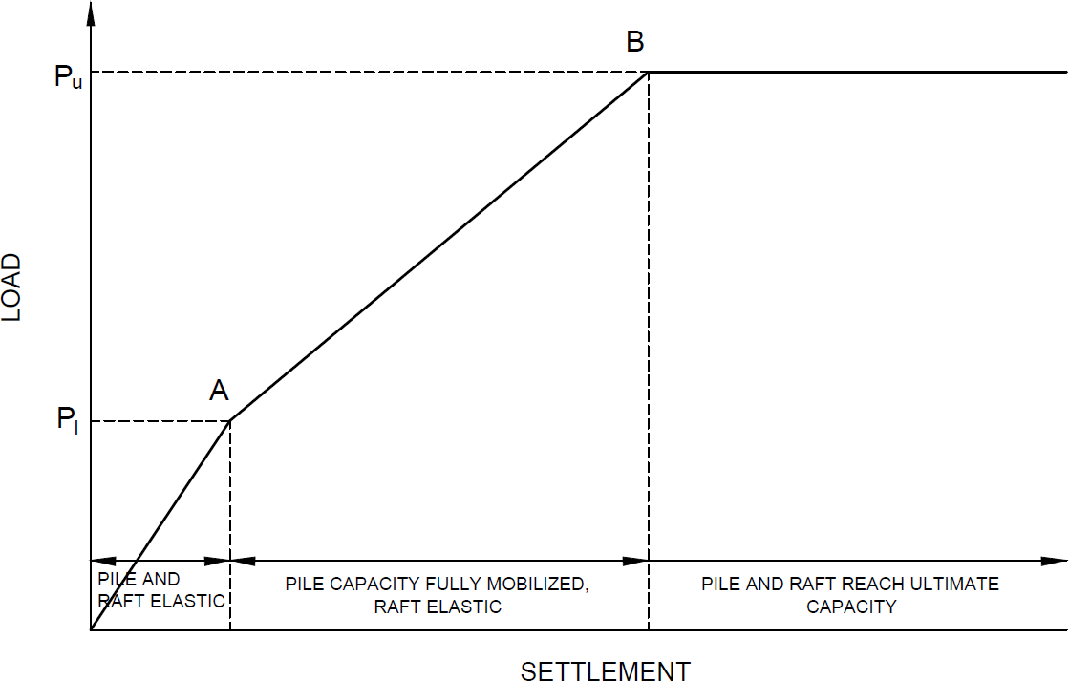

4B SIMPLIFIED LOAD SETTLEMENT CURVE OF A CPRF

FIG. 4 LOAD-SETTLEMENT BEHAVIOUR OF A CPRF

**5.4 Computational Model**

Analysis of CPRF shall be performed using computational model which will be able to simulate the appropriate behaviour of single pile. Later from the actual field test results on single pile, the computational model needs to be revised. The computational model shall capture all the interactions as mentioned in Fig. 2A. Also, the superstructure effect shall be considered appropriately as shown in Fig. 5A. The two features of estimating the stiffness of soil-pile-raft system are through estimation of pile spring stiffness and raft-soil spring stiffness. The iterative process of convergence of pile and raft response (if implicit) will only come after that. Fig. 5 presents the design model of CPRF system considering soil-pile-raft stiffness. Different values of pile stiffness can occur within a group of piles, depending on their position and on the relative stiffness of the raft.

***5.4.1*** *Estimation of Pile Spring Stiffness*

Stiffness of spring representing the pile shall be estimated by dividing the load carried by pile top element in respective direction with the corresponding top displacement of the pile.

Pile spring stiffness, $K_{p}=\frac{Normal contact force at nodes}{Nodal displacement}$

***5.4.2*** *Estimation of Raft-Soil Spring Stiffness*

The soil spring stiffness shall be estimated from the load deformation behaviour of the founding medium as given below:

Raft-soil spring stiffness, $K_{r}=\frac{Normal contact force at nodes}{Nodal displacement}$

**5.5 Allowable Settlement for Static Design Consideration**

For CPRF system, total settlement under gravity load should be restricted within 125 mm and the maximum angular distortion of raft as 1/500. There are four angular distortions (*θ*IL, *θ*IIL, *θ*IB and *θ*IIB) (*see* Fig. 1) and maximum of these four angular distortions will govern CPRF design for Serviceability Limit State (SLS). The total settlement under gravity load may be taken only as a guide and the permissible total settlement should be decided as per serviceability criteria to fulfil the load sharing mechanism of CPRF system.

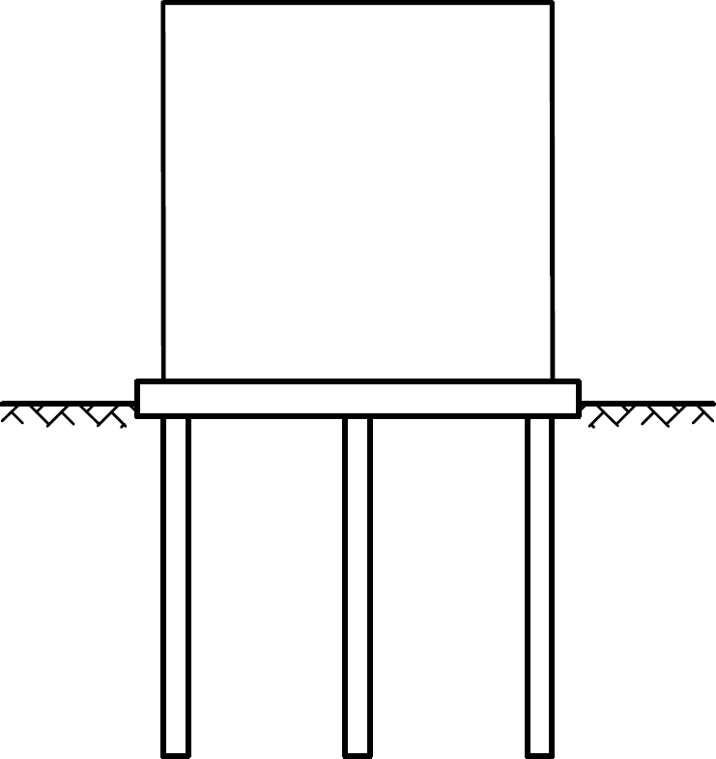

5A RAFT‒PILE‒SOIL IN A CPRF

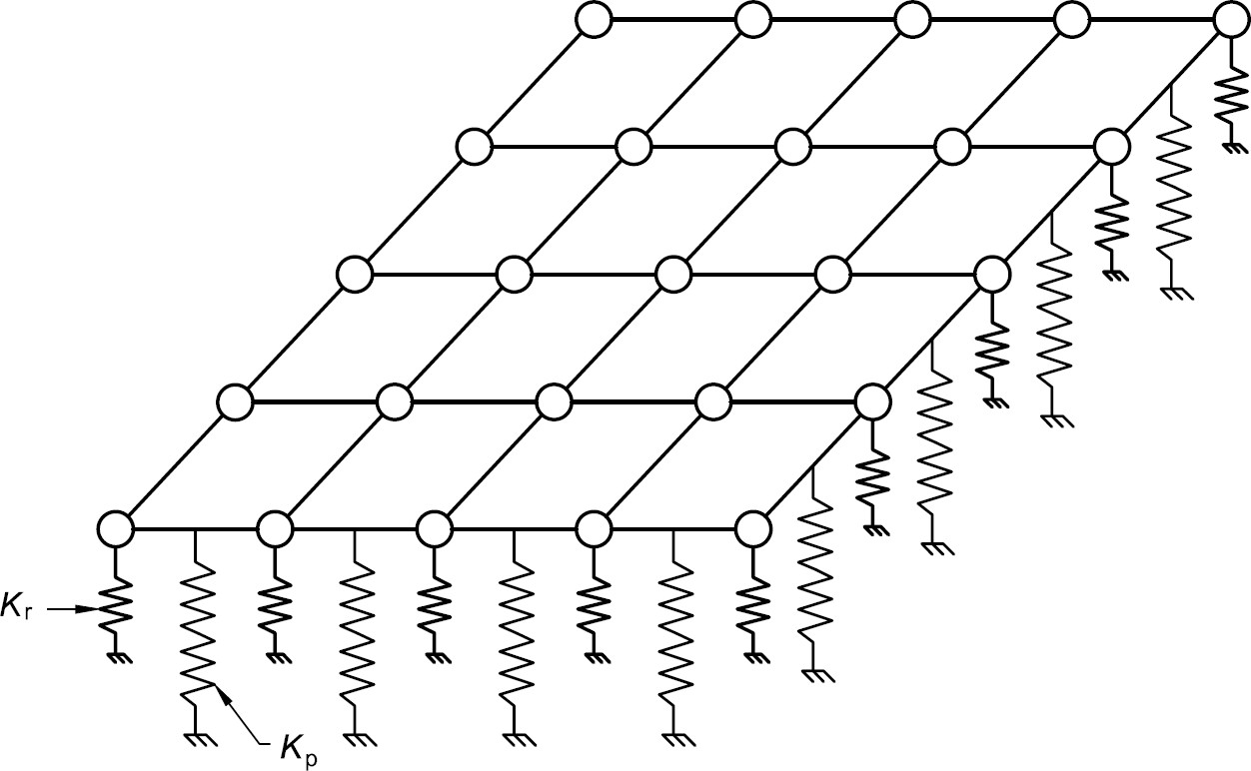

5B PILE AND RAFT-SOIL SPRINGS

FIG. 5 COMBINED ACTION OF SOIL-PILE SYSTEM (TYPICAL DESIGN MODEL)

**6 PROOF OF DESIGN AND CONSTRUCTION OF A CPRF**

The examination of the design and the construction of a CPRF with respect to the geotechnical engineering aspects should be controlled by a geotechnical expert particularly qualified on this subject, assigned by the owner or the supervising authority. This includes the construction for piles and deciding the foundation level. The protocols of the acceptance procedure and the measured values have to be included into the examination. The following aspects shall be considered:

a) Critical review of the soil investigation report (field and laboratory tests), including the selection of input parameters;

b) Evaluation of the computational model used for the design of the CPRF and the computation results by using independent comparative calculations. Apart from the independent comparative calculations, additional quality assurance measures in design should be ensured;

c) Assessment of the effects on the adjacent structures; and

d) Examination of the field monitoring (measuring) program within the construction process of the CPRF.

**7 MONITORING OF A CPRF**

The load-settlement behaviour and the load transfer within a CPRF should be monitored for further use by a geotechnical expert. The monitoring comprises of geotechnical and geodetic measurements at the new building and also at the adjacent buildings for settlement. The monitoring of the contact pressure at the level of raft, axial load in selected piles, settlement at the level of raft, ground water table and pore-pressure may be adopted for important projects. The monitoring of a CPRF is an elementary and indispensable component of the safety concept and should be used for the following purposes:

a) Observational method should be followed for monitoring of the response of CPRF both during and post construction phases for projects of high importance;

b) Verification of the computational model and the computational approaches;

c) Detection of possible critical conditions in CPRF system;

d) Examination of the quality assurance during the construction and post construction process; and

e) Examination of distribution of loads may be implemented on piles in centre and edges to capture soil-pile-raft interactions.

The monitoring program should be designed by a geotechnical expert during the design phase depending on importance of the project, complexity of the ground condition and long-term performance. Summary of desired instrumentations and their locations should be highlighted in plan as well as sectional view of the foundation layout.

**8 STRUCTURAL DESIGN**

The general provision for load, shrinkage, creep and temperature effects and provision of design, reinforcement and detailing shall conform to IS 456 and other relevant standards.

**9 SEISMIC DESIGN**

Design of the CPRF system considering the seismicity of the ground and entire structure and sub-structural system should be handled by experts to ensure conformity to various relevant standards. Both inertial and kinematic effects should be considered in the seismic design.

**Annex A**

(*Clause* 2)

|  |  |
| --- | --- |
| *IS No.* | *Title* |
| IS 456 : 2000 | Plain and reinforced concrete ― Code of practice (*fourth revision*) |
| IS 1892 : 2021 | Subsurface investigation for foundations ― Code of practice (*second revision*) |
| IS 1904 : 2021 | General requirements for design and construction of foundations in soils ― Code of practice (*third revision*) |
| IS 2911 | Design and construction of pile foundations — Code of practice |
| Part 1/Sec 1 : 2010 | Concrete piles, Section 1 Driven cast in-situ concrete piles (*second revision*) |
| Part 1/Sec 2 : 2010 | Concrete piles, Section 2 Bored cast in-situ concrete piles (*second revision*) |
| Part 1/Sec 3 : 2010 | Concrete piles, Section 3 Driven precast concrete piles (*second revision*) |
| Part 1/Sec 4 : 2010 | Concrete piles, Section 4 Precast concrete piles in prebored holes (*second revision*) |
| Part 4 : 2013 | Load test on piles (*second revision*) |
| IS 2950 (Part 1) : 1981 | Code of practice for design and construction of raft foundations: Part 1 Design (*second revision*) |
| IS 6403 : 1981 | Code of practice for determination of bearing capacity of shallow foundations (*first revision*) |
| IS 8009 | Code of practice for calculation of settlement of foundation |
| Part 1 : 1976 | Shallow foundation subjected to symmetrical static vertical loads |
| Part 2 : 1980 | Deep foundation subjected to symmetrical static vertical loading |

**ANNEX B**

(*Clause* 5.3.4)

**B-1 LOAD CARRYING CAPACITY OF CPRF SYSTEM**

**B-1.1** The ultimate vertical capacity shall be taken as the least of:

a) The capacity of the block containing the piles, plus that of the portion of the raft outside the periphery of the pile group;

b) The sum of the capacity of the raft, *Q*unpiled*-*raft and of all the piles *Q*pile*-*group in the system, expressed as, *Q*CPRF = 0.8 (*Q*unpiled*-*raft + *Q*pile-group); and

c) The capacity of CPRF system considering pile-soil-raft interactions. The capacity of CPRF should be expressed as,

$$Q_{CPRF}=α_{pr}α_{pp}\sum_{n=1}^{n}{Q_{single pile}+ α_{rp}Q_{unpiled raft}}$$

In the above expression,

1) 𝑄unpiled-raft should be calculated based on IS 6403.

2) Qsingle pile should be calculated based on IS 2911.

3) αpp, 𝛼rp and 𝛼pr are the pile-pile, raft-pile and pile-raft interaction factors, respectively. These interaction factors may be suitably taken from various relevant literature based on the expertise of the designer for case-to-case basis.

**ANNEX C**

(*Foreword*)

**COMMITTEE COMPOSITION**

Soil and Foundation Engineering Sectional Committee, CED 43

| *Organization* | *Representative(s)* |
| --- | --- |
|
| In Personal Capacity, *473, Vinayak Apartments, BHEL Housing Society, Plot No. C-58/19, Sector 62, Noida, Uttar Pradesh* - *201301* | Shri C. Pushpakaran **(*Chairperson*)** |
| AFCONS Infrastructure Limited, Mumbai | Dr Sunil Basarkar  Dr Lakshmana Rao Mantri (*Alternate-I*)  Shri Budhmal Jain (*Alternate-II*) |
| AIMIL Limited, New Delhi | Shri Rohitash Barua  Smt Aarti Bhargava (*Alternate-I*)  Shri Anil Singh (*Alternate-II*) |
| Bharat Heavy Electricals Ltd, New Delhi | Shri T. M. S. Rao  Shri Vikram S. (*Young Professional*) |
| CEM Engineers and Consultants Pvt Ltd, Bhubaneswar | Shri Ashok Basa  Shri Dilip Basa (*Alternate*) |
| Cengrs Geotechnica Pvt Ltd, Noida | Shri Sanjay Gupta  Shri Ravi Sundaram (*Alternate*)  Shri Sorabh Gupta (*Young Professional*) |
| Central Board of Irrigation and Power, New Delhi | Director |
| Central Electricity Authority,  New Delhi | Shri Baleshwar Thakur  Shri Deepak Singh Raghuvansi (*Alternate*) |
| Central Public Works Department,  New Delhi | Shri Nagendra Prasad  Shri Amrendra Kumar Jalan (*Alternate*) |
| Central Soil and Materials  Research Station, New Delhi | Dr Manish Gupta  Ms Swapna Varma (*Alternate*) |
| CSIR-Central Building Research  Institute, Roorkee | Shri Manojit Samanta  Dr S. Ganesh Kumar (*Alternate*)  Shri Kaushik Pandit (*Young Professional*) |
| CSIR-Central Road Research  Institute, New Delhi | Dr Kanwar Singh  Dr P. S. Prasad (*Alternate*) |
| CSIR-Structural Engineering  Research Centre, Chennai | Dr P. Kamatchi  Smt R Sreekala (*Alternate*)  Dr A. Thirumalaiselvi (*Young Professional*) |
| D-CAD Technologies,  New Delhi | Dr K. G. Bhatia |
| Delhi Development Authority,  New Delhi | Shri Arun Kumar  Shri Harindar Pal (*Alternate*) |
| Delhi Technological University,  New Delhi | Prof. Ashok Kumar Gupta |
| Engineers India Limited,  New Delhi | Shri V. K. Panwar  Shri Sampat Raj (Alternate-I)  Shri Anil Banoth (*Young Professional*) |
| Geodynamics Ltd, Vadodara | Dr Ravikiran Vaidya  Shri Sujan Kulkarni (*Alternate*) |
| Geological Survey of India,  Kolkata | Dr Timir Baran Ghosal  Shri Prashant Tukaram Ilamkar (*Alternate*) |
| Ground Engineering Limited,  New Delhi | Shri Ashok Kumar Jain  Shri Neeraj Kumar Jain (*Alternate*) |
| Hindustan Construction Company  Limited, Mumbai | **Representative** |
| Indian Geotechnical Society,  New Delhi | Prof H. N. Ramesh  Dr Anil Joseph (*Alternate*)  Prof D. Neelima Satyam (*Alternate-II*) |
| Indian Institute of Science,  Bengaluru | Prof Jyant Kumar  Prof G. Madhavi Latha (*Alternate*) |
| Indian Institute of Technology  Delhi, New Delhi | Dr G. V. Ramana  Dr J. T. Shahu (Alternate-I)  Dr Prashanth Vangla (*Young Professional*) |
| Indian Institute of Technology  Kanpur, Kanpur | Prof Priyanka Ghosh |
| Indian Institute of Technology  Madras, Chennai | Prof Subhadeep Banerjee  Prof Ramesh K Kandasami (*Alternate*) |
| Indian Institute of Technology  Bombay, Mumbai | Prof Deepankar Choudhury  Prof Dasaka Murty (*Alternate*) |
| Indian Institute of Technology  Roorkee, Roorkee | Dr Mahendra Singh  Dr Vishwas A. Sawant (*Alternate*) |
| Indian Road Congress, New Delhi | Secretary General  Director (T) (*Alternate*) |
| Indian Society of Earthquake  Technology, Roorkee | Prof B. K. Maheswari  Prof Vasant A. Matsagar (*Alternate*) |
| ITD Cementation India Ltd, Kolkata | Shri Manish Kumar  Shri Aminul Islam (*Alternate*) |
| Jadhavpur University, Kolkata | Prof Sibapriya Mukherjee  Prof Ramendu Bikas Sahu (*Alternate*) |
| Keller Ground Engineering Pvt Ltd, Chennai | Shri V. V. S. Ramadas  Shri Madan Kumar Annam (*Alternate*) |
| [L&T GeoStructure Private Limited, Chennai](javascript:;) | Shri M. Kumaran  Shri A. Vetriselvan (*Alternate*) |
| Military Engineer Services,  Engineer-in-Chief's Branch,  Integrated HQ of MoD (Army),  New Delhi | Shri Manoj Bapna  Shri Ajay Kumar Sinha (*Alternate*) |
| MECON Limited, Ranchi | Shri Shankar Ray  Shri Ayush Srivastava (*Alternate*) |
| Ministry of Ports, Shipping and  Waterways, New Delhi | Shri H. N. Aswath  Shri Anil Pruthi (*Alternate*) |
| Mumbai Port Trust, Mumbai | Dy Chief Engineer (Design)  Superintending Engineer (Design) (*Alternate*) |
| Nagadi Consultants Pvt Limited,  New Delhi | Dr V. V. S. Rao  Shri N. Santosh Rao (*Alternate*) |
| National Capital Region Transport  Corporation, New Delhi | Shri Jitender Kumar |
| National High Speed Rail  Corporation Ltd, Mumbai | **Representative** |
| National Institute of Disaster  Management, New Delhi | Dr Chandan Ghosh  Dr Amir Ali Khan (*Alternate*) |
| NTPC Limited, Noida | Shri Mohit Jhalani |
| Power Grid Corporation of India  Limited, Gurugram | **Representative** |
| Research Designs and Standards  Organization (Ministry of  Railways), Lucknow | Shri Sameer Singh  Shri S. K. Ojha (*Alternate*) |
| RITES Limited, Gurugram | Shri Koshy Vaidyan  Shri Sumeet Mahajan (*Alternate*) |
| Safe Enterprises, Mumbai | Shri Vikram Singh Rao  Shri Suryaveer Singh Rao (*Alternate*) |
| STUP Consultants Pvt Ltd, Mumbai | Shri Anirban Sengupta  Shri Yogesh Waingankar (*Alternate*) |
| Tata Consulting Engineers Limited, Mumbai | Shri Sanjeev Gupta  Shri B. N. Nagaraj (*Alternate*) |
| Telangana State Research  Laboratories, Hyderabad | Shri A. G. Manoj Kumar  Shri Ashirwadam Jakkula (*Alternate-I*)  Smt M. Manjula (*Alternate-II*) |
| The Pressure Piling Co (I) Pvt  Limited, Mumbai | Shri V. C. Deshpande  Shri Pushkar V. Deshpande (*Alternate*) |
| Unique Geocivil Services Pvt Ltd,  Surat | Shri Nehal H. Desai  Shri Hitesh H. Desai (*Alternate-I*)  Shri Dhruval D. Shah (*Alternate-II*) |
| In Personal Capacity, *1-B, Villakkupattam Palace, First Floor, 48, New Avadi Road, Kilpauk, Chennai 600010* | Dr V. Balakumar |
| BIS Directorate General | Shri Dwaipayan Bhadra, Scientist ‘E’/ Director and Head (Civil Engineering) [Representing Director General (*Ex-officio*)] |
| *Member Secretary*  Shri Dheeraj Damachya  Scientist ‘B’ / Assistant Director  (Civil Engineering), BIS | |

Working Group for Combined Piled-Raft Foundations ― Code of Practice, CED 43/ WG17

| *Organization* | *Representative(s)* |
| --- | --- |
| Indian Institute of Technology Bombay, Mumbai | Prof Deepankar Choudhury (***Convener***) |
| Bhabha Atomic Research Centre, Mumbai | Dr V. S. Phanikanth |
| Bharat Heavy Electricals Limited,  New Delhi | Shri T. M. S. Rao |
| Cengrs Geotechnica Pvt Ltd, Noida | Shri Sanjay Gupta |
| Geodynamics Ltd, Vadodara | Dr Jaykumar Shukla |
| Marsh McLennan, Mumbai | Shri Aniruddha Bhaduri |
| Indian Institute of Technology Delhi,  New Delhi | Prof Tanusree Chakraborty |
| Indian Institute of Technology Madras, Chennai | Prof Subhadeep Banerjee |
| Indian Institute of Technology Mandi, Kamand | Dr Ashutosh Kumar |
| Indian Institute of Technology Roorkee, Roorkee | Dr B. K. Maheshwari |
| National Institute of Technology Agartala, Agartala | Prof Rajib Saha |
| Nuclear Power Corporation of India Ltd, Mumbai | Shri Girish Patil |
| In Personal Capacity, *1-B, Villakkupattam Palace, First Floor, 48, New Avadi Road, Kilpauk, Chennai 600010* | Dr V. Balakumar |