*भारतीय मानक*

**मृदा परीक्षण के लिए अपरूपण बॉक्स (बड़ा) ― विशिष्टि**

**(*पहला पुनरीक्षण*)**

*Indian Standard*

**Shear Box (Large) for Testing of Soils ― Specification**

(*First Revision*)

ICS 93.020; 13.080.20



Soil and Foundation Engineering Sectional Committee, CED 43

**FOREWORD**

This Indian Standard (First Revision) was adopted by the Bureau of Indian Standards, after the draft finalized by the Soil and Foundation Engineering Sectional Committee had been approved by the Civil Engineering Division Council.

There are a series of standards on methods of testing of soils. It has been recognized that reliable and inter-comparable test results can be obtained only with the standard testing equipment capable of giving the desired level of accuracy. With this objective, a series of specifications covering the requirements of equipment used for testing soils have been published to encourage their development and manufacturing in the country.

The equipment covered in this standard is used as a part of the assembly for the equipment used for the laboratory determination of shear strength of the soil [*see* IS 2720 (Part 39/ Sec 1) : 1977 ‘Methods of test for soils: Part 39 Direct shear test for soils containing gravel, Section 1 Laboratory test’].

This standard was first published in 1986. The present revision has been taken up with a view to incorporate the modifications found necessary as a result of experience gained in the use of this standard. The other major modifications incorporated in this revision of the standard are given below:

1. The standard has been brought into latest style and format of Indian Standards,
2. References to Indian Standards, wherever applicable have been updated.
3. BIS certification marking clause has been modified to align with the revised *Bureau of Indian Standards Act, 2016*.

This standard contributes to the Sustainable Development Goal 9 - Industry, Innovation and Infrastructure: Build resilient infrastructure, promote inclusive and sustainable industrialization and foster innovation.

The composition of the Committee responsible for formulation of the standard is given in Annex A.

For the purpose of deciding whether a particular requirement of this standard is complied with, the final value, observed or calculated, expressing the result of a test or analysis, shall be rounded off in accordance with IS 2 : 2022 ‘Rules for rounding off numerical values (*second* *revision*)’. The number of significant places retained in the rounded off value should be the same as that of the specified value in this standard.

*Indian Standard*

**SHEAR BOX (LARGE) FOR TESTING OF SOILS ― SPECIFICATION**

(*First Revision*)

**1 SCOPE**

The equipment covered in this standard is used as a part of the assembly for the equipment used for laboratory determination of direct shear strength of the soil material with particle size up to 25 mm, that is, soils containing moorums, sands, gravels and other aggregates.

**2 REFERENCES**

The following standards contain provisions, which through reference in this text, constitute provisions of this standard. At the time of publication, the editions indicated were valid. All standards are subject to revision, and parties to agreement based on this standard are encouraged to investigate the possibility of applying the most recent editions of the standards indicated below:

|  |  |
| --- | --- |
| *IS No.* | *Title* |
| IS 513 (Part 1) : 2016 | Cold reduced carbon steel sheet and strip; Part 1 Cold forming and drawing purpose (*sixth revision*) |
| IS 2102 (Part 1) : 1993 | General tolerances: Part 1 Tolerances for linear and angular dimensions without individual tolerance indications (*third revision*) |

**3 GENERAL REQUIREMENTS**

The shear box shall consist of the following (*see* Fig. 1):

a) Upper and lower parts of the shear box coupled together with two pins;

b) Grid plates – 2 pairs;

c) Spacer plates;

d) Base plate;

e) Loading pad; and

f) Water jacket.

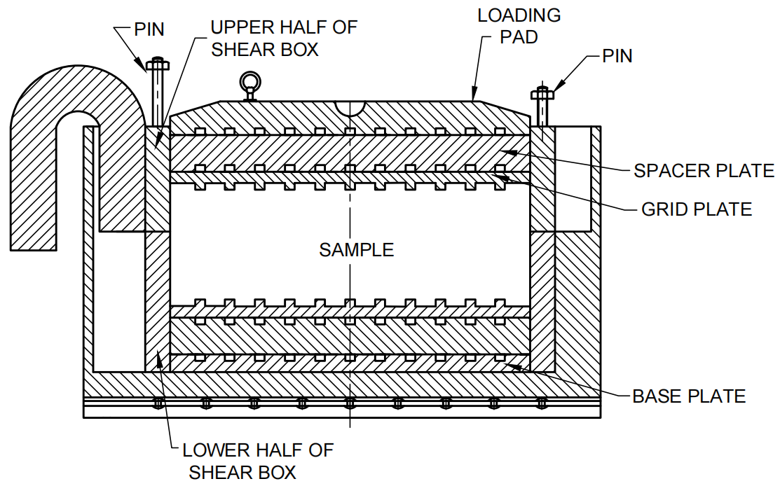

FIG. 1 SHEAR BOX (LARGE) ASSEMBLY

**4 MATERIALS**

The material used for the construction of the different components of shear box shall be as given in Table 1.

**Table 1 Materials of Construction for Different Components of Shear Box**

(*Clause* 4)

|  |  |  |  |
| --- | --- | --- | --- |
| **Sl No.** | **Component** | **Material** | **Conforming to Indian Standard** |
| (1) | (2) | (3) | (4) |
| i) | Upper and lower parts of shear box | Mild Steel | IS 513 (Part 1) |
| ii) | Grid plates - 2 pairs | Mild Steel | IS 513 (Part 1) |
| iii) | Spacer plates | Mild Steel | IS 513 (Part 1) |
| iv) | Base plate | Mild Steel | IS 513 (Part 1) |
| v) | Loading pad | Mild Steel | IS 513 (Part 1) |
| vi) | Water jacket | Mild Steel | IS 513 (Part 1) |

**5 SHAPE AND DIMENSIONS**

The shape and dimensions of the various components of the shear box shall be as given in Fig. 2 to 7. The tolerance to the dimensions shall be as given in IS 2102 (Part 1) and shall be of medium class.

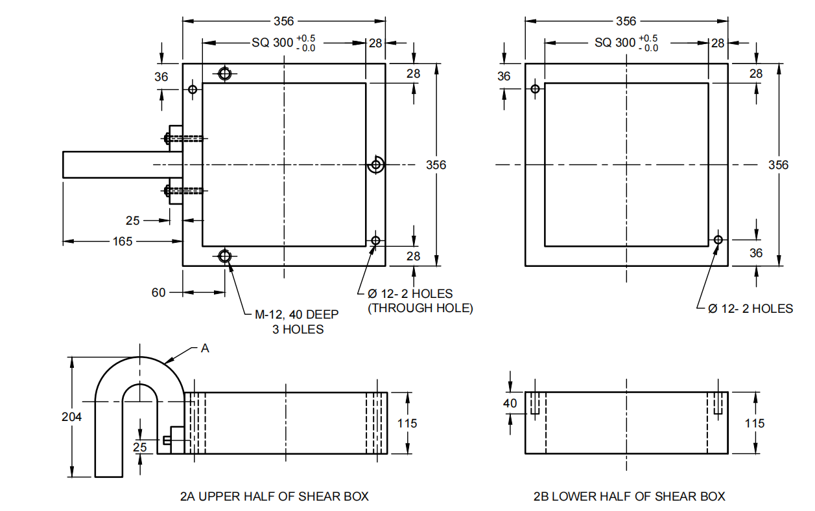

|  |  |
| --- | --- |
| 2A SIDE VIEW OF UPPER HALF OF SHEAR BOX | 2B LOWER HALF OF SHEAR BOX |

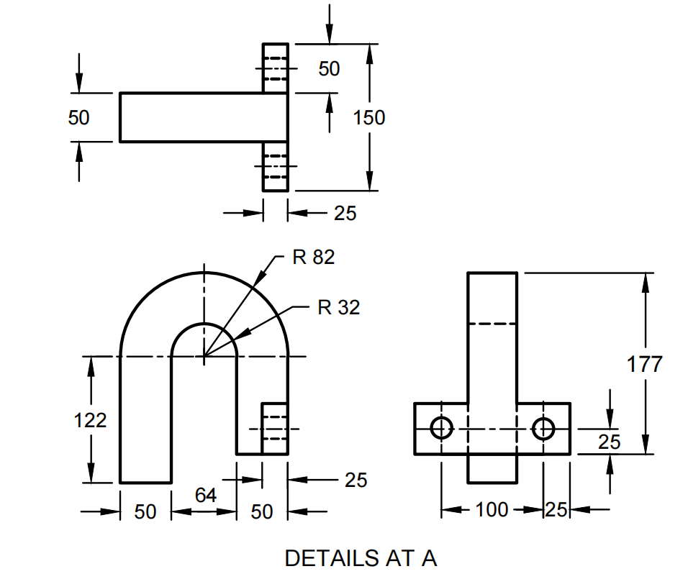

All dimensions in millimetres.

FIG. 2 DETAILS OF UPPER AND LOWER HALVES OF SHEAR BOX

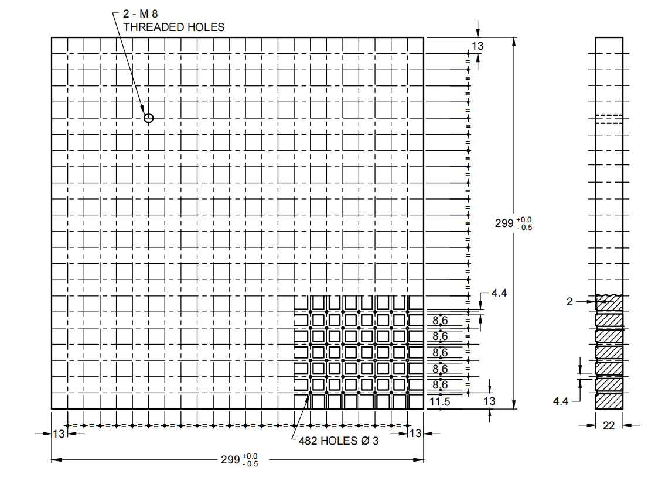

All dimensions in millimetres.

FIG. 3 SPACER PLATE

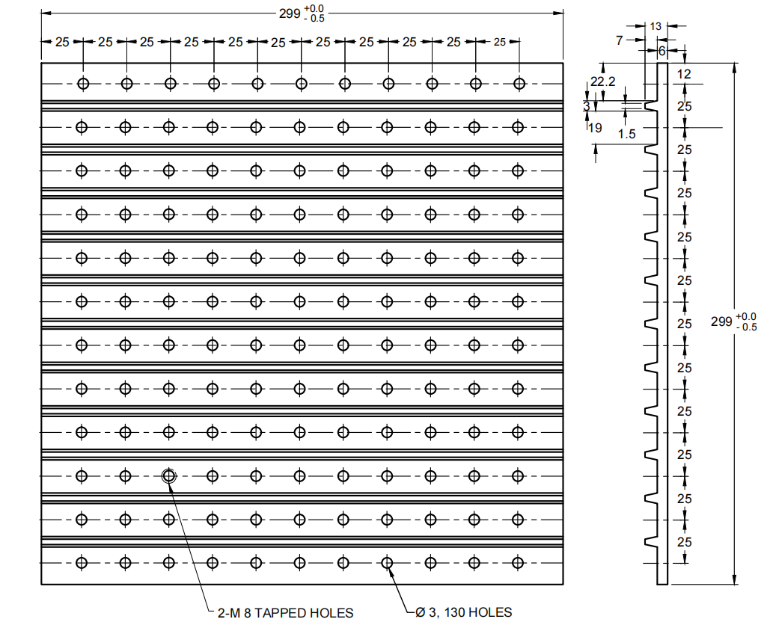

All dimensions in millimetres.

FIG. 4 GRID PLATE

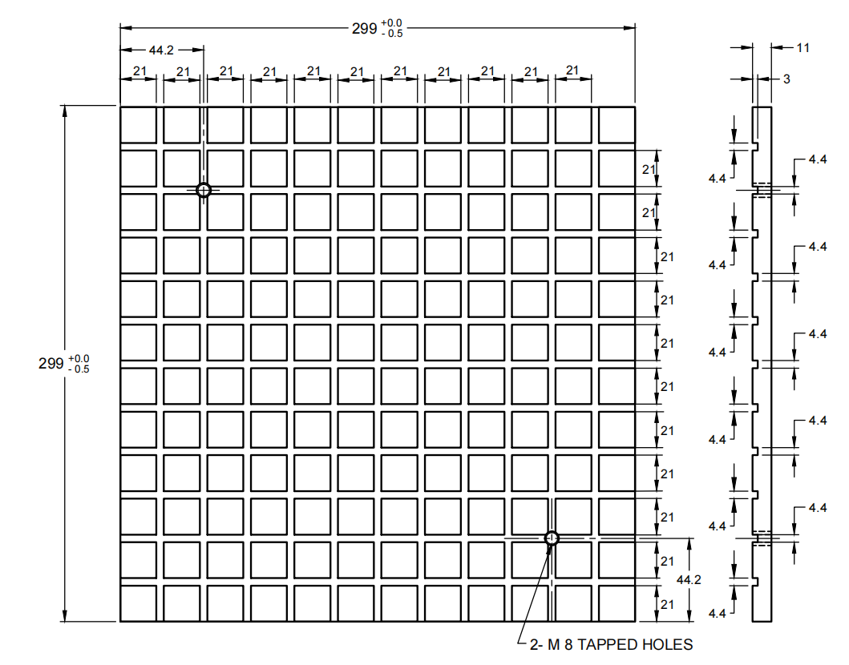

All dimensions in millimetres.

FIG. 5 BASE PLATE

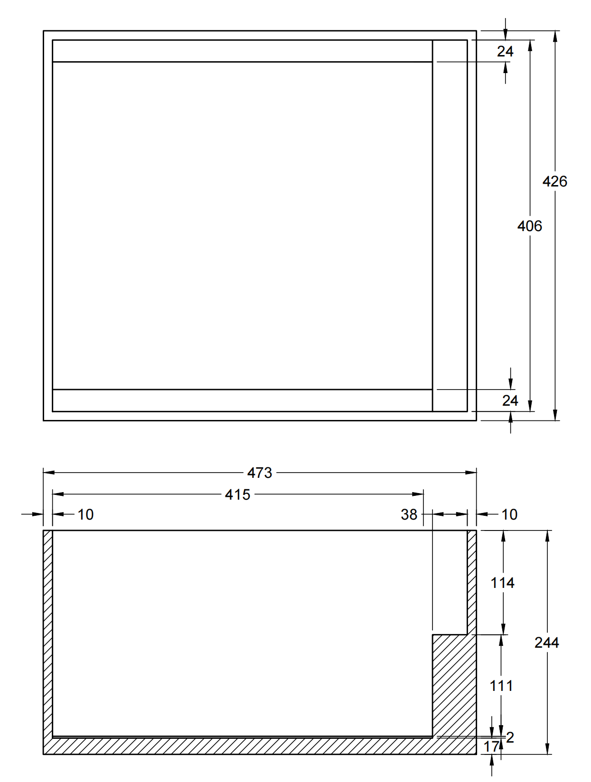

All dimensions in millimetres.

FIG. 6 WATER JACKET

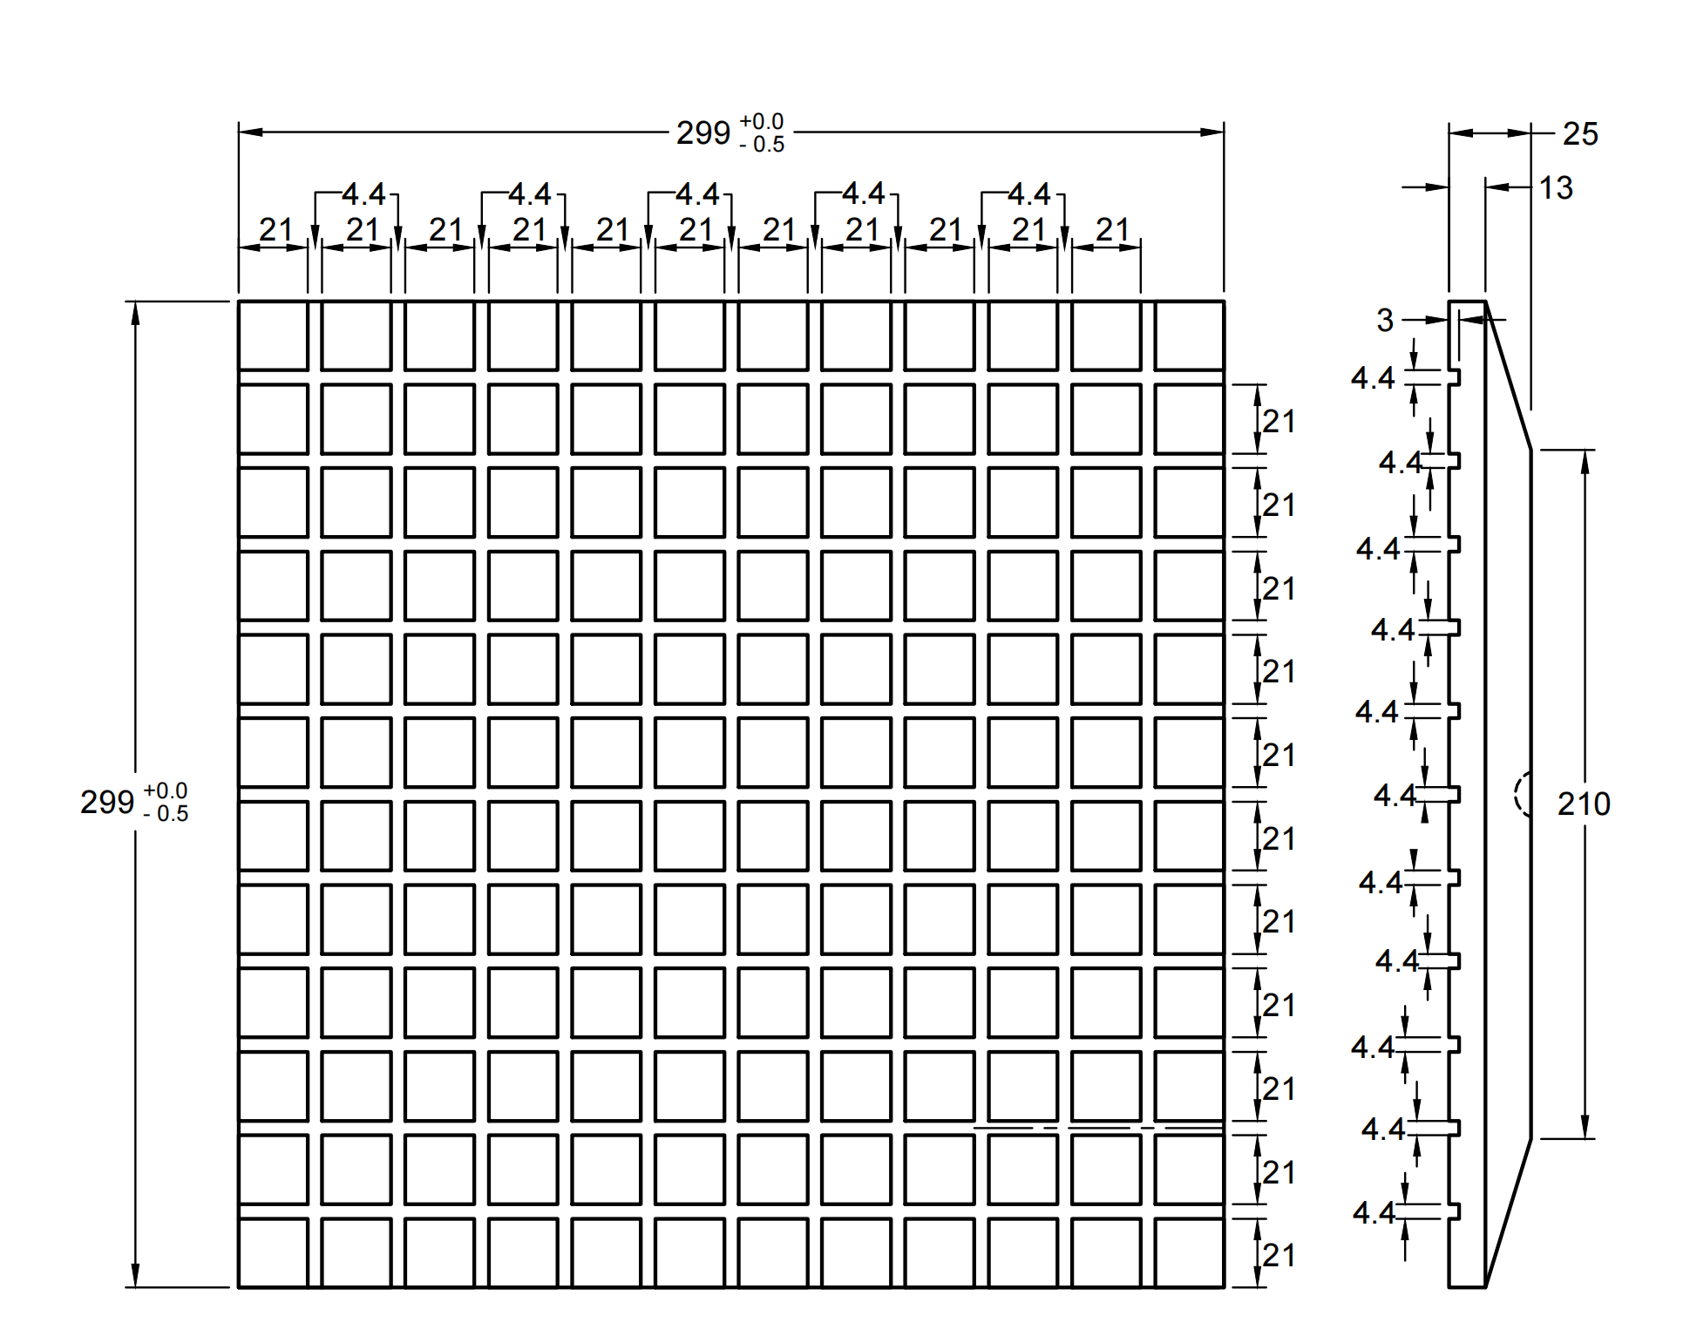

All dimensions in millimetres.

FIG. 7 LOADING PAD

**6 MARKING**

**6.1** The following information shall be clearly and indelibly marked on each component of equipment:

a) Name of the manufacturer or his registered trade-mark or both; and

b) Date of manufacture.

**6.2** **BIS Certification Marking**

The product conforming to the requirements of this standard may be certified as per the conformity assessment schemes under the provisions of the *Bureau of Indian Standards Act,* 2016 and the Rules and Regulations framed thereunder, and the product may be marked with the Standard Mark.

**ANNEX A**

(*Foreword*)

**COMMITTEE COMPOSITION**

Soil and Foundation Engineering Sectional Committee, CED 43

| *Organization* | *Representative(s)* |
| --- | --- |
|
| In Personal Capacity, *473, Vinayak Apartments, BHEL Housing Society, Plot No. C-58/19, Sector 62, Noida, Uttar Pradesh* - *201301* | Shri C. Pushpakaran **(*Chairperson*)** |
| AFCONS Infrastructure Limited, Mumbai | Dr Sunil Basarkar  Dr Lakshmana Rao Mantri (*Alternate-I*)  Shri Budhmal Jain (*Alternate-II*) |
| AIMIL Limited, New Delhi | Shri Rohitash Barua  Smt Aarti Bhargava (*Alternate-I*)  Shri Anil Singh (*Alternate-II*) |
| Bharat Heavy Electricals Ltd, New Delhi | Shri T. M. S. Rao  Shri Vikram S. (*Young Professional*) |
| CEM Engineers and Consultants Pvt Ltd, Bhubaneswar | Shri Ashok Basa  Shri Dilip Basa (*Alternate*) |
| Cengrs Geotechnica Pvt Ltd, Noida | Shri Sanjay Gupta  Shri Ravi Sundaram (*Alternate*)  Shri Sorabh Gupta (*Young Professional*) |
| Central Board of Irrigation and Power, New Delhi | Director |
| Central Electricity Authority,  New Delhi | Shri Baleshwar Thakur  Shri Deepak Singh Raghuvansi (*Alternate*) |
| Central Public Works Department,  New Delhi | Shri Nagendra Prasad  Shri Amrendra Kumar Jalan (*Alternate*) |
| Central Soil and Materials  Research Station, New Delhi | Dr Manish Gupta  Ms Swapna Varma (*Alternate*) |
| CSIR-Central Building Research  Institute, Roorkee | Shri Manojit Samanta  Dr S. Ganesh Kumar (*Alternate*)  Shri Kaushik Pandit (*Young Professional*) |
| CSIR-Central Road Research  Institute, New Delhi | Dr Kanwar Singh  Dr P. S. Prasad (*Alternate*) |
| CSIR-Structural Engineering  Research Centre, Chennai | Dr P. Kamatchi  Smt R Sreekala (*Alternate*)  Dr A. Thirumalaiselvi (*Young Professional*) |
| D-CAD Technologies,  New Delhi | Dr K. G. Bhatia |
| Delhi Development Authority,  New Delhi | Shri Arun Kumar  Shri Harindar Pal (*Alternate*) |
| Delhi Technological University,  New Delhi | Prof. Ashok Kumar Gupta |
| Engineers India Limited,  New Delhi | Shri V. K. Panwar  Shri Sampat Raj (Alternate-I)  Shri Anil Banoth (*Young Professional*) |
| Geodynamics Ltd, Vadodara | Dr Ravikiran Vaidya  Shri Sujan Kulkarni (*Alternate*) |
| Geological Survey of India,  Kolkata | Dr Timir Baran Ghosal  Shri Prashant Tukaram Ilamkar (*Alternate*) |
| Ground Engineering Limited,  New Delhi | Shri Ashok Kumar Jain  Shri Neeraj Kumar Jain (*Alternate*) |
| Hindustan Construction Company  Limited, Mumbai | **Representative** |
| Indian Geotechnical Society,  New Delhi | Prof H. N. Ramesh  Dr Anil Joseph (*Alternate*)  Prof D. Neelima Satyam (*Alternate-II*) |
| Indian Institute of Science,  Bengaluru | Prof Jyant Kumar  Prof G. Madhavi Latha (*Alternate*) |
| Indian Institute of Technology  Delhi, New Delhi | Dr G. V. Ramana  Dr J. T. Shahu (Alternate-I)  Dr Prashanth Vangla (*Young Professional*) |
| Indian Institute of Technology  Kanpur, Kanpur | Prof Priyanka Ghosh |
| Indian Institute of Technology  Madras, Chennai | Prof Subhadeep Banerjee  Prof Ramesh K Kandasami (*Alternate*) |
| Indian Institute of Technology  Bombay, Mumbai | Prof Deepankar Choudhury  Prof Dasaka Murty (*Alternate*) |
| Indian Institute of Technology  Roorkee, Roorkee | Dr Mahendra Singh  Dr Vishwas A. Sawant (*Alternate*) |
| Indian Road Congress, New Delhi | Secretary General  Director (T) (*Alternate*) |
| Indian Society of Earthquake  Technology, Roorkee | Prof B. K. Maheswari  Prof Vasant A. Matsagar (*Alternate*) |
| ITD Cementation India Ltd, Kolkata | Shri Manish Kumar  Shri Aminul Islam (*Alternate*) |
| Jadhavpur University, Kolkata | Prof Sibapriya Mukherjee  Prof Ramendu Bikas Sahu (*Alternate*) |
| Keller Ground Engineering Pvt Ltd, Chennai | Shri V. V. S. Ramadas  Shri Madan Kumar Annam (*Alternate*) |
| [L&T GeoStructure Private Limited, Chennai](javascript:;) | Shri M. Kumaran  Shri A. Vetriselvan (*Alternate*) |
| Military Engineer Services,  Engineer-in-Chief's Branch,  Integrated HQ of MoD (Army),  New Delhi | Shri Manoj Bapna  Shri Ajay Kumar Sinha (*Alternate*) |
| MECON Limited, Ranchi | Shri Shankar Ray  Shri Ayush Srivastava (*Alternate*) |
| Ministry of Ports, Shipping and  Waterways, New Delhi | Shri H. N. Aswath  Shri Anil Pruthi (*Alternate*) |
| Mumbai Port Trust, Mumbai | Dy Chief Engineer (Design)  Superintending Engineer (Design) (*Alternate*) |
| Nagadi Consultants Pvt Limited,  New Delhi | Dr V. V. S. Rao  Shri N. Santosh Rao (*Alternate*) |
| National Capital Region Transport  Corporation, New Delhi | Shri Jitender Kumar |
| National High Speed Rail  Corporation Ltd, Mumbai | **Representative** |
| National Institute of Disaster  Management, New Delhi | Dr Chandan Ghosh  Dr Amir Ali Khan (*Alternate*) |
| NTPC Limited, Noida | Shri Mohit Jhalani |
| Power Grid Corporation of India  Limited, Gurugram | **Representative** |
| Research Designs and Standards  Organization (Ministry of  Railways), Lucknow | Shri Sameer Singh  Shri S. K. Ojha (*Alternate*) |
| RITES Limited, Gurugram | Shri Koshy Vaidyan  Shri Sumeet Mahajan (*Alternate*) |
| Safe Enterprises, Mumbai | Shri Vikram Singh Rao  Shri Suryaveer Singh Rao (*Alternate*) |
| STUP Consultants Pvt Ltd, Mumbai | Shri Anirban Sengupta  Shri Yogesh Waingankar (*Alternate*) |
| Tata Consulting Engineers Limited, Mumbai | Shri Sanjeev Gupta  Shri B. N. Nagaraj (*Alternate*) |
| Telangana State Research  Laboratories, Hyderabad | Shri A. G. Manoj Kumar  Shri Ashirwadam Jakkula (*Alternate-I*)  Smt M. Manjula (*Alternate-II*) |
| The Pressure Piling Co (I) Pvt  Limited, Mumbai | Shri V. C. Deshpande  Shri Pushkar V. Deshpande (*Alternate*) |
| Unique Geocivil Services Pvt Ltd,  Surat | Shri Nehal H. Desai  Shri Hitesh H. Desai (*Alternate-I*)  Shri Dhruval D. Shah (*Alternate-II*) |
| In Personal Capacity, *1-B, Villakkupattam Palace, First Floor, 48, New Avadi Road, Kilpauk, Chennai 600010* | Dr V. Balakumar |
| BIS Directorate General | Shri Dwaipayan Bhadra, Scientist ‘E’/ Director and Head (Civil Engineering) [Representing Director General (*Ex-officio*)] |
| *Member Secretary*  Shri Dheeraj Damachya  Scientist ‘B’ / Assistant Director  (Civil Engineering), BIS | |